Synthesis of Novel Indole Derivatives, Antiproliferative Activity, Apoptosis, and Molecular Docking Studies
Mahsa Toolabi^{a,b}, Zahra Sabzevari^{b}, Zakaria Forouzanfar^{b}, Ayyub Mojaddami^{a,b,}*

ªToxicology Research Center, Medical Basic Sciences Research Institute, Ahvaz Jundishapur University of Medical Sciences, Ahvaz, Iran.
^{b}Department of Medicinal Chemistry, Faculty of Pharmacy, Ahvaz Jundishapur University of Medical Sciences, Ahvaz, Iran.

*Corresponding author. Tel.: +98 61 33112278; Fax: +98 61 33738381; Email: mojaddami.a@gmail.com

.
¹H, ¹³C NMR, IR, and Mass Spectra of synthetic compounds ………………….2-49

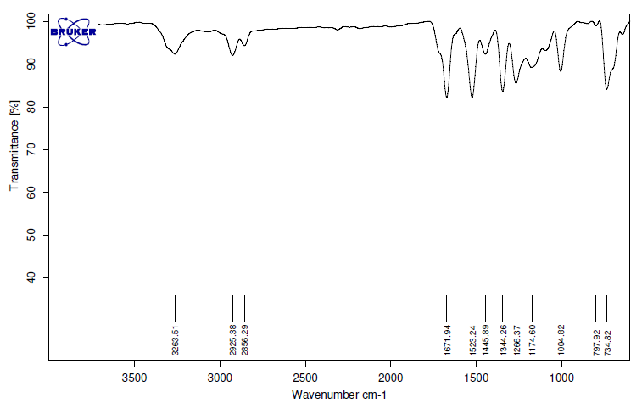
Fig S1. FT-IR spectrum of 4a

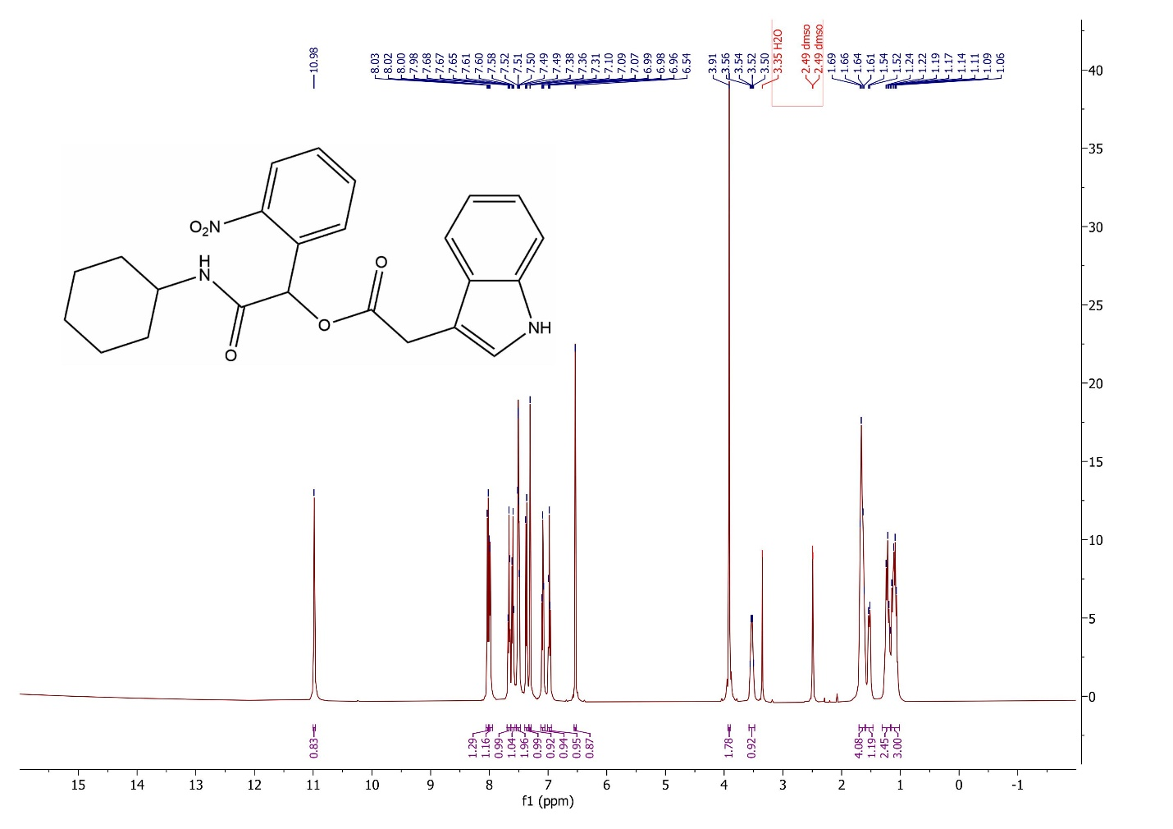
Fig S2. ¹H NMR spectrum of 4a

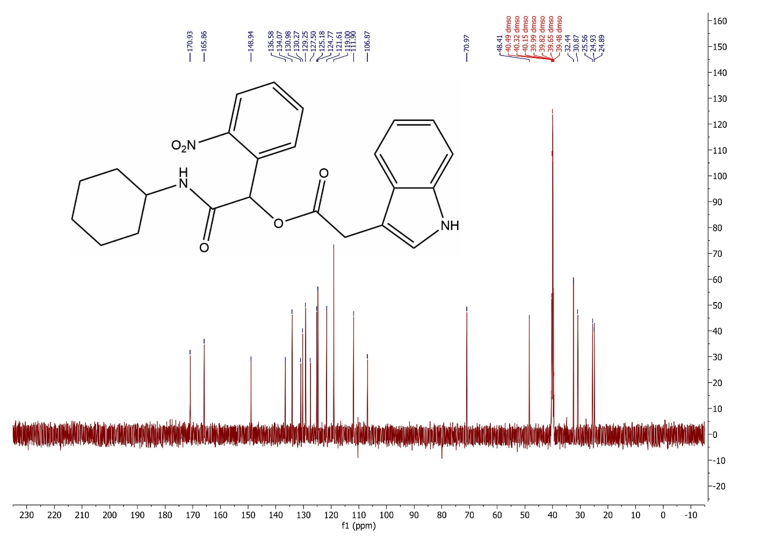
Fig S3. ¹³C NMR spectrum of 4a

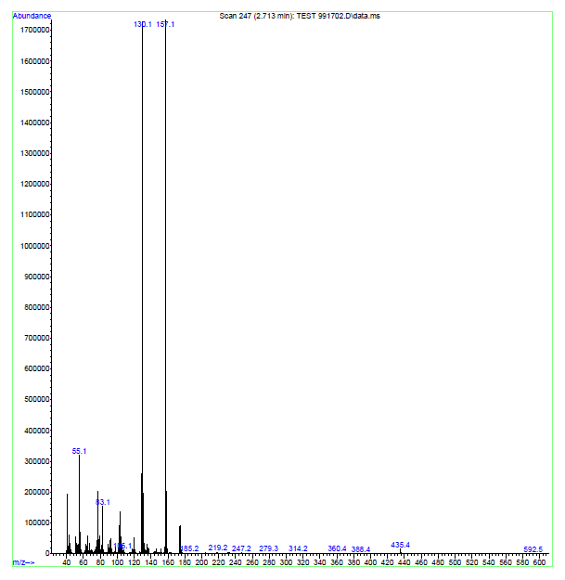
Fig S4. Mass spectrum of 4a

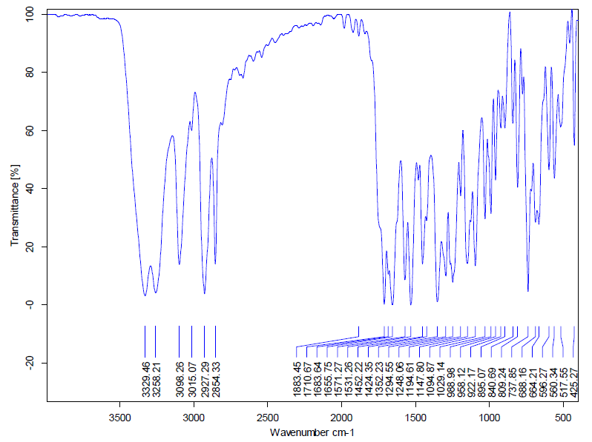
Fig S5. FT-IR spectrum of 4b

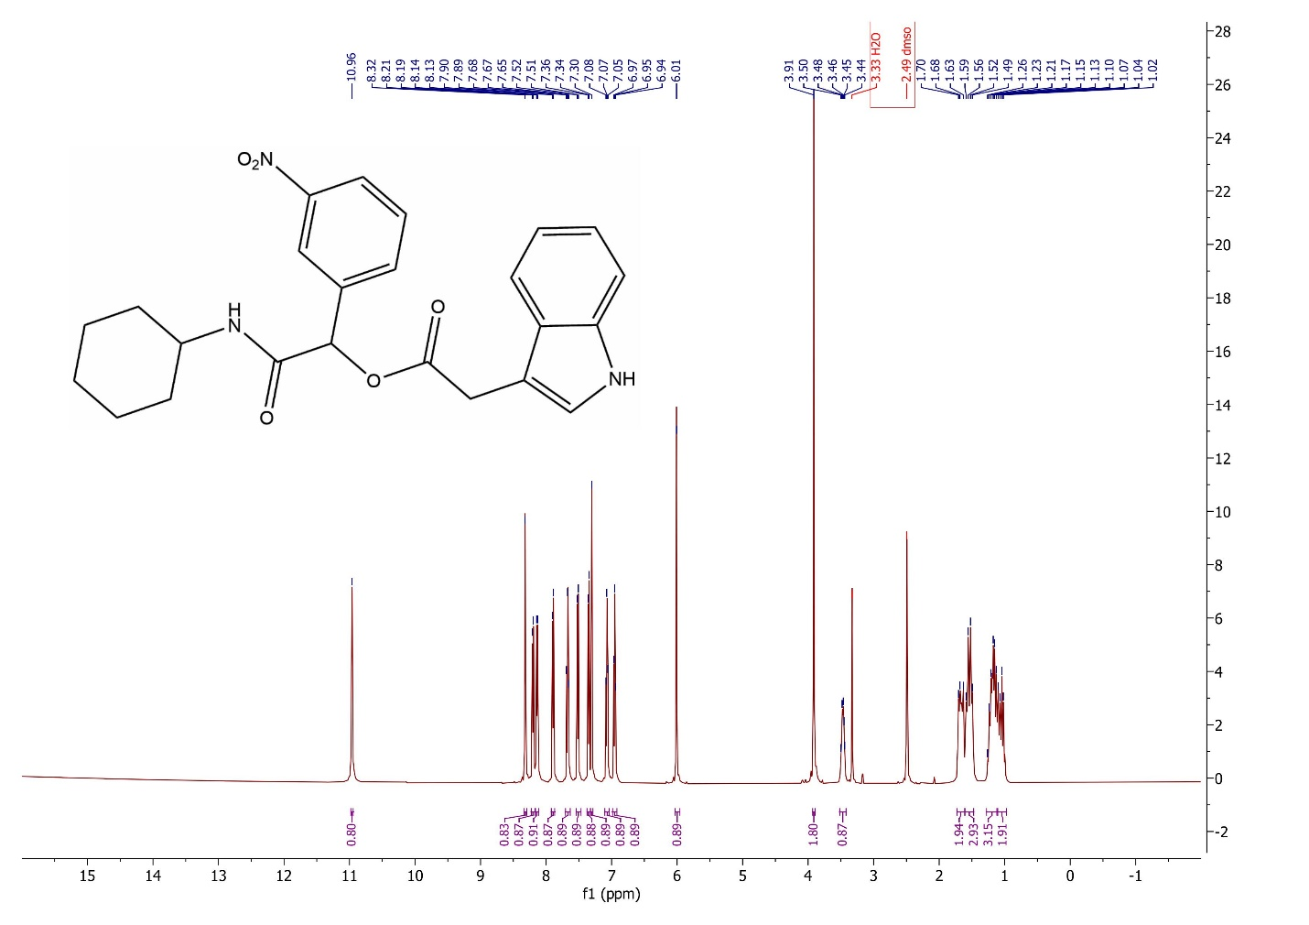

Fig S6. ¹H NMR spectrum of 4b

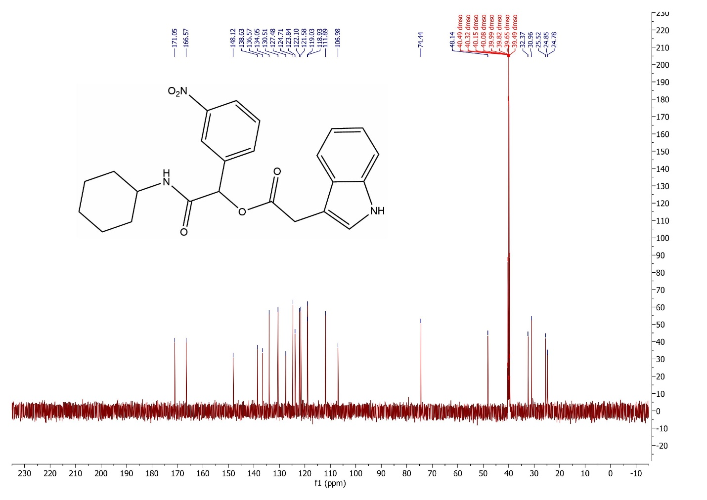
Fig S7. ¹³C NMR spectrum of 4b

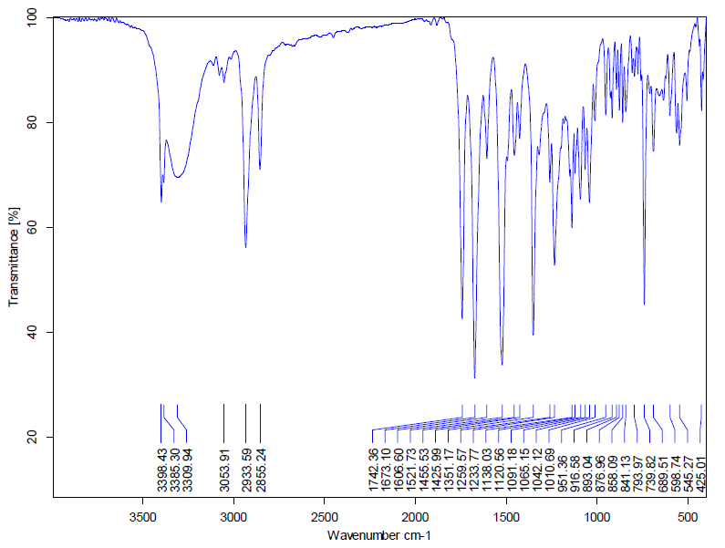

Fig S8. FT-IR spectrum of 4c

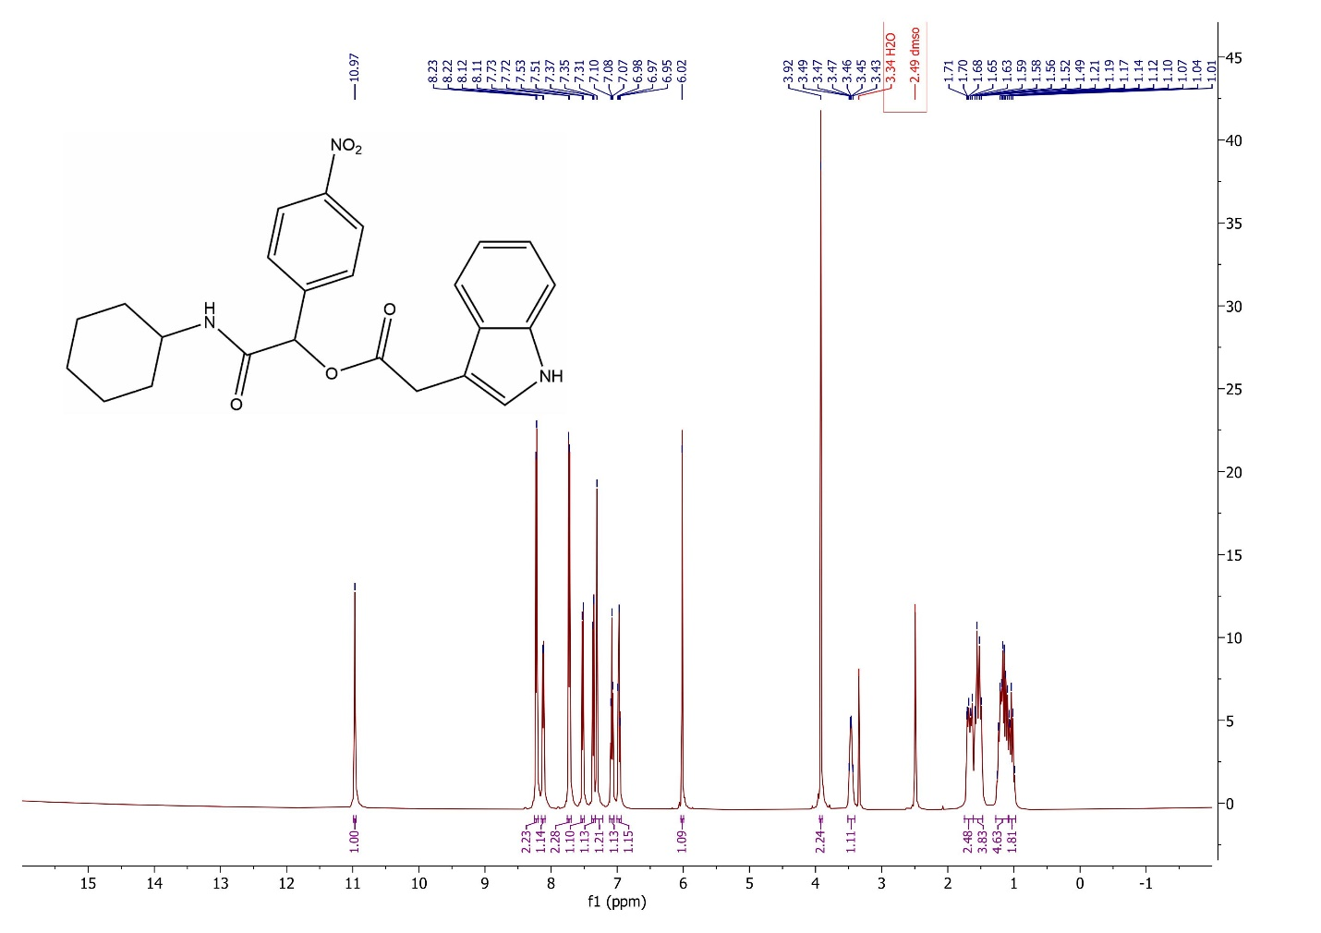
Fig S9. ¹H NMR spectrum of 4c

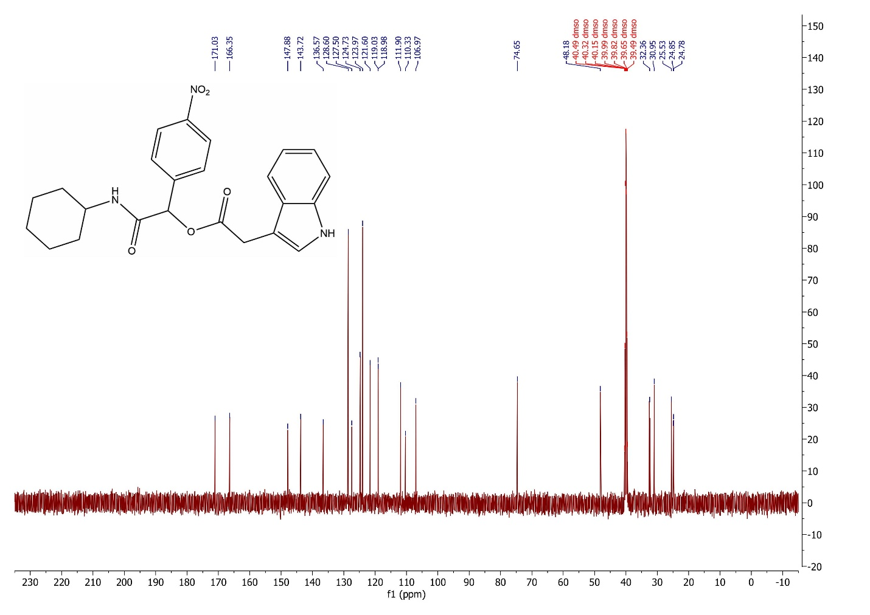
Fig S10. ¹³C NMR spectrum of 4c

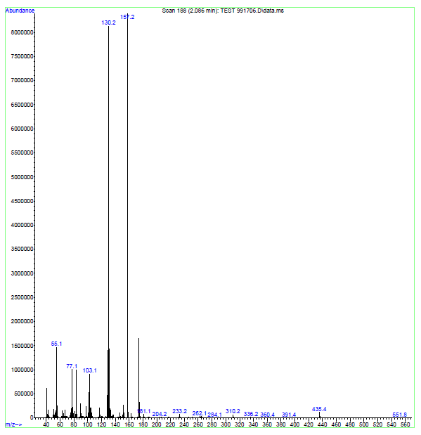
Fig S11. Mass spectrum of 4c

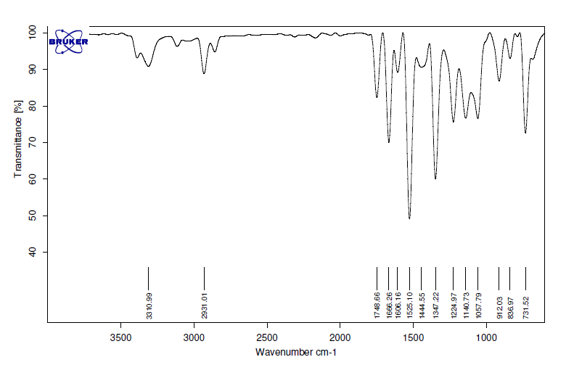
Fig S12. FT-IR spectrum of 4d

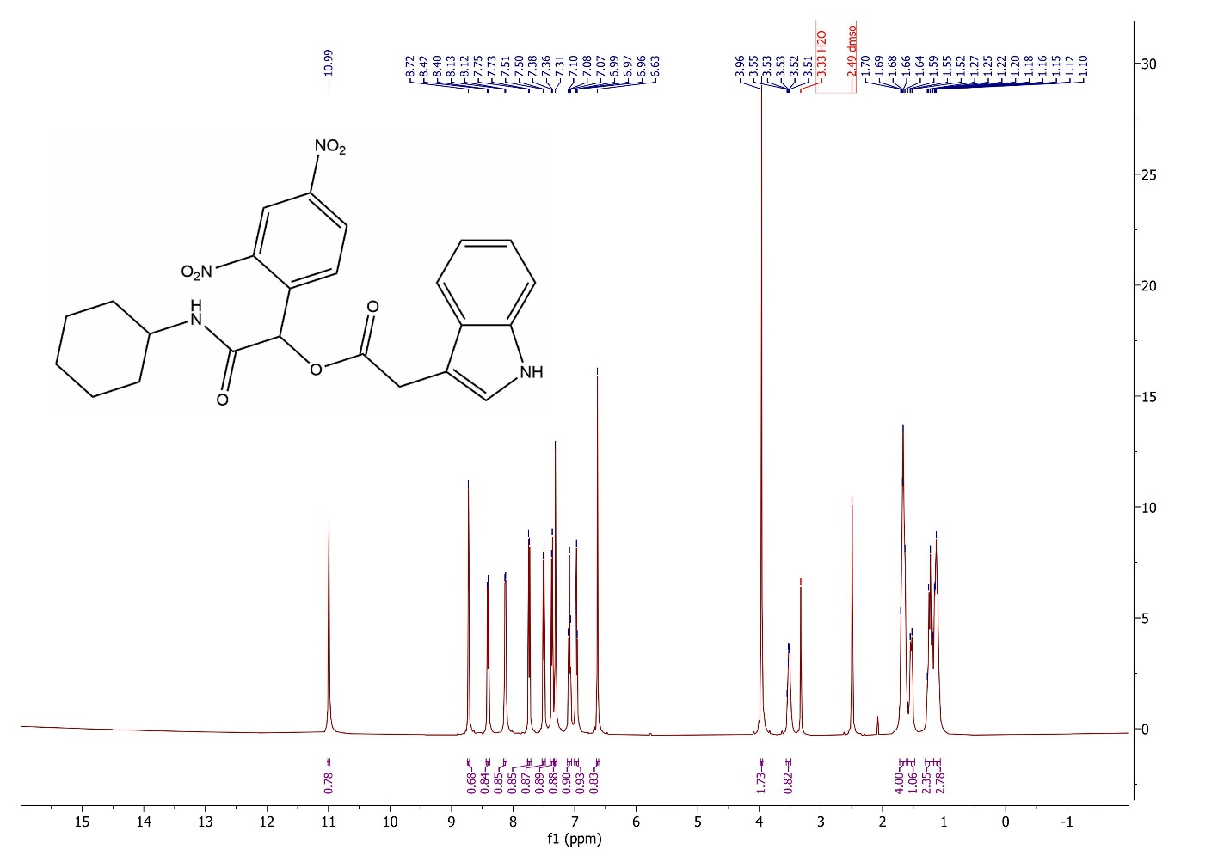
Fig S13. ¹H NMR spectrum of 4d

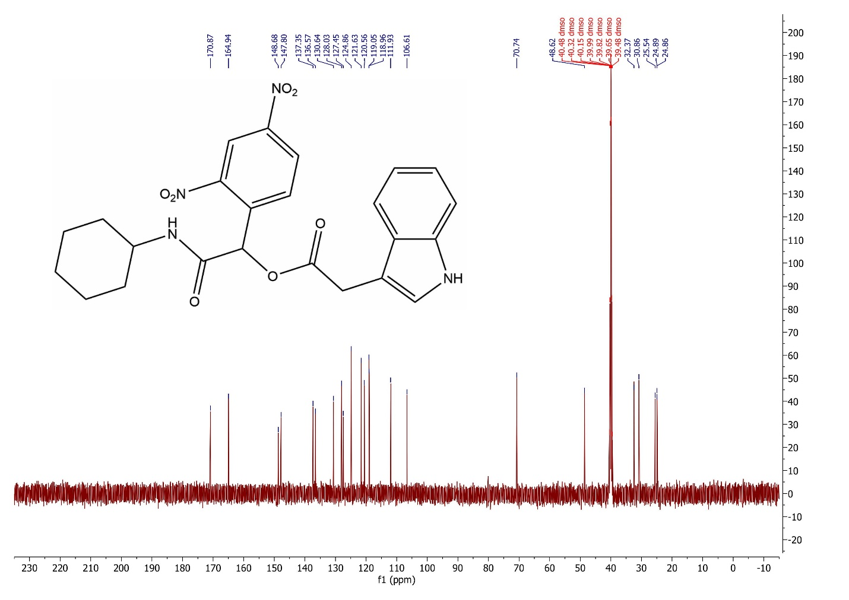 Fig 14. ¹³C NMR spectrum of 4d

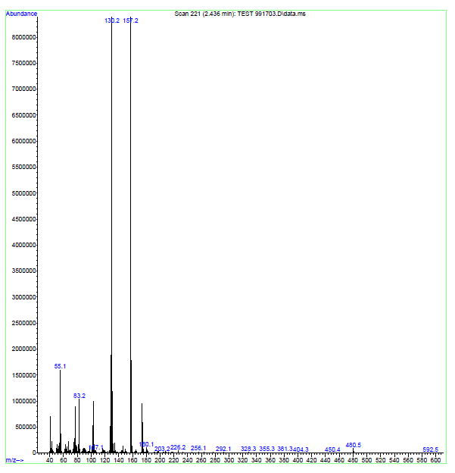

Fig S15. Mass spectrum of 4d

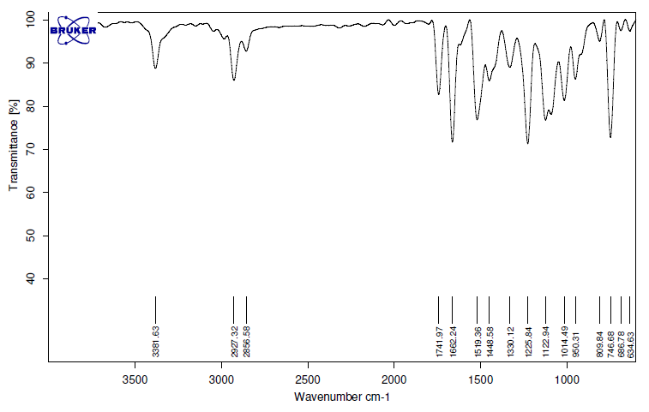

Fig S16. FT-IR spectrum of 4e

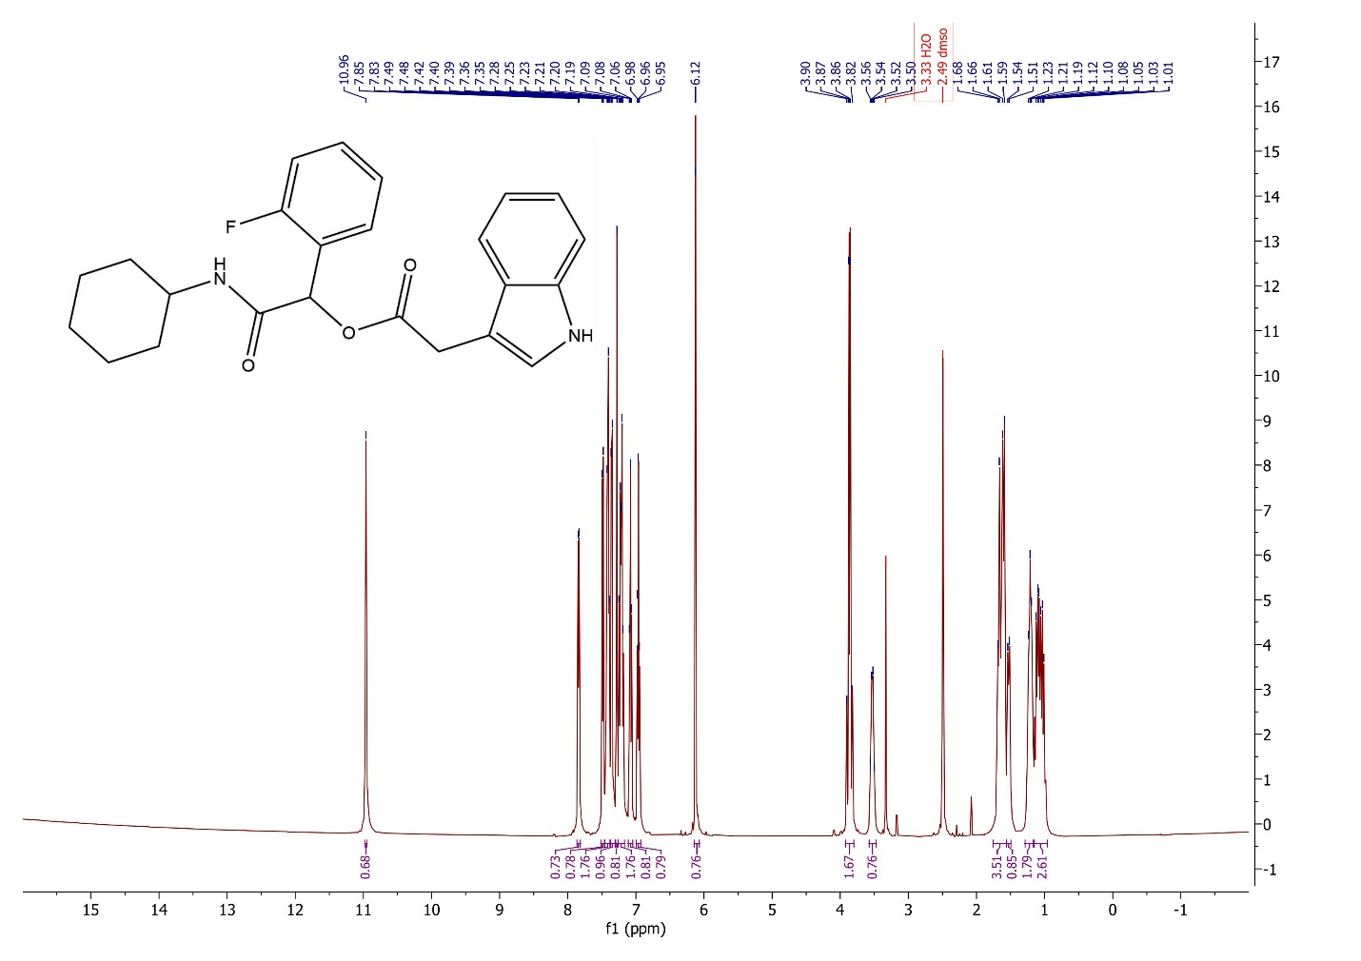
Fig S17. ¹H NMR spectrum of 4e

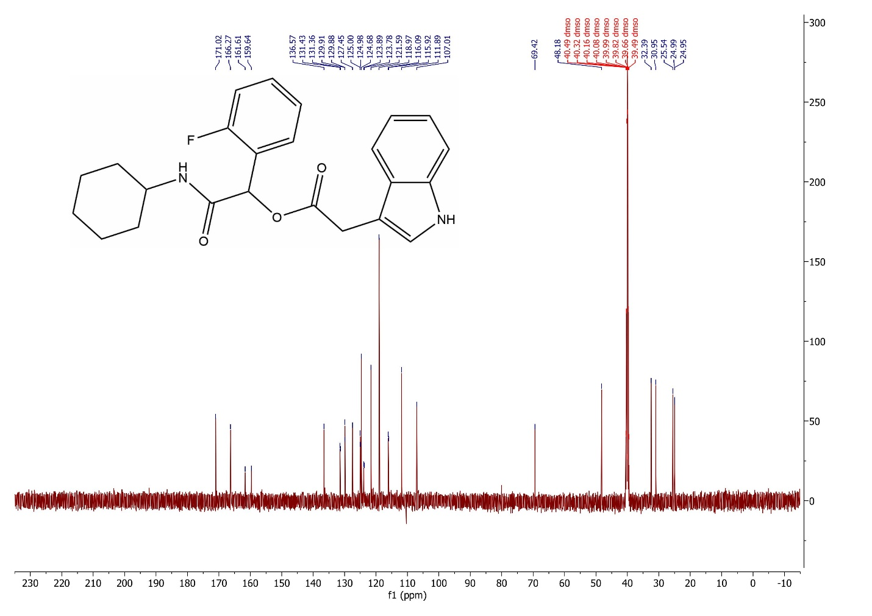
Fig S18. ¹³C NMR spectrum of 4e

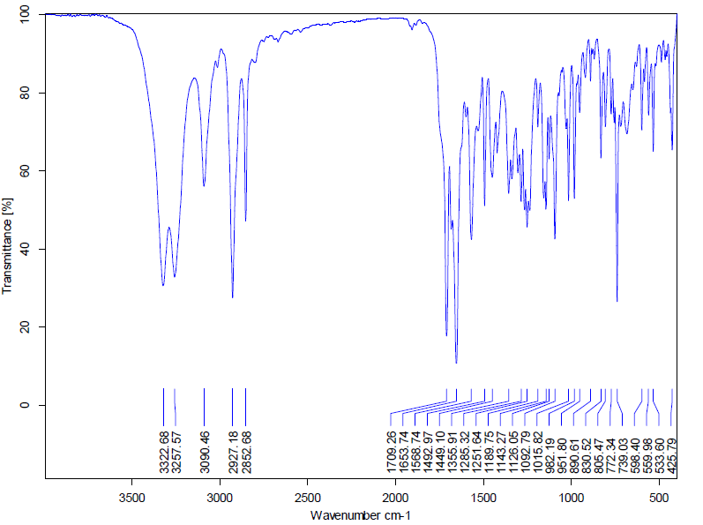

Fig S19. FT-IR spectrum of 4f

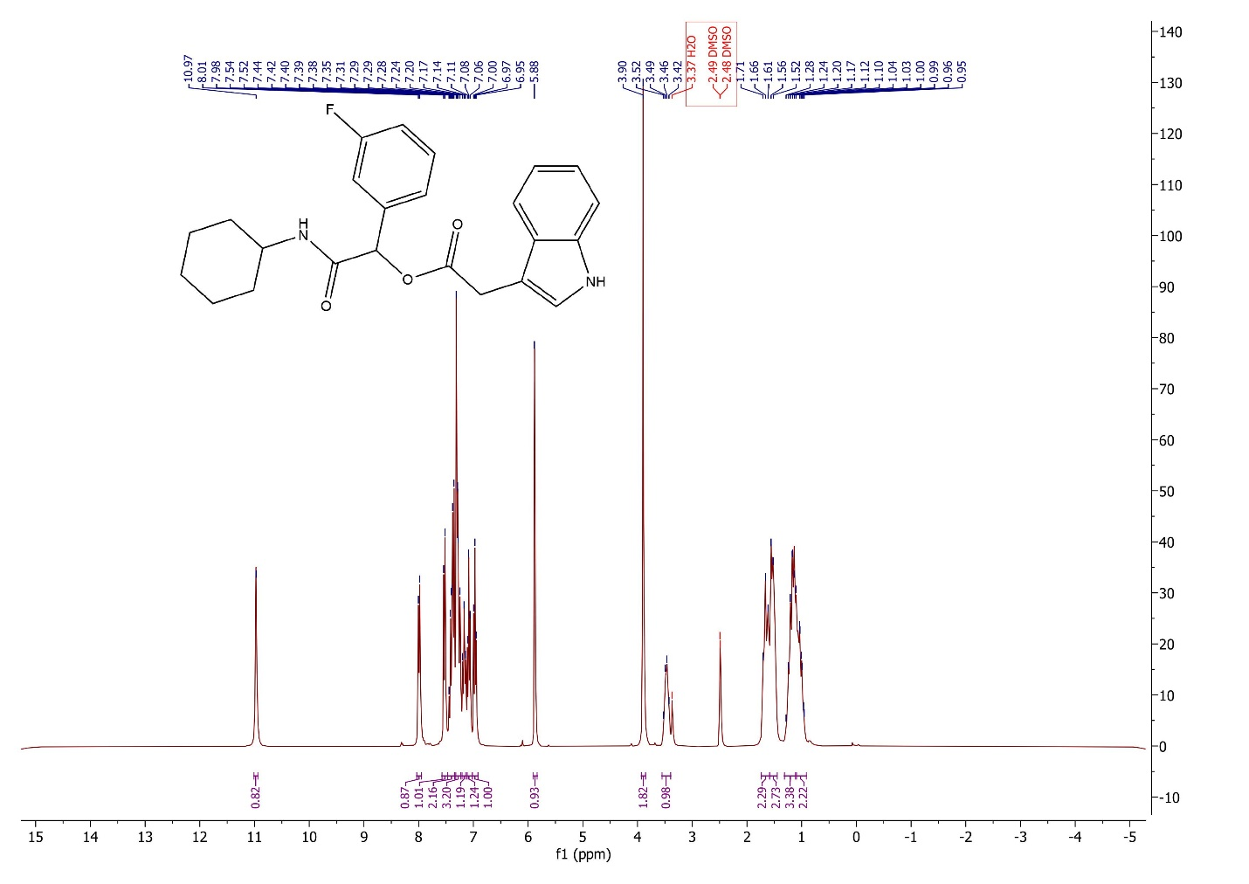

Fig S20. ¹H NMR spectrum of 4f

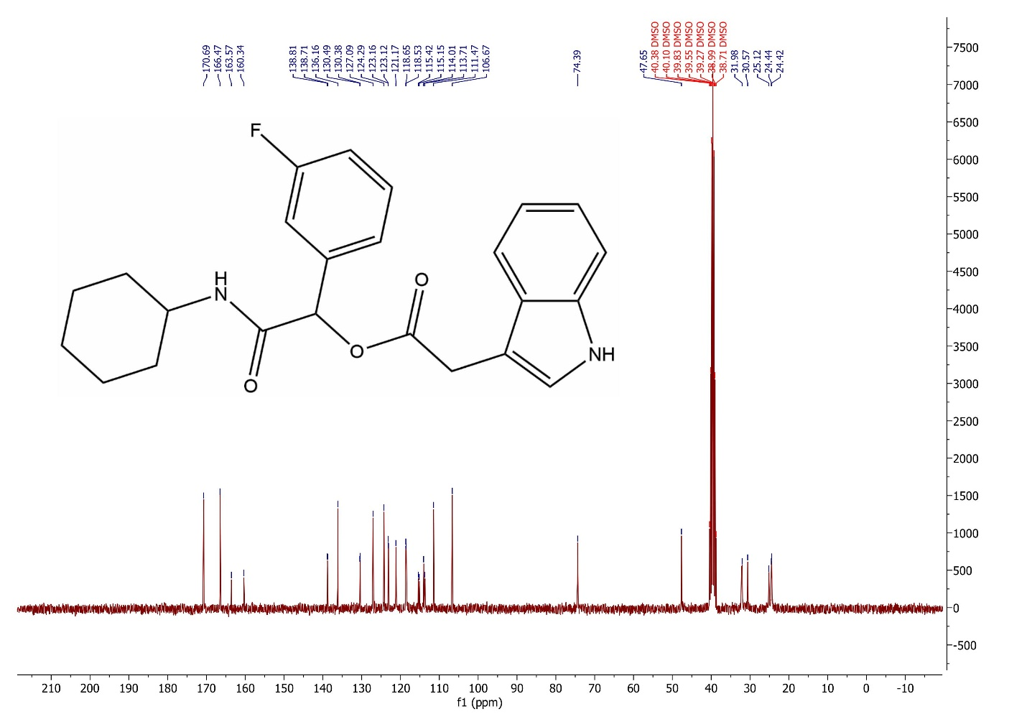

Fig S21. ¹³C NMR spectrum of 4f

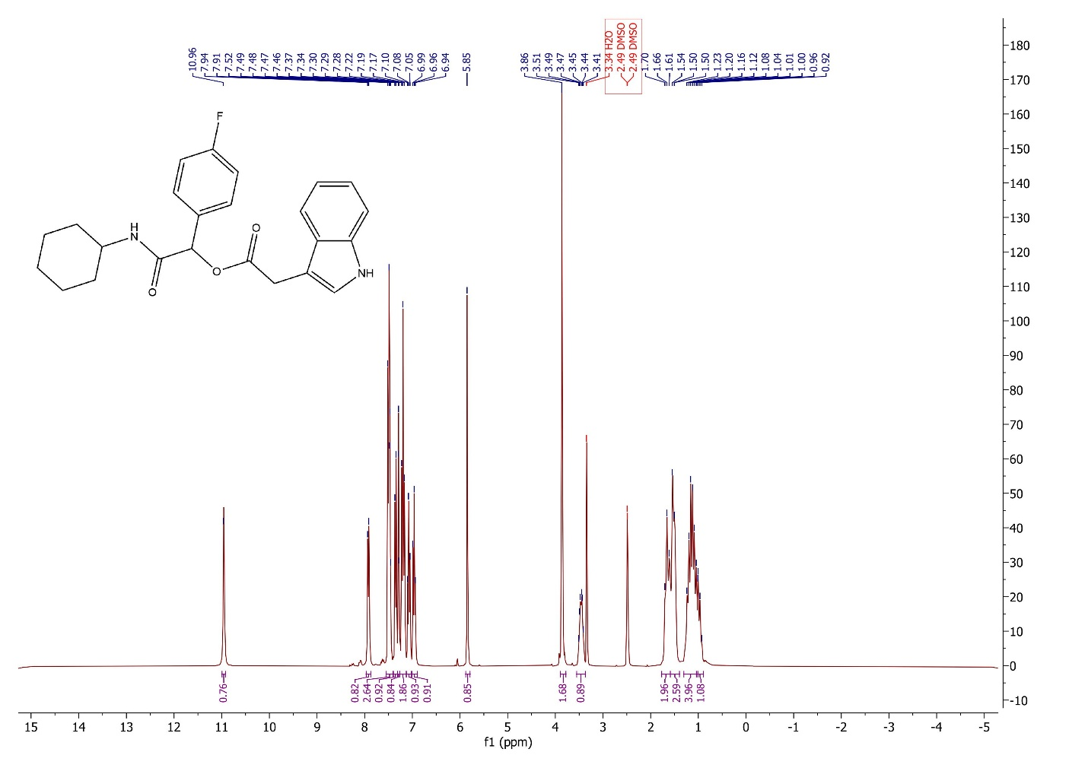
Fig S22. ¹H NMR spectrum of 4g

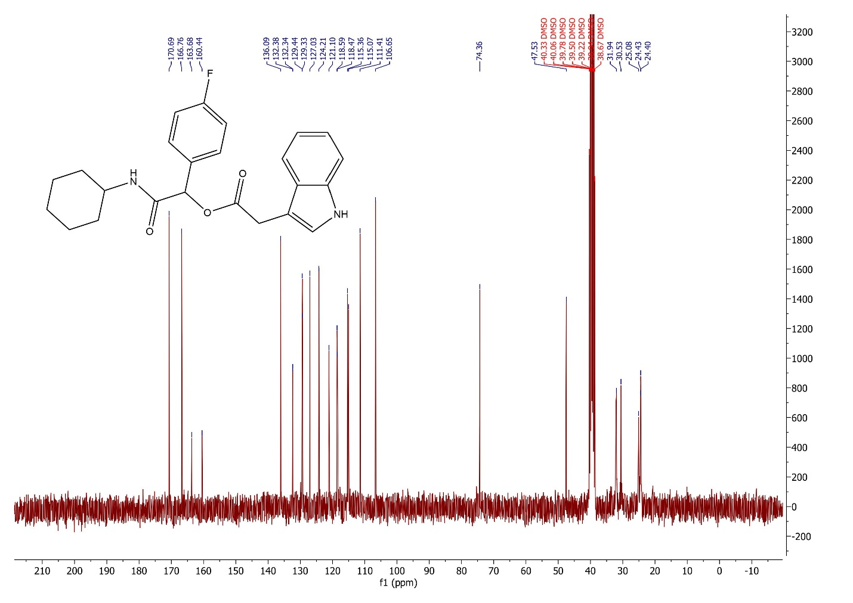

Fig S23. ¹³C NMR spectrum of 4g

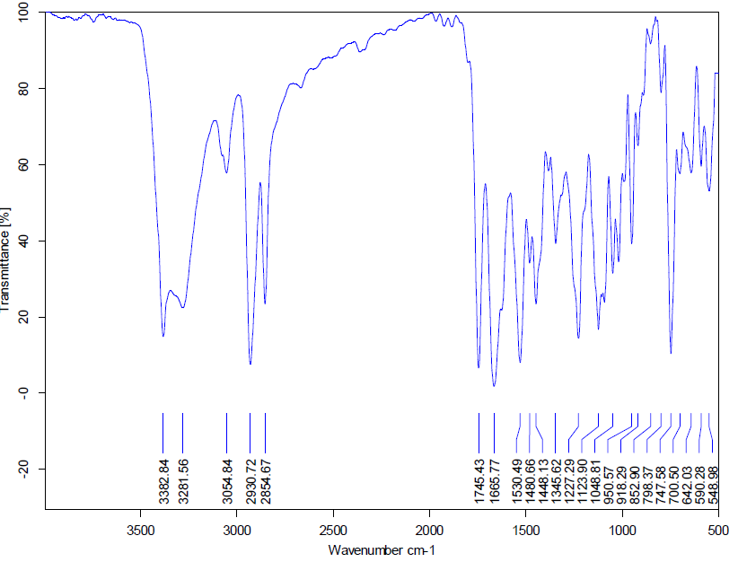
Fig S24. FT-IR spectrum of 4h

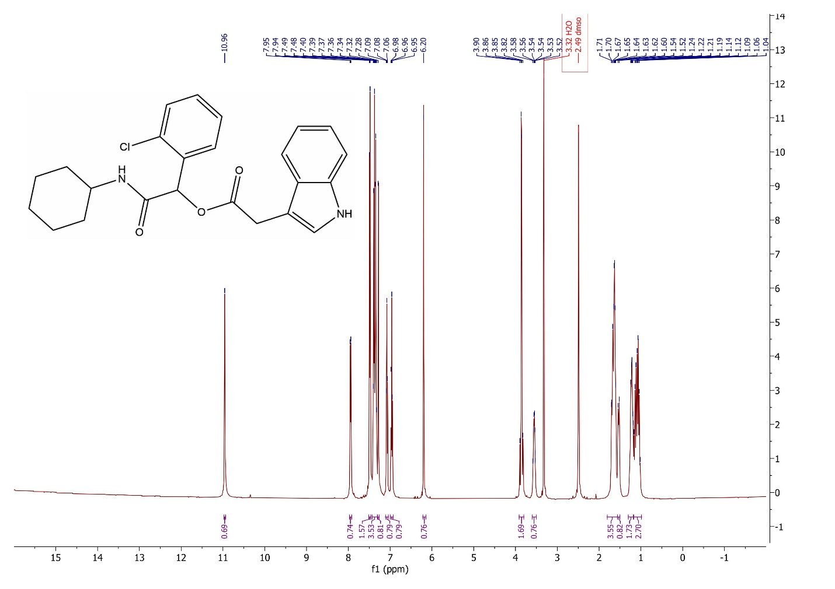

Fig S25. ¹H NMR spectrum of 4h

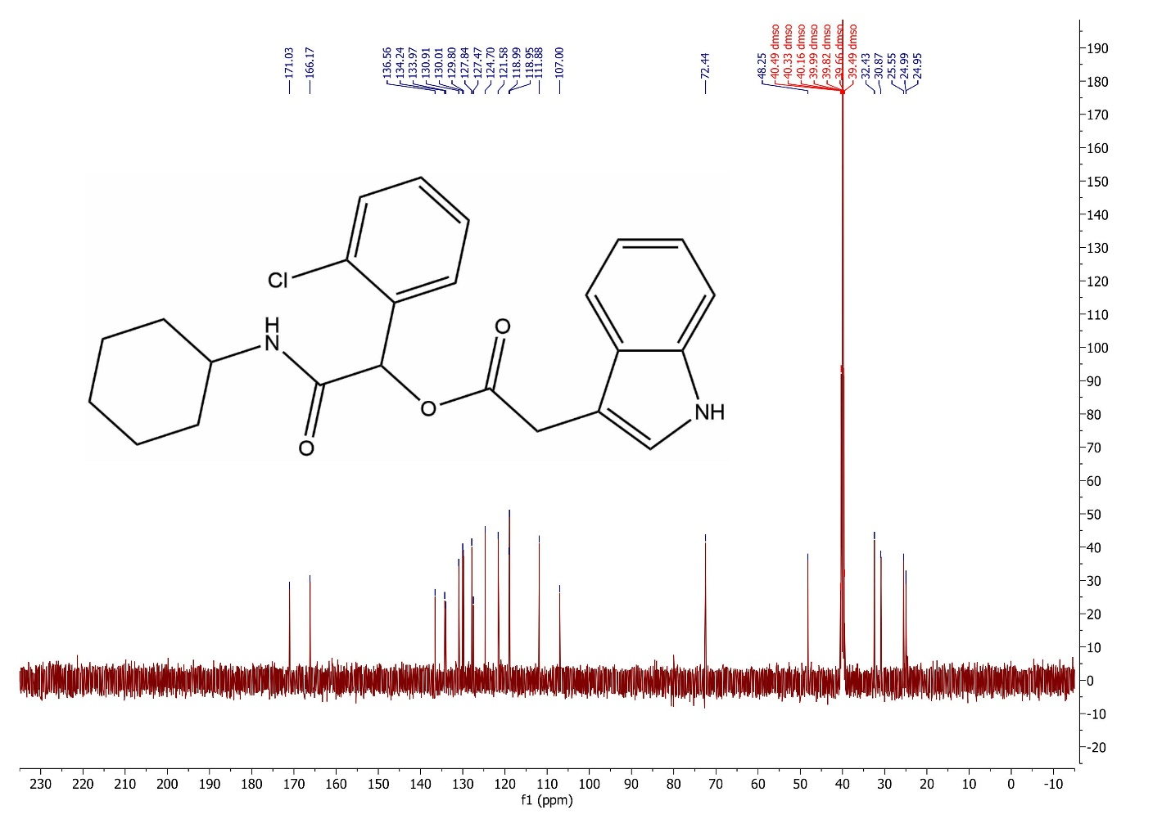

Fig S26. ¹³C NMR spectrum of 4h

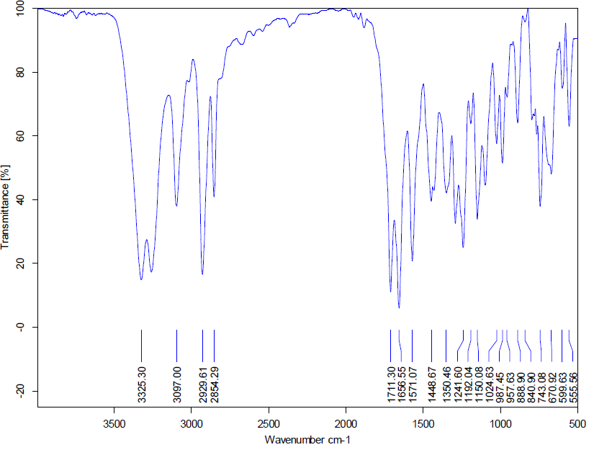
Fig S27. FT-IR spectrum of 4i

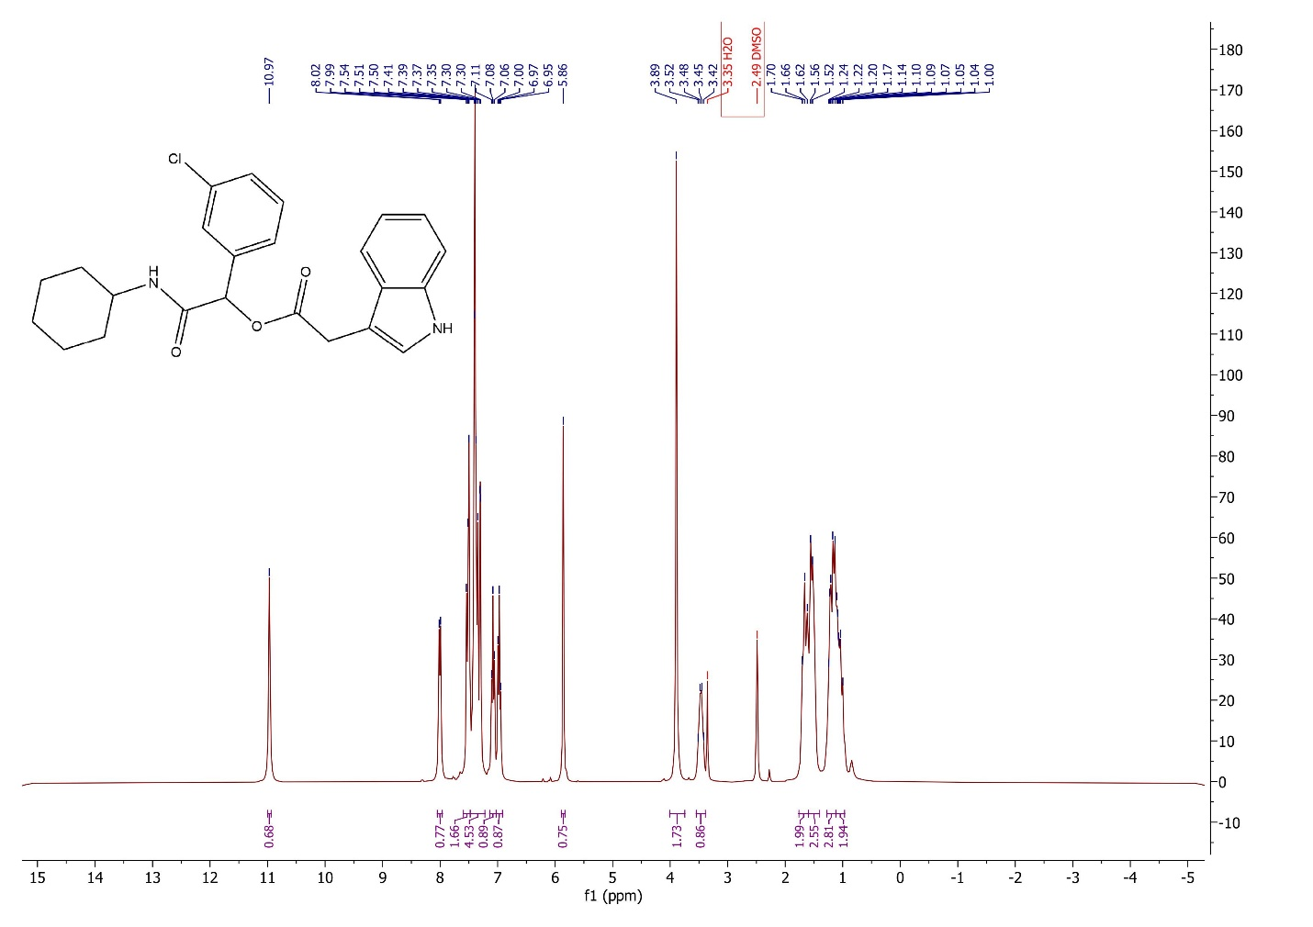

Fig S28. ¹H NMR spectrum of 4i

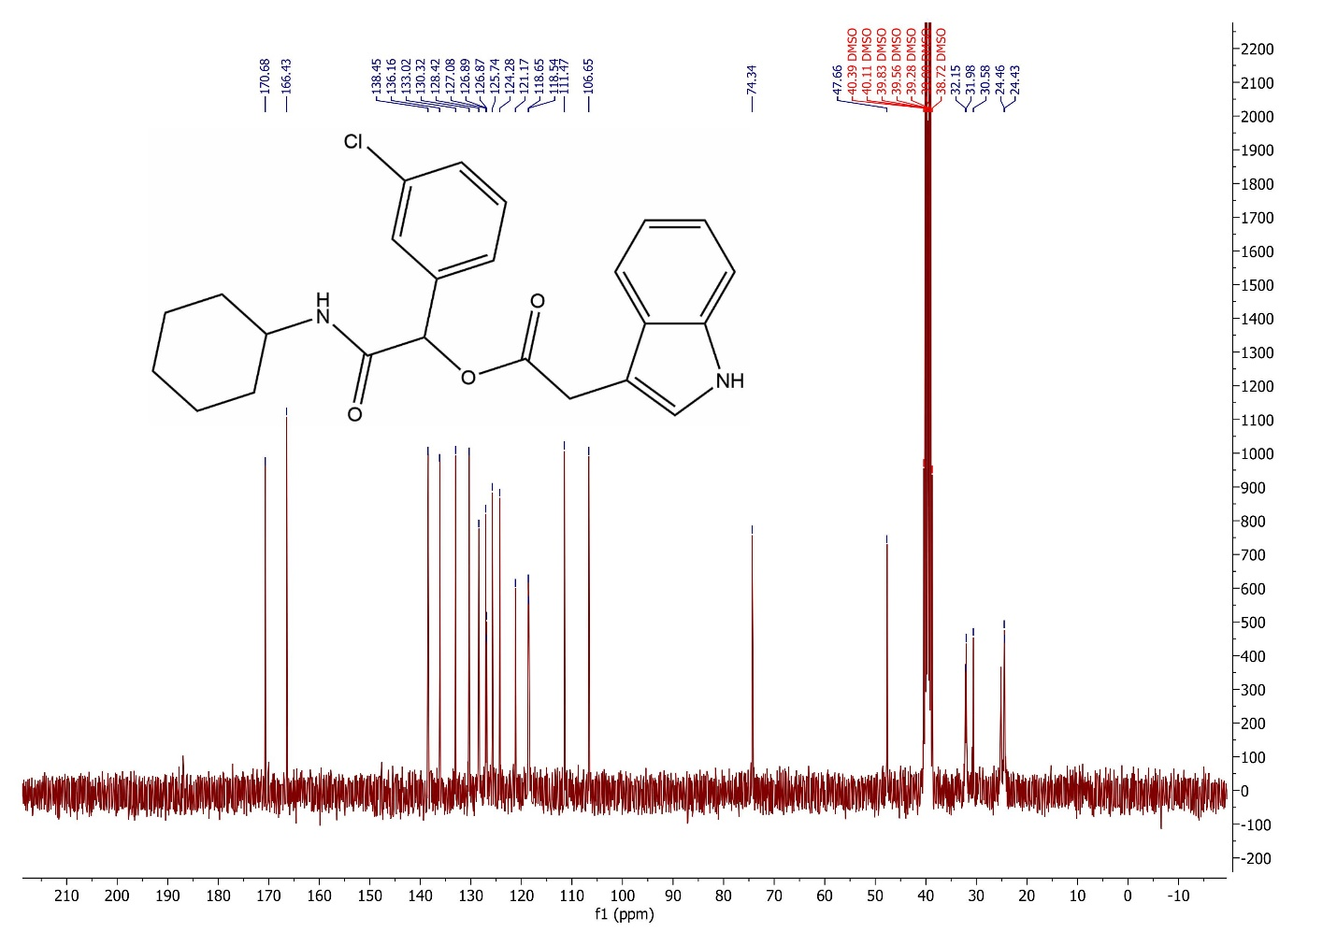

Fig S29. ¹³C NMR spectrum of 4i

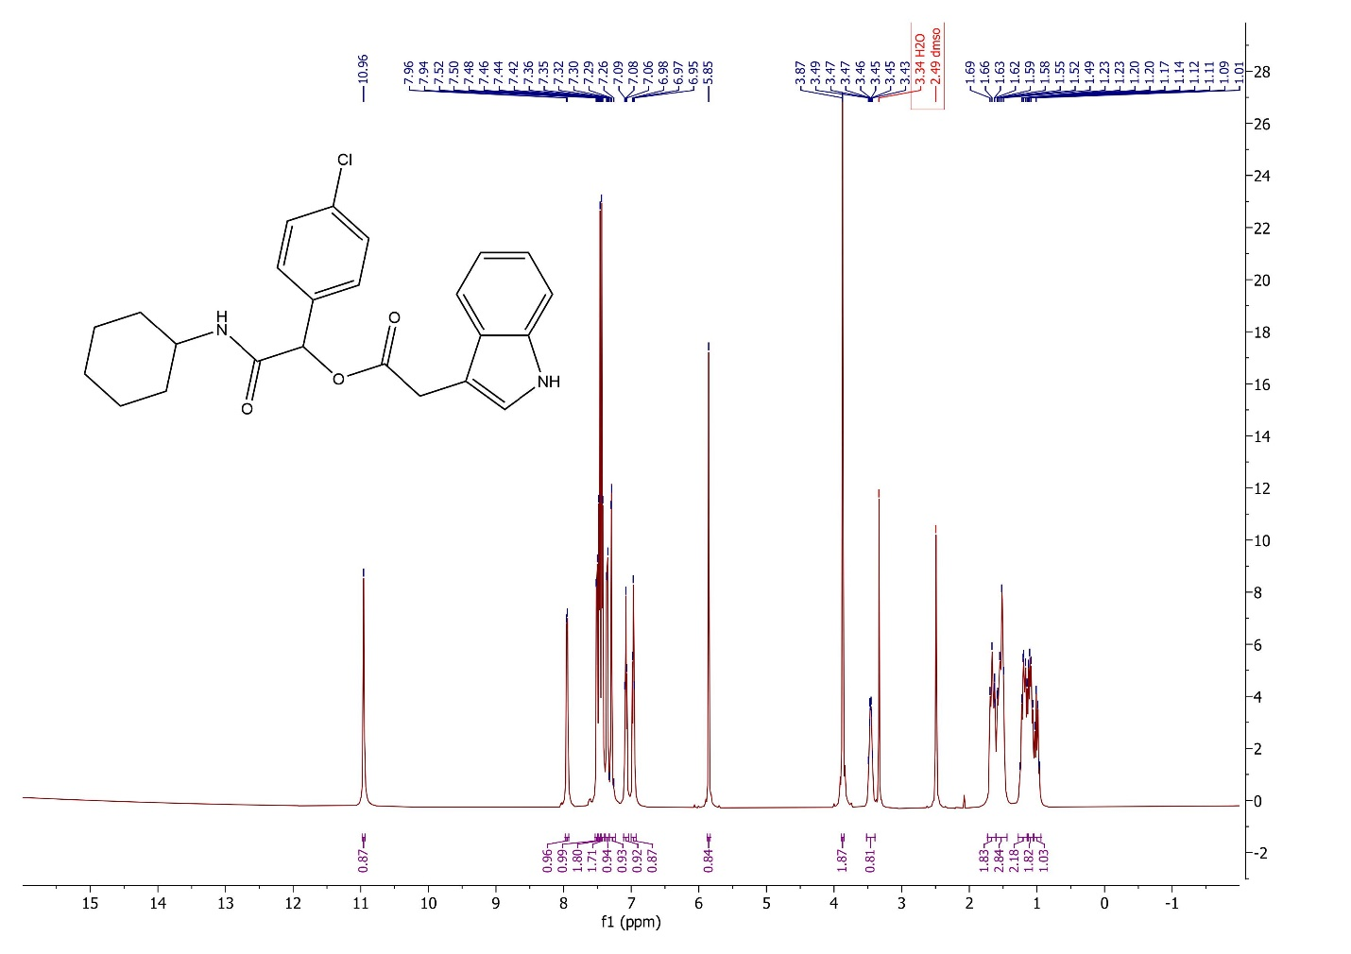

Fig S30. ¹H NMR spectrum of 4j

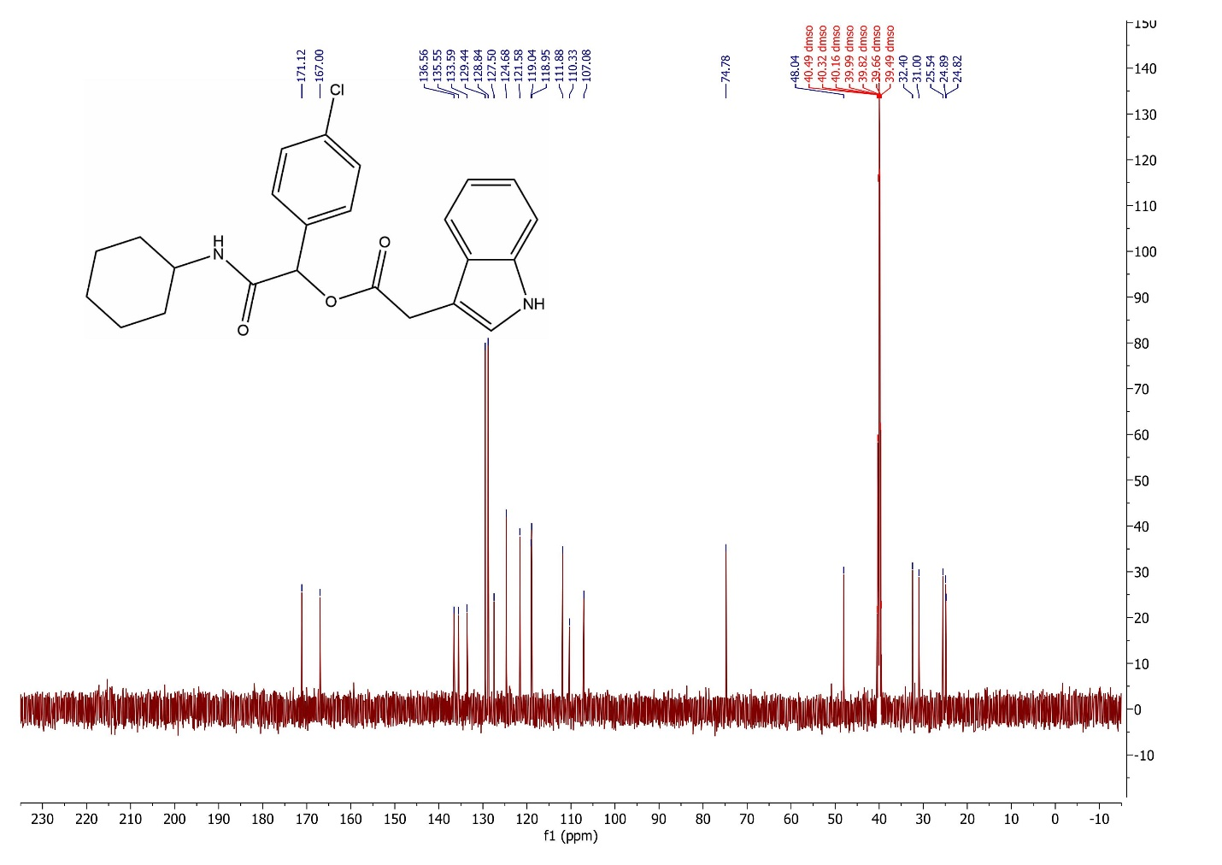

Fig S31. ¹³C NMR spectrum of 4j

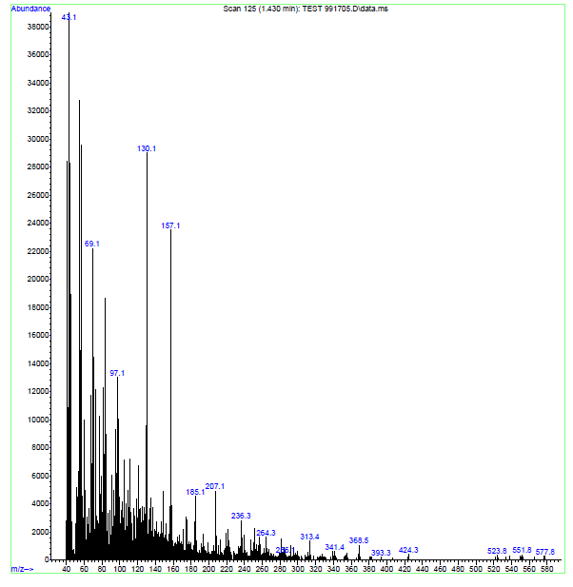
Fig S32. Mass spectrum of 4j

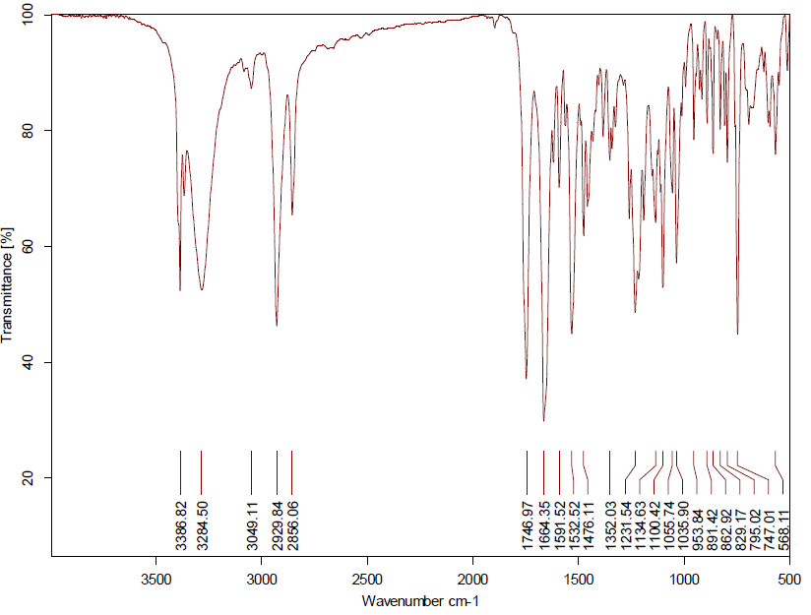
Fig S33. FT-IR spectrum of 4k

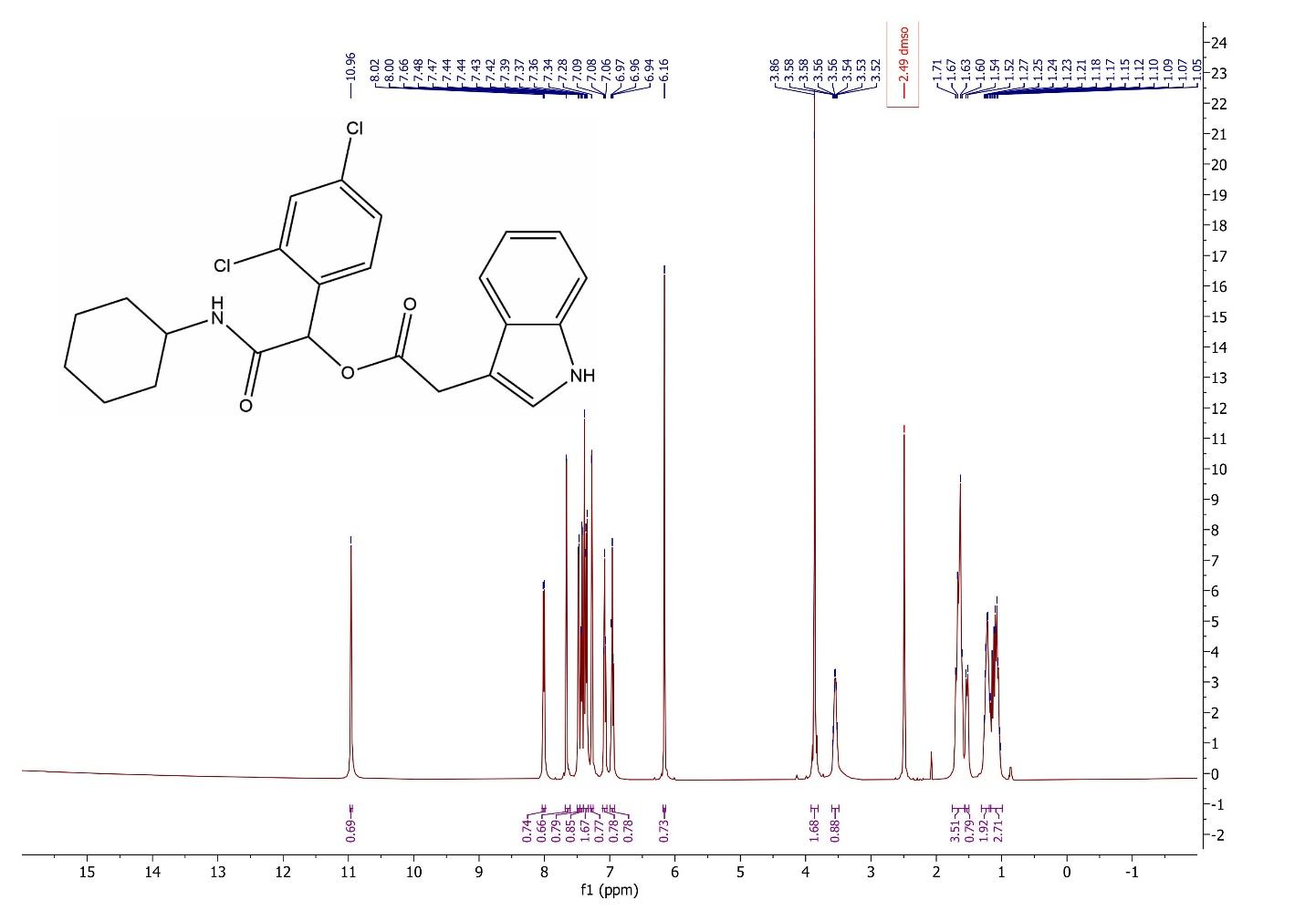
Fig S34. ¹H NMR spectrum of 4k

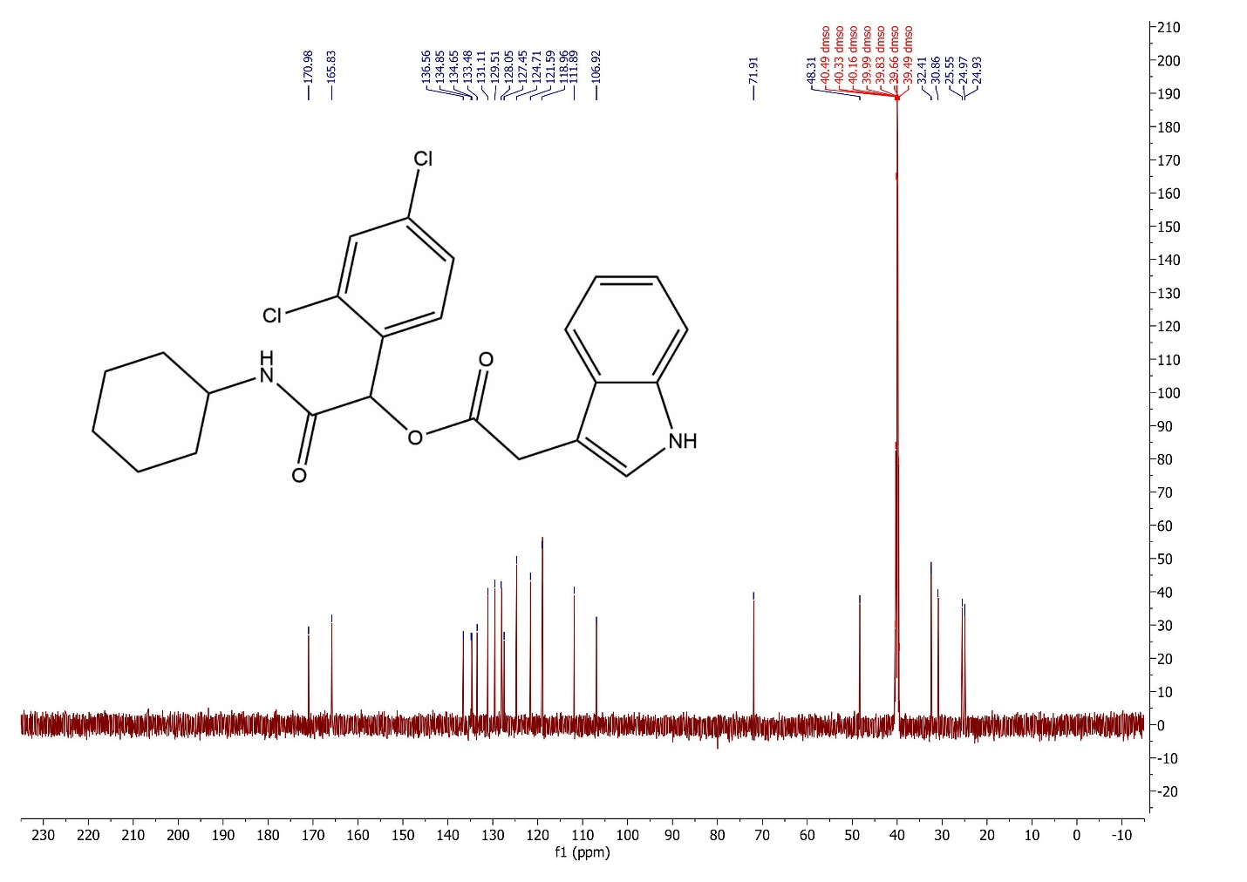
Fig S35. ¹³C NMR spectrum of 4k

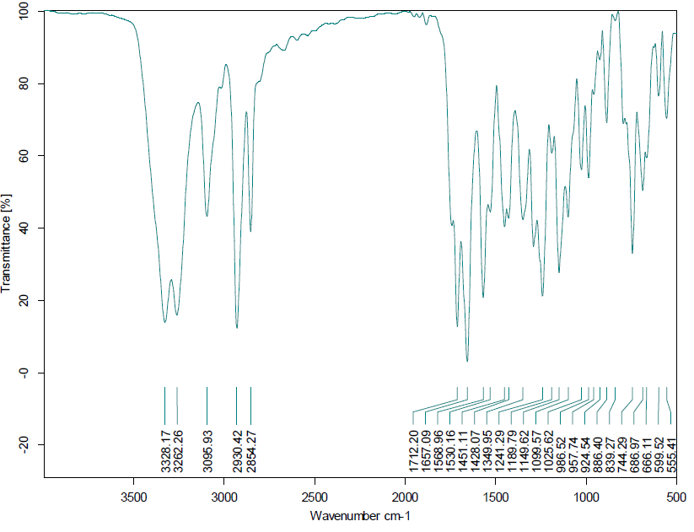
Fig S36. FT-IR spectrum of 4l

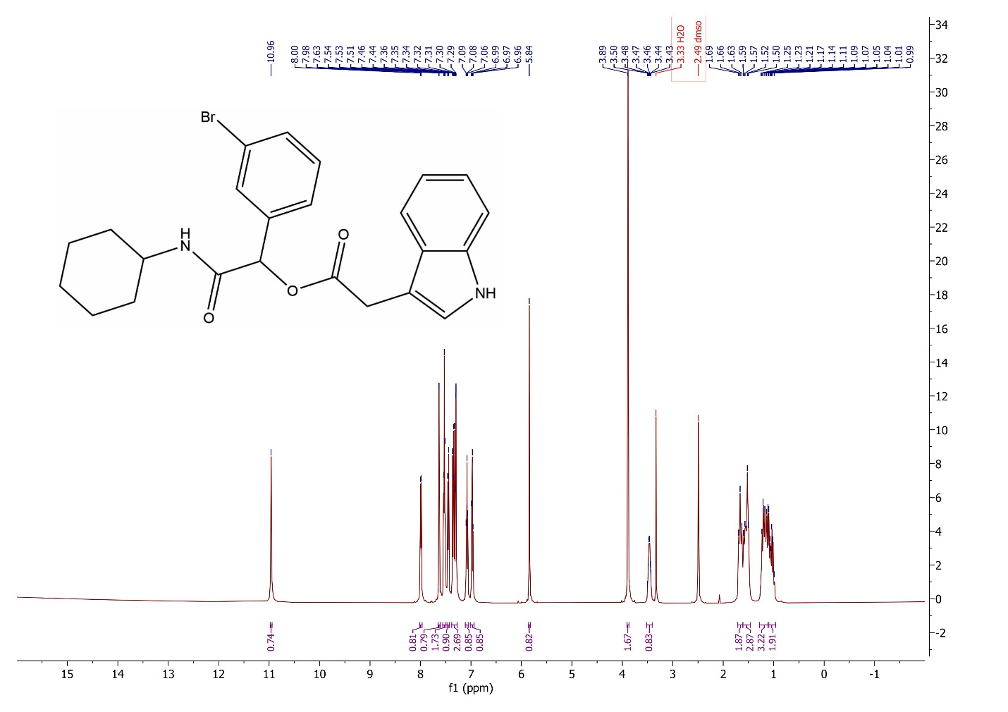
Fig S37. ¹H NMR spectrum of 4l

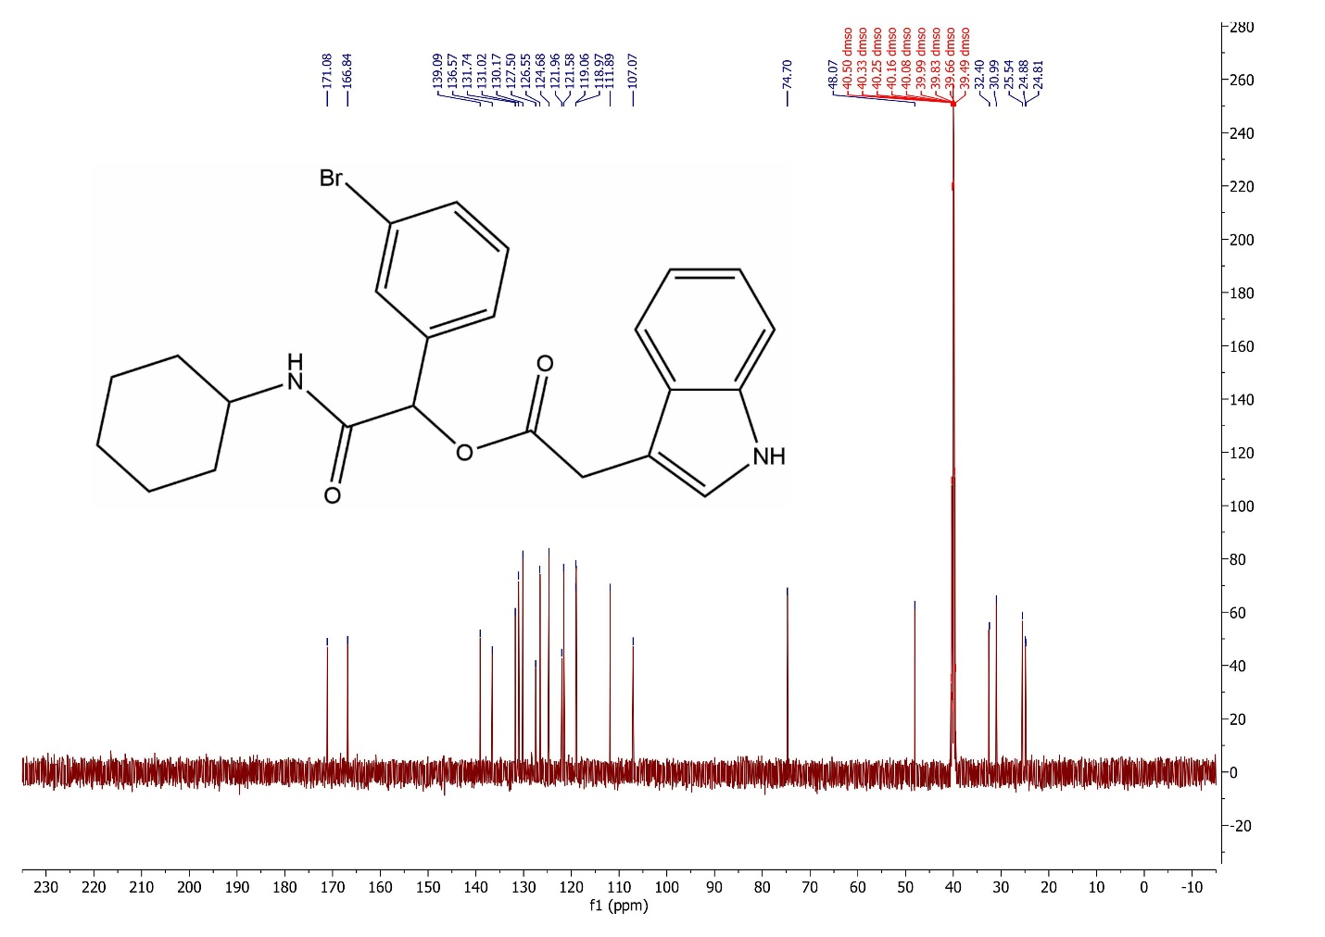
Fig S38. ¹³C NMR spectrum of 4l

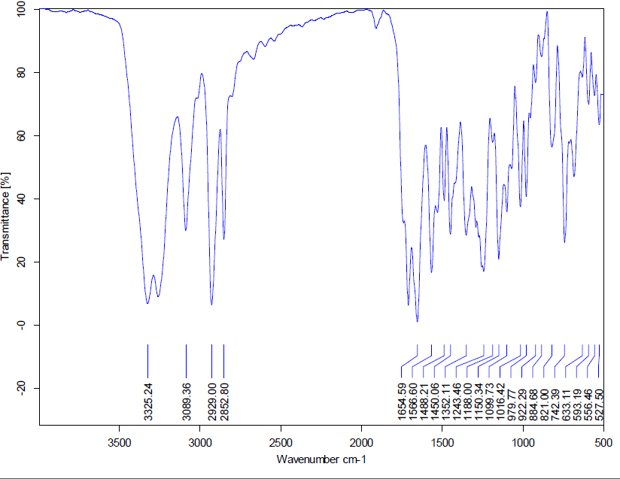
Fig S39. FT-IR spectrum of 4m

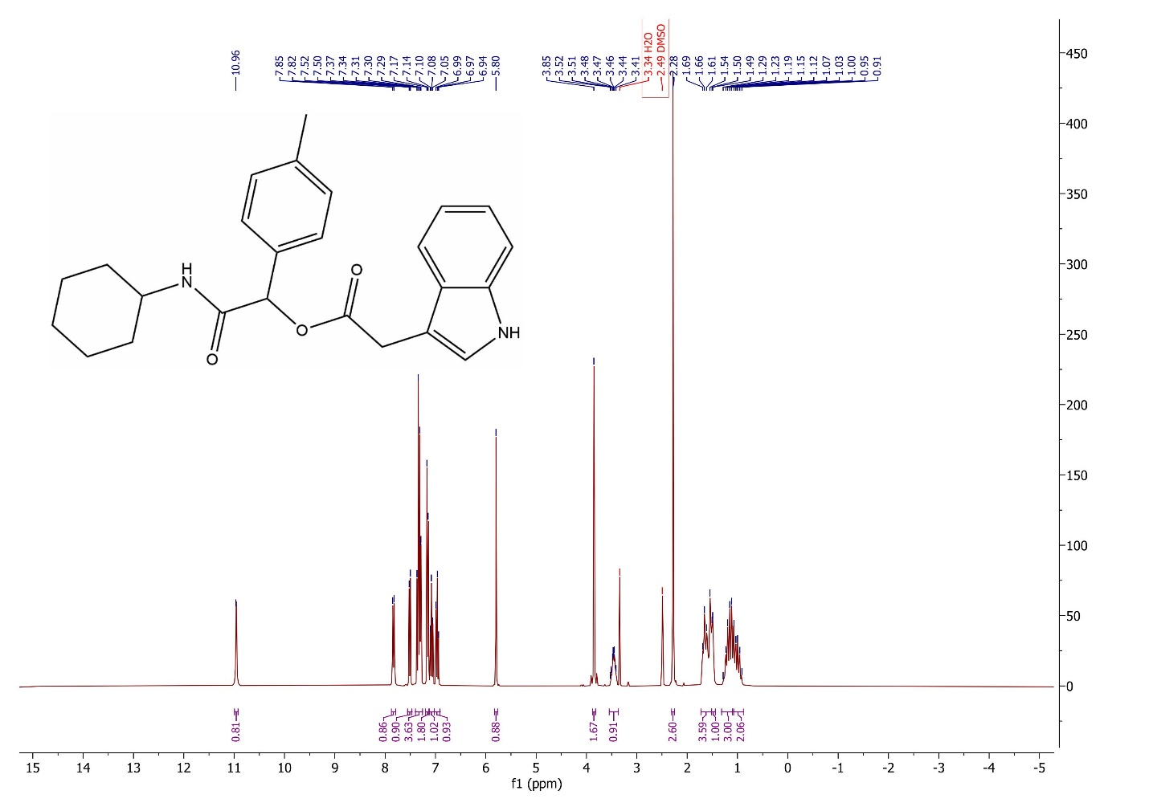
Fig S40. ¹H NMR spectrum of 4m

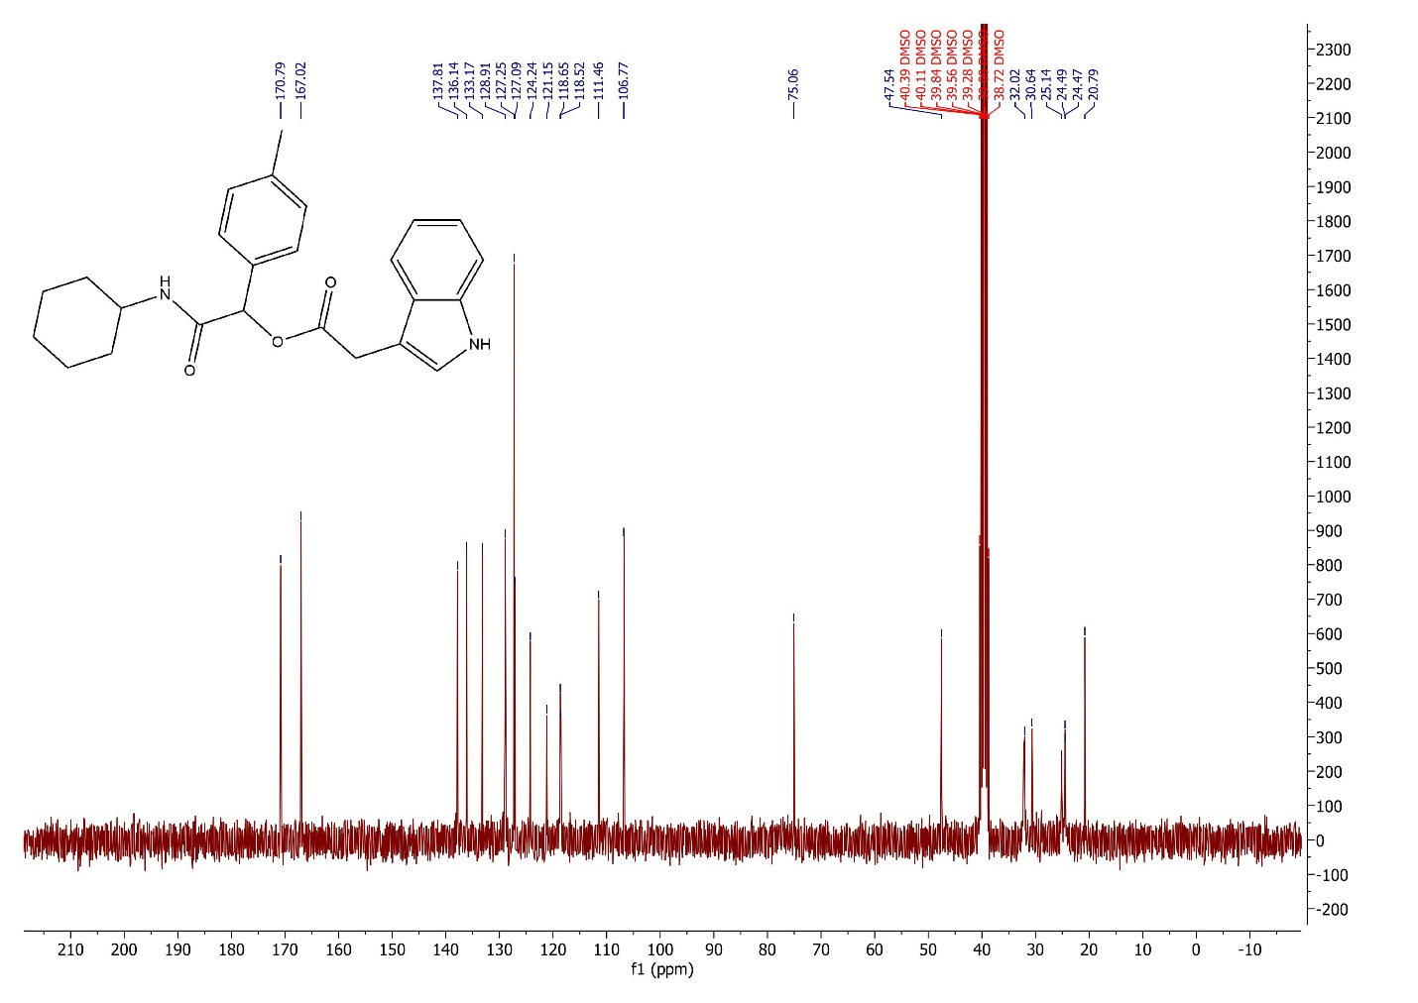
Fig S41. ¹³C NMR spectrum of 4m

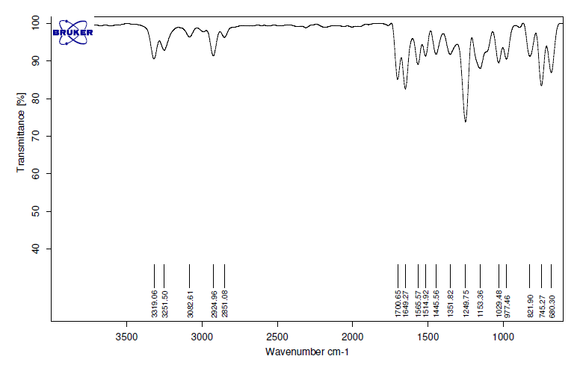
Fig S42. FT-IR spectrum of 4n

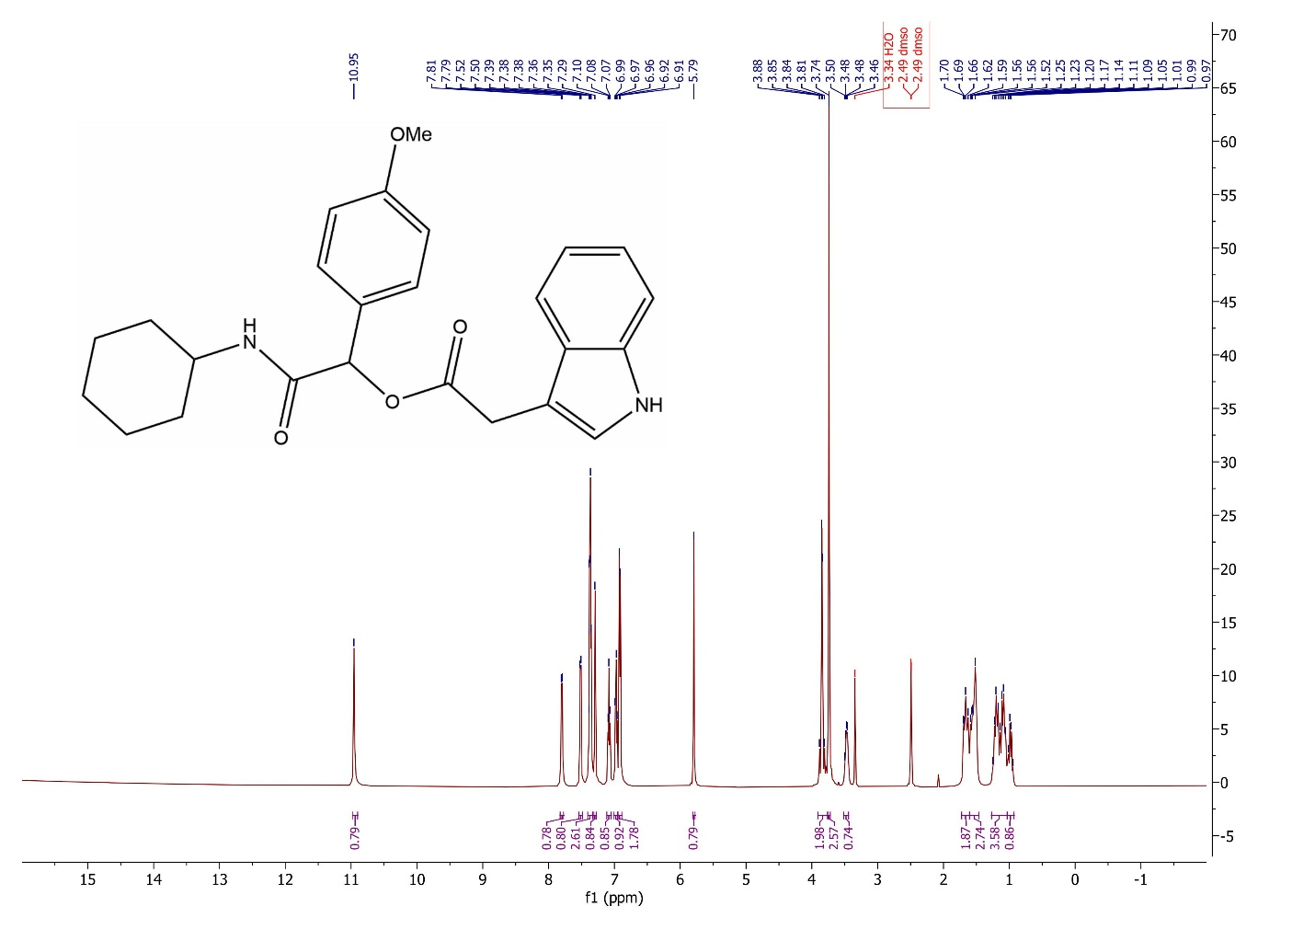
Fig S43. ¹H NMR spectrum of 4n

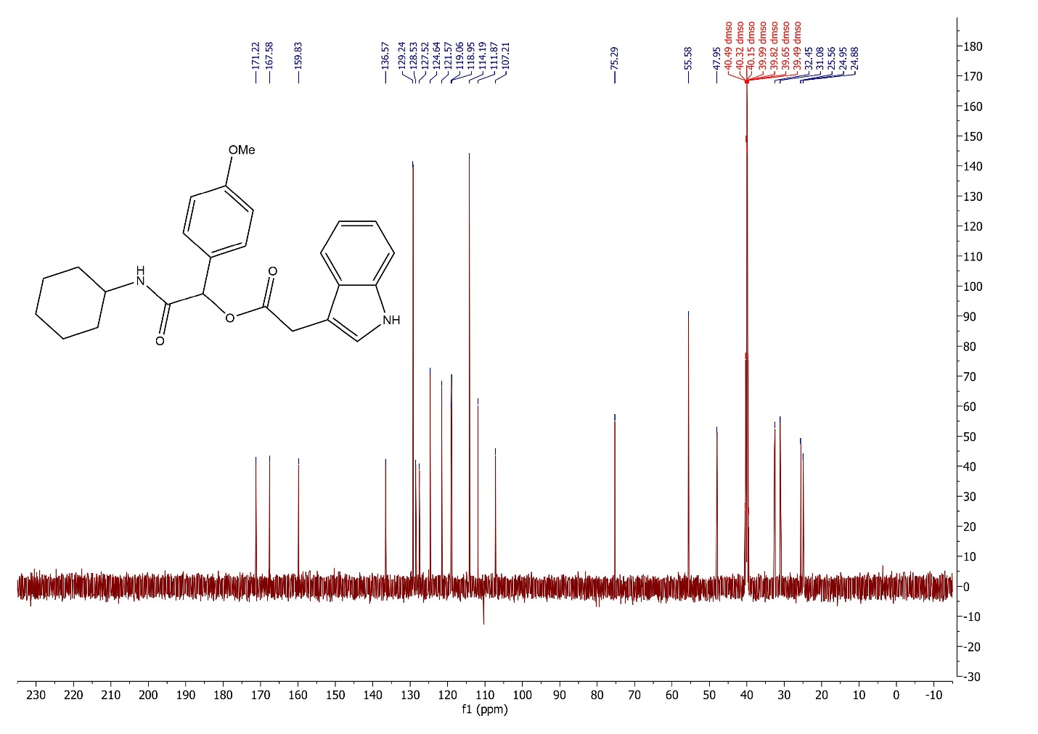
Fig S44. ¹³C NMR spectrum of 4n

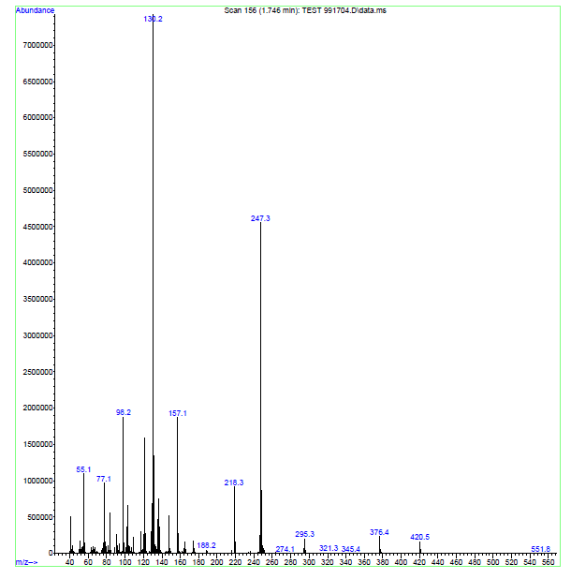
Fig S45. Mass spectrum of 4n

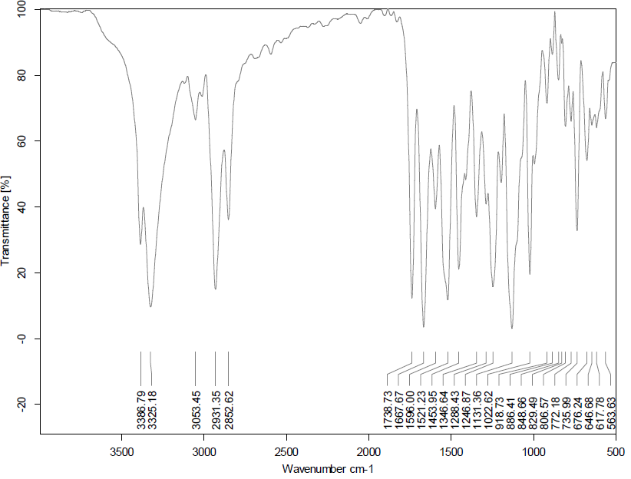

Fig S46. FT-IR spectrum of 4o

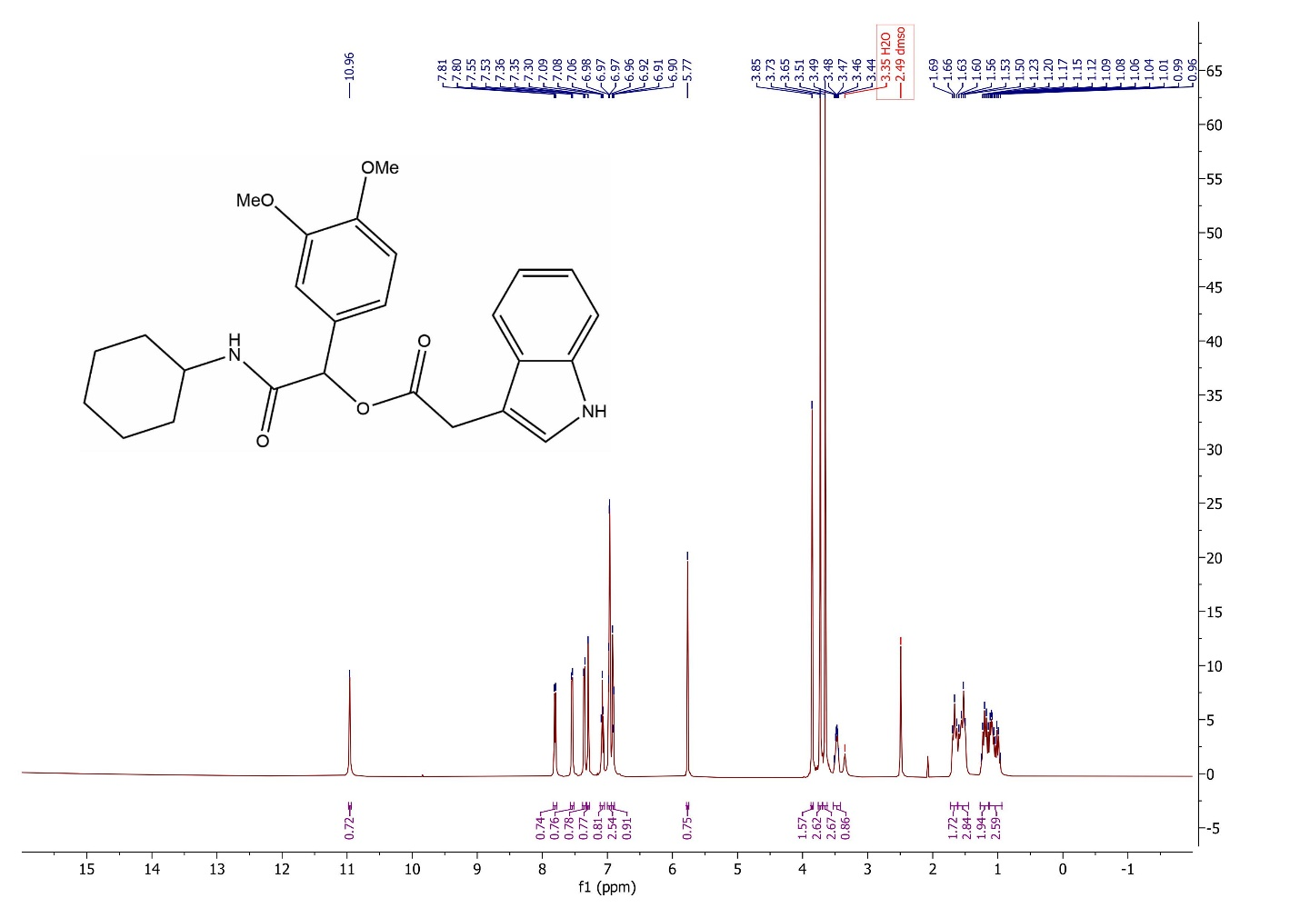
Fig S47. ¹H NMR spectrum of 4o

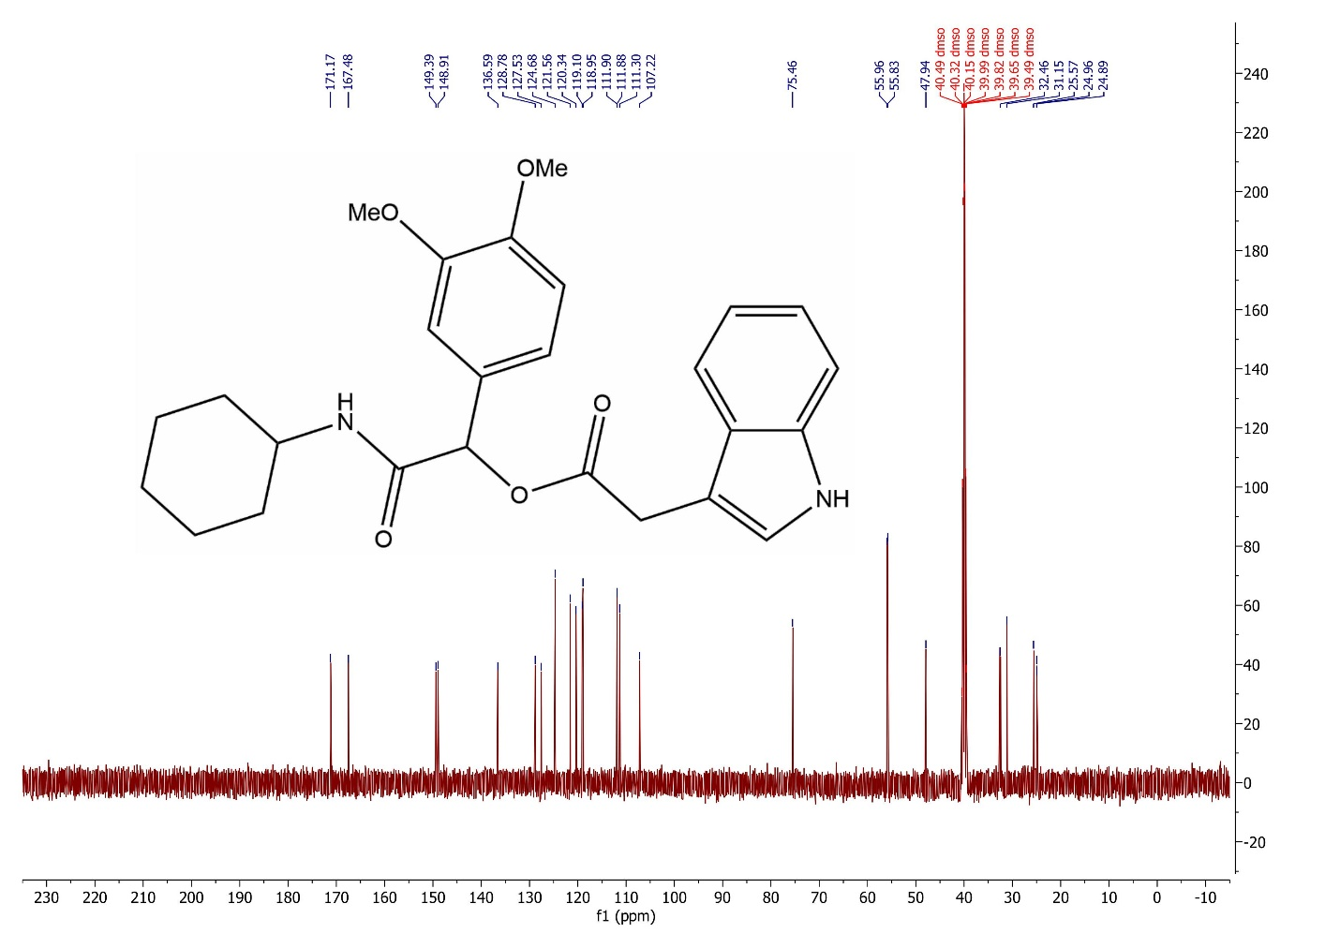
Fig S48. ¹³C NMR spectrum of 4o

