4-Bromobenzene Sulfonate Derivatives: Synthesis, Characterization, DFT and Molecular Docking Study

Meryem Evecen^{a,b,*}, Fatih Çelik^{c}, Yasemin Ünver^{c}, Halil İbrahim Güler^{d}

ªDepartment of Physics, Faculty of Arts and Sciences, Amasya University, 05100, Amasya, Turkey
^{b}Department of Electric and Electronic Engineering, Faculty of Engineering, Amasya University, Amasya 05100, Turkey
^{c}Department of Chemistry, Faculty of Sciences, Karadeniz Technical University, 61080 Trabzon, Turkey
^{d}Department of Molecular Biology and Genetics, Karadeniz Technical University Faculty of Science, 61080-Trabzon, Turkey
*Corresponding author: E-mail: meryem.evecen@amasya.edu.tr

Instrumentation

The ¹H- and ¹³C-Nuclear Magnetic Resonance spectra were recorded on a Bruker 400 MHz spectrometer. In this spectrometer, TMS was used as an internal standard and DMSO-d₆ as solvent. FTIR spectrum were recorded on a Perkin-Elmer Spectrum One FTIR spectrometer in KBr pellets and melting point was measured with an electrothermal device. All chemicals that were used in this research were purchased from commercial suppliers.

Molecular docking study
In this study, molecular docking simulations were conducted to evaluate the interactions between two novel compounds, designated as compound I and compound II, and four key receptor proteins. The target receptors, obtained from the Protein Data Bank (PDB), were chosen for their biological significance in cellular signaling and pathogenic pathways. The receptors included the Epidermal Growth Factor Receptor (EGFR) (PDB ID: 1M17, Chain: A, Resolution: 2.60 Å), Vascular Endothelial Growth Factor Receptor 1 (VEGFR1) (PDB ID: 3HNG, Chain: A, Resolution: 2.70 Å), Human Acetylcholinesterase (PDB ID: 4M0E, Chain: A, Resolution: 2.00 Å), and Trypanothione Reductase from Leishmania infantum (PDB ID: 2JK6, Chain: A, Resolution: 2.95 Å). These protein structures were downloaded from the PDB database, with each protein prepared for docking following removal of all non-standard residues, water molecules, and ions. Subsequently, polar hydrogen atoms, Kollman charges, and solvation parameters were added using AutoDock Tools (Morris et al., 2009).
The molecular structures of ligands compound I and compound II were initially created in ChemDraw software. Reference molecules were downloaded from the PubChem database (https://pubchem.ncbi.nlm.nih.gov/). Following structural design, both ligands were optimized using Avogadro software (Hanwell et al., 2012) with the MMFF94s force field until energy minimization convergence was achieved, ensuring stable conformations suitable for docking analysis. As reference ligands, erlotinib (EGFR), dovitinib and axitinib (VEGFR1), galantamine (AChE), and amphotericin B (Trypanothione Reductase) were employed, each prepared under the same protocol to allow direct comparison with the novel compounds. Ligand optimization was critical to minimize energy states and maximize binding accuracy with receptor proteins.
For molecular docking, AutoDock 4.2 software (Morris et al., 2009) was employed. The Lamarckian Genetic Algorithm was selected for conformational sampling, with docking parameters set as follows: population size of 150 individuals, 2,500,000 energy evaluations, and 54,000 generations. Each docking experiment was repeated with multiple independent runs to ensure reproducibility of results. During the docking process, receptors were treated as rigid bodies, while ligands were allowed full flexibility to explore binding conformations.
The docking grid was centered on the known active site residues of each receptor. A uniform grid box of 60 × 60 × 60 points, with a spacing of 0.375 Å, was applied across all simulations. Grid box centers were carefully defined to encompass catalytically or functionally relevant residues, ensuring accurate sampling of the binding pocket. This configuration facilitated reliable binding energy calculations by allowing ligands to explore conformational space effectively within the receptor’s active site.
Docking results were analyzed based on predicted binding energy and inhibition constant (Ki) values, which served as criteria for ranking ligand affinity towards each receptor. The lowest energy binding poses were selected for further interaction analysis. Following docking, BIOVIA Discovery Studio Visualizer 2018 (Dassault Systèmes BIOVIA, 2016) was employed to examine receptor–ligand complexes, focusing on hydrogen bonds, hydrophobic contacts, and van der Waals interactions. This software allowed clear identification of key amino acid residues stabilizing each complex, thereby providing valuable insights into binding mechanisms and potential pharmacological efficacy.
This workflow, combining systematic ligand optimization, rigorous docking protocols, and detailed interaction analysis, provides a comprehensive framework for understanding the binding dynamics of novel ligands with selected receptors.

References
Dassault Systèmes BIOVIA, Discovery Studio Modeling Environment, Release 2017, San Diego: Dassault Systèmes, 2016
Hanwell, M. D., Curtis, D. E., Lonie, D. C., Vandermeersch, T., Zurek, E., & Hutchison, G. R. (2012). Avogadro: an advanced semantic chemical editor, visualization, and analysis platform. Journal of Cheminformatics, 4(1), 17. DOI: 10.1186/1758-2946-4-17
Morris, G. M., Huey, R., Lindstrom, W., Sanner, M. F., Belew, R. K., Goodsell, D. S., & Olson, A. J. (2009). AutoDock4 and AutoDockTools4: Automated docking with selective receptor flexibility. Journal of Computational Chemistry, 30(16), 2785-2791. DOI:10.1002/jcc.21256

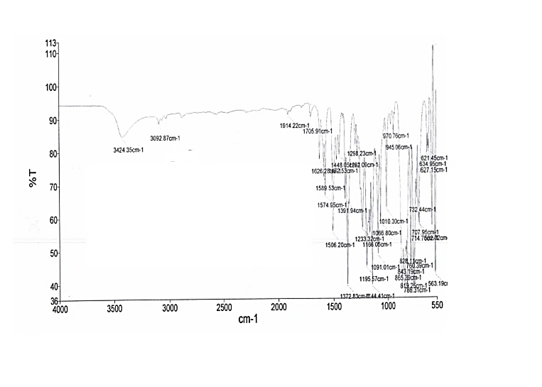

Figure S1. FT-IR spectrum of compound I.

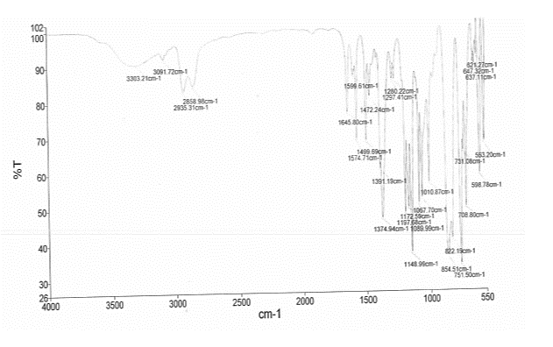

Figure S2. FT-IR spectrum of compound II.

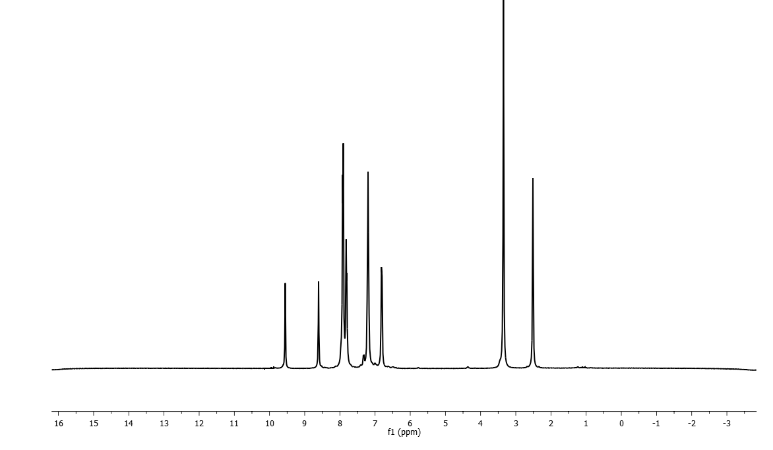
Figure S3. ¹H-NMR spectrum of compound I.

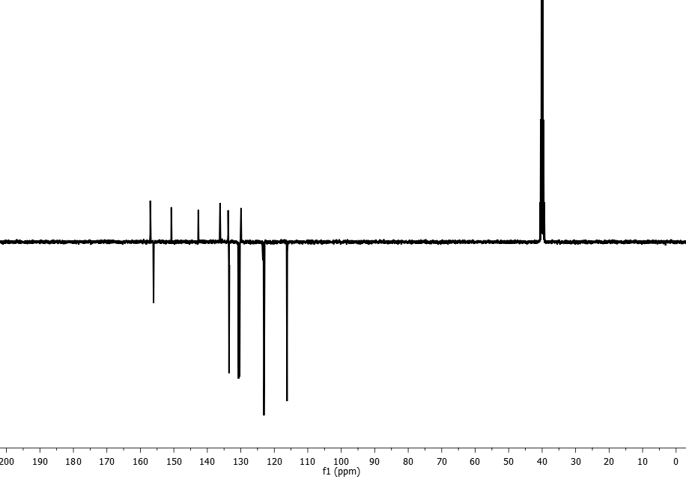
Figure S4. ¹³C-NMR (APT) spectrum of compound I.

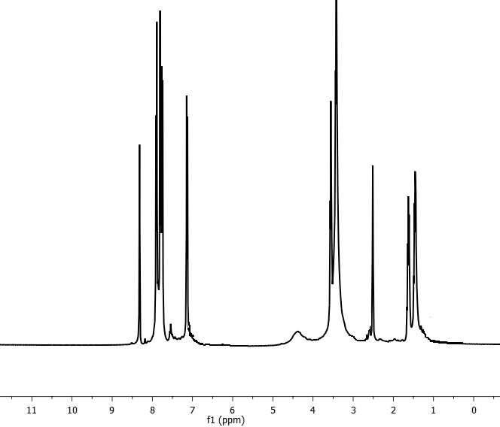

Figure S5. ¹H-NMR spectrum of compound II.

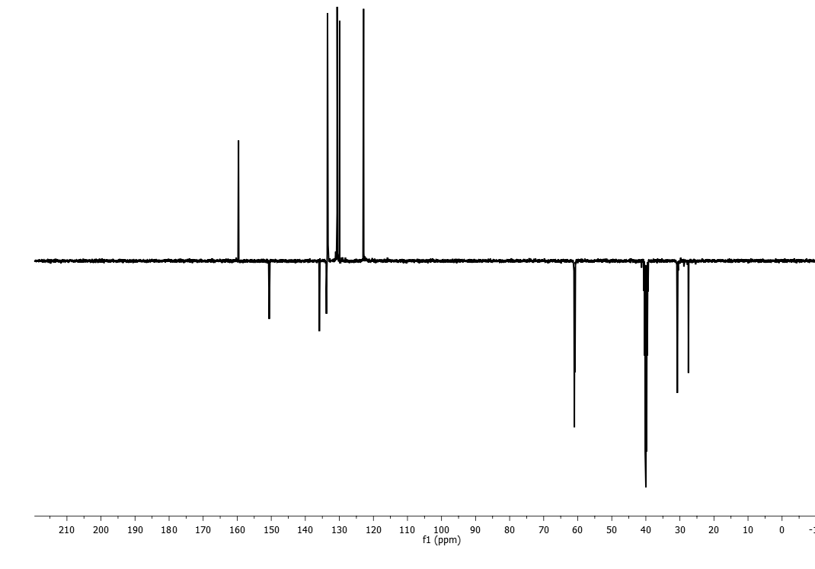
Figure S6. ¹³C-NMR (APT) spectrum of compound II.

Figure S7. Correlation graphic of experimental and calculated ¹³C NMR of I and II.

Figure S8. Correlation graphic of experimental and calculated ¹H NMR of I and II.

