Aβ₁₋₄₂ FREEDOCK1_C Docking Complex
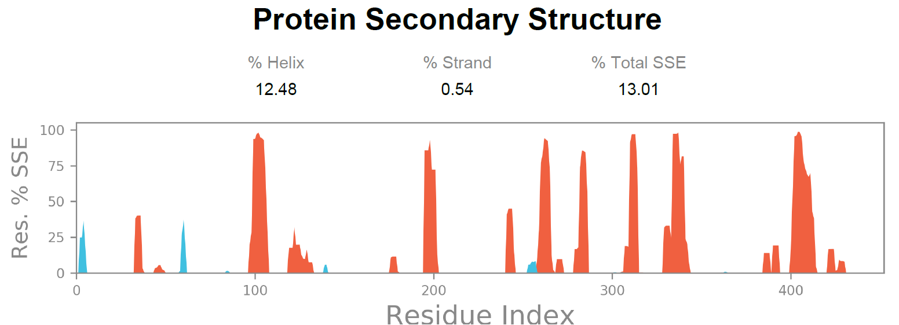

Aβ₁₋₄₂ IES1_A Docking Complex
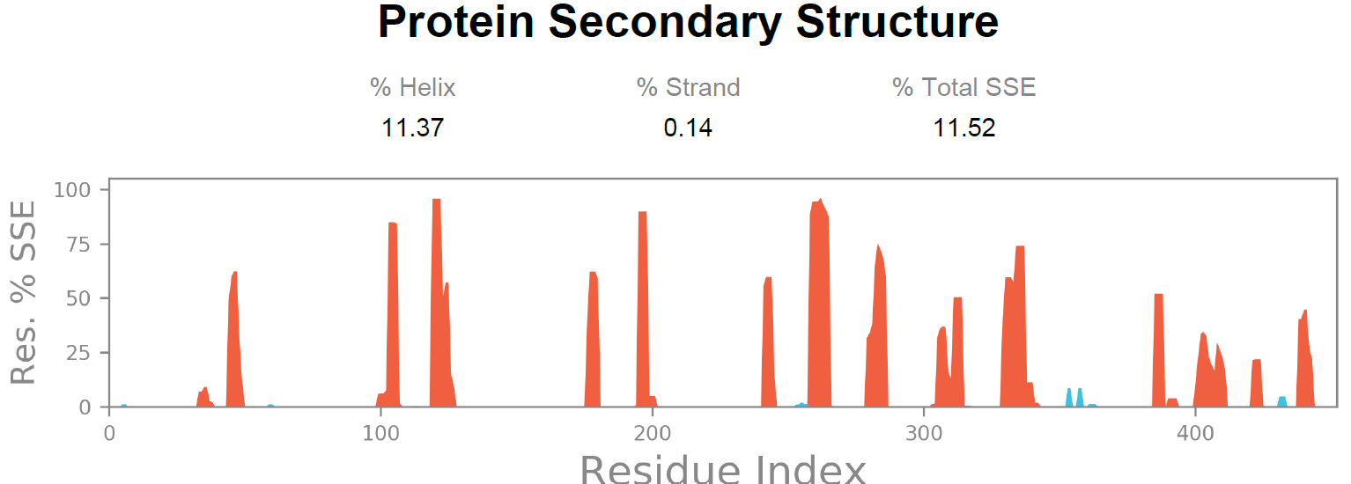

Aβ₁₋₄₂ IES6_B Docking Complex
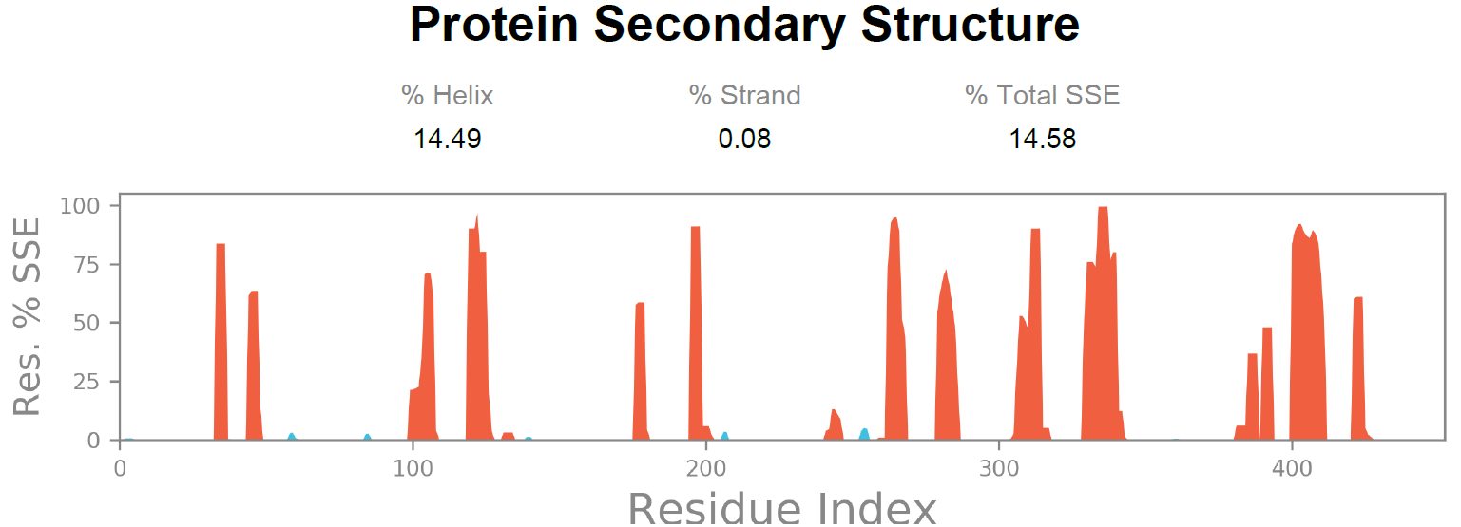

Aβ₁₋₄₂ IES9_C Docking Complex
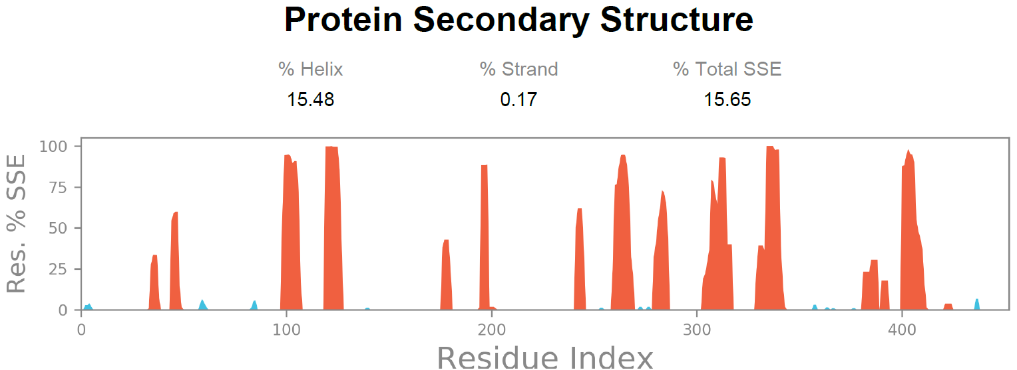

Aβ₁₋₂₈ FREEDOCK2_A Docking Complex
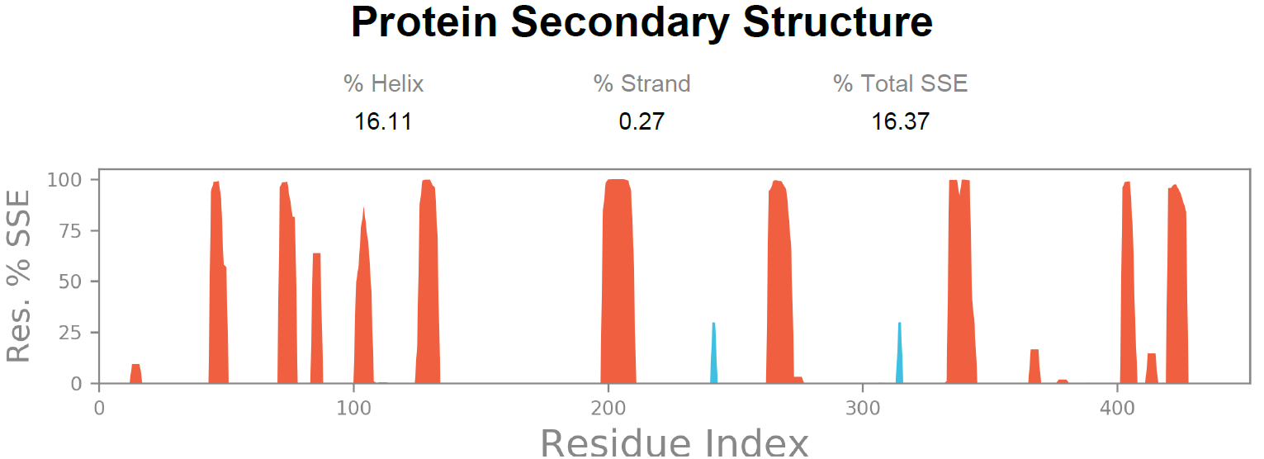

Aβ₁₋₂₈ FREEDOCK4_B Docking Complex
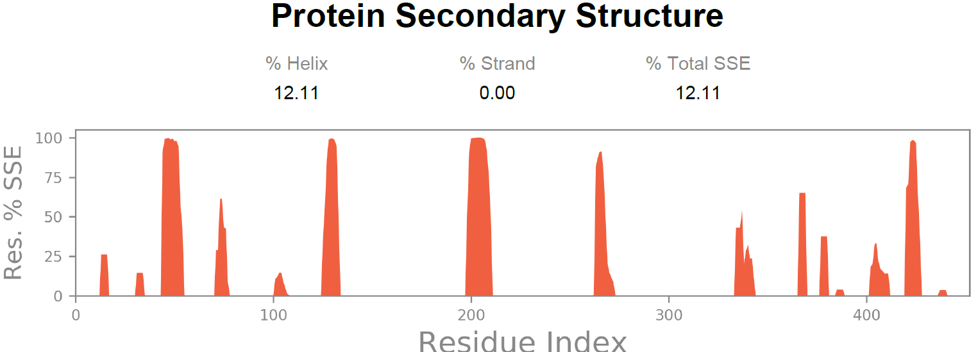

Aβ₁₋₂₈ FREEDOCK8_C Docking Complex
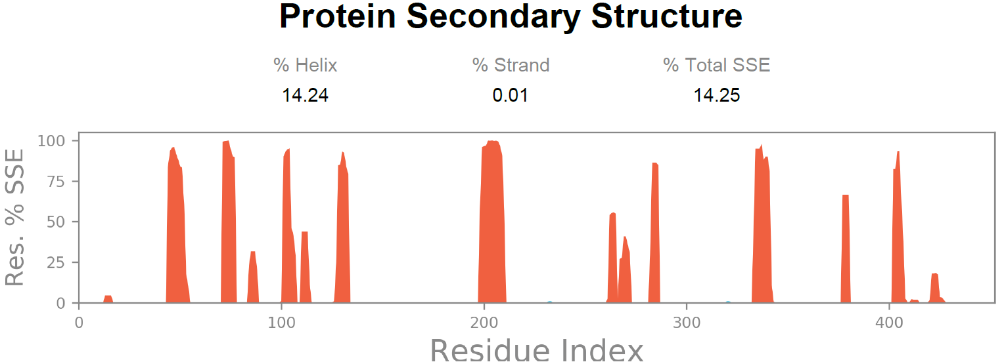

Aβ1-₂₈ SOAP_A₁ Docking Complex
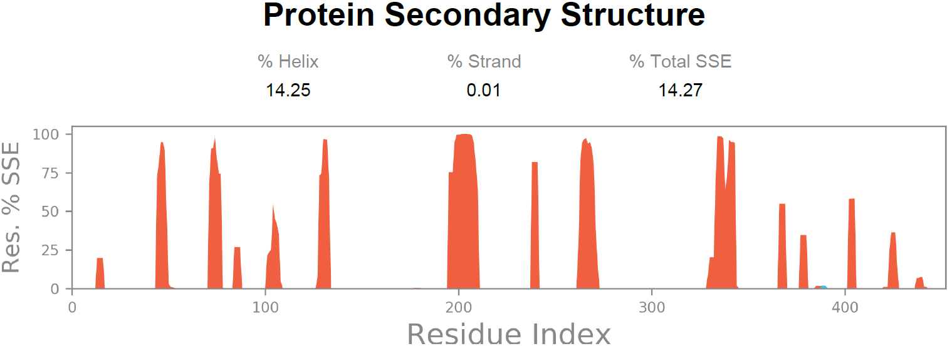

Aβ₁₋₂₈ SOAP_A₂ Docking Complex
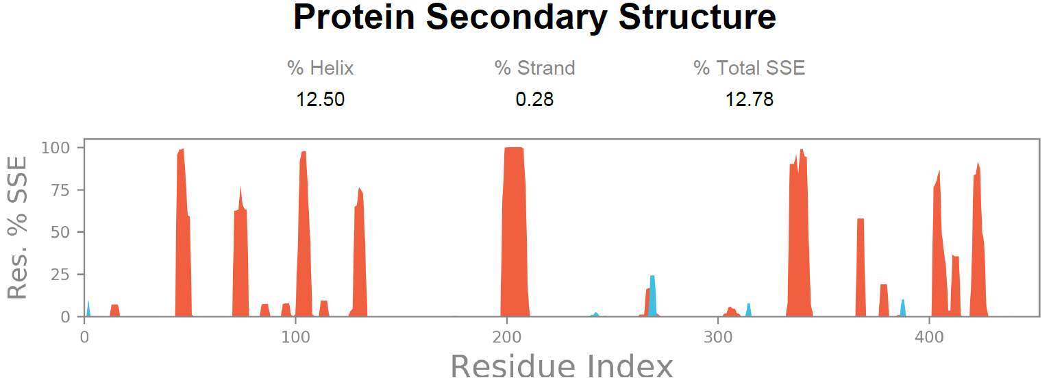
Aβ₁₋₂₈ IES2_B₁ Docking Complex
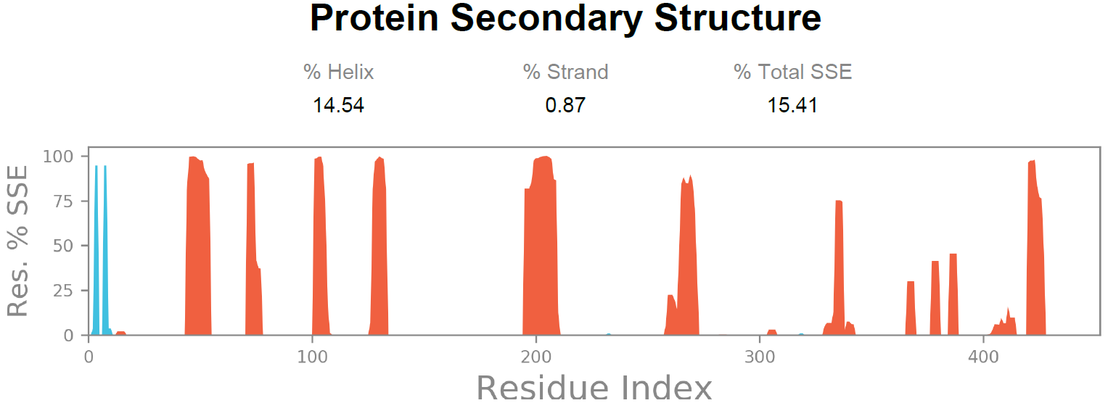

Aβ₁₋₂₈ IES2_B₂ Docking Complex
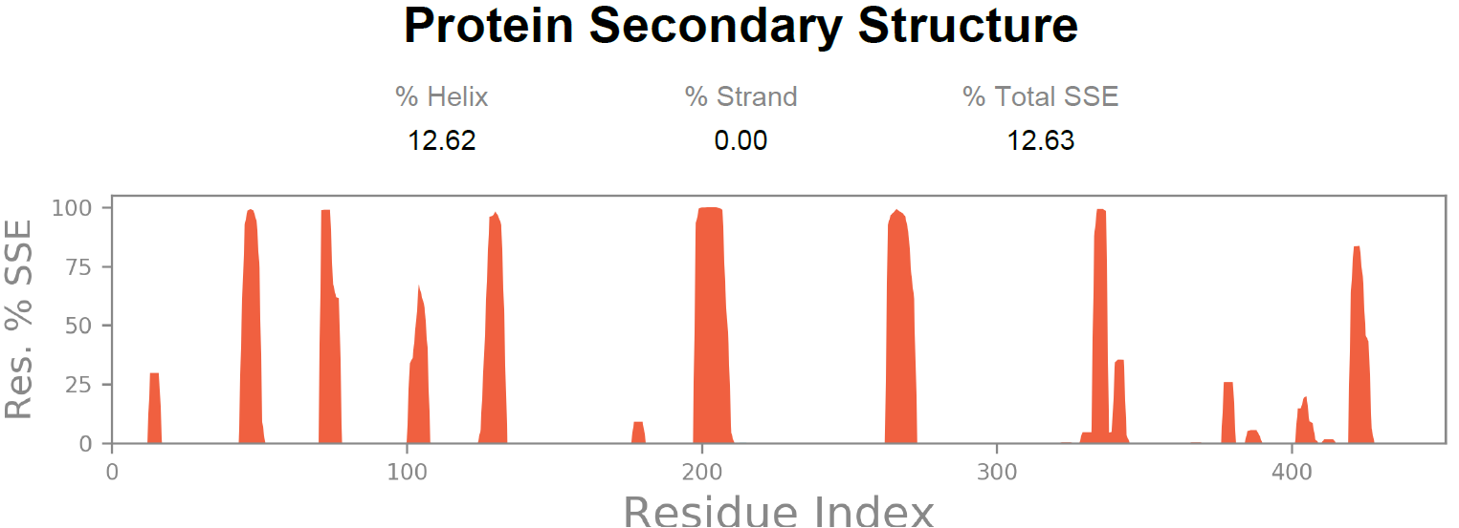

Alpha-helices Beta-strands

