Synthesis, DFT, and Molecular Docking Studies of Anti-cancer Imidazolidine-2,4-dione and Thiazolidine-2,4-dione Derivatives
Osama Alharbi¹
¹Department of Chemistry, College of Science, Taibah University,
Al-Madinah Al-Munawwarah, 30002, Saudi Arabia.
Corresponding author: E-mail: oamharbi@taibahu.edu.sa

Supplementary File

Density Functional Theory (DFT)
Geometry optimization

Table S1 All bond lengths(Å)
Atoms | Length (Å) | Atoms | Length (Å)
C1- C2 | 1.3927 | N14- H16 | 1.008
C1- C6 | 1.3911 | N14- C30 | 1.4511
C1- H7 | 1.0826 | C17- C18 | 1.3941
C2- C3 | 1.4044 | C17- C19 | 1.3941
C2- H8 | 1.084 | C18- C20 | 1.3921
C3- C4 | 1.4027 | C18- H21 | 1.0812
C3- N12 | 1.4054 | C19- C22 | 1.3925
C4- C5 | 1.3918 | C19- H23 | 1.0822
C4- H9 | 1.0836 | C20- C24 | 1.394
C5- C6 | 1.3916 | C20- H25 | 1.0839
C5- H10 | 1.0827 | C22- C24 | 1.3934
C6- Br11 | 1.9195 | C22- H26 | 1.0839
N12- C15 | 1.2726 | C24- H27 | 1.084
N13- C15 | 1.4136 | C28- O29 | 1.2063
N13- C17 | 1.4333 | C28- C30 | 1.5253
N13- C28 | 1.3921 | C30- H31 | 1.0957
N14- C15 | 1.3792 | C30- H32 | 1.093

Table S2 All bond angles (°)
Atoms | Angle (°) | Atoms | Angle (°) | Atoms | Angle (°) | Atoms | Angle (°)
C2- C1- C6 | 119.46 | C6- C5- H10 | 120.36 | N13- C17- C18 | 120.23 | C24- C22- H26 | 120.22
C2- C1- H7 | 120.16 | C1- C6- C5 | 120.75 | N13- C17- C19 | 119.21 | C20- C24- C22 | 119.81
C6- C1- H7 | 120.37 | C1- C6- Br11 | 119.59 | C18- C17- C19 | 120.55 | C20- C24- H27 | 120.09
C1- C2- C3 | 120.95 | C5- C6- Br11 | 119.66 | C17- C18- C20 | 119.47 | C22- C24- H27 | 120.1
C1- C2- H8 | 119.55 | C3-N12- C15 | 120.58 | C17- C18- H21 | 119.82 | N13- C28- O29 | 127.09
C3- C2- H8 | 119.49 | C15-N13-C17 | 124.57 | C20- C18- H21 | 120.7 | N13- C28- C30 | 106.34
C2- C3- C4 | 118.34 | C15-N13-C28 | 111.52 | C17- C19- C22 | 119.57 | O29- C28- C30 | 126.58
C2- C3- N12 | 122.24 | C17-N13-C28 | 123.91 | C17- C19- H23 | 119.9 | N14- C30- C28 | 102.71
C4- C3- N12 | 119.27 | C15-N14-H16 | 118.78 | C22- C19- H23 | 120.52 | N14- C30- H31 | 113.42
C3- C4- C5 | 121.05 | C15-N14-C30 | 111.84 | C18- C20- C24 | 120.35 | N14- C30- H32 | 112.93
C3- C4- H9 | 118.9 | H16-N14-C30 | 122.49 | C18- C20- H25 | 119.51 | C28- C30- H31 | 109.08
C5- C4- H9 | 120.05 | N12-C15-N13 | 123 | C24- C20- H25 | 120.14 | C28- C30- H32 | 109.92
C4- C5- C6 | 119.43 | N12-C15-N14 | 130.23 | C19- C22- C24 | 120.24 | H31- C30- H32 | 108.59
C4- C5- H10 | 120.2 | N13-C15-N14 | 106.77 | C19- C22- H26 | 119.53

Table S3 All torsion angles (°)
Atoms | Angle (°) | Atoms | Angle (°) | Atoms | Angle (°)
C6- C1- C2- C3 | -0.05 | C3- N12- C15- N14 | -3.26 | N13- C17- C19- C22 | -179.01
C6- C1- C2- H8 | -178.78 | C17- N13- C15- N12 | -6.21 | N13- C17- C19- H23 | 0.31
H7- C1- C2- C3 | 179.52 | C17- N13- C15- N14 | 173.99 | C18- C17- C19- C22 | 0
H7- C1- C2- H8 | 0.78 | C28- N13- C15- N12 | 174.79 | C18- C17- C19- H23 | 179.32
C2- C1- C6- C5 | 0.58 | C28- N13- C15- N14 | -5 | C17- C18- C20- C24 | -0.64
C2- C1- C6- Br11 | -179.94 | C15- N13- C17- C18 | 55.4 | C17- C18- C20- H25 | 179.59
H7- C1- C6- C5 | -178.99 | C15- N13- C17- C19 | -125.58 | H21- C18- C20- C24 | -179.59
H7- C1- C6- Br11 | 0.5 | C28- N13- C17- C18 | -125.72 | H21- C18- C20- H25 | 0.64
C1- C2- C3- C4 | -0.84 | C28- N13- C17- C19 | 53.29 | C17- C19- C22- C24 | -0.43
C1- C2- C3- N12 | -176.43 | C15- N13- C28-O29 | 179.52 | C17- C19- C22- H26 | 179.72
H8- C2- C3- C4 | 177.9 | C15- N13- C28- C30 | -0.65 | H23- C19- C22- C24 | -179.74
H8- C2- C3- N12 | 2.31 | C17- N13- C28-O29 | 0.51 | H23- C19- C22- H26 | 0.41
C2- C3- C4- C5 | 1.23 | C17- N13- C28- C30 | -179.65 | C18- C20- C24- C22 | 0.22
C2- C3- C4- H9 | -178.38 | H16- N14- C15- N12 | -19.09 | C18- C20- C24- H27 | -179.74
N12- C3- C4- C5 | 176.95 | H16- N14- C15- N13 | 160.69 | H25- C20- C24- C22 | 179.99
N12- C3- C4- H9 | -2.66 | C30- N14- C15- N12 | -170.76 | H25- C20- C24- H27 | 0.02
C2- C3- N12- C15 | -63.22 | C30- N14- C15- N13 | 9.02 | C19- C22- C24- C20 | 0.32
C4- C3- N12- C15 | 121.24 | C15- N14- C30- C28 | -9.11 | C19- C22- C24- H27 | -179.72
C3- C4- C5- C6 | -0.73 | C15- N14- C30- H31 | 108.46 | H26- C22- C24- C20 | -179.84
C3- C4- C5- H10 | 179.73 | C15- N14- C30- H32 | -127.44 | H26- C22- C24- H27 | 0.13
H9- C4- C5- C6 | 178.88 | H16- N14- C30- C28 | -159.56 | N13- C28- C30- N14 | 5.66
H9- C4- C5- H10 | -0.66 | H16- N14- C30- H31 | -41.99 | N13- C28- C30- H31 | -114.94
C4- C5- C6- C1 | -0.19 | H16- N14- C30- H32 | 82.1 | N13- C28- C30- H32 | 126.1
C4- C5- C6- Br11 | -179.68 | N13- C17- C18- C20 | 179.53 | O29- C28- C30-N14 | -174.5
H10- C5- C6-C1 | 179.34 | N13- C17- C18- H21 | -1.51 | O29- C28- C30-H31 | 64.9
H10- C5- C6- Br11 | -0.14 | C19- C17- C18- C20 | 0.53 | O29- C28- C30-H32 | -54.06
C3- N12- C15- N13 | 177 | C19- C17- C18- H21 | 179.49

Docking Simulation:

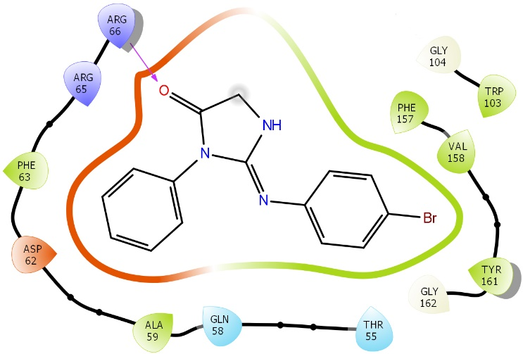
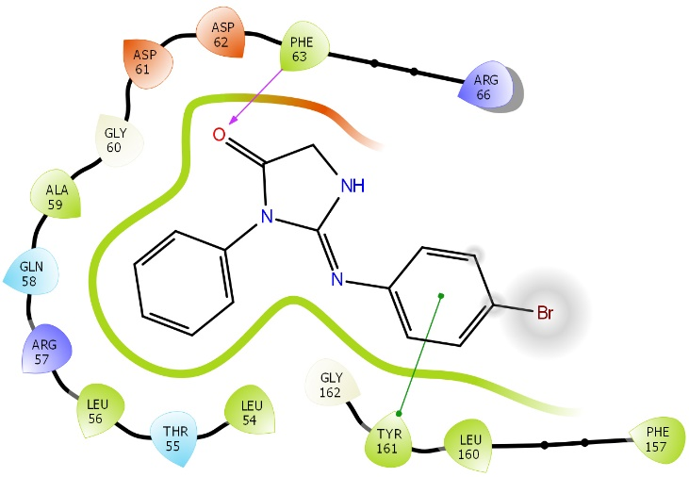
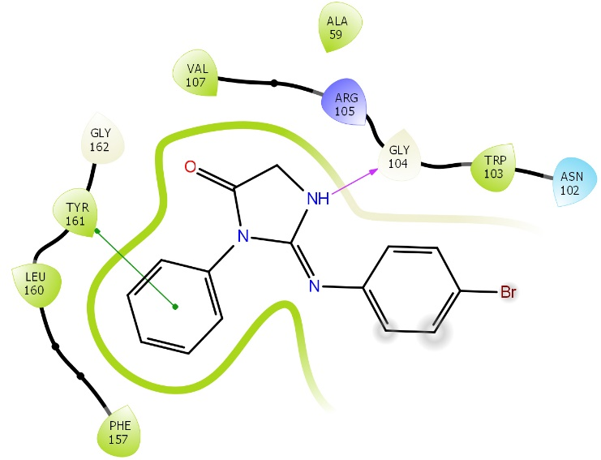
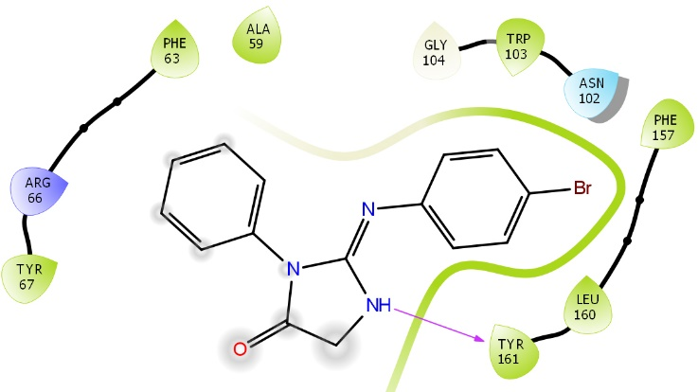
Conf. 2
Conf. 3
Conf. 4
Conf. 5

\

Fig S1. 2-D interaction plots for (2-5 conformations) of the compound 13b docked with 4IEH showing hydrogen bond and pi interactions.

¹H and ¹³C- NMR of synthesized compounds
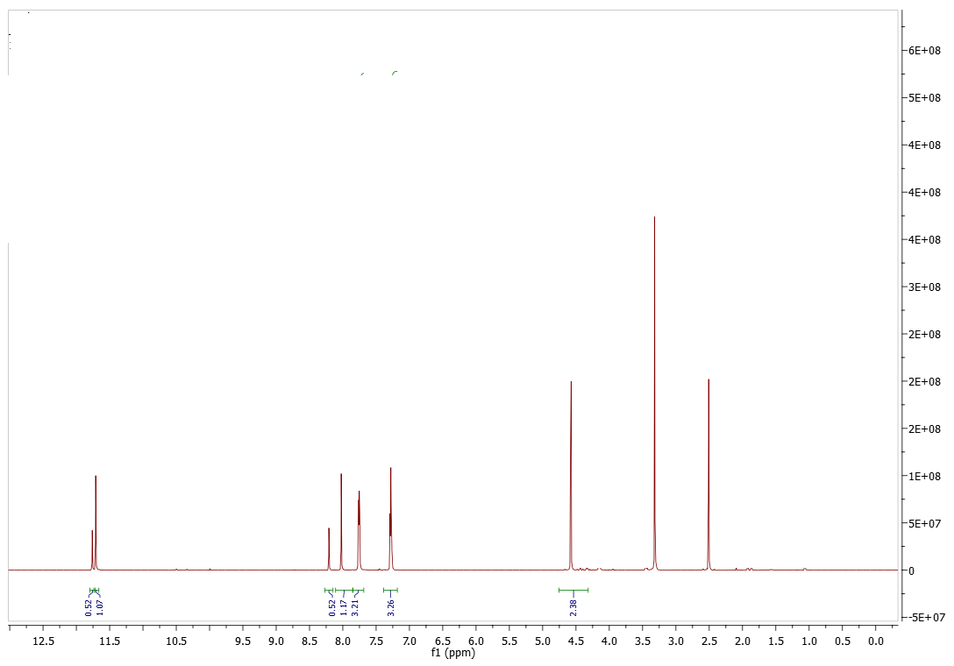
Figure 1. ¹H-NMR of 2-((3,6-dioxocyclohexa-1,4-dien-1-yl)oxy)-N'-(-4-(-(2,4-dioxothiazolidin-5-ylidene)methyl)benzylidene)acetohydrazide (9a)
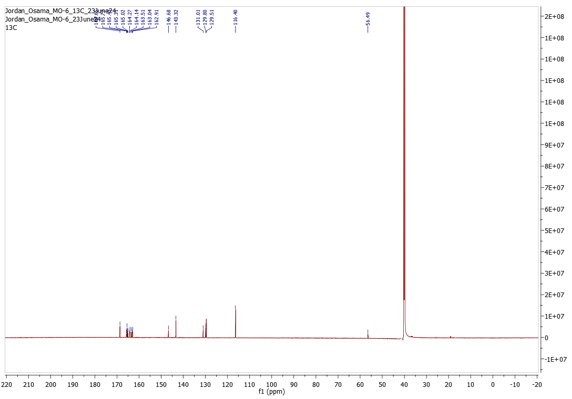
Figure 2. ¹³C-NMR of 2-((3,6-dioxocyclohexa-1,4-dien-1-yl)oxy)-N'-(-4-(-(2,4-dioxothiazolidin-5-ylidene)methyl)benzylidene)acetohydrazide (9a)

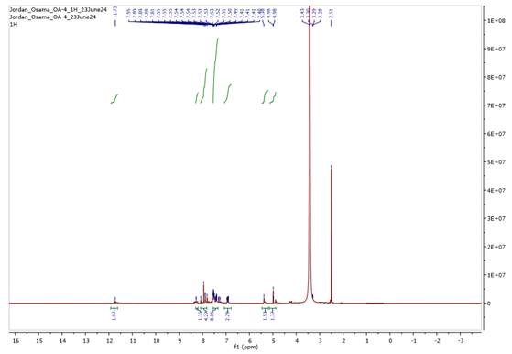
Figure 3. ¹H-NMR of N'-(-4-(-(2,4-dioxothiazolidin-5-ylidene)methyl)benzylidene)-2-(naphthalen-1-yloxy)acetohydrazide (9b)

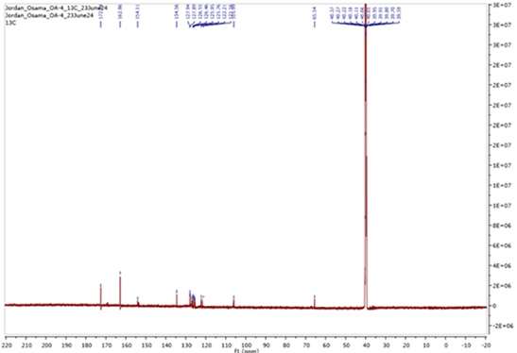
Figure 4. ¹³C-NMR of N'-(-4-(-(2,4-dioxothiazolidin-5-ylidene)methyl)benzylidene)-2-(naphthalen-1-yloxy)acetohydrazide (9b)
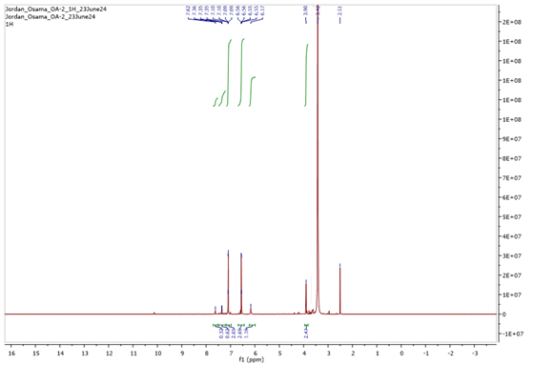
Figure 5. ¹H-NMR of 2-((4-chlorophenyl)imino)-3-phenylimidazolidin-4-one (13a)
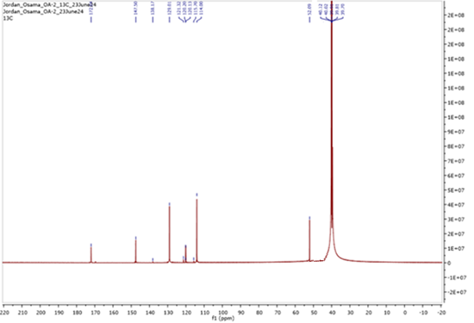
Figure 6. ¹³C-NMR of 2-((4-chlorophenyl)imino)-3-phenylimidazolidin-4-one (13a)

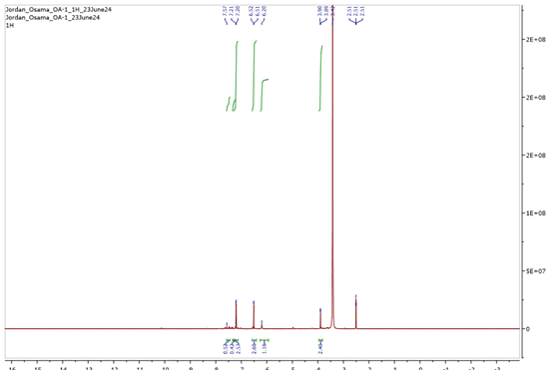
Figure 7. ¹H-NMR of 2-((4-bromophenyl)imino)-3-phenylimidazolidin-4-one (13b)
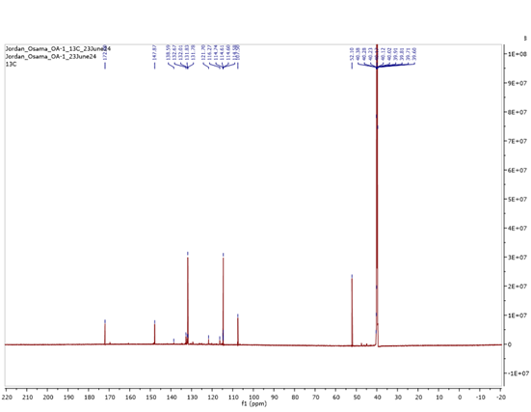
Figure 8. ¹³C-NMR of 2-((4-bromophenyl)imino)-3-phenylimidazolidin-4-one (13b)

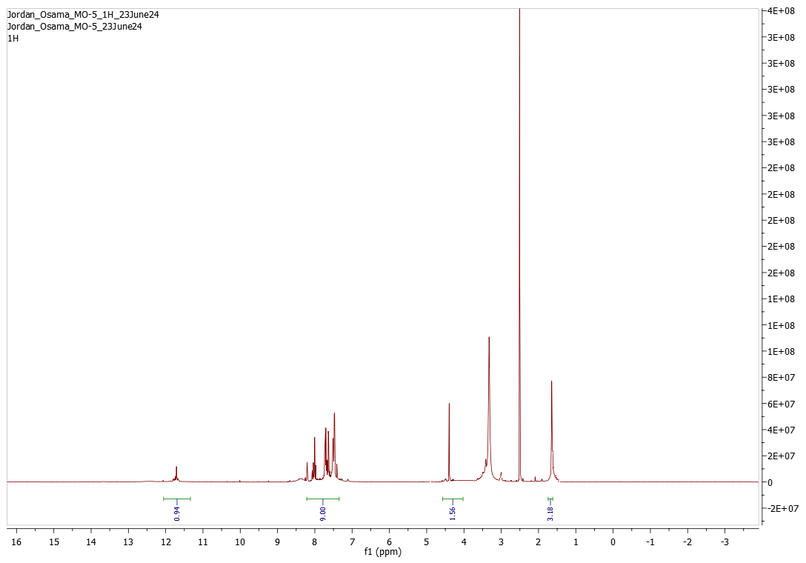
Figure 9. ¹H-NMR of 2-((4-acetylphenyl)imino)-3-phenylimidazolidin-4-one (13c)
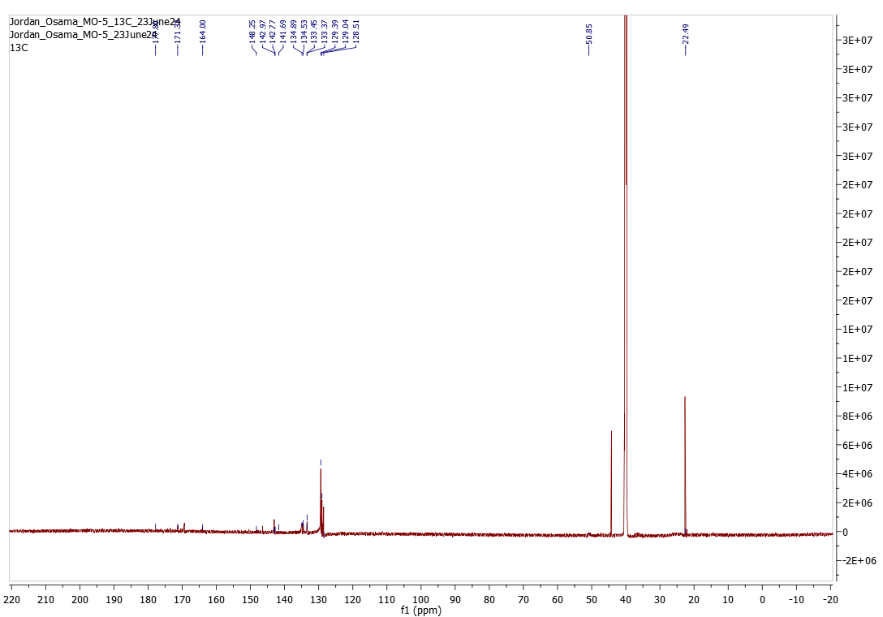
Figure 10. ¹³C-NMR of 2-((4-acetylphenyl)imino)-3-phenylimidazolidin-4-one (13c)

