HPLC-DAD analysis, antioxidant and antibacterial properties of fruit extracts from Pistacia atlantica Desf.
Younes Douffa¹, Karima Saffidine¹*, Nour Elhouda Belabes¹, Nadjet Azzi¹, Haifaa Laroui¹, Hafsa Silini Cherif², Thoraya Guemmaz¹, Fatima Zerargui¹ and Abderahmane Baghiani¹
¹Laboratory of Applied Biochemistry, Faculty of Nature and Life sciences, University Ferhat Abbas Setif1, Setif 19000, Algeria
²Laboratory of Applied Microbiology, Department of Microbiology, Faculty of Natural and Life, Ferhat Abbas Setif1 University, Setif 19000, Algeria
*Corresponding author: saffidinekarima@gmail.com

HPLC-DAD analysis of cude extract (CrE)

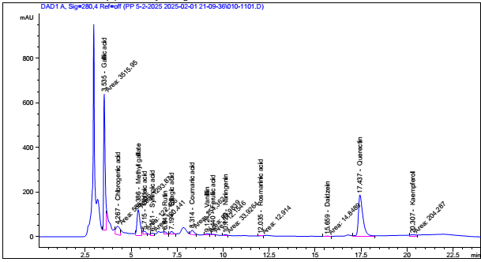

HPLC-DAD analysis of ethyl acetate extract (EAE)

