SUPPORTING INFORMATION
Novel Mannich Bases Based on Schiff Bases: Synthesis, Antimicrobial, Antioxidant Activities, and Anticancer Analysis with Molecular Docking Study
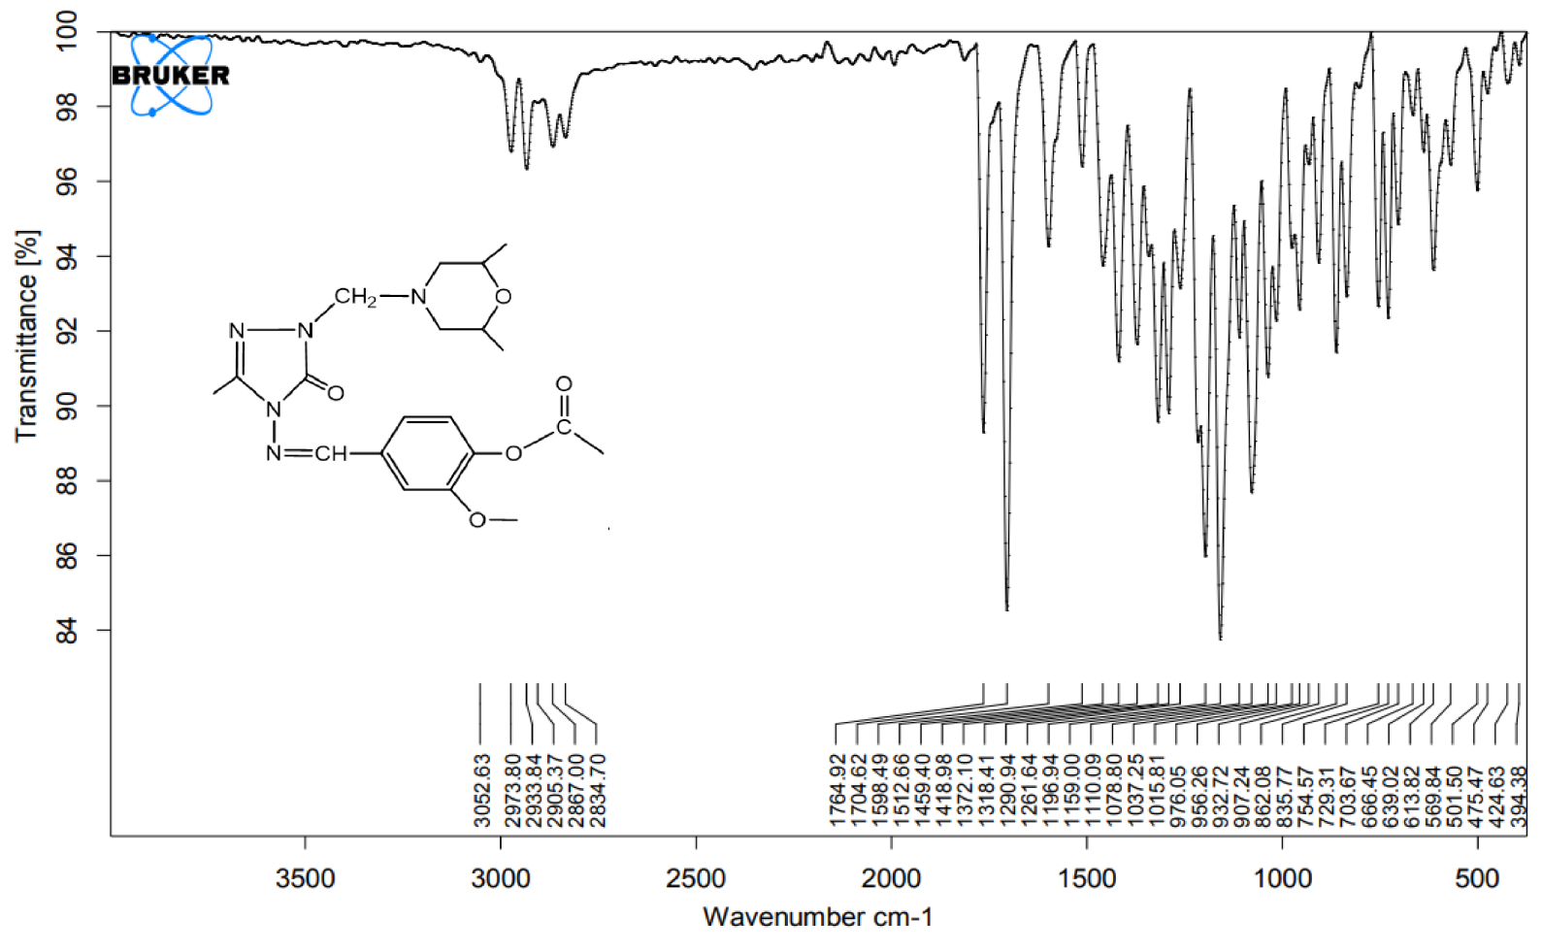
Fig.1 IR Spectrum of 6a compound.
Fig.2 ¹H NMR Spectrum of 6a compound.
Fig. 3 ¹³C NMR Spectrum of 6a compound.

Fig.4 IR Spectrum of 6b compound.

Fig.5 ¹H NMR Spectrum of 6b compound.

Fig. 6 ¹³C NMR Spectrum of 6b compound.

Fig.7 IR Spectrum of 6c compound.
Fig.8 ¹H NMR Spectrum of 6c compound.

Fig. 9 ¹³C NMR Spectrum of 6c compound.

Fig.10 IR Spectrum of 6d compound.
Fig.11 ¹H NMR Spectrum of 6d compound.

Fig. 12 ¹³C NMR Spectrum of 6d compound.
Fig.13 IR Spectrum of 6e compound
Fig.14 ¹H NMR Spectrum of 6e compound.

Fig. 15 ¹³C NMR Spectrum of 6e compound.

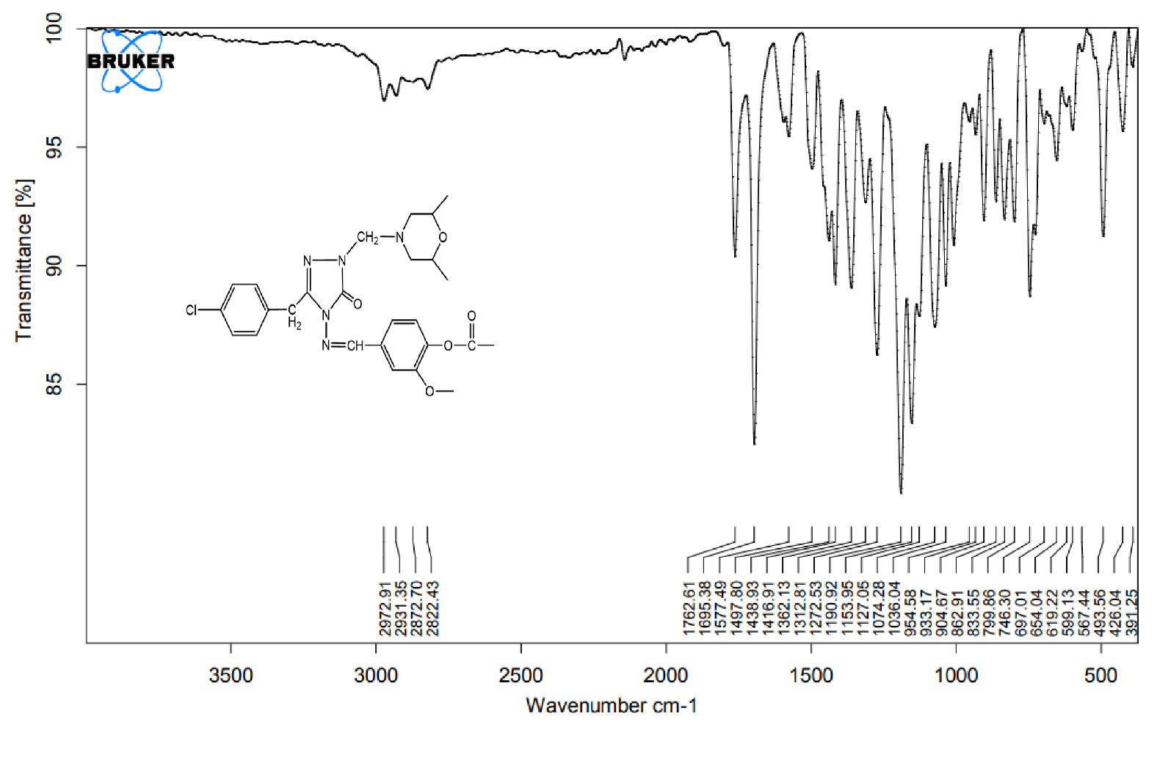
Fig.16 IR Spectrum of 6f compound.
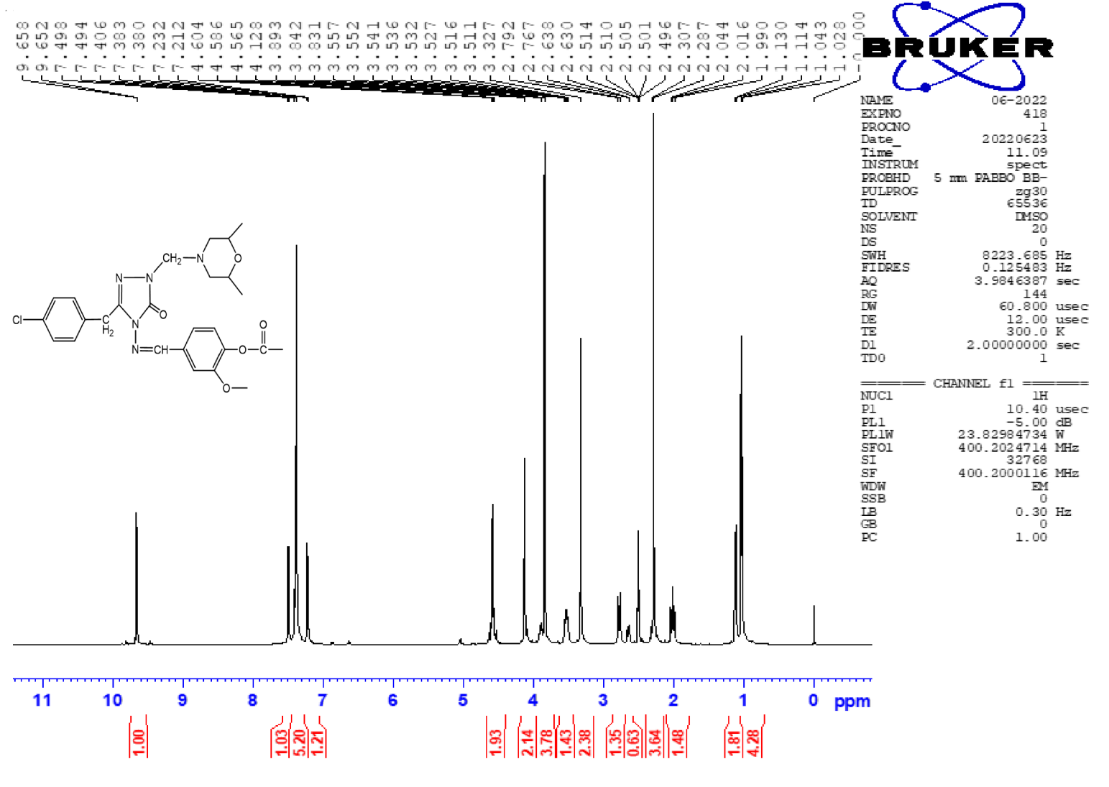
Fig.17 ¹H NMR Spectrum of 6f compound.

Fig. 18 ¹³C NMR Spectrum of 6f compound.

Fig.19 IR Spectrum of 6g compound.
Fig.20 ¹H NMR Spectrum of 6g compound.

Fig. 21 ¹³C NMR Spectrum of 6g compound.

Table S1. The reducing power of 6(a-g) compound
Compounds | Reducing Power
Compounds | 100 | 250 | 500
6a | 0.200 | 0.205 | 0.230
6b | 0.099 | 0.095 | 0.097
6c | 0.320 | 0.348 | 0.349
6d | 0.185 | 0.182 | 0.181
6e | 0.179 | 0.168 | 0.167
6f | 0.181 | 0.179 | 0.174
6g | 0.111 | 0.112 | 0.115
BHA | 0.424 | 0.677 | 0.873
BHT | 0.735 | 1.242 | 1.491
α-Tocopherol | 0.462 | 1.058 | 1.249
Absorbance of control reaction: 0.054

Table S2. Absorbance measurements and radical scavenging activity of 6(a-g)
Compounds | 12.5 |  | 25 |  | 37.5
Compounds | A | % Activity | A | % Activity | A | % Activity
6a | 0.123 | 15.8 | 0.093 | 36.3 | 0.093 | 36.3
6b | 0.110 | 24.7 | 0.110 | 24.7 | 0.086 | 41.1
6c | 0.114 | 20.3 | 0.106 | 25.9 | 0.098 | 31.5
6d | 0.116 | 20.5 | 0.101 | 30.8 | 0.098 | 32.9
6e | 0.119 | 16.8 | 0.106 | 25.9 | 0.102 | 28.7
6f | 0.121 | 17.1 | 0.109 | 25.3 | 0.102 | 30.1
6g | 0.119 | 18.5 | 0.104 | 28.8 | 0.104 | 28.8
BHT | 0.079 | 45.9 | 0.053 | 63.7 | 0.044 | 69.9
BHA | 0.020 | 86.3 | 0.019 | 87.0 | 0.018 | 87.7
α-Tocopherol | 0.014 | 90.4 | 0.014 | 90.4 | 0.013 | 91.1
Absorbance of control reaction: 0.146

Table S3. Absorbance measurements of 6(a-g) and percentage of associated metal chelation activities
Compounds | 30 |  | 45 |  | 60
Compounds | A | % Activity | A | % Activity | A | % Activity
6a | 0.029 | 85.3 | 0.029 | 85.3 | 0.028 | 85.8
6b | 0.030 | 84.8 | 0.028 | 85.8 | 0.029 | 85.3
6c | 0.029 | 85.3 | 0.029 | 85.3 | 0.028 | 85.8
6d | 0.031 | 84.3 | 0.028 | 85.8 | 0.028 | 85.8
6e | 0.030 | 84.8 | 0.030 | 84.8 | 0.028 | 85.8
6f | 0.030 | 84.8 | 0.030 | 84.8 | 0.029 | 85.3
6g | 0.029 | 85.3 | 0.029 | 85.3 | 0.029 | 85.3
α-Tocopherol | 0.080 | 59.4 | 0.075 | 61.9 | 0.037 | 81.2
EDTA | 0.029 | 85.3 | 0.027 | 86.3 | 0.027 | 86.3
Absorbance of control reaction: 0.197

