Structural diversity of different aminomethylpyridinium hexafluoridosilicates
Andrej Pevec*
Faculty of Chemistry and Chemical Technology, University of Ljubljana, Večna pot 113, 1000, Ljubljana, Slovenia

Supporting Information

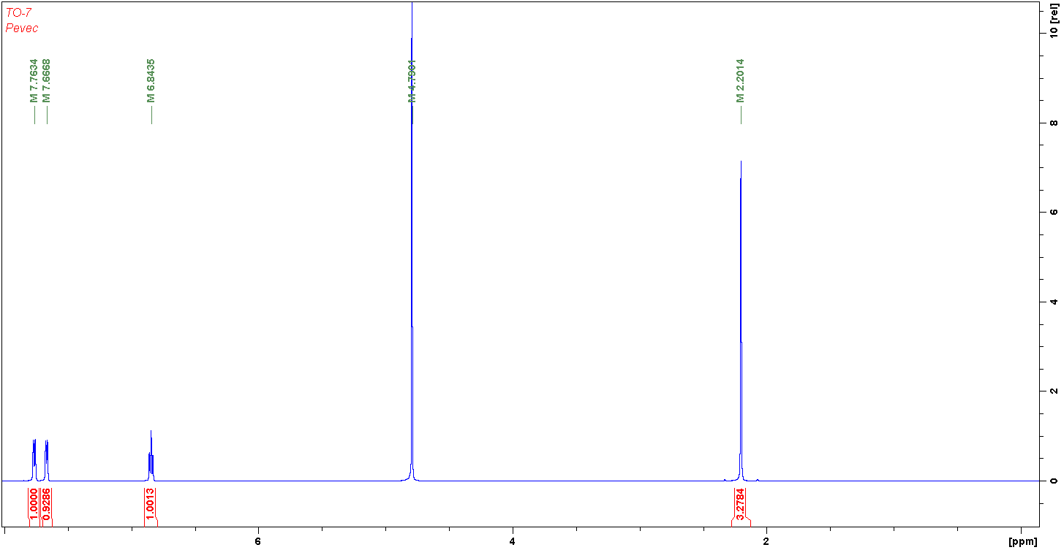
Figure S1. ¹H NMR spectrum of 1.

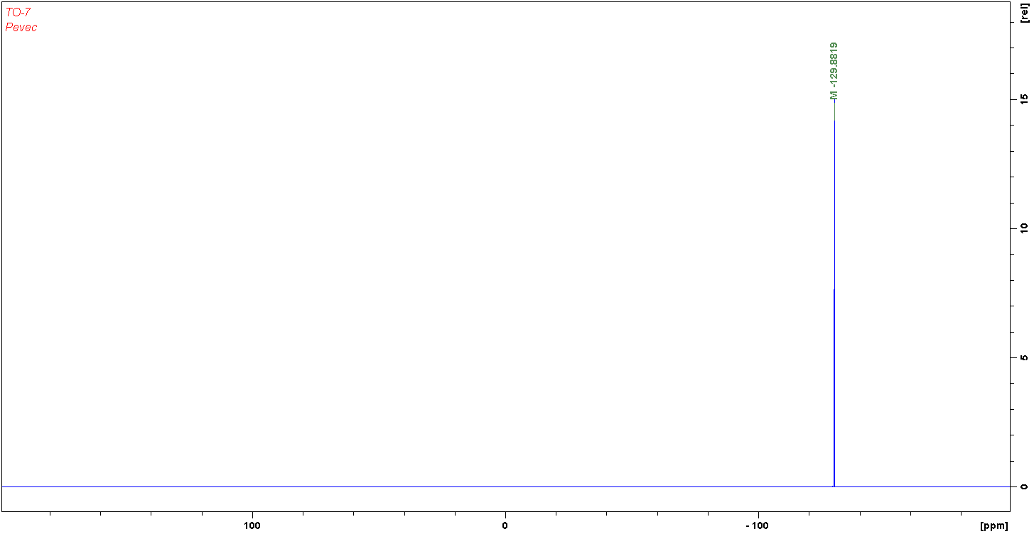
Figure S2. ¹⁹F NMR spectrum of 1.

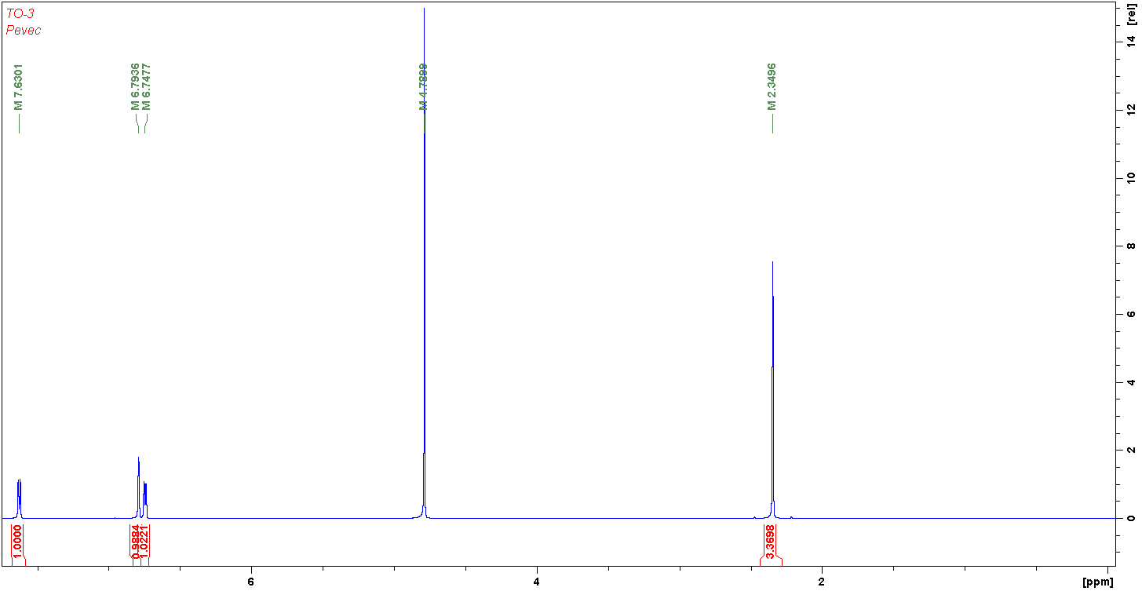
Figure S3 ¹H NMR spectrum of 2.

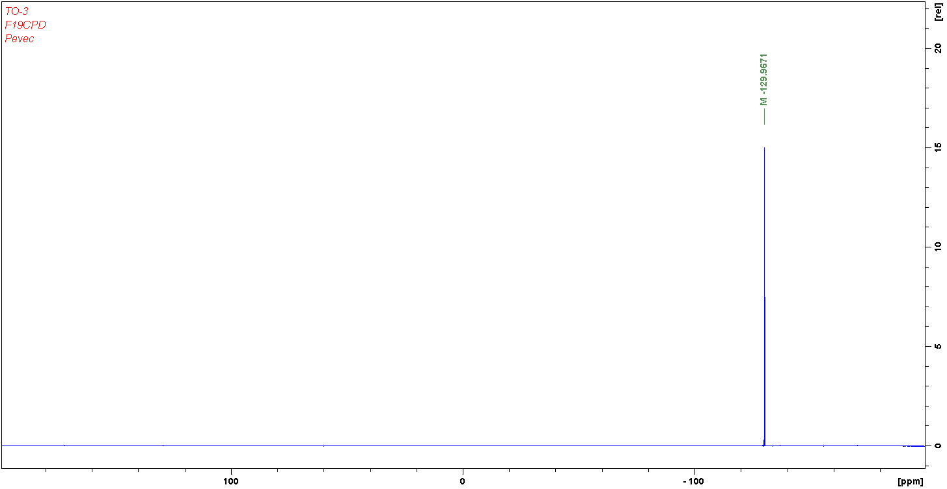
Figure S4. ¹⁹F NMR spectrum of 2.

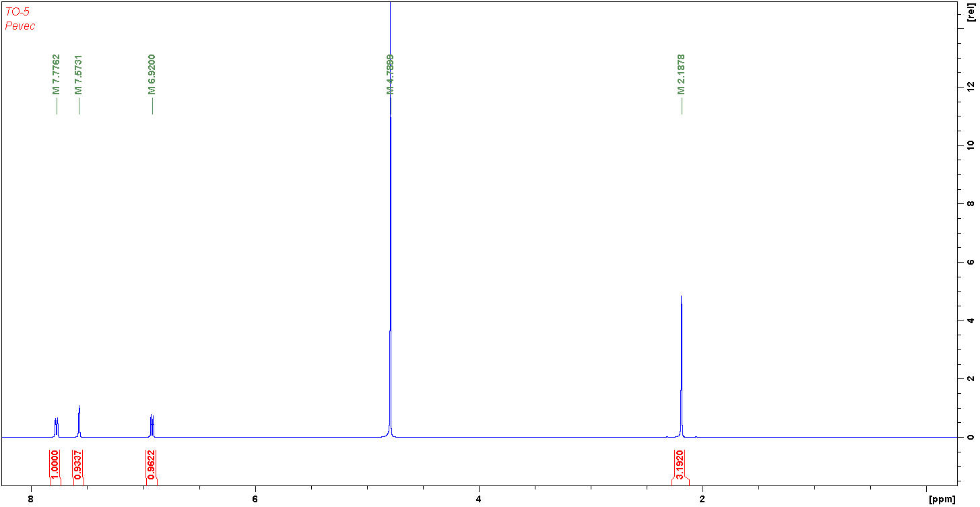
Figure S5. ¹H NMR spectrum of 3.

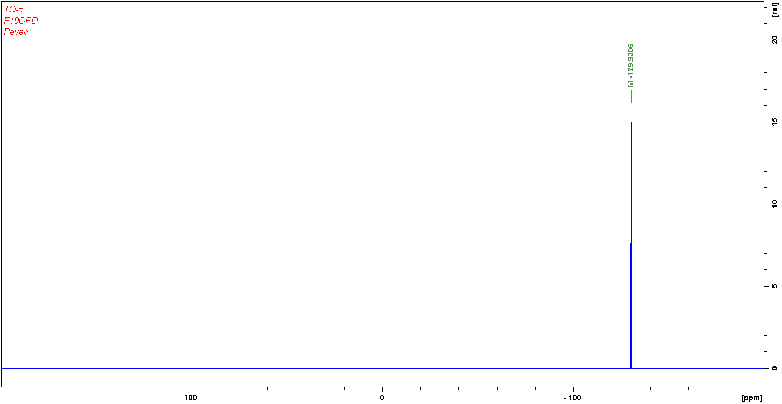
Figure S6. ¹⁹F NMR spectrum of 3.

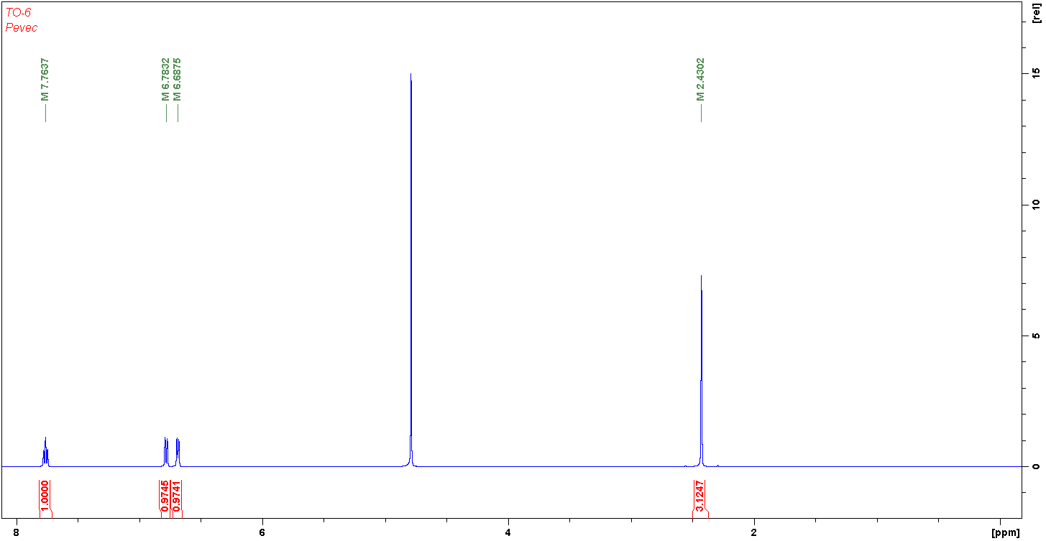
Figure S7. ¹H NMR spectrum of 4.

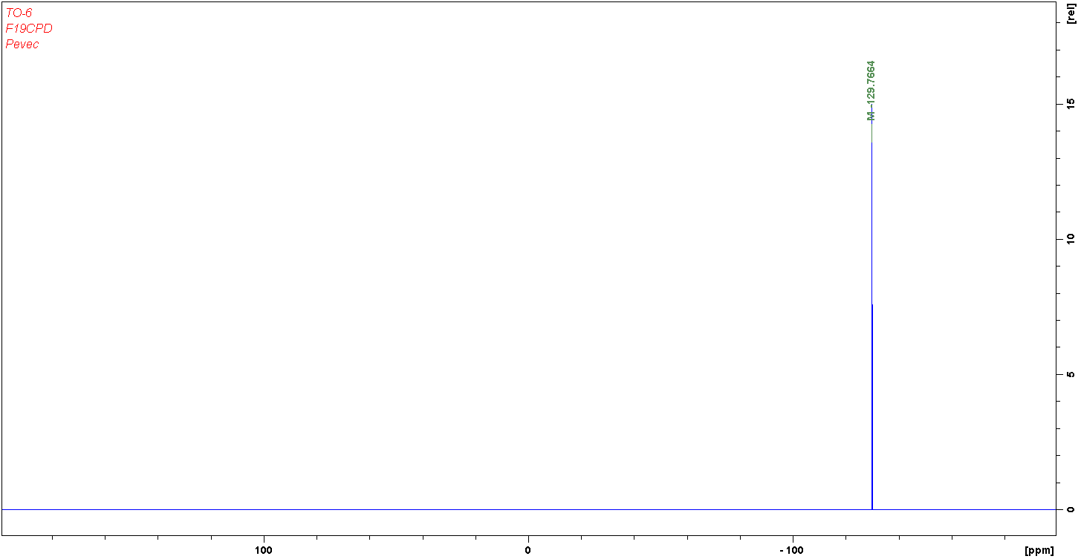
Figure S8. ¹⁹F NMR spectrum of 4.

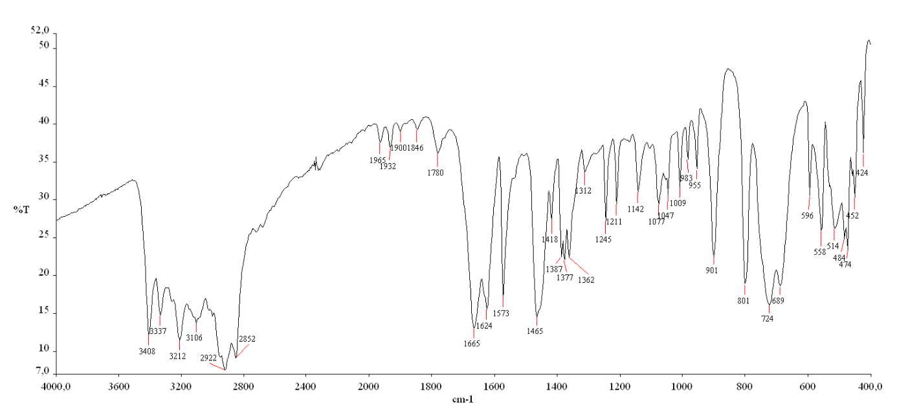
Figure S9. IR spectrum of 1 (Nujol).

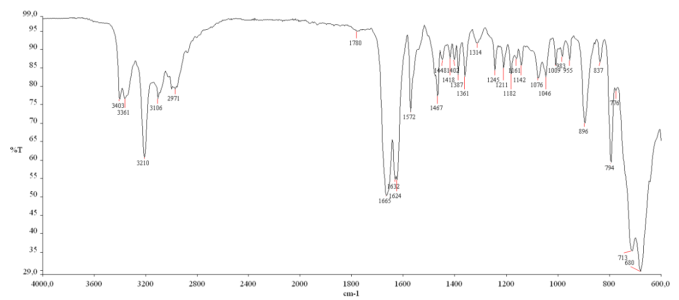

Figure S10. IR spectrum of 1 (ATR).

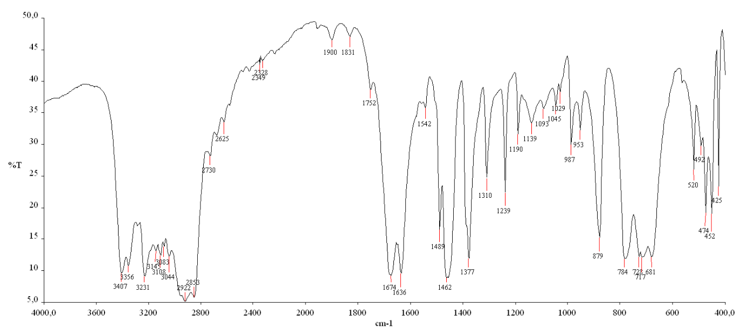

Figure S11. IR spectrum of 2 (Nujol).

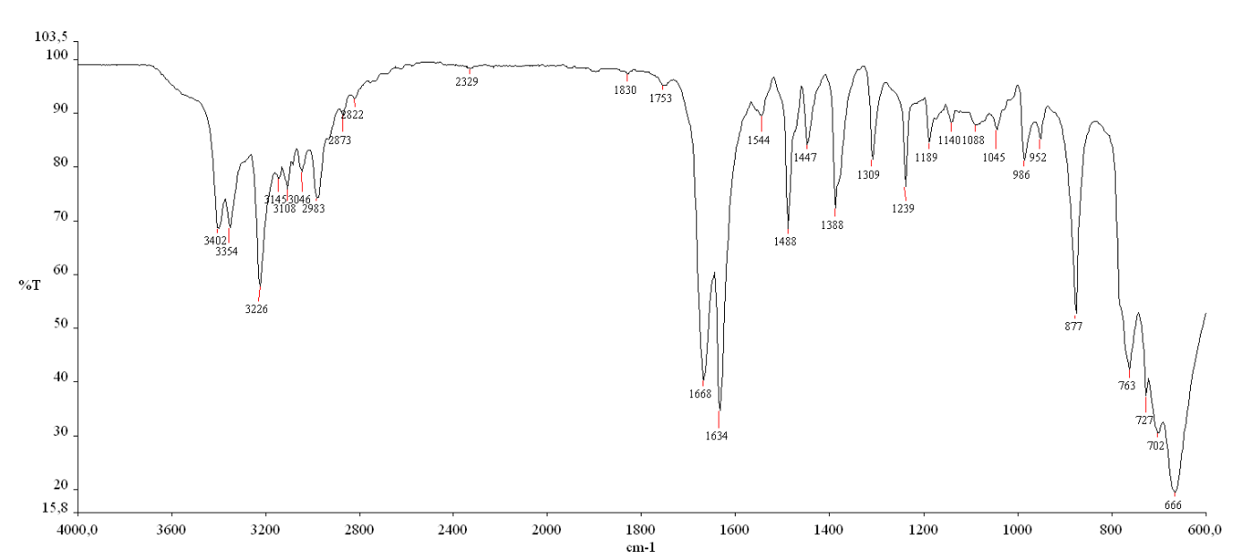
Figure S12. IR spectrum of 2 (ATR).
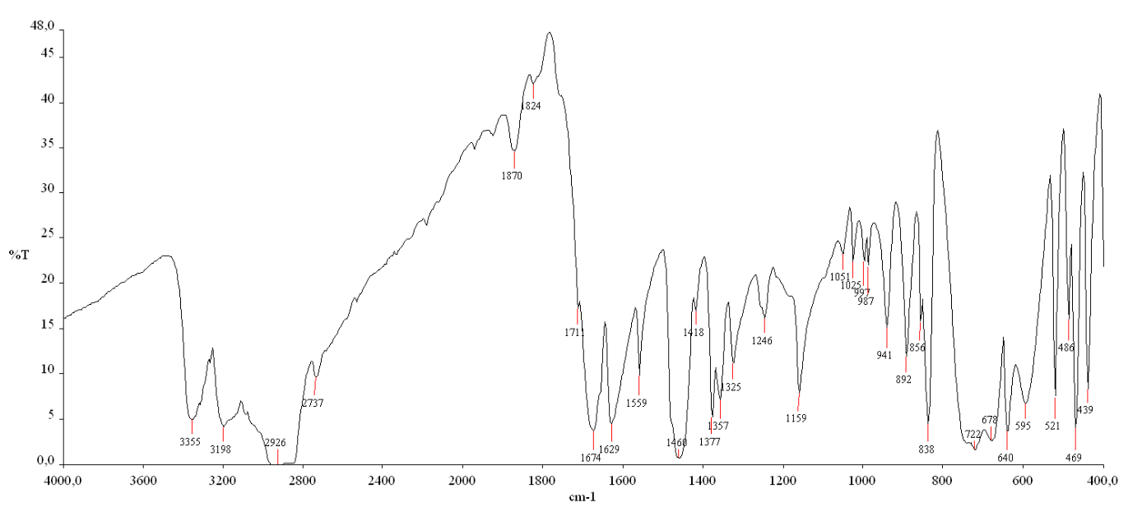

Figure S13. IR spectrum of 3 (Nujol).

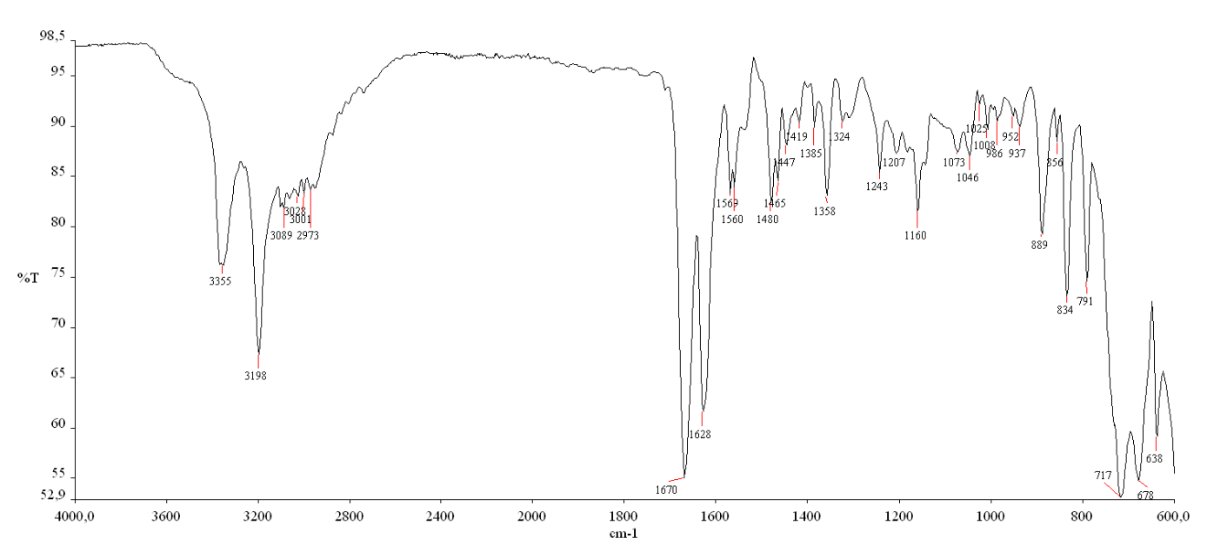

Figure S14. IR spectrum of 3 (ATR).

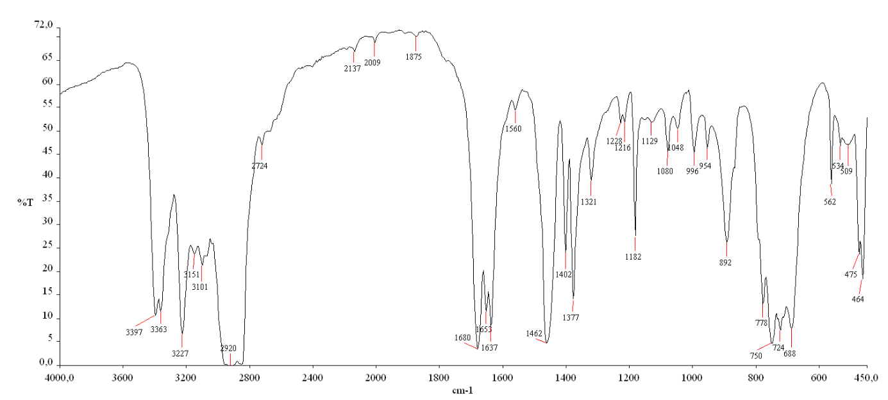

Figure S15. IR spectrum of 4 (Nujol).

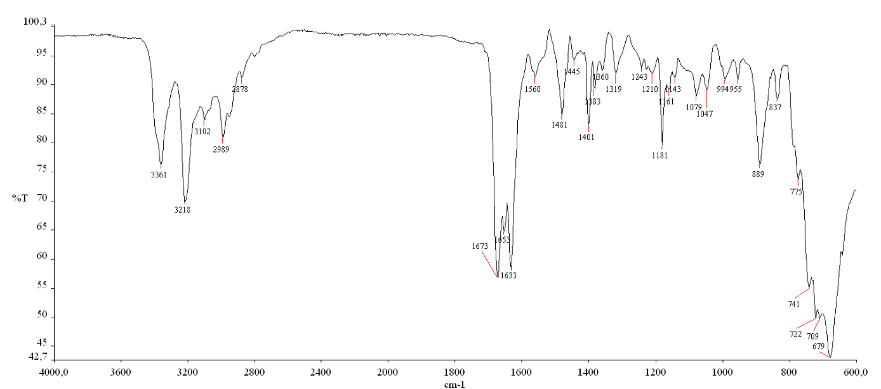
Figure S16. IR spectrum of 4 (ATR).

Table S1. Numerical parameters¹ for π‒π interactions in the structure of 1, 2 and 4.
centroid-centroid distance (Å) | dihedral  angle (°) | perpendicular (normal)  distance (Å) | slippage Å)
1
3.7409(9) | 5.75(7) | 3.4402(6) | 1.410
2
3.797(3) | 0.03(10) | 3.6562(9) | 1.024
3.892(3) | 0.03(10) | 3.7469(9) | 1.053
4
3.654(3) | 5.0(3) | 3.525(2) | 0.813
3.681(3) | 6.8(3) | 3.527(2) | 0.758
3.683(3) | 7.7(3) | 3.612(2) | 0.956
3.684(3) | 5.8(3) | 3.545(2) | 1.143
3.702(3) | 8.4(3) | 3.609(2) | 1.099
3.703(3) | 6.2(3) | 3.627(2) | 1.094
3.731(3) | 9.4(3) | 3.522(2) | 0.952
3.739(3) | 8.7(3) | 3.528(2) | 0.896

Reference:
- C. Janiak, J. Chem. Soc., Dalton Trans. 2000, 3885-3896.

