Supplementary information

Synthesis, Characterization, DFT Investigation and In Silico Anti-eczema Evaluation of a Novel Thiazolidinone Derivative

Amine Ould Rabahª, Abdelmadjid Benmohammed^{b,c}, Abdelkader Chouaih^{a,*}, Meriem Goudjil^{d}, Rachida Rahmani^{a,e}, Nour El-Houda Belkafoufª, Mohammed Hadj-Mortada Belhachemiª, Fatima Zohra Boudjenaneª, Ayada Djafri^{b}, Nourdine Boukabcha^{a,f}

ª Laboratory of Technology and Solid Properties (LTPS), Abdelhamid Ibn Badis University of Mostaganem, 27000 Mostaganem, Algeria.
^{b} Laboratory of Organic Applied Synthesis (LSOA), Department of Chemistry, Faculty of Sciences, University of Oran 1, Ahmed Ben Bella, 31000 Oran, Algeria.
^{c} Chemistry Department, Faculty of Exact Sciences, Mustapha Stambouli University of Mascara, B.P. 763, 29000 Mascara, Algeria.
^{d} Dipartimento di Scienze della Terra, Università degli Studi di Firenze, via G. La Pira 4, I-50121 Firenze, Italy.
^{e} Department of Process Engineering, Faculty of Sciences and Technology, Ahmed Zabana - University of Relizane, Relizane, Algeria.
^{f} Chemistry Department, Faculty of Exact Sciences and Informatics, Hassiba Benbouali University, 02000 Chlef, Algeria.

* Corresponding author: abdelkader.chouaih@univ-mosta.dz, achouaih@gmail.com

Table S1. Fractional atomic coordinates and isotropic/equivalent isotropic displacement parameters (Å²) by X-ray diffraction.
Atom | x | y | z | U_{iso}*/U_{eq}
C1 | 0.27527 (19) | 0.3015 (6) | 0.05974 (17) | 0.0401 (8)
C2 | 0.3552 (2) | −0.0343 (6) | 0.09183 (17) | 0.0424 (8)
C3 | 0.3669 (2) | −0.0142 (6) | 0.02544 (16) | 0.0427 (8)
C4 | 0.1588 (2) | 0.7822 (6) | 0.01936 (17) | 0.0427 (8)
H4 | 0.141 (2) | 0.819 (6) | 0.0614 (17) | 0.043 (10)*
C5 | 0.12408 (19) | 0.9320 (6) | −0.03179 (16) | 0.0386 (8)
C6 | 0.1322 (2) | 0.8772 (7) | −0.09314 (18) | 0.0485 (9)
H6 | 0.162 (2) | 0.727 (8) | −0.1041 (18) | 0.065 (12)*
C7 | 0.0951 (2) | 1.0170 (7) | −0.13947 (18) | 0.0497 (10)
H7 | 0.100 (2) | 0.975 (7) | −0.1823 (18) | 0.050 (10)*
C8 | 0.0483 (2) | 1.2191 (6) | −0.12663 (16) | 0.0426 (8)
C9 | 0.0416 (2) | 1.2768 (7) | −0.06605 (17) | 0.0461 (9)
H9 | 0.014 (2) | 1.409 (7) | −0.0544 (17) | 0.054 (11)*
C10 | 0.0788 (2) | 1.1348 (7) | −0.01922 (18) | 0.0464 (9)
H10 | 0.074 (2) | 1.179 (7) | 0.0245 (19) | 0.053 (11)*
C11 | −0.0611 (3) | 1.5939 (10) | −0.1587 (2) | 0.0647 (13)
H11A | −0.099 (3) | 1.501 (9) | −0.139 (2) | 0.089 (16)*
H11B | −0.082 (3) | 1.700 (11) | −0.192 (3) | 0.115 (19)*
H11C | −0.031 (2) | 1.707 (8) | −0.133 (2) | 0.060 (13)*
C12 | 0.4126 (2) | −0.1720 (7) | −0.00080 (19) | 0.0499 (10)
H12 | 0.4411 (18) | −0.286 (6) | 0.0221 (15) | 0.032 (9)*
C13 | 0.4211 (3) | −0.1618 (8) | −0.0665 (2) | 0.0619 (11)
C14 | 0.4901 (4) | −0.3112 (12) | −0.1518 (3) | 0.102 (2)
H14A | 0.484753 | −0.141949 | −0.167309 | 0.15 (3)*
H14B | 0.541692 | −0.371409 | −0.156513 | 0.16 (3)*
C15 | 0.4347 (4) | −0.4653 (12) | −0.1806 (4) | 0.128 (3)
H15A | 0.439189 | −0.466464 | −0.224061 | 0.192*
H15B | 0.384416 | −0.405857 | −0.173259 | 0.192*
H15C | 0.441811 | −0.631368 | −0.164588 | 0.192*
C16 | 0.2787 (2) | 0.1574 (6) | 0.16868 (17) | 0.0426 (8)
C17 | 0.2336 (2) | −0.0326 (7) | 0.18765 (19) | 0.0511 (10)
H17 | 0.215 (2) | −0.165 (7) | 0.1622 (19) | 0.063 (12)*
C18 | 0.2102 (3) | −0.0264 (9) | 0.2466 (2) | 0.0624 (11)
H18 | 0.176 (3) | −0.172 (9) | 0.261 (2) | 0.090 (16)*
C19 | 0.2334 (3) | 0.1657 (9) | 0.2855 (2) | 0.0651 (13)
H19 | 0.219 (2) | 0.159 (8) | 0.325 (2) | 0.070 (13)*
C20 | 0.2780 (3) | 0.3562 (9) | 0.2660 (2) | 0.0632 (12)
H20 | 0.295 (3) | 0.494 (9) | 0.292 (2) | 0.080 (14)*
C21 | 0.3010 (2) | 0.3539 (8) | 0.20724 (19) | 0.0526 (10)
H21 | 0.330 (2) | 0.482 (8) | 0.1968 (18) | 0.055 (12)*
N1 | 0.30374 (16) | 0.1449 (5) | 0.10742 (13) | 0.0409 (7)
N2 | 0.22712 (17) | 0.4761 (5) | 0.06817 (13) | 0.0444 (7)
N3 | 0.20495 (17) | 0.6017 (5) | 0.01240 (14) | 0.0462 (8)
O1 | 0.38645 (15) | −0.1849 (5) | 0.12767 (12) | 0.0553 (7)
O2 | 0.3861 (2) | −0.0130 (7) | −0.10049 (14) | 0.0885 (11)
O3 | 0.4713 (2) | −0.3282 (6) | −0.08330 (14) | 0.0837 (11)
S1 | 0.31185 (6) | 0.22654 (17) | −0.01023 (4) | 0.0463 (3)
S2 | 0.00468 (7) | 1.3850 (2) | −0.19011 (5) | 0.0667 (4)

Table S2. Atomic displacement parameters (Å²) by X-ray diffraction.
Atom | U¹¹ | U²² | U³³ | U¹² | U¹³ | U²³
C1 | 0.0355 (19) | 0.0368 (19) | 0.047 (2) | −0.0025 (15) | −0.0010 (15) | 0.0037 (15)
C2 | 0.042 (2) | 0.0394 (19) | 0.045 (2) | −0.0004 (16) | 0.0008 (16) | 0.0024 (16)
C3 | 0.043 (2) | 0.0382 (19) | 0.047 (2) | −0.0034 (15) | 0.0039 (16) | −0.0005 (16)
C4 | 0.046 (2) | 0.040 (2) | 0.042 (2) | 0.0031 (16) | 0.0022 (17) | 0.0015 (15)
C5 | 0.0387 (19) | 0.0373 (18) | 0.039 (2) | −0.0033 (14) | −0.0010 (15) | 0.0030 (14)
C6 | 0.058 (2) | 0.041 (2) | 0.048 (2) | 0.0082 (18) | 0.0080 (18) | −0.0028 (16)
C7 | 0.064 (3) | 0.048 (2) | 0.038 (2) | 0.0066 (18) | 0.0086 (19) | −0.0023 (17)
C8 | 0.053 (2) | 0.0392 (19) | 0.0352 (19) | 0.0000 (16) | 0.0017 (16) | 0.0013 (14)
C9 | 0.051 (2) | 0.043 (2) | 0.044 (2) | 0.0105 (18) | 0.0038 (17) | 0.0017 (16)
C10 | 0.055 (2) | 0.045 (2) | 0.039 (2) | 0.0075 (17) | 0.0046 (17) | −0.0026 (16)
C11 | 0.063 (3) | 0.071 (3) | 0.060 (3) | 0.016 (3) | 0.005 (3) | 0.021 (3)
C12 | 0.051 (2) | 0.046 (2) | 0.052 (3) | 0.0038 (18) | 0.0063 (19) | 0.0018 (18)
C13 | 0.067 (3) | 0.067 (3) | 0.052 (3) | 0.021 (2) | 0.009 (2) | −0.002 (2)
C14 | 0.077 (4) | 0.087 (4) | 0.146 (6) | −0.002 (3) | 0.027 (4) | −0.024 (4)
C15 | 0.108 (5) | 0.096 (5) | 0.175 (7) | −0.019 (4) | −0.003 (5) | −0.020 (5)
C16 | 0.043 (2) | 0.042 (2) | 0.042 (2) | 0.0090 (16) | 0.0027 (16) | 0.0058 (15)
C17 | 0.058 (3) | 0.046 (2) | 0.049 (2) | −0.0009 (19) | 0.0065 (19) | 0.0032 (18)
C18 | 0.070 (3) | 0.065 (3) | 0.055 (3) | 0.003 (2) | 0.018 (2) | 0.013 (2)
C19 | 0.082 (3) | 0.074 (3) | 0.041 (3) | 0.027 (3) | 0.018 (2) | 0.011 (2)
C20 | 0.085 (3) | 0.056 (3) | 0.048 (3) | 0.014 (2) | 0.003 (2) | −0.007 (2)
C21 | 0.062 (3) | 0.043 (2) | 0.052 (3) | 0.0019 (19) | 0.002 (2) | 0.0005 (18)
N1 | 0.0466 (18) | 0.0395 (16) | 0.0362 (16) | 0.0058 (13) | 0.0022 (13) | 0.0023 (12)
N2 | 0.0464 (18) | 0.0444 (17) | 0.0413 (18) | 0.0056 (14) | −0.0009 (14) | 0.0045 (13)
N3 | 0.0486 (19) | 0.0461 (18) | 0.0430 (18) | 0.0052 (14) | 0.0006 (14) | 0.0078 (13)
O1 | 0.0588 (17) | 0.0523 (15) | 0.0553 (17) | 0.0159 (13) | 0.0075 (13) | 0.0139 (12)
O2 | 0.113 (3) | 0.100 (2) | 0.0536 (19) | 0.049 (2) | 0.0150 (18) | 0.0087 (18)
O3 | 0.106 (3) | 0.093 (2) | 0.055 (2) | 0.043 (2) | 0.0214 (18) | −0.0072 (17)
S1 | 0.0519 (6) | 0.0456 (6) | 0.0413 (5) | 0.0033 (4) | 0.0033 (4) | 0.0055 (4)
S2 | 0.0968 (10) | 0.0629 (7) | 0.0384 (6) | 0.0256 (6) | −0.0024 (6) | 0.0046 (5)

Table S3. Experimental and theoretical bond lengths (Å).
Atom1−Atom2 | Bond length (Å) |  | Atom1−Atom2 | Bond length (Å)
Atom1−Atom2 | X-ray | DFT | Atom1−Atom2 | X-ray | DFT
C1—N1 | 1.389 (4) | 1.390 | C9—C10 | 1.382 (5) |  | 1.392
C1—N2 | 1.282 (4) | 1.281 | C11—S2 | 1.786 (5) |  | 1.821
C1—S1 | 1.760 (4) | 1.791 | C12—C13 | 1.459 (6) |  | 1.467
C2—C3 | 1.488 (5) | 1.501 | C13—O2 | 1.211 (5) |  | 1.216
C2—N1 | 1.379 (4) | 1.396 | C13—O3 | 1.327 (5) |  | 1.348
C2—O1 | 1.214 (4) | 1.209 | C14—C15 | 1.372 (8) |  | 1.519
C3—C12 | 1.330 (5) | 1.345 | C14—O3 | 1.565 (7) |  | 1.451
C3—S1 | 1.743 (4) | 1.757 | C16—C17 | 1.375 (5) |  | 1.392
C4—C5 | 1.456 (5) | 1.457 | C16—C21 | 1.380 (5) |  | 1.392
C4—N3 | 1.276 (4) | 1.285 | C16—N1 | 1.450 (5) |  | 1.440
C5—C6 | 1.392 (5) | 1.408 | C17—C18 | 1.389 (6) |  | 1.393
C5—C10 | 1.386 (5) | 1.399 | C18—C19 | 1.369 (6) |  | 1.394
C6—C7 | 1.367 (5) | 1.381 | C19—C20 | 1.377 (7) |  | 1.394
C7—C8 | 1.402 (5) | 1.408 | C20—C21 | 1.382 (6) |  | 1.392
C8—C9 | 1.374 (5) | 1.398 | N2—N3 | 1.411 (4) |  | 1.385
C8—S2 | 1.754 (4) | 1.776

Table S4. Experimental and theoretical bond angles (°).
Atom1−Atom2−Atom3 | Bond angles (°) |  | Atom1−Atom2−Atom3 | Bond angles (°)
Atom1−Atom2−Atom3 | X-ray | DFT | Atom1−Atom2−Atom3 | X-ray | DFT
N1—C1—S1 | 112.3 (2) | 112.3 | C9—C10—C5 | 121.3 (4) | 121.4
N2—C1—N1 | 121.5 (3) | 122.7 | C3—C12—C13 | 121.6 (4) | 122.0
N2—C1—S1 | 126.2 (3) | 125.1 | O2—C13—C12 | 122.2 (4) | 124.3
N1—C2—C3 | 110.2 (3) | 109.8 | O3—C13—C12 | 112.4 (4) | 111.5
O1—C2—C3 | 125.4 (3) | 125.4 | C15—C14—O3 | 101.5 (5) | 111.4
O1—C2—N1 | 124.4 (3) | 124.9 | C17—C16—C21 | 121.1 (4) | 120.9
C2—C3—S1 | 111.5 (3) | 112.1 | C17—C16—N1 | 118.5 (3) | 119.4
C12—C3—C2 | 121.3 (3) | 120.6 | C21—C16—N1 | 120.4 (3) | 119.8
C12—C3—S1 | 127.2 (3) | 127.4 | C16—C17—C18 | 119.4 (4) | 119.4
N3—C4—C5 | 123.0 (4) | 122.3 | C19—C18—C17 | 119.8 (4) | 120.2
C6—C5—C4 | 123.1 (3) | 122.3 | C18—C19—C20 | 120.4 (4) | 119.9
C10—C5—C4 | 118.7 (3) | 119.5 | C19—C20—C21 | 120.4 (4) | 120.2
C10—C5—C6 | 118.1 (3) | 118.2 | C16—C21—C20 | 118.9 (4) | 119.4
C7—C6—C5 | 120.6 (3) | 120.7 | C1—N1—C16 | 123.0 (3) | 122.7
C6—C7—C8 | 121.1 (4) | 120.7 | C2—N1—C1 | 115.3 (3) | 115.8
C7—C8—S2 | 116.6 (3) | 116.4 | C2—N1—C16 | 121.6 (3) | 121.6
C9—C8—C7 | 118.3 (3) | 119.0 | C1—N2—N3 | 110.5 (3) | 112.2
C9—C8—S2 | 125.0 (3) | 124.6 | C4—N3—N2 | 112.3 (3) | 113.5
C8—C9—C10 | 120.6 (4) | 120.0

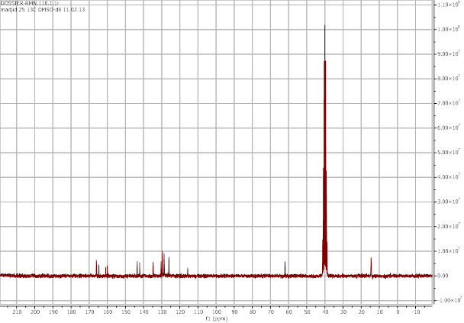
(a)
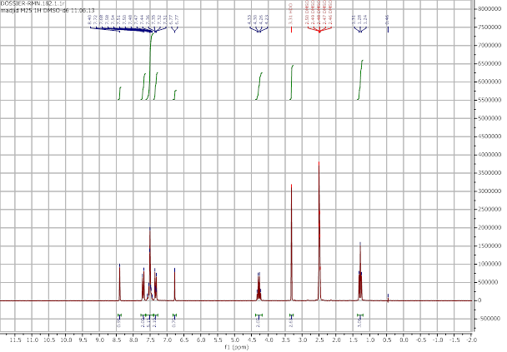
(b)
Figure S1. Experimental NMR spectra of EMBTh, (a) ¹³C NMR, (b) ¹H NMR.

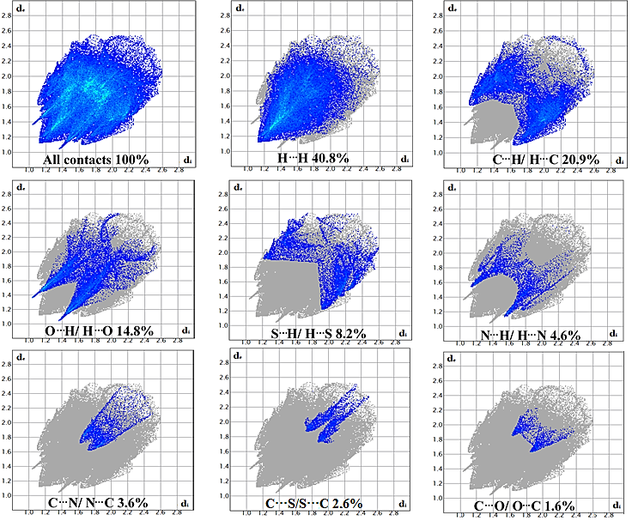
Figure S2. 2D fingerprint plots of the EMBTh showing the individual contribution of each interaction to the total Hirshfeld surface.
Figure S3. Computed MEP distribution for the title compound.

Figure S4. A pose of EMBTh in the active site.

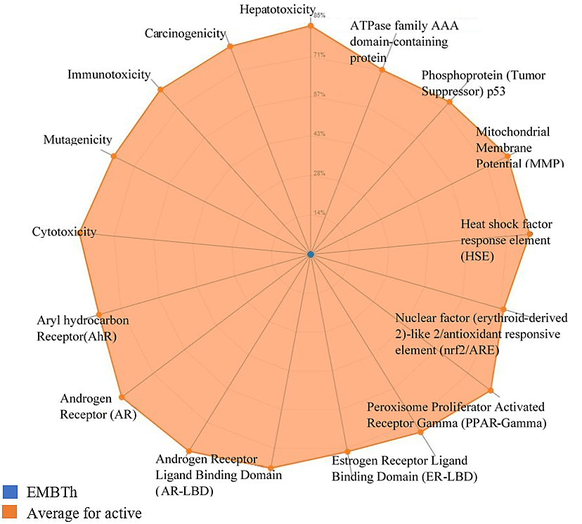
Figure S5. Toxicity radar plot for EMBTh.

