Manganese, cobalt, nickel and zinc complexes with pyrazine-2-carboxylic acid

Saša Petriček
Faculty of Chemistry and Chemical Technology, University of Ljubljana, Večna pot 113, 1000 Ljubljana,
Slovenia.
Correspondence: sasa.petricek@fkkt.uni-lj.si

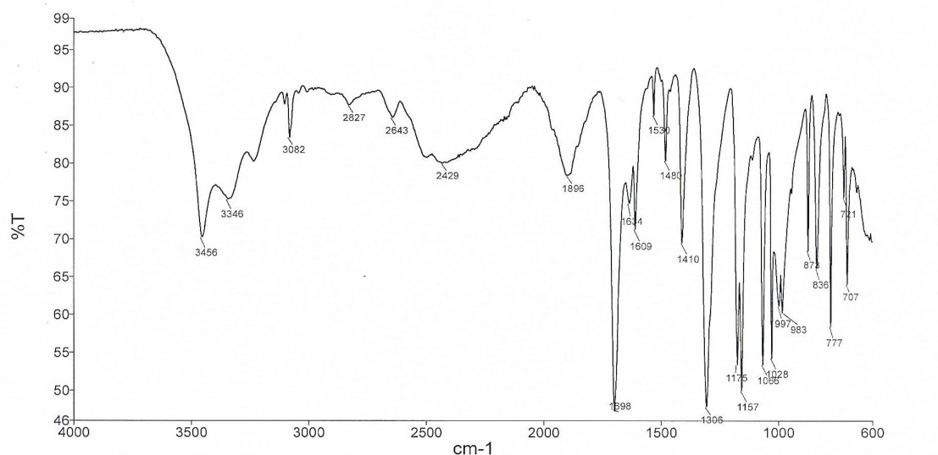
Figure S1. IR spectrum of 1, [ZnCl₂(pyzaH)₂]·2H₂O.

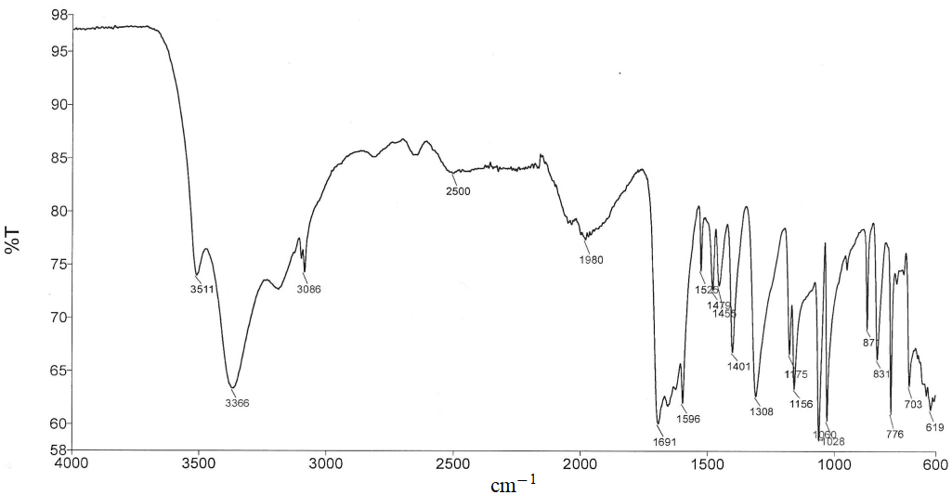
Figure S2. IR spectrum of 3, [CoCl₂(pyzaH)₂]_{n}·2nH₂O.

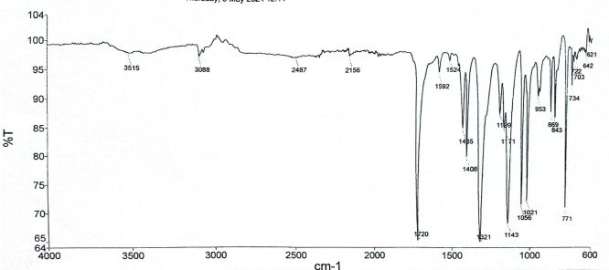
Figure S3. IR spectrum of 2a, [MnCl₂(pyzaH)₂].

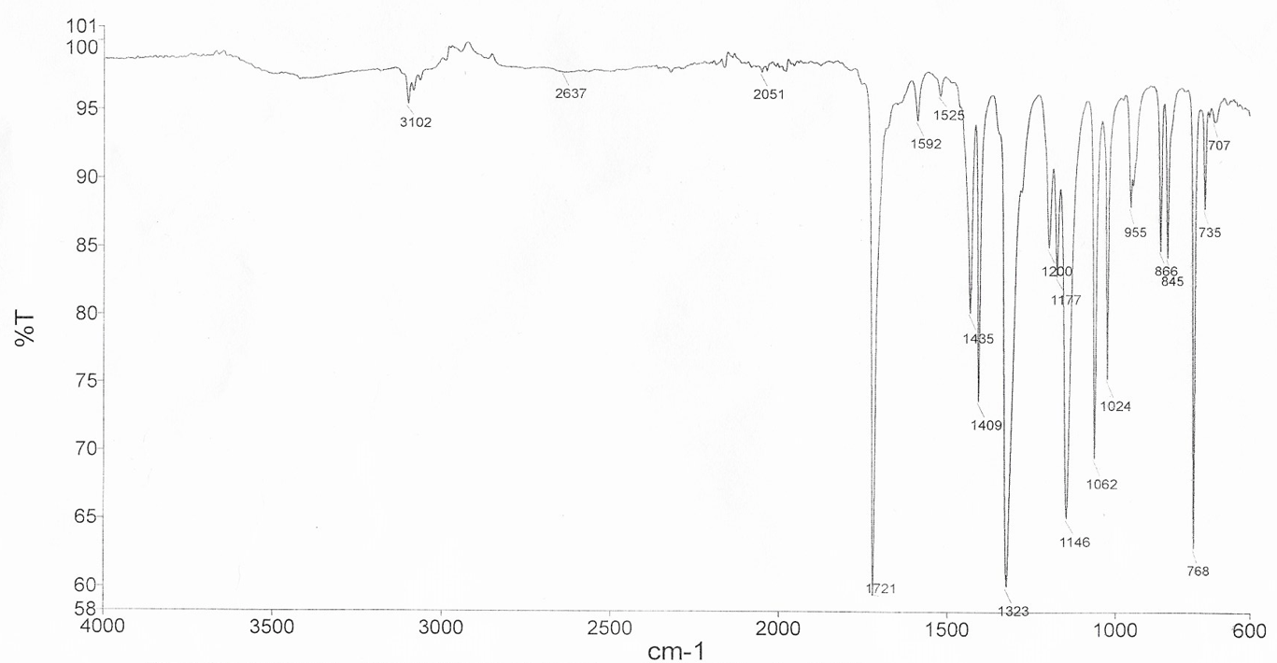

Figure S4. IR spectrum of 4, [NiCl₂(pyzaH)₂].

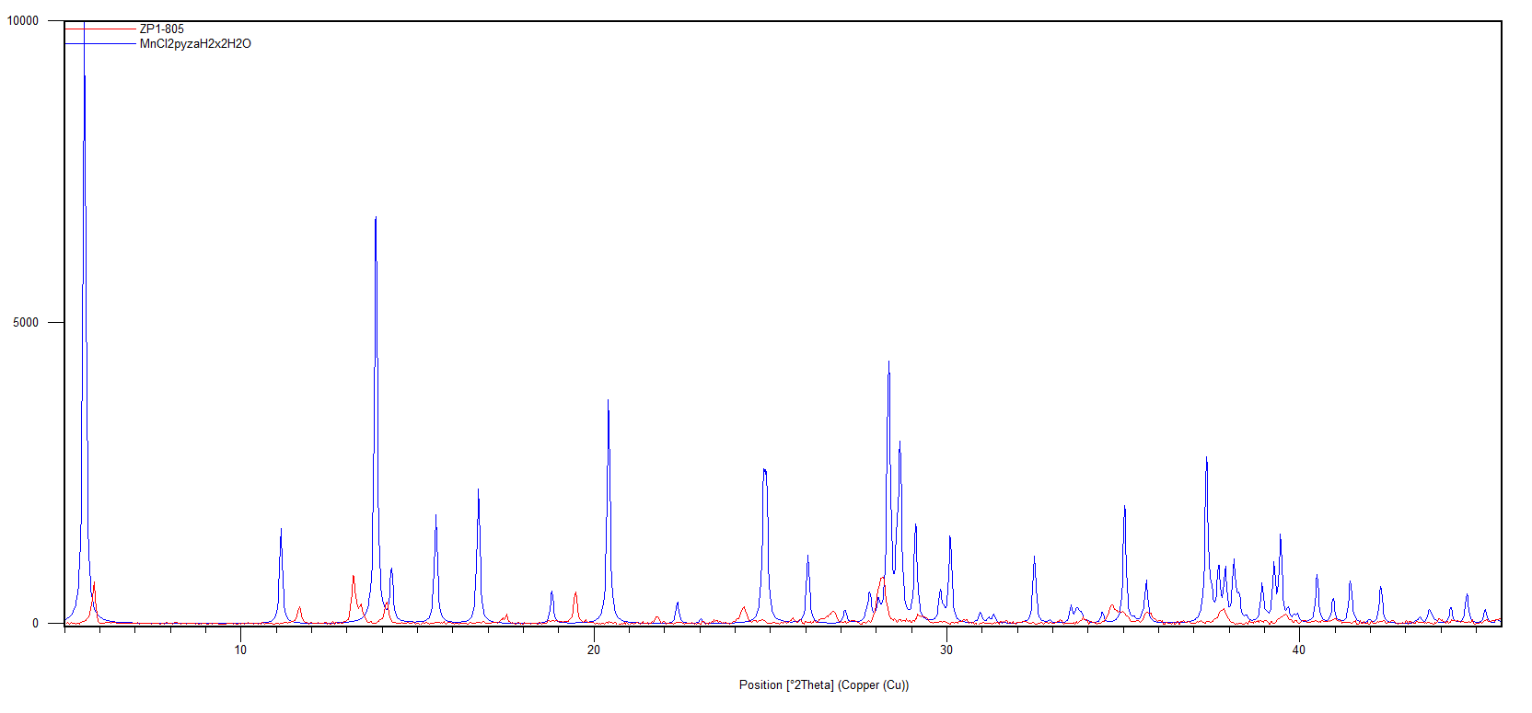
Figure S5. A comparison of the calculated X-ray diffraction powder pattern of 2 (blue) and that measured for 2a (red).
Counts

