Structures and properties of phenylethanoid glycosides from Barleria prionitis Linn.: Insights from theoretical and experimental investigations

Onesy Keomanykham,^{1,2} Hue Van Nguyen,³ Le Thi Phuong Hoa,⁴ Nguyen Xuan Ha,⁵ Bounnam Xangyaorn,² Hue Minh Thi Nguyen,^{3,6} Dang Ngoc Quang^{1,6}*

¹ Faculty of Chemistry, Hanoi National University of Education, 136-Xuan Thuy, Hanoi, Vietnam
² Luangnamtha Teacher Training College, Luang Namtha, Laos
³ Faculty of Chemistry and Center for Computational Science, Hanoi National University of Education, 136-Xuan Thuy, Hanoi, Vietnam
⁴ Faculty of Biology, Hanoi National University of Education, 136-Xuan Thuy, Hanoi, Vietnam
⁵ Institute of Natural Products Chemistry, Vietnam Academy of Science and Technology, 18 Hoang Quoc Viet, Cau Giay, Hanoi, Vietnam
⁶Institute of Natural Sciences, Hanoi National University of Education, 136-Xuan Thuy, Hanoi, Vietnam

Figure S1. The re-docking of Keap1 complex
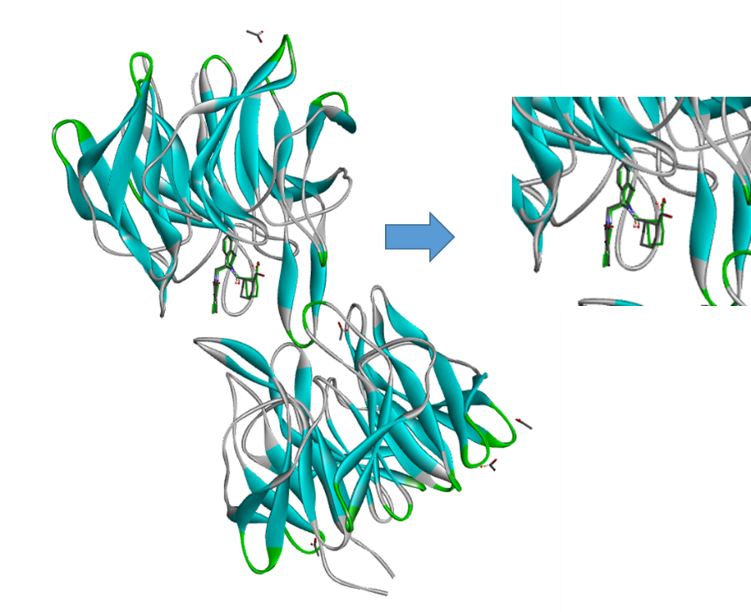

Figure S2. Superimposition of docked poses of 1-6 and co-crystallized ligand (1VV) against the Keap1 protein (PDB ID: 4L7B).

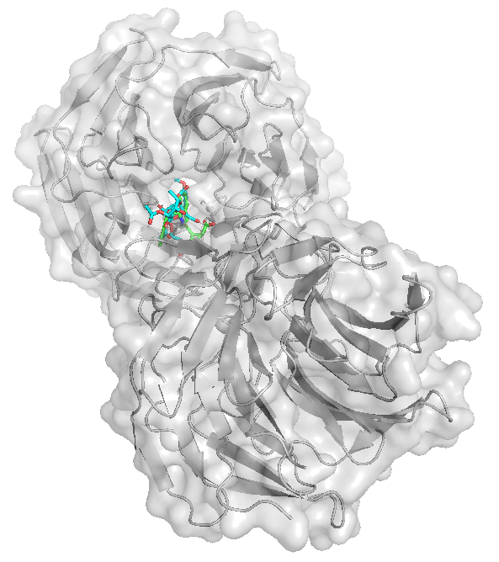 | 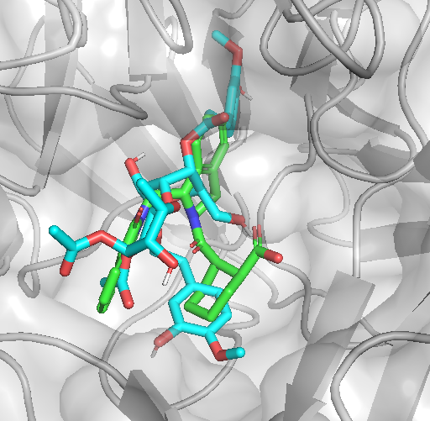
1
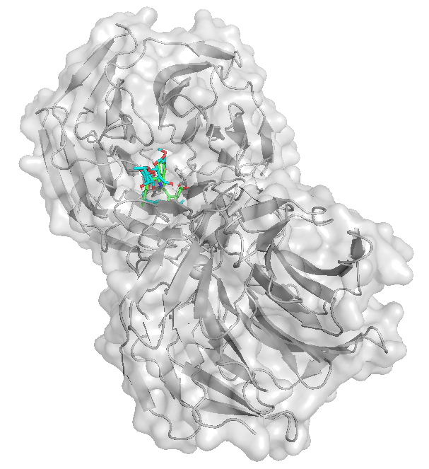 | 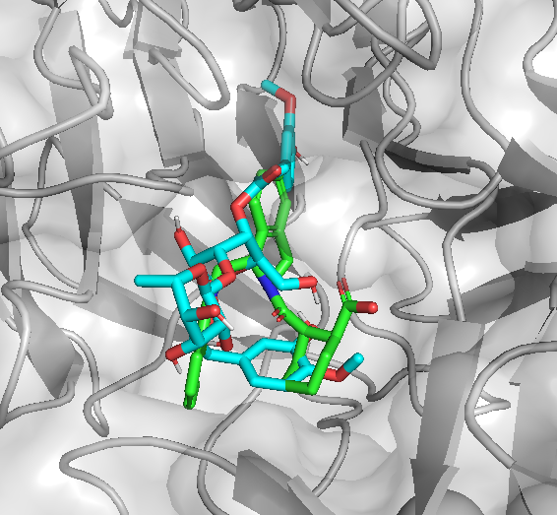
2
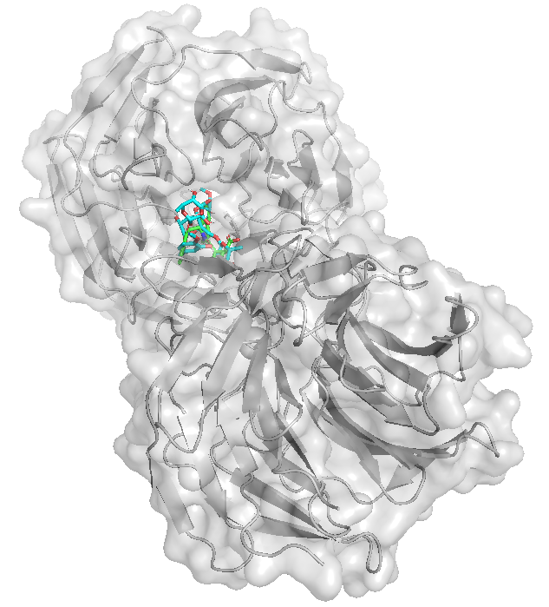 | 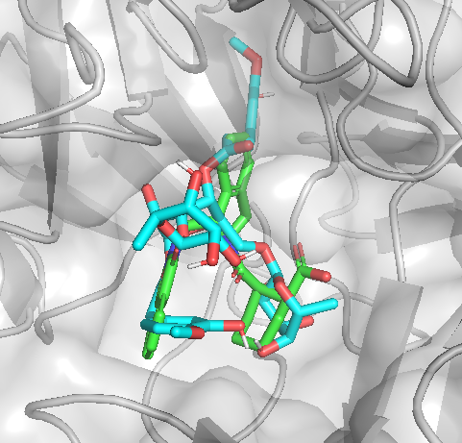
3
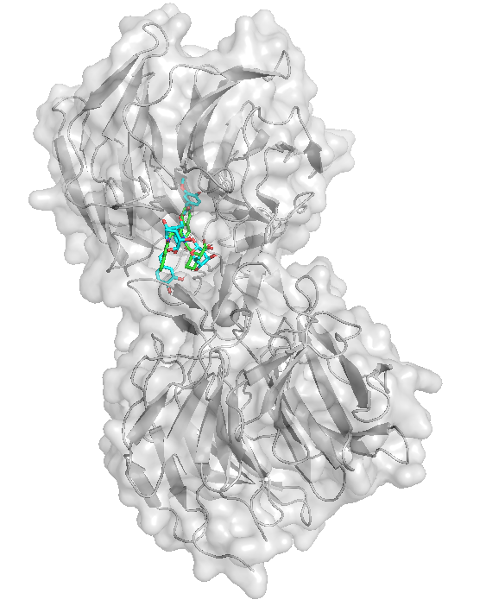 | 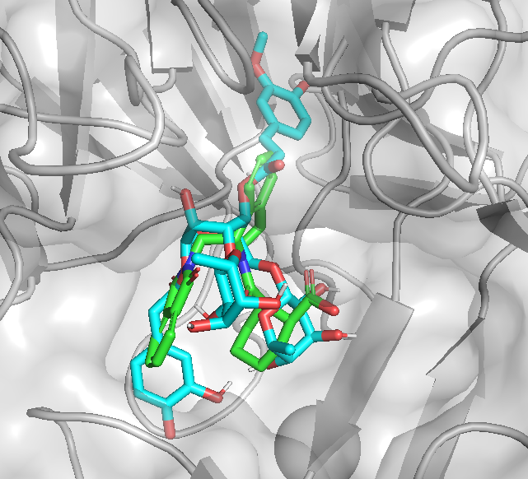
4
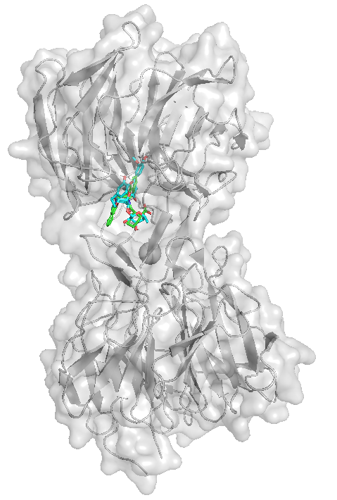 | 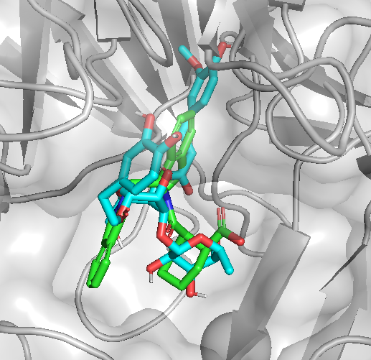
5
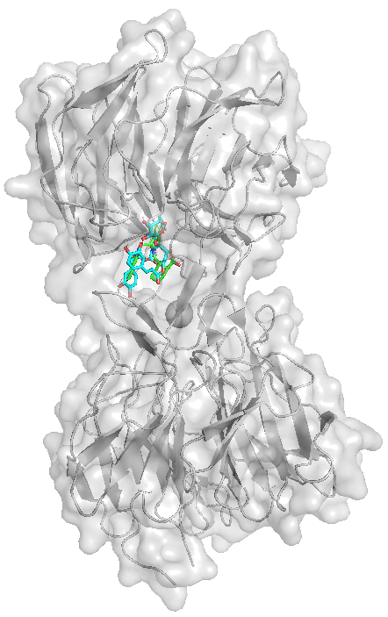 | 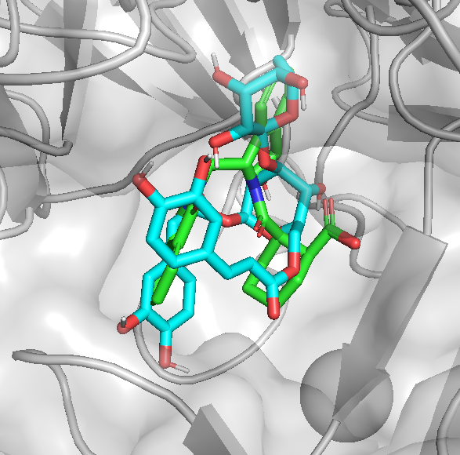
6

Table S1. Toxicity prediction of the compounds 1-6
ID | Predicted LD₅₀ (mg/kg) | Predicted Toxicity class | Average similarity  (%) | Prediction accuracy  (%)
1 | 5000 | 5 | 83.43 | 70.97
2 | 5000 | 5 | 83.43 | 70.97
3 | 5000 | 5 | 83.68 | 70.97
4 | 5000 | 5 | 100 | 100
5 | 5000 | 5 | 83.68 | 83.68
6 | 5000 | 5 | 83.43 | 70.97

Spectral data for 1-6
Acetylmartynoside A (1): ¹H NMR (600 MHz, MeOD): δ_{H} 7.70 (d, J = 16.2 Hz, H-7’’’), 7.22 (d, J = 1.8 Hz, H-2’’’), 7.11 (dd, J = 2.1, 8.1 Hz, H-6’’’), 6.84 (d, J = 8.4 Hz, H-5’’’, H-5), 6.76 (d, J = 1.8 Hz, H-2), 6.71 (dd, J = 2.1, 8.1 Hz, H-6), 6.40 (d, J = 16.2 Hz, H-8’’’), 5.37 (dd, J = 1.8, 3.0 Hz, H-2’’), 5.21 (d, J = 1.8 Hz, H-1’’), 5.00 (t, J = 9.0 Hz, H-4’), 4.98 (dd, J = 3.3, 9.9 Hz, H-3’’), 4.39 (d, J = 7.8 Hz, H-1’), 4.07 (m, H-8a), 3.91 (s, 3’’’-OMe), 3.86 (t, J = 9.3 Hz, H-3’), 3.83 (s, 4-OMe), 3.76 (m, H-8b, H-5’’), 3.65 (m, H-6a’), 3.58 (m, H-6b’, H-5’), 3.48 (dd, J = 7.8, 9.0 Hz, H-2’), 3.43 (t, J = 9.6 Hz, H-4’’), 2.48 (m, H-7), 2.08 (s, 2’’-COMe), 1.99 (s, 3’’-COMe), 1.16 (d, J = 6.6 Hz, H-6’’). ¹³C NMR (150 MHz, MeOD): δ_{C} 172.23 (3’’-CO), 171.64 (2’’-CO), 168.16 (C-9’’’), 150.84 (C-4’’’), 149.40 (C-3’’’), 148.02 (C-7’’’), 147.56 (C-3), 147.40 (C-4), 132.97 (C-1), 127.68 (C-1’’’), 124.34 (C-6’’’), 121.18 (C-6), 117.09 (C-2), 116.52 (C-5’’’), 115.02 (C-8’’’), 112.94 (C-5), 111.89 (C-2’’’), 104.21 (C-1’), 100.33 (C-1’’), 81.99 (C-3’), 76.03 (C-5’), 75.94 (C-2’), 73.20 (C-3’’), 72.10 (C-8), 71.39 (C-2’’), 71.16 (C-4’’), 70.56 (C-4’), 70.44 (C-5’’), 62.40 (C-6’), 56.52 (3’’’-OMe), 56.48 (4-OMe), 36.55 (C-7), 20.83 (3’’-COMe), 20.66 (2’’-COMe), 18.40 (C-6’’). ESI-MS: m/z 759.26 [M+Na]⁺.

Martynoside (2): ¹H NMR (600 MHz, MeOD): δ_{H} 7.68 (d, J = 16.2 Hz, H-7’’’), 7.22 (d, J = 2.4 Hz, H-2’’’), 7.10 (dd, J = 1.8, 7.8 Hz, H-6’’’), 6.84 (d, J = 8.4 Hz, H-5’’’, H-5), 6.76 (d, J = 1.8 Hz, H-2), 6.71 (dd, J = 2.1, 8.1 Hz, H-6), 6.39 (d, J = 16.2 Hz, H-8’’’), 5.22 (d, J = 1.8 Hz, H-1’’), 4.94 (t, J = 9.3 Hz, H-4’), 4.40 (d, J = 8.4 Hz, H-1’), 4.08 (m, H-8a), 3.94 (dd, J = 1.8, 3.3 Hz, H-2’’), 3.91 (s, 3’’’-OMe), 3.85 (t, J = 9.0 Hz, H-3’), 3.84 (s, 4-OMe), 3.77 (m, H-8b), 3.55-3.79 (m, H-5’, H-6’, H-3’’, H-4’’, H-5’’), 3.42 (dd, J = 8.4, 9.0 Hz, H-2’), 2.85 (m, H-7), 1.12 (d, J = 6.0 Hz, H-6’’). ¹³C NMR (150 MHz, MeOD): δ_{C}) 168.26 (C-9’’’), 150.81 (C-4’’’), 149.39 (C-3’’’), 147.88 (C-7’’’), 147.56 (C-3), 147.40 (C-4), 132.95 (C-1), 127.68 (C-1’’’), 124.33 (C-6’’’), 121.16 (C-6), 117.08 (C-5), 116.51 (C-5’’’), 115.15 (C-8’’’), 112.93 (C-2), 111.85 (C-2’’’), 104.23 (C-1’), 102.97 (C-1’’), 81.51 (C-3’), 76.20 (C-2’), 76.06 (C-5’), 73.79 (C-4’’), 72.35 (C-2’’), 72.12 (C-8), 72.09 (C-3’’), 70.67 (C-4’), 70.40 (C-5’’), 62.40 (C-6’), 56.53 (4-OMe), 56.48 (3’’’-OMe), 36.54 (C-7), 18.41 (C-6’’). ESI-MS: m/z 675.11 [M+Na]⁺.
3-O-methylpoliumoside (3): ¹H NMR (600 MHz, MeOD): δ_{H} 7.67 (d, J = 15.6 Hz, H-7’’’), 7.22 (d, J = 1.8 Hz, H-2’’’), 7.11 (dd, J = 1.8, 8.4 Hz, H-6’’’), 6.84 (d, J = 7.8 Hz, H-5’’’), 6.72 (s, overlap with H-5, H-2), 6.71 (d, J = 7.8 Hz, H-5), 6.59 (dd, J = 2.1, 8.1 Hz, H-6), 6.39 (d, J = 15.6 Hz, H-8’’’), 5.22 (dd, J = 1.8 Hz, H-1’’), 5.01 (t, J = 9.9 Hz, H-4’), 4.65 (d, J = 1.8 Hz, H-1’’’’), 4.40 (d, J = 7.8 Hz, H-1’), 4.00 (m, H-8a), 3.94 (dd, J = 1.8, 3.0 Hz, H-2’’/2’’’’), 3.91 (s, 3’’’-OMe), 3.86 (dd, J = 1.5, 3.3 Hz, H-2’’/2’’’’), 3.83 (t, J = 9.3 Hz, H-3’), 3.77 (m, H-6’a), 3.76 (m, H-8b), 3.50 (dd, J = 5.7, 11.1 Hz, H-6’b), 3.36-3.71 (m, H-5’, H-3’’, H-4’’, H-5’’, H-3’’’’, H-4’’’’, H-5’’’’), 2.82 (m, H-7), 1.22 (d, J = 6.0 Hz, H-6’’), 1.11 (d, J = 6.0 Hz, H-6’’’’). ¹³C NMR (150 MHz, MeOD): δ_{C} 167.96 (C-9’’’), 150.82 (C-4’’’), 149.40 (C-3’’’), 147.92 (C-7’’’), 146.12 (C-3), 144.69 (C-4), 131.45 (C-1), 127.69 (C-1’’’), 124.35 (C-6’’’), 121.29 (C-6), 117.12 (C-2), 116.52 (C-5’’’), 116.38 (C-5), 115.18 (C-8’’’), 111.88 (C-2’’’), 104.37 (C-1’), 102.99 (C-1’’), 102.29 (C-1’’’’), 81.50 (C-3’), 76.18 (C-2’), 74.72 (C-5’), 73.95 (C-4’’), 73.77 (C-4’’’’), 72.41 (C-2’’), 72.35 (C-2’’’’), 72.29 (C-8), 72.09 (C-3’’), 72.00 (C-3’’’’), 70.41 (C-4’), 69. 89 (C-5’’), 69.15 (C-5’’’’), 67.62 (C-6’), 56.49 (3’’’-OMe), 36.66 (C-7), 18.39 (C-6’’’’), 18.01 (C-6’’). ESI-MS: m/z 807.15 [M+Na]⁺.
Isoacteoside (4): ¹H NMR (600 MHz, MeOD): δ_{H} 7.58 (d, J = 16.2 Hz, H-7’’’), 7.06 (d, J = 2.4 Hz, H-2’’’), 6.92 (dd, J = 1.8, 7.8 Hz, H-6’’’), 6.79 (d, J = 7.8 Hz, H-5’’’), 6.69 (d, J = 2.4 Hz, H-2), 6.65 (d, J = 7.8 Hz, H-5), 6.56 (dd, J = 2.1, 8.1 Hz, H-6), 6.31 (d, J = 15.6 Hz, H-8’’’), 5.20 (d, J = 1.2 Hz, H-1’’), 4.52 (dd, J = 2.4, 12.0 Hz, H-6’a), 4.38 (dd, J = 5.7, 12.0 Hz, H-6’b), 4.35 (d, J = 8.4 Hz, H-1’), 4.02 (m, H-8a), 3.74 (m, H-8b), 3.40-3.97 (m, H-2’, H-3’, H-4’, H-5’, H-2’’, H-3’’, H-4’’, H-5’’), 2.80 (m, H-7), 1.27 (d, J = 6.6 Hz, H-6’’). ¹³C NMR (125 MHz, MeOD): δ_{C}) 169.13 (C-9’’’), 149.65 (C-4’’’), 147.25 (C-7’’’), 146.80 (C-3’’’), 146.14 (C-3), 144.67 (C-4), 131.39 (C-1), 127.69 (C-1’’’), 123.15 (C-6’’’), 121.26 (C-6), 117.07 (C-2), 116.54 (C-5’’’), 116.36 (C-5), 115.07 (C-2’’’), 114.84 (C-8’’’), 104.41 (C-1’), 102.72 (C-1’’), 83.95 (C-3’), 75.70 (C-2’), 75.43 (C-5’), 74.00 (C-4’’), 72.42 (C-8), 72.35 (C-2’’), 72.26 (C-3’’), 70.39 (C-4’), 70.04 (C-5’’), 64.62 (C-6’), 36.69 (C-7), 17.86 (C-6’’).
Leucosceptoside A (5): ¹H NMR (600 MHz, MeOD): δ_{H} 7.68 (d, J = 15.6 Hz, H-7’’’), 7.22 (d, J = 1.8 Hz, H-2’’’), 7.10 (dd, J = 1.8, 8.4 Hz, H-6’’’), 6.84 (d, J = 7.8 Hz, H-5’’’), 6.72 (d, J = 1.8 Hz, H-2), 6.70 (d, J = 7.8 Hz, H-5), 6.59 (dd, J = 2.4, 7.8 Hz, H-6), 6.39 (d, J = 16.2 Hz, H-8’’’), 5.22 (d, J = 1.8 Hz, H-1’’), 4.94 (t, J = 9.3 Hz, H-4’), 4.40 (d, J = 8.4 Hz, H-1’), 4.07 (m, H-8a), 3.94 (dd, J = 1.5, 3..3 Hz, H-2’’), 3.91 (s, 3’’’-OMe), 3.75 (m, H-8b), 3.55-3.86 (m, H-3’, H-4’, H-5’, H-3’’, H-4’’, H-5’’), 3.42 (dd, J = 8.1, 9..3 Hz, H-2’), 2.82 (m, H-7), 1.12 (d, J = 6.0 Hz, H-6’’). ¹³C NMR (125 MHz, MeOD): δ_{C}) 168.25 (C-9’’’), 150.83 (C-3’’’), 149.40 (C-4’’’), 147.88 (C-7’’’), 146.15 (C-4), 144.70 (C-3), 131.47 (C-1), 127.68 (C-1’’’), 124.36 (C-6’’’), 121.25 (C-6), 117.11 (C-5), 116.50 (C-2), 116.30 (C-5’’’), 115.14 (C-8’’’), 111.81 (C-2’’’), 104.24 (C-1’), 102.98 (C-1’’), 81.49 (C-3’), 76.23 (C-2’), 76.07 (C-5’), 73.79 (C-4’’), 72.36 (C-3’’), 72.27 (C-2’’), 72.08 (C-8), 70.65 (C-5’’), 70.41 (C-4’), 62.39 (C-6’), 56.45 (3’’’-OMe), 36.58 (C-7), 18.42 (C-6’’). ESI-MS: m/z 637.14 [M-H]⁻.
2-(3-hydroxy-4-methoxyphenyl)-ethyl-O-(α-l-rhamnosyl)-(1-3)-O-(α-l-rhamnos-yl)-(1-6)-4-O-E-feruloyl-β-d-glucopyranoside (6): ¹H NMR (600 MHz, MeOD): δ_{H} 7.69 (d, J = 16.2 Hz, H-7’’’), 7.22 (d, J = 2.4 Hz, H-2’’’), 7.11 (dd, J = 1.8, 8.4 Hz, H-6’’’), 6.86 (d, J = 8.4 Hz, H-5), 6.84 (d, J = 8.4 Hz, H-5’’’), 6.76 (d, J = 2.4 Hz, H-2), 6.72 (dd, J = 2.1, 8.1 Hz, H-6), 6.39 (d, J = 16.2 Hz, H-8’’’), 5.22 (dd, J = 1.8 Hz, H-1’’), 5.02 (d, J = 9.9 Hz, H-4’), 4.65 (d, J = 1.8 Hz, H-1’’’’), 4.40 (d, J = 8.4 Hz, H-1’), 4.02 (m, H-8a), 3.94 (dd, J = 1.5, 3.3 Hz, H-2’’/2’’’’), 3.91 (s, 4-OMe), 3.86 (dd, J = 1.5, 3.3 Hz, H-2’’/2’’’’), 3.84 (s, 3’’’-OMe), 3.79 (m, H-8b), 3.76 (m, H-6’a), 3.50 (m, H-6’b), 3.41 (dd, J = 8.1, 9.3 Hz, H-2’), 3.43 (t, J = 9.6 Hz, H-4’’/4’’’’), 2.85 (m, H-7), 1.22 (d, J = 6.0 Hz, H-6’’/6’’’’), 1.11 (d, J = 6.6 Hz, H-6’’/6’’’’). ¹³C NMR (150 MHz, MeOD): δ_{C} 167.96 (C-9’’’), 150.83 (C-4’’’), 149.41 (C-3’’’), 147.92 (C-7’’’), 147.59 (C-3), 147.40 (C-4), 132.90 (C-1), 127.69 (C-1’’’), 124.35 (C-6’’’), 121.18 (C-6), 117.07 (C-2), 116.52 (C-5’’’), 115.18 (C-8’’’), 112.99 (C-5), 111.88 (C-2’’’), 104.39 (C-1’), 103.01 (C-1’’), 102.31 (C-1’’’’), 81.51 (C-3’), 76.17 (C-2’), 74.73 (C-5’), 73.95 (C-4’’), 73.78 (C-4’’’’), 72.35 (C-2’’), 72.31 (C-2’’’’), 72.26 (C-8), 72.10 (C-3’’), 72.01 (C-3’’’’), 70.49 (C-4’), 70.42 (C-5’’), 69.90 (C-5’’’’), 67.63 (C-6’), 56.54 (3’’’-OMe), 56.49 (4-OMe), 36.64 (C-7), 18.40 (C-6’’), 18.01 (C-6’’’’). ESI-MS: m/z 807.15 [M+Na]⁺.

