Supporting Information

Synthesis, characterization and DFT study of Ti(IV) phthalocyanines
with quinoline groups

Seyda Aydogdu, Oznur Dulger Kutlu, Ali Erdogmus and Arzu Hatipoglu*
Department of Chemistry, Yildiz Technical University, 34220, Istanbul, Turkey

Contents

Figure S1. The FT-IR spectra of TiPc1, TiPc2 and TiPc3
Figure S2. The ¹H NMR spectra of phthalonitrile derivatives 1 (a) in DMSO-d₆, 2 (b) and 3 (c) in Chloroform-d
Figure S3. The ¹H NMR spectra of TiPc1 (a), TiPc2 (b) and TiPc3 (c) in Chloroform-d
Figure S4. The MALDI-TOF mass spectra of 1 (a), 2 (b), 3 (c), TiPc1 (d), TiPc2 (e) and TiPc3 (f)
Figure S5. UV spectrum of a) TiPc1 b) TiPc2 and c) TiPc3 for different phases
Figure S6. FMOs of complexes in DMSO and DMF
Figure S7. FMOs of complexes in THF and vacuum
Scheme S1. General structures of complexes
Table S1. Comparison of experimental and calculated selected ¹H NMR results for TiPc1, TiPc2 and TiPc3
Table S2. Frontier molecular orbital energies (eV) of TiPc0, TiPc1, TiPc2 and TiPc3
Table S3. Calculated geometrical parameters of TiPc0, TiPc1, TiPc2 and TiPc3
Table S4. Thermodynamic parameters of complexes
Table S5. Mulliken charges of TiPc1
Table S6. Mulliken charges of TiPc2
Table S7. Mulliken charges of TiPc3
Table S8. Fukui indices and local softness values of TiPc1
Table S9. Fukui indices and local softness values of TiPc2
Table S10. Fukui indices and local softness values of TiPc3

Figure S1. The FT-IR spectra of TiPc1, TiPc2 and TiPc3

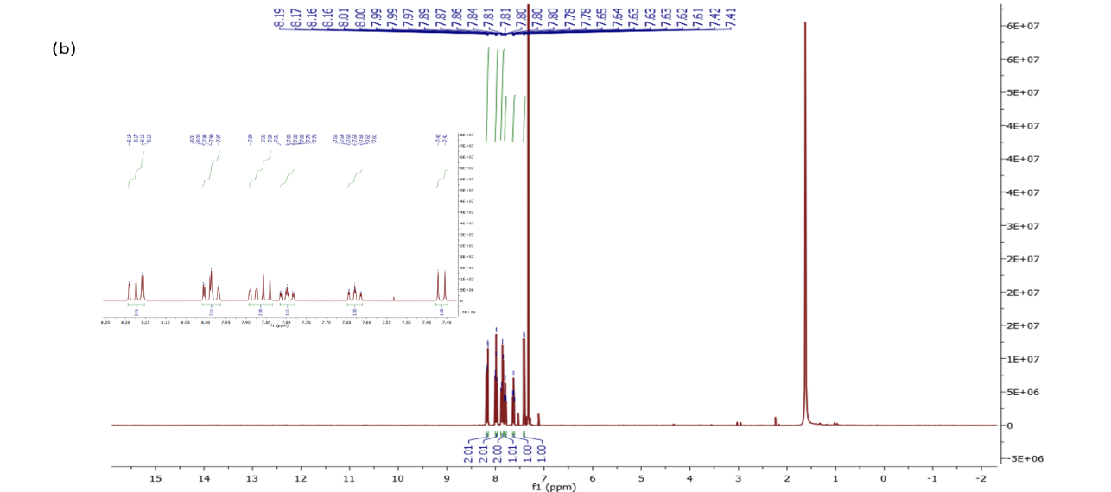

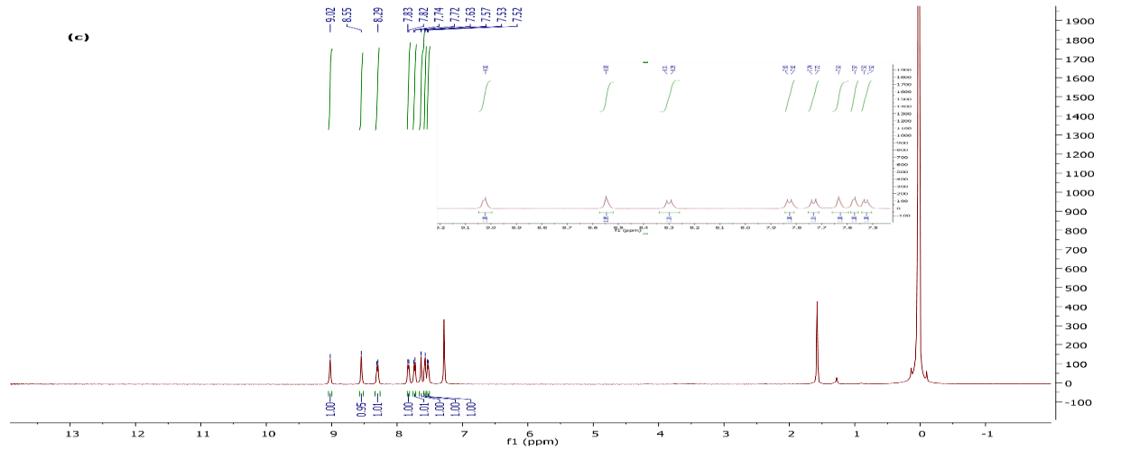
Figure S2. The ¹H NMR spectra of phthalonitrile derivatives 1 (a) in DMSO-d₆, 2 (b) and 3 (c) in Chloroform-d

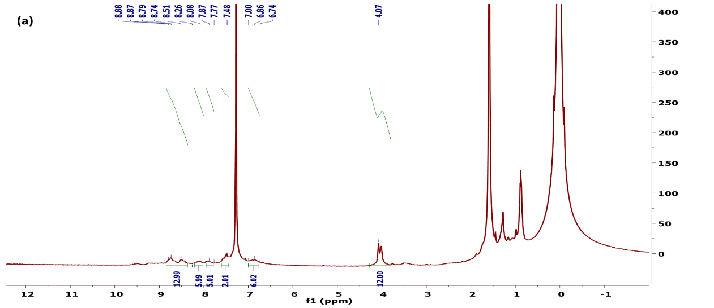

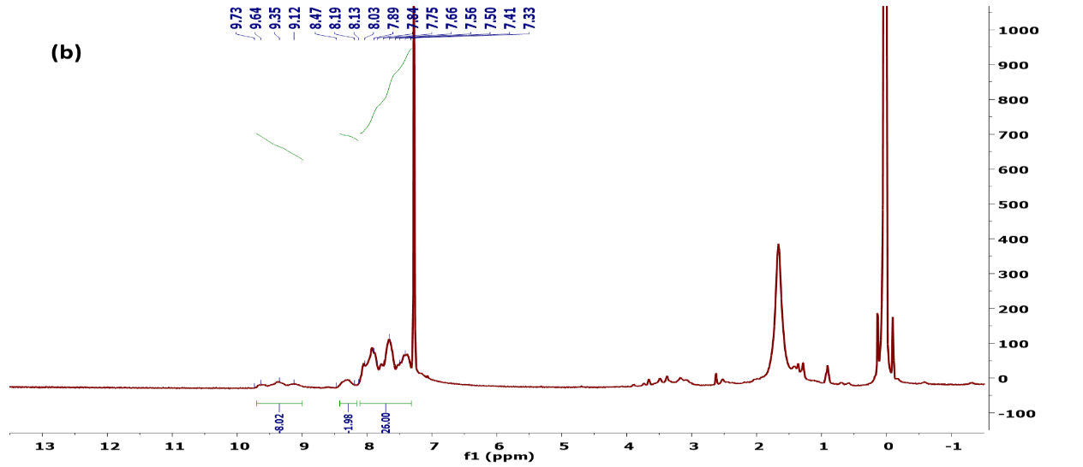

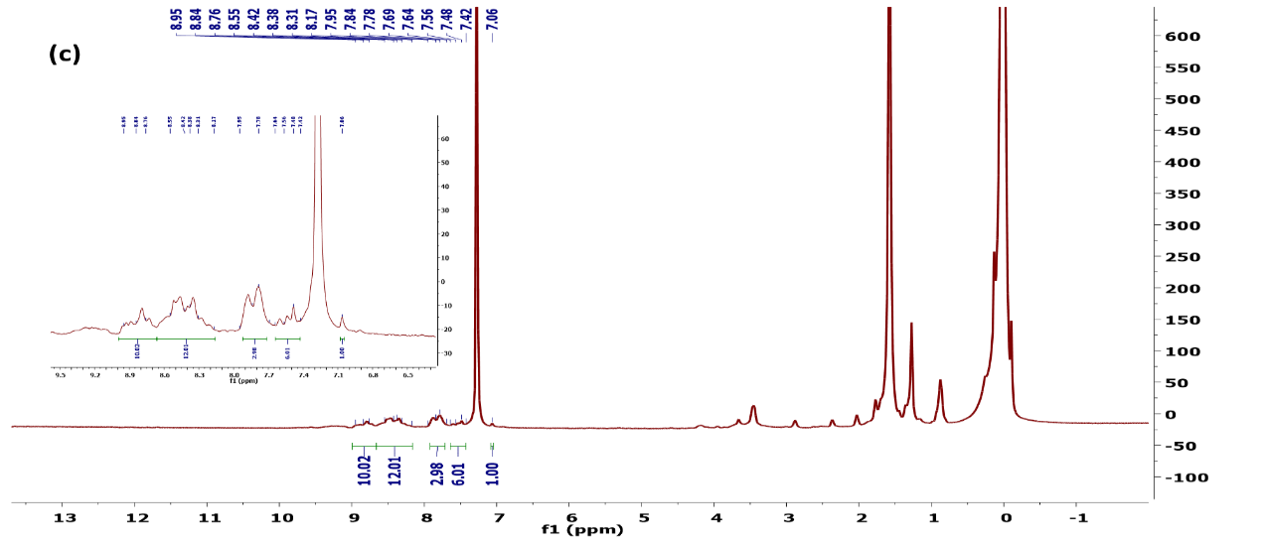
Figure S3. The ¹H NMR spectra of TiPc1 (a), TiPc2 (b) and TiPc3 (c) in Chloroform-d

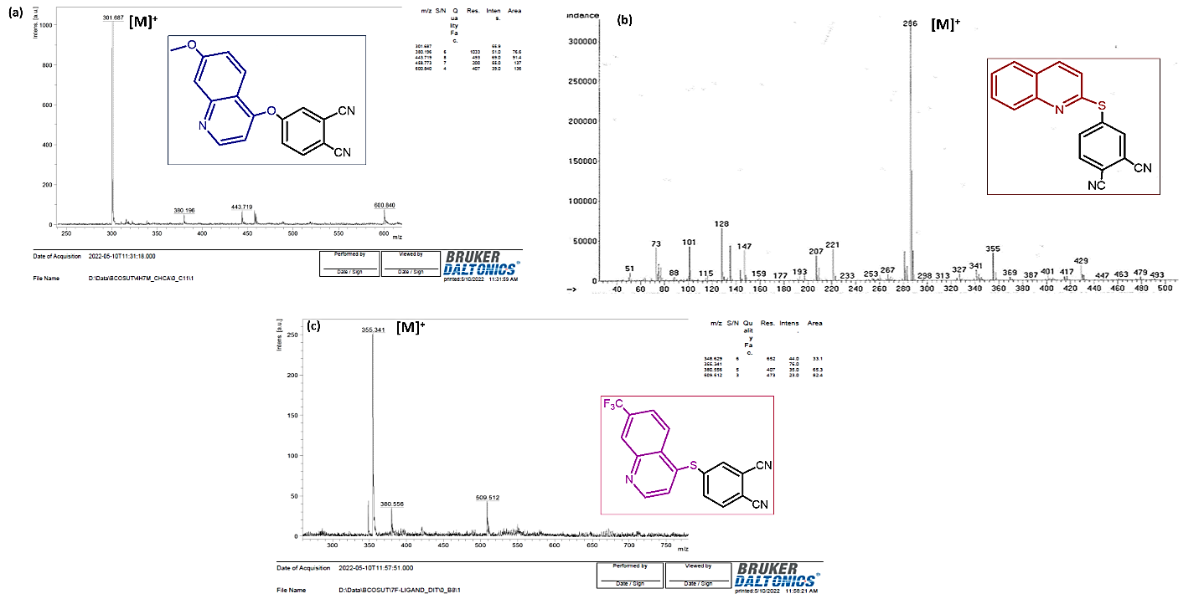

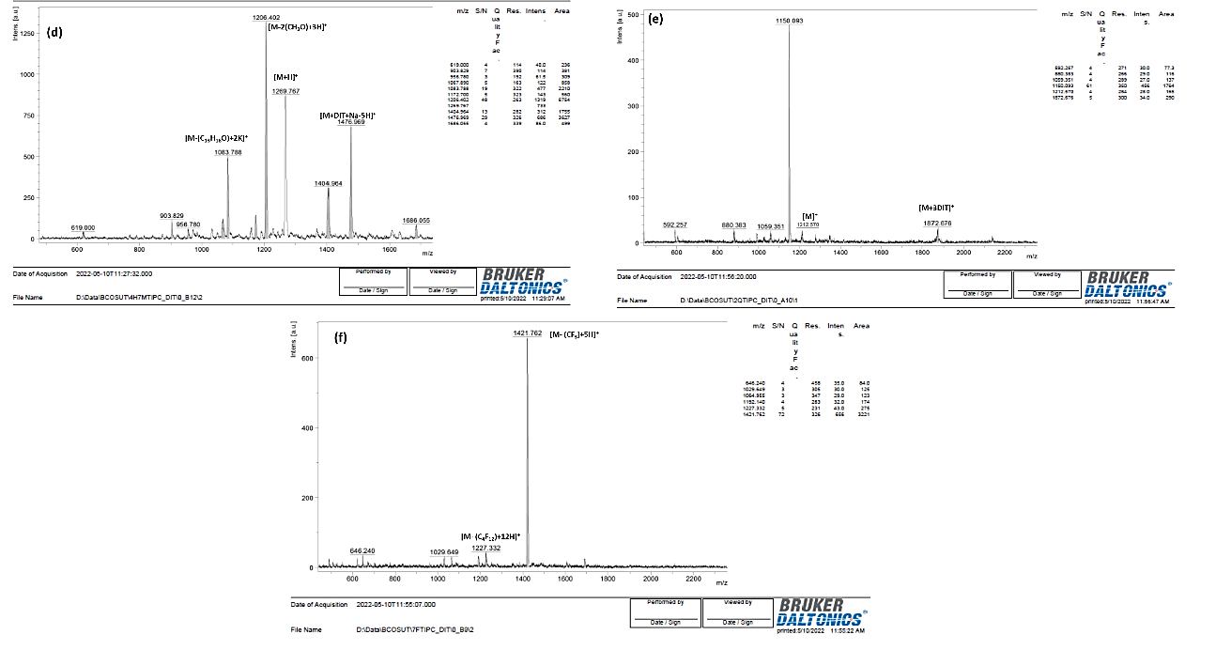
Figure S4. The MALDI-TOF mass spectra of 1 (a), 2 (b), 3 (c), TiPc1 (d), TiPc2 (e) and TiPc3 (f)

a) | b) | c)

Figure S5. UV spectrum of a) TiPc1 b) TiPc2 and c) TiPc3 for different phases
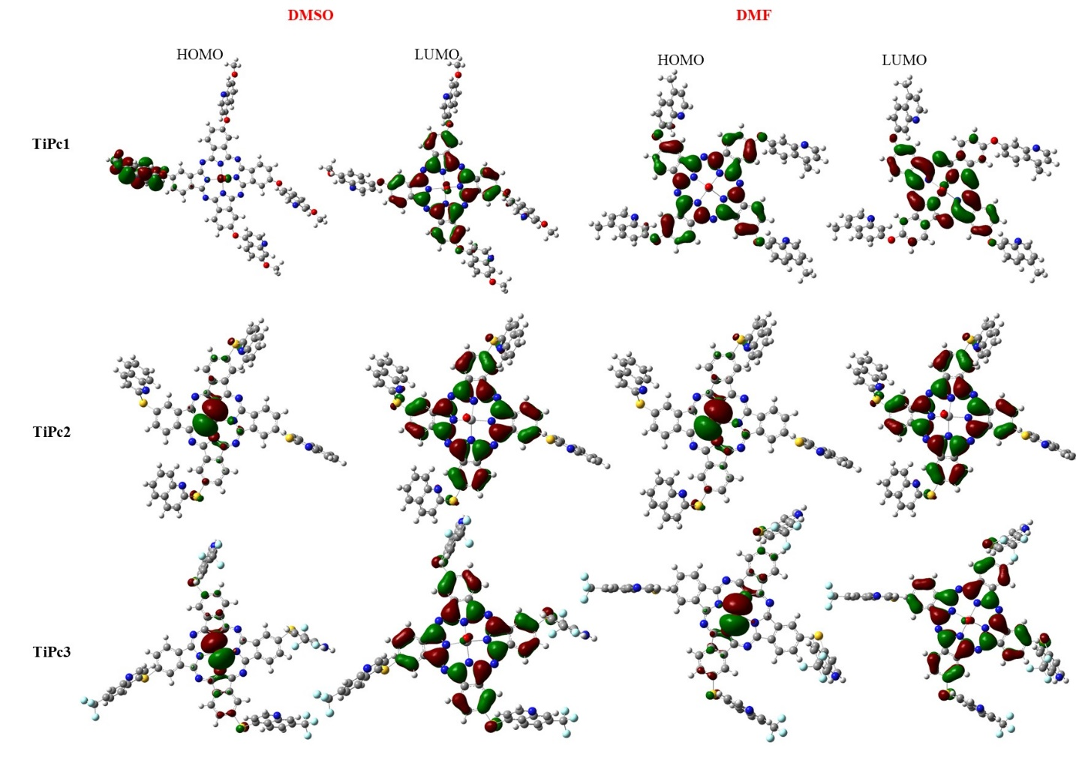
Figure S6. FMOs of complexes in DMSO and DMF

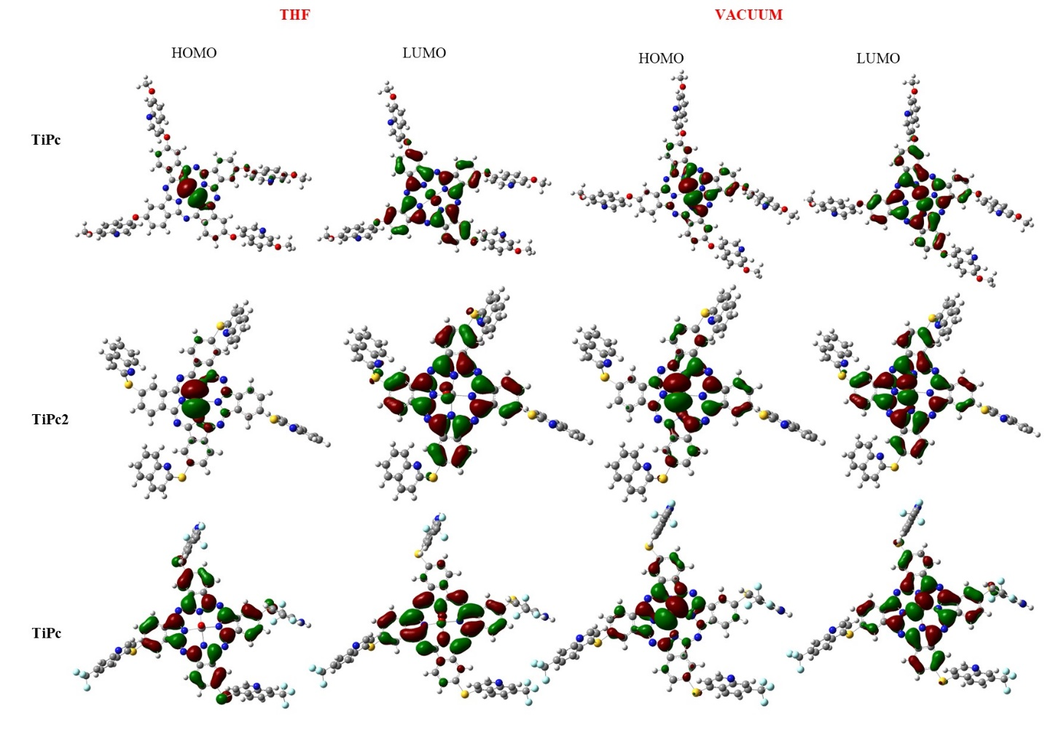
Figure S7. FMOs of complexes in THF and vacuum

Scheme S1. General structures of complexes

Table S1 Comparison of experimental and calculated selected ¹H NMR results for TiPc1, TiPc2 and TiPc3
 | TiPc1 |  | TiPc2 |  | TiPc3
 | Cal. | Exp. | Cal. | Exp. | Cal. | Exp.
Aromatic hydrogens | 8.47- 8.12 | 8.88-8.00 | 9.90- 9.16  7.18- 6.78 | 9.73-9.12  8.47-8.19 | 9.67- 8.74  8.44- 8.02 | 9.00-8.60 8.65-8.17
Pc hydrogens | 7.91- 7.56 | 8.00-6.74 | 8.11- 7.27 | 8.13-7.32 | 8.12- 6.68 | 7.95-7.06
Methyl hydrogens | 3.44- 3.12 | 3.90-4.20 | - | - | - | -

Table S2. Frontier molecular orbital energies (eV) of TiPc0, TiPc1, TiPc2 and TiPc3
 | DMSO |  | DMF |  | THF |  | CHCl₃ |  | Vacuum
 | E_{HOMO} | E_{LUMO} | E_{HOMO} | E_{LUMO} | E_{HOMO} | E_{LUMO} | E_{HOMO} | E_{LUMO} | E_{HOMO} | E_{LUMO}
TiPc0 | -5.31 | -3.26 | -5.31 | -3.26 | -5.28 | -3.22 | -5.26 | -3.20 | -5.13 | -3.04
TiPc1 | -6.07 | -5.39 | -6.07 | -5.38 | -6.01 | -5.32 | -5.95 | -5.13 | -5.68 | -4.77
TiPc2 | -6.18 | -5.40 | -6.16 | -5.39 | -5.95 | -5.30 | -5.87 | -5.28 | -5.48 | -4.86
TiPc3 | -6.21 | -5.42 | -6.20 | -5.42 | -6.06 | -5.38 | -6.09 | -5.40 | -5.96 | -5.32

Table S3. Calculated geometrical parameters of TiPc0, TiPc1, TiPc2 and TiPc3
 | r₁ (Ǻ) | r₂ (Ǻ) | a₁ (⁰) | a₂ (⁰)
TiPc0 | 2.08 | 3.47 | 85.79 | 85.79
TiPc1 | 2.07 | 3.47 | 85.76 | 85.90
TiPc2 | 2.08 | 3.47 | 85.80 | 85.81
TiPc3 | 2.08 | 3.47 | 85.85 | 85.80

Table S4. Thermodynamic parameters of complexes
 | TiPc0 | TiPc1 | TiPc2 | TiPc3
C_{v} (cal/molK) | 118.46 | 289.98 | 259.79 | 312.84
S (cal/mol/K) | 182.98 | 412.30 | 381.15 | 465.24
ΔH (Hartrees) | -1799.91 | -4160.76 | -3442.42 | -4790.57
ΔG (Hartrees) | -1800.00 | -4160.95 | -3442.60 | -4790.79

Table S5. Mulliken charges of TiPc1
 |  | Neutral | Cation | Anion |  |  | Neutral | Cation | Anion
1 | H | 0.2694 | 0.2807 | 0.2507 | 70 | H | 0.2139 | 0.2195 | 0.2104
2 | C | -0.3514 | -0.3404 | -0.3737 | 71 | H | 0.2344 | 0.2439 | 0.2275
3 | C | -0.3892 | -0.3751 | -0.4047 | 72 | H | 0.2136 | 0.2153 | 0.2133
4 | C | 0.4118 | 0.4171 | 0.4028 | 73 | O | -0.3638 | -0.3525 | -0.3700
5 | C | -0.5644 | -0.5445 | -0.5891 | 74 | H | 0.2500 | 0.2570 | 0.2441
6 | H | 0.2649 | 0.2726 | 0.2567 | 75 | C | -0.3350 | -0.3292 | -0.3402
7 | H | 0.2876 | 0.2951 | 0.2779 | 76 | H | 0.2630 | 0.2605 | 0.2686
8 | C | 0.2718 | 0.2745 | 0.2692 | 77 | C | -0.3436 | -0.3401 | -0.3439
9 | C | 0.2590 | 0.2622 | 0.2475 | 78 | C | -0.4547 | -0.4428 | -0.4619
10 | C | -0.0179 | -0.0003 | -0.0298 | 79 | C | 0.2329 | 0.2385 | 0.2267
11 | N | -0.4909 | -0.4959 | -0.4908 | 80 | C | 0.3523 | 0.3568 | 0.3485
12 | C | -0.0329 | -0.0133 | -0.0635 | 81 | C | -0.0063 | -0.0077 | -0.0041
13 | N | 0.0837 | 0.0909 | 0.0464 | 82 | C | 0.2820 | 0.2798 | 0.2872
14 | N | 0.0856 | 0.0916 | 0.0752 | 83 | H | 0.2680 | 0.2759 | 0.2613
15 | H | 0.2693 | 0.2817 | 0.2509 | 84 | C | -0.3090 | -0.3028 | -0.3097
16 | C | -0.3520 | -0.3402 | -0.3681 | 85 | H | 0.2531 | 0.2487 | 0.2634
17 | C | 0.4103 | 0.4168 | 0.3977 | 86 | C | -0.3600 | -0.3562 | -0.3625
18 | C | -0.3894 | -0.3748 | -0.4103 | 87 | H | 0.2358 | 0.2434 | 0.2296
19 | C | -0.5646 | -0.5441 | -0.5844 | 88 | N | -0.0477 | -0.0348 | -0.0595
20 | H | 0.2655 | 0.2723 | 0.2565 | 89 | O | -0.3056 | -0.2981 | -0.3098
21 | H | 0.2878 | 0.2954 | 0.2793 | 90 | C | -0.4795 | -0.4802 | -0.4793
22 | C | 0.2714 | 0.2741 | 0.2586 | 91 | H | 0.2353 | 0.2428 | 0.2288
23 | C | -0.0343 | -0.0146 | -0.0453 | 92 | H | 0.2140 | 0.2173 | 0.2116
24 | N | -0.4904 | -0.4956 | -0.4904 | 93 | H | 0.2135 | 0.2168 | 0.2110
25 | C | -0.0175 | 0.0016 | -0.0482 | 94 | O | -0.3621 | -0.3544 | -0.3661
26 | C | 0.2609 | 0.2636 | 0.2602 | 95 | H | 0.2497 | 0.2587 | 0.2430
27 | N | 0.0882 | 0.0945 | 0.0503 | 96 | C | -0.3350 | -0.3283 | -0.3403
28 | H | 0.2622 | 0.2750 | 0.2447 | 97 | H | 0.2617 | 0.2618 | 0.2658
29 | C | -0.3658 | -0.3526 | -0.3896 | 98 | C | -0.3438 | -0.3383 | -0.3444
30 | C | 0.3925 | 0.3977 | 0.3835 | 99 | C | -0.4538 | -0.4414 | -0.4599
31 | C | -0.3833 | -0.3686 | -0.3978 | 100 | C | 0.2301 | 0.2351 | 0.2248
32 | C | -0.5500 | -0.5331 | -0.5723 | 101 | C | 0.3528 | 0.3579 | 0.3492
33 | H | 0.2644 | 0.2727 | 0.2560 | 102 | C | -0.0077 | -0.0090 | -0.0053
34 | H | 0.2975 | 0.3038 | 0.2871 | 103 | C | 0.2904 | 0.2889 | 0.2967
35 | C | 0.2856 | 0.2885 | 0.2827 | 104 | H | 0.2682 | 0.2760 | 0.2622
36 | C | -0.0321 | -0.0123 | -0.0628 | 105 | C | -0.3081 | -0.3012 | -0.3074
37 | N | -0.4907 | -0.4952 | -0.4913 | 106 | H | 0.2528 | 0.2511 | 0.2623
38 | C | -0.0168 | 0.0008 | -0.0284 | 107 | C | -0.3596 | -0.3575 | -0.3601
39 | C | 0.2594 | 0.2626 | 0.2480 | 108 | H | 0.2377 | 0.2449 | 0.2329
40 | N | 0.0856 | 0.0892 | 0.0748 | 109 | N | -0.0443 | -0.0316 | -0.0548
41 | C | -0.0352 | -0.0153 | -0.0659 | 110 | O | -0.3057 | -0.2963 | -0.3104
42 | N | -0.4891 | -0.4934 | -0.4899 | 111 | C | -0.4796 | -0.4802 | -0.4795
43 | C | -0.0190 | 0.0002 | -0.0308 | 112 | H | 0.2136 | 0.2147 | 0.2134
44 | C | 0.2595 | 0.2623 | 0.2481 | 113 | H | 0.2350 | 0.2441 | 0.2280
45 | C | -0.5517 | -0.5342 | -0.5755 | 114 | H | 0.2139 | 0.2189 | 0.2104
46 | C | -0.3615 | -0.3480 | -0.3858 | 115 | O | -0.3611 | -0.3490 | -0.3682
47 | C | 0.3901 | 0.3945 | 0.3821 | 116 | H | 0.2354 | 0.2442 | 0.2299
48 | C | -0.3823 | -0.3669 | -0.3969 | 117 | C | -0.3347 | -0.3287 | -0.3387
49 | C | 0.2870 | 0.2899 | 0.2846 | 118 | H | 0.2605 | 0.2608 | 0.2660
50 | H | 0.2954 | 0.3019 | 0.2851 | 119 | C | -0.3664 | -0.3583 | -0.3673
51 | H | 0.2658 | 0.2742 | 0.2574 | 120 | C | -0.4461 | -0.4279 | -0.4540
52 | H | 0.2621 | 0.2749 | 0.2447 | 121 | C | 0.2362 | 0.2423 | 0.2303
53 | H | 0.2494 | 0.2590 | 0.2428 | 122 | C | 0.3573 | 0.3640 | 0.3539
54 | C | -0.3353 | -0.3284 | -0.3404 | 123 | C | 0.0019 | 0.0007 | 0.0046
55 | H | 0.2625 | 0.2634 | 0.2663 | 124 | C | 0.2829 | 0.2838 | 0.2883
56 | C | -0.3434 | -0.3372 | -0.3439 | 125 | H | 0.2795 | 0.2903 | 0.2726
57 | C | -0.4536 | -0.4390 | -0.4597 | 126 | C | -0.3137 | -0.3031 | -0.3135
58 | C | 0.2369 | 0.2419 | 0.2318 | 127 | H | 0.2517 | 0.2502 | 0.2624
59 | C | 0.3524 | 0.3579 | 0.3489 | 128 | C | -0.3584 | -0.3527 | -0.3606
60 | C | -0.0062 | -0.0078 | -0.0036 | 129 | H | 0.2352 | 0.2448 | 0.2293
61 | C | 0.2826 | 0.2822 | 0.2882 | 130 | N | -0.0364 | -0.0212 | -0.0482
62 | H | 0.2680 | 0.2769 | 0.2619 | 131 | O | -0.3028 | -0.2905 | -0.3081
63 | C | -0.3025 | -0.2942 | -0.3013 | 132 | C | -0.4807 | -0.4814 | -0.4806
64 | H | 0.2502 | 0.2488 | 0.2607 | 133 | H | 0.2387 | 0.2486 | 0.2315
65 | C | -0.3624 | -0.3593 | -0.3632 | 134 | H | 0.2085 | 0.2133 | 0.2073
66 | H | 0.2359 | 0.2445 | 0.2309 | 135 | H | 0.2082 | 0.2134 | 0.2067
67 | N | -0.0456 | -0.0315 | -0.0563 | 136 | O | -0.3633 | -0.3555 | -0.3672
68 | O | -0.3062 | -0.2957 | -0.3108 | 137 | Ti | 1.1713 | 1.1863 | 1.1458
69 | C | -0.4798 | -0.4806 | -0.4797 | 138 | O | -0.3912 | -0.3754 | -0.4197

Table S6. Mulliken charges of TiPc2
 |  | Neutral | Cation | Anion |  |  | Neutral | Cation | Anion
1 | H | 0.2495 | 0.2645 | 0.2342 | 62 | H | 0.2589 | 0.2633 | 0.2541
2 | C | -0.2197 | -0.2000 | -0.2428 | 63 | H | 0.2276 | 0.2311 | 0.2240
3 | C | -0.1462 | -0.1535 | -0.1358 | 64 | C | -0.0933 | -0.0914 | -0.0949
4 | C | -0.3939 | -0.3729 | -0.4082 | 65 | C | -0.0773 | -0.0797 | -0.0747
5 | C | -0.3391 | -0.3167 | -0.3585 | 66 | N | -0.0095 | -0.0057 | -0.0133
6 | H | 0.2650 | 0.2748 | 0.2581 | 67 | C | 0.4115 | 0.4143 | 0.4087
7 | H | 0.2881 | 0.2988 | 0.2796 | 68 | C | -0.3153 | -0.3106 | -0.3207
8 | C | 0.2225 | 0.2256 | 0.2201 | 69 | C | -0.3625 | -0.3576 | -0.3675
9 | C | -0.0374 | -0.0105 | -0.0646 | 70 | H | 0.2405 | 0.2428 | 0.2380
10 | N | -0.4911 | -0.4977 | -0.4943 | 71 | H | 0.2495 | 0.2346 | 0.2656
11 | C | -0.0197 | 0.0050 | -0.0292 | 72 | S | 0.2046 | 0.2467 | 0.1749
12 | C | 0.2646 | 0.2681 | 0.2543 | 73 | C | -0.3039 | -0.3059 | -0.3000
13 | N | 0.0888 | 0.0964 | 0.0526 | 74 | C | -0.3774 | -0.3700 | -0.3839
14 | N | 0.0911 | 0.0985 | 0.0798 | 75 | C | -0.2043 | -0.2003 | -0.2074
15 | C | -0.1540 | -0.1621 | -0.1457 | 76 | C | -0.2347 | -0.2293 | -0.2384
16 | C | -0.3438 | -0.3215 | -0.3620 | 77 | H | 0.2308 | 0.2351 | 0.2284
17 | C | -0.2121 | -0.1926 | -0.2338 | 78 | H | 0.2259 | 0.2355 | 0.2176
18 | C | -0.3928 | -0.3720 | -0.4144 | 79 | H | 0.2609 | 0.2526 | 0.2717
19 | H | 0.2857 | 0.2955 | 0.2766 | 80 | H | 0.2284 | 0.2374 | 0.2203
20 | H | 0.2505 | 0.2653 | 0.2338 | 81 | C | -0.0922 | -0.0840 | -0.0997
21 | H | 0.2653 | 0.2748 | 0.2555 | 82 | C | -0.1620 | -0.1564 | -0.1661
22 | C | 0.2648 | 0.2679 | 0.2624 | 83 | N | 0.0131 | 0.0001 | 0.0285
23 | C | 0.2254 | 0.2289 | 0.2122 | 84 | C | 0.3980 | 0.3992 | 0.3981
24 | C | -0.0361 | -0.0111 | -0.0501 | 85 | C | -0.2859 | -0.2754 | -0.2950
25 | N | -0.4920 | -0.4988 | -0.4888 | 86 | C | -0.2951 | -0.2924 | -0.2974
26 | C | -0.0203 | 0.0043 | -0.0528 | 87 | H | 0.2415 | 0.2514 | 0.2326
27 | N | 0.0890 | 0.0967 | 0.0784 | 88 | H | 0.2404 | 0.2459 | 0.2357
28 | C | -0.1601 | -0.1685 | -0.1481 | 89 | S | 0.2107 | 0.2505 | 0.1771
29 | C | -0.2075 | -0.1873 | -0.2322 | 90 | C | -0.3038 | -0.3060 | -0.3004
30 | C | -0.3462 | -0.3233 | -0.3675 | 91 | C | -0.3778 | -0.3706 | -0.3847
31 | C | -0.3936 | -0.3718 | -0.4081 | 92 | C | -0.2046 | -0.2009 | -0.2081
32 | H | 0.2510 | 0.2663 | 0.2353 | 93 | C | -0.2349 | -0.2298 | -0.2392
33 | H | 0.2851 | 0.2952 | 0.2767 | 94 | H | 0.2303 | 0.2343 | 0.2271
34 | H | 0.2643 | 0.2746 | 0.2569 | 95 | H | 0.2253 | 0.2345 | 0.2165
35 | C | 0.2658 | 0.2686 | 0.2546 | 96 | H | 0.2608 | 0.2528 | 0.2711
36 | C | -0.0222 | 0.0039 | -0.0319 | 97 | H | 0.2281 | 0.2368 | 0.2197
37 | N | -0.4915 | -0.4983 | -0.4949 | 98 | C | -0.0922 | -0.0846 | -0.0997
38 | C | -0.0352 | -0.0099 | -0.0639 | 99 | C | -0.1607 | -0.1554 | -0.1652
39 | C | 0.2255 | 0.2293 | 0.2234 | 100 | N | 0.0204 | 0.0073 | 0.0366
40 | N | 0.0895 | 0.0981 | 0.0523 | 101 | C | 0.3986 | 0.3996 | 0.3984
41 | C | -0.2881 | -0.2966 | -0.2796 | 102 | C | -0.2860 | -0.2760 | -0.2959
42 | C | -0.3854 | -0.3605 | -0.4063 | 103 | C | -0.3040 | -0.3015 | -0.3071
43 | C | -0.1711 | -0.1493 | -0.1947 | 104 | H | 0.2412 | 0.2508 | 0.2319
44 | C | -0.3960 | -0.3762 | -0.4164 | 105 | H | 0.2401 | 0.2455 | 0.2353
45 | H | 0.2879 | 0.2967 | 0.2796 | 106 | S | 0.2130 | 0.2529 | 0.1830
46 | H | 0.2598 | 0.2748 | 0.2434 | 107 | C | -0.3033 | -0.3052 | -0.2995
47 | H | 0.2671 | 0.2754 | 0.2575 | 108 | C | -0.3777 | -0.3705 | -0.3842
48 | C | 0.2565 | 0.2599 | 0.2529 | 109 | C | -0.2044 | -0.2005 | -0.2077
49 | C | 0.2387 | 0.2431 | 0.2246 | 110 | C | -0.2350 | -0.2297 | -0.2388
50 | C | -0.0410 | -0.0153 | -0.0538 | 111 | H | 0.2301 | 0.2341 | 0.2276
51 | N | -0.4869 | -0.4944 | -0.4840 | 112 | H | 0.2252 | 0.2344 | 0.2169
52 | C | -0.0249 | 0.0017 | -0.0563 | 113 | H | 0.2606 | 0.2524 | 0.2713
53 | Ti | 1.1658 | 1.1843 | 1.1413 | 114 | H | 0.2279 | 0.2367 | 0.2198
54 | O | -0.3942 | -0.3749 | -0.4218 | 115 | C | -0.0923 | -0.0844 | -0.0998
55 | S | 0.3071 | 0.3305 | 0.2807 | 116 | C | -0.1607 | -0.1553 | -0.1647
56 | C | -0.3060 | -0.3014 | -0.3112 | 117 | N | 0.0224 | 0.0089 | 0.0385
57 | C | -0.3779 | -0.3744 | -0.3816 | 118 | C | 0.3986 | 0.3997 | 0.3986
58 | C | -0.2061 | -0.2012 | -0.2113 | 119 | C | -0.2859 | -0.2758 | -0.2950
59 | C | -0.2370 | -0.2314 | -0.2431 | 120 | C | -0.3057 | -0.3030 | -0.3081
60 | H | 0.2265 | 0.2351 | 0.2174 | 121 | H | 0.2410 | 0.2507 | 0.2322
61 | H | 0.2240 | 0.2320 | 0.2154 | 122 | H | 0.2401 | 0.2454 | 0.2355

Table S7. Mulliken charges of TiPc3
 |  | Neutral | Cation | Anion |  |  | Neutral | Cation | Anion
1 | C | -0.1788 | -0.1858 | -0.1699 | 63 | C | -0.0421 | -0.0442 | -0.0398
2 | C | -0.2359 | -0.2186 | -0.2584 | 64 | C | -0.3319 | -0.3332 | -0.3299
3 | C | -0.3319 | -0.3072 | -0.3531 | 65 | C | -0.3340 | -0.3309 | -0.3368
4 | C | -0.3904 | -0.3701 | -0.4044 | 66 | C | -0.4550 | -0.4467 | -0.4632
5 | H | 0.2502 | 0.2656 | 0.2341 | 67 | H | 0.2557 | 0.2448 | 0.2661
6 | H | 0.2827 | 0.2931 | 0.2741 | 68 | H | 0.2594 | 0.2616 | 0.2578
7 | H | 0.2674 | 0.2778 | 0.2596 | 69 | H | 0.2965 | 0.3035 | 0.2896
8 | C | 0.2625 | 0.2660 | 0.2509 | 70 | C | 0.3138 | 0.3179 | 0.3096
9 | C | -0.0155 | 0.0098 | -0.0257 | 71 | F | -0.1929 | -0.1886 | -0.1971
10 | N | -0.4907 | -0.4976 | -0.4932 | 72 | F | -0.1877 | -0.1827 | -0.1926
11 | C | -0.0295 | -0.0040 | -0.0583 | 73 | F | -0.1930 | -0.1927 | -0.1930
12 | C | 0.2324 | 0.2367 | 0.2295 | 74 | S | 0.2833 | 0.3196 | 0.2538
13 | N | 0.0853 | 0.0926 | 0.0755 | 75 | S | 0.2644 | 0.3122 | 0.2301
14 | N | 0.0883 | 0.0977 | 0.0511 | 76 | H | 0.2518 | 0.2594 | 0.2457
15 | C | -0.2575 | -0.2680 | -0.2472 | 77 | C | -0.3617 | -0.3609 | -0.3614
16 | C | -0.3854 | -0.3607 | -0.4055 | 78 | N | -0.0162 | -0.0058 | -0.0249
17 | C | -0.1756 | -0.1531 | -0.1990 | 79 | C | -0.1273 | -0.1253 | -0.1265
18 | C | -0.3923 | -0.3720 | -0.4124 | 80 | C | -0.2464 | -0.2529 | -0.2401
19 | H | 0.2889 | 0.2977 | 0.2809 | 81 | H | 0.2580 | 0.2583 | 0.2591
20 | H | 0.2622 | 0.2777 | 0.2460 | 82 | C | 0.3560 | 0.3607 | 0.3533
21 | H | 0.2678 | 0.2768 | 0.2582 | 83 | C | 0.3606 | 0.3600 | 0.3617
22 | C | 0.2603 | 0.2637 | 0.2567 | 84 | C | -0.0463 | -0.0492 | -0.0428
23 | C | 0.2372 | 0.2422 | 0.2233 | 85 | C | -0.3639 | -0.3630 | -0.3634
24 | C | -0.0385 | -0.0131 | -0.0500 | 86 | C | -0.3246 | -0.3197 | -0.3289
25 | N | -0.4856 | -0.4932 | -0.4840 | 87 | C | -0.4516 | -0.4453 | -0.4565
26 | C | -0.0229 | 0.0050 | -0.0537 | 88 | H | 0.2620 | 0.2584 | 0.2643
27 | N | 0.0894 | 0.0972 | 0.0784 | 89 | H | 0.2581 | 0.2654 | 0.2517
28 | H | 0.2543 | 0.2692 | 0.2378 | 90 | H | 0.2970 | 0.3029 | 0.2918
29 | C | -0.1365 | -0.1224 | -0.1518 | 91 | C | 0.3136 | 0.3183 | 0.3093
30 | C | -0.4024 | -0.3827 | -0.4227 | 92 | F | -0.1961 | -0.1948 | -0.1967
31 | C | -0.1870 | -0.1897 | -0.1866 | 93 | F | -0.1928 | -0.1867 | -0.1984
32 | C | -0.4364 | -0.4099 | -0.4553 | 94 | F | -0.1873 | -0.1832 | -0.1909
33 | H | 0.2672 | 0.2756 | 0.2584 | 95 | S | 0.2544 | 0.2789 | 0.2272
34 | H | 0.2788 | 0.2880 | 0.2709 | 96 | H | 0.2459 | 0.2492 | 0.2425
35 | C | 0.2461 | 0.2491 | 0.2331 | 97 | C | -0.3830 | -0.3818 | -0.3843
36 | C | 0.2615 | 0.2650 | 0.2597 | 98 | N | -0.0290 | -0.0188 | -0.0396
37 | C | -0.0159 | 0.0086 | -0.0476 | 99 | C | -0.1165 | -0.1158 | -0.1173
38 | N | -0.4924 | -0.4993 | -0.4900 | 100 | C | -0.2180 | -0.2162 | -0.2200
39 | C | -0.0266 | -0.0010 | -0.0391 | 101 | H | 0.2470 | 0.2322 | 0.2628
40 | C | -0.1843 | -0.1870 | -0.1801 | 102 | C | 0.3658 | 0.3713 | 0.3598
41 | C | -0.1376 | -0.1229 | -0.1558 | 103 | C | 0.3663 | 0.3665 | 0.3661
42 | C | -0.4376 | -0.4100 | -0.4595 | 104 | C | -0.0177 | -0.0187 | -0.0164
43 | C | -0.4042 | -0.3836 | -0.4184 | 105 | C | -0.3269 | -0.3255 | -0.3283
44 | H | 0.2523 | 0.2682 | 0.2361 | 106 | C | -0.3357 | -0.3300 | -0.3418
45 | H | 0.2780 | 0.2878 | 0.2704 | 107 | C | -0.4609 | -0.4538 | -0.4685
46 | H | 0.2664 | 0.2757 | 0.2595 | 108 | H | 0.2436 | 0.2403 | 0.2471
47 | C | 0.2603 | 0.2640 | 0.2494 | 109 | H | 0.2562 | 0.2626 | 0.2495
48 | C | -0.0178 | 0.0075 | -0.0276 | 110 | H | 0.2948 | 0.3002 | 0.2891
49 | N | -0.4900 | -0.4969 | -0.4925 | 111 | C | 0.3115 | 0.3159 | 0.3067
50 | C | -0.0299 | -0.0020 | -0.0570 | 112 | F | -0.1954 | -0.1918 | -0.1991
51 | C | 0.2459 | 0.2486 | 0.2434 | 113 | F | -0.1952 | -0.1910 | -0.1995
52 | N | 0.0866 | 0.0946 | 0.0499 | 114 | F | -0.1885 | -0.1847 | -0.1924
53 | Ti | 1.1742 | 1.1930 | 1.1499 | 115 | S | 0.2818 | 0.3188 | 0.2557
54 | O | -0.3867 | -0.3670 | -0.4141 | 116 | H | 0.2495 | 0.2595 | 0.2403
55 | H | 0.2503 | 0.2601 | 0.2407 | 117 | C | -0.3552 | -0.3512 | -0.3589
56 | C | -0.3542 | -0.3504 | -0.3580 | 118 | N | -0.0159 | -0.0043 | -0.0263
57 | N | -0.0153 | -0.0040 | -0.0264 | 119 | C | -0.1740 | -0.1648 | -0.1820
58 | C | -0.1740 | -0.1650 | -0.1831 | 120 | C | -0.2508 | -0.2538 | -0.2457
59 | C | -0.2502 | -0.2532 | -0.2449 | 121 | H | 0.2585 | 0.2609 | 0.2560
60 | H | 0.2584 | 0.2609 | 0.2557 | 122 | C | 0.3746 | 0.3761 | 0.3752
61 | C | 0.3747 | 0.3761 | 0.3744 | 123 | C | 0.3617 | 0.3607 | 0.3629
62 | C | 0.3624 | 0.3613 | 0.3638 | 124 | C | -0.0427 | -0.0446 | -0.0405

Table S8. Fukui indices and local softness values of TiPc1
 |  | Q_{N} | Q_{N+1} | Q_{N-1} | ϯ⁺ | ϯ⁻ | ϯ⁰ | S⁺ | S⁻ | S⁰
2 | C | 6.3514 | 6.3737 | 6.3404 | 0.0223 | 0.0110 | 0.0167 | 0.0245 | 0.0121 | 0.0183
3 | C | 6.3892 | 6.4047 | 6.3751 | 0.0155 | 0.0141 | 0.0148 | 0.0171 | 0.0155 | 0.0163
4 | C | 5.5882 | 5.5972 | 5.5829 | 0.0090 | 0.0053 | 0.0072 | 0.0099 | 0.0058 | 0.0079
5 | C | 6.5644 | 6.5891 | 6.5445 | 0.0247 | 0.0199 | 0.0223 | 0.0271 | 0.0219 | 0.0245
8 | C | 5.7282 | 5.7308 | 5.7255 | 0.0026 | 0.0026 | 0.0026 | 0.0029 | 0.0029 | 0.0029
9 | C | 5.7410 | 5.7525 | 5.7378 | 0.0116 | 0.0031 | 0.0073 | 0.0127 | 0.0034 | 0.0081
10 | C | 6.0179 | 6.0298 | 6.0003 | 0.0119 | 0.0176 | 0.0148 | 0.0131 | 0.0194 | 0.0163
11 | N | 7.4909 | 7.4908 | 7.4959 | -0.0001 | -0.0050 | -0.0025 | -0.0001 | -0.0055 | -0.0028
12 | C | 6.0329 | 6.0635 | 6.0133 | 0.0306 | 0.0196 | 0.0251 | 0.0337 | 0.0216 | 0.0276
13 | N | 6.9163 | 6.9536 | 6.9091 | 0.0373 | 0.0072 | 0.0222 | 0.0410 | 0.0079 | 0.0245
14 | N | 6.9144 | 6.9248 | 6.9084 | 0.0104 | 0.0060 | 0.0082 | 0.0114 | 0.0066 | 0.0090
16 | C | 6.3520 | 6.3681 | 6.3402 | 0.0161 | 0.0118 | 0.0140 | 0.0178 | 0.0130 | 0.0154
17 | C | 5.5897 | 5.6023 | 5.5832 | 0.0126 | 0.0065 | 0.0096 | 0.0139 | 0.0072 | 0.0105
18 | C | 6.3894 | 6.4103 | 6.3748 | 0.0208 | 0.0146 | 0.0177 | 0.0229 | 0.0161 | 0.0195
19 | C | 6.5646 | 6.5844 | 6.5441 | 0.0198 | 0.0205 | 0.0202 | 0.0218 | 0.0226 | 0.0222
22 | C | 5.7286 | 5.7415 | 5.7259 | 0.0128 | 0.0028 | 0.0078 | 0.0141 | 0.0031 | 0.0086
23 | C | 6.0343 | 6.0453 | 6.0146 | 0.0110 | 0.0197 | 0.0154 | 0.0121 | 0.0217 | 0.0169
24 | N | 7.4904 | 7.4904 | 7.4956 | 0.0000 | -0.0052 | -0.0026 | 0.0000 | -0.0057 | -0.0029
25 | C | 6.0175 | 6.0482 | 5.9984 | 0.0307 | 0.0190 | 0.0249 | 0.0338 | 0.0209 | 0.0274
26 | C | 5.7391 | 5.7398 | 5.7364 | 0.0007 | 0.0027 | 0.0017 | 0.0008 | 0.0030 | 0.0019
27 | N | 6.9118 | 6.9497 | 6.9055 | 0.0379 | 0.0063 | 0.0221 | 0.0416 | 0.0070 | 0.0243
29 | C | 6.3658 | 6.3896 | 6.3526 | 0.0238 | 0.0132 | 0.0185 | 0.0261 | 0.0146 | 0.0203
30 | C | 5.6075 | 5.6165 | 5.6023 | 0.0089 | 0.0053 | 0.0071 | 0.0098 | 0.0058 | 0.0078
31 | C | 6.3833 | 6.3978 | 6.3686 | 0.0144 | 0.0147 | 0.0146 | 0.0159 | 0.0162 | 0.0160
32 | C | 6.5500 | 6.5723 | 6.5331 | 0.0223 | 0.0169 | 0.0196 | 0.0245 | 0.0186 | 0.0215
35 | C | 5.7144 | 5.7173 | 5.7115 | 0.0028 | 0.0030 | 0.0029 | 0.0031 | 0.0032 | 0.0032
36 | C | 6.0321 | 6.0628 | 6.0123 | 0.0306 | 0.0198 | 0.0252 | 0.0337 | 0.0218 | 0.0277
37 | N | 7.4907 | 7.4913 | 7.4952 | 0.0005 | -0.0045 | -0.0020 | 0.0006 | -0.0050 | -0.0022
38 | C | 6.0168 | 6.0284 | 5.9992 | 0.0116 | 0.0176 | 0.0146 | 0.0128 | 0.0194 | 0.0161
39 | C | 5.7406 | 5.7520 | 5.7374 | 0.0114 | 0.0032 | 0.0073 | 0.0125 | 0.0035 | 0.0080
40 | N | 6.9144 | 6.9252 | 6.9108 | 0.0107 | 0.0036 | 0.0072 | 0.0118 | 0.0040 | 0.0079
41 | C | 6.0352 | 6.0659 | 6.0153 | 0.0307 | 0.0199 | 0.0253 | 0.0337 | 0.0219 | 0.0278
42 | N | 7.4891 | 7.4899 | 7.4934 | 0.0008 | -0.0043 | -0.0017 | 0.0009 | -0.0047 | -0.0019
43 | C | 6.0190 | 6.0308 | 5.9998 | 0.0118 | 0.0192 | 0.0155 | 0.0130 | 0.0211 | 0.0171
44 | C | 5.7405 | 5.7519 | 5.7377 | 0.0114 | 0.0028 | 0.0071 | 0.0126 | 0.0030 | 0.0078
45 | C | 6.5517 | 6.5755 | 6.5342 | 0.0239 | 0.0174 | 0.0206 | 0.0262 | 0.0192 | 0.0227
46 | C | 6.3615 | 6.3858 | 6.3480 | 0.0243 | 0.0135 | 0.0189 | 0.0267 | 0.0149 | 0.0208
47 | C | 5.6099 | 5.6179 | 5.6055 | 0.0080 | 0.0045 | 0.0062 | 0.0088 | 0.0049 | 0.0068
48 | C | 6.3823 | 6.3969 | 6.3669 | 0.0146 | 0.0154 | 0.0150 | 0.0161 | 0.0170 | 0.0165
49 | C | 5.7130 | 5.7154 | 5.7101 | 0.0024 | 0.0029 | 0.0027 | 0.0027 | 0.0032 | 0.0029
54 | C | 6.3353 | 6.3404 | 6.3284 | 0.0052 | 0.0069 | 0.0060 | 0.0057 | 0.0076 | 0.0066
56 | C | 6.3434 | 6.3439 | 6.3372 | 0.0004 | 0.0063 | 0.0034 | 0.0005 | 0.0069 | 0.0037
57 | C | 6.4536 | 6.4597 | 6.4390 | 0.0061 | 0.0145 | 0.0103 | 0.0067 | 0.0160 | 0.0113
58 | C | 5.7631 | 5.7682 | 5.7581 | 0.0051 | 0.0050 | 0.0051 | 0.0057 | 0.0055 | 0.0056
59 | C | 5.6476 | 5.6511 | 5.6421 | 0.0035 | 0.0055 | 0.0045 | 0.0039 | 0.0060 | 0.0050
60 | C | 6.0062 | 6.0036 | 6.0078 | -0.0026 | -0.0015 | -0.0021 | -0.0029 | -0.0017 | -0.0023
61 | C | 5.7174 | 5.7118 | 5.7179 | -0.0056 | -0.0004 | -0.0030 | -0.0061 | -0.0005 | -0.0033
63 | C | 6.3025 | 6.3013 | 6.2942 | -0.0012 | 0.0083 | 0.0036 | -0.0013 | 0.0091 | 0.0039
65 | C | 6.3624 | 6.3632 | 6.3593 | 0.0008 | 0.0031 | 0.0019 | 0.0008 | 0.0034 | 0.0021
67 | N | 7.0456 | 7.0563 | 7.0315 | 0.0107 | 0.0142 | 0.0124 | 0.0118 | 0.0156 | 0.0137
68 | O | 8.3062 | 8.3108 | 8.2957 | 0.0046 | 0.0105 | 0.0076 | 0.0050 | 0.0116 | 0.0083
69 | C | 6.4798 | 6.4797 | 6.4806 | -0.0001 | -0.0009 | -0.0005 | -0.0001 | -0.0009 | -0.0005
73 | O | 8.3638 | 8.3700 | 8.3525 | 0.0062 | 0.0113 | 0.0087 | 0.0068 | 0.0124 | 0.0096
75 | C | 6.3350 | 6.3402 | 6.3292 | 0.0052 | 0.0058 | 0.0055 | 0.0057 | 0.0064 | 0.0061
77 | C | 6.3436 | 6.3439 | 6.3401 | 0.0002 | 0.0035 | 0.0019 | 0.0003 | 0.0039 | 0.0021
78 | C | 6.4547 | 6.4619 | 6.4428 | 0.0071 | 0.0119 | 0.0095 | 0.0078 | 0.0131 | 0.0105
79 | C | 5.7671 | 5.7733 | 5.7615 | 0.0062 | 0.0056 | 0.0059 | 0.0068 | 0.0062 | 0.0065
80 | C | 5.6477 | 5.6515 | 5.6432 | 0.0038 | 0.0045 | 0.0042 | 0.0042 | 0.0050 | 0.0046
81 | C | 6.0063 | 6.0041 | 6.0077 | -0.0022 | -0.0014 | -0.0018 | -0.0024 | -0.0016 | -0.0020
82 | C | 5.7180 | 5.7128 | 5.7202 | -0.0052 | -0.0022 | -0.0037 | -0.0057 | -0.0024 | -0.0041
84 | C | 6.3090 | 6.3097 | 6.3028 | 0.0007 | 0.0062 | 0.0034 | 0.0007 | 0.0068 | 0.0038
86 | C | 6.3600 | 6.3625 | 6.3562 | 0.0025 | 0.0038 | 0.0031 | 0.0027 | 0.0042 | 0.0034
88 | N | 7.0477 | 7.0595 | 7.0348 | 0.0118 | 0.0128 | 0.0123 | 0.0130 | 0.0141 | 0.0136
89 | O | 8.3056 | 8.3098 | 8.2981 | 0.0042 | 0.0075 | 0.0058 | 0.0046 | 0.0082 | 0.0064
90 | C | 6.4795 | 6.4793 | 6.4802 | -0.0002 | -0.0007 | -0.0004 | -0.0002 | -0.0008 | -0.0005
94 | O | 8.3621 | 8.3661 | 8.3544 | 0.0040 | 0.0077 | 0.0059 | 0.0044 | 0.0085 | 0.0064
96 | C | 6.3350 | 6.3403 | 6.3283 | 0.0053 | 0.0067 | 0.0060 | 0.0059 | 0.0073 | 0.0066
98 | C | 6.3438 | 6.3444 | 6.3383 | 0.0005 | 0.0055 | 0.0030 | 0.0006 | 0.0060 | 0.0033
99 | C | 6.4538 | 6.4599 | 6.4414 | 0.0061 | 0.0124 | 0.0092 | 0.0067 | 0.0136 | 0.0101
100 | C | 5.7699 | 5.7752 | 5.7649 | 0.0053 | 0.0050 | 0.0051 | 0.0058 | 0.0054 | 0.0056
101 | C | 5.6472 | 5.6508 | 5.6421 | 0.0036 | 0.0051 | 0.0043 | 0.0040 | 0.0056 | 0.0048
102 | C | 6.0077 | 6.0053 | 6.0090 | -0.0024 | -0.0013 | -0.0019 | -0.0027 | -0.0014 | -0.0020
103 | C | 5.7096 | 5.7033 | 5.7111 | -0.0062 | -0.0015 | -0.0039 | -0.0069 | -0.0017 | -0.0043
105 | C | 6.3081 | 6.3074 | 6.3012 | -0.0007 | 0.0069 | 0.0031 | -0.0008 | 0.0076 | 0.0034
107 | C | 6.3596 | 6.3601 | 6.3575 | 0.0006 | 0.0021 | 0.0013 | 0.0006 | 0.0023 | 0.0014
109 | N | 7.0443 | 7.0548 | 7.0316 | 0.0105 | 0.0126 | 0.0116 | 0.0116 | 0.0139 | 0.0127
110 | O | 8.3057 | 8.3104 | 8.2963 | 0.0047 | 0.0094 | 0.0071 | 0.0052 | 0.0104 | 0.0078
111 | C | 6.4796 | 6.4795 | 6.4802 | -0.0001 | -0.0007 | -0.0004 | -0.0001 | -0.0007 | -0.0004
115 | O | 8.3611 | 8.3682 | 8.3490 | 0.0071 | 0.0121 | 0.0096 | 0.0078 | 0.0133 | 0.0105
117 | C | 6.3347 | 6.3387 | 6.3287 | 0.0040 | 0.0060 | 0.0050 | 0.0044 | 0.0066 | 0.0055
119 | C | 6.3664 | 6.3673 | 6.3583 | 0.0009 | 0.0080 | 0.0045 | 0.0010 | 0.0088 | 0.0049
120 | C | 6.4461 | 6.4540 | 6.4279 | 0.0080 | 0.0182 | 0.0131 | 0.0088 | 0.0200 | 0.0144
121 | C | 5.7638 | 5.7697 | 5.7577 | 0.0059 | 0.0061 | 0.0060 | 0.0065 | 0.0067 | 0.0066
122 | C | 5.6427 | 5.6461 | 5.6360 | 0.0034 | 0.0067 | 0.0051 | 0.0038 | 0.0074 | 0.0056
123 | C | 5.9981 | 5.9954 | 5.9993 | -0.0027 | -0.0012 | -0.0019 | -0.0030 | -0.0013 | -0.0021
124 | C | 5.7171 | 5.7117 | 5.7162 | -0.0053 | 0.0009 | -0.0022 | -0.0059 | 0.0010 | -0.0024
126 | C | 6.3137 | 6.3135 | 6.3031 | -0.0003 | 0.0106 | 0.0052 | -0.0003 | 0.0117 | 0.0057
128 | C | 6.3584 | 6.3606 | 6.3527 | 0.0022 | 0.0057 | 0.0039 | 0.0024 | 0.0062 | 0.0043
130 | N | 7.0364 | 7.0482 | 7.0212 | 0.0118 | 0.0152 | 0.0135 | 0.0129 | 0.0168 | 0.0148
131 | O | 8.3028 | 8.3081 | 8.2905 | 0.0052 | 0.0123 | 0.0088 | 0.0058 | 0.0135 | 0.0096
132 | C | 6.4807 | 6.4806 | 6.4814 | -0.0001 | -0.0007 | -0.0004 | -0.0001 | -0.0008 | -0.0004
136 | O | 8.3633 | 8.3672 | 8.3555 | 0.0039 | 0.0078 | 0.0059 | 0.0043 | 0.0086 | 0.0064
137 | Ti | 20.8287 | 20.8542 | 20.8137 | 0.0256 | 0.0149 | 0.0203 | 0.0281 | 0.0164 | 0.0223
138 | O | 8.3912 | 8.4197 | 8.3754 | 0.0285 | 0.0158 | 0.0221 | 0.0313 | 0.0174 | 0.0244

Table S9. Fukui indices and local softness values of TiPc2
 |  | Q_{N} | Q_{N+1} | Q_{N-1} | ϯ⁺ | ϯ⁻ | ϯ⁰ | S⁺ | S⁻ | S⁰
2 | C | 6.2197 | 6.2428 | 6.2000 | 0.0232 | 0.0196 | 0.0214 | 0.0371 | 0.0314 | 0.0342
3 | C | 6.1462 | 6.1358 | 6.1535 | -0.0104 | -0.0072 | -0.0088 | -0.0167 | -0.0116 | -0.0141
4 | C | 6.3939 | 6.4082 | 6.3729 | 0.0142 | 0.0211 | 0.0176 | 0.0227 | 0.0337 | 0.0282
5 | C | 6.3391 | 6.3585 | 6.3167 | 0.0194 | 0.0224 | 0.0209 | 0.0310 | 0.0358 | 0.0334
8 | C | 5.7775 | 5.7799 | 5.7744 | 0.0023 | 0.0031 | 0.0027 | 0.0037 | 0.0050 | 0.0044
9 | C | 6.0374 | 6.0646 | 6.0105 | 0.0272 | 0.0269 | 0.0271 | 0.0436 | 0.0430 | 0.0433
10 | N | 7.4911 | 7.4943 | 7.4977 | 0.0031 | -0.0065 | -0.0017 | 0.0050 | -0.0104 | -0.0027
11 | C | 6.0197 | 6.0292 | 5.9950 | 0.0095 | 0.0247 | 0.0171 | 0.0152 | 0.0395 | 0.0273
12 | C | 5.7354 | 5.7457 | 5.7319 | 0.0103 | 0.0035 | 0.0069 | 0.0165 | 0.0056 | 0.0110
13 | N | 6.9112 | 6.9474 | 6.9036 | 0.0362 | 0.0076 | 0.0219 | 0.0579 | 0.0122 | 0.0350
14 | N | 6.9089 | 6.9202 | 6.9015 | 0.0113 | 0.0075 | 0.0094 | 0.0180 | 0.0119 | 0.0150
15 | C | 6.1540 | 6.1457 | 6.1621 | -0.0084 | -0.0081 | -0.0082 | -0.0134 | -0.0129 | -0.0131
16 | C | 6.3438 | 6.3620 | 6.3215 | 0.0182 | 0.0223 | 0.0203 | 0.0292 | 0.0356 | 0.0324
17 | C | 6.2121 | 6.2338 | 6.1926 | 0.0217 | 0.0195 | 0.0206 | 0.0348 | 0.0312 | 0.0330
18 | C | 6.3928 | 6.4144 | 6.3720 | 0.0216 | 0.0208 | 0.0212 | 0.0346 | 0.0332 | 0.0339
22 | C | 5.7352 | 5.7376 | 5.7321 | 0.0023 | 0.0031 | 0.0027 | 0.0038 | 0.0050 | 0.0044
23 | C | 5.7746 | 5.7878 | 5.7711 | 0.0131 | 0.0035 | 0.0083 | 0.0210 | 0.0056 | 0.0133
24 | C | 6.0361 | 6.0501 | 6.0111 | 0.0139 | 0.0250 | 0.0195 | 0.0223 | 0.0400 | 0.0311
25 | N | 7.4920 | 7.4888 | 7.4988 | -0.0031 | -0.0068 | -0.0050 | -0.0050 | -0.0109 | -0.0080
26 | C | 6.0203 | 6.0528 | 5.9957 | 0.0325 | 0.0246 | 0.0285 | 0.0520 | 0.0393 | 0.0457
27 | N | 6.9110 | 6.9216 | 6.9033 | 0.0106 | 0.0077 | 0.0091 | 0.0169 | 0.0123 | 0.0146
28 | C | 6.1601 | 6.1481 | 6.1685 | -0.0121 | -0.0084 | -0.0102 | -0.0193 | -0.0134 | -0.0164
29 | C | 6.2075 | 6.2322 | 6.1873 | 0.0247 | 0.0201 | 0.0224 | 0.0395 | 0.0322 | 0.0359
30 | C | 6.3462 | 6.3675 | 6.3233 | 0.0213 | 0.0230 | 0.0221 | 0.0341 | 0.0367 | 0.0354
31 | C | 6.3936 | 6.4081 | 6.3718 | 0.0145 | 0.0218 | 0.0181 | 0.0232 | 0.0348 | 0.0290
35 | C | 5.7342 | 5.7454 | 5.7314 | 0.0112 | 0.0028 | 0.0070 | 0.0179 | 0.0045 | 0.0112
36 | C | 6.0222 | 6.0319 | 5.9961 | 0.0097 | 0.0261 | 0.0179 | 0.0155 | 0.0418 | 0.0286
37 | N | 7.4915 | 7.4949 | 7.4983 | 0.0034 | -0.0068 | -0.0017 | 0.0054 | -0.0110 | -0.0028
38 | C | 6.0352 | 6.0639 | 6.0099 | 0.0287 | 0.0253 | 0.0270 | 0.0459 | 0.0405 | 0.0432
39 | C | 5.7745 | 5.7766 | 5.7707 | 0.0021 | 0.0038 | 0.0030 | 0.0034 | 0.0061 | 0.0048
40 | N | 6.9105 | 6.9477 | 6.9019 | 0.0371 | 0.0087 | 0.0229 | 0.0594 | 0.0139 | 0.0366
41 | C | 6.2881 | 6.2796 | 6.2966 | -0.0086 | -0.0085 | -0.0085 | -0.0137 | -0.0136 | -0.0136
42 | C | 6.3854 | 6.4063 | 6.3605 | 0.0208 | 0.0250 | 0.0229 | 0.0333 | 0.0400 | 0.0366
43 | C | 6.1711 | 6.1947 | 6.1493 | 0.0237 | 0.0217 | 0.0227 | 0.0379 | 0.0348 | 0.0363
44 | C | 6.3960 | 6.4164 | 6.3762 | 0.0204 | 0.0198 | 0.0201 | 0.0327 | 0.0316 | 0.0322
48 | C | 5.7435 | 5.7471 | 5.7401 | 0.0037 | 0.0034 | 0.0035 | 0.0058 | 0.0055 | 0.0057
49 | C | 5.7613 | 5.7754 | 5.7569 | 0.0141 | 0.0043 | 0.0092 | 0.0226 | 0.0070 | 0.0148
50 | C | 6.0410 | 6.0538 | 6.0153 | 0.0127 | 0.0257 | 0.0192 | 0.0203 | 0.0411 | 0.0307
51 | N | 7.4869 | 7.4840 | 7.4944 | -0.0028 | -0.0075 | -0.0052 | -0.0045 | -0.0120 | -0.0083
52 | C | 6.0249 | 6.0563 | 5.9983 | 0.0314 | 0.0265 | 0.0290 | 0.0503 | 0.0425 | 0.0464
53 | Ti | 20.8342 | 20.8587 | 20.8156 | 0.0245 | 0.0185 | 0.0215 | 0.0392 | 0.0296 | 0.0344
54 | O | 8.3942 | 8.4218 | 8.3749 | 0.0276 | 0.0193 | 0.0234 | 0.0442 | 0.0308 | 0.0375
55 | S | 15.6929 | 15.7193 | 15.6695 | 0.0264 | 0.0234 | 0.0249 | 0.0423 | 0.0374 | 0.0399
56 | C | 6.3060 | 6.3112 | 6.3014 | 0.0052 | 0.0046 | 0.0049 | 0.0084 | 0.0074 | 0.0079
57 | C | 6.3779 | 6.3816 | 6.3744 | 0.0038 | 0.0035 | 0.0036 | 0.0060 | 0.0056 | 0.0058
58 | C | 6.2061 | 6.2113 | 6.2012 | 0.0052 | 0.0049 | 0.0051 | 0.0084 | 0.0079 | 0.0081
59 | C | 6.2370 | 6.2431 | 6.2314 | 0.0061 | 0.0056 | 0.0058 | 0.0098 | 0.0089 | 0.0094
64 | C | 6.0933 | 6.0949 | 6.0914 | 0.0016 | 0.0019 | 0.0018 | 0.0026 | 0.0030 | 0.0028
65 | C | 6.0773 | 6.0747 | 6.0797 | -0.0026 | -0.0024 | -0.0025 | -0.0042 | -0.0039 | -0.0040
66 | N | 7.0095 | 7.0133 | 7.0057 | 0.0038 | 0.0038 | 0.0038 | 0.0061 | 0.0061 | 0.0061
67 | C | 5.5885 | 5.5913 | 5.5857 | 0.0028 | 0.0028 | 0.0028 | 0.0045 | 0.0044 | 0.0045
68 | C | 6.3153 | 6.3207 | 6.3106 | 0.0054 | 0.0047 | 0.0051 | 0.0087 | 0.0075 | 0.0081
69 | C | 6.3625 | 6.3675 | 6.3576 | 0.0051 | 0.0049 | 0.0050 | 0.0081 | 0.0078 | 0.0079
72 | S | 15.7954 | 15.8251 | 15.7533 | 0.0297 | 0.0421 | 0.0359 | 0.0476 | 0.0673 | 0.0574
73 | C | 6.3039 | 6.3000 | 6.3059 | -0.0039 | -0.0020 | -0.0029 | -0.0062 | -0.0031 | -0.0047
74 | C | 6.3774 | 6.3839 | 6.3700 | 0.0065 | 0.0074 | 0.0070 | 0.0104 | 0.0119 | 0.0111
75 | C | 6.2043 | 6.2074 | 6.2003 | 0.0031 | 0.0040 | 0.0036 | 0.0050 | 0.0064 | 0.0057
76 | C | 6.2347 | 6.2384 | 6.2293 | 0.0037 | 0.0054 | 0.0046 | 0.0059 | 0.0087 | 0.0073
81 | C | 6.0922 | 6.0997 | 6.0840 | 0.0075 | 0.0082 | 0.0078 | 0.0120 | 0.0131 | 0.0126
82 | C | 6.1620 | 6.1661 | 6.1564 | 0.0040 | 0.0056 | 0.0048 | 0.0065 | 0.0090 | 0.0077
83 | N | 6.9869 | 6.9715 | 6.9999 | -0.0154 | -0.0131 | -0.0142 | -0.0246 | -0.0209 | -0.0228
84 | C | 5.6020 | 5.6019 | 5.6008 | 0.0000 | 0.0012 | 0.0006 | 0.0000 | 0.0019 | 0.0010
85 | C | 6.2859 | 6.2950 | 6.2754 | 0.0091 | 0.0105 | 0.0098 | 0.0145 | 0.0168 | 0.0157
86 | C | 6.2951 | 6.2974 | 6.2924 | 0.0023 | 0.0027 | 0.0025 | 0.0037 | 0.0043 | 0.0040
89 | S | 15.7893 | 15.8229 | 15.7495 | 0.0337 | 0.0397 | 0.0367 | 0.0539 | 0.0636 | 0.0587
90 | C | 6.3038 | 6.3004 | 6.3060 | -0.0034 | -0.0021 | -0.0028 | -0.0054 | -0.0034 | -0.0044
91 | C | 6.3778 | 6.3847 | 6.3706 | 0.0069 | 0.0072 | 0.0070 | 0.0110 | 0.0114 | 0.0112
92 | C | 6.2046 | 6.2081 | 6.2009 | 0.0035 | 0.0038 | 0.0036 | 0.0056 | 0.0060 | 0.0058
93 | C | 6.2349 | 6.2392 | 6.2298 | 0.0043 | 0.0051 | 0.0047 | 0.0069 | 0.0082 | 0.0075
98 | C | 6.0922 | 6.0997 | 6.0846 | 0.0075 | 0.0076 | 0.0076 | 0.0121 | 0.0121 | 0.0121
99 | C | 6.1607 | 6.1652 | 6.1554 | 0.0044 | 0.0053 | 0.0049 | 0.0071 | 0.0085 | 0.0078
100 | N | 6.9796 | 6.9634 | 6.9927 | -0.0162 | -0.0132 | -0.0147 | -0.0259 | -0.0211 | -0.0235
101 | C | 5.6014 | 5.6016 | 5.6004 | 0.0002 | 0.0009 | 0.0006 | 0.0004 | 0.0015 | 0.0010
102 | C | 6.2860 | 6.2959 | 6.2760 | 0.0099 | 0.0100 | 0.0099 | 0.0158 | 0.0160 | 0.0159
103 | C | 6.3040 | 6.3071 | 6.3015 | 0.0031 | 0.0025 | 0.0028 | 0.0050 | 0.0040 | 0.0045
106 | S | 15.7870 | 15.8170 | 15.7471 | 0.0301 | 0.0399 | 0.0350 | 0.0481 | 0.0638 | 0.0560
107 | C | 6.3033 | 6.2995 | 6.3052 | -0.0037 | -0.0019 | -0.0028 | -0.0060 | -0.0031 | -0.0045
108 | C | 6.3777 | 6.3842 | 6.3705 | 0.0065 | 0.0072 | 0.0069 | 0.0104 | 0.0116 | 0.0110
109 | C | 6.2044 | 6.2077 | 6.2005 | 0.0033 | 0.0039 | 0.0036 | 0.0052 | 0.0062 | 0.0057
110 | C | 6.2350 | 6.2388 | 6.2297 | 0.0038 | 0.0052 | 0.0045 | 0.0061 | 0.0084 | 0.0073
115 | C | 6.0923 | 6.0998 | 6.0844 | 0.0075 | 0.0079 | 0.0077 | 0.0119 | 0.0126 | 0.0123
116 | C | 6.1607 | 6.1647 | 6.1553 | 0.0040 | 0.0054 | 0.0047 | 0.0064 | 0.0086 | 0.0075
117 | N | 6.9776 | 6.9615 | 6.9911 | -0.0161 | -0.0136 | -0.0148 | -0.0258 | -0.0217 | -0.0237
118 | C | 5.6014 | 5.6014 | 5.6003 | 0.0000 | 0.0011 | 0.0005 | 0.0000 | 0.0017 | 0.0009
119 | C | 6.2859 | 6.2950 | 6.2758 | 0.0091 | 0.0101 | 0.0096 | 0.0145 | 0.0162 | 0.0154
120 | C | 6.3057 | 6.3081 | 6.3030 | 0.0024 | 0.0027 | 0.0026 | 0.0038 | 0.0044 | 0.0041

Table S10. Fukui indices and local softness values of TiPc3

 |  | Q_{N} | Q_{N+1} | Q_{N-1} | ϯ⁺ | ϯ⁻ | ϯ⁰ | S⁺ | S⁻ | S⁰
1 | C | 6.1788 | 6.1699 | 6.1858 | -0.0089 | -0.0070 | -0.0079 | -0.0128 | -0.0101 | -0.0114
2 | C | 6.2359 | 6.2584 | 6.2186 | 0.0225 | 0.0173 | 0.0199 | 0.0324 | 0.0249 | 0.0286
3 | C | 6.3319 | 6.3531 | 6.3072 | 0.0212 | 0.0247 | 0.0230 | 0.0305 | 0.0356 | 0.0331
4 | C | 6.3904 | 6.4044 | 6.3701 | 0.0140 | 0.0202 | 0.0171 | 0.0201 | 0.0292 | 0.0246
8 | C | 5.7375 | 5.7491 | 5.7340 | 0.0116 | 0.0035 | 0.0076 | 0.0167 | 0.0051 | 0.0109
9 | C | 6.0155 | 6.0257 | 5.9902 | 0.0102 | 0.0253 | 0.0177 | 0.0147 | 0.0364 | 0.0255
10 | N | 7.4907 | 7.4932 | 7.4976 | 0.0026 | -0.0069 | -0.0022 | 0.0037 | -0.0100 | -0.0031
11 | C | 6.0295 | 6.0583 | 6.0040 | 0.0288 | 0.0256 | 0.0272 | 0.0415 | 0.0368 | 0.0392
12 | C | 5.7676 | 5.7705 | 5.7633 | 0.0029 | 0.0043 | 0.0036 | 0.0042 | 0.0061 | 0.0052
13 | N | 6.9147 | 6.9245 | 6.9074 | 0.0098 | 0.0073 | 0.0085 | 0.0141 | 0.0105 | 0.0123
14 | N | 6.9117 | 6.9489 | 6.9023 | 0.0372 | 0.0093 | 0.0233 | 0.0536 | 0.0134 | 0.0335
15 | C | 6.2575 | 6.2472 | 6.2680 | -0.0104 | -0.0105 | -0.0104 | -0.0149 | -0.0151 | -0.0150
16 | C | 6.3854 | 6.4055 | 6.3607 | 0.0201 | 0.0247 | 0.0224 | 0.0290 | 0.0356 | 0.0323
17 | C | 6.1756 | 6.1990 | 6.1531 | 0.0234 | 0.0225 | 0.0229 | 0.0337 | 0.0324 | 0.0330
18 | C | 6.3923 | 6.4124 | 6.3720 | 0.0200 | 0.0203 | 0.0202 | 0.0288 | 0.0293 | 0.0291
22 | C | 5.7397 | 5.7433 | 5.7363 | 0.0036 | 0.0035 | 0.0035 | 0.0052 | 0.0050 | 0.0051
23 | C | 5.7628 | 5.7767 | 5.7578 | 0.0140 | 0.0049 | 0.0095 | 0.0201 | 0.0071 | 0.0136
24 | C | 6.0385 | 6.0500 | 6.0131 | 0.0115 | 0.0254 | 0.0185 | 0.0166 | 0.0366 | 0.0266
25 | N | 7.4856 | 7.4840 | 7.4932 | -0.0016 | -0.0076 | -0.0046 | -0.0023 | -0.0110 | -0.0066
26 | C | 6.0229 | 6.0537 | 5.9950 | 0.0309 | 0.0278 | 0.0293 | 0.0445 | 0.0401 | 0.0423
27 | N | 6.9106 | 6.9216 | 6.9028 | 0.0110 | 0.0078 | 0.0094 | 0.0158 | 0.0112 | 0.0135
29 | C | 6.1365 | 6.1518 | 6.1224 | 0.0153 | 0.0141 | 0.0147 | 0.0220 | 0.0204 | 0.0212
30 | C | 6.4024 | 6.4227 | 6.3827 | 0.0203 | 0.0197 | 0.0200 | 0.0292 | 0.0283 | 0.0288
31 | C | 6.1870 | 6.1866 | 6.1897 | -0.0004 | -0.0027 | -0.0016 | -0.0006 | -0.0039 | -0.0022
32 | C | 6.4364 | 6.4553 | 6.4099 | 0.0190 | 0.0265 | 0.0227 | 0.0273 | 0.0381 | 0.0327
35 | C | 5.7539 | 5.7669 | 5.7509 | 0.0130 | 0.0030 | 0.0080 | 0.0187 | 0.0044 | 0.0115
36 | C | 5.7385 | 5.7403 | 5.7350 | 0.0018 | 0.0034 | 0.0026 | 0.0027 | 0.0049 | 0.0038
37 | C | 6.0159 | 6.0476 | 5.9914 | 0.0317 | 0.0245 | 0.0281 | 0.0456 | 0.0353 | 0.0404
38 | N | 7.4924 | 7.4900 | 7.4993 | -0.0023 | -0.0070 | -0.0047 | -0.0034 | -0.0100 | -0.0067
39 | C | 6.0266 | 6.0391 | 6.0010 | 0.0125 | 0.0256 | 0.0190 | 0.0179 | 0.0369 | 0.0274
40 | C | 6.1843 | 6.1801 | 6.1870 | -0.0042 | -0.0027 | -0.0034 | -0.0060 | -0.0038 | -0.0049
41 | C | 6.1376 | 6.1558 | 6.1229 | 0.0182 | 0.0146 | 0.0164 | 0.0262 | 0.0211 | 0.0237
42 | C | 6.4376 | 6.4595 | 6.4100 | 0.0219 | 0.0276 | 0.0247 | 0.0316 | 0.0397 | 0.0356
43 | C | 6.4042 | 6.4184 | 6.3836 | 0.0142 | 0.0206 | 0.0174 | 0.0204 | 0.0296 | 0.0250
47 | C | 5.7397 | 5.7506 | 5.7360 | 0.0109 | 0.0038 | 0.0073 | 0.0156 | 0.0054 | 0.0105
48 | C | 6.0178 | 6.0276 | 5.9925 | 0.0098 | 0.0253 | 0.0175 | 0.0141 | 0.0364 | 0.0253
49 | N | 7.4900 | 7.4925 | 7.4969 | 0.0026 | -0.0069 | -0.0022 | 0.0037 | -0.0099 | -0.0031
50 | C | 6.0299 | 6.0570 | 6.0020 | 0.0271 | 0.0279 | 0.0275 | 0.0390 | 0.0402 | 0.0396
51 | C | 5.7542 | 5.7566 | 5.7514 | 0.0025 | 0.0028 | 0.0026 | 0.0036 | 0.0040 | 0.0038
52 | N | 6.9134 | 6.9501 | 6.9054 | 0.0367 | 0.0080 | 0.0224 | 0.0529 | 0.0115 | 0.0322
53 | Ti | 20.8258 | 20.8501 | 20.8069 | 0.0243 | 0.0189 | 0.0216 | 0.0350 | 0.0272 | 0.0311
54 | O | 8.3867 | 8.4141 | 8.3670 | 0.0274 | 0.0197 | 0.0236 | 0.0395 | 0.0284 | 0.0339
56 | C | 6.3542 | 6.3580 | 6.3504 | 0.0038 | 0.0038 | 0.0038 | 0.0054 | 0.0054 | 0.0054
57 | N | 7.0153 | 7.0264 | 7.0040 | 0.0111 | 0.0113 | 0.0112 | 0.0159 | 0.0163 | 0.0161
58 | C | 6.1740 | 6.1831 | 6.1650 | 0.0091 | 0.0090 | 0.0090 | 0.0131 | 0.0130 | 0.0130
59 | C | 6.2502 | 6.2449 | 6.2532 | -0.0052 | -0.0030 | -0.0041 | -0.0076 | -0.0043 | -0.0059
61 | C | 5.6253 | 5.6256 | 5.6239 | 0.0002 | 0.0015 | 0.0009 | 0.0003 | 0.0021 | 0.0012
62 | C | 5.6376 | 5.6362 | 5.6387 | -0.0013 | -0.0011 | -0.0012 | -0.0019 | -0.0016 | -0.0018
63 | C | 6.0421 | 6.0398 | 6.0442 | -0.0023 | -0.0021 | -0.0022 | -0.0033 | -0.0030 | -0.0032
64 | C | 6.3319 | 6.3299 | 6.3332 | -0.0020 | -0.0013 | -0.0017 | -0.0029 | -0.0018 | -0.0024
65 | C | 6.3340 | 6.3368 | 6.3309 | 0.0028 | 0.0031 | 0.0030 | 0.0041 | 0.0045 | 0.0043
66 | C | 6.4550 | 6.4632 | 6.4467 | 0.0083 | 0.0082 | 0.0082 | 0.0119 | 0.0119 | 0.0119
70 | C | 5.6862 | 5.6904 | 5.6821 | 0.0042 | 0.0041 | 0.0042 | 0.0060 | 0.0060 | 0.0060
71 | F | 9.1929 | 9.1971 | 9.1886 | 0.0042 | 0.0043 | 0.0043 | 0.0061 | 0.0062 | 0.0062
72 | F | 9.1877 | 9.1926 | 9.1827 | 0.0050 | 0.0050 | 0.0050 | 0.0071 | 0.0072 | 0.0071
73 | F | 9.1930 | 9.1930 | 9.1927 | 0.0000 | 0.0003 | 0.0001 | -0.0001 | 0.0004 | 0.0002
74 | S | 15.7167 | 15.7462 | 15.6804 | 0.0295 | 0.0363 | 0.0329 | 0.0425 | 0.0523 | 0.0474
75 | S | 15.7356 | 15.7699 | 15.6878 | 0.0343 | 0.0478 | 0.0410 | 0.0494 | 0.0688 | 0.0591
77 | C | 6.3617 | 6.3614 | 6.3609 | -0.0003 | 0.0008 | 0.0002 | -0.0005 | 0.0012 | 0.0003
78 | N | 7.0162 | 7.0249 | 7.0058 | 0.0087 | 0.0105 | 0.0096 | 0.0125 | 0.0151 | 0.0138
79 | C | 6.1273 | 6.1265 | 6.1253 | -0.0007 | 0.0020 | 0.0006 | -0.0011 | 0.0029 | 0.0009
80 | C | 6.2464 | 6.2401 | 6.2529 | -0.0063 | -0.0065 | -0.0064 | -0.0090 | -0.0094 | -0.0092
82 | C | 5.6440 | 5.6467 | 5.6393 | 0.0027 | 0.0047 | 0.0037 | 0.0039 | 0.0068 | 0.0053
83 | C | 5.6394 | 5.6383 | 5.6400 | -0.0011 | -0.0006 | -0.0009 | -0.0016 | -0.0009 | -0.0013
84 | C | 6.0463 | 6.0428 | 6.0492 | -0.0035 | -0.0029 | -0.0032 | -0.0051 | -0.0041 | -0.0046
85 | C | 6.3639 | 6.3634 | 6.3630 | -0.0005 | 0.0009 | 0.0002 | -0.0007 | 0.0013 | 0.0003
86 | C | 6.3246 | 6.3289 | 6.3197 | 0.0042 | 0.0049 | 0.0046 | 0.0061 | 0.0071 | 0.0066
87 | C | 6.4516 | 6.4565 | 6.4453 | 0.0049 | 0.0063 | 0.0056 | 0.0071 | 0.0090 | 0.0081
91 | C | 5.6864 | 5.6907 | 5.6817 | 0.0043 | 0.0047 | 0.0045 | 0.0062 | 0.0067 | 0.0065
92 | F | 9.1961 | 9.1967 | 9.1948 | 0.0007 | 0.0013 | 0.0010 | 0.0010 | 0.0019 | 0.0014
93 | F | 9.1928 | 9.1984 | 9.1867 | 0.0057 | 0.0061 | 0.0059 | 0.0082 | 0.0088 | 0.0085
94 | F | 9.1873 | 9.1909 | 9.1832 | 0.0036 | 0.0040 | 0.0038 | 0.0052 | 0.0058 | 0.0055
95 | S | 15.7456 | 15.7728 | 15.7211 | 0.0271 | 0.0245 | 0.0258 | 0.0391 | 0.0353 | 0.0372
97 | C | 6.3830 | 6.3843 | 6.3818 | 0.0014 | 0.0012 | 0.0013 | 0.0020 | 0.0017 | 0.0018
98 | N | 7.0290 | 7.0396 | 7.0188 | 0.0107 | 0.0101 | 0.0104 | 0.0154 | 0.0146 | 0.0150
99 | C | 6.1165 | 6.1173 | 6.1158 | 0.0008 | 0.0007 | 0.0007 | 0.0011 | 0.0010 | 0.0011
100 | C | 6.2180 | 6.2200 | 6.2162 | 0.0020 | 0.0018 | 0.0019 | 0.0029 | 0.0026 | 0.0027
102 | C | 5.6342 | 5.6402 | 5.6287 | 0.0060 | 0.0055 | 0.0057 | 0.0086 | 0.0079 | 0.0083
103 | C | 5.6337 | 5.6339 | 5.6335 | 0.0002 | 0.0003 | 0.0002 | 0.0002 | 0.0004 | 0.0003
104 | C | 6.0177 | 6.0164 | 6.0187 | -0.0013 | -0.0011 | -0.0012 | -0.0018 | -0.0015 | -0.0017
105 | C | 6.3269 | 6.3283 | 6.3255 | 0.0014 | 0.0014 | 0.0014 | 0.0020 | 0.0021 | 0.0020
106 | C | 6.3357 | 6.3418 | 6.3300 | 0.0061 | 0.0057 | 0.0059 | 0.0088 | 0.0082 | 0.0085
107 | C | 6.4609 | 6.4685 | 6.4538 | 0.0076 | 0.0071 | 0.0074 | 0.0110 | 0.0103 | 0.0106
111 | C | 5.6885 | 5.6933 | 5.6841 | 0.0048 | 0.0044 | 0.0046 | 0.0069 | 0.0063 | 0.0066
112 | F | 9.1954 | 9.1991 | 9.1918 | 0.0037 | 0.0035 | 0.0036 | 0.0053 | 0.0051 | 0.0052
113 | F | 9.1952 | 9.1995 | 9.1910 | 0.0043 | 0.0042 | 0.0043 | 0.0063 | 0.0060 | 0.0061
114 | F | 9.1885 | 9.1924 | 9.1847 | 0.0039 | 0.0038 | 0.0038 | 0.0056 | 0.0054 | 0.0055
115 | S | 15.7182 | 15.7443 | 15.6812 | 0.0261 | 0.0370 | 0.0315 | 0.0376 | 0.0532 | 0.0454
117 | C | 6.3552 | 6.3589 | 6.3512 | 0.0037 | 0.0040 | 0.0038 | 0.0053 | 0.0057 | 0.0055
118 | N | 7.0159 | 7.0263 | 7.0043 | 0.0105 | 0.0116 | 0.0110 | 0.0151 | 0.0167 | 0.0159
119 | C | 6.1740 | 6.1820 | 6.1648 | 0.0080 | 0.0092 | 0.0086 | 0.0115 | 0.0133 | 0.0124
120 | C | 6.2508 | 6.2457 | 6.2538 | -0.0052 | -0.0030 | -0.0041 | -0.0074 | -0.0042 | -0.0058
122 | C | 5.6254 | 5.6248 | 5.6239 | -0.0006 | 0.0015 | 0.0004 | -0.0009 | 0.0021 | 0.0006
123 | C | 5.6383 | 5.6371 | 5.6393 | -0.0012 | -0.0010 | -0.0011 | -0.0017 | -0.0014 | -0.0016
124 | C | 6.0427 | 6.0405 | 6.0446 | -0.0022 | -0.0019 | -0.0021 | -0.0032 | -0.0028 | -0.0030
125 | C | 6.3329 | 6.3309 | 6.3342 | -0.0020 | -0.0014 | -0.0017 | -0.0029 | -0.0020 | -0.0024
126 | C | 6.3339 | 6.3364 | 6.3307 | 0.0025 | 0.0032 | 0.0028 | 0.0036 | 0.0046 | 0.0041
127 | C | 6.4549 | 6.4628 | 6.4464 | 0.0079 | 0.0085 | 0.0082 | 0.0113 | 0.0122 | 0.0118
131 | C | 5.6858 | 5.6897 | 5.6816 | 0.0039 | 0.0042 | 0.0040 | 0.0056 | 0.0060 | 0.0058
132 | F | 9.1929 | 9.1967 | 9.1887 | 0.0038 | 0.0042 | 0.0040 | 0.0055 | 0.0060 | 0.0057
133 | F | 9.1877 | 9.1925 | 9.1826 | 0.0048 | 0.0051 | 0.0050 | 0.0070 | 0.0073 | 0.0071
134 | F | 9.1925 | 9.1923 | 9.1922 | -0.0002 | 0.0004 | 0.0001 | -0.0003 | 0.0005 | 0.0001

