Supporting Information
Aaptamine, Isolated from the Bunaken National Park’s Sponge, Aaptos sp., Promotes Cell Cycle Arrest and Induces Necrotic Cell Death of Colorectal Cancers

Annisa Elcentia Fajarwati ^{1,2}, Mutia Hardhiyuna¹, Febby Nurdiya Ningsih¹, Adam Hermawan^{3,4}, Dyaningtyas Dewi Pamungkas Putri^{3,4}, Nurul Fatimah^{3,4}, Asep Bayu¹, Andi Setiawan², Ucu Yanu Arbi⁵, Tutik Murniasih¹, A’liyatur Rosyidah¹, Tri Aryono Hadi⁵, Masteria Yunovilsa Putra¹, and Peni Ahmadi^{1,*}

Figure S1. Purification flow chart of compound 1.

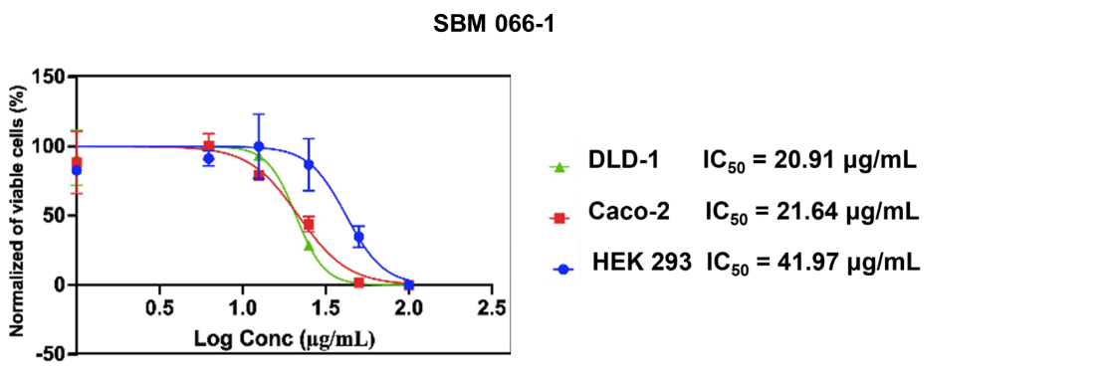

Figure S2. The cytotoxicity profiles of SBM 066-1 extract against DLD-1, Caco-2, and HEK-293 cells (in µg/mL). The graph of viability cells. Vertical bars represent the standard deviation of means (SD) (n= 3).

Table S1. IC₅₀ values of SBM 066-1 extract against several cell lines.
No | Cell lines | Compounds | IC₅₀ (µg/mL) | Selectivity Index (SI)
1. | DLD-1 | SBM 066-1 | 20.91 | 2.007173601
 |  | Doxorubicin | 0.25 | 5.28
2. | Caco-2 | SBM 066-1 | 21.64 | 1.939463956
 |  | Doxorubicin | 1.08 | 1.222222222
3. | HEK293 | SBM 066-1 | 41.97 | -
 |  | Doxorubicin | 1.32 | -

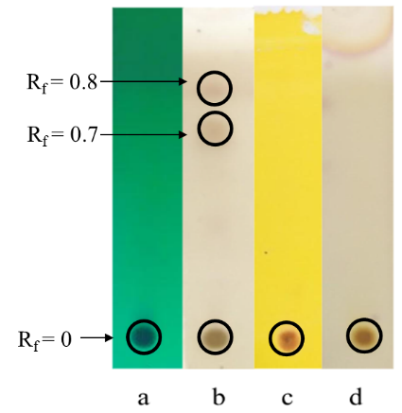
Figure S3. Visualization of TLC SBM 066-1 using (a) UV 254 nm, (b) Ce(SO₄)₂ reagent, (c) Dragendorff’s reagent, and (d) Ninhydrin.

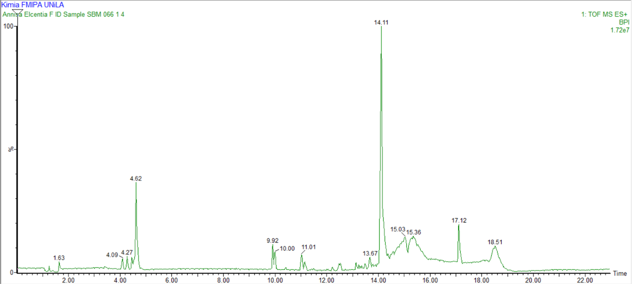
Figure S4. Chromatograms of SBM 066-1-4 fraction of the sponge Aaptos sp.

Table S2. Predicted compounds contained in SBM 066-1-4.
No | RT(Min) | Calculated Mass | Formula [M+H]⁺ | Fit. Configuration (%) | Identified | Class Compound
1 | 1.63 | 191.0457 | C₉H₇N₂O₃ | 99.95 | Nitroxoline | Nitro compound
2 | 4.09 | 215.0821 | C₁₂H₁₁N₂O₂ | 100 | 4-(4-Nitrobenzyl)pyridine | Heterocyclic compound
3 | 4.27 | 213.0671 | C₁₇H₉ | 58.46 | 1-Phenyl-1,3,5,7,9-undecapentayne | Aliphatic compound
4 | 4.62 | 229.0977 | C₁₃ H₁₃N₂O₃ | 99.20 | Aaptamine | Alkaloid
5 | 9.92 | 274.2746 | C₁₆H₃₆ NO₂ | 99.85 | N-Lauryldiethanolamine | Amide
6 | 10.00 | 318.2981 | C₁₄H₃₆N₇O | 70.13 | N-[2-[2-[bis[2-(2-aminoethylamino)ethyl]amino]ethylamino]ethyl]acetamide | Amide
7 | 11.01 | 437.1937 | C₂₂H₂₅N₆O₄ | 66.42 | 5-[[3-[3-(dimethylamino)-1,2,4-oxadiazol-5-yl]-2-hydroxyphenyl]methyl-propan-2-ylamino]-1H-indazole-3-carboxylic acid | Carboxylic acid
8 | 13.67 | 482.3567 | C₂₂H₄₄N₉O₃ | 45.86 | N-[2-[1,4-diazepane-6-carbonyl-[2-(1,4-diazepane-6-carbonylamino)ethyl]amino]ethyl]-1,4-diazepane-6-carboxamide | Amide
9 | 14.11 | 496.3724 | C₂₃H₄₆N₉O₃ | 50.51 | -
10 | 15.03 | 577.5196 | C₃₇H₆₉O₄ | 75.64 | Cohibin C | Lactones
11 | 15.36 | 577.5196 | C₃₇H₆₉O₄ | 73.59 | Cohibin C | Lactones
12 | 17.12 | 413.2665 | C₂₂H₃₃N₆O₂ | 90.46 | 1-{trans-4-[(8-Cyclopentyl-7-Oxo-7,8-Dihydropyrido[2,3-D]pyrimidin-2-Yl)amino]cyclohexyl}-3-Propan-2-Ylurea | Urea
13 | 18.50 | 577.5196 | C₃₇H₆₉O₄ | 78.94 | Cohibin C | Lactones

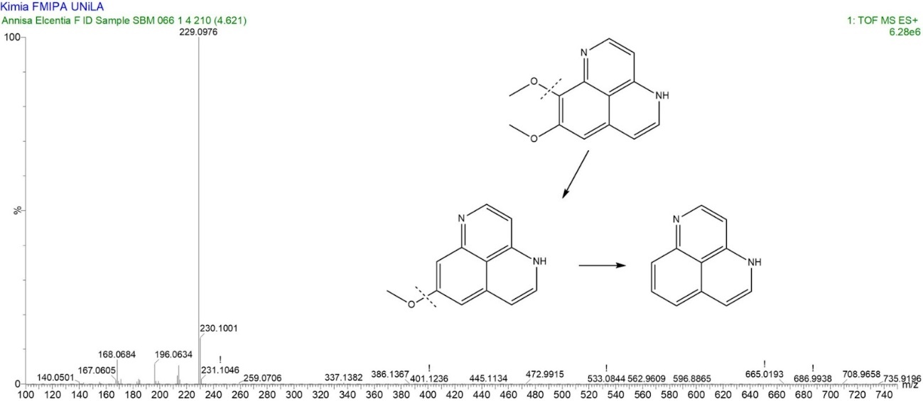
Figure S5. Experimental fragmented mass spectrum for SBM 066-1-4

Figure S6. ¹H-NMR spectrum of fraction SBM 066-1-4.

Table S6. ¹H-NMR Spectra of SBM 066-1-4

 | δ_{H} (J in Hz) |  | No. atom H
Data Experiment ª | Luyao et al., 2021 ^{b} | Calcul et al.,  2003 ^{c} | No. atom H
3,89 s | 3,93 s | 3,77 s | 9-OMe
4,04 s | 4,04 s | 3,93 s | 8-OMe
6,35 d (J = 7,5) | 6,34 d (J = 7,1) | 6,49 d (J = 7,0) | 3
6,88 d (J = 7,5) | 6,86 d (J = 7,2) | 6,78 d (J = 7,4) | 6
7,59 d (J= 7,5) | 7,23 d (J = 7,2) | 7,30 d (J = 7,1) | 5
7,78 d (J= 7,5) | 7,77 d (J = 7,1) | 7,80 d (J = 7,0) | 2
8,19 s | 7,04 (s) | 7,02 s | 7
ª Measured at 500 MHz in MeOD ^{b} Measured at 600 MHz in MeOD; ^{c} Measured at 400.13 MHz in DMSO-_{d6}

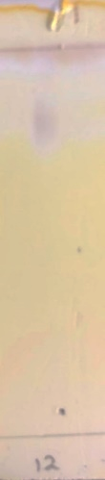

Figure S7. Visualization of TLC SBM 066-1-4-1 (compound 1) using Ce(SO₄)₂ reagent. A single spot was observed in TLC confirming a single major compound and qualitatively indicating a high purity fraction.

Reference:
H. Luyao, H. Luesch & M. Uy. Molecules. 2021, 26(18), 5618.
L. Calcul, A. Longeon, A. Al Mourabit, M. Guyot, & M. L. Bourguet-Kondracki, Tetrahedron. 2003, 59(34), 6539-6544.

