Supporting Information

Martin Möbs,¹ Antti J. Karttunen, ² and Florian Kraus¹*
[1] Anorganische Chemie, Fluorchemie, Philipps-Universität Marburg, Hans-Meerwein-Str. 4, 35032 Marburg, Germany
[2] Department of Chemistry and Materials Science, Aalto University, 00076 Espoo, Finland
Corresponding author: E-mail: f.kraus@uni-marburg.de

Content
1 Crystallographic details 2
1.1 Details of the crystal structure of [NMe₄][(BrF₅)₆(HF₂)] 2
1.2 Details of the crystal structure of Cs₂[(BrF₅)₆(HF₂)(H₂F₃)] 5
2 Quantum Chemical Calculations 9
2.1 Basis set details for the CRYSTAL23^{[1]} calculations 9
2.2 Optimized structures in CIF format 11
2.3 Visualisation of the X-ray crystal structure of [NMe₄][(BrF₅)₆(HF₂)] in comparison to the optimized solid-state structure 14
2.4 Visualisation of the X-ray crystal structure of Cs₂[(BrF₅)₆(HF₂)(H₂F₃)] in comparison to the optimized solid-state structure 15
3 Band assignment for the Raman spectra 16
3.1 Band assignment for the Raman spectrum of [NMe₄][(BrF₅)₆(HF₂)] 16
3.2 Calculated Raman spectrum and band assignment of Cs₂[(BrF₅)₆(HF₂)(H₂F₃)] 17
4 NMR spectra of [NMe₄][HF₂] 19
References 20

Crystallographic details

Details of the crystal structure of [NMe₄][(BrF₅)₆(HF₂)]
Table S 1. Fractional atomic coordinates and equivalent isotropic displacement parameters (Å²) for [NMe₄][(BrF₅)₆(HF₂)].
 | x | y | z | U_{iso}*/U_{eq} | Occ. (<1)
Br1 | 0.73970 (2) | 0.10151 (4) | 0.64918 (2) | 0.02793 (10)
Br2 | 0.54754 (2) | 0.18191 (4) | 0.42238 (2) | 0.03101 (10)
Br3 | 0.69085 (2) | 0.53534 (4) | 0.56244 (2) | 0.03126 (11)
F1 | 0.70206 (12) | 0.2585 (2) | 0.52291 (11) | 0.0282 (4)
F1A | 0.74396 (18) | −0.0476 (3) | 0.70145 (14) | 0.0535 (7)
F1B | 0.6789 (2) | 0.1741 (4) | 0.6915 (2) | 0.0745 (10)
F1C | 0.65233 (15) | 0.0157 (3) | 0.57834 (15) | 0.0533 (7)
F1D | 0.80213 (17) | 0.0001 (3) | 0.61717 (16) | 0.0566 (7)
F1E | 0.82866 (18) | 0.1535 (3) | 0.73111 (14) | 0.0594 (8)
F2A | 0.45413 (17) | 0.2018 (3) | 0.34877 (17) | 0.0679 (9)
F2B | 0.49464 (18) | 0.1928 (3) | 0.47957 (18) | 0.0578 (7)
F2C | 0.55006 (16) | 0.3743 (3) | 0.41978 (17) | 0.0538 (7)
F2D | 0.5827 (2) | 0.1755 (4) | 0.35054 (18) | 0.0706 (9)
F2E | 0.52503 (16) | −0.0062 (3) | 0.40949 (15) | 0.0499 (7)
F3A | 0.7076 (2) | 0.6832 (3) | 0.61888 (16) | 0.0607 (8)
F3B | 0.60735 (18) | 0.5052 (3) | 0.58444 (18) | 0.0645 (8)
F3C | 0.75681 (17) | 0.4490 (3) | 0.65007 (14) | 0.0517 (7)
F3D | 0.77938 (16) | 0.5927 (3) | 0.55324 (16) | 0.0592 (8)
F3E | 0.63026 (16) | 0.6535 (3) | 0.48750 (15) | 0.0485 (6)
H1 | 0.750000 | 0.250000 | 0.500000 | 0.07 (2)*
N1 | 0.500000 | 0.7169 (4) | 0.250000 | 0.0361 (11)
C1 | 0.4180 (5) | 0.8012 (15) | 0.2038 (4) | 0.041 (3) | 0.5
H1A | 0.371303 | 0.739238 | 0.196735 | 0.062* | 0.5
H1B | 0.414565 | 0.828851 | 0.153432 | 0.062* | 0.5
H1C | 0.416909 | 0.888363 | 0.232221 | 0.062* | 0.5
C2 | 0.4884 (6) | 0.6585 (9) | 0.3210 (3) | 0.060 (3) | 0.5
H2A | 0.492054 | 0.739025 | 0.355329 | 0.090* | 0.5
H2B | 0.531456 | 0.587624 | 0.348739 | 0.090* | 0.5
H2C | 0.434495 | 0.612255 | 0.303268 | 0.090* | 0.5
C3 | 0.5036 (7) | 0.5931 (7) | 0.2050 (5) | 0.082 (5) | 0.5
H3A | 0.464121 | 0.519669 | 0.204211 | 0.124* | 0.5
H3B | 0.559063 | 0.552073 | 0.228064 | 0.124* | 0.5
H3C | 0.490001 | 0.624082 | 0.152270 | 0.124* | 0.5
C4 | 0.5676 (6) | 0.8147 (14) | 0.2743 (5) | 0.053 (4) | 0.5
H4A | 0.567696 | 0.864030 | 0.229341 | 0.080* | 0.5
H4B | 0.619012 | 0.760950 | 0.300725 | 0.080* | 0.5
H4C | 0.562574 | 0.886430 | 0.309376 | 0.080* | 0.5

Table S 2. Atomic displacement parameters (Å²) for [NMe₄][(BrF₅)₆(HF₂)].
 | U11 | U22 | U33 | U12 | U13 | U23
Br1 | 0.02841 (19) | 0.0339 (2) | 0.02307 (17) | 0.00186 (15) | 0.01265 (14) | 0.00222 (15)
Br2 | 0.02338 (18) | 0.0329 (2) | 0.0332 (2) | −0.00012 (15) | 0.00889 (15) | 0.00398 (16)
Br3 | 0.0367 (2) | 0.02819 (19) | 0.03078 (19) | −0.00013 (16) | 0.01641 (16) | −0.00536 (15)
F1 | 0.0265 (10) | 0.0318 (11) | 0.0286 (10) | −0.0004 (9) | 0.0140 (9) | −0.0003 (9)
F1A | 0.0809 (19) | 0.0415 (14) | 0.0358 (14) | −0.0059 (14) | 0.0232 (14) | 0.0098 (12)
F1B | 0.092 (2) | 0.072 (2) | 0.099 (3) | 0.0163 (18) | 0.080 (2) | 0.0021 (19)
F1C | 0.0370 (14) | 0.0606 (17) | 0.0452 (15) | −0.0188 (13) | 0.0017 (12) | 0.0099 (13)
F1D | 0.0534 (16) | 0.0649 (18) | 0.0602 (17) | 0.0173 (14) | 0.0328 (14) | −0.0042 (14)
F1E | 0.0592 (17) | 0.0694 (19) | 0.0297 (13) | −0.0134 (15) | 0.0007 (12) | −0.0017 (13)
F2A | 0.0402 (15) | 0.078 (2) | 0.0546 (18) | 0.0031 (15) | −0.0083 (13) | 0.0119 (16)
F2B | 0.0647 (18) | 0.0542 (17) | 0.076 (2) | 0.0083 (14) | 0.0506 (16) | 0.0080 (15)
F2C | 0.0463 (15) | 0.0342 (13) | 0.0736 (19) | 0.0056 (11) | 0.0190 (14) | 0.0171 (13)
F2D | 0.085 (2) | 0.084 (2) | 0.0639 (19) | 0.0051 (19) | 0.0511 (18) | 0.0101 (17)
F2E | 0.0482 (15) | 0.0388 (14) | 0.0578 (17) | −0.0100 (12) | 0.0182 (13) | −0.0073 (12)
F3A | 0.090 (2) | 0.0416 (15) | 0.0503 (16) | −0.0054 (15) | 0.0306 (16) | −0.0230 (13)
F3B | 0.0567 (17) | 0.076 (2) | 0.078 (2) | −0.0001 (16) | 0.0455 (17) | 0.0087 (17)
F3C | 0.0599 (17) | 0.0572 (16) | 0.0308 (13) | 0.0049 (14) | 0.0129 (12) | −0.0022 (12)
F3D | 0.0447 (15) | 0.088 (2) | 0.0480 (16) | −0.0151 (15) | 0.0226 (13) | −0.0002 (15)
F3E | 0.0547 (16) | 0.0366 (13) | 0.0510 (15) | 0.0111 (12) | 0.0199 (13) | 0.0059 (12)
N1 | 0.028 (2) | 0.043 (3) | 0.028 (2) | 0.000 | 0.0035 (19) | 0.000
C1 | 0.028 (5) | 0.055 (7) | 0.036 (6) | 0.017 (5) | 0.009 (5) | 0.020 (5)
C2 | 0.062 (8) | 0.052 (7) | 0.053 (6) | 0.011 (6) | 0.012 (6) | 0.028 (6)
C3 | 0.044 (6) | 0.097 (10) | 0.094 (10) | −0.005 (7) | 0.018 (7) | −0.060 (8)
C4 | 0.036 (6) | 0.069 (9) | 0.044 (7) | −0.015 (7) | 0.008 (6) | −0.021 (7)

Table S 3. Selected interatomic distances (Å) in the X-ray crystal structure of [NMe₄][(BrF₅)₆(HF₂)] in comparison to the optimized solid-state structure (DFT-PBE0-TZVP level of theory).
 | Experiment | DFT-PBE0-TZVP |  |  | Experiment | DFT-PBE0-TZVP
Br1–F1A | 1.690(2) | 1.708 |  | Br3–F3A | 1.692(2) | 1.708
Br1–F1B | 1.760(3) | 1.777 |  | Br3–F3B | 1.757(3) | 1.774
Br1–F1C | 1.767(2) | 1.773 |  | Br3–F3C | 1.781(3) | 1.780
Br1–F1D | 1.771(3) | 1.796 |  | Br3–F3D | 1.766(3) | 1.774
Br1–F1E | 1.765(3) | 1.771 |  | Br3–F3E | 1.765(2) | 1.775
Br1–F1 | 2.660(2) | 2.697 |  | Br3–F1 | 2.704(2) | 2.737
Br2–F2A | 1.681(3) | 1.705 |  | F1–F1^{i} | 2.266(4) | 2.262
Br2–F2B | 1.748(3) | 1.763 |  | N1–C1 | 1.5666 | 1.490
Br2–F2C | 1.781(3) | 1.778 |  | N1–C2 | 1.569 | –
Br2–F2D | 1.758(3) | 1.785 |  | N1–C3 | 1.4563 | 1.490
Br2–F2E | 1.779(3) | 1.789 |  | N1–C4 | 1.4263 | –
Br2–F1 | 2.716(2) | 2.696
Symmetry codes: (i) 3/2–x, ½–y, 1–z

Table S 4. Selected interatomic angles (°) in the X-ray crystal structure of [NMe₄][(BrF₅)₆(HF₂)] in comparison to the optimized solid-state structure (DFT-PBE0-TZVP level of theory).
 | experiment | DFT-PBE0-TZVP/SVP |  |  | experiment | DFT-PBE0-TZVP/SVP
Br1-F1-Br3 | 106.19(7) | 102.192 |  | F2A-Br2-F2E | 84.45(14) | 83.444
Br1-F1-Br2 | 106.79(7) | 108.379 |  | F2A-Br2-F2C | 84.01(14) | 84.07
Br3-F1-Br2 | 105.61(7) | 106.743 |  | F2A-Br2-F2B | 84.50(17) | 84.407
C1-N1-C2 | 102.600 | 109.873 |  | F2B-Br2-F2C | 89.30(13) | 88.868
C3-N1-C1 | 109.100 | 109.062 |  | F2B-Br2-F2E | 89.45(13) | 90.517
C3-N1-C2 | 107.900 | 109.349 |  | F2B-Br2-F1 | 101.99(12) | 112.244
C4-N1-C2 | 110.500 | 109.873 |  | F2B-Br2-F2D | 169.36(15) | 167.691
C4-N1-C1 | 109.600 | 109.61 |  | F2C-Br2-F1 | 74.27(10) | 75.031
C4-N1-C3 | 116.200 | 109.062 |  | F2D-Br2-F2E | 89.73(14) | 89.463
F1^{i}-F1-Br3 | 109.81(13) | 112.751 |  | F2D-Br2-F2C | 89.38(15) | 88.495
F1^{i}-F1-Br2 | 115.24(13) | 111.404 |  | F2D-Br2-F1 | 87.80(13) | 78.619
F1-F1-Br1 | 112.60(13) | 114.707 |  | F2E-Br2-F2C | 168.46(12) | 167.498
F1A-Br1-F1E | 84.20(13) | 83.47 |  | F2E-Br2-F1 | 117.19(10) | 116.603
F1A-Br1-F1C | 83.71(13) | 83.297 |  | F3A-Br3-F3B | 84.61(15) | 83.995
F1A-Br1-F1 | 156.85(10) | 155.745 |  | F3A-Br3-F3E | 84.39(14) | 83.703
F1A-Br1-F1D | 84.54(14) | 83.566 |  | F3A-Br3-F3D | 84.49(15) | 84.156
F1A-Br1-F1B | 84.87(15) | 84.341 |  | F3A-Br3-F1 | 158.83(11) | 153.083
F1B-Br1-F1E | 89.38(17) | 89.472 |  | F3A-Br3-F3C | 83.74(14) | 83.506
F1B-Br1-F1 | 104.70(12) | 81.851 |  | F3B-Br3-F3E | 90.18(14) | 90.215
F1B-Br1-F1D | 169.40(14) | 167.905 |  | F3B-Br3-F1 | 95.45(11) | 113.752
F1B-Br1-F1C | 90.16(16) | 88.517 |  | F3B-Br3-F3C | 89.50(14) | 89.438
F1C-Br1-F1 | 75.37(10) | 76.522 |  | F3B-Br3-F3D | 169.04(15) | 168.135
F1C-Br1-F1D | 89.02(14) | 89.902 |  | F3C-Br3-F1 | 75.09(10) | 76.913
F1D-Br1-F1 | 85.31(11) | 109.419 |  | F3D-Br3-F3C | 88.11(14) | 88.589
F1E-Br1-F1D | 89.21(15) | 89.327 |  | F3D-Br3-F1 | 94.27(11) | 77.146
F1E-Br1-F1C | 167.89(13) | 166.748 |  | F3E-Br3-F3C | 168.10(12) | 167.17
F1E-Br1-F1 | 116.41(11) | 116.132 |  | F3E-Br3-F1 | 116.78(10) | 114.82
F2A-Br2-F2D | 84.86(17) | 83.363 |  | F3E-Br3-F3D | 89.96(13) | 89.123
F2A-Br2-F1 | 157.13(12) | 152.586
Symmetry codes: (i) 3/2–x, ½–y, 1–z

Table S 5. Distances (Å) and angles (°) of hydrogen bonds in the crystal structure of [NMe₄][(BrF₅)₆(HF₂)].
D—H···A | D—H | H···A | D···A | D—H···A
F1—H1···F1^{i} | 1.13 (1) | =D–H | 2.266 (4) | 180
C2—H2B···F2C | 0.98 | 2.34 | 3.153 (7) | 140
C1—H1B···F2E^{ii} | 0.98 | 2.48 | 3.310 (12) | 143
Symmetry codes: (i) −x+3/2, −y+1/2, −z+1; (ii) −x+1, y+1, −z+1/2.

Details of the crystal structure of Cs₂[(BrF₅)₆(HF₂)(H₂F₃)]
Table S 6. Fractional atomic coordinates and equivalent isotropic displacement parameters (Å²) for Cs₂[(BrF₅)₆(HF₂)(H₂F₃)].
 | x | y | z | U_{iso}*/U_{eq}
F1A | 0.6140 (5) | 0.2300 (4) | 0.4577 (2) | 0.0442 (9)
F1B | 0.6627 (5) | 0.1913 (5) | 0.3359 (2) | 0.0512 (11)
F1C | 0.8901 (5) | 0.3619 (5) | 0.4391 (2) | 0.0437 (9)
F1D | 0.7377 (5) | 0.5068 (4) | 0.4714 (2) | 0.0420 (9)
F1E | 0.5091 (5) | 0.3338 (5) | 0.3667 (2) | 0.0490 (10)
F3 | 0.3371 (5) | 0.5237 (5) | 0.2453 (2) | 0.0462 (10)
F2A | 1.3032 (4) | 0.9501 (4) | 0.3913 (2) | 0.0461 (10)
F2B | 1.2503 (5) | 0.8141 (5) | 0.2730 (2) | 0.0559 (11)
F2C | 1.0833 (5) | 0.9385 (5) | 0.3128 (2) | 0.0487 (10)
F2D | 1.0462 (5) | 0.8013 (5) | 0.4300 (2) | 0.0486 (10)
F2E | 1.2119 (5) | 0.6796 (5) | 0.3904 (2) | 0.0496 (10)
F4 | 0.9392 (5) | 0.4668 (5) | 0.2903 (2) | 0.0417 (9)
F3A | 0.6072 (5) | 0.9251 (5) | 0.4385 (2) | 0.0453 (10)
F3B | 0.8769 (5) | 1.0251 (4) | 0.4111 (2) | 0.0493 (10)
F3C | 0.6317 (5) | 0.8495 (5) | 0.3175 (2) | 0.0511 (10)
F3D | 0.5166 (5) | 0.6526 (5) | 0.4095 (2) | 0.0494 (10)
F3E | 0.7613 (5) | 0.8278 (5) | 0.5056 (2) | 0.0476 (10)
F5 | 0.7685 (4) | 0.3799 (4) | 0.1753 (2) | 0.0403 (9)
F4A | 0.2529 (5) | 0.0480 (5) | 0.1004 (2) | 0.0543 (11)
F4B | 0.3337 (5) | 0.3150 (5) | 0.0983 (2) | 0.0481 (10)
F4C | 0.5076 (5) | 0.1992 (5) | 0.0592 (2) | 0.0540 (11)
F4D | 0.4770 (5) | 0.0701 (5) | 0.1802 (2) | 0.0526 (11)
F4E | 0.3027 (5) | 0.1897 (5) | 0.2176 (2) | 0.0528 (11)
F5A | 0.8929 (5) | 0.7865 (4) | 0.0520 (2) | 0.0433 (9)
F5B | 0.8326 (6) | 0.8014 (5) | 0.1731 (2) | 0.0544 (11)
F5C | 1.0126 (5) | 0.6932 (6) | 0.1407 (3) | 0.0623 (13)
F5D | 0.7999 (6) | 0.5146 (5) | 0.0327 (2) | 0.0565 (12)
F5E | 0.6179 (5) | 0.6252 (5) | 0.0665 (2) | 0.0524 (11)
F6A | 0.9643 (5) | 0.1082 (4) | 0.0833 (2) | 0.0444 (10)
F6B | 1.0430 (5) | 0.3747 (5) | 0.1215 (3) | 0.0573 (12)
F6C | 0.9042 (6) | 0.1556 (5) | 0.2025 (2) | 0.0569 (12)
F6D | 0.6844 (5) | −0.0048 (4) | 0.0934 (2) | 0.0506 (11)
F6E | 0.8226 (5) | 0.2156 (5) | 0.0132 (2) | 0.0490 (10)
H1 | 0.683 (12) | 0.567 (11) | 0.270 (5) | 0.09 (3)*
H2 | 0.456 (18) | 0.508 (16) | 0.241 (8) | 0.18 (6)*
H3 | 0.860 (12) | 0.429 (11) | 0.259 (6) | 0.08 (3)*
Br1 | 0.70991 (8) | 0.36220 (7) | 0.39622 (4) | 0.03359 (15)
Br2 | 1.12889 (8) | 0.79099 (7) | 0.34624 (4) | 0.03484 (16)
Br3 | 0.70615 (8) | 0.82857 (7) | 0.40735 (4) | 0.03562 (16)
Br4 | 0.42417 (8) | 0.21259 (8) | 0.14401 (4) | 0.03755 (17)
Br5 | 0.80671 (8) | 0.64305 (7) | 0.10992 (4) | 0.03459 (16)
Br6 | 0.85229 (7) | 0.19419 (7) | 0.11113 (4) | 0.03480 (16)
F1 | 0.7675 (5) | 0.6318 (5) | 0.3228 (2) | 0.0405 (9)
F2 | 0.5762 (5) | 0.5172 (5) | 0.2157 (2) | 0.0454 (10)
Cs1 | 0.15396 (5) | 0.32149 (5) | 0.35602 (2) | 0.03677 (12)
Cs2 | 0.35556 (5) | 0.71149 (5) | 0.11945 (2) | 0.03981 (13)

Table S 7. Atomic displacement parameters (Å²) for Cs₂[(BrF₅)₆(HF₂)(H₂F₃)].
 | U¹¹ | U²² | U³³ | U¹² | U¹³ | U²³
F1A | 0.038 (2) | 0.035 (2) | 0.047 (2) | 0.0075 (17) | 0.0100 (18) | 0.0066 (17)
F1B | 0.060 (3) | 0.037 (2) | 0.046 (2) | 0.016 (2) | 0.004 (2) | −0.0042 (18)
F1C | 0.040 (2) | 0.050 (2) | 0.041 (2) | 0.0211 (19) | 0.0018 (17) | 0.0092 (18)
F1D | 0.043 (2) | 0.036 (2) | 0.040 (2) | 0.0144 (18) | 0.0089 (18) | −0.0001 (17)
F1E | 0.029 (2) | 0.047 (2) | 0.059 (3) | 0.0090 (18) | 0.0032 (18) | 0.008 (2)
F3 | 0.045 (2) | 0.045 (2) | 0.044 (2) | 0.018 (2) | 0.0081 (19) | 0.0073 (18)
F2A | 0.031 (2) | 0.034 (2) | 0.054 (2) | 0.0036 (17) | −0.0037 (18) | −0.0055 (18)
F2B | 0.055 (3) | 0.059 (3) | 0.046 (2) | 0.021 (2) | 0.016 (2) | 0.003 (2)
F2C | 0.048 (2) | 0.038 (2) | 0.055 (3) | 0.0167 (19) | 0.003 (2) | 0.0115 (19)
F2D | 0.041 (2) | 0.053 (3) | 0.040 (2) | 0.013 (2) | 0.0044 (18) | 0.0044 (19)
F2E | 0.046 (2) | 0.040 (2) | 0.059 (3) | 0.0207 (19) | −0.009 (2) | −0.0002 (19)
F4 | 0.039 (2) | 0.041 (2) | 0.042 (2) | 0.0184 (19) | 0.0004 (19) | −0.0025 (18)
F3A | 0.042 (2) | 0.040 (2) | 0.056 (3) | 0.0214 (19) | 0.0093 (19) | 0.0028 (19)
F3B | 0.034 (2) | 0.031 (2) | 0.066 (3) | 0.0016 (17) | 0.0133 (19) | 0.0060 (19)
F3C | 0.057 (3) | 0.046 (2) | 0.046 (2) | 0.023 (2) | 0.000 (2) | 0.0047 (19)
F3D | 0.034 (2) | 0.039 (2) | 0.065 (3) | 0.0101 (18) | 0.0043 (19) | 0.007 (2)
F3E | 0.056 (3) | 0.042 (2) | 0.041 (2) | 0.022 (2) | −0.0012 (19) | 0.0023 (18)
F5 | 0.0318 (19) | 0.038 (2) | 0.046 (2) | 0.0133 (17) | 0.0071 (17) | 0.0065 (17)
F4A | 0.037 (2) | 0.039 (2) | 0.061 (3) | 0.0002 (18) | −0.001 (2) | −0.009 (2)
F4B | 0.041 (2) | 0.048 (2) | 0.047 (2) | 0.0175 (19) | −0.0057 (18) | −0.0005 (19)
F4C | 0.045 (2) | 0.068 (3) | 0.042 (2) | 0.022 (2) | 0.0097 (19) | 0.000 (2)
F4D | 0.055 (3) | 0.035 (2) | 0.059 (3) | 0.016 (2) | 0.005 (2) | 0.0055 (19)
F4E | 0.057 (3) | 0.041 (2) | 0.048 (2) | 0.011 (2) | 0.024 (2) | 0.0059 (18)
F5A | 0.044 (2) | 0.038 (2) | 0.046 (2) | 0.0164 (18) | 0.0132 (18) | 0.0108 (17)
F5B | 0.071 (3) | 0.037 (2) | 0.043 (2) | 0.016 (2) | 0.011 (2) | −0.0023 (18)
F5C | 0.031 (2) | 0.063 (3) | 0.080 (3) | 0.012 (2) | 0.001 (2) | 0.024 (2)
F5D | 0.074 (3) | 0.042 (2) | 0.052 (3) | 0.025 (2) | 0.021 (2) | 0.001 (2)
F5E | 0.038 (2) | 0.059 (3) | 0.049 (2) | 0.015 (2) | 0.0038 (19) | 0.016 (2)
F6A | 0.039 (2) | 0.034 (2) | 0.061 (3) | 0.0178 (18) | 0.0090 (19) | 0.0036 (18)
F6B | 0.032 (2) | 0.030 (2) | 0.092 (4) | 0.0026 (18) | 0.005 (2) | −0.003 (2)
F6C | 0.068 (3) | 0.062 (3) | 0.042 (2) | 0.036 (3) | −0.004 (2) | 0.002 (2)
F6D | 0.035 (2) | 0.032 (2) | 0.066 (3) | 0.0014 (17) | 0.006 (2) | 0.0015 (19)
F6E | 0.062 (3) | 0.050 (2) | 0.042 (2) | 0.032 (2) | 0.010 (2) | 0.0083 (19)
Br1 | 0.0297 (3) | 0.0291 (3) | 0.0338 (3) | 0.0083 (3) | 0.0027 (3) | 0.0020 (2)
Br2 | 0.0298 (3) | 0.0295 (3) | 0.0352 (3) | 0.0074 (3) | 0.0011 (3) | −0.0001 (3)
Br3 | 0.0313 (3) | 0.0287 (3) | 0.0394 (3) | 0.0089 (3) | 0.0049 (3) | 0.0017 (3)
Br4 | 0.0313 (3) | 0.0306 (3) | 0.0370 (3) | 0.0048 (3) | 0.0039 (3) | −0.0012 (3)
Br5 | 0.0302 (3) | 0.0294 (3) | 0.0363 (3) | 0.0085 (3) | 0.0035 (3) | 0.0030 (3)
Br6 | 0.0280 (3) | 0.0267 (3) | 0.0401 (4) | 0.0059 (3) | 0.0043 (3) | 0.0010 (3)
F1 | 0.035 (2) | 0.040 (2) | 0.043 (2) | 0.0156 (18) | 0.0065 (17) | 0.0058 (17)
F2 | 0.043 (2) | 0.040 (2) | 0.043 (2) | 0.0122 (19) | 0.0085 (19) | −0.0023 (18)
Cs1 | 0.0317 (2) | 0.0332 (2) | 0.0399 (2) | 0.01136 (17) | 0.00463 (17) | 0.00506 (17)
Cs2 | 0.0321 (2) | 0.0311 (2) | 0.0451 (3) | 0.00648 (17) | 0.00553 (18) | 0.00472 (17)

Table S 8. Selected interatomic distances (Å) in the X-ray crystal structure of Cs₂[(BrF₅)₆(HF₂)(H₂F₃)] in comparison to the optimized solid-state structure (DFT-PBE0-TZVP/SVP level of theory).
 | Experiment | DFT-PBE0-TZVP/SVP |  |  | Experiment | DFT-PBE0-TZVP/SVP
Br1-F1A | 1.690(4) | 1.7042 |  | Br5-F5C | 1.758(5) | 1.7851
Br1-F1B | 1.758(4) | 1.7629 |  | Br5-F5D | 1.782(4) | 1.7951
Br1-F1C | 1.776(5) | 1.7771 |  | Br5-F5E | 1.775(5) | 1.7863
Br1-F1D | 1.791(4) | 1.7964 |  | Br6-F6A | 1.701(5) | 1.7042
Br1-F1E | 1.775(5) | 1.7886 |  | Br6-F6B | 1.772(5) | 1.7747
Br2-F2A | 1.693(4) | 1.7073 |  | Br6-F6C | 1.767(4) | 1.7758
Br2-F2B | 1.766(4) | 1.7800 |  | Br6-F6D | 1.781(4) | 1.8011
Br2-F2C | 1.773(5) | 1.7831 |  | Br6-F6E | 1.786(4) | 1.8000
Br2-F2D | 1.770(4) | 1.7760 |  | F1-Br1 | 2.798(4) | 2.8021
Br2-F2E | 1.765(5) | 1.7720 |  | F1-Br2 | 2.925(4) | 2.8205
Br3-F3A | 1.697(5) | 1.7024 |  | F1-Br3 | 2.664(4) | 2.8552
Br3-F3B | 1.783(4) | 1.7876 |  | F2-Br4 | 2.739(4) | 2.9523
Br3-F3C | 1.748(4) | 1.7639 |  | F2-Br5 | 2.857(4) | 2.7132
Br3-F3D | 1.768(5) | 1.7728 |  | F4-Br1 | 2.841(4) | 2.7293
Br3-F3E | 1.785(4) | 1.7905 |  | F4-Br2 | 2.808(4) | 2.7961
Br4-F4A | 1.694(4) | 1.7159 |  | F5-Br4 | 2.790(4) | 2.8173
Br4-F4B | 1.754(5) | 1.7682 |  | F5-Br5 | 2.714(4) | 2.7474
Br4-F4C | 1.797(4) | 1.7981 |  | F5-Br6 | 2.529(4) | 2.5533
Br4-F4D | 1.787(5) | 1.7926 |  | F1-F2 | 2.305(5) | 2.3012
Br4-F4E | 1.772(4) | 1.7728 |  | F2-F3 | 2.363(6) | 2.3574
Br5-F5A | 1.689(4) | 1.7050 |  | F4-F5 | 2.321(5) | 2.2929
Br5-F5B | 1.753(4) | 1.7672

Table S 9. Selected interatomic angles (°) in the X-ray crystal structure of Cs₂[(BrF₅)₆(HF₂)(H₂F₃)] in comparison to the optimized solid-state structure (DFT-PBE0-TZVP/SVP level of theory).
 | experiment | DFT-PBE0-TZVP/SVP |  |  | experiment | DFT-PBE0-TZVP/SVP
F1A-Br1-F1B | 84.44(18) | 84.172 |  | F5A-Br5-F5B | 84.11(18) | 83.823
F1A-Br1-F1C | 84.2(2) | 83.883 |  | F5A-Br5-F5C | 83.9(2) | 83.693
F1A-Br1-F1D | 83.54(17) | 83.17 |  | F5A-Br5-F5D | 83.61(18) | 82.949
F1A-Br1-F1E | 84.0(2) | 83.446 |  | F5A-Br5-F5E | 84.0(2) | 83.489
F1B-Br1-F1C | 89.6(2) | 89.549 |  | F5B-Br5-F5C | 88.5(3) | 88.799
F1B-Br1-F1D | 167.98(18) | 167.342 |  | F5B-Br5-F5D | 167.72(19) | 166.772
F1B-Br1-F1E | 89.2(2) | 88.906 |  | F5B-Br5-F5E | 89.8(2) | 89.454
F1C-Br1-F1D | 88.9(2) | 89.03 |  | F5C-Br5-F5D | 90.1(3) | 89.789
F1C-Br1-F1E | 168.15(19) | 167.327 |  | F5C-Br5-F5E | 167.9(2) | 167.176
F1D-Br1-F1E | 89.8(2) | 89.727 |  | F5D-Br5-F5E | 88.9(2) | 89.011
F2A-Br2-F2B | 83.86(19) | 83.417 |  | F6A-Br6-F6B | 84.7(2) | 83.652
F2A-Br2-F2C | 83.98(19) | 83.296 |  | F6A-Br6-F6C | 84.6(2) | 84.227
F2A-Br2-F2D | 84.08(19) | 83.723 |  | F6A-Br6-F6D | 83.6(2) | 83.294
F2A-Br2-F2E | 83.76(19) | 83.518 |  | F6A-Br6-F6E | 84.3(2) | 83.895
F2B-Br2-F2C | 89.8(2) | 89.675 |  | F6B-Br6-F6C | 89.8(2) | 89.442
F2B-Br2-F2D | 167.9(2) | 167.137 |  | F6B-Br6-F6D | 168.2(2) | 166.942
F2B-Br2-F2E | 89.5(2) | 89.473 |  | F6B-Br6-F6E | 89.2(2) | 89.000
F2C-Br2-F2D | 89.5(2) | 89.077 |  | F6C-Br6-F6D | 89.92(19) | 89.563
F2C-Br2-F2E | 167.7(2) | 166.798 |  | F6C-Br6-F6E | 168.9(2) | 168.119
F2D-Br2-F2E | 88.6(2) | 88.828 |  | F6D-Br6-F6E | 88.82(18) | 89.299
F3A-Br3-F3B | 84.1(2) | 83.735 |  | H1-F2-H2 | 104(9) | 106.337
F3A-Br3-F3C | 84.6(2) | 84.193 |  | Br1-F1-Br2 | 97.68(12) | 96.524
F3A-Br3-F3D | 85.0(2) | 84.251 |  | Br2-F1-Br3 | 102.14(12) | 100.314
F3A-Br3-F3E | 83.9(2) | 83.584 |  | Br3-F1-Br1 | 110.26(14) | 109.081
F3B-Br3-F3C | 89.26(19) | 89.028 |  | Br1-F4-Br2 | 99.46(12) | 99.205
F3B-Br3-F3D | 169.1(2) | 167.986 |  | Br4-F5-Br5 | 95.73(12) | 93.438
F3B-Br3-F3E | 89.50(18) | 89.536 |  | Br5-F5-Br6 | 119.12(14) | 119.567
F3C-Br3-F3D | 89.5(2) | 89.802 |  | Br6-F5-Br4 | 102.93(13) | 100.195
F3C-Br3-F3E | 168.5(2) | 167.777 |  | Br4-F2-Br5 | 93.65(12) | 93.361
F3D-Br3-F3E | 89.53(19) | 89.081 |  | F1A-Br1-F1 | 151.57(17) | 149.247
F4A-Br4-F4B | 83.7(2) | 83.305 |  | F2A-Br2-F1 | 145.03(16) | 144.341
F4A-Br4-F4C | 83.5(2) | 82.846 |  | F3A-Br3-F1 | 159.90(16) | 156.439
F4A-Br4-F4D | 83.7(2) | 82.588 |  | F1A-Br1-F4 | 148.65(17) | 149.992
F4A-Br4-F4E | 84.1(2) | 83.675 |  | F2A-Br2-F4 | 152.59(17) | 153.383
F4B-Br4-F4C | 89.0(2) | 88.923 |  | F4A-Br4-F5 | 147.68(18) | 146.774
F4B-Br4-F4D | 167.4(2) | 165.891 |  | F5A-Br5-F5 | 153.33(16) | 151.433
F4B-Br4-F4E | 89.2(2) | 89.597 |  | F6A-Br6-F5 | 162.77(16) | 157.769
F4C-Br4-F4D | 89.3(2) | 89.132 |  | F4A-Br4-F2 | 150.86(18) | 151.072
F4C-Br4-F4E | 167.6(2) | 166.521 |  | F5A-Br5-F2 | 146.30(17) | 147.298
F4D-Br4-F4E | 89.8(2) | 89.045

Table S 10. Distances (Å) and angles (°) of hydrogen bonds in the crystal structure of Cs₂[(BrF₅)₆(HF₂)(H₂F₃)].
D—H···A | D—H | H···A | D···A | D—H···A
F1—H1···F2 | 1.10 (10) | 1.22 (10) | 2.305 (5) | 166 (9)
F3—H2···F2 | 1.19 (15) | 1.22 (15) | 2.363 (6) | 158 (13)
F4—H3···F5 | 0.80 (9) | 1.58 (10) | 2.321 (5) | 155 (11)

Quantum Chemical Calculations

Basis set details for the CRYSTAL23^{[1]} calculations
We have used basis sets on the triple zeta valence polarisation (TZVP) level for C, H, N, Br and F atoms^{[2–4]} and a split valence + polarization (SVP) level basis set for the Cs atoms.^{[5]} They are derived from molecular Karlsruhe basis sets^{[6]} and are optimized for their use in solid state calculations with CRYSTAL.^{[3,5,7,8]} The basis sets in CRYSTAL input format are as follows:
C_tzvp  6 7  0 0 6 2.0 1.0  13575.349682 0.22245814352E-03  2035.2333680 0.17232738252E-02  463.22562359 0.89255715314E-02  131.20019598 0.35727984502E-01  42.853015891 0.11076259931  15.584185766 0.24295627626  0 0 2 2.0 1.0  6.2014220319 0.41440263448  2.5635353470 0.23744968655  0 0 1 0.0 1.0  0.61801563857 1.0000000000  0 1 1 0.0 1.0  0.20000000000 1.0 1.0  0 2 3 2.0 1.0  32.126170250 0.53333657805E-02  7.2898846165 0.35864109092E-01  2.1593634335 0.14215873329  0 2 1 0.0 1.0  0.69577170992 1.0000000000  0 3 1 0.0 1.0  0.80000000000 1.0000000000 | H_tzvp  1 4  0 0 3 1.0 1.0  45.351741106 0.60251978000E-02  6.8233001522 0.45021094000E-01  1.5944879907 0.20189726000  0 0 1 0.0 1.0  0.44546978735 1.00000000000  0 0 1 0.0 1.0  0.13000000000 1.00000000000  0 2 1 0.0 1.0  0.80 1.00000000000
N_tzvp  7 7  0 0 6 2.0 1.0  19730.800647 0.21887984991E-03  2957.8958745 0.16960708803E-02  673.22133595 0.87954603538E-02  190.68249494 0.35359382605E-01  62.295441898 0.11095789217  22.654161182 0.24982972552  0 0 2 2.0 1.0  8.9809711129 0.40623896148  3.6377863436 0.24338217176  0 0 1 0.0 1.0  0.72643334701 1.0000000000  0 1 1 0.0 1.0  0.22000000000 1.0 1.0  0 2 4 3.0 1.0  63.222276180 0.55552416751E-02  15.013291910 0.38052379723E-01  4.6766636605 0.14953671029  1.7814167689 0.34949305230  0 2 1 0.0 1.0  0.68476710337 1.0000000000  0 3 1 0.0 1.0  1.00000000000 1.0000000000 | F_tzvp  9 8  0 0 6 2.0 1.0  35479.100441 0.21545014888E-03  5318.4728983 0.16700686527E-02  1210.4810975 0.86733211476E-02  342.85518140 0.35049933175E-01  112.01943181 0.11165320133  40.714740248 0.25988506647  0 0 2 2.0 1.0  16.043087032 0.39422966880  6.5321300268 0.24998238551  0 0 1 0.0 1.0  1.5988881515 1.0000000000  0 0 1 0.0 1.0  0.69433443154 1.0000000000  0 1 1 0.0 1.0  0.28000000000 1.0 1.0  0 2 4 5.0 1.0  89.322913079 0.63685999134E-02  20.934929831 0.44303143530E-01  6.5143926757 0.16867248708  2.3716075957 0.36166346255  0 2 1 0.0 1.0  0.87224572628 1.0000000000  0 3 1 0.0 1.0  1.4000000000 1.0000000000  1.2811002356 1.0000000000  0 3 1 0.0 1.0  0.38900000000 1.0000000000  0 4 1 0.0 1.0  0.57083312 1.0
Br_tzvp  35 14  0 0 8 2.0 1.0  565073.25256 0.23660314690E-03  84701.723179 0.18348332508E-02  19276.271900 0.95465849860E-02  5456.4284576 0.38877142153E-01  1776.9503500 0.12718314231  639.19398276 0.30437662191  248.78823961 0.44490940497  98.678305494 0.24381643058  0 0 4 2.0 1.0  606.07824568 -0.26527158709E-01  188.45598484 -0.12484584809  31.497144506 0.56468683559  13.736008320 0.55555268564  0 0 2 2.0 1.0  21.203212766 -0.24940920493  3.7616420178 0.71213119743  0 0 1 2.0 1.0  1.7746451186 1.0000000000  0 0 1 0.0 1.0  0.41866387672 1.0000000000  0 1 1 0.0 1.0  0.15000000000 1.0 1.0  0 2 6 6.0 1.0  3019.6955723 0.24971049798E-02  715.35481126 0.20419267596E-01  229.98328751 0.96897148309E-01  86.167844615 0.28053901252  34.667870802 0.44606390473  14.113870307 0.24410073923  0 2 4 6.0 1.0  57.085653082 -0.21855950710E-01  8.8193845840 0.32707075320  3.9340302872 0.57855229520  1.7998830384 0.33570987698  0 2 1 5.0 1.0  0.81215544389 1.0000000000  0 2 1 0.0 1.0  0.42645670950 1.0000000000  0 3 5 10.0 1.0  172.96589322 0.89663981988E-02  51.354003745 0.62062059316E-01  18.922677588 0.21474732384  7.6219611670 0.40335336746  3.1528525983 0.42208813080  0 3 1 0.0 1.0 | Cs_svp  255 6  INPUT  9. 0 2 2 2 1 0  4.07975066 84.54773062 0  2.41740635 16.65417395 0  5.51408016 157.04905939 0  2.16031682 26.42330704 0  1.80741000 13.17275381 0  0.85818223 3.34283398 0  3.12326906 -28.88430917 0  0 0 3 2.0 1.0  5.8778113443 0.12859994983  4.3631538286 -0.34632569725  1.8048475155 0.69930637051  0 0 1 1.0 1.0  0.40 1.0000000000  0 0 1 0.0 1.0  0.20 1.0000000000  0 1 1 0.0 1.0  0.10 1.0 1.0  0 2 4 6.0 1.0  4.2751856154 0.45723074174E-01  1.9656663360 -0.25019961976  0.47689195212 0.55660850066  0.21529749588 0.58218553406  0 3 1 0.0 1.0  0.2026 1.0000000

Optimized structures in CIF format
In the following section, atomic positions and lattice parameters of the optimized structures [NMe₄][(BrF₅)₆(HF₂)] and Cs₂[BrF₅)₆(HF₂)(H₂F₃)] are given in CIF format created from the crystal output using the FINDSYM^{[9]} program.
data_[NMe4][(BrF5)6(HF2)]
_audit_creation_method FINDSYM

_cell_length_a 18.1542023366
_cell_length_b 9.2007657172
_cell_length_c 19.9527594400
_cell_angle_alpha 90.0000000000
_cell_angle_beta 114.1182960756
_cell_angle_gamma 90.0000000000
_cell_volume 3041.8230069357

_symmetry_space_group_name_H-M "C 1 2/c 1"
_symmetry_Int_Tables_number 15
_space_group.reference_setting '015:-C 2yc'
_space_group.transform_Pp_abc a,b,c;0,0,0

loop_
_space_group_symop_id
_space_group_symop_operation_xyz
1 x,y,z
2 -x,y,-z+1/2
3 -x,-y,-z
4 x,-y,z+1/2
5 x+1/2,y+1/2,z
6 -x+1/2,y+1/2,-z+1/2
7 -x+1/2,-y+1/2,-z
8 x+1/2,-y+1/2,z+1/2

loop_
_atom_site_label
_atom_site_type_symbol
_atom_site_symmetry_multiplicity
_atom_site_Wyckoff_label
_atom_site_fract_x
_atom_site_fract_y
_atom_site_fract_z
_atom_site_occupancy
_atom_site_fract_symmform
Br1 Br 8 f 0.74175 0.13928 0.65580 1.00000 Dx,Dy,Dz
Br2 Br 8 f 0.55544 0.18395 0.43263 1.00000 Dx,Dy,Dz
Br3 Br 8 f 0.19356 0.05508 0.55686 1.00000 Dx,Dy,Dz
F1 F 8 f 0.70479 0.26888 0.52475 1.00000 Dx,Dy,Dz
F1A F 8 f 0.72239 0.04572 0.72077 1.00000 Dx,Dy,Dz
F1B F 8 f 0.66732 0.26163 0.65850 1.00000 Dx,Dy,Dz
F1C F 8 f 0.66295 0.02963 0.59400 1.00000 Dx,Dy,Dz
F1D F 8 f 0.31236 0.49477 0.66724 1.00000 Dx,Dy,Dz
F1E F 8 f 0.81499 0.22817 0.73306 1.00000 Dx,Dy,Dz
F2A F 8 f 0.46757 0.20541 0.35661 1.00000 Dx,Dy,Dz
F2B F 8 f 0.49159 0.15730 0.47838 1.00000 Dx,Dy,Dz
F2C F 8 f 0.54763 0.37471 0.44257 1.00000 Dx,Dy,Dz
F2D F 8 f 0.60053 0.22031 0.36979 1.00000 Dx,Dy,Dz
F2E F 8 f 0.04384 0.49758 0.40474 1.00000 Dx,Dy,Dz
F3A F 8 f 0.23377 0.22103 0.59051 1.00000 Dx,Dy,Dz
F3B F 8 f 0.13518 0.08469 0.60839 1.00000 Dx,Dy,Dz
F3C F 8 f 0.77391 0.48944 0.63761 1.00000 Dx,Dy,Dz
F3D F 8 f 0.26143 0.06010 0.51339 1.00000 Dx,Dy,Dz
F3E F 8 f 0.12382 0.15880 0.48327 1.00000 Dx,Dy,Dz
H1 H 4 c 0.25000 0.25000 0.00000 1.00000 0,0,0
N1 N 4 e 0.00000 0.21885 0.25000 1.00000 0,Dy,0
C1 C 8 f -0.07312 0.31248 0.22775 1.00000 Dx,Dy,Dz
H1A H 8 f -0.07752 0.37867 0.18116 1.00000 Dx,Dy,Dz
H1B H 8 f -0.06716 0.38151 0.27396 1.00000 Dx,Dy,Dz
H1C H 8 f 0.87410 0.24305 0.21290 1.00000 Dx,Dy,Dz
C2 C 8 f 0.00522 0.12550 0.31282 1.00000 Dx,Dy,Dz
H2A H 8 f 0.05866 0.05746 0.32889 1.00000 Dx,Dy,Dz
H2B H 8 f -0.04891 0.05871 0.29550 1.00000 Dx,Dy,Dz
H2C H 8 f 0.00952 0.19493 0.35840 1.00000 Dx,Dy,Dz

# end of cif

data_Cs2[BrF5)6(HF2)(H2F3)]
_audit_creation_method FINDSYM

_cell_length_a 9.4293302500
_cell_length_b 9.6941972200
_cell_length_c 18.0875418200
_cell_angle_alpha 92.6564430000
_cell_angle_beta 95.2156430000
_cell_angle_gamma 118.7919610000
_cell_volume 1435.2636475884

_symmetry_space_group_name_H-M "P -1"
_symmetry_Int_Tables_number 2
_space_group.reference_setting '002:-P 1'
_space_group.transform_Pp_abc a,b,c;0,0,0

loop_
_space_group_symop_id
_space_group_symop_operation_xyz
1 x,y,z
2 -x,-y,-z

loop_
_atom_site_label
_atom_site_type_symbol
_atom_site_symmetry_multiplicity
_atom_site_Wyckoff_label
_atom_site_fract_x
_atom_site_fract_y
_atom_site_fract_z
_atom_site_occupancy
_atom_site_fract_symmform
F1 F 2 i 0.76616 0.62976 0.32005 1.00000 Dx,Dy,Dz
F2 F 2 i 0.57674 0.51758 0.21513 1.00000 Dx,Dy,Dz
F3 F 2 i 0.34485 0.53208 0.24350 1.00000 Dx,Dy,Dz
F4 F 2 i -0.06207 0.46323 0.29170 1.00000 Dx,Dy,Dz
F5 F 2 i 0.77784 0.38850 0.17829 1.00000 Dx,Dy,Dz
F1A F 2 i 0.61885 0.23959 0.46011 1.00000 Dx,Dy,Dz
F1B F 2 i 0.66780 0.19188 0.34050 1.00000 Dx,Dy,Dz
F1C F 2 i 0.89212 0.36629 0.44115 1.00000 Dx,Dy,Dz
F1D F 2 i 0.74293 0.51406 0.46847 1.00000 Dx,Dy,Dz
F1E F 2 i 0.51644 0.33599 0.36623 1.00000 Dx,Dy,Dz
F2A F 2 i 0.29727 -0.04544 0.38731 1.00000 Dx,Dy,Dz
F2B F 2 i 0.24921 0.81778 0.27089 1.00000 Dx,Dy,Dz
F2C F 2 i 0.07769 -0.06451 0.30940 1.00000 Dx,Dy,Dz
F2D F 2 i 0.04369 0.80318 0.42673 1.00000 Dx,Dy,Dz
F2E F 2 i 0.21415 0.68759 0.38910 1.00000 Dx,Dy,Dz
F3A F 2 i 0.60973 -0.07615 0.43555 1.00000 Dx,Dy,Dz
F3B F 2 i 0.87875 0.02577 0.41138 1.00000 Dx,Dy,Dz
F3C F 2 i 0.64155 0.84836 0.31706 1.00000 Dx,Dy,Dz
F3D F 2 i 0.52308 0.65504 0.41044 1.00000 Dx,Dy,Dz
F3E F 2 i 0.75973 0.83164 0.50609 1.00000 Dx,Dy,Dz
F4A F 2 i 0.27128 0.04860 0.10224 1.00000 Dx,Dy,Dz
F4B F 2 i 0.34126 0.31211 0.09877 1.00000 Dx,Dy,Dz
F4C F 2 i 0.52228 0.20641 0.06176 1.00000 Dx,Dy,Dz
F4D F 2 i 0.49336 0.07849 0.18169 1.00000 Dx,Dy,Dz
F4E F 2 i 0.31425 0.18730 0.21801 1.00000 Dx,Dy,Dz
F5A F 2 i 0.88436 0.78752 0.05200 1.00000 Dx,Dy,Dz
F5B F 2 i 0.81891 0.80450 0.17143 1.00000 Dx,Dy,Dz
F5C F 2 i 0.00884 0.70502 0.14341 1.00000 Dx,Dy,Dz
F5D F 2 i 0.80287 0.51980 0.03627 1.00000 Dx,Dy,Dz
F5E F 2 i 0.61262 0.62125 0.06609 1.00000 Dx,Dy,Dz
F6A F 2 i -0.02929 0.11728 0.09062 1.00000 Dx,Dy,Dz
F6B F 2 i 0.04456 0.37761 0.12859 1.00000 Dx,Dy,Dz
F6C F 2 i 0.88559 0.15540 0.20331 1.00000 Dx,Dy,Dz
F6D F 2 i 0.68871 0.00118 0.08825 1.00000 Dx,Dy,Dz
F6E F 2 i 0.84832 0.22890 0.01364 1.00000 Dx,Dy,Dz
Br1 Br 2 i 0.71612 0.36617 0.39661 1.00000 Dx,Dy,Dz
Br2 Br 2 i 0.12627 0.79176 0.34370 1.00000 Dx,Dy,Dz
Br3 Br 2 i 0.71136 0.82939 0.40784 1.00000 Dx,Dy,Dz
Br4 Br 2 i 0.43790 0.21751 0.14564 1.00000 Dx,Dy,Dz
Br5 Br 2 i 0.80098 0.64614 0.11149 1.00000 Dx,Dy,Dz
Br6 Br 2 i 0.85402 0.20054 0.11129 1.00000 Dx,Dy,Dz
Cs1 Cs 2 i 0.15654 0.32438 0.35322 1.00000 Dx,Dy,Dz
Cs2 Cs 2 i 0.35205 0.71558 0.11705 1.00000 Dx,Dy,Dz
H1 H 2 i 0.68368 0.58002 0.27255 1.00000 Dx,Dy,Dz
H2 H 2 i 0.44152 0.52463 0.23292 1.00000 Dx,Dy,Dz
H3 H 2 i 0.86459 0.42965 0.23981 1.00000 Dx,Dy,Dz

# end of cif

Visualisation of the X-ray crystal structure of [NMe₄][(BrF₅)₆(HF₂)] in comparison to the optimized solid-state structure
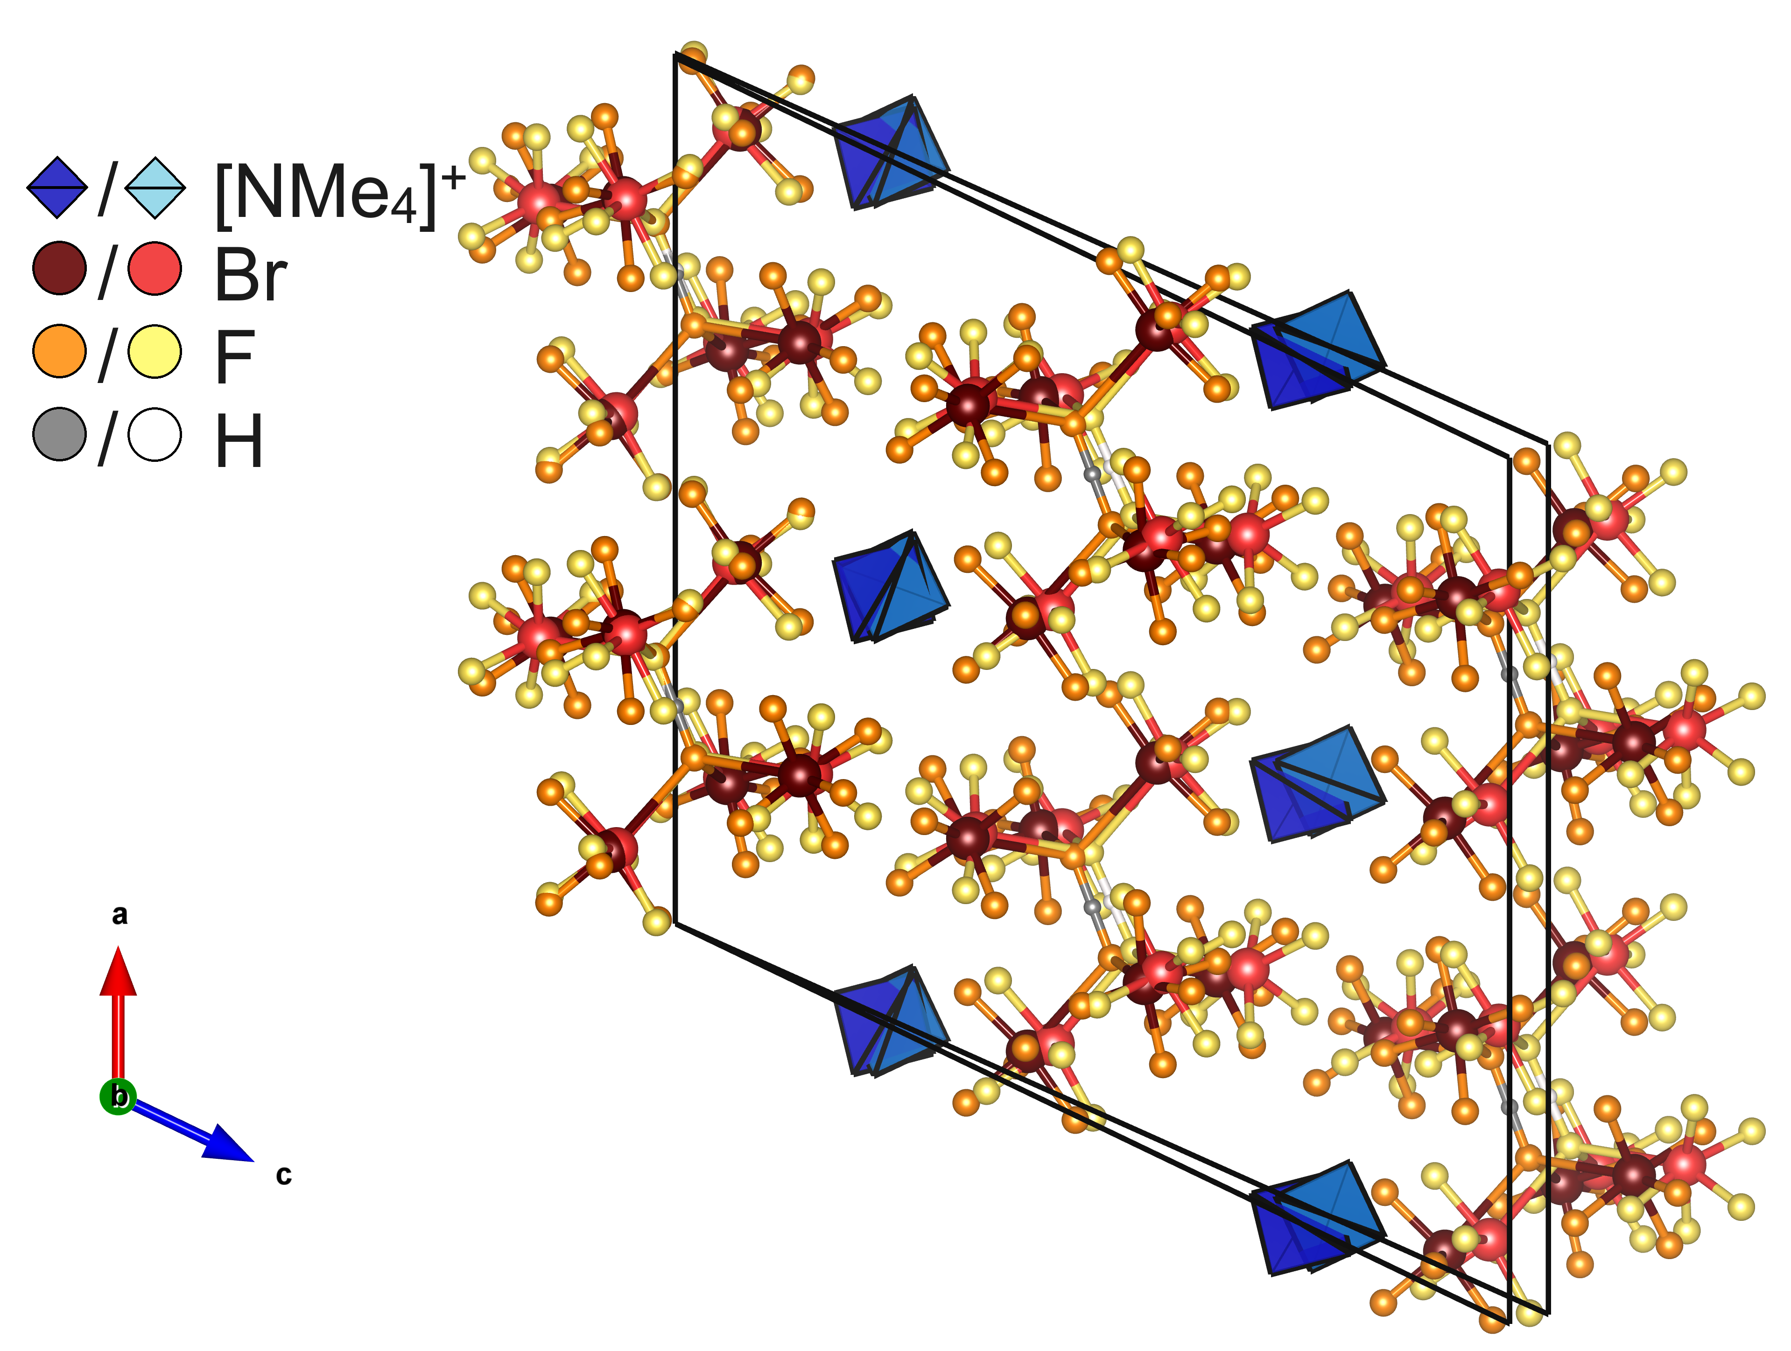
Figure S 1. Superimposed visualizations of the X-ray crystal structure (strong colored atoms and polyhedra) and the optimized structure (pale colored atoms and polyhedral) of [NMe₄][(BrF₅)₆(HF₂)]. Atoms are shown as spheres with arbitrary radii. The tetramethylammonium ions are shown as polyhedra. The disorder in the X-ray crystal structure is not shown for better clarity, instead the averaged structure of both orientations of the tetramethylammonium ions is shown.

Visualisation of the X-ray crystal structure of Cs₂[(BrF₅)₆(HF₂)(H₂F₃)] in comparison to the optimized solid-state structure
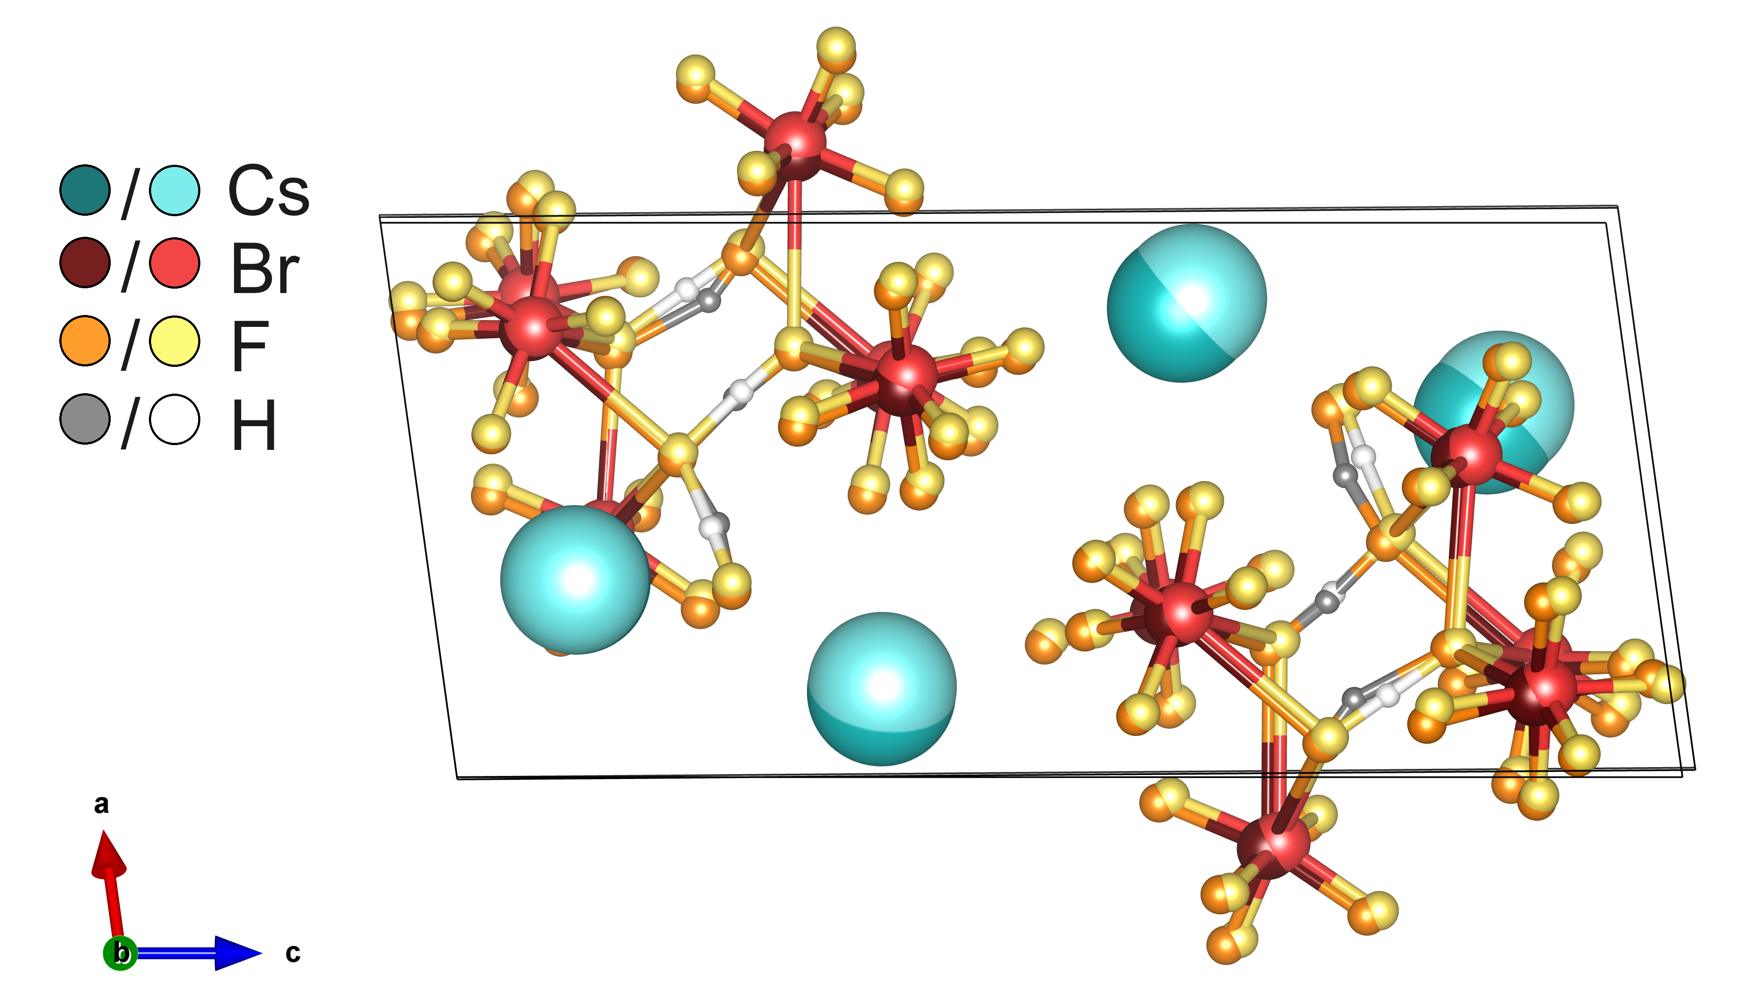
Figure S 2. Superimposed visualizations of the X-ray crystal structure (strong colored atoms and polyhedra) and the optimized structure (pale colored atoms and polyhedral) of Cs₂[(BrF₅)₆(HF₂)(H₂F₃)]. Atoms are shown as spheres with arbitrary radii.

Band assignment for the Raman spectra

Band assignment for the Raman spectrum of [NMe₄][(BrF₅)₆(HF₂)]
Table S11. Band assignment for the calculated Raman spectrum of [NMe₄][(BrF₅)₆(HF₂)]. The notation for band assignments is the following: ν – stretching, δ – deformation, s symmetric, as – asymmetric. vw – very weak, w – weak, m – medium, s –strong, vs – very strong. The band assignment is derived from visual inspection of the calculated normal modes using the visualization tool CRYSPLOT.^{[10]}
ν(observed) / cm^{–1} | ν(calculated) / cm^{–1} | Assignment
3050(w) | 3216, 3210, 3204 | NMe₄: ν_{as}(CH₃)
2989(m) | 3104 | NMe₄: ν_{s}(CH₃)
2962(w) | – | [NMe₄]⁺: 2nd order vibrations^{[11,12]}
2930(m) | – | [NMe₄]⁺: 2nd order vibrations^{[11,12]}
2900(vw) | – | [NMe₄]⁺: 2nd order vibrations^{[11,12]}
2872(vw) | – | [NMe₄]⁺: 2nd order vibrations^{[11,12]}
2826(w) | – | [NMe₄]⁺: 2nd order vibrations^{[11,12]}
1451(m) | 1491 | [NMe₄]⁺: δ_{as}(CH₃) combined with  [HF₂]–: ν_{as}(H–F) pendulum motion
1420(vw) | 1448 | [NMe₄]⁺: δ_{s}(CH₃) combined with  [HF₂]–: ν_{as}(H–F) pendulum motion
1288(vw) | 1326 | [NMe₄]⁺: δ_{as}(CH₃) combined with δ_{as}(N–C)
1168(vw) | 1195 | [NMe₄]⁺: δ_{as}(CH₃)
952(w) | 982 | [NMe₄]⁺: ν_{as}(N–C)
754(m) | 779 | [NMe₄]⁺: ν_{s}(N–C)
685(vs) | 720 | BrF₅: ν_{s}(Br–F_{ap}), ν_{s}(Br–F_{eq}) in phase stretching
625(vw) | 643 | BrF₅: ν_{as}(Br–F_{eq}), combined with  [HF₂]–: ν_{as}(H–F) pendulum motion
566(s) | 586 | BrF₅: ν_{s}(Br–F_{ap}), ν_{s}(Br–F_{eq}) out of phase stretching combined with  [HF₂]–: ν_{as}(H–F) pendulum motion
529(s) | 542 | BrF₅: ν_{s}(Br–F_{eq}) out of phase stretching
412(m) | 434 | BrF₅: wagging δ(F_{ap}–Br–F_{eq})
372(m) | 385 | BrF₅: umbrella mode δ(Br–F_{eq}) combined with  [NMe₄]⁺: δ(C–N–C)
308(m) | 320 | BrF₅: scissoring mode δ(Br–F_{eq}) combined with  [NMe₄]⁺: δ(CH₃) twisting motion
238(w) | 251 | BrF₅: δ(Br–F_{eq}) wagging
233(w) | 239 | BrF₅: δ(Br–F_{eq}) wagging

Calculated Raman spectrum and band assignment of Cs₂[(BrF₅)₆(HF₂)(H₂F₃)]
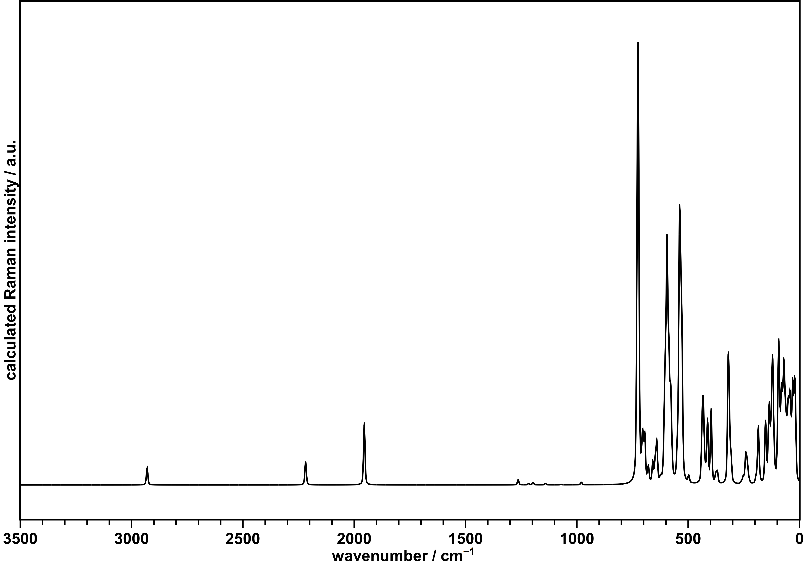
Figure S3. Raman spectrum of Cs₂[(BrF₅)₆(HF₂)(H₂F₃)] calculated on DFT-PBE0-TZVP/SVP level of theory using the CRYSTAL23^{[1]} software.

Table S12. Band assignment for the calculated Raman spectrum (>150 cm^{–1}) of Cs₂[(BrF₅)₆(HF₂)(H₂F₃)]. The notation for band assignments is the following: ν – stretching, δ – deformation, s symmetric, as – asymmetric. The band assignment is derived from visual inspection of the calculated normal modes using the visualization tool CRYSPLOT.^{[10]}
ν(calculated) / cm^{–1} | Assignment
2931 | [H₂F₃]–: ν_{as}(F–H)
2217 | [H₂F₃]–: ν_{as}(F–H)
1264 | [H₂F₃]–: δ(F–H–F)  [HF₂]–: δ(F–H–F)
1217 | [H₂F₃]–: δ(F–H–F)  [HF₂]–: δ(F–H–F)
1198 | [HF₂]–: δ(F–H–F)
1142 | [H₂F₃]–: δ(F–H–F)
1072 | [H₂F₃]–: δ(F–H–F)
981 | [H₂F₃]–: δ(F–H–F)
725 | BrF₅: ν_{s}(Br–F_{ap}), ν_{s}(Br–F_{eq}) in phase stretching
705, 695 | BrF₅: ν_{s}(Br–F_{ap})
679 | BrF₅: ν_{s}(Br–F_{eq}) out of phase stretching
659 | BrF₅: ν_{as}(Br–F_{eq})
641 | BrF₅: ν_{as}(Br–F_{eq})
595 | BrF₅: ν_{s}(Br–F_{ap}), ν_{s}(Br–F_{eq}) out of phase stretching
538 | BrF₅: ν_{s}(Br–F_{eq}) out of phase stretching
433 | BrF₅: wagging δ(F_{ap}–Br–F_{eq})
412 | [H₂F₃]–: ν_{as}(F···F)
397 | BrF₅: umbrella mode δ(Br–F_{eq})
377, 371 | BrF₅: umbrella mode δ(Br–F_{eq})
320 | BrF₅: scissoring mode δ(Br–F_{eq})
242 | BrF₅: δ(Br–F_{eq}) wagging
186 | [H₂F₃]–: δ(F···F···F)
153 | ν(Br–F) stretching of Br–F contacts between [H₂F₃]– and [HF₂]– anions and the surroundimg BrF₅ molecules
The symmetric stretch of the HF₂⁻ anion is not visible at 600 cm⁻¹ as too many other bands are present.

NMR spectra of [NMe₄][HF₂]
The [NMe₄][HF₂] used for the synthesis of [NMe₄][(BrF₅)₆(HF₂)] was initially believed to be tetramethylammonium fluoride, [NMe₄]F, but was found to be essentially pure [NMe₄][HF₂], as evidenced by ¹H and ¹⁹F NMR spectroscopy. Figure S 4 and S 5 show the corresponding spectra. The compound had been stored together with other fluorides in a closed container inside the glove box for several years. Assuming the high affinity of [NMe₄]F to hydrogen fluoride, it is likely that the compound had slowly reacted with atmospheric HF that had built up inside the storage container by the time.
The NMR spectra were recorded using a Bruker AvanceNeo 300 NB NMR spectrometer.
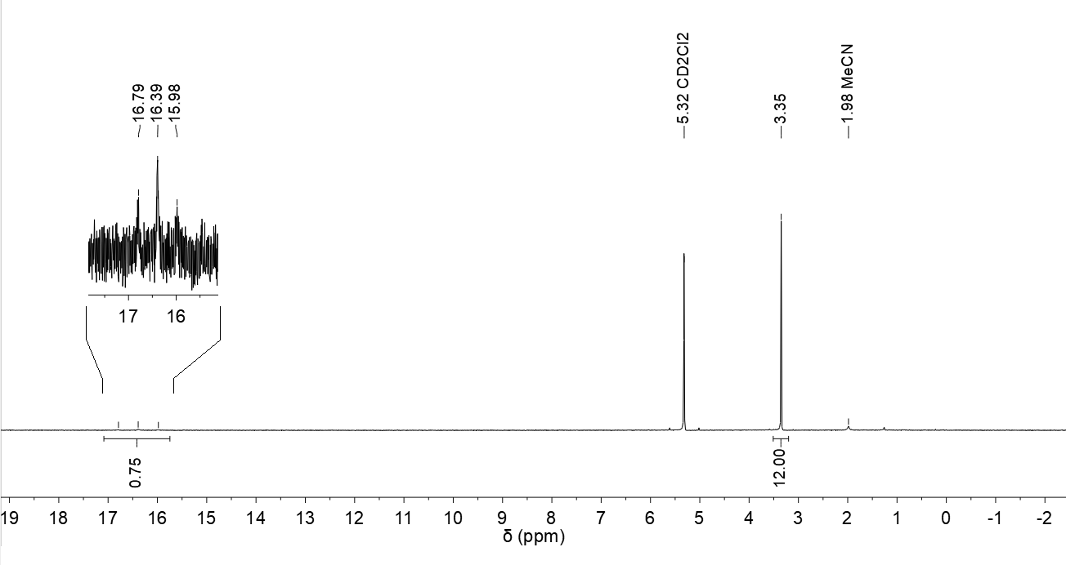
Figure S 4. ¹H NMR spectrum of [NMe₄][HF₂]. ¹H NMR (300 MHz, CD₂Cl₂) δ = 16.39 (t, ²J_{HF} = 124.3 Hz, 1H, HF₂), 3.35 (s, 12 H, N(CH₃)₄).
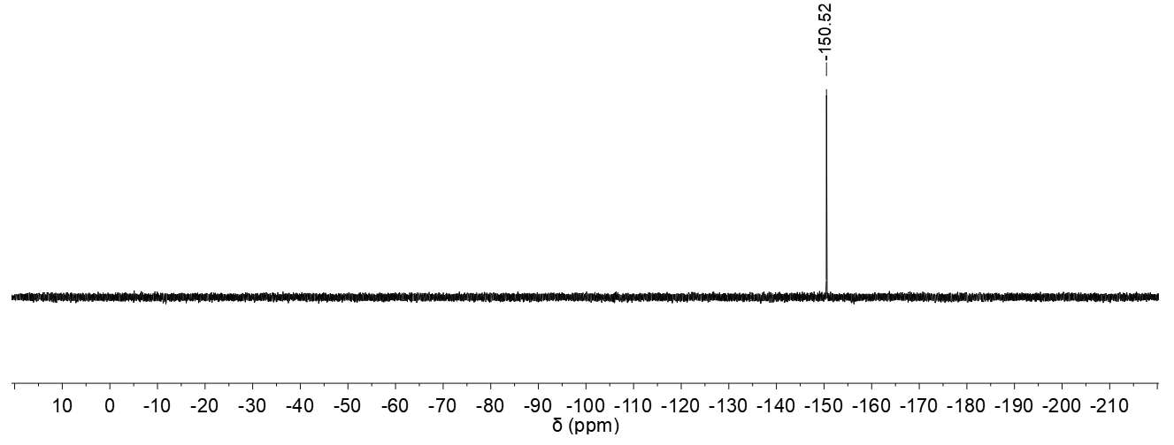
Figure S 5. ¹⁹F NMR spectrum of [NMe₄][HF₂]. ¹⁹F NMR (283 MHz, CD₂Cl₂) δ = –150.52 (s, 1F, HF₂).

References
[1] A. Erba, J. K. Desmarais, S. Casassa, B. Civalleri, L. Donà, I. J. Bush, B. Searle, L. Maschio, L. Edith-Daga, A. Cossard, C. Ribaldone, E. Ascrizzi, N. L. Marana, J.-P. Flament, B. Kirtman, J. Chem. Theory Comput. 2023, 19, 6891–6932.
[2] S. I. Ivlev, K. Gaul, M. Chen, A. J. Karttunen, R. Berger, F. Kraus, Chem. - Eur. J. 2019, 25, 5793–5802.
[3] A. J. Karttunen, T. Tynell, M. Karppinen, J. Phys. Chem. C 2015, 119, 13105–13114.
[4] S. S. Rudel, T. Graubner, A. J. Karttunen, F. Kraus, Z. Anorg. Allg. Chem. 2020, 646, 1396–1402.
[5] R. E. Stene, B. Scheibe, A. J. Karttunen, W. Petry, F. Kraus, Eur. J. Inorg. Chem. 2019, 2019, 3672–3682.
[6] F. Weigend, R. Ahlrichs, Phys. Chem. Chem. Phys. 2005, 7, 3297–3305.
[7] M. S. Kuklin, K. Eklund, J. Linnera, A. Ropponen, N. Tolvanen, A. J. Karttunen, Molecules 2022, 27, 874.
[8] B. Scheibe, R. Haiges, S. I. Ivlev, A. J. Karttunen, U. Müller, K. O. Christe, F. Kraus, Eur. J. Inorg. Chem. 2020, 2020, 4483–4496.
[9] H. T. Stokes, D. M. Hatch, J. Appl. Cryst. 2005, 38, 237–238.
[10] “CRYSPLOT - A modern and easy to use visualization environment for plotting properties of crystalline solids as computed by means of the CRYSTAL code,” can be found under http://crysplot.crystalsolutions.eu/index.html, 2022.
[11] G. Kabisch, J. Raman Spectrosc. 1980, 9, 279–285.
[12] G. Kabisch, M. Klose, J. Raman Spectrosc. 1978, 7, 311–315.

