Electronic Supplementary Information for
A new multifunctional phenanthroline-derived probe for colorimetric sensing of Fe²⁺ and ﬂuorometric sensing of Zn²⁺
Chen-Yu Qi^{†1}, Xue Dong^{†1}, Ying-Cui Fan¹, Jun-Ru Yuan¹, Zi-Jie Song¹, Yong-Han Zhang¹, Ya-Ping Xie¹, Feng Yang¹, Jian-Ping Ma^{2,*}, Meng Wang^{1*}, Jie Qin^{1*}
¹ School of Life Sciences and Medicine, Shandong University of Technology, Zibo 255049, P. R. China
² College of Chemistry, Chemical Engineering and Materials Science, Key Laboratory of Molecular and Nano Probes, Shandong Normal University, Jinan 250014, P. R. China
* Corresponding author: Jian-Ping Ma, E-mail address: xxgk123@163.com
Meng Wang, E-mail address:wm902012@163.com
Jie Qin qinjiesdut@163.com
Tel.: 0086-533-2786607; Fax: 0086-533-2781329.
† These authors contributed equally to this work.

Table S1 Crystallographic data for 1.
 | 1
Empirical formula | C₃₇H₂₈N₆O
M_{r} | 572.65
crystsyst | triclinic
Space group | P-1
a (Å) | 9.9561(4)
b (Å) | 11.0295(5)
c (Å) | 15.2669(8)
α (°) | 69.839(4)
β (°) | 82.053(4)
γ (°) | 88.512(4)
V (Å³) | 1558.22(13)
Z | 2
ρ_{c} (gcm⁻³) | 1.221
F(000) | 600
T / K | 298(2) 164(2)
μ(Mo-Kα)/ mm⁻¹ | 0.602
Data / param. / restr. | 5526 /400 / 0
GOF (F²) | 1.041
R₁ª, ^{b}wR₂ (I>2σ(I)) | 0.0444 / 0.1165
Large diff. peak / hole (e Å⁻³) | 0.243 / -0.247
ª R₁ = Σ||C| − |F_{c}||/ΣF_{o}|. ^{b} wR₂ = [Σw(F_{o}² − F_{c}²)²/Σw(F_{o}²)]^{1/2}
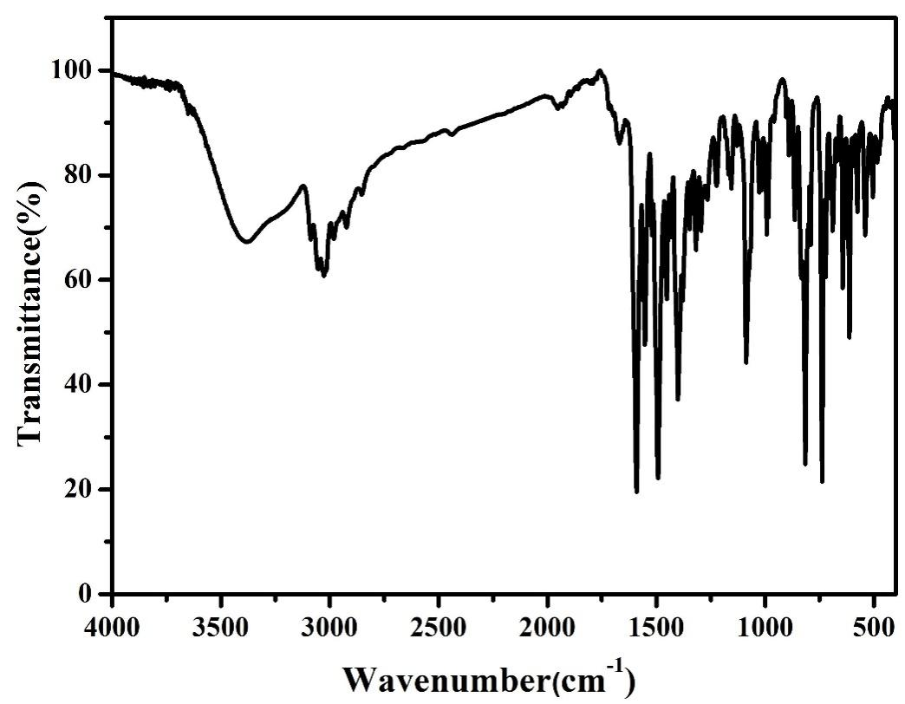
Figure S1. IR spectrum of 1.
Figure S2. ¹H NMR spectrum of 1 in CDCl₃.
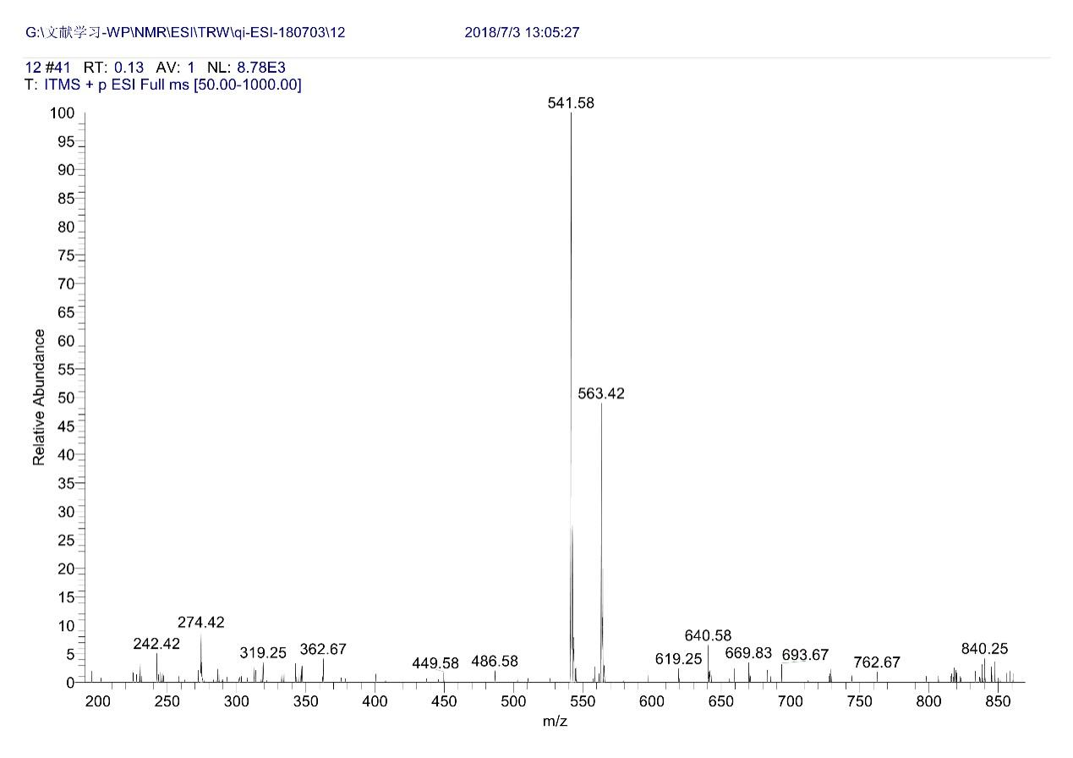
Figure S3. ESI-MS spectrum of 1.
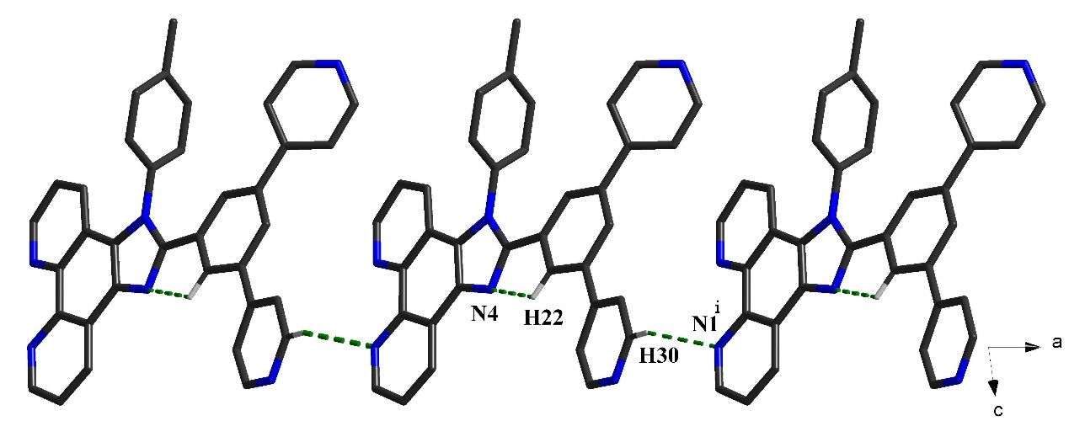
Figure S4. The hydrogen-bond-driven 1D chain extended in crystallographic a axis of 1 (symmetry code: (i) 1+x, 1+y, z).
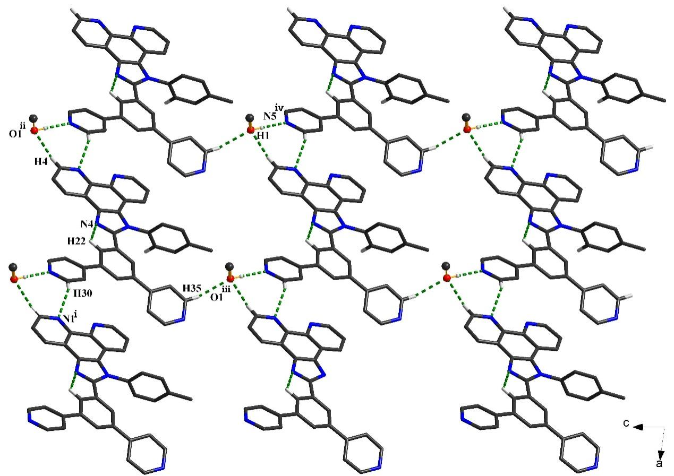
Figure S5. The hydrogen-bond-driven 2D sheet of 1 extended in crystallographic ac plane. (symmetry code: (ii) -1+x, y, 1+z; (iii) x, 1+y, z; (iv) x, -1+y, -1+z).
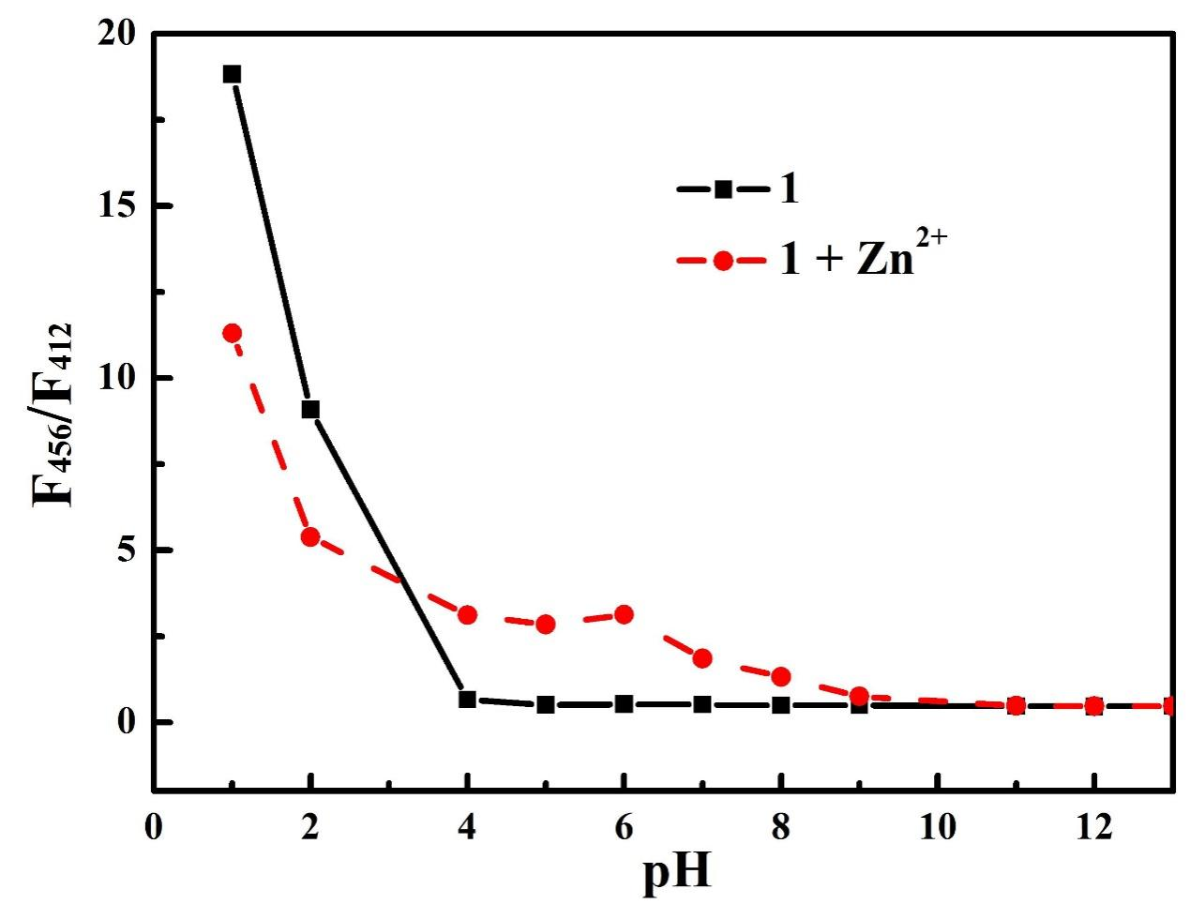
Figure S6. Emission ratio F₄₅₆/F₄₁₂ of 1 and 1-Zn²⁺ complex (50 μM) in EtOH-HEPES buffer at diﬀerent pH.
Scheme S1 Proposed coordination mechanism of 1 with Fe²⁺/Zn²⁺.

