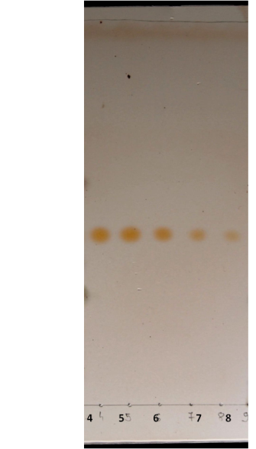
Figure S1. TLC chromatogram of estradiol at different concentration range (4 – 125 μM, 5 – 100 μM, 6 – 75 μM, 7 – 50 μM, 8 – 25 μM). Toluene and ethyl acetate (2:1) solvent were used for development and spots were visualized by spraying with 50% H₂SO₄ and heating.
Figure S2. Standard curve of peak areas from TLC-densitometry vs. concentrations of estradiol (25, 50, 75, 100 and 125 μM).

Figure S3. Standard curve of fluorescence intensity of alkali product vs. NADPH concentrations (2.5, 25, 62.5, 125, 250 μM)

