New Compounds Derived from Nitrophenol Synthesis, Structural Investigation and Anticorrosion Properties
Ali Mahdi Farhan,^{1,*} Hanaa Kadtem Egzar,² and Hawraa Mahdi Alabidi²
¹ Ministry of Education, Al-Najaf, Iraq
² Department of Chemistry, College of Science- University of Kufa
*Corresponding author: E-mail: aliphd256@gmail.com

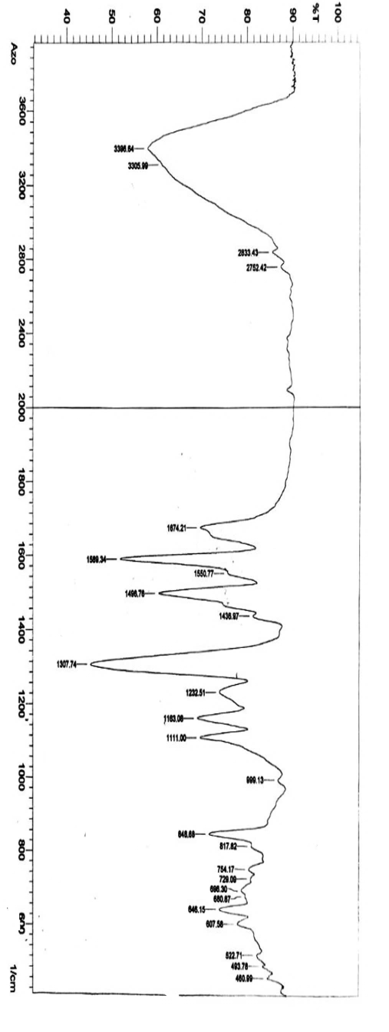
Figure S1. FT-IR of azo compound 3.
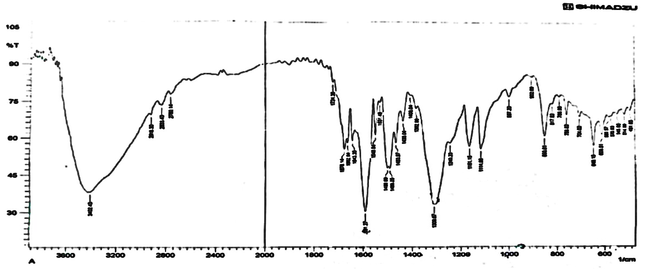
Figure S2. FT-IR of azo-Schiff derivative 4.
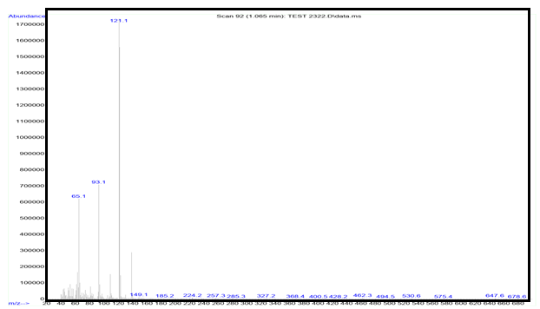
Figure S3. Mass spectrum of the azo compound 3.
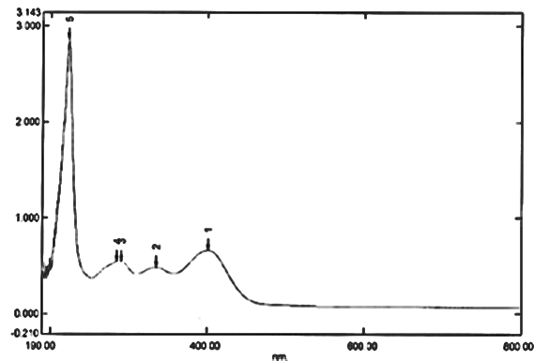
Figure S4. UV-Vis spectrum of the azo compound 3 (401 nm).
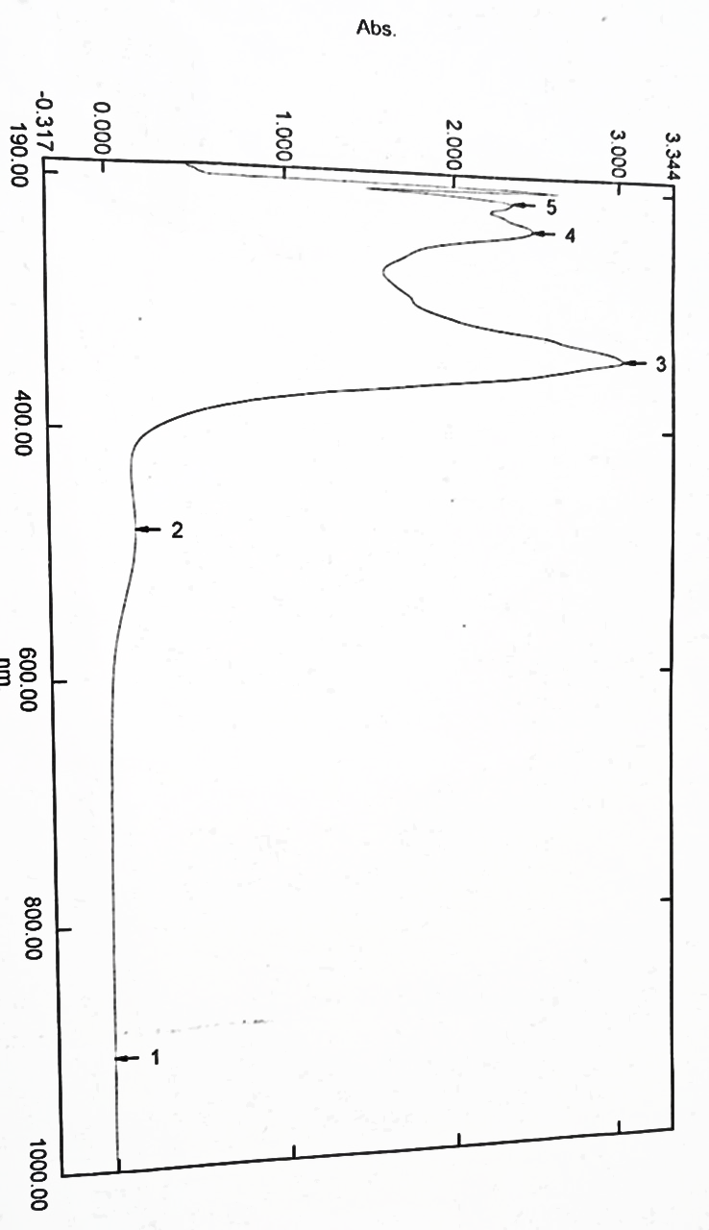
Figure S5. UV-Vis spectrum of the azo-Schiff compound 4.

