Synthesis, Characterization and Biological Activity Evaluation of Novel Quinoline Derivatives as Antibacterial Drug
Maryam Jamaal Kassar¹ , Mohammed Oday Ezzat *^{,2}
¹ Department of Chemistry, College of Education for Pure Sciences, University of Anbar, Ramadi, Anbar, Iraq.
E-mail: mar13u4015@uoanbar.edu.iq
² Department of Chemistry, College of Education for Women, University of Anbar, Ramadi, Anbar, IRAQ.
*Corresponding author E-mail: edw.mohamed_oday@uoanbar.edu.iq.; (https://orcid.org/0000-0001-6671-0417 ).

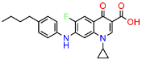
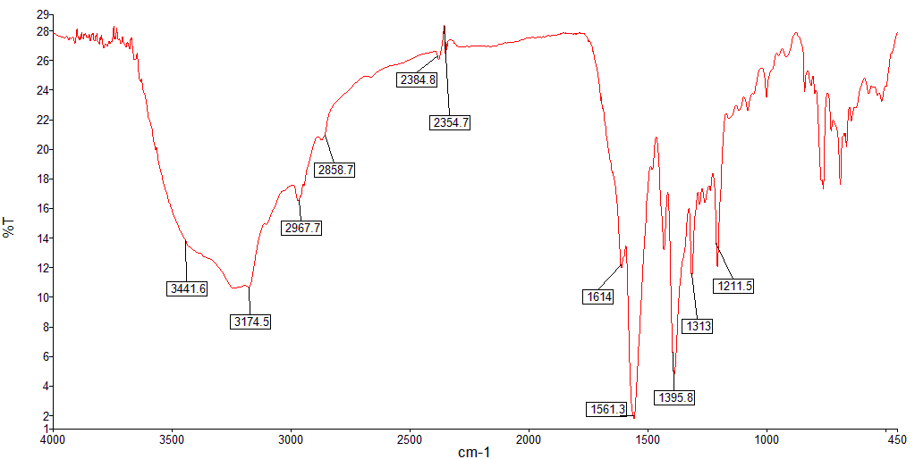
Figure S1. Infrared spectrum of 4

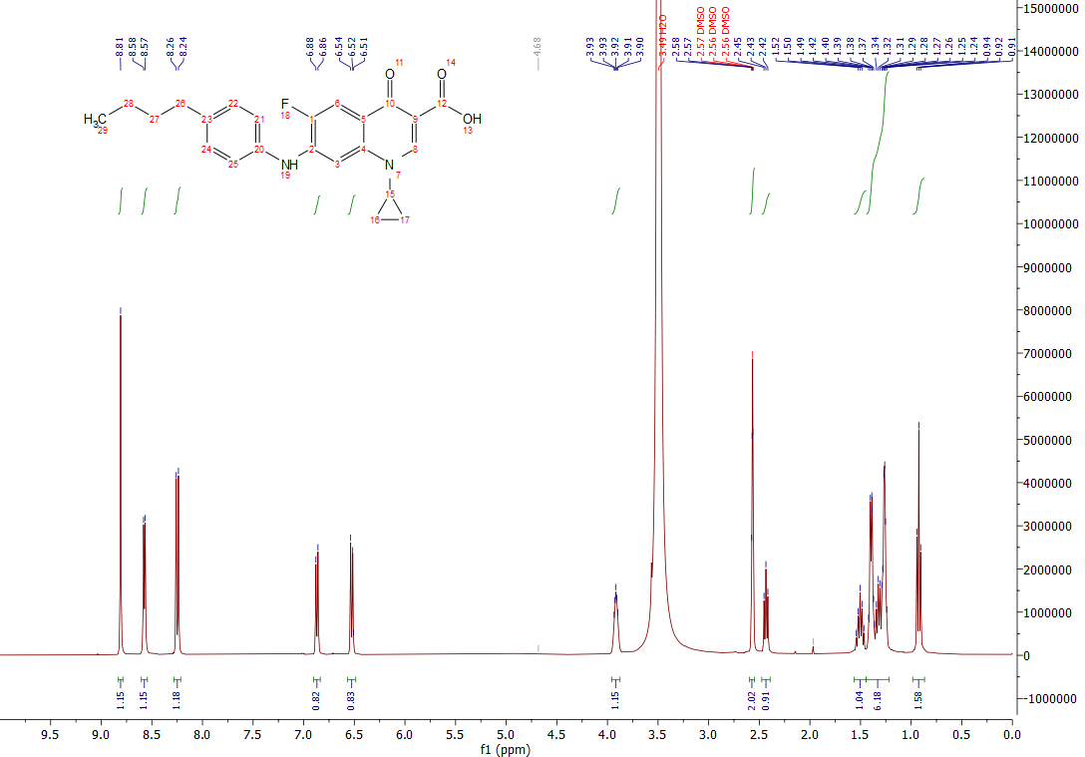
Figure S2. ¹H NMR spectrum of 4

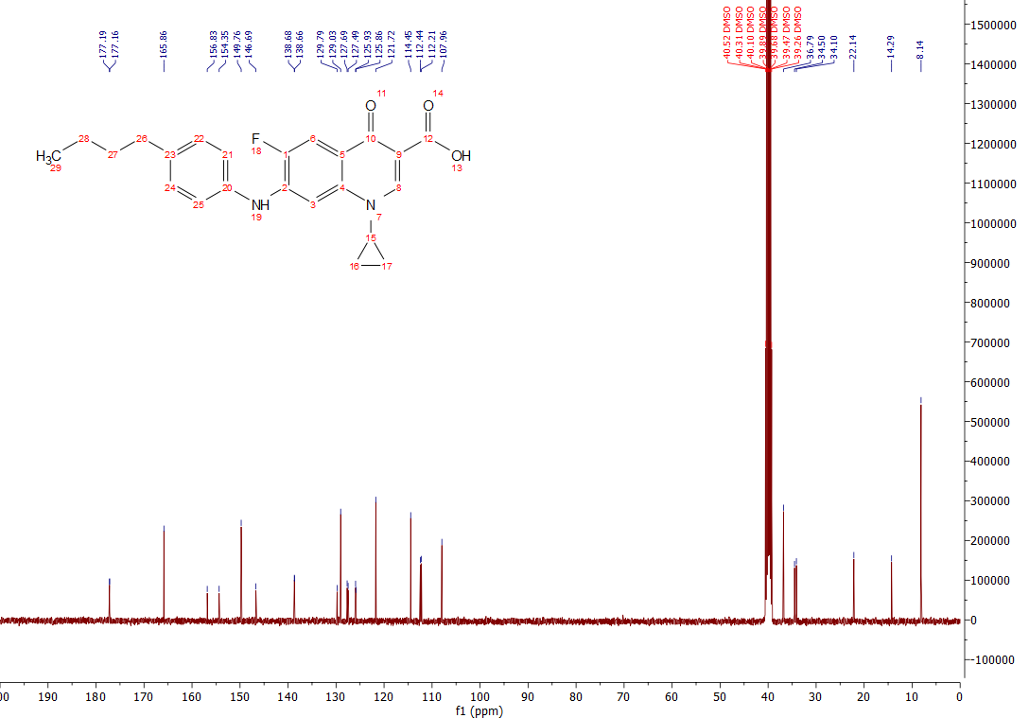
Figure S3. ¹³C NMR spectrum of 4

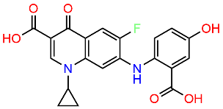
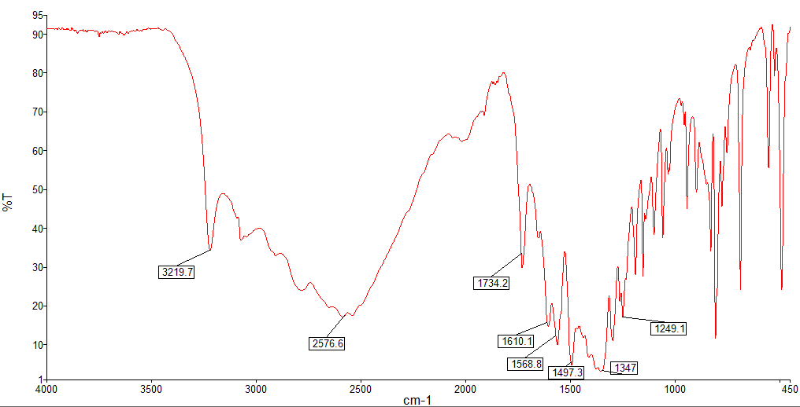
Figure S4. Infrared spectrum of 1

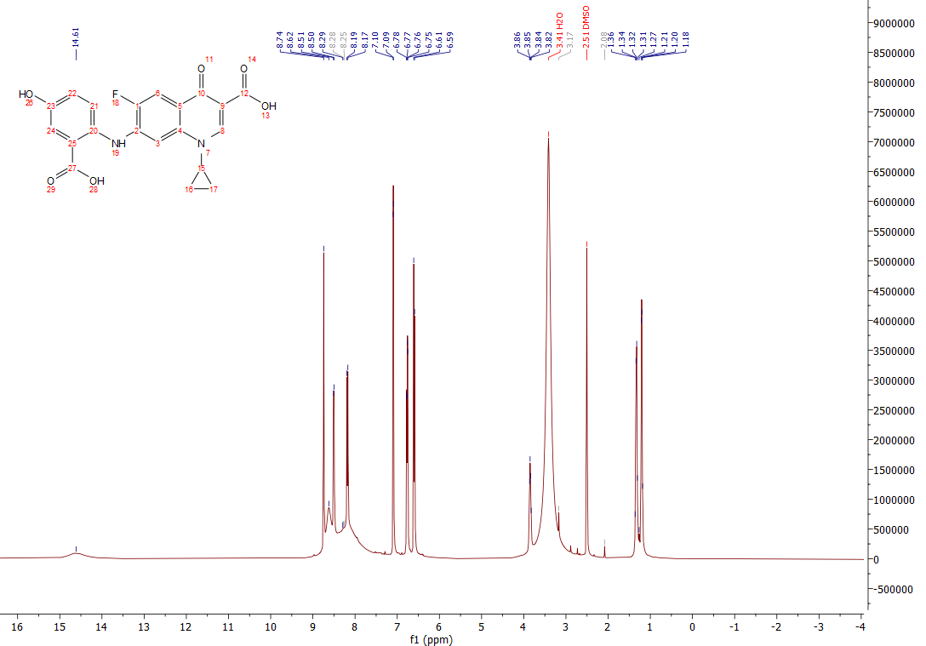
Figure S5. ¹H NMR spectrum of 1

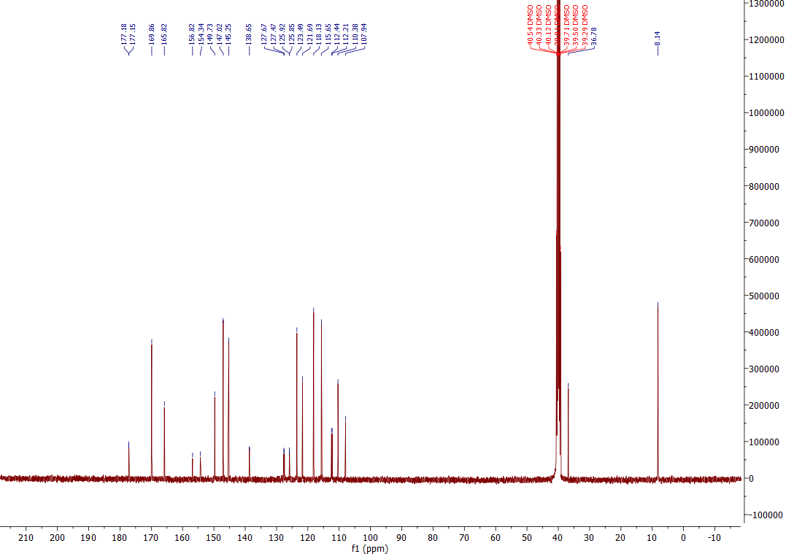
Figure S6. ¹³C NMR spectrum of 1

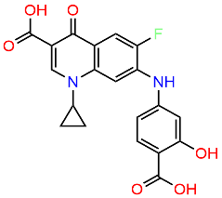
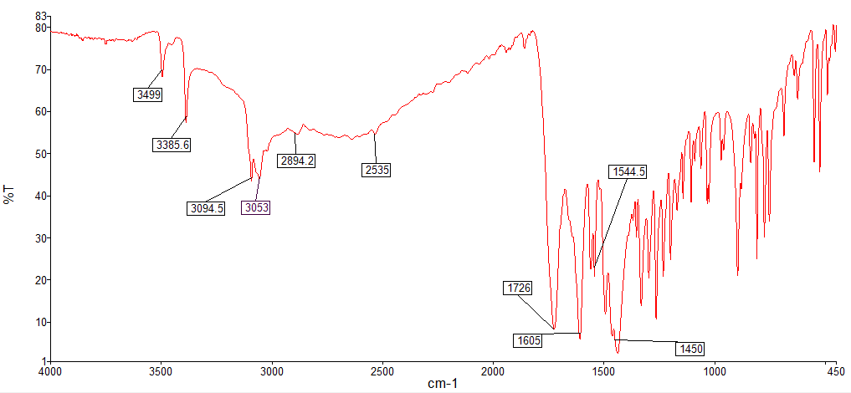
Figure S7. Infrared spectrum of 2

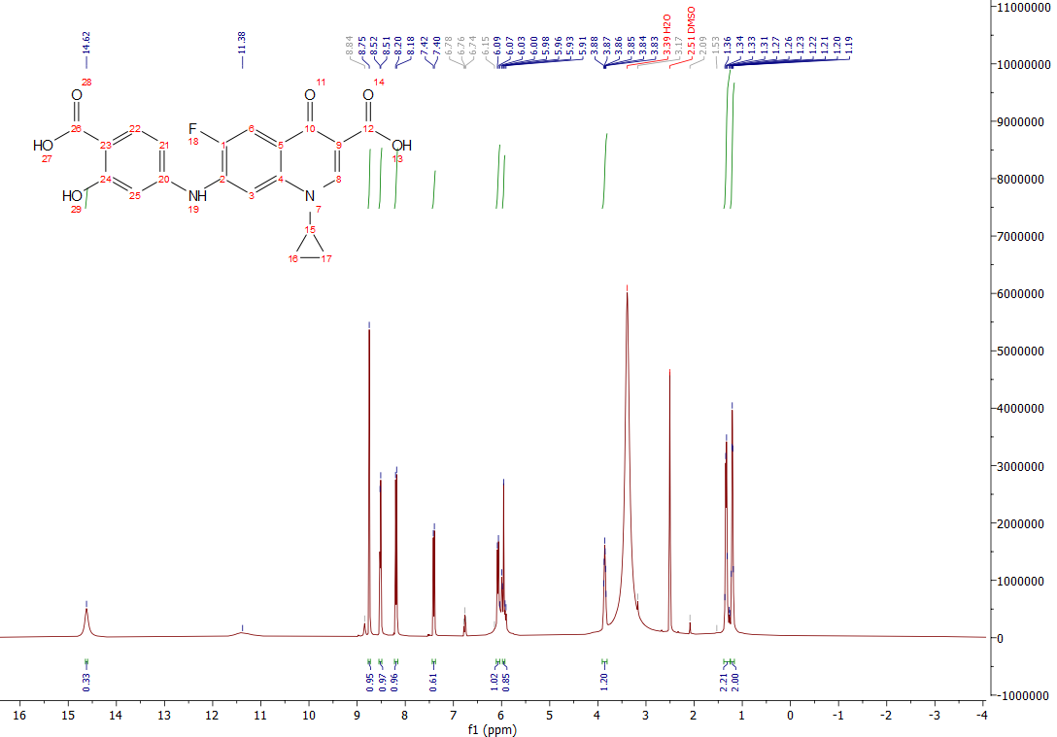
Figure S8. ¹H NMR spectrum of 2

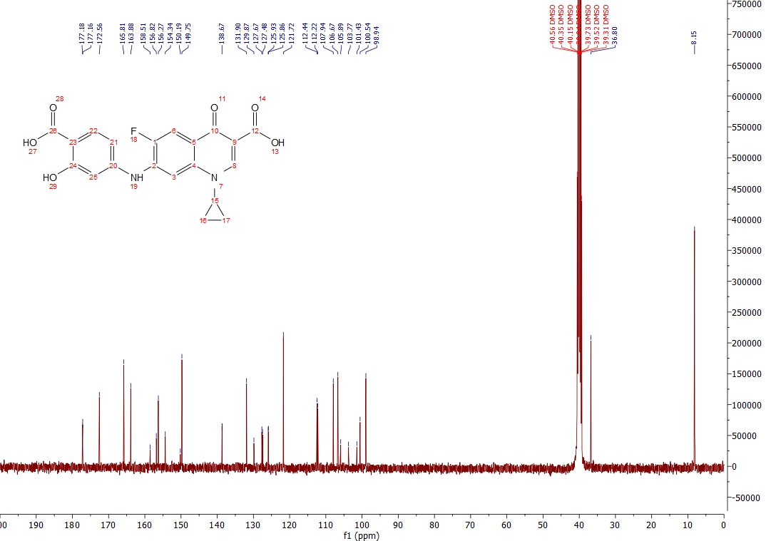
Figure S9. ¹³C NMR spectrum of 2

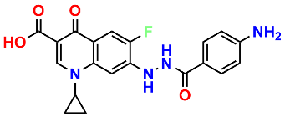
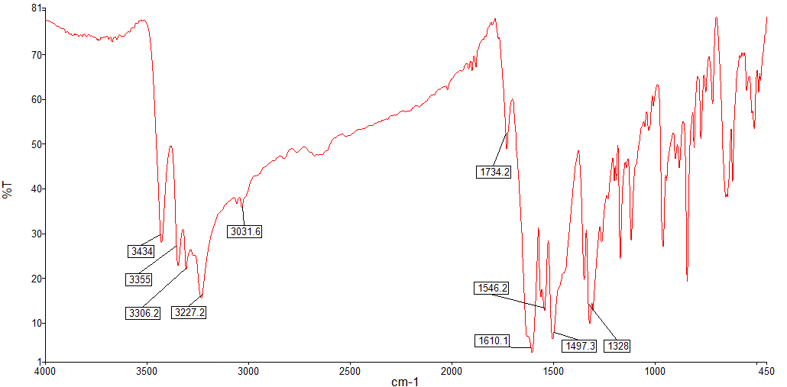
Figure S10. Infrared spectrum of 3

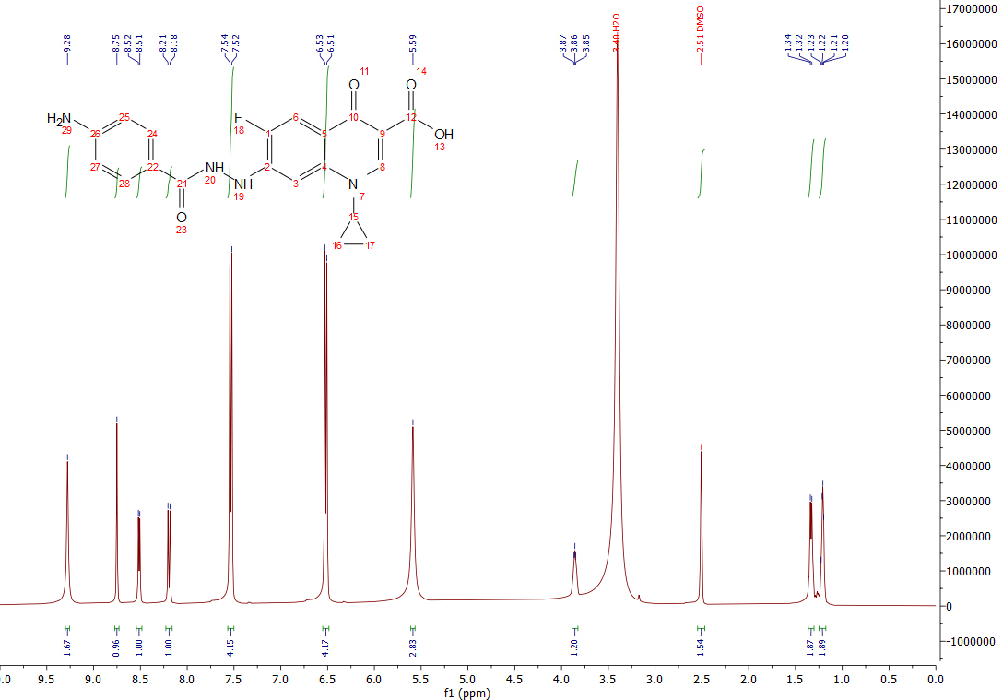
Figure S11. ¹H NMR spectrum of 3

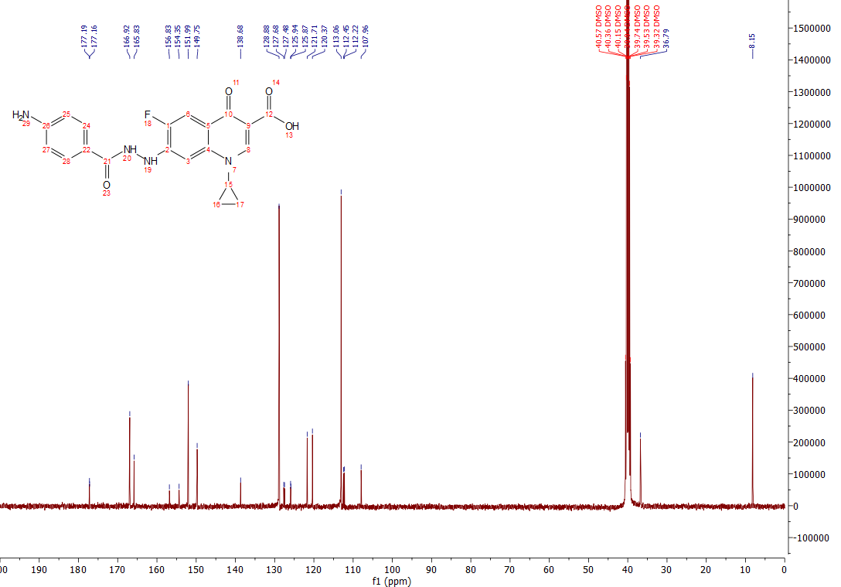Figure S12. ¹³C NMR spectrum of 3

