SUPPLEMENTARY MATERIAL

Synthesis of Novel cis-2-Azetidinones from Imines and Chloroacyl Chloride Using Triethylamine

Handan Can Sakarya,^{1,*} Aslı Ketrez²

¹Department of Chemistry, Faculty of Arts and Science, Eskişehir Osmangazi University, 26480 Eskişehir, Turkey.
²Department of Chemistry, Graduate School of Natural and Applied Sciences, Eskişehir Osmangazi University, 26480 Eskişehir, Turkey
* Corresponding author: E-mail: hsakarya@ogu.edu.tr
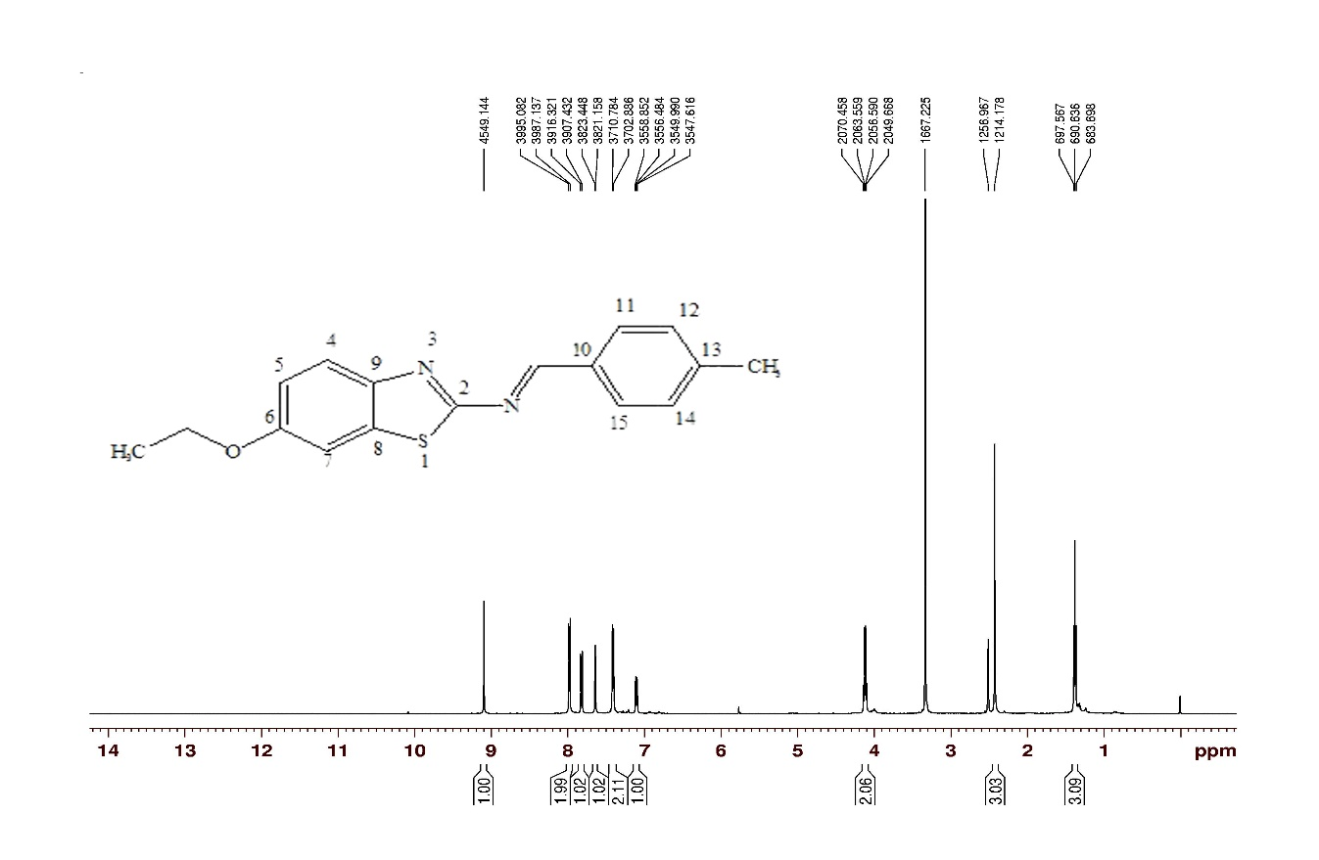
Fig. S1. ¹H NMR Spectrum of 6-ethoxybenzothiazol-2-yl-(4-methylbenzylidene)amine (1a)

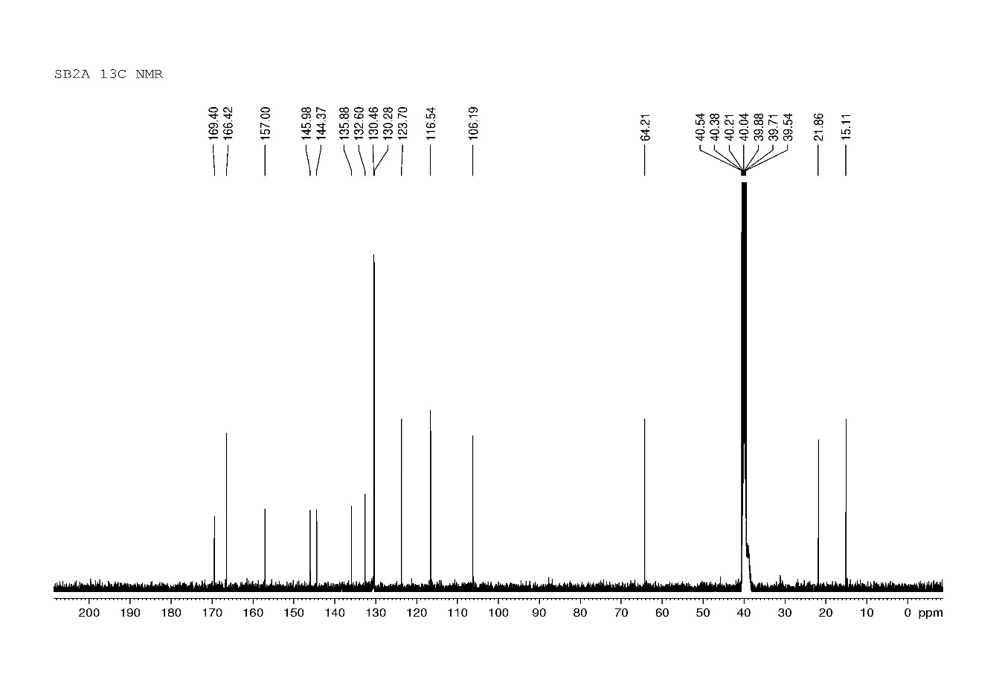
Fig. S2. ¹³C NMR Spectrum of 6-ethoxybenzothiazol-2-yl-(4-methylbenzylidene)amine (1a)

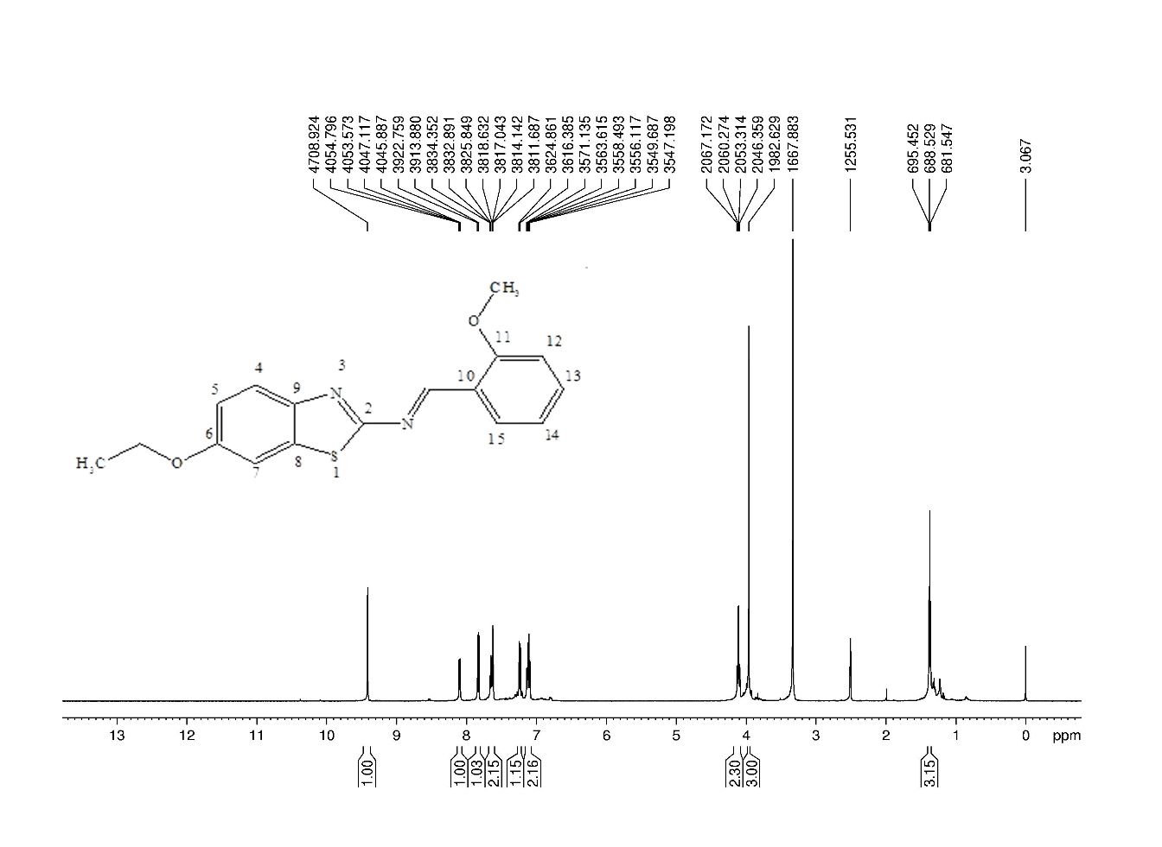
Fig. S3. ¹H NMR spectrum of 6-ethoxybenzothiazol-2-yl-(2-methoxybenzylidene)amine (1b)
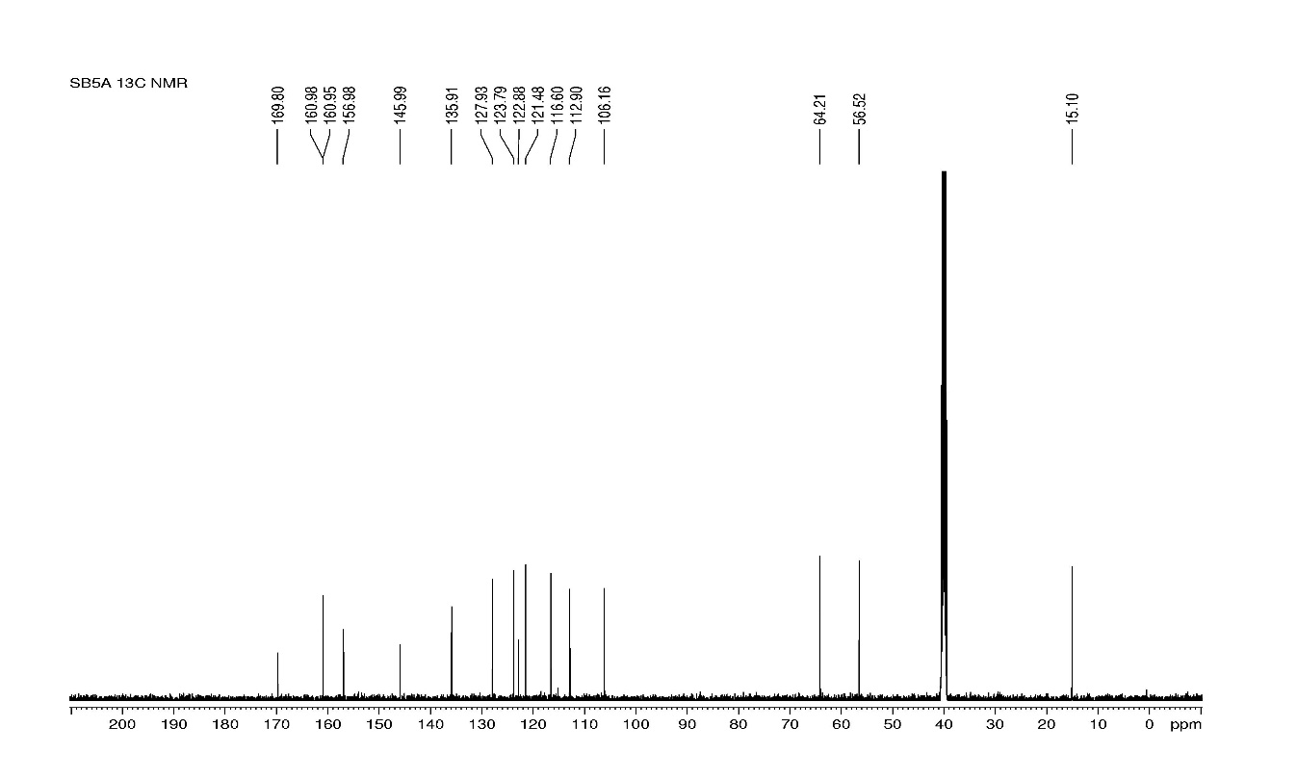
Fig. S4. ¹³C NMR spectrum of 6-ethoxybenzothiazol-2-yl-(2-methoxybenzylidene)amine (1b)
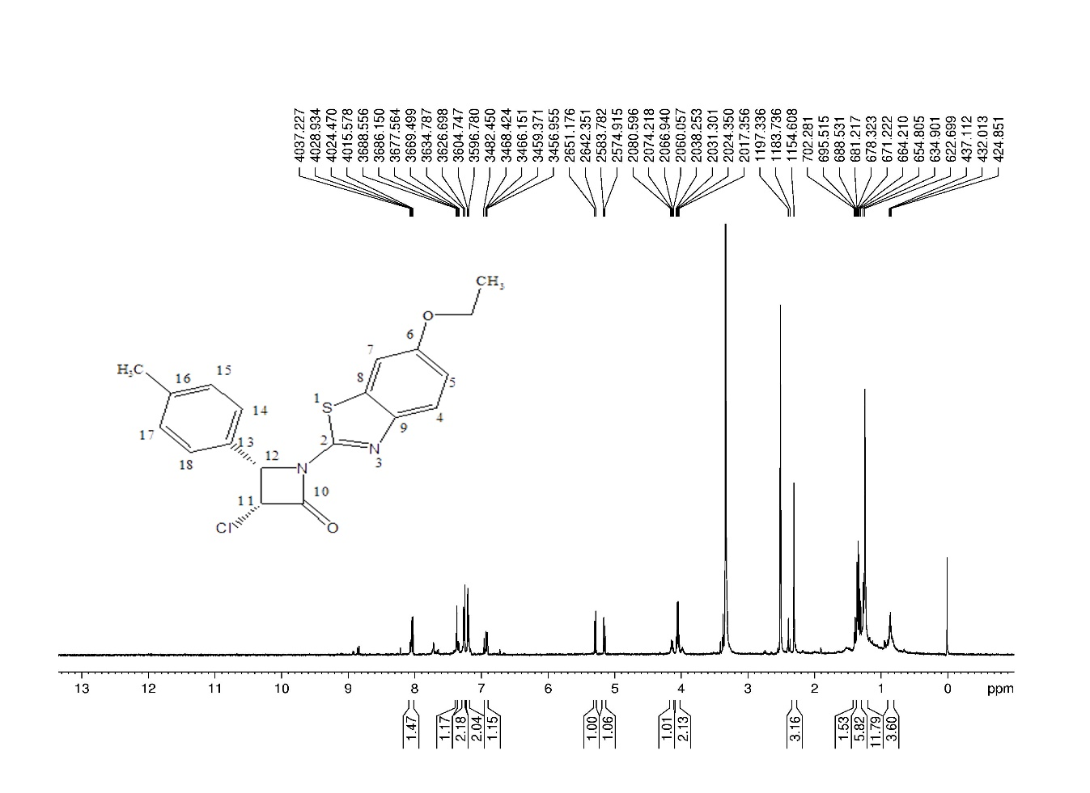

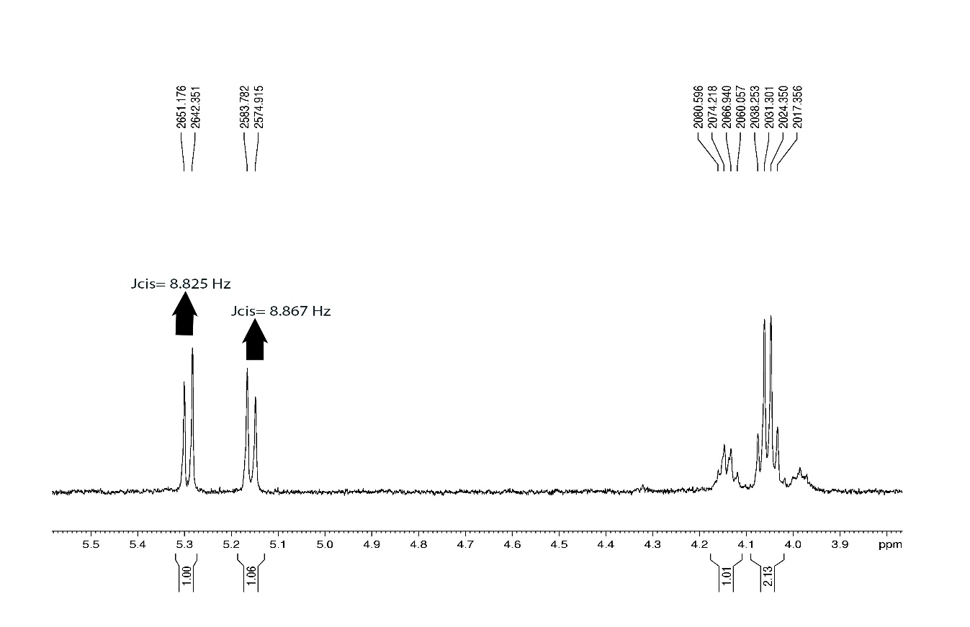
Fig. S5. ¹H NMR spectrum of 3-chloro-1-(6-ethoxybenzothiazol-2-yl)-4-para-tolylazetidin-2-one (2a)

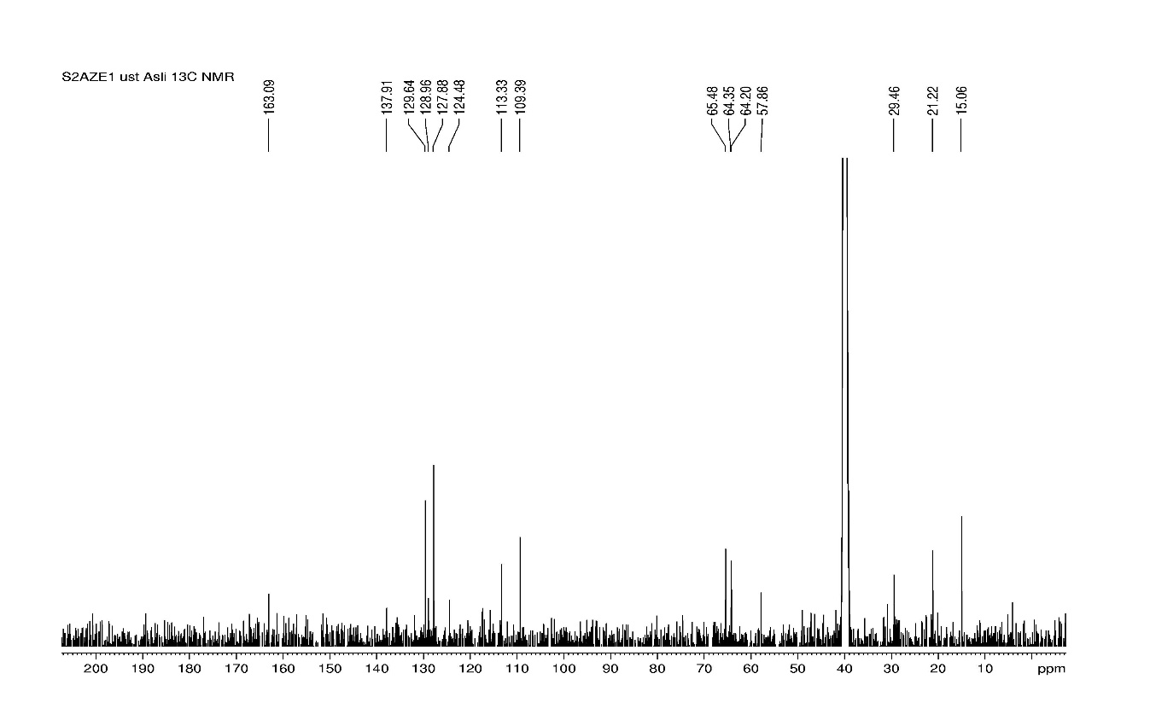
Fig. S6. ¹³C NMR spectrum of 3-chloro-1-(6-ethoxybenzothiazol-2-yl)-4-para-tolylazetidin-2-one (2a)

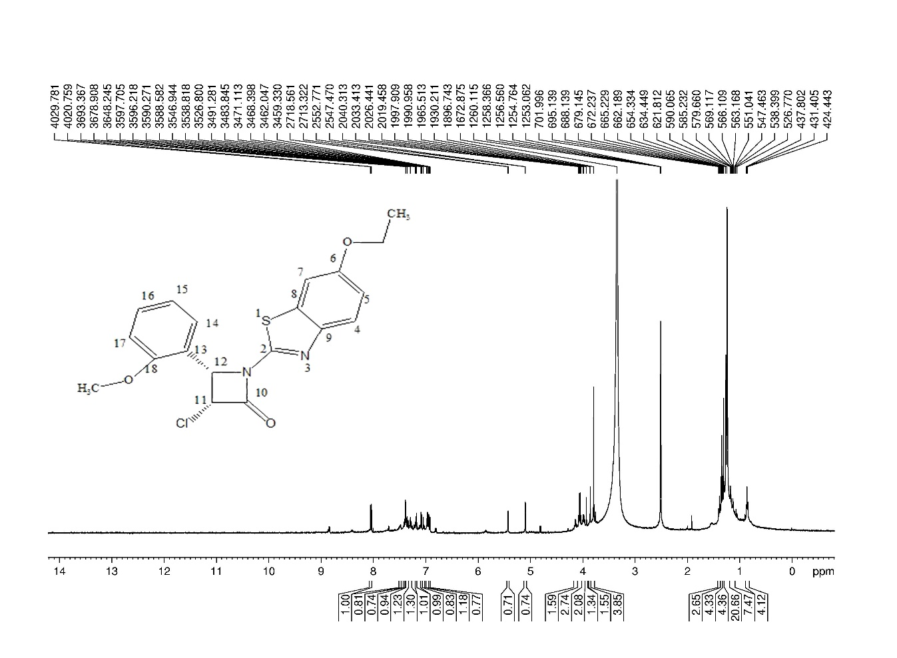
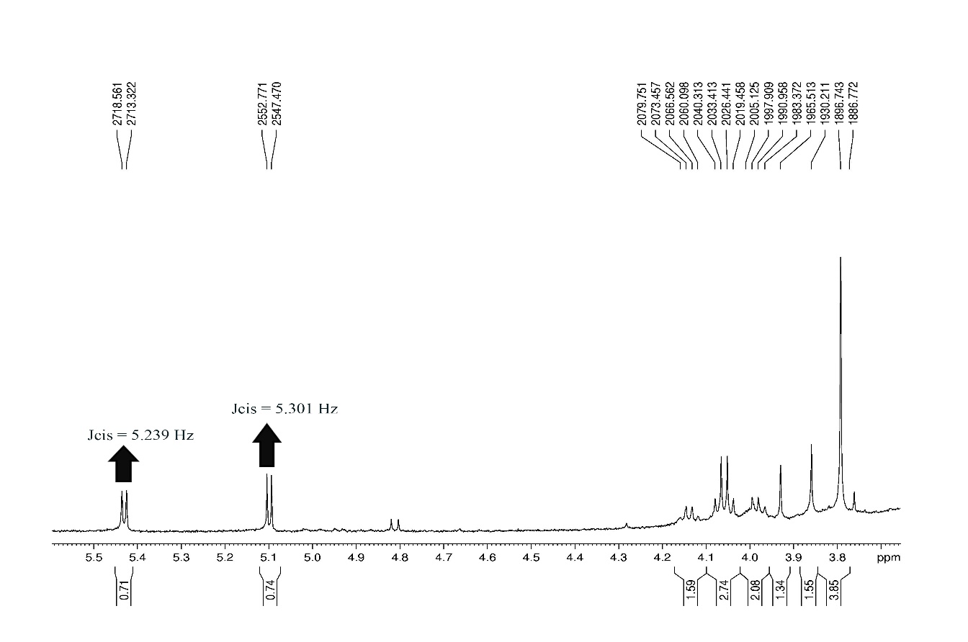
Fig. S7. ¹H NMR spectrum of 3-chloro-1-(6-ethoxybenzothiazol-2-yl)-4-(2-methoxyphenyl)azetidin-2-one (2b)
Fig. S8. ¹³C NMR spectrum of 3-chloro-1-(6-ethoxybenzothiazol-2-yl)-4-(2-methoxyphenyl)azetidin-2-one (2b)
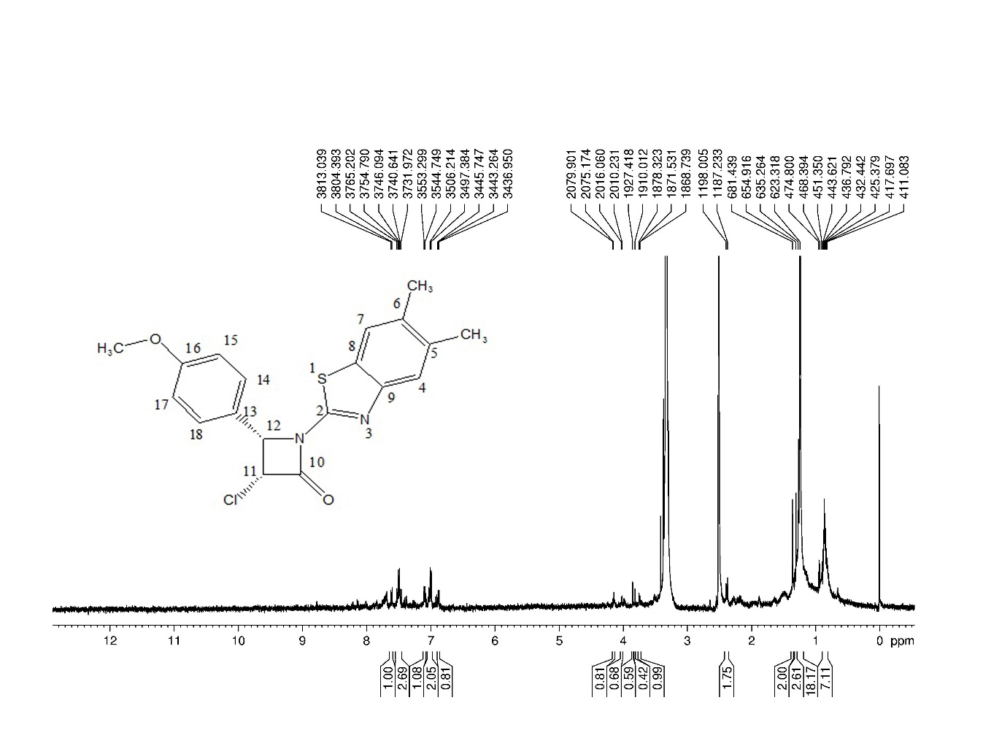
Fig. S9. ¹H NMR spectrum of 3-chloro-1-(5,6-dimethylbenzothiazol-2-yl)-4-(4-methoxyphenyl)azetidin-2-one (2c)

