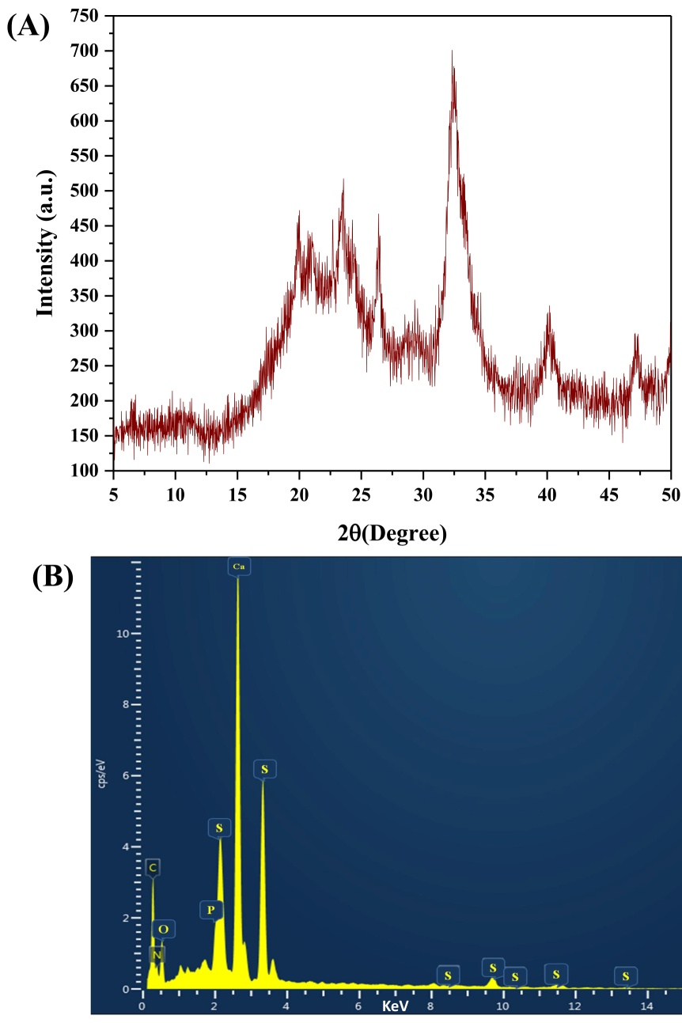
Figure S1: (A) Diffractogram of bone meal; (B) EDAX spectrum of bone meal.

