Supplementary Information

Synthesis, Crystal Structure and In Vitro Cytotoxicity of Novel Cu(II) Complexes Derived from Isatine Hydrazide-Hydrazone Ligands
Cansu Gökçe Topkaya,^{1*}
¹Muğla Sıtkı Koçman University, Department of Chemistry, 48000 Muğla, Turkey
*Corresponding author E-mail: cansutopkaya@mu.edu.tr
Phone: +90 252 2111502, fax: +90 252 2111472

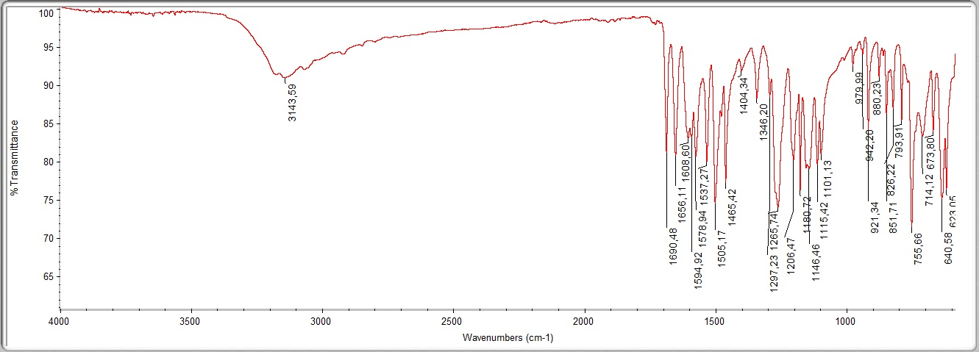

Figure S1. IR spectrum of HL¹

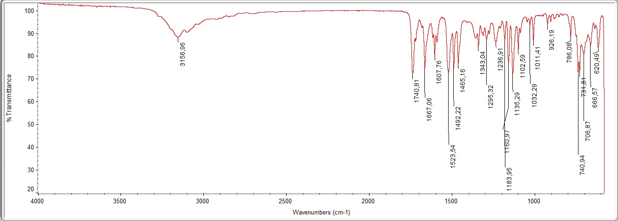

Figure S2. IR spectrum of HL²

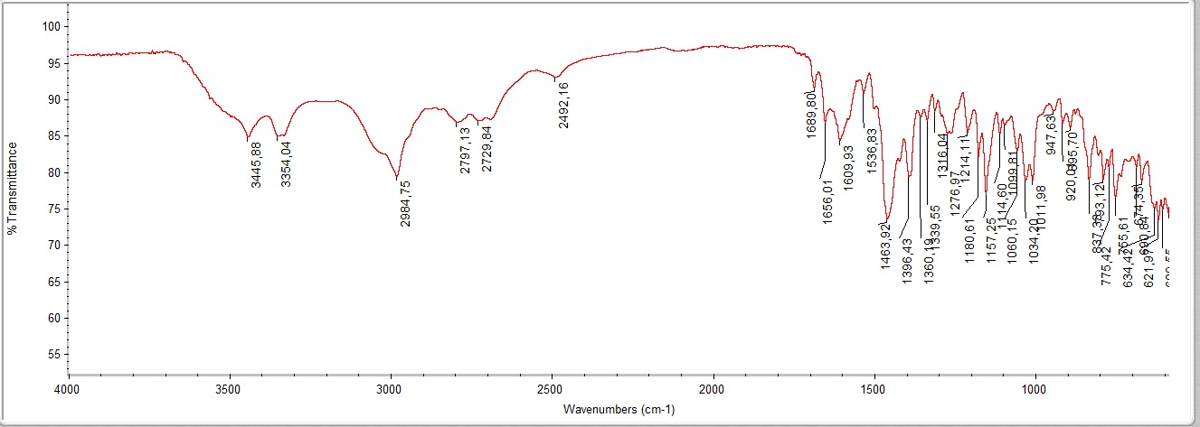

Figure S3. IR spectrum of Cu(L¹)₂

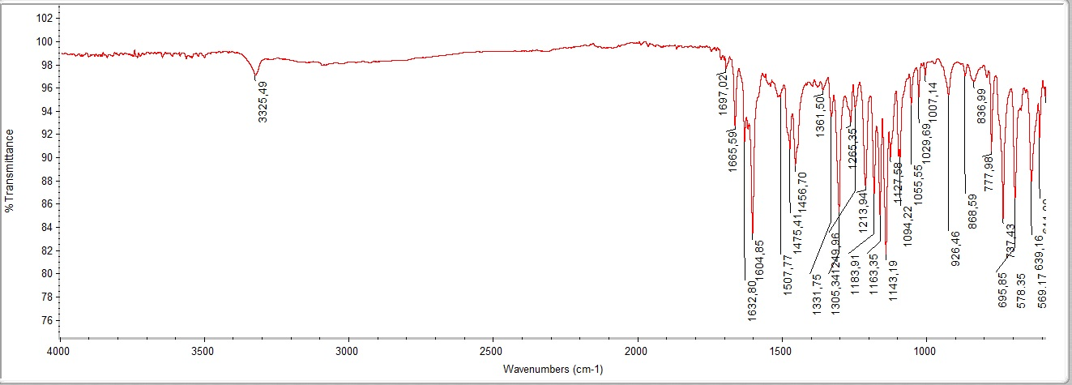

Figure S4. IR spectrum of Cu(L²)₂

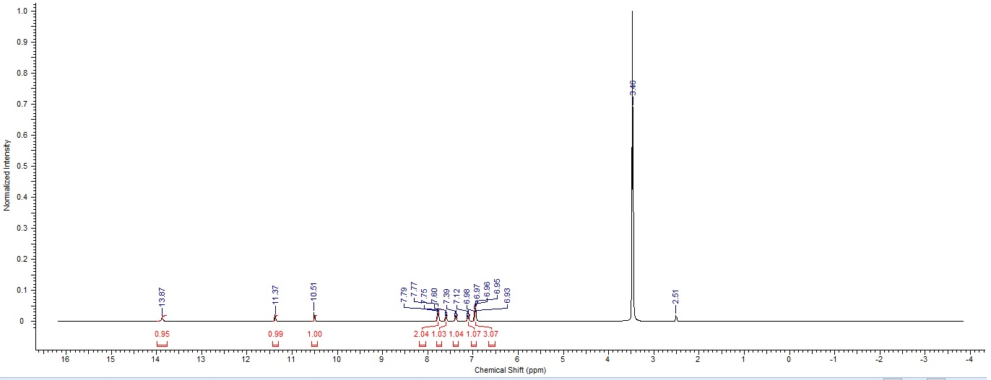

Figure S5. ¹H-NMR spectrum of HL¹

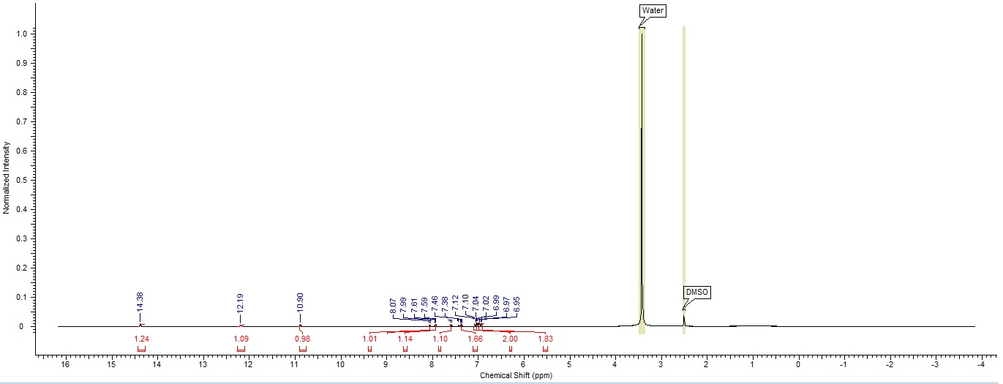

Figure S6. ¹H-NMR spectrum of HL²

Figure S7. UV-Vis spectrum of HL¹

Figure S8. UV-Vis spectrum of HL²

Figure S9. UV-Vis and stability spectrum of Cu(L¹)₂

Figure S10. UV-Vis and stability spectrum of Cu(L²)₂

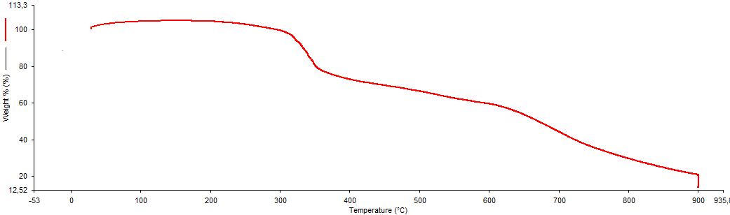

Figure S11. TGA spectrum of Cu(L¹)₂

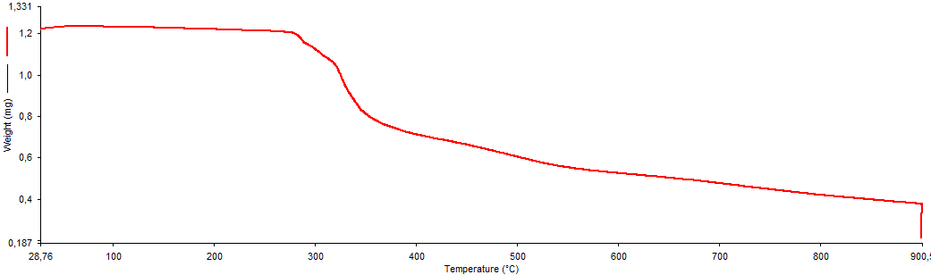

Figure S12. TGA spectrum of Cu(L²)₂

