Supplementary Information File

Synthesis, Structure Elucidation, Supramolecular Assembly Exploration Via Hirshfeld Surface Analysis and DFT Study of an Anilide Compound

Muhammad Nawaz Tahir,¹ Muhammad Ashfaq,^{1*} Akbar Ali,^{2*} Chin Hung Lai,^{3,4} Bojja Rajeshwar Rao,⁵ Khurram Shahzad Munawar, ^{6,7} Irshad Ali Shahid¹

¹ Department of Physics, University of Sargodha, Sargodha 40100, Pakistan
² Department of Chemistry, Government College University, Faisalabad, Pakistan
³ Department of Medical Applied Chemistry, Chung Shan Medical University, Taichung 40241, Taiwan
⁴ Department of Medical Education, Chung Shan Medical University Hospital, Taichung 402, Taiwan
⁵ Senior Chemist (Retired), Chemical Division, Kakatiya Thermal Power Project (O&M) Chelpur-506 170, Telangana State, India
⁶ Department of Chemistry, University of Mianwali, 42200, Pakistan
⁷ Department of Chemistry, University of Sargodha, 40100, Pakistan

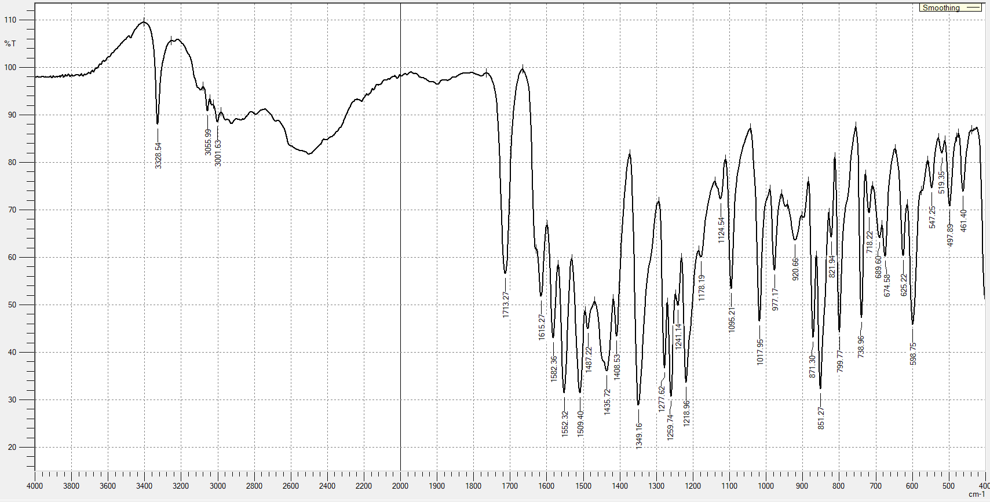
Figure S1. FT-IR spectrum of MAOA.

Figure S2. UV-Vis spectrum of MAOA.
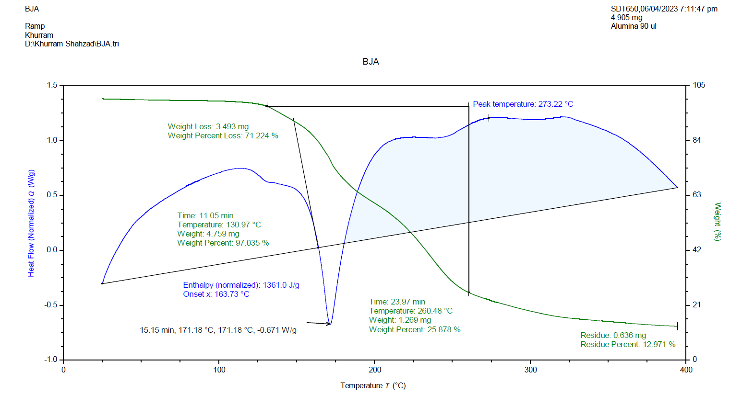
Figure S3. TGA/DSC curves of MAOA.

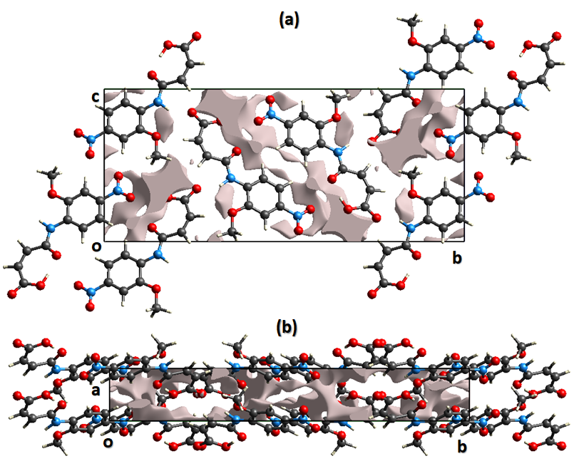Figure S4. Graphical representation of voids in the crystal packing for MAOA along (a) a-axis, (b) c-axis.
Table S1. Enrichment ratio for the pair of chemical species in MAOA. The enrichment ratio is not calculated for the pair having random contact less than 1%.
Contact % | Atom | H | C | N | O
Contact % | H | 22.6 | 12.7 | 1.7 | 39.8
Contact % | C | 12.7 | 6.2 | - | 5.9
Contact % | N | 1.7 | - | - | 3.7
Contact % | O | 39.8 | 5.9 | 3.7 | 7.2
Surface% |  | 49.7 | 15.5 | 2.7 | 31.9
Random Contacts % | Atom | H | C | N | O
Random Contacts % | H | 24.70 | - | - | -
Random Contacts % | C | 15.41 | 2.40 | - | -
Random Contacts % | N | 2.68 | 0.84 | 0.07 | -
Random Contacts % | O | 31.71 | 9.89 | 1.72 | 10.18
Enrichment ratio | Atom | H | C | N | O
Enrichment ratio | H | 0.91 | - | - | -
Enrichment ratio | C | 0.82 | 2.58 | - | -
Enrichment ratio | N | 0.63 | - | - | -
Enrichment ratio | O | 1.26 | 0.60 | 2.15 | 0.71

Comparison of the X-ray data with computational B3LYP data
In order to compare structure in solid state and gaseous state, the computations of DFT-B3LYP were executed by utilization of Gaussian 16. The important bond lengths and bond angles obtained by XRD and DFT are compared and listed in Table S2.
Table S2. Important bond lengths (Å) of XRD and corresponding ones by DFT.
Bond lengths | XRD | DFT
O1—C1 | 1.299 (4) | 1.319
O2—C1 | 1.210 (4) | 1.201
O3—C4 | 1.226 (4) | 1.224
O4—C6 | 1.363 (4) | 1.357
O4—C11 | 1.440 (4) | 1.420
O6—N2 | 1.208 (4) | 1.210
N1—C4 | 1.347 (4) | 1.362
N1—C5 | 1.400 (4) | 1.401
N2—C8 | 1.471 (4) | 1.476
The conceptual density functional theory provides some quantum chemical descriptors to represent the chemical activity of a molecule. Accordingly, the quantum chemical descriptors including the chemical potential (μ), chemical hardness (η), softness (S), and electrophilicity index (ω) were calculated by the following equations:
where I and A are the ionization energy and electron affinity of a species, respectively. The stability and reactivity of molecules are significantly related to their chemical hardness and global softness. A smaller (greater) the value of hardness (softness) a molecule has, the more reactive it should be. Moreover, the previous relevant studies showed the toxicity of a species seems to have a relationship with its electrophilicity index (ω).^{1, 2}
According to the Koopmans’ theory,³ the ionization energy (I) and the electron affinity (A) of a species could be calculated by
The energy of the HOMO (E_{HOMO}), the energy of the LUMO (E_{LUMO}), dipole moment (D), and the quantum chemical descriptors were summarized as Table S3 shows

Table S3. E_{HOMO,} E_{LUMO,} D and the quantum chemical descriptors of MAOA.
E_{HOMO} (eV) | -8.5772
E_{LUMO} (eV) | -2.3631
D (Debye) | 8.0832
μ (eV) | 5.4702
η (eV) | 3.1071
S (eV⁻¹) | 0.3218
ω (eV) | 4.8153

(3,-3) CP | 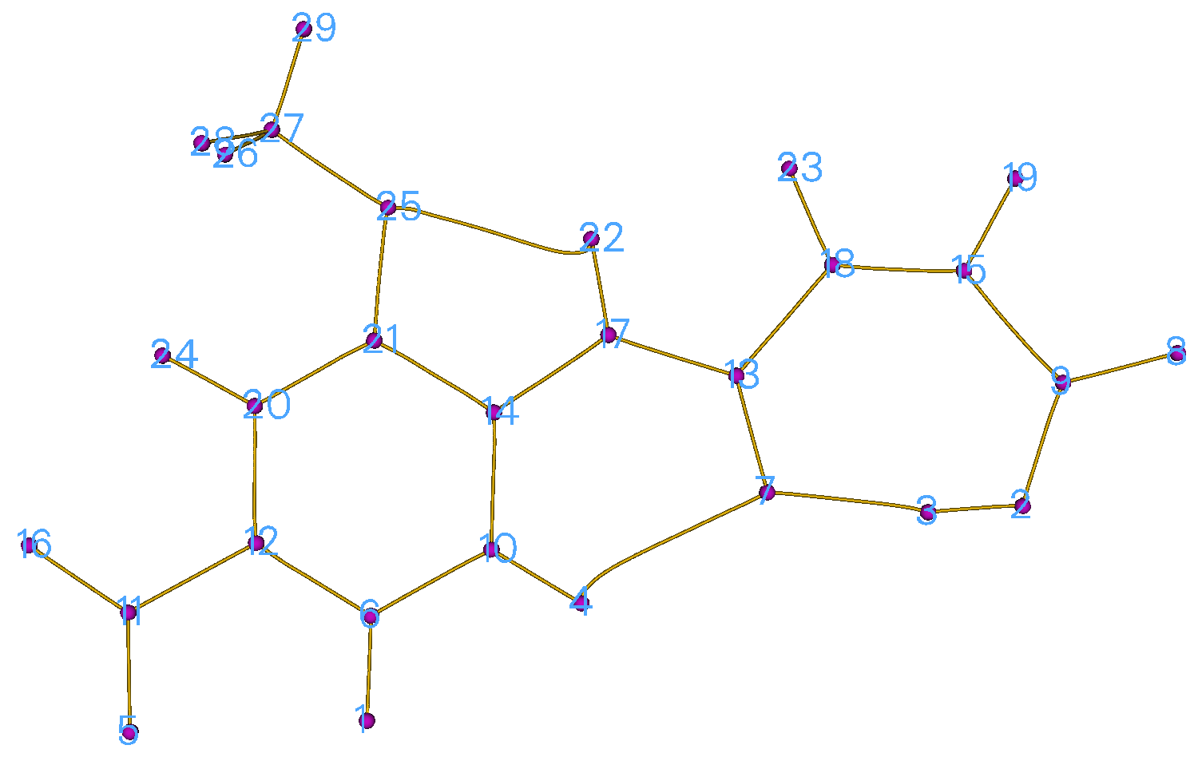
(3,-1) CP | 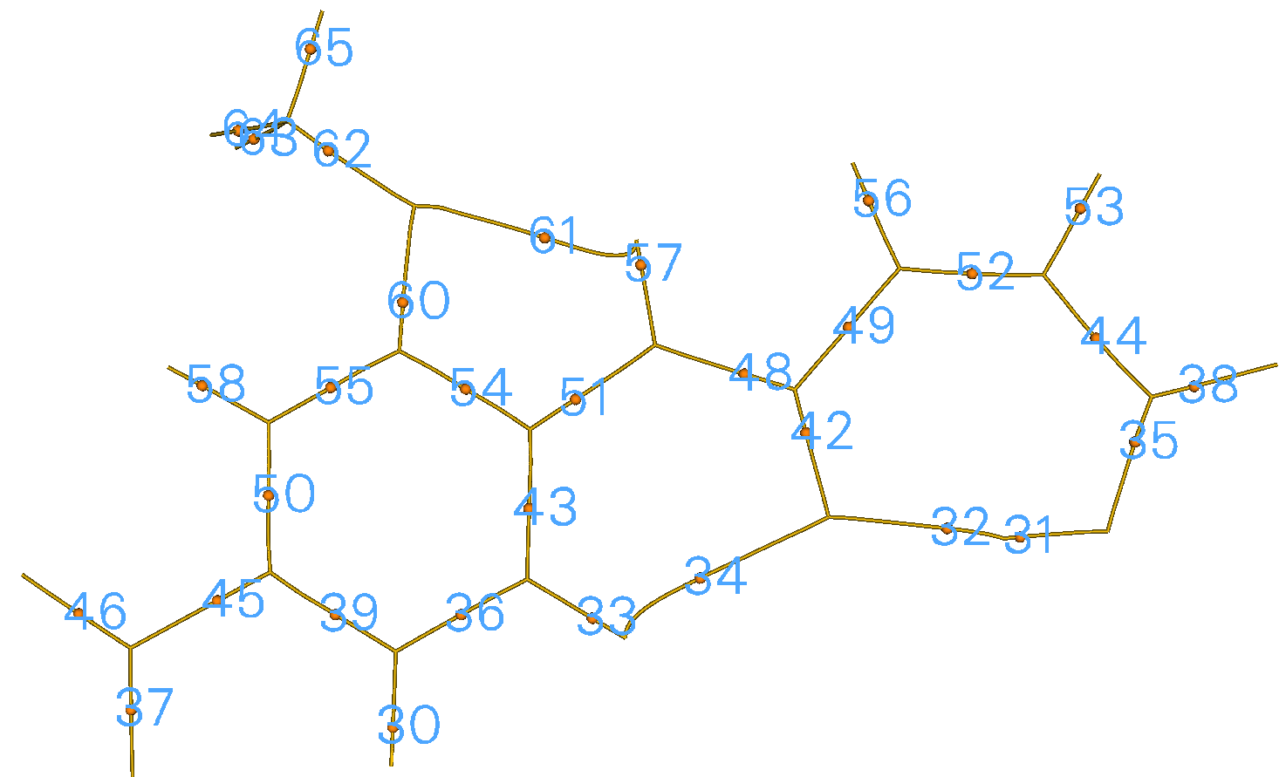
(3,+1) CP | 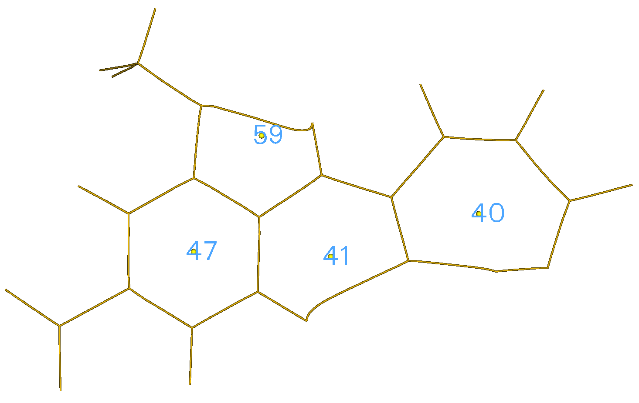
Figure S5. (a) (3,-3) critial points (b) (3,-1) critical points and (c) (3,+1) critical points of MAOA.

Austin Model-1 method for the molecular conformation analysis of MAOA
Austin Model-1 method is one of the semi-empirical methods which utilizes experimental parameters and considerable simplification of Schrödinger’s equation (HΨ = EΨ) to optimize molecules for computation of numerous properties in the gaseous state [1-3], thus obtained values were compared with single crystal X-ray studies in solid state [4-6]. In view of these observations, it is prompted us to study conformational analysis on MAOA by utilization of single crystal X-ray diffraction and AM1 method.
The structure of MAOA in solid state and gaseous state vary mainly in the bond angles, dihedral angles and torsion angles near to the sites of the intermolecular interactions [7-10]. In order to compare structure in solid state and gaseous state, the computations of semi-empirical molecular orbital were executed by utilization of Austin Model-1 (AM1) platform. Geometry computations in the ground state (key words: GNORM=5, MMOK, GEO-OK, CHARGE, and PRECISE) were thoroughly optimized until the lowest energy conformation has been realized. The initial molecular geometry was adopted as Pople’s standard data [11], and subsequently utilizing completely optimized energy gradient method. The conformations were designated by Klyne-Prelog terms [12] using s = syn, a = anti, p = peri-planar (0±30⁰& 180±30⁰) and all other angles c = clinal. Conformational investigation of isolated molecule was performed in the way for conformational flexible compounds [13-14]. Semi-empirical AM1 calculations were executed on the X-ray structure for the molecule. Geometry optimizations of the crystal structure of the title compound were carried out using the algorithm implemented in the package and the PRECISE option toimprove the convergence criteria [15]. The correlation data of various molecular parameters obtained by experimental XRD in Table 1 and semi-empirical AM1 calculations in Table S2.

Table S2 Heat of formation (∆H_{f}º in kcal/mol), ionization potential (eV), dipole moment (µ in Debye), energies of frontier molecular orbitals (in eV) and the atomic charges on hetero-atoms of (2Z)-4-(2-Methoxy-4-nitroanilino)-4-oxobut-2-enoic acid (1) calculated from AM1 calculations.
∆H_{f}º(kcal/mol) | -112.5648
Ionization potential (eV) | 9.3595
µ (Debye) | 6.9576
E_{HOMO} (eV) | -9.359
E_{LUMO} (eV) | -1.203
Electron excitation energies [E_{HOMO}-E_{LUMO}] or E_{gap} (eV) | 8.156
N₇ (atomic charge) | +0.5720
N₉ (atomic charge) | -0.3099
O₈ (atomic charge) | -0.2232
O₁₅ (atomic charge) | -0.3232
O₂₀ (atomic charge) | -0.3666
O₂₁ (atomic charge) | -0.3565
O₂₅ (atomic charge) | -0.3280
O₂₈ (atomic charge) | -0.3263
Note: The position of atom in the molecule is shown as subscript (Fig S1)

The minute deviations are noticed between X-ray diffraction data in the solid state, and computational data (AM1 method) in the gaseous state under vacuum. Table S3-S5 specify geometrical parameters related to bond lengths bond angles and dihedral angles, respectively. These outcomes can be applicable as ground work for investigating and forecasting the other properties of the molecule MAOA. The numbering scheme of atoms for AM1 computations are displayed in Fig 9.
Fig. S1 AM1-Structure along with atom-numbering

Comparison of the X-ray data with computational data (AM1 method)
The crystal structure of MAOA is the combination of aliphatic, aromatic, amide, methoxy, nitro- and acid moieties. Heat of formation (∆H_{f}º in kcal/mol), ionization potential (eV), dipole moment (µ in Debye), energies of frontier molecular orbitals (in eV) and the atomic charges on hetero-atoms of MAOA are calculated from AM1 method and specified in Table S2. It is observed that N₉-atom in amido group is more negative charge than N₇-atom in nitro group. It is also investigated that O₂₀-atom and O₂₁-atom of nitro-group are more charge than other attached O-atoms. O₈-atom is less negative charge is due to the ether linkage.

Deviations of Geometrical parameters from experimental Single Crystal XRD and Calculated AM1 calculations

Table S3 Bond length (Å) of (2Z)-4-(2-Methoxy-4-nitroanilino)-4-oxobut-2-enoic acid (1) from experimental Single Crystal XRD and Calculated AM1 calculations
Bond type |  | Bond length (Å)ª | XRD | AM1 | (AM₁-XRD)^{b}
σH-C(sp²) | Aromatic | H₁₆−C₃ | 0.930 | 1.1049 | 0.1749
σH-C(sp²) | Aromatic | H₁₇−C₄ | 0.930 | 1.1041 | 0.1741
σH-C(sp²) | Aromatic | H₁₈−C₆ | 0.930 | 1.1033 | 0.1733
σH-C(sp²) | Alkenyl | H₂₆−C₁₂ | 0.930 | 1.1073 | 0.1773
σH-C(sp²) | Alkenyl | H₂₇−C₁₃ | 0.930 | 1.1067 | 0.1767
σH-C(sp³) | Aliphatic | H₂₂−C₁₀ | 0.960 | 1.1199 | 0.1599
σH-C(sp³) | Aliphatic | H₂₃−C₁₀ | 0.960 | 1.1168 | 0.1568
σH-C(sp³) | Aliphatic | H₂₂−C₁₀ | 0.960 | 1.1179 | 0.1579
σH-O(sp³) |  | H₂₉−O₁₅ | 0.820 | 0.9721 | 0.1521
σH-N(sp³) |  | H₁₉−N₉ | 0.860 | 1.0035 | 0.1435
N(sp³)-O(sp²) | Nitro | N₇−O₂₀ | 1.210 | 1.2030 | -0.0070
N(sp³)-O(sp²) | Nitro | N₇−O₂₁ | 1.207 | 1.2019 | -0.0051
σN(sp³)-C(sp²) |  | N₇−C₅ | 1.473 | 1.4841 | 0.0111
σN(sp³)-C(sp²) | Amido | N₉−C₂ | 1.403 | 1.3991 | -0.0039
σN(sp³)-C(sp²) | Amido | N₉−C₁₁ | 1.346 | 1.3882 | 0.0422
σC(sp²)-O(sp³) | Ether | O₈−C₁ | 1.363 | 1.3848 | 0.0218
σC(sp²)-O(sp³) | Acidic | O₁₅−C₁₄ | 1.299 | 1.3653 | 0.0663
σC(sp³)-O(sp³) | Ether | O₈−C₁₀ | 1.439 | 1.4232 | -0.0158
σC(sp²)-C(sp²) | Single-bond | C₁₁−C₁₂ | 1.482 | 1.4919 | 0.0099
σC(sp²)-C(sp²) | Single-bond | C₁₄−C₁₃ | 1.487 | 1.4688 | -0.0182
C(sp²)-C(sp²) | Alkenyl | C₁₃−C₁₂ | 1.328 | 1.3313 | 0.0033
C(sp²)-C(sp²) | Aromatic | C₂−C₁ | 1.411 | 1.4360 | 0.0250
C(sp²)-C(sp²) | Aromatic | C₃−C₂ | 1.385 | 1.4093 | 0.0243
C(sp²)-C(sp²) | Aromatic | C₄−C₃ | 1.385 | 1.3916 | 0.0066
C(sp²)-C(sp²) | Aromatic | C₅−C₄ | 1.374 | 1.3980 | 0.0240
C(sp²)-C(sp²) | Aromatic | C₆−C₅ | 1.376 | 1.4062 | 0.0302
O(sp²)-C(sp²) | Carbonyl | O₂₅−C₁₁ | 1.226 | 1.2439 | 0.0179
O(sp²)-C(sp²) | Carbonyl | O₂₈−C₁₄ | 1.209 | 1.2323 | 0.0233
ª Deviations from Solid to Gas state
^{b} The position of atom in the molecule is shown as subscript (Fig S1)

Bond lengths (Å) are varying in the gaseous state and reported in the Table 5. It is noticed that σH-C(sp²) of aromatic and alkenyl are increased by +0.1733 Å to +0.1773 Å in the gaseous state. σH-C(sp³) of aliphatic is enhanced by +0.1568 Å. to +0.1599 Å. σH-O(sp³) and σH-C(sp³) are increased by 0.1521 Å and 0.1435 Å respectively. Nitro group of N(sp³)-O(sp²) is decreased by -0.0051 Å to -0.0070 Å due to stability of Nitro group in gaseous state. σN(sp³)-C(sp²) is increased from -0.0039 Å to +0.0422 Å due to the effect of carbonyl and aromatic groups. σC(sp²)-O(sp³) is increased in the range of +0.0218 Å. to +0.0633 Å and σC(sp³)-O(sp³) is decreased by -0.0158 Å. σC(sp²)-C(sp²) is increased from -0.0182 Å to +0.0099 Å. C(sp²)-C(sp²) of alkenyl and aromatic is increased from +0.0033 Å. to +0.0302 Å. O(sp2)-C(sp2) of carbonyl group is increased in the range of +0.0179 Å. to +0.0233 Å.
Table S4 Bond angle (º) of (2Z)-4-(2-Methoxy-4-nitroanilino)-4-oxobut-2-enoic acid (1) from experimental XRD and Calculated AM1 calculations
Bond angle(º) at atom hybridisation | Bond angle (º)ª | XRD | AM1 | (AM1-XRD)
Bond angle(º) at Csp²
Aromatic | C₃ C₂ C₁ | 118.8 | 117.47 | -1.33
Aromatic | C₄ C₃ C₂ | 120.9 | 121.57 | 0.67
Aromatic | C₅ C₄ C₃ | 118.3 | 119.65 | 1.35
Aromatic | C₆ C₅ C₄ | 122.8 | 120.87 | -1.93
Aromatic | C₇ C₅ C₄ | 118.6 | 119.99 | 1.39
Aromatic | C₈ C₁ C₂ | 114.9 | 115.88 | 0.98
Aromatic | N₉ C₂ C₃ | 124.3 | 123.31 | -0.99
Aromatic | H₁₆ C₃ C₂ | 119.5 | 120.31 | 0.81
Aromatic | H₁₇ C₄ C₃ | 120.8 | 119.79 | -1.01
Aromatic | H₁₈ C₆ C₅ | 120.7 | 119.55 | -1.15
Aliphatic | C₁₂ C₁₁ N₉ | 114.2 | 116.36 | 2.16
Aliphatic | C₁₃ C₁₂ C₁₁ | 128.4 | 127.65 | -0.75
Aliphatic | C₁₄ C₁₃ C₁₂ | 133.3 | 126.81 | -6.49
Aliphatic | O₁₅ C₁₄ C₁₃ | 121.0 | 114.73 | -6.27
Aliphatic | O₂₅ C₁₁ N₉ | 122.6 | 123.85 | 1.25
Aliphatic | H₂₆ C₁₂ C₁₁ | 115.8 | 111.75 | -4.05
Aliphatic | H₂₇ C₁₃ C₁₂ | 113.3 | 120.89 | 7.59
Aliphatic | O₂₈ C₁₄ C₁₃ | 118.4 | 128.49 | 10.09
Bond angle(º) at Csp³ | H₂₂ C₁₀ O₈ | 109.5 | 103.26 | -6.24
Bond angle(º) at Csp³ | H₂₃ C₁₀ O₈ | 109.5 | 111.13 | 1.63
Bond angle(º) at Nsp³ | C₁₁ N₉ C₂ | 128.0 | 127.11 | -0.89
Bond angle(º) at Nsp³ | C₁₉ N₉ C₂ | 116.0 | 115.53 | -0.47
Bond angle(º) at Nsp³ | O₂₀ N₇ C₅ | 118.3 | 119.00 | 0.7
Bond angle(º) at Nsp³ | C₂₁ N₇ C₅ | 118.2 | 119.02 | 0.82
Bond angle(º) at Osp³ | C₁₀ O₈ C₁ | 117.8 | 116.58 | -1.22
Bond angle(º) at Osp³ | H₂₉ O₁₅ C₁₄ | 109.5 | 109.77 | 0.27
ª Deviations from Solid to Gas state
^{b} The position of atom in the molecule is shown as subscript (Fig S1)

Bond angles (º) are observed variations from solid to gaseous state and incorporated in the Table 5. Bond angle (º) at C-sp² is found to vary from -1.93º to +1.39º due to angle strain or aromatic strain in the gaseous state and it is also observed in the range of -6.49º to +10.09º in the case of alkenyl. Bond angle (º) at C-sp³ is found to vary from -6.24º to +1.63º due to methoxyl-group effect. Bond angle (º) at N-sp³ is found in the range of -0.89º to +0.82º. Bond angle (º) at O-sp³ is decreased by -1.22º due to aromatic ring effect and increased by +0.27 º in the case of intra-molecular H-bonding nature.

Table S5 Dihedral angle (º) of MAOA from XRD and AM1 calculations
Dihedral angle (º)ª | XRD |  | AM1
Dihedral angle (º)ª | Angle | (*) | Angle | (*)
C₄ C₃ C₂ C₁ | -0.5 | -sp | +0.54 | +sp
C₅ C₄ C₃ C₂ | -1.5 | -sp | -0.17 | -sp
C₆ C₅ C₄ C₃ | +2.1 | +sp | -0.38 | -sp
C₇ C₅ C₄ C₃ | -177.9 | -ap | +179.89 | +ap
O₈ C₁ C₂ C₃ | -177.3 | -ap | +178.93 | +ap
C₁₀ O₈ C₁ C₂ | +175.7 | +ap | +174.64 | +ap
C₁₁ N₉ C₂ C₃ | +6.1 | +sp | +1.29 | +sp
C₁₂ C₁₁ N₉ C₂ | -178.3 | -ap | -177.17 | -ap
C₁₃ C₁₂ C₁₁ N₉ | -179.1 | -ap | -55.24 | -sc
C₁₄ C₁₃ C₁₂ C₁₁ | +2.7 | +sp | +0.78 | +sp
O₁₅ C₁₄ C₁₃ C₁₂ | -10.2 | -sp | +68.60 | +sc
O₂₀ N₇ C₅ C₄ | -10.3 | -sp | -179.75 | -ap
O₂₁ N₇ C₅ C₄ | -170.5 | -ap | +0.32 | +sp
O₂₅ C₁₁ N₉ C₂ | +2.5 | +sp | +0.13 | +sp
O₂₈ C₁₄ C₁₃ C₁₂ | +170.0 | +ap | -114.09 | -ac
* Conformational analyses using prefixes a = anti, s = syn, c = clinal, p = peri-planar (0±30⁰& 180±30⁰) and + & - signs
ª The position of atom in the molecule is shown as subscript (Fig S1)
Red Color indicates change of conformation

The conformational changes are observed in solid (XRD) and gaseous state (AM1) of the molecule MAOA, which are incorporated in Table 6. The dihedral angle of C₆C₅C₄C₃ is altered from +sp to -sp conformation. The conformation –sp of C₄C₃C₂C₁, O₁₅C₁₄C₁₃C₁₂ and O₂₀N₇C₅C₄ are changed to +sp, +sc and –ap conformations. The conformation -ap of C₇C₅C₄C₃, and O₈C₁C₂C₃ are changed +ap conformation. The conformation –ap of C₁₃C₁₂C₁₁N₉, and O₂₁N₇C₅C₄ are changed –sc and +sp conformations respectively. The dihedral angle of O₂₈C₁₄C₁₃C₁₂ is altered the conformation from +ap to -ac and observed the rest of positions have moderate change.

References:

- Dewar MJ, Zoebisch EG, Healy EF, Stewart JJ (1985) J Am Chem Soc 107: 3902-3909.
- Stewart JJP (1997) MOPAC, A general molecular orbital package, QCPE 455, 5th edn, 1988.
- Kavitha Reddy P, Rajeshwar Rao B (2019) World J Pharmaceutical Res 9: 978-1020.
- Alaa AM, Al-Omar MA, El-Azab AS, Kunieda T (2010) J Mol Struct 969: 145-154.
- Burley JC, Gilmour R, Prior TJ, Day GM (2008) Acta Crystallogr C64: 610-614.
- Santos AG, Candeias SX, Afonso CA, Jenkins K, Caddick S, Treweeke NR, Pardoe D (2001) Tetrahedron 57: 6607-6614.
- Allen FH, Kennard O, Watson DG, Brammer L, Orpen AG, Taylor R (1987) J Chem Soc Perkin Trans 2 12: S1-S19.
- Kapon M, Reisner GM (1989) Acta Crystallogr C45: 780-782.
- Peeters OM, Blaton NM, De Ranter CJ (1984) Acta Crystallogr C40: 1748-1750.
- Ueda H, Onishi H, Nagai, T (1986) Acta Crystallogr C42: 462-464.
- Pople JA, Beveridge DL (1970) McGraw-Hill, New York.
- Rajeshwar Rao B (2019). World J Pharm Res 8(9): 511-531.
- Crawford TD, Sherrill CD, Valeev EF, Fermann JT, King RA, Leininger ML, Allen W D (2007) J Comput Chem 28: 1610-1616.
- Stewart JJ (1989) J Comput Chem 10: 221-264.
- Fletcher R, Powell MJ (1963) Compu J 6: 163-168.

checkCIF/PLATON report of MAOA
Structure factors have been supplied for datablock(s) ntmal_tw

THIS REPORT IS FOR GUIDANCE ONLY. IF USED AS PART OF A REVIEW PROCEDURE FOR PUBLICATION, IT SHOULD NOT REPLACE THE EXPERTISE OF AN EXPERIENCED CRYSTALLOGRAPHIC REFEREE.

No syntax errors found. CIF dictionary Interpreting this report

Datablock: ntmal_tw

Bond precision: C-C = 0.0047 A Wavelength=0.71073

Cell:  Temperature: | a=3.8664(6)  alpha=90  296 K |  | b=26.282(4) beta=96.461(9) | c=11.2114(17)  gamma=90
 | Calculated |  | Reported
Volume Space group Hall group  Moiety formula | 1132.0(3)  P 21/c  -P 2ybc C11 H10 N2 | O6 | 1132.0(3)  P 21/c  -P 2ybc  C11 H10 N2 O6
Sum formula | C11 H10 N2 | O6 | C11 H10 N2 O6
Mr | 266.21 |  | 266.21
Dx,g cm-3 | 1.562 |  | 1.562
Z | 4 |  | 4
Mu (mm-1) | 0.130 |  | 0.130
F000 | 552.0 |  | 552.0
F000’ | 552.35
h,k,lmax | 4,32,13 |  | 4,32,13
Nref | 2227 |  | 2168
Tmin,Tmax | 0.969,0.977 |  | 0.910,0.970
Tmin’ | 0.952

Correction method= # Reported T Limits: Tmin=0.910 Tmax=0.970 AbsCorr = MULTI-SCAN

Data completeness= 0.974 Theta(max)= 26.000

R(reflections)= 0.0811( 1388) wR2(reflections)=
0.1988( 2168)
S = 1.071 Npar= 175

The following ALERTS were generated. Each ALERT has the format
test-name_ALERT_alert-type_alert-level.
Click on the hyperlinks for more details of the test.

Alert level C
PLAT029_ALERT_3_C _diffrn_measured_fraction_theta_full value Low . 0.979 Why? PLAT242_ALERT_2_C Low ’MainMol’ Ueq as Compared to Neighbors of N2 Check PLAT250_ALERT_2_C Large U3/U1 Ratio for Average U(i,j) Tensor .... 2.1 Note PLAT340_ALERT_3_C Low Bond Precision on C-C Bonds ............... 0.00467 Ang. PLAT906_ALERT_3_C Large K Value in the Analysis of Variance ...... 13.151 Check PLAT906_ALERT_3_C Large K Value in the Analysis of Variance ...... 2.101 Check PLAT906_ALERT_3_C Large K Value in the Analysis of Variance ...... 2.693 Check PLAT911_ALERT_3_C Missing FCF Refl Between Thmin & STh/L= 0.600 42 Report

Alert level G
PLAT007_ALERT_5_G Number of Unrefined Donor-H Atoms .............. 2 Report PLAT480_ALERT_4_G Long H...A H-Bond Reported H2 ..O4 . 2.62 Ang.
PLAT480_ALERT_4_G Long H...A H-Bond Reported H11C ..O5 . 2.63 Ang. PLAT870_ALERT_4_G ALERTS Related to Twinning Effects Suppressed .. ! Info PLAT910_ALERT_3_G Missing # of FCF Reflection(s) Below Theta(Min). 2 Note PLAT912_ALERT_4_G Missing # of FCF Reflections Above STh/L= 0.600 14 Note PLAT931_ALERT_5_G CIFcalcFCF Twin Law ( 0 0 1) Est.d BASF 0.21 Check PLAT941_ALERT_3_G Average HKL Measurement Multiplicity ........... 1.0 Low PLAT992_ALERT_5_G Repd & Actual _reflns_number_gt Values Differ by 5 Check

0 ALERT level A = Most likely a serious problem - resolve or explain
0 ALERT level B = A potentially serious problem, consider carefully
- ALERT level C = Check. Ensure it is not caused by an omission or oversight
- ALERT level G = General information/check it is not something unexpected

0 | ALERT | type | 1 | CIF construction/syntax error, inconsistent or missing data
2 | ALERT | type | 2 | Indicator that the structure model may be wrong or deficient
8 | ALERT | type | 3 | Indicator that the structure quality may be low
4 | ALERT | type | 4 | Improvement, methodology, query or suggestion
3 | ALERT | type | 5 | Informative message, check

It is advisable to attempt to resolve as many as possible of the alerts in all categories. Often the minor alerts point to easily fixed oversights, errors and omissions in your CIF or refinement strategy, so attention to these fine details can be worthwhile. In order to resolve some of the more serious problems it may be necessary to carry out additional measurements or structure refinements. However, the purpose of your study may justify the reported deviations and the more serious of these should normally be commented upon in the discussion or experimental section of a paper or in the "special_details" fields of the CIF. checkCIF was carefully designed to identify outliers and unusual parameters, but every test has its limitations and alerts that are not important in a particular case may appear. Conversely, the absence of alerts does not guarantee there are no aspects of the results needing attention. It is up to the individual to critically assess their own results and, if necessary, seek expert advice.

Publication of your CIF in IUCr journals

A basic structural check has been run on your CIF. These basic checks will be run on all CIFs submitted for publication in IUCr journals (Acta Crystallographica, Journal of Applied Crystallography, Journal of Synchrotron Radiation); however, if you intend to submit to Acta Crystallographica Section C or E or IUCrData, you should make sure that full publication checks are run on the final version of your CIF prior to submission.

Publication of your CIF in other journals

Please refer to the Notes for Authors of the relevant journal for any special instructions relating to CIF submission.

PLATON version of 12/09/2022; check.def file version of 09/08/2022

Datablock ntmal_tw - ellipsoid plot
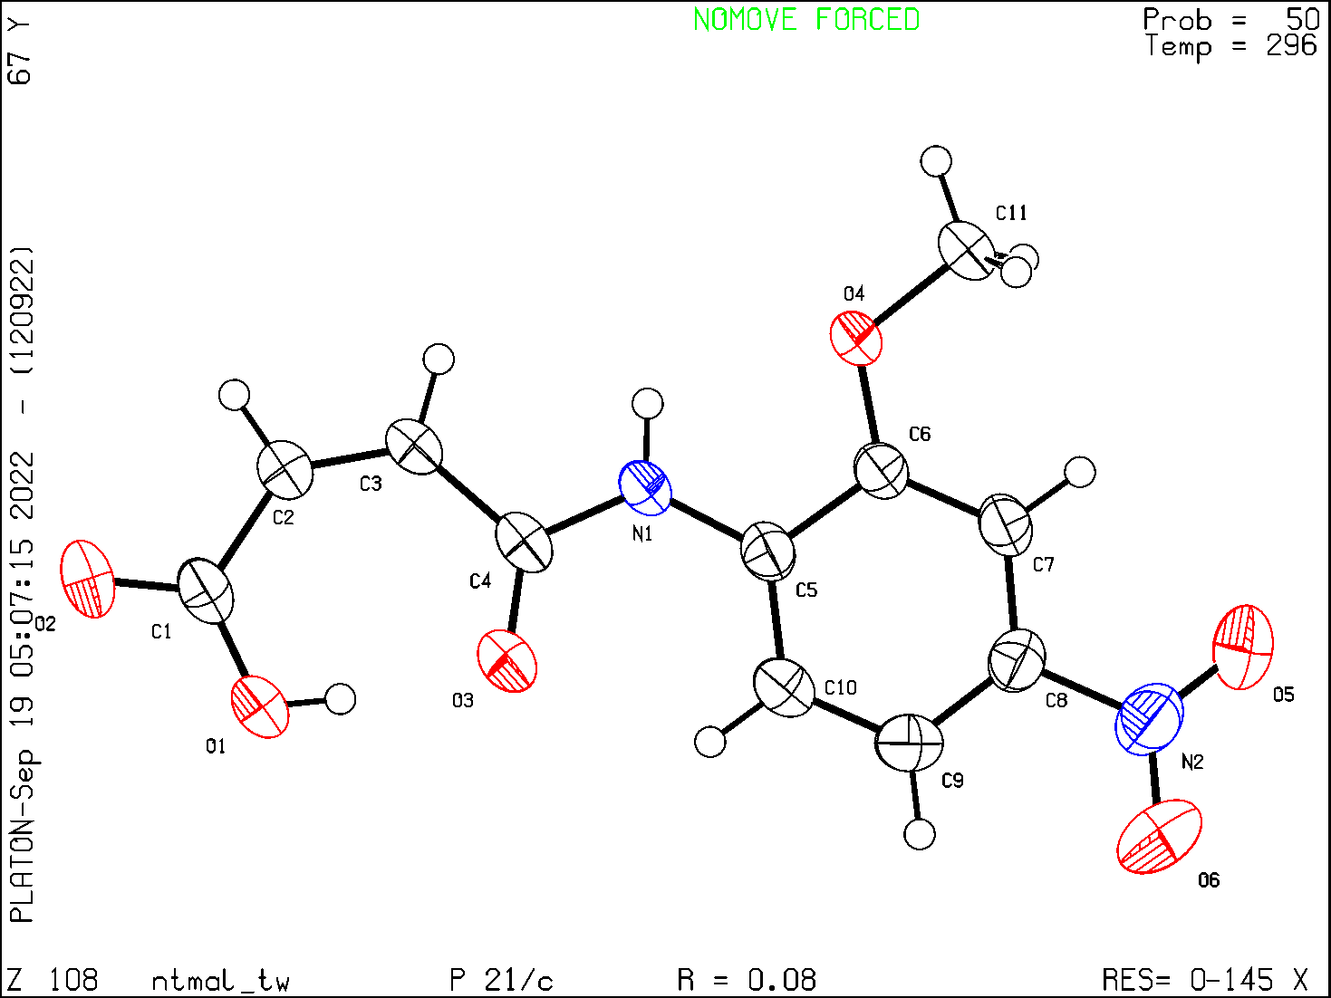

data_global

#==============================================================
# PROCESSING SUMMARY (IUCr Office Use only)

_publ_contact_author
;
Muhammad Nawaz Tahir
University of Sargodha
Department of Physics
Sargodha
Pakistan
;
_publ_contact_author_phone '0092 48 92 30 914'
_publ_contact_author_fax '0092 48 32 22 121'
_publ_contact_author_email 'dmntahir_uos@yahoo.com'
_publ_requested_journal ''
_journal_date_recd_electronic ?

_journal_date_to_coeditor ?
_journal_date_from_coeditor ?
_journal_date_accepted ?

_journal_date_printers_first ?
_journal_date_printers_final ?
_journal_date_proofs_out ?
_journal_date_proofs_in ?

_journal_coeditor_name ?
_journal_coeditor_code ?
_journal_paper_category ?
_journal_coeditor_notes
;
;

_journal_techeditor_code ?
_iucr_compatibility_tag ?
_journal_techeditor_notes
;
;

_journal_coden_ASTM ?
_journal_name_full ?
_journal_year ?
_journal_volume ?
_journal_issue ?
_journal_page_first ?
_journal_page_last ?

_journal_suppl_publ_number ?
_journal_suppl_publ_pages ?
#==============================================================

loop_
_publ_author_name
_publ_author_address

'Muhammad Ashfaq'
;
Department of Physics
University of Sargodha
Sargodha, 40100
Pakistan
;

'Muhammad Nawaz Tahir'
;
Department of Physics
University of Sargodha
Sargodha, 40100
Pakistan
;

'Akbar Ali'
;
Department of Chemistry
University of Sargodha
Sargodha, 40100
Pakistan
;

'Chin Hung Lai '
;
Department of Medical Applied Chemistry
Chung Shan Medical University
Taichung 40241
China
;

'Irshad Ahmad Shad'
;
Department of Physics
University of Sargodha
Sargodha, 40100
Pakistan
;
'Bojja Rajeshwar Rao'
;
Kakatiya Thermal Power Project,
Chemical Division,
Chelpur-506 170 Telangana State,
India
;

_audit_creation_date ?
_audit_creation_method ?
#==============================================================================

# TEXT

_publ_section_title
;
(2Z)-4-(2-Methoxy-4-nitroanilino)-4-oxobut-2-enoic acid
;

_publ_section_abstract
;
;

_publ_section_comment
;
;

_publ_section_exptl_refinement
;
;

_publ_section_exptl_prep
;
;

_publ_section_related_literature
;
;

_publ_section_references
;
Bruker (2005). <i>SADABS</i>. Bruker AXS Inc., Madison, Wisconsin, USA.

Bruker (2007). <i>APEX2</i> and <i>SAINT</i>. Bruker AXS Inc.,
Madison, Wisconsin, USA.

Farrugia, L. J. (2012). <i>J. Appl. Cryst.</i> <b>45</b>, 849--854.

Sheldrick, G. M. (2014). <i>Acta Cryst.</i> A<b>70</b>, C1437.

Sheldrick, G. M. (2015). <i>Acta Cryst.</i> C<b>71</b>, 3--8.

Spek, A. L. (2009). <i>Acta Cryst.</i> D<b>65</b>, 148--155.
;

_publ_section_figure_captions
;
;
_publ_section_acknowledgements
;
;

data_ntmal_tw

_audit_creation_method 'SHELXL-2019/2'
_shelx_SHELXL_version_number '2019/2'
_chemical_name_common ?
_chemical_absolute_configuration '.'
_chemical_name_systematic
;
(2Z)-4-(2-Methoxy-4-nitroanilino)-4-oxobut-2-enoic acid
;
_chemical_formula_moiety 'C11 H10 N2 O6'
_chemical_formula_sum 'C11 H10 N2 O6'
_chemical_formula_iupac 'C11 H10 N2 O6'
_chemical_formula_weight 266.21

loop_
_atom_type_symbol
_atom_type_description
_atom_type_scat_dispersion_real
_atom_type_scat_dispersion_imag
_atom_type_scat_source
'C' 'C' 0.0033 0.0016
'International Tables Vol C Tables 4.2.6.8 and 6.1.1.4'
'H' 'H' 0.0000 0.0000
'International Tables Vol C Tables 4.2.6.8 and 6.1.1.4'
'N' 'N' 0.0061 0.0033
'International Tables Vol C Tables 4.2.6.8 and 6.1.1.4'
'O' 'O' 0.0106 0.0060
'International Tables Vol C Tables 4.2.6.8 and 6.1.1.4'

_space_group_crystal_system monoclinic
_space_group_IT_number 14
_space_group_name_H-M_alt 'P 21/c'
_space_group_name_Hall '-P 2ybc'

_shelx_space_group_comment
;
The symmetry employed for this shelxl refinement is uniquely defined
by the following loop, which should always be used as a source of
symmetry information in preference to the above space-group names.
They are only intended as comments.
;

loop_
_space_group_symop_operation_xyz
'x, y, z'
'-x, y+1/2, -z+1/2'
'-x, -y, -z'
'x, -y-1/2, z-1/2'

_cell_length_a 3.8664(6)
_cell_length_b 26.282(4)
_cell_length_c 11.2114(17)
_cell_angle_alpha 90
_cell_angle_beta 96.461(9)
_cell_angle_gamma 90
_cell_volume 1132.0(3)
_cell_formula_units_Z 4
_cell_measurement_reflns_used 1383
_cell_measurement_theta_min 2.397
_cell_measurement_theta_max 26.000
_cell_measurement_temperature 296(2)
_exptl_crystal_description needle
_exptl_crystal_colour 'light yellow'
_exptl_crystal_size_max 0.38
_exptl_crystal_size_mid 0.20
_exptl_crystal_size_min 0.18
_exptl_crystal_density_diffrn 1.562
_exptl_crystal_density_meas ?
_exptl_crystal_density_method 'not measured'
_exptl_crystal_F_000 552
_exptl_absorpt_coefficient_mu 0.130
_exptl_absorpt_correction_type multi-scan
_exptl_absorpt_process_details '(SADABS; Bruker, 2005)'
_exptl_absorpt_correction_T_min 0.910
_exptl_absorpt_correction_T_max 0.970
_exptl_special_details
;
;

_diffrn_ambient_temperature 296(2)
_diffrn_radiation_type MoK\a
_diffrn_radiation_wavelength 0.71073
_diffrn_radiation_source 'fine-focus sealed tube'
_diffrn_radiation_monochromator graphite
_diffrn_measurement_device_type 'Bruker Kappa APEXII CCD'
_diffrn_measurement_method \w
_diffrn_detector_area_resol_mean 8.10
_diffrn_reflns_number 8207
_diffrn_reflns_av_unetI/netI 0.0710
_diffrn_reflns_av_R_equivalents 0.0777
_diffrn_reflns_limit_h_min -4
_diffrn_reflns_limit_h_max 4
_diffrn_reflns_limit_k_min -32
_diffrn_reflns_limit_k_max 32
_diffrn_reflns_limit_l_min -13
_diffrn_reflns_limit_l_max 13
_diffrn_reflns_theta_min 2.397
_diffrn_reflns_theta_max 26.000
_diffrn_reflns_theta_full 26.000
_diffrn_measured_fraction_theta_max 0.979
_diffrn_measured_fraction_theta_full 0.979
_diffrn_standards_number 0
_diffrn_standards_interval_count ?
_diffrn_standards_interval_time ?
_diffrn_standards_decay_% ?

_refine_special_details
;
Refinement of <i>F</i>^2^ against ALL reflections. The weighted <i>R</i>-factor
<i>wR</i> and goodness of fit <i>S</i> are based on <i>F</i>^2^, conventional
<i>R</i>-factors <i>R</i> are based on <i>F</i>, with <i>F</i> set to zero for
negative <i>F</i>^2^. The threshold expression of <i>F</i>^2^ >
\s(<i>F</i>^2^) is used only for calculating <i>R</i>-factors(gt) <i>etc</i>.
and is not relevant to the choice of reflections for refinement.
<i>R</i>-factors based on <i>F</i>^2^ are statistically about twice as large
as those based on <i>F</i>, and <i>R</i>- factors based on ALL data will be
even larger.
;
_reflns_number_total 2168
_reflns_number_gt 1388
_reflns_threshold_expression I>2\s(I)
_refine_ls_structure_factor_coef Fsqd
_refine_ls_matrix_type full
_refine_ls_R_factor_all 0.1191
_refine_ls_R_factor_gt 0.0811
_refine_ls_wR_factor_ref 0.1988
_refine_ls_wR_factor_gt 0.1770
_refine_ls_goodness_of_fit_ref 1.071
_refine_ls_restrained_S_all 1.071
_refine_ls_number_reflns 2168
_refine_ls_number_parameters 175
_refine_ls_number_restraints 0
_refine_ls_extinction_method none
_refine_ls_extinction_coef .
_refine_ls_hydrogen_treatment constr
_refine_ls_weighting_scheme calc
_refine_ls_weighting_details
'w=1/[\s^2^(Fo^2^)+(0.1036P)^2^] where P=(Fo^2^+2Fc^2^)/3'
_atom_sites_solution_hydrogens geom
_atom_sites_solution_primary direct
_atom_sites_solution_secondary difmap
_refine_ls_shift/su_max 0.000
_refine_ls_shift/su_mean 0.000
_computing_data_collection 'APEX2 (Bruker, 2007)'
_computing_cell_refinement 'SAINT (Bruker, 2007)'
_computing_data_reduction 'SAINT (Bruker, 2007)'
_computing_structure_solution 'SHELXT2014 (Sheldrick, 2008)'
_computing_structure_refinement 'SHELXL2019/2 (Sheldrick, 2008)'
_computing_publication_material
;
WinGX (Farrugia, 2012) and PLATON (Spek, 2009)
;

loop_
_atom_site_label
_atom_site_type_symbol
_atom_site_fract_x
_atom_site_fract_y
_atom_site_fract_z
_atom_site_U_iso_or_equiv
_atom_site_adp_type
_atom_site_occupancy
_atom_site_site_symmetry_order
_atom_site_calc_flag
_atom_site_refinement_flags_posn
_atom_site_refinement_flags_adp
_atom_site_refinement_flags_occupancy
_atom_site_disorder_assembly
_atom_site_disorder_group
O1 O 0.4933(8) 0.17710(10) 1.2890(2) 0.0682(8) Uani 1 1 d . . . . .
H1 H 0.422919 0.159937 1.230157 0.102 Uiso 1 1 calc R U . . .
O2 O 0.4783(7) 0.25630(10) 1.3456(2) 0.0634(8) Uani 1 1 d . . . . .
O3 O 0.3058(7) 0.13257(10) 1.0907(2) 0.0686(8) Uani 1 1 d . . . . .
O4 O -0.2800(6) 0.14423(8) 0.68910(17) 0.0475(7) Uani 1 1 d . . . . .
O5 O -0.2088(8) -0.03949(10) 0.5713(3) 0.0802(9) Uani 1 1 d . . . . .
O6 O 0.1404(9) -0.07213(13) 0.7113(3) 0.0996(11) Uani 1 1 d . . . . .
N1 N -0.0196(7) 0.14892(10) 0.9150(2) 0.0398(7) Uani 1 1 d . . . . .
H1A H -0.135573 0.172406 0.874789 0.048 Uiso 1 1 calc R U . . .
N2 N -0.0303(8) -0.03700(12) 0.6671(3) 0.0560(8) Uani 1 1 d . . . . .
C1 C 0.3882(9) 0.22379(15) 1.2723(3) 0.0458(9) Uani 1 1 d . . . . .
C2 C 0.1565(8) 0.23859(13) 1.1632(3) 0.0430(8) Uani 1 1 d . . . . .
H2 H 0.068169 0.271388 1.167094 0.052 Uiso 1 1 calc R U . . .
C3 C 0.0487(8) 0.21476(13) 1.0613(2) 0.0410(8) Uani 1 1 d . . . . .
H3 H -0.092298 0.233644 1.004926 0.049 Uiso 1 1 calc R U . . .
C4 C 0.1245(8) 0.16196(13) 1.0258(3) 0.0418(8) Uani 1 1 d . . . . .
C5 C -0.0040(7) 0.10190(12) 0.8571(2) 0.0362(7) Uani 1 1 d . . . . .
C6 C -0.1537(8) 0.09927(12) 0.7364(2) 0.0361(7) Uani 1 1 d . . . . .
C7 C -0.1644(8) 0.05395(13) 0.6750(3) 0.0405(8) Uani 1 1 d . . . . .
H7 H -0.269267 0.051922 0.596359 0.049 Uiso 1 1 calc R U . . .
C8 C -0.0170(8) 0.01164(12) 0.7323(3) 0.0409(8) Uani 1 1 d . . . . .
C9 C 0.1415(8) 0.01295(14) 0.8484(3) 0.0468(9) Uani 1 1 d . . . . .
H9 H 0.244824 -0.016044 0.884154 0.056 Uiso 1 1 calc R U . . .
C10 C 0.1436(9) 0.05842(13) 0.9109(3) 0.0456(8) Uani 1 1 d . . . . .
H10 H 0.245569 0.059779 0.990026 0.055 Uiso 1 1 calc R U . . .
C11 C -0.4126(9) 0.14503(13) 0.5639(3) 0.0481(9) Uani 1 1 d . . . . .
H11A H -0.234229 0.133922 0.516736 0.072 Uiso 1 1 calc R U . . .
H11B H -0.482429 0.179018 0.540908 0.072 Uiso 1 1 calc R U . . .
H11C H -0.609433 0.122667 0.550395 0.072 Uiso 1 1 calc R U . . .

loop_
_atom_site_aniso_label
_atom_site_aniso_U_11
_atom_site_aniso_U_22
_atom_site_aniso_U_33
_atom_site_aniso_U_23
_atom_site_aniso_U_13
_atom_site_aniso_U_12
O1 0.104(2) 0.0528(18) 0.0391(13) -0.0061(12) -0.0290(13) 0.0129(16)
O2 0.0792(18) 0.0631(19) 0.0421(13) -0.0157(13) -0.0179(12) -0.0025(14)
O3 0.096(2) 0.0583(17) 0.0429(13) -0.0100(13) -0.0278(13) 0.0228(15)
O4 0.0752(16) 0.0354(14) 0.0279(11) -0.0008(9) -0.0115(10) 0.0041(11)
O5 0.113(2) 0.0542(19) 0.0677(18) -0.0206(15) -0.0150(16) -0.0059(17)
O6 0.137(3) 0.052(2) 0.105(2) -0.0116(19) -0.010(2) 0.037(2)
N1 0.0527(16) 0.0368(16) 0.0272(12) 0.0006(11) -0.0079(11) -0.0009(12)
N2 0.066(2) 0.042(2) 0.0610(19) -0.0057(16) 0.0087(15) 0.0007(16)
C1 0.052(2) 0.052(2) 0.0308(16) -0.0034(16) -0.0057(14) -0.0022(17)
C2 0.051(2) 0.042(2) 0.0330(16) -0.0027(14) -0.0044(13) 0.0046(16)
C3 0.0462(18) 0.044(2) 0.0297(15) 0.0008(14) -0.0079(12) 0.0045(15)
C4 0.0456(19) 0.049(2) 0.0288(15) -0.0005(14) -0.0062(13) 0.0008(15)
C5 0.0386(16) 0.0386(19) 0.0305(15) -0.0007(13) 0.0003(12) -0.0042(14)
C6 0.0411(17) 0.0363(19) 0.0300(15) 0.0006(13) -0.0009(12) -0.0021(13)
C7 0.0471(18) 0.043(2) 0.0296(14) -0.0029(14) -0.0014(12) -0.0035(15)
C8 0.0453(19) 0.035(2) 0.0426(17) -0.0047(15) 0.0050(14) -0.0018(15)
C9 0.051(2) 0.041(2) 0.0472(19) 0.0062(16) -0.0005(15) 0.0044(16)
C10 0.0540(19) 0.046(2) 0.0347(16) 0.0032(15) -0.0058(13) 0.0009(16)
C11 0.061(2) 0.048(2) 0.0320(16) -0.0013(15) -0.0120(14) 0.0055(17)

_geom_special_details
;
All esds (except the esd in the dihedral angle between two l.s. planes)
are estimated using the full covariance matrix. The cell esds are taken
into account individually in the estimation of esds in distances, angles
and torsion angles; correlations between esds in cell parameters are only
used when they are defined by crystal symmetry. An approximate (isotropic)
treatment of cell esds is used for estimating esds involving l.s. planes.
;

loop_
_geom_bond_atom_site_label_1
_geom_bond_atom_site_label_2
_geom_bond_distance
_geom_bond_site_symmetry_2
_geom_bond_publ_flag
O1 C1 1.299(4) . ?
O1 H1 0.8200 . ?
O2 C1 1.210(4) . ?
O3 C4 1.226(4) . ?
O4 C6 1.363(4) . ?
O4 C11 1.440(4) . ?
O5 N2 1.211(4) . ?
O6 N2 1.208(4) . ?
N1 C4 1.347(4) . ?
N1 C5 1.400(4) . ?
N1 H1A 0.8600 . ?
N2 C8 1.471(4) . ?
C1 C2 1.484(4) . ?
C2 C3 1.329(4) . ?
C2 H2 0.9300 . ?
C3 C4 1.482(5) . ?
C3 H3 0.9300 . ?
C5 C10 1.385(4) . ?
C5 C6 1.412(4) . ?
C6 C7 1.374(4) . ?
C7 C8 1.375(4) . ?
C7 H7 0.9300 . ?
C8 C9 1.375(4) . ?
C9 C10 1.385(5) . ?
C9 H9 0.9300 . ?
C10 H10 0.9300 . ?
C11 H11A 0.9600 . ?
C11 H11B 0.9600 . ?
C11 H11C 0.9600 . ?

loop_
_geom_angle_atom_site_label_1
_geom_angle_atom_site_label_2
_geom_angle_atom_site_label_3
_geom_angle
_geom_angle_site_symmetry_1
_geom_angle_site_symmetry_3
_geom_angle_publ_flag
C1 O1 H1 109.5 . . ?
C6 O4 C11 117.7(2) . . ?
C4 N1 C5 128.1(3) . . ?
C4 N1 H1A 116.0 . . ?
C5 N1 H1A 116.0 . . ?
O6 N2 O5 123.6(3) . . ?
O6 N2 C8 118.3(3) . . ?
O5 N2 C8 118.2(3) . . ?
O2 C1 O1 120.5(3) . . ?
O2 C1 C2 118.4(3) . . ?
O1 C1 C2 121.1(3) . . ?
C3 C2 C1 133.4(3) . . ?
C3 C2 H2 113.3 . . ?
C1 C2 H2 113.3 . . ?
C2 C3 C4 128.3(3) . . ?
C2 C3 H3 115.8 . . ?
C4 C3 H3 115.8 . . ?
O3 C4 N1 122.5(3) . . ?
O3 C4 C3 123.2(3) . . ?
N1 C4 C3 114.3(3) . . ?
C10 C5 N1 124.3(3) . . ?
C10 C5 C6 118.8(3) . . ?
N1 C5 C6 116.9(3) . . ?
O4 C6 C7 124.5(3) . . ?
O4 C6 C5 114.9(3) . . ?
C7 C6 C5 120.6(3) . . ?
C6 C7 C8 118.6(3) . . ?
C6 C7 H7 120.7 . . ?
C8 C7 H7 120.7 . . ?
C9 C8 C7 122.6(3) . . ?
C9 C8 N2 118.6(3) . . ?
C7 C8 N2 118.7(3) . . ?
C8 C9 C10 118.5(3) . . ?
C8 C9 H9 120.8 . . ?
C10 C9 H9 120.8 . . ?
C9 C10 C5 120.9(3) . . ?
C9 C10 H10 119.6 . . ?
C5 C10 H10 119.6 . . ?
O4 C11 H11A 109.5 . . ?
O4 C11 H11B 109.5 . . ?
H11A C11 H11B 109.5 . . ?
O4 C11 H11C 109.5 . . ?
H11A C11 H11C 109.5 . . ?
H11B C11 H11C 109.5 . . ?

loop_
_geom_torsion_atom_site_label_1
_geom_torsion_atom_site_label_2
_geom_torsion_atom_site_label_3
_geom_torsion_atom_site_label_4
_geom_torsion
_geom_torsion_site_symmetry_1
_geom_torsion_site_symmetry_2
_geom_torsion_site_symmetry_3
_geom_torsion_site_symmetry_4
_geom_torsion_publ_flag
O2 C1 C2 C3 170.0(4) . . . . ?
O1 C1 C2 C3 -9.9(6) . . . . ?
C1 C2 C3 C4 2.5(6) . . . . ?
C5 N1 C4 O3 2.5(5) . . . . ?
C5 N1 C4 C3 -178.3(3) . . . . ?
C2 C3 C4 O3 0.1(6) . . . . ?
C2 C3 C4 N1 -179.1(3) . . . . ?
C4 N1 C5 C10 5.9(5) . . . . ?
C4 N1 C5 C6 -174.8(3) . . . . ?
C11 O4 C6 C7 -4.4(4) . . . . ?
C11 O4 C6 C5 175.5(3) . . . . ?
C10 C5 C6 O4 -177.4(3) . . . . ?
N1 C5 C6 O4 3.3(4) . . . . ?
C10 C5 C6 C7 2.4(4) . . . . ?
N1 C5 C6 C7 -176.8(3) . . . . ?
O4 C6 C7 C8 177.9(3) . . . . ?
C5 C6 C7 C8 -2.0(4) . . . . ?
C6 C7 C8 C9 -0.2(5) . . . . ?
C6 C7 C8 N2 179.6(3) . . . . ?
O6 N2 C8 C9 -10.4(5) . . . . ?
O5 N2 C8 C9 170.4(3) . . . . ?
O6 N2 C8 C7 169.8(3) . . . . ?
O5 N2 C8 C7 -9.3(4) . . . . ?
C7 C8 C9 C10 1.8(5) . . . . ?
N2 C8 C9 C10 -177.9(3) . . . . ?
C8 C9 C10 C5 -1.3(5) . . . . ?
N1 C5 C10 C9 178.4(3) . . . . ?
C6 C5 C10 C9 -0.8(5) . . . . ?

loop_
_geom_hbond_atom_site_label_D
_geom_hbond_atom_site_label_H
_geom_hbond_atom_site_label_A
_geom_hbond_distance_DH
_geom_hbond_distance_HA
_geom_hbond_distance_DA
_geom_hbond_angle_DHA
_geom_hbond_site_symmetry_A
_geom_hbond_publ_flag
O1 H1 O3 0.82 1.73 2.545(3) 169.4 . yes
N1 H1A O2 0.86 2.40 3.200(4) 156.0 4_465 yes
C2 H2 O4 0.93 2.62 3.539(4) 169.8 4_566 yes
C3 H3 O2 0.93 2.31 3.176(4) 154.2 4_465 yes
C10 H10 O3 0.93 2.22 2.823(4) 121.8 . yes
C11 H11C O5 0.96 2.63 3.411(4) 138.7 3_456 yes

_refine_diff_density_max 0.331
_refine_diff_density_min -0.252
_refine_diff_density_rms 0.076

_shelx_res_file
;

TITL NTMAL_0m in P2(1)/c LIGHT YELLOW NEEDLE
shelx.res
created by SHELXL-2018/3 at 14:22:01 on 13-Jun-2020
CELL 0.71073 3.8664 26.2820 11.2114 90.000 96.461 90.000
ZERR 4.00 0.0006 0.0039 0.0017 0.000 0.009 0.000
LATT 1
SYMM -x, y+1/2, -z+1/2
SFAC C H N O
UNIT 44 40 8 24
ACTA
L.S. 40
BOND $H
HTAB
CONF
LIST 4
FMAP 2
PLAN 20
TEMP 23.000
SIZE 0.38 0.20 0.18
MPLA 3 N2 O6 O5
MPLA 7 O1 C1 O2 C2 C3 C4 O3
MPLA 7 N1 C5 C6 C7 C8 C9 C10 O4 C11
MPLA 3 N2 O5 O6
HTAB O1 O3
EQIV $1 x-1, -y+1/2, z-1/2
HTAB N1 O2_$1
EQIV $2 x, -y+1/2, z+1/2
HTAB C2 O4_$2
HTAB C3 O2_$1
HTAB C10 O3
EQIV $3 -x-1, -y, -z+1
HTAB C11 O5_$3
WGHT 0.103600
BASF 0.08154
FVAR 10.36723
O1 4 0.493327 0.177105 1.288994 11.00000 0.10419 0.05280 =
0.03907 -0.00606 -0.02899 0.01285
AFIX 147
H1 2 0.422919 0.159937 1.230157 11.00000 -1.50000
AFIX 0
O2 4 0.478300 0.256295 1.345613 11.00000 0.07920 0.06310 =
0.04214 -0.01566 -0.01789 -0.00250
O3 4 0.305757 0.132570 1.090713 11.00000 0.09629 0.05831 =
0.04294 -0.00997 -0.02783 0.02276
O4 4 -0.280002 0.144233 0.689103 11.00000 0.07520 0.03536 =
0.02795 -0.00081 -0.01150 0.00415
O5 4 -0.208833 -0.039488 0.571331 11.00000 0.11304 0.05422 =
0.06775 -0.02058 -0.01500 -0.00588
O6 4 0.140447 -0.072126 0.711292 11.00000 0.13660 0.05164 =
0.10504 -0.01164 -0.01044 0.03701
N1 3 -0.019563 0.148924 0.914976 11.00000 0.05270 0.03683 =
0.02718 0.00056 -0.00789 -0.00088
AFIX 43
H1A 2 -0.135573 0.172406 0.874789 11.00000 -1.20000
AFIX 0
N2 3 -0.030300 -0.036997 0.667113 11.00000 0.06569 0.04158 =
0.06104 -0.00573 0.00868 0.00073
C1 1 0.388199 0.223787 1.272272 11.00000 0.05234 0.05180 =
0.03084 -0.00342 -0.00571 -0.00223
C2 1 0.156463 0.238587 1.163246 11.00000 0.05141 0.04242 =
0.03301 -0.00268 -0.00444 0.00465
AFIX 43
H2 2 0.068169 0.271388 1.167094 11.00000 -1.20000
AFIX 0
C3 1 0.048732 0.214761 1.061251 11.00000 0.04620 0.04444 =
0.02967 0.00084 -0.00788 0.00451
AFIX 43
H3 2 -0.092298 0.233644 1.004926 11.00000 -1.20000
AFIX 0
C4 1 0.124514 0.161958 1.025753 11.00000 0.04560 0.04852 =
0.02883 -0.00051 -0.00623 0.00076
C5 1 -0.003966 0.101896 0.857098 11.00000 0.03860 0.03859 =
0.03051 -0.00068 0.00034 -0.00416
C6 1 -0.153698 0.099269 0.736447 11.00000 0.04112 0.03626 =
0.02996 0.00060 -0.00085 -0.00211
C7 1 -0.164445 0.053949 0.675046 11.00000 0.04713 0.04337 =
0.02955 -0.00292 -0.00141 -0.00354
AFIX 43
H7 2 -0.269267 0.051922 0.596359 11.00000 -1.20000
AFIX 0
C8 1 -0.017003 0.011644 0.732347 11.00000 0.04528 0.03474 =
0.04259 -0.00466 0.00497 -0.00183
C9 1 0.141459 0.012951 0.848419 11.00000 0.05099 0.04071 =
0.04722 0.00619 -0.00046 0.00437
AFIX 43
H9 2 0.244824 -0.016044 0.884154 11.00000 -1.20000
AFIX 0
C10 1 0.143641 0.058421 0.910899 11.00000 0.05405 0.04572 =
0.03466 0.00316 -0.00583 0.00090
AFIX 43
H10 2 0.245569 0.059779 0.990026 11.00000 -1.20000
AFIX 0
C11 1 -0.412568 0.145026 0.563850 11.00000 0.06066 0.04770 =
0.03197 -0.00128 -0.01199 0.00552
AFIX 137
H11A 2 -0.234229 0.133922 0.516736 11.00000 -1.50000
H11B 2 -0.482429 0.179018 0.540908 11.00000 -1.50000
H11C 2 -0.609433 0.122667 0.550395 11.00000 -1.50000
AFIX 0
HKLF 5

REM NTMAL_0m in P2(1)/c LIGHT YELLOW NEEDLE
REM wR2 = 0.1988, GooF = S = 1.071, Restrained GooF = 1.071 for all data
REM R1 = 0.0811 for 1383 Fo > 4sig(Fo) and 0.1191 for all 2168 data
REM 175 parameters refined using 0 restraints

END

WGHT 0.1036 0.0000

REM Instructions for potential hydrogen bonds
HTAB O1 O3
HTAB N1 O2_$1
HTAB C2 O4_$2
HTAB C3 O2_$1
HTAB C10 O3
HTAB C11 O5_$3

REM Highest difference peak 0.331, deepest hole -0.252, 1-sigma level 0.076
Q1 1 -0.0026 0.1456 0.7006 11.00000 0.05 0.33
Q2 1 -0.5873 0.1431 0.6779 11.00000 0.05 0.31
Q3 1 0.7760 0.2499 1.3641 11.00000 0.05 0.31
Q4 1 0.2415 0.1509 0.9285 11.00000 0.05 0.31
Q5 1 0.0281 0.1327 1.0995 11.00000 0.05 0.30
Q6 1 -0.7742 0.1483 0.6939 11.00000 0.05 0.30
Q7 1 -0.7114 0.1482 0.5597 11.00000 0.05 0.29
Q8 1 -0.4981 -0.0406 0.6026 11.00000 0.05 0.29
Q9 1 -0.3019 -0.0410 0.6564 11.00000 0.05 0.28
Q10 1 0.2088 -0.0411 0.6099 11.00000 0.05 0.27
Q11 1 0.1881 0.1737 1.2995 11.00000 0.05 0.26
Q12 1 0.2361 0.1016 0.8719 11.00000 0.05 0.25
Q13 1 0.2410 0.0126 0.7572 11.00000 0.05 0.25
Q14 1 -0.2942 0.1504 0.9047 11.00000 0.05 0.25
Q15 1 0.3873 0.1603 1.0373 11.00000 0.05 0.25
Q16 1 -0.2394 0.2160 1.0538 11.00000 0.05 0.24
Q17 1 0.8733 0.1746 1.2842 11.00000 0.05 0.24
Q18 1 0.4344 0.1517 0.9090 11.00000 0.05 0.24
Q19 1 0.6786 0.1304 1.0820 11.00000 0.05 0.23
Q20 1 0.1019 0.1012 0.7715 11.00000 0.05 0.22

References1. S. Karthikeyan, G. Bharanidharan, R. Mangaiyarkarasi, S. Chinnathambi, R. Sriram, K. Gunasekaran, K. Saravanan, M. Gopikrishnan, P. Aruna, S. Ganesan. Luminescence, 2018, 33, 731-741. DOI: https://doi.org/10.1002/bio.3470.
2. D. Roy, R. Parthasarathi, B. Maiti, V. Subramanian, P. Chattaraj. Bioorg. Med. Chem., 2005, 13, 3405-3412. DOI: https://doi.org/10.1016/j.bmc.2005.03.011.
3. T. Koopmans. physica, 1934, 1, 104-113. DOI: https://doi.org/10.1016/S0031-8914(34)90011-2.

