Supplementary materials
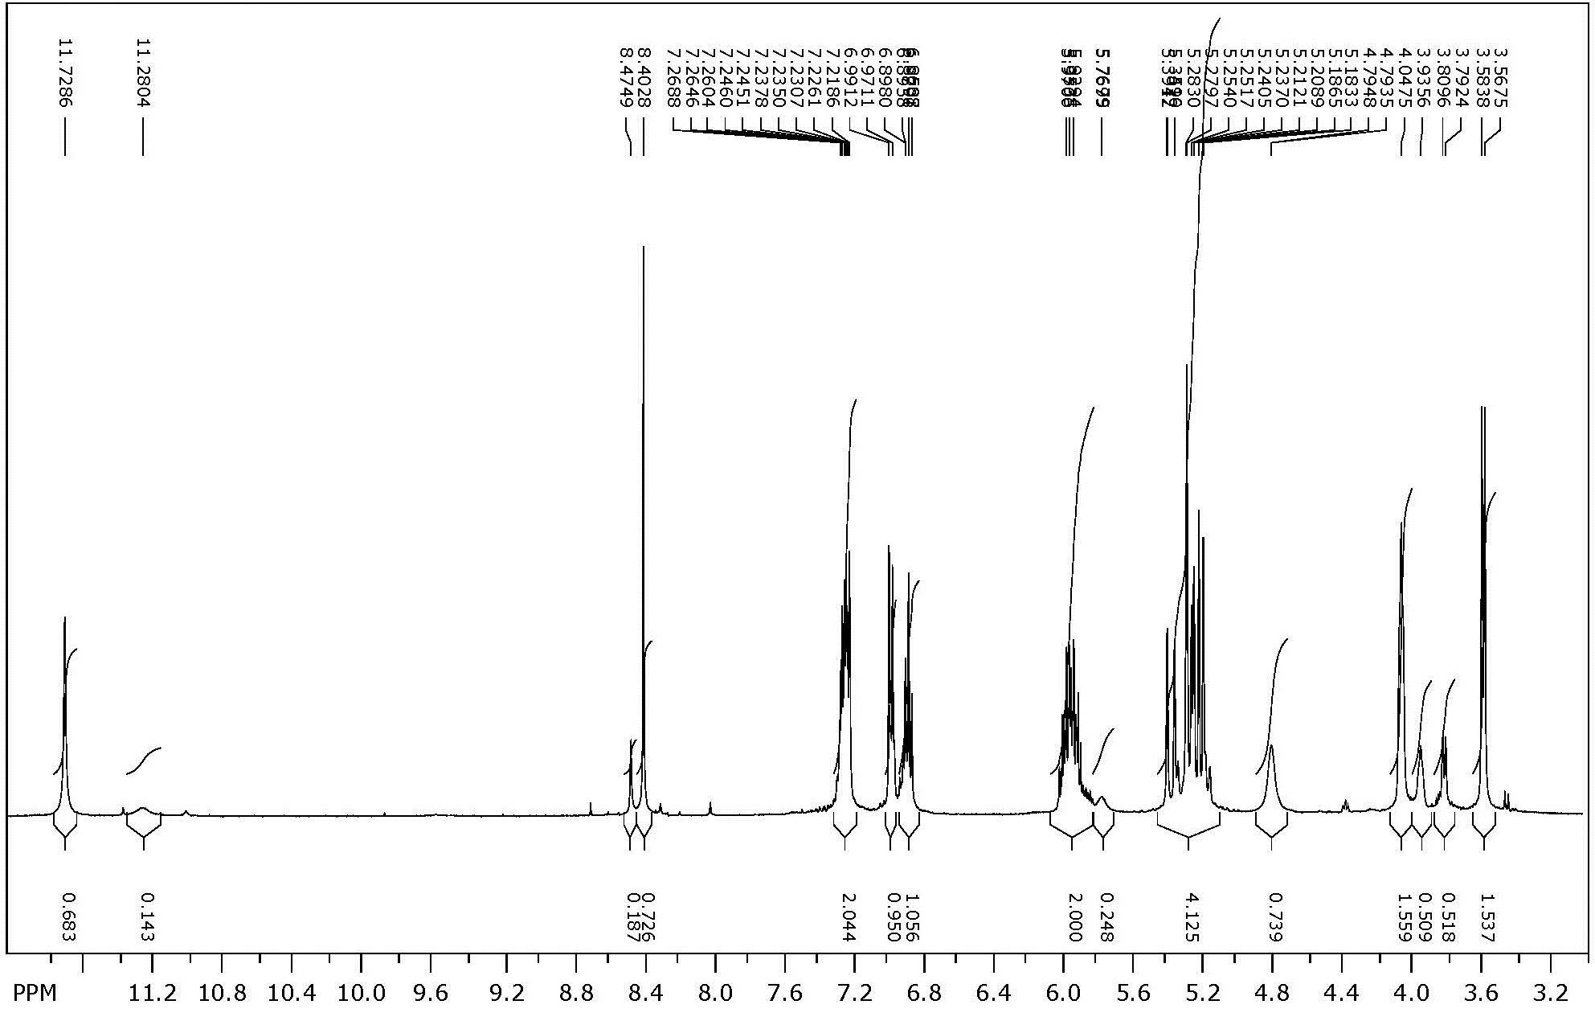
Figure S1. ¹H NMR spectrum of HL.
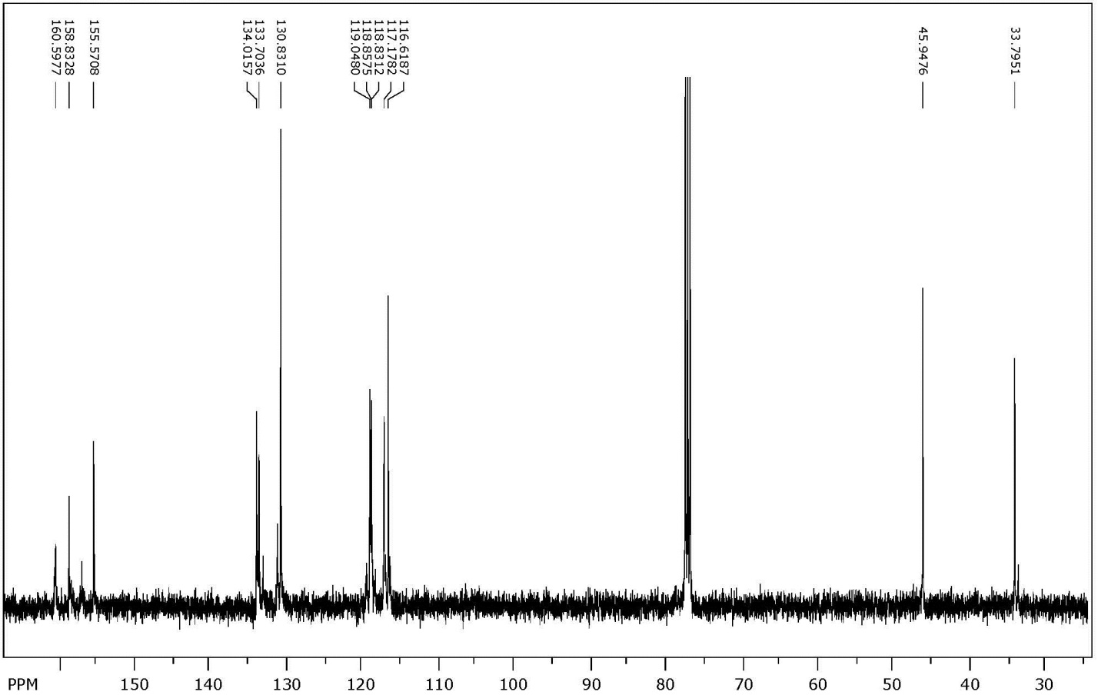
Figure S2. ¹³C NMR spectrum of HL.
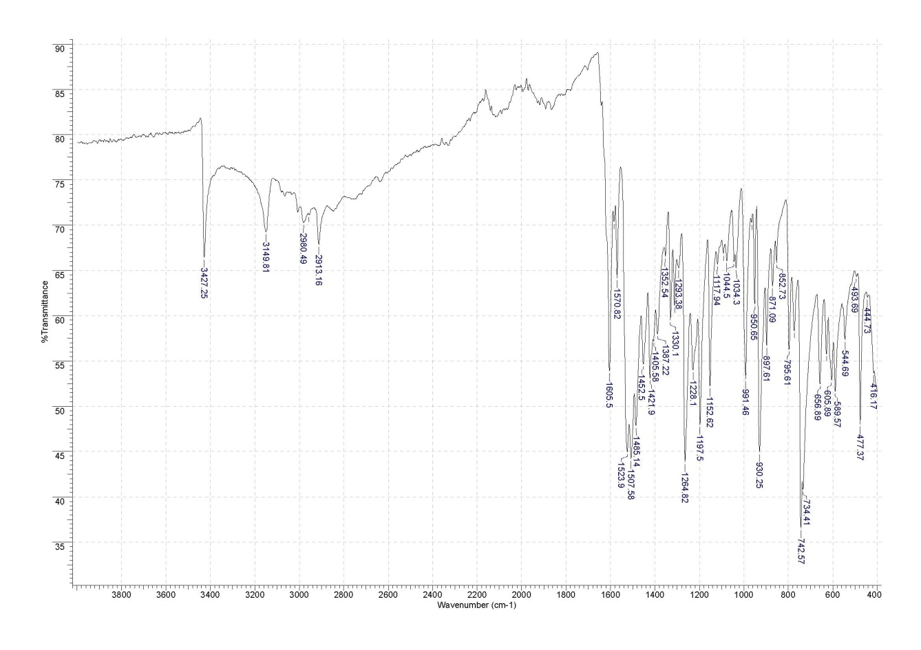
Figure S3. IR spectrum of HL.
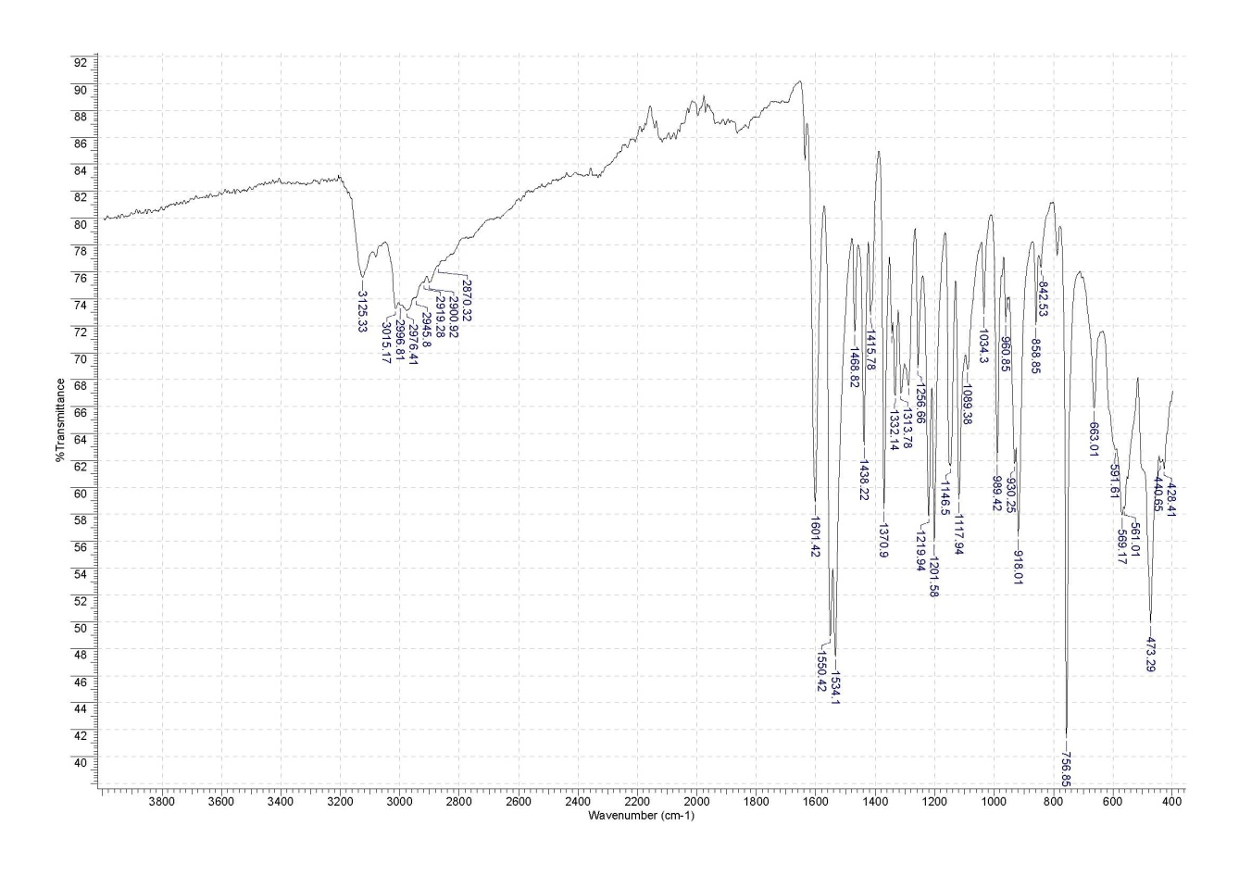
Figure S4. IR spectrum of 1.

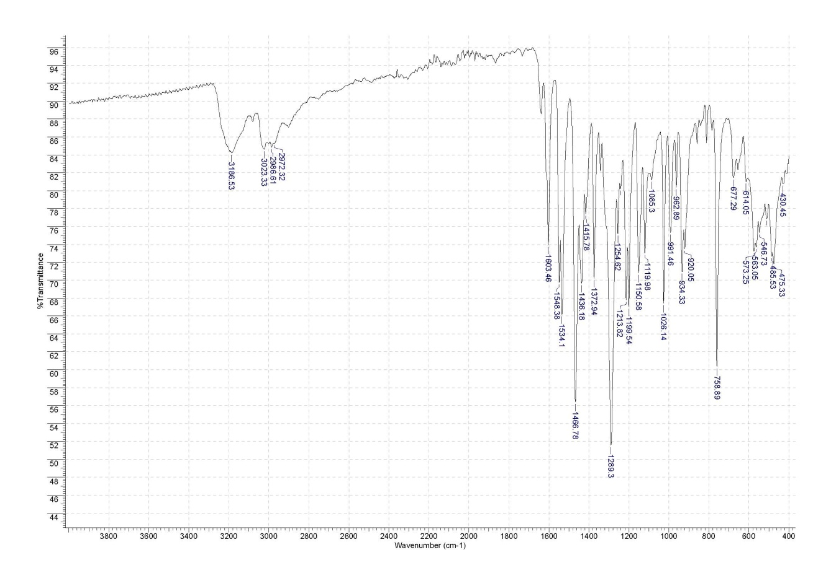
Figure S5. IR spectrum of 2.

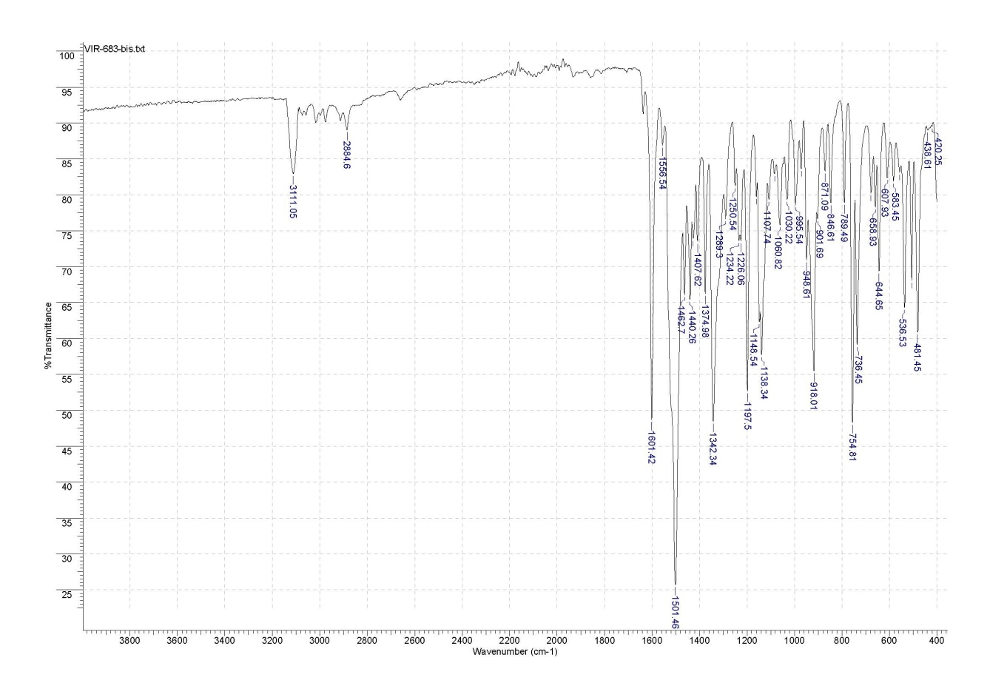
Figure S6. IR spectrum of 3.
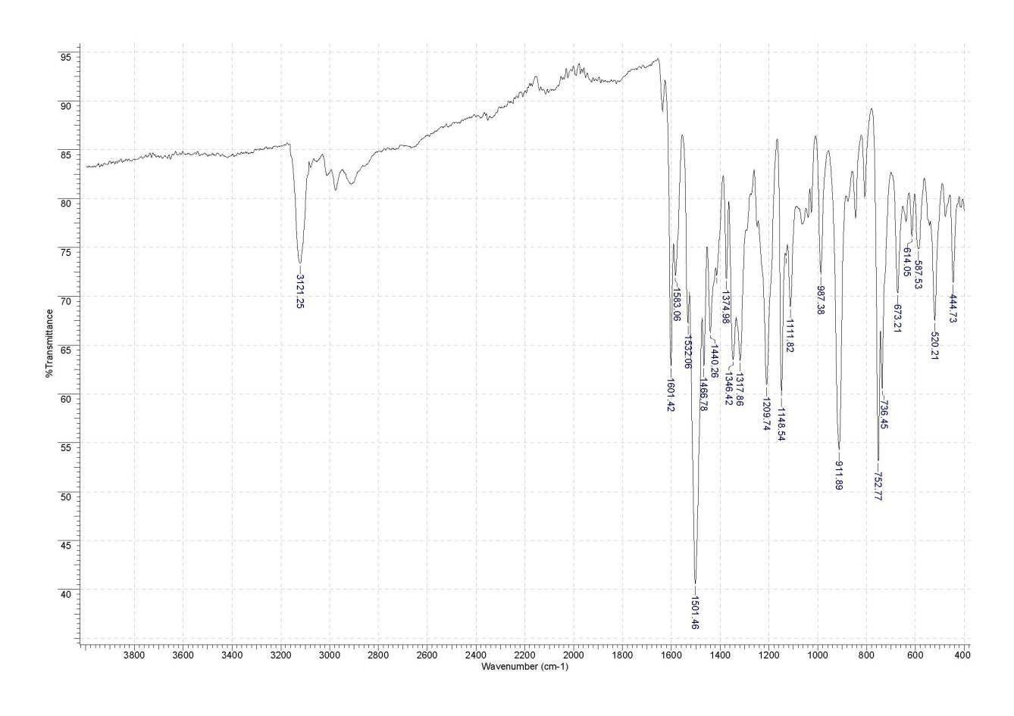
Figure S7. IR spectrum of 4.

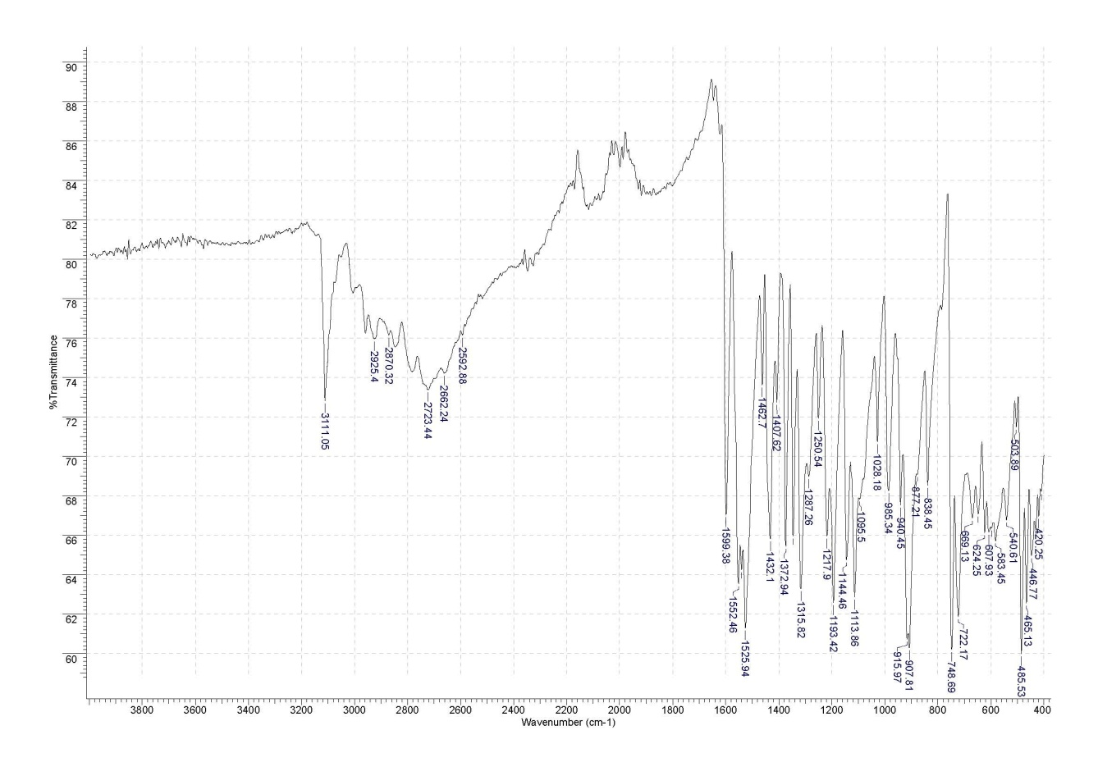
Figure S8. IR spectrum of 5.
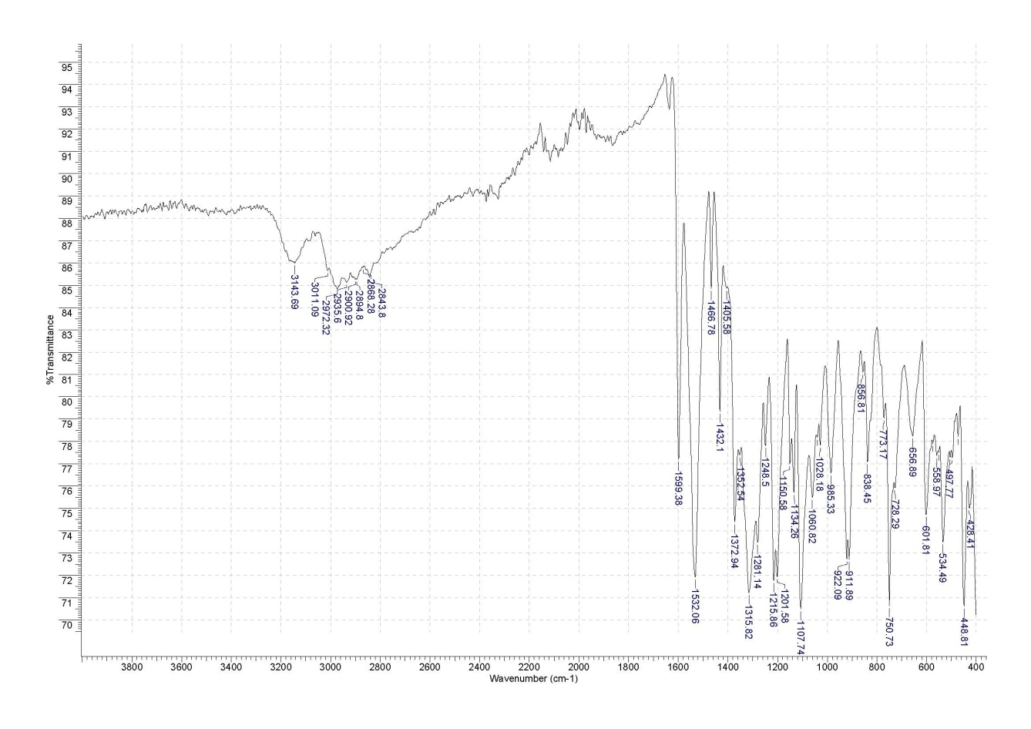
Figure S9. IR spectrum of 6.

