Electronic Supplementary Material on Article

Interaction of Copper(II) Complexes of Bidentate Benzaldehyde Nicotinic Acid Hydrazones with BSA: Spectrofluorimetric and Molecular Docking Approach
Adnan Zahirović,¹ Irnesa Osmanković,¹ Amar Osmanović,² Aleksandar Višnjevac,³ Amina Magoda,⁴ Selma Hadžalić¹ and Emira Kahrović*¹

¹ Laboratory for Inorganic and Bioinorganic Chemistry, Department of Chemistry, Faculty of Science, University of Sarajevo, Sarajevo, Bosnia and Herzegovina
² Faculty of Pharmacy, University of Sarajevo, Sarajevo, Bosnia and Herzegovina
³ Laboratory for Chemical and Biological Crystallography, Ruđer Bošković Institute, Zagreb, Croatia
⁴ Faculty of Veterinary Medicine, University of Sarajevo, Sarajevo, Bosnia and Herzegovina

*Correspondence should be sent to: emira_kahrovic@yahoo.com

Contents

Figure S1. Infrared spectra of nicotinic acid hydrazide, aromatic aldehydes and corresponding hydrazone ligands. 3
Figure S2. Calculated isotopic abundances for [(1)+H⁺]. 4
Figure S3. Experimental isotopic abundances for [(1)+H⁺]. 4
Figure S4. Calculated isotopic abundances for [(2)+H⁺]. 5
Figure S5. Experimental isotopic abundances for [(2)+H⁺]. 5
Table S1. Calculated and experimental isotopic abundances for [(1)+H⁺]. 6
Table S2. Calculated and experimental isotopic abundances for [(2)+H⁺]. 6
Figure S6. Electronic spectra of copper complexes (1) and (2) and corresponding hydrazone ligands in DMSO (5 × 10⁻⁵ M). 7
Table S3. Data on spectroscopic titration of (1) with CT DNA in 10 mM Tris-HCl buffer. 8
Table S4. Data on spectroscopic titration of (2) with CT DNA in 10 mM Tris-HCl buffer. 8
Table S5. Data on spectroscopic titration of HL¹ with CT DNA in 10 mM Tris-HCl buffer. 9
Table S6. Data on spectroscopic titration of HL² with CT DNA in 10 mM Tris-HCl buffer. 9
Figure S7. Spectroscopic titration of (1) (5.00 × 10⁻⁵ M) with CT DNA in 10 mM Tris-HCl buffer. Inset: Graphical determination of binding constant. 10
Figure S8. Spectroscopic titration of HL¹ (5.00 × 10⁻⁵ M) with CT DNA in 10 mM Tris-HCl buffer. Inset: Graphical determination of binding constant. 10
Figure S9. Spectroscopic titration of HL² (5.00 × 10⁻⁵ M) with CT DNA in 10 mM Tris-HCl buffer. Inset: Graphical determination of binding constant. 11
Table S7. Data on BSA fluorescence quenching by (1) in 10 mM Tris-HCl buffer. 12
Table S8. Data on BSA fluorescence quenching by HL¹ in 10 mM Tris-HCl buffer. 12
Table S9. Data on BSA fluorescence quenching by HL² in 10 mM Tris-HCl buffer. 12
Figure S10. Changes in fluorescence intensity of BSA (1 μM) in presence of an increasing concentration of (2) in 10 mM Tris-HCl buffer. a) Initial fluorescence quenching, b) Increase of BSA fluorescence after [complex]/[BSA ] = 1.5. 13
Figure S11. Interaction of HL¹ with BSA (1 μM) in 10 mM Tris-HCl buffer: a) Decrease of BSA fluorescence with increasing concentration of HL², b) graphical determination of Stern-Volmer constant, c) graphical determination of binding constant and number of binding sites. 14
Figure S12. Interaction of HL² with BSA (1 μM) in 10 mM Tris-HCl buffer: a) Decrease of BSA fluorescence with increasing concentration of HL¹, b) graphical determination of Stern-Volmer constant, c) graphical determination of binding constant and number of binding sites. 15
Figure S13. Changes in synchronous emission spectra of BSA (1 μM) in 10 mM Tris-HCl buffer pH 7.42 in absence and presence of (2) at [complex]/[BSA] = 3: a) Δλ = 15 nm; b) Δλ = 60 nm. 16
Figure S14. Changes in synchronous emission spectra of BSA (1 μM) in 10 mM Tris-HCl buffer pH 7.42 in absence and presence of HL¹ at [ligand]/[BSA] = 2: a) Δλ = 15 nm; b) Δλ = 60 nm. 16
Figure S15. Changes in synchronous emission spectra of BSA (1 μM) in 10 mM Tris-HCl buffer pH 7.42 in absence and presence of HL² at [ligand]/[BSA] = 2: a) Δλ = 15 nm; b) Δλ = 60 nm. 17
Figure S16. Best fitting position for binding of HL² to BSA. 18
Figure S17. Binding of (2) to BSA. Inset: Close-up projection of binding. 18
Figure S18. Distance of copper center in complex (2) from two tryptophan residues of BSA. 19

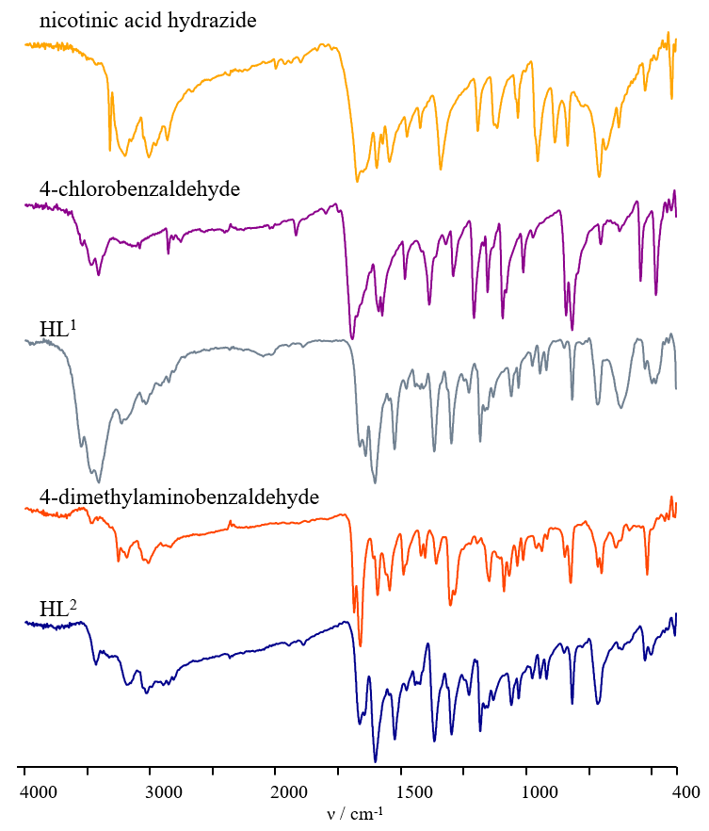

Figure S1. Infrared spectra of nicotinic acid hydrazide, aromatic aldehydes and corresponding hydrazone ligands.

Figure S2. Calculated isotopic abundances for [(1)+H⁺].

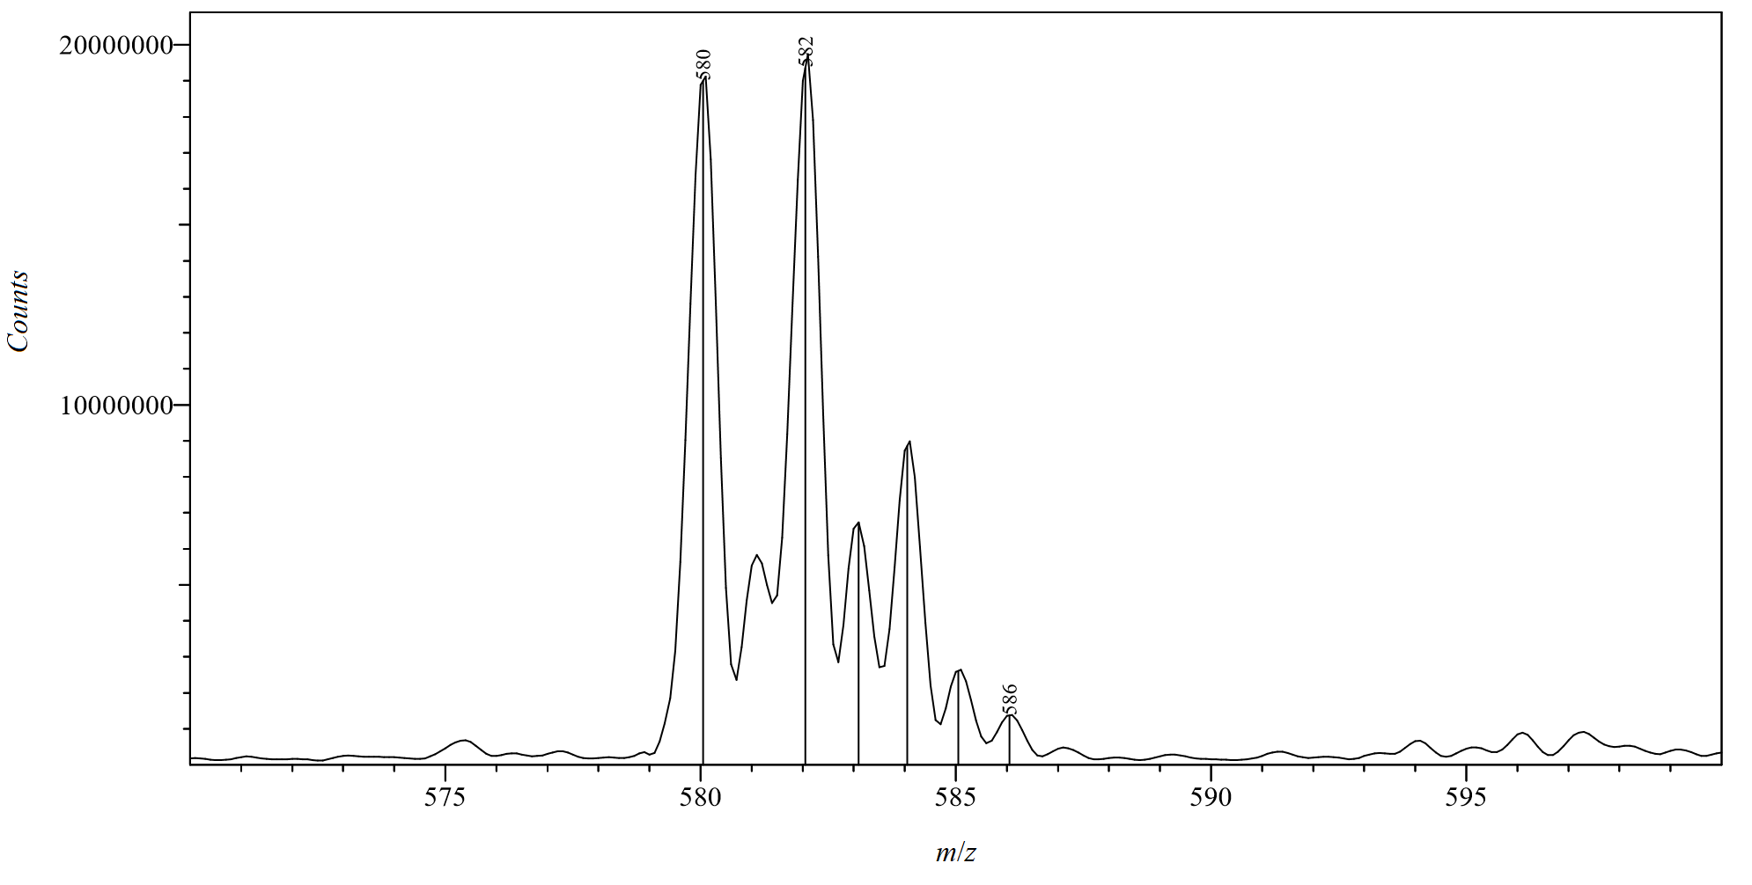

Figure S3. Experimental isotopic abundances for [(1)+H⁺].

Figure S4. Calculated isotopic abundances for [(2)+H⁺].

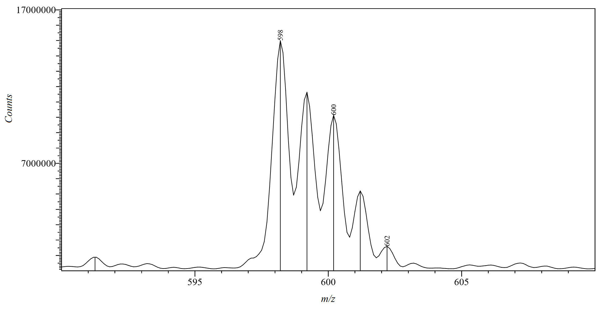

Figure S5. Experimental isotopic abundances for [(2)+H⁺].

Table S1. Calculated and experimental isotopic abundances for [(1)+H⁺].
Calculated |  | Experimental
m/z | Rel. Intensity | m/z | Rel. intensity
580.03 | 88.14 | 580.05 | 93.74
582.03 | 100.00 | 582.05 | 100.00
583.03 | 29.84 | 583.10 | 34.16
584.03 | 38.90 | 584.05 | 41.93
585.03 | 11.01 | 585.05 | 12.67

Table S2. Calculated and experimental isotopic abundances for [(2)+H⁺].
Calculated |  | Experimental
m/z | Rel. Intensity | m/z | Rel. intensity
598.20 | 100.00 | 598.20 | 100.00
599.20 | 35.93 | 599.20 | 96.02
600.20 | 51.26 | 600.20 | 74.63
601.20 | 16.87 | 601.20 | 43.09
602.20 | 3.06 | 602.20 | 12.77

Figure S6. Electronic spectra of copper complexes (1) and (2) and corresponding hydrazone ligands in DMSO (5 × 10⁻⁵ M).

Table S3. Data on spectroscopic titration of (1) with CT DNA in 10 mM Tris-HCl buffer.
V_{add} / μL | V_{total} / μL | [DNA] / 10⁻⁴ M | [DNA]/  [complex] | [complex] / 10⁻⁵ M | ε / 10⁴ M⁻¹ cm⁻¹ | Abs. | [DNA]/(ε_{f}―ε_{a}) /  10⁻⁷ M² cm
0 | 2000 | 0.00 | 0.00 | 5.00 | 1.72 | 0.8624
10 | 2010 | 0.36 | 0.72 | 4.98 | 1.64 | 0.8212 | 0.43
20 | 2020 | 0.71 | 1.43 | 4.95 | 1.63 | 0.8149 | 0.75
30 | 2030 | 1.06 | 2.13 | 4.93 | 1.62 | 0.8115 | 1.05
40 | 2040 | 1.41 | 2.82 | 4.90 | 1.60 | 0.8012 | 1.16
50 | 2050 | 1.76 | 3.51 | 4.88 | 1.58 | 0.7914 | 1.24
60 | 2060 | 2.10 | 4.19 | 4.85 | 1.57 | 0.7868 | 1.39
70 | 2070 | 2.43 | 4.87 | 4.83 | 1.56 | 0.7804 | 1.49

Table S4. Data on spectroscopic titration of (2) with CT DNA in 10 mM Tris-HCl buffer.
V_{add} / μL | V_{total} / μL | [DNA] / 10⁻⁴ M | [DNA]/  [complex] | [complex] / 10⁻⁵ M | ε / 10⁴ M⁻¹ cm⁻¹ | Abs. | [DNA]/(ε_{f}―ε_{a}) /  10⁻⁷ M² cm
0 | 2000 | 0.00 | 0.00 | 5.00 | 1.75 | 0.8764
10 | 2010 | 0.36 | 0.72 | 4.98 | 1.71 | 0.8557 | 0.86
20 | 2020 | 0.71 | 1.43 | 4.95 | 1.71 | 0.8553 | 1.69
30 | 2030 | 1.06 | 2.13 | 4.93 | 1.71 | 0.8540 | 2.38
40 | 2040 | 1.41 | 2.82 | 4.90 | 1.70 | 0.8509 | 2.77
50 | 2050 | 1.76 | 3.51 | 4.88 | 1.70 | 0.8483 | 3.13
60 | 2060 | 2.10 | 4.19 | 4.85 | 1.69 | 0.8446 | 3.30
70 | 2070 | 2.43 | 4.87 | 4.83 | 1.68 | 0.8422 | 3.56

Table S5. Data on spectroscopic titration of HL¹ with CT DNA in 10 mM Tris-HCl buffer.
V_{add} / μL | V_{total} / μL | [DNA] / 10⁻⁴ M | [DNA]/  [ligand] | [ligand] / 10⁻⁵ M | ε / 10⁴ M⁻¹ cm⁻¹ | Abs. | [DNA]/(ε_{f}―ε_{a}) /  10⁻⁷ M² cm
0 | 2000 | 0.00 | 0.00 | 5.00 | 2.80 | 1.3997
10 | 2010 | 0.36 | 0.72 | 4.98 | 2.78 | 1.3899 | 1.83
20 | 2020 | 0.71 | 1.43 | 4.95 | 2.76 | 1.3806 | 1.87
30 | 2030 | 1.06 | 2.13 | 4.93 | 2.75 | 1.3758 | 2.23
40 | 2040 | 1.41 | 2.82 | 4.90 | 2.75 | 1.3725 | 2.60
50 | 2050 | 1.76 | 3.51 | 4.88 | 2.74 | 1.3704 | 3.00

Table S6. Data on spectroscopic titration of HL² with CT DNA in 10 mM Tris-HCl buffer.
V_{add} / μL | V_{total} / μL | [DNA] / 10⁻⁴ M | [DNA]/  [complex] | [complex] / 10⁻⁵ M | ε / 10⁴ M⁻¹ cm⁻¹ | Abs. | [DNA]/(ε_{f}―ε_{a}) /  10⁻⁷ M² cm
0 | 2000 | 0.00 | 0.00 | 5.00 | 2.83 | 1.4131
10 | 2010 | 0.36 | 0.72 | 4.98 | 2.81 | 1.4054 | 2.33
20 | 2020 | 0.71 | 1.43 | 4.95 | 2.80 | 1.4009 | 2.92
30 | 2030 | 1.06 | 2.13 | 4.93 | 2.80 | 1.3976 | 3.43
40 | 2040 | 1.41 | 2.82 | 4.90 | 2.79 | 1.3945 | 3.80
50 | 2050 | 1.76 | 3.51 | 4.88 | 2.79 | 1.3943 | 4.67

Figure S7. Spectroscopic titration of (1) (5.00 × 10⁻⁵ M) with CT DNA in 10 mM Tris-HCl buffer. Inset: Graphical determination of binding constant.

Figure S8. Spectroscopic titration of HL¹ (5.00 × 10⁻⁵ M) with CT DNA in 10 mM Tris-HCl buffer. Inset: Graphical determination of binding constant.

Figure S9. Spectroscopic titration of HL² (5.00 × 10⁻⁵ M) with CT DNA in 10 mM Tris-HCl buffer. Inset: Graphical determination of binding constant.

Table S7. Data on BSA fluorescence quenching by (1) in 10 mM Tris-HCl buffer.
V_{add} / μL | V_{total} / μL | [complex] / 10⁻⁶ M | Intensity | I₀ / I | log[(I₀-I)/I] | log[complex]
0 | 2000 | 0.00 | 783 | 1.000
10 | 2010 | 0.50 | 635 | 1.233 | -0.633 | -6.303
20 | 2020 | 0.99 | 554 | 1.413 | -0.384 | -6.004
30 | 2030 | 1.48 | 507 | 1.544 | -0.264 | -5.830
40 | 2040 | 1.96 | 471 | 1.662 | -0.179 | -5.708
50 | 2050 | 2.44 | 442 | 1.771 | -0.113 | -5.613
60 | 2060 | 2.91 | 417 | 1.878 | -0.057 | -5.536

Table S8. Data on BSA fluorescence quenching by HL¹ in 10 mM Tris-HCl buffer.
V_{add} / μL | V_{total} / μL | [ligand] / 10⁻⁶ M | Intensity | I₀ / I | log[(I₀-I)/I] | log[ligand]
0 | 2000 | 0.00 | 783 | 1.00
10 | 2010 | 0.50 | 730 | 1.073 | -1.139 | -6.303
20 | 2020 | 0.99 | 670 | 1.169 | -0.773 | -6.004
30 | 2030 | 1.48 | 645 | 1.214 | -0.670 | -5.830
40 | 2040 | 1.96 | 633 | 1.237 | -0.625 | -5.708
50 | 2050 | 2.44 | 617 | 1.269 | -0.570 | -5.613
60 | 2060 | 2.91 | 600 | 1.305 | -0.516 | -5.536

Table S9. Data on BSA fluorescence quenching by HL² in 10 mM Tris-HCl buffer.
V_{add} / μL | V_{total} / μL | [ligand] / 10⁻⁶ M | Intensity | I₀ / I | log[(I₀-I)/I] | log[ligand]
0 | 2000 | 0.00 | 781 | 1.000
10 | 2010 | 0.50 | 734 | 1.064 | -1.194 | -6.303
20 | 2020 | 0.99 | 709 | 1.102 | -0.993 | -6.004
30 | 2030 | 1.48 | 703 | 1.111 | -0.955 | -5.830
40 | 2040 | 1.96 | 695 | 1.124 | -0.907 | -5.708
50 | 2050 | 2.44 | 686 | 1.138 | -0.859 | -5.613
60 | 2060 | 2.91 | 670 | 1.166 | -0.781 | -5.536

Figure S10. Changes in fluorescence intensity of BSA (1 μM) in presence of an increasing concentration of (2) in 10 mM Tris-HCl buffer. a) Initial fluorescence quenching, b) Increase of BSA fluorescence after [complex]/[BSA ] = 1.5.

Figure S11. Interaction of HL¹ with BSA (1 μM) in 10 mM Tris-HCl buffer: a) Decrease of BSA fluorescence with increasing concentration of HL², b) graphical determination of Stern-Volmer constant, c) graphical determination of binding constant and number of binding sites.

Figure S12. Interaction of HL² with BSA (1 μM) in 10 mM Tris-HCl buffer: a) Decrease of BSA fluorescence with increasing concentration of HL¹, b) graphical determination of Stern-Volmer constant, c) graphical determination of binding constant and number of binding sites.

Figure S13. Changes in synchronous emission spectra of BSA (1 μM) in 10 mM Tris-HCl buffer pH 7.42 in absence and presence of (2) at [complex]/[BSA] = 3: a) Δλ = 15 nm; b) Δλ = 60 nm.

Figure S14. Changes in synchronous emission spectra of BSA (1 μM) in 10 mM Tris-HCl buffer pH 7.42 in absence and presence of HL¹ at [ligand]/[BSA] = 2: a) Δλ = 15 nm; b) Δλ = 60 nm.

Figure S15. Changes in synchronous emission spectra of BSA (1 μM) in 10 mM Tris-HCl buffer pH 7.42 in absence and presence of HL² at [ligand]/[BSA] = 2: a) Δλ = 15 nm; b) Δλ = 60 nm.

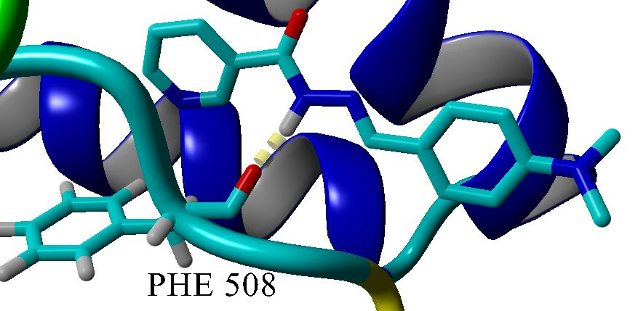

Figure S16. Best fitting position for binding of HL² to BSA.

Figure S17. Binding of (2) to BSA. Inset: Close-up projection of binding.

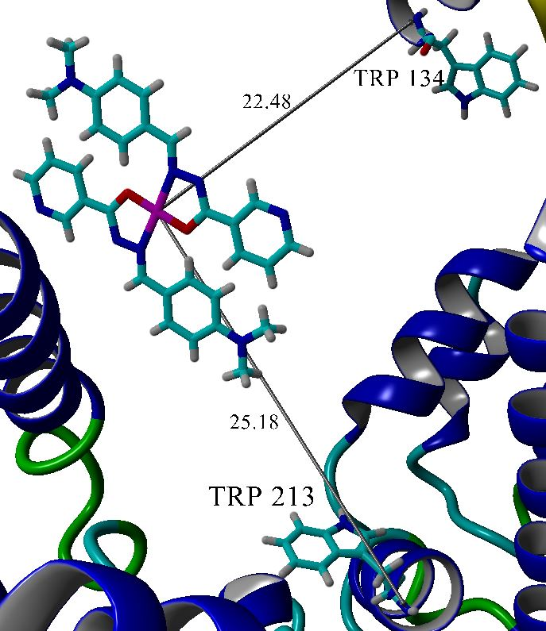

Figure S18. Distance of copper center in complex (2) from two tryptophan residues of BSA.

