Biotreatability improvement of antibiotic-contaminated waters: High efficiency of direct ozonation in comparison to hydroxyl radical oxidation
Igor Boševski* and Andreja Žgajnar Gotvajn
University of Ljubljana, Faculty of Chemistry and Chemical Technology, Večna pot 113, SI-1000 Ljubljana, Slovenia.
*igor.bosevski@gmail.com

Efficiencies of direct ozonation and hydroxyl radical oxidation by Fenton process were compared, aiming to improve biotreatability of antibiotics contaminated water (tiamulin, amoxicillin and levofloxacin). Biodegradability, COD (chemical oxygen demand) and TOC (total organic carbon) were measured before and after applying oxidative process. It was confirmed that significantly smaller molar dose of ozone (1.1 mg_{O3} / mg_{atb}) against the hydrogen peroxide (17 mg_{H2O2} / mg_{atb}), deliver comparable improvements of biodegradability; Tiamulin biodegraded up to 60 %, levofloxacin close to 100 %. Ozonation removed more TOC (10%, 29% and 8% for tiamulin, levofloxacin and amoxicillin, respectively) than Fenton process. This is confirming mineralization of antibiotics, not only biodegradable intermediates formation. In terms of costs, ozonation is more feasible in oxidizing complex antibiotics in water, as it targets functional groups which carry antimicrobial properties. This brings not only improved biodegradability needed for a conventional biological treatment plant, but also reduces long-term impacts of the antibiotics in the environment.
Keywords: Antibiotic, Biodegradability, Fenton process, Ozonation, Water
- Introduction
Since discovered, antibiotics have brought immense benefits in terms of human and animal health, as well as food production. On the other hand, antibiotics are source of environmental pollution of growing attention, especially in the perspective of bacterial antibiotic resistance phenomena. Studies indicate that surface water concentrations of some most common antibiotics are low, an order of magnitude lower than the toxic concentrations to water organisms. ^{1, 2, 3} A study of Johnson et al.⁴ found, that the average concentration of antibiotic in most European rivers does not exceed 10 ng L⁻¹. Although without any direct toxic effects, such concentrations do promote a development of bacterial antibiotic resistance genes. Resistance was found most frequently against tetracyclines and sulfonamides, as nowadays we see more and more resistance against advanced generation antibiotics such as β-lactams.⁵ In order to control the distribution of antibiotics into the environment, use of proper antibiotic removal or deactivation techniques is mandatory. These should ensure that antimicrobial properties of the substance are removed. This not only enables conventional biological treatment, but also limits antibiotic resistance development, as the molecules are released into the environment.
Ozone is reacting with organic matter by direct reaction with dissolved ozone or indirectly through hydroxyl radicals. Scope of both mechanisms and degradation rate of the organic matter depends on the properties of the matter itself, ozone dose and pH of the media. Under pH 4, direct reaction is prevailing, while above pH 9, indirect path of oxidation (hydroxyl radicals) is dominant. ⁶ Ozonation in general does not lead to full mineralization; therefore, combination with subsequent biological treatment may be appropriate. ⁷ It case of antibiotics it has been found that, e.g., erythromycin and ethyl-paraben can be removed by low doses of ozone within two minutes and even erythromycin and ethyl-paraben resistant bacteria (Escherichia coli) were eliminated after 15 min of ozonation. ⁸ Antibiotics are susceptible to ozonation, as they carry one or more reactive functional groups in their molecular structure, such as amine nitrogen, sulfur, carbon-carbon double bond and the activated aromatic ring. During ozonation the molecule is partially decomposed as well as the structure of the key ozone-susceptible functional groups is changed. This transforms a molecule into pharmacologically inactive, biodegradable form. Identification and quantification of degradation by products arising from ozonation, as well as their environmental properties are a continuing topic of research. ^{9, 10}
Fenton oxidation is a technique using free hydroxyl radicals as oxidant reagent. It is a mixture of hydrogen peroxide (oxidizing reagent) and Fe salt (catalyst), which oxidizes organic matter by means of hydroxyl radicals, which are powerful, non-selective oxidants. Reaction rate is determined by the rate of radical generation, which is controlled by a concentration of iron catalyst. Common molar ration Fe²⁺ : H₂O₂ is 1 : (5 – 10), although concentrations of Fe²⁺ below 25 – 50 mg L⁻¹ may lead to disproportionally long reaction time (from 10 to 48 hours). The drawback of oxidation with Fenton process is that it generates waste ferric sludge, which requires further disposal, as well as treated pollutants or by-products of the process at higher concentrations may adsorb to the sludge⁶. A few studies have demonstrated high effectiveness of Fenton process in treating wastewaters from antibiotics formulation (cefuroxime axetil, ceftriaxone, sulfisoxazole), with COD as high as 1,000 mg L⁻¹ as well as treatment of wastewater with single antibiotic (norfloxacin), reaching mineralization rate of 55% in 60 min. ¹¹
The aim of our study was to evaluate and compare effectiveness of direct ozonation and Fenton process generating non-selective hydroxyl radicals for oxidation of selected antibiotics dissolved in water, leading to increased biodegradability. Selected antibiotics in the study were from three different groups; i) tiamulin (TML), diterpene, veterinary antibiotic, poorly biodegradable; ii) amoxicillin (AMX), β-lactam, biodegradable; and iii) levofloxacin (LFX), fluoroquinolone, non-biodegradable. This study has generated new data regarding behaviour of the antibiotics during different AOPs, evaluated through biodegradability and process kinetics. This should support both development of a treatment process that delivers an optimum effectiveness in terms of cost and long-term environment impact mitigation.
- Materials and Methods
Lab scale ozonation of water, contaminated with antibiotic was conducted in a continuous mode with water circulation, while Fenton oxidation experiments were conducted in a conventional homogenous batch mode, with hydrogen peroxide and Fe(II)sulfate as a catalyst. The effectiveness of the methods applied was evaluated by measuring a change of Chemical Oxygen Demand (COD), Total Organic Carbon (TOC) and aerobic biodegradability. Antibiotics belonging to three different groups were used in the experiments, all containing several functional groups in their structure (amine nitrogen, sulfur, carbon-carbon double bond, activated aromatic ring), which are susceptible to direct reactions with ozone, as presented in Table 1.
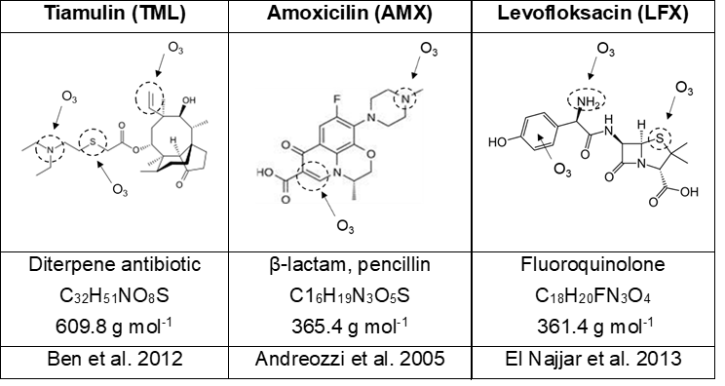
Table 1: Molecular structure of antibiotics and proposed attack points of ozone in direct ozonation reaction.

These groups, marked in Table 1, are susceptible to a reaction with hydroxyl radicals as well.¹² Experiments were performed using 400 and 100 mg L⁻¹ solutions of antibiotics in demineralized water. pH of the solutions was in the case of TML 6.0 ± 0.1, and for AMX and LFX 7.0 ± 0.1, at the ambient temperature of 22 ± 2 ⁰C. In this case, the prevailing reaction route was assumed a direct reaction with ozone. Before or during the ozonation, no pH adjustment was done.

Ozonation
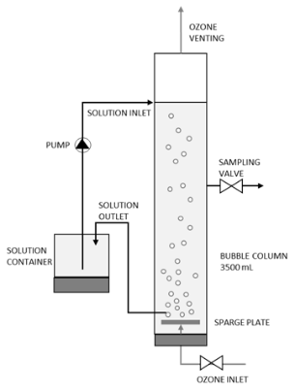
In the experimental set-up, ozone was purged through a glass column (3,500 mL, diameter 12 cm, height 50 cm), as shown in Figure 1.
Figure 1: Bench-scale ozonation system

Water solution of antibiotic was circulated in a counter-current mode with respect to ozone bubble path, in a closed loop including a reservoir with a flow of 1 mL s⁻¹ at ambient temperature (22 ± 2⁰ C). The operating pressure of the ozone generator (Xylem Water Solutions, Herford GmbH, Germany, 2012) was 0.5 bar, the gas flow of 0.05 m³ h⁻¹, and the capacity of the system was 7 g h⁻¹. The nominal concentration of ozone in the gas phase was 140 g m⁻³ (NTP). The ozone amount delivered into the liquid phase was determined by the calibration line.¹³ Calibration line was derived by ozonating water in the same set-up and conditions as the experiments, while measuring ozone concentration colorimetrically (118755, Merck Ozone Test) every five minutes until saturation. Ozone concentration (y, mg_{ozone} L⁻¹) was plotted against time (x, min) and the ozone delivery rate was determined by the constant in the line equation, which was 3 mg_{ozone} L⁻¹ min⁻¹. Oxidant dose was then determined by the time of ozonation, which was ranging from 45 to 180 minutes as a maximal ozonation time for selected antibiotic. Doses and other experimental details are outlined in Table 2.

Table 2: Ozone doses used at experiments.
Ozonation time, min | Ozone dose*  mol_{ozone} mol_{COD}⁻¹ |  |  | Ozone dose **  mg_{ozone} g_{anitbiotic}⁻¹
Ozonation time, min | TML | LFX | AMX | All antibiotics
0 | 0.00 | 0.00 | 0.00 | 0
15 | 0.04 | 0.03 | 0.04 | 104
30 | 0.07 | 0.07 | 0.07 | 182
45 | 0.11 | 0.10 | 0.15 | 286
90 | 0.22 | 0.21 | 0.23 | 572
120 | 0.29 | 0.28 | 0.29 | 754
135 | 0.33 | 0.31 | 0.35 | 858
180 | 0.44 | 0.42 | 0.44 | 1,144
* Calculated according to the initial COD of the solution of the antibiotic.
** Calculated according to the initial mass of the antibiotic in the solution, the same for all antibiotics.

Fenton process
For Fenton process, common laboratory glassware was used. 200 mL of antibiotic solution (400 mg L⁻¹) was put in a beaker and stirred at 200 rpm; pH was adjusted to 2.5 – 3.0 with concentrated HCl (Merck, Germany). Reagents Ferrous sulphate heptahydrate (FeSO₄ · 7H₂O; Fluka Analytical, Germany) and hydrogen peroxide (H₂O₂, 30 %; Merck, Germany) were used in a molar ratio FeSO₄/H₂O₂ = 1/10. This ratio is at the high end among the commonly used ratios in Fenton process, aiming to have most oxidant available for the reaction. Experiments were conducted at ambient temperature (22 ± 2⁰ C). After 30 minutes, solution was boiled for 3 minutes to remove any possible residual peroxide. Antibiotic molecules were proven to be stable during this period, as separate blank test was carried out, with boiling antibiotic solution for 3 minutes – there was no change observed in TOC before and after the boiling. Samples were cooled, pH raised to 9.0±0.1 to precipitate Fe³⁺ salts, then filtered by using paper filter Whatman No. 41. Filtrate was used for further analysis. Experiments were run in duplicates. Doses of oxidant are outlined in Table 3.

Table 3: Hydrogen peroxide doses used at Fenton process.
Experiment | V H₂O₂  ml | Dose H₂O₂*  mol_{H2O2} mol_{COD}⁻¹ |  |  | Dose H₂O₂**  mg_{H2O2} g_{antibiotc}⁻¹
Experiment | V H₂O₂  ml | TML | LFX | AMX | All antibiotics
I. | 0.5 | 0.9 | 1.1 | 1.1 | 2,081
II. | 1.0 | 1.8 | 2.1 | 2.2 | 4,163
III. | 2.0 | 3.6 | 4.1 | 4.4 | 8,325
IV. | 4.0 | 7.1 | 8.5 | 8.8 | 16,650
*Calculated according to the initial COD of the antibiotic solution.
** Calculated according to the initial mass of the antibiotic in the solution, the same for all antibiotics.

  - Analytical methods
The degradation rate of all selected antibiotics before and after the oxidation was evaluated by measuring COD and TOC, according to standard ISO methods 6060:1989 and 8245:1999.^{14, 15} Actual concentrations of the antibiotics were not measured. Biodegradability was assessed according to ISO 9408:1999 method.¹⁶ This method evaluates the ultimate aerobic biodegradability of organic compounds, by determining oxygen demand in a closed respirometer, using aerobic microorganisms. Solution (150 mL) of investigated antibiotic (400 mg L⁻¹) was added to non-adapted activated sludge microorganisms (30 mg _{VSS} L⁻¹), including nutrient mineral solution (6.5 mL) and stirred in a closed flask (total volume 500 mL). The degradation was followed over a period of 22 days by measuring oxygen consumption as a consequence of biodegradation. Activated sludge microorganisms were taken from a municipal wastewater treatment plant of Ljubljana city, Slovenia. Overall measuring accuracy was ±2% for the TOC, ±4% for the COD and ±6% for the biodegradabilty.

- Results and discussion

  - Ozonation
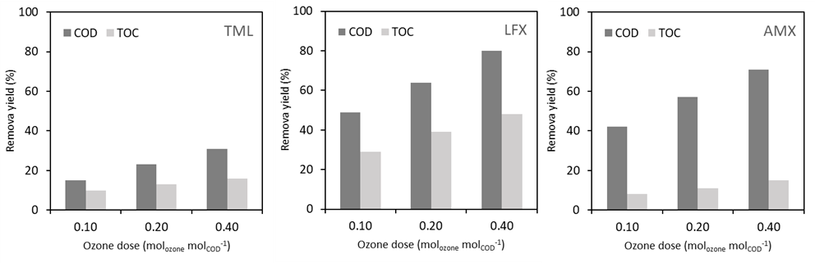
COD and TOC removal yields in ozonation experiments for all three investigated antibiotics are shown in Figure 2. pH remained constant during the process.
Figure 2: Comparison of COD and TOC removal yields in ozonation experiments with antibiotics
(100 mg L⁻¹ of antibiotics); A - tiamulin; B – levofloxacin; C – amoxicillin.

Figure 2 (A-C) shows that the maximum incremental effect is achieved with the smallest dose of 0.1 mol_{ozone}mol_{COD}⁻¹. At this dose, a COD reduction of 15% is achieved with TML (Fig 2 A), 49% with LFX (Fig 2 B) and 42% with AMX (Fig 2 C). TOC reduction is 10%, 29% and 8% for TML, LFX and AMX, respectively. A double or even quadruple dose of ozone did not lead to proportionally larger effect; a fourfold dose size resulted in doubled effect of COD removal for TML, and 1.7 times larger removal with LFX and AMX. The increase in TOC reduction effect was 1.6-fold for TML and LFX and 1.9-fold for AMX.
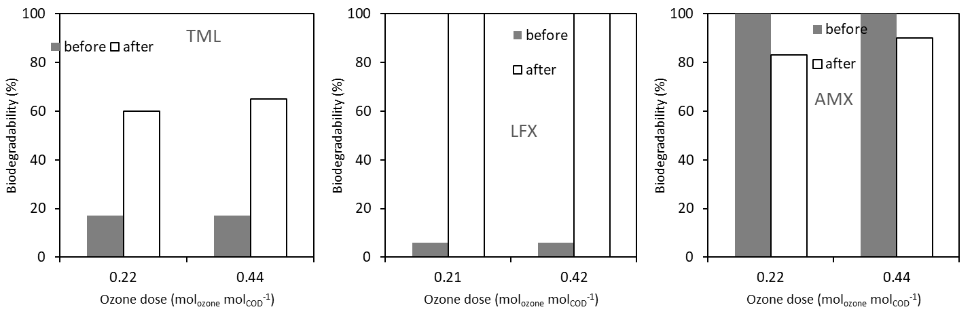
Since ozonation is considered primarily as a pretreatment method prior to biological treatment, its effect on biodegradation is particularly important, which is shown in Figure 3.
Figure 3: Biodegradability before and after ozonation (100 mg L-1 of antibiotics): A - tiamulin;
B – levofloxacin; C – amoxicillin.
As Figure 3 (A-C) shows, analogous to the removal of COD or TOC, a double dose (0.2 vs. 0.4 mol ozone per mol_{COD}⁻¹) did not significantly affect the change in biodegradability. At both doses, TML biodegradability improves from less than 20 to 60% and for LFX from non-biodegradable to completely biodegradable. According to the studies of El Naijar et al. (2013) and Andreozzi et al. (2005) where oxidative degradation of LFX and AMX was studied, complex organic molecules react with ozone in a direct or indirect way to the point where products are formed, that do not react with ozone anymore. For this reason, further increase in ozone dose delivers no significant improvement in COD or TOC removal, as noticed in our study, too. Furthermore, biodegradability of AMX after ozonation is lower (from 100 to 80%), which could be due to a product of ozonation (2-amino-2-(p-hidroxyphenyl)aceto acid) which exhibits lower biodegradability than the parent molecule (Andreozzi et al. 2005). The biodegradation was followed over a period of 22 days although in most cases, maximal level of biodegradation was reached within 14 days. Abiotic degradation of all three antibiotics was checked and found to be < 2% which confirms that measured degradation is not related to any non-biological, physicochemical processes.
Combining the data from Figures 2 and 3, it can be assumed that for the pretreatment of the antibiotics TML and LFX, a dose of ozone 0.22 mol_{ozone}mol_{COD}⁻¹ is sufficient to achieve a significant biodegradability improvement (TML to 60% and LFX to 100%). Furthermore, COD was reduced by 23% in the case of TML (Fig 2 A) and by 64% in the case of LFX (Fig 2 B); TOC was reduced by 13% in the case of TML (Fig 2 A) and by 39% in the case of LFX (Fig 2 B). Considering the reduction of biodegradation of AMX after ozonation (from 100 to 82 % at 0.22 mol_{ozone}mol_{COD}⁻¹ and from 100 to 91 % at 0.44 mol_{ozone}mol_{COD}⁻¹; Fig 3 C), ozonation is of no value here, although the biodegradation process begins earlier (in two days) comparing to the start of biodegradation of parent molecule (six days).

  - Hydroxyl radical oxidation – Fenton process
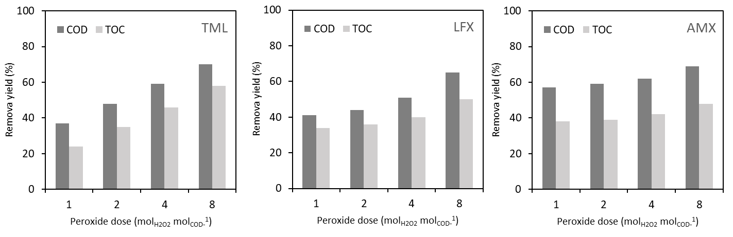
COD and TOC removal yields achieved by Fenton process are shown in Figure 4. pH remained constant during the experiments (± 0.4). Figure 4 shows that the maximum incremental effect is achieved with the lowest dose, 1 mol_{H2O2}mol_{COD}⁻¹. At this dose, a COD reduction of 37% for TML (Fig 4 A), 41% for LFX (Fig 4 B) and 57% for AMX (Fig 4 C) is achieved. The TOC reduction is 24%, 34% and 38% for TML, LFX and AMX respectively. Reduction is larger for COD than TOC as the antibiotics are oxidized, but only partially mineralized, so COD decreases faster than TOC.
Figure 4: Comparison of COD and TOC removal yields in Fenton process experiments with antibiotics
(400 mg L⁻¹ of antibiotics):A -tiamulin; B – levofloxacin; C – amoxicillin.
An increased dose of hydrogen peroxide does not result in a linear increase of removal yield; a fourfold dose resulted in a 60% removal yield increase of COD at TML, a 7% increase at LFX, and 8% increase at AMX. The reduction of TOC was 90% higher for TML, 10% for LFX and 7% for AMX. The oxidation products apparently no longer react with hydroxyl radicals, so oxidation does not progress and the removal effects do not increase proportionally with the H₂O₂ dose increase (Figure 4).
Since Fenton oxidation is considered here as a pre-treatment method before biological treatment, the effect on biodegradation is important, shown in Figure 5.
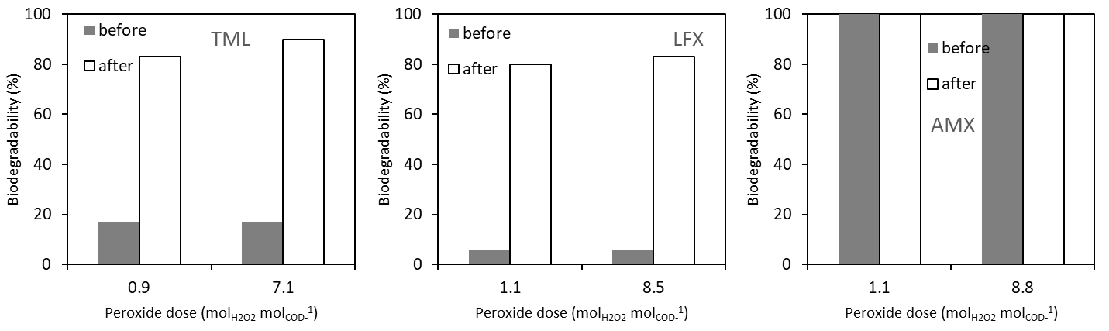
Figure 5: Biodegradability before and after Fenton process (400 mg L⁻¹ of antibiotic):
A - tiamulin; B – levofloxacin; C – amoxicillin.
As can be seen from Figure 5, the largest change in biodegradability is achieved with relatively small doses of hydrogen peroxide, 1 mol_{H2O2}mol_{COD}⁻¹. At this dose of oxidant, biodegradability of both TML and LFX reached 80%. Increasing the dose does not have a proportional effect on increasing biodegradability because the oxidation products no longer react with hydroxyl radicals. It can be assumed that for the purpose of antibiotic pretreatment, resulting in increased biodegradability, a dose of 1 mol_{H2O2}mol_{COD}⁻¹ is sufficient.

  - Comparison of direct reaction with ozone and oxidation by hydroxyl radicals
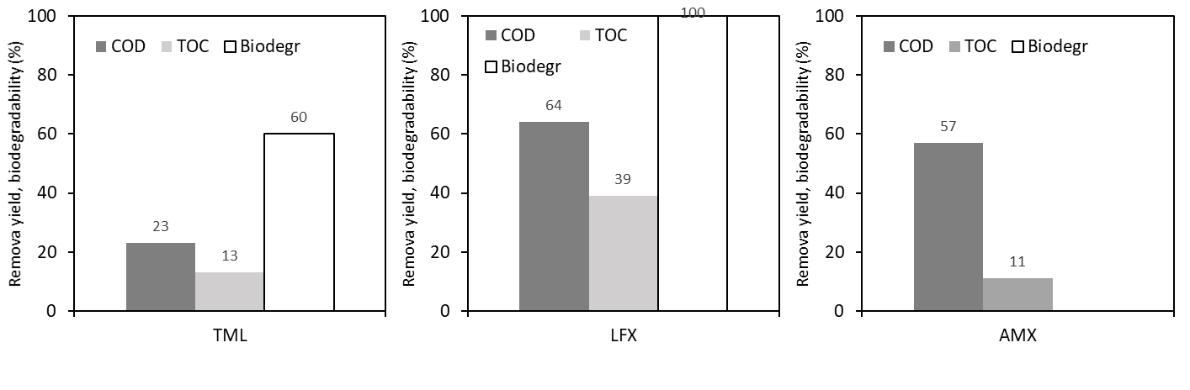
A comparison of the effects of direct reaction with ozone and oxidation with hydroxyl radicals from Fenton process is outlined in Figure 6. With Fenton process five times higher molar dose of oxidant per unit of COD was used in comparison to ozonation. Reaction mechanism of Fenton process is based on generation of free radicals, which then react with organic matter, while ozone reacts directly with organic compounds. In spite of higher oxidant dose in the case of Fenton as well as with more aggressive reaction mechanism, the effects on COD or TOC reduction between the two techniques do not differ proportionally to the dose of the oxidant applied.
Ozone, dose: 0.2 mol _{ozone} mol _{COD}⁻¹
A | B | C
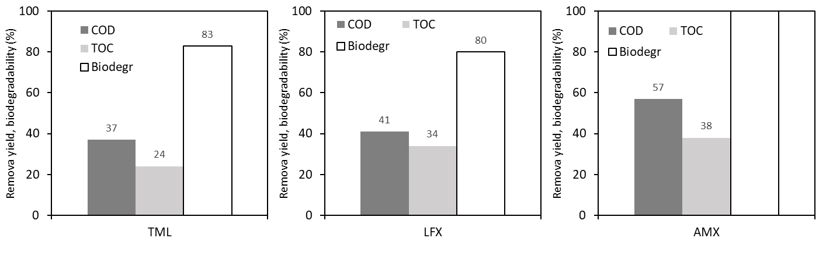
Figure 6: Comparison of effects of ozonation and Fenton process to COD/TOC reduction and change of
biodegradability of antibiotics water solution, ozone dose 0.2 mol_{ozone}mol_{COD}⁻¹ (100 mg L⁻¹ of antibiotics),
Fenton dose 1.0 mol_{H2O2} mol_{COD}⁻¹; (400 mg L⁻¹ of antibiotics)
A, D - tiamulin; B, E – levofloxacin; C, F – amoxicillin.
Fenton, dose: 1 mol _{H2O2} mol _{COD}⁻¹
D | E | F
For TML, reduction of COD with Fenton's process is 1.6-fold larger than in the case of ozonation while a reduction of TOC is larger by 1.8 times. The opposite is true with LFX, where reductions of COD and TOC are larger in the case of ozone against the Fenton's process. For AMX, reduction of COD with Fenton's process is the same as with ozone, while the reduction in TOC is 3.5-fold larger with Fenton's process. Oxidation with Fenton improves biodegradability of TML from 17 to 83%, biodegradability of LVX is increased up to 80%, and the biodegradability of AMX is 100%.
Figure 6 shows that for comparable COD and TOC removal efficiencies, significantly higher doses of oxidant need to be used for Fenton process comparing to ozonation. The improvement of LFX biodegradability actually larger at a lower dose of ozone compared to a higher dose of hydrogen peroxide. Higher doses of Fenton otherwise achieve better biodegradability for TML and AMX. The results show that both ozonation and Fenton process are effective techniques for the oxidation of antibiotics in aqueous solution, but the effects are not easily predictable due to formation of variety of different transformation products, exhibiting lower or higher biodegradability as the parent molecule. Above all, experiments indicated that it may not be assumed that higher doses of oxidant will result in proportionally larger effects in COD/TOC reductions, regardless of the oxidation technique used.
Considering the operational costs of both ozone and Fenton, referencing to the study of Cañizares et al., ¹⁷ cost of ozone treatment according to Figure 6 is 0.5 € mol_{COD}⁻¹, while Fenton treatment cost is in the range of 0.1 € mol_{COD}⁻¹. This is considerable difference, also if sludge treatment costs are added, in the range of 100 € m⁻³ dry sludge. On the other hand, ozone treatment neither generates any waste that needs further disposal nor uses any chemicals that require transport, storage and disposal. In terms of environmental sustainability, this advantage, which economically may not yet be fully recognized.

  - Reaction kinetics of ozonation
To determine the kinetics of the direct reaction of ozone, measured through the removal of COD and TOC, a completely mixed two-phase system was assumed. CO₂ and ozonation intermediates are constantly generated in the process. The reaction stops at the stage where oxidation products no longer react with ozone. Due to the purging of the solution with ozone-containing gas, CO₂ formed during the oxidation of antibiotics is continuously removed from the system. For both TML and LFX, reduction of TOC and COD over time follows zero-order kinetics, however in two phases - where the reaction rate is higher in the first than in the second phase. The stepwise nature of the reaction can be justified by the analysis of structural changes of the molecule during ozonation. First, oxidation intermediates appear in the process, which react further and are transformed into molecular entities, which eventually no longer react with ozone.
Ozonation of TML leads in the first 30 minutes to the formation of a carboxylic acid and as well as sulfur atom is oxidized, which produces the molecule (with a mass of 543 g mol⁻¹), predominant in the first phase of ozonation. In the second phase, this is then followed by the oxidation of the nitrogen atom and thus the degradation of TML gradually progresses. ¹⁸ The two reaction phases are clearly seen in Figure 7 for TOC and Figure 8 for COD.

k₂ = 0.02 mg L⁻¹ min⁻¹
R² = 0.9386
k₁ = 0.15 mg L⁻¹ min⁻¹
R² = 0.9357
Figure 7. Removal of TOC by ozonation of tiamulin solution (100 mg L⁻¹), measured values and assumed course by zero-order kinetics.

Figure 8. Removal of COD by ozonation of tiamulin solution (100 mg L⁻¹), measured values and assumed course by zero-order kinetics.

The reaction rate constants are; TOC (Figure 7): k₁ = 0.15 min⁻¹, k₂ = 0.02 L mg⁻¹ and COD (Figure 8): k₁ = 0.57 min⁻¹, k₂ = 0.22 L mg⁻¹ ; respectively for the first and for the second phase of reaction.
In case of LFX, the first ozonation product is formed as a consequence of a rapid direct attack of ozone on to the double bond of the quinolone moiety, followed by decarboxylation. The second product is formed because of the ozone attack on to the tertiary amine of the piperazine moiety. The ozonation products are in the second phase formed due to the ozone attack on to the tertiary amine of the piperazine moiety with the loss of the methyl group, which is again followed by the quinolone double bond attack and decarboxylation. ¹⁹ Reaction kinetics of COD and TOC removal follows zero order (Figure 9 for TOC and Figure 10 for COD), with two phases, first being significantly faster than the second is. The reaction rate constants are; TOC (Figure 9): k₁ = 0.38 min⁻¹, k₂ = 0.04 L mg⁻¹ and COD (Figure 10): k₁ = 2.58 min⁻¹, k₂ = 0.26 L mg⁻¹ respectively for the first and for the second phase of reaction. A rate constant of LFX (parent molecule) ozonation was reported to be 6.0 x 10⁴ M⁻¹ s⁻¹ at pH 7.2. ¹⁹

Figure 9. Removal of TOC by ozonation of levofloxacin solution (100 mg L⁻¹), measured values and assumed course by zero-order kinetics.

Figure 10. Removal of COD by ozonation of levofloxacin solution (100 mg L⁻¹), measured values and assumed course by zero-order kinetics
As can be seen from Figures 9 and 10, the transition from the first and the second stage of the reaction is very pronounced. The TOC decreases 11 times faster in the first stage and the COD 10 times faster than in the second stage.
For AMX data shows that the decrease of TOC and COD over time follows kinetics of variable order (from zero to first). Reaction rate constants are; TOC (Figure 11): k₁ (s) = 0.18 min⁻¹, k₂ (s) = 1.29 L mg⁻¹ and COD (Figure 12): k₁ (s) = 0.85 min⁻¹, k₂ (s) = 0.25 L mg⁻¹, respectively for the first and for the second phase of reaction. AMX is degraded by an attack of ozone on the phenolic ring and the sulfur atom, leading to the formation of two isomers, and the reaction is terminated by a single product. ²⁰

Figure 11. Removal of TOC by ozonation of amoxicillin solution (100 mg L⁻¹), measured values and assumed course of variable order kinetics.

Figure 12. Removal of COD by ozonation of amoxicillin solution (100 mg L⁻¹), measured values and assumed course of variable order kinetics

As it can be seen from Figure 11, TOC reduces for only about 5 %, while the final product of amoxicillin ozonation is formed with 90% yield ²⁰ – which is also consistent with a significant COD reduction of 70 % (Figure 12).

- Conclusions
The aim of the work was to compare oxidation efficiency in case of antibiotics dissolved in water, either by a direct reaction with ozone or by means of indirect oxidation with hydroxyl radicals from Fenton reagent. Overall goal was to increase biodegradability to a degree that enables further biological treatment. Selected antibiotics were TML, LFX and AMX.
In terms of oxidant reagent consumption, direct reaction with ozone has proven to be more efficient, as comparable biodegradability improvement, including TOC reduction was achieved with an ozone dose, tenfold smaller than the equivalent molar dose of oxidant (H₂O₂) from Fenton reagent. On the other hand, comparable COD reductions were achieved with oxidant doses (O₃ and H₂O₂) in the same order of magnitude. This means that antibiotics were oxidized equally either by direct reaction with ozone or hydroxyl radicals from Fenton reagent. In case of direct ozone reaction however, entities of the molecule, which carry antibiotic potential, were targeted. This delivers effective biodegradability improvements already at low doses of oxidant. Overall rate of mineralization is not critical, as this is not primary the objective of the oxidation. Reaction kinetics of ozonation shows that there are two phases of the reaction, with the first being significantly faster than the second. This is also the part, where biodegradability is improved most, while in the second phase, molecule is being degraded further and mineralized.
In terms of operational costs, Fenton costs about five times less than ozone, providing the effectiveness discussed in this study, however ozone has advantages in terms of broader sustainability, given that generates no side waste that requires further treatment and disposal.

Acknowledgements
The authors are grateful to Nastja Smolnikar, Polona Starašinič, Damjan Koder and Matjaž Škedelj for laboratory assistance. This work was financed by the Slovenian Research Agency, research program of Chemical Engineering (P2-0191) and Organic Chemistry (P1-0230).

References

- A. B. A. Boxall, D. W. Kolpin, B. Halling-Sørensen, J. Tolls, Environ. Sci. Technol. 2003, 37(15), 286A-294A.

- P. H. Jensen John, Chemosphere 2003, 50(3), 437–443.

- B. Halling-Sørensen, Chemosphere 2000, 40(7), 731-739.

- A. C. Johnson, V. Keller, E. Dumont, J. P. Sumpter, Sci. Total Environ. 2015, 511, 747-755.

- R. Singh, A. P. Singh, S. Kumar, B. S. Giri, K. H. Kim, J. Clean. Prod. 2019, 234, 1484-1505.

- E. M. Cuerda-Correa, M. F. Alexandre-Franco, C. Fernández-González, Water 2020, 12(1), 2-52.

- J. Gomes, R. Costa, R. M. Quinta-Ferreira, R. C. Martins, Sci. Total Environ. 2017, 586, 265-283.

- I. Michael-Kordatou, R. Andreou, M. Iacovou, Z. Frontistis, E. Hapeshi, C. Michael, D. Fatta-Kassinos, J. Hazard. Mater. 2017, 323(A), 414-425.

- I.C. Iakovides, I. Michael-Kordatou, N. F. F. Moreira, A. R. Ribeiro, T. Fernandes, M. F. R. Pereira, O. C. Nunes, C. M. Manaia, A. M. T. Silva, D. Fatta-Kassinos, Water Res. 2019, 159, 333-347.

- Y. Zheng, D. Chen, T. Chen, M. Cai, Q. Zhang, Z. Xie, R. Li, Z. Xiao, G. Liu, W. Lv, Chemosphere 2019, 227, 198-206.

- L. V. Santos, A. M. Meireles, L. C. Lange, J. Environ. Manage. 2015, 154, 8-12.

- I. Epold, M. Trapido, N. Dulova, J. Chem. Eng. 2015, 279, 452–462.

- M. Muz, M. S. Ak, O. T. Komesli, C. F. Gökçay, J. Chem. Eng. 2013, 217, 273-280.

- International organization for standardization, international standard, ISO 6060:1989, 1989.

- International organization for standardization, international standard ISO 8245:1999, 1999.

- International organization for standardization, international standard ISO 9408:1999, 1999.

- P. Cañizares, R. Paz, C. Sáez, M. A. Rodrigo, J. Environ. Manage. 2009, 90(1), 410-420.

- I. Bosevski, G. Kalcikova, J. Cerkovnik J., A. Zgajnar Gotvajn, Ozone: Sci. Eng. 2019, 42(2), 128-135.

- N. H. El Najjar, A. Touffet, M. Deborde, R. Journel, N. K. Vel Leitner, Chemosphere 2013 93(4), 604-611.

- R. Andreozzi, M. Canterino, R. Marotta, N. Paxeus, J. Hazard. Mater 2005, 122(3), 243-250.

