Supporting Information

Copper & Magnetic Activated Carbon Nanocomposites: Application as Recoverable Catalyst for C-S Coupling Reaction

Vajihe Nejadshafiee*, Ehsan Ghonchepour†, Hojatollah Khabazzadeh, Shahrzad Mahdavi Aliabad, Fatemeh Hassani Bagheri, and Mohammad Reza Islami‡
Chemistry Department, Shahid Bahonar University of Kerman, Kerman 76169, Iran.

Table of content page
¹H and ¹³C NMR and CHN analysis of aryl thioquinazoline S1

Copy of ¹H NMR, ¹³C NMR & CHNS of the synthesized compounds.
3-phenyl-2-(phenylthio) quinazoline-4-(3H)-one (3a).
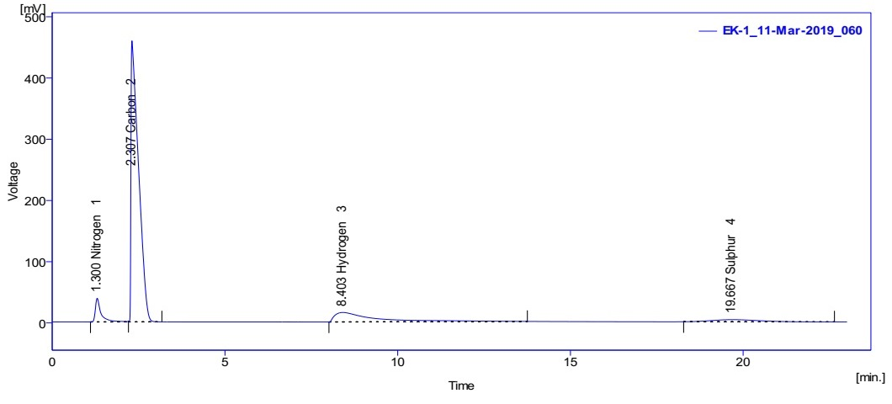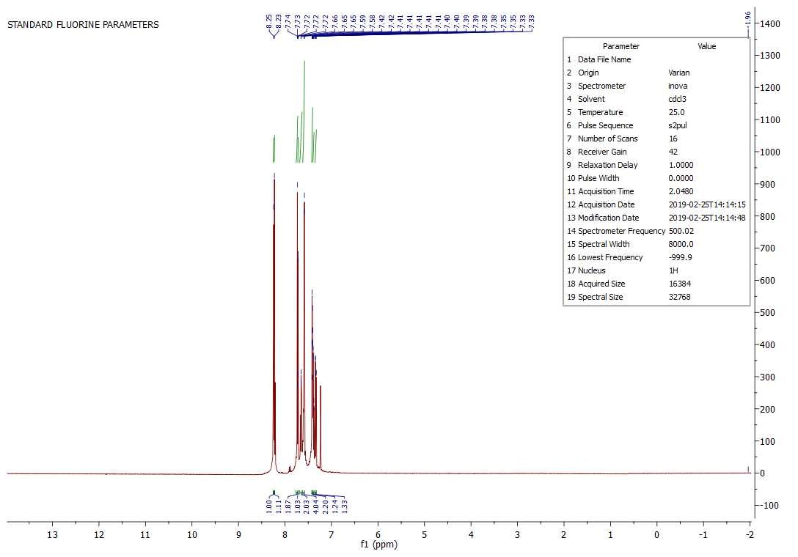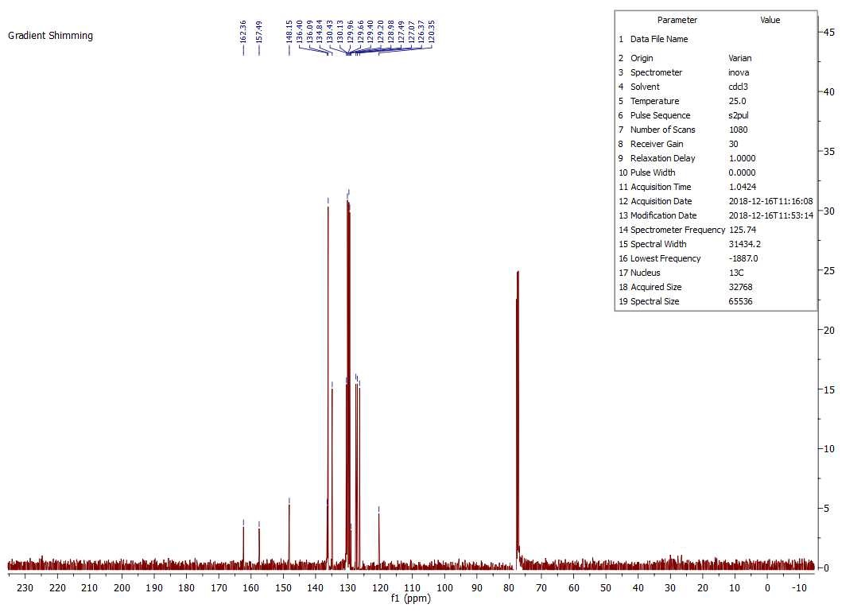

2-((4-methoxyphenyl)thio-3-phenylquinazoline-4-(3H)-one (3b).
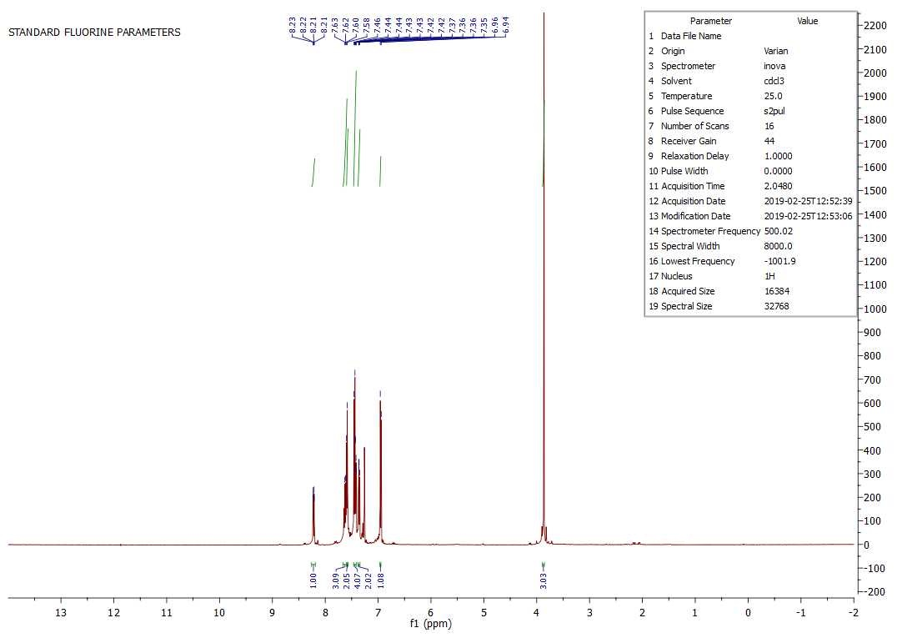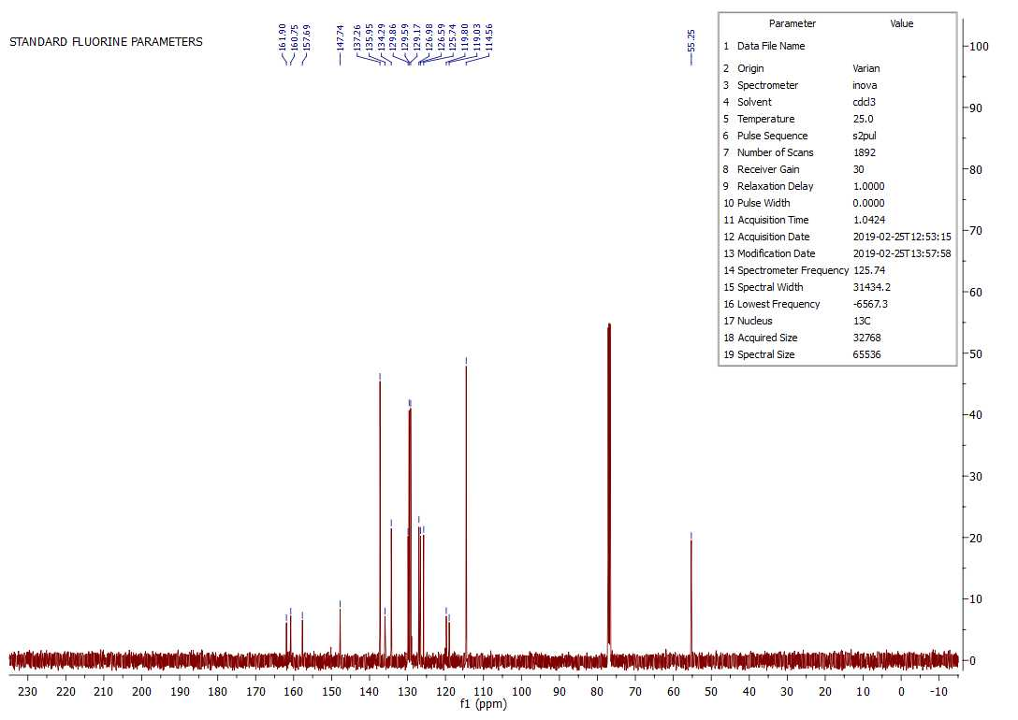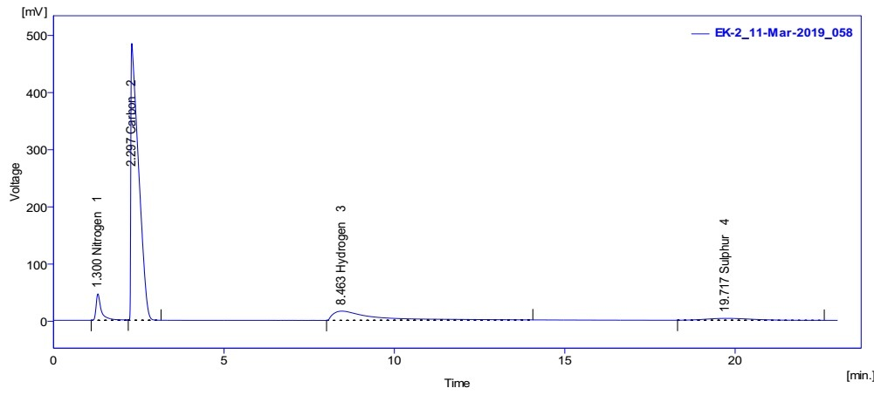

3-phenyl-2-(p-tolylthio)quinazoline-4-(3H)-one (3c).
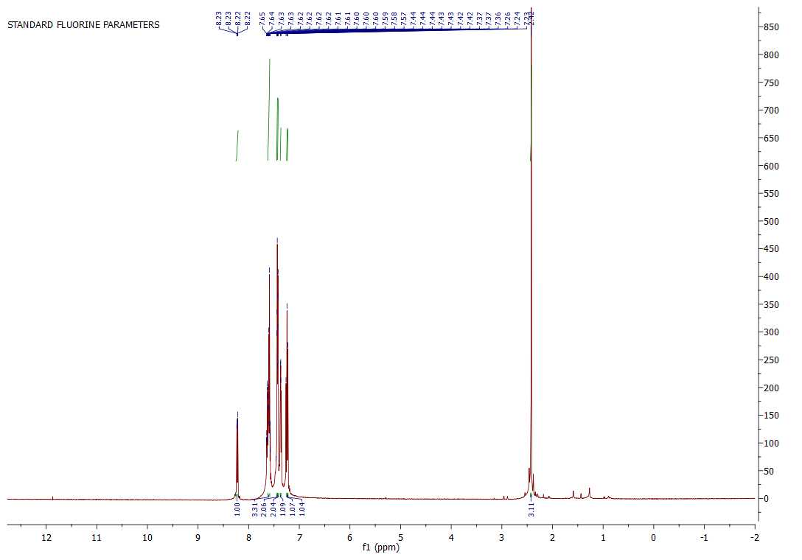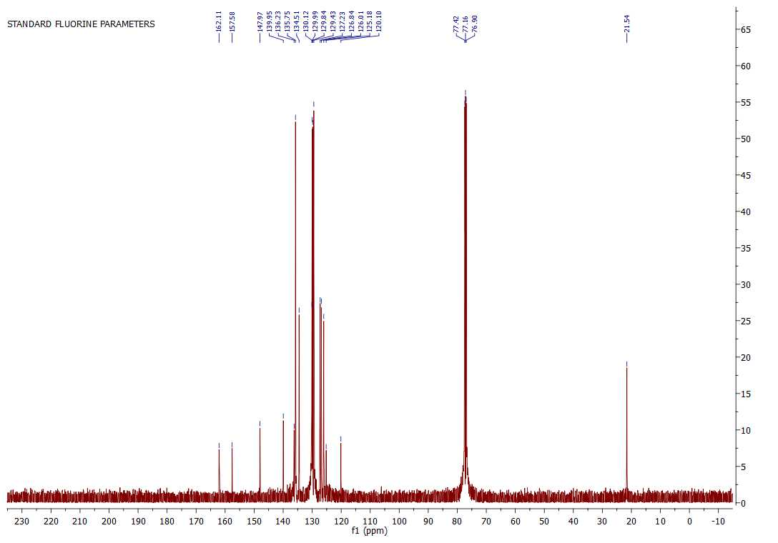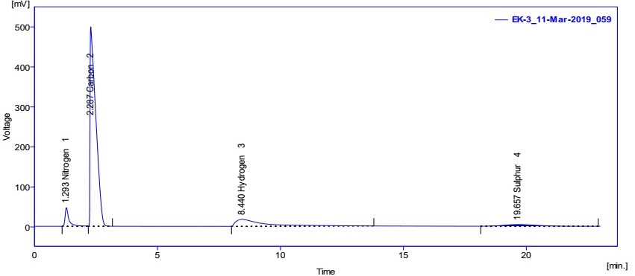

2-((4-nitrophenyl)thio)-3-phenylquinazoline-4-(3H)-one (3d).

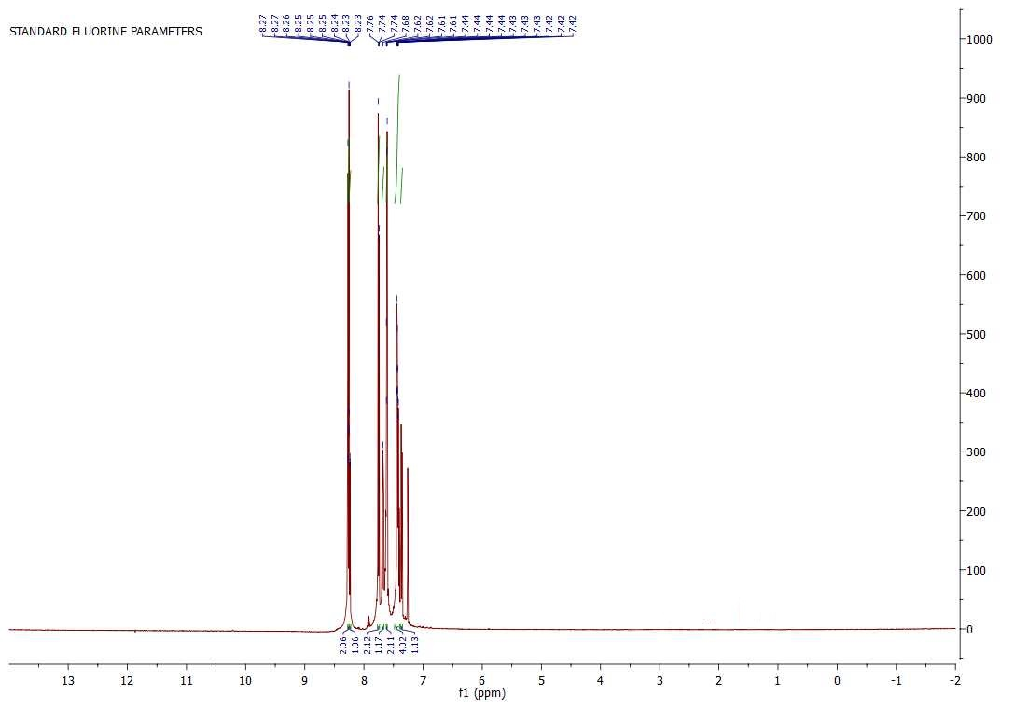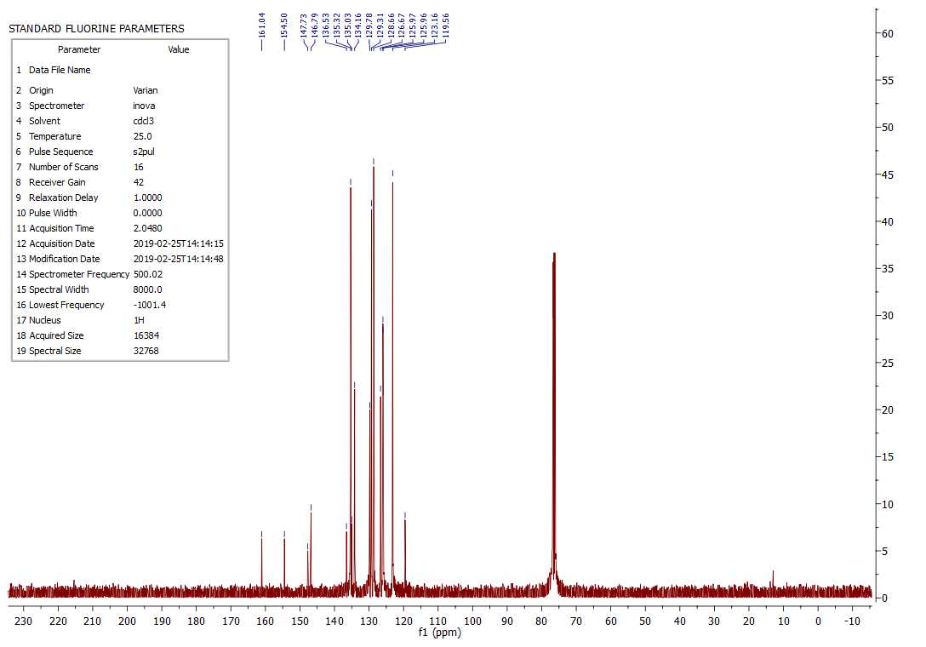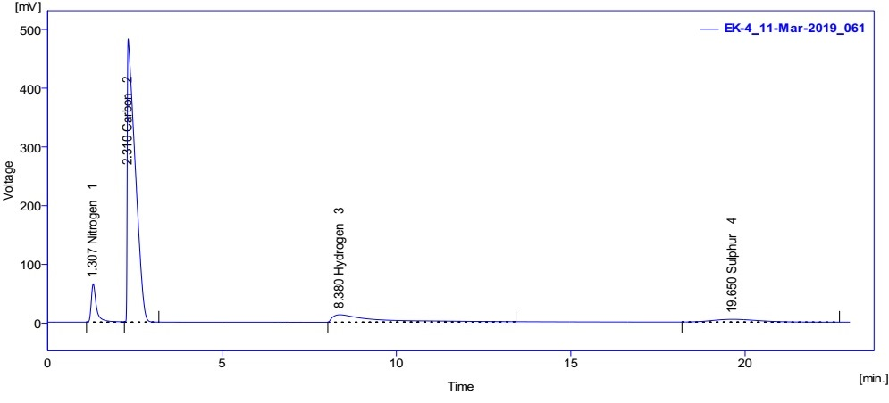

2-((4-bromophenyl)thio)-3-phenylquinazoline-4-(3H)-one (3e).
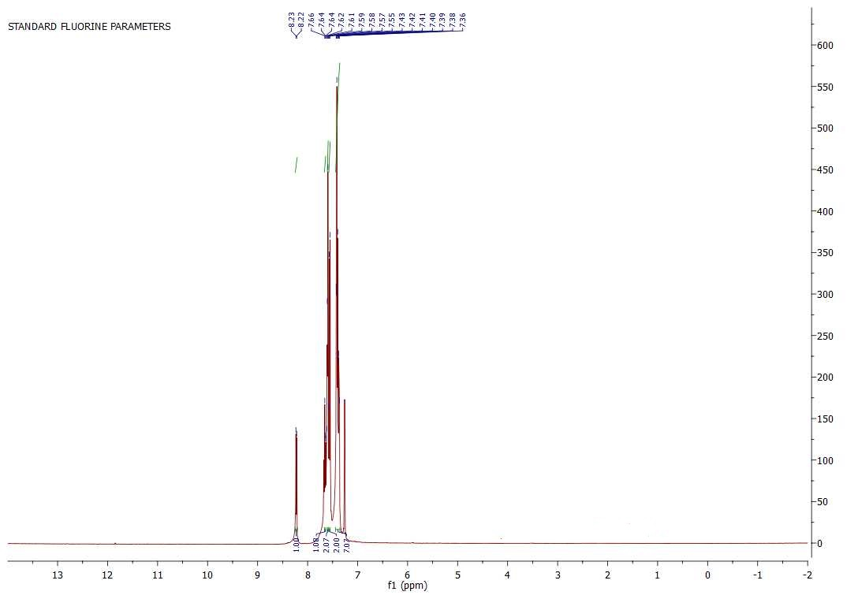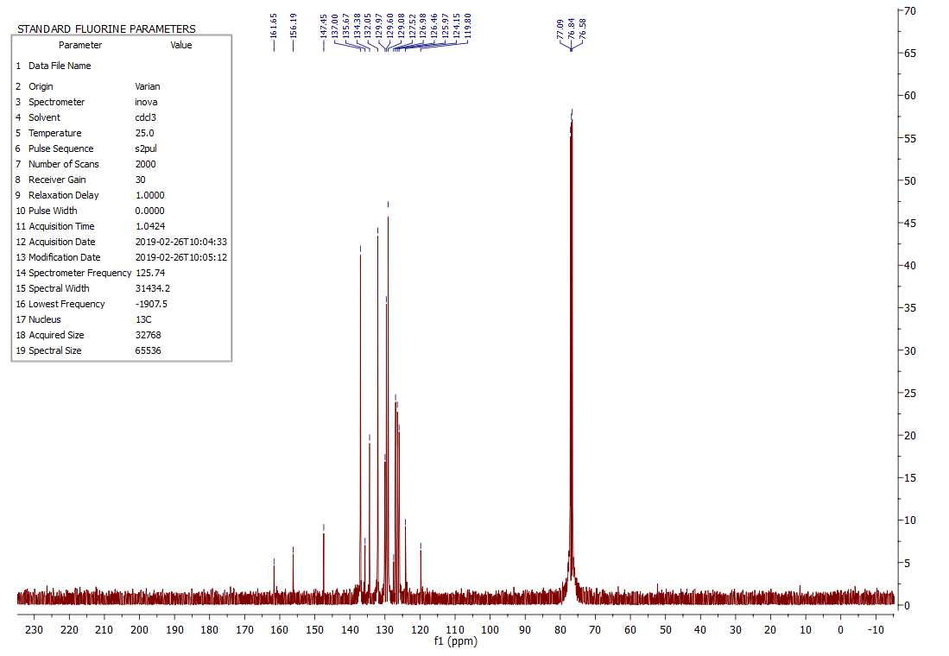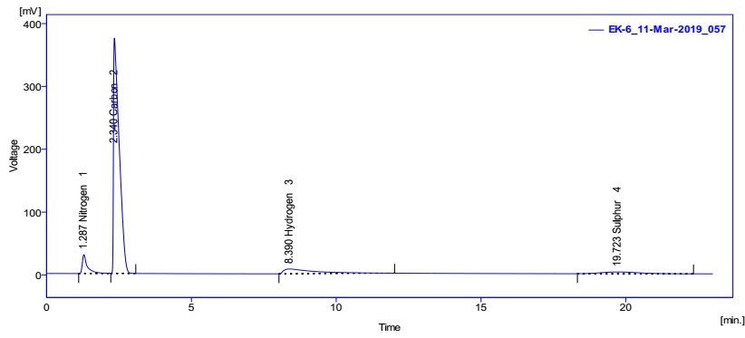

* Corresponding author. Tel: +98 034 31312200, E-mail address: nejadshafiee@sci.uk.ac.ir
† Ghonchepoor@gmail.com
‡ mrislami@uk.ac.ir

