SUPPLEMENTARY INFORMATION

Carbon-Paste Electrode Modified by β-Cyclodextrin as Sensor for Determination of Sunset Yellow FCF and Ponceau 4R in Soft Drinks

Konstantin Pliutaª, Denys Snigur^{a*}

ªDepartment of Analytical and Toxicological Chemistry, Faculty of Chemistry and Pharmacy, Odesa I.I. Mechnikov National University, Odessa, 65082, Ukraine
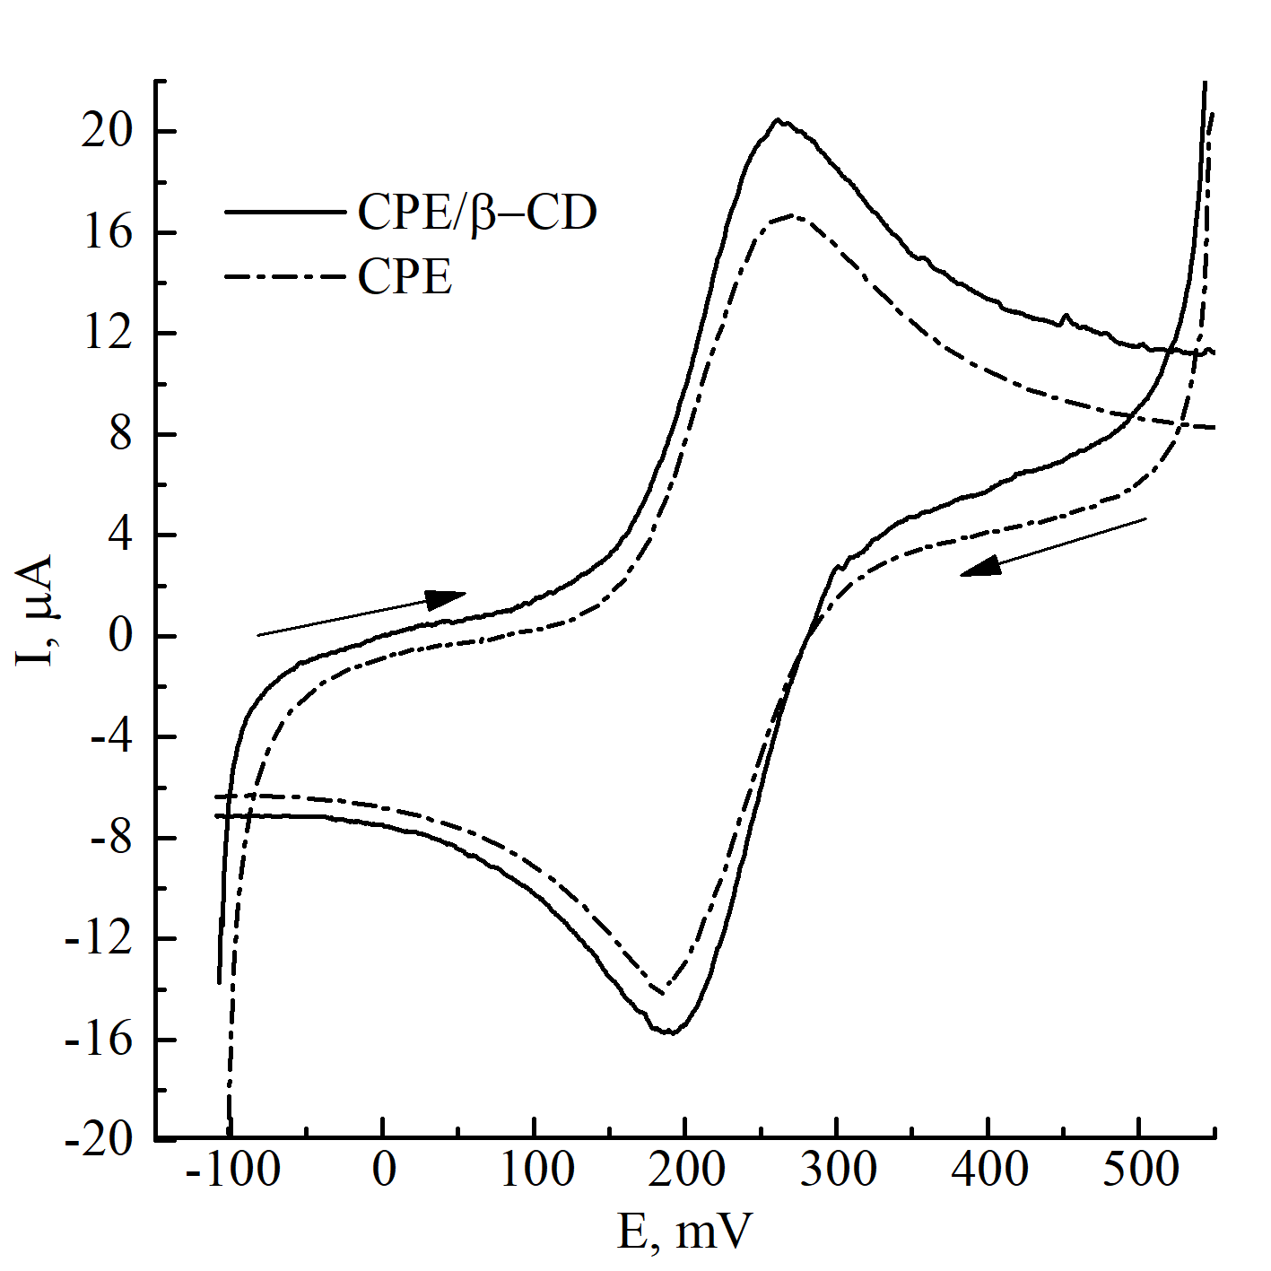
* Corresponding author: 270892denis@gmail.com (Denys Snigur)

Fig S1. CV of 1 mM K₄[Fe(CN)₆] solution in 0.1 M KCl solution on CPE/β-CD and bare CPE (υ=50 mVs⁻¹)

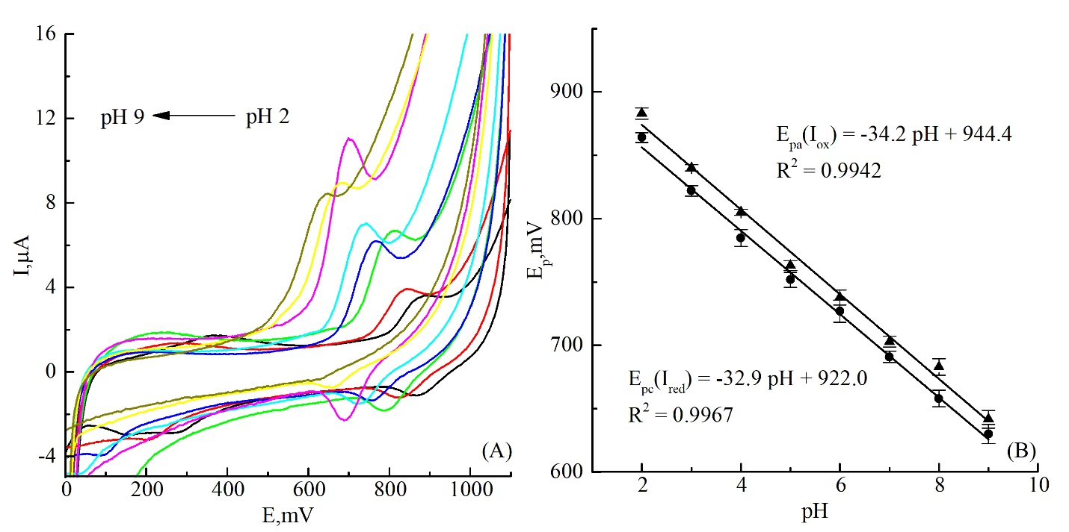
Fig S2. (A) CV of buffer solution at different pH onto CPE/β-CD after adsorption on its surface of a solution (10 µl) of SY with a concentration of 100 µM for 3 min. (B) Plot of the oxidation peak potential triangle) and reduction peak potential (circles) as a function of pH.

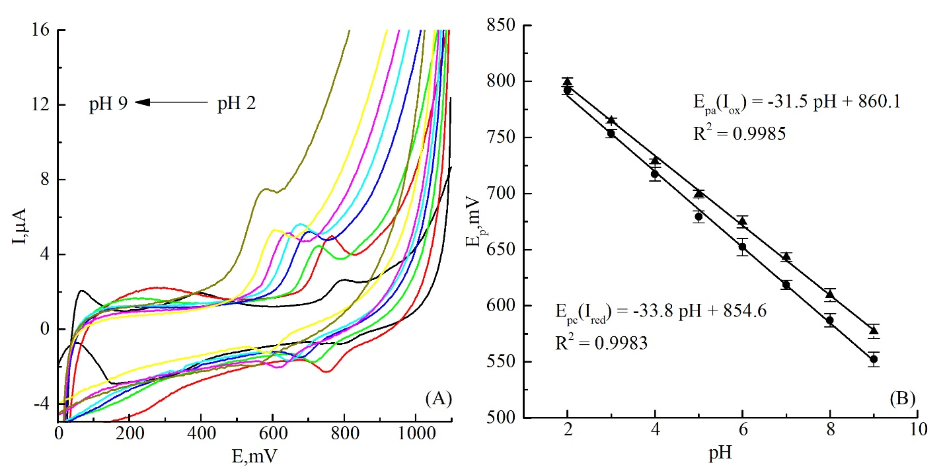Fig S3. (A) CV of buffer solution at different pH on CPE/β-CD after adsorption on its surface of a solution (10 µl) of P4R with a concentration of 100 µM for 3 min. (B) Plot of the oxidation peak potential triangle) and reduction peak potential (circles) as a function of pH.

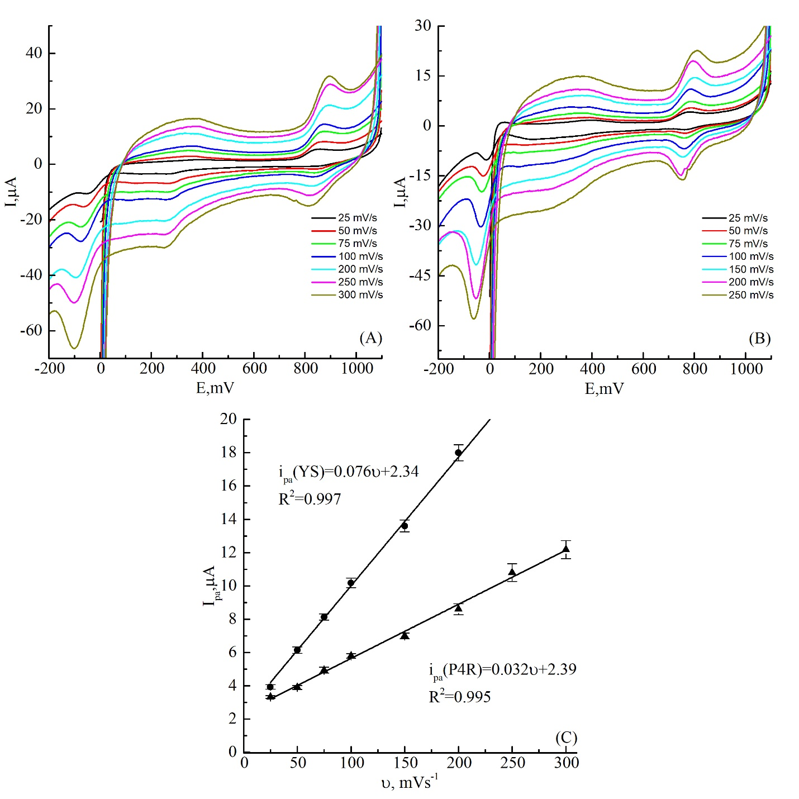

Fig S4. CV of (A) SY solution (100 µM, pH 2) and (B) P4R solution (100 µM, pH 2) on CPE/β-CD at different scan rate. (C) Plot of peak oxidation current SY (circles) and P4R (triangle) as a function of scan rate.

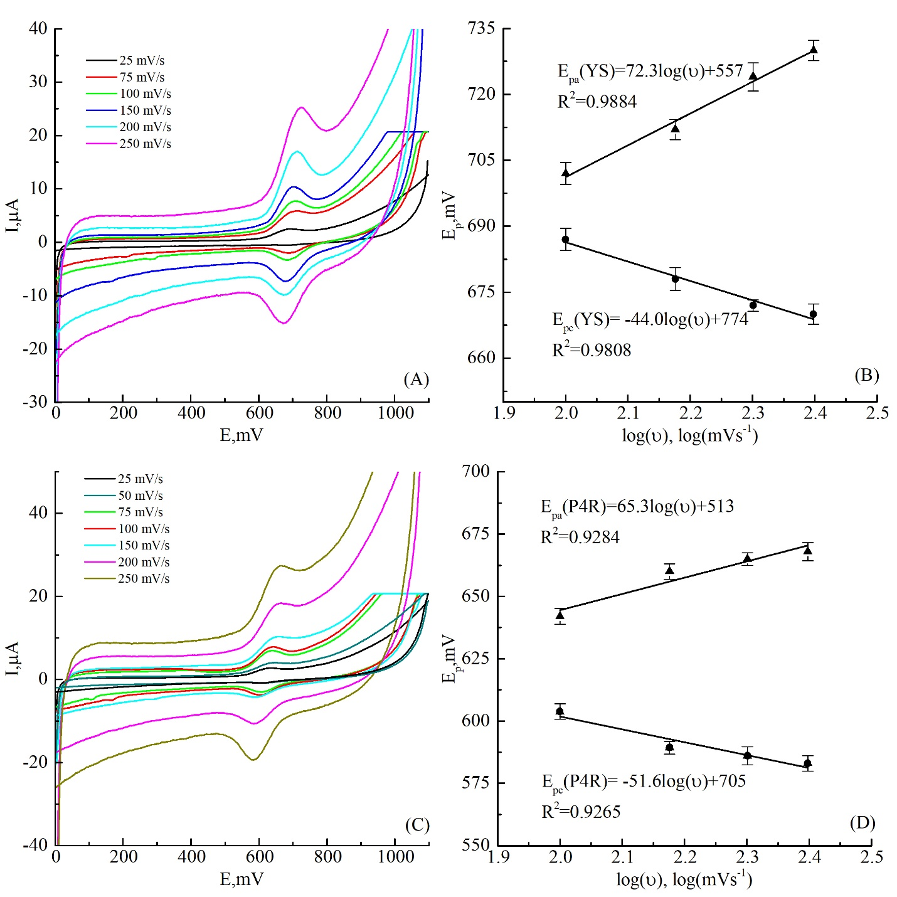
Fig S5. CV of buffer solution (pH 7) at different scan rate on CPE/β-CD after adsorption on its surface of a solution (10 µl) (A) SY (100 µM, pH 2) and (C) P4R (100 µM, pH 2). Plot of peak oxidation and reduction potential (B) SY and (D) P4R as function of decimal logarithm of scan rate.

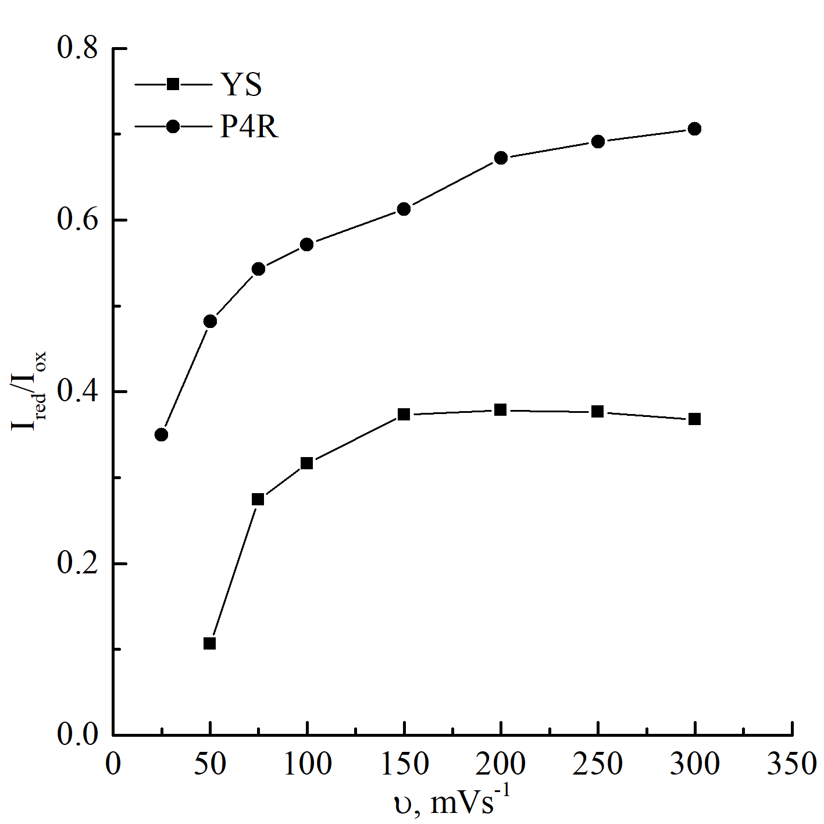
Fig S6. The plot of the ratio of reduction current to oxidation current for SY and P4R as a function of scan rate.

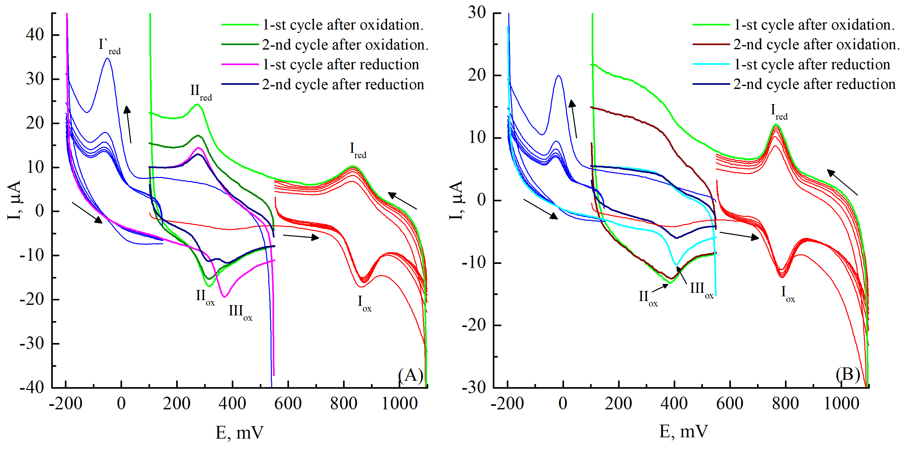
Fig S7. СV of (A) SY solution (100 µM) and (B) P4R solution (100 µM) on CPE/β-CD at different numbers of cycles (pH = 2, υ=50 mVs⁻¹).
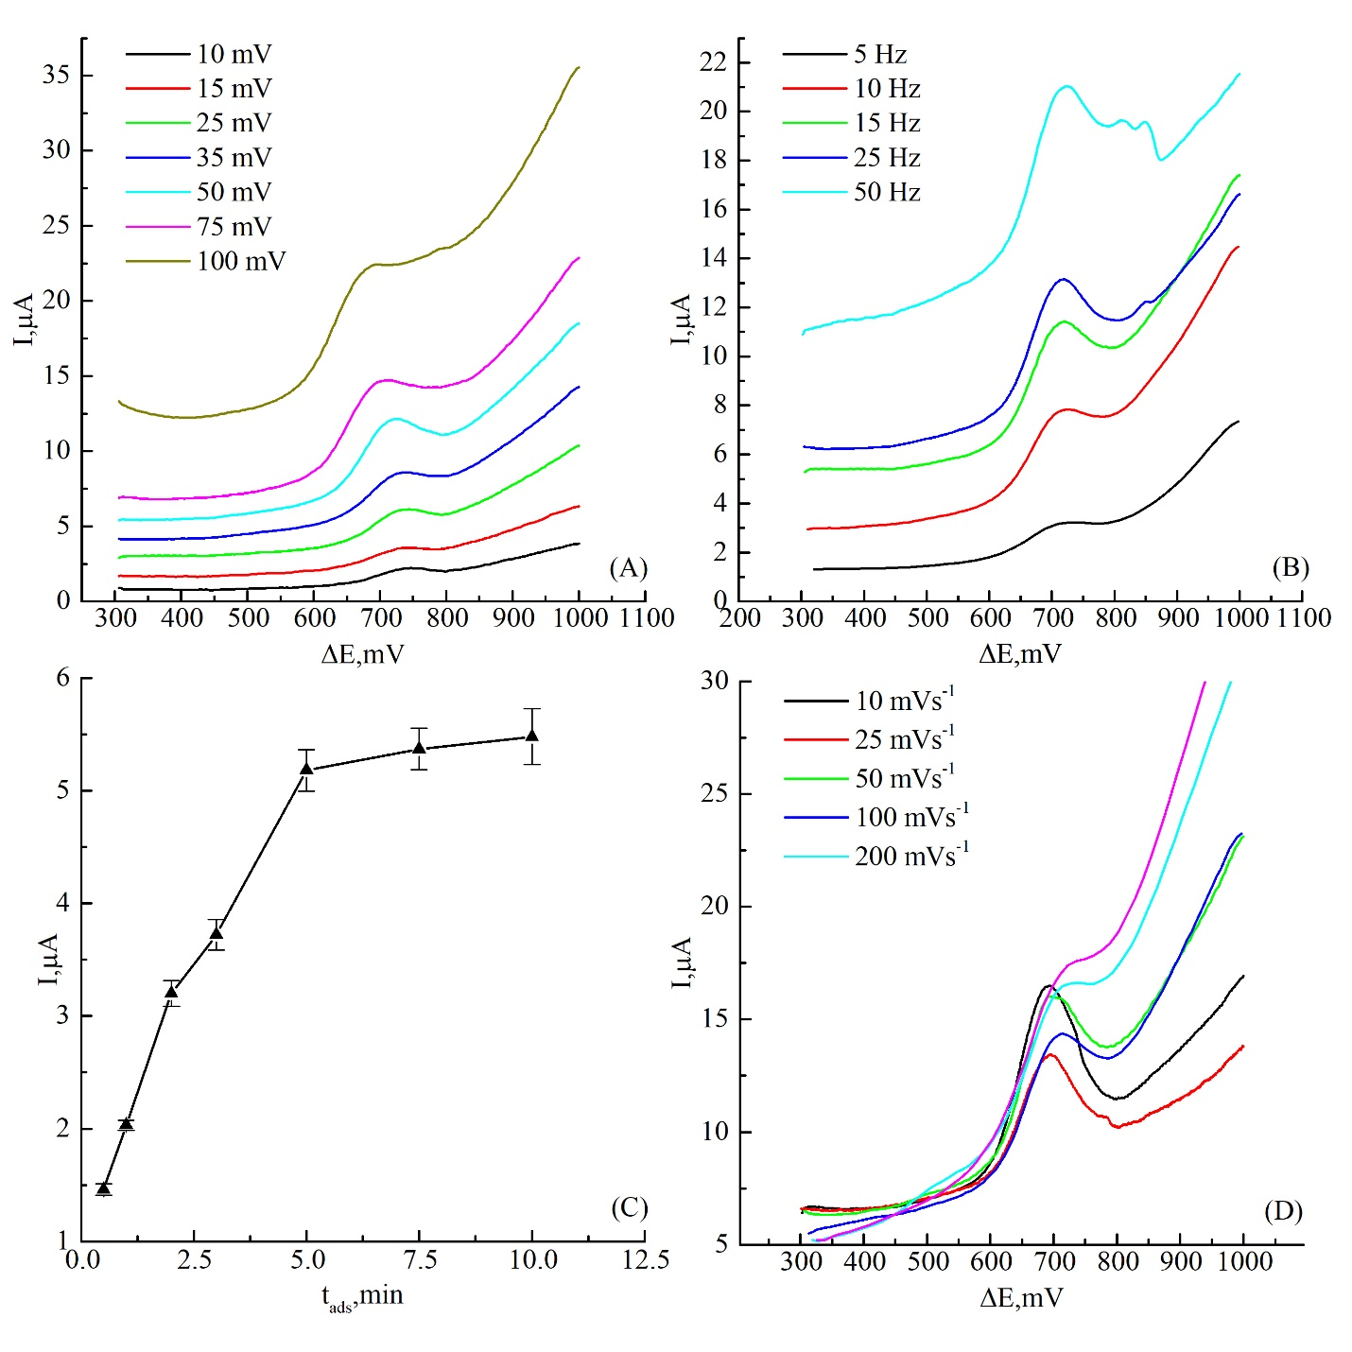

Fig S8. Square-wave voltammograms of buffer solution (pH7) on CPE/β-CD after adsorption on its surface of a solution (10 µl) of SY with a concentration of 100 µM for 3 min at difference (A) potential amplitude, (B) frequency, (D) scan rate. (C) Plot of the oxidation peak current of SY solution as function of time of adsorption.

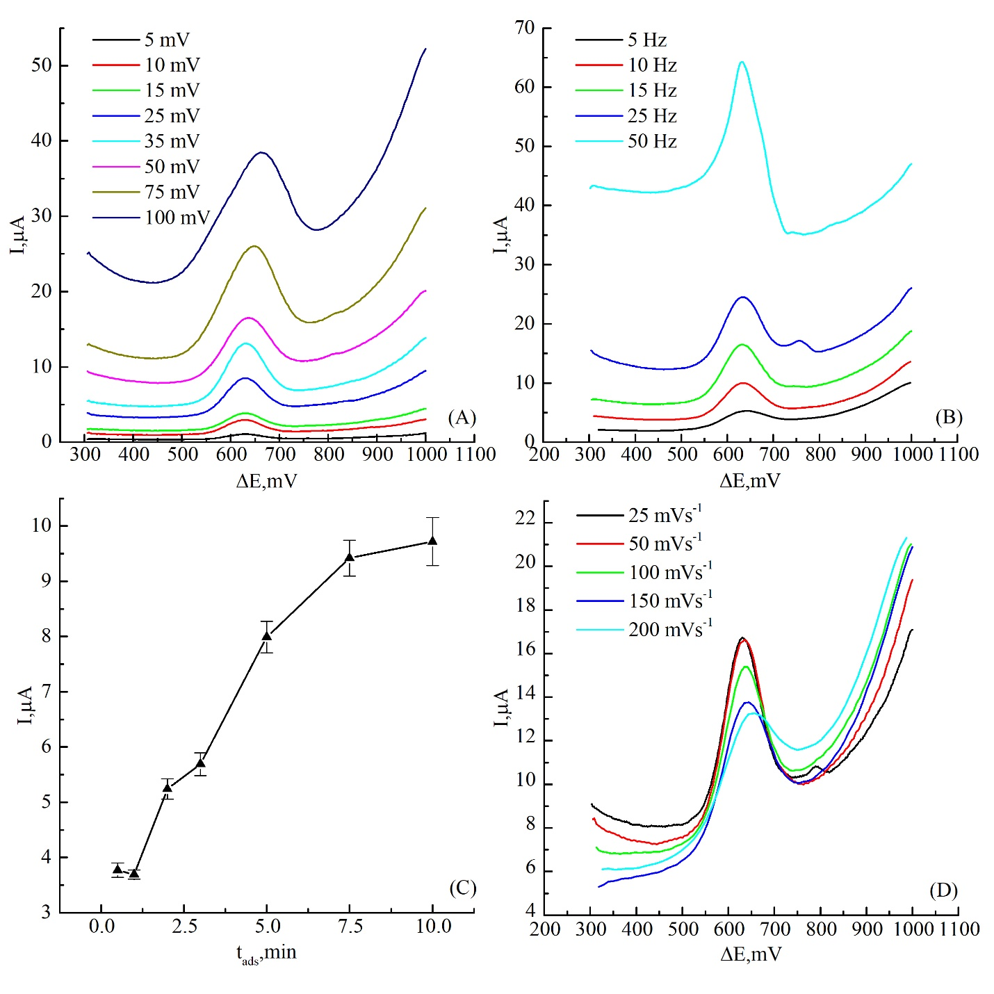

Fig S9. Square-wave voltammograms of buffer solution (pH7) on CPE/β-CD after adsorption on its surface of a solution (10 µl) of P4R with a concentration of 100 µM for 3 min at difference (A) potential amplitude, (B) frequency, (D) scan rate. (C) Plot of the oxidation peak current of P4R solution as function of time of adsorption.

HPLC program:
The following HPLC parameters were used to determine food dyes: mobile phase A = 20 mM ammonium acetate (pH 5); mobile phase B: methanol; gradient program: A (0 min): 90% - A (25 min): 30% - A (26 min): 90% - A (35 min): 90%; column thermostat temperature: 30 ºС; injection volume: 20 μL; detector wavelength change program: 427 nm (0 min) - 508 nm (10 min) - 482 nm (13 min) – 508 nm (16 min) - 516 nm (19 min).

Determination of azo dyes by HPLC:
In the case of carbonated samples, degassing was performed before determination. For this, 25 mL of the sample was poured into a 50 mL chemical beaker, placed in an ultrasonic bath and degassed under the influence of ultrasound for 15 min. If there is sediment in the water, a portion of the sample was centrifuged in a 15 mL plastic test tube at a speed of 10,000 rpm for 3 min. When the azo dyes were determined, an aliquot of the sample was diluted with deionized water in a volumetric flask with a capacity of 10 mL. The resulting solution was filtered through a hydrophilic PTFE filter, transferred to a chromatographic vial and injected into the device. Determination was carried out using external calibration, taking into account the dilution factor.

Table S1. Determination of SY and P4R in real samples by CPE/β-CD and HPLC

Sample | Dye | , mg/L | , mg/L | S_{CPE/β-CD}, mg/L | S_{HPLC},  mg/L | F | F_{crit.} | t | t_{кр}
Beverage 1 | SY | 31.82 ± 4.35 | 32.85 ± 2.61 | 1.8 | 1.05 | 2.77 | 19.00 | 2.14 | 2.78
Low alcohol drink 1 | SY | 34.81 ± 5.62 | 35.67 ± 5.23 | 2.3 | 2.10 | 1.16 | 19.00 | 1.18 | 2.78
Low alcohol drink 2 | P4R | 1.65 ± 0.27 | 1.59 ± 0.15 | 0.1 | 0.06 | 3.18 | 19.00 | 2.01 | 2.78
Energy drink 1 | P4R | 2.20 ± 0.31 | 2.24 ± 0.18 | 0.1 | 0.07 | 2.78 | 19.00 | 1.18 | 2.78

