Statement of novelty

Prof. Ksenija Kogej

Editor-in-Chief
Acta Chimica Slovenica
July 12, 2022
Research title
Zinc(II) complex containing oxazole ring: Synthesis, crystal structure, characterization, DFT calculations, and Hirshfeld surface analysis
Dear Professor
we are pleased to submit an original article for consideration for publication in the Acta Chimica Slovenica. This paper contains a novel zinc complex verified with CCDC numbers because only new complexes not previously synthesized and numbered can receive the number CCDC. We believe that this manuscript is appropriate for publication in the Acta Chimica Slovenica because this journal publishes critical scientific articles in the coordination compounds and inorganic fields.
We declare that this manuscript is original, has not been published before, and is not currently being considered for publication elsewhere. As authors, we confirm that the manuscript has been read and approved for submission by Karwan O. Ali, the author.
Thank you for your consideration.
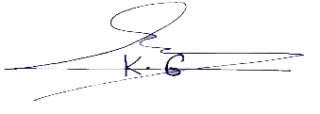
Dr.: *Karwan Omer Ali
Halabja, Kurdistan Region, Iraq
E-mail: Karwan.ali@uoh.edu.iq
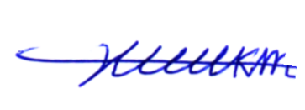
Professor: Hikmat Ali Mohamad
Erbil, Kurdistan Region, Iraq
E-mail: hikmatmohamad@yahoo.com
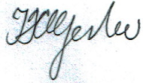
Professor: Thomas Gerber
Port Elizabeth, South Africa.
E-mail: Thomas.Gerber@nmmu.ac.az
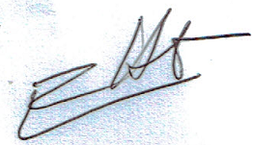
Dr.: Eric Hosten
Port Elizabeth, South Africa.
E-mail: Eric.Hosten@nmmu.ac.az

