The paramagnetic or spin crossover iron(III) complexes based-on penta-dentate Schiff-base ligand: crystal structure, magnetic property and theoretical investigation
Supporting Information
Scheme 1. Structure of the Schiff-base iron(III) precursor and the trans-dicyano building blocks.
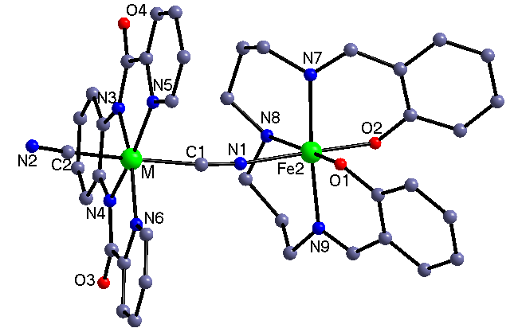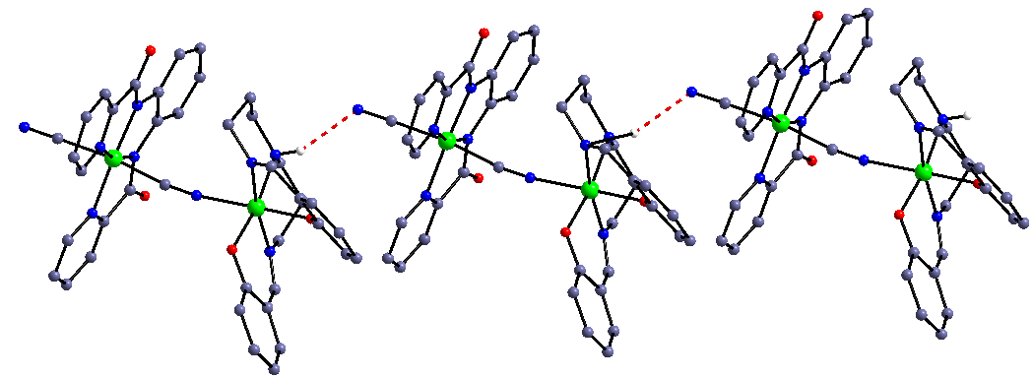
Figure1. The neutral binuclear structures of complexes 1 and 2 (M = Fe, Co, top) and the 1D supramolecular chain constructed by H-bond interactions (bottom). All the H atoms (except one used to form H-bond) and the solvent content have been omitted for clarity.
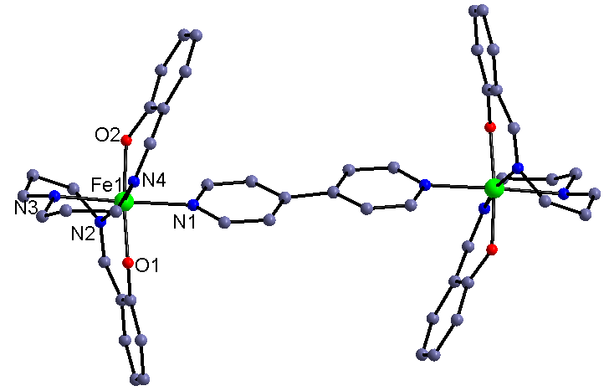
Figure 2. The cationic binuclear structure of complex 3. All the H atoms and the balanced anions have been omitted for clarity.
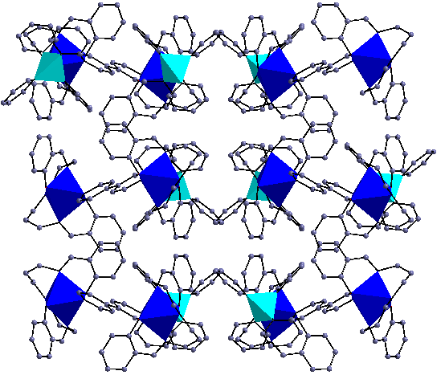
Figure 3. The cell packing diagram of complex 3 along b axial. All the H atoms have been omitted for clarity.
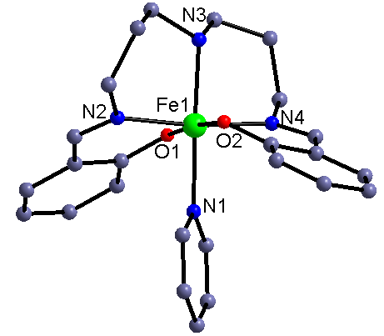
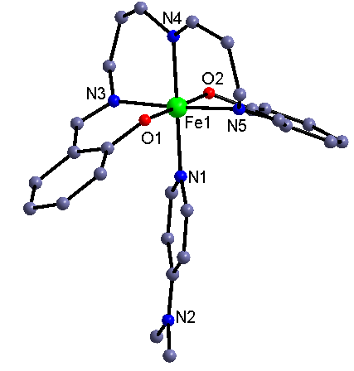
Figure 4. The cationic mononuclear structure of complexes 4(top) and 5(bottom). All the H atoms and the balanced anion have been omitted for clarity.
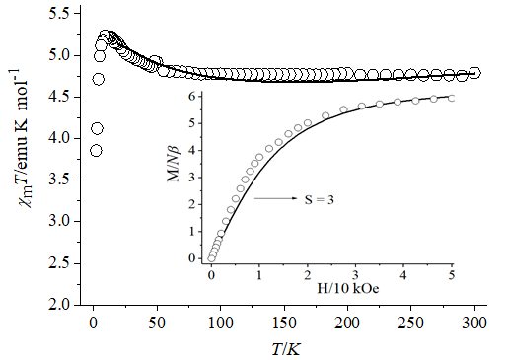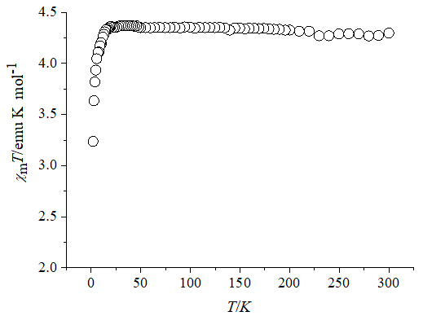
Figure 5. Temperature dependence of χ_{m}T of 1 (top) and 2(bottom). Inset: Field dependence of magnetization at 2 K (the solid Brillouin curve is the ferromagnetic coupled one low spin Fe(III) ion and one high spin Fe(III) ion for complex 1).
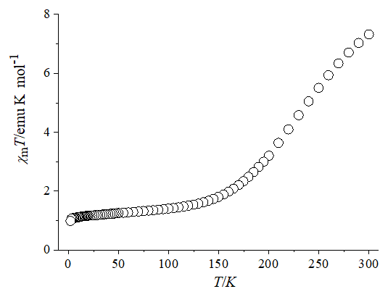
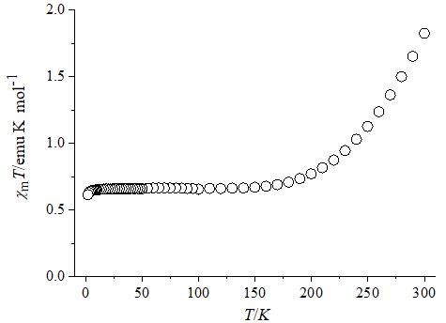
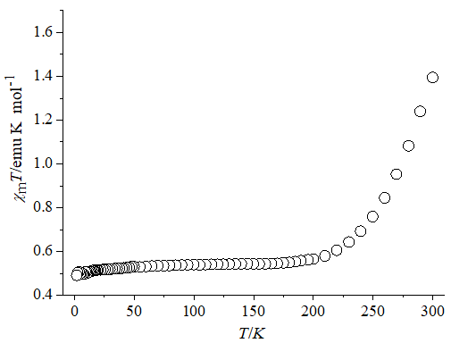
Figure 6. Temperature dependences of χ_{m}T of 3 (top), 4(middle) and 5(bottom).
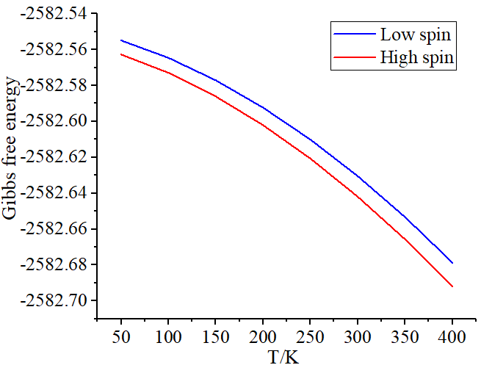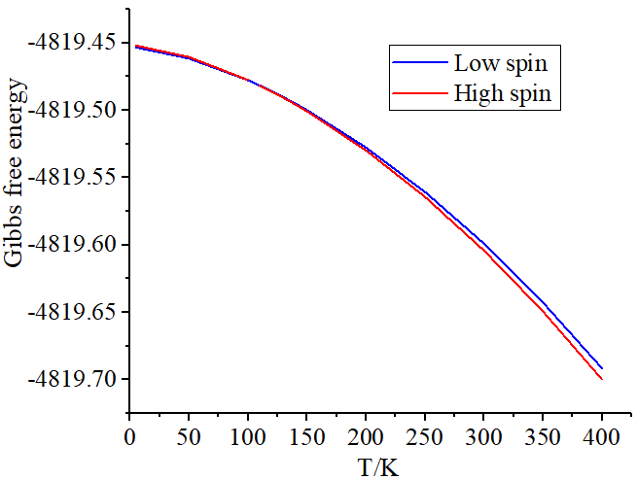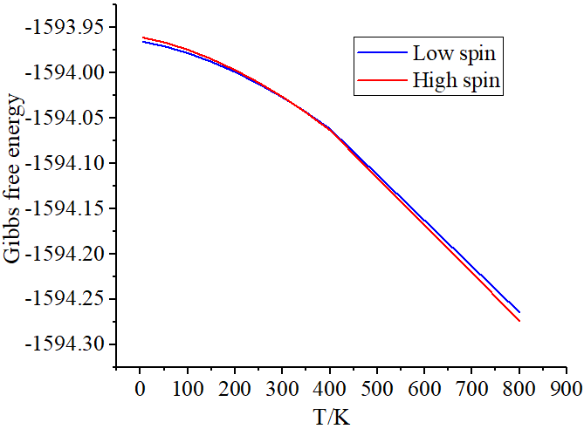
Figure 7. The temperature dependence of the calculated Gibbs free energy for complex 1(top), 3(middle) and 5(bottom).

