The paramagnetic or spin crossover iron(III) complexes based-on penta-dentate Schiff-base ligand: crystal structure, magnetic property and theoretical investigation
Zhijie Xu,ª Shuo Meng,ª Tong Cao,ª Yu Xin,ª Mingjian Zhang,ª Xiaoyi Duan,ª Zhen Zhou,ª and Daopeng Zhang ^{a,*}
ªCollege of Chemical and Chemical Engineering, Shandong University of Technology, Zibo 255049, PR China. dpzhang73@126.com
Abstract
A series of bi- or mononuclear hexacoordinate iron(III) complexes, [Fe(⁵L)][Fe(bpb)(CN)₂]·CH₃OH·0.5H₂O (1), [Fe(⁵L)][Co(bpb)(CN)₂]·CH₃OH (2) [Fe(⁵L)₂(4,4’-Bipy)](BPh₄)₂ (3), [Fe(⁵L)(Py)](BPh₄) (4) and [Fe(saldptn)(DMAP)](BPh₄) (5) (bpb = 1,2-bis(pyridine-2-carboxamido)benzenate, ⁵L = N,N’-bis(2-hydroxybenzyliden)-1,7-diamino-4-azaheptane, DMAP = 4-Dimethylaminopyridine), The experimental study and theoretical simulation of the magnetic property discovered the ferromagnetic coupling between the Fe(III) ions bridged by cyanide group in complex 1 and the always high spin state of the Fe(III) ion coordinated to the Schiff-base ligand in both complexes 1 and 2. The temperature dependent magnetic susceptibility investigation over complexes 3-5 showed the occurrence of the thermo-induced gradual complete spin crossover (SCO) property at about 115, 170 and 200 K, respectively. Both the spin transition in complexes 3-5 and the stable high spin state of the Fe(III) ion in complex 1 have been further confirmed by the DFT calculations.
Keywords: Cyanide-bridged, Ferromagneitic coupling, Spin crossover, DFT calculation
- Introduction
Since the 21st century, the synthesis of materials with special functions and applications based on coordination chemistry has been one of the important directions of current chemical research.¹⁻¹⁰ Molecular materials with spin crossover behavior have very broad application prospects in the fields of nano device, spintronics, information storage, sensors, digital display, and so on.¹¹⁻¹⁸ The use of spin crossover complexes as switches or sensors depends on spin transition distinguished by different magnetic, optical and structural characteristics, which includes structural changes between two different spin states and can be realized under the suitable coordination field by external stimuli such as temperature, light irradiation and guest solvent molecules.¹⁹⁻²⁵ It is generally found that the metal centers with the 3d⁴ to 3d⁷ electronic configurations and involved in octahedral coordination surroundings can readily occur spin transition between the different spin states.²⁶⁻²⁸
Among which, the strong interest has always been devoted to the switchable molecular materials centered with iron(II) ion. During the past several decades, a great deal of the Fe(II)-based complexes with diverse structure types from 0D clusters, 1D infinite chains to 2-3D networks and interesting SCO properties have been reported. However, with comparison to the intensely studied divalent Fe(II) in SCO field, research on Fe(III) ion, which is also with the SCO possibility between the high spin S = 5/2 and low spin S = 1/2, under the consideration of obtaining SCO material are comparatively limited.²⁹⁻³³ The pentadentate Schiff-base ligands (Scheme 1), which can encapsulate the hexa-coordinated metal with sixth position weakly bonded by other ligand, is a types of good organic precursors for preparation function complexes³⁴⁻³⁶. In fact, some previous reports have proven that the above pentadentate Schiff-base based iron(III) compounds are suitable candidates for assembling SCO materials under the help of the pyridine-like ligands ³⁷⁻³⁸ and some of the obtained complexes have been structurally characterized and experimentally magnetic investigated. Taking into account that the cyanometallic precursors with tunable coordination field, such as [M(CN)₄]²⁻(M = Ni, Pd, Pt), [M’(CN)₂]⁻(M’ = Cu, Ag, Au) and other polycyanometallates, have been widely employed to construct SCO materials, especially for those ones with Hoffman topologic structures ³⁹⁻⁴²,the reactions of the pentadentate Schiff-base iron(III) compound with the trans-dicyanoiron(III)/cobalt(III) building blocks (Scheme 1), for the latter which have been extensively used to prepare cyanide-bridged molecular magnetic materials by our group ⁴³⁻⁴⁶, were investigated, resulting in two new binuclear homo- or heterometallic complexes formulated as [Fe(saldptn)][Fe(bpb)(CN)₂]·CH₃OH·0.5H₂O (1), [Fe(saldptn)][Co(bpb)(CN)₂]·CH₃OH (2) (bpb = 1,2-bis(pyridine-2-carboxamido)benzenate, ⁵L=saldptn = N,N’-bis(2-hydroxybenzyliden)-1,7-diamino-4-azaheptane) ⁴⁷⁻⁴⁸. At the same time, by using 4,4’-bipy,⁴⁹ Py or DMAP (DMAP = 4-Dimethylaminopyridine) as ancillary ligand, three monometallic Fe(III) complexes with the formula [Fe(saldptn)₂(4,4’-Bipy)](BPh₄)₂ (3), [Fe(saldptn)(Py)](BPh₄) (4) and [Fe(saldptn)(DMAP)](BPh₄) (5) have been successfully obtained. The synthesis, crystal structure and magnetic property for the reported complexes, as well as the DFT calculation aimed to clarity the correlation between spin stability and temperature, will be detailed described in this paper.
Scheme 1. Structure of the Schiff-base iron(III) precursor and the trans-dicyano building blocks.
- Experimental Section
Elemental analyses (C, H and N) were carried out with a VarioEl element analyser. IR spectroscopic analysis on KBr pellets was performed on a Magna-IR 750 spectrophotometer in the 4000-400 cm⁻¹ region. Variable-temperature magnetic susceptibility and ﬁeld-dependent magnetization measurements were performed on a Quantum Design MPMS SQUID magnetometer. The experimental susceptibilities were corrected for the diamagnetism of the constituent atoms (Pascal’stables).
General procedures and materials. All the reactions were carried out under an air atmosphere and all chemicals and solvents used were reagent grade without further purification. H₂saldptn, [Fe(saldptn)]Cl, K[Fe(bpb)(CN)₂] and K[Co(bpb)(CN)₂] were prepared according to experimental methods already described.⁵⁰⁻⁵²
Caution! KCN is hypertoxic and should be handled in small quantities with great care.
2.1 The preparation of the complexes 1 and 2
A solution containing K[Fe(bpb)(CN)₂] (0.10 mmol, 46.5 mg) or K [Co(bpb)(CN)₂](0.10 mmol, 46.7mg), (112 mg, 0.10 mmol) dissolved in methanol (10 mL) was slowly added into the methanol-water (10 ml, 4:1 v/v) solution of [Fe(saldptn)]Cl (43 mg, 0.10 mmol) under the stirring. The mixture was stirred at room temperature for several minutes and filtered to remove any insoluble substances. Then the filtrate was allowed for slowly evaporating without interference for about two weeks. Dark brown crystals suitable for X-ray diffraction were collected by filtration, washed with cold methanol and dried in air.
Complex 1: Yield: 52.9 mg, 61.7%. Anal. Calcd. For C₄₁H₄₀Fe₂N₉O_{5.50}: C, 57.36; H, 4.70; N, 14.68. Found: C, 57.47; H, 4.62; N, 14.79. Main IR bands (cm⁻¹): 2160, 2120 (s, vC≡N), 1630 (vs νC=N).
Complex 2: Yield 53.9 mg, 63.3%. Anal. Calcd. For C₄₁H₃₉CoFeN₉O₅: C, 57.76; H, 4.61; N, 14.79. Found: C, 57.87; H, 4.52; N, 14.89. Main IR bands (cm⁻¹): 2158, 2122 (s, vC≡N), 1630 (vs νC=N).
2.2 The Preparation of complexes 3-5
To a methanol solution of [Fe(saldptn)]Cl (43 mg, 0.10 mmol) was added 4,4’-bipy(7 mg, 0.05 mmol) or Py(8 mg, 0.1 mmol) or DMAP(12 mg, 0.1 mmol). The mixture was stirred for about ten minutes at 60 ℃ before an excess of sodium tetraphenylborate (855 mg, 2.5 mmol) was added. After the insoluble substances was filtered out, the filtrate was partial evaporated and the crystals obtained was collected and washed with methanol and ether.
Complex 3: Yield 48.0 mg, 60.7 %. Anal. Calcd. for C₉₈H₉₄B₂Fe₂N₈O₄: C, 74.44; H, 5.99; N, 7.09. Found: C, 74.52; H, 5.93; N, 7.15. Main IR bands (cm⁻¹): 1630 (vs νC=N)
Complex 4: Yield 42.0 mg, 53.1 %. Anal. Calcd. for C₄₉H₄₈BFeN₄O₂: C, 74.34; H, 6.11; N, 7.08. Found: C, 74.44; H, 6.01; N, 7.15. Main IR bands (cm⁻¹): 1628 (vs νC=N)
Complex 5: Yield 42.6 mg, 51.2 %. Anal. Calcd. for C₅₁H₅₂BFeN₅O₂: C, 73.48; H, 6.29; N, 8.40. Found: C, 73.54; H, 6.19; N, 8.54. Main IR bands (cm⁻¹): 1630 (vs νC=N)
2.3 X-ray Data Collection and Structure Refinement.
Single crystals of all the complexes for X-ray diffraction analyses with suitable dimensions were mounted on a glass rod and the crystal data were collected on a Bruker SMART CCD diffractometer with a Mo Kα sealed tube (λ = 0.71073 Å) at 293 K, using a ω scan mode. For complexes 3 and 4, their structures have been further measured at about 120K. The structures were solved by direct methods and expanded using Fourier difference techniques with the SHELXTL-97 program package. The non-hydrogen atoms were refined anisotropically, while hydrogens were introduced as fixed contributors. All non-hydrogen atoms were refined with anisotropic displacement coefficients. Hydrogens were assigned isotropic displacement coefficients U(H) = 1.2U(C) or 1.5U(C), and their coordinates were allowed to ride on their respective carbons using SHELXL-2018, except some hydrogens of solvent molecules, which were refined isotropically with fixed U values and the DFIX command was used to rationalize the bond parameters. CCDC 2169018-2169022 for complexes 1-5 contain the supplementary crystallographic data for this paper. These data can be obtained free of charge from the Cambridge Crystallographic Data Centre via www.ccdc.cam.ac.uk/data_request/cif.Details of the crystal parameters, data collection, and refinement are summarized in tables 1 and 2.
Table 1. Crystallographic data for complexes 1, 2 and 5.
 | 1 | 2 | 5
Chemical formula | C₄₁H₄₀Fe₂N₉O_{5.5} | C₄₁H₃₉CoFeN₉O₅ | C₅₁H₅₃BFeN₅O₂
Fw | 858.52 | 852.59 | 834.64
Crystal system | Monoclinic | Monoclinic | Monoclinic
Space group | P2₁/c | P2₁ | P2₁/n
a/Å | 10.8753(10) | 10.875(7) | 18.3588(16)
b/Å | 10.0446(9) | 10.065(6) | 14.5766(13)
c/Å | 36.595(3) | 18.331(11) | 18.5738(16)
α/deg | 90.0 | 90.0 | 90
β/deg | 92.349(2) | 95.586(11) | 117.698(2)
γ/deg | 90.0 | 90.0 | 90
Z | 2 | 2 | 4
V/Å3 | 3994.2(6) | 1997(2) | 4400.9(7)
F(000) | 1780.0 | 882.0 | 1764.0
GOF | 1.030 | 1.028 | 1.024
R₁ [I >2σ(I)] | 0.1241 | 0.073 | 0.1180
wR₂ (all data) | 0.1435 | 0.1901 | 0.1455(7731)
Table 2. Crystallographic data for complexes 3 and 4.
 | 3(293k) | 3(120k) | 4(293k) | 4(120k)
Chemical formula | C₄₉H₄₈BFeN₄O₂ | C₄₉H₄₈BFeN₄O₂ | C₉₈H₉₄B₂Fe₂N₈O₄ | C₉₈H₉₄B₂Fe₂N₈O₄
Fw | 791.57 | 791.57 | 1581.13 | 1581.13
Crystal system | Monoclinic | Monoclinic | Monoclinic | Monoclinic
Space group | P2₁/c | P2₁/c | C2/c | C2/c
a/Å | 18.373(2) | 18.295(4) | 33.480(2) | 33.1757(16)
b/Å | 11.9535(13) | 11.880(2) | 16.7773(11) | 16.7010(6)
c/Å | 21.064(2) | 20.678(4) | 16.3933(11) | 16.0077(6)
α/deg | 90.0 | 90.0 | 90.0 | 90.0
β/deg | 114.530(2) | 114.60(3) | 117.094(1) | 116.567(5)
γ/deg | 90.0 | 90.0 | 90.0 | 90.0
Z | 4 | 4 | 4 | 4
V/Å3 | 4208.6(8) | 4086.5(4) | 8197.6(10) | 7932.9(6)
F(000) | 1668.0 | 1668.0 | 3328.0 | 3328.0
GOF | 1.006 | 1.028 | 1.005 | 1.027
R₁ [I >2σ(I)] | 0.0415 | 0.0462 | 0.1159 | 0.0607
wR₂ (all data) | 0.1086 | 0.0793 | 0.1394 | 0.1503
3 Results and discussion
3.1 Crystal structure description
3.1.1 Crystal structures of complexes 1 and 2
The selected important structural parameters for complexes 1 and 2 are collected in Table 3. The neutral binuclear structure and the 1D supramolecular single chain structure constructed by the hydrogen bond interactions are shown in Figure 1.
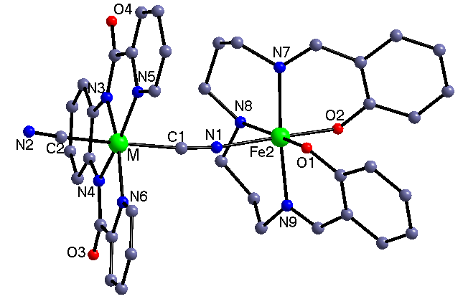
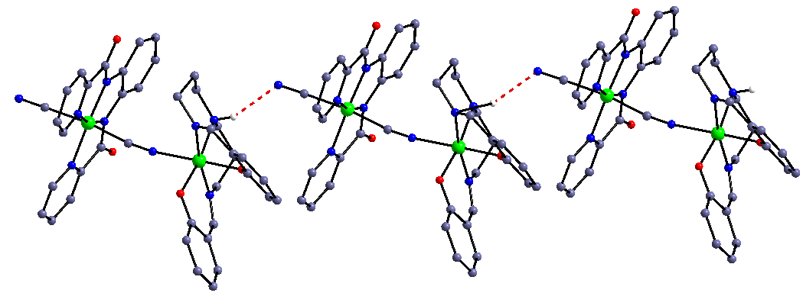
Figure1. The neutral binuclear structures of complexes 1 and 2 (M = Fe, Co, top) and the 1D supramolecular chain constructed by H-bond interactions (bottom). All the H atoms (except one used to form H-bond) and the solvent content have been omitted for clarity.
Table 3. Selected bond lengths (Å) and angles (°) for complexes 1 and 2.
Complexes | 1(M=Fe) | 2(M=Co)
M1-N1 | 2.134(4) | 2.141(7)
M1-N8 | 2.201(4) | 2.202(7)
M1-N9 | 2.108(4) | 2.115(8)
M1-O3 | 1.911(3) | 1.918(5)
M1-N7 | 2.098(4) | 2.087(7)
M1-O4 | 1.927(3) | 1.900(5)
M1-M | 1.976(5) | 1.923(8)
O4-M1-O3 | 92.26(13) | 92.6(2)
O3-M1-N7 | 86.30(14) | 87.8(2)
O3-M1-N9 | 89.66(14) | 95.1(3)
O4-M1-N1 | 179.01(15) | 179.2(3)
N7-M1-N1 | 94.69(16) | 91.8(3)
N9-M1-N1 | 92.48(15) | 94.0(3)
O3-M1-N8 | 171.44(13) | 171.2(2)
The complexes 1 and 2, crystallizing in space group P2₁/c and P2₁ containing four and two independent units in the unit cell, respectively, structurally belong to neutral binuclear entity. The [Fe/Co(bpb)(CN)₂]⁻ anion acting as monodentate ligand connects the [Fe(saldptn)]⁺ cation through one cyanide group with the other one terminal, therefore forming neutral binuclear dimer. The Fe^{III}/Co^{III} in the cyano precursors with low spin state is coordinated by an equatorial N₄ unit from bpb and two carbons of cyanide in the trans position, forming a slightly distorted octahedral geometry. In addition, the results are slightly longer than the M-C_{cyanide} bond length of 1.923-1.976Å. As listed in Table 3, the bond angles of M-C≡N very close to 180° clearly indicate that the three atoms are linear.
The coordination sphere of Fe^{III} ion in [Fe(saldptn)]⁺ is six-coordinated octahedron, in which the four equatorial positions are occupied by three N atoms and one O atom from the Schiff-base ligand and the two axial ones coordinated by one O atom of the Schiff-base ligand and one N atom of the bridge cyanide group. The averaged Fe-N_{cyanide} and Fe-N_{Schiff-base} bond lengths in complexes 1 and 2 are 2.134, 2.141 and 2.136 and 2.147 Å, respectively, a little longer than the averaged Fe-O_{Schiff-base} bond with the values of 1.919 and 1.909 Å, demonstrating the slightly distorted octahedral geometry around the Fe(III) ion in [Fe(saldptn)]⁺ unit. These bond lengths are in good agreement with the corresponding bond lengths around the high spin Fe(III) ion found in the reported complex,⁵³ indicative of the high spin state of Fe(III) ions involved in the Schiff-base precursor in these two complexes. Different from the perfect linear M-C≡N unit, the C≡N-Fe bond angles are some bent with the values of 172.2(5) and 169.7(6)°, respectively. Under the help of the intermolecular N-H N hydrogen bond interactions, the binuclear entity can be further constructed into supramolecular 1D infinite structure.
3.1.2 Crystal structures of complexes 3-5
Some important bond parameters for complexes 3-5 are given in Table 4. The cationic bi- or mononuclear structure are presented in Figure 2 and the cell packing diagram with complex 3 as representative is shown in Figure 3. As can be found, the three complexes, which crystallize in C2/c, P2₁/c and P2₁/n space group, respectively, are composed by cationic bi- or mononuclear entity and the balanced BPh₄⁻ anion(s). For complex 3, the asymmetric unit contains only half the dinuclear molecule. In complexes 3-5, the coordination geometry of the hexa-coordinated Fe(III) ion is octahedron, in which the equatorial plane is connected by the N₂O₂ unit from the Schiff-base ligand, different from that in complexes 1 and 2, and the two axial positions are occupied by the N atom of the Schiff-base ligand and the N atom of the pyridine ligand. It should be pointed out that the configuration of the Schiff-base ligand in these three complexes are obviously different from that in complexes 1 and 2, implying maybe the different spin state of the Fe(III) ion. Additional, there exist weak π-π stacking interactions in complex 3 between the pyridine ring and the benzene ring of the BPh₄⁻ with center-center distance of 3.74(7) Å.
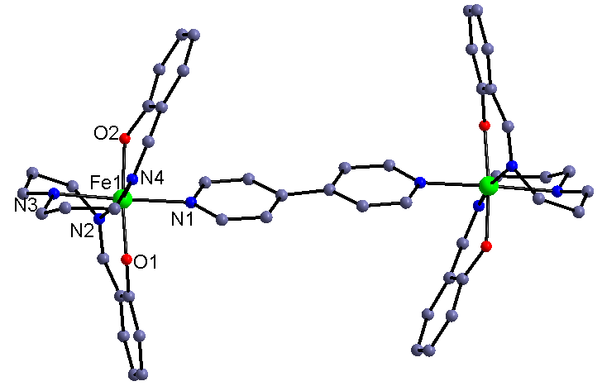
Figure 2. The cationic binuclear structure of complex 3. All the H atoms and the balanced anions have been omitted for clarity.
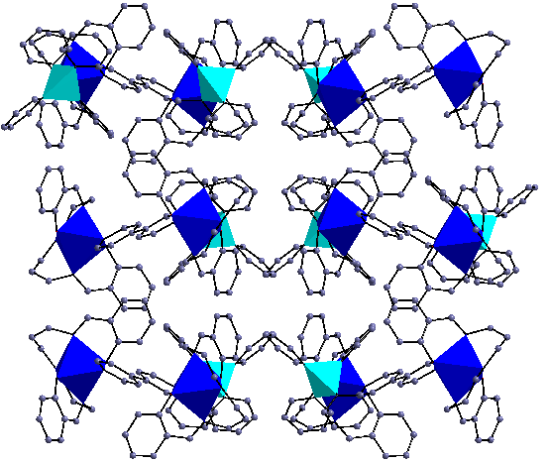
Figure 3. The cell packing diagram of complex 3 along b axial. All the H atoms have been omitted for clarity.
Table 4. Selected bond lengths (Å) and angles (°) for complexes 3 and 4 and 5 at room temperature and low temperature
Complex 3 (293K)
Fe1-O1 | 1.889(5) | N2-Fe1-N4 | 172.9(3)
Fe1-O2 | 1.895(5) | O2-Fe1-N3 | 90.7(2)
Fe1-N2 | 1.999(7) | N3-Fe1-N1 | 177.6(3)
Fe1-N4 | 2.007(6) | O2-Fe1-N2 | 92.2(3)
Fe1-N3 | 2.083(6) | O2-Fe1-N4 | 89.5(2)
Fe1-N1 | 2.094(7) | O1-Fe1-N1 | 88.2(3)
O1-Fe1-O2 | 89.5(3)
(Low Temperature 120K)
Fe1-O1 | 1.8725(5) | Fe1-N4 | 1.961(6)
Fe1-O2 | 1.8827(5) | Fe1-N3 | 2.01(6)
Fe1-N2 | 1.952(7) | Fe1-N1 | 2.012(7)
Complex 4 (293K)
Fe1-O2 | 1.900(2) | O2-Fe1-N3 | 91.66(11)
Fe1-O1 | 1.907(2) | O1-Fe1-N3 | 93.90(10)
Fe1-N2 | 2.045(3) | N2-Fe1-N3 | 84.52(12)
Fe1-N4 | 2.054(3) | N4-Fe1-N3 | 83.67(12)
Fe1-N3 | 2.142(3) | O2-Fe1-N1 | 86.14(10)
Fe1-N1 | 2.156(3) | O1-Fe1-N1 | 88.34(9)
O2-Fe1-O1 | 174.20(10) | N2-Fe1-N1 | 94.26(11)
O2-Fe1-N2 | 92.72(11) | N4-Fe1-N1 | 97.59(11)
O2-Fe1-N4 | 88.58(12) | N3-Fe1-N1 | 177.43(10)
N2-Fe1-N4 | 168.15(12) | C7-O1-Fe1 | 129.9(2)
(Low Temperature 120K)
Fe1-O2 | 1.888(3) | Fe1-N4 | 1.965(3)
Fe1-O1 | 1.876(3) | Fe1-N3 | 2.023(3)
Fe1-N2 | 1.956(3) | Fe1-N1 | 2.027(3)
Complex 5 (293K)
Fe1-O1 | 1.883(2) | O2-Fe1-N3 | 91.31(12)
Fe1-O2 | 1.901(2) | N5-Fe1-N3 | 176.01(13)
Fe1-N5 | 1.985(3) | O1-Fe1-N1 | 92.09(11)
Fe1-N3 | 1.996(3) | N3-Fe1-N1 | 91.52(12)
Fe1-N1 | 2.011(3) | O2-Fe1-N4 | 91.30(13)
Fe1-N4 | 2.060(4) | N1-Fe1-N4 | 179.95(19)
O1-Fe1-O2 | 179.06(11) | C24-N4-Fe1 | 116.8(4)
O1-Fe1-N5 | 90.63(12) | C25-N4-Fe1 | 117.6(4)
O2-Fe1-N5 | 89.78(12)
To further confirm the spin transition, the structures of complexes 3 and 4 have been measured at low temperature (120K). As tabulated in Table 4, the cell volume for these two complexes in the low temperature contracted obviously from 8197.68 to 7932.85 Å³ for 3 and 4208.58 to 4086.34 Å³ for 4, respectively. The averaged Fe-N and Fe-O bond lengths at low temperature are 1.984 Å,1.993 Å and 1.878 Å,1.867 Å, which are conspicuously shorter than the room temperature ones with the values 2.045(7) and 2.099(2) Å, indicating different spin state of the Fe(III) ion in these complexes. The comparatively smaller difference for complex 4 can be attributed to the mixed spin state of Fe(III) ion at room temperature, proved also by the magnetic property (vide infra).
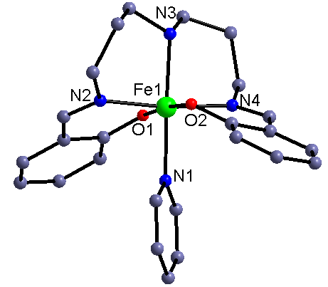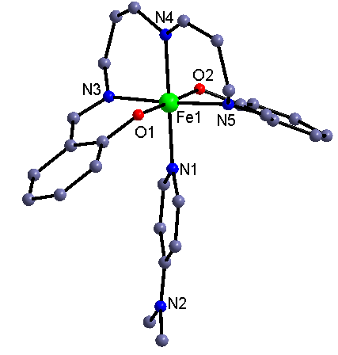
Figure 4. The cationic mononuclear structure of complexes 4(top) and 5(bottom). All the H atoms and the balanced anion have been omitted for clarity.
3.2 Magnetic properties of complexes 1-5.
The temperature dependence of magnetic susceptibilities of the five complexes was measured by using the corresponding single crystal with quality about 10-20 mg in the range of 2-300 K under an external magnetic field of 2000 Oe. The room temperature χ_{m}T values of complexes 1 and 2 (Figure 5) are 4.78 and 4.29 emu K mol⁻¹, respectively, which are basically consistent with the spin only value 4.75 and 4.375 emu K mol⁻¹ for the free low spin Fe(III) and high spin Fe(III) ion or the only high spin Fe(III) ion(the cyanide precursor in complex 2 is diamagnetic), respectively. For complex 1, the χ_{m}T value increases with very low speed and attain the highest peak about 5.23 emu K mol⁻¹ with the decreasing of the temperature to about 10 K, and then decreases at a high speed and reaches the value of about 3.85 emu K mol⁻¹ at 2 K. The χ_{m}T-T change tendency can preliminarily confirm the ferromagnetic coupling between the high spin and low spin Fe(III) ion through the cyanide bridge. For complex 2, with temperature decreasing from 300 K, the χ_{m}T value kept always constant until the sample was cooled to about 20 K, and since then the χ_{m}T began to decrease obviously and reached the lowest value about 3.23 emu K mol^{–1} at 2 K, demonstrating the always high spin state of the Fe(III) ion in this complex.
The ferromagnetic coupling observed in complex 1 can be understood by the orthogonality between the t_{2g} and e_{g} magnetic orbital of high and low spin Fe(III) ions through the bridging cyanide group. On the basis of the binuclear model, the magnetic susceptibility of complex 1 can be fitted accordingly by the following expression derived from the exchange spin Hamiltonian Ĥ = -JŜ_{Fe(HS)}Ŝ_{Fe(LS):}
By using the above model, the susceptibility over the temperature range of 10-300 K was simulated, giving the best-fit parameters J = 1.47(1), g = 2.01(2), R = ∑(χ_{obsd}T-χ_{cald}T)²/∑(χ_{obsd}T)² = 4.37 × 10⁻⁵. The small positive J value indicates also the ferromagnetic interaction in complex 1. To further confirm the magnetic coupling nature in complex 1, the field-dependent magnetization measured up to 50 kOe at 2 K was carried out. The M-H curve is given in the inset of the corresponding χ_{m}T-T figure. The experimental data are basically consistent with the calculated Brillouin function corresponding to the ferromagnetic coupled low spin Fe(III) (S = 1/2) ion and high spin Fe(III) (S = 5/2) ion with g = 2.0 at 2 K. The saturated magnetization value is about 5.89 Nβ, which is very close to the corresponding expected theoretical value (6.0 Nβ), indicating further the existed operation of overall weak ferromagnetic interactions between the adjacent Fe(III) ions.
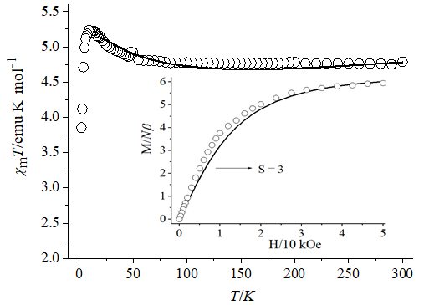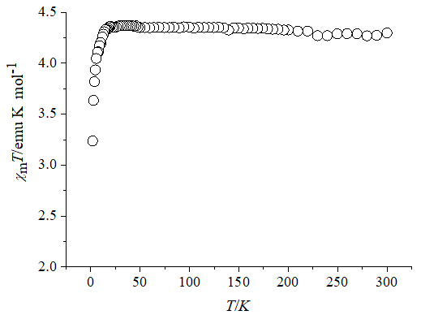
Figure 5. Temperature dependence of χ_{m}T of 1 (top) and 2(bottom). Inset: Field dependence of magnetization at 2 K (the solid Brillouin curve is the ferromagnetic coupled one low spin Fe(III) ion and one high spin Fe(III) ion for complex 1).
The χ_{m}T-T curves of complexes 3-5 are shown in Figure 6. The room temperature χ_{m}T value for complex 3 is about 7.4 emu K mol^{–1}, indicating the two Fe(III) ions bridged by the bipyridine ligand are with almost complete high spin state. For complexes 4 and 5, the χ_{m}T values at 300K are only 1.82 and 1.41 emu K mol^{–1}, providing clear information that the stable high spin state of the Fe(III) ions in these two complexes outclass the room temperature. With the lowering of the temperature, the χ_{m}T for all the three complexes decrease at a rapid rate to about 1.33, 0.61 and 0.55 cm³ K mol⁻¹ at about 115, 170 and 200 K, respectively, showing the occurrence of a gradually almost complete spin transition to low spin state. After that, the χ_{m}T values keep almost constant with the temperature cooling to 2K, indicating the stable low spin state at low temperature for these three complexes. Such type of the χ_{m}T-T change tendency can also be found in the reported examples based on the similar pentadentate Schiff-base Fe(III) precursor and pyridine-like ligands.
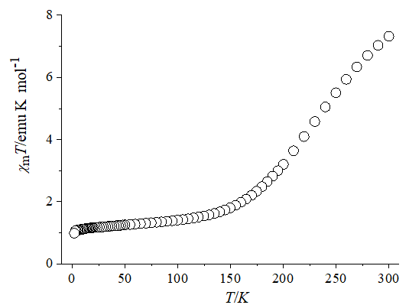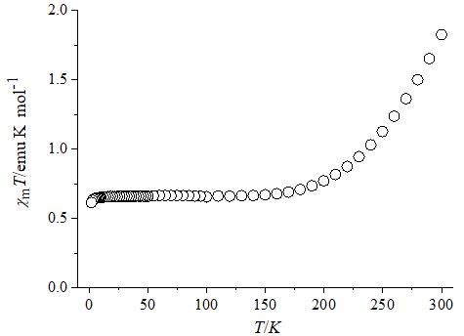
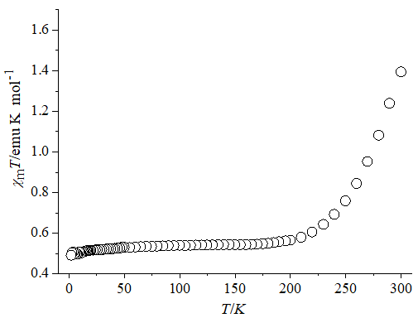
Figure 6. Temperature dependences of χ_{m}T of 3 (top), 4(middle) and 5(bottom).
In order to further study the temperature influence on the electron spin state of the Fe(III) ion in the above molecular systems, density functional theory (DFT) calculations were carried out at the method of pbe1pbe and a mix basis set that including LanL2Dz for Fe and 6-31g* for all the other atoms. The calculated Gibbs free energy with the complexes 1, 3 and 5 as representatives, which can be used to deduce the comparatively stability of the different spin state of the metal ions, showed that these complexes owned the different modes of electron spin state under the different temperature conditions. As shown in Figure 7, the Gibbs free energies of the complex 1 for the high spin state are always lower than the corresponding low spin ones, indicating this molecular system is more stable with the metal ion in a low spin state within the whole temperature range, which is consistent with the experimental magnetic susceptibility result. For complex 3, the Gibbs free energy of low spin state below at exactly 112K is lower than that in the high spin state, demonstrating the spin crossover at about this temperature, basically in agreement with the χ_{m}T-T curve change tendency described vide supra, in which the almost complete spin transition temperature is about 115K. For DMAP molecular system (complex 5), within the temperature range 210-400K, the Gibbs free energy for the two spin states are almost equal to each other. However, when the temperature is below 210K, the low spin state begin to become slightly smaller than that in the high spin state, contrary to that when the temperature above 400K, for which the high spin Gibbs free energy is smaller than the low spin ones, implying that the spin crossover occurs around 210K, corresponding also to the temperature dependent magnetic susceptibility measurement. All the calculated results are coincide with the experimental results and, theoretically, proved further the spin stability of Fe(III) ion under different temperatures, for which can be attributed to the different coordination field strength from the auxiliary ligand(s) attached to the Fe(III) center.
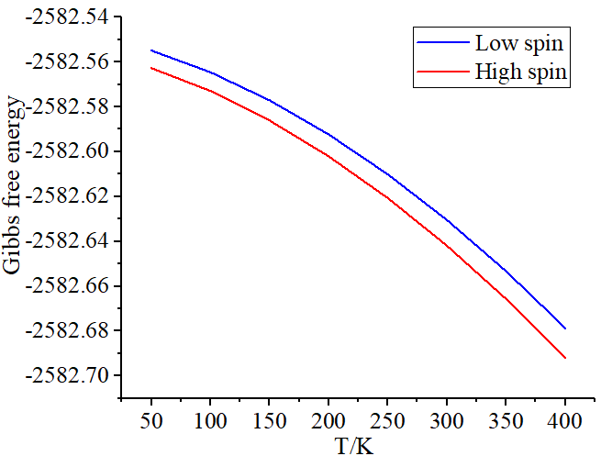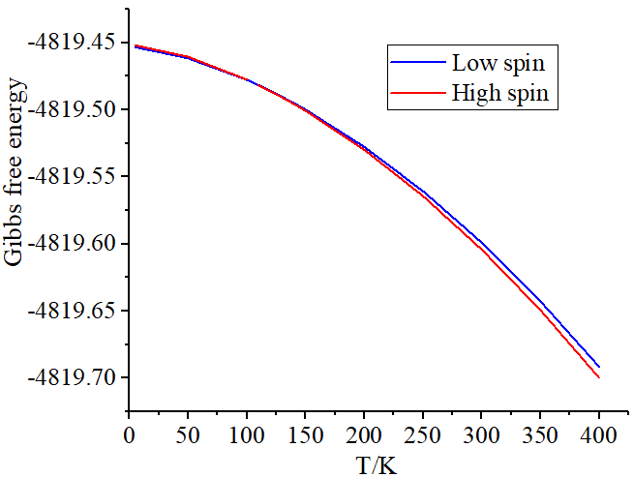
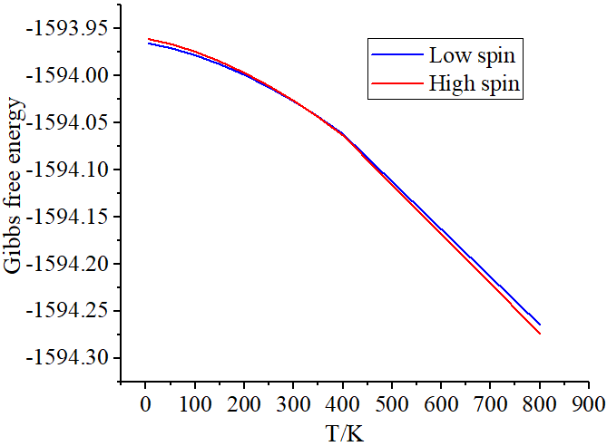
Figure 7. The temperature dependence of the calculated Gibbs free energy for complex 1(top), 3(middle) and 5(bottom).
4 Conclusion
In summary, for the purpose of preparation of Fe(III)-based spin crossover molecular magnetic materials, the reactions of pentadentate Schiff-base based Fe(III) compound with the trans-dicyanometallates or the pyridine-type ligands were investigated, leading to cyano precursor or 4,4’-bipy bridged binuclear and pyridine coordinated mononuclear complexes. The study over the temperature dependence of the magnetic susceptibility and the field-dependent magnetization, as well as the theoretically magnetic fitting, revealed the ferromagnetic coupling in cyanide-bridged Fe(III)(low spin)-Fe(III)(high spin) complex. For the pyridine involved monometallic Fe(III) complexes, the thermo-induced gradual complete spin crossover behavior occurring at different temperatures could be found, which has been further confirmed by the DFT calculation with the temperature dependent of the Gibbs free energy as reference.
5 Acknowledgement
This work was supported by the Natural Science Foundation of China (22171166).
6 References
All author disclosed no relevant relationships.
- P. Wang, Y. Xu, Q. Lin and M. Lu, Chem. Soc. Rev. 2018, 20, 7522-7538.
- P. He, J. G. Zhang, X. Yin, J. T. Wu, L. Wu, Z. N. Zhou and T. L. Zhang, Chem. Eur. J. 2016, 22, 7670-7685.
- D. K. Mahapatra, S. K. Bharti, V. Asati and S. K. Singh, Eur. J. med. Chem. 2019, 174, 142-158.
- J. K. Sun, X. D. Yang, G. Y. Yang and J. Zhang, Coord. Chem. Rev. 2019, 378, 533-560.
- J. G. Haasnoot, Coord. Chem. Rev. 2000, 200, 131-185.
- G. N. Liu, W. J. Zhu, Y. N. Chu and C. Li, Inorg. Chim. Acta. 2015, 425, 28-35.
- R. Mukherjee, Coord. Chem. Rev. 2000, 203, 151-218.
- M. B. Bushuev, Y. V. Gatilov, V. P. Krivopalov and O. P. Shkurko, Inorg. Chim. Acta. 2015, 425, 182-188.
- C. Gao, J. Wang, H. Xu and Y. Xiong, Chem. Soc. Rev. 2017, 46, 2799-2823.
- R. D. Antonio, J. M. Antonio, C. Joan, R. José, D. C. L. Duane and C. Enrique, Dalton Trans. 2009, 32, 6335-6344.
- J. S. Miller and D. Gatteschi, Chem. Soc. Rev. 2011, 40, 3065-3066.
- T. K. Ekanayaka, G. Hao, A. Mosey, A. S. Dale, X. Jiang, A. J. Yost, K. R. Sapkota, G. T. Wang, J. Zhang, A. T. N’Diaye, A. Marshall, R. Cheng, A. Naeemi, X. Xu and P. A. Dowben, Magnetochemistry. 2021, 7, 37.
- Y. Chen, J. G. Ma, J. J. Zhang, W. Shi, P. Cheng, D. Z. Liao and S. P. Yan, Chem. Commun. 2010, 46, 5073-5075.
- M.-L. Hu, A. Morsali and L. Aboutorabi, Coord. Chem. Rev. 2011, 255, 2821-2859.
- B. Brizet, A. Eggenspiller, C. P. Gros, J. M. Barbe, C. Goze, F. Denat and P. D. Harvey, J. Org. Chem. 2012, 77, 3646-3650.
- D. Tanaka, N. Aketa, H. Tanaka, T. Tamaki, T. Inose, T. Akai, H. Toyama, O. Sakata, H. Tajiri and T. Ogawa, Chem. Commun. 2014, 50, 10074-10077.
- M. A. Halcrow, Chem. Lett. 2014, 43, 1178-1188.
- A. Bousseksou, G. Molnár, L. Salmon and W. Nicolazzi, Chem. Soc. Rev. 2011, 40, 3313-3335.
- A. Tissot, X. Kesse, S. Giannopoulou, I. Stenger, L. Binet, E. Rivière and C. Serre, Chem. Commun. 2019, 55, 194-197.
- D. Gao, Y. Liu, B. Miao, C. Wei, J. G. Ma, P. Cheng and G. M. Yang, Inorg. Chem. 2018, 57, 12475-12479.
- A. B. Gaspar, V. Ksenofontov, M. Seredyuk and P. Gütlich, Coord Chem. Rev. 2005, 249, 2661-2676.
- B. Benaicha, K. Van. Do, A. Yangui, A. Yangui, N. Pittala, A. Lusson, M. Sy, G. Bouchez, H. Fourati, C. J. Gómez-García, S. Triki and K. Boukheddaden, Chem. Sci. 2019, 10, 6791-6798.
- R. Ohtani and S. Hayami, Chem. Eur. J. 2017, 23, 2236-2248.
- Z. P. Ni, J. L. Liu, M. N. Hoque, W. Liu, J. Y. Li, Y. C. Chen and M. L. Tong, Coord. Chem. Rev. 2017, 335, 28-43.
- J. L. Wang, Q. Liu, Y. S. Meng, X. Liu, H. Zheng, Q. Shi, C. Y. Duan and T. Liu, Chem. Sci. 2018, 9, 2892-2897.
- S. Soleymani-Babadi, A. Beheshti, M. Bahrani-Pour, P. Mayer, H. Motamedi, D. Trzybinski and K. Wozniak, Cryst. Growth. Des. 2019, 19, 4934-4948.
- A. Beheshti, E. S. M. Fard, M. Kubicki, P. Mayer, C. T. Abrahams and S. E. Razatofighi, CrystEngComm. 2019, 21, 251-262.
- M. A. Halcrow, Chem. Soc. Rev. 2011, 40, 4119-4142.
- I. Nemec, R. Boča, R. Herchel, Z. Trávníček, M. Gembický and W. Linert, Monats. Chem. 2009, 140, 815-828.
- Y. Komatsumaru, M. Nakaya, F. Kobayashi, R. Ohtani, M. Nakamura, L. F. Lindoy and S. Hayami, Z. Anorg. Allge. Chem. 2018, 644, 729-734.
- S. Vela, M. Fumanal, J. Cirera and J. Ribas-Arino, Phys. Chem. Chem. Phys. 2020, 22, 4938-4945.
- T. Fujinami, K. Nishi, R. Kitashima, K. Murakami, N. Matsumoto, S. Iijima and K. Toriumi, Inorg. Chim. Acta. 2011, 376, 136-143.
- D. J. Harding, P. Harding and W. Phonsri, Coord. Chem. Rev. 2016, 313, 38-61.
- S. Mukherjee, T. Weyhermüller, E. Bill, K. Wieghardt and P. Chaudhuri, Inorg. Chem. 2005, 44, 7099-7108.
- H. Chun, C. N. Verani, P. Chaudhuri, E. Bothe, E. Bill, T. Weyhermüller and K. Wieghardt, Inorg. Chem. 2001, 40, 4157-4166.
- M. Arai, W. Kosaka, T. Matsuda and S. Ohkoshi, Chem. Int. Ed. 2008, 47, 6885-6887.
- K. Tanimura, R. Kitashima, N. Brefuel, M. Nakamura, N. Matsumoto, S. Shova and J. P. Tuchagues, Bull. Chem. Soc. Jpn. 2005, 78, 1279-1282.
- R. Kitashima, S. Imatomi, M. Yamada, N. Matsumoto and Y. Maeda, Chem. Lett. 2005, 34, 1388-1389.
- W. Phonsri, L. C. Darveniza, S. R. Batten and K. S. Murray, Inorganics. 2017, 5, 51.
- W. Phonsri, D. Macedo, B. A. Lewis, D. F. Wain and K. S. Murray, Magnetochemistry. 2019, 5, 37.
- W. Phonsri, B. A. I. Lewis, G. N. L Jameson and K. S. Murray, Chem. Commun. 2019, 55, 14031-14034.
- O. I. Kucheriv, I. O Fritsky and A. Il'ya, Inorg. Chim. Acta. 2021, 521, 120303.
- Z. H. Ni, L. F. Zhang, C. H. Ge, A. L. Cui,H. Z. Kou and J. Jiang, Transit. Metal. Chem. 2008, 11, 94-96.
- D. Zhang and H. Zhang, Polyhedron. 2015, 100, 36-42.
- D. Zhang, L. Kong, P. Wang and X. Chen, Synth. Ynth. React. Inorg. M. 2016, 46, 828-831.
- J. Shi, Q. Meng, C. Xue, Q. Liu and D. Zhang, Transit. Metal. Chem. 2018, 43, 45-52.
- Z. H. Ni, H. Z. Kou, L. F. Zhang, C. Ge, R. J. Wang and A. L. Cui, J. Chem. Crystallog. 2006, 36, 465-472.
- D. Zhang, P. Wang, Z. Zhao and X. Chen, J. Coord. Chem. 2014, 67, 1664-1672.
- R. Boča, Y. Fukuda, M. Gembický, R. Herchel, R. Jaroščiak, W. Linert, F. Renz and J. Yuzurihara, Chem. Phys. Lett. 2000, 325, 411-419.
- R. Kitashima, S. Imatomi, M. Yamada, N. Matsumoto and Y. Maeda, Chem. Lett. 2005, 34, 1388-1389.
- N. Matsumoto, S. Ohta, C. Yoshimura, A. Ohyoshi, S. Kohata, H. Okawa and Y. Maeda, J. Chem. Soc. Dalton Trans. 1985, 12, 2575-2584.
- H. Z. Kou, Z. H. Ni, C. M. Liu, D. Q. Zhang and A. L. Cui, New J. Chem. 2009, 33, 2296-2299.
- T. Senapati, C. Pichon, R. Ababei, C. Mathonièr and R. Clérac, Inorg. Chem. 2012, 51, 3796-3812.

