Synthesis and biological evaluation of some hydrazide-hydrazone derivatives as anticancer agents
Kadriye Akdağ¹, Fatih Tok¹, Sevgi Karakuş^{1,*}, Ömer Erdoğan², Özge Çevik², Bedia Kaymakçıoğlu¹
¹Department of Pharmaceutical Chemistry, Faculty of Pharmacy, Marmara University, 34854, Istanbul, Turkey
²Department of Biochemistry, School of Medicine, Aydin Adnan Menderes University, 09010, Aydın, Turkey
*Corresponding author: E-mail: skarakus@marmara.edu.tr

Supplementary Figures
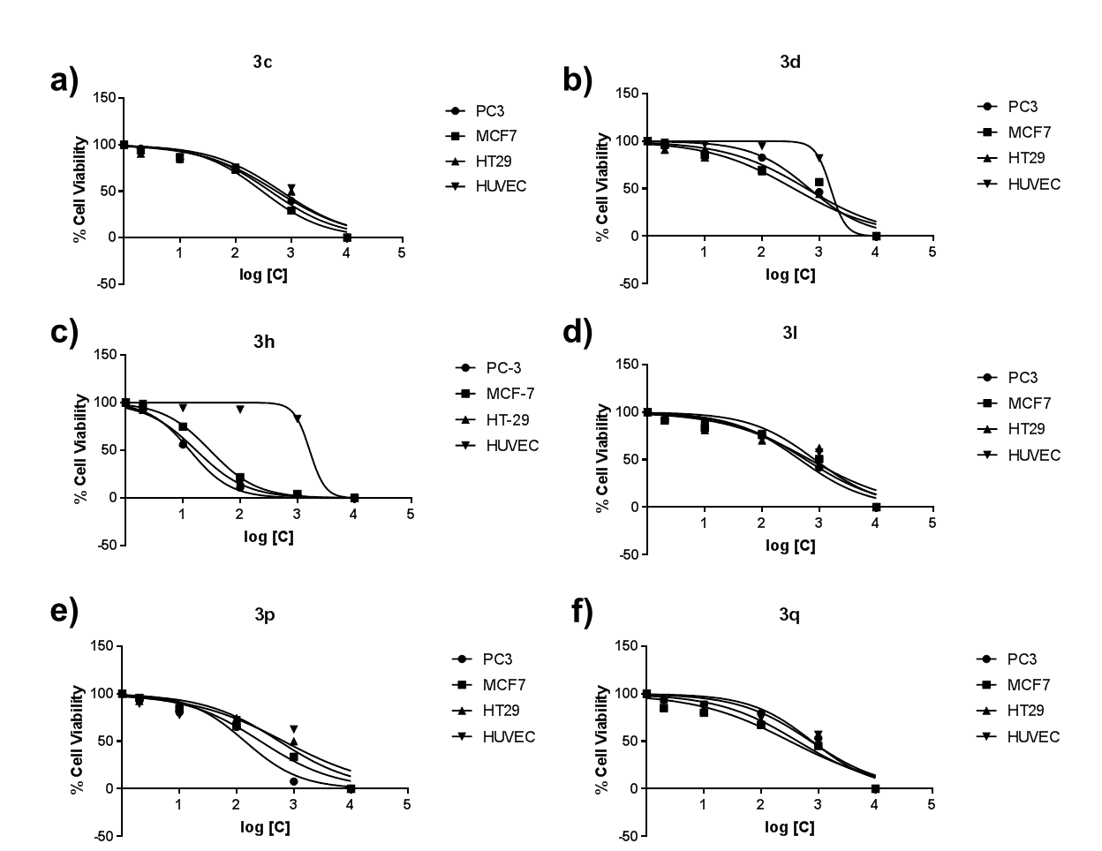

Figure S1: Dose response curve graphics for compound a) 3c, b) 3d, c) 3h, d) 3l, e) 3p and f) 3q at doses of 0.1, 1, 10, 100 and 1000 µM concentration on HUVEC, MCF-7, PC-3, and HT-29 cells

SUPPORTING INFORMATION PART OF THE CHEMISTRY

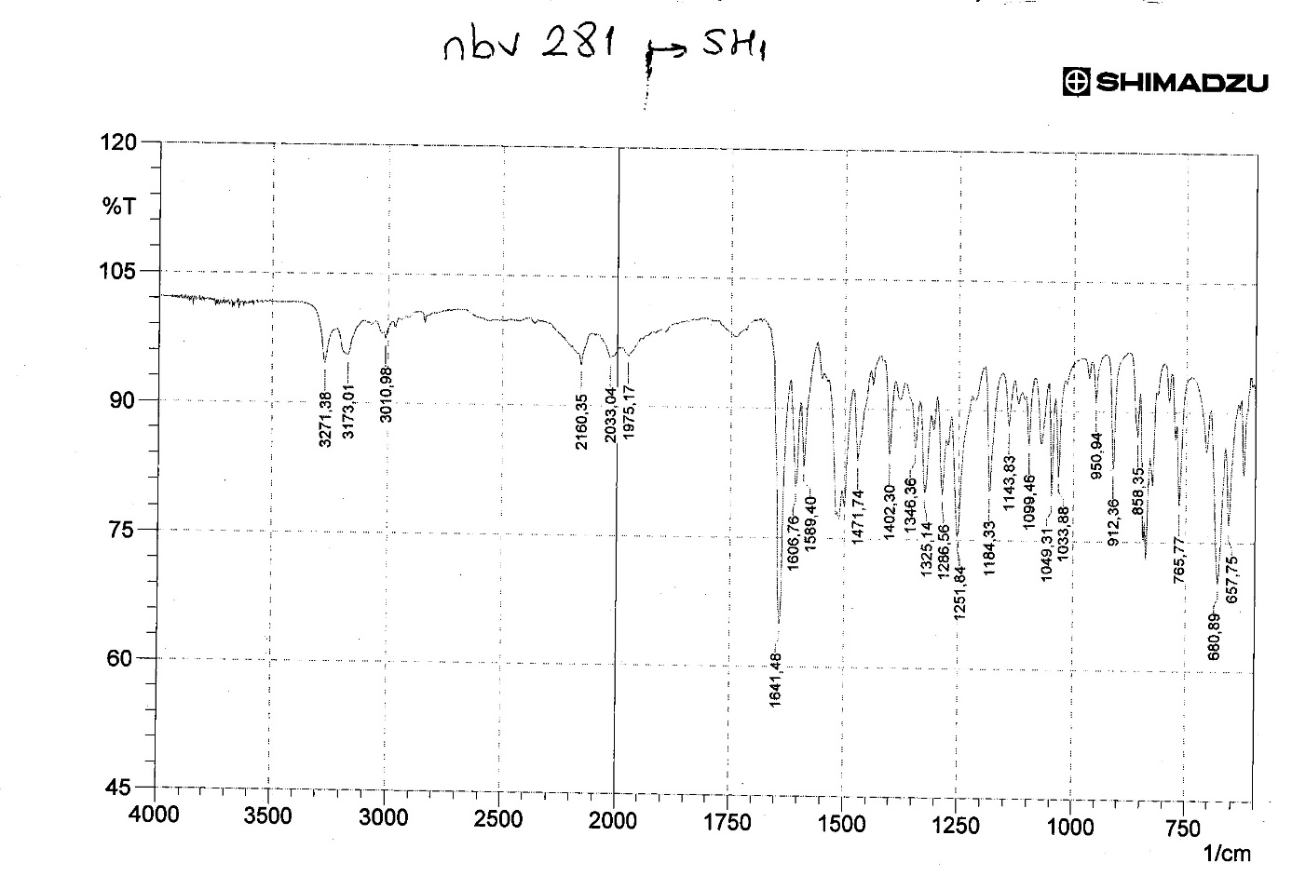
Figure S2: IR spectrum of compound 3a
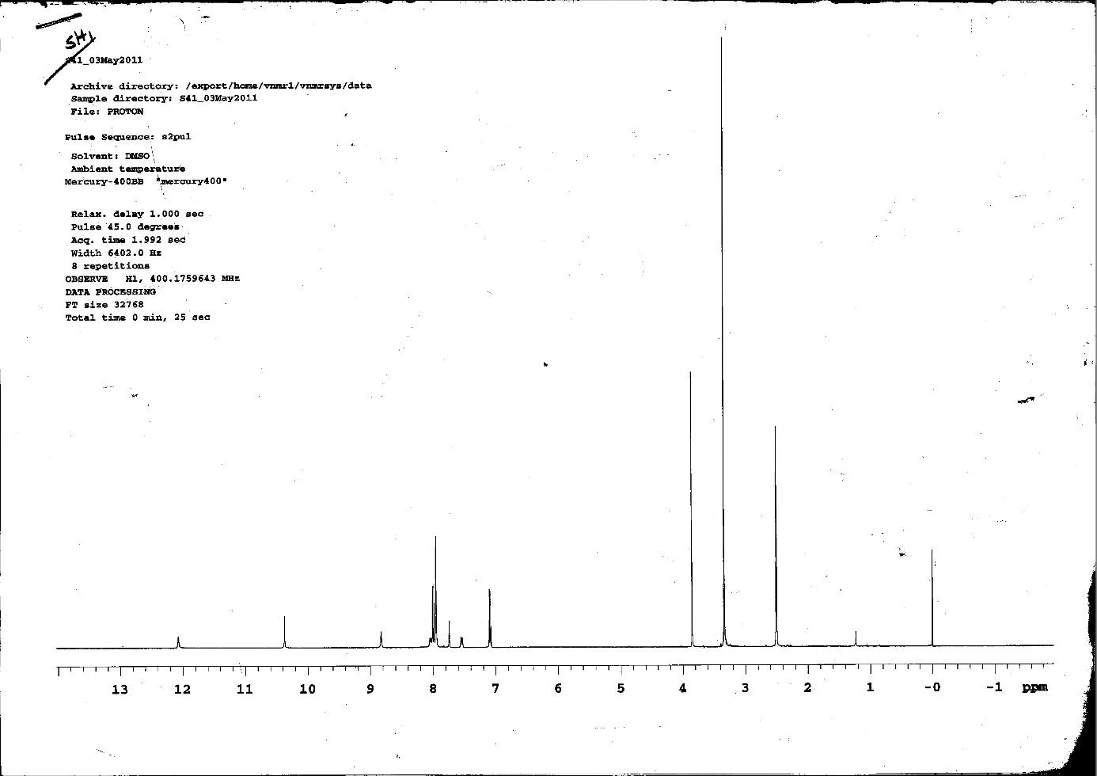
Figure S3: ¹H-NMR spectrum of compound 3a
Figure S4: ¹³C-NMR spectrum of compound 3a
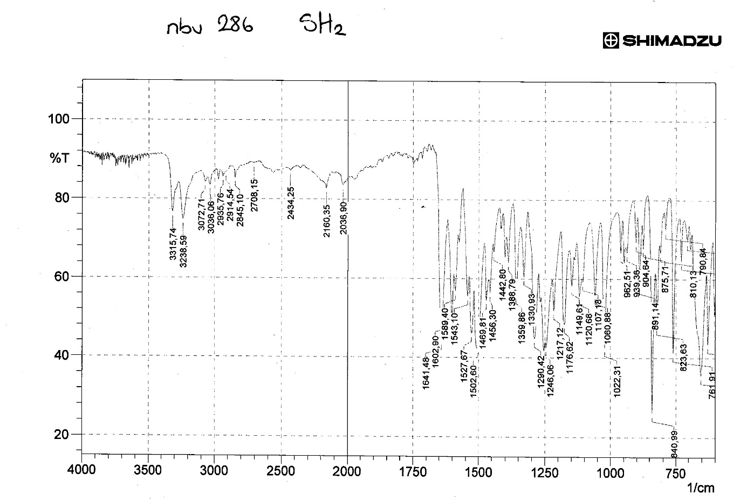
Figure S5: IR spectrum of compound 3b
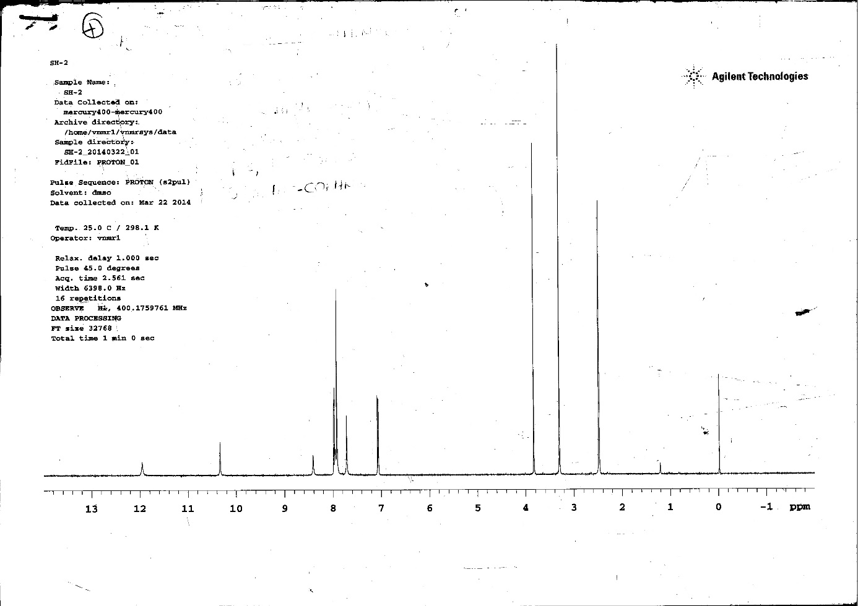
Figure S6: ¹H-NMR spectrum of compound 3b
Figure S7: ¹³C-NMR spectrum of compound 3b
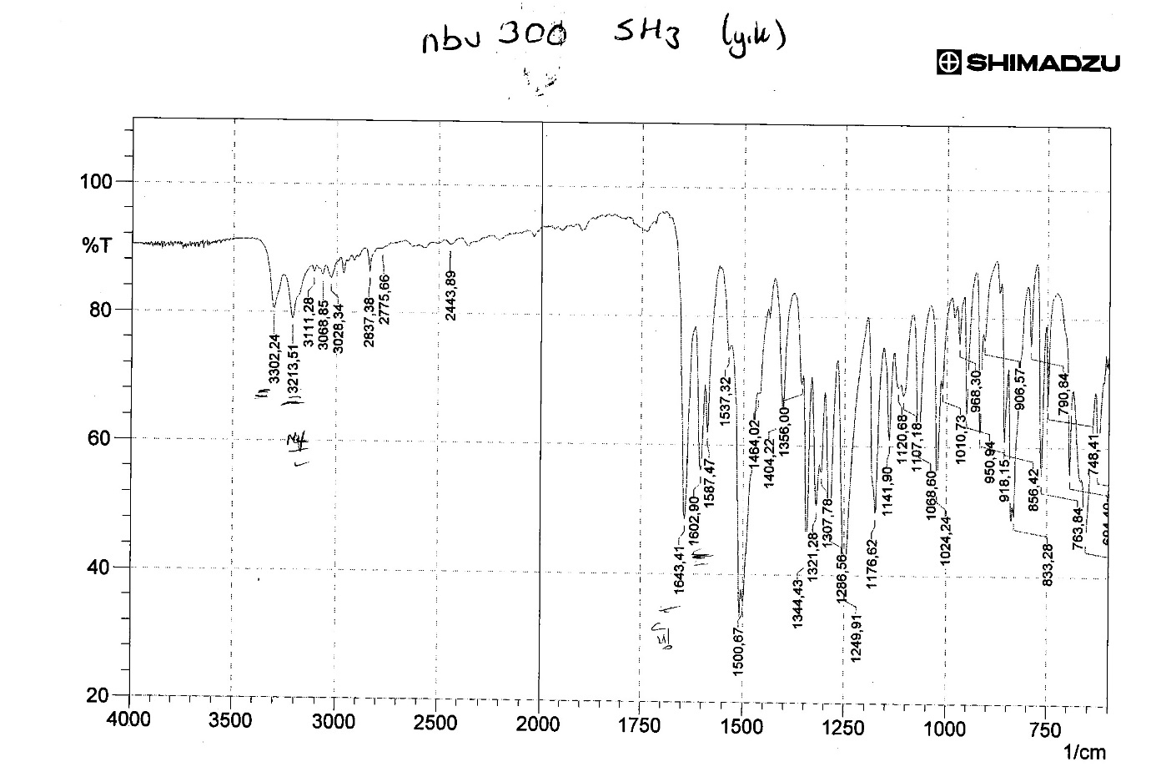
Figure S8: IR spectrum of compound 3c
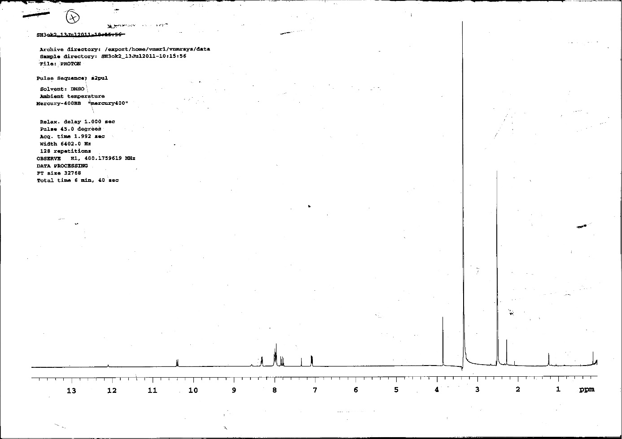
Figure S9: ¹H-NMR spectrum of compound 3c
Figure S10: ¹³C-NMR spectrum of compound 3c
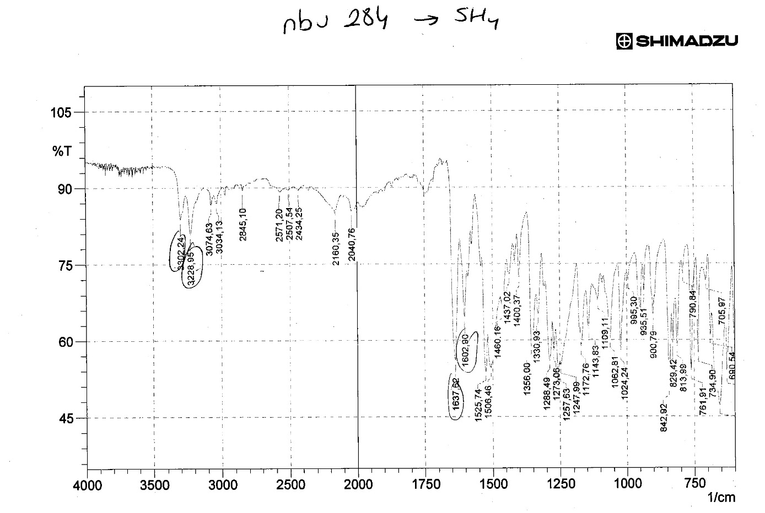
Figure S11: IR spectrum of compound 3d
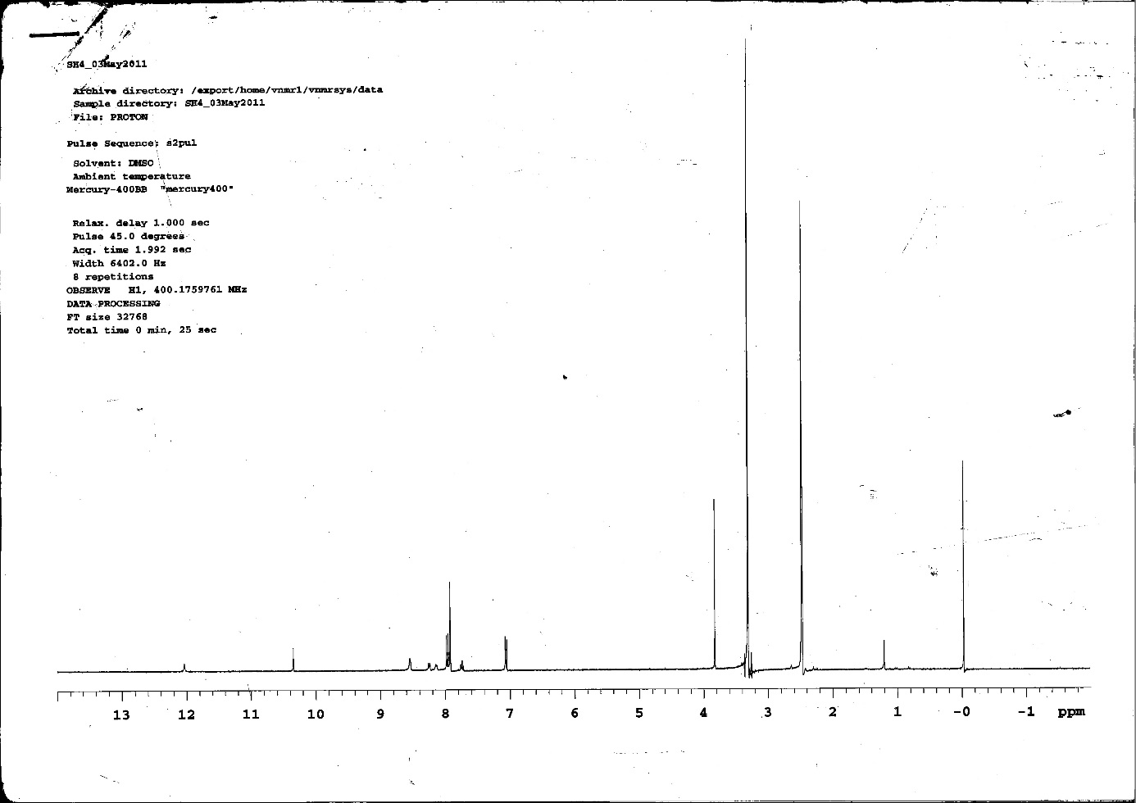
Figure S12: ¹H-NMR spectrum of compound 3d
Figure S13: ¹³C-NMR spectrum of compound 3d
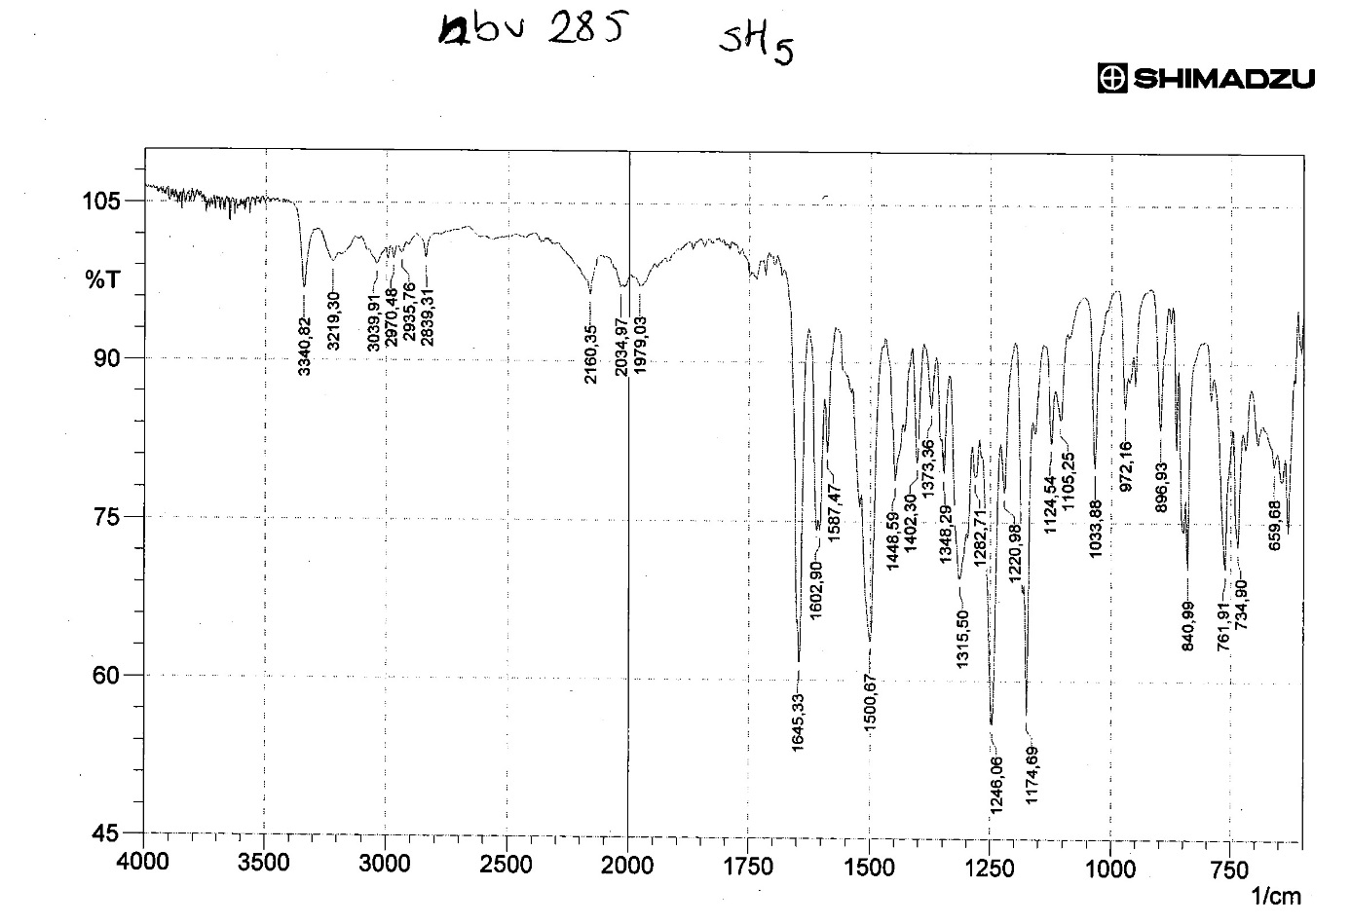
Figure S14: IR spectrum of compound 3e
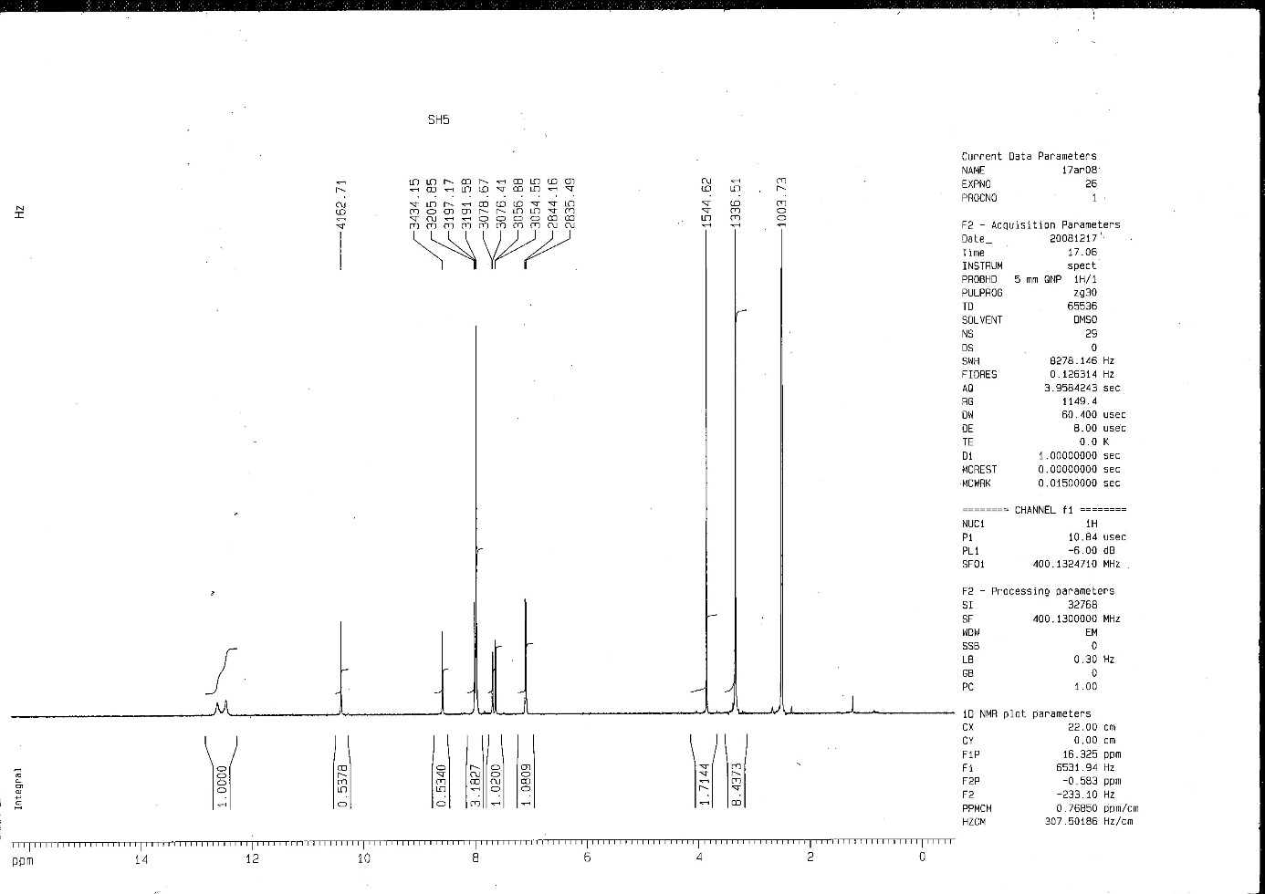
Figure S15: ¹H-NMR spectrum of compound 3e
Figure S16: ¹³C-NMR spectrum of compound 3e
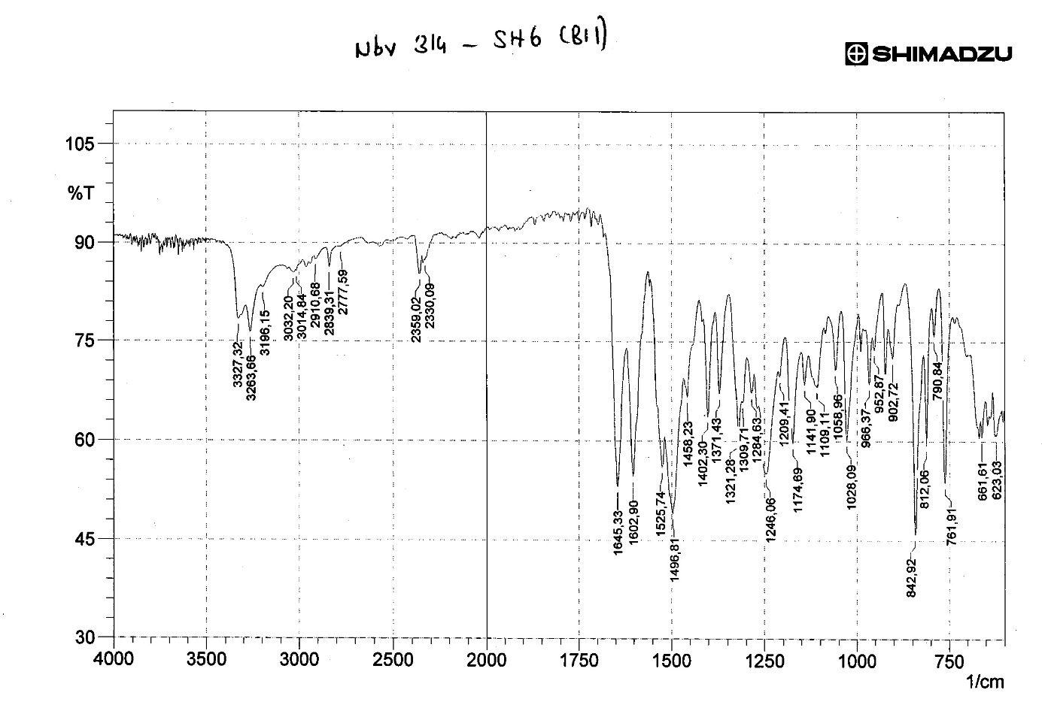
Figure S17: IR spectrum of compound 3f
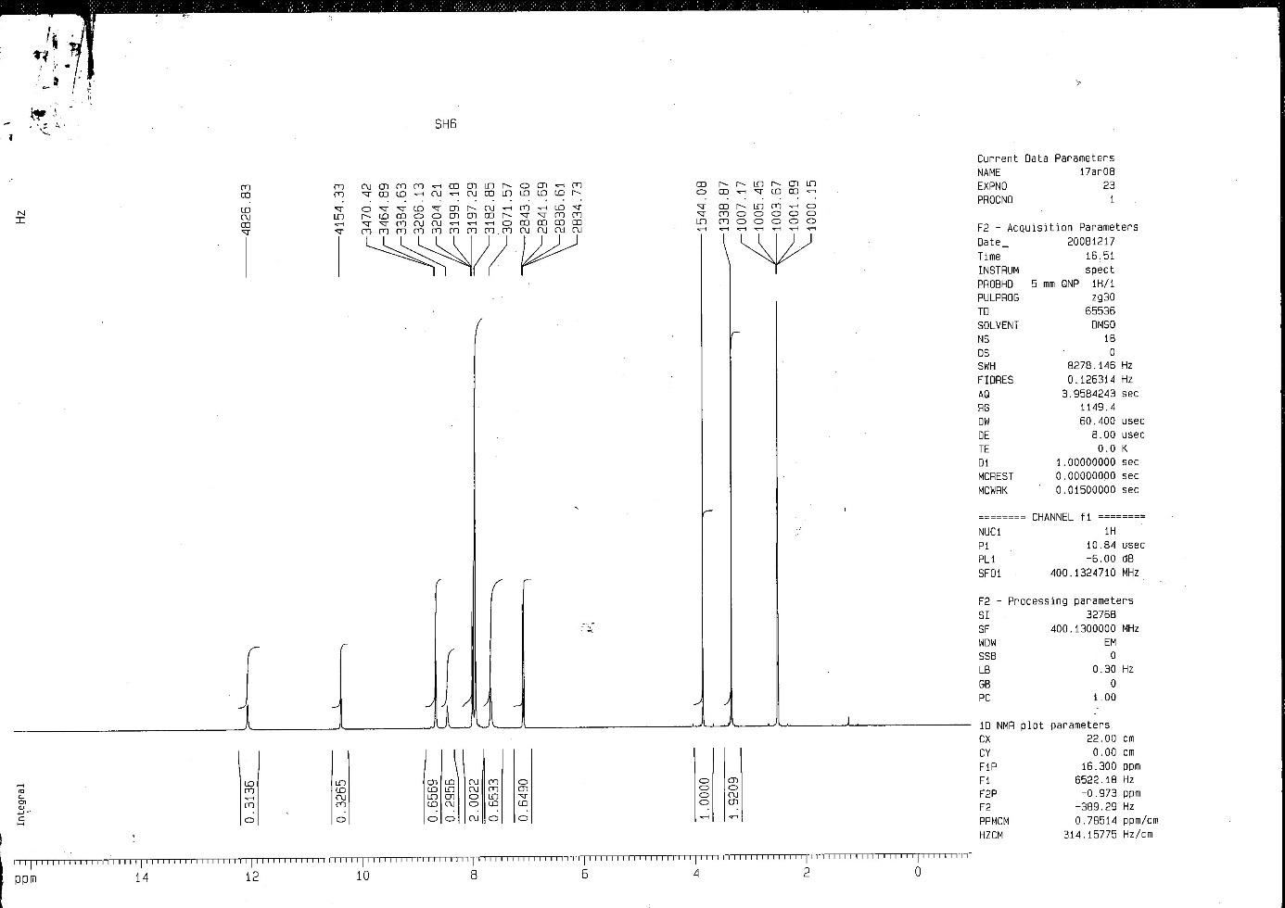
Figure S18: ¹H-NMR spectrum of compound 3f
Figure S19: ¹³C-NMR spectrum of compound 3f
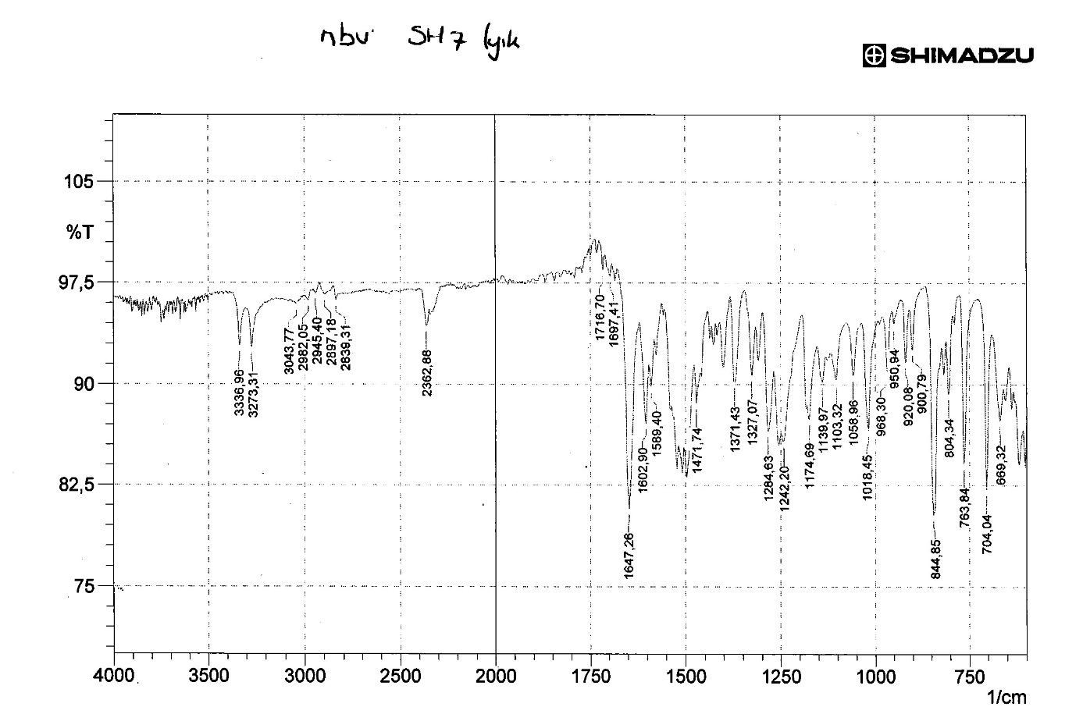
Figure S20: IR spectrum of compound 3g
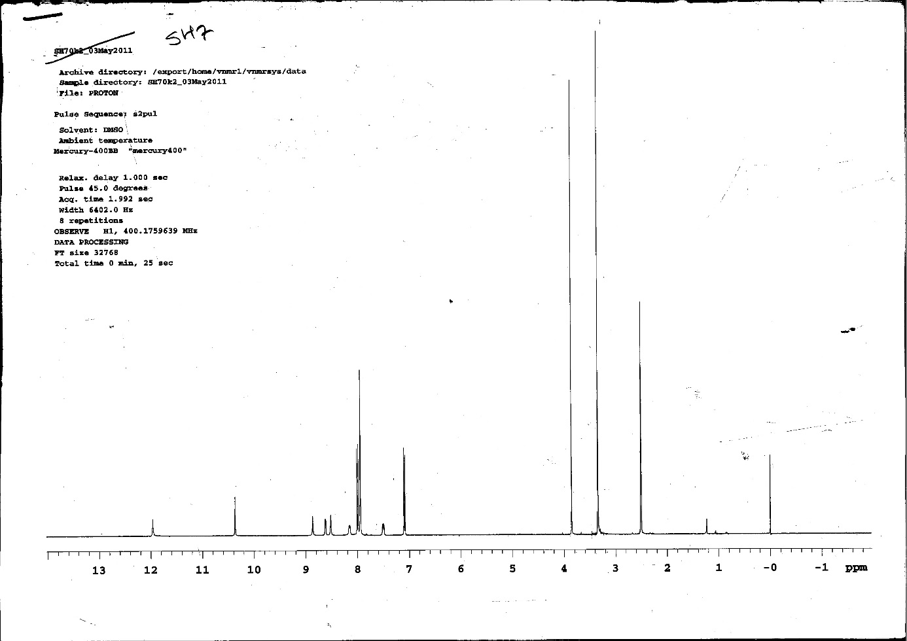
Figure S21: ¹H-NMR spectrum of compound 3g
Figure S22: ¹³C-NMR spectrum of compound 3g
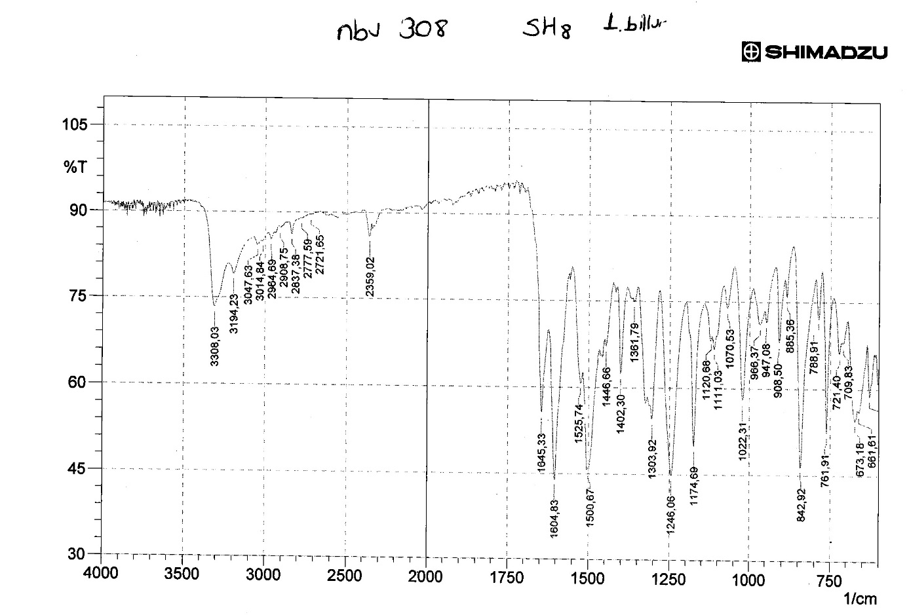
Figure S23: IR spectrum of compound 3h
Figure S24: ¹H-NMR spectrum of compound 3h
Figure S25: ¹³C-NMR spectrum of compound 3h
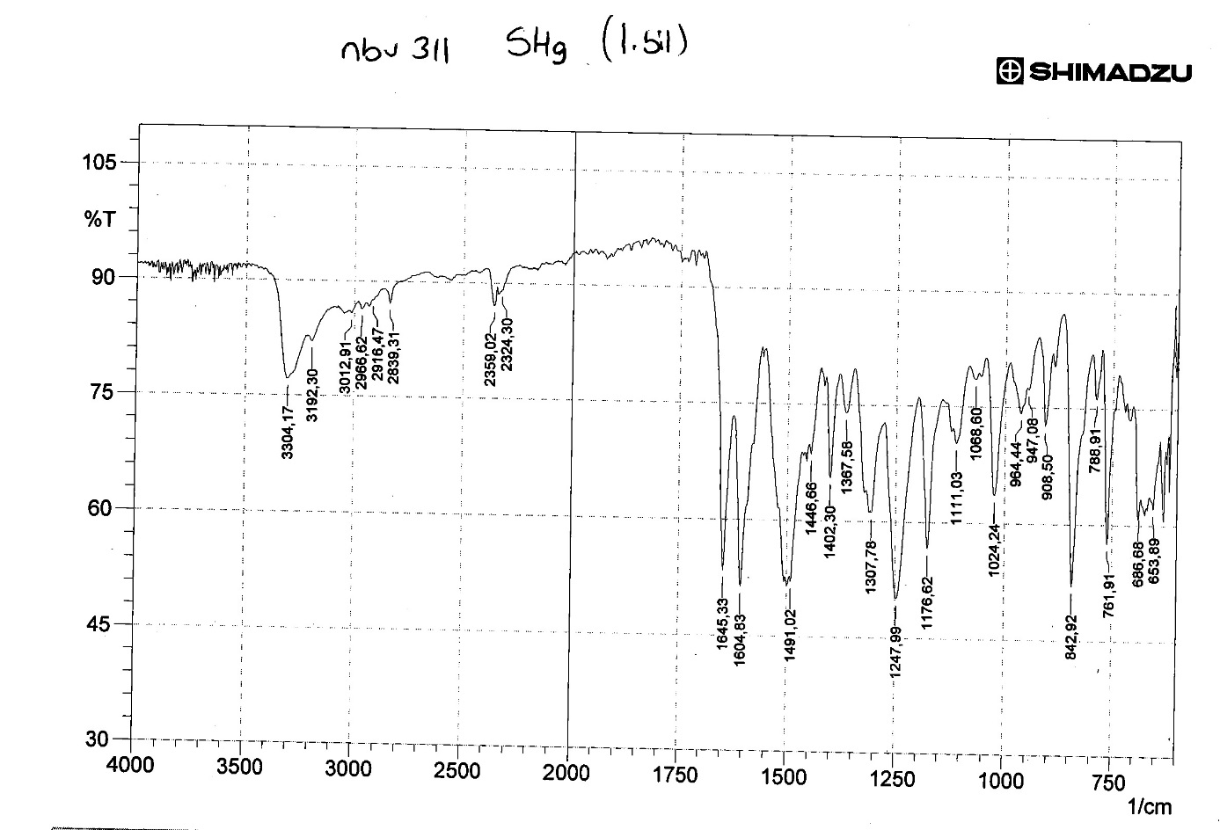
Figure S26: IR spectrum of compound 3i
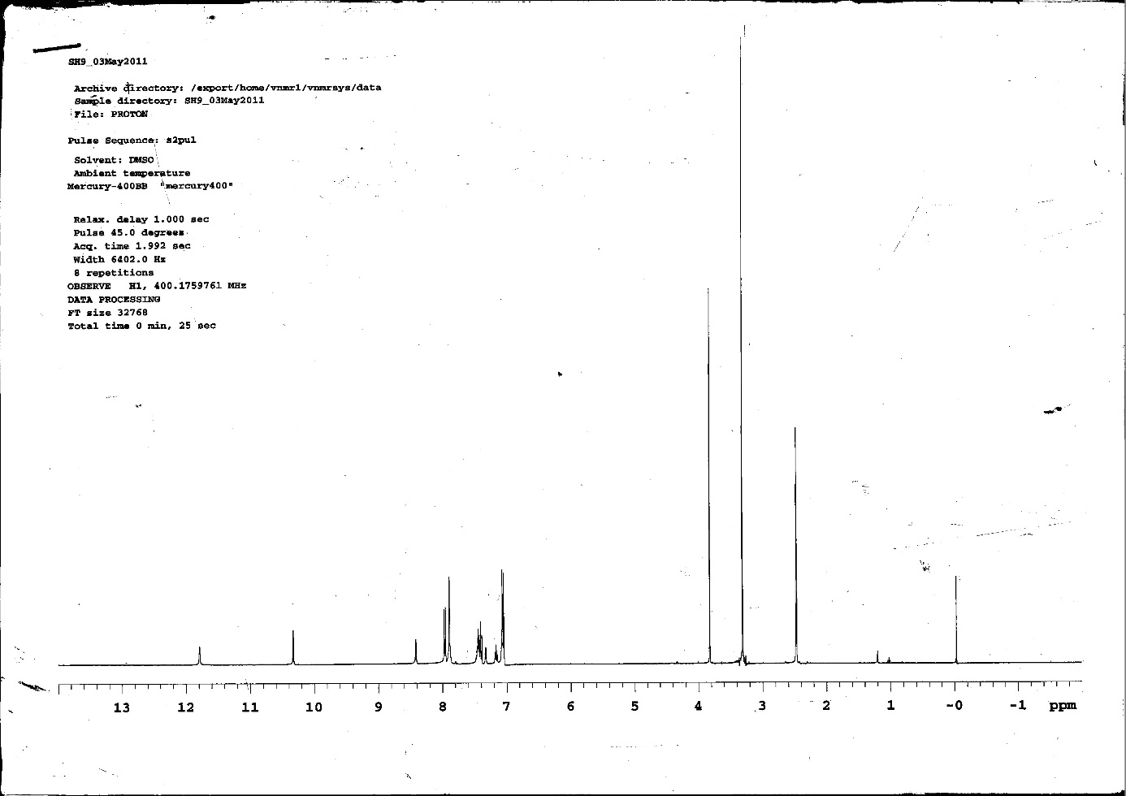
Figure S27: ¹H-NMR spectrum of compound 3i
Figure S28: ¹³C-NMR spectrum of compound 3i
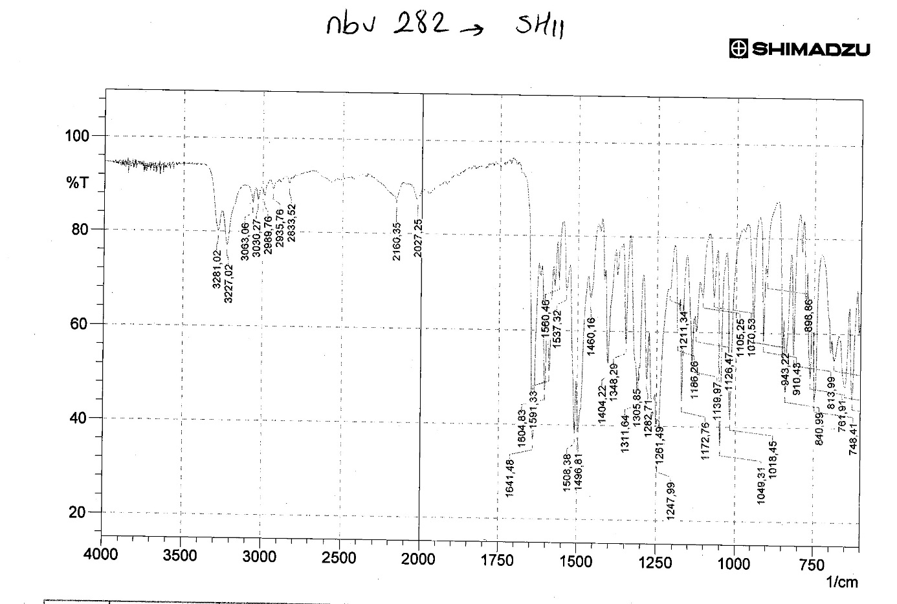
Figure S29: IR spectrum of compound 3k
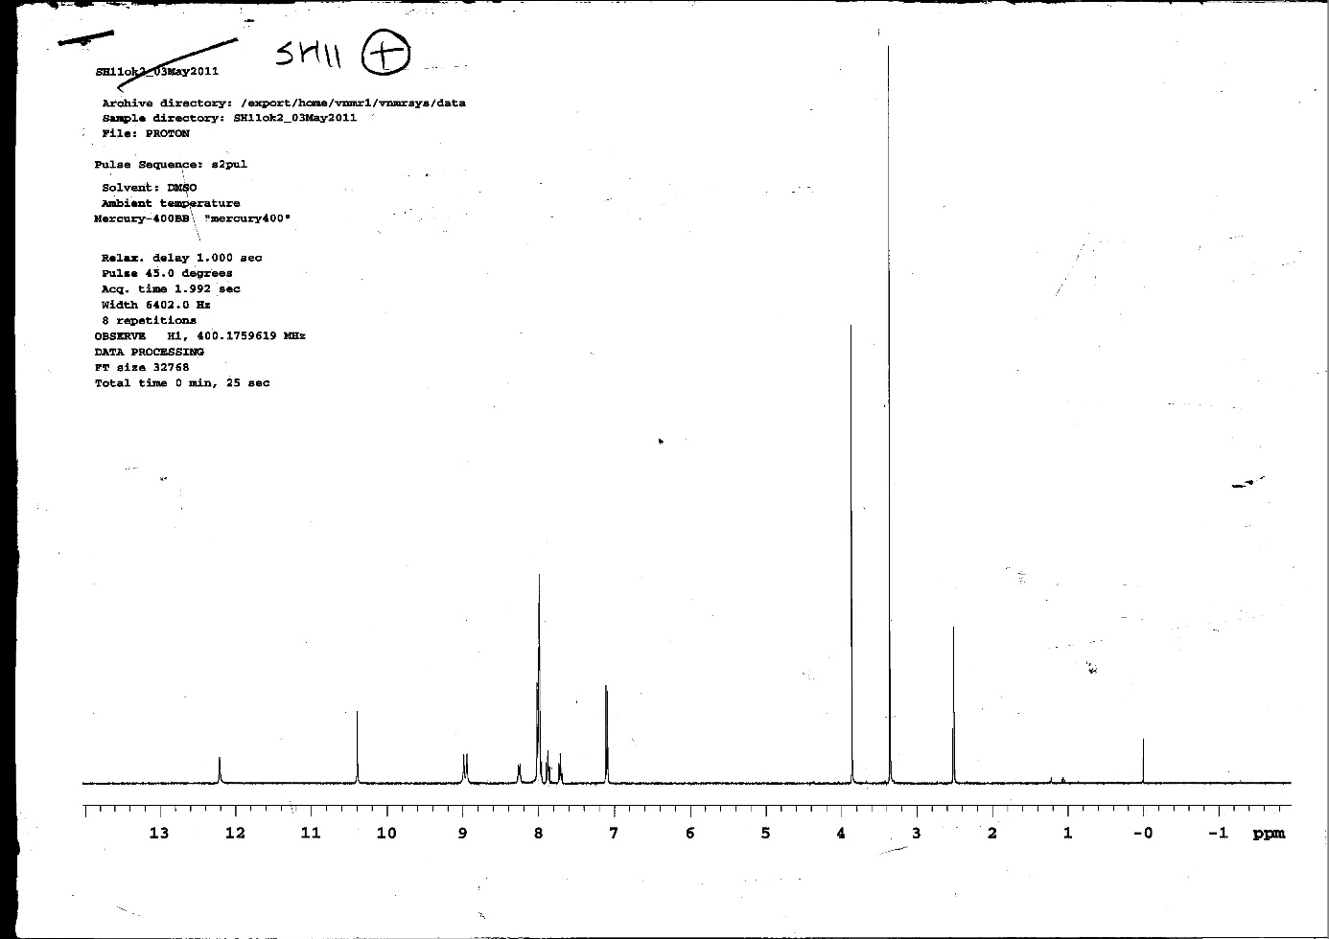
Figure S30: ¹H-NMR spectrum of compound 3k
Figure S31: ¹³C-NMR spectrum of compound 3k
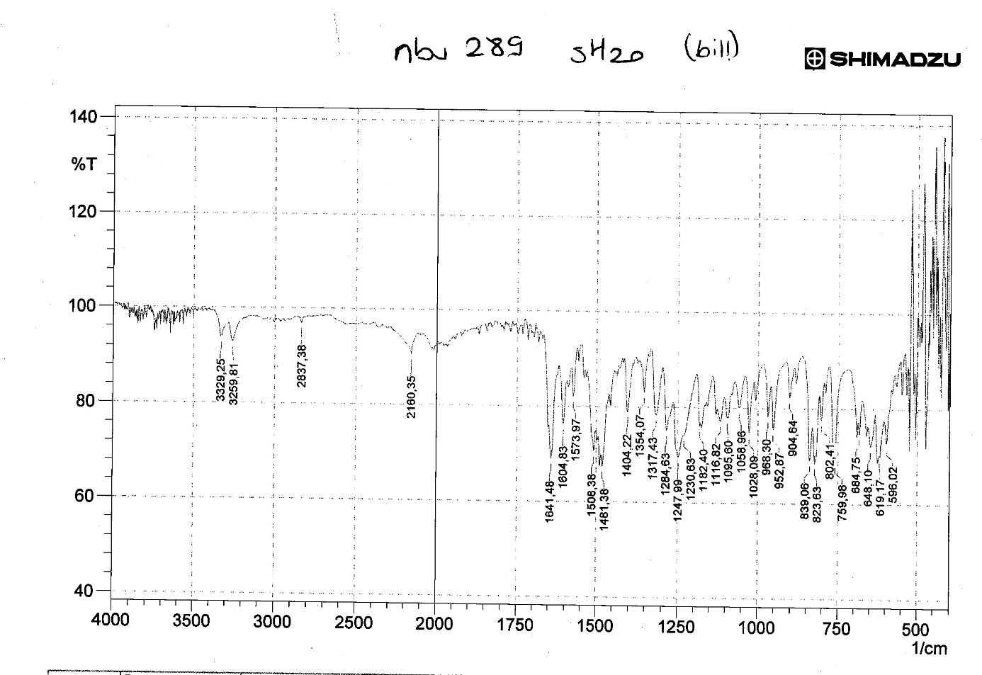
Figure S32: IR spectrum of compound 3o
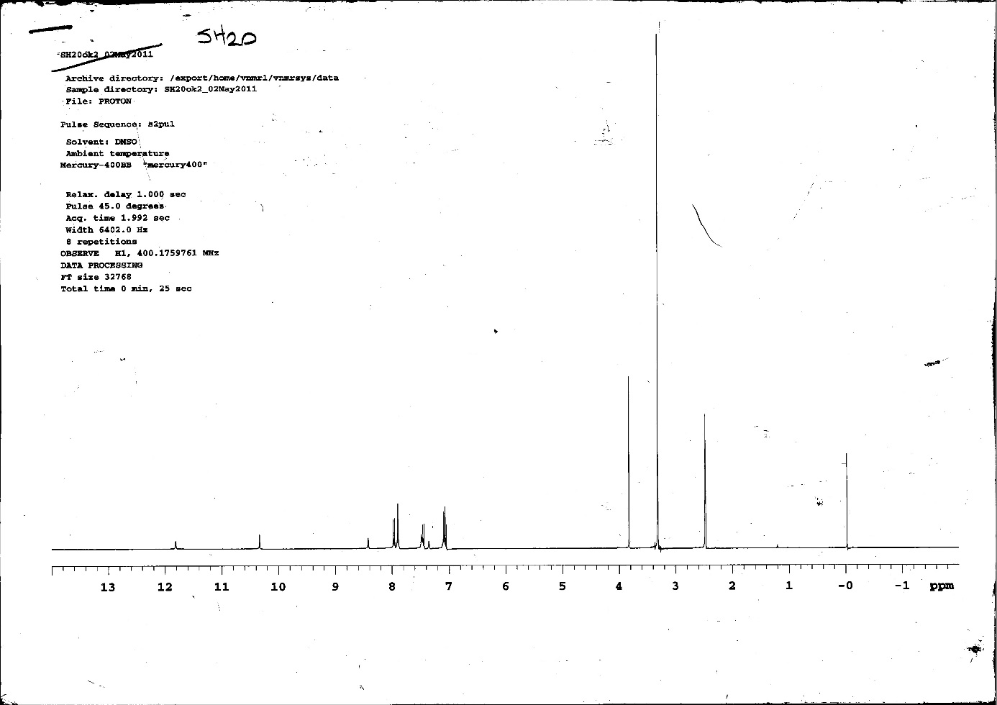
Figure S33: ¹H-NMR spectrum of compound 3o
Figure S34: ¹³C-NMR spectrum of compound 3o
Figure S35: IR spectrum of compound 3p
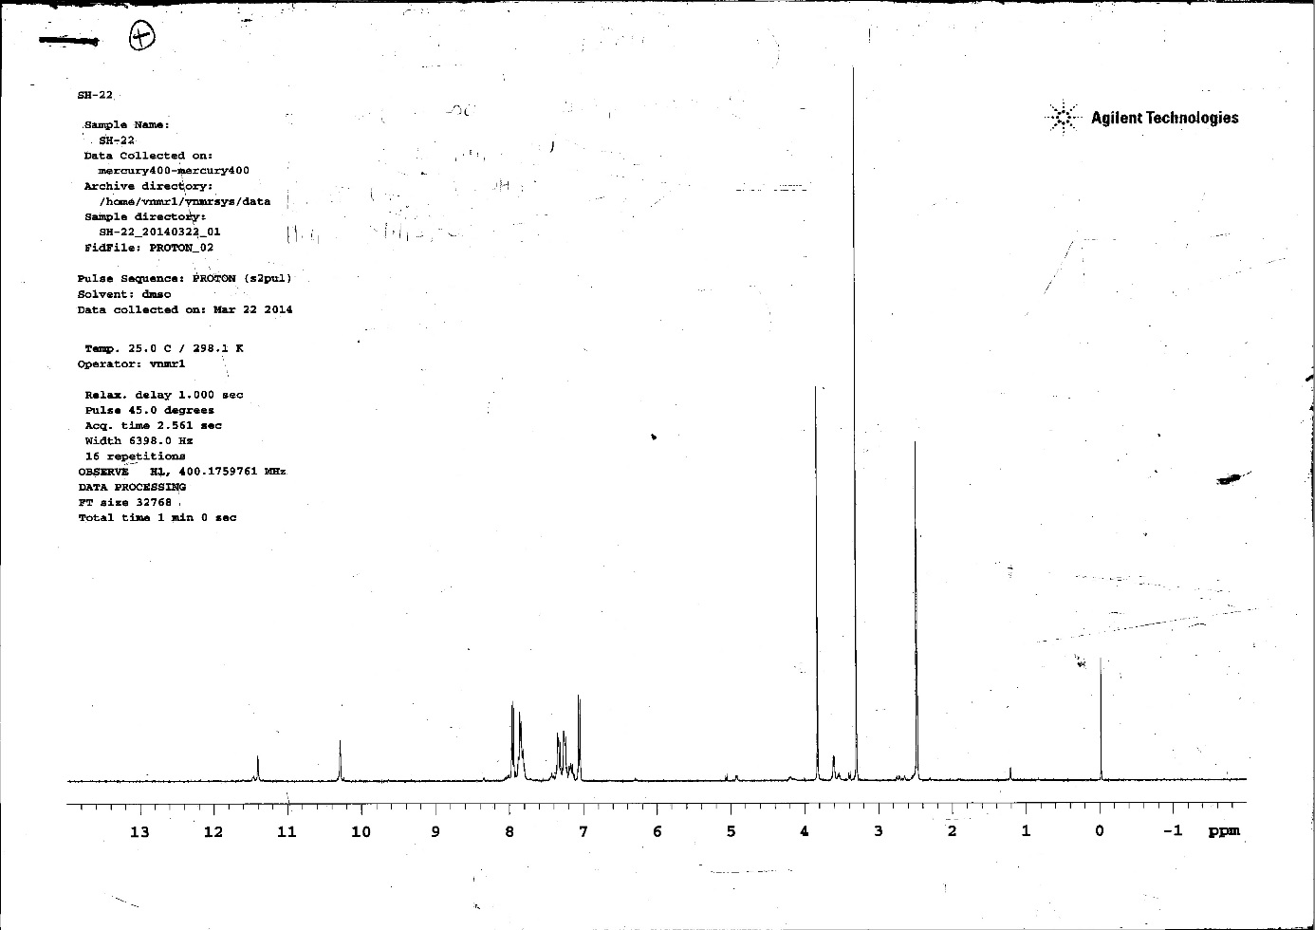
Figure S36: ¹H-NMR spectrum of compound 3p
Figure S37: ¹³C-NMR spectrum of compound 3p
Figure S38: IR spectrum of compound 3q
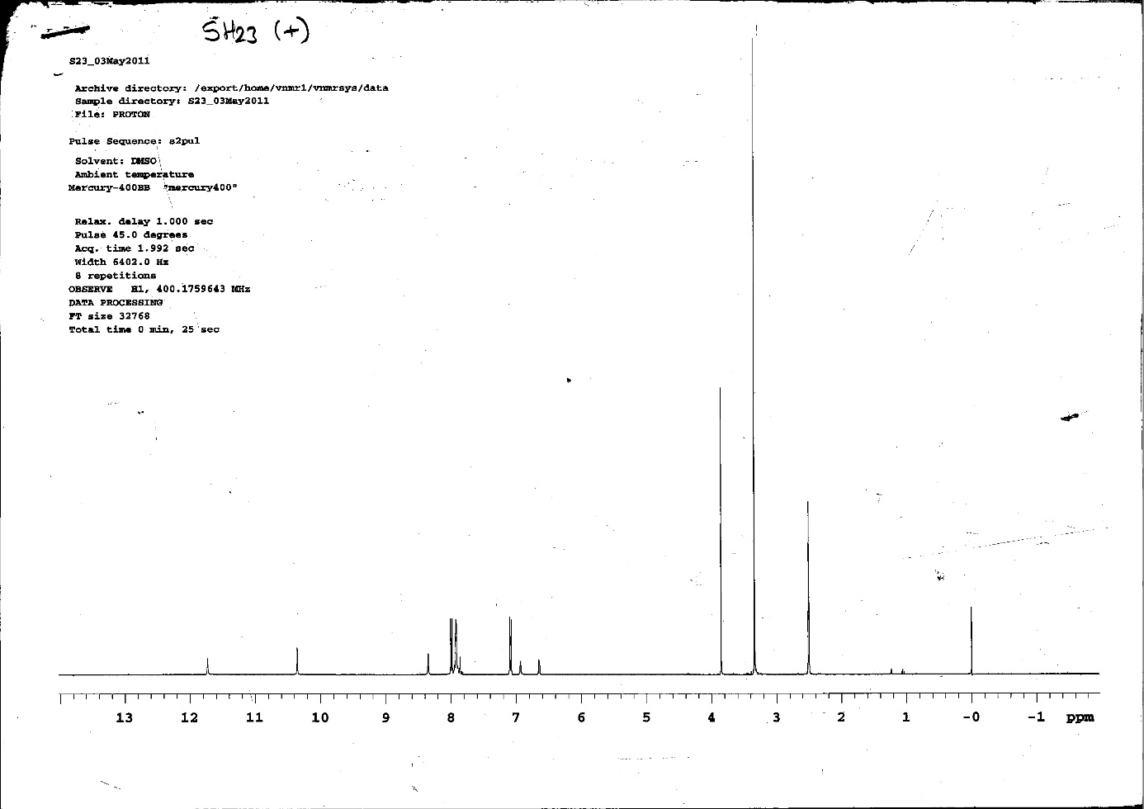
Figure S39: ¹H-NMR spectrum of compound 3q
Figure S40: ¹³C-NMR spectrum of compound 3q
Figure S41: IR spectrum of compound 3s
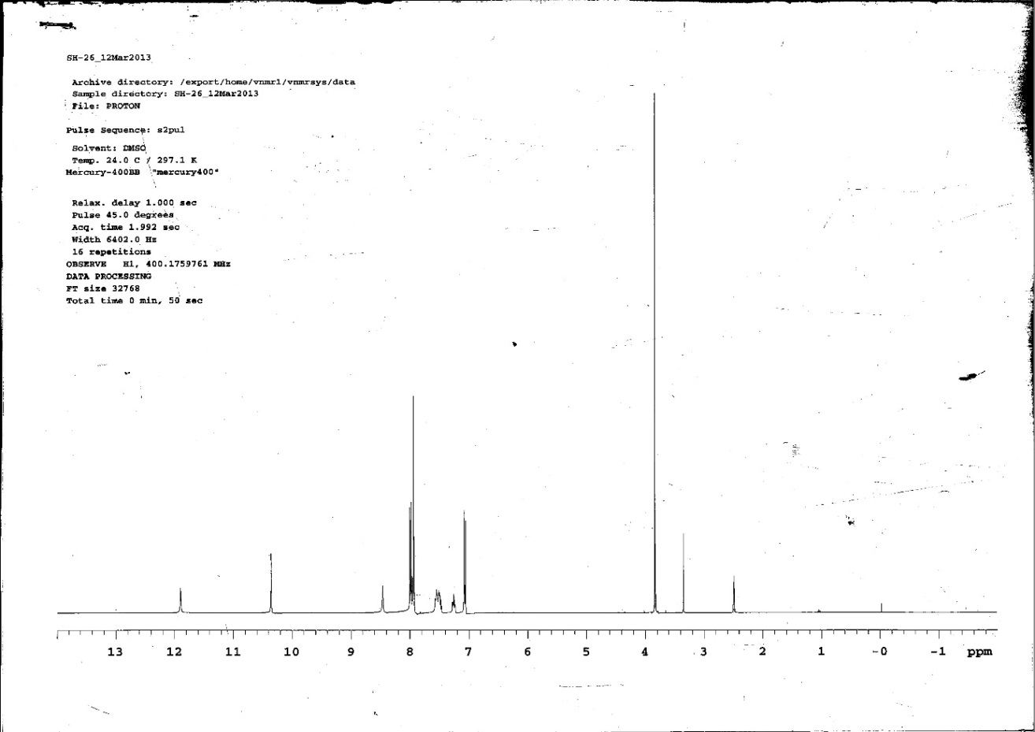
Figure S42: ¹H-NMR spectrum of compound 3s
Figure S43: ¹³C-NMR spectrum of compound 3s
Figure S44: IR spectrum of compound 3t
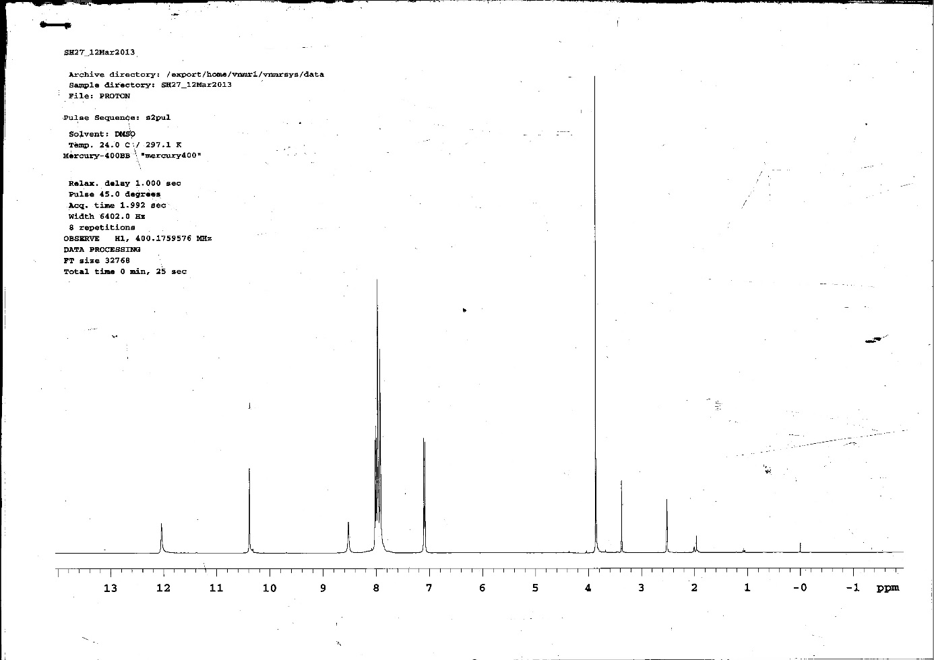
Figure S45: ¹H-NMR spectrum of compound 3t
Figure S46: ¹³C-NMR spectrum of compound 3t

