Synthesis and biological evaluation of some hydrazide-hydrazone derivatives as anticancer agents
Kadriye Akdağ¹, Fatih Tok¹, Sevgi Karakuş^{1,*}, Ömer Erdoğan², Özge Çevik², Bedia Kaymakçıoğlu¹
¹Department of Pharmaceutical Chemistry, Faculty of Pharmacy, Marmara University, 34854, Istanbul, Turkey
²Department of Biochemistry, School of Medicine, Aydin Adnan Menderes University, 09010, Aydın, Turkey
*Corresponding author: E-mail: skarakus@marmara.edu.tr

SUPPORTING INFORMATION PART OF THE CHEMISTRY

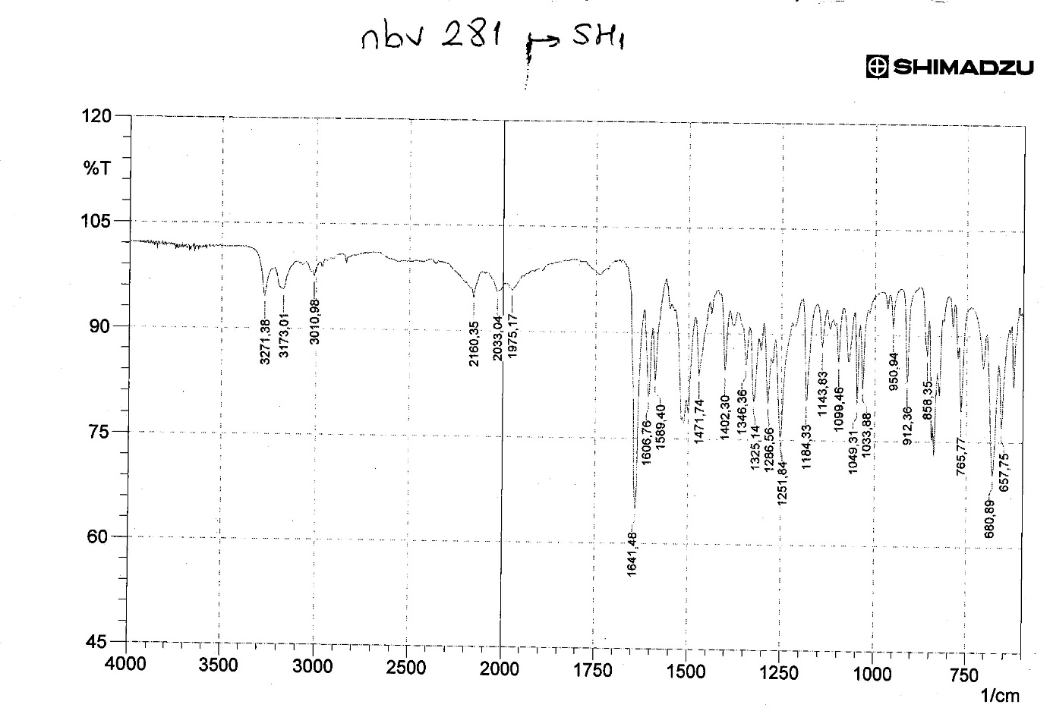
Figure S1: IR spectrum of compound 3a
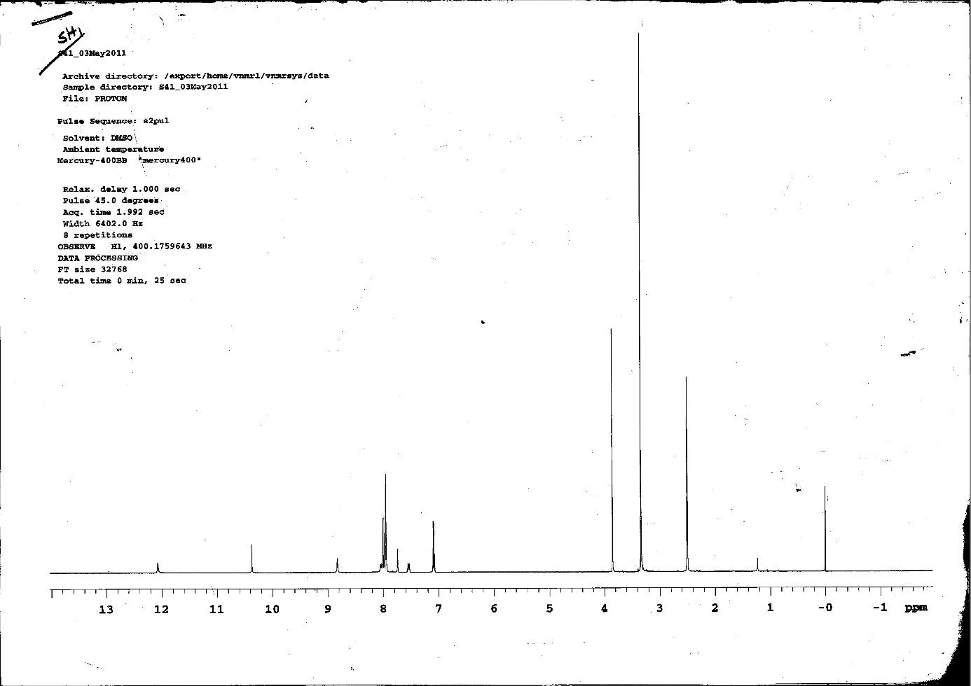
Figure S2: ¹H-NMR spectrum of compound 3a
Figure S3: ¹³C-NMR spectrum of compound 3a
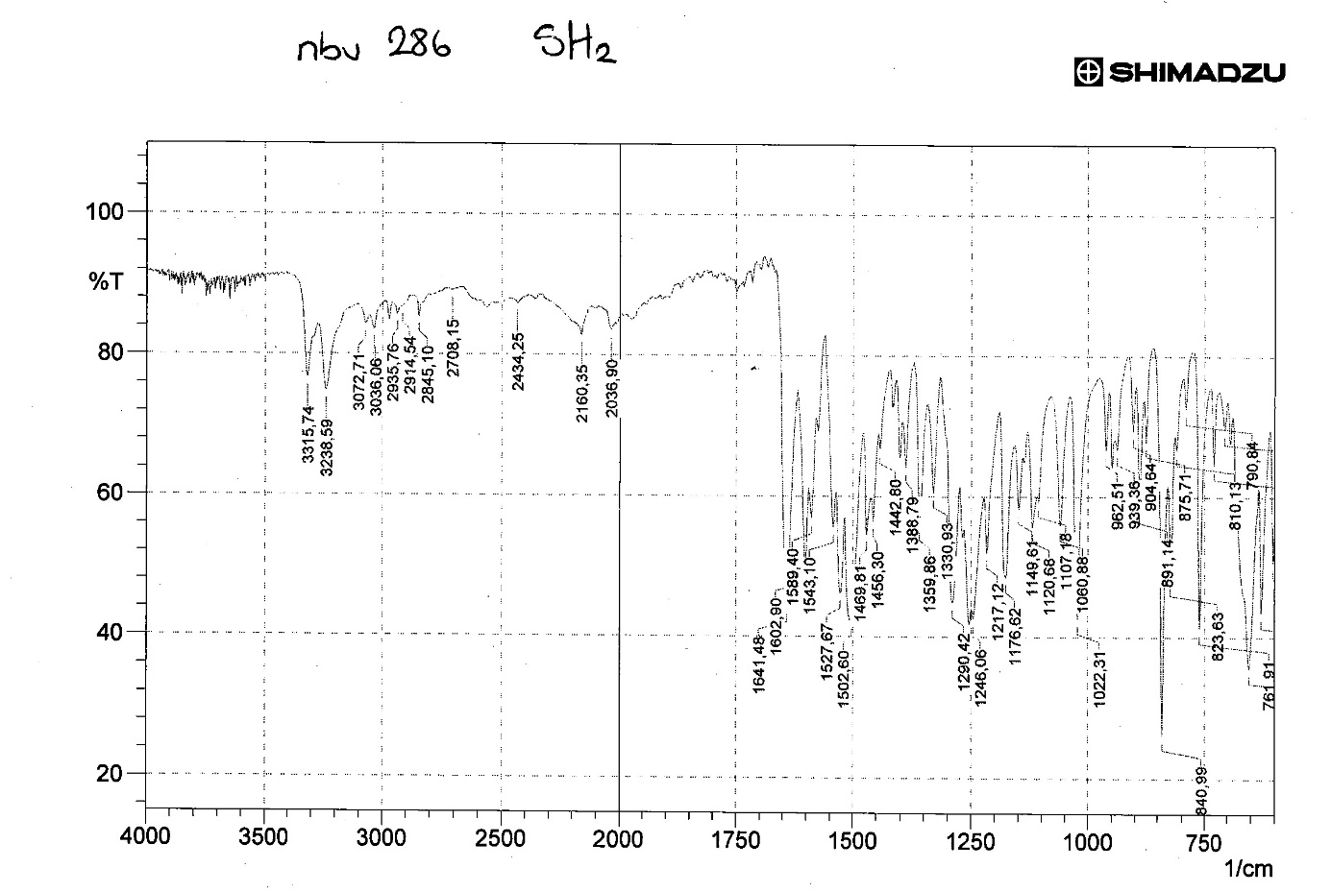
Figure S4: IR spectrum of compound 3b
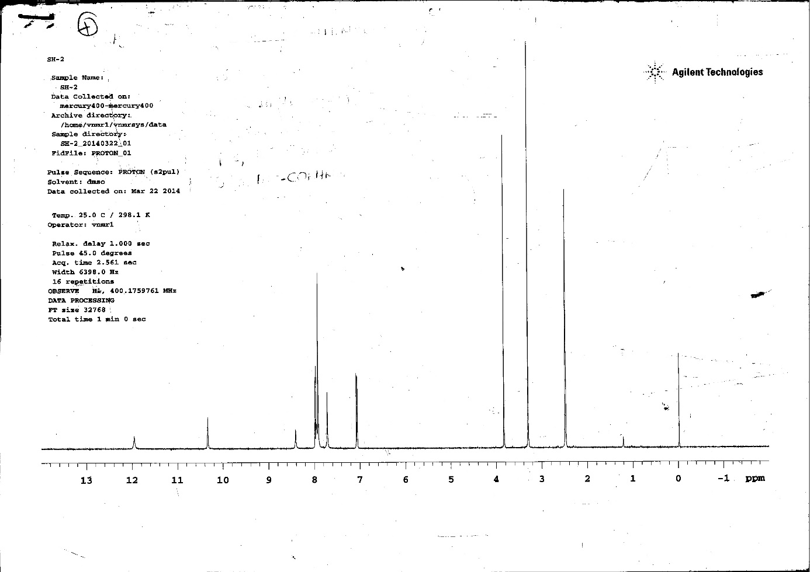
Figure S5: ¹H-NMR spectrum of compound 3b
Figure S6: ¹³C-NMR spectrum of compound 3b
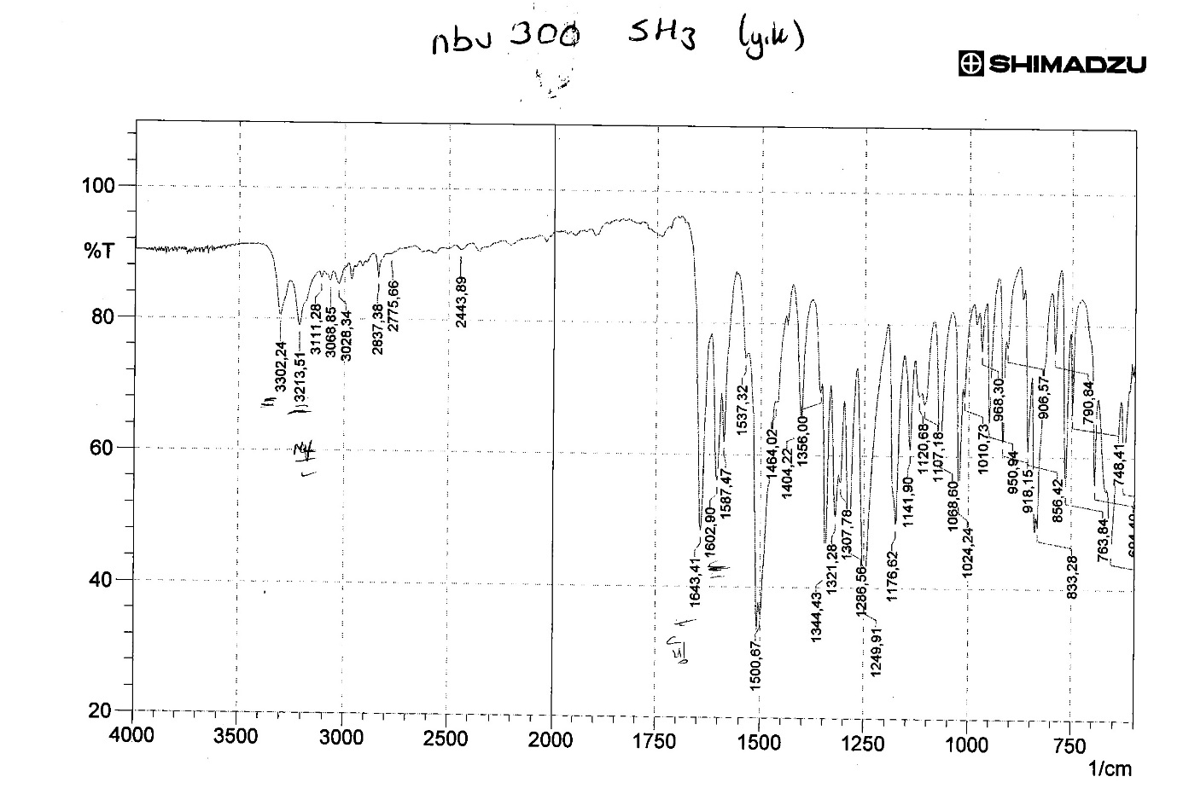
Figure S7: IR spectrum of compound 3c
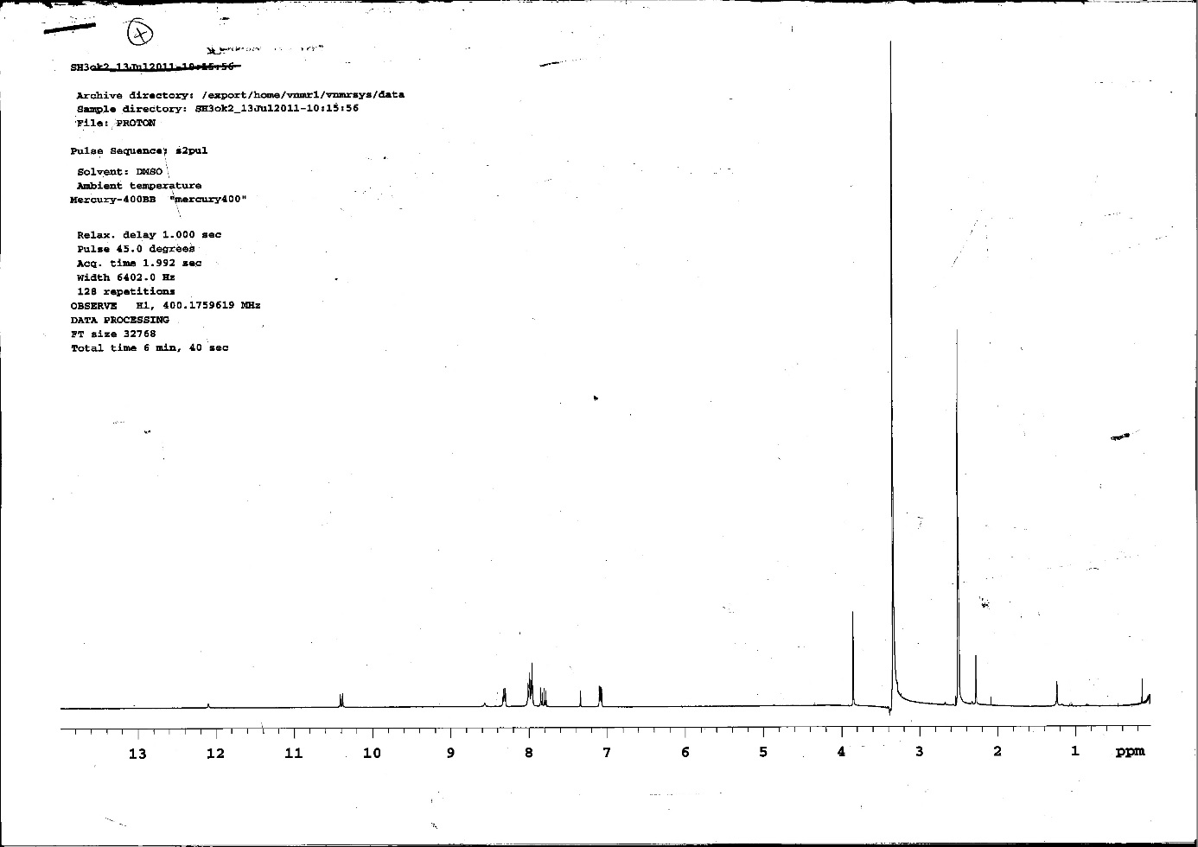
Figure S8: ¹H-NMR spectrum of compound 3c
Figure S9: ¹³C-NMR spectrum of compound 3c
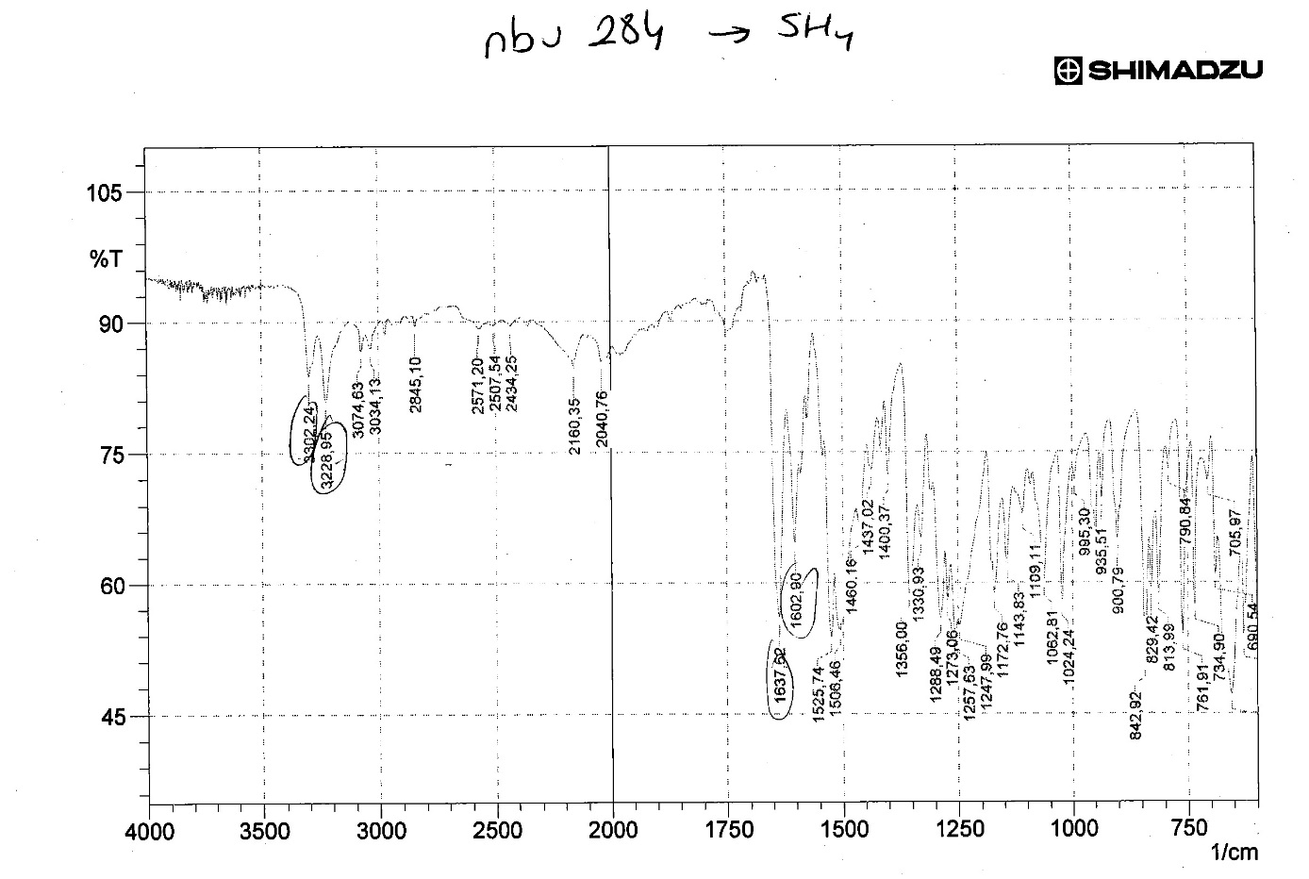
Figure S10: IR spectrum of compound 3d
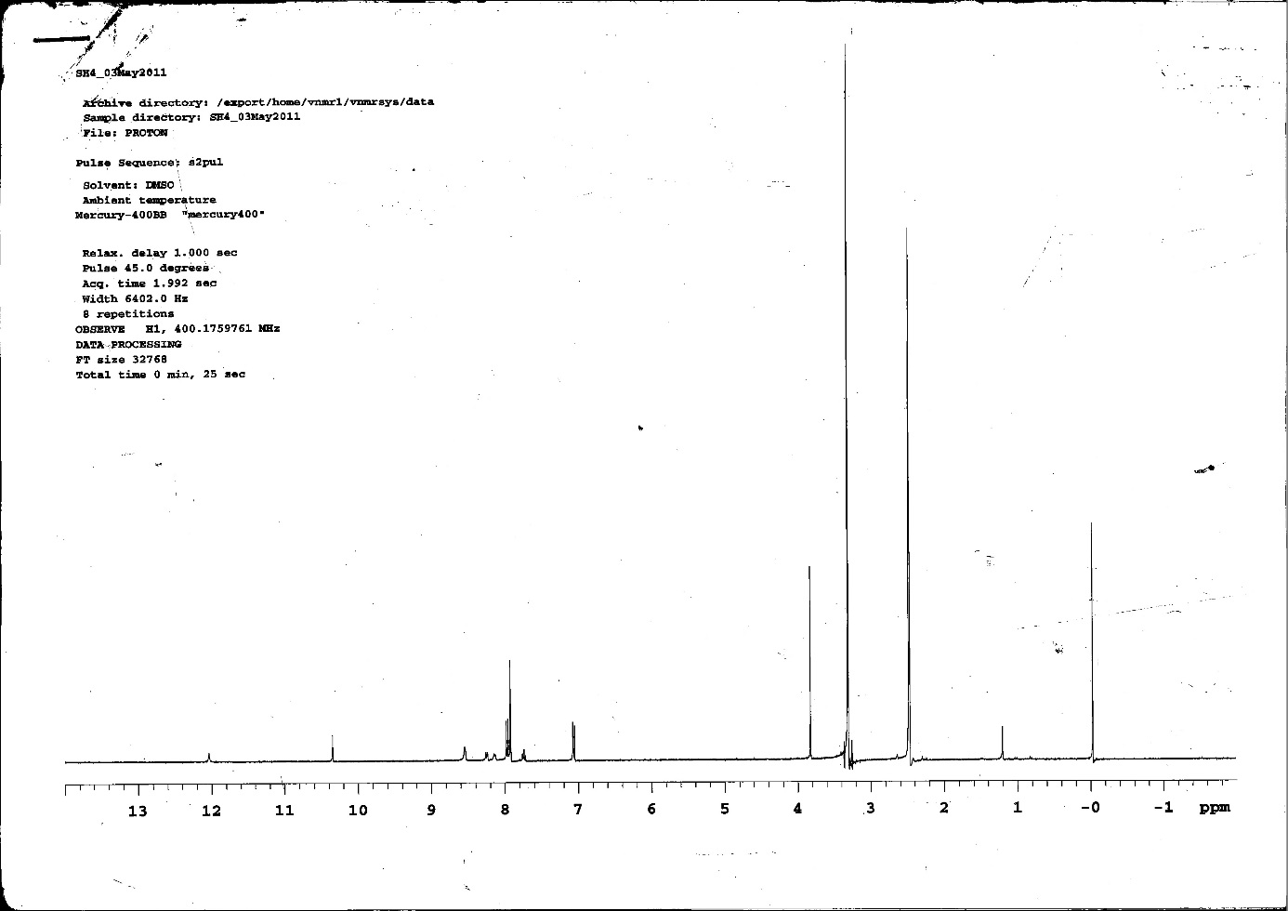
Figure S11: ¹H-NMR spectrum of compound 3d
Figure S12: ¹³C-NMR spectrum of compound 3d
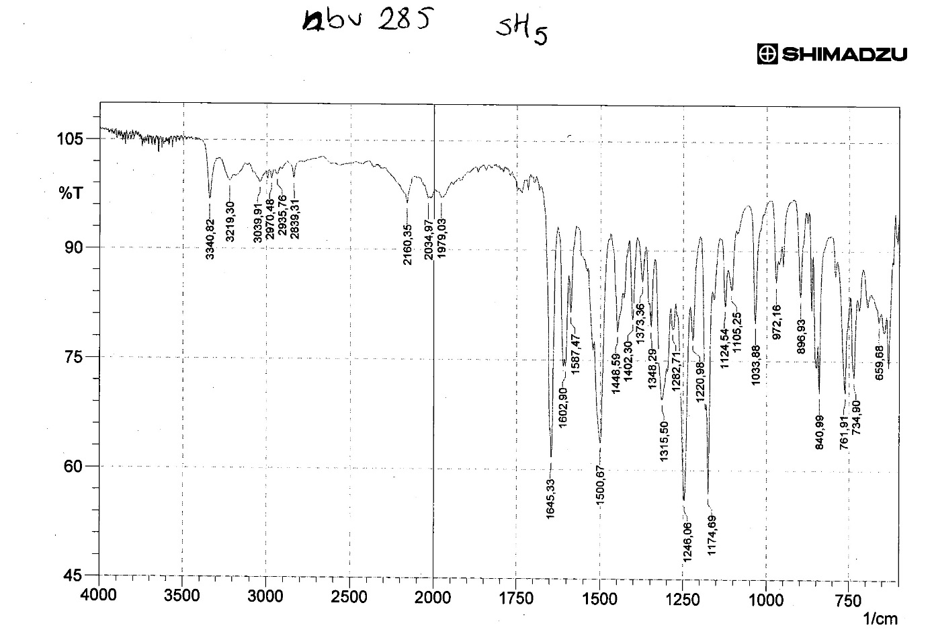
Figure S13: IR spectrum of compound 3e
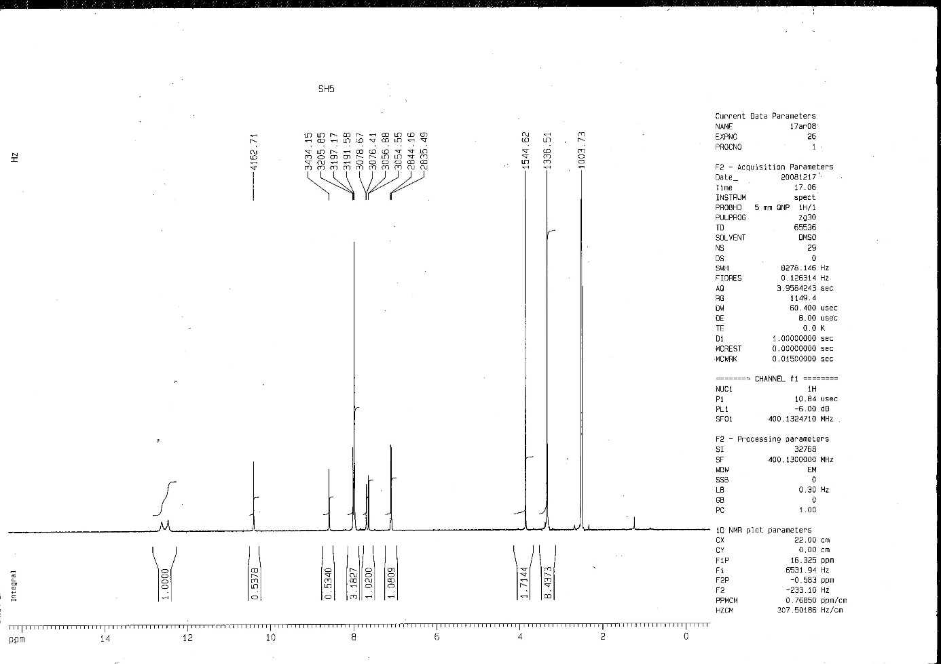
Figure S14: ¹H-NMR spectrum of compound 3e
Figure S15: ¹³C-NMR spectrum of compound 3e
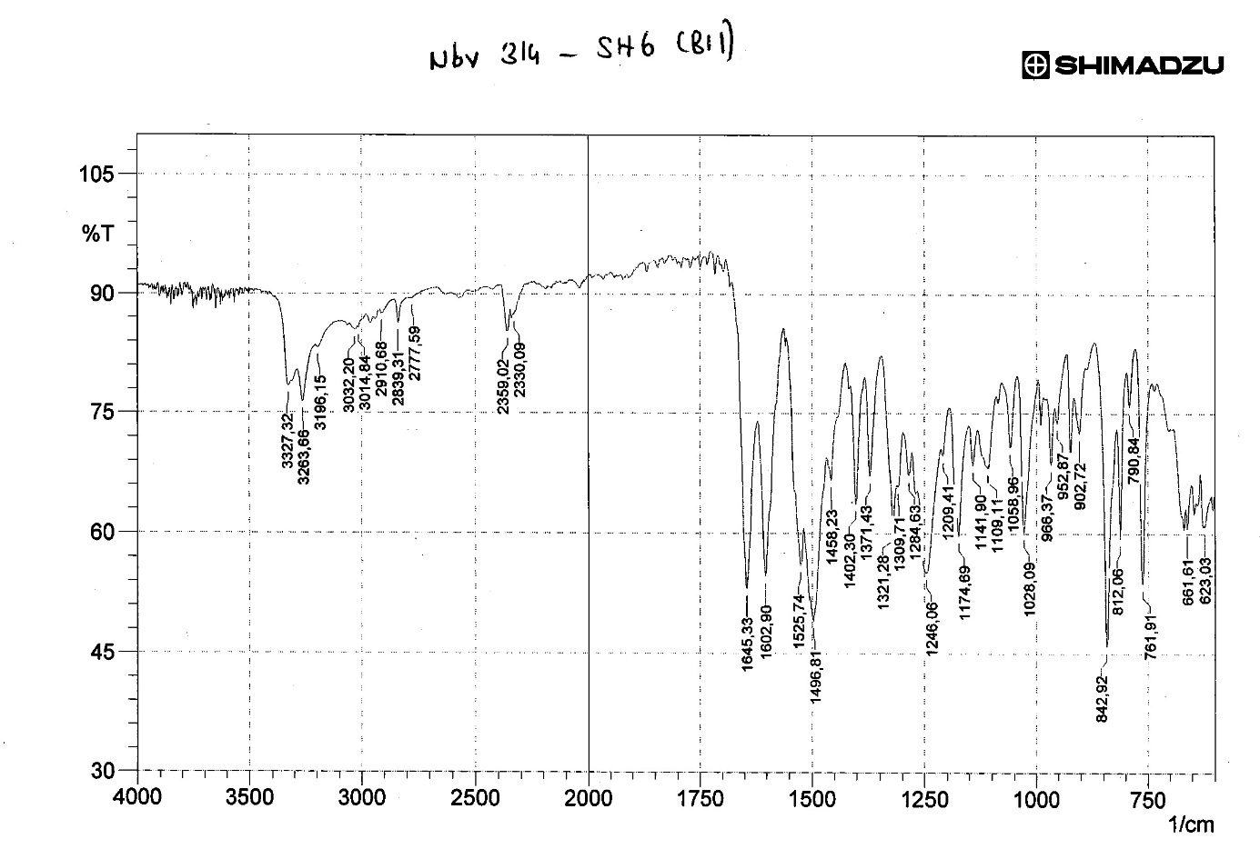
Figure S16: IR spectrum of compound 3f
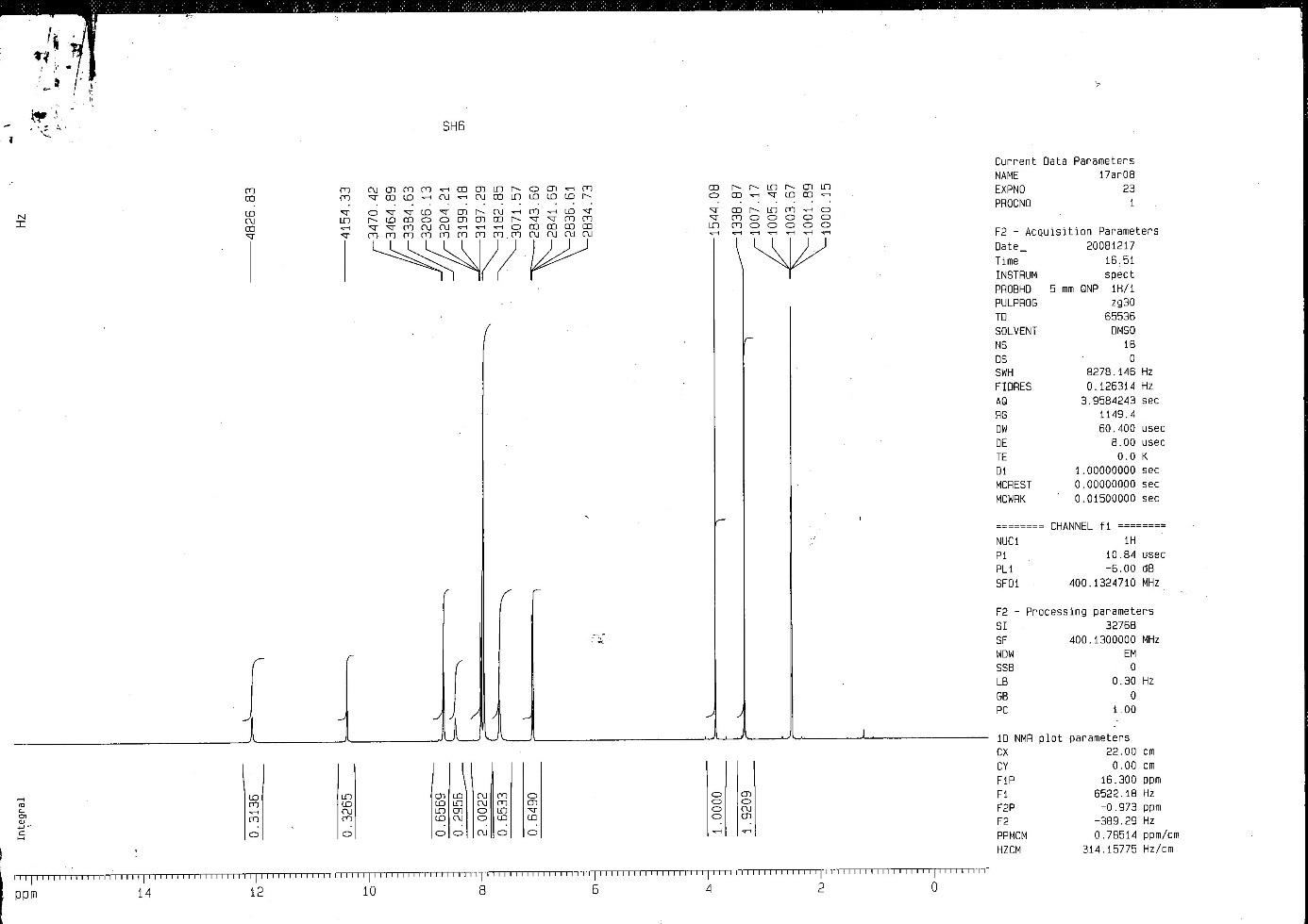
Figure S17: ¹H-NMR spectrum of compound 3f
Figure S18: ¹³C-NMR spectrum of compound 3f
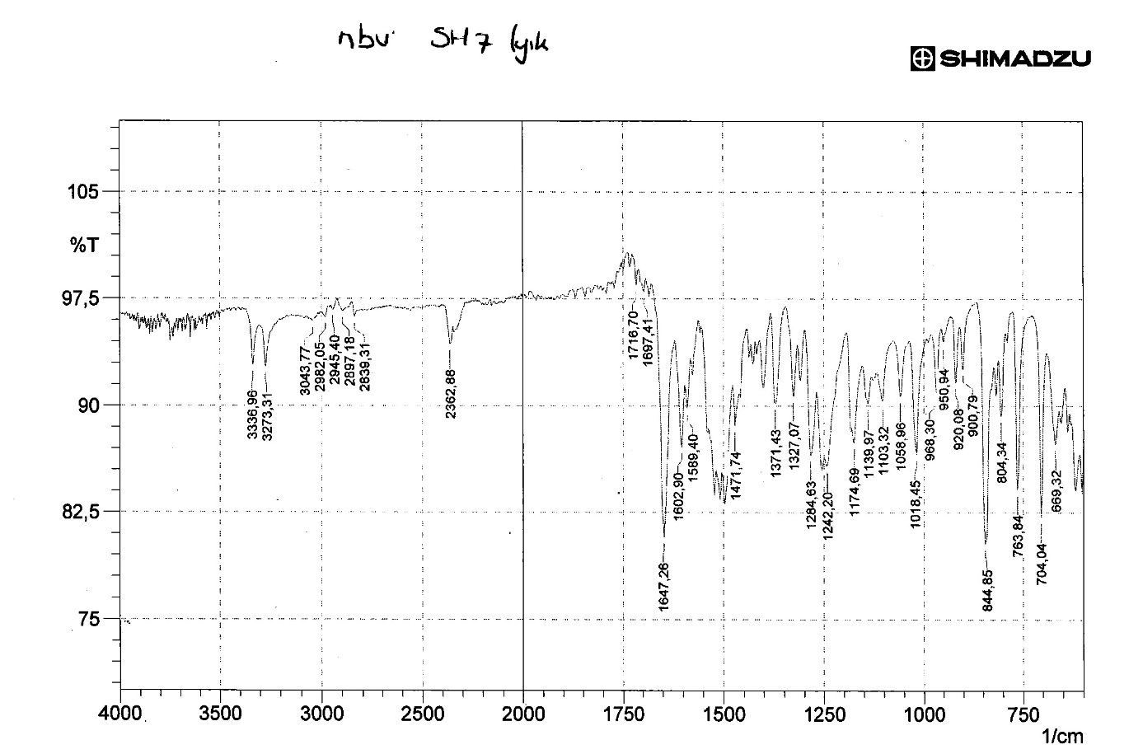
Figure S19: IR spectrum of compound 3g
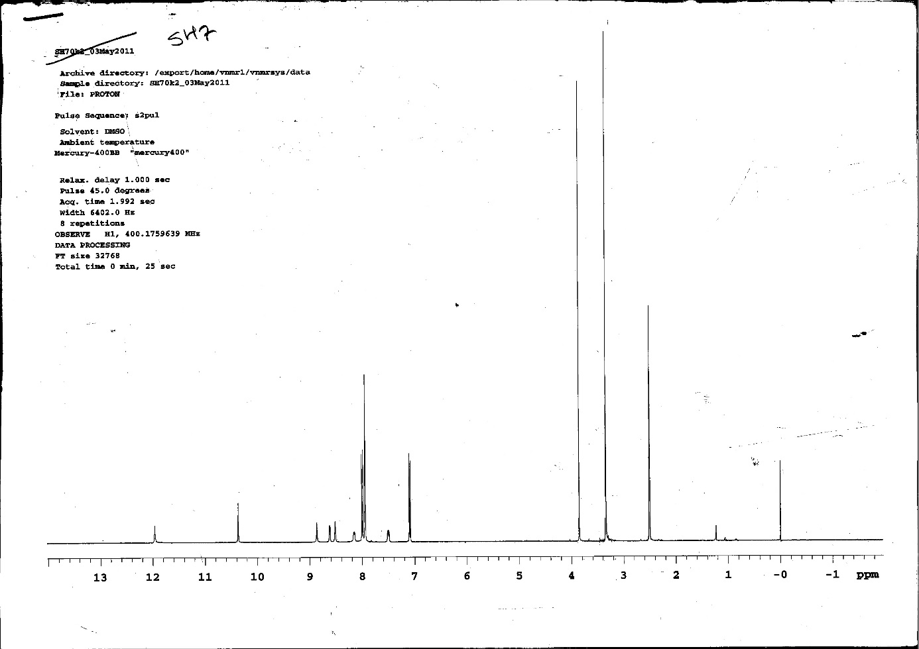
Figure S20: ¹H-NMR spectrum of compound 3g
Figure S21: ¹³C-NMR spectrum of compound 3g
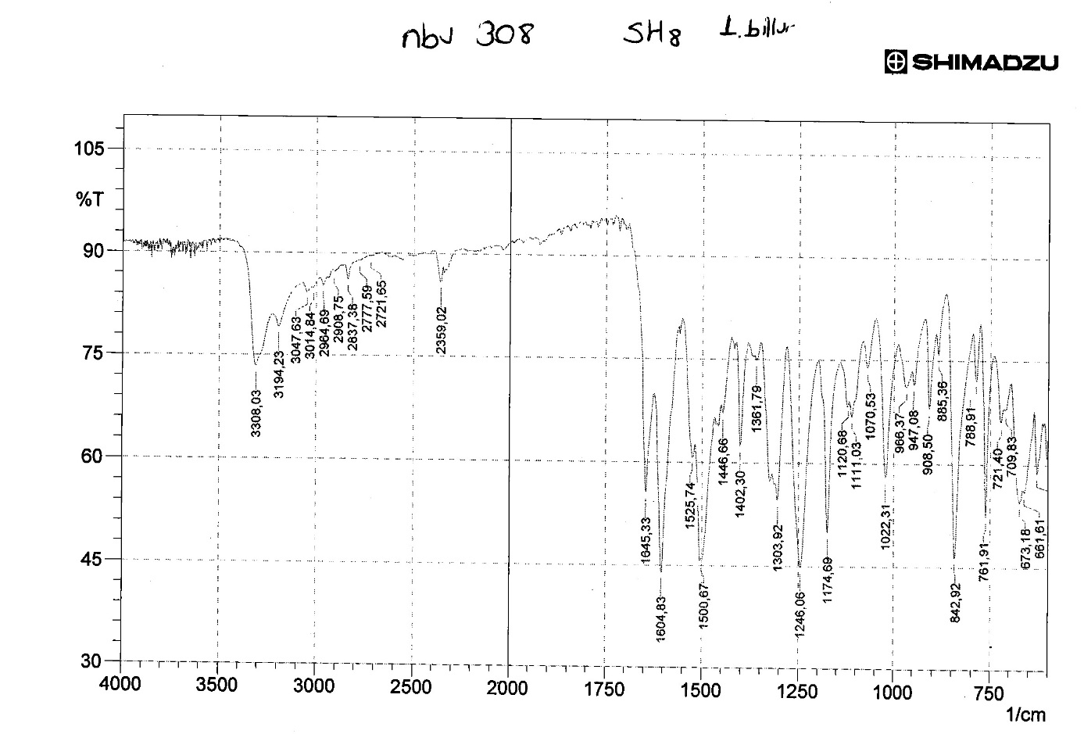
Figure S22: IR spectrum of compound 3h
Figure S23: ¹H-NMR spectrum of compound 3h
Figure S24: ¹³C-NMR spectrum of compound 3h
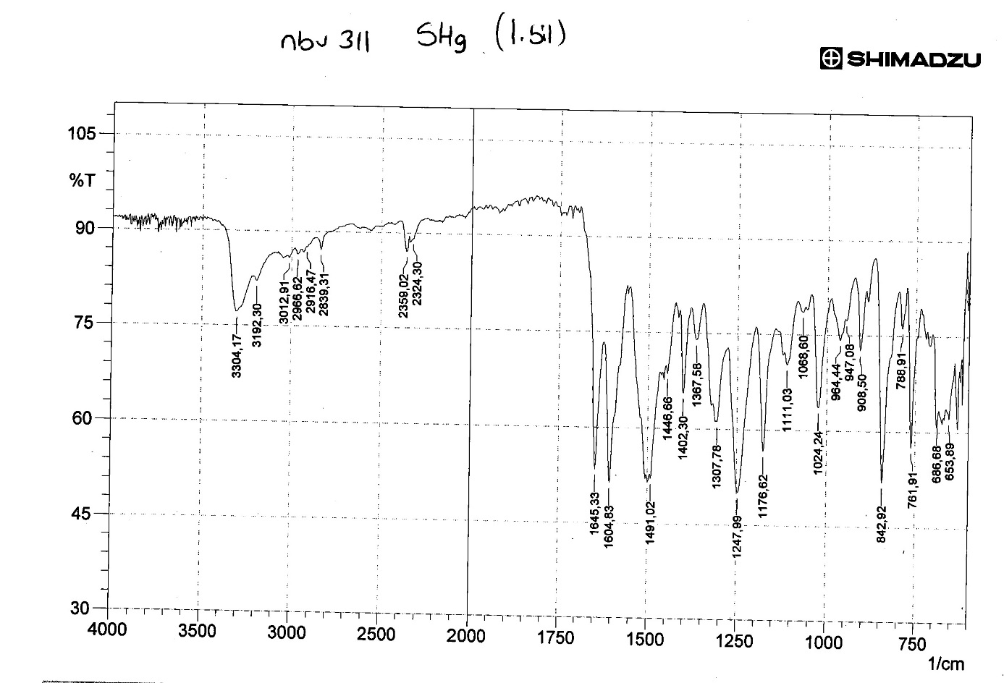
Figure S25: IR spectrum of compound 3i
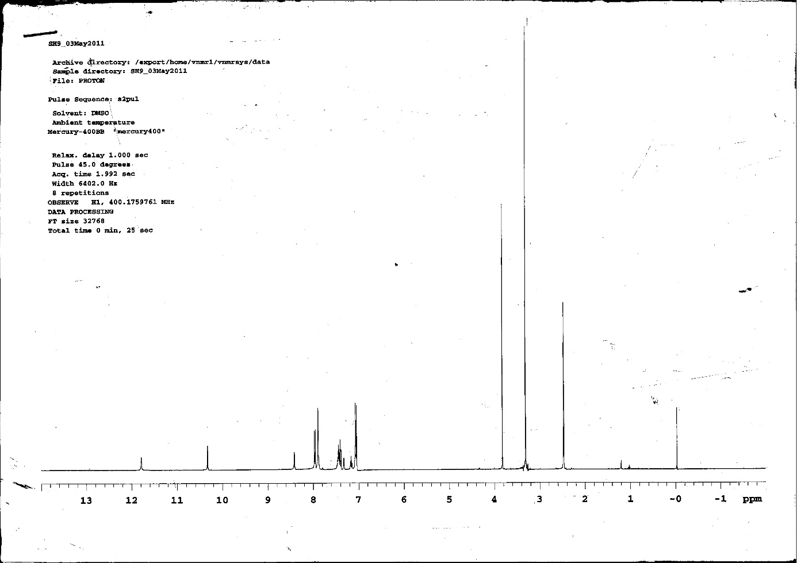
Figure S26: ¹H-NMR spectrum of compound 3i
Figure S27: ¹³C-NMR spectrum of compound 3i
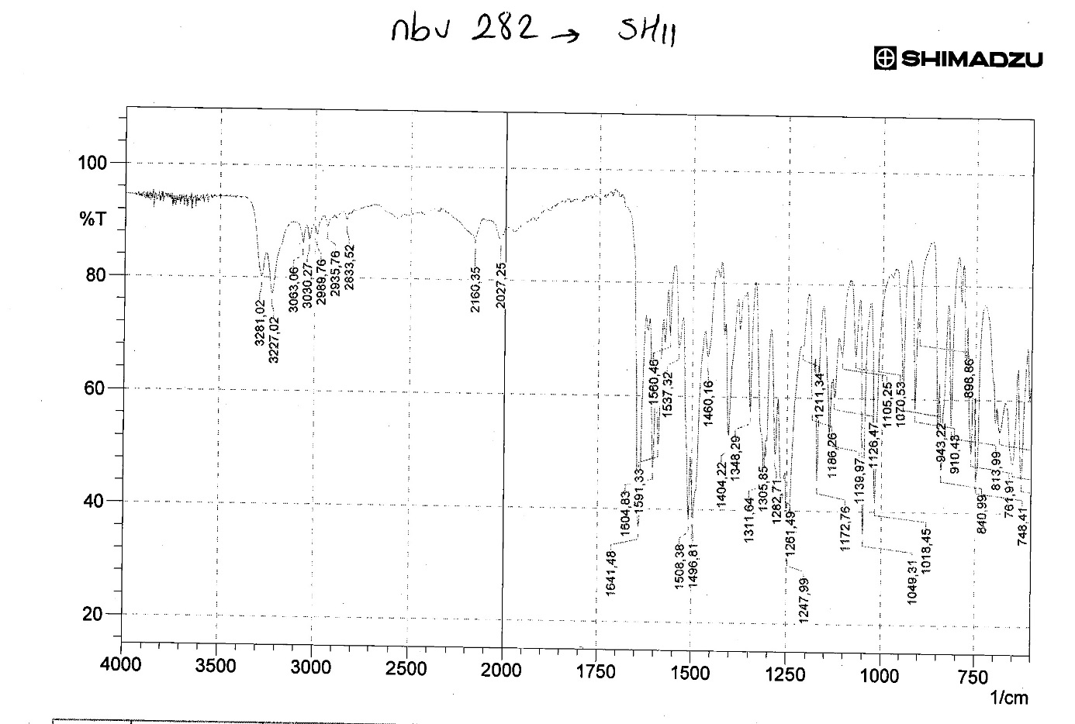
Figure S28: IR spectrum of compound 3k
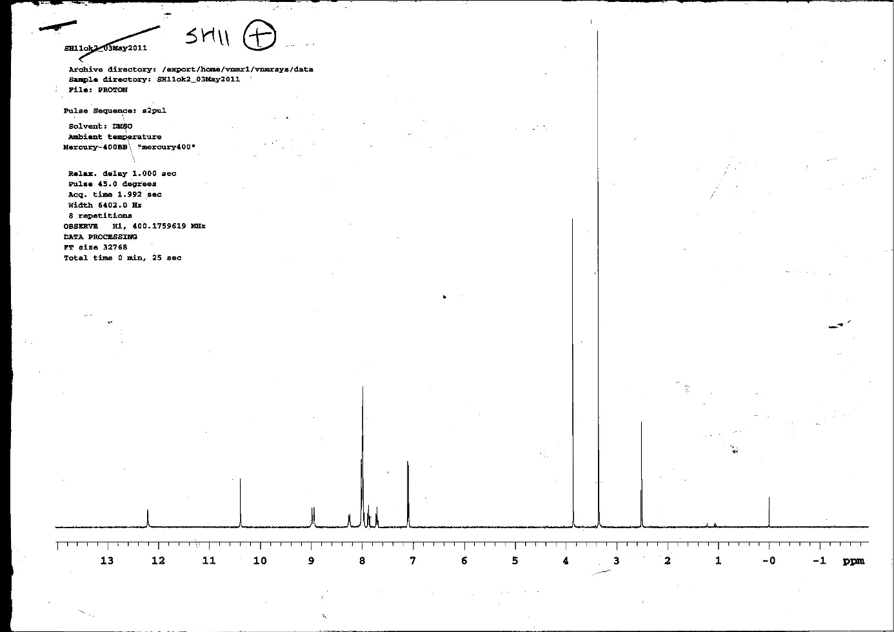
Figure S29: ¹H-NMR spectrum of compound 3k
Figure S30: ¹³C-NMR spectrum of compound 3k
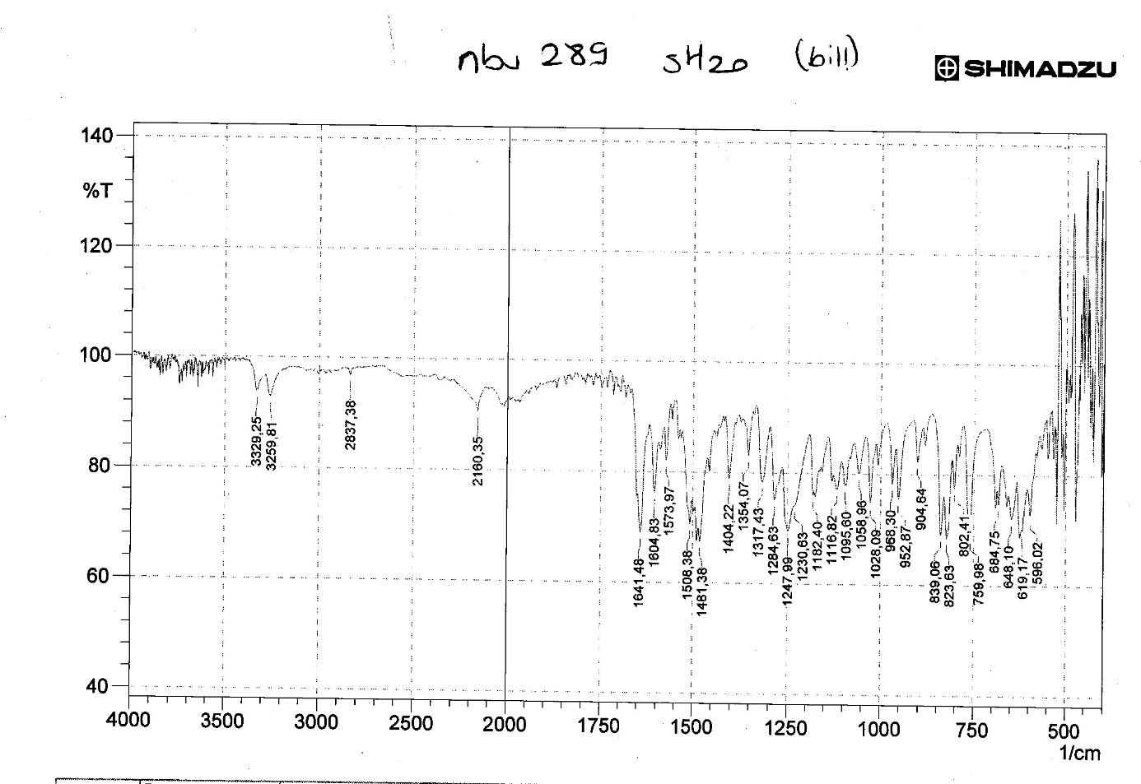
Figure S31: IR spectrum of compound 3o
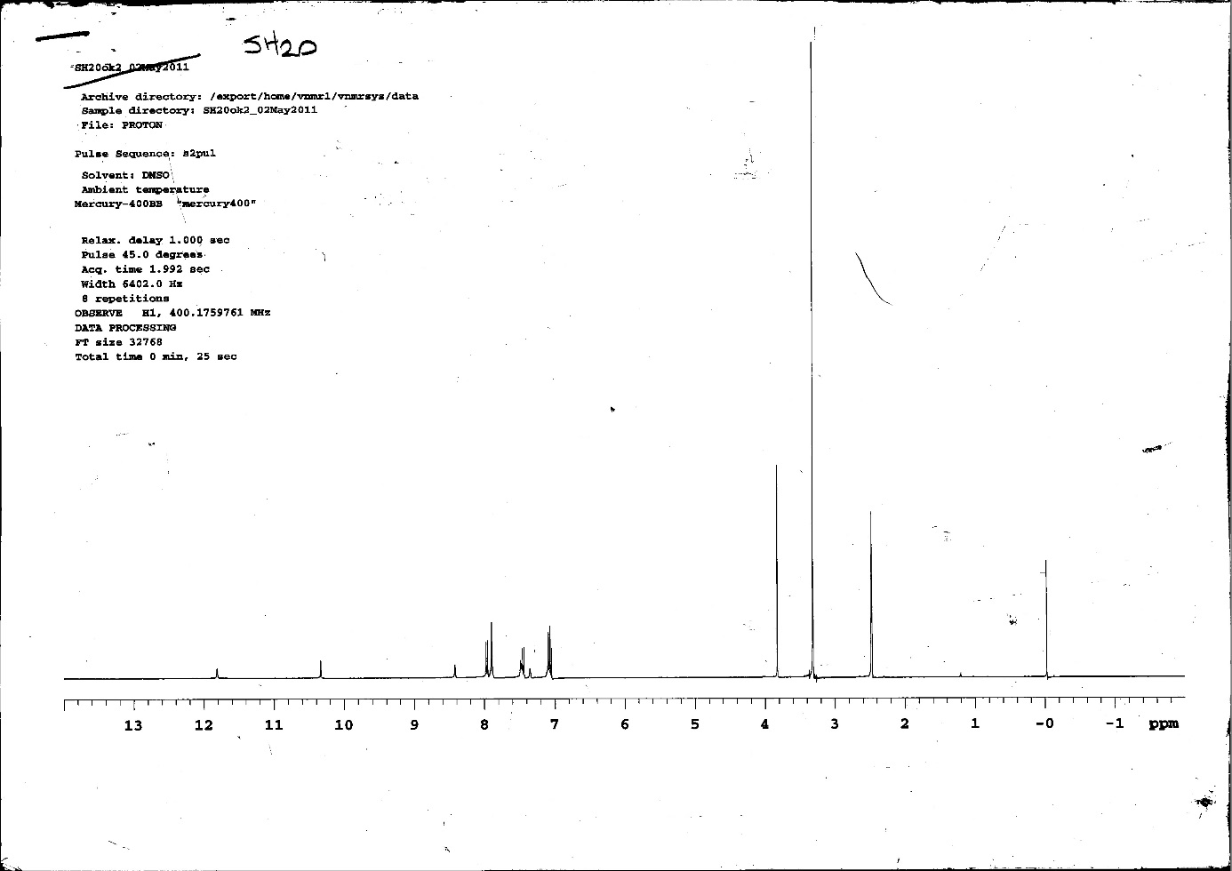
Figure S32: ¹H-NMR spectrum of compound 3o
Figure S33: ¹³C-NMR spectrum of compound 3o
Figure S34: IR spectrum of compound 3p
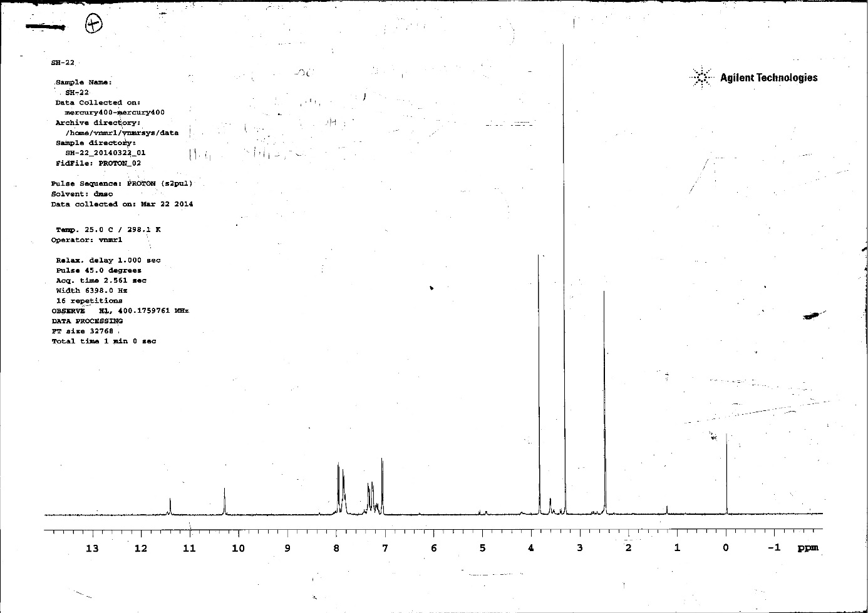
Figure S35: ¹H-NMR spectrum of compound 3p
Figure S36: ¹³C-NMR spectrum of compound 3p
Figure S37: IR spectrum of compound 3q
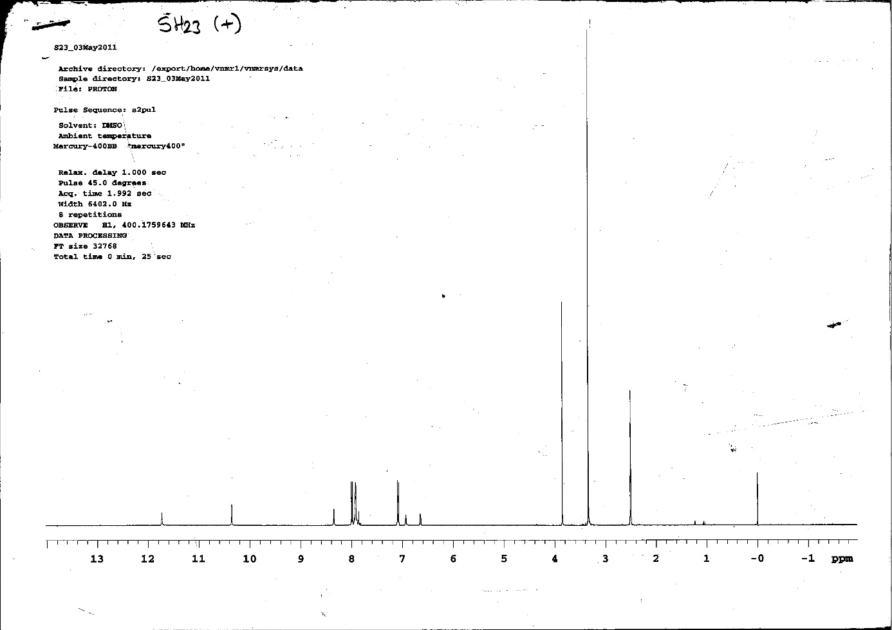
Figure S38: ¹H-NMR spectrum of compound 3q
Figure S39: ¹³C-NMR spectrum of compound 3q
Figure S40: IR spectrum of compound 3s
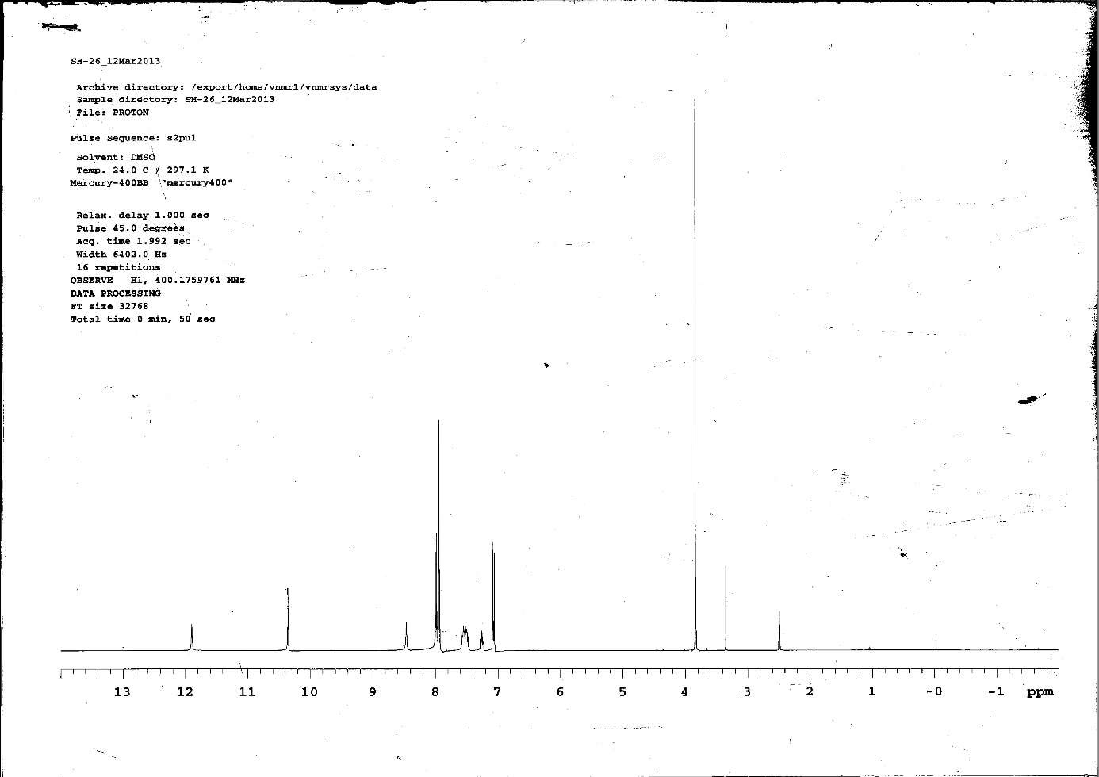
Figure S41: ¹H-NMR spectrum of compound 3s
Figure S42: ¹³C-NMR spectrum of compound 3s
Figure S43: IR spectrum of compound 3t
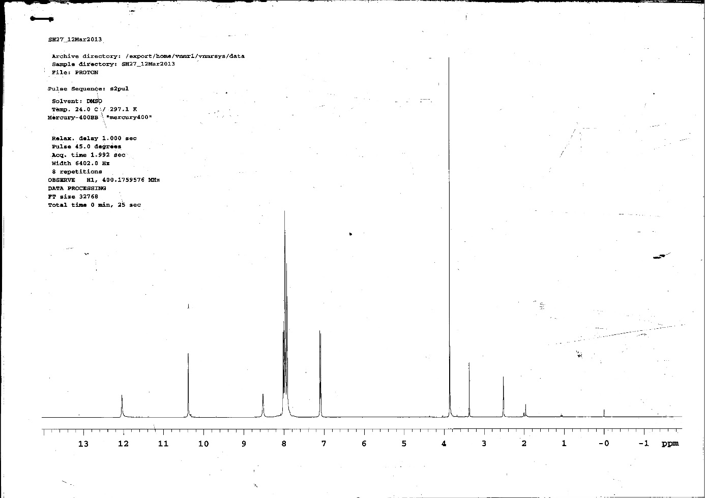
Figure S44: ¹H-NMR spectrum of compound 3t
Figure S45: ¹³C-NMR spectrum of compound 3t

