Hybrid Polymer Composite of Prussian Red Doped Polythiophene for
Adsorptive Waste Water Treatment Application

Mohd Mustafa¹, Shabnum Bashir¹, Syed Kazim Moosvi², Mohd. Hanief Najar³, Mubashir Hussain Masoodi⁴ * Masood Ahmad Rizvi¹*

1Department of Chemistry, University of Kashmir, Hazratbal Srinagar, 190006, J&K, India.

2Department of School Education, Government of Jammu and Kashmir, Srinagar, Jammu and Kashmir, India.

3Department of Chemistry, Government College of Engineering & Technology, Safapora 193504, Jammu and Kashmir, India.

4Department of Pharamaceutical Sciences, University of Kashmir, Hazratbal Srinagar, 190006, J&K, India.

E-mail: masoodku2@gmail.com, mubashir@kashmiruniversity.ac.in

Abstract: Coordination compounds as dopants to pristine conducting polymer matrix can be a promising systems for adsorption and photocatalytic applications.This inorganic-organic hybrid composites complement the desirable properties of the individual components for a synergistic effect towards degradation of environmental contaminants. Prussian red (PR) as an iron (III) coordination compound was used as a dopant for the polythiophene (PTP) matrix to explore its propensity as water treatment composite material .Upon PR doping improvements in the mechano, thermal, electrical, and photocatalytic descriptors of pure PTP was observed. The physicochemical and structural characteristics of synthesized PTP/PR composite were determined using Brunauer–Emmett–Teller (BET), powder X-ray diffraction,TEM,TGA, FT-IR, and UV-visible spectroscopic techniques. Detailed optimization of adsorption process conditions, kinetic ,thermodynamic and adsorbent regeneration studies were carried out using malachite green1 (MG) dye as model waste water system. The observed results indicate 92% adsorption for MG by PTP/PR nanocomposite in 20 minutes at pH 7.Besides the experimental samples, PTP/PR nanocomposite also demonstrated a complimentary performance with real wastewater samples. Thermodynamic investigations indicated that the process was spontaneous with electrostatic attraction as the predominant non-covalent interaction involved in the adsorption process. This study thus presents a strategy for designing high-performance water treatment adsorbents utilizing synergism of adsorption and photocatalysis
Keywords:Adsorption;Malachite Green; Prussian red; Hybrid Material, Nyquist plot; Kinetics; Isotherms
1.Introduction
Water is the most significant substance for living beings, water scarcity is a global problem,and contamination further adds to it.Persistent contaminants from industrial effluents, domestic sewage, and agricultural practices make water unsafe to the aquatic ecosystem as well as human life.^{1,2}Dyes as coloring agents have many applications,limiting their usage is practically impossible, and their eventual disperse in the waste water/ environment is inevitable. Synthetic dyes as water contaminants pose toxicity risks as well as aesthetic concerns. Malachite green is a triaryl methane cationic dye commonly used in pharmaceutics, paper, textile and printing industries.³ Many treatment methods based on ozonation,nano-filtration,reverse osmosis,flocculation,
electrochemical,photocatalytic and advanced oxidation processes are in vogue for discoloration of waste water.⁴ Among water treatment methods such as advanced -oxidation, filtration, flocculation, coagulation and microbial degradation,^{5,6} adsorption based methods are more interesting environmentally.This is because of their simplicity, non invasive reactions, adaptability to environmental conditions,broader scale applicability,no treatment byproducts,lower operational cost and recyclability.^{7,8} Consequently, adsorption based methods are still desirable for safer and effective wastewater treatment application.
Designing adsorbents with high adsorption capacity and selectivity is a major concern for effective adsorption processes. Natural adsorbents , although pleasing, have
limitations of selectivity and lesser adsorption capacity.⁹ Synthetic adsorbents can be desirably tuned as per demand and show improved results under controlled conditions such as in sewage treatment plants. Among synthetic adsorbents, conducting polymers(CP) are attractive for adsorptive removal because of their charge distribution over the entire polymeric surface generating many adsorption sites. CPs are significantly influenced in shape, porosity, charge separation etc by doping with suitable dopant. A well engineered conducting polymer composite can desirably improve the adsorption capacity of the pristine conducting polymer.¹⁰ PR was selected as a dopant with the rationale of its good crystallinity, stability over environmental pH range, high charge density,
moderate paramagnetism, redox and light responsive nature with relatively lower toxicity.¹¹Thus in continuation of our interests in applications of transition metal complexes¹²⁻¹⁶,especially as photocatalysts in organic synthesis,^{17,18} and as dopants in conducting polymers for electrical and environmental applications¹⁹-²¹, herein we envisaged the effect of Prussian red ( PR) as a transition metal complex dopant to the polythiophene conducting
polymer matrix. We synthesized polythiophene (PTP)
Prussian red (PR) nanocomposite PTP/PR to envisage the effect of this versatile dopant on its polymer properties. The effect of PR dopant on the polymer properties indicated an enhancement in the mechano, thermal, electrochemical
and photocatalytic descriptors of pure PTP. The comparative studies of PR doping to PTP, relative to other organic dopants, revealed an increased surface area, electrical conductivity, charge separation dynamics, and
electrochemical stability desirable for sensing, photocatalytic activity and device fabrication. The observed
physicochemical properties of synthesized PTP/PR nanocomposite proposed its suitability as material for environmental applications, which were modelled using malachite green (MG) dye adsorption in aqueous phase. PTP/PR nanocomposite displayed significant adsorptive tendency towards decoloration of samples having upto 100ppm of MG dye concentration under environmental conditions (pH 6-7).The effect of adsorbent dose, dye concentration, temperature, adsorption time and pH effect were optimized for its possible usage in water treatment plants. The observed data of MG adsorption over PTP/PR nanocomposite was analyzed for adsorption parameters such as: kinetics, adsorption isotherms and thermodynamics.PTP/PR signified good propensity as hybrid material towards adsorptive handle of water treatment. Further development of PTP/PR nanocomposite
for a wider water treatment application via synergistic
adsorptive and photocatalytic elimination of persistent water contaminants is underway in our laboratory.
2. Experimental
2.1.Materials
All the reagents used in the study were of analytical grade and procured from Himedia and Merck India.Thiophene was distilled prior to its use. Malachite green (MG),Potassium ferricyanide and anhydrous Ferric chloride were purchased from Merck India. Potassium ferricyanide was ground by ball milling for size reduction to nano dimension (<10nm).

2.2. Synthesis of nanocomposite
The synthesis of PTP/PR nanocomposite was carried out via oxidative polymerization using FeCl3 as oxidant in a non-aqueous medium.²¹In the optimized synthetic procedure, 180 mL of 0.055M FeCl3 solution in chloroform solvent were added (dropwise) to a magnetically stirred solution of 0.022M distilled thiophene monomer(in 70 mL of chloroform).The reaction mixture contained about 1g of ground PR dopant (Scheme1).The polymerization reaction mixture was continuously stirred for 24 h, followed by filtering and washing the product several times with methanol to remove any oligomers and unreacted impurities.After repeated acetone washings and room temperature drying, the polymer composite as a brown powder was taken for structural characterization.

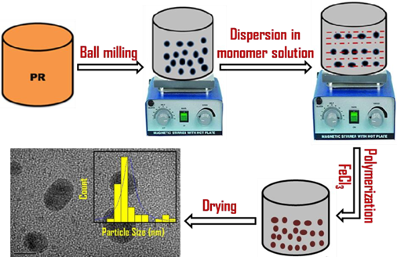

Scheme1.Schematic depiction of PTP/PR nanocomposite synthesis via FeCl₃ oxidative polymerization.

2.3.Measurements
The characterization of the synthesized composite was done using appropriate analytical methods and spectroscopic techniques. Infrared spectra were obtained over a Bruker Alpha FTIR spectrophotometer in the range 4000-500 cm⁻¹. The structural characterization of samples was performed by the powder X-ray diffraction (PXRD) method using a PW 3050 diffractometer (CuKα radiations, λ = 1.5418 Å). The particle shape and size of PTP/PR nanocomposite was analyzed using transmission electron microscopy (TEM) measurements performed on Hitachi SU 8000 microscope at an accelerating voltage of 30 kV. For TEM studies, the samples were prepared by spin-casting a THF solution of PTP/PR nanocomposite (3 mg/L) on copper grids with carbon coating. The thermo-gravimetric analysis (TGA) of samples was performed on a SEIKO TG/DTA6200 instrument.Thermal analysis was done from room temperature to 800°C at a heating rate of 10°C min⁻¹ under nitrogen environment.Adsorption measurements were performed using Double Beam Microprocessor UV-VIS Spectrophotometer (Model: LI-2802).Zeta Potential (surface charge) of the adsorbent particles were determined using a Anton Par Particle Size Analyser (Model:Litesizer 500).BET studies for surface area were attained at 77K using BET instrument, Quantachrome Austosorb IQ Station.The specific surface
area and pore size distribution was calculated using a multiple point BET method and non-local density function-
al theory (NLDFT) equilibrium model .Electrochemical
experiments were carried out on Bio-Logic SAS Potentiostat (Model SP 150) using three-electrode system.
2.4. Adsorption experiments
For adsorption studies, 20mg of PTP/PR nanocomposite was added to a 30 mL solution of 10ppm MG dye and the suspension was magnetically stirred. Under the optimized reaction conditions, at the regular time intervals aliquots were taken , the adsorbent was separated via centrifugation at 4000 rpm for 20 min and the left over concentration of dye in the supernatant was measured by a UV–visible spectrophotometer at λ=617nm(corresponding to MG dye). The adsorptive capacity of PTP/PR hybrid material was optimized under different influencing parameters like, adsorbent dose,contact time and initial MG dye concentration and temperature range of 25-45⁰C. The equations 1, 2 were used to calculate adsorption capacity of PTP/PR nanocomposite and % dye removal efficiency.²²
Adsorption capacity $q=\frac{C_{0}-C_{t}}{m} V$ $q=\frac{C_{0}-C_{t}}{m} V$ $q=\frac{C_{0}-C_{t}}{m} V$ (1)
$\% Removal= \frac{C_{0}-C_{t}}{C_{0}}100$(2)
where, C₀ and C_{t} (mg/L) are the initial and final (after adsorption) concentrations of MG dye solution respectively, m(g) is the weight of PTP/PR nanocomposite, and V (L) is the initial volume of dye solution.
2.5.Adsorption studies of M.G dye in Real water samples
To test the adsorption efficiency of PTH/PR in real samples, the analysis was performed on collected industrial effluent from local textile dye shop (Hazratbal, Srinagar). The dye sample of (1 mg/mL) concentration was prepared in100mL deionised water to which required quantities of fixing agent and mordant were also added.To 30mL of this prepared dye solution 20mg of PTP/PR composite was added, samples were magnetically stirred and subjected for left over MG dye estimation over different time intervals using UV-visible spectrophotometry.Furthermore, analysis of M.G dye adsorption propensity of samples prepared in different water samples (Tap water and deionised water) was also explored under optimized conditions for comparative studies.
2.6.Cyclic voltammetry experiments
The electrochemical experiments were carried out using three electrode system with Ag/AgCl as reference electrode, glassy carbon electrode as a working electrode, and platinum wire as a counter electrode with 0.1M KNO₃ as supporting electrolyte. The solid samples of PTP/PR and PR each were dispersed in 0.5mL ethanol solution to which 15μL of nafion was added as binder. The suspensions were kept on ultrasonication for about 30 min to make the slurries of each suspension. The obtained slurries were drop-casted onto glassy carbon electrodes and left for open air drying for 40 min.
3. Results and Discussion
A planned dopant to the polymer matrix can generate composites with unique properties for aimed applications. PR turned out to be one such interesting dopant to the polythiophene matrix in terms of modulating essential parameters of a polymer composite system for potential applications. These include enhancement in the mechano, thermal, electrochemical and photocatalytic attributes of pure PTP. The comparative studies of PR doping to PTP relative to organic dopants revealed an increased surface area, conductivity and electrochemical stability desirable for electrochemical sensing and device fabrication. The shifting of band gap towards visible region and prevention of charge carrier recombination after PR doping are important attributes for its development as photocatalyst.
3.1. Characterization analysis
3.1.1 IR spectral analysis
The FT-IR spectra of synthesized composite were compared with pure reactant forms and are as shown in Figure 1. The broad band around 1630cm⁻¹ and 3300-3400cm⁻¹ is attributed to O-H stretching vibration of adsorbed water on PTP surface, and the range of 600- 1500 cm⁻¹ reflects the fingerprint region of PTP.^{23,24}Furthermore,the C-S stretching vibration of PTP and C-H out of plane deformation modes are designated by weak absorption bands around 690-1300cm^{-1.} From the figure1, the black line corresponding to pure PR shows a specific absorption band around 2100cm⁻¹ that designates CN stretching and the peak at around 600 cm⁻¹ is due to Fe-CN vibrations.Moreover,the PTP/PR nanocomposite spectrum exhibits peaks from both the constituents (green line).The intensity of pure PR vibrations are shifted and observed at 2078cm⁻¹ and 497cm⁻¹ in the nanocomposite FT-IR spectrum.In addition, shifting of major stretching frequencies of PTP and PR in nanocomposite depicts the inclusion of PR particles in PTP matrix
3.1.2. Thermal Analysis
Thermal stability is an essential parameter for material applications, and thermo-gravimetric analysis (TGA) is used to examine this important property via % weight change over programmed heating. TGA curves of pure PTP and PTP/PR nanocomposite are shown in Figure 2. It is evident from TGA plots that incorporation of PR into PTP matrix has enhanced its thermal stability noticeably. The 33% enhancement in thermal stability of PTP/PR composite compared to pristine PTP at higher temperature indicates stronger interaction between PR dopant and PTP matrix possibly via noncovalent supramolecular type forces. The observed initial weight loss at a lower temperature in case of PTP/PR composite can be attributed to the evaporation of the solvent and clinging low molecular mass volatile compounds. Furthermore, the improved mechano strength of PTP post PR doping is evident from the less sharper slope of % weight loss with temperature in the PTP/PR TGA plot. At 600ºC the amount of weight loss in the case of PTP/PR composite is only 60% compared to almost 100% for pristine PTP. Thus it can be inferred from the thermograms that PR doping introduces interactions between dopant and polymer matrix which modulates the mechanical strength of pristine PTP polymer leading to its enhanced thermal stability . A comparative analysis of the dopant effect on the thermal stability of PTP composites with varied dopants indicates the improved thermal stability in the presence of PR dopant.^{25,26} The changes in pure PTP structure and function post PR doping were also analyzed using PXRD, Microscopy, and BET analysis.
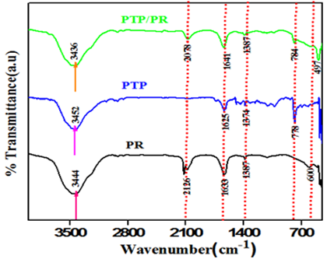
Figure 1. PTP/PR composite characterization (from selected peak picking) using FTIR spectra‘s.
3.1.3. XRD analysis
The characteristic peaks in the XRD pattern of PTP and PTP/PR nanocomposite were listed using powder X software and are presented in Figure 3D.The diffraction pattern for PR nanoparticles corresponds to a monoclinic lattice with FCC structure. Pure PTP shows a broad hump at 2θ value of 20-30° and thus, amorphous.²⁷ The XRD pattern of PTP/PR nanocomposite depicts sharp peaks between 20° to 45° with a maximum at 2θ = 32° with other low-intensity peaks between 45° to 60°.The occurrence of peaks diagnostic of PR in the PTP/PR nanocomposite illustrates the incorporation of PR nanoparticles in PTP matrix and hence corroborate with the FT-IR and thermal analysis results.Polymers as high molecular weight systems are capable of stronger van der Waals and other types of non covalent interactions with dopant molecules. These polymer dopant supra interactions lead to a fair degree of order in the composite material owing to which its degree of crystallinity increases which as is evident from XRD results of PTP/PR nanocomposite.The interactional compactness induced in the PTP/PR nanocomposite results in the improvement of the weak links between the grains. The coupling through the grain boundary becomes stronger and may lead to increased macroscopic conductivity.²⁴
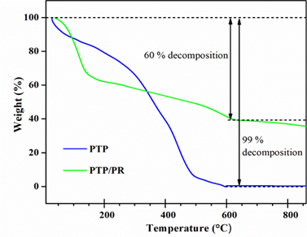
Figure2.Thermogravimetric analysis plots depicting PR enhanced thermal stability of PTP polymer
3.1.4.TEM Analysis
The microstructure of synthesized PTP/PR, was investigated using transmission electron microscopy (TEM).The TEM image of PTP/PR nanocomposite is shown in (Figure 3 A,B). As can be seen from Figure 3 A,B, PR particles appear as spherical/ granular structures of nano dimension dispersed in the PTP matrix. PR nano particles can be observed to be present in PTP matrix in discrete as well as agglomerated bigger sized spherical nano-particles. The PR particles are dispersed within the PTP matrix with an average size of 2-5nm(Figure 3C), revealing a mesoporous character. From TEM results, it is clear that PTP/PR is a nanocomposite. Thus, PR particles are expected to bestow a coarse surface to the nanocomposite with enhanced surface area for adsorption/photocatalytic activity. The enhanced surface area was also confirmed from BET analysis.
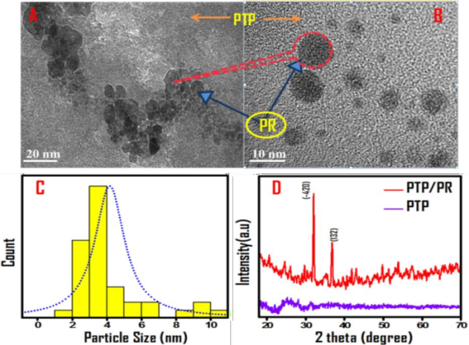

Figure3.Microstructure analysis of PTP/PR nanocomposite: (A,B)TEM images portraying PTP/PR nanocomposite features, (C) Average particle size analysis of PTP/PR nanocompsite (D) Relative PXRD pattern of PTP and PTP/PR nanocomposite

3.1.5.Structural and Textural Characterization
Adsorption propensity is greatly influenced by the surface area and pore size of the catalyst,BET analysis was attempted to determine surface characteristics of the synthesized PTP/PR nanocomposite.The N₂ adsorption-desorption isotherms and pore diameter distributions of PTP/PR nanocomposite, PR, pure PTP are as shown in Figure4.The measured surface area for PTP/PR nanocomposite was found to be 81.018 m² g⁻ ¹, which is higher than both PTP (25.560 m²/g) and PR (15.453 m²/g) respectively. Besides, the N₂ adsorption/desorption isotherm portrays combined type-II and IV isotherm behavior which is typical of mesoporous structure based on the IUPAC classification.^{28,29} Pure PTP has a granular texture with lesser inter-particle distance, which is evident from its lower porosity and smaller surface area. However, on addition of PR, the inter particle space gets increased, which is evident from increased porosity, in case of PTP/PR nanocomposite. The observed increase in porosity can be the reason for the enhanced surface area of PTP/PR nanocomposite compared to un doped PTP.³⁰ The major pore size distribution of the PTP/PR nanocomposite (2.769nm) is within the range of 1–3nm, which is a characteristic of smaller pore volume systems.Thus,mesoporous structure with enhanced surface area gives PTP/PR nanocomposite a good adsorptive capacity desirable for an adsorption based waste water treatment application.The good surface area and visible region bandgap also makes PTP/PR a possible photocatalyst.
The comparative analysis of PTP/PR nanocomposite with other closely related PTP nanocomposite systems indicates a significant increase in surface area for adsorption in case of PTP/PR Table 1.
Table 1.Comparative effect of dopants on the surface area of PTP composites

PTP Composite | Surface area(m²/g) | Reference
PTP/Fe(CN)₃(NO)(bpy).4H₂O | 18.9 | 31
PTP /Fe₃O₄ | 19.4 | 27
PTP/Cu | 20.88 | 32
PTP/CuFe₂O₄ | 30.9 | 33
PTP/PR | 81.018 | Present work
3.2. Modeling Adsorptive Propensity of PTP/PR towards Industrial Dye Malachite Green (MG)
The higher surface area with negative zeta potential value around pH 7 range indicates selectivity of PTP/PR nanocomposite towards cationic water contaminants.With this rationale, we used Malachite green as a model cationic dye for exploring the adsorptive propensity of PTP/PR nanocomposite under environmental conditions.
3.2.1.Effects of contact time and initial MG solution concentration
The effects of initial MG dye concentration and its contact time on PTP/PR nanocomposite adsorption capacity were observed around 20^{ο}C±2^{ο}C under fixed pH and concentrations from 10 to 25mg/L. The adsorption capacity of MG dye on PTP/PR nanocomposite under different initial concentrations with contact time is shown in Figure S1a.At lower dye concentrations the removal rate of the pollutant was relatively fast and equilibrium was reached within 20 min which shifted to 25 min at higher concentrations.The adsorption rate was high for first 20min and then progressively saturated with increasing contact time (after 60min).This observation can be corroborated with the progressive filling and saturation of the available surface sites with increasing contact time. Since many of the adsorption sites get occupied initially and as the process proceeds the number of available vacant sites is decreased and many of the sites are difficult to occupy due to repulsive forces between the adsorbate molecules on the surface and bulk phases²² which also mark the equilibrium point in the adsorption process. The effect of initial concentration of dye on equilibrium adsorption capacity is shown in Figure S1a. From Figure S1b it can be seen that the equilibrium adsorption capacities of MG dye under different initial concentrations offered an increasing trend from 14.187 to 34.5mg/g signifying that MG dye concentration gradient affords a stronger driving force to reduce the mass transfer resistance of the MGdye. The removal efficiency of MG by PTP/PR displayed relatively higher % removal at low concentrations with decreasing trend towards high concentrations which can be corroborated with the fixed adsorption capacity of the certain amount (20 mg) of PTP/PR sample. Thus, keeping consideration of adsorption capacities and removal efficiency of (20 mg) of PTP/PR, 10 mg/L was chosen as the optimized concentration of MG dye in the subsequent experiments as at this concentration, both removal efficiency and adsorption capacity of PTP/PR towards MG dye was observed to be optimum.
3.2.2. Effect adsorbent dosage
The effect of PTP/PR nanocomposite dosage on adsorption properties was studied by adding its increasing amounts (0.01 to 0.030 g) to 30 mL of 10 mg/L MG dye solution at 298 K with stirring for 160 min. The corresponding results are presented in Figure S2.The removal efficiency of MG dye increases from 93.8 to 95.94% on increasing adsorbent dosage from 0.01g to 0.030g. This behavior can be attributed to the fact that there are more accessible active adsorption sites for MG dye over increasing adsorbent dosage, which increases its % removal efficiency. However, the adsorption capacity reduces from 28.2 to 9.59 mg/g with increasing PTP/PR dose which can be attributed to the aggregate formation at high concentration.³⁴The aggregated particles create diffusion resistance for MG dye towards the adsorbent surface,decreasing the adsorption capacity. The PTP/PR dosage (0.020 g), gives 94.58% removal efficiency under an adsorption capacity of 14.2 mg/g, respectively, and further increase in PTP/PR was not observed to significantly increase the removal efficiency. Therefore, the adsorbent dose of 0.020 g was considered the optimal dose for adsorptive removal for subsequent experiments.
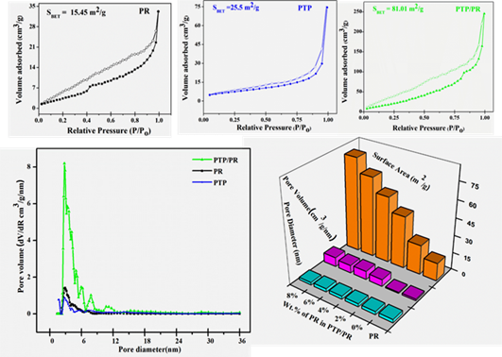
Figure 4. N₂ adsorption-desorption isotherms of PR, PTP and PTP/PR nanocomposite.The filled markers are for adsorption and hollow for desorption. Pore size distribution curves, Effect of PR Wt% on the surface area, pore volume of PTP/PR.

3.3. Adsorption Kinetic analysis
Adsorption as a physicochemical process involves the mass transfer of a solute from bulk liquid to the adsorbent surface. Kinetic investigations of such a transfer pave a significant understanding of the adsorption parameters.The kinetics of MG dye adsorption on the PTP/PR nanocomposite was explored by using three kinetic models: pseudo-first-order, pseudo-second-order and Elovich models Figure5A-C.These kinetic models can be stated in their linear form as equations (3-5). ^{35,36}

$\ln\left(q_{e}-q_{t}\right)=\ln\left(q_{e}\right)-k_{1}t$ (3)

$\frac{t}{{ q}_{t}}=\frac{1}{k_{2q_{e}^{2}}}+\frac{t}{q_{e}}$ (4)

$q_{t}=1/{βInαβ}+1/{βInt }$ (5) $\ln\left(q_{e}-q_{t}\right)=\ln\left(q_{e}\right)-k_{1}t$
where, q_{t} (mg/g) and q_{e} (mg/g) are the amounts of MG adsorbed at any time t (min) and at equilibrium, respectively; k₁ (min⁻¹) and k₂ (g mg⁻¹/min) are the rate constants of pseudo-first-order and pseudo-second-order kinetic models, respectively.The kinetic parameter counting correlation coefficients (R²), k₁, k₂ and q_{e} (cal) values were determined by linear regression. The ‘α’ in the equation 5 denotes initial adsorption rate (mg/g/min) and‘β’ is the desorption constant (g/mg).From the plot of qt vs lnt, elovich constants (α , β) were determined from slope and intercept values and the values are presented in Table 2. It is seen from table 2, that the R² value (0.9999) for the pseudo-second-order kinetic model was much higher than that of pseudo-first-order as well as Elovich kinetic models.In addition,the values of,qe_{cal} calculated under pseudo-second-order model were found close to the experimental qe_{exp}. Based on these observations, the pseudo-second-order kinetic model can be predicted to be the suitable to quantify the adsorption kinetics of MG onto PTP/PR nanocomposite.
$\ln\left(q_{e}-q_{t}\right)=\ln\left(q_{e}\right)-k_{1}t$ 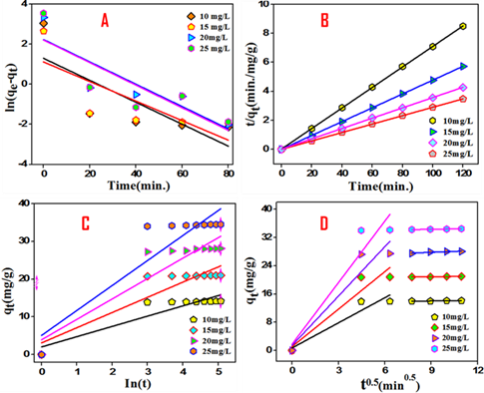
$\ln\left(q_{e}-q_{t}\right)=\ln\left(q_{e}\right)-k_{1}t$ Figure 5. Kinetic models for data fitting of MG (a-d= 10,15, 20, 25 mg)adsorption onto PTP/PR adsorbent (20mg in 30mL solution at 298K) :(A)Pseudo-first order (B) Pseudo-second order (C) Elovich kinetic models (D) Intraparticle diffusion model
As is evident from descriptors calculated in table 2, the experimental data do not have an acceptable fitting to pseudo first order and elovich models. Apparently, the pseudo-second-order kinetic model more effectively describes the adsorption behavior of MG onto PTP/PR nanocomposite.The pseudo-second-order kinetic model broadly comprises all steps of adsorption, including external film diffusion, intraparticle diffusion and surface adsorption.²²Typically,the intraparticle diffusion is considered as a possible rate-limiting step for a batch reaction. To envisage the rate-limiting step of the MG dye adsorption process on PTP/PR nanocomposite, the probability of intraparticle diffusion was tested by using Weber–Morris equation 6.³⁶
$q_{t =}K_{id}t^{0.5}+C$ (6)
Here, Ki (mg g⁻¹/min⁻²) is the intraparticle diffusion rate constant,C (mg/g) is the intercept related to the thickness of the boundary layer. Figure 5D displays the plot of qt against t^{0.5}, and the corresponding kinetic parameters are listed in table S1. It is seen that the regression of qt versus t^{0.5} was prompted to be linear and the plots did not pass through the origin, interpreting that the besides intraparticle diffusion, film diffusion may also be involved in the rate-controlling step. The Figure 5D shows two stages, an initial stage showing a faster adsorption rate of MG dye from solution, and the flat portion depicting decreased adsorption rate as fewer active sites are available for effective adsorption to take place.^{37,38} Also, the smaller slope of the intra-particle stage than that of the film diffusion stage illustrates that lower adsorption is occurring at intra-particle stage.³⁹Besides the more significant intercept of the second segment, which gives the thickness of the boundary layer indicates that surface adsorption is also involved in the rate limiting step.⁴⁰ Thus, adsorption of MG dye over PTP/PR nanocomposite involves film dispersion and intraparticle diffusion as possible mechanistic processes, with the intraparticle diffusion as a dominant adsorption mechanism.
3.4. Adsorption isotherms
In general, adsorption isotherm marks the relationship between the amount of adsorbate adsorbed per unit mass of an adsorbent at a given temperature. Adsorption isotherms are essential descriptors for analyzing and developing any adsorption system.⁴¹The equilibrium adsorption isotherm unfolds the interaction between the adsorbate and adsorbent. In view of this, MG,PTP/PR system was tested for Langmuir, Freundlich, Temkin isotherm models Figure 6. The Langmuir isotherm model considers monolayer adsorption with all the sorption sites identical and energetically equivalent. ⁴² The Freundlich isotherm is based on multilayer adsorption on the heterogeneous surface, and there are interactions between the adsorbed molecules.⁴³ Temkin model considers adsorption on heterogeneous surfaces, effects of indirect adsorbate/adsorbate interactions and assumes heat of adsorption of all molecules decreases linearly with an increase in surface coverage.⁴² The linear forms of the three isotherms are given by the following Equations (7-9).
$\frac{1}{q_{e}}=\frac{1}{q_{m}}+\frac{1}{K_{L}q_{m}C_{e}}$ (7)

Here, q_{e} (mg/g) is the amount of MG adsorbed at equilibrium time, C_{e}(mg/L) is the equilibrium concentration,q_{m}(mg/g)is the maximum adsorption capacity and K_{L} (L/mg) is the adsorption rate .The parameters of Langmuir model can be calculated from the slope and intercept of the linear plot 1/q_{e}vs 1/C_{e.}

$log{(q}_{e} )=\log\left(k_{f}\right)+\frac{1}{n}logCe$ (8)
K_{F} and n are Freundlich constants.

$q_{e}=βlnA_{T}+βlnCe$ (9)

Where $β$ = RT/b_{T} ,b_{T}(Kj/mol) is temkin constant gives heat of adsorption,T is the absolute temp.(K),R is the universal gas constant (equal to 8.314 j/mol), and A_{T} is equilibrium binding constant(L/g).The value of temkin constant indicates the possible mechanism (physical or chemical adsorption)on the adsorbent surface. Ifb_{T}>40kj/mol,
chemisorption occurs and if b_{T}<40kj/mol,physisorption proceeds ⁴⁴.
The quantities K_{F}, K_{L}, n, q₀, b and qt were calculated and the values are summarized in Table 3. The correlation coefficient for Langmuir isotherm has been found to be higher (0.997) and the adsorption capacity calculated from Langmuir model (34.48 mg/g) is found to be close to the experimental value (34.5mg/g). This suggests that the Langmuir isotherm could well explain the adsorption characteristic of PTP/PR nanocomposite.In addition, the separation factor or equilibrium parameter (R_{L}) of Langmuir adsorption isotherm, which evaluates the feasibility of adsorption on adsorbent was calculated by Equation (10). ⁴⁵
$$R_{L}=\frac{1}{1+K_{L}C_{0}} (10)$$
where, K_{L} was the Langmuir equilibrium constant and C₀ (mg/L) was the initial MG dye concentration. The value of R_{L} indicated the type of the isotherm to be either irreversible (R_{L} =0), favorable (0 < R_{L}< 1), unfavorable (R_{L}> 1) or linear (R_{L} = 1). The calculated value of RL was found in the range of 0.01 – 0.1 in this study ⁴⁶,indicating the adsorption of MG on PTP/PR is favorable, and as such, it can be a good adsorbent material for MG removal from aqueous solution.
In addition, the calculated R² value of 0.994, for the Freundlich isotherm model signifies a good degree of fit and the heterogeneity factor (n) was calculated to be 1.304. This also confirms a conducive adsorption processes as a reaction is classified as favorable if 1< n < 10.⁴⁷ The fitting of observed adsorption data with regression values of R² > 0.99 to both Langmuir and Freundlich isotherms models indicate that adsorption of MG dye over PTP/PR nanocomposite includes combined physical as well as chemical adsorption with monolayer /multilayer adsorption.^{48,49} The possible forces involved in adsorbate
adsorbent interaction include π-π stacking, hydrogen-bond
interaction,and electrostatic interaction.

Table 2. Kinetic models for the adsorption of MG on PTP/PR nanocomposite at adsorbent

 |  | Pseudo-Ist-order |  |  | Pseudo-2nd-order |  |  | Elovich model
C₀  (mg/l) | q_{eexp} (mg/g) | k₁  (min⁻¹) | q_{ecal}  (mg/g) | R² | k₂  g/(mgmin) | q_{e}cal  (mg/g) | R² | α  (mg/g/min) | β  (g/mg) | R²
10 | 13.92 | 0.05 | 1.042 | 0.50 | 0.18 | 14.14 | 0.99 | 7.787 | 0.368 | 0.821
15 | 20.81 | 0.046 | 1.218 | 0.51 | 0.22 | 21.28 | 0.99 | 22.606 | 0.248 | 0.813
20 | 27.45 | 0.045 | 17.95 | 0.78 | 0.06 | 28.17 | 0.99 | 51.779 | 0.185 | 0.831
25 | 34.15 | 0.031 | 6.184 | 0.86 | 0.116 | 34.5 | 0.99 | 164.130 | 0.151 | 0.814

. Table3.Isotherm parameters for the adsorption of MG onto PTP/PR nanocomposite at 298 K
Langmuir |  |  |  | Freundlich |  |  | Temkin
K_{L}(L/mg) | q_{m}(mg/g) | R_{L} | R² | K_{f}(L/g) | n | R² | b_{t} (kJ/mol) | K_{t}
1.14 | 34.48 | 0.08 | 0.997 | 18 | 1.304 | 0.994 | 0.145 | 12.47

3.5.Effect of temperature
To assess effect of temperature on adsorption capacity of PTP/PR nanocomposite for MG, batch adsorption experiments in the temperature range of 25-45⁰C were carried out. The adsorption propensity of the PTP/PR nanocomposite improved slightly with increase of system temperature Figure 7A.This can be attributed to the increased thermal motion of MG molecules at higher temperature and consequently more MG molecules can interact with the active sites on PTP/PR nanocomposite at higher temperatures.Furthermore, rate of diffusion of MG molecules increases with increasing of temperature, due to decrease in viscosity of the solution.⁵⁰An important observation to note was that the adsorption capacities of PTP/PR for MG remained at relatively high value of above 14.5 mg/g over the entire investigated temperature range, specifying it to be a good adsorbent towards removal of MG dye under varied real time temperature conditions.

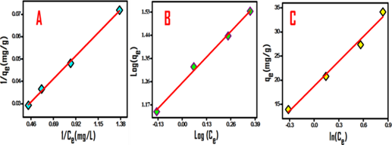

3.6. Thermodynamic analysis
The thermodynamic parameters,{change in Gibbs free energy (∆G), enthalpy (∆H) and entropy (∆S)} were assessed from the effect of temperature on the adsorption of MG dye onto PTP/PR using the equations (11,12)
$∆G°=-RTln(K_{L})$ (11)

$\operatorname{In}\left(K_{L}\right)=-∆H°/RT +∆S°/R$ (12)

where, K_{L} (L/mol) is the Langmuir equilibrium constant; T(K) is system temperature and R (8.314 J/(mol K)) is the molar gas constant. The negative values of ∆G calculated using equation 11 inferred that adsorption of MG onto PTP/PR nanocomposite is thermodynamically feasible. ∆H and ∆S calculated from slope and intercept of the van 't Hoff plot log(K_{L}) versus 1/T shown in Figure 7B. The calculated thermodynamic parameters of MG dye onto PTP/PR are presented in Table 4. Furthermore, the positive value of ∆H (9.03 kJ/mol K) specified that the adsorption process is endothermic in nature. Also, the positive value of ∆S (54.95 J/ mol K) means that the randomness increased at the solid–
liquid interface during the adsorption of MG dye in the aqueous solution on the PTP/PR nanocomposite.
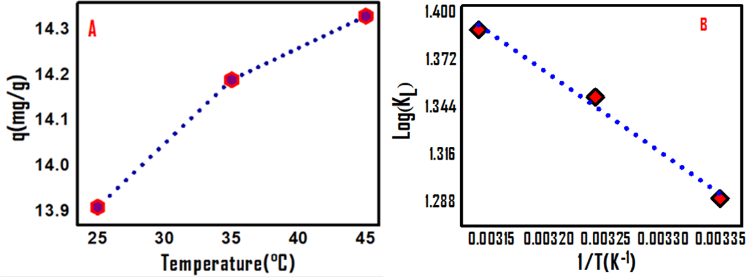

Figure 6.Adsorption isotherms of MG on PTP/PR nanocomposite; (A) Langmuir (B) Freundlich (C)Temkin

Figure 7 (A)Temperature effect on MG (10 mg/l, 30 ml) adsorption on 20 mg PTP/PR composite (B)Van’t Hoff plot for adsorption thermodynamics
3.7.Effect of pH
The pH is a vital parameter to consider adsorptive propensity as it influences surface charge of the adsorbent, degree of ionization of different adsorbates, protonation/ deprotonation of functional groups at the adsorbent active sites as well as adsorbate. Moreover, for a significant real time application the adsorption shall occur in the environmentally viable pH range ⁵¹ Accordingly, pH effect for MG dye adsorption on PTP/PR nanocomposite was studied. The Figure 8A depicts comparative pH influence towards MG dye adsorption on PTP/PR nanocomposite. Noticeably,the adsorption capacities of PTP/PR nanocomposite for MG were relatively higher at pH 7 (14.187 mg/g) and progressively decreased from pH 7 to 4 from 14.187 to 13.53 mg/g. The higher adsorption of MG dye by PTP/PR nanocomposite from the neutral solutions was an encouraging result from the waste water treatment point of view. The pH influence on the adsorption can be corroborated as, under acidic pH surface of the PTP/PR gets positively charged due to protonation of sulphur atom of the thiophene units in the polymer matrix,⁵² thereby repelling the cationic MG dye from polymer matrix. Moreover, when the solution pH was lower than 7.0, MG dye gradually takes positive charge due to protonation on its nitrogen atoms⁵³ which decrease adsorption capacities with decreasing solution pH. Around pH 7 deprotonation of sulphur atoms of polymer matrix is complete which attracts cationic MG dye towards PTP/PR surface leading to increased adsorption capacity at environmentally viable neutral pH.The pH effect results were supported by zeta potential studies of PTP/PR nanocomposite over a pH scan Figure 8B. From the zeta potential studies the pH corresponding to point of zero charge (pHpzc) of pristine PTP⁵⁴and PTP/PR nanocomposite were calculated to be 4.3 and 3.79 respectively. PTP/PR nanocomposite has a point of zero charge (pHpzc) at pH of 3.79 which also marks its transient pH. Above this pH its surface is negatively charged and below it positively charged.The lowered value of pHpzc corroborates with the presence of negative surface charge in case of PTP/PR nanocomposite above pH 3.8. In pH range of 0-3 surface of the nanocomposite is expected to have positive zeta potential, which progressively changes with increasing pH and acquires a maximum negative zeta potential value around pH 7 Figure 8B. From zeta potential studies repulsive interaction at lower pH as well as attractive interaction near neutral pH between cationic MG dye and adsorbent surface can hence be confirmed. The negative surface charge under the environmental pH range of 6 to 8 makes, PTP/PR nanocomposite an excellent adsorbent for cationic contaminants in waste water. The adsorptive propensity of PTP/PR nanocomposite for cationic MG dye prepared in tap, deionized waters and also with anionic dyes was attempted for comparative analysis.

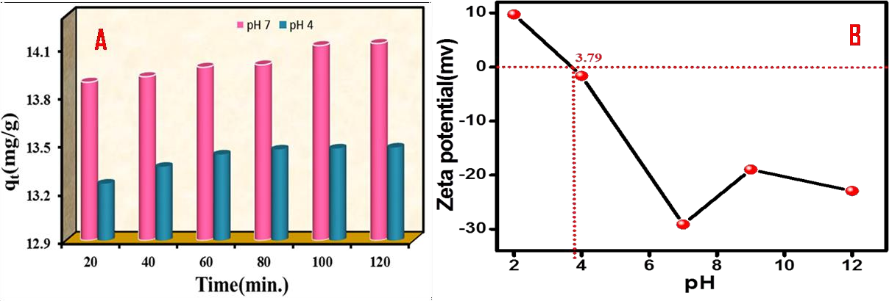
Figure 8. (A) Effects of solution pH on adsorption of MG (10 mg/l, 30 ml) onto the 20 mg of PTP/PR nanocomposite at 298 K.(B) Zeta potential studies of PTP/PR over pH range of 2-12

Although pH and zeta potential studies indicate dominance of electrostatic interaction for MG dye adsorption onto PTP/PR nanocomposite but the possibility of other interactional forces such as pi–pi stacking and Vander Waal type interactions cannot be ruled out. The adsorption studies of PTP/PR nanocomposite suggest its prospective towards MG dye elimination from waste waters under the environmentally viable conditions.
Table 4.Thermodynamic parameters for adsorption of MG (10mg/L,30mL)onto (20mg/L) PTP/PR nanocomposite.
Temp(K) | G(kJ/Mol) | H(kJ/molK) | S(J/molK)
298 | -3.194 | 9.03 | 54.95
308 | -3.446 | 9.03 | 54.95
318 | -3.663 | 9.03 | 54.95

3.8. Adsorption mechanism IR spectrum
To gain some insights about the adsorption mechanism, FTIR spectral analysis of PTP/PR nanocomposite before and after MG dye adsorption was carried out and are as shown in Fig.S3. The FTIR bands of PTP/PR nanocomposite at 490-498 cm⁻¹ corresponding to –C-S-C- ring deformation are decreased in intensity and the absorption bands corresponding to –C-H-, -C-C-,O-H stretch get slightly shifted to lower wave numbers post adsorption with MG dye. These changes indicate role of sulphur site –S- in MG dye adsorption process. A prominent absorption band at 2090cm⁻¹characteristic of -C-N- stretching frequency due to PR particles also gets decreased in intensity after MG dye adsorption indicates ionic type interaction with -C-N- group. Furthermore, the red shift in absorption frequencies can be attributed to electrostatic attraction resulting from lone pair on -S- and cationic MG dye. In addition, pi-pi stacking interaction could be possible between aromatic rings of MG dye and polythiophene matrix. The possible adsorption mechanism and probable interactions are shown in Fig.S4.
3.9 Adsorption studies of MG dye in real time samples
The real time efficiency of PTP/PR nanocomposite was examined via dye removal efficiency in textile industry waste water samples. The good adsorptive removal of MG dye from textile industry effluents offers the possibility of using PTP/PR nanocomposite in environmental waste water treatment application.⁵⁵The efficacy of PTP/PR nanocomposite towards MG dye removal in lab samples, samples prepared in normal tap water and also de-ionized water depicted more or less similar % adsorption under optimized conditions Figure 9A. The viability of selective adsorption using PTP/PR were studied by taking Rhodamine as cationic dye ; Congo Red and Methyl Orange as anionic dyes. It was found that the synthesized PTP/PR exhibited higher adsorption capacity towards cationic dyes than anionic dyes Figure 9B. This can be ascribed to the negative surface charge on the PTP/PR nanocomposite under an environmentally viable pH range.
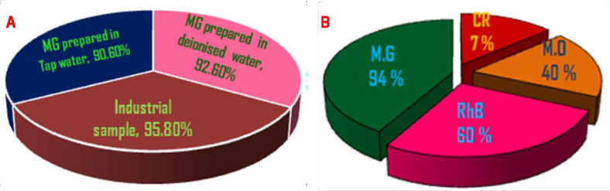

Figure 9. Adsorptive efficiency of PTP/PR towards: (A) real time samples (B) representative dyes from different dye classes.

4. Adsorbent recovery and recycling.
Adsorption process being a benign and non invasive method for the widespread waste water treatment applications is often limited by adsorbent recovery and regeneration post treatment. With regard to regeneration and reusability of adsorbent post treatment, recovery is one of the crucial parameters, magnetic separation is a very helpful method to recover magnetically active adsorbents for an improved economic feasibility. PTP/PR nanocomposite has PR as a magnetic core in the adsorbent nanocomposite, bringing the chances of easy magneticseparation. PTP/PR nanocomposite adsorbent was recovered non-invasively using magnetic separation without any possible contamination of the sample or any undesired change which enhances its recyclability. The adsorption capacity of PTP/PR nanocomposite decreased overall by around 20% after five consecutive cycles. The adsorption equilibrium time of 30 minutes progressively increased to 50 minutes after 5 cycles.
4.1. Synergism of photocatalysis and Adsorption for removal of MG dye by PTP/PR nanocomposite.
In our attempt to investigate the PR based modulation of the PTP matrix, we calculated the band gap of PTP/PR nanocomposite using Tauc Method.⁵⁶ The calculated band gap of 8 wt% PTP/PR was found to be 2.4 eV relative to the band gap of 3.0 eV for pure PTP matrix. This PR lowering of band gap has made the PTP/PR nanocomposite as visible light absorbing semiconductor.The larger surface area of 81m²/g and visible region band gap of PTP/PR nanocomposite are desirable features for the photocatalytic activity. To examine the PR effect on the photo generated hole electron pair recombination of PTP/PR nanocomposite cyclic voltammetry (CV) technique was used. CV experiments in 0.1M KNO₃ supporting electrolyte at varying scan rates. were carried out using PTP/PR nanocomposite and PR modified Glassy carbon electrodes(GCE). The changes in the voltammograms of modified GCE with increasing scan rates from 20 to 100 mV/s can be ascribed to the modified rate of the PR electron transfer in the form of PTP/PR nanocomposite. From Figure 10, It was seen that peak currents increased with scan rate and can be linearly correlated with square root of scan rates suggesting diffusion controlled process. The shifting of peak potentials on increasing scan rate corroborates with the overall quasi reversibility of redox process.

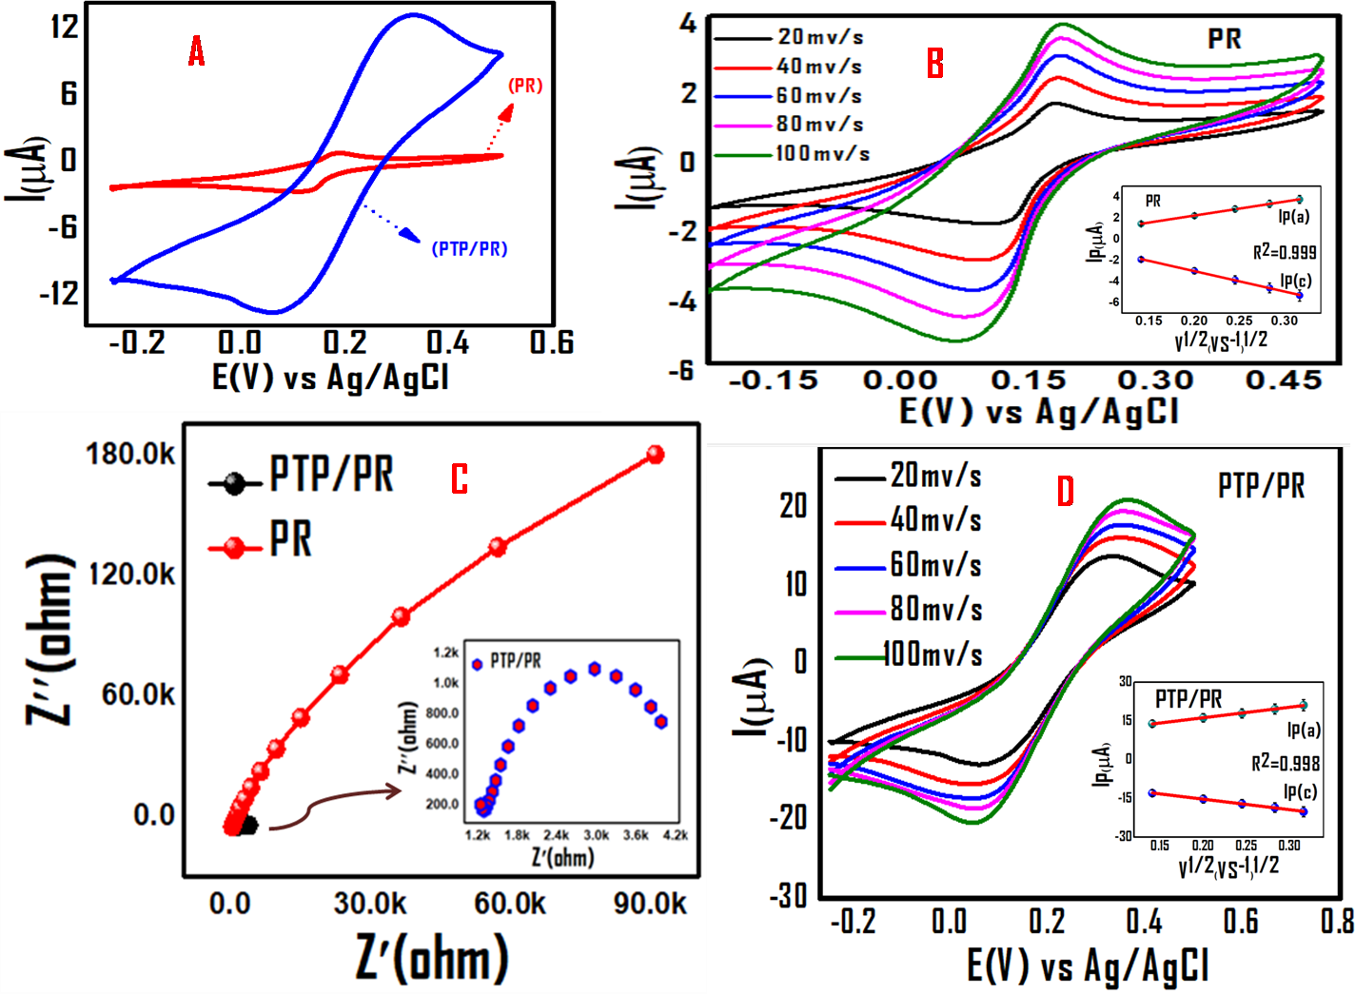

Figure 10.Comparative Cyclic Voltammograms of PR and PTP/PR at constant and increasing scan rates (A,B, D), (C) Comparative Nyquist plots for PR and PTP/PR nanocomposite.
The electrochemical impedance spectroscopy (EIS) analysis of the PTP/PR modified electrode was observed in 0.1M KNO₃.The results of EIS are represented as Nyquist plots depicting semicircular and linear regions. The semicircular part portraying high-frequency zone describes electron-transfer resistance (Rct), while the lower frequency linear position indicates diffusion controlled operation. The higher resistance of PR/GCE electrode can be evidenced from the larger diameter of semicircle which is typically under high Rct condition. The comparatively lower semi circular arc diameter (Nyquist plot inset of Figure 10) in case of PTP/PR confirms attenuation of Rct on composite formation with PR dopant. The lowering of Rct on composite formation with PTP, indicates that hybrid material (PTP/PR) possesses lower charge transfer resistance indicating that charge carriers (photogenerated electron-hole pairs) are more separated with higher mobility and lower recombination tendency. These attributes are highly desirable for photocatalytic activity.⁵⁷ With such desirable properties of PTP/PR nanocomposite towards photocatalytic activity, we envisaged a synergistic effect of photo catalysis and adsorption by PTP/PR nanocomposite towards the MG dye attenuation. The synergistic effect of photocatalysis and adsorption could be observed within 30 minutes under the irradiation from 150 W CFL. The results of synergistic effect are summarized in the Fig.11.
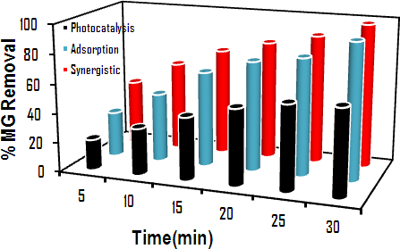

Figure 11. The synergistic effect of photocatalysis and adsorption for MG dye attenuation by PTP/PR nanocomposite

5.Conclusion
Prussian red (PR) on account of its unique properties was envisaged as an inorganic dopant towards polythiophene (PTP) conducting polymer matrix. Oxidative polymerization reaction via solvo thermal route was utilized for incorporating ball milled PR in the polythiophene matrix. The interaction of PR with PTP matrix was observed from the spectral changes in the FTIR and PXRD patterns. TEM imaging data identified PTP/PR hybrid material as a nanocomposite system. The observed thermal, electrochemical and photocatalytic descriptors of PTP/PR over pristine PTP suggested a desirable enhancement in these properties for the possible applications as water treatment nano-material. Zeta potential and pH studies suggest good adsorptive propensity towards cationic dyes under environmental conditions. An adsorption capacity of 35mg/g for removal of cationic dye Malachite Green (MG) was observed in the real time effluents from dye industry. From structural analysis, electrostatic, and pi-pi type interactions have been predicted to be predominant non covalent forces involved in adsorption of MG dye over PTP/PR nanocomposite. Adsorption data fitted Langmuir and Freundlich adsorption isotherms suggesting monolayer as well as multi layer adsorption process, besides kinetic studies revealed pseudo-second order model for the adsorption of MG dye over nanocomposite.Negative value
of free energy indicated thermodynamic spontaneity, recyclability with good regeneration was observed even after five cycles. Taken together PR as novel dopant in the PTP matrix has desirably enhanced its polymeric properties and as PTP/PR nanocomposite, it has increased the potency of conducting polymer towards waste water treatment application. Further development of PTP/PR nanocomposite for a wider water treatment application involving combined effect of adsorptive and photocatalytic elimination of persistent water contaminants is underway in our laboratory.
Acknowledgements
The authors are grateful to Head Dept. of Chemistry NIT Srinagar for allowing the BET studies. MM acknowledges the University Grants Commission GOI, for the award of JRF fellowship.
Conflict of interest: The authors declare that they have no conflict of interest and no competing financial interest.

5.References
1.A.Jamieson,T.Malkocs,S.Piertney,T.Fujii,Z.Zhang.Nat.Ecol.Evol.2017,1,1-4.
DOI :10.1038/s41559-016-0051
2. W.Ahmad, R.D.Alharthy, M. Zubair, M. Ahmed, A. Hameed, S.Rafque.,Sci.Rep. 2021,11,17006.
DOI: 10.1038/s41598-021-94616-4.
3.N.P.Raval,P.U. Shah, N. K. Shah. Appl Water Sci., 2017, 7, 3407–3445.
DOI : 10.1007/s13201-016-0512-2s.
4.R.Al-Tohamy,S.S.Ali,F.Li,K.M.Okasha,Yehia A.G.Mahmoud,
T.Elsamahy,H.Jiao, Y. Fu, J.Sun. Ecotoxicol.Environ.Saf.2022,231, 113160.
DOI: 10.1016/j.ecoenv.2021.113160.
5.Z.Peng, D.Wu, W.Wang, F.Tan, T.Ng, J.Che, X.Qiao, P.Wong. Appl. Surf. Sci.2017,396, 19- 25.
DOI: 10.1016/j.apsusc.2016.11.026.
6.M.Shaban,M.R.Abukhadra.Environ Earth Sci.2017,76,2–16.
DOI: 10.1007/s12665-017-6636-3
7.S.Dutta,B.Gupta,S.K.Srivastava,A.K.Gupta.,Mater.Adv.2021,2,4497.
DOI:10.1039/D1MA00354B
8.Q.Liu,Y.Li,H.Chen,J.Lu,G.Yu,M.Möslang,J.Y.Zhou.J.Hazard.Mater.2020,382,121040.
DOI: 10.1016/j.jhazmat.2019.121040.
9.I.Custodio,M.Candido,I.Carolina,B.Pires,H.P.Oliveira.CLEAN-SOIL AIR WATER 2021,49,1863-0650.
DOI: 10.1002/clen.202000189.
10.J.Stejskal,M.Kohl,M.Trchova,Z.Kolská,M.Pekárek,I.Křivka,J.Prokeš. Mater.Adv.2021,2,706-717.
DOI:10.1039/d0ma00730g.
11. K.R.Dunbar, R.A.Heintz.." PROG. INORG. CHEM .1997,45, 283-391
12.M.A.Rizvi,N.Teshima,G.M.Peerzada.,Croat.Chem.Acta.2013,86,345-350
DOI:10.5562/cca2167
13.M. A. Rizvi, S. A. Akhoon, S. R. Maqsood, G. M. Peerzada, J. Anal. Chem. 2015,70, 633-638
DOI: 10.1134/S1061934815050093
14.I.Yousuf,M.Zeeshan,F.Arjmand,M.A.Rizvi,S.Tabassum.,Inorg.Chem.Commun.2019,106,48-53.
DOI: 10.1016/j.inoche.2019.05.027 .
15.Y. Dangat, M. A. Rizvi, P.Pandey,K.Vanka, J. Organomet. Chem. 2016,801,30-41.
DOI: 10.1016/j.jorganchem.2015.10.015
16. M.A. Rizvi, M.Mane, M.A. Khuroo, G.M. Peerzada, Monatsh Chem. 2017,148, 655–668
DOI:10.1007/s00706-016-1813-8
17.M. Kumar, A. Kumar, M. Rizvi, M. Mane, S.C. Taneja, K. Vanka, B.A. Shah, Eur. J. Org. Chem. 2014, 2014 , 5247–5255. DOI: 10.1002/ejoc.201402551
18. S Devari, M Kumar, R Deshidi, M. Rizvi, BA Shah, Beilstein J. Org. Chem. 2014, 10, 2649–2653.
DOI: 10.3762/bjoc.10.277.
19.M.A.Rizvi, S.K.Moosvi, T.Jan, S.Bashir, P.Kumar, W.D.Roos, H.C.Swart. Polymer 2019, 163,1-12.
DOI:10.1016/j.polymer.2018.12.044.
20.T.Jan,M.A.Rizvi,S.K.Moosvi,M.H.Najar,S.H.Mir,G.M.
Peerzada.ACSOmega 2021,6,7413-7421.
DOI:10.1021/acsomega.0c05799.
21.T.Jan,S.K.Moosvi,M.H.Najar,G.M.Peerzada,M.A.Rizvi,J Mater Sci: Mater Electron, 2022,33, 8179–8192 .
DOI:10.1007/s10854-022-07969-5.
22.Q.Xin,J.Fu,Z.Chen,S.Liu, Ya.Yan,J.Zhang,Q.Xu.,J.Environ.
Chem.Eng.2015,3,1637-1647.
DOI:10.1016/j.jece.2015.06.012
23.G.Ma,X.Liang,L.Li,R.Qiao,D.Jiang,Y.Ding,H.Chen.,Chemosphere, 2014,100,146-151.
DOI: 10.1016/j.chemosphere.2013.11.053
24.M.Faisal,F.A.Harraz,A.E.Al-Salami,S.A.Al-Sayari,A.Al Hajry,M.S.AlAssiri.,Mater.Chem.Phys.2018,214,126-134. DOI:10.1016/j.matchemphys.2018.04.085
25.M.Sharif,B.Pourabas.RSC Adv.2016, 6, 93680-93693.
DOI: 10.1039/C6RA16701B
26.K.Namsheer,C.S.Rout.,RSCAdv.2021,11,5659-5697.
DOI: 10.1039/d0ra07800j
27.F.Zhanga,Y.Shi,Z.Zhao,W.Song,Y.Cheng.Appl.Catal.B:Environmental,2014,150–151,472–478. DOI:10.1016/j.apcatb.2013.12.049.
28.F.Rojas,I.Kornhauser,C.Felipe,J.M.Esparza,S.Cordero,A.Dominguez,J.L.Riccardo.Phys.Chem.Chem.Phys.2002,4,2346–2355.
DOI: 10.1039/b108785a
29.M.Thommes,K.Kaneko,AV.Neimark,JP.Olivier,F.R.Reinoso, J.Rouquerol,K.S.W.Sing.Pure Appl Chem.2015,87, 1051–1069.
DOI:10.1515/pac-2014-1117
30.S.P.Takle,S.D.Naik,S.K.Khore,S.A.Ohwal,N.M.Bhujbal,S.L. Landge,B. B. Kale , R. S. Sonawane., RSC Adv.2018,8,20394.
DOI: 10.1039/c8ra02869a
31.M.H.Najar,K.Majid.,RSCAdv.2015,5, 107209-107221.
DOI: 10.1039/c5ra19992a
32.M.Karegar,M.M.Khodaei.,J.Appl.Polym Sci.2021,139,51489.
DOI:10.1002/app.51489
33.A.H.Kamel,A.A.Hassan,A.E.E.Amr,H.H.El-Shalakany,M.A.Al-Omar.,Nanomaterials 2020 ,10, 586.
DOI:10.3390/nano10030586
34.M.Rajabi,K.Mahanpoor,O.Moradi.,J. APPL. POLYM. SCI.2019, 136, 47495.
DOI: 10.1002/app.47495
35.M.Zhang, L.Chang,Y.Zhao ,Z.Yu. , Arab.J .Sci Eng. 2019, 44, 111–121.
DOI:10.1007/s13369-018-3258-3
36. N.F.Al-Harby,E.F.Albahly,N.A.Mohamed. Polymers 2021, 13, 4446.
DOI:10.3390/ polym1324444
37.R-L.Liu,Y.Liu,X-Y.Zhou,Z-Q.Zhang,J.Zhang,FQ.Dang.
Bioresour.Technol.2014,154,138–147.
DOI: 10.1016/j.biortech.2013.12.034
38.N.Rajic,D.Stojakovic,D.Jovanovic,N.Z.Logar,M.Mazaj,V.Kaucic.Appl.Surf.Sci.2010,257,1524-1532 .
DOI:10.1016/j.apsusc.2010.08.090
39.K.Z.Setshedi,M.Bhaumik,S.Songwane,M.S.Onyango,A.Maity.Chem.Eng.J.2013,222,186–197.
DOI: 10.1016/j.cej.2013.02.061
40.H.K.Boparai,M.Joseph,D.M.O’Carroll.,J.Hazard. Mater.2011,
186,458-465.
DOI:10.1016/j.jhazmat.2010.11.029
41.M.A.AGhouti, D.A.Da'ana., J.Hazard.Mater.2020, 393,122383. DOI:10.1016 /j.jhazmat. 2020.122383
42.J.Wang,X.Guo.Chemosphere 2020, 258,127279.
DOI: 10.1016/j.chemosphere.2020.127279
43. R.Saadi, Z.Saadi, R.Fazaeli, N.E.Fard., Korean J. Chem.Eng. 2015, 32, 787-799.
DOI: 10.1007/s11814-015-0053-7
44.AnnyL. Taka ,E. F.Kankeu,K.Pillay,X.Y.Mbianda., Environ Sci Pollut Res.2018,25,21752-21767.
DOI: 10.1007/s11356-018-2055-6
45.S.Pandey,S.B.Mishra,J.Colloid Interface Sci.2011,361, 509–520. DOI: 10.1016/j.jcis. 2011.05.031
46.J.N.Edokpayi,E.Makete.,Phys.Chem.Earth 2021,123,103007.
DOI: 10.1016/j.pce. 2021. 103007
47.K.Parashar,N.Ballav,S.Debnath,K.Pillay,A.Maity.,J.Colloid Interface Sci.2016, 476, 103–118.
DOI: 10.1016/j.jcis.2016.05.013
48.Y.Chen,J.Li,F.Wang,H.Yang,L.Liu.Chemosphere2021,265, 129133.
DOI: 10.1016 /j.chemosphere.2020.129133
49.K.Y.Foo,B.H.Hameed.,Chem.EngJ.2010,156,2-10.
DOI:10.1016/j.cej.2009.09.013
50.C.H.Wu.,J.Hazard.Mater.2007,144,93-100.
DOI: 10.1016/j.jhazmat.2006.09.083
51.M.A.Rizvi, Y.Dangat, T.Shams, K.Z.Khan. J.Chem. Educ. 2016, 93, 355–361.
DOI:10.1021/acs.jchemed.5b00499
52.N.C.Joshi,N.Malik,AjaySingh.J.Inorg.Organomet.Polym.Mater.2020,30,1438–1447.
DOI: 10.1007/s10904-019-01252-7
53.G.Y.Abate,A.N.Alene,A.T.Habte,D. M. Getahun. Environ. Syst. Res. 2020, 9, 29.
DOI:10.1186/s40068-020-00191-4
54.M.Karegar,M.M.Khodaei.,J.Appl.Polym.Sci.2022,139, 51489.
DOI: 10.1002/app.51489
55.S.M.Botsa,K.Basavaiah.Sci.Rep.2020,10,14080.
DOI: 10.1038/s41598-020-70194-9
56.M.M.Abdia,H.N.MEkramulMahmud,L C.Abdullah ,A.Kassim,
M.Zaki.Ab.Rahman,J.L.YingChyi.,Chinese,J.Polym. Sci. 2012, 30, 93-100.
DOI: 10.1007/s10118-012-1093-7
57.J.Luo,Y.Ma,H.Wang,J.Chen.,Electrochim.Acta 2015, 167, 119–125. DOI :10.1016/j.electacta.2015.03.097

