Ionic Liquid Supported on Magnetic Graphen Oxide as a Highly Efficient and Stable Catalysts for the Synthesis of Triazolopyrimidines

Azar Jahanbakhshi, Mahnaz Farahi* and Yeganeh Aghajani

Department of Chemistry, Yasouj University, Yasouj 75918-74831, Iran
Email: farahimb@yu.ac.ir

Abstract: A novel supported sulfonic acid functionalized ionic liquid was prepared by anchoring of 1-(propyl-3-sulfonate) vinylimidazolium hydrogen sulfate ([(CH₂)₃SO₃HVIm]HSO₄) on Fe₃O₄@GO. The prepared heterogeneous catalyst was characterized using via XRD, FT-IR, EDX, SEM, VSM and TGA techniques. The results suggested that [(CH₂)₃SO₃HVIm]HSO₄ had been successfully supported on the surface of Fe₃O₄@GO and the prepared ionic liquid catalyst had good thermal stability. The prepared catalyst activity was investigated in the preparation of triazolo[1,5-a]pyrimidine derivatives by a one-pot three-component reaction of active methylene compound (malononitrile or ethyl cyanoacetate), 3-amine-1H-1,2,4-triazole and aryl aldehydes under solvent-free conditions. This catalyst could be quickly separated by an external magnet and recycled seven times without significant loss of its catalytic activity.

Keywords: Ionic liquid; graphen oxide; triazolopyrimidines; Fe₃O₄

- Introduction:
Ionic liquids (ILs) have gained more and more recognition as green materials, alternative reaction media and promising catalysts for their unique properties, such as tunable acidity, selective dissolvability, negligible vapor pressure, wide liquid range and high thermal stability.^{1,2} Ionic liquids have been developed for several special applications like catalysts, fossil fuel desulfurization reagents, lubricants and as monomers for the synthesis of ionic polymers. Also, they are well known as ‘versatile chemicals’ in diverse fields of synthetic chemistry.^{3,4} Among them, the sulfonic acid group functionalized acidic ionic liquids with a hydrogen sulfate counteranion has been intensively studied as a class of dual acidic functionalized ILs, because the existence of both SO₃H-functional groups and the hydrogen sulfate counteranion can enhance their acidities. Despite the benefits of ionic liquids, their extensive application was still hampered by some drawbacks such as unendurable viscosity, hard product isolation and catalyst recovery, high cost and requirements of long reaction time.^{5,6} Immobilization of ionic liquids on various solid supports is one of the efficient ways to overcome these problems. Supported ionic liquids have the benefits of combining the ionic liquid characteristics with the common advantages of immobilizations, such as ease of recycling and improved selectivity in applications involving catalytic activity.⁷ The heterogenization of ILs on appropriate porous carriers,⁸⁻¹⁰ suitable magnetic nanoparticles,¹¹⁻¹³ immobilized on solid supports by either physical coating of ionic liquids on Al₂O₃,^{14,15} SiO₂^{16,17}and TiO₂^{18,19} or covalent attachment of ionic liquids to the support surface, would be a viable and appealing approach to prepare an efficient solid catalyst with superior activity and stability.²⁰ While reasonable recyclability was observed in most of the cases, the dispersion of ionic liquid on the solid support was low and leaching of ionic liquid would occur leading to loss of activity.^{21,22} To overcome these drawbacks, graphene oxide (GO) can be used as support material for immobilizing ionic liquid with an objective of better dispersion, excellent activity, covalent bonding and good reusability. In general, graphene oxide possesses a number of oxygen-containing functionalities (such as epoxy, carboxy, and hydroxy groups). So, it can be a promising candidate as a beneficial support for immobilization of ILs.²³⁻²⁷ Graphene oxide supported ILs display advantages because of their physicochemical properties, still it is the tedious and time-consuming separation techniques which limits their practical applications. In this respect, the development of magnetic graphene oxide has emerged as a promising support material.²⁸⁻³⁰
In recent years, green chemistry has been one of the most important aspects of chemist’s experimental and industrial efforts. Due to their considerable atom efficiency and significant diversity, multicomponent reactions (MCRs) have occupied an important part of the green chemistry world.³¹⁻³³ Multi-component reaction is a powerful synthetic strategy in modern chemistry in which three or more simple components as starting reagents are involved in a one-pot system to achieve new complex molecules at a less processing procedure in compare to the step-by-step procedure with usually few side-products. Multicomponent reactions are one beneficial tool for the synthesis of important heterocyclic compounds which have many biological activities.³⁴⁻³⁶ Family of pyrimidine is the most important nitrogen containing heterocycles due to their presence in many natural and biological active products. It is well known that the condensation of triazole and pyrimidine gives rise to the formation of bicyclic heterocycles known as triazolopyrimidines which exhibit a wide range of biological properties.³⁷⁻³⁹ Triazolopyrimidines can be applied in a variety of synthetic pharmacophores. Furthermore, they participate as useful building blocks in the structure of many herbicidal drugs as penoxsulam, diclosulam, flumetsulam, azafenidin, and floransulan.⁴⁰⁻⁴² Also, triazolopyrimidines are synthetic analogs of purines and nucleosides. [1,2,4]Triazolo[1,5-a]pyrimidines, a subtype of purine bioisosteric analogs, were also reported to possess potential anti-tumor activities, especially those bearing functional groups at C-5, C-6 or C-7 positions.^{43,44} Several synthetic strategies have been reported for the preparation of triazolopyrimidine derivatives which most of them are based on modification of the classical Biginelli reaction.^{45,46} Although, some of these procedures are efficient, a number of them have limiting factors including long reaction time, side reaction, rigid workup, high-temperature condition and non-recyclable reagent.
To continue our effort to establish an environmentally friendly method for the synthesis of reusable catalysts,⁴⁷⁻⁵⁶ we report a novel magnetic graphene oxide supported dual acidic ionic liquid and subsequently the catalytic activities toward the synthesis of triazolo[1,5-a]pyrimidine derivatives.

- Experimental
All the solvents, reagents and chemicals were bought from Sigma-Aldrich, Merck and Fluka chemical companies. X-ray diffraction analysis were recorded using a Philips X Pert Pro X diffractometer operated with Ni-filtered Cu-Ka radiation source. XRD diffraction patterns were obtained from 2θ = 10-80°. The EDS was performed using the TESCAN vega model. Scanning electron microscopy images was taken with a SEM: KYKY-EM3200 instrument operated. Thermogravimetric analysis was carried out with a Perkin Elmer STA 6000 instrument in the temperature range of 25-900 °C under air atmosphere. The vibrating sample magnetometry of magnetic materials was used by the Kavir Magnet VSM. The IR spectrum was recorded out in the range 400-4000 cm⁻¹ via a FT-IR JASCO 6300D instrument. ¹H NMR and ¹³C NMR spectra were recorded on a Bruker Ultrashield spectrometer (400 MHz) using DMSO-d₆ as the solvent.

Preparation of [(CH₂)₃SO₃H-VIm]HSO₄ (IL)
Firstly, a mixture of 1-vinylimidazole (9.4 g) and 1,4-butanesultone (12.4 g) was stirred for 24 h at room temperature. Then, the obtained white solid was collected and washed with diethyl ether and dried at 50 °C. The prepared material was dissolved in H₂O (5 mL) in a 100 mL round bottom flask and equal molar H₂SO₄ was added dropwise at 0 °C. After the dropping was finished, the mixture was stirred at 50 °C for 12 h, and resulting in the formation of the ionic liquid. Finally, the ionic liquid was washed repeatedly with diethyl ether and dried under vacuum at 50 °C.²
Synthesis of graphene oxide (GO)
Graphene oxide was synthesized using graphite powders by the modified Hummer method. In a typical synthesis process, graphite powder (3 g) was put into a mixture of concentrated H₂SO₄ (12 mL), K₂S₂O₈ (2.5 g) and P₂O₅ (2.5 g) in a beaker of 500 mL and was stirred for 5 h at 80 °C. The mixture was then cooled down to room temperature and diluted with deionized water and then stirred at room temperature for 24 h. Next, the mixture was filtered and washed with deionized water and ethanol and dried. After drying, the resulting powder was dissolved in H₂SO₄ (120 mL) and KMnO₄ (15 g) in an ice bath and stirred until the contents were completely dissolved. During stirring, the deionized water (250 mL) was slowly added, and then heated at 35 °C for 2 h. Afterwards that, the reaction was stopped by addition of deionized water (250 mL) and finally hydrogen peroxide (20 mL, 30%). The resulting mixture was washed several times with HCl aqueous solution (1:10) using a centrifuge and then dried at 60 °C in an oven. Finally, the graphite oxide was sonicated in deionized water for 1 h to obtain graphene oxide nanosheets.⁵⁷
Preparation of magnetic Fe₃O₄ nanoparticles (MNPs)
First, to synthesis Fe₃O₄ magnetic nanoparticles, FeCl₃.6H₂O (2.7 g, 10 mmol) and FeCl₂.4H₂O (1 g, 5 mmol) were dissolved in deionized water (45 mL) under N₂ atmosphere at 80 °C for 30 min. In the next step, NaOH solution (10 mL, 25%) was slowly added dropwise until the color darkened and after was stirred for 1 h. Finally, the black product of Fe₃O₄ magnetic nanoparticles was collected using an external magnet and washed with deionized water and ethanol and dried.⁴⁹
Synthesis of Fe₃O₄@GO nanocomposite
Fe₃O₄@GO nanocomposite was synthesized by using liquid self-assembly method. In a typical synthesis, GO (50 mg) was dispersed in DMF (5 mL) by ultrasonic treatment for 2 h, and afterward dispersed Fe₃O₄ (40 mg) in chloroform (10 mL) was added slowly dropwise. The mixture was sonicated for 4 h at room temperature. The Fe₃O₄@GO black color nanocomposite was separated using an external magnet and washed with deionized water and ethanol and finally dried.⁵⁸
Preparation of Fe₃O₄@GO-Pr-SH
For functionalization of Fe₃O₄@GO nanocomposite, 3-mercaptopropyltrimethoxysilane (2 mL) was added to Fe₃O₄@GO (1 g) in dry toluene (30 mL), and the mixture was stirred under N₂ atmosphere and refluxed for 24 h. The resulting product (Fe₃O₄@GO-Pr-SH) was separated by an external magnet, washed with distilled water and ethanol and dried.
Synthesis Fe₃O₄@GO-Pr-S/IL (1)
For the preparation of supported acidic ionic liquid on modified GO (nanocatalyst 1), a mixture of Fe₃O₄@GO-Pr-SH (1 g), [(CH₂)₃SO₃H-VIm]HSO₄ (5 mL) and azobisisobutyronitrile (AIBN) (5 mol %) in toluene (100 mL) was refluxed under N₂ atmosphere for 30 h. Next, the catalyst was separated using an external magnet, washed with diethyl ether several times and then dried at 50 °C.
General procedure for the synthesis of triazolopyrimidines 5
To a mixture of aldehyde (1 mmol), ethyl cyanoacetate or malononitrile (1 mmol) and 3-amine-1H-1,2,4-triazole (1 mmol) was added catalyst 1 (0.004 g) under solvent-free conditions at 80 °C. The reaction progress was monitored by TLC (n-hexane/EtOAc). After the process was completed, EtOAc (10 mL) was added and Fe₃O₄@GO-Pr-S/IL nanocatalyst was separated using an external magnet. Finally, further purification of the product was achieved by recrystallization from EtOH.
General procedure for the recovery of nanocatalyst 1
The recovery of Fe₃O₄@GO-Pr-S/IL was performed in the synthesis of pyrimidine derivatives. The mixture of benzaldehyde (1 mmol), ethyl cyanoacetate or malononitrile (1 mmol) and 3-amine-1H-1,2,4-triazole (1 mmol) in the presence of catalyst 1 (0.004 g) was stirred under optimum conditions. After the completion of the reaction, hot EtOAc (10 mL) was added and the nanocatalyst was separated from the reaction mixture using an external magnetic. Afterward, the recovered catalyst was washed several times by EtOAc (10 mL) and deionized water (10 mL), and then dried. Finally, the recycled catalyst was reused for seven successive times under the like conditions.
Selected spectral data
Ethyl 5-amino-7-phenyl-1,7-dihydro-[1,2,4]triazolo[1,5-a]pyrimidine-6-carboxylate (5a). FT-IR (KBr) (ῡ_{max}, cm⁻¹): 3396, 3375, 3326, 2746, 1687, 1565, 1490, 1110. ¹H NMR (400 MHz, DMSO-d₆): δ = 9.25 (s, 1H), 8.08 (d, 1H, J = 8 Hz), 7.66 (s, 2H), 5.37 (s, 1H), 3.93 (q, 2H, J = 8 Hz), 0.84 (t, 3H, J = 8 Hz), 7.57-7.64 (m, 5H) ppm.
Ethyl 5-amino-7-(4-chlorophenyl)-4,7-dihydro-[1,2,4]triazolo[1,5-a]pyrimidine-6-carboxylate (5b). FT-IR (KBr) (ῡ_{max}, cm⁻¹): 3412, 3253, 3115, 2872, 1692, 1532, 1485, 1203, ¹H NMR (400 MHz, DMSO-d₆): δ = 9.25 (s, 1H), 8.08 (d, 1H, J = 8 Hz), 7.65 (s, 2H), 5.41 (s, 1H), 4.38 (q, 2H, J = 7 Hz), 0.92 (t, 3H, J = 7 Hz), 7.45-7.58 (m, 5H) ppm.¹³C NMR (100 MHz, DMSO-d₆): δ = 163.83, 160.63, 154.82, 134.82, 130.96, 129.87, 129.04, 110.16, 61.09, 57.01, 14.02 ppm.
Ethyl 5-amino-7-(4-bromophenyl)-4,7-dihydro-[1,2,4]triazolo[1,5-a]pyrimidine-6-carboxylate (5c). FT-IR (KBr) (ῡ_{max}, cm^{–1}): 3427, 3389, 3098, 2923, 1677, 1587, 1488, 1178. ¹H NMR (400 MHz, DMSO-d₆): δ = 9.16 (s, 1H), 7.08 (d, 1H, J= 3.6 Hz), 8.39 (s, 2H), 5.21 (s, 1H), 3.98 (q, 2H, J =6.4 Hz), 1.33 (t, 3H, J = 6.6 Hz), 7.41-7.43 (m, 5H) ppm. ¹³C NMR (100 MHz, DMSO-d₆): δ = 169.6, 156, 146, 141.99, 132.5, 129, 126.8, 62.1, 40.6, 27.5 ppm.
Ethyl 5-amino-7-(4-nitrophenyl)-4,7-dihydro-[1,2,4]triazolo[1,5-a]pyrimidine-6-carboxylate (5d). FT-IR (KBr) (ῡ_{max}, cm^{–1}): 3480, 3430, 3198, 2917, 1680, 1604, 1504, 1054. ¹H NMR (400 MHz, DMSO-d₆) δ = 13.99 (s, 1H), 8.10 (d, 1H, J = 8 Hz), 7.83-7.91 (m, 4 H), 5.99 (s, 1H), 4.43 (q, 2H, J = 7.2 Hz), 1.03 (t, 1H, J = 3.2 Hz) ppm. ¹³C NMR (100 MHz, DMSO-d₆) δ = 163.62, 154.95, 149.60, 144.21, 134.01, 131.06, 130.42, 124.86, 124.46, 114.11, 63.57, 59.84, 14.00 ppm.
Ethyl 5-amino-7-(3-nitrophenyl)-1,7-dihydro-[1,2,4]triazolo[1,5-a]pyrimidine-6-carboxylate (5e). FT-IR (KBr) (ῡ_{max}, cm^{–1}): 3444, 3328, 3097, 2888, 1697, 1623, 1531, 1272. ¹H NMR (400 MHz, DMSO-d₆): δ = 6.41 (s, 1H), 8.09 (d, 1H, J = 8 Hz), 7.80-7.83 (m, 5H), 5.69 (s, 1H), 4.03 (q, 2H, J = 8 Hz), 0.92 (t, 3H, J = 8 Hz) ppm. ¹³C NMR (100 MHz, DMSO-d₆): δ = 163.63, 154.55, 150.36, 147.93, 134.84, 131.17, 130.83, 125.30, 123.78, 123.13, 113.63, 63.19, 59.06, 13.86 ppm.
Ethyl 5-amino-7-(2,4dichlorophenyl)-1,7-dihydro-[1,2,4]triazolo[1,5-a]pyrimidine-6-carboxylate (5f). FT-IR (KBr) (ῡ_{max}, cm^{–1}): 3489, 3421, 3085, 2878, 1699, 1586, 1474, 1106. ¹H NMR (400 MHz, DMSO-d₆): δ = 11.67 (s, 1H), 8.11 (d, 1H, J = 8 Hz), 7.87 (s, 2H), 4.16 (s, 1H), 2.48 (q, 2H, J = 8 Hz), 1.25 (t, 3H, J = 7 Hz), 7.26-7.77 (m, 5H) ppm. ¹³C NMR (100 MHz, DMSO-d₆): δ = 160.6, 153.6, 137.6, 130.2, 120.8, 127, 67.1, 40.4, 21.6 ppm.
Ethyl 5-amino-7-(4-methylphenyl)-7,8-dihydro-[1,2,4]-triazolo[4,3-a]pyrimidine-6-carbonitrile (5g). FT-IR (KBr) (ῡ_{max}, cm^{–1}): 3347, 3262, 3185, 3118, 2921, 2192, 1660, 1633, 1531, 1482, 1363, 1286, 1214, 1157. ¹H NMR (400 MHz, DMSO-d₆) δ = 2.28 (s, 3H), 5.29 (d, 1H, J = 2.4 Hz), 7.18 (s, 4H), 7.21 (s, 2H), 7.71 (s, 1H), 8.75 (d, 1H, J = 1.6 Hz) ppm. ¹³C NMR (100 MHz, DMSO-d₆) δ = 20.64, 53.70, 56.06, 119.06, 126.00, 129.18, 137.26, 140.24, 146.93, 151.83, 153.92 ppm.
Ethyl 5-amino-7-(4-isopropylphenyl)-7,8-dihydro-[1,2,4]-triazolo[4,3-a]pyrimidine-6-carbonitrile (5h). FT-IR (KBr) (ῡ_{max}, cm^{–1}): 3378, 3295, 3181, 3118, 2964, 2186, 1656, 1627, 1523, 1479, 1367, 1284, 1211, 1151. ¹H NMR (400 MHz, DMSO-d₆) δ = 1.23 (d, 6H, J = 6.8 Hz), 2.92 (s, 1H), 5.33 (d, 1H, J = 2Hz), 7.24 (s, 4H), 7.31 (s, 2H), 7.76 (s, 1H), 8.80 (d, 1H, J = 1.6 Hz) ppm. ¹³C NMR (100 MHz, DMSO-d₆) δ = 23.81, 33.11, 53.68, 55.97, 119.11, 125.99, 126.59, 140.71, 146.95, 148.21, 151.83, 153.91 ppm.

- Results and discussion
The procedure followed to obtain Fe₃O₄@GO-Pr-S/IL nanocatalyst (1) is outlined in Scheme 1. The Bronsted acidic ionic liquid [(CH₂)₃SO₃HVIm]HSO₄ was synthesized via the reaction of 1-vinylimidazole with 1,4-butane sultone, followed by treatment with sulfuric acid. Next, Fe₃O₄@GO nanocomposite was prepared and then functionalized by 3-mercaptopropyltrimethoxysilane (MPTMS) through covalent bonds to produce Fe₃O₄@GO-Pr-SH. Finally, Fe₃O₄@GO-Pr-S/IL nanocatalyst 1 was obtained by the reaction of [(CH₂)₃SO₃HVIm]HSO₄ and Fe₃O₄@GO-Pr-SH in the presence azobisisobutyronitrile (AIBN) in toluene under N₂ atmosphere. After successful synthesis of Fe₃O₄@GO-Pr-S/IL, the structure of this new nanocatalyst was characterized by XRD, EDS, FT-IR, VSM, SEM and TGA techniques.
Scheme 1. Preparation of Fe₃O₄@GO-Pr-S/IL (1).

Fig. 1 is shown X-ray diffraction spectroscopy patterns of GO, Fe₃O₄ and Fe₃O₄@GO-Pr-S/IL. As shown in Fig. 1a, the peak at 2θ = 10.5° and 43.5° can be corresponded to the (0 0 1) and (101) sheets of GO.^{59,60} In Fig. 1b, peaks located at 30.26°, 35.7°, 43.5°, 53.59°, 57.5° and 63.26° are related to (2 2 0), (3 1 1), (4 0 0), (4 2 2), (5 1 1) and (4 4 0) free Fe₃O₄, respectively, which are in good agreement with well with the pattern of Fe₃O₄.^{61,62} After grafting different functional groups on GO sheets (Fig. 1c), the 001 diffraction peak of GO completely vanished, suggesting complete exfoliation of GO and hampers aggregation of GO sheets after partial reduction. Also, the Fe₃O₄@GO-Pr-S/IL nanocatalyst is shown characteristic peaks at 2θ which were corresponded to the basic peaks of Fe₃O₄.
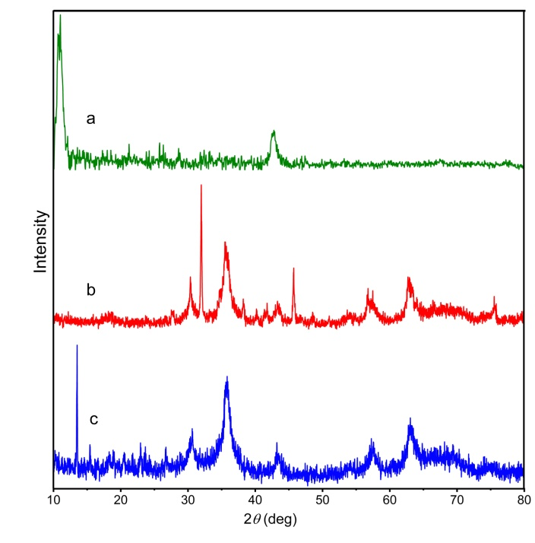
Fig. 1. XRD patterns of a) GO, b) Fe₃O₄ and c) Fe₃O₄@GO-Pr-S/IL.

Elemental analysis of Fe₃O₄@GO-Pr-S/IL was performed by EDX analysis (Fig. 2). As depicted, the EDX spectrum proves the presence of expected elements containing C, O, Fe, N, Si and S in the catalyst structure.
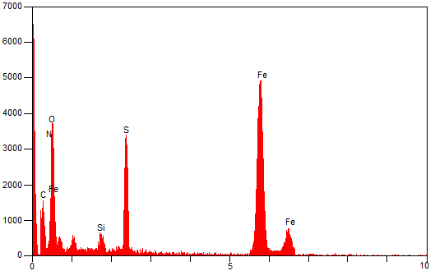
Fig. 2. EDS diagram of Fe₃O₄@GO-Pr-S/IL.

The functional group attached to IL, GO, Fe₃O₄, Fe₃O₄@GO, Fe₃O₄@GO-Pr-SH and Fe₃O₄@GO-Pr-S/IL was evaluated by FT-IR (Fig. 3). In Fig. 3a, three absorption peaks at around 645, 1050 and 1135 cm⁻¹ are related to vibration of S-O, SO₂ and C-S bands. Also, the characteristic peaks of imidazolium ring were observed around 1563 cm⁻¹ (Fig. 3a).⁶³⁻⁶⁵ FT-IR spectra of GO is presented in Fig. 3b. The peak appeared at 1227 cm⁻¹ is assigned to stretching vibration of C–O of the epoxy group and peak of C=O of the carboxylic and carbonyl groups are at 1724 cm⁻¹ (Fig. 3b).^{66,67} The strong peak in all spectra 3400 cm ⁻¹ is corresponding to the OH group (Fig. 3b-f). In the Fe₃O₄@GO-Pr-S/IL, this peak (OH group) is considerably more severe than Fe₃O₄@GO-Pr-SH due to sulfonic acid groups. In addition, typical peak at 580 cm⁻¹ in all spectra (fig. 3c-f) is assigned to Fe-O stretching.⁶⁸ Further, Si-O bond symmetric and asymmetric vibrations appears at about 973 and 1140 cm⁻¹, which the presence of the MPTMS was confirmed (Fig. 3d).⁶⁹ The presence of all these peaks shows the successful joined of Bronsted acidic ionic liquid on the Fe₃O₄@GO-Pr-SH via radical reaction.
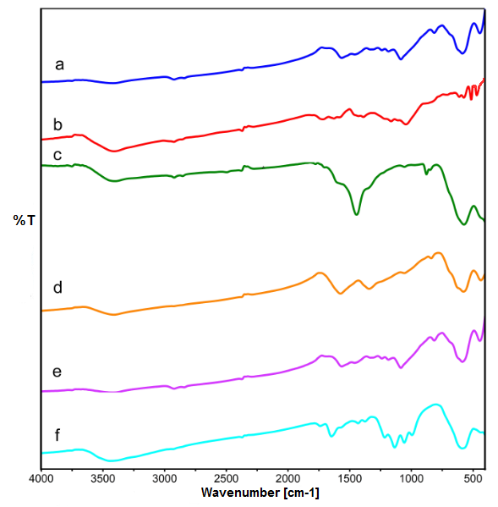
Fig. 3. FT-IR spectra of a) IL, b) GO, c) Fe₃O₄, d) Fe₃O₄@GO, e) Fe₃O₄@GO-Pr-SH and f) Fe₃O₄@GO-Pr-S/IL.

The magnetic property of Fe₃O₄ and Fe₃O₄@GO-Pr-S/IL nanocatalyst was determined by VSM at room temperature (Fig. 4). The curves in Fig. 4 indicate that the values of the saturation magnetization of Fe₃O₄@GO-Pr-S/IL (20.55 emu/g) is lower than that of the bare Fe₃O₄ nanoparticles (53.03 emu/g). The decrease of the saturation magnetization Fe₃O₄@GO-Pr-S/IL nanocatalyst may be related to the functionalized GO and presence of acid group on the surface of the ionic liquid that connected to support.
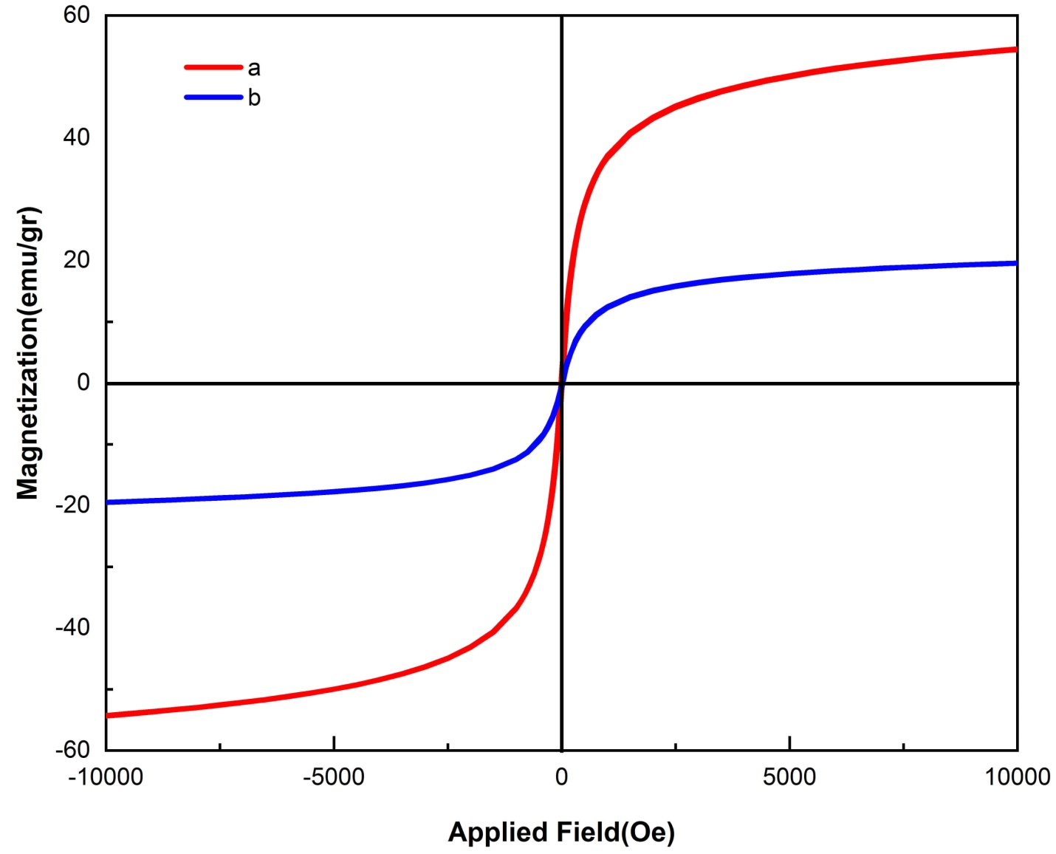
Fig. 4. VSM analysis of a) Fe₃O₄ and b) Fe₃O₄@GO-Pr-S/IL.

The morphology and size of GO and Fe₃O₄@GO-Pr-S/IL nanocatalyst was studied by SEM (Fig. 5). GO has a 2D structure with a wrinkled edge and large thickness (Fig. 5a). However, after immobilization of ionic liquid, GO surface is seen smooth (Fig. 5b). According to this image, the average particle size is 77-90 nm and the surface of the nanocatalyst is almost uniform.
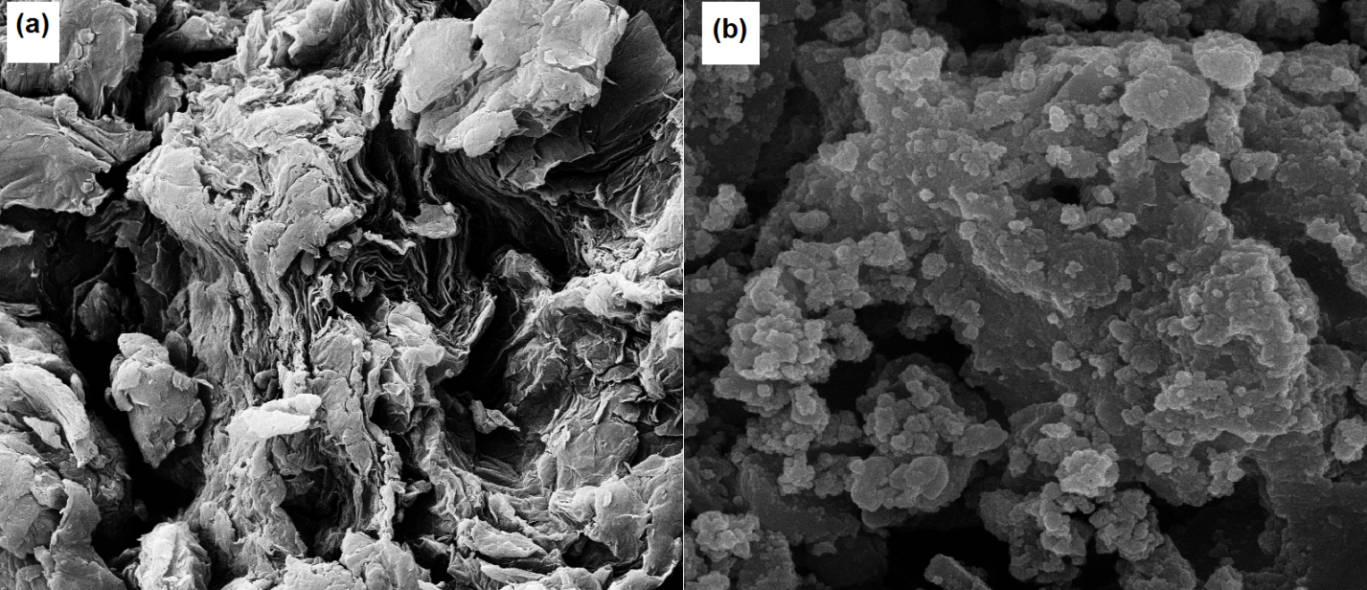
Fig. 5. SEM images a) GO and b) Fe₃O₄@GO-Pr-S/IL.

The thermal stability of the Fe₃O₄@GO-Pr-S/IL nanocatalyst was also investigated by thermal gravimetric analysis (TGA) (Fig. 6). TGA curve of nanocatalyst 1 shows three steps of weight loss between 25 and 900 °C. In this curve, the first weight loss below 220 °C (18%), is related to desorption of chemisorbed and physically adsorbed solvents and organic solvents and hydroxyl groups. The second weight loss occurs at around 220-550 °C (8%), which is due attributed to the decomposition of oxygen-containing groups in GO, organic groups, acid groups and amin groups. The last weight losses occur at 550-900 °C (10%) and may be due to removal of those immobilized organic species on the GO nanosheets surface and confirms the thermal stability of the prepared nanocatalyst.

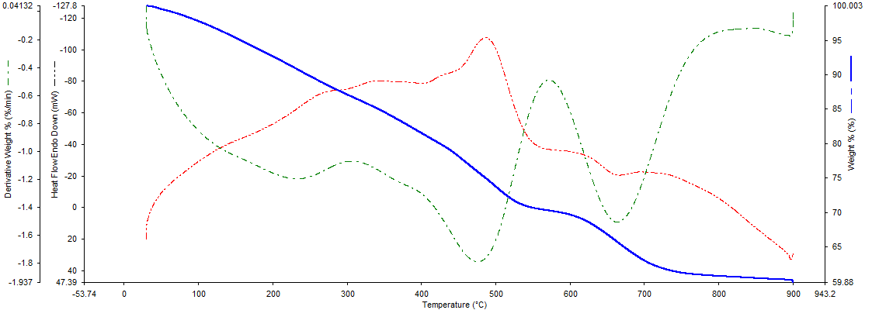
Fig. 6. TGA curve of Fe₃O₄@GO-Pr-S/IL.

In the next step, Fe₃O₄@GO-Pr-S/IL was applied as an effective nanocatalyst for the synthesis of triazolo[1,5-a]pyrimidine derivatives 5 (Scheme 2).
Scheme 2. Synthesis of triazolo[1,5-a]pyrimidine derivatives 5 in the presence of nanocatalyst 1.

Table 1 shows the effect of the catalyst amount, temperature and different solvents on the reaction between benzaldehyde (1 mmol), ethyl cyanoacetate (1 mmol) and 3-amine-1H-1,2,4-triazole (1 mmol) as a sample reaction. The model reaction was performed at different temperature which the best yield was obtained at 80 ºC. We have optimized the amount of the catalyst; maximum yield of the product was reported when 0.004 g of catalyst was used under solvent free condition. The yield of product was maximum when reaction proceed under solvent free condition and when EtOH, MeCN, Toluene, H₂O and H₂O/EtOH (1:1) were used as solvent, the yield of the product decreased. When GO, Fe₃O₄ and Fe₃O₄@GO were used as catalyst under solvent free conditions at 80 ºC, the yield of the product was much lower. The reaction did not proceed in the absence of a catalyst (Table 1, entry 16) which signified the necessity of the catalyst to promote the reaction. Following the optimization of the reaction conditions, the efficiency of Fe₃O₄@GO-Pr-S/IL nanocatalyst in the synthesis of triazolo[1,5-a]pyrimidines was further checked using a variety of aromatic aldehydes and malononitrile. The results are tabulated in Table 2 and it was found that almost all the substrates gave good to excellent yield of their desired products within a very short reaction time.

Table 1. The effect of catalyst loading, solvent and temperature in the synthesis of 5a.ª
Entry | Catalyst 1 (g) | Solvent | Temp. (°C) | Yield^{b} (%)
1 | 0.002 | - | 25 | 62
2 | 0.002 | - | 60 | 70
3 | 0.002 | - | 80 | 80
4 | 0.001 | - | 80 | 65
5 | 0.004 | - | 80 | 95
6 | 0.006 | - | 80 | 90
7 | 0.008 | - | 80 | 90
8 | 0.004 | EtOH | 80 | 80
9 | 0.004 | CH₃CN | 80 | 82
10 | 0.004 | Toluene | 80 | 70
11 | 0.004 | H₂O | 80 | 65
12 | 0.004 | H₂O/EtOH (1:1) | reflux | 75
13 | 0.004 | GO | 80 | 37
14 | 0.004 | Fe₃O₄ | 80 | 45
15 | 0.004 | Fe₃O₄@GO | 80 | 57
16 | - | - | 80 | trace
ªReaction conditions: benzaldehyde (1 mmol), ethyl cyanoacetate (1 mmol), 3-amine-1H-1,2,4-triazole (1 mmol), time: 20 min. ^{b}Isolated yields.

Table 2. Synthesis of triazolo[1,5-a]pyrimidines in the presence of Fe₃O₄@GO-Pr-S/IL nanocatalyst.ª
Entry | Aldehyde | Product 5 | Yield (%)^{b} | Mp (°C)
5a | C₆H₄CHO |  | 95 | 189-191^{c}
5b | 4-Cl C₆H₄CHO |  | 97 | 190-191⁷⁰
5c | 4-Br C₆H₄CHO |  | 93 | 184-184⁷⁰
5d | 4-NO₂ C₆H₄CHO |  | 95 | 194-196⁷⁰
5e | 3-NO₂ C₆H₄CHO |  | 90 | 190-192^{c}
5f | 2,4-Cl₂ C₆H₃CHO |  | 88 | 243-245^{c}
5g | 4-CH₃ C₆H₄CHO |  | 85 | 243-245⁷¹
5h | 4-i-Pr C₆H₄CHO |  | 84 | 218-220^{c}
5i | 4-NO₂ C₆H₄CHO |  | 90 | 245-247⁷¹
5j | 2-Cl C₆H₄CHO |  | 92 | 263-266⁷¹
5k | 4-Br C₆H₄CHO |  | 89 | 264-266⁷¹
5l | 4-Cl C₆H₄CHO |  | 93 | 257-258⁷¹
ªReaction conditions: arylaldehyde (1 mmol), ethyl cyanoacetate or malononitrile (1 mmol), 3-amine-1H-1,2,4-triazole (1 mmol), catalyst 1 (0.004 g), solvent-free, 80 °C. ^{b}Isolated yields. ^{c}Novel compound.

A admissible mechanism for the three component synthesis of triazolo[1,5-a]pyrimidines 5 based on antecedent reports^{70,71} has been shown in Scheme 3. Initially, the aldehyde and active methylene compounds (cyanoacetate or malononitrile), are activated with the acidic surface of the catalyst, and the Knoevenagel condensation occurs to give intermediate I. Then, the intermediate I reacts with 3-amine-1H-1,2,4-triazole to produce intermediate II (via the Michael addition). Finally, the desirable product was synthesized after an intramolecular cyclization and then tautomerization.
Scheme 3. Proposed mechanism for the synthesis of 5 in the presence of Fe₃O₄@GO-Pr-S/IL as catalyst.
Furthermore, a hot filtration test was performed in order to investigate the catalyst leaching during the course of the reaction. For this, after about 50% of process was completed, boiling EtOAc (5 mL) was added and the catalyst was separated by a magnet. Next, the solvent was removed, to the reaction was allowed to continue under optimized conditions, but no remarkable increment in product conversion was observed in the reaction progress indicating that the catalyst works as a heterogeneous method and the ionic liquid moiety was held intact and efficiently on the solid support. Furthermore, reusability of Fe₃O₄@GO-Pr-S/IL was studied in the model reaction of benzaldehyde, ethyl cyanoacetate and 3-amine-1H-1,2,4-triazole under optimum conditions. After the reaction was completed, boiling EtOAc was added and the catalyst was separated by an external magnet, washed and reused in the next runs. As shown in Fig. 7, the synthesized catalyst can be recovered and reused at least 7 runs without considerable decrease in its efficiency.

Fig. 7. Reusability of the heterogeneous nanocatalyst 1 for the synthesis of 5a.

In Fig.8, the FT-IR spectrum of the nanocatalyst after seven reuses can be seen. This spectrum also confirms the stability of the structure of the recycled nanocatalyst. Also, the XRD pattern (Fig. 9) clearly indicates the structural stability of the catalyst after being reused. The position and relative intensities of all peaks confirm this well.
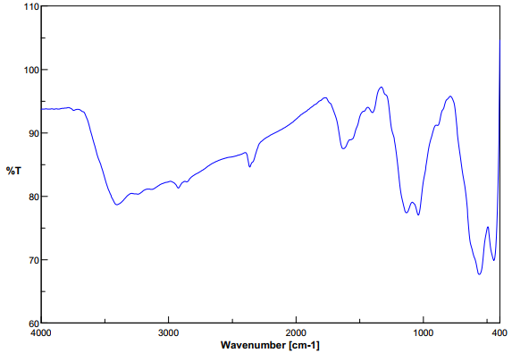
Fig. 8. FT-IR spectrum of recycled Fe₃O₄@GO-Pr-S/IL.

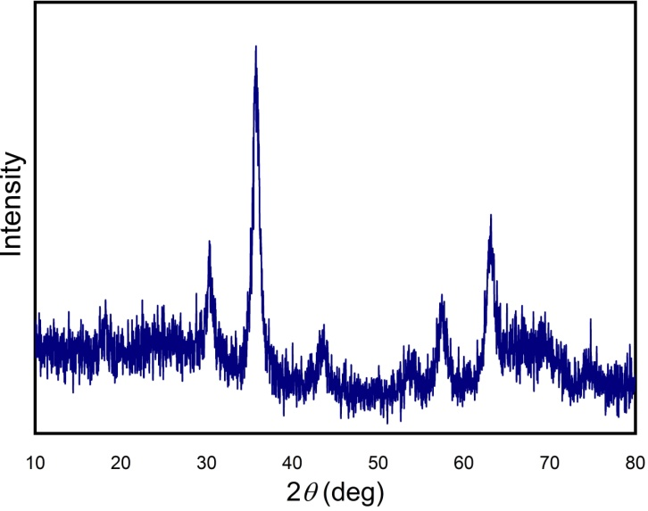
Fig. 9. The XRD pattern of recycled nanocatalyst 1.

- Conclusions
In this work, Fe₃O₄@GO-Pr-S/IL as a new nanocatalyst was prepared and used in the synthesis triazolo[1,5-a]pyrimidine derivatives under green conditions and gave the products in high yields. This magnetic nanocatalyst was characterized via utilizing various techniques such as XRD, FT-IR, EDX, SEM, VSM and TGA. Fe₃O₄@GO-Pr-S/IL was employed as efficient catalyst with good durability, high selectivity and stability, mild reaction conditions and short reaction times. Also, the Fe₃O₄@GO-Pr-S/IL heterogeneous catalyst was successfully recovered for seven times with keeping its activity.

References
- M. Tajbakhsh, H. Alinezhad, M. Norouzi, S. Baghery, M. Akbari, J. Mol. Liq. 2013, 177, 44-48. DOI: 10.1016/j.molliq.2012.09.017.
- J. Miao, H. Wan, G. Guan, Catal. Commun. 2011, 12, 353-356. DOI: 10.1016/j.catcom.2010.10.014.
- P. Elavarasan, S. Rengadurai, S. Upadhyayula, Adv. Chem. Eng. 2020, 4, 100045-100053. DOI: 10.1016/j.ceja.2020.100045.
- J. Miao, H. Wan, Y. Shao, G. Guan, B. Xu, J. Mol. Catal. A Chem. 2011, 348, 77-82. DOI: 10.1016/j.molcata.2011.08.005.
- A. R. Hajipour, F. Rafiee, Org. Prep. Proced. Int. 2010, 42, 285-362. DOI: 10.1080/00304948.2010.490177.
- A. S. Amarasekara, O. S. Owereh, Catal. Commun. 2010, 11, 1072-1075. DOI: 10.1016/j.catcom.2010.05.012.
- Z. M. Li, Y. Zhou, D. J. Tao, W. Huang, X. S. Chen, Z. Yang, RSC Adv. 2014, 4, 12160-12167. DOI: 10.1039/C4RA00092G.
- L. T. Oliveira, R. V. Goncalves, D. V. Goncalves, D. C. S. de Azevedo, S. M. Pereira de Lucena, J. Chem. Eng. Data 2019, 64, 2221-2228. DOI: 10.1021/acs.jced.8b01177.
- Q. Sun, B. Aguila, J. Perman, L. D. Earl, C. W. Abney, Y. Cheng, H. Wei, N. Nguyen, L. Wojtas, S. Ma, J. Am. Chem. Soc. 2017, 139, 2786-2793. DOI: 10.1021/jacs.6b12885.
- Q. Wang, S. Zhang, Y. Yu and B. Dai, Catal. Commun. 2020, 147, 106122-106142. DOI: 10.1016/j.catcom.2020.106122.
- M. A. Zolfigol, R. Ayazi-Nasrabadi, S. Baghery, V. Khakyzadeh, S. Azizian, J. Mol. Catal. A: Chem. 2016, 418, 54-67. DOI: 10.1016/j.molcata.2016.03.027.
- M. Sheykhan, L. Ma’mani, A. Ebrahimi, A. Heydari, J. Mol. Catal. A: Chem. 2011, 335, 253-261. DOI: 10.1016/j.molcata.2010.12.004.
- Q. Zhang, H. Su, J. Luo, Y. Wei, Green Chem. 2012, 14, 201-208. DOI: 10.1039/C1GC16031A.
- R. Li, Y. Jiang, J. Zhao, D. Ramella, Y. Peng, Y. Luan, RSC. Adv. 2017, 7, 34591-34597. DOI: 10.1039/C7RA06201J.
- M. Khoshnevis, A. Davoodnia, A. Zare-Bidaki, N. Tavakoli-Hoseini, Synth. React. Inorg. Met. 2013, 43, 1154-1161. DOI: 10.1080/15533174.2012.756897.
- M. L. Testa, V. La Parola, A. M. Venezia, Catal. Today 2010, 158, 109-113. DOI: 10.1016/j.cattod.2010.05.027.
- K. Niknam, A. Deris, F. Naeimi, F. Majleci, Tetrahedron Lett. 2011, 52, 4642-4645. DOI: 10.1016/j.tetlet.2011.06.105.
- S. V. Atghia, S. Sarvi-Beigbaghlou., J. Appl. Organomet. Chem. 2013, 745, 42-49. DOI: 10.1016/j.jorganchem.2013.07.033.
- E. Tabrizian, A. Amoozadeh, S. Rahmani, RSC Adv. 2016, 6, 21854-21864. DOI: 10.1039/C5RA20507G.
- J. Safari and M. Ahmadizadeh, J. Taiwan Inst. Chem. Eng. 2017, 74, 14-24. DOI: 10.1016/j.jtice.2016.12.010.
- C. Wang, B. Lin, G. Qiao, L. Wang, L. Zhu, F. Chu, T. Feng, N. Yuan, J. Ding, Mater. Lett. 2016, 173, 219-222. DOI: 10.1016/j.matlet.2016.03.057.
- B. Yin, X. Zhang, X. Zhang, J. Wang, Y. Wen, H. Jia, Q. Ji, L. Ding, Polym. Adv. Technol. 2016, 28, 293-302. DOI: 10.1002/pat.3886.
- K. Thakur, B. Kandasubramanian, J. Chem. Eng. Data 2019, 64, 833-867. DOI: 10.1021/acs.jced.8b01057.
- Y. Zhu, S. Murali, W. Cai, X. Li, J. W. Suk, J. R. Potts, R. S. Ruoff, Adv. Mater. 2010, 22, 3906-3924.‏ DOI: 10.1002/adma.201001068.
- S. Farhadi, M. Hakimi, M. Maleki, Acta Chim. Slov. 2017, 64, 1005-1019. DOI: 10.17344/acsi.2017.3731.
- W. Yu, L. Sisi, Y. Haiyana. L. Jie, RSC Adv. 2020, 10, 15328-15345. DOI: 10.1039/D0RA01068E.
- E. Doustkhah, S. Rostamnia, J. Colloid Interface Sci. 2016, 478, 280-287.‏ DOI: 10.1016/j.jcis.2016.06.020.
- F. Boorboor-Ajdari, E. Kowsari, A. Ehsani, M. Schorowski, T. Ameri, Electrochim. Acta 2018, 292, 789-804. DOI: 10.1016/j.electacta.2018.09.177.
- M. Tu, K. Wang, S. Bao, R. Zhang, Q. Tan, X. Kong, L. Yu, G. Wu, B. Xu. J. Colloid Interface Sci. 2022, 608, 1707-1717. DOI: 10.1016/j.jcis.2021.10.068.
- A. Omidvar, B. Jaleh, M. Nasrollahzadeh, H. RezaDasmeh, Chem. Eng. Res. Des. 2017, 121, 339-347. DOI: 10.1016/j.cherd.2017.03.026.
- L. H. Choudhury, T. Parvin, Tetrahedron 2011, 67, 8213-8228. DOI: 10.1016/j.tet.2011.07.020.
- T. Kaur, P. Wadhwa, S. Bagchi, A. Sharma, Chem. Commun. 2016, 52, 6958-6976. DOI: 10.1039/C6CC01562J.
- N. Kerru, L. Gummidi, S. Maddila, S. B. Jonnalagadda, Curr. Org. Chem. 2021, 25, 4-39.‏ DOI: 10.2174/1385272824999201020204620.
- K. Nikoofar, F. M. Yielzoleh, Curr. Org. Synth. 2022, 19, 115-147.‏ DOI: 10.2174/1570179418666210910111208.
- Y. Xiao, Q. Zhou, Z. Fu, L. Yu, J. Wang, Macromolecules 2022, 55, 2424-2432.‏ DOI: 10.1021/acs.macromol.1c02348.
- B. Alkan, O, Daglar, S. Luleburgaz, B, Gungor, U. S. Gunay, G. Hizal, U. Tunca, H. Durmaz, Polym. Chem. 2022,13, 258-266. DOI: 10.1039/D1PY01528A.
- S. S. Sajadikhah, F. Saeedi, H. Dehghan, Appl. Chem. 2022, 17, 169-178.‏ DOI: 10.22075/CHEM.2021.23425.1973.
- Z. Li, K. Qiu, X. Yang, W. Zhou, Q. Cai, Org. Lett. 2022, 24, 2989-2992. DOI: 10.1021/acs.orglett.2c00863.
- S. Yuan, S. Wang, M. Zhao, D. Zhang, J. Chen, J. X. Li, J. Zhang, Y. Song, J. Wang, B. Yu, H. Liu, Chin. Chem. Lett. 2020, 31, 349-352.‏ DOI: 10.1016/j.cclet.2019.07.019.
- S. Lahmidi, H. Anouar, M. Hafi, M. Boulhaoua, A. Ejjoummany, M. Jemli, M. Essassi, J. T. Mague, J. Mol. Struct. 2019, 1177, 131-142. DOI: 10.1016/j.molstruc.2018.09.046.
- P. N. Kalaria, S. C. Karad, D. K. Raval, Eur. J. Med. Chem. 2018, 158, 917-936. DOI: 10.1016/j.ejmech.2018.08.040.
- A. Ziyaei-Halimehjani, I. N. N. Namboothiri, S. E. Hooshmand, RSC Adv. 2014, 4, 48022-48084. DOI: 10.1039/C4RA08828J.
- Y. Huang, J. Liao, W. Wang, H. Liu, H. Guo, Chem. Commun. 2020, 56, 15235-15281.‏ DOI: 10.1039/D0CC05699E.
- Y. Zheng, X. Qi, S. Chen, S. Song, Y. Zhang, K. Wang, Q. Zhang, ACS Appl. Mater. Interfaces 2021, 13, 28390-28397.‏ DOI: 10.1021/acsami.1c07558.
- L. G. do Nascimento, I. M. Dias, G. B. de Souza, L. C. Mourão, M. B. Pereira, J. C. V. Viana, L. M. Lião, G. R. de Oliveira, C. G. Alonso, New J. Chem. 2022, 46, 6091-6102.‏ DOI: 10.1039/D1NJ04686A.
- S. Prakash, N. Elavarasan, A. Venkatesan, K. Subashini, M. Sowndharya, V. Sujatha, Adv Powder Technol. 2018. 29. 3315-3326.‏ DOI: 10.1016/j.apt.2018.09.009.
- S. Akrami, B. Karami, M. Farahi, RSC Adv. 2017, 7, 34315-34320. DOI: 10.1039/C7RA06240K.
- F. Motamedi-Nia, M. Farahi, B. Karami, R. Keshavarz, Lett. Org. Chem. 2021 18, 407-414. DOI: 10.2174/1570178617999200807214103.
- K. Fattahi, M. Farahi, B. Karami, R. Keshavarz, Bulg. Chem. Commun. 2021, 53, 174-179. DOI: 10.34049/bcc.53.2.5307.
- H. Mohamadi-Tanuraghaj, M. Farahi, Monatsh. Chem. 2019, 150, 1841-1847. DOI: 10.1007/s00706-019-02471-x.
- H. Mohamadi-Tanuraghaj, M. Farahi, RSC Adv. 2018, 8, 27818-27824. DOI: 10.1039/c8ra05501g.
- J. E. Gholtash, M. Farahi, RSC Adv. 2018, 8, 40962-40967. DOI: 10.1039/C8RA06886K.

H. Mohamadi-Tanuraghaj, M. Farahi, New J. Chem. 2019, 43, 4823-4829. DOI: 10.1039/C8NJ06415F.

B. Karami, M. Farahi, S. Akrami, D. Elhamifar, New J. Chem. 2018, 42, 12811-12816. DOI: 10.1039/C8NJ02699H.

B. Karami, M. Farahi, Z. Banaki, Synlett 2015. 26, 1804-1807. DOI: 10.1055/s-0034-1380677.

M. Farahi, B. Karami, R. Keshavarz, F. Khosravian, RSC Adv. 2017. 7, 46644-46650. DOI: 10.1039/C7RA08253C.
- H. Zhang, X. Wang, Na. Li, J. Xia, Q. Meng, J. Ding, J. Lu, RSC Adv. 2018, 8, 34241-34251. DOI: 10.1039/C8RA06681G.
- O. Metin, S. Aydoğan, K. Meral, J. Alloys Compd. 2014, 585, 681-688.‏ DOI: 10.1016/j.jallcom.2013.09.159.
59. G. Vinodha, P. D. Shima, L. Cindrella, J. Mater. Sci. 2019, 54, 4073-4088.‏ DOI: 10.1007/s10853-018-3145-z.
60. T. Guo, C. Bulin, B. Li, Z. Zhao, H. Yu, H. Sun, H. B. Zhang, Adsorpt. Sci. Technol. 2018, 36, 1031-1048. DOI: 10.1177/0263617417744402.
61. G. He, W. Liu, X. Sun, Q. Chen, X. Wang, H. Chen, Mater. Res. Bull. 2013, 48, 1885-1890. DOI: 10.1016/j.materresbull.2013.01.038.
62. S. Feng, Z. Ni, S. Feng, Z. Zhang, S. Liu, R. Wang, J. Hu, J. Radioanal. Nucl. Chem. 2019, 319, 737-748. DOI:10.1007/s10967-018-6379-y.
63. Q. Zhang, H. Su, J. Luo, Y. We, Green Chem. 2012, 14, 201-208. DOI:10.1039/C1GC16031A.
64. H. Zhang, H. Li, H. Pan, A. Wang, S. Souzanchi, C. Xu, S. Yang, Appl. Energy 2018, 223, 416-429. DOI: 10.1016/j.apenergy.2018.04.061.
65. K. Qiao, H. Hagiwara, C. Yokoyama, J. Mol. Catal. A: Chem. 2006, 246, 65-69. DOI: 10.1016/j.molcata.2005.07.031.
66. M. Yadav, K. Y. Rhee, S. J. Park, D. Hui, Compos. B. Eng. 2014, 66, 89-96. DOI: 10.1016/j.compositesb.2014.04.034.
67. S. F. Hojati, A. Amiri, M. Mahamed, Res. Chem. Intermed. 2020, 46, 1091-1107. DOI: 10.1007/s11164-019-04021-w.
68. X. Yang, W. Chen, J. Huang, Y. Zhou, Y. Zhu, C. Li, Sci. Rep. 2015, 5, 1-10.‏ DOI: 10.1038/srep10632.
69. N. Patel, D. Katheriya, H. Dadhania, A. Dadhania, Res. Chem. Intermed. 2019, 45, 5595-5607. DOI: 10.1007/s11164-019-03922-0.
70. L. Zaharani, N. Ghaffari-Khaligh, T. Mihankhah, M. R. Johan, N. A. Hamizi, Can. J. Chem. 2020, 98, 630-634. DOI: 10.1139/cjc-2020-0145.
71. M. Singh, S. Fatma, P. Ankit, S. B. Singh, J. Singh, Tetrahedron Lett. 2014, 55, 525-527. DOI: 10.1016/j.tetlet.2013.11.090.

