Supplementary Material
Table 1. Components and their properties used in the design of DES for the ultrasonic-assisted extraction of Rosa canina L. fruits
DES/No. | HBA | Chemical formula | HBD | Chemical formula | pH
DES 1 | Citric acid | C₆H₈O₇ | Glycerol | C₃H₈O₃ | 1.5
DES 2 | Citric acid | C₆H₈O₇ | Ethylene glycol | C₂H₆O₂ | 1.0

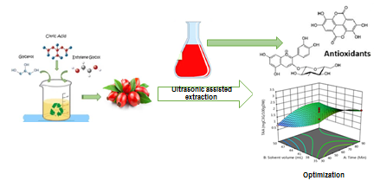

Figure 1. Design experiments

Table 2. Operation parameters of the ultrasonic-assisted extraction of Rosa canina L. fruits
Independent parameter | Unit | Symbol | Levels with the codes  −1 0 +1
Time | Min | A | 30 60 90
Solvent volume | mL | B | 35 42.5 50
Water content | %, v/v | C | 10 30 50

Figure 2. Comparative results of the selected DES on the performance of ultrasonic-assisted extraction of Rosa canina L. fruits

Table 3. Effects of operation factors on the responses of Rosa canina L. fruits extract obtained by ultrasonic-assisted extraction
Run | Factor 1  A:Time  (Min) | Factor 2  B: Solvent volume (mL) | Factor 3  C: Water content (%, v/v) | Response 1  TPC (mg GAE/gDW) | Response 2  TAA mgC3G/100gDW) | Response 3  DPPH (inhibition %)
1 | 60 | 35 | 50 | 90.66$±$0.01 | 2.5±0.02 | 102.77±0.01
2 | 60 | 42.5 | 30 | 98.44±0.03 | 3.25±0.03 | 95.01±0.01
3 | 30 | 50 | 30 | 106.72±0.03 | 2.41±0.02 | 101.65±0.02
4 | 90 | 50 | 30 | 105.64±0.02 | 2.46±0.02 | 101.15±0.03
5 | 60 | 42.5 | 30 | 95.66±0.01 | 1.53±0.01 | 101.61±0.03
6 | 30 | 35 | 30 | 102.21±0.02 | 1.57±0.01 | 93.36±0.04
7 | 60 | 50 | 50 | 104.19±0.03 | 2.62±0.02 | 99.43±0.02
8 | 60 | 42.5 | 30 | 95.61±0.04 | 1.8±0.01 | 103.66±0.02
9 | 30 | 42.5 | 10 | 101.49±0.01 | 2.23±0.02 | 101.24±0.01
10 | 30 | 42.5 | 50 | 105.12±0.03 | 2.03±0.03 | 99.77±0.03
11 | 60 | 42.5 | 30 | 92.94±0.04 | 1.92±0.03 | 97.03±0.01
12 | 90 | 35 | 30 | 96.96±0.04 | 0.84±0.01 | 99.62±0.01
13 | 90 | 42.5 | 50 | 101.06±0.02 | 2.07±0.01 | 98.07±0.02
14 | 90 | 42.5 | 10 | 101.29±0.01 | 2.01±0.02 | 107.75±0.01
15 | 60 | 50 | 10 | 98.32±0.02 | 2.89±0.02 | 101.10±0.02
16 | 60 | 35 | 10 | 104.86±0.02 | 2.10±0.01 | 101.23±0.01
17 | 60 | 42.5 | 30 | 98.50±0.01 | 0.98±0.01 | 103.51±0.03

Table 4. Analysis of variance test for the Box-Behnken design for the ultrasonic-assisted extraction for TPC, TAA and %DPPH
Source Sum of squares df Mean square F value p value
TPC Model 302.04 9 33.56 5.32 0.0192
A-Time 13.97 1 13.97 2.22 0.0102
B-Solvent volume 50.95 1 50.95 8.08 0.0249
C-Water content 3.04 1 3.04 0.4817 0.5100
AB 4.34 1 4.34 0.6886 0.4340
AC 3.74 1 3.74 0.5928 0.4665
BC 100.72 1 100.72 15.97 0.0052
A² 92.65 1 92.65 14.69 0.0064
B² 16.17 1 16.17 2.57 0.1533
C² 7.32 1 7.32 1.16 0.3169
Residual 44.13 7 6.30
Lack of fit 22.59 3 7.53 1.40 0.3658
Pure error 21.55 4 5.39
Cor total 346.17 16

TAA Model 3.03 9 0.3370 0.7472 0.0257
A-Time 0.0925 1 0.0925 0.2050 0.6644
B-Solvent volume 1.42 1 1.42 3.15 0.0493
C-Water content 0.0000 1 0.0000 0.0000 0.0259
AB 0.1521 1 0.1521 0.3373 0.5796
AC 0.0169 1 0.0169 0.0375 0.8520
BC 0.1122 1 0.1122 0.2489 0.6332
A² 0.2830 1 0.2830 0.6275 0.4543
B² 0.1414 1 0.1414 0.3135 0.5930
C² 0.8460 1 0.8460 1.88 0.2131
Residual 3.16 7 0.4510
Lack of fit 0.3407 3 0.1136 0.1613 0.9171
Pure error 2.82 4 0.7040
Cor total 6.19 16

DPPH Model 83.39 9 9.27 0.6531 0.0299
A-Time 13.98 1 13.98 0.9852 0.3540
B-Solvent volume 5.04 1 5.04 0.3555 0.0298
C-Water content 15.91 1 15.91 1.12 0.0348
AB 11.42 1 11.42 0.8051 0.3994
AC 16.86 1 16.86 1.19 0.3117
BC 2.58 1 2.58 0.1818 0.6826
A² 0.4300 1 0.4300 0.0303 0.8667
B² 3.38 1 3.38 0.2379 0.6406
C² 14.61 1 14.61 1.03 0.3439
Residual 99.30 7 14.19
Lack of fit 37.36 3 12.45 0.8044 0.5532
Pure error 61.93 4 15.48
Cor total 182.68 16

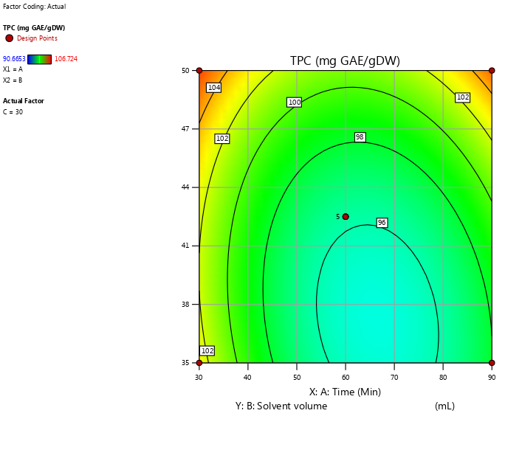
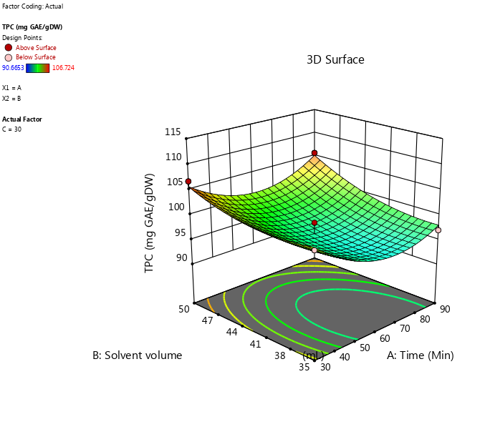

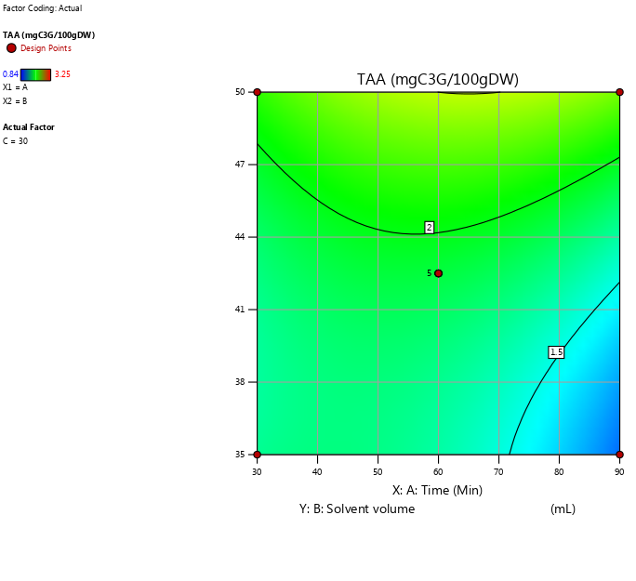
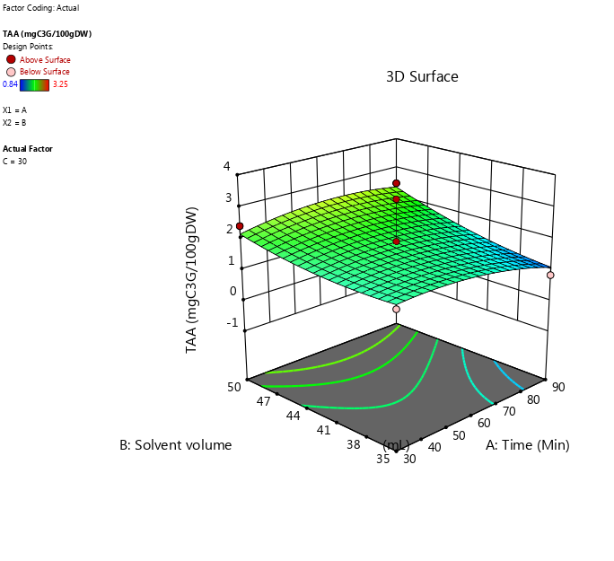
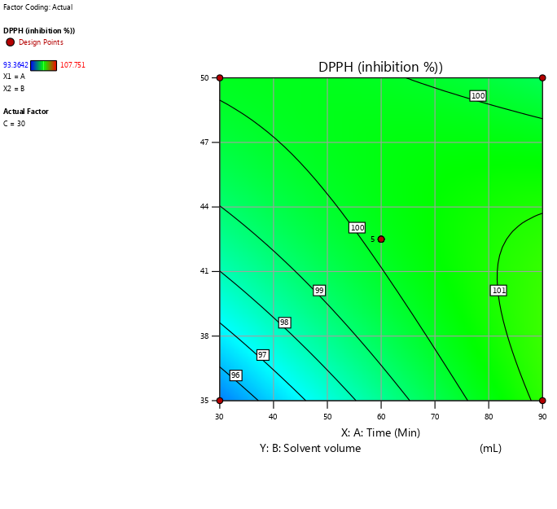
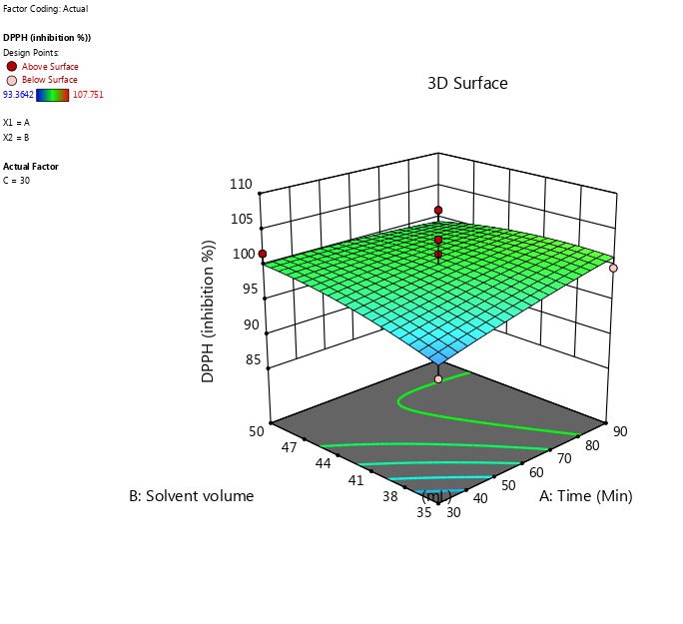
Figure 3. A two-dimensional contour plots and three-dimensional response surface of TPC, TAA, and DPPH as a function of time (min) and solvent volume (mL)

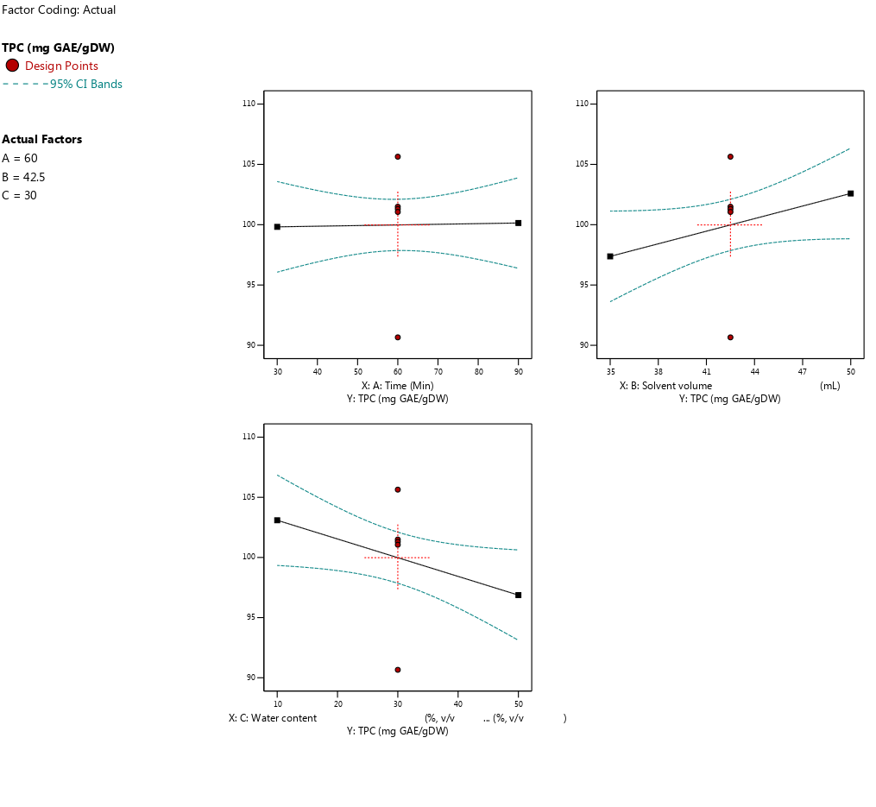
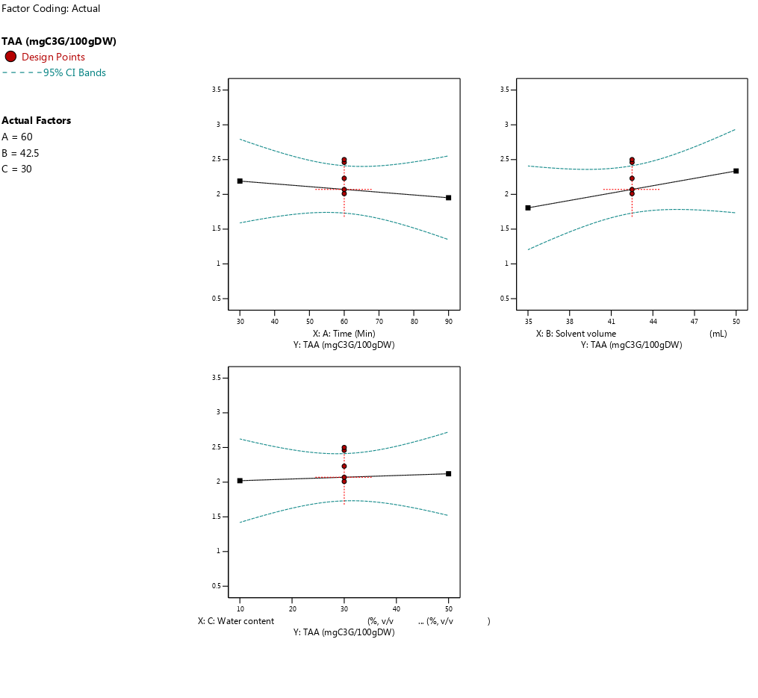
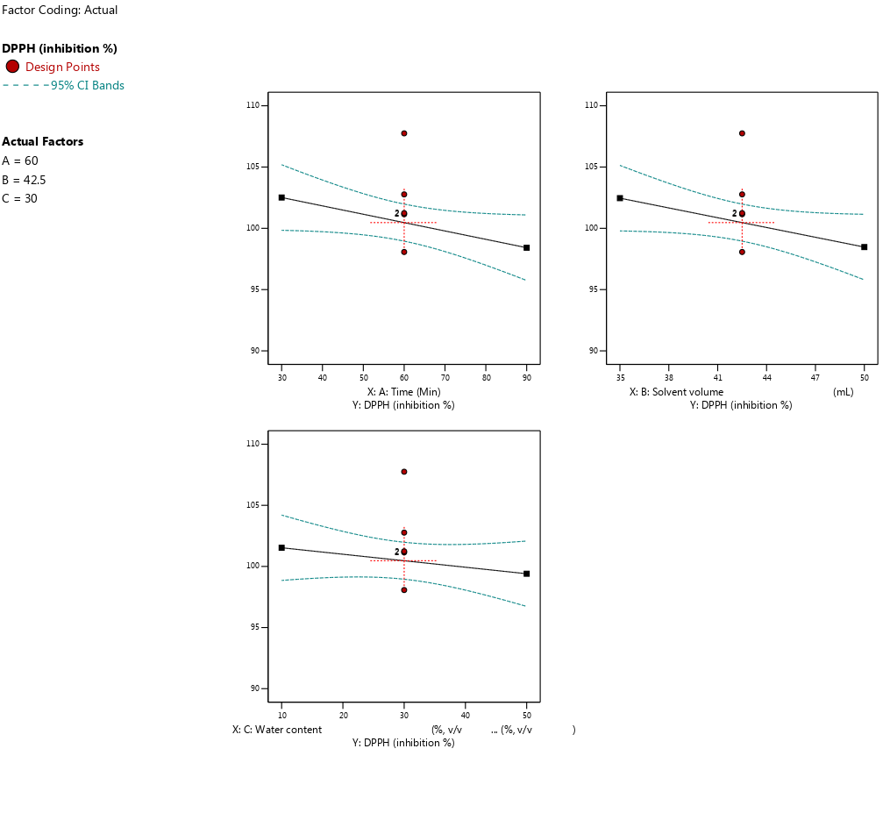
Figure 4. The effect of DES extraction parameters (Time, solvent volume, water content) on TPC, TAA, and DPPH

