Environmentally Friendly Extraction of Bioactive Compounds from Rosa canina L. fruits Using Deep Eutectic Solvent (DES) as Green Extraction Media

Hyrije Koraqi ^{1,2,}*, Bujar Qazimi¹, Cengiz Çesko² and Anka Trajkovska Petkoska³
¹Faculty of Pharmacy, UBT-Higher Education Institution, St. Rexhep Krasniqi No.56,10000 Pristina, Kosovo
²Faculty of Food Science and Biotechnology, UBT-Higher Education Institution, St. Rexhep Krasniqi No.56,10000 Pristina, Kosovo
³Faculty of Technology and Technical Sciences, St. Clement of Ohrid University of Bitola, Dimitar Vlahov, 1400 Veles, Republic of North Macedonia
* Corresponding author: E-mail: hyrie.koraqi@ubt-uni.net
Phone: +383 38 541 400 Fax: +383 38 542 138

Abstract
In this study, the green extraction of Bioactive compounds and antioxidant activity from Rosehip (Rosa canina L.) fruits was investigated using ultrasound-assisted extraction combined with deep eutectic solvents (DES). A Deep eutectic solvent-based on citric acid has been specially designed. Hydrogen bond donor (HBD) such as glycerol and ethylene glycol were used and a hydrogen bond acceptor (HBA) like citric acid was used. After choosing the best option of DES, extraction of the bioactive ingredients, optimal extraction conditions of the ultrasonic-assisted extraction have been optimized through Box-Behnken design of response surface methodology (RSM). Total phenolics content (TPC), total anthocyanins content (TAA), and antioxidant activity against 2,2-diphenyl-1-picrylhydrazyl (DPPH) have been found as 103.37 mg GAE/g DW in DES2, 92.23 mg GAE/g DW in DES1, 3.25mg C3G/100g-DW in DES2,1.31 mg C3G/100g-DW in DES1, and 101.85% Inhibition in DES2, 94.32 %.The results showed that this method is a competitive sustainable, green, and effective extraction of bioactive compounds from Rosehip (Rosa canina L.) fruits.
Keywords: Rosa canina L. fruits, deep eutectic solvent, Green extraction, Antioxidant activity, Experimental design
1. Introduction
Rosa canina L, which is also known as Rosehip, is a member of the Rosaceae family and the genus Rosa which comprises nearly 200 species that are naturally distributed almost in many countries such as Europe, Asia, the Middle East, and North America.¹⁻³ In Kosovo, Rosa canina L. fruits are found in all areas of the country and are traditionally used for food or medical purposes. Functional foods or food supplements including herbal food supplements and nutraceuticals that can protect humans from oxidative stress and several diseases have attracted worldwide interest. Rosa canina L. fruits, are known as plant rich with phenolic compounds that act as natural antioxidants, flavonoids, anthocyanins, high vitamin C content, as well as contains vitamin A, B₁, B₂, B₆, D, E, and K, organic acids such as citric acid, malic acid, carotenoids, sugars, mineral elements and fiber.⁴⁻⁶ Rosa canina L. is remarkable fruit that is a rich source of biologically active compounds with pharmacological features. Moreover, it is used for a wide variety of purposes like protection of health and therapy in flu, infections, protect the kidneys from oxidative stress, antidiabetic, antimicrobial, inflammatory diseases, and chronic pains. Also, it is known for its chemoprevention, antioxidant, antimutagenic, and anticarcinogenic activities. As well has beneficial implications for skincare and antiulcer treatments.^{7,8} Due to the above-mentioned properties, Rosa canina L. fruits are commonly used in the food, pharmaceutical, and cosmetic industries. Namely, it could be, used as food and drink such as tea, marmalades, jellies, and jams; however, it has recently been utilized as an ingredient in probiotic drinks, yogurts, and soups as health supplements.⁴ In the scientific literature, there is still lack of information on phenolic compounds, flavonoids and the antioxidant activity of Rosa canina L. fruits. Novel applications are given in a very limited number of studies mainly on the extraction of phenolic compounds and antioxidant activity based on solid-liquid extraction with traditional organic solvents (methanol, ethanol, acetone, ethyl acetate, etc.) and water/organic solvent mixtures have been used to extract the bioactive components from Rosa canina L. fruits. However, organic solvents possess some drawbacks such as toxicity, volatility, non-degradability, flammability, and are with relatively high price, but at the same time their use in the extraction process has potential risks to both human health and the environment.^{9,10} From the point of view of Green Chemistry several studies have been conducted to overcome these issues by replacing conventional organic solvents with deep eutectic solvents (DES) as a new generation of eco-friendly solvents.¹¹⁻¹³ Therefore, a recent ionic liquid has been developed and entitled as deep eutectic solvent (DES). DES are designable solvents formed by molecular interactions, especially hydrogen bonds.¹⁴ 2 or 3 inexpensive materials such as organic acids, polyols, sugars, amines, and quaternary ammonium salts.¹⁵ Ultrasound-assisted extraction (UAE) is a novel extraction method known for being efficient and environmentally friendly. The frequency of the ultrasonic bath has a significant effect on the extraction process. Ultrasound irritation helps to reduce reaction time and increase mass transfer during this operation. In addition, ultrasound allows greater penetration of the solvent into the food matrix, which increases the contact surface area between solid and liquid phases.¹⁶ In the current study, DES containing hydrogen bond donors (polyol) and hydrogen bond acceptor (organic acid) has been synthesized and used for total phenolic content, total flavonoid content, anthocyanin content, and antioxidant activity from Rosa canina L. fruits using UAE. After the determination of the best designed DES, the UAE experiments were designed by Box-Behnken design (BBD) along with response surface methodology (RSM). To the best of our knowledge, there is no report on the green extraction of antioxidant phenolic compounds from Rosa canina L. fruits using this combination of UAE-DES. Thus, the main objectives of this study are (i) to evaluate the most effective solvent to extract phenolic compounds from Rosa canina L. fruits, (ii) to screen significant extraction variables in UAE-DES using a Box-Behnken design (BBD) along with response surface methodology (RSM), and (iii) to quantify the phenolic compounds and antioxidant activity of the Rosa canina L. extract at optimum conditions.
2. Materials and methods
2.1. Plant material
Rosa canina L. fruits were collected during September 2021 from the spontaneous flora of the central part of Kosovo. Rosehips were washed several times with tap water and dried at room temperature. The fruits were immediately transferred to the laboratory in polyethylene bags and stored at –4°C until analysis.
2.2. Chemical materials
All chemicals used in experiments were analytical grade. Ethanol was provided from Alkaloid (Skopje, North Macedonia). Folin–Ciocalteu reagent, citric acid, glycerol, ethylene glycol, sodium carbonate, and gallic acid were purchased from Sigma–Aldrich (Germany).
2.2. Extract preparation
Ultrasound-assisted extraction was conducted in a digital ultrasonic bath at 25 ◦C. Rosehip fruits (500 mg) and solvent were sealed in an Erlenmeyer flask and placed into the digital ultrasonic bath. The extract was centrifuged at 5000×g for 25 min. After centrifugation, the supernatant was filtered through a 0.45 μm syringe and stored at −4 ◦C until analysis.
2.3. Preparation of Deep eutectic solvent-DES
A hydrogen bond acceptor (HBA) and a hydrogen bond donor (HBD) were dried at 45◦C for 24 h before use. Before were mixed along with heating at 80 °C by a magnetic stirrer. When a homogeneous liquid was observed, the acidity of the liquids was measured by a pH meter. The appropriate molar ratio of the used solvents, was weight and it is listed in table 1. The prepared DES compositions were stored in a desiccator to prevent moisture absorption until further analysis.
Table 1. Components and their properties used in the design of DES for the ultrasonic-assisted extraction of Rosa canina L. fruits
DES/No. | HBA | Chemical formula | HBD | Chemical formula | pH
DES 1 | Citric acid | C₆H₈O₇ | Glycerol | C₃H₈O₃ | 1.5
DES 2 | Citric acid | C₆H₈O₇ | Ethylene glycol | C₂H₆O₂ | 1.0

2.4. Experimental designs
2.4.1. Screening of solvents
In the initial screening of the extraction efficiencies of the solvents, the Rosa canina L. fruits samples (500 mg) were mixed with the selected solvents (5 mL). Other parameters were kept constant in accordance with the concept that one factor at a time approach will be changed. The extraction of phenolic compounds was conducted at 40 ◦C for 30 min with an ultrasound amplitude of 20 %. The supernatant phase was collected after centrifugation at 10,000xg for 10 min. The extracts were stored at -4 ◦C under dark conditions dark.
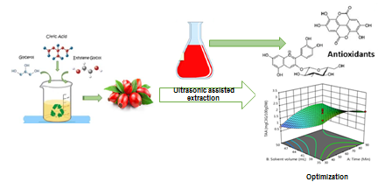
Figure 1. Design experiments
2.5 Determination of bioactive properties and antioxidant activity (TPC, TAA, DPPH)
Total phenolics content (TPC) was determined by Folin Ciocalteu Reagent spectrophotometrically at 765 nm using the method of Singleton et al. (1999),¹⁷ with some modifications reported Koraqi and Lluga-Rizani (2022)¹⁸. The results are presented as mg gallic acid (mg GAE/g DW) equivalent per gram Rosa canina L. fruits sample. Total anthocyanin analysis (TAA) was conducted by the pH differential method reported by Lee et al. (2005)¹⁹ with some modifications.²⁰ TAA is based on the measurement of the absorbance of the anthocyanins, which depends on the pH alteration (pH 1.0 and pH 4.5). The wavelength was adjust to 700 nm. As for Total anthocyanin content, is presented as mg cyaniding-3-glucoside (mg C3G/g DW) equivalent per gram Rosa canina L. fruits. Regarding antioxidant activity against a free radical,the 2,2-diphenyl-1-picrylhydrazyl (DPPH) test was applied at 517 nm.²¹ Inhibition power of the extracts towards DPPH radical is stated as a percentage (% inhibition), equation 1:
Antioxidant activity % inhibition of DPPH = [(A_{control} − A_{sample})/ A_{contro}l] × 100 (1)
A_{control} represents the absorbance of the diluted DPPH solution, and A_{sample} represents the absorbance of the sample.
2.6. Statistical analysis
The differences among extraction solvents were determined using analysis of variance (ANOVA), followed by Duncan tests (SPSS 22 package program for Windows, Chicago, IL, USA). Statistical significance was defined at a 95 % confidence level. Design Expert v13.0 trial software (Stat-Ease, USA) was used for the construction of experimental designs (BBD and RSA), regression analysis of experimental data, and plotting of 3D response surface graphs. ANOVA test was used to assess the statistical significance of the regression coefficient by F-test at 95 % confidence level. The adequacy of the fitted polynomial model was expressed by the coefficient of determination (R²) and lack of fit test.
3. Results and discussion
3.1. Comparison of the Deep eutectic solvent (DES)
Citric acid-based DES has been synthesized with polyol HBD such as glycerol and ethylene glycol. Figure 2 shows that the superior yield for all dependent variables (DPPH, TPC, and TAA) has been gained by the citric acid/ethylene glycol combination. Hrnčič et al. (2019)²² extracted Rosa canina L. fruits with conventional solvents (methanol solution-MeOH and water), where TPC and DPPH changed between 8.13 mg GAE/g extract and 9.01 % DPPH Inhibition, respectively. Our results for TPC were 13 times better, whilst our phenolic quantity was almost twice compared to those of the previous studies. Su et al. (2007)²³ also reported a poorer value of TPC lower than 5.09 mg GAE/g in 50% acetone extract and 2.57 mg GAE/g in 80% methanolic extract. Furthermore, Fascella et al. (2019)²⁴ declared a lower value of TPC (6784.5 mg GAE/100 g DW), a similar value with our results for TAA (3.86 mg CGE/100g DW) and antioxidant activity DPPH IC₅₀(80.8%) against DPPH radical when they extracted Rosa canina L. fruits with traditional extraction method through the water.IC₅₀ values in the DPPH assay correspond to lower antioxidant activity, and vice versa.²⁴Lower value of TPC in ethanolic extract (40%-70% EtOH) has been reported by Ilbay et al.(2013)¹⁶ as well, 47.23 mg GAE/g DW in optimal conditions (40% EtOH,temp.50˚C, time 81.23 min.). Bozhuyuk et al. (2021)²⁵ reported similar results with conventional solvents as TPC (390-532 mg GAE/100g DW; TAA 3.62-7.81 mg/kg) extracted from Rosa canina L. fruits.Our findings for TPC were higher in comparison with these studies.Even though both of the DES mixtures surpassed the conventional solvents reported in the literature, citric acid/ethylene glycol formulation was the best one. This is a matter of viscosity.²⁶ Since ethylene glycol is a less viscous liquid than glycerol, its mixture with citric acid has been shown better due to its diffusion into the plant matrix.²⁷ After the success of the citric acid/ethylene glycol, a statistical experimental design study was performed. In order to achieve a clearer and more fluid liquid, water addition into the DES system is a good addition to rising polarity.²⁷ Hence, the water content in the DES has been chosen as a process variable for the ultrasonic-assisted extraction of Rosa canina L. fruits (Table 2).
3.2 Box-Behnken design and modeling of ultrasonic-assisted extraction
After the success of the citric acid/ethylene glycol, a statistical experimental design study was performed. In order to achieve a clearer and more fluid liquid, water addition into the DES system is a must in addition to rising polarity.²⁷ Hence, the water content in the DES has been chosen as a process variable for the UAE of Rosa canina L. fruits (Table 2). Table 3 gives the content of TPC, TAA, and DPPH obtained by UAE under several process conditions. Table 4 summarizes the statistical outcome of the current system depending on the ANOVA test of BBD through RSM. The final equation in terms of coded factors for TPC (Response 1) is given as equation 2:
TPC =96.23-1.32A+2.52B-0.6162C+1.04AB-0.9666AC+5.02BC+4.69A²+1.96B²+1.32C² (2)
Table 2. Operation parameters of the ultrasonic-assisted extraction of Rosa canina L. fruits
Independent parameter | Unit | Symbol | Levels with the codes  −1 0 +1
Time | Min | A | 30 60 90
Solvent volume | mL | B | 35 42.5 50
Water content | %, v/v | C | 10 30 50

Figure 2. Comparative results of the selected DES on the performance of ultrasonic-assisted extraction of Rosa canina L. fruits
F 5.32 and p-value 0.0192 for the model are indications of the significance of the model. Regarding process parameters, if the p-value is less than 0.05 (p < 0.05), it means that the terms of the model are significant. Time of UAE was the most influential parameter, followed by solvent quantity (p < 0.05). Effects of interactions between the variables were also found statistically important (p < 0.05). According to the ANOVA test, R² was found as 0.9702, whilst adjusted-R² was 0.9086. That means that there is a convincing relationship between the experimental and calculated data as seen in Figure 3. The quadratic polynomial model derived from the BBD of RSM for TAA (response 2) is given in Equation 3:
TAA=1.90-0.1075A+0.4213B-0.0013C+0.1950AB+0.0650AC-0.1675BC-0.2593A²+0.1833B²+0.4482C² (3)
Similarly, the model was statistically significant to represent the experimental data based on the F and p values (Table 4). The most influential parameter was solvent volume (v/v) of DES (p < 0.05). However, water addition into the DES solution was not a statistically significant process parameter depending on the ANOVA test results (p > 0.05). A satisfactory relationship was also observed between the experimental and calculated data for response 2 (Figure), where R² and adjusted-R² were 0.9649 and 0.9198, respectively. The second-order equation in terms of coded factors for response 3 is given in Equation 4:
DPPH = 100.17+1.32A+0.7940B-1.41C-1.69AB-2.05AC-0.8030BC-0.3196A²-0.8954B²+1.86C² (4)
The equation derived for DPPH was statistically important for making estimations about the response for given levels of each factor as seen in Table 4. Time of UAE was the most effective independent factor, followed by solvent volume (p < 0.05). Unexpectedly, the amount of water in the extractant system was not a statistically effective process parameter (p > 0.05). As already seen in Figure, there is a convincing relationship between the actual and estimated results. Depending on the ANOVA findings, R² was found as 0.9780, whereas adjusted-R² was 0.9326.
Table 3. Effects of operation factors on the responses of Rosa canina L. fruits extract obtained by ultrasonic-assisted extraction
Run | Factor 1  A:Time  (Min) | Factor 2  B: Solvent volume (mL) | Factor 3  C: Water content (%, v/v) | Response 1  TPC (mg GAE/gDW) | Response 2  TAA mgC3G/100gDW) | Response 3  DPPH (inhibition %)
1 | 60 | 35 | 50 | 90.66$±$0.01 | 2.5±0.02 | 102.77±0.01
2 | 60 | 42.5 | 30 | 98.44±0.03 | 3.25±0.03 | 95.01±0.01
3 | 30 | 50 | 30 | 106.72±0.03 | 2.41±0.02 | 101.65±0.02
4 | 90 | 50 | 30 | 105.64±0.02 | 2.46±0.02 | 101.15±0.03
5 | 60 | 42.5 | 30 | 95.66±0.01 | 1.53±0.01 | 101.61±0.03
6 | 30 | 35 | 30 | 102.21±0.02 | 1.57±0.01 | 93.36±0.04
7 | 60 | 50 | 50 | 104.19±0.03 | 2.62±0.02 | 99.43±0.02
8 | 60 | 42.5 | 30 | 95.61±0.04 | 1.8±0.01 | 103.66±0.02
9 | 30 | 42.5 | 10 | 101.49±0.01 | 2.23±0.02 | 101.24±0.01
10 | 30 | 42.5 | 50 | 105.12±0.03 | 2.03±0.03 | 99.77±0.03
11 | 60 | 42.5 | 30 | 92.94±0.04 | 1.92±0.03 | 97.03±0.01
12 | 90 | 35 | 30 | 96.96±0.04 | 0.84±0.01 | 99.62±0.01
13 | 90 | 42.5 | 50 | 101.06±0.02 | 2.07±0.01 | 98.07±0.02
14 | 90 | 42.5 | 10 | 101.29±0.01 | 2.01±0.02 | 107.75±0.01
15 | 60 | 50 | 10 | 98.32±0.02 | 2.89±0.02 | 101.10±0.02
16 | 60 | 35 | 10 | 104.86±0.02 | 2.10±0.01 | 101.23±0.01
17 | 60 | 42.5 | 30 | 98.50±0.01 | 0.98±0.01 | 103.51±0.03
Data are given as the mean (n = 3) ± standard deviation.
Table 4. Analysis of variance test for the Box-Behnken design for the ultrasonic-assisted extraction for TPC, TAA and %DPPH
Source Sum of squares df Mean square F value p value
TPC Model 302.04 9 33.56 5.32 0.0192
A-Time 13.97 1 13.97 2.22 0.0102
B-Solvent volume 50.95 1 50.95 8.08 0.0249
C-Water content 3.04 1 3.04 0.4817 0.5100
AB 4.34 1 4.34 0.6886 0.4340
AC 3.74 1 3.74 0.5928 0.4665
BC 100.72 1 100.72 15.97 0.0052
A² 92.65 1 92.65 14.69 0.0064
B² 16.17 1 16.17 2.57 0.1533
C² 7.32 1 7.32 1.16 0.3169
Residual 44.13 7 6.30
Lack of fit 22.59 3 7.53 1.40 0.3658
Pure error 21.55 4 5.39
Cor total 346.17 16

TAA Model 3.03 9 0.3370 0.7472 0.0257
A-Time 0.0925 1 0.0925 0.2050 0.6644
B-Solvent volume 1.42 1 1.42 3.15 0.0493
C-Water content 0.0000 1 0.0000 0.0000 0.0259
AB 0.1521 1 0.1521 0.3373 0.5796
AC 0.0169 1 0.0169 0.0375 0.8520
BC 0.1122 1 0.1122 0.2489 0.6332
A² 0.2830 1 0.2830 0.6275 0.4543
B² 0.1414 1 0.1414 0.3135 0.5930
C² 0.8460 1 0.8460 1.88 0.2131
Residual 3.16 7 0.4510
Lack of fit 0.3407 3 0.1136 0.1613 0.9171
Pure error 2.82 4 0.7040
Cor total 6.19 16

DPPH Model 83.39 9 9.27 0.6531 0.0299
A-Time 13.98 1 13.98 0.9852 0.3540
B-Solvent volume 5.04 1 5.04 0.3555 0.0298
C-Water content 15.91 1 15.91 1.12 0.0348
AB 11.42 1 11.42 0.8051 0.3994
AC 16.86 1 16.86 1.19 0.3117
BC 2.58 1 2.58 0.1818 0.6826
A² 0.4300 1 0.4300 0.0303 0.8667
B² 3.38 1 3.38 0.2379 0.6406
C² 14.61 1 14.61 1.03 0.3439
Residual 99.30 7 14.19
Lack of fit 37.36 3 12.45 0.8044 0.5532
Pure error 61.93 4 15.48
Cor total 182.68 16

3.3 Effect of process parameters on ultrasonic-assisted extraction of Rosa canina L. fruits
Figures 3 presented the three-dimensional (3D) surfaces for the UAE of Rosa canina L. fruits. As seen in Figure 3, the time of UAE has a predominant effect on the phenolics extraction of the current plant material. Increasing the time lead to enhancement in the TPC extraction, where there had been quick cell breakage based on the rise in temperature. Regarding the solvent amount to extract the plant, there was a slight effect such as increasing the yield. Since the current DES is not too viscous, the water addition had a mild effect on the enhancement of the TPC extraction.

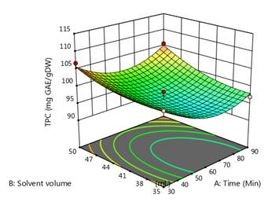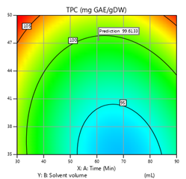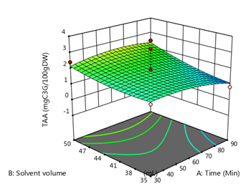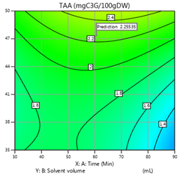

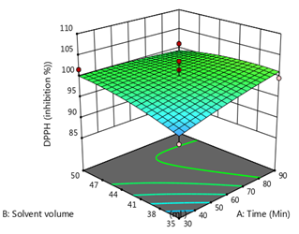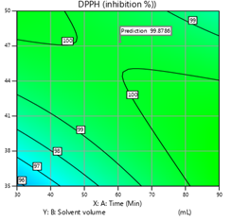
Figure 3. A two-dimensional contour plots and three-dimensional response surface of TPC, TAA, and DPPH as a function of time (min) and solvent volume (mL)

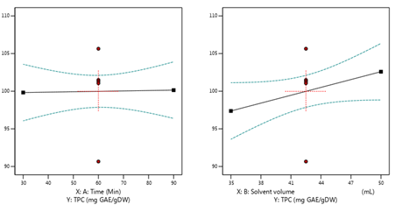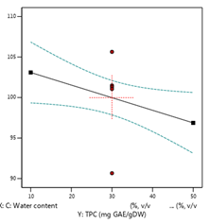

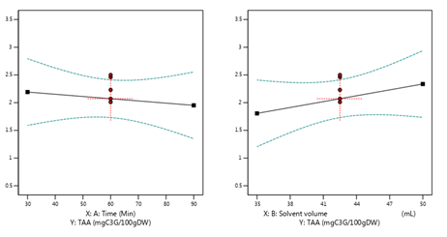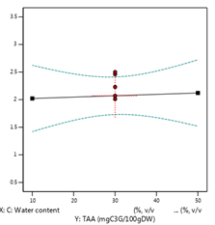

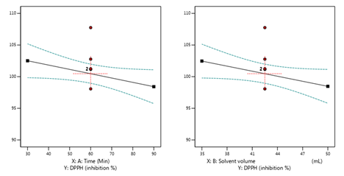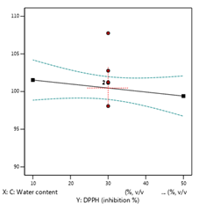

Figure 4. The effect of DES extraction parameters (Time, solvent volume, water content) on TPC, TAA, and DPPH

Actually, time did not have a profound impact on the TAA yield as seen in the figure 3 and 4 presented that water content rise in the extractant system favors the TAA extraction due to the decline in surface tension and viscosity as well as an increase in polarity. In respect of DPPH, we observed similar inclinations towards the process parameters of UAE of Rosa canina L. fruits. This finding is in good agreement with the correlation (r = 0.879) between the total phenolics and antioxidant activity of Rosa canina L. fruits. In the matter of TAA, its relationship (r =0.003) with the antioxidant effect against DPPH radical (% Inhibition) has been found to be extremely weak.
4. Conclusions
This study revealed an efficient and sustainable approach for the extraction of antioxidant phenolic compounds from Rosa canina L. fruits. In the extraction process, the combination of green solvents-DES and ultrasound-assisted extraction was evaluated and optimized using experimental design approaches including one variable at a time, solvent volume, and water content (v/v). Two different deep eutectic solvents have been prepared using glycerol and ethylene glycol (hydrogen bond donor) and citric acid (hydrogen bond acceptor). Citric acid/ethylene glycol mixture has produced the most efficient Rosa canina L. fruits extract through ultrasonic-assisted extraction. The correlation (r > 0.99) between the phenolics and the anthocyanin contents in Rosa canina L. fruits indicates that anthocyanins contribute the most to the phenolic in the plant. On the other hand, the proposed second-order models of the Box-Behnken design have been decided to be satisfactory depending on the statistical indicators such as p < 0.05, R² > 0.96 and adjusted R² > 0.91. We could optimize the bioactive ingredients in the Rosa canina L. fruits extract obtained by ultrasonic-assisted extraction as an efficient, economically and applicable approach. On the other hand, the results of this study can be utilized for further applications of antioxidant phenolic compounds from Rosa canina L. fruits in the food, cosmetical, and pharmaceutical industries as well as this study could help in using the same approach for extraction of the bioactive compounds from other plants.
References
- G. Angelov, S.S. Boyadzhieva, S.S. Georgieva, Cent. Eur. J. Chem., 2014,12, 502-508. DOI: 10.2478/s11532-013-0395-0
- C. Moldovan, M. Babotă, A. Mocan, L. Menghini, S. Cesa, A. Gavan, C. Sisea, C.D. Vodnar, I.M. Dias,C. Pereira, I.C.F.R. Ferreira, G. Crişana, L. Barros,Food&Function,2021,12, 3939. DOI: https://doi.org/10.1039/D0FO02783A
- A. Bhave, V. Schulzova, H. Chmelarova, L. Mrnka, J. Hajslova, Journal of food and drug analysis,2017, 25, 681-690. DOI: https://doi.org/10.1016/j.jfda.2016.12.019
- N. Demir, O. Yildiz, M. Alpaslan, A.A. Hayaloglu, LWT - Food Science and Technology,2014, 57, 126-133. DOI: https://doi.org/10.1016/j.lwt.2013.12.038
- S. Alp, S. Ercisli, T. Jurikova, O. Cakir, S. Gozlekci, Not Bot Horti Agrobo., 2016, 44,472-476. DOI: https://doi.org/10.15835/nbha44210432
- N. Koczka, E. Stefanovits-Bányai, A. Ombódi,Medicines 2018, 5, 84. DOI: https://doi.org/10.3390/medicines5030084
- M. Polumackanycz, M. Kaszuba, A. Konopacka, U. Marzec-Wróblewska, M. Wesolowski, K. Waleron, A. Bucinski, A. Viapiana, Molecules 2020, 25, 5272. DOI: https://doi.org/10.3390/molecules25225272
- M. Liaudanskas, I. Noreikiene, K. Zymone, R. Juodyte, V. Žvikas, V. Janulis, Antioxidants, 2021, 10, 545. DOI: https://doi.org/10.3390/antiox10040545
- J.C. Clarke, W.C. Tu, O. Levers, A. Bröhl, P.J. Hallett, Chem. Rev. 2018, 118, 2, 747–800. DOI: https://doi.org/10.1021/acs.chemrev.7b00571
- B. Tang, H. Zhang, K.H. Row, Journal of Separation Science,2015,38,1053–1064. DOI: https://doi.org/10.1002/jssc.201401347
- B. Ozturk, C. Parkinson, M. Gonzalez-Miquel, Separation and Purification Technology,2018,206,1-13. DOI: https://doi.org/10.1016/j.seppur.2018.05.052
- X. Wang, Y. Wu, J. Li, A. Wang, G. Li, X. Ren, W. Yin, Industrial Crops & Products, 2020, 151,112442. DOI: https://doi.org/10.1016/j.indcrop.2020.112442
- L. Wu, Z. Chen, S. Li, L. Wang, J. Zhang, Separation and Purification Technology, 2021, 262,118339. DOI: https://doi.org/10.1016/j.seppur.2021.118339
- J.M. Silva, E. Silva, R.L. Reis, A.R.C. Duarte, Sustainable Chemistry and Pharmacy,2019,14,100192. DOI: https://doi.org/10.1016/j.scp.2019.100192
- E.L. Smith, A.P. Abbott, K.S. Ryder, Chemical Reviews,2014,114(21),11060–11082. DOI: https://doi.org/10.1021/cr300162p
- Z. Ilbay, S. S¸ahin, S.I. Kırbaslar, J Sci Food Agric.,2013, 93,2804–2809. DOI: https://doi.org/10.1002/jsfa.6104
- V.L. Singleton, R. Orthofer, R.M. Lamuela-Raventos, Methods in Enzymology,1999,299,152-178. DOI: https://doi.org/10.1016/S0076-6879(99)99017-1
- H. Koraqi and K. Lluga-Rizani, Agriculture and Forestry, 2022, 68,1,159-171. DOI: doi:10.17707/AgricultForest.68.1.09
- J. Lee, R.W. Durst, R.E. Wrolstad, Journal of AOAC INTERNATIONAL, 2005, 88, 5, 1269–1278. DOI: https://doi.org/10.1093/jaoac/88.5.1269
- M.M. Giusti and R.E. Wrolstad, Current Protocols in Food Analytical Chemistry,2001, F1.2.1–F1.2.13. DOI: https://doi.org/10.1002/0471142913.faf0102s00
- S. Şahin S. and R. Şamli, Ultrasonics Sonochemistry,2013,20,595–602. DOI: https://doi.org/10.1016/j.ultsonch.2012.07.029
- K.M. Hrnčič, D. Cör, P. Kotnik, Ž Knez, Acta Chim. Slov.,2019, 66, 751–761.DOI: http://dx.doi.org/10.17344/acsi.2019.5253
- L. Su, J. Yin, D. Charles, K. Zhou, J. Moore, L. Yu, Food Chemistry,2007,100,990–997.DOI: https://doi.org/10.1016/j.foodchem.2005.10.058
- G. Fascella, F. D'Angiolillo, M.M. Mammano, M. Amenta, V.F. Romeo, P. Rapisarda, G. Ballistreri, Food Chemistry,2019, 289,56–64. DOI: https://doi.org/10.1016/j.foodchem.2019.02.127
- M.R. Bozhuyuk, S. Ercisli, N. Karatas, H. Ekiert, H.O. Elansary, A. Szopa, Sustainability, 2021, 13,14, 8060. DOI: https://doi.org/10.3390/su13148060
- L. Duan, L. L. Dou, L. Guo, P. Li, E.H. Liu, ACS Sustainable Chem. Eng., 2016,4,2405–2411. DOI: https://doi.org/10.1021/acssuschemeng.6b00091
- E. Kurtulbaş, G.A. Pekel, M. Bilgin, P.D. Makris, S. Şahin, Biomass Conv. Bioref.,2022, 12, 351–360. DOI: https://doi.org/10.1007/s13399-020-00606-3

