Design, Synthesis and Biological Activity of Novel Triketone-containing Quinoxaline as HPPD Inhibitor
Xinyu Lengª, Fei Yeª*
ªDepartment of Applied Chemistry, College of Arts and Sciences, Northeast Agricultural University, Harbin 150030, China
*Correspondence to: Fei Ye, Department of Applied Chemistry, College of Arts and Sciences, Northeast Agricultural University, Harbin 150030, China, E-mail: yefei@neau.edu.cn

Compound 6a
3-hydroxy-5-methyl-2-(quinoxaline-6-carbonyl)cyclohex-2-en-1-one
C₁₆H₁₄N₂O₃
IR
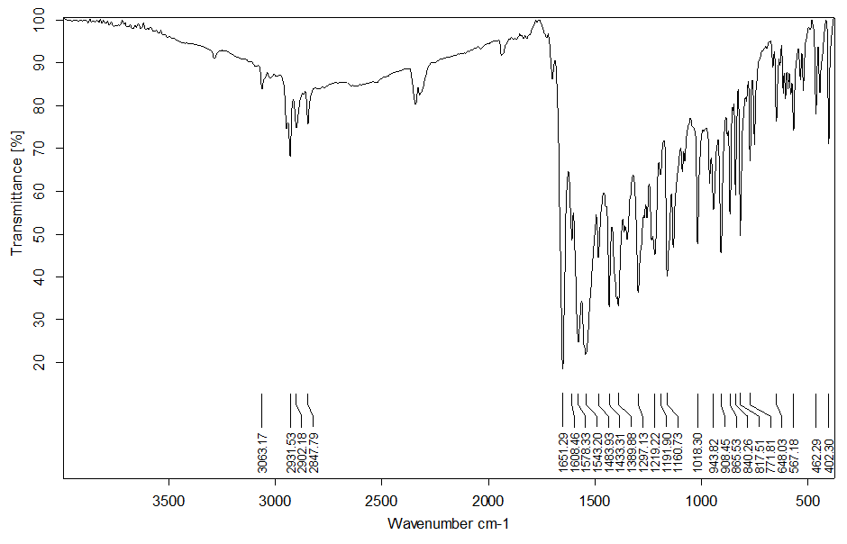
¹H NMR
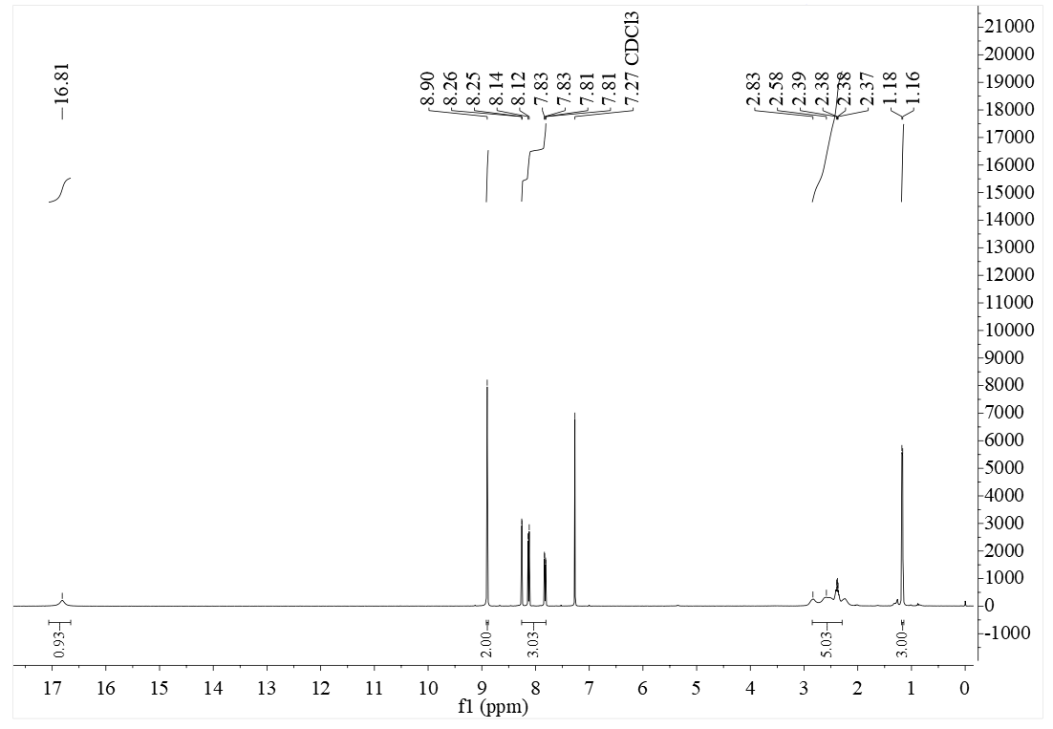
¹³C NMR
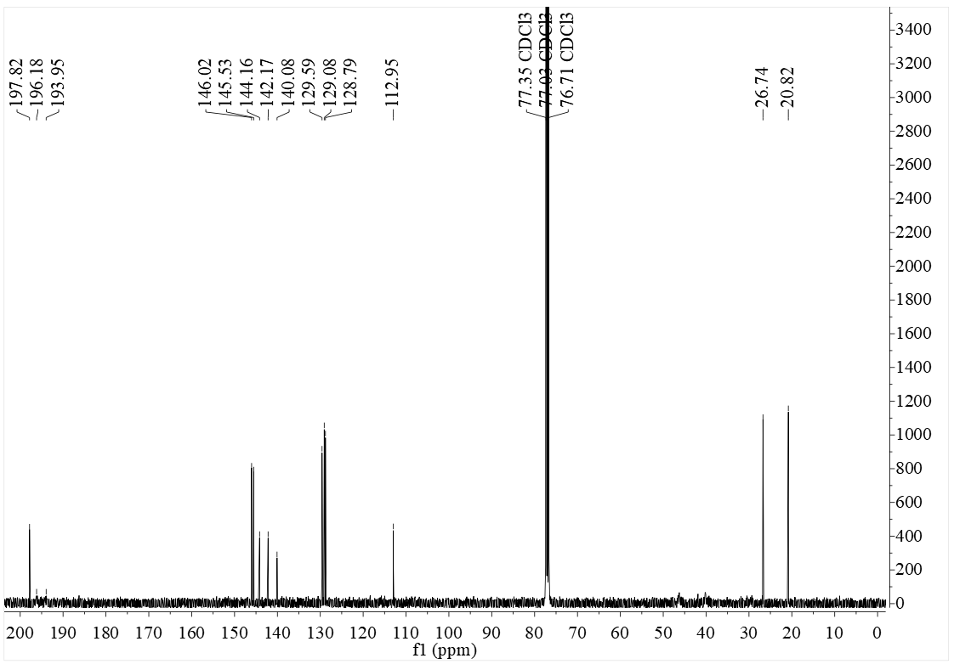

MS
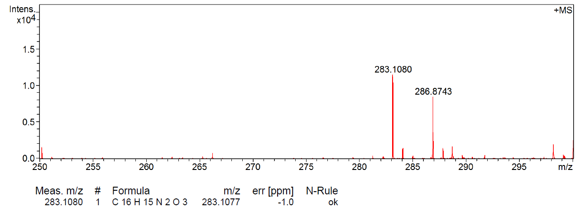

Compound 6b
3-hydroxy-5,5-dimethyl-2-(3-ethoxyquinoxaline-6-carbonyl)cyclohex-2-en-1-one C₁₉H₂₀N₂O₄
IR
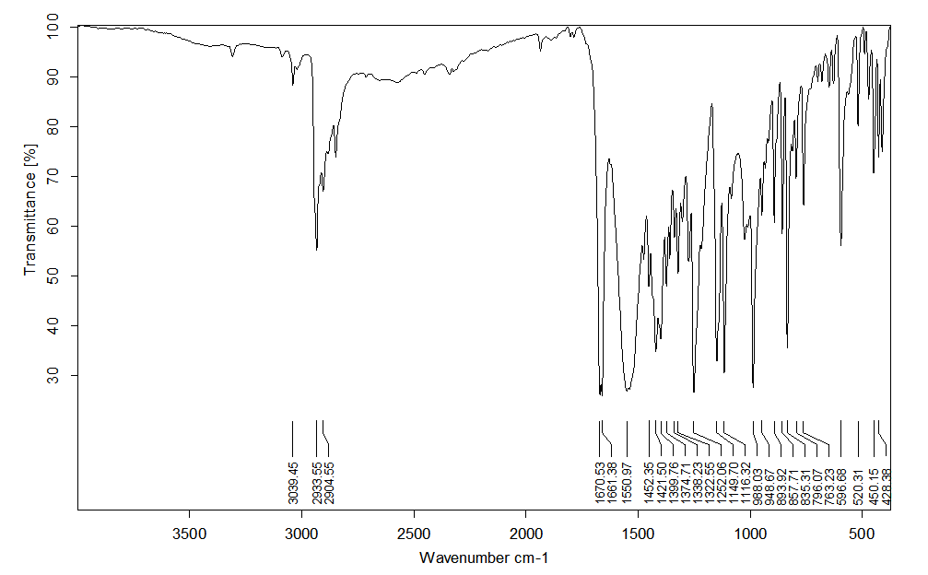
¹H NMR
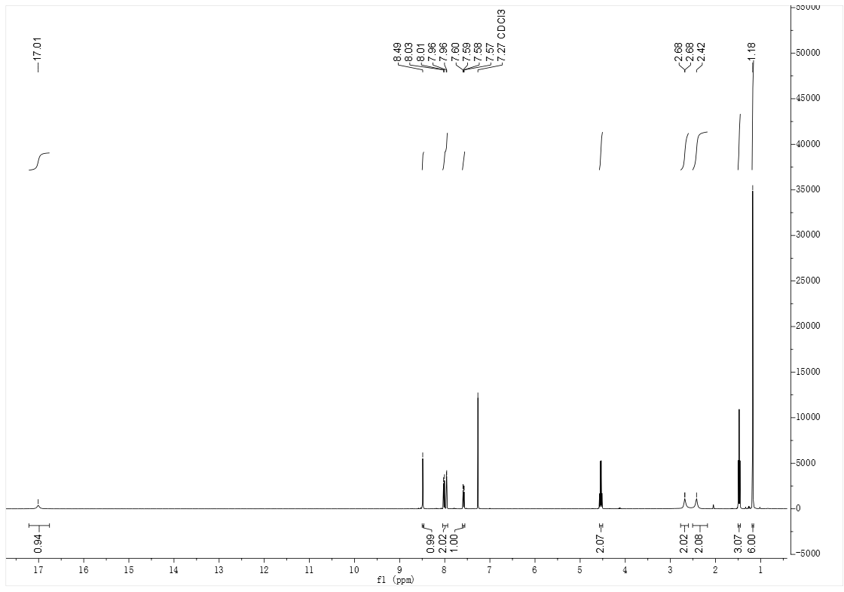
¹³C NMR
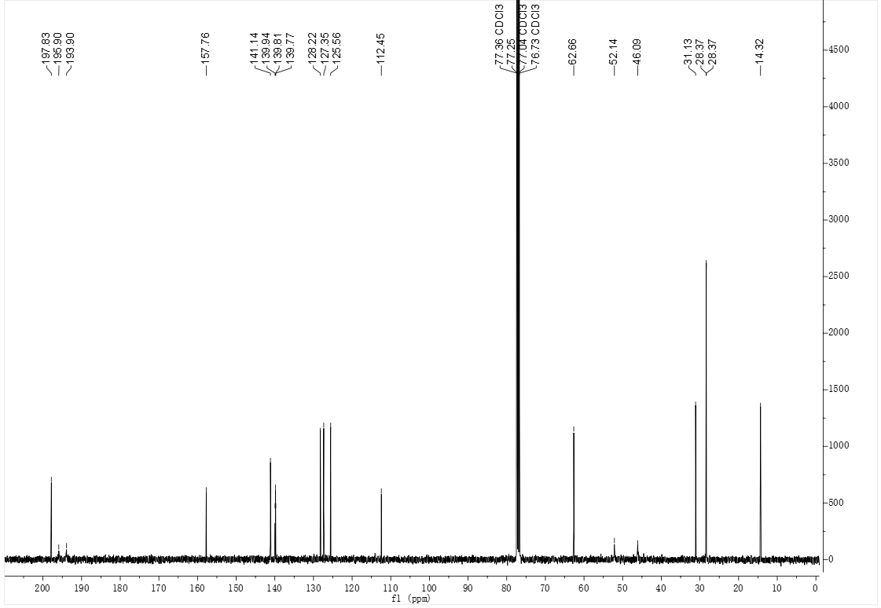

MS

