Synthesis, Antimicrobial and Molecular Docking studies of Some New Derivatives of 2,3-dihydroquinazolin-4(1H)-one
Karim Zahmatkesh¹, Karim Akbari Dilmaghani^{1*} Yasin Sarveahrabi²
1-Department of Organic Chemistry, Faculty of Chemistry, Urmia University, Urmia, 57159, Iran.
2-Department of Biology, Central Tehran Branch, Islamic Azad University, Tehran, Iran.
* Corresponding author: E-mail: k.adilmaghani@urmia.ac.ir
Tel: (+98)914-443-1392; Fax: (+98)44-357153-165
relationship of products with their spectral data (figures) based on Table 2
 | 4a | 4b | 4c | 4d | 4e | 4f | 4g | 4h | 4i | 4j | 4k | 4l
¹Hnmr | 3,4 | 9,10 | 15,16 | 21,22 | 27,28 | 33,34 | 40,41 | 46,47 | 53,54 | 59,60 | 65,66 | 71,72
¹³Cnmr | 5,6 | 11,12 | 17,18 | 23,24 | 29,30 | 35,36 | 42,43 | 48,49 | 55,56 | 61,62 | 67,68 | 73,74
IR | 7 | 13 | 19 | 25 | 31 | 37 | 44 | 50 | 57 | 63 | 69 | 75
Mass | 8 | 14 | 20 | 26 | 32 | 38,39 | 45 | 51,52 | 58 | 64 | 70 | 76
*The number of Figures is like a manuscript.
Product representation spectra (¹Hnmr, ¹³Cnmr, IR, mass Respectively)
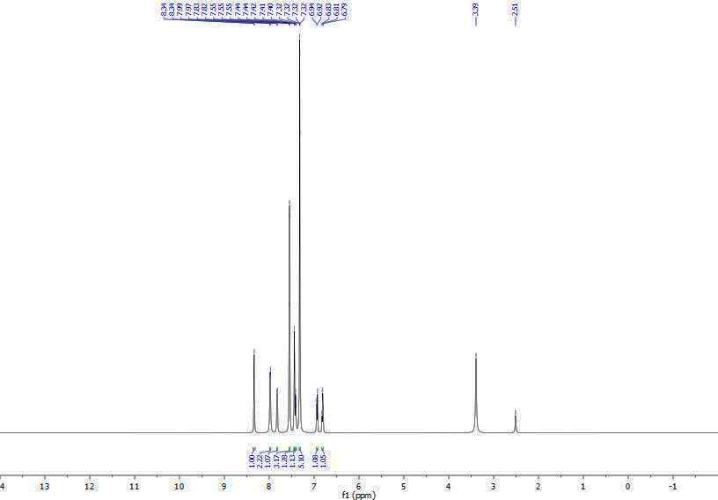
Fig 3. The whole range ¹H NMR spectrum of compound (4a)
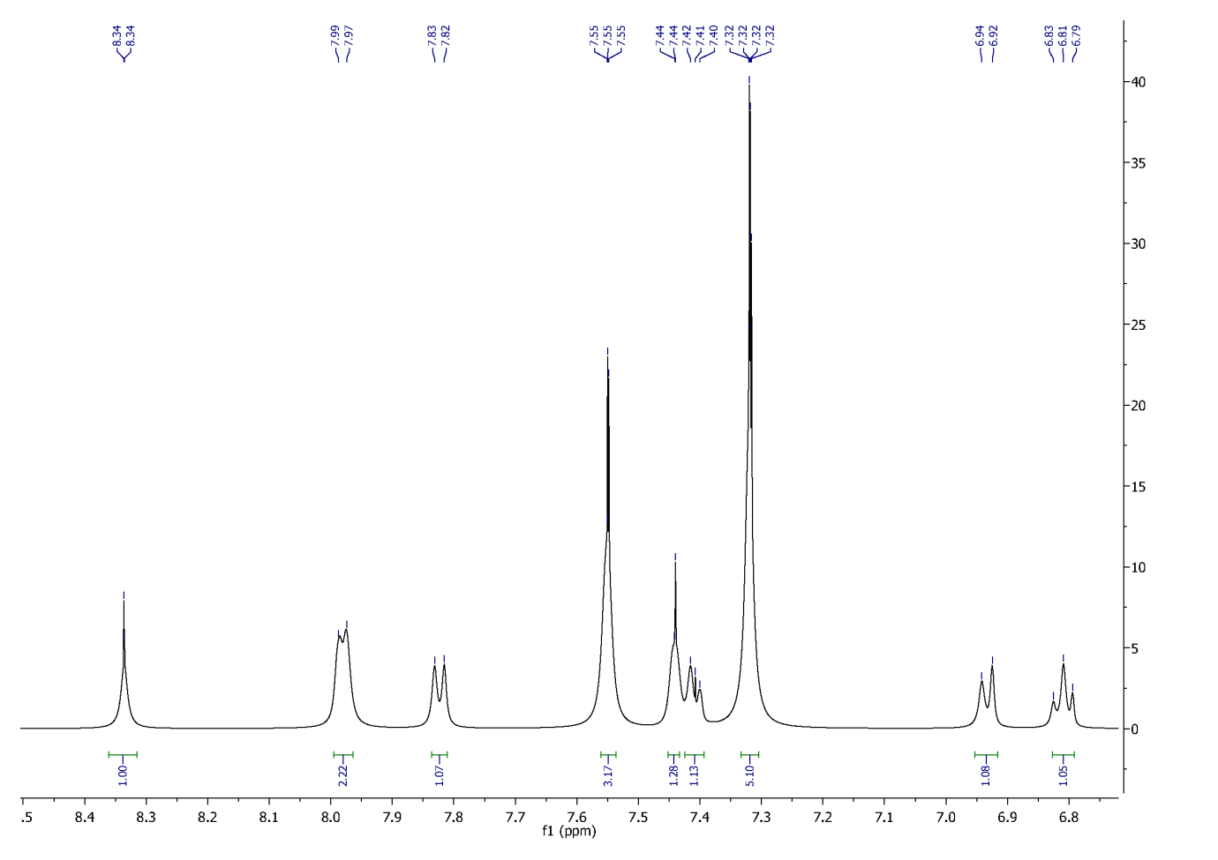
Fig 4. Aromatic range 1H NMR spectrum of compound (4a)

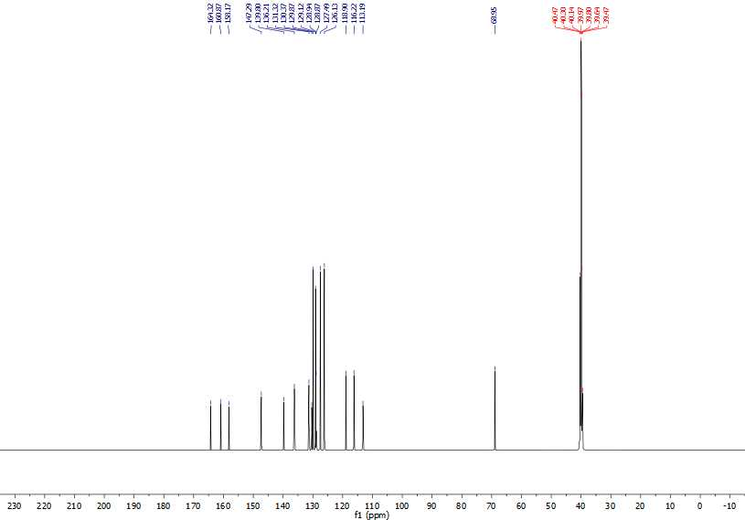 Fig 5. The whole range ¹³C NMR spectrum of compound (4a)

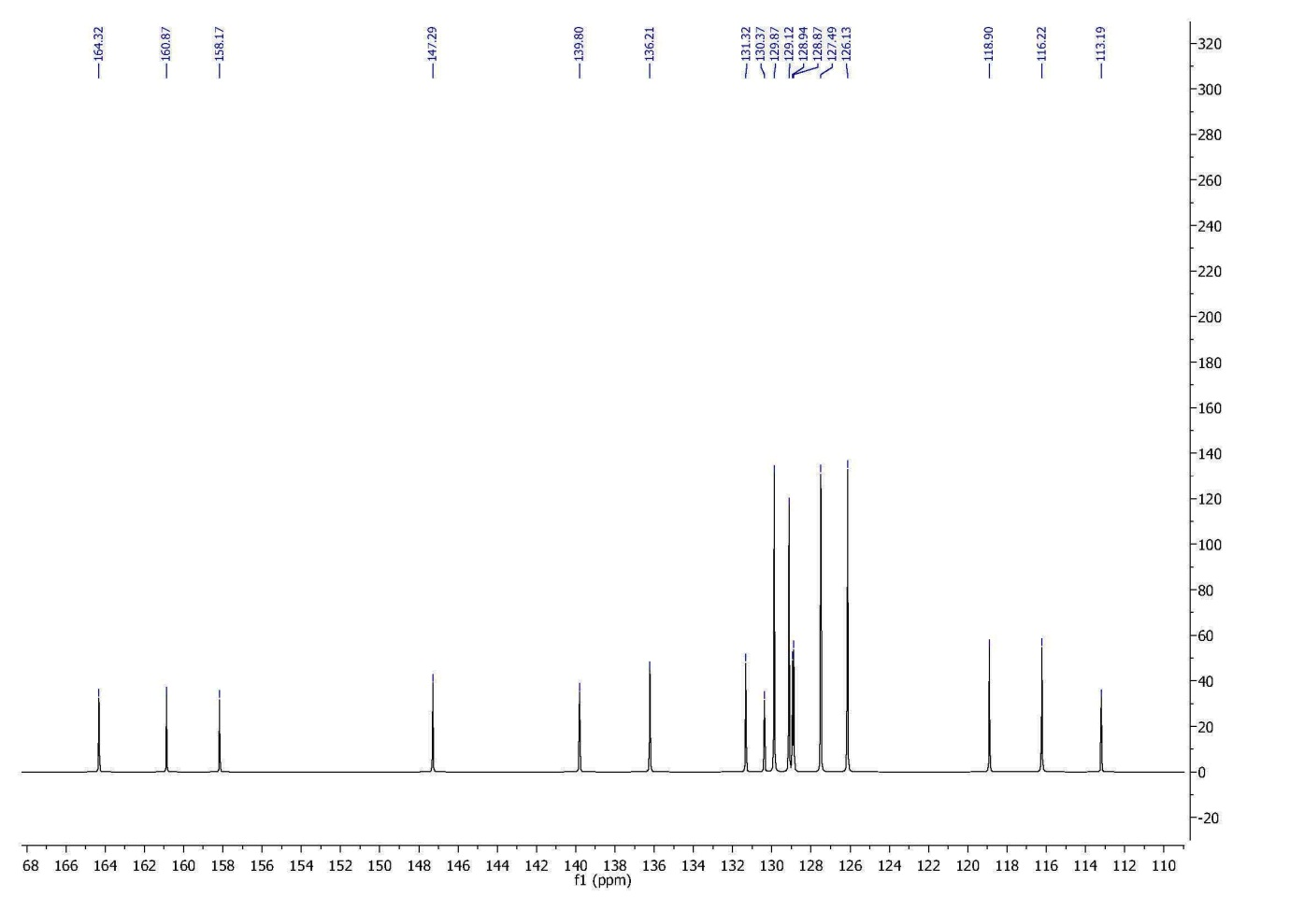 Fig 6. Doubl bond range ¹³C NMR spectrum of compound (4a)

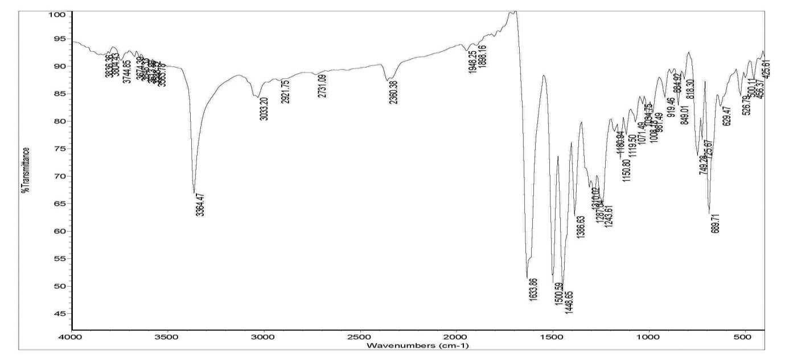 Fig 7. IR spectrum of compound (4a)

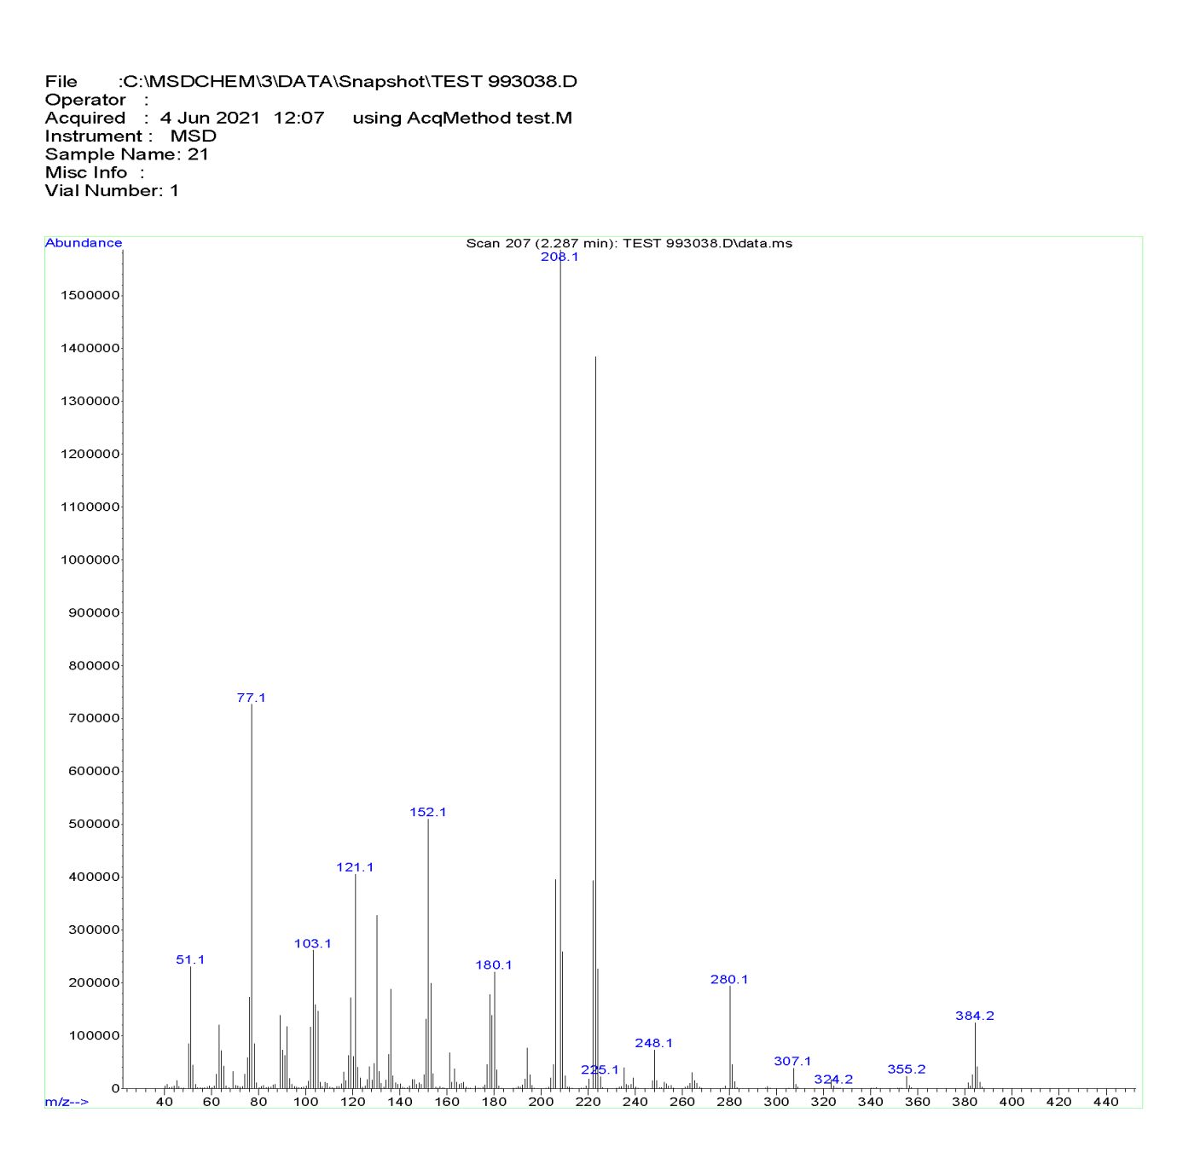 Fig 8. Mass spectrum of compound (4a)
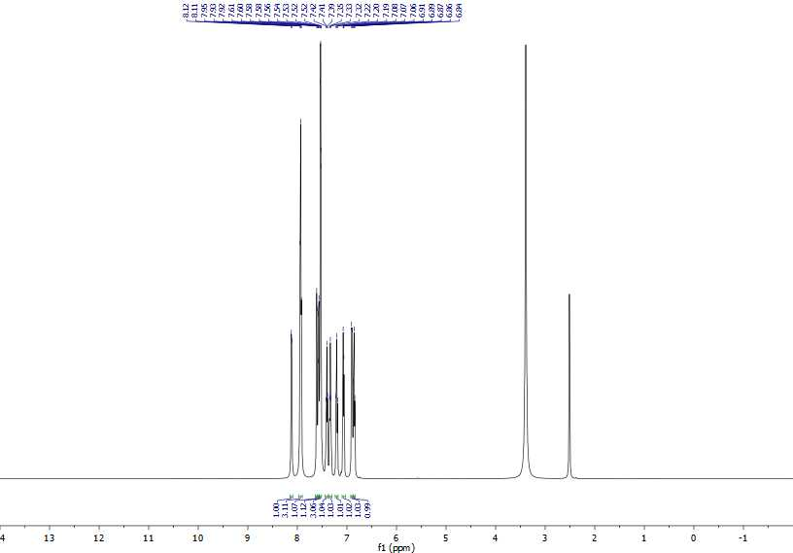 Fig 9. The whole range ¹H NMR spectrum of compound (4b)

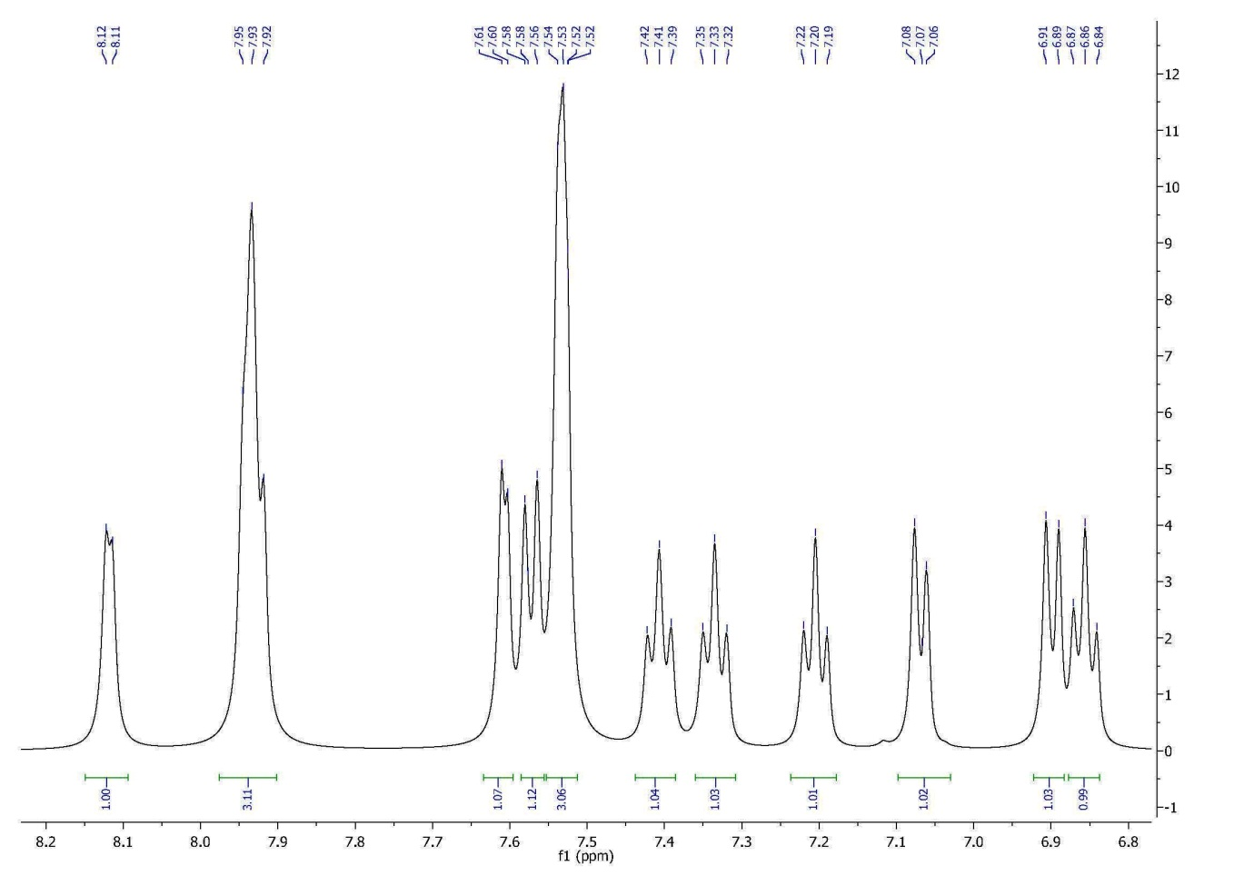 Fig 10. Aromatic range ¹H NMR spectrum of compound (4b)

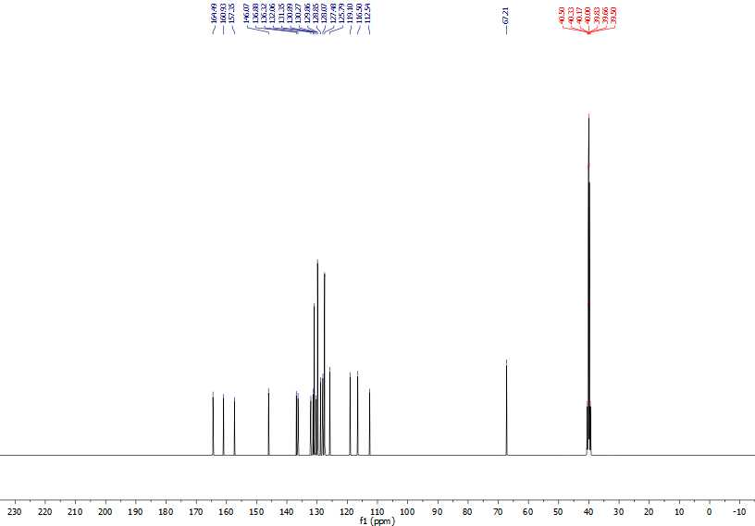 Fig 11. The whole range ¹³C NMR spectrum of compound (4b)

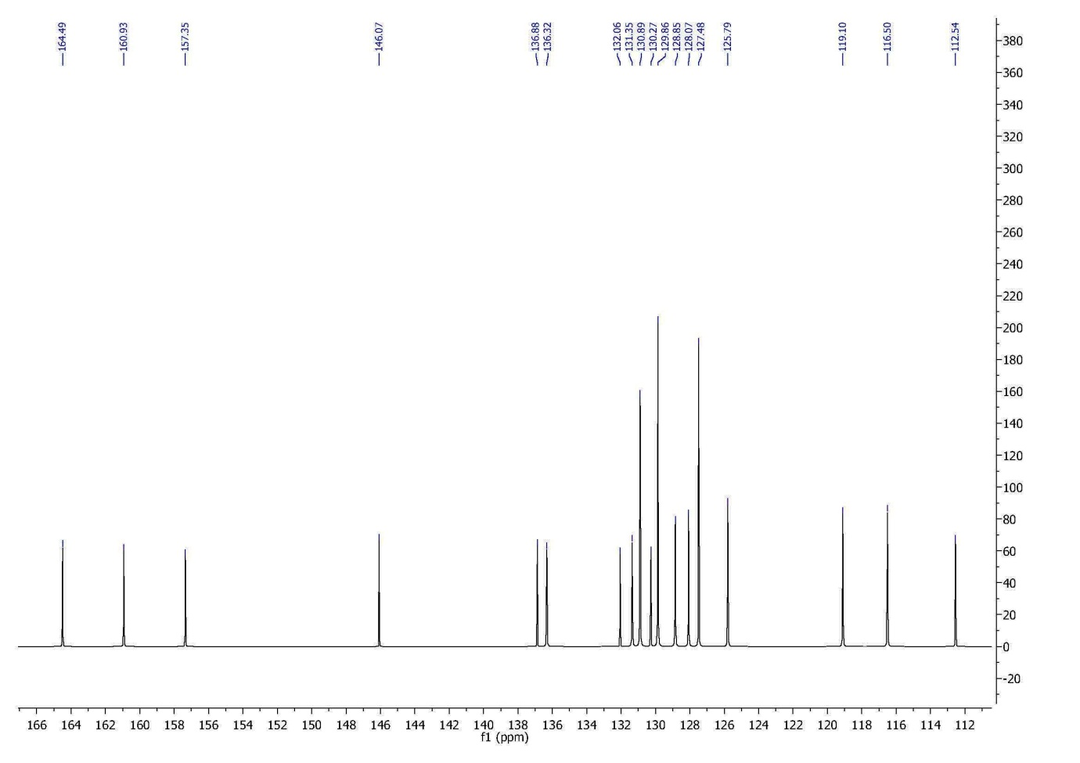 Fig 12. Doubl bond range ¹³C NMR spectrum of compound (4b)

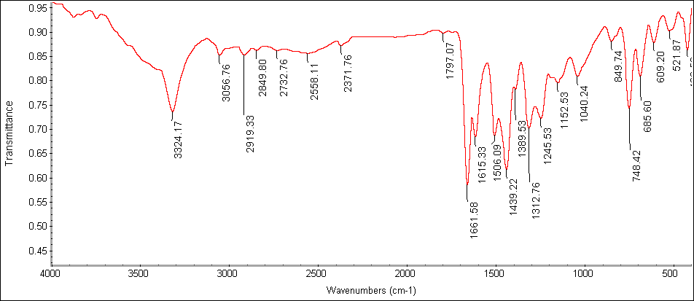 Fig 13. IR spectrum of compound (4b)

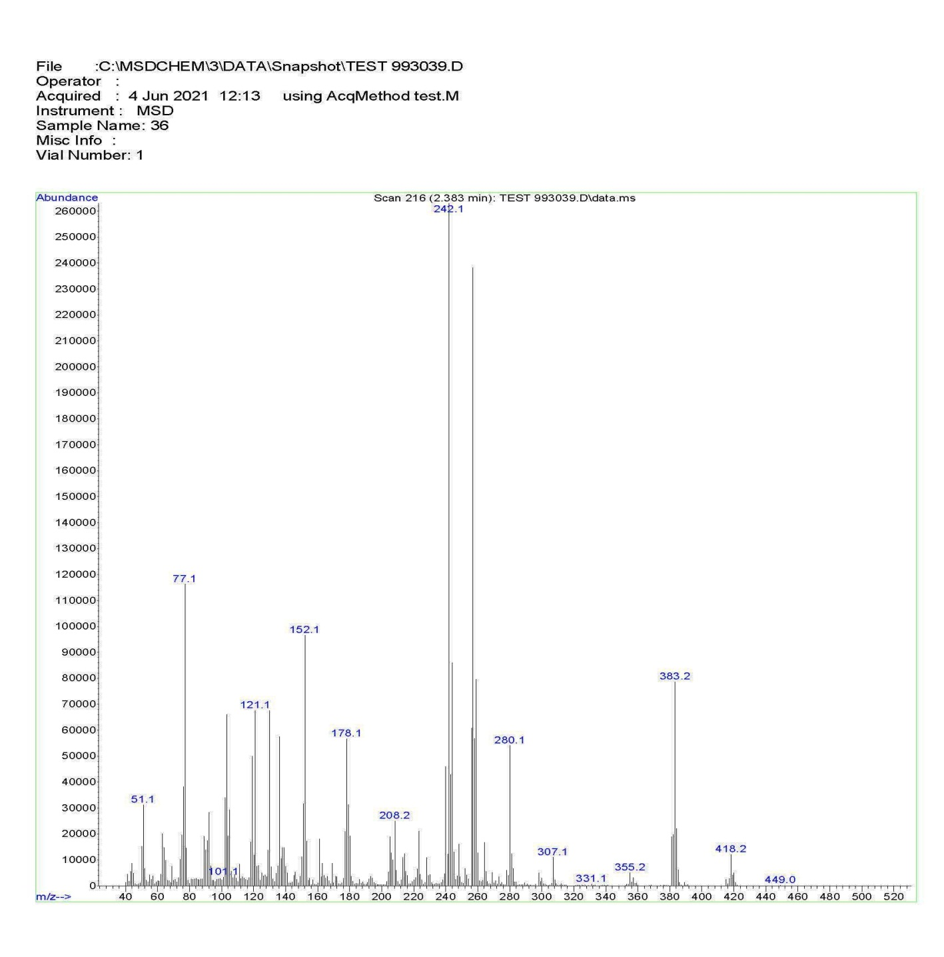 Fig 14. Mass spectrum of compound (4b)
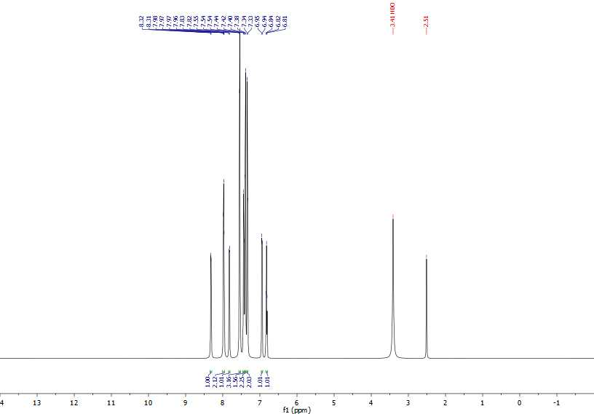 Fig 15. The whole range ¹H NMR spectrum of compound (4c)

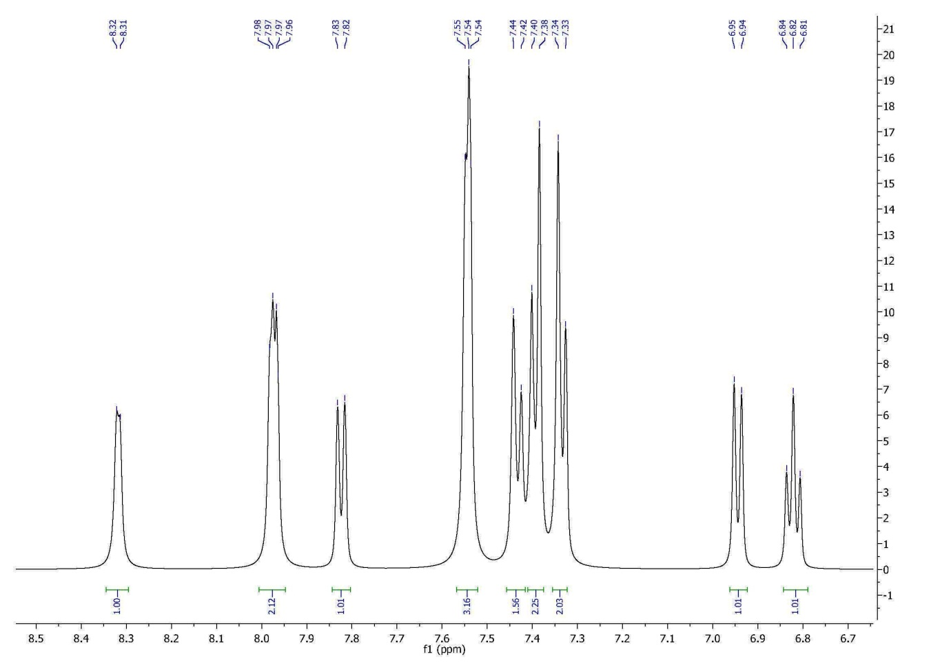 Fig 16. Aromatic range ¹H NMR spectrum of compound (4c)

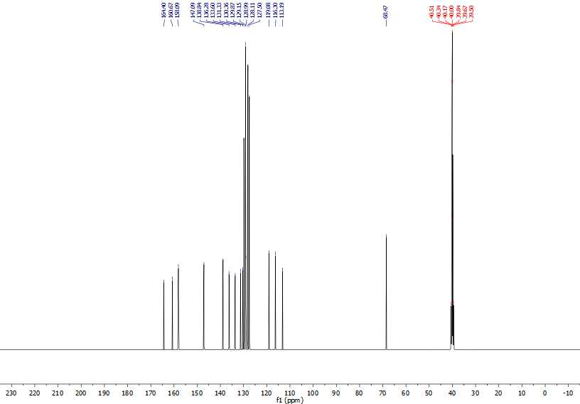 Fig 17. The whole range ¹³C NMR spectrum of compound (4c)

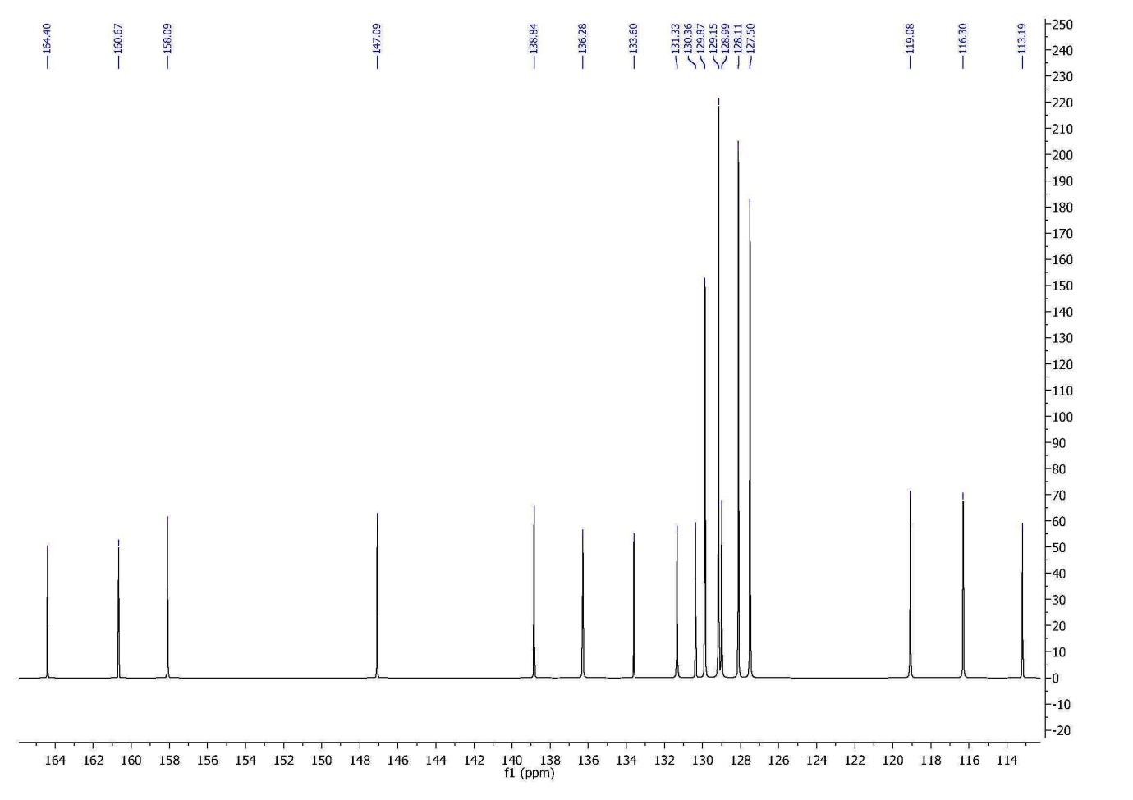 Fig 18. Doubl bond range ¹³C NMR spectrum of compound (4c)

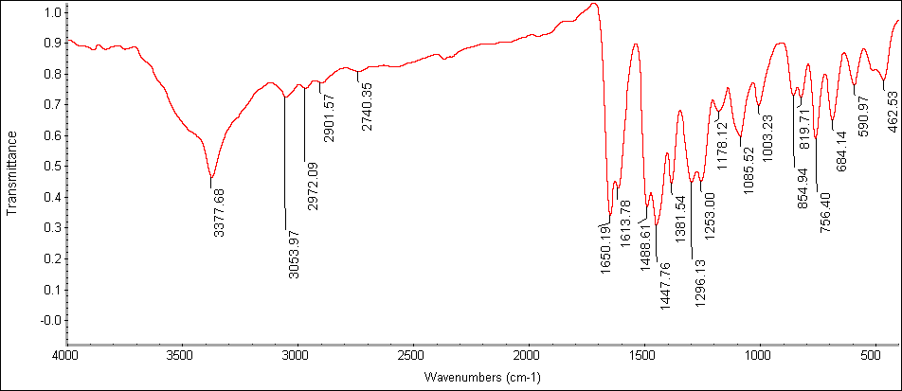 Fig 19. IR spectrum of compound (4c)

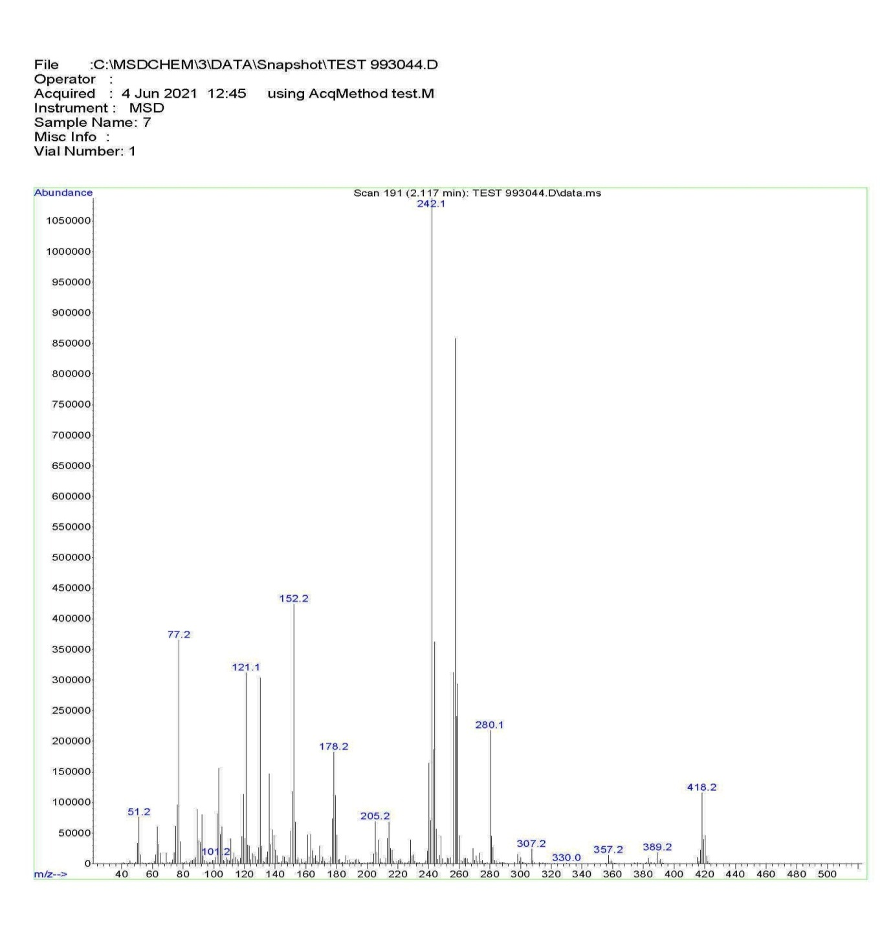 Fig 20. Mass spectrum of compound (4c)
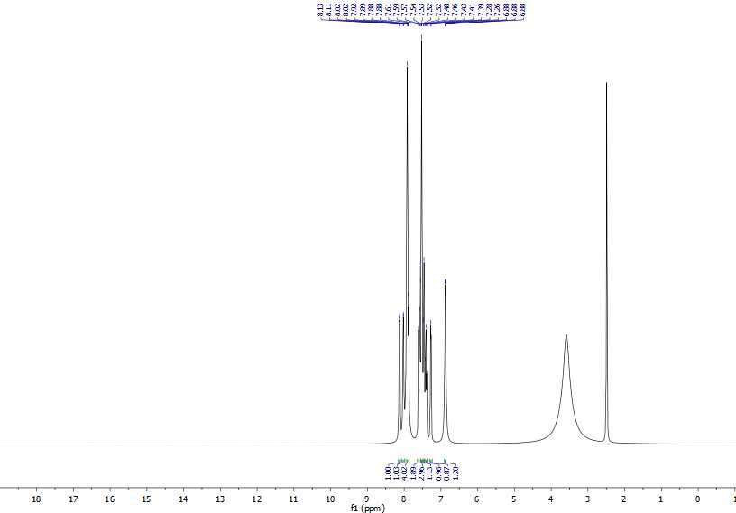 Fig 21. The whole range ¹H NMR spectrum of compound (4d)

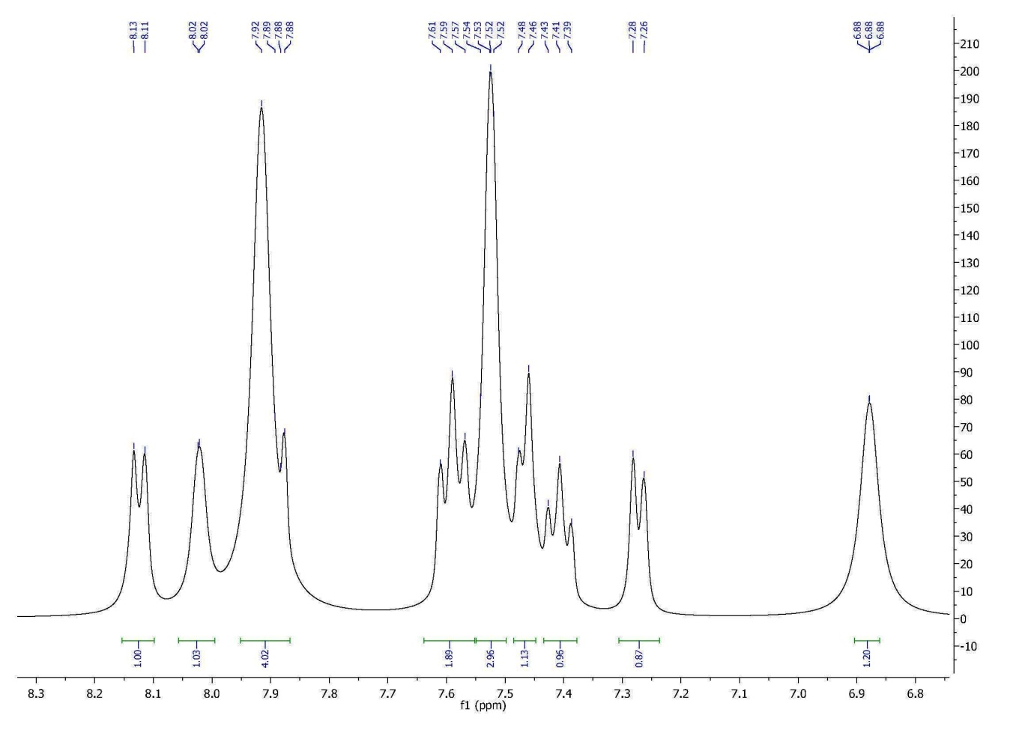 Fig 22. Aromatic range ¹H NMR spectrum of compound (4d)

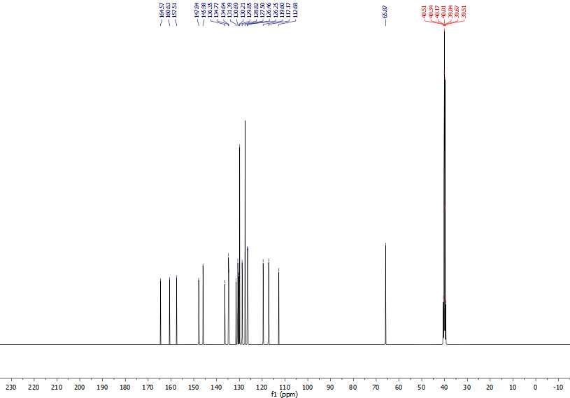 Fig 23. The whole range ¹³C NMR spectrum of compound (4d)

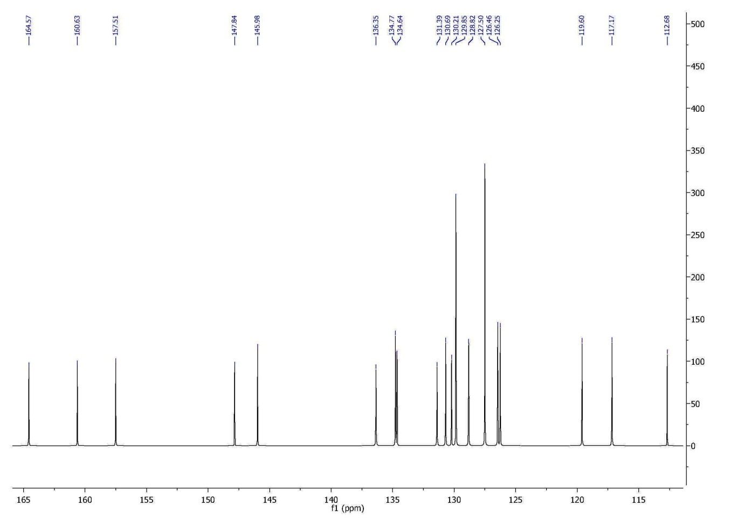 Fig 24. Doubl bond range ¹³C NMR spectrum of compound (4d)

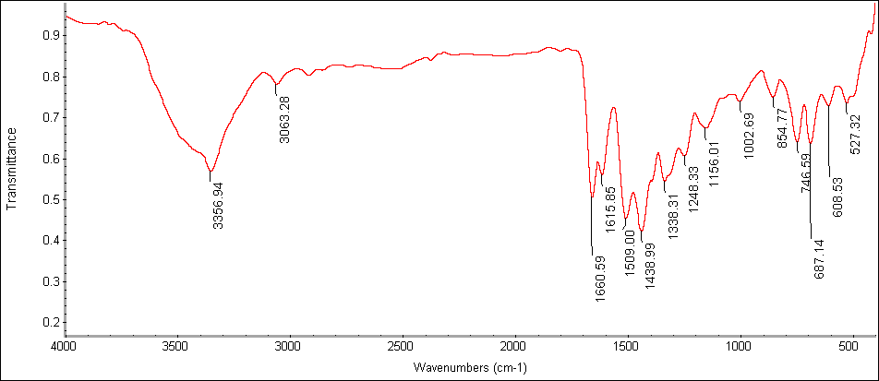 Fig 25. IR spectrum of compound (4d)

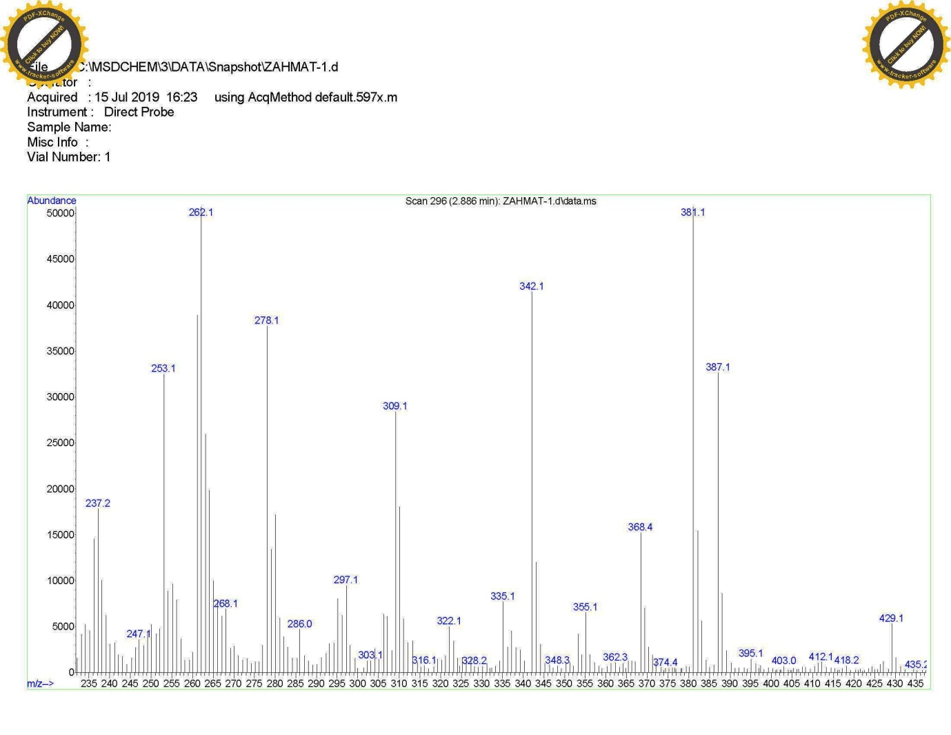 Fig 26. Mass spectrum of compound (4d)

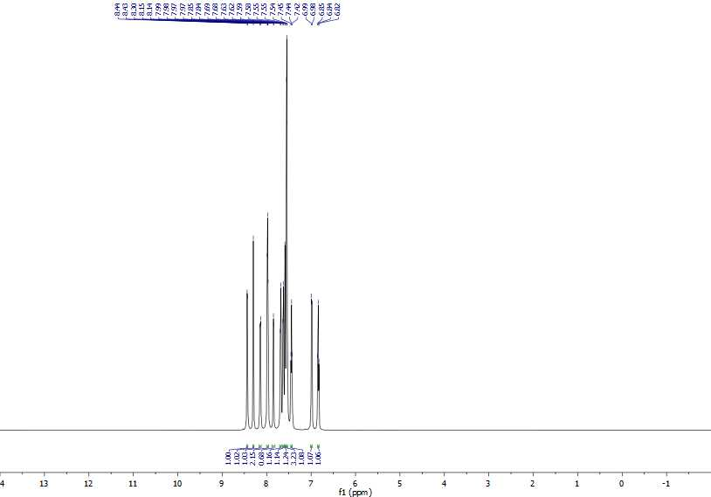 Fig 27. The whole range ¹H NMR spectrum of compound (4e)

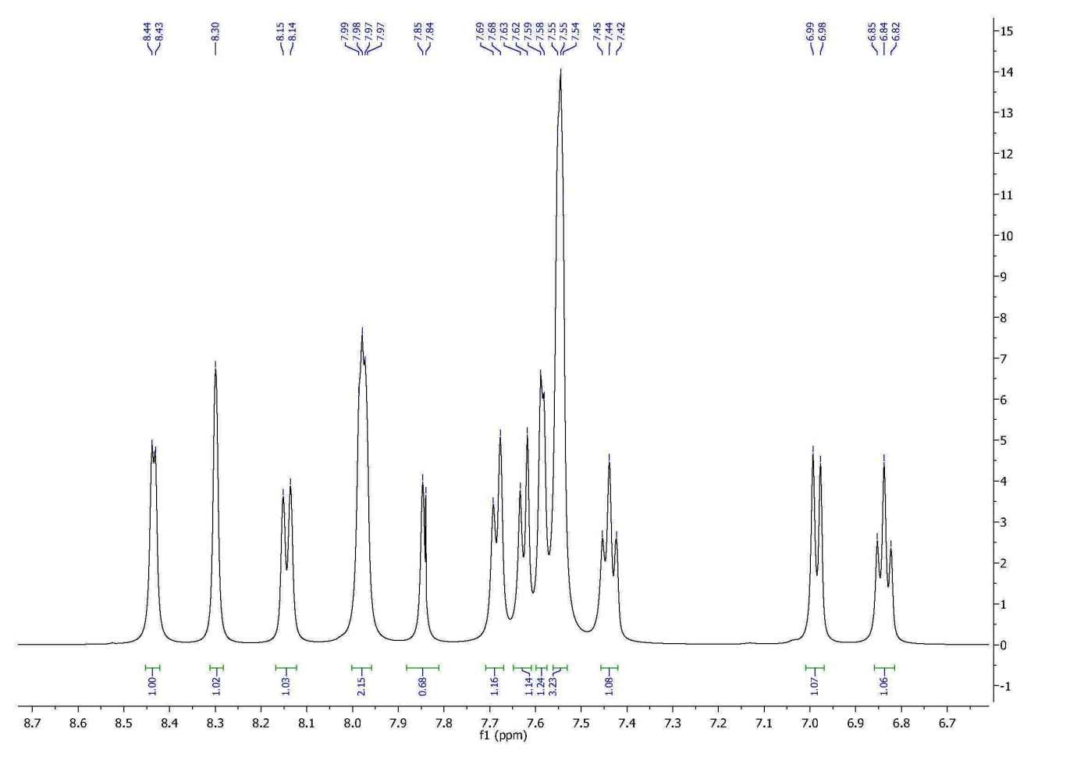 Fig 28. Aromatic range ¹H NMR spectrum of compound (4e)

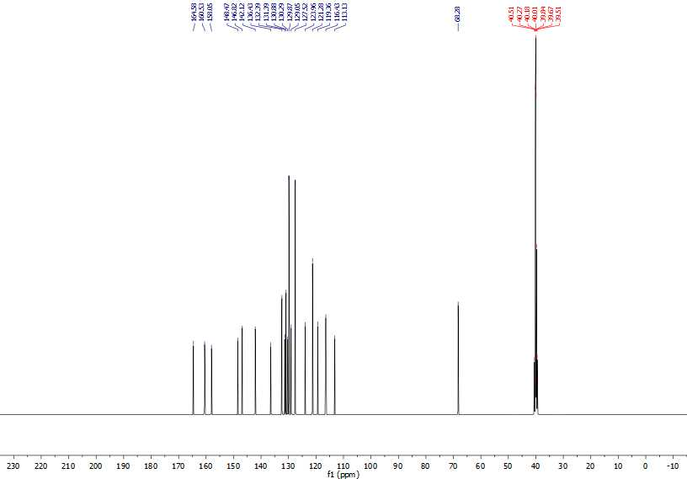 Fig 29. The whole range ¹³C NMR spectrum of compound (4e)

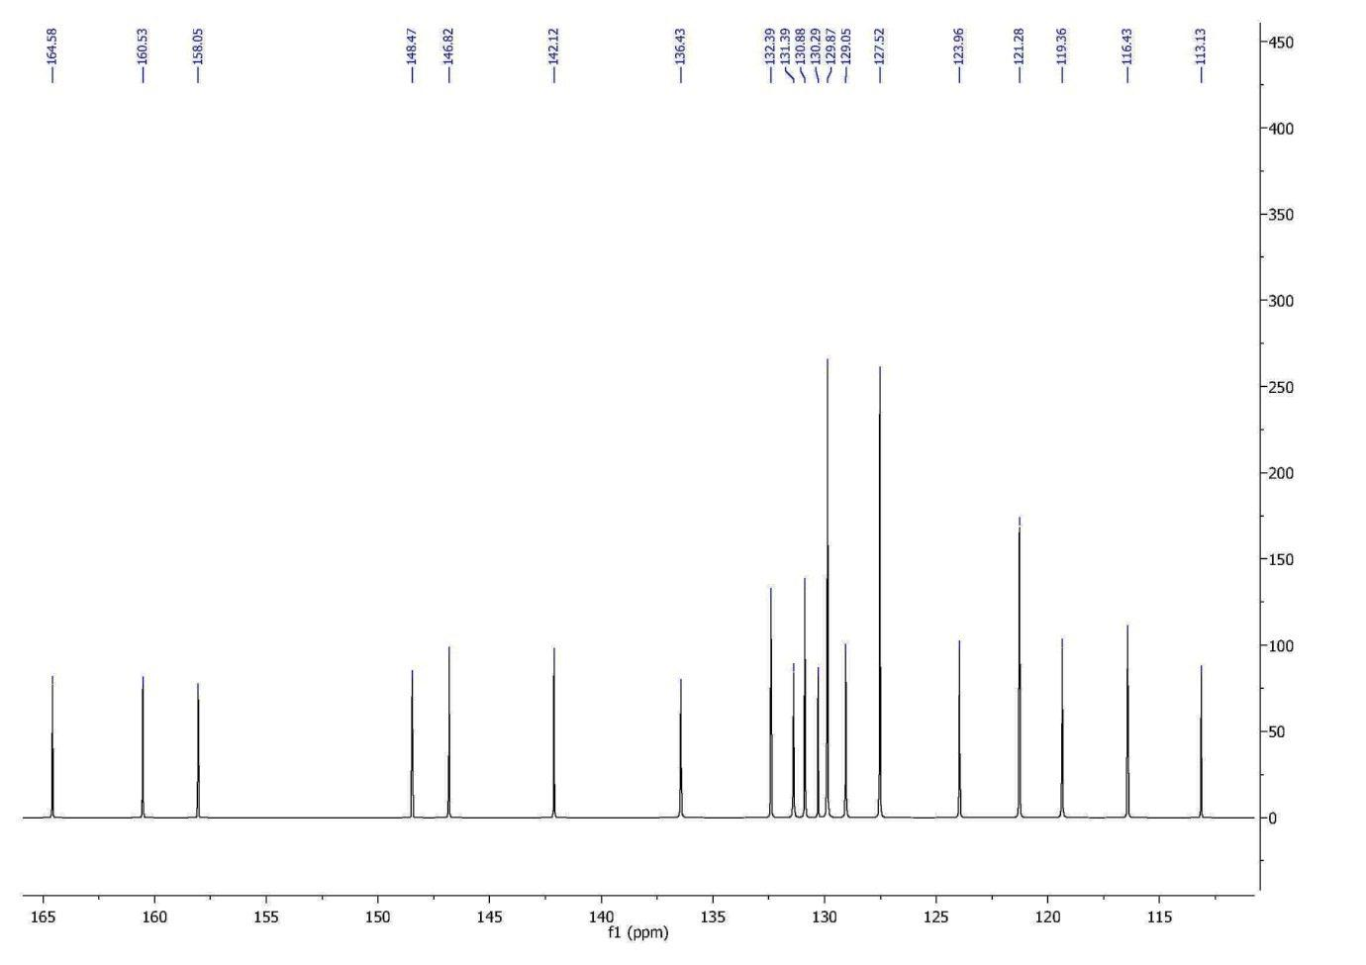 Fig 30. Doubl bond range ¹³C NMR spectrum of compound (4e)

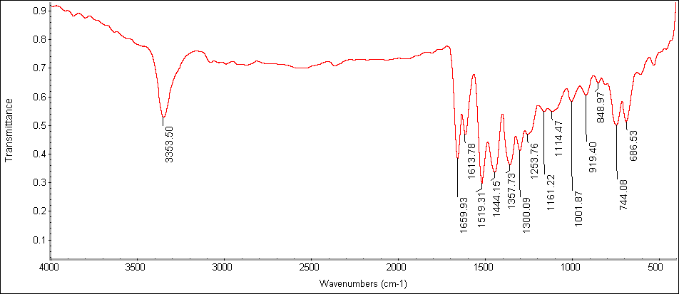 Fig 31. IR spectrum of compound (4e)

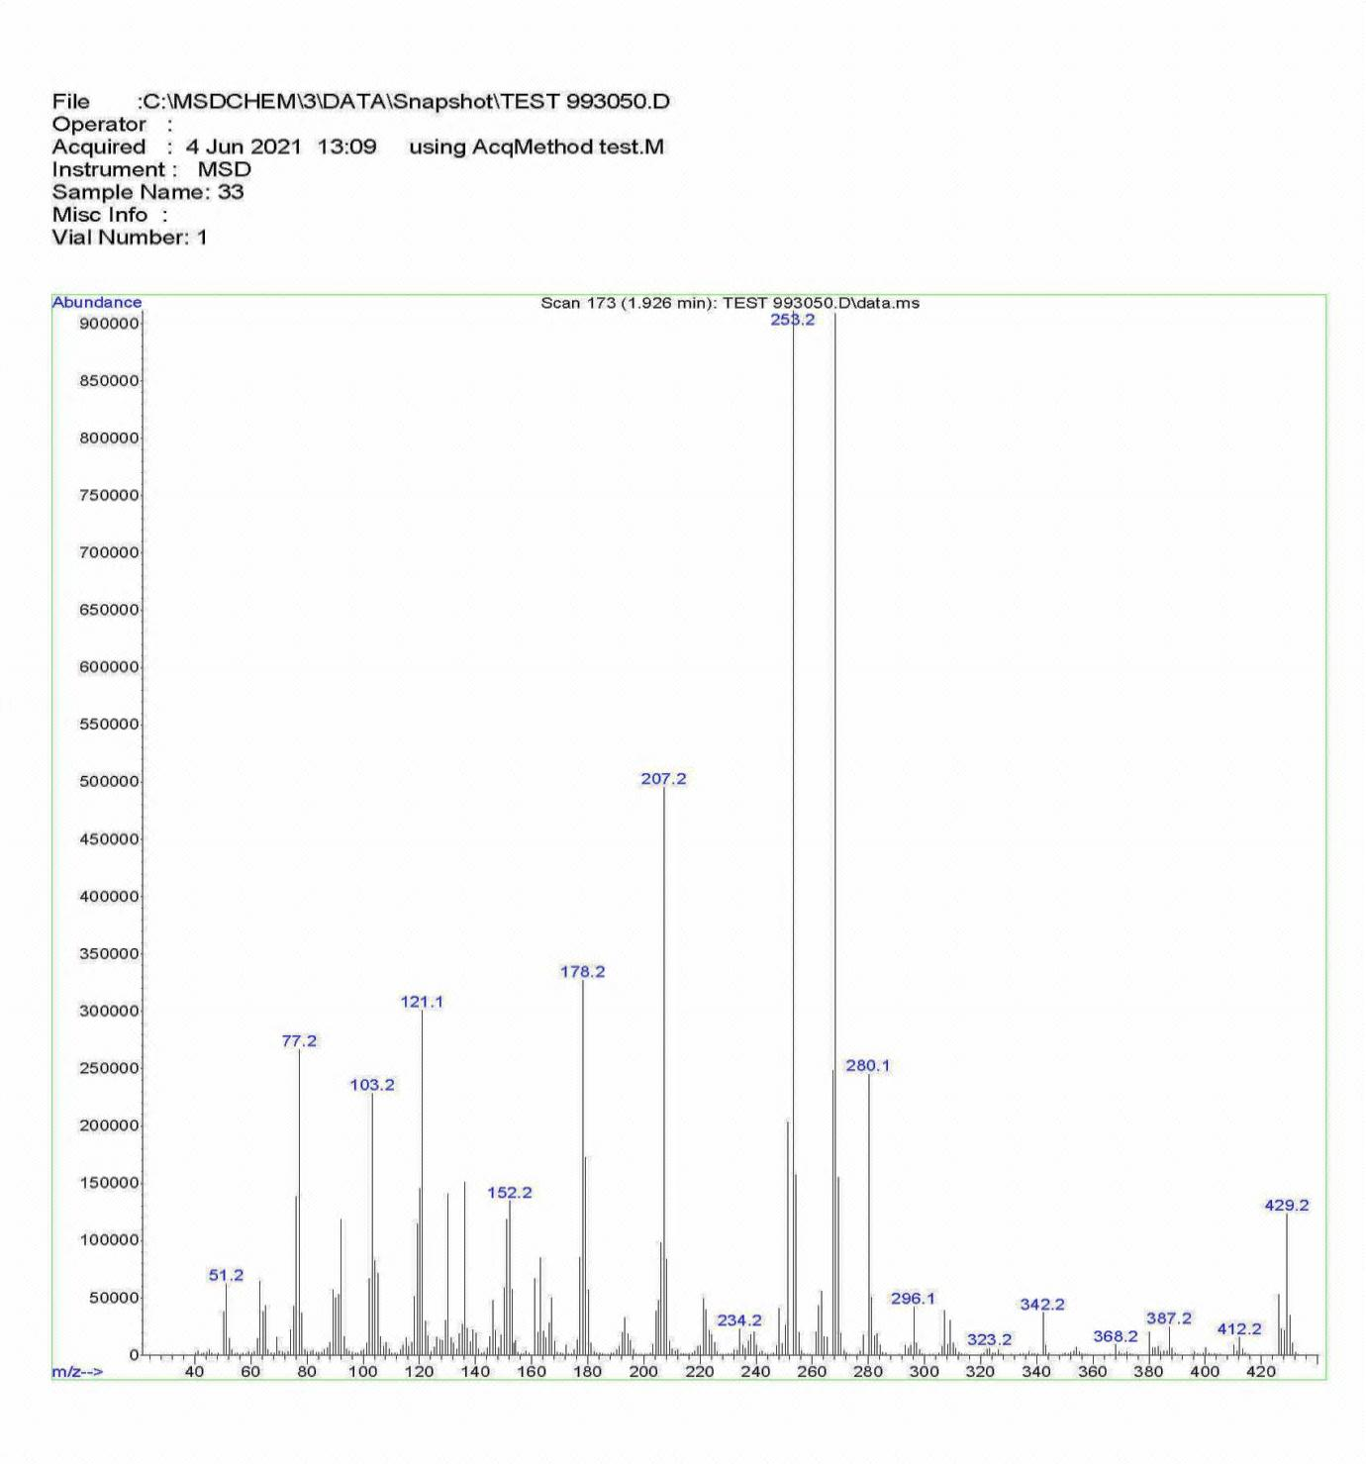 Fig 32. Mass spectrum of compound (4e)
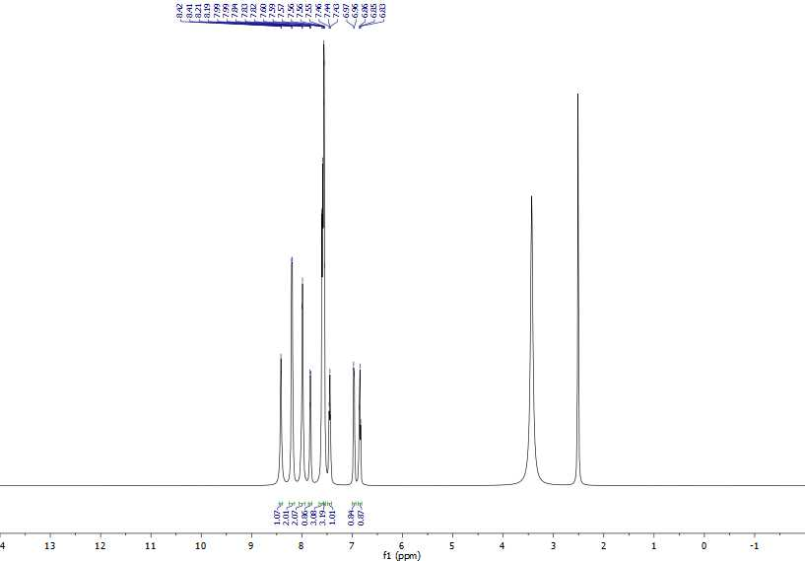 Fig 33. The whole range ¹H NMR spectrum of compound (4f)

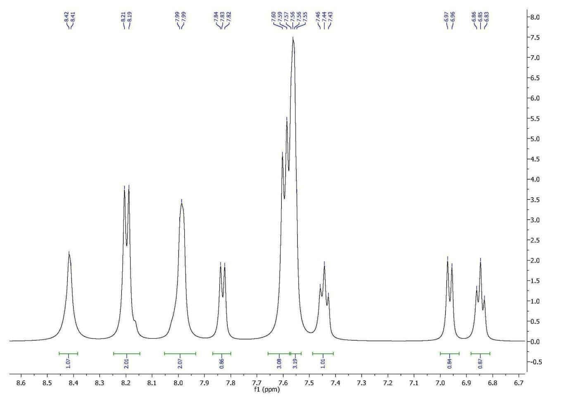 Fig 34. Aromatic range ¹H NMR spectrum of compound (4f)

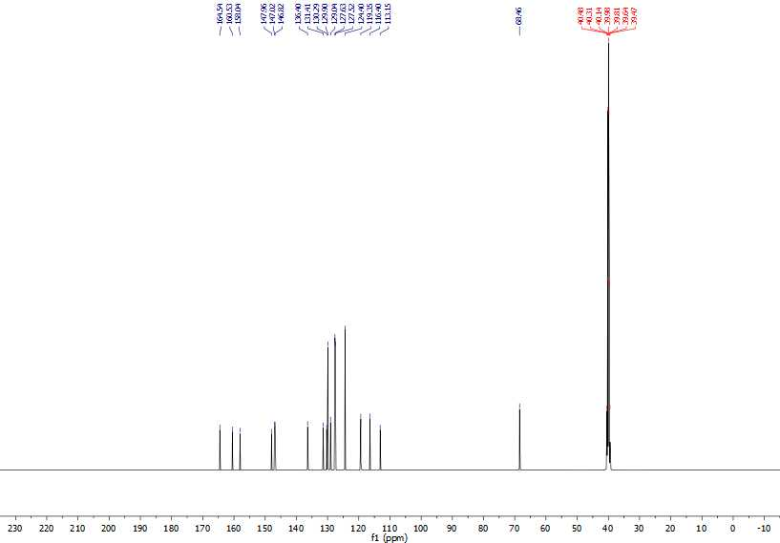 Fig 35. The whole range ¹³C NMR spectrum of compound (4f)

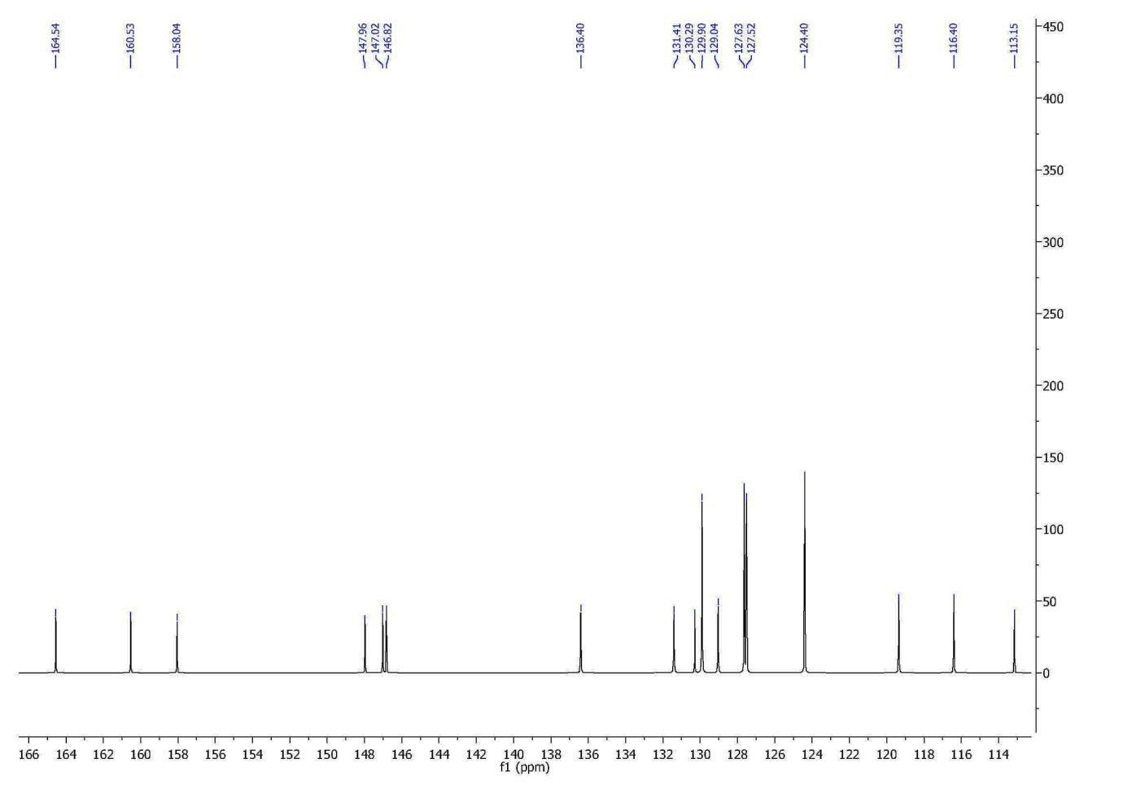 Fig 36. Doubl bond range ¹³C NMR spectrum of compound (4f)

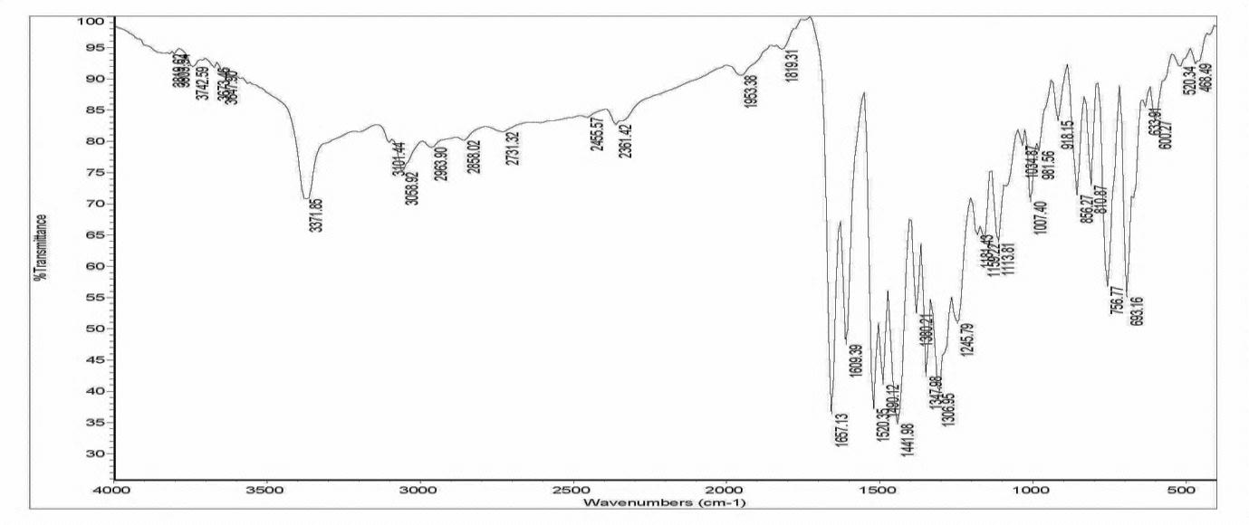 Fig 37. IR spectrum of compound (4f)

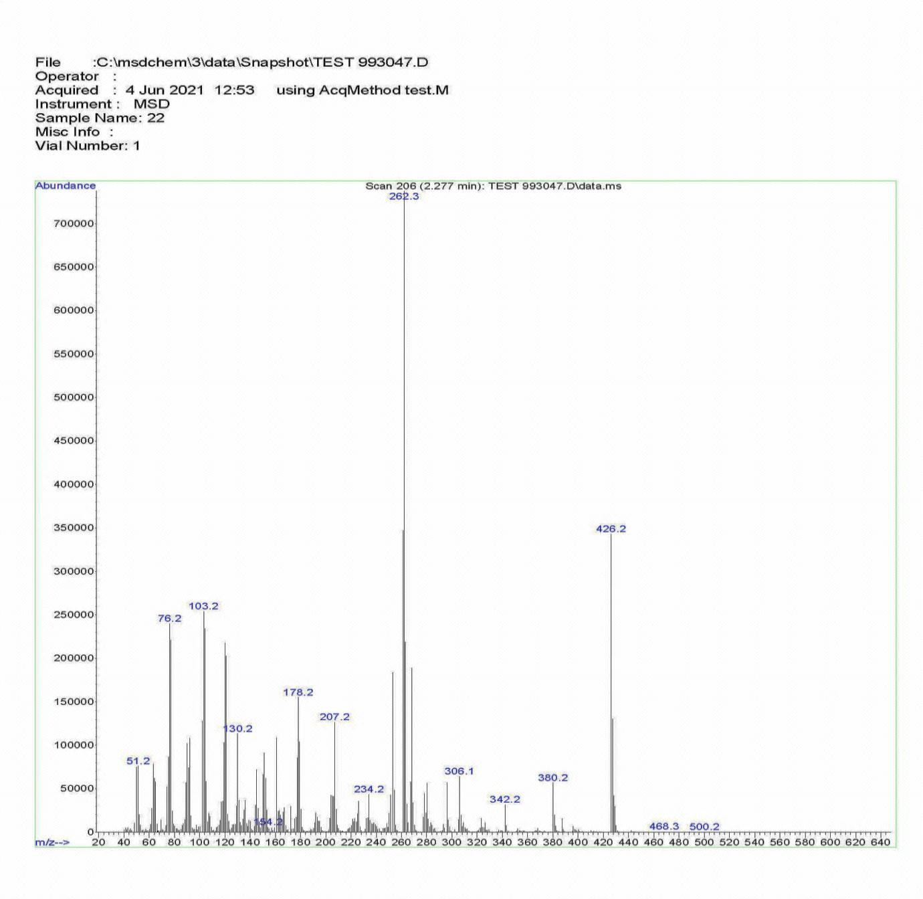 Fig 38. Mass spectrum of compound (4f)
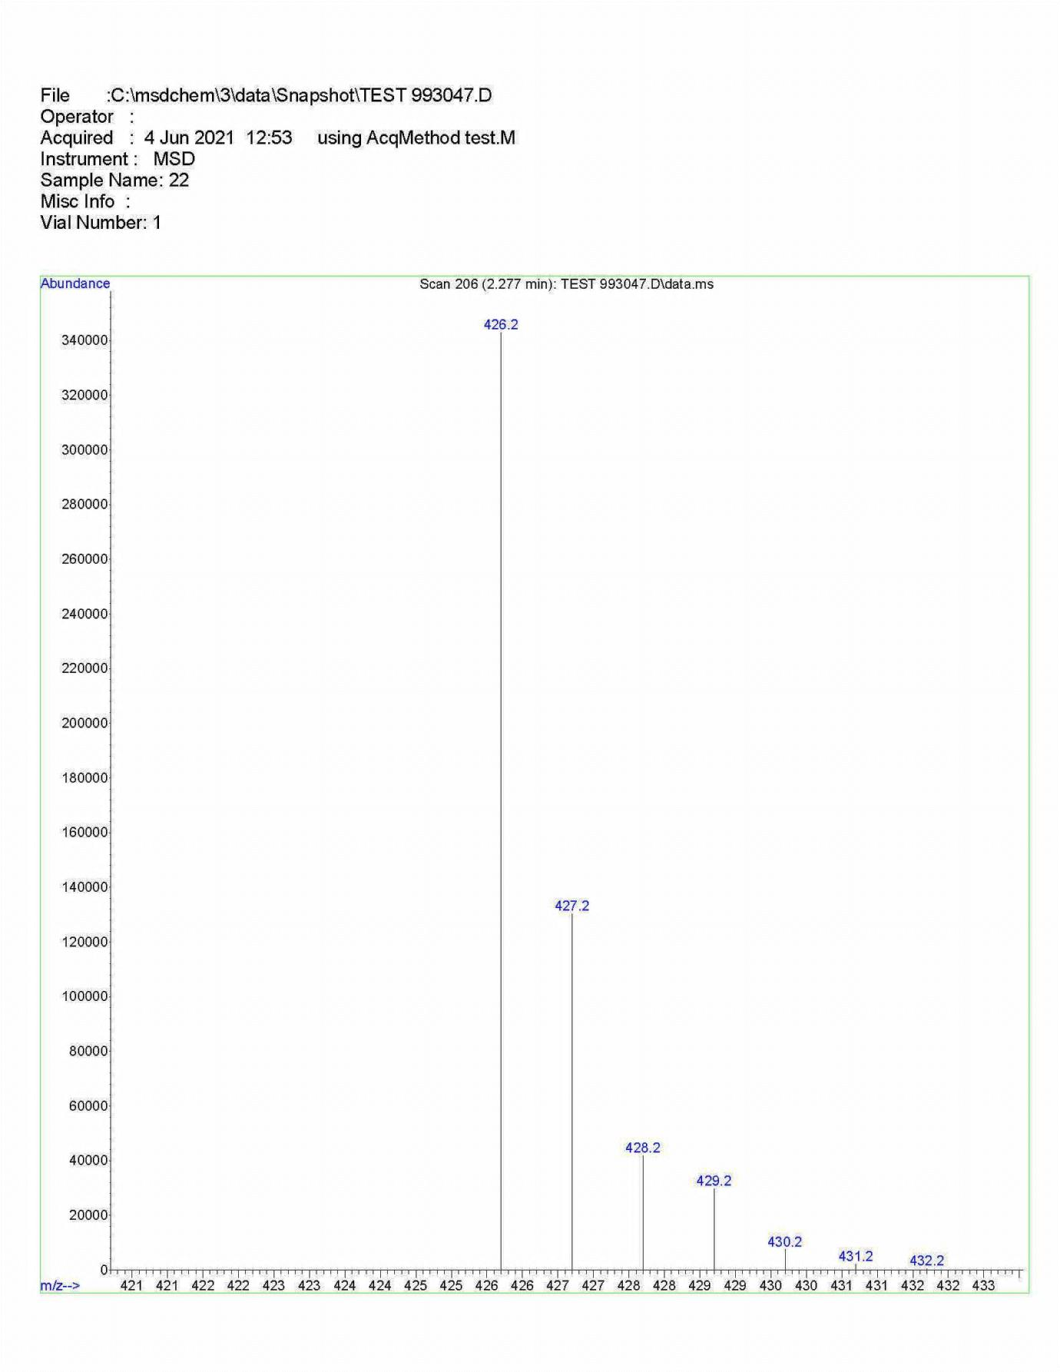 Fig 39. Mass spectrum of compound (4f), From a closer look

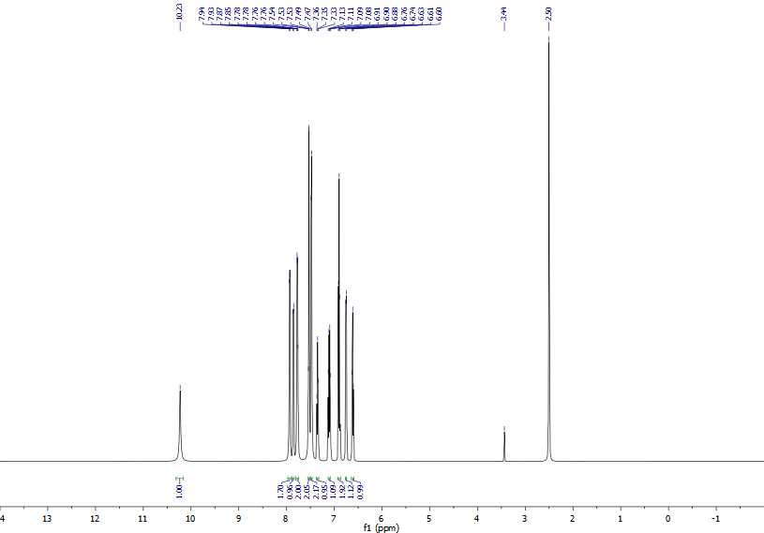 Fig 40. The whole range ¹H NMR spectrum of compound (4g)

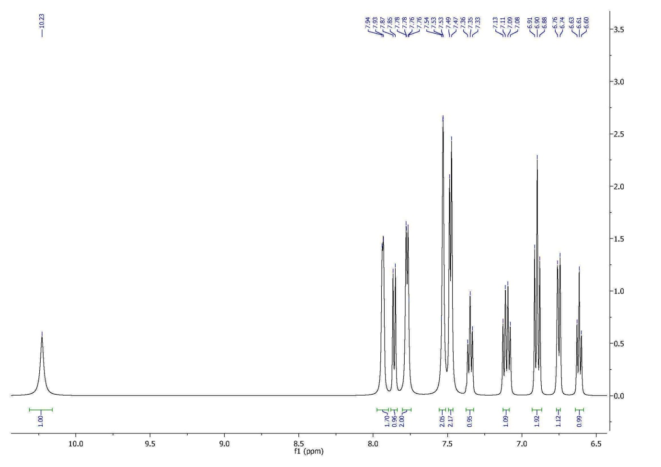 Fig 41. Aromatic range ¹H NMR spectrum of compound (4g)

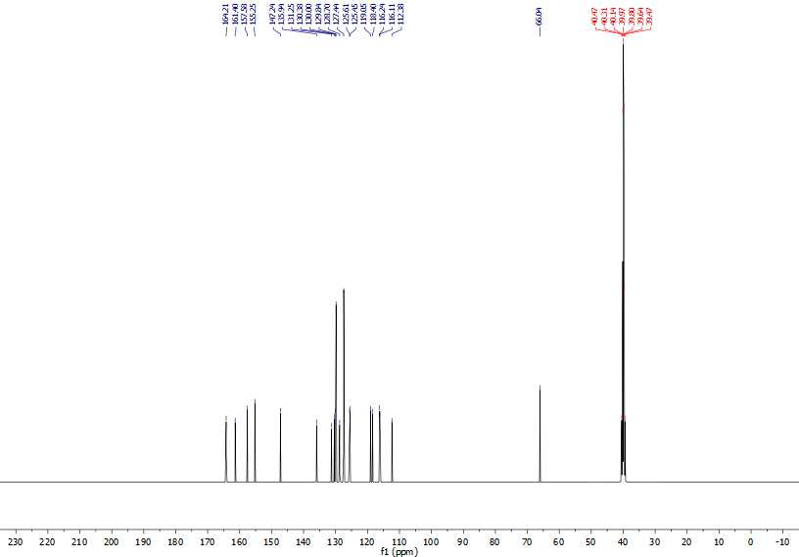 Fig 42. The whole range ¹³C NMR spectrum of compound (4g)

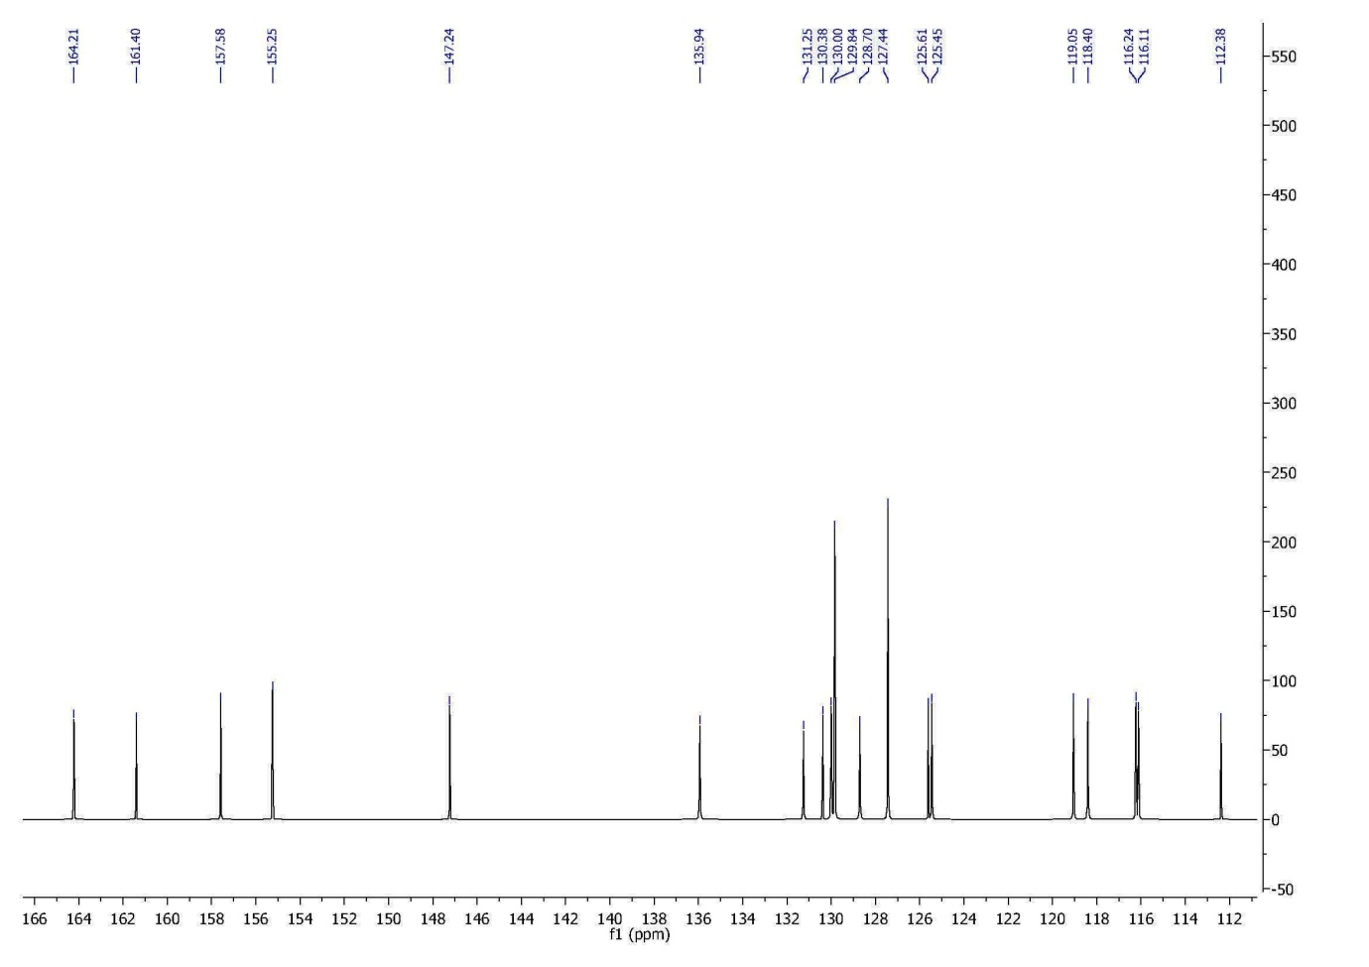 Fig 43. Doubl bond range ¹³C NMR spectrum of compound (4g)

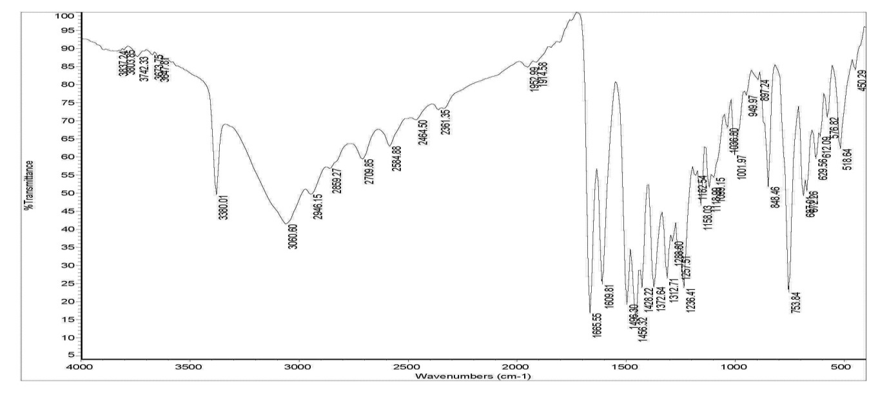 Fig 44. IR spectrum of compound (4g)

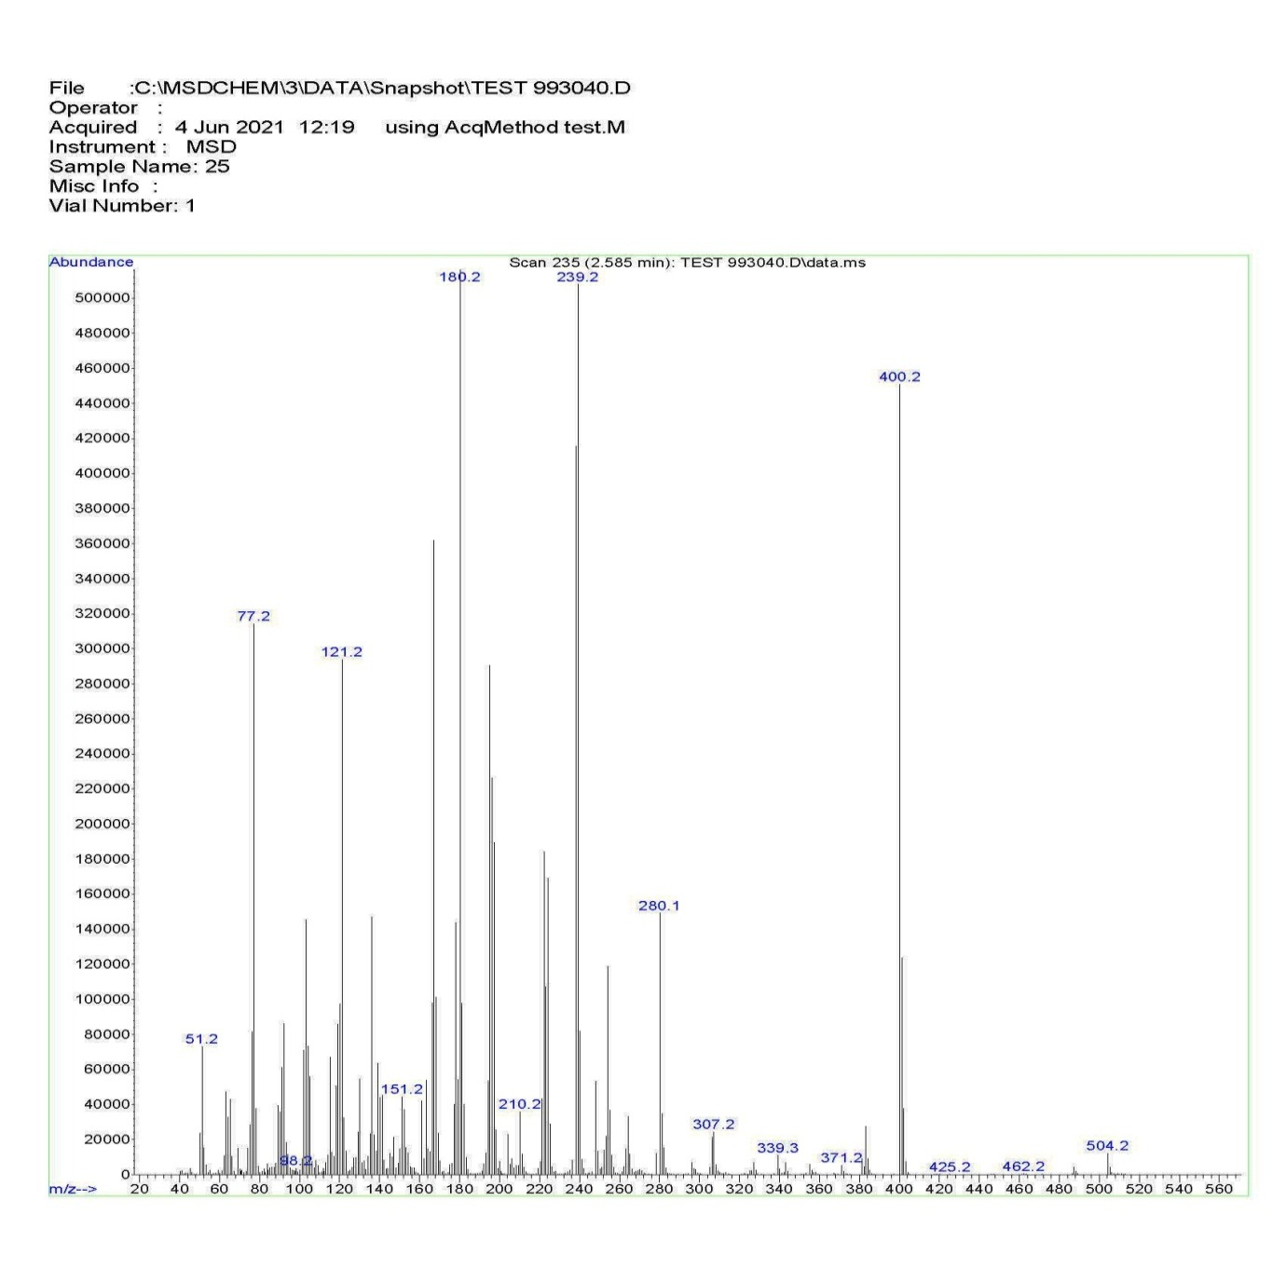 Fig 45. Mass spectrum of compound (4g)
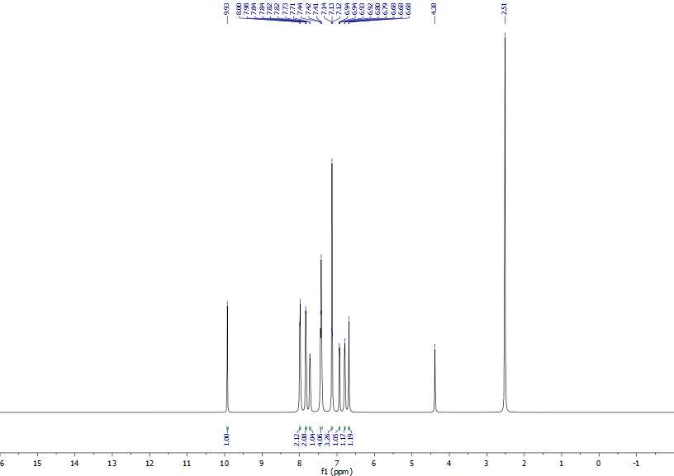 Fig 46. The whole range ¹H NMR spectrum of compound (4h)

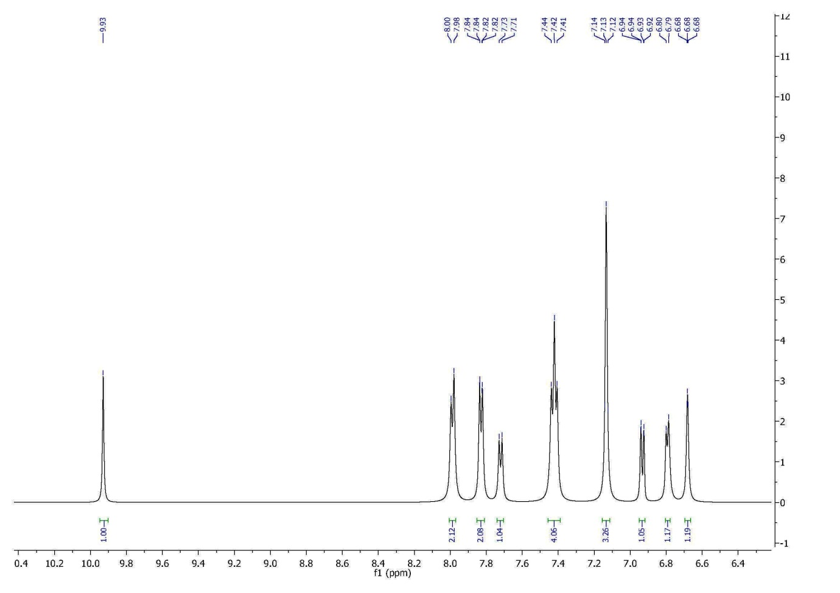 Fig 47. Aromatic range ¹H NMR spectrum of compound (4h)

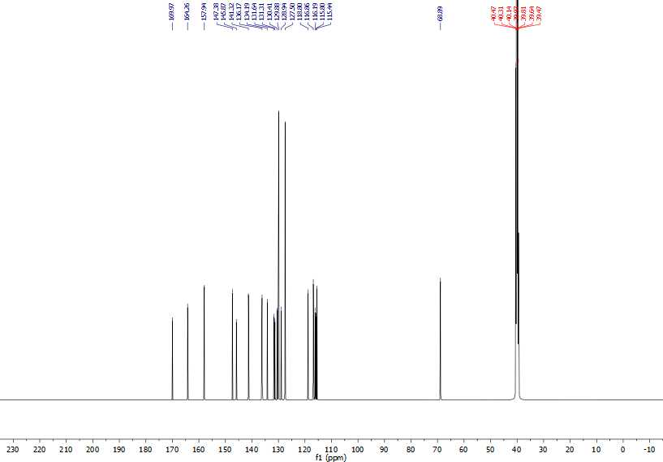 Fig 48. The whole range ¹³C NMR spectrum of compound (4h)

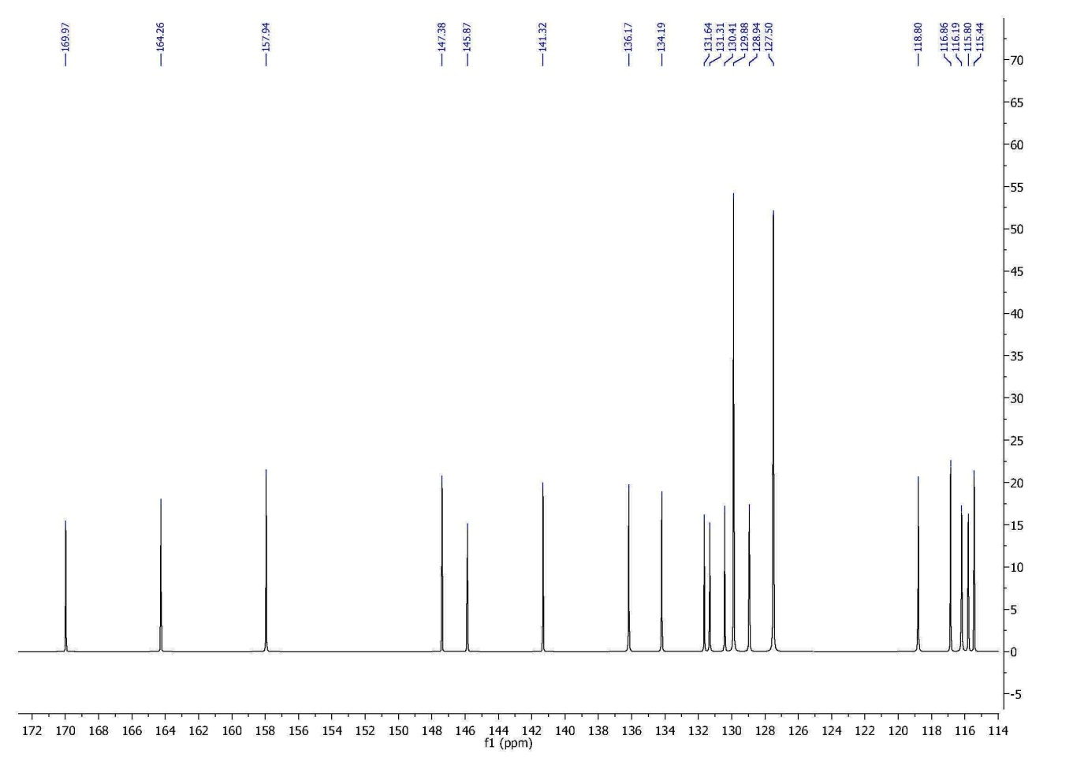 Fig 49. Doubl bond range ¹³C NMR spectrum of compound (4h)

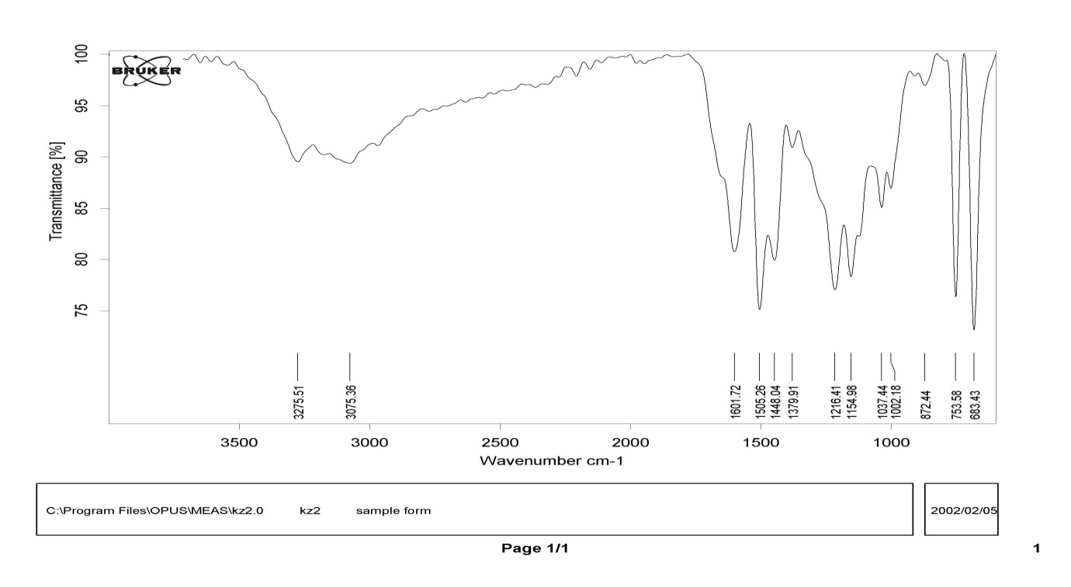 Fig 50. IR spectrum of compound (4h)

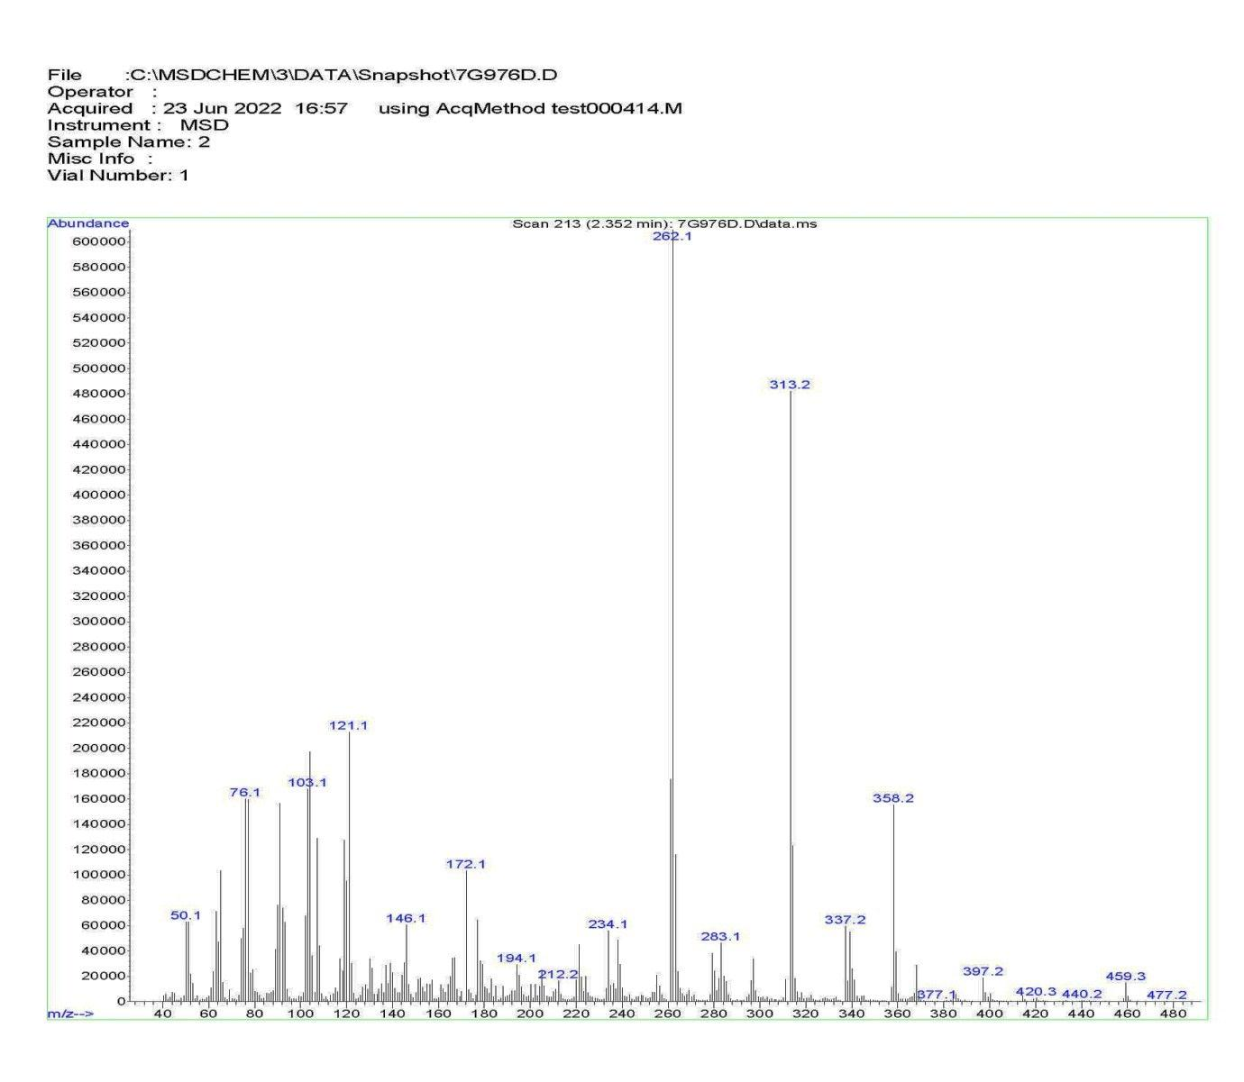 Fig 51. Mass spectrum of compound (4h)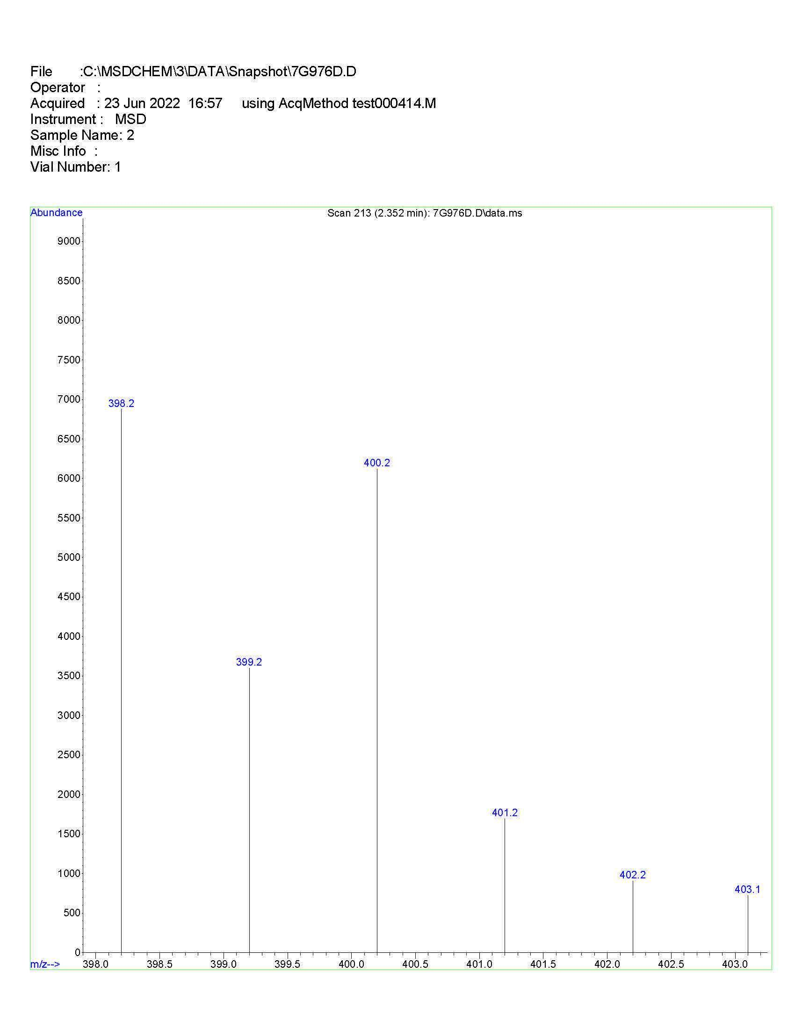 Fig 52. Mass spectrum of compound (4h), from a closer look

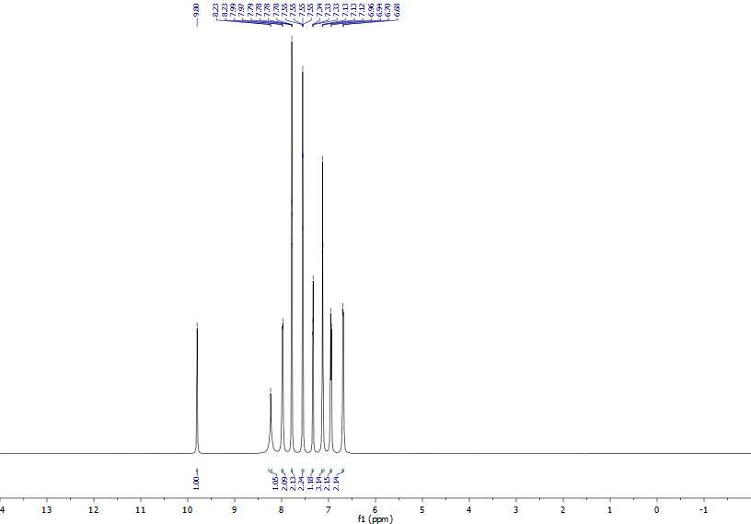 Fig 53. The whole range ¹H NMR spectrum of compound (4i)

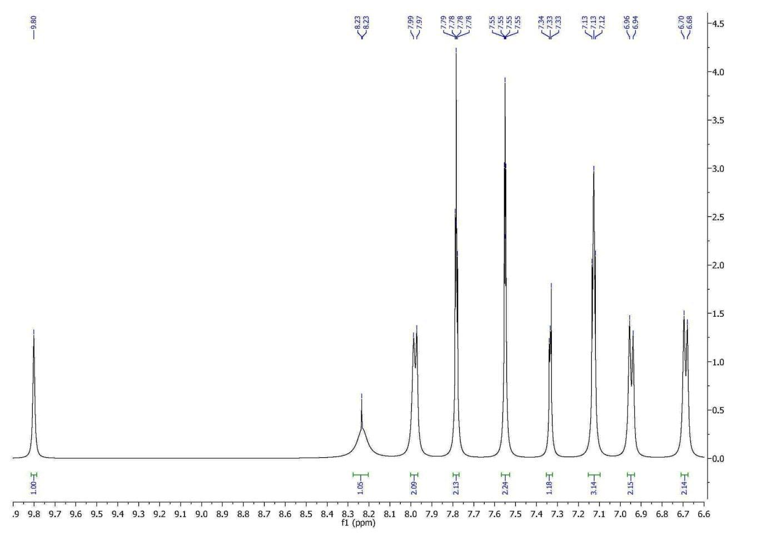 Fig 54. Aromatic range ¹H NMR spectrum of compound (4i)

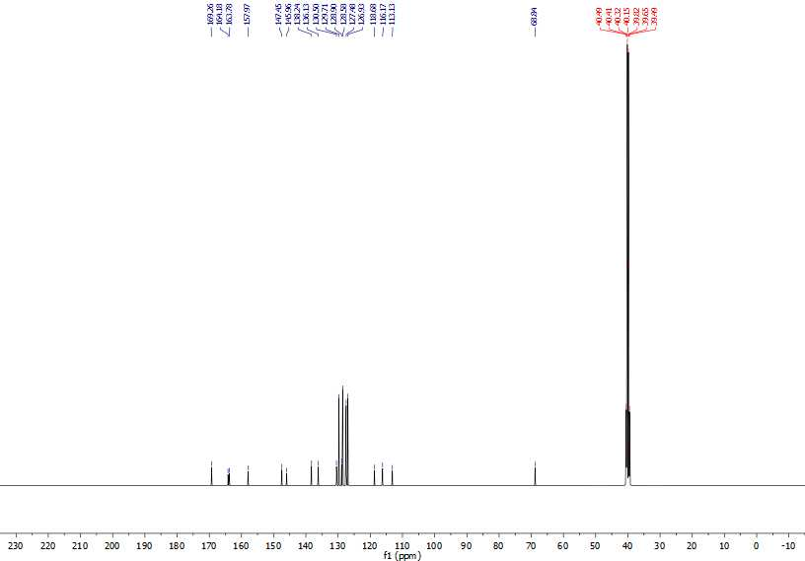 Fig 55. The whole range ¹³C NMR spectrum of compound (4i)

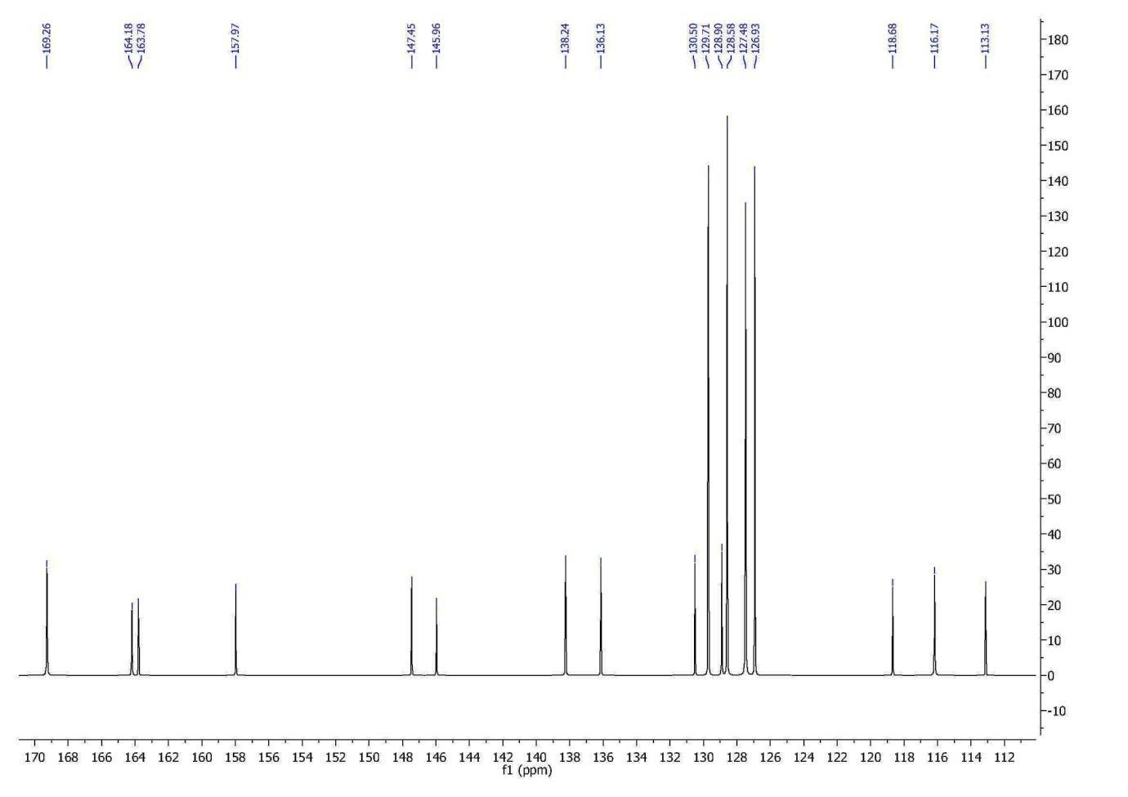 Fig 56. Doubl bond range ¹³C NMR spectrum of compound (4i)

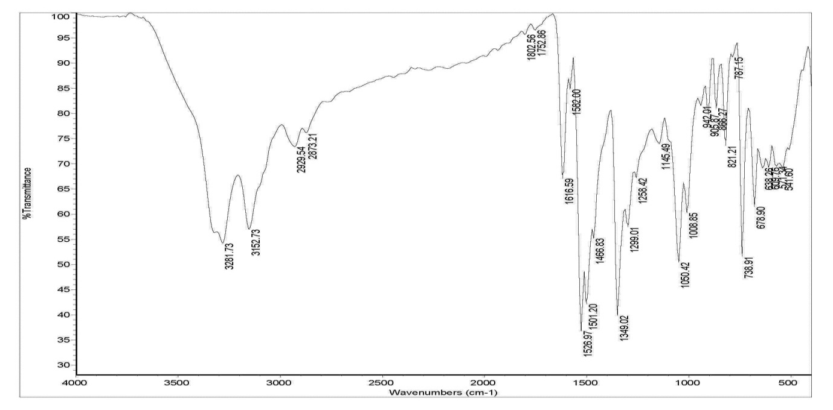 Fig 57. IR spectrum of compound (4i)

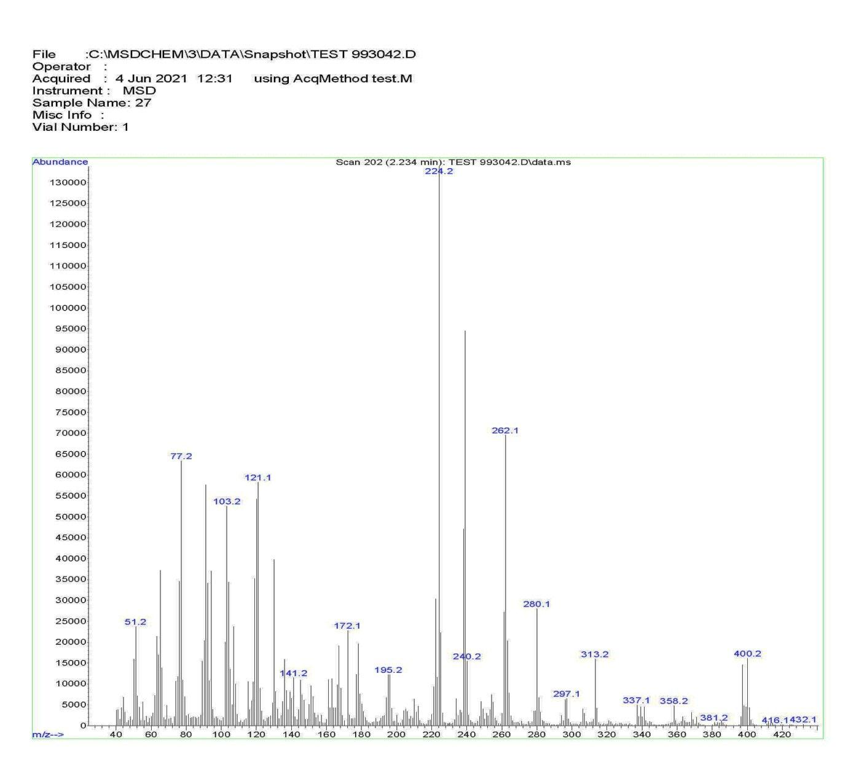 Fig 58. Mass spectrum of compound (4i)
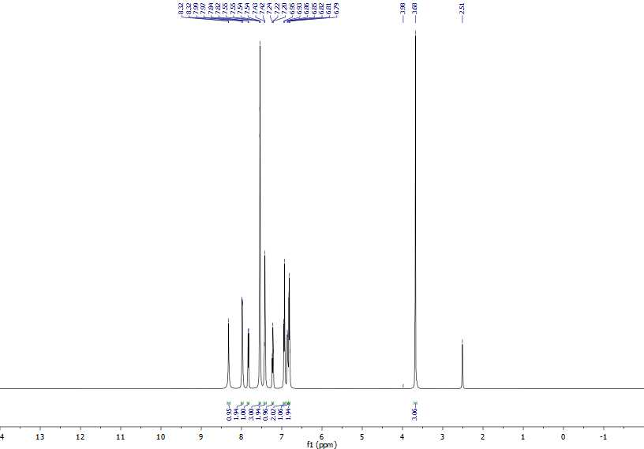 Fig 59. The whole range ¹H NMR spectrum of compound (4j)

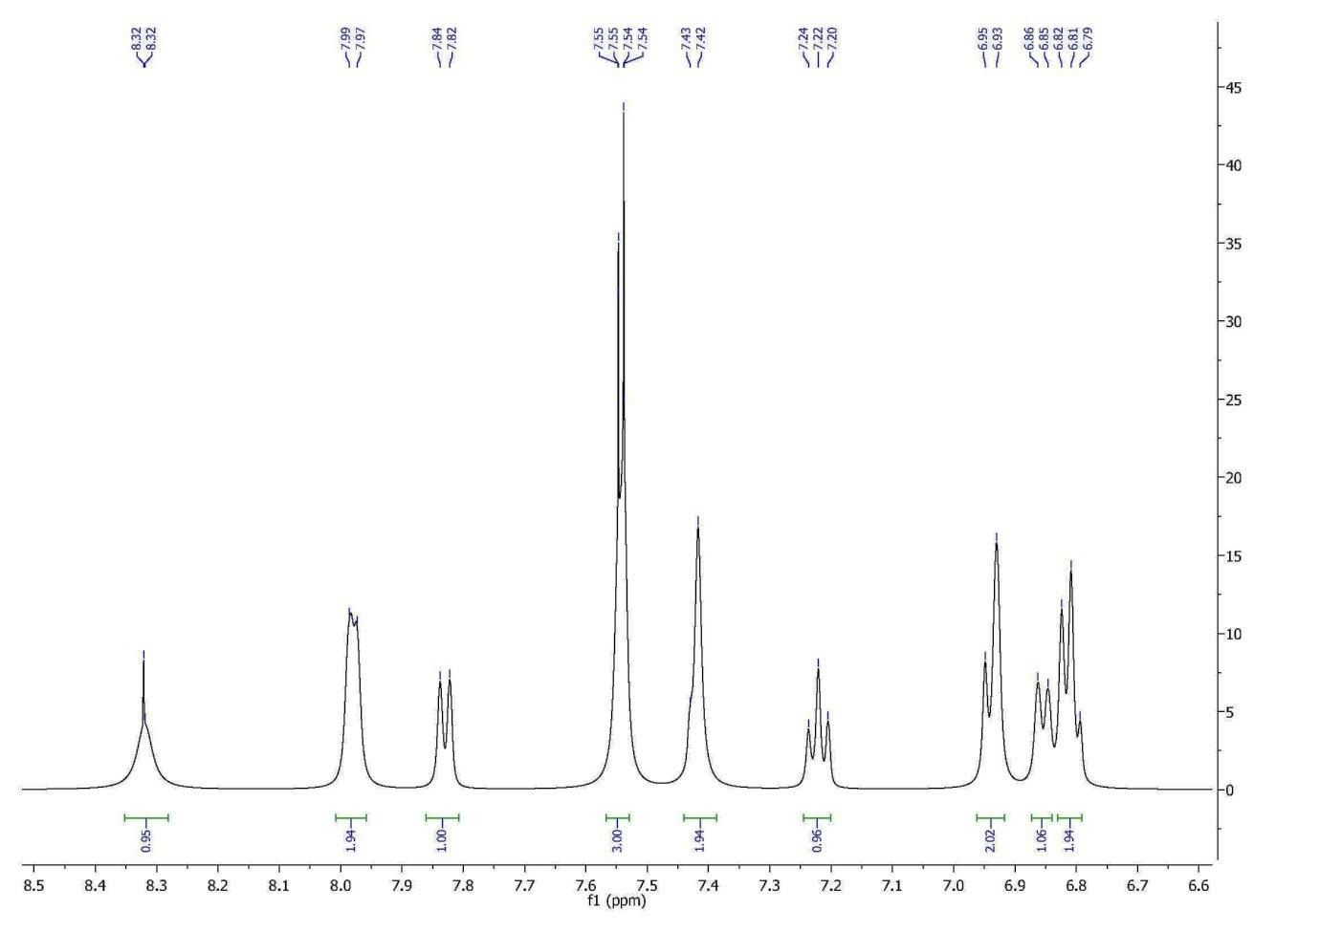 Fig 60. Aromatic range ¹H NMR spectrum of compound (4j)

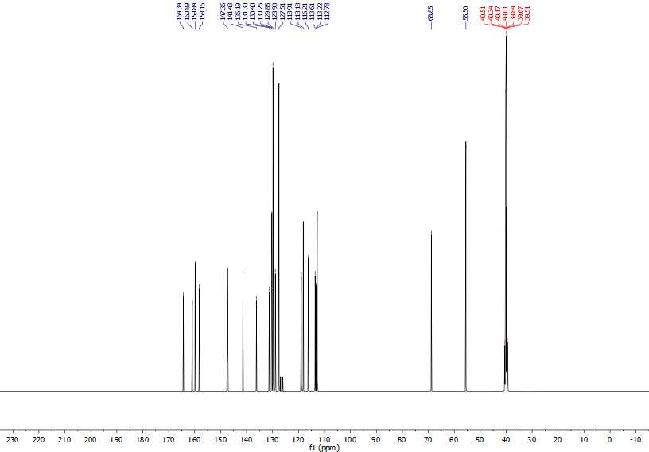 Fig 61. The whole range ¹³C NMR spectrum of compound (4j)

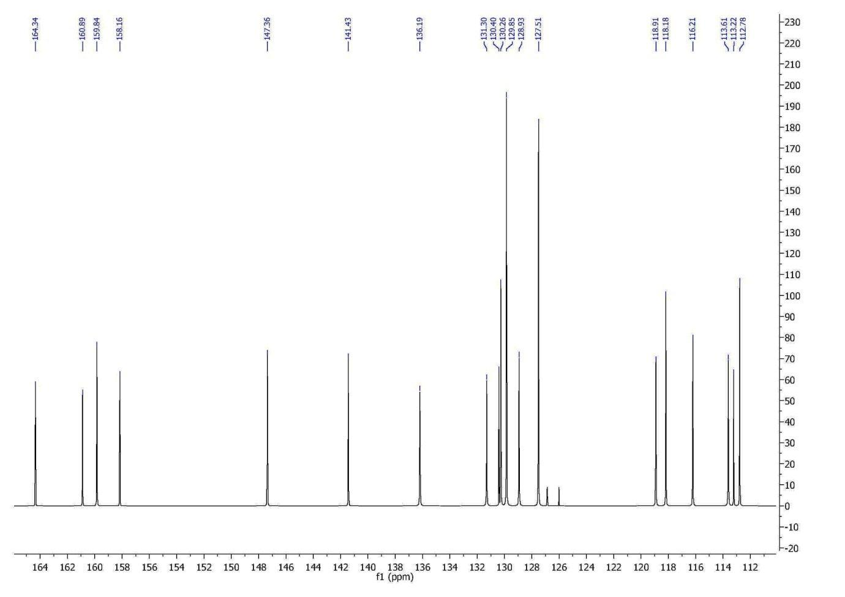 Fig 62. Doubl bond range ¹³C NMR spectrum of compound (4j)

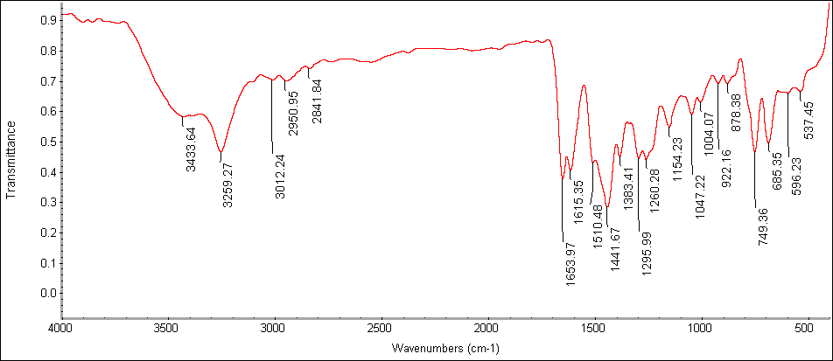 Fig 63. IR spectrum of compound (4j)

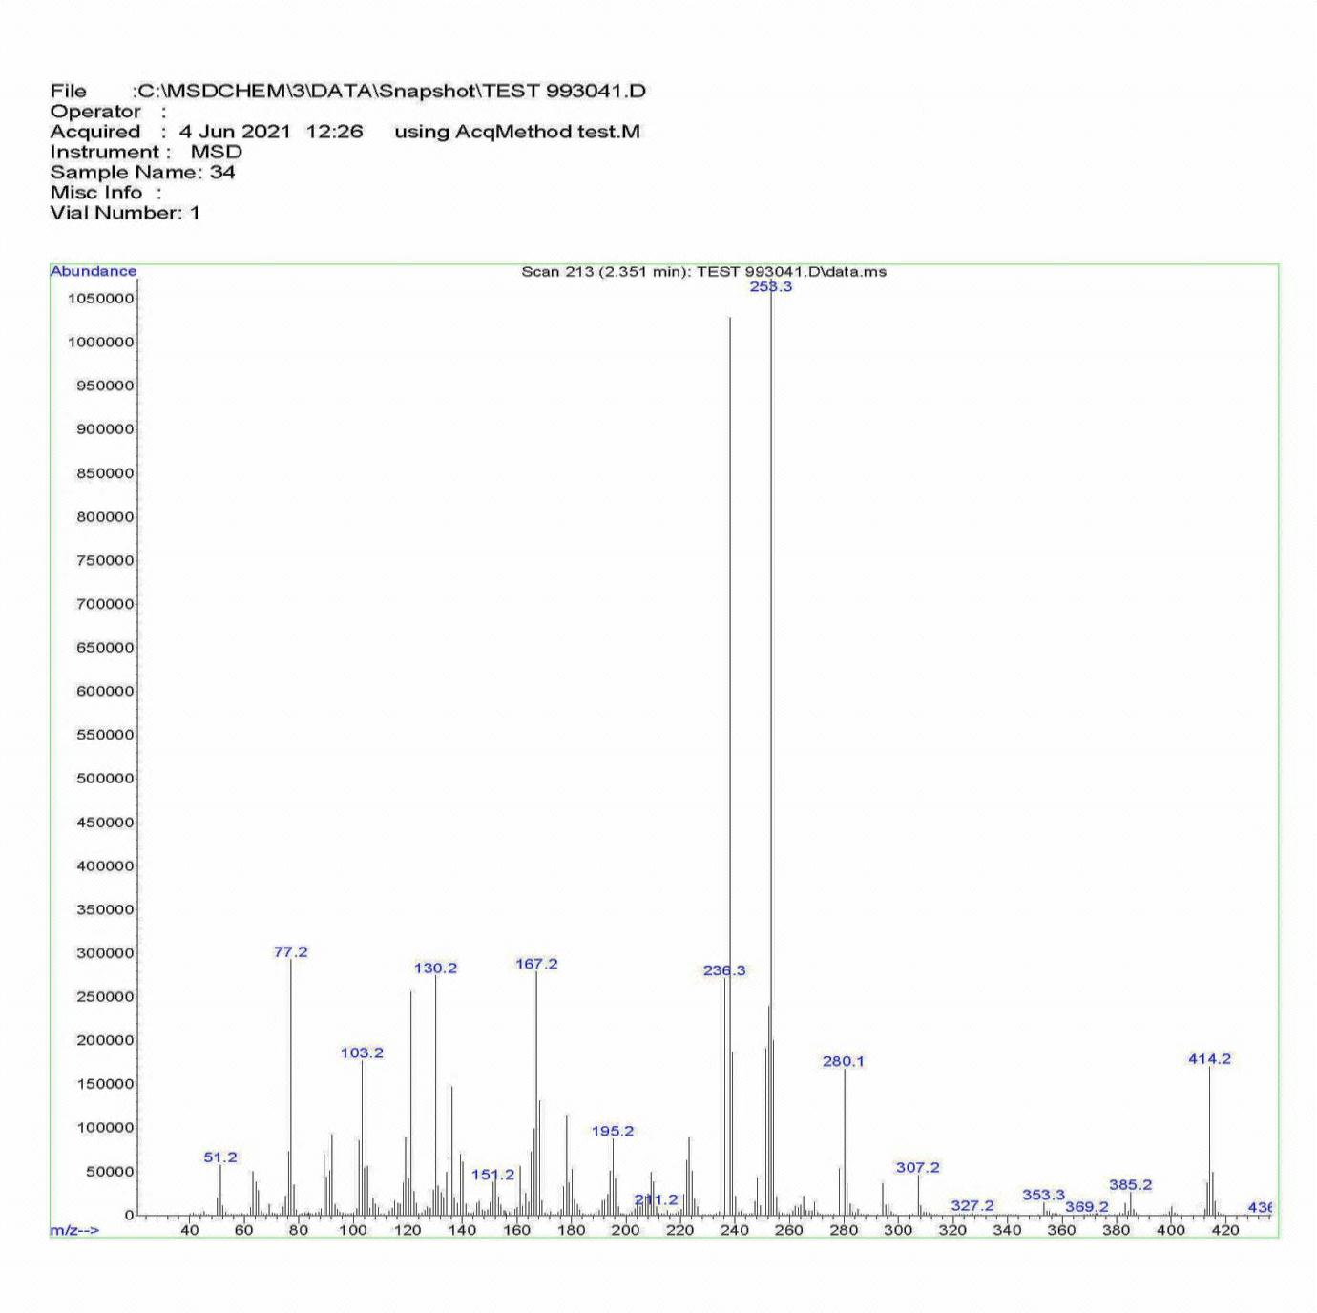 Fig 64. Mass spectrum of compound (4j)
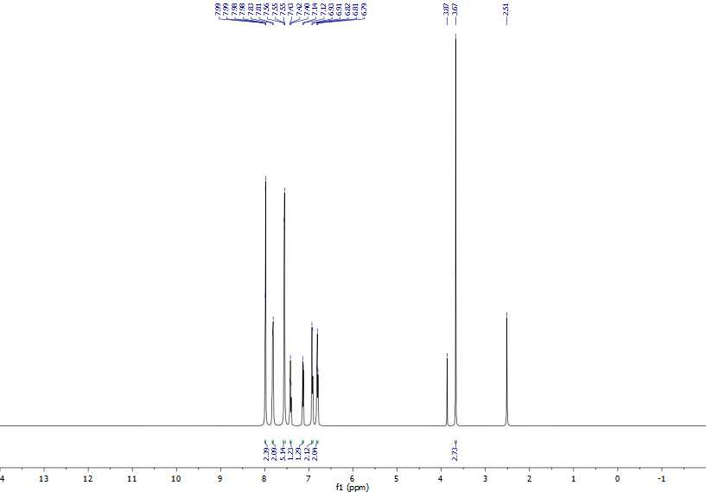 Fig 65. The whole range ¹H NMR spectrum of compound (4k)

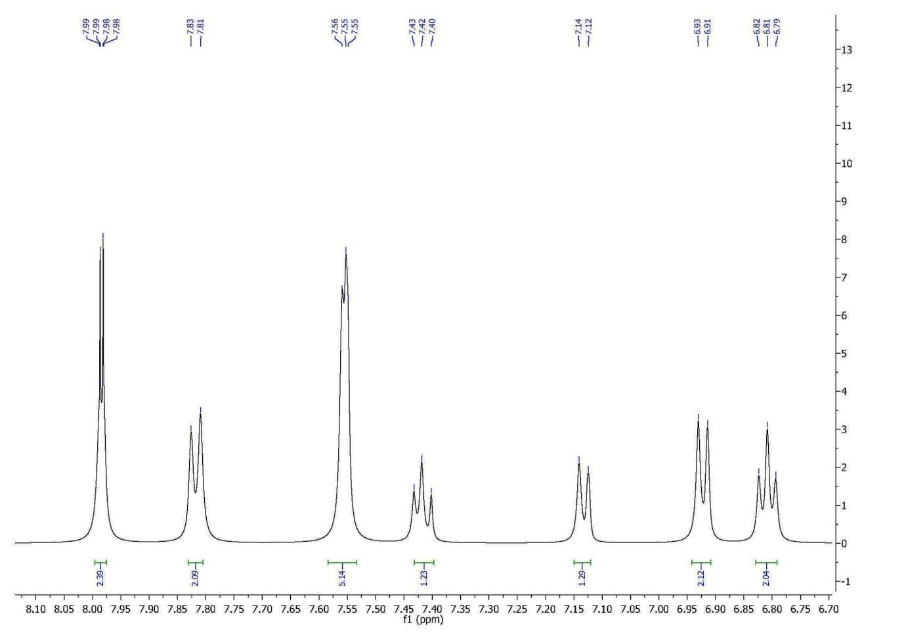 Fig 66. Aromatic range ¹H NMR spectrum of compound (4k)

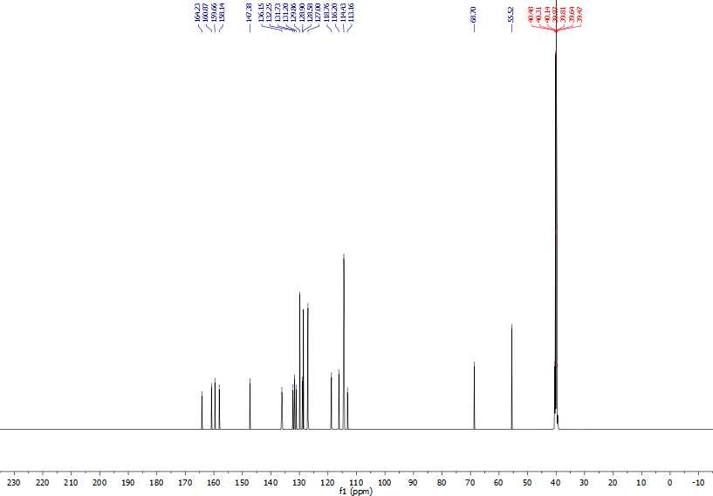 Fig 67. The whole range ¹³C NMR spectrum of compound (4k)

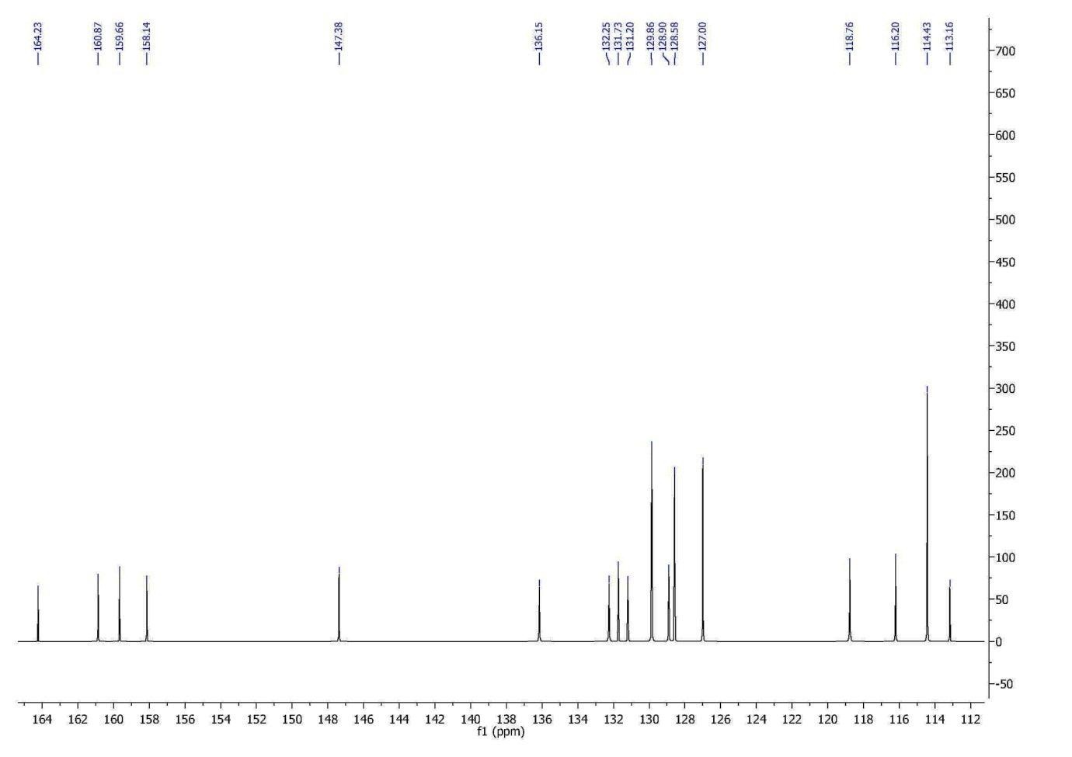 Fig 68. Doubl bond range ¹³C NMR spectrum of compound (4k)

Fig 69. IR spectrum of compound (4k)

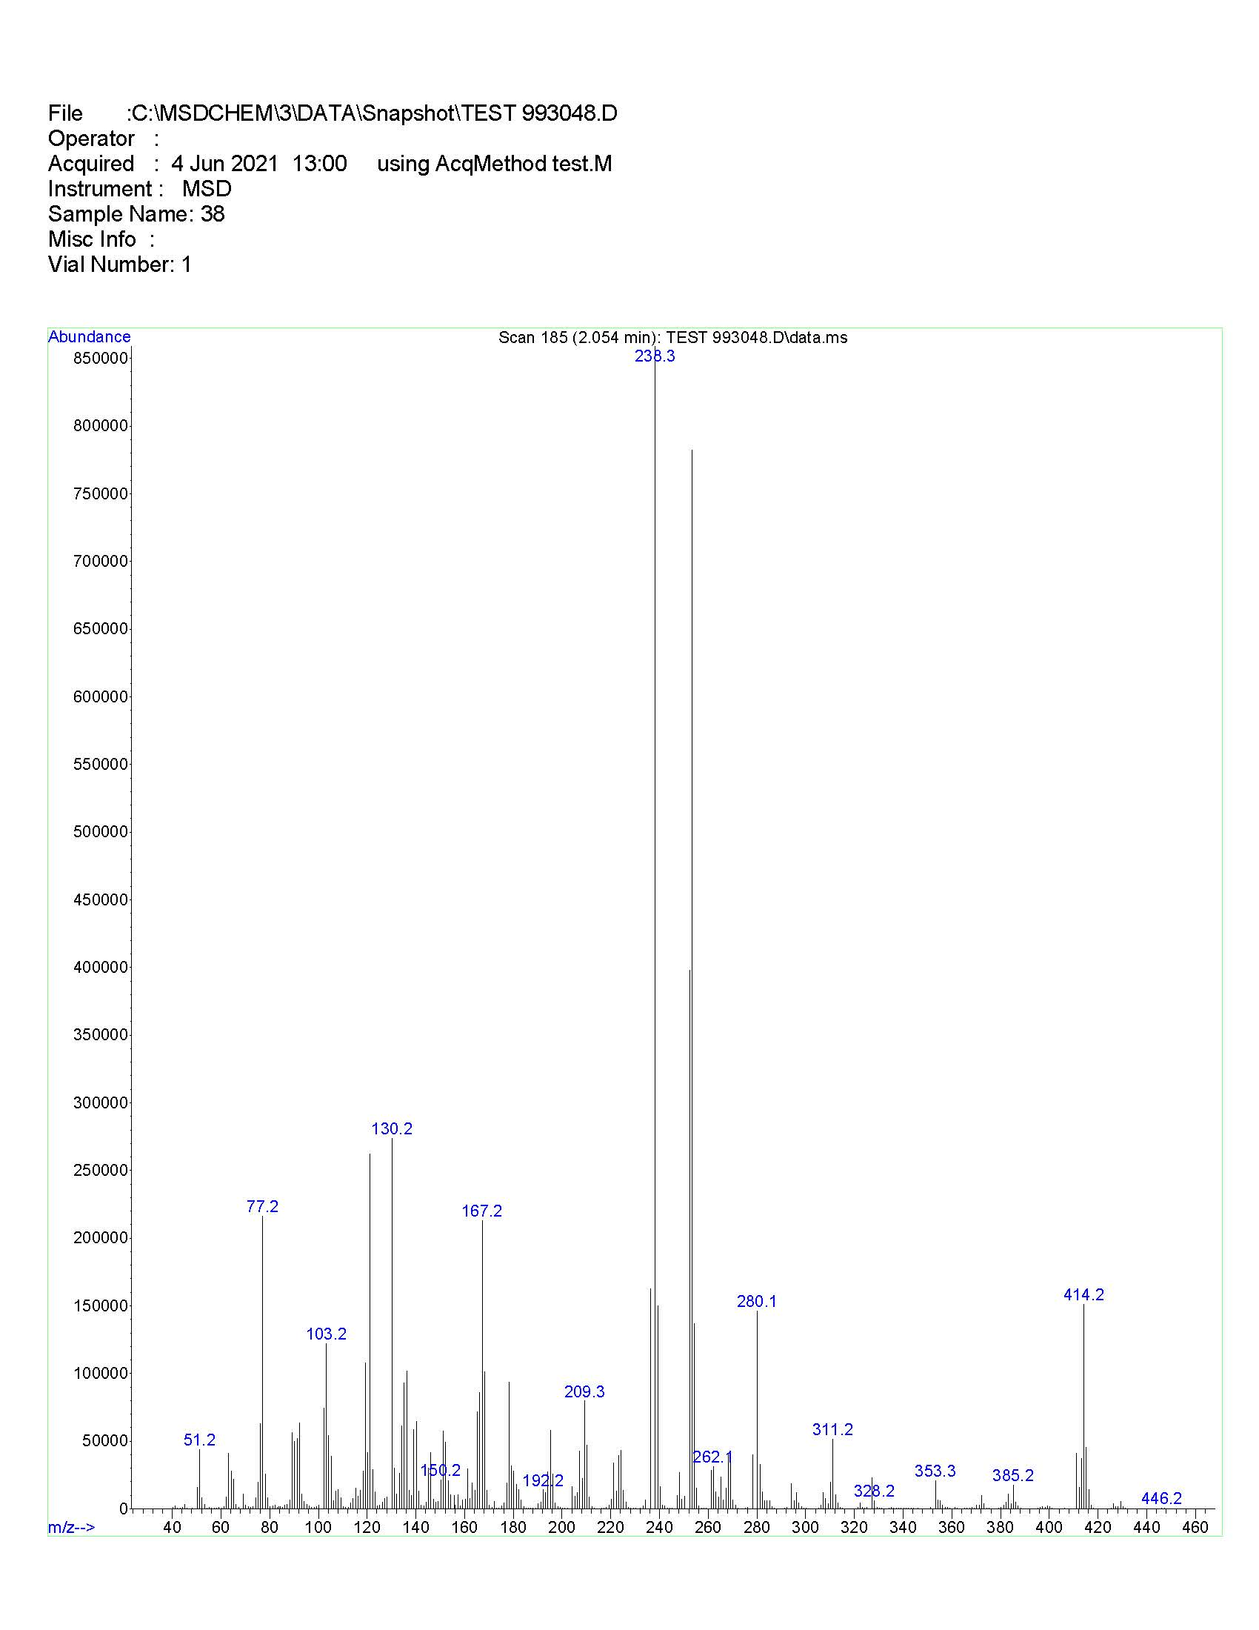 Fig 70. Mass spectrum of compound (4k)
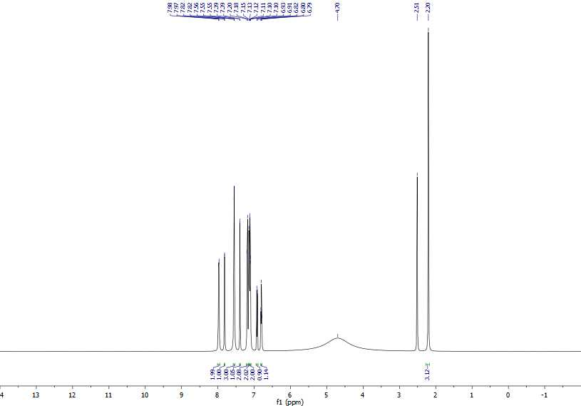 Fig 71. The whole range ¹H NMR spectrum of compound (4l)

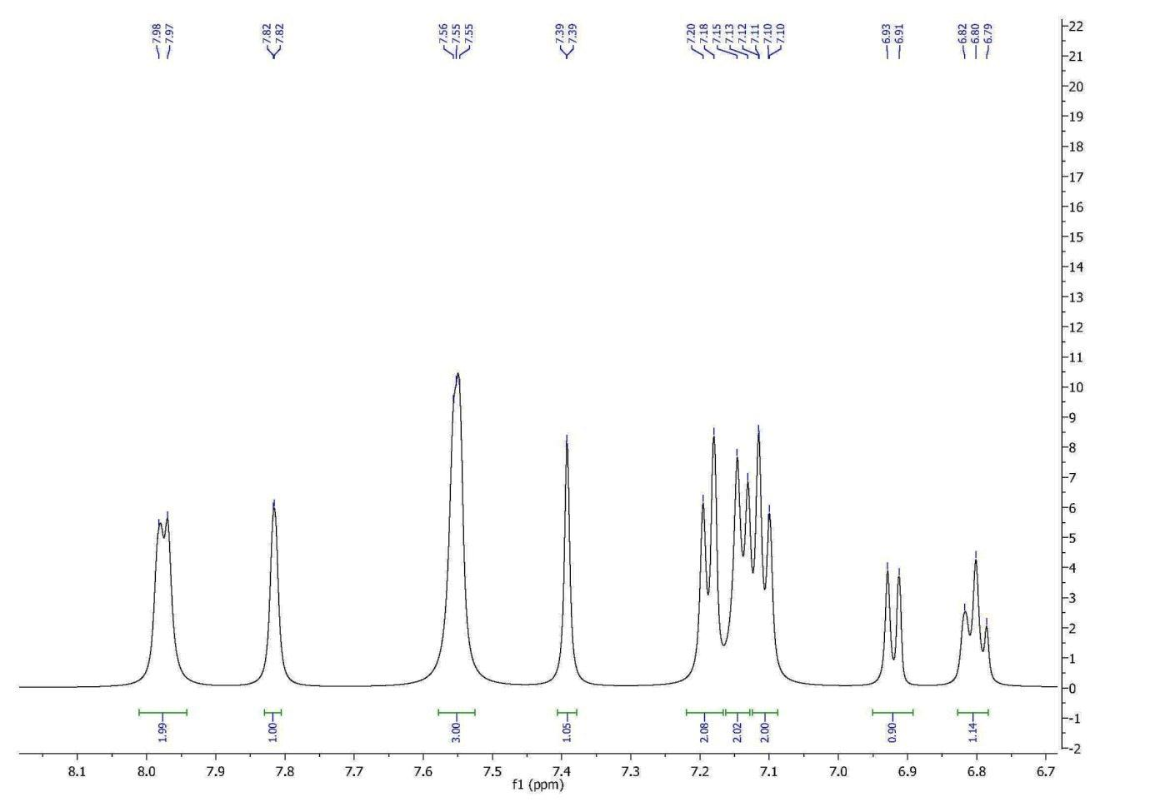 Fig 72. Aromatic range ¹H NMR spectrum of compound (4l)

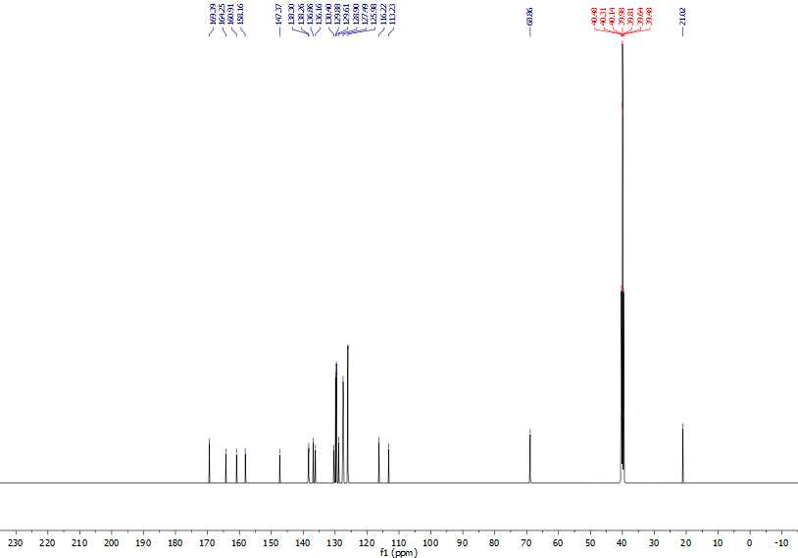 Fig 73. The whole range ¹³C NMR spectrum of compound (4l)

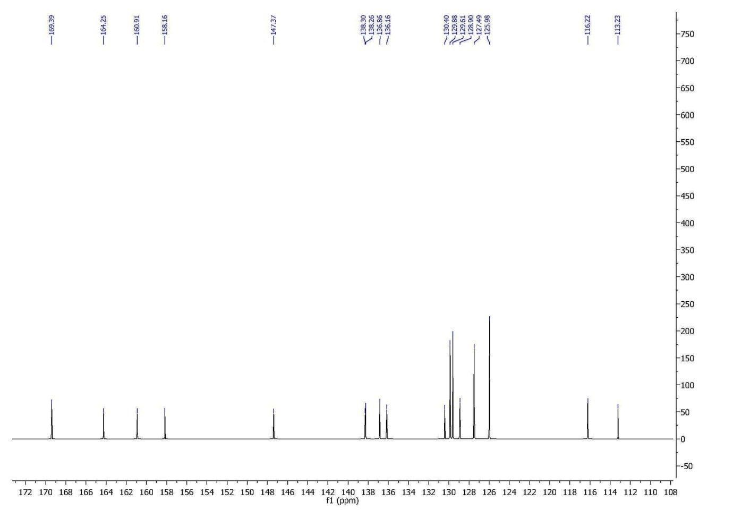 Fig 74. Doubl bond range ¹³C NMR spectrum of compound (4l)

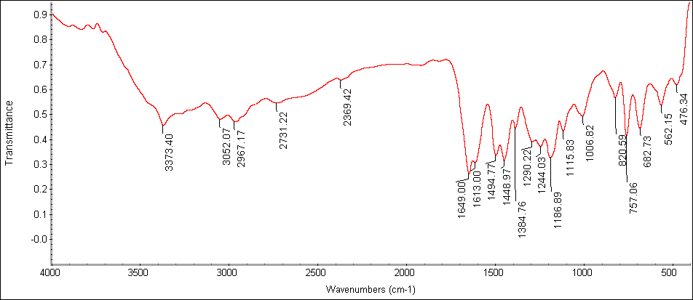 Fig 75. IR spectrum of compound (4l)

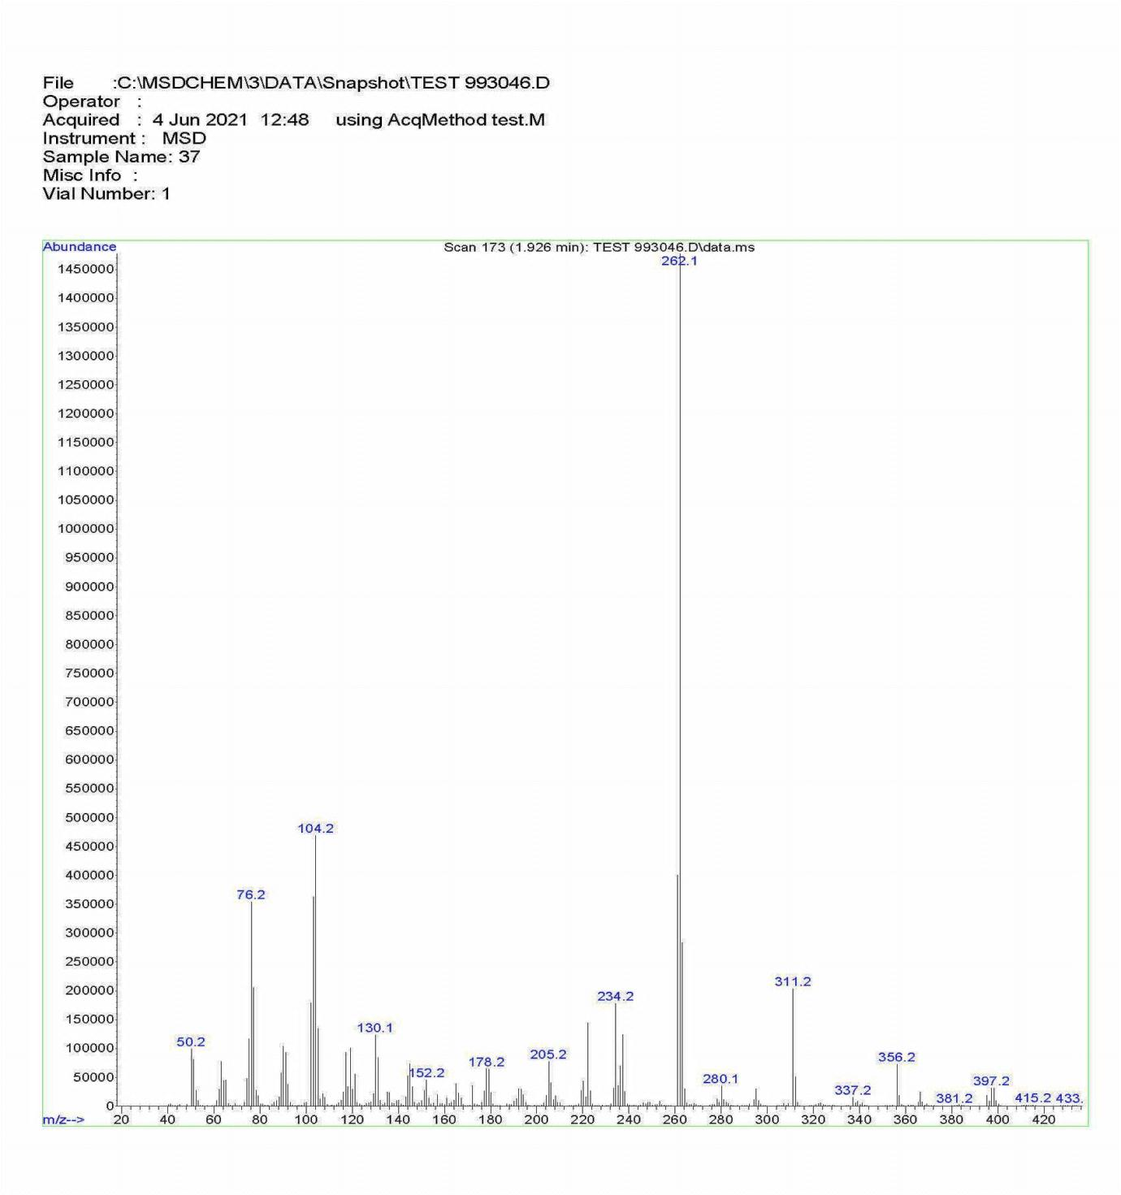 Fig 76. Mass spectrum of compound (4l)

