Synthesis, Antimicrobial and Molecular Docking studies of Some New Derivatives of 2,3-dihydroquinazolin-4(1H)-one
Karim Zahmatkesh¹, Karim Akbari Dilmaghani^{1*} Yasin Sarveahrabi²
1-Department of Organic Chemistry, Faculty of Chemistry, Urmia University, Urmia, 57159, Iran.
2-Department of Biology, Central Tehran Branch, Islamic Azad University, Tehran, Iran.
* Corresponding author: E-mail: k.adilmaghani@urmia.ac.ir
Tel: (+98)914-443-1392; Fax: (+98)44-357153-165

Abstract
In the present study a series of novel 2-(substituted phenyl)-3-(5-phenyl-1-3,4-thiadiazol-2-yl)-2,3-dihydroquinazolin-4(1H)-one derivatives were synthesized by refluxing Isatoic anhydride, 5-phenyl-1,3,4-thiadiazol-2-amine and aromatic aldehydes in the presence of p-TsOH as catalyst and in H₂O as solvent and characterized by spectral data and analytical methods. Antibacterial and antifungal activity of the title compounds are evaluated against two gram positive and two gram negative bacterial strains and strains of fungi Compared with standard drugs, using well diffusion method, minimum bactericidal/fungicidal concentration methods. The potential Alpha-amylase and Alpha-glucosidase inhibitory activity of compounds 4(a-l) were investigated in silico using molecular docking simulation method. Therefore, these 2,3-dihydroquinazolin-4(1H)-one derivatives may be considered as promising candidates for the development of new classes of antimicrobial and antidiabetic drugs.

Keywords: Isatoic anhydride, 2,3-dihydroquinazolin-4(1H)-one , antibacterial activity, antifungal activity, anti-diabetic activity.

1. Introduction
The 2,3-dihydroquinazolin-4(1H)-one (DHQ) is an important nitrogen-containing heterocyclic scaffold. DHQ ring system is a distinguished scaffold in drug design. DHQ in medicinal chemistry as an important pharmacophore has drawn much attention due to its broad spectrum of pharmaceutical activities, which include antibacterial,^{1,2} antifungal,³⁻⁵ anticancer,⁶⁻⁸ Antidiabetic,⁹ anti-tuberculin,¹⁰ anti-inflammatory,¹¹⁻¹³ Cholinesterase inhibitor,¹⁴ antihypertensive activities^{15,16} and insecticidal activity¹⁷.
On the other hand, 2-Amino-1,3,4-thiadiazole and its derivatives have drawn attention of many organic chemists during recent years, since many of these compounds known to possess interesting biological properties such as antibacterial,^{18,19} antifungal,²⁰⁻²² anticancer,²³⁻²⁵ antihypertensive^{26,27} activities. With Considering the reactivity of the amine group in the derivatization process, 2-amino-1,3,4-thiadiazole moiety is a good scaffold for drug synthesis. Most of the DHQ derivatives are substituted on the carbon 2 and 3. Due to their attractive properties, 2-substituted DHQs are becoming a prominent synthetic intermediate for organic chemists and pharmacologist.
Based on the above observations we report here the synthesis of a new series of 2,3-dihydroquinazolin-4(1H)-one derivatives 4(a-l) with structure modifications involving incorporation of 5-phenyl-1,3,4-thiadiazol-2-amine 3 at position 3 and aromatic aldehydes 2(a-l) at position 2 of DHQ ring system. In the present study, various aryl aldehydes groups were specifically incorporated at position 2 of the DHQ scaffold with the aim of new antibacterial, antifungal and anti diabetic drugs.

2. Experimental
Starting materials, solvents, and culture environments (nutrient agar/broth, sabouraud dextroseand agar/broth) were obtained from Merck, Germany and used without any more filtration. Microbiological tests were performed using a Memmert- INC153T2T3 incubator. Melting points are determined in Philip Harris C4954718 melting point apparatus and are uncorrected. IR spectra are recorded on a Thermo Nicolet Nexus-670 FTIR spectrophotometer, using potassium bromide pellets and the frequencies are expressed in cm⁻¹. The ¹H NMR and ¹³C NMR spectra are recorded with a Bruker Avance-400MHz spectrometer, using TMS as the internal reference, with DMSO-d₆ as solvent, The chemical shifts are reported in parts per million (ppm). Mass spectra were obtained on a 5973 Network Mass Selective Detector instrument using electron impact ionization ((EI) 70eV). Elemental analysis is performed on FlashEA 1112 series (Thermo Finnigan) CHNS analyzer.
2.1. Synthesis of 5-phenyl-1,3,4-thiadiazol-2-amine. (3)
A stirring mixture of benzoic acid (50 mmol), thiosemicarbazide (50 mmol) and phosphorus oxychloride (POCl₃) (15 ml) was heated at 75 °C for 1 h. After cooling to room temperature, water was added; the reaction mixture was further refluxed for 4 h. After cooling, the mixture was basified to pH 8 by the dropwise addition of 50% potassium hydroxide solution under stirring. thus, obtained precipitate was filtered and recrystallized from ethanol.²⁸
This compound was obtained as yellow solid in a yield of 85%; m.p.: 225-227 °C;
¹H NMR (500 MHz, DMSO-d₆) δ 7.42 (S, 2H, NH), 7.44-7.46 (m, 3H, ArH), 7.74 (d, j = 7.73 Hz, 2H, ArH).
¹³C NMR (125 MHz, DMSO-d₆) δ 126.74 (2CH), 129.56 (2CH), 130.00 , 131.43 , 156.84 (C=N), 168.98 (C=N).
IR (KBr, v , cm⁻¹); 3267.45, 3062.96 (v_{NH}), 1629.53 (v_{C=N}),1510.55 (strong bending v_{NH}), 664.71(v_{C-S} );
MS (m/z): 177.1 (M⁺ + H)
Anal. Calcd for C8H7N3S (%): C, 54.22; H, 3.98; N, 23.71; S, 18.09. Found: C,
54.23; H, 3.99; N, 23.74; S, 18.13.
2.2. General procedure for the synthesis of compounds 2-substituted phenyl-3-(5-phenyl-1-3,4-thiadiazol-2-yl)-2,3-dihydroquinazolin-4(1H)-one 4(a-l).
To a round-bottom flask containing H₂O (5 mL) was added isatoic anhydride (1 mmol, 0.1631 g), relevant aldehyde (1 mmol), 1,3,4-thiadiazol-2-amine (1.1 mmol, 0.1949 g), and p-TsOH (Our inventory was its monohydrate) (0.6 mmol, 0.1141 g). The mixture was heated under reflux for 2 hours. The precipitate was filtered and recrystallized from EtOH.²⁹
According to Table 1&2 and Scheme 1.
2.2.1. 2-phenyl-3-(5-phenyl-1,3,4-thiadiazol-2-yl)-2,3-dihydroquinazolin-4(1H)-one (4a):
This compound was obtained as light brown solid in a yield of 81%; m.p.: 171-173 °C.
¹H NMR (500 MHz, DMSO-d₆): δ 6.81 (t, j = 7.48 Hz,1H, NH), 6.93 (d, j = 8.15 Hz, 1H, CH), 7.32 (m, 5H, ArH), 7.41 (t, j = 3.75 Hz, 1H, ArH), 7.44 (d, j= 0.58 Hz, 1H, ArH), 7.55 (m, 3H, ArH), 7.82 (d, j = 7.92 Hz, 1H, ArH), 7.98 (d, j = 6.47 Hz, 2H, ArH), 8.34 (d, j = 0.18 Hz, 1H, ArH).
¹³C NMR (125 MHz, DMSO-d₆) δ 68.95 (N-C-N), 113.19, 116.22, 118.90, 126.13 (2CH), 127.49 (2CH), 128.87, 128.94, 129.12 (2CH), 129.87 (2CH), 130.37, 131.32, 136.21, 139.80, 147.29, 158.17 (C=O), 160.87 (C=N), 164.32 (C=N).
IR (KBr, v, cm⁻¹); 3364.47 (v_{NH}), 3033.20 (v_{C-H}), 1633.86 (v_{C=O}), 1500.59 (v_{C=N}), 1448.65 (strong bending v_{NH}), 1386.63 (v_{C-N}), 1180.94 (v_{N-N}), 689.71 (v_{C-S}).
MS (m/z): 384.2 (M⁺ + H)
Anal. Calcd for C₂₂H₁₆N₄OS (%): C, 68.73; H, 4.20; N, 14.57; S, 8.34. Found: C, 68.77; H, 4.25; N, 15.02; S, 8.29.
2.2.2. 2-(2-chlorophenyl)-3-(5-phenyl-1,3,4-thiadiazol-2-yl)-2,3-dihydroquinazolin-4(1H)-one (4b):
This compound was obtained as brownish yellow solid in a yield of 84%; m.p.: 210- 212 °C.
¹H NMR (500 MHz, DMSO-d₆): δ 6.86 (t, j = 7.55 Hz, 1H, NH), 6.90 (d j = 8.22 Hz, 1H, CH), 7.07 (d, j = 7.80 Hz, 1H, ArH), 7.20 (t, j = 7.67 Hz, 1H, ArH), 7.33 (t, j = 7.63 Hz, 1H, ArH), 7.41 ( t, j = 7.78 Hz, 1H, ArH), 7.53 (t, j = 3.29 Hz, 3H, ArH), 7.57 (d, j = 7.87 Hz, 1H, ArH), 7.60 (d, j = 3.34 Hz, 1H, ArH), 7.93 (t, j = 7.44 Hz, 3H, ArH), 8.11 (d, j = 4.25 Hz, 1H, ArH).
¹³C NMR (125 MHz, DMSO-d₆) δ 67.21 (N-C-N), 112.54, 116.50, 119.10, 125.79, 127.48 (2CH), 128.07, 128.85, 129.86 (2CH), 130.27, 130.89 (2CH), 131.35 (C-Cl), 132.06, 136.32, 136.88, 146.07, 157.35 (C=O), 160.93 (C=N), 164.49 (C=N).
IR (KBr, v, cm⁻¹); 3324.17 (v_{NH}), 3056.76 (v_{C-H}), 1661.58 (v_{C=O}), 1615.33 (v_{C=N}), 1506.09 (strong bending v_{NH}), 1439.22 (v_{C-N}), 1245.53 (v_{N-N}), 748.42 (v_{C-Cl}), 685.60 (v_{C-S}).
MS (m/z): 418.2 (M⁺ + H)
Anal. Calcd for C₂₂H₁₅ClN₄OS (%): C, 63.08; H, 3.61; N, 13.38; S, 7.65. Found: C, 63.05; H, 3.62; N, 13.45; S, 7.77.
2.2.3. 2-(4-chlorophenyl)-3-(5-phenyl-1,3,4-thiadiazol-2-yl)-2,3-dihydroquinazolin-4(1H)-one (4c):
This compound was obtained as greenish yellow solid in a yield of 85%; m.p.: 227- 229 °C.
¹H NMR (500 MHz, DMSO-d₆): δ 6.82 (t, j = 7.44 Hz, 1H,NH), 6.94 (d, j = 8.25 Hz. 1H, CH), 7.33 (d, j = 8.18 Hz, 2H, ArH), 7.39 (d, j = 8.26 Hz, 2H, ArH), 7.43 (d, j = 8.62 Hz, 2H, ArH), 7.54 (t, j = 4.03 Hz, 3H, ArH), 7.82 (d, j = 7.88 Hz, 1H, ArH), 7.97 (m, 2H, ArH), 8.31 (d, j = 3.95 Hz, 1H, ArH).
¹³C NMR (125 MHz, DMSO-d₆) δ 68.47 (N-C-N), 113.19, 116.30, 119.08, 127.50 (2CH), 128.11(2CH), 128.99, 129.15 (2CH), 129.87 (2CH), 130.36, 131.33 (C-Cl), 133.60, 136.28, 138.84, 147.09, 158.09 (C=O), 160.67 (C=N), 164.40 (C=N).
IR (KBr, v, cm⁻¹); 3377.68 (v_{NH}), 3053.97 (v_{C-H}), 1650.19 (v_{C=O}), 1613.78 (v_{C=N}), 1488.61 (strong bending v_{NH}), 1447.76 (v_{C-N}), 1253.00 (v_{N-N}), 756.40 (v_{C-Cl}), 684.14 (v_{C-S}).
MS (m/z): 418.2 (M⁺ + H)
Anal. Calcd for C₂₂H₁₅ClN₄OS (%): C, 63.08; H, 3.61; N, 13.38; S, 7.65. Found: C, 63.07; H, 3.60; N, 13.41; S, 7.76.
2.2.4. 2-(2-nitrophenyl)-3-(5-phenyl-1,3,4-thiadiazol-2-yl)-2,3-dihydroquinazolin-4(1H)-one (4d):
This compound was obtained as yellow solid in a yield of 82%; m.p.: 199- 201 °C.
¹H NMR (500 MHz, DMSO-d₆): δ 6.88 (t, j = 0.50 Hz. 1H, NH), 7.27 (d, j = 7.43 Hz, 1H, CH), 7.41 (t, j= 8.08Hz, 1H), 7.47 (d, j= 6.82Hz, 1H), 7.52 (t, j= 1.98Hz, 3H), 7.59 (t, j = 8.67 Hz, 2H, ArH), 7.92 (m, 4H, ArH), 8.02 (d, j = 0.77 Hz, 1H, ArH), 8.12 (d, j = 7.55 Hz, 1H, ArH).
¹³C NMR (125 MHz, DMSO-d₆) δ 65.87 (N-C-N), 112.68, 117.17, 119.60, 126.25, 126.46, 127.50 (2CH), 128.82, 129.85 (2CH), 130.21, 130.69, 131.39, 134.64, 134.77, 136.35, 145.98, 147.84 (C-NO₂), 157.51 (C=O), 160.63 (C=N), 164.57 (C=N).
IR (KBr, v, cm⁻¹); 3356.94 (v_{NH}), 3063.28 (v_{C-H}), 1660.59 (v_{C=O}), 1615.85 (v_{C=N}), 1509.00 (strong bending v_{NH}), 1438.99 (v_{C-N}), 1509.00 & 1338.31 (v_{No2}), 1248.33 (v_{N-N}), 687.14 (v_{C-S}).
MS (m/z): 429.1 (M⁺ + H)
Anal. Calcd for C₂₂H₁₅N₅O₃S (%): C, 61.53; H, 3.52; N, 16.31; S, 7.47. Found: C, 61.50; H, 3.55; N, 16.38; S, 7.41.
2.2.5. 2-(3-nitrophenyl)-3-(5-phenyl-1,3,4-thiadiazol-2-yl)-2,3-dihydroquinazolin-4(1H)-one (4e):
This compound was obtained as brownish yellow solid in a yield of 85%; m.p.: 226- 228 °C.
¹H NMR (500 MHz, DMSO-d₆): δ 6.84 (t, j = 7.55 Hz, 1H, NH), 6.98 (d, j = 8.17 Hz, 1H, CH), 7.44 (t, j = 7.52 Hz, 1H, ArH), 7.56 (t, j = 3.50 Hz, 3H, ArH), 7.58 (d, j = 3.91 Hz, 1H, ArH), 7.62 (d, j = 8.03 Hz, 1H, ArH), 7.68 (d, j = 7.81 Hz, 1H, ArH), 7.85 (d, j = 3.32 Hz, 1H, ArH), 7.98 (m, 2H, ArH), 8.14 (d, j = 8.12 Hz, 1H, ArH), 8.30 (s, 1H, ArH), 8.43 (d, j = 4.04 Hz, 1H, ArH).
¹³C NMR (125 MHz, DMSO-d₆) δ 68.28 (N-C-N), 113.13, 116.43, 119.36, 121.28, 123.96, 127.52 (2CH), 129.05, 129.87 (2CH), 130.29, 130.88, 131.39, 132.39, 136.43, 142.12, 146.82, 148.47 (C-NO₂), 158.05 (C=O), 160.53 (C=N), 164.58 (C=N).
IR (KBr, v, cm⁻¹); 3353.50 (v_{NH}), 3065.72 (v_{C-H}), 1659.93 (v_{C=O}), 1613.78 (v_{C=N}), 1519.31(strong bending v_{NH}), 1444.15 (v_{C-N}), 1519.31 & 1357.73 (v_{No2}), 1300.09 (v_{N-N}), 686.53 (v_{C-S}).
MS (m/z): 429.2 (M⁺ + H)
Anal. Calcd for C₂₂H₁₅N₅O₃S (%): C, 61.53; H, 3.52; N, 16.31; S, 7.47. Found: C, 61.55; H, 3.50; N, 16.36; S, 7.59.
2.2.6. 2-(4-nitrophenyl)-3-(5-phenyl-1,3,4-thiadiazol-2-yl)-2,3-dihydroquinazolin-4(1H)-one (4f):
This compound was obtained as light green solid in a yield of 84%; m.p.: 190- 192 °C.
¹H NMR (500 MHz, DMSO-d₆): δ 6.85 (t, j = 7.59 Hz, 1H, NH), 6.96 (d, j = 8.32 Hz, 1H, CH), 7.44 (t, j = 8Hz, 1H, ArH), 7.56 (m, 3H, ArH), 7.59 (m, 3H, ArH), 7.83 (t, j = 3.98 Hz, 1H, ArH), 7.99 (d, j = 3.58 Hz, 2H, ArH), 8.20 (d, j = 8.45 Hz, 2H, ArH), 8.41 (d, j = 3.69 Hz, 1H, ArH).
¹³C NMR (125 MHz, DMSO-d₆) δ 68.46 (N-C-N), 113.15, 116.40, 119.35, 124.40 (2CH), 127.52 (2CH), 127.63 (2CH), 129.04, 129.90 (2CH), 130.29, 131.41, 136.40, 146.82, 147.02 (C-NO₂), 147.96, 158.04 (C=O), 160.53 (C=N), 164.54 (C=N).
IR (KBr, v, cm⁻¹); 3371.85 (v_{NH}), 3058.92 (v_{C-H}), 1657.13 (v_{C=O}), 1609.39 (v_{C=N}), 1520.35(strong bending v_{NH}), 1441.98 (v_{C-N}), 1490.12 & 1347.08 (v_{No2}), 1306.95 (v_{N-N}), 693.16 (v_{C-S}).
MS (m/z): 429.2 (M⁺ + H)
Anal. Calcd for C₂₂H₁₅N₅O₃S (%): C, 61.53; H, 3.52; N, 16.31; S, 7.47. Found: C, 61.50; H, 3.54; N, 16.30; S, 7.38.
2.2.7. 2-(2-hydroxyphenyl)-3-(5-phenyl-1,3,4-thiadiazol-2-yl)-2,3-dihydroquinazolin-4(1H)-one (4g):
This compound was obtained as green solid in a yield of 78%; m.p.: 218- 220 °C.
¹H NMR (500 MHz, DMSO-d₆): δ 6.61 (t, j = 7.39 Hz, 1H, NH), 6.75 (d, j = 8.46 Hz, 1H, CH), 6.90 (t, j = 8.57 Hz, 2H, ArH), 7.12 (m, 1H, ArH), 7.35 (t, j = 7.77 Hz, 1H, ArH), 7.48 (d, j = 7.03 Hz, 2H, ArH), 7.53 (m, 2H, ArH), 7.77 (m, 2H, ArH), 7.86 (d, j = 8.10 Hz, 1H, ArH), 7.93 (d, j = 4.99 Hz, 2H, ArH), 10.23 (s, 1H, OH).
¹³C NMR (125 MHz, DMSO-d₆) δ 66.04 (N-C-N), 112.38, 116.11, 116.24, 118.40, 119.05, 125.45, 125.61, 127.44 (2CH), 128.70, 129.84 (2CH), 130.00, 130.38, 131.25, 135.94, 147.24, 155.25 (C-OH), 157.58 (C=O), 161.40 (C=N), 164.21 (C=N).
IR (KBr, v, cm⁻¹); 3380.01 (v_{NH}), 3060.60 (v_{O-H}), 2946.15 (v_{C-H}), 1665.55 (v_{C=O}), 1609.81 (v_{C=N}), 1496.30(strong bending v_{NH}), 1456.32 (v_{C-N}), 1312.71 (v_{N-N}), 1236.41(v_{C-O}), 687.01 (v_{C-S}).
MS (m/z): 400.2 (M⁺ +H)
Anal. Calcd for C₂₂H₁₆N₄O₂S (%): C, 65.99; H, 4.03; N, 13.99; S, 8.01. Found: C, 66.07; H, 4.01; N, 13.95; S, 8.25.
2.2.8. 2-(3-hydroxyphenyl)-3-(5-phenyl-1,3,4-thiadiazol-2-yl)-2,3-dihydroquinazolin-4(1H)-one (4h):
This compound was obtained as brown solid in a yield of 80%; m.p.: 207- 209 °C.
¹H NMR (500 MHz, DMSO-d₆): δ 6.68 (t, j = 1.30 Hz, 1H, NH), 6.79 (d, j = 7.05 Hz, 1H, CH), 6.93 (m, 1H, ArH), 7.13 (t, j = 4.41 Hz, 3H, ArH), 7.42 (t, j = 8.68 Hz, 4H, ArH), 7.72 (d, j = 8.11 Hz, 1H, ArH), 7.83 (m, 2H, ArH), 7.99 (d, j = 8.11 Hz, 2H, ArH), 9.93 (s, 1H, OH).
¹³C NMR (125 MHz, DMSO-d₆) δ 68.89 (N-C-N), 115.44, 115.80, 116.19, 116.86, 118.80, 127.50 (2CH), 128.94, 129.88 (2CH), 130.41, 131.31, 131.64, 134.19, 136.17, 141.32, 145.87, 147.38 (C-OH), 157.94 (C=O), 164.26 (C=N), 169.97 (C=N).
IR (KBr, v, cm⁻¹); 3275.51(v_{NH}), 3075.36 (v_{O-H}), 2910.10 (v_{C-H}), 1601.72 (v_{C=O),} 1505.26 (v_{C=N}), 1505.26(strong bending v_{NH}), 1448.04 (v_{C-N}), 1379.91 (v_{N-N}), 1216.41(v_{C-O}), 683.43 (v_{C-S).}
MS (m/z): 400.2 (M⁺ + H)
Anal. Calcd for C₂₂H₁₆N₄O₂S (%): C, 65.99; H, 4.03; N, 13.99; S, 8.01. Found: C, 66.02; H, 4.04; N, 14.05; S, 8.13.
2.2.9. 2-(4-hydroxyphenyl)-3-(5-phenyl-1,3,4-thiadiazol-2-yl)-2,3-dihydroquinazolin-4(1H)-one (4i):
This compound was obtained as red solid in a yield of 80%; m.p.: 210- 212 °C.
¹H NMR (500 MHz, DMSO-d₆): δ 6.69 (m, 2H, NH, CH), 6.95 (d, j = 8.50 Hz, 2H, ArH), 7.13 (t, j = 4.02 Hz, 3H, ArH), 7.33 (t, j = 2.98 Hz, 1H, ArH), 7.55 (m, 2H, ArH), 7.78 (m,2H, ArH), 7.98 (d, j = 7.61 Hz, 2H, ArH), 8.23 (d, j = 1.45 Hz, 1H, ArH), 9.80 (s, 1H, OH).
¹³C NMR (125 MHz, DMSO-d₆) δ 68.84 (N-C-N), 113.13, 116.17, 118.68, 126.93 (2CH), 127.48 (2CH), 128.58 (2CH), 128.90, 129.71(2CH), 130.50, 136.13, 138.24, 145.96, 147.45, 157.97 (C-OH), 163.78 (C=O), 164.18 (C=N), 169.26 (C=N).
IR (KBr, v, cm⁻¹); 3281.73(v_{NH}), 3152.73 (v_{O-H}), 2929.54 (v_{C-H}), 1616.59 (v_{C=O}), 1582.00 (v_{C=N}), 1526.97(strong bending v_{NH}), 1501.20 (v_{C-N}), 1299.01 (v_{N-N}), 1258.42(v_{C-O}), 678.90 (v_{C-S}).
MS (m/z): 400.2 (M⁺ + H)
Anal. Calcd for C₂₂H₁₆N₄O₂S (%): C, 65.99; H, 4.03; N, 13.99; S, 8.01. Found: C, 65.90; H, 4.06; N, 13.92; S, 7.87.
2.2.10. 2-(3-methoxyphenyl)-3-(5-phenyl-1,3,4-thiadiazol-2-yl)-2,3-dihydroquinazolin-4(1H)-one (4j):
This compound was obtained as greenish yellow solid in a yield of 76%; m.p.: 192- 194 °C.
¹H NMR (500 MHz, DMSO-d₆): δ 3.68 (s, 3H, CH₃), 6.81 (m, 2H, NH, CH), 6.85 (d, j = 8.14 Hz, 1H, ArH), 6.94 (d, j = 9.37 HJz, 2H, ArH), 7.22 (t. j = 8.08 Hz, 1H, ArH), 7.42 (d, j = 6.50 Hz, 2H, ArH), 7.54 (m, 3H, ArH), 7.83 (d, j = 7.95 Hz, 1H, ArH), 7.98 (d, j = 6.15 Hz, 2H, ArH), 8.32 (d, j = 0.98 Hz, 1H, ArH).
¹³C NMR (125 MHz, DMSO-d₆) δ 55.50 (CH₃), 68.85 (N-C-N), 112.78, 113.22, 113.61, 116.21, 118.18, 118.91, 127.51 (2CH), 128.93, 129.85 (2CH), 130.26, 130.40, 131.30, 136.19, 141.43, 147.36, 158.16 (C-OCH₃), 159.84(C=O), 160.89 (C=N), 164.34 (C=N).
IR (KBr, v, cm⁻¹); 3259.27(v_{NH}), 3012.24 (v_{C-H}), 1653.97 (v_{C=O}), 1615.35 (v_{C=N}), 1510.68(strong bending v_{NH}), 1441.67 (v_{C-N}), 1295.99 (v_{N-N}), 1260.28(v_{C-O}), 685.30 (v_{C-S}).
MS (m/z): 414.2 (M⁺ + H)
Anal. Calcd for C₂₃H₁₈N₄O₂S (%): C, 66.65; H, 4.38; N, 13.52; S, 7.73. Found: C, 66.90; H, 4.34; N, 13.83; S, 7.57.
2.2.11. 2-(4-methoxyphenyl)-3-(5-phenyl-1,3,4-thiadiazol-2-yl)-2,3-dihydroquinazolin-4(1H)-one (4k):
This compound was obtained as brownish yellow solid in a yield of 78%; m.p.: 220- 222 °C.
¹H NMR (500 MHz, DMSO-d₆): δ 3.67 (s, 3H, CH₃), 6.81 (m, 2H, NH, CH), 6.92 (d, j = 8.07 Hz, 2H, , ArH), 7.13 (d, j = 7.99 Hz, 1H, ArH), 7.42 (m, 1H, ArH), 7.55 (m, 5H, ArH), 7.82 (d, j = 8.33 Hz, 2H, ArH), 7.98 (m, 2H, ArH).
¹³C NMR (125 MHz, DMSO-d₆) δ 55.52 (CH₃), 68.70 (N-C-N), 113.16, 114.43 (2CH), 116.20, 118.76, 127.00 (2CH), 128.58 (2CH), 128.90, 129.86 (2CH), 131.20, 131.73, 132.25, 136.15, 147.38, 158.14 (C-OCH₃), 159.66 (C=O), 160.87 (C=N), 164.23 (C=N).
IR (KBr, v, cm⁻¹); 3397.48(v_{NH}), 3057.61 (v_{C-H),} 1660.24 (v_{C=O}), 1609.56 (v_{C=N}), 1504.27(strong bending v_{NH}), 1455.58 (v_{C-N}), 1300.42 (v_{N-N}), 1242.84(v_{C-O}), 686.93 (v_{C-S}).
MS (m/z): 414.2 (M⁺ + H)
Anal. Calcd for C₂₃H₁₈N₄O₂S (%): C, 66.65; H, 4.38; N, 13.52; S, 7.73. Found: C, 66.73; H, 4.47; N, 13.43; S, 7.88.
2.2.12. 3-(5-phenyl-1,3,4-thiadiazol-2-yl)-2-(p-tolyl)-2,3-dihydroquinazolin-4(1H)-one (4l):
This compound was obtained as brownish yellow solid in a yield of 72%; m.p.: 208- 210 °C.
¹H NMR (500 MHz, DMSO-d₆): δ 2.20 (s, 3H, CH₃), 6.80 (t, j= 8.07Hz, 1H, NH), 6.92 (d, j = 8.20 Hz, 1H, CH), 7.11 (m, 2H, ArH), 7.14 (d, j = 7.85 Hz, 2H, ArH), 7.19 (d, j = 7.85 Hz, 2H, ArH), 7.39 (d, j = 0.31 Hz, 1H, ArH), 7.55 (m, 3H, ArH), 7.82 (d, j = 0.60 Hz, 1H, ArH), 7.97 (d, j = 6.41 Hz, 2H, ArH).
¹³C NMR (125 MHz, DMSO-d₆) δ 21.02 (CH₃), 68.86 (N-C-N), 113.23, 116.22, 125.98 (2CH), 127.49 (2CH), 128.90, 129.61 (2CH), 129.88 (2CH), 130.40, 136.16, 136.86, 138.26, 138.30 (C-CH₃), 147.37, 158.16, 160.91 (C=O), 164.25 (C=N), 169.39 (C=N).
IR (KBr, v, cm⁻¹); 3373.40 (v_{NH}), 3052.07 (v_{C-H}), 1649.00 (v_{C=O}), 1613.00 (v_{C=N),} 1494.77 (strong bending v_{NH}), 1448.97 (v_{C-N}), 1290.22 (v_{N-N}), 682.73 (v_{C-S}).
MS (m/z): 398.2 (M⁺ + H)
Anal. Calcd for C₂₃H₁₈N₄OS (%): C, 69.33; H, 4.55; N, 14.06; S, 8.05. Found: C, 69.63; H, 4.59; N, 14.16; S, 8.23.
Table 1. groups (X) attached to benzaldehyde
4 & 2: | a | b | c | d | e | f | g | h | i | j | k | l
X: | H | 2-Cl | 4-Cl | 2-NO₂ | 3-NO₂ | 4-NO₂ | 2-OH | 3-OH | 4-OH | 3-OCH₃ | 4-OCH₃ | 4-CH₃

Table 2. Structure of compounds
4a |  | 4g
4b |  | 4h
4c |  | 4i
4d |  | 4j
4e |  | 4k
4f |  | 4l

2.3. Antibacterial activity (In vitro)
The antibacterial activity of synthesized compounds 4(a-l) were evaluated against two Gram positive and two-gram negative bacteria by using the well diffusion method, minimum inhibitory concentration (MIC), and minimum bactericidal concentration (MBC). Ciprofloxaasin was employed as a standard drug to compare the results. Strains of Staphylococcus aureus PTCC1826, Staphylococcus epidermidis PTCC1856, Escherichia coli PTCC1789, and Pseudomonas aeruginosa PTCC1950, were taken from the iranian industrial microorganisms collection center (lyophilized). The bacterial cultures were developed by selective nutrient broth at 37 °C, 24h. Nutrient broth was used for the preparation of inoculums of the bacteria and nutrient agar and broth were used for the screening method²¹ and their results were tabulated in Table 3.
2.4. Antifungal activity (In vitro)
Also, the antifungal activity of synthesized compounds 4(a-l) were evaluated against two fungal strains by using the well diffusion method, minimum inhibitory concentration (MIC), and minimum fungicidal concentration (MFC). Amphotericin B was employed as a standard drug to compare the results. Strains of Candida albicans PTCC5027 and Aspergillus niger PTCC5320, were taken from the iranian industrial microorganisms collection center. The fungal cultures were developed by selective Saboroud dextrose broth at 37 °C and stored at 4 °C for further use. Saboroud dextrose broth was used for the preparation of inoculums of the fungi and Saboroud dextrose agar and broth were used for the screening method²¹ and their results were tabulated in Table 4.
2.5. Anti-diabetic propertises by molecular docking (In silico)
AutoDock Vina v.1.2.0 was used to perform all docking simulations. A set of new quinazolin derivatives were subjected to docking with Alpha-amylase (PDB ID: 1hny) and Alpha-glucosidase (PDB ID: 2ze0) from the protein data bank (RCSB) (http://www.rcsb.org/pdb). To carry out in silico studies, the 2D structures of the synthesized ligands 4(a-l) were drawn by ChemDraw 19.1.1 and converted to energy minimized 3D structures in the pdb file format using Chem3D. By removing the heteroatoms, water molecule and cofactors, the target protein file was prepared by leaving the associated residue with protein by using Discovery Studio 4.5 Client. Preparation of target protein file AutoDockTools-1.5.6 has been done, which involves the assing of Gasteiger charges for all the atoms of molecules converting into AD4 type. Grid box for 1hny was 64×64×64 and for 2ze0 was 72×72×72. Docking simulations for the compounds 4(a-l) were performed against the active site of Alpha-amylase and Alpha-glucosidase, finally Discovery Studio 4.5 Client was used to visualize docking results tabulated in Table 5 and Figure 1.

3. Results and Discussion
3.1. Chemistry
Considering the importance of 2,3-dihydroquinazolin-4(1H)-ones several methods have been revealed for synthesis of these compounds³⁰⁻³² In this study the compounds of 2-(substituted phenyl)-3-(5-phenyl-1-3,4-thiadiazol-2-yl)-2,3-dihydroquinazolin-4(1H)-one 4(a-l) were obtained by refluxing Isatoic anhydride 1, 5-phenyl-1,3,4-thiadiazol-2-amine 3 and aromatic aldehydes 2(a-l) in the presence of p-TsOH as catalyst in H₂O as solvent as shown in scheme 1.
5-phenyl-1,3,4-thiadiazol-2-amine 3 was obtained by refluxing Benzoic acid and thiosemicarbazide in phosphorous oxychloride according to scheme 2.
Different spectral data were used to confirm 2-(substituted phenyl)-3-(5-phenyl-1-3,4-thiadiazol-2-yl)-2,3-dihydroquinazolin-4(1H)-one 4(a-l). All of the newly synthesized products 4(a-l) were characterized by FT-IR spectroscopy,¹H and ¹³C NMR spectra, mass spectrometry and elemental analysis. In the FT-IR spectra of compounds 4(a-l) the strong and sharp absorption bands due to NH and (N-CO) groups were observed at around 3379–3282 cm⁻¹ and 1655–1608 cm⁻¹, respectively.
Also, in the ¹H NMR spectra, the NH proton of the 2,3- dihydroquinazolin-4(1H)-one ring appeared as a broad signal at 8.36-7.03 ppm and C-H proton of position 2 appeared at 5.8-6.5ppm.The ¹³C NMR spectra showed a signal at 171–162 ppm assigned to the (N-C=O) group and a signal for C-H at 66-70 ppm that confirmed the synthesis of 2,3-dihydroquinazolin-4(1H)-ones.

Scheme 1. Synthesis of 2-substituted-2,3-dihydroquinazolin-4(1H)-one derivatives

Scheme 2. Synthesis of 5-phenyl-1,3,4-thiadiazol-2-amine

3.2. Antibacterial activity (In vitro)
As illustrated by the inhibition zone in Table 3, all tested compounds showed antibacterial activity against all Gram-positive and Gram-negative strains. The greatest effects of all compounds in bacteria samples were observed against E. coli. The best effect of the compounds against Gr⁺ bacteria's: S. aureus: 4k: (IZ = 26±0.52), (MIC = 250), (MBC = 500). S. epidermidis: 4j: (IZ = 28±0.31), (MIC = 125) (MBC = 250). In this group (Gr+), compound 4k has the highest performance compared with ciprofloxasin than the other compounds, 4k probably works well in penetrating the membrane of these bacteria and causes more degradation of peptidoglycans than the other synthetic structures. The best effect of the compounds against Gr- bacteria's: E. coli: 4l: (IZ = 31±0.96), (MIC = 125) (MBC = 250). P. aeruginosa: 4i: (IZ = 26±0.14), (MIC = 250) (MBC = 500). In this group (Gr-), 4l has shown the highest performance compared with ciprofloxasin than the other compounds. This compound is likely to penetrate and destroy these bacteria by destroying the inner and outer membranes. According to the results obtained from the antibacterial activity of the compounds, it can be concluded that the synthesized compounds that have substituted phenyl groups along with thiadiazol and quinazoline 4(a-l) compared to other compounds in this study, can perform good in eliminating human bacterial pathogens.
Table 3. Antibacterial activity of compounds 4(a-l)
Concentration of compounds: 1mg/ml
Inhibition Zone (IZ): mm
Minimum Inhibitory Concentration (MIC): 0-1000µg/ml
Minimum Bactericidal Concentration (MBC): 0-1000µg/ml
±: average three times
Cip: Ciprofloxacin
Well diameter: 9mm
compounds | Gr+ |  |  |  |  |  | Gr-
compounds | S. aureus  PTCC1826 |  |  | S. epidermidis  PTCC1856 |  |  | E. coli  PTCC1789 |  |  | P. aeruginosa  PTCC1950
compounds | IZ | MIC | MBC | IZ | MIC | MBC | IZ | MIC | MBC | IZ | MIC | MBC
4a | 19±0.22 | 500 | 1000 | 21±0.23 | 500 | 1000 | 17±0.33 | 1000 | 1000 | 21±0.02 | 500 | 1000
4b | 21±0.21 | 250 | 500 | 22±0.26 | 250 | 500 | 19±0.42 | 1000 | 1000 | 21±0.21 | 500 | 1000
4c | 17±0.96 | 500 | 1000 | 14±0.75 | 1000 | 1000 | 16±0.78 | 1000 | 1000 | 20±0.48 | 500 | 1000
4d | 14±0.33 | 1000 | 1000 | 15±0.34 | 1000 | 1000 | 12±0.92 | 1000 | 1000 | 16±0.92 | 1000 | 1000
4e | 16±0.28 | 500 | 1000 | 19±0.67 | 500 | 1000 | 14±0.28 | 1000 | 1000 | 14±0.35 | 1000 | 1000
4f | 16±0.66 | 500 | 1000 | 17±0.33 | 500 | 1000 | 19±0.34 | 1000 | 1000 | 19±0.46 | 1000 | 1000
4g | 16±0.66 | 500 | 1000 | 16±0.33 | 1000 | 1000 | 18±0.39 | 1000 | 1000 | 19±0.44 | 1000 | 1000
4h | 19±0.56 | 500 | 1000 | 22±0.42 | 250 | 500 | 21±0.37 | 500 | 1000 | 25±0.23 | 500 | 1000
4i | 18±0.41 | 500 | 1000 | 19±0.22 | 500 | 1000 | 22±0.82 | 500 | 1000 | 26±0.14 | 250 | 500
4j | 24±0.76 | 250 | 500 | 28±0.31 | 125 | 250 | 24±0.47 | 500 | 1000 | 21±0.29 | 500 | 1000
4k | 26±0.52 | 250 | 500 | 25±0.57 | 250 | 500 | 26±0.33 | 500 | 1000 | 24±0.68 | 250 | 500
4l | 24±0.19 | 250 | 500 | 27±0.29 | 125 | 250 | 31±0.96 | 125 | 250 | 24±0.16 | 250 | 500
Cip | 41±0.35 | 15.62 | 31.25 | 46±0.21 | 7.81 | 15.625 | 37±0.33 | 31.25 | 62.50 | 34±0.66 | 62.50 | 125

3.3. Antifungal activity (In vitro)
It was found that the synthesized compounds exhibited varied antifungal effects against two fungal strains (Table 4). The highest number of compounds affecting antifungal activity was observed against C .albicans. The best effect of the compounds against Fungal specimens: C. albicans: 4j (IZ = 26±0.33), (MIC = 250), (MBC = 500) and A. niger: 4k (IZ = 21±0.66), (MIC = 500), (MBC = 1000). According to the results obtained from the antifungal activity of the compounds, it can be concluded that the synthesized compounds that have substituted phenyl groups along with thiadiazol and quinazoline 4(a-l) compared with Amphotericin-B in this study, can perrform good in eliminating human fungal pathogens.
Table 4. Antifungal activity of compounds 4(a-l).
Concentration of compounds: 1mg/ml
Inhibition Zone (IZ): mm
Minimum Inhibitory Concentration (MIC): 0-1000µg/ml
Minimum Fungicidal Concentration (MFC): 0-1000µg/ml
±: average three times
AB: Amphotericin B
NA: No Activity
Well diameter: 9mm
compounds | C .albicans  PTCC5027 |  |  | A .niger  PTCC5320
compounds | IZ | MIC | MFC | IZ | MIC | MFC
4a | 21±0.33 | 500 | 1000 | 17±0.66 | 1000 | 1000
4b | 23±0.33 | 500 | 1000 | 20±0.66 | 500 | 1000
4c | 20±0.33 | 500 | 1000 | 14±0.66 | 1000 | 1000
4d | 14±0.33 | 1000 | 1000 | 11±0.66 | NA | NA
4e | 19±0.33 | 1000 | 1000 | 15±0.66 | 1000 | 1000
4f | 19±0.33 | 1000 | 1000 | 16±0.66 | 1000 | 1000
4g | 17±0.33 | 1000 | 1000 | 12±0.66 | NA | NA
4h | 21±0.33 | 500 | 1000 | 19±0.66 | 1000 | 1000
4i | 20±0.33 | 500 | 1000 | 14±0.66 | 1000 | 1000
4j | 26±0.33 | 250 | 500 | 20±0.66 | 500 | 1000
4k | 25±0.33 | 500 | 1000 | 21±0.66 | 500 | 1000
4l | 21±0.33 | 500 | 1000 | 19±0.66 | 1000 | 1000
AB | 36±0.33 | 62.50 | 125 | 34±0.66 | 62.50 | 125

3.4. Anti-diabetic (In silico)
In this section, it has been performed docking simulation of the newly synthesized derivatives 4(a–l) binding the active site of the Alpha-amylase (PDB ID: 1hny) and Alpha-glucosidase (PDB ID: 2ze0). The docking result of the tested compounds 4c, 4d and 4g showed lowest ΔG_{bind} with Alpha-amylase by -10.0 kcal/mol, and compounds 4e, 4f and 4i showed lowest ΔG_{bind} , Respectively -10.6, -9.5 and -10.1 with Alpha-glucosidase. The binding energies, inhibition constants, and residues involved in H-bonding are tabulated in Table 5 and Figure 1 & 2.
Table 5- Molecular docking reports for compounds 4(a-l) against protein 1hny and 2ze0.
compounds | Total Energy  (Kcal/mol) | Alpha-amylase  PDB ID: 1hny |  | Alpha-glucosidase  PDB ID: 2ze0
compounds | Total Energy  (Kcal/mol) | Affinity  (Kcal/mol) | H-Bond | Affinity  (Kcal/mol) | H-Bond
4a | 11.3828 | -9.6 | - | -8.9 | Arginine: 407
4b | 13.3308 | -9.1 | - | -9.4 | Arginine: 407
4c | 11.6324 | -10.0 | Glutamic acid: 233 | -9.2 | Valine: 383
4d | -12.5194 | -10.0 | Aspartic acid: 197  Glutamic acid: 233  Histidine: 299 | -9.1 | Arginine: 407
4e | -2.1596 | -9.1 | - | -10.6 | Arginine: 407  Glutamine: 167
4f | 7.2655 | -8.7 | - | -9.5 | Arginine: 197  Asparagine: 324
4g | 7.8283 | -10.0 | Glutamic acid: 233  Aspartic acid: 300 | -9.0 | Arginine: 407
4h | 9.9999 | -9.1 | - | -9.0 | Arginine: 407
4i | 10.1567 | -9.5 | - | -10.1 | Arginine: 407  Glutamine: 167
4j | 16.9915 | -9.1 | - | -9.1 | Arginine: 407
4k | 17.1349 | -9.5 | - | -9.0 | -
4l | 11.1987 | -9.8 | - | -9.3 | -

compounds | Alpha-amylase, PDB ID: 1hny
compounds | 2D | 3D
4c | 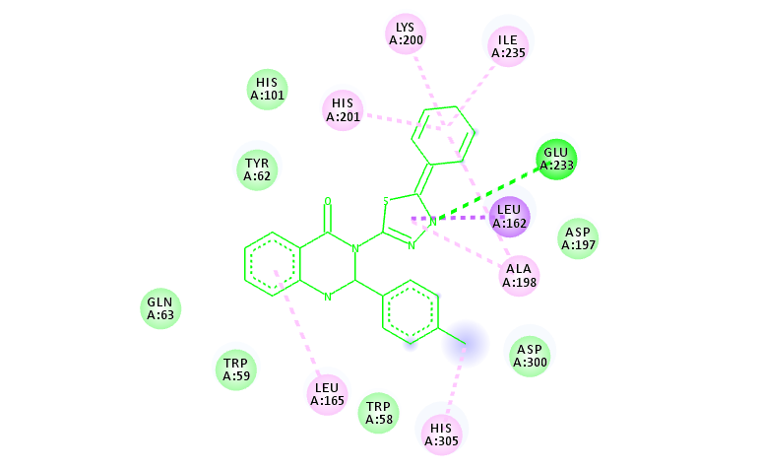 | 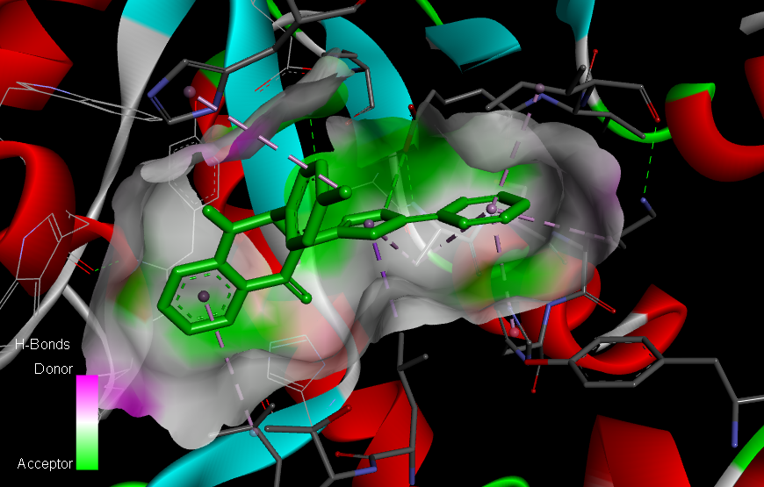
4d | 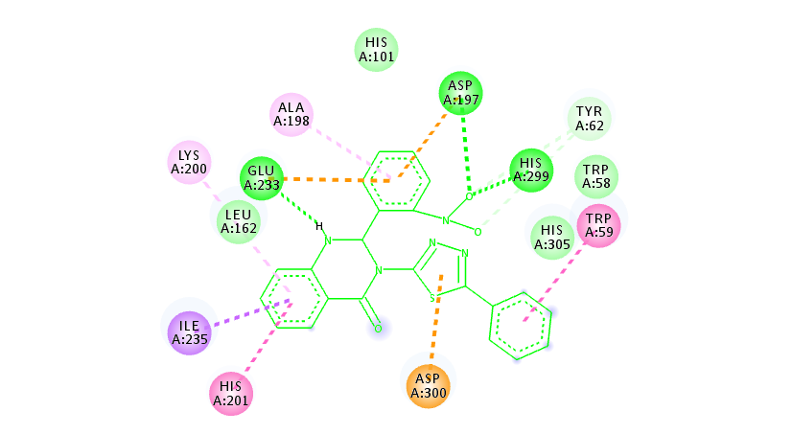 | 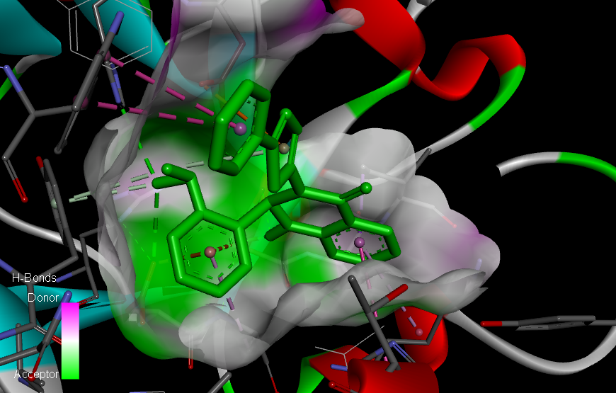
4g | 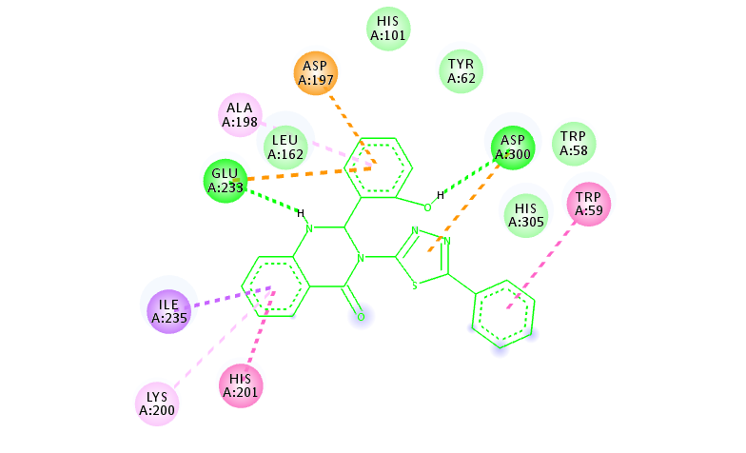 | 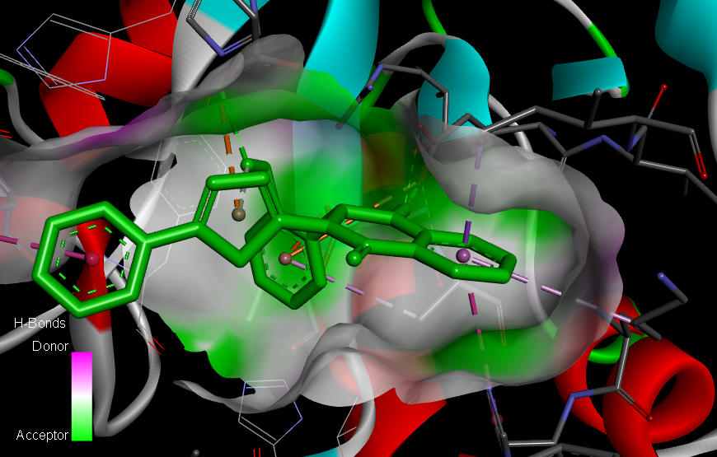
Fig 1. Ligand–Protein 2D and 3D interaction on the active site of 1hny.

compounds | Alpha-glucosidase, PDB ID: 2ze0
compounds | 2D | 3D
4e | 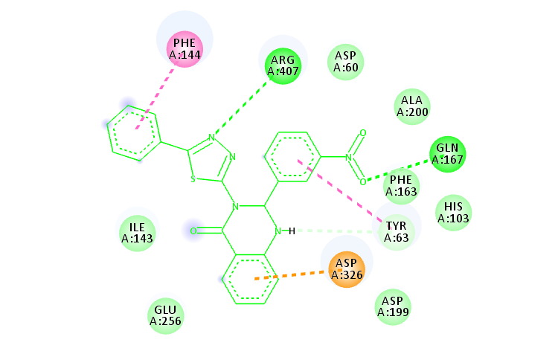 | 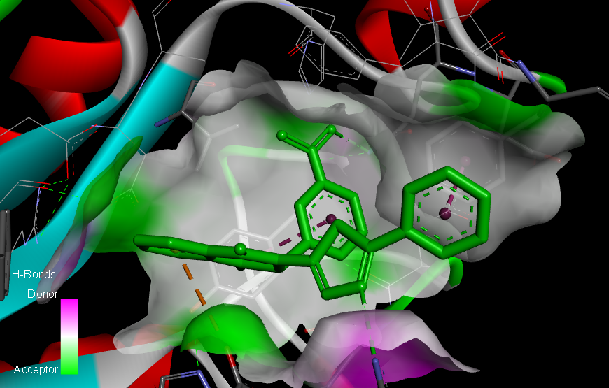
4f | 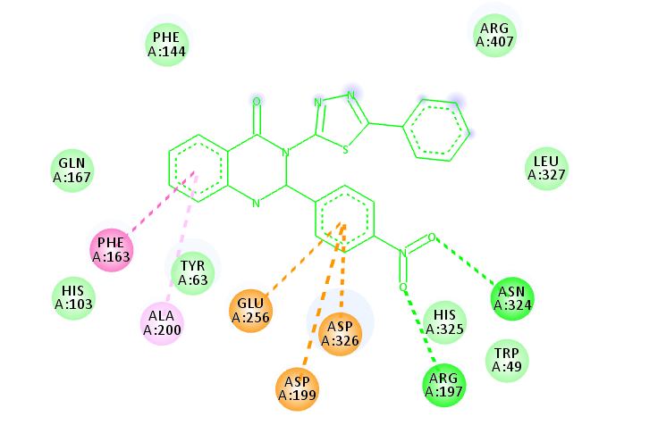 | 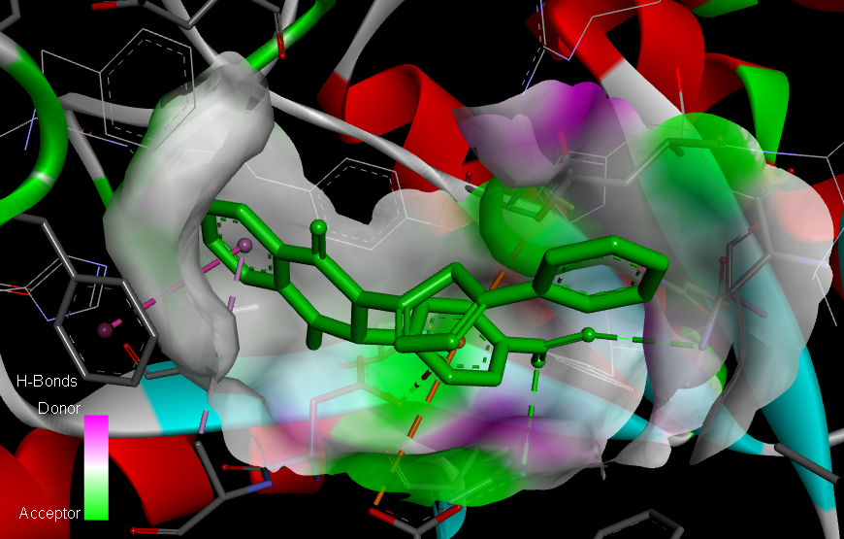
4i | 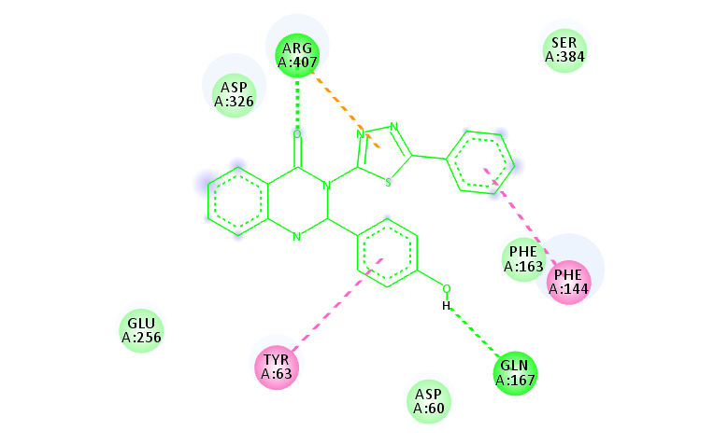 | 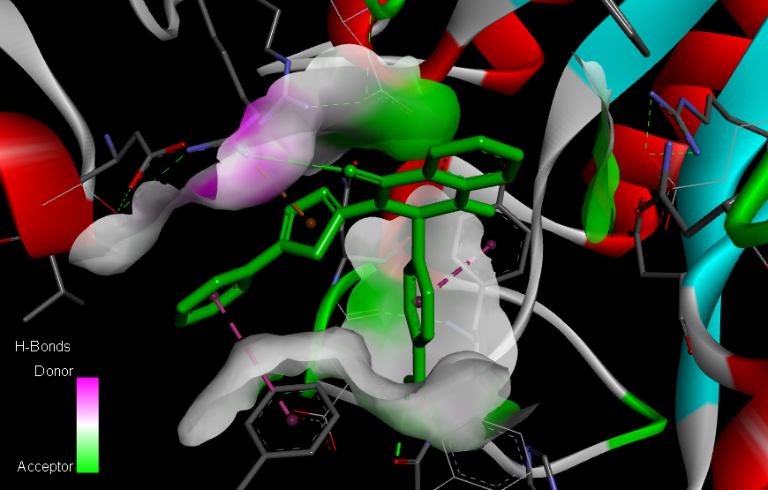
Fig 2. Ligand–Protein 2D and 3D interaction on the active site of 2ze0.

4. Conclusion
In summary, in the present study target molecules 4(a-l) were synthesized via a one-pot condensation reaction between isatoic anhydride 1 and 5-phenyl-1,3,4-thiadiazol-2-amine 3 with aromatic aldehydes 2(a-l) using p-TsOH as a catalyst in refluxing water. The newly synthesized compounds were characterized by Mass, FT- IR, ¹H NMR,¹³C NMR spectra and analytical methods. The antibacterial activities of the synthesized compounds showed that compounds 4k against S. aureus, 4j against S. epidermidis, 4l against E. coli, and 4i against P. aeruginosa have comparable inhibitory effects with the standards used. also, The antifungal activities of the synthesized compounds showed that compounds 4j against C .albicans and 4k against A .niger have comparable inhibitory effects with the standards used. All compounds showed good results especially compound 4e showed the lowest ΔG_{bind} results (-10.6 Kcal/mol) against Alpha-glucosidase and compounds 4c and 4g showed the lowest ΔG_{bind} results (-10.0 Kcal/mol) against Alpha-amylase.

5. Acknowledgments
The authors are grateful to Urmia University for providing a fellowship for the present work.

6. References
1- J. Zhang, J. Zhao, L. Wang, J. Liu, D. Ren,Y. Ma, ChemInform Abstract: Design, Synthesis and Docking Studies of Some Spiro-Oxindole Dihydroquinazolinones as Antibacterial Agents. Tetrahedron, 2016, 72, 936–943. DOI: 10.1016/j.tet.2015.12.055.
2- K. F. Sina, A. Yahyazadeh, N. Mahmoodi, Synthesis, Characterization and Antibacterial Evaluation of 2, 3- Dihydroquinazolin-4(1H)-Ones and Some New Bis 2, 3- Dihydroquinazolin-4(1H)-Ones Using Pre-made Pyrazole Carbaldehyde Derivatives, Letters in Organic Chemistry, 2021, 18(3), 176 – 182. DOI: 10.2174/1570178617999200706010203.
3- K.Hemalatha, G. Madhumitha, L. Ravi, V. GopieshKhanna; N. AbdullahAl-Dhabi, M. ValanArasu, Binding mode of dihydroquinazolinones with lysozyme and its antifungal activity against Aspergillus species. Journal of Photochemistry and Photobiology, B: Biology, 2016, 161, 71-79. DOI: 10.1016/j.jphotobiol.2016.05.005.
4- V. Jatav, S. Kashaw, P. Mishra, “Synthesis, antibacterial and antifungal activity of some novel 3-[5-(4-substituted phenyl) 1,3,4-thiadiazole-2-yl]-2-styryl quinazoline-4(3H)-ones,” Medicinal Chemistry Research, 2008,17, 2–7, 169–18. DOI: 10.1007/s00044-007-9047-2.

5- R. Appani, B. Bhukya, K. Gangarapu, Synthesis and Antibacterial Activity of 3-(Substituted)-2-(4-oxo-phenylquinazolin-3(4H)-ylamino) quinazolin-4(3H)-one, Scientifica, 2016, Volume 2016, Article ID 1249201. DOI: 10.1155/2016/1249201.
6- M. R. Mohareb, A P. Halim, Uses of Anthranilic Acid for the Synthesis of Dihydroquinazolin Derivatives with Antitumor, Antiproliferative and Pim-1 kinase Activities, Acta Chim. Slov. 2018, 65, 554–568. DOI: 10.17344/acsi.2017.4146
7- S. Poorirani, S. Sadeghian-Rizi, Gh. Khodarahmi, M. R. Khajouei, F. Hassanzadeh, Synthesis and cytotoxic evaluation of novel quinazolinone derivatives as potential anticancer agents, Res Pharm Sci. 2018, 13(5) , 450–459. DOI: 10.4103/1735-5362.236838.
8- R. M. Mohareb, R. A. Ibrahim, A. M. Elmetwally, M. S. Gamaan, Synthesis of Fused Quinoline Derivatives with Antiproliferative Activities and Tyrosine Kinases, Pim-1 Kinase Inhibitions, Acta Chim. Slov. 2022, 69, 13–29. DOI: 10.17344/acsi.2021.6733.
9- A. Barmak, K. Niknam, Gh. Mohebbi, Synthesis, Structural Studies, and α-Glucosidase Inhibitory, Antidiabetic, and Antioxidant Activities of 2,3-Dihydroquinazolin-4(1H)-ones Derived from Pyrazol-4-carbaldehyde and Anilines, ACS Omega, 2019, 4, 19, 18087–18099. DOI: 10.1021/acsomega.9b01906.
10- N. Nagaladinne, A. A. Hindusta, D. Nayakanti, Synthesis, Characterization and Docking Studies of N-Methyl-2, 3-Dihydro Quinazolin-4-Ones Linked 1,3-Thiazole Hybrids as Potent Anti-Tubercular Agents. Indian J Pharm Sci. 2020, 82(6), 984-995. DOI: 10.36468/pharmaceutical-sciences.730.
11. N. Krasovska, V. Stavytskyi, I. Nosulenko, O. Karpenko, O. Voskoboinik, S. Kovalenko1, Quinazoline-containing Hydrazydes of Dicarboxylic Acids and Products of Their Structural Modification: A Novel Class of Anti-inflammatory Agents, Acta Chim. Slov. 2021, 68, 395–403. DOI: 10.17344/acsi.2020.6440.

12- A. A. Abdel-Aziz, L. A. Abou-Zeid, K. E. H. ElTahir, M. A. Mohamed, M. A. Abu El-Enin; A. S. El-Azab, Design, synthesis of 2,3-disubstitued 4(3H)-quinazolinone derivatives as anti-inflammatory and analgesic agents: COX-1/2 inhibitory activities and molecular docking studies, Bioorg Med Chem. 2016, 15, 24(16), 3818-28. DOI: 10.1016/j.bmc.2016.06.026.
13- K. Hemalatha, G. Madhumitha, C. S. Vasavi, P. Munusami, 2,3-Dihydroquinazolin-4(1H)-ones: Visible light mediated synthesis, solvatochromism and biological activity. Journal of photochemistry and Photobiology, B: Biology, 2015, 143, 139-147. DOI:10.1016/j.jphotobiol.2014.12.028.

14- M. Sarfraz, N. Sultana, U. Rashid, M. S. Akram, A. Sadiq, M. I. Tariq, Synthesis, biological evaluation and docking studies of 2,3-dihydroquinazolin-4(1H)-one derivatives as inhibitors of cholinesterases, Bioorg Chem. 2017, 70, 237-244. DOI:10.1016/j.bioorg.2017.01.004.

15- N. Irshad, A.Khan, Alamgeer, S. Khan, M. Sh. Iqbal, Antihypertensive potential of selected pyrimidine derivatives: Explanation of underlying mechanistic pathways, Biomedicine & Pharmacotherapy, 2021, 139, 111567. DOI: 10.1016/j.biopha.2021.111567.

16- S. Mahgoub, M.K. El-Sayed, M. F. El-Shehry, S. M. Awad, Y. E. Mansour, S. S. Fatahala, Synthesis of novel calcium channel blockers with ACE2 inhibition and dual antihypertensive/anti-inflammatory effects: A possible therapeutic tool for COVID-19, Bioorganic Chemistry, 2021, 116, 105272. DOI: 10.1016/j.bioorg.2021.105272.
17. Y. Zhou, Q. Feng, F. Dia, Q. Liu, D. Wang, Y. Chen, L. Xiong, H. Song, Y. Lia, Zh. Lia, Synthesis and insecticidal activities of 2,3-dihydroquinazolin-4(1H)-one derivatives targeting calcium channel. Bioorganic & Medicinal Chemistry, 2013, 21(17), 4968-75, DOI: 10.1016/j.bmc.2013.06.060.

18- H. Tahtaci, H. Karacık, A. Ece, M. Er, M. GulSeker, Design, Synthesis, SAR and Molecular Modeling Studies of Novel Imidazo[2,1-b][1,3,4]Thiadiazole Derivatives as Highly Potent Antimicrobial Agents, Mol. Inf. 2017, 36, 1700083, DOI: 10.1002/minf.201700083.

19- Ch. Kamoutsis, M. Fesatidou, A. Petrou, A. Geronikaki, V. Poroikov, M. Ivanov, M. Sokovic; P. Mladenka, Triazolo Based-Thiadiazole Derivatives. Synthesis, Biological Evaluation and Molecular Docking Studies, Antibiotics, 2021, 10, 804. DOI: 10.3390/antibiotics10070804.

20- M. Er; A. M. Abounakhla; H. Tahtaci, A. H. Bawah, S. S. CH, A. Onaran, A. Ece, An integrated approach towards the development of novel antifungal agents containing thiadiazole: synthesis and a combined similarity search, homology modelling, molecular dynamics and molecular docking study, Chemistry Central Journal, 2018, 12, 121. DOI: 10.1186/s13065-018-0485-3.

21- A. A. Radwan, F. K. Alanazi, M. H. Al-Agamy, 1,3,4-Thiadiazole and 1,2,4-triazole-3(4H)-thione bearing salicylate moiety: synthesis and evaluation as anti-Candida albicans, Braz. J. Pharm. Sci. 2017, 53(1). DOI: 10.1590/s2175-97902017000115239.

22- A. CH. Karaburun, U. A. Chevik, D. Osmaniye, B. N. Saghlık, B. K. Chavushoghlu, S. Levent, Y. Ozkay, A. S. Koparal, M. Behcet, Z. A. Kaplancıklı, Synthesis and Evaluation of New 1,3,4-Thiadiazole Derivatives as Potent Antifungal Agents, Molecules, 2018, 23(12), 3129. DOI: 10.3390/molecules23123129.

23. S. M. Gomha, M. M. Edrees, Z. A. Muhammad, A. A. El-Reedy, 5-(Thiophen-2-yl)-1,3,4-thiadiazole derivatives: synthesis, molecular docking and in vitro cytotoxicity evaluation as potential anticancer agents, Drug Design, Development and Therapy, 2018, 12, 1511–1523. DOI: 10.2147/DDDT.S165276.

24- R. Kumar, S. Bua, S. Ram, S. Del Prete, C. Capasso, C. T. Supuran, P. K. Sharma, Benzenesulfonamide bearing imidazothiadiazole and thiazolotriazole scaffolds as potent tumor associated human carbonic anhydrase IX and XII inhibitors, Bioorganic & Medicinal Chemistry, 2017 , 1, 25(3), 1286-1293. DOI: 10.1016/j.bmc.2016.12.047.

25- A. Aliabadi, A. M. Farani; S. Roodabeh, F. Ahmadi, Synthesis and Biological Evaluation of N-(5-(pyridin-2-yl)-1,3,4-thiadiazol2-yl)benzamide Derivatives as Lipoxygenase Inhibitor with Potential Anticancer Activity, Iranian Journal of Pharmaceutical Research, 2017, 16 (1), 165-172. PMID: 28496472 Free PMC article.

26- Y. Xiao, S. Sun, J. T. Yu; J. Cheng, Recent Advances in the Synthesis of Thiadiazoles, Synlett. 2019, 30, A–J. DOI: 10.1055/s-0037-1611905.

27- W. A. M. A. El-Enany; S. M. Gomha, A. K El-Ziaty, W. Hussein, M. M. Abdulla, Sh. A. Hassan, H. A. Sallam, R. S. Ali, Synthesis and molecular docking of some new bis-thiadiazoles as anti-hypertensive α-blocking agents, Synthetic Communications, 2019, 50, 1, 85-96, DOI: 10.1080/00397911.2019.1683207.

28- Sh. G. Alegaon, K. R. Alagawadi, New thiazolidinedione-5-acetic acid amide derivatives: synthesis, characterization and investigation of antimicrobial and cytotoxic properties, Med Chem Res. 2012, 21, 816-824. DOI: 10.1007/s00044-011-9598-0.

29- M. Baghbanzadeh, P. Salehi, M. Dabiri, G. Kozehgary, Water-Accelerated Synthesis of Novel Bis-2,3-dihydroquinazolin-4(1H)-one Derivatives, SYNTHESIS, 2006, 2, 0344–0348. DOI: 10.1055/s-2005-924766.

30- N. Ramesh, M. G. Rao, R. Valara, V. U. Rao, B. H. Babu, Mercuric chloride catalyzed synthesis of some anticancer 2-aryl-2,3-dihydroquinizolin-4(1H)-ones, Med. Chem. Res. 2016, 25, 1945–1951. DOI: 10.1007/s00044-016-1630-y.

31- P. Sivaguru, K. Parameswaran, M. Kiruthiga, P. Vadivel, A. Lalitha, Synthesis of 2-aryl-2,3-dihydroquinazolin-4(1H)-ones using boric acid-functionalized MCM-41 as a novel heterogeneous catalyst under solvent-free condition, J. Iran. Chem. Soc. 2015, 12, 95–100. DOI: 10.1007/s13738-014-0459-x.
32- X. Wu, S. Oschatz, A. Block, A. Spannenberg, P. Langer, Base mediated synthesis of 2-aryl-2,3- dihydroquinazolin-4(1H)-ones from 2-aminobenzonitriles and aromatic aldehydes in water, Org. Biomol. Chem. 2014, 12, 1865–1870. DOI: 10.1039/c3ob42434k.

