Supporting Information

Carvacrol derivatives as antifungal agents: synthesis, antimicrobial activity and in silico studies on carvacryl esters.

Jelena Lazarević^{1*}, Ana Marković², Andrija Šmelcerović¹, Gordana Stojanović³, Pierangela Ciuffreda⁴, Enzo Santaniello⁵

¹Department of Chemistry, Faculty of Medicine, University of Niš, Bulevar dr Zorana Đinđića 81, 18000, Niš, Serbia;
²Department of Pharmacy, Faculty of Medicine, University of Niš, Bulevar dr Zorana Đinđića 81, 18000, Niš, Serbia;
³Department of Chemistry, Faculty of Science and Mathematics, University of Niš, Višegradska 33, 18000, Niš, Serbia
⁴Dipartimento di Scienze Biomediche e Cliniche "L. Sacco", Università degli Studi di Milano, Via G.B. Grassi 74, 20157 Milano, Italy
⁵Faculty of Medicine. University of Milan, Italy

*correspondence to jelena217@yahoo.com; jelena.lazarevic@medfak.ni.ac.rs

Table of Content

Figures S.1.1.-S.1.3. ¹H and ¹³C NMR spectra recorded in CDCl₃ and MS scan of 3a 3
Figures S.1.4.-S.1.6. ¹H and ¹³C NMR spectra recorded in CDCl₃ and MS scan of 3b 4
Figures S.1.7.-S.1.9. ¹H and ¹³C NMR spectra recorded in CDCl₃ and MS scan of 3c 5
Figures S.1.10.-S.1.12. ¹H and ¹³C NMR spectra recorded in CDCl₃ and MS scan of 3d 6
Figures S.1.13.-S.1.15. ¹H and ¹³C NMR spectra recorded in CDCl₃ and MS scan of 3e 7
Figures S.1.16.-S.1.18. ¹H and ¹³C NMR spectra recorded in CDCl₃ and MS scan of 3f 8
Figures S.1.19.-S.1.21. ¹H and ¹³C NMR spectra recorded in CDCl₃ and MS scan of 3g 9
Figures S.1.22.-S.1.24. ¹H and ¹³C NMR spectra recorded in CDCl₃ and MS scan of 3h 10
Figures S.1.25.-S.1.27. ¹H and ¹³C NMR spectra recorded in CDCl₃ and MS scan of 3i 11
Figures S.1.28.-S.1.30. ¹H and ¹³C NMR spectra recorded in CDCl₃ and MS scan of 3j 12
Figures S.1.31.-S.1.33. ¹H and ¹³C NMR spectra recorded in CDCl₃ and MS scan of 3k 13
Figures S.1.34.-S.1.36. ¹H and ¹³C NMR spectra recorded in CDCl₃ and MS scan of 3l 14
Figures S.1.37.-S.1.39. ¹H and ¹³C NMR spectra recorded in CDCl₃ and MS scan of 3m 15
Figures S.1.40.-S.1.42. ¹H and ¹³C NMR spectra recorded in CDCl₃ and MS scan of 3n 16
Figures S.1.43.-S.1.45. ¹H and ¹³C NMR spectra recorded in CDCl₃ and MS scan of 3o 17
Figures S.1.46.-S.1.48. ¹H and ¹³C NMR spectra recorded in CDCl₃ and MS scan of 3p 18
Figures S.1.49.-S.1.51. ¹H and ¹³C NMR spectra recorded in CDCl₃ and MS scan of 3q 19
Figures S.1.52.-S.1.54. ¹H and ¹³C NMR spectra recorded in CDCl₃ and MS scan of 3r 20
Figures S.1.55.-S.1.57. ¹H and ¹³C NMR spectra recorded in CDCl₃ and MS scan of 3s 21
Figures S.1.58.-S.1.60. ¹H and ¹³C NMR spectra recorded in CDCl₃ and MS scan of 3t 22
Figures S.1.61.-S.1.63. ¹H and ¹³C NMR spectra recorded in CDCl₃ and MS scan of 3u 23
Figures S.1.64.-S.1.66. ¹H and ¹³C NMR spectra recorded in CDCl₃ and MS scan of 3v 24
Figures S.1.67.-S.1.69. ¹H and ¹³C NMR spectra recorded in CDCl₃ and MS scan of 3w 25
Figures S.1.70.-S.1.72. ¹H and ¹³C NMR spectra recorded in CDCl₃ and MS scan of 3x 26
Figures S.1.73.-S.1.75. ¹H and ¹³C NMR spectra recorded in CDCl₃ and MS scan of 3y 27
Table S1. Physico-chemical properties of the studied compounds predicted by the Molinspiration 28
Table S2. Absorption properties of the studied compounds predicted by admetSAR 29
Table S3. Metabolic properties of the studied compounds predicted by admetSAR 30
Table S4. Toxicological properties of the studied compounds predicted by DataWarrior 31
Table S5. Toxicological properties of the studied compounds predicted by admetSAR 32
Table S6. Possibility of the studied compounds to bind to potential targets of endocrine disruptors
predicted by admetSAR 33
Table S7. Genotoxicity of the studied compounds predicted by admetSAR 34
Table S8. Ecotoxicity of the studied compounds predicted by admetSAR 35
Table S9. Ability of the studied compounds to bind to DNA and proteins predicted by Toxtree 36

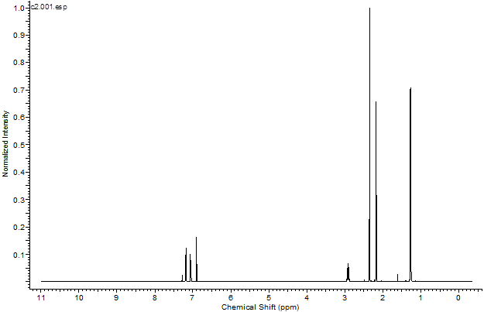
Figure S.1.1. ¹H spectrum of compound 3a (carvacryl acetate) recorded in CDCl₃

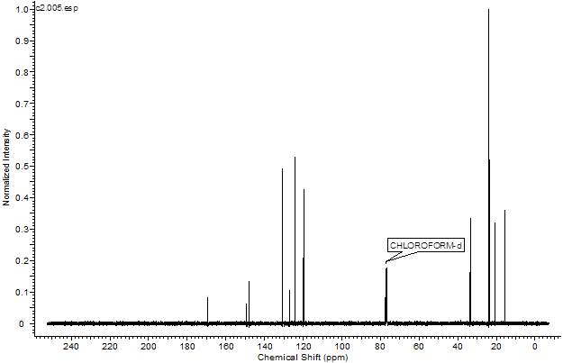
Figure S.1.2. ¹³C spectrum of compound 3a (carvacryl acetate) recorded in CDCl₃

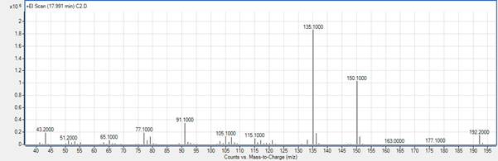
Figure S.1.3. MS scan of compound 3a (carvacryl acetate)

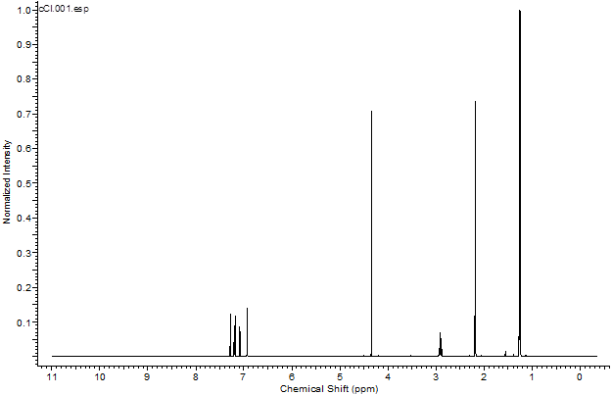
Figure S.1.4. ¹H spectrum of compound 3b (carvacryl 2-chloroacetate) recorded in CDCl₃

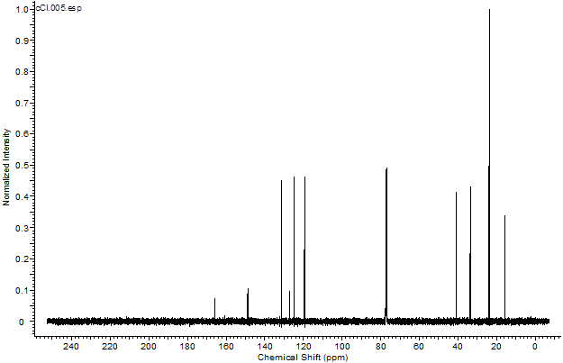
Figure S.1.5. ¹³C spectrum of compound 3b (carvacryl 2-chloroacetate) recorded in CDCl₃

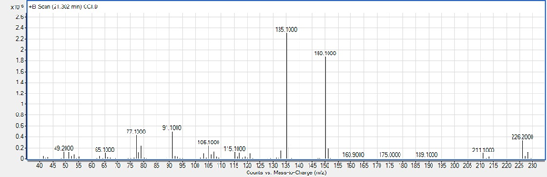
Figure S.1.6. MS scan of compound 3b (carvacryl 2-chloroacetate)

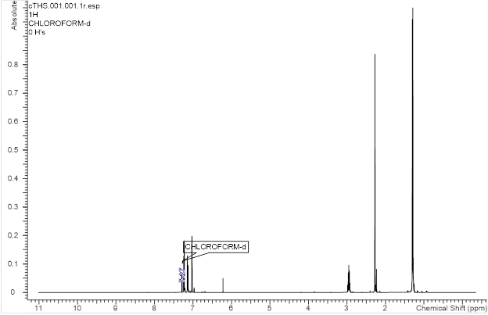
Figure S.1.7. ¹H spectrum of compound 3c (carvacryl trichloroacetate) recorded in CDCl₃

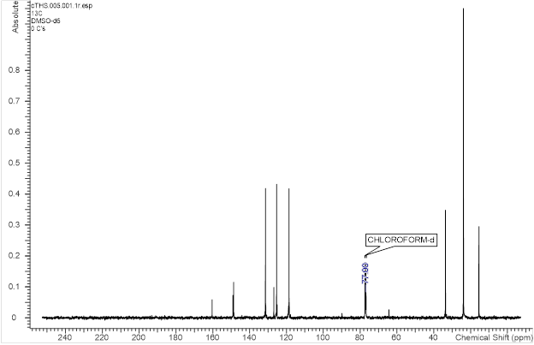
Figure S.1.8. ¹³C spectrum of compound 3c (carvacryl trichloroacetate) recorded in CDCl₃

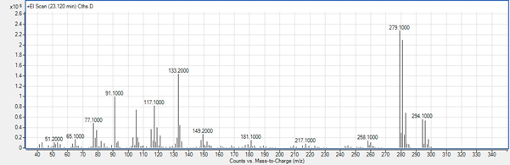
Figure S.1.9. MS scan of compound 3c (trichloroacetate)

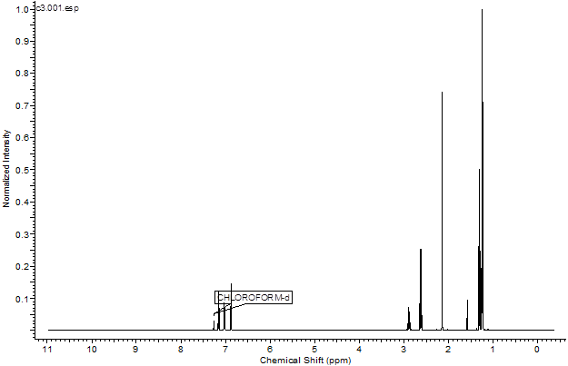
Figure S.1.10. ¹H spectrum of compound 3d (carvacryl propanoate) recorded in CDCl₃

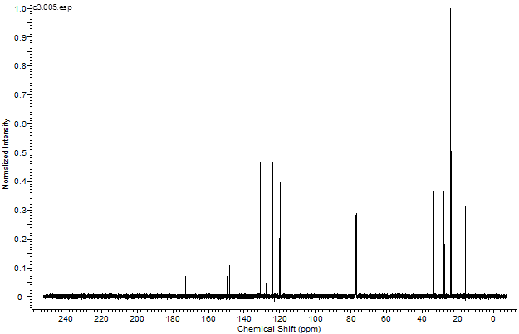
Figure S.1.11. ¹³C spectrum of compound 3d (carvacryl propanoate) recorded in CDCl₃

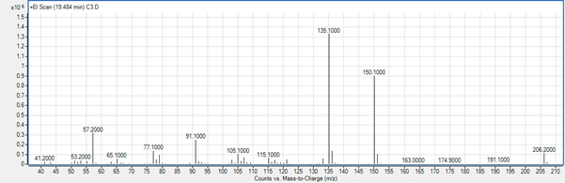
Figure S.1.12. MS scan of compound 3d (carvacryl propanoate)

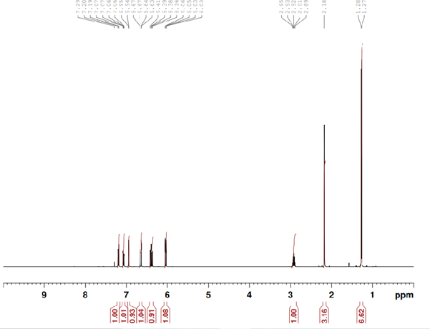
Figure S.1.13. ¹H spectrum of compound 3e (carvacryl acrylate) recorded in CDCl₃

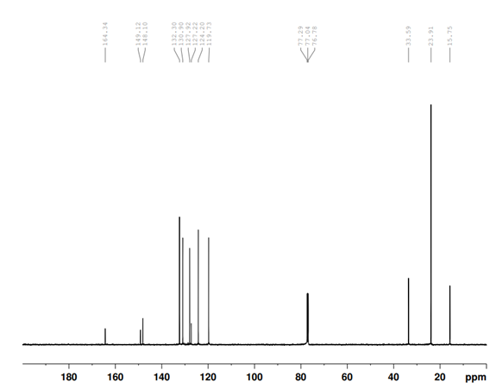
Figure S.1.14. ¹³C spectrum of compound 3e (carvacryl acrylate) recorded in CDCl₃

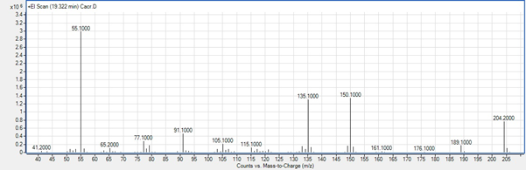
Figure S.1.15. MS scan of compound 3e (carvacryl acrylate)

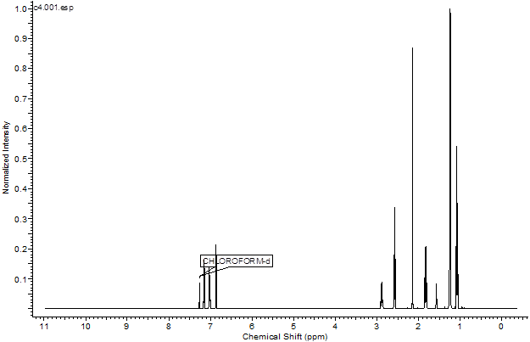
Figure S.1.16. ¹H spectrum of compound 3f (carvacryl butanoate) recorded in CDCl₃

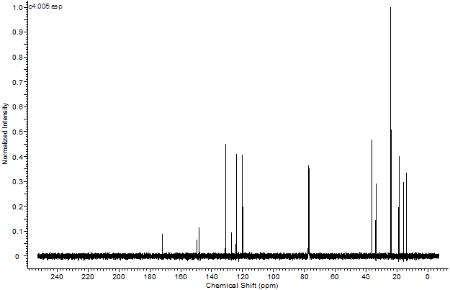
Figure S.1.17. ¹³C spectrum of compound 3f (carvacryl butanoate) recorded in CDCl₃

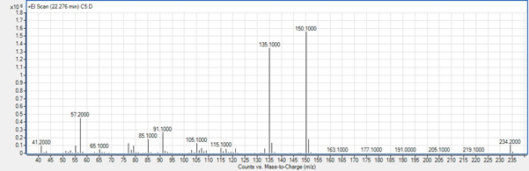
Figure S.1.18. MS scan of compound 3f (carvacryl butanoate)

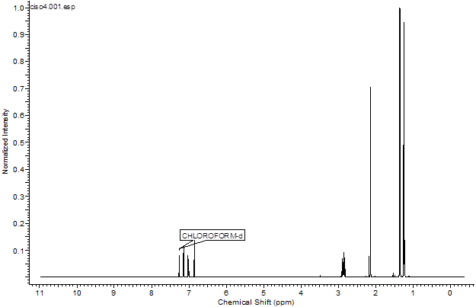
Figure S.1.20. ¹H spectrum of compound 3g (carvacryl 2-methylpropanoate) recorded in CDCl₃

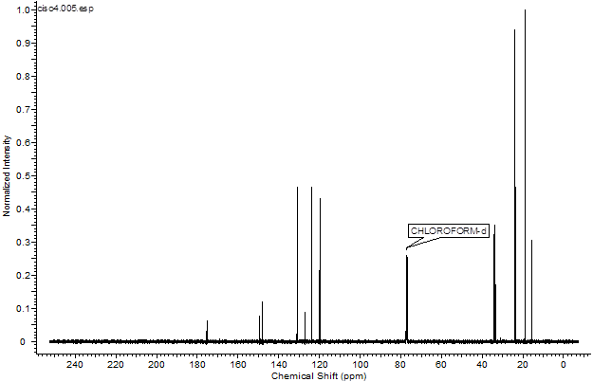
Figure S.1.20. ¹³C spectrum of compound 3g (carvacryl 2-methylpropanoate) recorded in CDCl₃

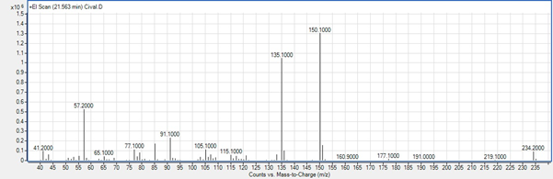
Figure S.1.21. MS scan of compound 3g (carvacryl 2-methylpropanoate)

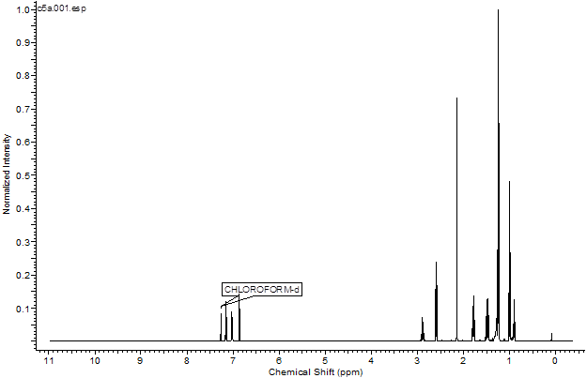
Figure S.1.22. ¹H spectrum of compound 3h (carvacryl pentanoate) recorded in CDCl₃

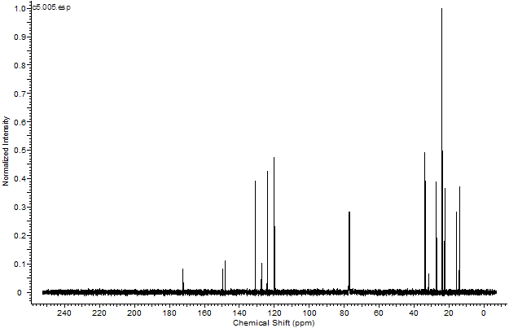
Figure S.1.23. ¹³C spectrum of compound 3h (carvacryl pentanoate) recorded in CDCl₃

Figure S.1.24. MS scan of compound 3h (carvacryl pentanoate)

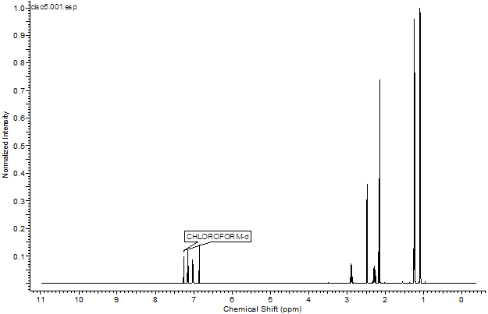
Figure S.1.25. ¹H spectrum of compound 3i (carvacryl 3-methylbutanoate) recorded in CDCl₃

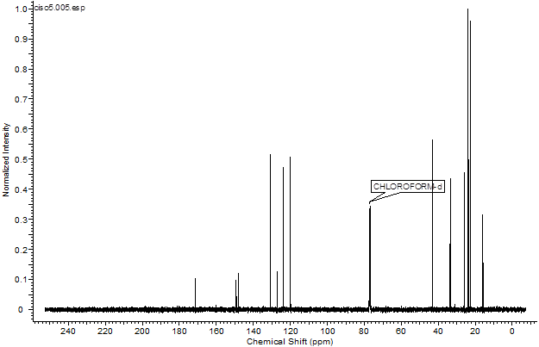
Figure S.1.26. ¹³C spectrum of compound 3i (carvacryl 3-methylbutanoate) recorded in CDCl₃

Figure S.1.27. MS scan of compound 3i (carvacryl 3-methylbutanoate)

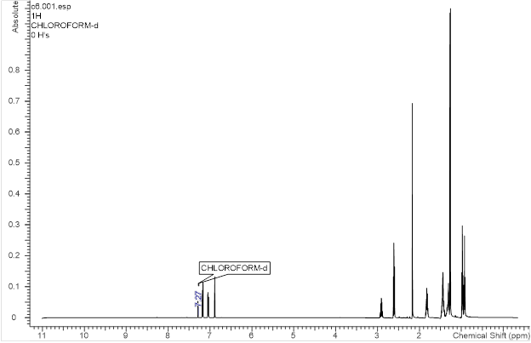
Figure S.1.28. ¹H spectrum of compound 3j (carvacryl hexanoate) recorded in CDCl₃

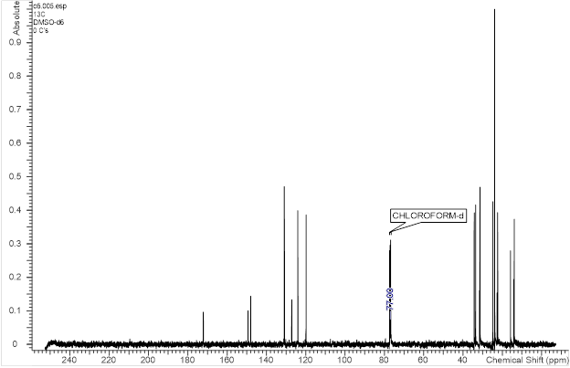
Figure S.1.29. ¹³C spectrum of compound 3j (carvacryl hexanoate) recorded in CDCl₃

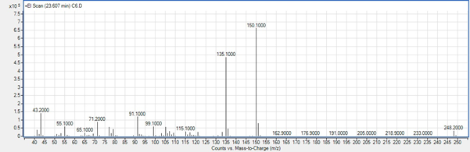
Figure S.1.30. MS scan of compound 3j (carvacryl hexanoate)

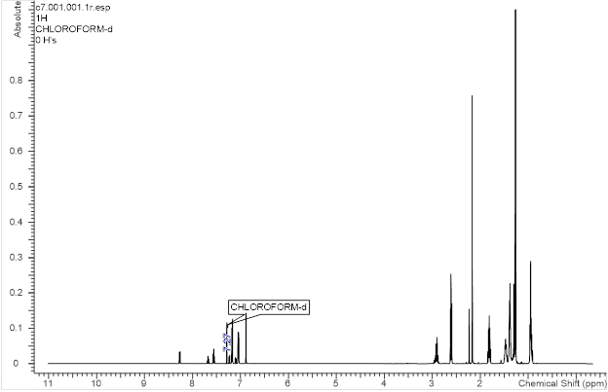
Figure S.1.31. ¹H spectrum of compound 3k (carvacryl heptanoate) recorded in CDCl₃

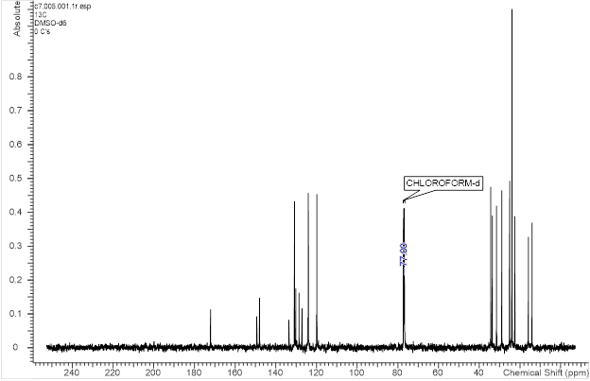
Figure S.1.32. ¹³C spectrum of compound 3k (carvacryl heptanoate) recorded in CDCl₃

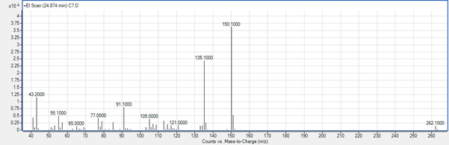
Figure S.1.33. MS scan of compound 3k (carvacryl heptanoate)

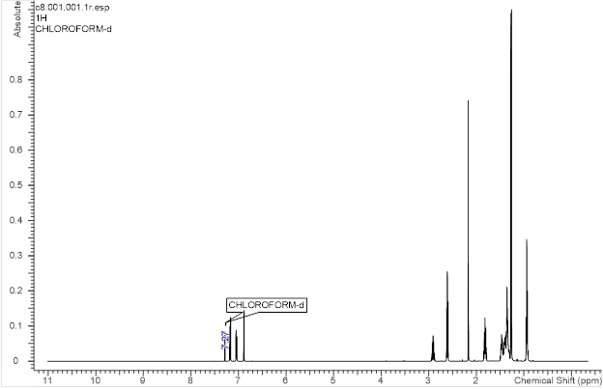
Figure S.1.34. ¹H spectrum of compound 3l (carvacryl octanoate) recorded in CDCl₃

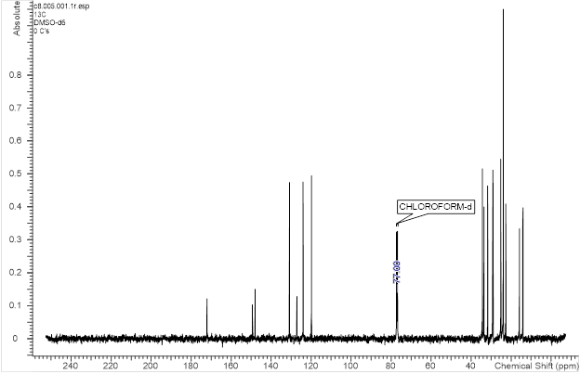
Figure S.1.35. ¹³C spectrum of compound 3l (carvacryl octanoate) recorded in CDCl₃

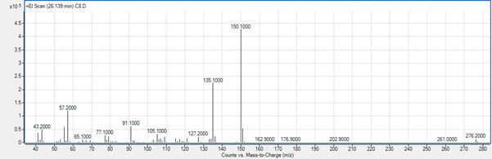
Figure S.1.36. MS scan of compound 3l (carvacryl octanoate)

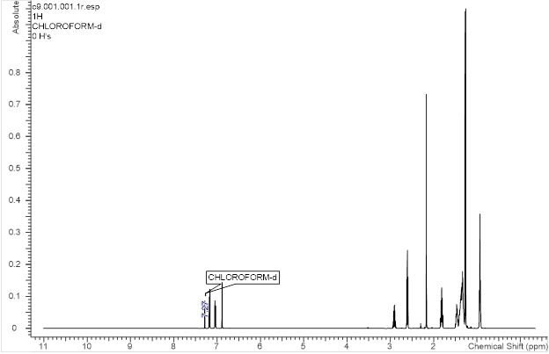
Figure S.1.37. ¹H spectrum of compound 3m (carvacryl nonanoate) recorded in CDCl₃

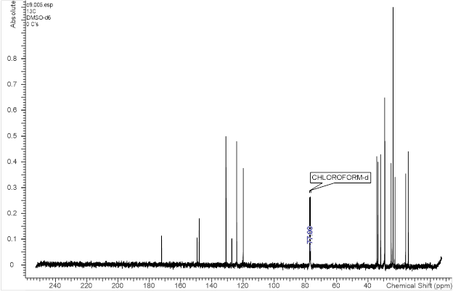
Figure S.1.38. ¹³C spectrum of compound 3m (carvacryl nonanoate) recorded in CDCl₃

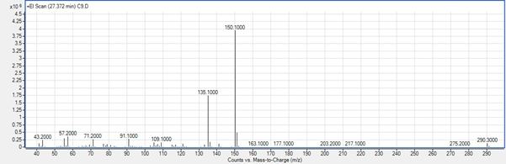
Figure S.1.39. MS scan of compound 3m (carvacryl nonanoate)

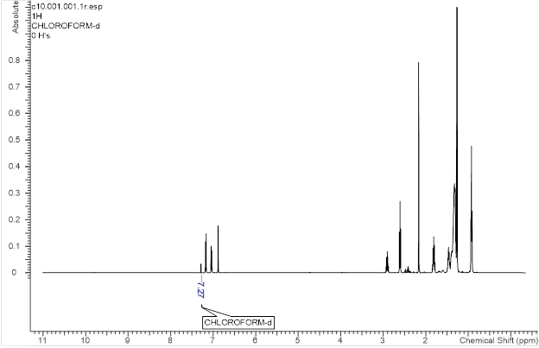
Figure S.1.40. ¹H spectrum of compound 3n (carvacryl decanoate) recorded in CDCl₃

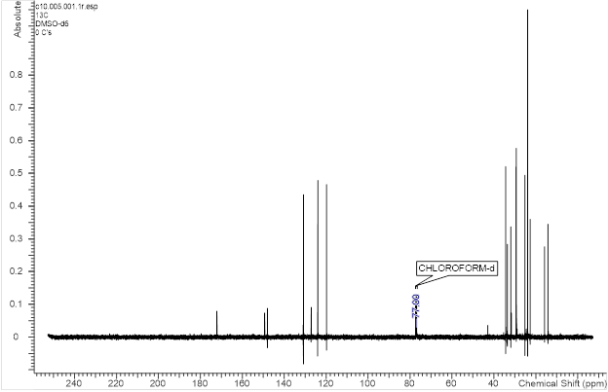
Figure S.1.41. ¹³C spectrum of compound 3n (carvacryl decanoate) recorded in CDCl₃

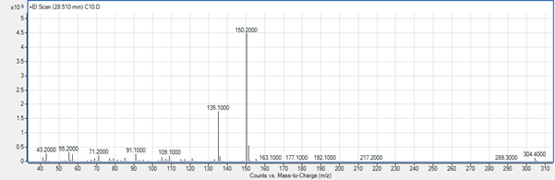
Figure S.1.42. MS scan of compound 3n (carvacryl decanoate)

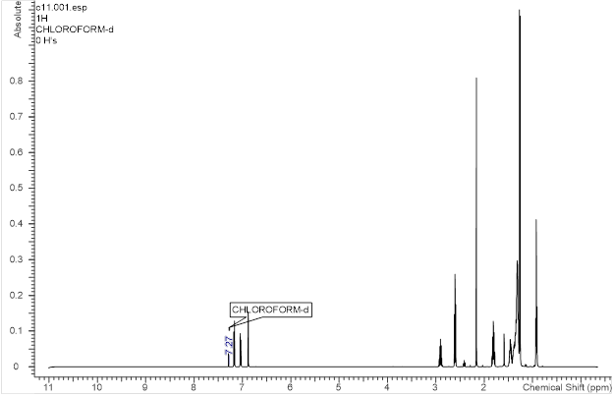
Figure S.1.43. ¹H spectrum of compound 3o (carvacryl undecanoate) recorded in CDCl₃

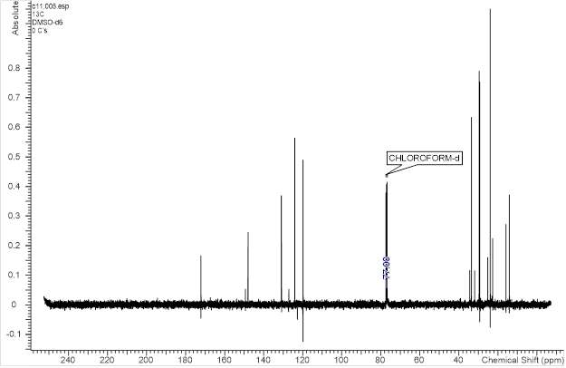
Figure S.1.44. ¹³C spectrum of compound 3o (carvacryl undecanoate) recorded in CDCl₃

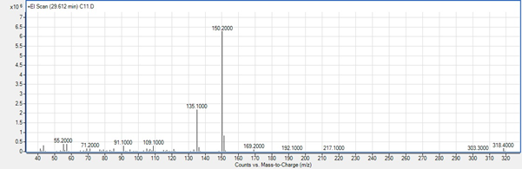
Figure S.1.45. MS scan of compound 3o (carvacryl undecanoate)

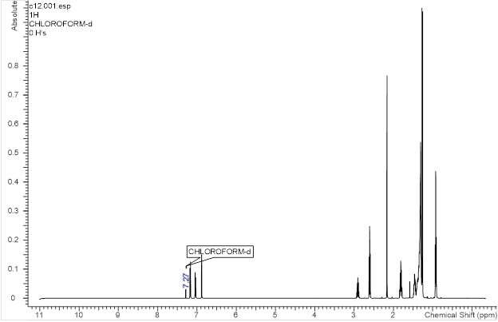
Figure S.1.46. ¹H spectrum of compound 3p (carvacryl dodecanoate) recorded in CDCl₃

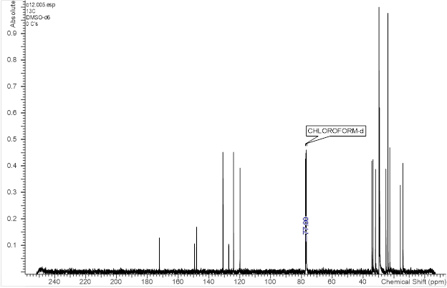
Figure S.1.47. ¹³C spectrum of compound 3p (carvacryl dodecanoate) recorded in CDCl₃

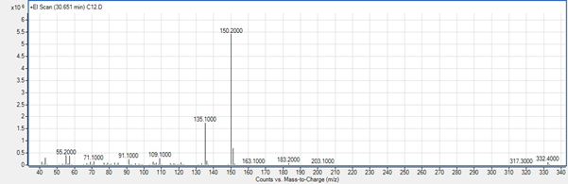
Figure S.1.48. MS scan of compound 3p (carvacryl dodecanoate)

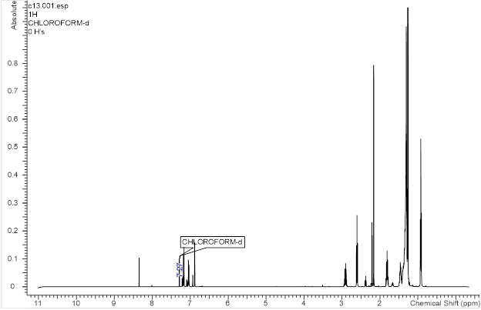
Figure S.1.49. ¹H spectrum of compound 3q (carvacryl tridecanoate) recorded in CDCl₃

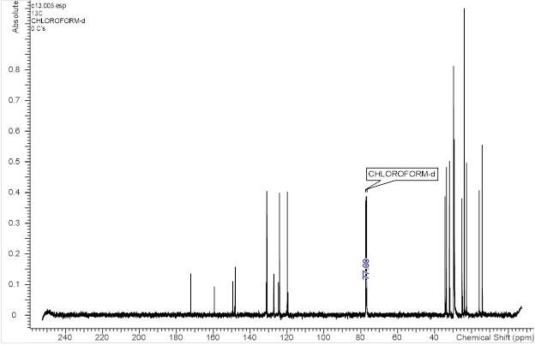
Figure S.1.50. ¹³C spectrum of compound 3q (carvacryl tridecanoate) recorded in CDCl₃

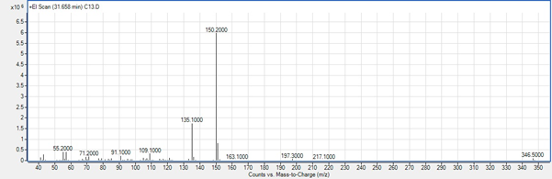
Figure S.1.51. MS scan of compound 3q (carvacryl tridecanoate)

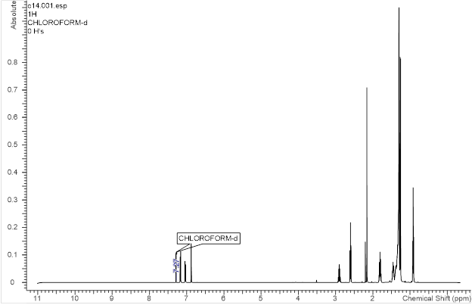
Figure S.1.52. ¹H spectrum of compound 3r (carvacryl tetradecanoate) recorded in CDCl₃

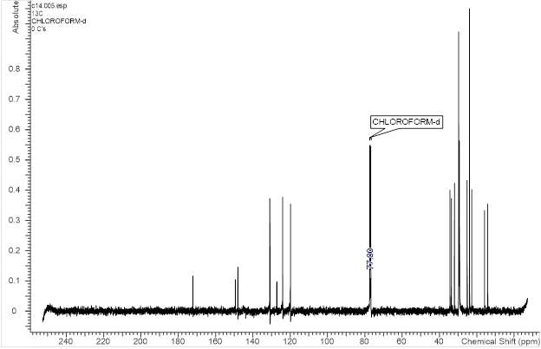
Figure S.1.53. ¹³C spectrum of compound 3r (carvacryl tetradecanoate) recorded in CDCl₃

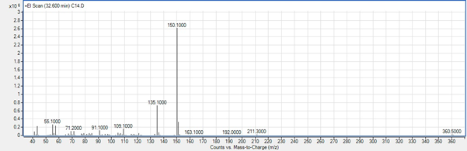
Figure S.1.54. MS scan of compound 3r (carvacryl tetradecanoate)

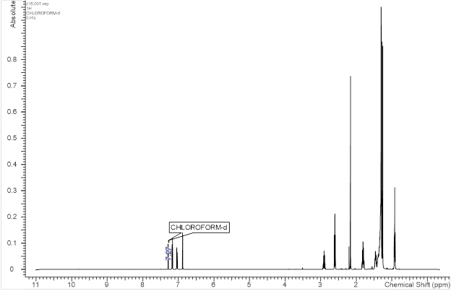
Figure S.1.55. ¹H spectrum of compound 3s (carvacryl pentadecanoate) recorded in CDCl₃

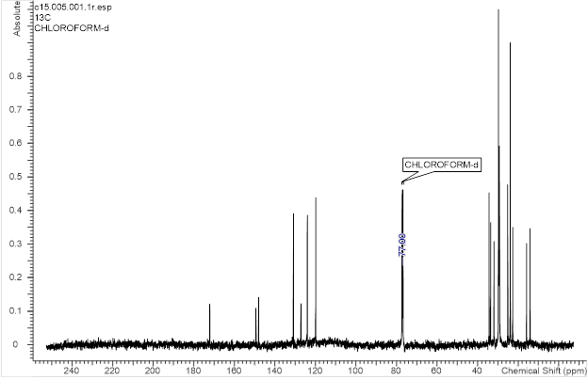
Figure S.1.56. ¹³C spectrum of compound 3s (carvacryl pentadecanoate) recorded in CDCl₃

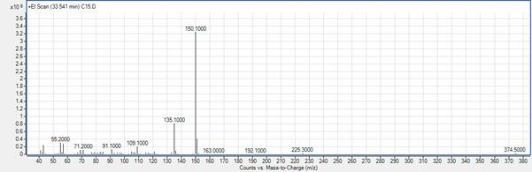
Figure S.1.57. MS scan of compound 3s (carvacryl pentadecanoate)

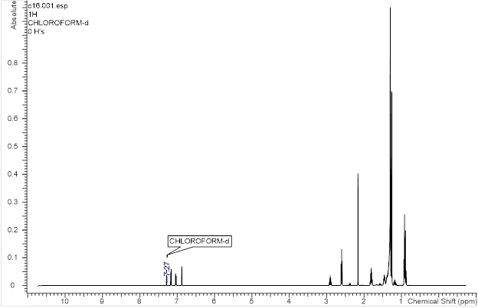
Figure S.1.58. ¹H spectrum of compound 3t (carvacryl hexadecanoate) recorded in CDCl₃

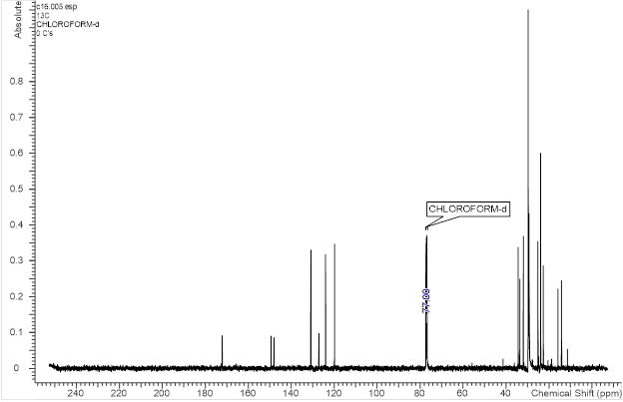
Figure S.1.59. ¹³C spectrum of compound 3t (carvacryl hexadecanoate) recorded in CDCl₃

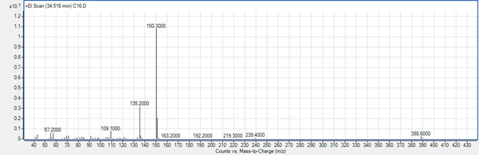
Figure S.1.60. MS scan of compound 3t (carvacryl hexadecanoate)

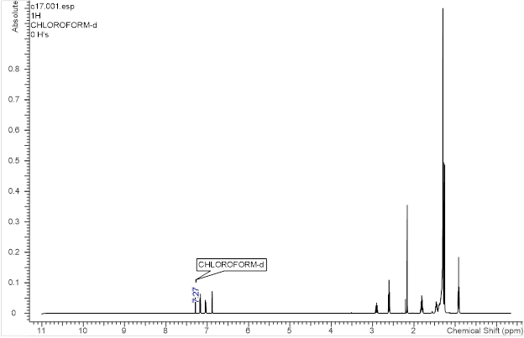
Figure S.1.61. ¹H spectrum of compound 3u (carvacryl heptadecanoate) recorded in CDCl₃

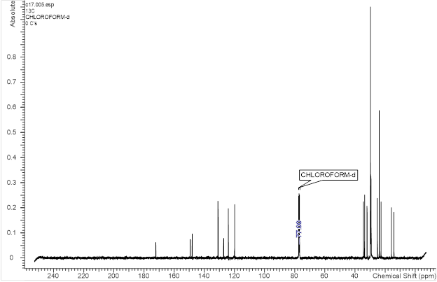
Figure S.1.62. ¹³C spectrum of compound 3u (carvacryl heptadecanoate) recorded in CDCl₃

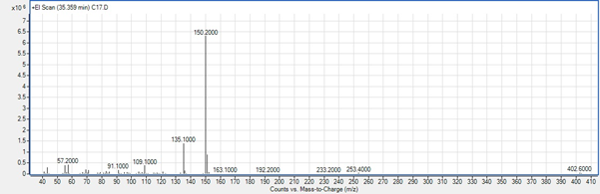
Figure S.1.63. MS scan of compound 3u (carvacryl heptadecanoate)

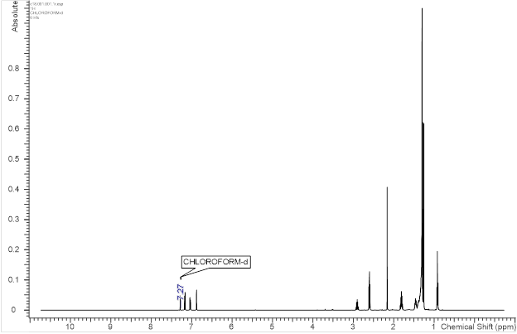
Figure S.1.64. ¹H spectrum of compound 3v (carvacryl octadecanoate) recorded in CDCl₃

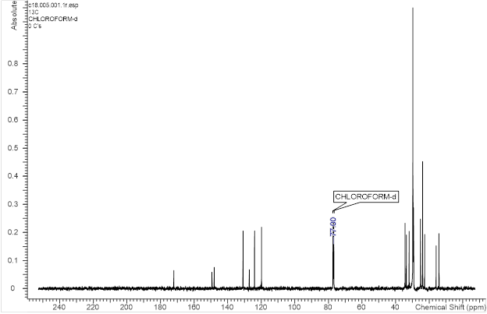
Figure S.1.65. ¹³C spectrum of compound 3v (carvacryl octadecanoate) recorded in CDCl₃

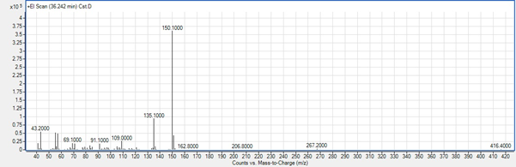
Figure S.1.66. MS scan of compound 3v (carvacryl octadecanoate)

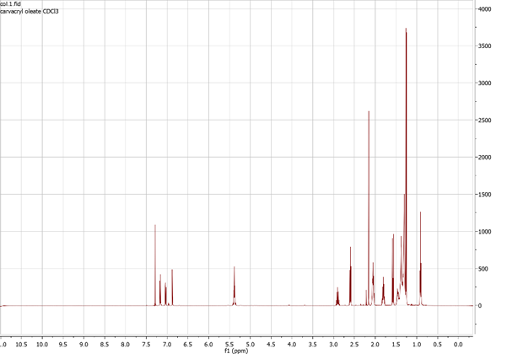
Figure S.1.67. ¹H spectrum of compound 3w (carvacryl oleate) recorded in CDCl₃

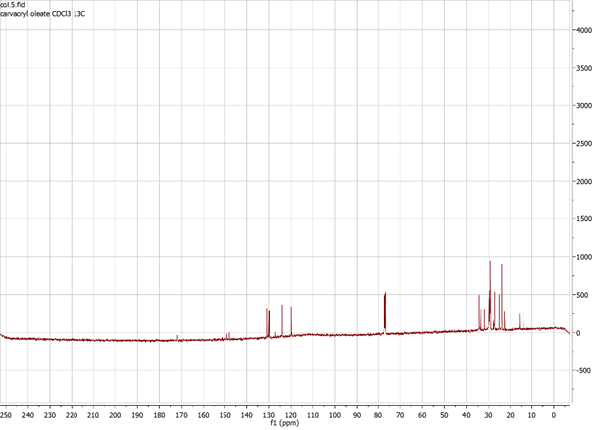
Figure S.1.68. ¹³C spectrum of compound 3w (carvacryl oleate) recorded in CDCl₃

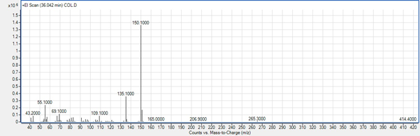
Figure S.1.69. MS scan of compound 3w (carvacryl oleate)

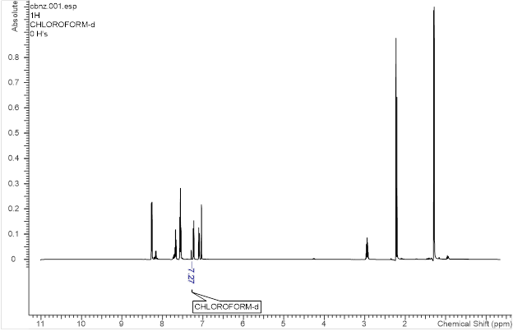
Figure S.1.70. ¹H spectrum of compound 3x (carvacryl benzoate) recorded in CDCl₃

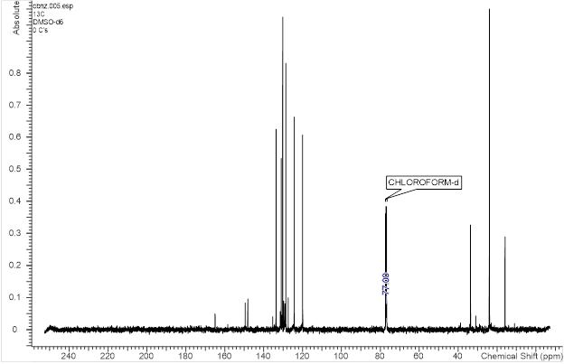
Figure S.1.71. ¹³C spectrum of compound 3x (carvacryl benzoate) recorded in CDCl₃

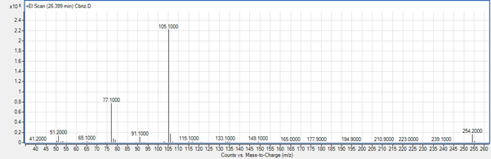
Figure S.1.72. MS scan of compound 3x (carvacryl benzoate)

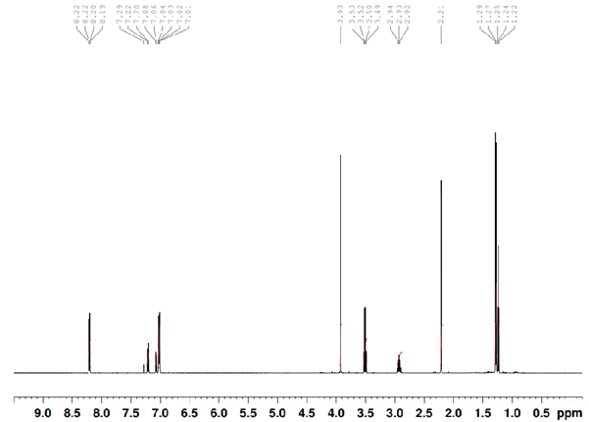
Figure S.1.73. ¹H spectrum of compound 3y (carvacryl 4-methoxy benzoate) recorded in CDCl₃

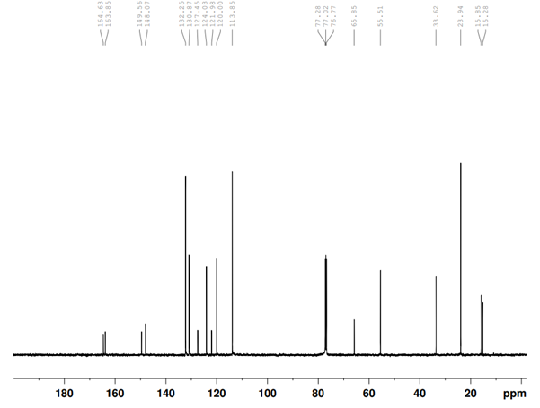
Figure S.1.74. ¹³C spectrum of compound 3y (carvacryl 4-methoxy benzoate) recorded in CDCl₃

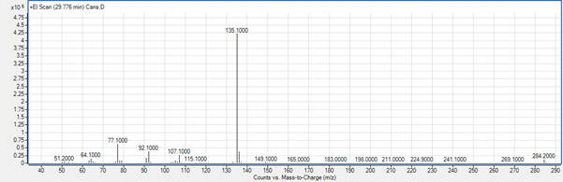
Figure S.1.75. MS scan of compound 3y (carvacryl 4-methoxy benzoate)

Table S1. Physico-chemical properties of the studied compounds predicted by the Molinspiration tool [www.molinspiration.com].
Compound | m_{i}LogPª | TPSA^{b} | n_{atoms}^{c} | MW^{d} | n_{ON}^{e} | n_{OHNH}^{f} | n_{rotb}^{g} | MV^{h}
1 | 3.81 | 20.23 | 11 | 150.22 | 1 | 1 | 1 | 158.57
a | 3.38 | 26.30 | 14 | 192.26 | 2 | 0 | 3 | 195.08
b | 3.77 | 26.30 | 15 | 226.70 | 2 | 0 | 4 | 208.86
c | 5.02 | 26.30 | 17 | 295.59 | 2 | 0 | 4 | 235.63
d | 4.05 | 26.30 | 15 | 206.28 | 2 | 0 | 4 | 211.88
e | 3.81 | 26.30 | 15 | 204.27 | 2 | 0 | 4 | 206.25
f | 4.61 | 26.30 | 16 | 220.31 | 2 | 0 | 5 | 228.69
g | 4.29 | 26.30 | 16 | 220.31 | 2 | 0 | 4 | 228.47
h | 5.11 | 26.30 | 17 | 234.34 | 2 | 0 | 6 | 245.49
i | 4.82 | 26.30 | 17 | 234.34 | 2 | 0 | 5 | 245.27
j | 5.62 | 26.30 | 18 | 248.37 | 2 | 0 | 7 | 262.29
k | 6.12 | 26.30 | 19 | 262.39 | 2 | 0 | 8 | 279.09
l | 6.63 | 26.30 | 20 | 276.42 | 2 | 0 | 9 | 295.89
m | 7.13 | 26.30 | 21 | 290.45 | 2 | 0 | 10 | 312.70
n | 7.64 | 26.30 | 22 | 304.47 | 2 | 0 | 11 | 329.50
o | 8.13 | 26.30 | 23 | 318.50 | 2 | 0 | 12 | 346.30
p | 8.50 | 26.30 | 24 | 332.53 | 2 | 0 | 13 | 363.10
q | 8.77 | 26.30 | 25 | 346.56 | 2 | 0 | 14 | 379.90
r | 8.98 | 26.30 | 26 | 360.58 | 2 | 0 | 15 | 396.70
s | 9.15 | 26.30 | 27 | 374.61 | 2 | 0 | 16 | 413.51
t | 9.30 | 26.30 | 28 | 388.64 | 2 | 0 | 17 | 430.31
u | 9.43 | 26.30 | 29 | 402.66 | 2 | 0 | 18 | 447.11
v | 9.54 | 26.30 | 30 | 416.69 | 2 | 0 | 19 | 463.91
w | 9.43 | 26.30 | 30 | 414.67 | 2 | 0 | 18 | 457.73
x | 5.69 | 26.30 | 19 | 254.33 | 2 | 0 | 4 | 249.93
y | 5.75 | 35.54 | 21 | 284.36 | 3 | 0 | 5 | 275.48
ªOctanol-water partition coefficient, ^{b}Topological polar surface area, ^{c}Number of nonhydrogen atoms, ^{d}Molecular weight, ^{e}Number of hydrogen-bond acceptors (O and N atoms), ^{f}Number of hydrogen-bond donors (OH and NH groups), ^{g}Number of rotatable bonds, ^{h}Molecular volume.
Table S2. Absorption properties of the studied compounds predicted by admetSAR [http://lmmd.ecust.edu.cn/admetsar2].
Compound | Caco-2  cells | Intestinal  absorption | Blood brain  Barrier | P-glycoprotein  inhibitor | P- glycoprotein  substrate
1 | + | + | + | - | -
a | + | + | + | - | -
b | + | + | + | - | -
c | + | + | + | - | -
d | + | + | + | - | -
e | + | + | + | - | -
f | + | + | + | - | -
g | + | + | + | - | -
h | + | + | + | - | -
i | + | + | + | - | -
j | + | + | + | - | -
k | + | + | + | - | -
l | + | + | + | - | -
m | + | + | + | - | -
n | + | + | + | - | -
o | + | + | + | - | -
p | + | + | + | - | -
q | + | + | + | - | -
r | + | + | + | + | -
s | + | + | + | + | -
t | + | + | + | + | -
u | + | + | + | + | -
v | + | + | + | + | -
w | + | + | + | + | -
x | + | + | + | - | -
y | + | + | + | + | -

Table S3. Metabolic properties of the studied compounds predicted by admetSAR [http://lmmd.ecust.edu.cn/admetsar2].
Compound | CYP450 substrate |  |  |  | CYP450 inhibitor
Compound | 2C9 | 2D6 | 3A4 |  | 1A2 | 2C9 | 2C19 | 2D6 | 3A4
1 | + | + | - |  | + | - | - | - | -
a | - | - | - |  | + | - | - | - | -
b | - | - | - |  | + | - | + | - | -
c | - | - | - |  | + | - | + | - | -
d | - | - | - |  | + | - | - | - | -
e | + | - | - |  | + | - | - | - | -
f | - | - | - |  | + | - | + | - | -
g | - | - | - |  | + | - | - | - | -
h | - | - | - |  | + | - | - | - | -
i | - | - | - |  | + | - | - | - | -
j | - | - | - |  | + | - | + | - | -
k | - | - | - |  | + | - | + | - | -
l | - | - | - |  | + | - | + | - | -
m | - | - | - |  | + | - | + | - | -
n | - | - | - |  | + | - | + | - | -
o | - | - | - |  | + | - | + | - | -
p | - | - | - |  | + | - | + | - | -
q | - | - | - |  | + | - | + | - | -
r | - | - | - |  | + | - | + | - | -
s | - | - | - |  | + | - | + | - | -
t | - | - | - |  | + | - | + | - | -
u | - | - | - |  | + | - | + | - | -
v | - | - | - |  | + | - | + | - | -
w | - | - | - |  | + | - | + | - | -
x | - | - | - |  | + | + | + | - | -
y | - | - | - |  | + | - | + | - | -

Table S4. Toxicological properties of the studied compounds predicted by DataWarrior [www.openmolecules.org/datawarrior].
Compound | Mutagenic | Tumorigenic | Reproductive  Effective | Irritant
1 | none | none | none | high
a | none | none | none | high
b | high | high | high | high
c | high | low | high | high
d | none | none | none | high
e | high | high | low | high
f | none | none | none | high
g | none | none | none | high
h | none | none | none | high
i | none | none | none | high
j | none | high | none | high
k | none | none | none | high
l | none | none | none | high
m | none | none | none | high
n | none | none | none | high
o | none | none | none | high
p | none | none | none | high
q | none | none | none | high
r | none | none | none | high
s | none | none | none | high
t | none | none | none | high
u | none | none | none | high
v | none | none | none | high
w | none | none | none | high
x | none | none | none | high
y | none | none | none | high

Table S5. Toxicological properties of the studied compounds predicted by admetSAR [http://lmmd.ecust.edu.cn/admetsar2].
Compound | Hepatotoxicity | Human  ether-à-go-go  inhibition | Acute oral  toxicity  (category) | Eye  corrosion | Eye  irritation
1 | - | - | III | + | +
a | - | - | III | + | +
b | + | - | II | + | +
c | - | - | III | + | +
d | - | - | III | - | +
e | + | - | III | + | +
f | - | - | III | - | +
g | - | - | III | + | -
h | - | - | III | - | -
i | - | + | III | + | +
j | - | + | III | - | -
k | - | + | III | - | -
l | - | + | III | - | -
m | - | + | III | - | -
n | - | + | III | - | -
o | - | + | III | - | -
p | - | + | III | - | -
q | - | + | III | - | -
r | - | + | III | - | -
s | - | + | III | - | -
t | - | + | III | - | -
u | - | + | III | - | -
v | - | - | III | - | -
w | - | + | III | - | -
x | + | + | III | - | -
y | + | - | III | - | +

Table S6. Possibility of the studied compounds to bind to potential targets of endocrine disruptors predicted by admetSAR [http://lmmd.ecust.edu.cn/admetsar2].
Compound | Estrogen  receptor | Aromatase | Glucocorticoid  receptor | PPAR γª | Thyroid  receptor
1 | - | - | - | - | -
a | - | - | - | - | -
b | - | - | - | - | -
c | - | + | - | + | -
d | - | - | - | - | -
e | - | + | - | - | -
f | - | - | - | - | -
g | - | - | - | - | -
h | - | - | - | - | -
i | - | - | - | - | -
j | - | - | - | + | -
k | - | - | - | + | -
l | - | - | - | + | +
m | - | - | - | + | +
n | - | - | - | + | +
o | - | - | + | + | +
p | - | - | - | + | +
q | + | - | - | + | +
r | + | - | - | + | +
s | - | - | - | + | +
t | - | - | - | + | -
u | - | - | - | + | -
v | - | - | - | + | -
w | - | - | + | + | -
x | + | + | - | - | +
y | + | + | + | + | +
ªPeroxisome proliferator-activated receptor γ

Table S7. Genotoxicity of the studied compounds predicted by admetSAR [http://lmmd.ecust.edu.cn/admetsar2].
Compound | AMES  toxicity | Carcinogenicity  (TD₅₀) | Micronucleus  test
1 | - | - | -
a | - | - | -
b | - | - | -
c | - | - | -
d | - | - | -
e | - | - | -
f | - | - | -
g | - | - | -
h | - | - | -
i | - | - | -
j | - | - | -
k | - | - | -
l | - | - | -
m | - | - | -
n | - | - | -
o | - | - | -
p | - | - | -
q | - | - | -
r | - | - | -
s | - | - | -
t | - | - | -
u | - | - | -
v | - | - | -
w | - | - | -
x | - | - | -
y | - | - | -

Table S8. Ecotoxicity of the studied compounds predicted by admetSAR [http://lmmd.ecust.edu.cn/admetsar2].
Compound | Crustacea | Avian | Fish | Honey bee | T. pyriformis | Biodegradation
1 | + | - | + | + | + | -
a | - | - | + | + | + | -
b | - | - | + | + | + | -
c | - | - | + | + | + | -
d | - | - | + | + | + | -
e | - | - | + | + | + | -
f | - | - | + | + | + | -
g | - | - | + | + | + | -
h | + | - | + | + | + | -
i | - | - | + | + | + | -
j | + | - | + | + | + | -
k | + | - | + | + | + | -
l | + | - | + | + | + | -
m | + | - | + | + | + | -
n | + | - | + | + | + | -
o | + | - | + | + | + | -
p | + | - | + | + | + | -
q | + | - | + | + | + | -
r | + | - | + | + | + | +
s | + | - | + | + | + | +
t | + | - | + | + | + | +
u | + | - | + | + | + | -
v | + | - | + | + | + | -
w | + | - | + | + | + | -
x | - | - | + | + | + | -
y | - | - | + | + | + | -

Table S9. Ability of the studied compounds to bind to DNA and proteins predicted by Toxtree [Toxtree, v.2.6.13].
 | Alerts for DNA binding |  |  |  |  | Alerts for Protein binding
Compound | S_{N}1ª | Schiff  Base^{b} | Michael  Acceptor^{c} | Acyl  Transfer^{d} | S_{N}2e | S_{N}Ar^{f} | Schiff Base | Michael  Acceptor | Acyl  Transfer | S_{N}2
1 | no | no | yes | no | no | no | no | yes | no | yes
a | no | no | yes | no | no | no | no | yes | yes | yes
b | no | no | yes | no | no | no | no | yes | yes | yes
c | no | no | yes | no | no | no | no | yes | yes | yes
d | no | no | yes | no | no | no | no | yes | yes | yes
e | no | no | yes | no | no | no | no | yes | yes | yes
f | no | no | yes | no | no | no | no | yes | yes | yes
g | no | no | yes | no | no | no | no | yes | yes | yes
h | no | no | yes | no | no | no | no | yes | yes | yes
i | no | no | yes | no | no | no | no | yes | yes | yes
j | no | no | yes | no | no | no | no | yes | yes | yes
k | no | no | yes | no | no | no | no | yes | yes | yes
l | no | no | yes | no | no | no | no | yes | yes | yes
m | no | no | yes | no | no | no | no | yes | yes | yes
n | no | no | yes | no | no | no | no | yes | yes | yes
o | no | no | yes | no | no | no | no | yes | yes | yes
p | no | no | yes | no | no | no | no | yes | yes | yes
q | no | no | yes | no | no | no | no | yes | yes | yes
r | no | no | yes | no | no | no | no | yes | yes | yes
s | no | no | yes | no | no | no | no | yes | yes | yes
t | no | no | yes | no | no | no | no | yes | yes | yes
u | no | no | yes | no | no | no | no | yes | yes | yes
v | no | no | yes | no | no | no | no | yes | yes | yes
w | no | no | yes | no | no | no | no | yes | yes | yes
x | no | no | yes | no | no | no | no | yes | yes | yes
y | no | no | yes | no | no | no | no | yes | yes | yes
ªAbility to undergo nucleophilic aliphatic substitution (S_{N}1 reactions), ^{b}Ability to form Schiff base, ^{c}Ability to undergo Michael addition, ^{d}Ability to participate in acyl transfer, ^{e}Ability to undergo S_{N}2 reactions, ^{f}Ability to undergo nucleophilic aromatic substitution (S_{N}Ar reactions)

