Combined Pharmacophore Modeling, 3D-QSAR, Molecular Docking and Molecular Dynamics study on Indolyl-aryl-sulfone Derivatives as New HIV1 Inhibitors

Mebarka Ouassaf ¹, Faizan Abul Qais ², Salah Belaidi ^{1,}*, Mohamed Bakhouch ³,
Ahmed Said Mohamed ⁴, Samir Chtita ⁵

¹ Group of Computational and Medicinal Chemistry, LMCE Laboratory, University of Biskra, BP 145 Biskra 707000, Algeria
² Department of Agricultural Microbiology, Faculty of Agricultural Sciences, Aligarh Muslim University, Aligarh, UP-202002, India
³ Laboratory of Bioorganic Chemistry, Department of Chemistry, Faculty of Sciences, Chouaïb Doukkali University, El Jadida, Morocco
⁴ Institut de Recherche Médicinale, Centre d’Etude et de Recherche de Djibouti, Djibouti
⁵ Laboratory of Analytical and Molecular Chemistry, Faculty of Sciences Ben M’Sik, Hassan II University of Casablanca, B.P 7955, Casablanca, Morocco
** Corresponding author: E-mail: s.belaidi@univ-biskra.dz

Table S1: The inter-site distances between the selected pharmacophore hypotheses ADRRR1.
Site 1 | Site 2 | Distance (Å)
R11 | R10 | 5.81
R11 | R9 | 4.82
R11 | D4 | 6.37
R11 | A3 | 4.68
A3 | R9 | 3.56
A3 | R10 | 5.71
A3 | D4 | 3.94
D4 | R9 | 2.18
D4 | R10 | 3.52
R10 | R9 | 2.17

Table S2: The inter-site angles between the selected pharmacophore hypotheses.
Site 1 | Site2 | Site 3 | Angle (°)
R11 | A3 | D4 | 94.7
A3 | D4 | R10 | 99.6
D4 | R14 | R9 | 36.1
R10 | R9 | D4 | 108.1
D4 | R9 | A3 | 82.9
A3 | R11 | R10 | 64.9
A3 | R11 | R9 | 44
A3 | R11 | D4 | 38.1
D4 | R11 | R9 | 16
D4 | R11 | R10 | 33.2
D4 | A3 | R9 | 33.6
Table S3: Golbraikh and Tropsha’s criteria for the model.
$$R_{pred}^{2}$$ | K | K’ | $$R^{°2}$$ | $$R^{'°2}$$ | $$\frac{R^{2}-R^{°2}}{R^{2}}$$ | $$\frac{R^{2}-R^{'°2}}{R^{2}}$$ | $$\left|R_{0}^{2}-R_{°}^{'2}\right|$$
0.848 | 1,002 | 0.944 | 0.999 | 0.999 | 0.178 | -0.178 | 0.0006
>0.6 | >0.85 | <1.15 | close to 1 | close to 1 | <0.1 | <0.1 | < 0.3

r_{m}² parameter |  |  | Concordance correlation coefficient
$$r_{m}^{2}$$ | $$r_{m}^{'2}$$ | $$Δr_{m(test)}^{2}$$ | CCC
0.662  >0.5 | 0.661  >0.5 | 0.001  <0.2 | 0.969  >0.85
Table S4: The enrichment factor.
Model | ROC | AUC | EF1
ADRRR1 | 0.99 | 0.98 | 21.67
ADRRR2 | 0.86 | 0.95 | 21.12
ADRRR3 | 0.89 | 0.95 | 21.12
ADRRR4 | 0.81 | 0.56 | 21.12
ADRRR5 | 0.59 | 0.56 | 16.90
ADRRR6 | 0.78 | 0.97 | 21.12

Table S5: Count and percentage of Decoys.
%Decoys | 1% | 2% | 5% | 10% | 20%
#Actives | 17 | 21 | 21 | 23 | 23
%Actives | 73.9 | 91.3 | 91.3 | 100 | 100

Table S6: Count and percentage of actives.
%Results | 1% | 2% | 5% | 10% | 20%
#Actives | 2 | 8 | 21 | 22 | 23
%Decoys | 8.7 | 34.8 | 91.3 | 95.7 | 100

Table S7: Enrichment factors with respect to N% sample size.
%Sample | 1% | 2% | 5% | 10 | 20%
EF | 13 | 19 | 18 | 9.6 | 5
EF* %Decoys | 85 | 46 | 18 | 10 | 5
EF' | 47 | 48 | 37 | 21 | 11
dEF | 7 | 8 | 18 | 9.6 | 5
dEF* | 84 | 46 | 18 | 10 | 5
dEF' | 47 | 48 | 37 | 21 | 11
Eff | 0.973 | 0.957 | 0.896 | 0.818 | 0.667

Table S8: Experimental and estimated pC₅₀ values of the training set and test set compounds based on pharmacophore model ADRRR1.
 | Experimental activity | Phase predicted  activity | Category | Difference (δ) | Pharmacophore  set | Fitness score
45 | 6,52 | 6,52 | Training | 0,001 | Moderately | 2.962
43 | 6,72 | 6,70 | Training | 0,026 | Moderately | 2.978
42 | 6,49 | 7,27 | Training | -0,780 | Active | 2.978
41 | 7,30 | 7,50 | Training | -0,197 | Moderately | 2.981
40 | 8,00 | 7,37 | Training | 0,630 | Active | 3.000
37 | 5,30 | 5,18 | Training | 0,120 | Inactive | 2.728
36 | 5,82 | 5,84 | Training | -0,02371 | Inactive | 2.727
35 | 6,26 | 6,20 | Training | 0,06225 | Inactive | 2.739
34 | 7,60 | 7,89 | Training | -0,29259 | Moderately | 2.907
33 | 7,82 | 7,83 | Training | -0,00917 | Moderately | 2.906
31 | 7,40 | 7,08 | Training | 0,3148 | Moderately | 2.908
32 | 8,70 | 8,80 | Training | -0,09589 | Active | 2,943
29 | 8,40 | 8,36 | Training | 0,03765 | Active | 2,945
28 | 8,40 | 8,36 | Training | 0,03765 | Active | 2.932
27 | 6,87 | 6,61 | Training | 0,25785 | Moderately | 2,869
26 | 7,10 | 6,90 | Training | 0,19392 | Moderately | 2,899
25 | 7,96 | 7,76 | Training | 0,19545 | Moderately | 2,959
21 | 9,00 | 9,27 | Training | -0,27299 | Active | 2,962
20 | 6,52 | 6,34 | Training | 0,17958 | Moderately | 2,924
18 | 5,79 | 5,81 | Training | -0,02433 | Inactive | 2,694
16 | 8,22 | 8,17 | Training | 0,05211 | Active | 2,694
19 | 6,74 | 7,46 | Training | -0,72427 | Moderately | 2,960
15 | 5,10 | 5,25 | Training | -0,14796 | Inactive | 2,629
14 | 5,72 | 5,94 | Training | -0,21792 | Inactive | 2,655
12 | 5,85 | 5,95 | Training | -0,10695 | Inactive | 2,710
10 | 7,69 | 7,15 | Training | 0,53309 | Moderately | 2,721
9 | 5,05 | 4,90 | Training | 0,14112 | Inactive | 2,678
8 | 5,85 | 6,40 | Training | -0,55237 | Inactive | 2,703
6 | 5,60 | 5,47 | Training | 0,12707 | Inactive | 2,832
5 | 5,43 | 5,51 | Training | -0,08253 | Inactive | 2,955
3 | 5,64 | 5,74 | Training | -0,09894 | Inactive | 2,691
2 | 5,85 | 5,80 | Training | 0,05593 | Inactive | 2,700
1 | 9,00 | 8,34 | Training | 0,66005 | Active | 2,980
4 | 5,60 | 5,77 | Test | -0,16902 | Inactive | 2,683
7 | 5,72 | 5,50 | Test | 0,223692 | Inactive | 2,850
11 | 6,52 | 5,89 | Test | 0,63 | Inactive | 2,710
13 | 5,51 | 5,98 | Test | -0,47677 | Inactive | 2,709
17 | 5,92 | 5.70 | Test | 0.32 | Inactive | 2,694
22 | 9.00 | 8,92 | Test | 0,08 | Active | 2,962
23 | 8,52 | 8,10 | Test | 0,422 | Active | 2,962
24 | 7,85 | 8,33 | Test | -0,477 | Active | 2,959
30 | 7.00 | 6,60 | Test | 0,3998 | Moderately | 2,942
38 | 5.00 | 5,19 | Test | -0,195 | Inactive | 2,727
39 | 6,28 | 6,68 | Test | -0,4026 | Moderately | 2,980
44 | 6,52 | 6,51 | Test | 0,01 | Moderately | 2,963
Table S9: Molecular docking results of hits compounds obtained from PubChem.
CID | SP  score | Fitness  score | CID | SP  score | Fitness  score
11560933 | -7.953 | 2.703 | 12117442 | -4.234 | 2.772
11654778 | -7.875 | 2.710 | 15959005 | -4.226 | 2.662
11710411 | -7.532 | 2.737 | 510652 | -4.211 | 2.657
55868948 | -7.269 | 2.766 | 60195493 | -4.185 | 2.664
11567743 | -6.950 | 2.893 | 22401463 | -4.178 | 2.755
11630770 | -6.558 | 2.692 | 68886437 | -4.497 | 2.699
22401475 | -5.885 | 2.661 | 15958940 | -4.143 | 2.670
129906653 | -5.589 | 2.907 | 15959019 | -4.127 | 2.817
49769086 | -5.537 | 2.710 | 22401512 | -4.125 | 2.690
506881 | -5.538 | 2.654 | 67095882 | -4.123 | 2.671
16072857 | -5.499 | 2.626 | 143275098 | -4.121 | 2.785
3010610 | -5.436 | 2.627 | 506884 | -4.094 | 2.647
22401484 | -5.437 | 2.922 | 86177811 | -4.093 | 2.880
16072859 | -5.409 | 2.808 | 143230681 | -4.090 | 2.669
506883 | -5.408 | 2.890 | 20847441 | -4.079 | 2.848
143230693 | -5.373 | 2.738 | 15958967 | -4.074 | 2.701
454853 | -5.320 | 2.752 | 22401511 | -4.551 | 2.823
11522222 | -5.327 | 2.669 | 143230630 | -4.063 | 2.875
15958959 | -5.284 | 2.823 | 51357378 | -4.045 | 2.650
483558 | -5.273 | 2.875 | 68886437 | -4.551 | 2.787
506865 | -5.253 | 2.799 | 15959011 | -4.040 | 2.667
506861 | -5.236 | 2.654 | 483557 | -4.494 | 2.637
11573191 | -5.238 | 2.907 | 483557 | -4.494 | 2.662
11024991 | -5.179 | 2.910 | 6478997 | -4.023 | 2.748
22401492 | -5.179 | 2.664 | 22401524 | -4.020 | 2.688
22401518 | -5.174 | 2.785 | 15958930 | -4.005 | 2.785
11281963 | -5.137 | 2.630 | 57681370 | -3.996 | 2.751
70684362 | -5.124 | 2.634 | 15959026 | -3.987 | 2.670
506857 | -5.099 | 2.759 | 15958982 | -3.979 | 2.751
454852 | -5.083 | 2.660 | 60195493 | -3.968 | 2.627
142861985 | -5.082 | 2.786 | 11810950 | -3.948 | 2.643
11573191 | -5.056 | 2.702 | 69753559 | -3.933 | 2.689
506871 | -5.037 | 2.772 | 15958968 | -3.930 | 2.689
154300423 | -5.029 | 2.638 | 67754238 | -3.911 | 2.631
11731750 | -5.009 | 2.659 | 23626962 | -3.913 | 2.691
11660234 | -5.005 | 2.664 | 51357098 | -3.939 | 2.691
15958947 | -4.929 | 2.800 | 22401475 | -4.551 | 2.710
71072563 | -4.929 | 2.801 | 454851 | -3.895 | 2.908
22401496 | -4.925 | 2.629 | 15958999 | -3.889 | 2.647
11948688 | -4.923 | 2.834 | 22401507 | -3.879 | 2.647
118711016 | -4.923 | 2.634 | 483552 | -3.869 | 2.626
59029677 | -4.907 | 2.689 | 3003006 | -3.869 | 2.629
10893473 | -4.904 | 2.629 | 506875 | -3.828 | 2.762
69027838 | -4.889 | 2.863 | 15958969 | -3.823 | 2.823
22401511 | -5.234 | 2.655 | 57681236 | -3.821 | 2.875
11601625 | -4.868 | 2.661 | 151503021 | -3.811 | 2.762
506867 | -4.857 | 2.787 | 49769084 | -3.806 | 2.787
151883388 | -5.625 | 2.819 | 51353997 | -4.281 | 2.794
11111263 | -4.834 | 2.655 | 15958949 | -3.793 | 2.816
44592290 | -4.829 | 2.656 | 483546 | -3.788 | 2.670
16072858 | -4.815 | 2.693 | 483552 | -3.750 | 2.670
15958945 | -4.791 | 2.905 | 21148544 | -3.750 | 2.737
506859 | -4.773 | 2.702 | 118722695 | -3.746 | 2.691
506869 | -4.768 | 2.927 | 15958964 | -3.691 | 2.691
483544 | -5.653 | 2.691 | 483550 | -3.676 | 2.837
117987279 | -4.752 | 2.787 | 21301079 | -3.673 | 2.847
44592323 | -4.740 | 2.628 | 15958966 | -3.664 | 2.626
153871765 | -4.741 | 2.641 | 143230531 | -3.628 | 2.907
22401509 | -4.720 | 2.641 | 69088329 | -3.600 | 2.910
3010609 | -4.717 | 2.810 | 11807186 | -3.587 | 2.818
506882 | -4.715 | 2.796 | 22401526 | -3.570 | 2.907
11089803 | -4.712 | 2.817 | 153780673 | -3.564 | 2.922
506864 | -4.709 | 2.889 | 151294507 | -3.778 | 2.628
506846 | -4.701 | 2.772 | 151294507 | -3.778 | 2.890
151294507 | -5.424 | 2.818 | 15958992 | -3.545 | 2.780
151294507 | -5.424 | 2.819 | 151294507 | -5.520 | 2.922
70694870 | -4.696 | 2.905 | 454849 | -3.462 | 2.627
151883388 | -4.881 | 2.906 | 57681364 | -3.419 | 2.637
506868 | -4.688 | 2.649 | 15959011 | -3.385 | 2.890
154260103 | -4.672 | 2.889 | 10184287 | -3.317 | 2.794
51353997 | -4.997 | 2.669 | 11522222 | -5.218 | 2.893
15958941 | -4.633 | 2.655 | 57681364 | -3.307 | 2.801
11728901 | -4.629 | 2.656 | 51357377 | -3.426 | 2.817
87803286 | -4.625 | 2.816 | 118722695 | -5.439 | 2.638
142861985 | -4.623 | 2.902 | 51357377 | -3.982 | 2.755
139696357 | -4.622 | 2.661 | 143230540 | -3.175 | 2.656
15958939 | -4.622 | 2.655 | 15959012 | -3.170 | 2.796
142861985 | -4.619 | 2.910 | 483557 | -3.526 | 2.927
57681329 | -4.602 | 2.779 | 483557 | -3.526 | 2.906
143275106 | -4.600 | 2.816 | 15958999 | -3.065 | 2.634
506860 | -4.598 | 2.657 | 22401516 | -3.048 | 2.670
151503021 | -4.597 | 2.818 | 22401516 | -3.048 | 2.688
57681325 | -4.596 | 2.667 | 483544 | -3.734 | 2.783
15958956 | -4.594 | 2.883 | 510652 | -5.333 | 2.902
11561152 | -4.594 | 2.769 | 11573191 | -5.097 | 2.818
11810607 | -4.591 | 2.869 | 11573191 | -5.089 | 2.889
57681375 | -4.572 | 2.742 | 11660234 | -4.961 | 2.808
22401506 | -4.566 | 2.783 | 15958991 | -2.726 | 2.816
69088303 | -4.557 | 2.908 | 51357102 | -3.116 | 2.908
142180051 | -4.537 | 2.670 | 151294507 | -4.642 | 2.902
15958934 | -4.522 | 2.918 | 151294507 | -4.642 | 2.649
15958992 | -4.490 | 2.902 | 51357102 | -2.290 | 2.816
15958942 | -4.444 | 2.835 | 51357098 | -3.725 | 2.669
483555 | -4.809 | 2.835 | 57681261 | -1.728 | 2.691
11392524 | -4.473 | 2.771 | 57681229 | -1.555 | 2.748
11392524 | -4.473 | 2.653 | 60195493 | -3.801 | 2.629
22401510 | -4.410 | 2.913 | 60195493 | -3.801 | 2.655
506866 | -4.409 | 2.626 | 22401475 | -1.653 | 2.656
149715880 | -4.406 | 2.641 | 22401516 | -2.669 | 2.703
454844 | -4.405 | 2.869 | 22401516 | -2.669 | 2.669
454853 | -4.376 | 2.897 | 15958936 | 0.572 | 2.800
15958960 | -4.374 | 2.641 | 22401486 | -4.251 | 2.693
149930115 | -4.374 | 2.662 | 57747801 | -4.243 | 2.765
3010611 | -4.370 | 2.799 | 142861983 | -4.235 | 2.817
44591983 | -4.370 | 2.696 | 15958969 | -5.966 | 2.845
15958938 | -4.367 | 2.667 | 57681236 | -3.995 | 2.784
3013830 | -4.359 | 2.759 | 151503021 | -3.967 | 2.652
57681266 | -4.358 | 2.902 | 49769084 | -5.995 | 2.853
44427962 | -4.345 | 2.823 | 51353997 | -3.805 | 2.638
15958953 | -4.339 | 2.689 | 15958949 | -5.909 | 2.696
483555 | -4.795 | 2.689 | 483546 | -6.063 | 2.671
483555 | -4.795 | 2.643 | 483552 | -6.063 | 2.910
22401470 | -4.330 | 2.923 | 21148544 | -6.001 | 2.654
506863 | -4.323 | 2.803 | 118722695 | -5.172 | 2.837
154105366 | -4.321 | 2.746 | 15958964 | -5.600 | 2.659
506879 | -4.314 | 2.800 | 483550 | -5.600 | 2.656
510648 | -4.310 | 2.800 | 21301079 | -5.167 | 2.786
11392524 | -5.780 | 2.670 | 15958966 | -5.110 | 2.661
11392524 | -5.780 | 2.814 | 143230531 | -5.973 | 2.907
15958952 | -4.304 | 2.656 | 69088329 | -5.973 | 2.710
23627120 | -4.302 | 2.814 | 11807186 | -5.642 | 2.654
483547 | -4.295 | 2.692 | 22401526 | -5.629 | 2.626
506847 | -4.295 | 2.902 | 153780673 | -5.538 | 2.627
506880 | -4.288 | 2.787 | 151294507 | -5.520 | 2.922
67754356 | -4.274 | 2.737
15958943 | -4.270 | 2.654
9797087 | -4.263 | 2.668
483555 | -4.624 | 2.642

Table S10: 3D-structure of cid55868948with HIV protease (PDB ID: 5v4y).
Ligand | Receptor | Interaction | Distance (Å) | 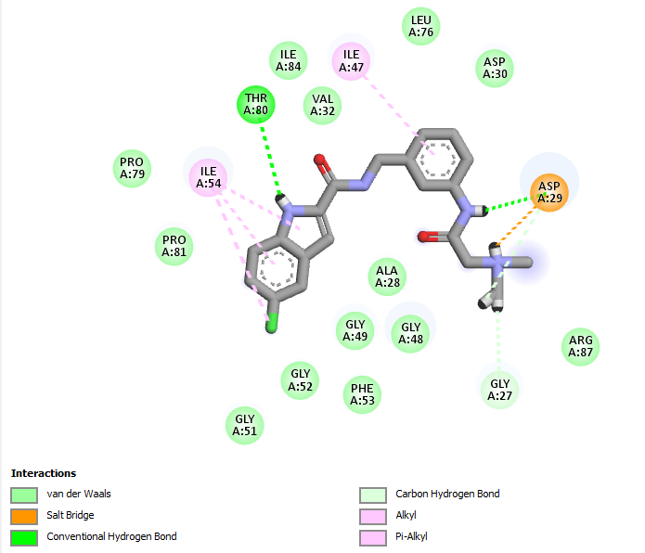
N14  N25  N47  N25  5-ring  6-ring  5-ring  Cl | ASP 29 THR 80 GLY 27 ASP 29 ALA 28 ILE 54  ILE 54  ILE 54 | H-donor  H-donor H- donor Ionic  Pi-H Pi-H  Pi-H Pi-H | 2.79  2.85  2.95  2.85  3.89  4.12 4.24 4.14

Table S11: 3D-structure of Cid 11710411 with PR (PDB ID: 5v4y).
ligand | Receptor | Interaction | Distance (Å) | 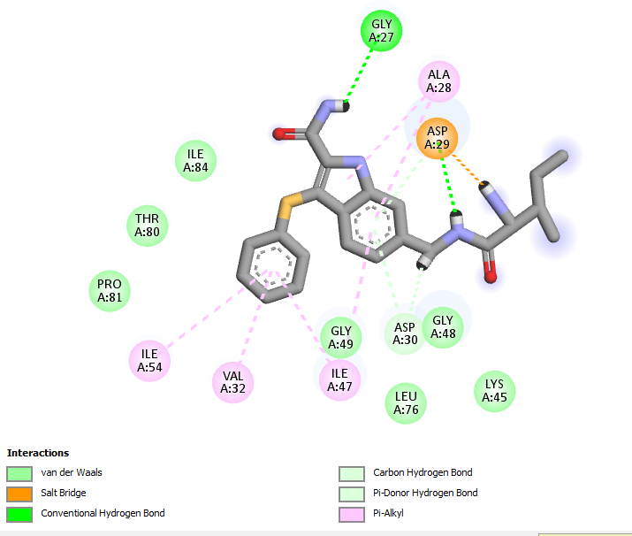
N36 N47  N47  N47  6-ring  6-ring | OD2 ASP29  OD2 ASP29  OD1 ASP29  OD2 ASP29  N ASP29  N ASP30 | H-donor  H-donor Ionic  Ionic  Pi- H  Pi-H | 2.87 2.89  3.22  2.89  4.12 4.34

Table S12: 3D-structure of Cid 11654778 with PR (PDB ID: 5v4y).
Ligand | Receptor | Interaction | Distance (Å) | 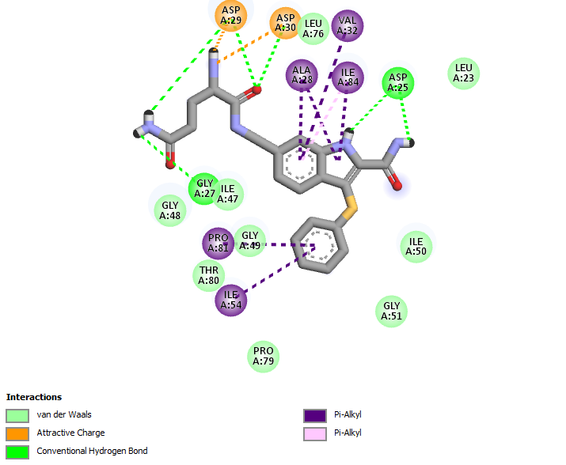
N15  N37  N59  N48  C13 O12  O12  N37  6-ring | OD2 ASP25 OD2 ASP29  O GLY27  OD2 ASP25  O GLY 48 N ASP 29  N ASP 30  OD2 ASP29  CA GLY 49 | H-donor  H-donor  H-donor  H-donor  H-donor  H-acceptor H-acceptor Ionic  Pi-H | 3.33  2.96  3.02  2.70  3.26  2.75 3.12 2.96  4.66
Table S13: 3D-structure of Cid 11630770 with PR (PDB ID: 5v4y).
Ligand | Receptor | Interaction | Distance (Å) | 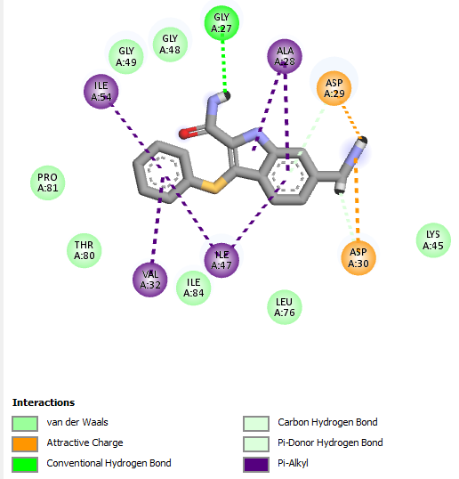
N24 N34 N24  N48  5-ring 6-ring 5-ring 6-ring | ASP30 ASP29 GLY27 ASP25 ALA28  ILE54  VAL32  ASP29 | H-donor  Ionic  H- donor  H- donor  Pi-alkyl  Pi-H  Pi-H  Pi-H | 2.74  2.74  3.06  2.70  3.95  4.13  4.34  4.31

Table S14: 3D-structure of Cid 11567743with PR (PDB ID: 5v4y).
Ligand | Receptor | Interaction | Distance (Å) | 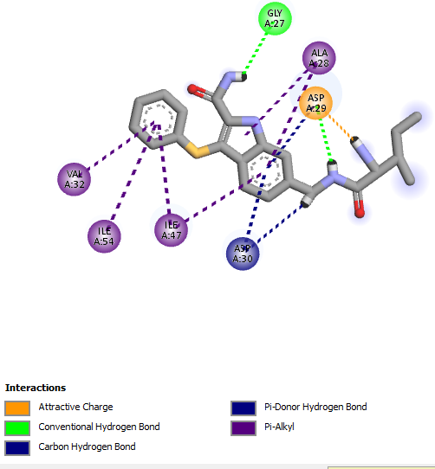
N14  N25 N47  N25  5-ring 6-ring  5-ring 6-ring | ASP29  ASP30  GLY27  ASP29  ALA 28  Val32  ILE54  ILE47 | H-donor  H-donor H-donor Ionic  Pi-alkyl Pi- alkyl Pi- alkyl  Pi- alkyl | 2.79  2.85  2.95  2.85  3.89  4.12 4.24  4.14

Table S15: 3D-structure of cid 11560933with PR (PDB ID: 5v4y).
Ligand | Receptor | Interaction | Distance (Å) | 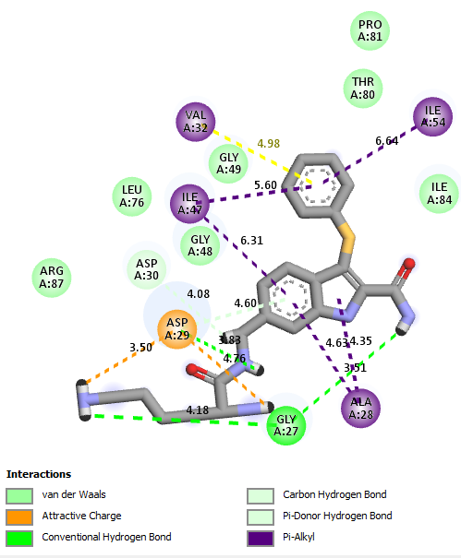
N14  N25 N47  N47  N58 N36  N47 N47  5-ring  5ring 6-ring  5-ring 6-ring | ASP29  ASP30  GLY27  ASP29  GLY27  ASP 29  ASP 29  ASP29  ALA 28  Ala28  Val32  Ile54  Ile47 | H-donor  H-donor  H- donor  H- donor  H- donor Ionic  Ionic  Ionic  Pi-H  pi- alkyl  pi- alkyl  pi- alkyl  pi- alkyl | 2.75  3.00  3.11  2.84  3.08  3.00  2.84  3.19  3.84  3.51  4.63  4.98  5.60

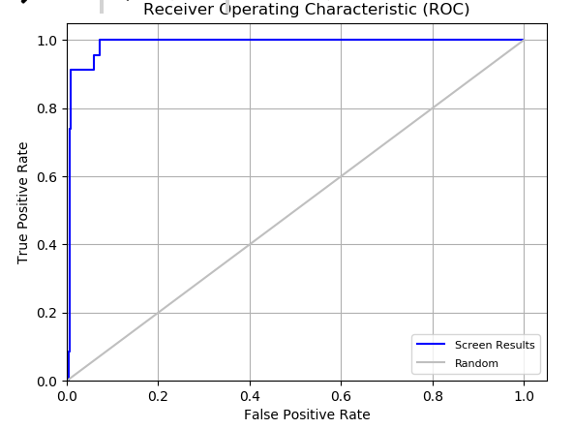
Figure S1: The ROC (Receiver Operating Characteristic) plot featuring the robustness of concerned virtual screening.

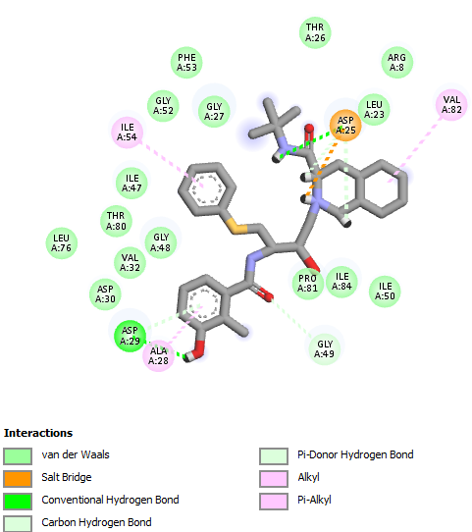 | 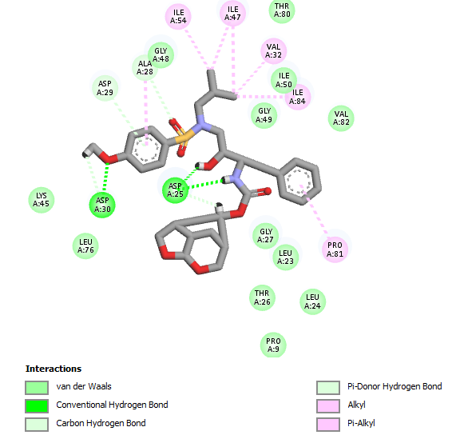
Figure S2: 3D-structure of a- Nelfinavir b- 8FM with PR1 (PDB ID: 5v4y).

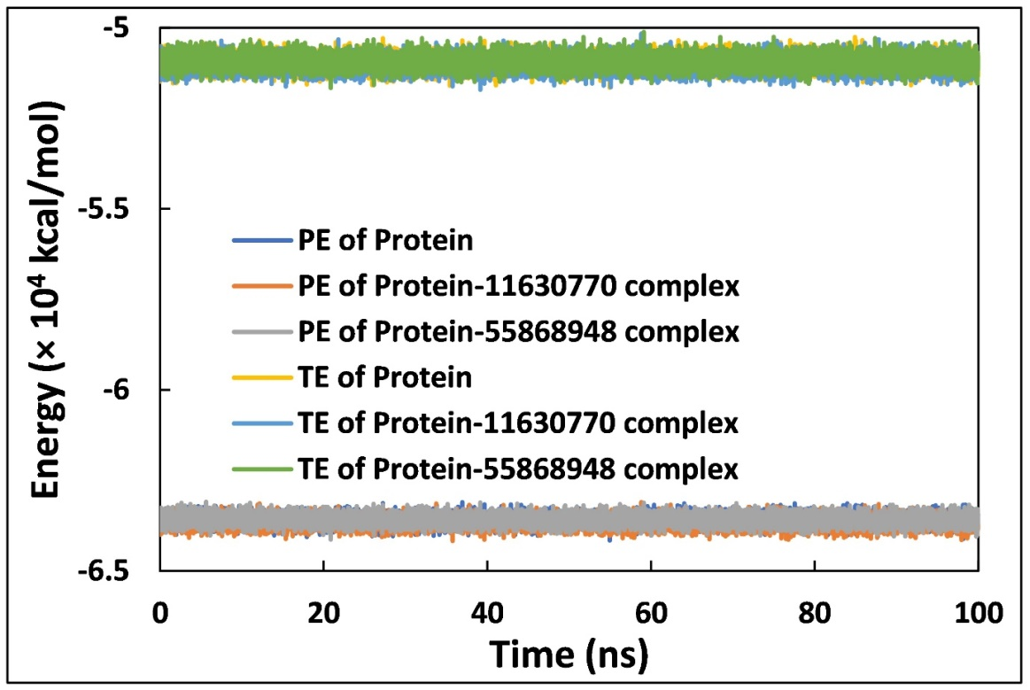
Figure S3: The Potential Energy (PE) and Total Energy (TE) of HIV-1 protease in the absence and presence of 11630770 and 55868948 r as a function of simulation time.

