Synthesis, Characterization, Anti-Glycation, and Anti-Oxidant Activities of Sulfanilamide Schiff Base Metal Chelates
Muhammad Yaqoob,¹ Waqas Jamil,,* Muhammad Taha,² Sorath Solangi¹
¹Institute of Advanced Research Studies in Chemical Sciences, University of Sindh, Jamshoro, Pakistan
²Institute for Research and Medical Consultations (IRMC), Imam Abdulrahman Bin Faisal University, Dammam, Saudi Arabia

SUPPLEMENTARY DATA

List of Tables
Table S.1 Physical Parameters of Metal Complexes S3
Table S.2 Elemental CHN/S Microanalysis of Ligand and Metal Complexes S3
Table S.3 Uv-Vis Spectra of Ligand and Metal Chelates S4
Table S.4 FTIR Values for Ligand and Metal Chelates S4
Table S.5 Thermal Analysis of the Ligand and Metal Chelates S5
List of Figures
S.1 Proton NMR of spectrum of ligand S6
S.2 Mass spectrum of ligand S7
S.3 UV-Vis spectrum of ligan S7
S.4 UV-Vis spectrum of Mn(L)₂ complex S8
S.5 UV-Vis spectrum of Co(L)₂ comples S8
S.6 UV-Vis spectrum of Ni(L)₂ complex S9
S.7 UV-Vis spectrum of Cu(L)₂ complex S10
S.8 UV-Vis spectrum of Zn(L)₂ complex S10
S.9 FT-IR spectrum of ligand S11
S.10 FT-IR spectrum of Mn(L)₂ complex S12
S.11 FT-IR spectrum of Co(L)₂ comples S13
S.12 FT-IR spectrum of Ni(L)₂ complex S14
S.13 FT-IR spectrum of Cu(L)₂ complex S15
S.14 FT-IR spectrum of Zn(L)₂ complex S16
S.15 TGA and DTA of ligand S17
S.16 TGA and DTA spectrum of Mn(L)₂ complex S18
S.17 TGA and DTA spectrum of Co(L)₂ comples S19
S.18 TGA and DTA spectrum of Ni(L)₂ complex S20
S.19 TGA and DTA spectrum of Cu(L)₂ complex S21
S.20 TGA and DTA spectrum of Zn(L)₂ complex S22
S.21 Structure of Mn(L)₂ complex S23
S.22 Structure of Ni(L)₂ complex S23
S.23 Structure of Cu(L)₂ complex S24
S.24 Structure of Zn(L)₂ complex S24

Table S.1. Physical Parameters of Metal Complexes
S# | Compounds | Colour | m.p.  ºC | Yield  % | Electrical  Conductance  µScm^{–1} | Solubility
 |  |  |  |  |  | In DMSO & DMF*
 | Ligand | Yellow | 278 | 80 | 2.74 | S
 | Mn(L)₂∙2H₂O | Red orange | 235 | 83 | 5.22 | S
 | Co(L)₂∙2H₂O | Yellowish orange | 170 | 84 | 9.53 | S
 | Ni(L)₂∙2H₂O | Green Yellow | 250 (decomp.) | 87 | 0.25 | S
 | Cu(L)₂∙2H₂O | Light Brown | 210 | 85 | 53.9 | S
 | Zn(L)₂∙2H₂O | Yellow | 250 (decomp.) | 81 | 2.02 | S
S = Completely Soluble

Table S.2. Elemental CHN/S Microanalysis of Ligand and Metal Complexes
S# | Compounds | Molecular Formula | M. W. | M:L ratio | Elemental analysis  % calculated % (Found) values
 |  |  |  |  | C | H | N | S
 | Ligand | C₁₇H₁₄N₂O₃S | 326 | — | 62.56  (62.51) | 4.32  (4.30) | 8.85  (8.79) | 9.82  (9.80)
 | Mn(L)₂∙2H₂O | C₃₄H₂₆N₄O₆S₂Mn | 705.66 | 1:2 | 55.06  (55.01) | 4.08  (4.01) | 7.55  (7.51) | 8.65  (8.60)
 | Co(L)₂∙2H₂O | C₃₄H₃₀N₄O₈S₂Co | 745.69 | 1:2 | 54.76  (54.73) | 4.06  (4.01) | 7.51  (7.47) | 8.60  (8.51)
 | Ni(L)₂∙2H₂O | C₃₄H₃₀N₄O₈S₂Ni | 745.45 | 1:2 | 54.78  (54.70) | 4.06  (4.02) | 7.52  (7.46) | 8.60  (8.64)
 | Cu(L)₂∙2H₂O | C₃₄H₃₀N₄O₈S₂Cu | 750.30 | 1:2 | 54.43  (54.40) | 4.03  (4.01) | 7.47  (7.41) | 8.55  (8.49)
 | Zn (L)₂∙2H₂O | C₃₄H₃₀N₄O₈S₂Zn | 752.14 | 1:2 | 54.29  (54.25) | 4.02  (4.01) | 7.45  (7.38) | 8.53  (8.44)

Table S.3. Uv-Vis Spectra of Ligand and Metal Chelates
S# | Compounds | Wavelength λ (nm)
 | Ligand | 364, 315
 | Mn(L)₂∙2H₂O | 467, 365, 316
 | Co(L)₂∙2H₂O | 471, 370, 277
 | Ni(L)₂∙2H₂O | 473, 262
 | Cu(L)₂∙2H₂O | 470, 412, 372
 | Zn(L)₂∙2H₂O | 472, 362, 318

Table S.4. FTIR Values for Ligand and Metal Chelates
S# | Compounds | ν (H₂O)  cm⁻¹ | ν (-O-H), (-N-H)  cm⁻¹ | ν (-C=N)  cm⁻¹ | ν (O=S=O)  cm⁻¹ | ν (-C=C-)  cm⁻¹
 | Ligand | — | 3290 | 1622 | 1347 | 1586
 | Mn(L)₂∙2H₂O | 3480 | 3278 | 1615 | 1348 | 1587
 | Co(L)₂∙2H₂O | 3472 | 3320 | 1612 | 1349 | 1587
 | Ni(L)₂∙2H₂O | 3478 | 3323 | 1610 | 1348 | 1587
 | Cu(L)₂∙2H₂O | 3481 | 3288 | 1611 | 1347 | 1588
 | Zn(L)₂∙2H₂O | 3485 | 3292 | 1612 | 1347 | 1586

Table S.5. Thermal Analysis of the Ligand and Metal Chelates
S# | Compounds | n | Temperature ºC  Weight Loss (%) |  |  |  |  | Total  Wt. loss  % | DTA
 |  |  |  |  |  |  |  |  | Exo | Endo
 | Ligand | 2 | Stage-I  250–300⁰C  (1.8) |  |  |  | Stage-II  300–350⁰C  (39.5) | 41.35 | 328 | 270
 | Mn(L)₂∙2H₂O | 3 | Stage-I  150–200⁰C  (5.78) | Stage-II  200–250⁰C  (13.7) |  |  | Stage-III  250–350⁰C  (28.1) | 47.58 | — | 172, 219,  326, 402
 | Co(L)₂∙2H₂O | 2 | Stage-I  150–200⁰C  (3.658) |  |  |  | Stage-II  200–350⁰C  (59.04) | 62.69 | — | 115, 225
 | Ni(L)₂∙2H₂O | 3 | Stage-I  150–250⁰C  (39.9) | Stage-II  250–350⁰C  (11.79) |  |  | Stage-III  350–410⁰C  (16.05) | 67.74 | 179 | 127, 325,  388
 | Cu(L)₂∙2H₂O | 2 | Stage-I  150–200⁰C  (4.14) |  | Stage-II  200–350⁰C  (28.07) |  |  | 37.87 | — | 91, 246  300
 | Zn(L)₂∙2H₂O | 3 | Stage-I  150–270⁰C  (4.23 ) 4.8 | Stage-II  270–370⁰C  (28.7) |  | Stage-III  400–460⁰C  (10.89) |  | 44.76 | — | 108, 148, 251, 346,  441
n = number of stages of weight loss

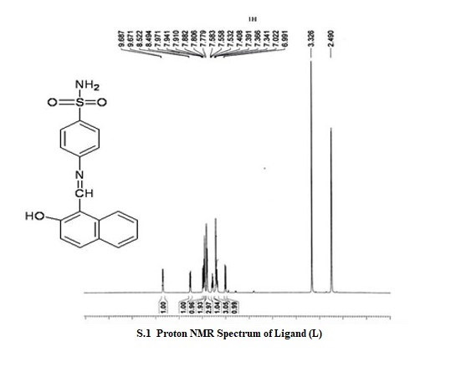

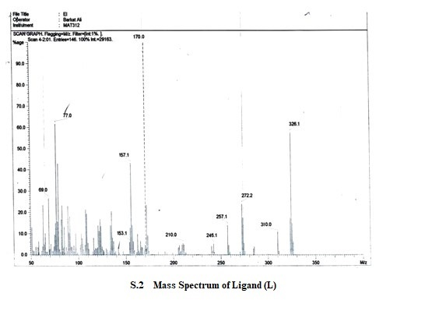

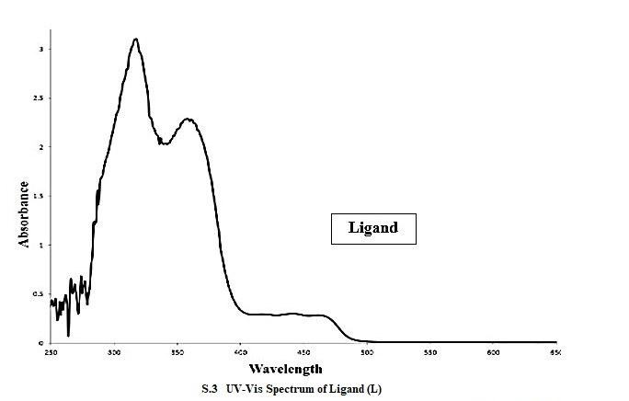

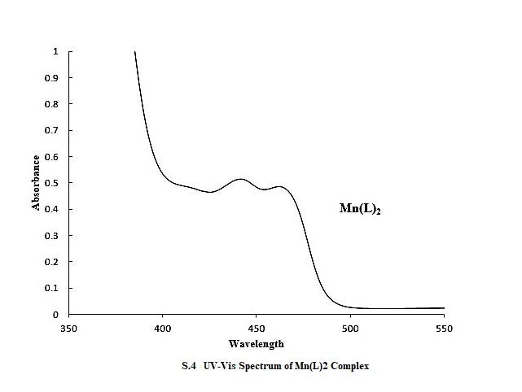

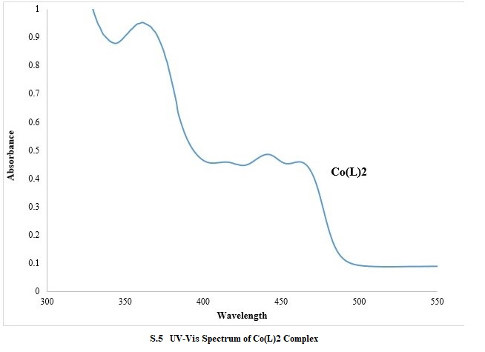
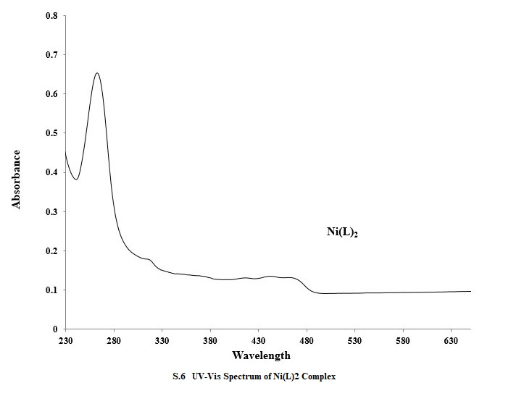

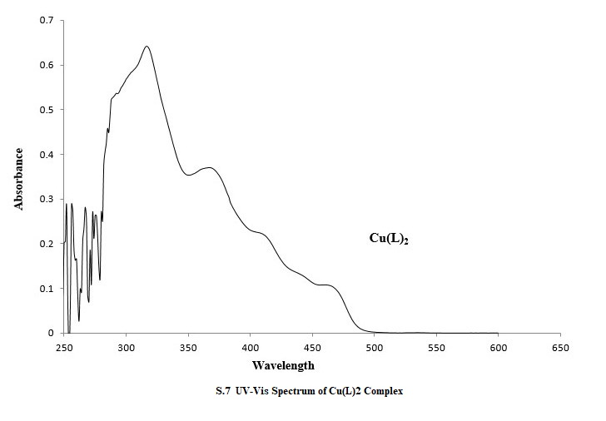

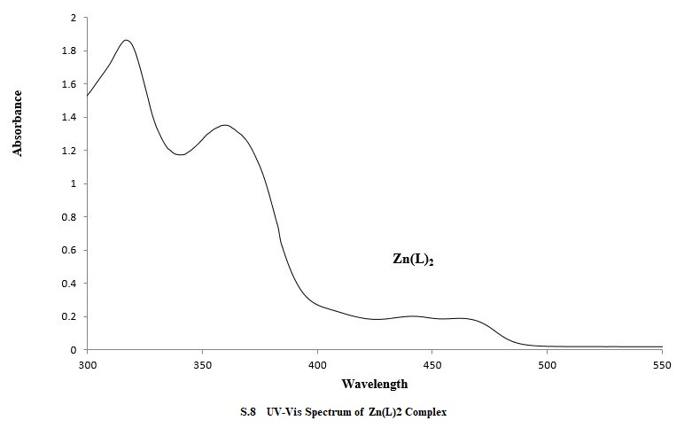

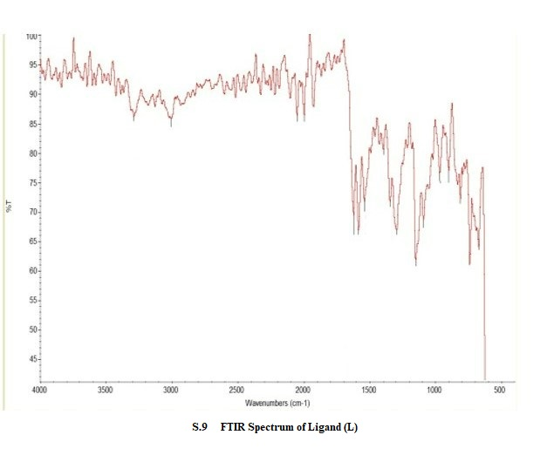

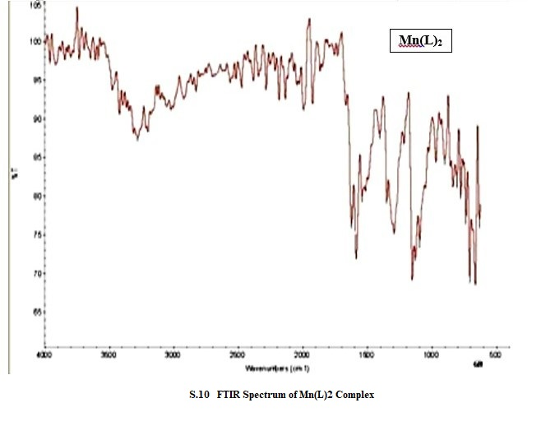

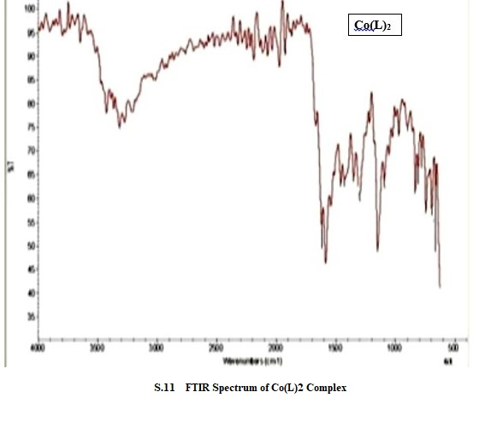

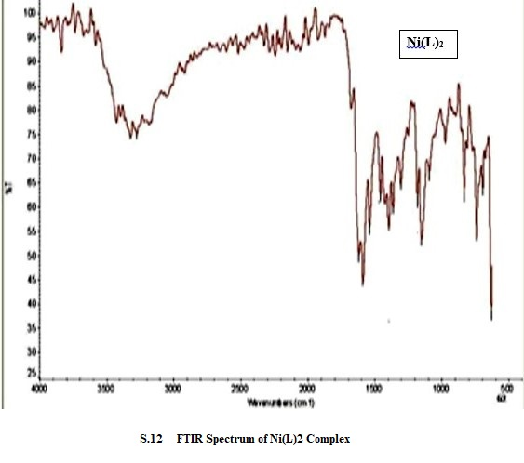

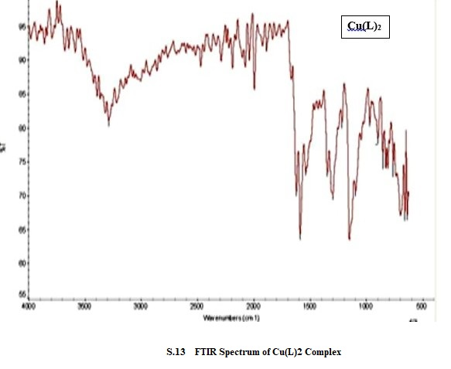

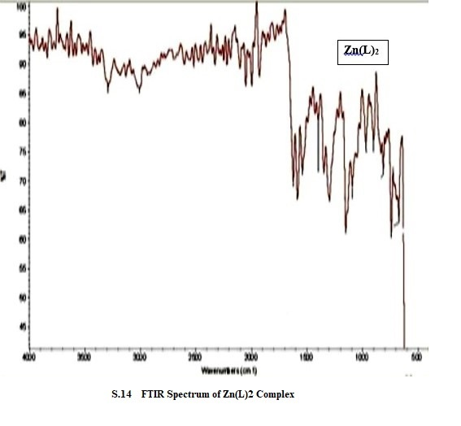

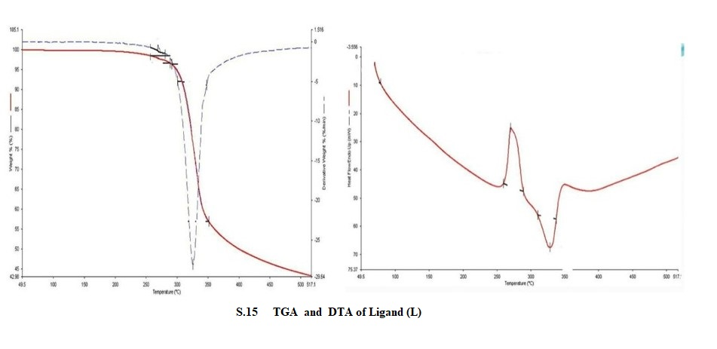
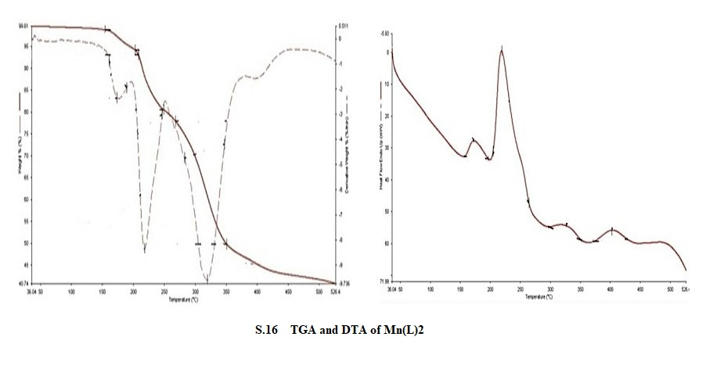
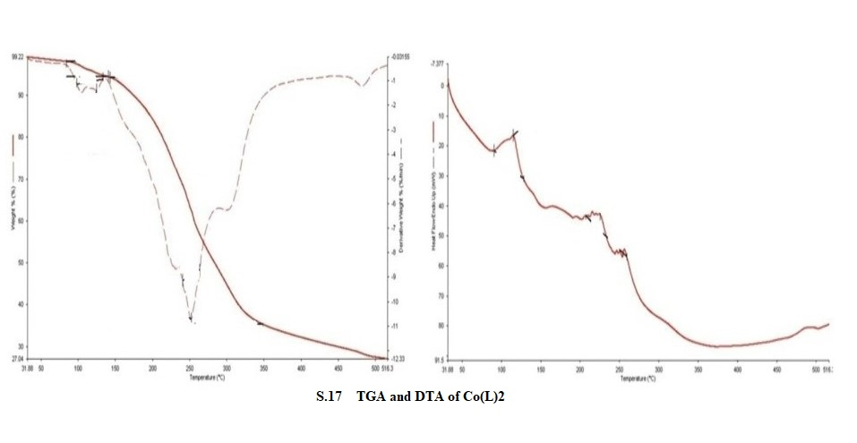
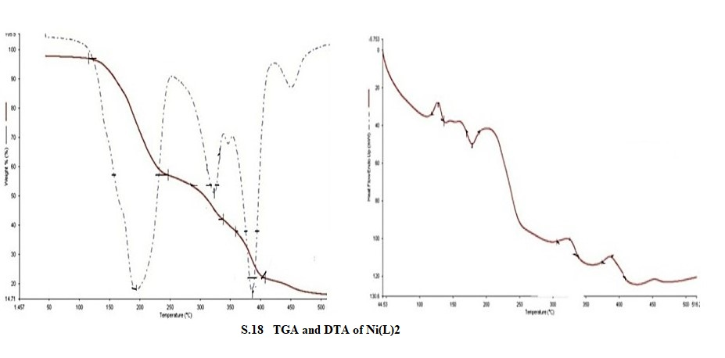
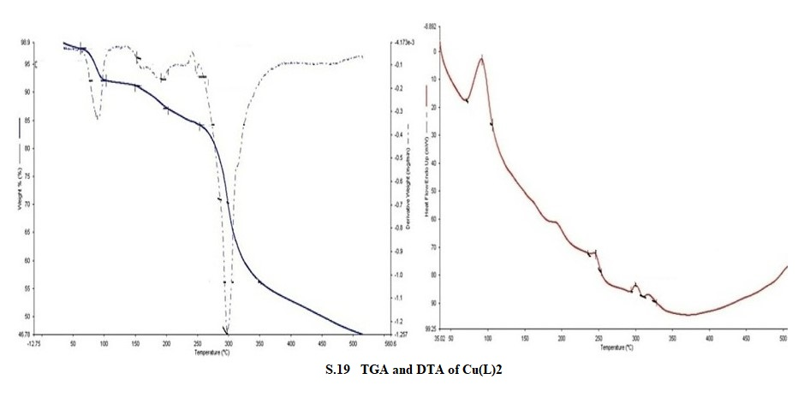

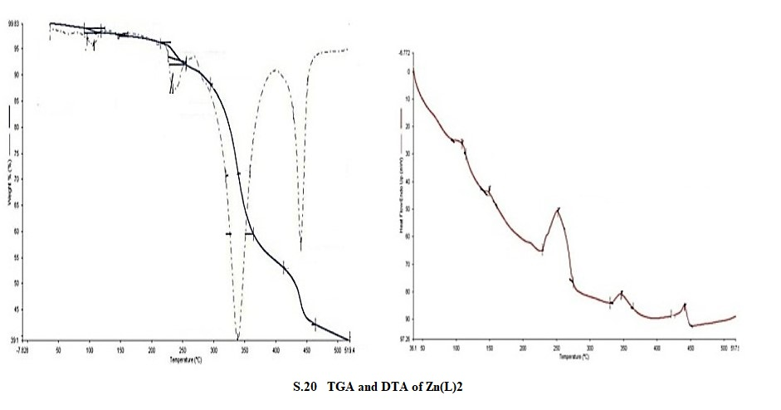

S.21 S.22

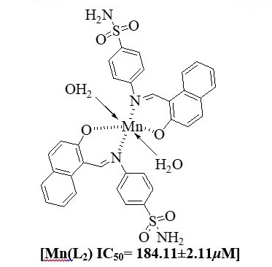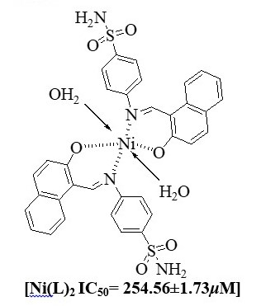

S.23 S.24
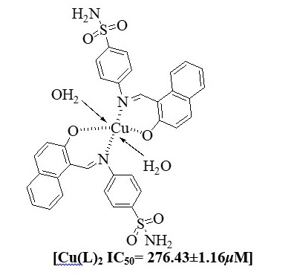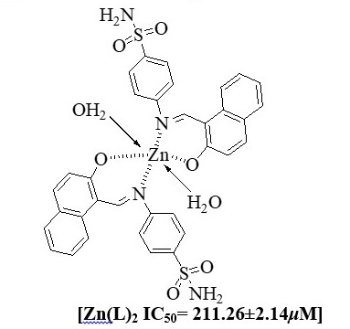

Corresponding Authors: waqas.jamil@usindh.edu.pk; Tel.+923322324551

