Nickel removing by electrocoagulation of Ni(II)-NH₃-CO₂-SO₂-H₂O system. Kinetics, isothermal, mechanism and estimated cost of operation

*Armando Rojas Vargas¹, Margarita Penedo Medina², Alba González Vives³, Noureddine Barka⁴, Aymara Ricardo Riverón⁵

¹Empresa de Servicios Técnicos de Computación, Comunicaciones y Electrónica "Rafael Fausto Orejón Forment", Nicaro, Holguín, Cuba
²Universidad de Oriente, Facultad de Ingeniería Química, Santiago de Cuba, Cuba
³POLYMAT, Departamento de Ciencia y Tecnología de Polímeros, Universidad del País Vasco, España
⁴Sultan Moulay Slimane University of Beni Mellal, Research Group SEMA, FP Khouribga, Morocco
⁵Centro de Investigaciones del Níquel "Alberto Fernández Montes de Oca", Nicaro, Holguín, Cuba
* Corresponding author: E-mail: arojas@eros.moa.minem.cu)
Tel: +53-24-51-6695

Abstract
The nickel removing by electrocoagulation of Ni(II)-NH₃-CO₂-SO₂-H₂O system was studied at laboratory scale. The operation parameters were an initial nickel concentration between 293 and 1356 mg·L⁻¹, pH 8.6, current density 9.8 mA·cm⁻², 30 min of electrolysis, 60 ºC and the electrodes pair Al/Al. The chemical analyzes were performed by AAS, ICP-OES, XRD and FTIR. The removal efficiency was from 97.7 to 99.7 %. A kinetic model to estimate the electrocoagulation time was obtained, which refers the combined effect of the resistances of the mechanisms: external diffusion, nucleation, and as controlling step the chemical reaction and a possible autocatalytic contribution. The process followed the Langmuir´s isotherm and the maximum adsorption capacity was 7519 mg·g⁻¹. The precipitate presented a typical structure of Ni-Al layered double hydroxide with 33.4 - 40.7 % nickel and 6.3 to 7.0 % aluminum. The operation costs by energy and electrode consumption were 382 - 537 $·t⁻¹ of removed nickel.

Key words: electrocoagulation – isotherm – kinetic – layered double hydroxides –mechanism – nickel removing

1. Introduction
In the production plant located in Punta-Gorda Cuba, the Ammoniacal Carbonate Leaching Technology is used for the selective recovering of nickel and cobalt form lateritic ore. In the distillation effluents a suspension of basic nickel carbonate (CBN) is obtained,¹ after the sedimentation of this suspension, in the clear liquor appears several ionic species with the composition according to proportions: 1.8<Ni/S<3.2, 1.5<NH₃/CO₂<2.0, 10.4<CO₂/S<13.8 of this system Ni(II)-NH₃-CO₂-SO₂-H₂O. The temperature of the liquor is between 70 and 85 ºC and the pH from 7.4 to 9.0.²
The dissolved nickel in the clear liquor reaches a concentration between 0.2 and 1.0 g·L⁻¹ in the form of hydroxide and coordination compounds,^{1,2} it precipitates with NH₄HS in a piston flow reactor and a nickel sulfide is obtained.³ Those reagents are toxic, corrosive and of high hazard for the environment.
In a previous study, the possibility of substituting chemical precipitation for the electrocoagulation (EC) process was analyzed.⁴
The EC consists of the destabilization of suspended, emulsified or dissolved compounds in an electrolytic cell facilitating their removal.⁵ In relation to the mechanisms of the process, the fundamental stages have been reported:⁶⁻¹²
1- Electrolytic reactions on the surface of the electrodes.
2- Formation of coagulants in the aqueous phase.
3- Destabilization and adsorption of pollutants on coagulants (coagulation).
4- Aggregation of destabilized particles and formation of flocs (flocculation).
5- Removal of contaminating material by means of secondary treatment.
It also refers to the contribution of mechanism functioning synergistically and benefits removal efficiency such as: chemistry precipitation by the formation of the pollutant metal hydroxides; reduction of metal ions, inions and gases at the cathode; co-precipitation and complexation of anions and organic compounds.^{8,9,11,13,}
The parameters that influence the efficiency of EC process can be classified into two categories: design parameters and operational parameters. The most important design parameters are related with material, shape, arrangement and spacing of electrodes, as well as type of power supply, either direct current (DC), alternating current (AC) or alternating pulsed current (APC). Regarding operational parameters are current density, electrocoagulation time, aqueous solution pH, temperature, agitation speed, initial ions concentration and supporting electrolyte.^{4,7,8,10,13,14,15}
Through a complete experimental design 2^{K} with 1 central level and 2 replicates, the most favorable conditions for the nickel removal from the Ni(II)-NH₃-CO₂-SO₂-H₂O system by EC were determined with the electrode pair Al/Al. An efficiency of 95 % was achieved for a current density of 9.8 mA·cm⁻², 60 ºC, pH 8.65 and 660 mg·L⁻¹ of initial nickel concentration, this represented a specific energy consumption of 5.41 kW-h·kg⁻¹ of Ni.⁴
Some authors have identified the potential effectiveness of EC to synthesize Hydrotalcite-like layered double hydroxides (LDHs). Zhao (2010) proposed that the formation of Mg/Al-F-LDH is one of the mechanisms for EC defluoridation in systems containing both F⁻ and Mg²⁺.¹⁶ Mendoza, et al. (2018) synthesized Mg/Al-LDH in-situ using synthetic water under laboratory-scale conditions, with aluminum and AZ31 magnesium alloys electrodes at 5 mA·cm⁻², the coagulants were generated through electrochemical oxidation of the electrodes and changing the polarity which lead to LDHs production.¹⁷ Jiang (2021) synthetized Zn/Al-LDH in situ to remove strontium in a simulated liquid radioactive waste;¹⁸ and finally, Ou (2021) fabricated Ni/Fe-LDH using nickel-plating wastewater.¹⁹
LDHs are represented by the general [Me²⁺_{1-x}Me³⁺_{x}(OH)₂]^{x+}(A^{n-}_{x/n})·mH₂O, where M²⁺ is a divalent cation (Mg²⁺, Ca²⁺, Mn²⁺, Co²⁺, Ni²⁺, Cu²⁺, Zn²⁺), M³⁺, the trivalent cation (Al³⁺, Cr³⁺, Mn³⁺, Fe³⁺, Co³⁺, Ni³⁺), An⁻, interlayer anion (Cl⁻, NO₃⁻, ClO₄⁻, CO₃²⁻, SO₄²⁻, S₂O₃²⁻ and other organic compounds), x is the charge density for the molar ratio M³⁺/ (M²⁺ + M³⁺) between 0.2 to 0.35. ²⁰⁻³¹
These compounds have been extensively investigated to improving the microstructure, increasing the active electrochemical sites and their applications.
In the case of Ni/Al-LDH, highly efficient has been reported in the adsorption of metals (Au, Cd, Cu, Pb, Se),^{28,32} anions (F⁻, IO₃⁻)^{33,34} and organic compounds.^{24-26,29,35,36}
Ni-based LDHs in the energy storage and conversion field are still limited by their intrinsically poor conductivity, aggregation, limited active sites and stability.^{23,31} Ni/Al-LDH exhibits a specific capacitance 2128 F·g⁻¹ at 1 A·g⁻¹ and coulombic efficiency above 80 % during 1000 cycles (Ni/Al:3),^{37,38} to improve the electrochemical performance, nanostructured Ni/Al-LDH have been synthetized using different routes.^{23,39,40,41}
This compound, followed by controlled thermal decomposition, represents an appropriate material for the preparation of ceramic pigments with different properties;⁴² carbonate intercalated with a c-axis preferred orientation, show excellent anticorrosive performance with polarization current density of 10⁻⁹ A·cm⁻².⁴³ It is active for the photocatalytic conversion of CO₂ to CO in water, under UV light irradiation,⁴⁴ and promising catalyst precursors for fine CO₂ removal from hydrogen-rich gas streams through the methanation reaction and methane dry reforming.^{45,46}
Moreover, the combination of nickel and aluminum finds applications in the production of superalloys (53.3≤Ni≤73.0 %, 1.2≤Al≤6.0 %) and permanent magnets (15≤Ni≤26 %, 8≤Al≤12 %).
It was assumed that the thermodynamic, kinetic-chemical, equilibrium analysis through adsorption isotherms, the characterization of the adsorbate and the adsorbent through techniques such as: AAS, ICP-OES, DXR, FTIR, and the analysis of chemical-physical interactions through Stern's electrical double layer model, coordination surface and the electrode processes, provide elements to propose the removal mechanism by electrocoagulation.^{30,47,48}
The purpose of this work was to determine the reaction kinetics, the adsorption isotherm, the mechanism and the preliminary cost of operation for the nickel removing by electrocoagulation from the Ni(II)-NH₃-CO₂-SO₂-H₂O system, at different concentrations of dissolved nickel in the initial liquor.
2. Materials and methods
2.1. Materials
The liquor used for electrocoagulation was sampled spot in the distillation columns discharge at the production plant in Punta-Gorda Cuba. The pH was adjusted with ammonium carbonate dissolution (pH 11.7) or with a mixture of hydrochloric and nitric acid. On the other hand, to adjust the nickel concentration distilled water and liquor of feeding to the columns were used. The resulting concentration was: nickel 293 - 1356 mg·L⁻¹, ammonia [NH₃] 0.51 - 4.70 g·L⁻¹, carbon dioxide [CO₂] 0.30 - 3.27 g·L⁻¹, sulfur 2.14 - 3.20 g·L⁻¹ and sulfate ion 3.46 - 6.82 g·L⁻¹ (table 1).

Table 1. Characterization of the liquor fed to the electrocoagulation cell
Ni (mg·L⁻¹) | NH₃ (g·L⁻¹) | CO₂ (g·L⁻¹) | S (g·L⁻¹) | [SO₄]²⁻ (g·L⁻¹)
293 | 0.51 | 0.33 | 2.70 | 3.59
379 | 0.92 | 0.50 | 2.14 | 3.52
474 | 1.10 | 0.25 | 2.43 | 3.53
505 | 1.08 | 0.29 | 2.31 | 3.46
646 | 1.40 | 0.30 | 2.73 | 5.70
775 | 1.20 | 0.35 | 3.00 | 3.46
953 | 1.21 | 0.35 | 3.47 | 6.83
1356 | 4.70 | 3.27 | 3.20 | 6.82

The equipment and utensils used for electrocoagulation were: Direct current source of 0.01 - 30 V, maximum amperage 10 A, power supply 220 ±10 %, 50 Hz and 250 W; multimeter, stopwatch, glassware, utensils and laboratory miscellaneous.
The electrochemical cell consisted of a discontinuous cylindrical glass reactor, with a useful capacity of 500 mL. It was equipped with a pair of flat electrodes, arranged vertically, in parallel, 10 mm spacing, submerged 57 mm in the liquor with a total area of 5.6·10⁻³ m² and an effective area of 4.6·10⁻³ m². The material used as electrode was aluminum with a composition of 98.98 % Al, 0.5 % Mg, 0.33 % Fe and 0.114 % Si.
The physical-chemical analysis was performed using the following equipment: pH meter Philips PW-9420, 115 - 230 V, 50 - 60 Hz; Optical emission spectrometer GS 1000-II to characterize the electrodes; Atomic absorption spectroscopy (AAS), Spectrophotometer SP-9 to determine the concentration of metals in solution.
In addition, the analysis of the precipitate was performed by the techniques:
Inductively Coupled Plasma Optical Emission Spectrometry (ICP-OES), Spectro ARCOS FHX.
X-ray diffraction (XRD), Bruker D8 Advance equipment, Cu anode lamp (CuKα radiation) and wavelength 1.5405 Å, constant scanning at a measurement interval of 2theta (2θ) between 5 – 6 to 100º with a step of 0.05º measured every 5 min.
Fourier transform infrared spectroscopy (FTIR), Nicolet 6700 Spectrometer, range between 4000 and 400 cm⁻¹, resolution of 4 cm⁻¹.
2.2. Methods
The nickel removal experiments by electrocoagulation consisted in assuming:
Fixed variables: the current density of 9.8 mA·cm⁻², pH 8.6, temperature 60 ºC and electrolysis time 30 min, according to the most favorable conditions for the nickel removal from the Ni(II)-NH₃-CO₂-SO₂-H₂O system.⁴
Dependent variables: nickel removal, electrode and electrical energy consumption.
Independent variable: initial concentration of nickel [Ni] dissolved in the liquor that was fed to the electrocoagulation cell.
The experimental electrocoagulation installation was placed under a laboratory hood. The positive terminal of the current source was connected directly to the electrode (anode) and the negative terminal to the multimeter and from this (COM) to the cathode. The source allowed to regulate the voltage to keep the electric current amperage constant (Fig. 1).
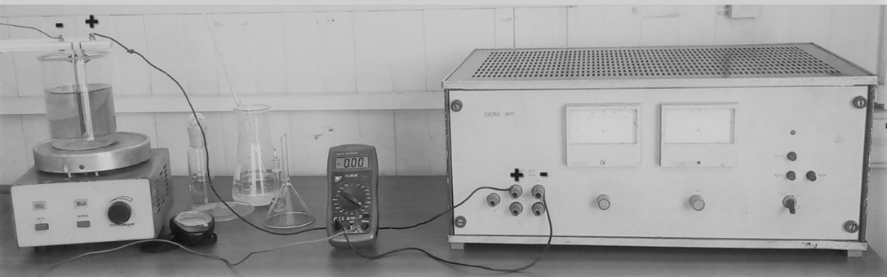
Figure 1. Experimental installation of electrocoagulation

The overflow liquor from the nickel basic carbonate settler tank, previously conditioned at the temperature and pH of the experiment, was fed to the reactor and after starting stirring at 100 rpm the system was energized. The magnetic stirrer had thermal control; the temperature was measured with a probe and displayed on an ASCON KR3 controller. The samples were removed from the reactor to a volumetric flask. Then, they were covered and allowed to settle for 24 h. Finally, the aliquot required for chemical analysis was pipetted.
The preparation of the electrodes consisted of polishing the surface with coarse and fine sandpaper, and washing with distilled water. After electrocoagulation, they were cleaned with phosphoric acid solution, sodium hexametaphosphate and distilled water until the deposited layer was removed. Later these electrodes were weighed. Each anode was used for at most two experiments.
2.3. Adsorption kinetics models
The adsorption capacity (Q_{t}) or amount of adsorbate adsorbed per adsorbent unit (mg∙g⁻¹) was determined by Eq. (1).
$$Q_{t}=\left(C_{0}-C_{t}\right)⋅\frac{V}{ΔM_{F}} (1)$$
Where C₀ (mg·L⁻¹) is the initial concentration of nickel, C_{t} (mg·L⁻¹) concentration in each time interval in the liquid phase, V volume of solution, ΔMF (g) amount of metal that dissolves according to Faraday's Law, Eq. (2).
$$ΔM_{F}=\frac{I⋅M⋅t}{n⋅F} (2)$$
Where: I (A) is the current intensity, M the molecular weight of [Al] 26.98 g·mol⁻¹, t (s) the electrocoagulation time, number of electrons for aluminum (n: 3), Faraday constant (F: 96487 c·mol⁻¹). When the duration of the process is long enough, Q_{t} is constant and determines the charge or adsorption capacity at experimental equilibrium (Q_{e}, mg∙L⁻¹), corresponding to the concentration at equilibrium (C_{e}, mg∙L⁻¹).
Many adsorption kinetic models were evaluated: pseudo-second order, Elovich, Avrami, Bangham and intra-particle diffusion model by Weber-Morris.^{48,49,50}
The parameters were adjusted with StatGraphic 5.1 and Microsoft Excel; the best quality of fit was decided by the highest coefficient of determination (R²). The most representative models of the data are described below.
The pseudo-second order model presents the kinetic Eq. (3), integrating results Eq. (4), where k₂ (g∙mg⁻¹∙min⁻¹) is the adsorption rate constant while h is assumed as the initial reaction rate (g·mg⁻¹).
$$\frac{dQ_{t}}{dt}=k_{2}⋅{\left(Q_{e}-Q_{t}\right)}^{2} (3)$$
$$\frac{t}{Q_{t}}=\frac{1}{k_{2}⋅Q_{e}^{2}}+\frac{1}{Q_{e}}⋅t=\frac{1}{h}+\frac{1}{Q_{e}}⋅t (4)$$
Avrami's fractional kinetic model is based on the KJMA theory,⁵¹ and consist of phase transformations via homogenous and spontaneous nucleation and growth of a crystal as a function of crystallization time; although it has been assumed as an empirical model for the analysis of adsorption kinetic data.⁴⁷ It is represented by Eq. (5), integrated (6) and linearized (7).
$$\frac{dQ_{t}}{dt}=k_{av}^{n}⋅t^{n-1}⋅\left(Q_{e}-Q_{t}\right) (5)$$
$$Q_{t}=Q_{e}⋅\left\{1-\exp\left[-{\left(k_{av}⋅t\right)}^{n_{av}}\right]\right\} \left(6\right)$$
$$\ln\left[-\ln\left(1-\frac{Q_{t}}{Q_{e}}\right)\right]=n_{av}⋅\ln{k_{av}}+n_{av}⋅\ln{t} (7)$$
Where, K_{av} is the kinetic constant (min⁻¹) or global constant, n_{av} fractional reaction order, which refers to the nucleation, growth and orientation of crystallites or possible changes in the adsorption mechanism.
In addition, the fit quality of several models was evaluated in order to investigate the controlling mechanism in the removal process, these are:⁵²
External diffusion: 1-D, 2-D, 3-D, boundary layer.
Internal diffusion: 1-D, 2-D, Ginstling-Brounshtein, Jander.
Nucleation: 1-D, Kolgomorov-Johnson-Mehl-Avrami-Erofeev, nucleation and crystallization.
Chemical reaction: Power Law.
Autocatalysis: Roginskii - Shultz, Kolmogorov, autocatalysis.

2.4. Adsorption isotherm models
The Langmuir, Freundlich, Temkin, Toth, Koble - Carrigan and Redlich - Peterson adsorption isotherm models were evaluated. ^{10,25,35,48,49,50}
Langmuir´s isotherm had the greater interest for the results; its linearized form is shown in Eq. (8), and the equilibrium parameter is defined in Eq. (9).
$$\frac{C_{e}}{Q_{e}}=\frac{C_{e}}{q_{max}}+\frac{1}{q_{max}∙K_{L}} (8)$$
$$R_{L}=\frac{1}{1+K_{L}∙C_{0}} (9)$$
Where, the maximum adsorption capacity in the monolayer is q_{max} (mg·g⁻¹), K_{L} (L·mg⁻¹) the Langmuir adsorption constant that defines the affinity of the adsorbate for the adsorbent. For its part, the equilibrium parameter of the Langmuir´s isotherm is R_{L}.
The verification of the consistency of adsorption models and the theoretical assumptions of adsorption models was made by Average Relative Error (ARE) and Marquardt’s Percent Standard Deviation (MPSD) Eq. (10) and (11) respectively.³⁵
$$ARE=\frac{100}{n}∙\sum_{i=1}^{n}{\left[\left(\frac{Q_{e, i ,cal}-Q_{e, i ,exp}}{Q_{e, i ,exp}}\right)\right]} (10)$$
$$MPSD=\sqrt{\frac{1}{n-P}∙\sum_{i=1}^{n}{{\left[\left(\frac{Q_{e, i ,cal}-Q_{e, i ,exp}}{Q_{e, i ,exp}}\right)\right]}^{2}} } (11)$$
Where, the number of data points (n) and number of parameters (P).

2.5. Operating cost estimate
The operating cost per kg of nickel removed was calculated by Eq. (12).
$$C_{op}=\left[a∙C_{en}+b∙∆M_{exp}\right]∙\frac{1}{m_{Ni}} (12)$$
Where, Cop ($·kg⁻¹) operating cost, a ($ 0.090 / kW-h) cost of electricity, C_{en} (kW-h) power consumption, b (1,445 $·kg⁻¹) cost of the aluminum electrode; ΔMexp (g) experimental weight loss of the electrodes, m_{Ni} (kg) mass of nickel removed.
Transforming Eq. (13):
$$C_{op}=\left[a∙U∙I∙t∙\frac{1}{60}+b∙∆M_{exp}\right]∙\frac{1}{\left[Ni\right]∙V∙x_{Ni}} (13)$$
Where, U (V) voltage, I (A) current intensity, t (min) electrocoagulation time, [Ni] (g·L⁻¹) initial concentration of dissolved nickel, V (0.5 L) useful volume of the cell, x_{Ni} fraction converted or nickel removing.
The current efficiency (𝜂) and the specific energy consumption per kg electrode dissolved (See, kW-h·kg⁻¹) were determined by Eq. (14) and (15), respectively.
$$η=\frac{ΔM_{exp}}{ΔM_{F}} (14)$$
$$See=\frac{n⋅F⋅U}{3600⋅M⋅η} (15)$$
3. Results and Discussion
3.1 Adsorption kinetics
The study of adsorption kinetics provides information on the mechanisms involved in the process. For the experimental conditions of 9.8 mA·cm⁻², 60 ºC, pH 8.6, 30 min of electrolysis and initial concentration 293≤[Ni]≤956 mg·L⁻¹, the nickel removal efficiency was between 99.0≤X≤99.7 % (Table 2).

Table 2. Efficiency of nickel removal by electrocoagulation
Ni (mg·L⁻¹) | 293 | 379 | 474 | 505 | 646 | 775 | 953 | 1356¹
X (%) | 99.7 | 99.3 | 99.3 | 99.5 | 99.0 | 99.0 | 99.0 | 97.7
¹40 min of electrolysis

A model was obtained that relates the conversion time (t) as a function of the converted fraction (x), nickel initial concentration (mg·L⁻¹), mass of aluminum [Al] and the coefficients o constants a, b, c, d, e, f, Eq. (16).
$t=\left\{\begin{aligned}a⋅\left[1-{\left(1-x\right)}^{\frac{1}{2}}\right] \\ +b⋅\left[5⋅{\left[-\ln\left(1-x\right) \right]}^{\frac{1}{5}} \right] \\ +c⋅\left[1-{\left(1-x\right)}^{\frac{1}{3}}\right] \\ +d⋅\left[x^{\frac{2}{3}}⋅{\left(1-x\right)}^{\frac{2}{3}} \right] \end{aligned}\right\}⋅{\left[Ni\right]}^{e}⋅{\left[Al_{t}\right]}^{f} (16)$
From Faraday's law to determine the mass of dissolved aluminum, Eq. (17) is obtained.
$$t^{n}=\left\{\begin{aligned}a⋅\left[1-{\left(1-x\right)}^{\frac{1}{2}}\right] \\ +b⋅\left[5⋅{\left[-\ln\left(1-x\right) \right]}^{\frac{1}{5}} \right] \\ +c⋅\left[1-{\left(1-x\right)}^{\frac{1}{3}}\right] \\ +d⋅\left[x^{\frac{2}{3}}⋅{\left(1-x\right)}^{\frac{2}{3}} \right] \end{aligned}\right\}⋅{\left[Ni\right]}^{e}⋅K_{Al} ( 17)$$

Where, the constant (n) refers to the conversion time, the resistance coefficient to external diffusion (a), nucleation (b), chemical reaction (c) and its autocatalytic contribution (d), the nickel exponent (e), and the coefficient (K_{AL}) for the estimate of dissolved aluminum by Faraday's Law.
The parameters of the conversion time (CVT) model (17) are shown in table 2 for the concentration ranges: 293≤Ni≤646 mg·L⁻¹; 775≤Ni≤1356 mg·L⁻¹; 293≤Ni≤1356 mg·L⁻¹. It reflects between 99.18 and 99.88 % of the variability in nickel removal. The coefficient of determination (R²) adjusted by the degrees of freedom (g.l.) allows compare this model with others with the same number of independent variables.
CVT model expresses that the nickel removing is determined by the combined effect of the resistances of the mechanisms:
- External diffusion (a), in the film or boundary layer to the adsorbent surface, by the two-dimensional (2-D) diffusion model.
- Nucleation and crystallization (b), by the Kolgomorov-Johnson-Mehl-Avrami-Erofeev equation, which refers to the random formation and growth of the adsorption surface due to the hydrolysis and polymerization reactions of aluminum, giving rise to the species monomeric, polymeric, oligomeric aluminum and Al(OH)₃, where the contaminants adsorption occurs (Ni²⁺, S_{x}O_{y}^{z-}, CO₃²⁻, NH₃) in the active centers by electrostatic interaction and coordination surface, and subsequent crystallization; in competition with that nucleation that occurs when the deposits grow on the electrodes.
- The chemical reaction (c) in the active centers of the adsorption surface, by the model of spherical particles according to the Power Law.
- Contribution to the chemical reaction due to the synergistic effect that promotes the nickel removing and a possible autocatalytic effect is estimated, according to the Roginskii - Shultz equation (e).

When the nickel concentration increases between 775 and 1356 mg·L⁻¹, there is a greater effect on the removal by the chemical reaction mechanism due to the processes that exert a synergistic effect on the process; while in the lower interval (293≤Ni≤646 mg·L⁻¹), the chemical reaction and external diffusion predominate which can be seen by the coefficient’s values of the kinetic model, (see table 3).

Table 3. CVT model constants by Eq. (15) and quality of fit
 | $$n$$ | $$a$$ | $$b$$ | $$c$$ | $$d$$ | $$e$$ | $$k_{Al}∙{10}^{-2}$$ | R² | R² (g.l.)
¹ | 0.2938 | 8.8582 | 1.1429 | 12.4190 | 10.4680 | 0.3054 | 1.4834 | 99.41 | 99.18
² | 0.3029 | 0.9418 | 1.7497 | 16.7428 | 18.7548 | 0.2812 | 1.5661 | 99.91 | 99.88
³ | 0.2985 | 9.9782 | 2.6673 | 13.2262 | 20.1508 | 0.2337 | 1.5250 | 99.35 | 99.24
¹[Ni] de 293 a 646 mg·L⁻¹; ²[Ni] de 775 a 1356 mg·L⁻¹; ³[Ni] de 293 a 1356 mg·L⁻¹.

The adsorption kinetic models were ordered by their quality of fit: (1) pseudo 2nd order ≈ (2) Avrami > (3) Elovich ≈ (4) Bangham >> (5) Weber-Morris. These were used to validate the conversion time model, Eq. (17).
The pseudo-second order (PSO) model showed a high quality of fit (96.1≤ R²≤99.8 %). As the initial nickel concentration increased, the rate constant k₂ (g·mg⁻¹·min⁻¹) decreased, which is attributed to the progressive saturation of the active sites in the adsorption surface with the cation [Ni²⁺], (Fig. 2 a), and causes an increase in the necessary electrocoagulation time, Eq. (17).

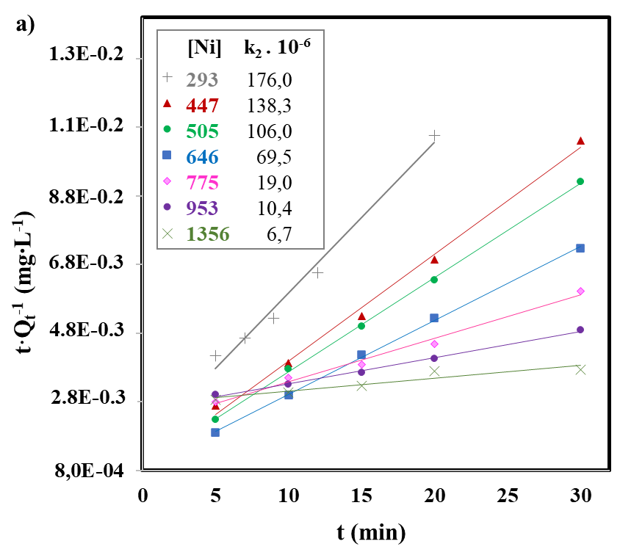
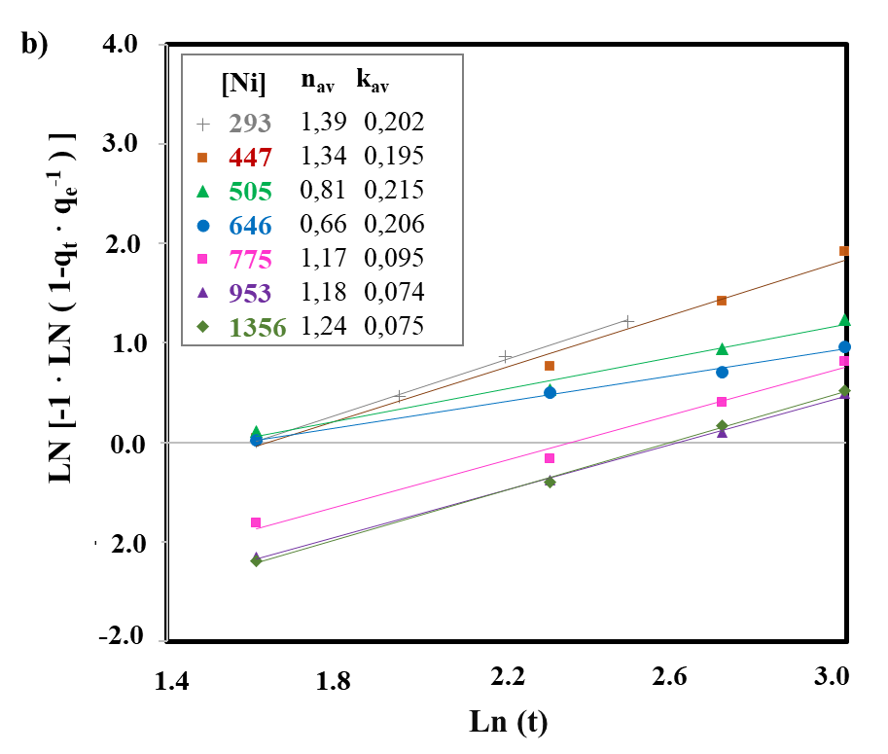
Figure 2. Adsorption of nickel with the electrode pair Al/Al at 9.8 mA·cm⁻², 60 ºC, pH 8.6, a) Pseudo-second order kinetic model b) Avrami model.

The Avrami´s model was representative of dates because of its high quality of fit. The removal rate (k_{av}) for initial nickel concentration between 293 and 646 mg·L⁻¹ was assumed constant and equal to 0.20 (+/- 0.01) min⁻¹ (97.94≤R²≤99.62 %); but in the range of 775 to 1356 mg·L⁻¹ the kinetic behavior changed and k_{av} decreased between 50 and 60 % (98.82≤R²≤99.75 %) due to the increase in adsorbate concentration. It was regarded that in the first interval the contribution of the mechanism external diffusion resistance influenced in the higher value of k_{av}, while in the second interval k_{av} was lower under the mechanism control the chemical reaction resistance (Fig. 2 b) (see table 3).
With respect to the lines slopes that reflect the fractional order (n_{av}) of Avrami´s model, in the interval 293≤[Ni²⁺]≤646 mg·L⁻¹ decreased from 1.39 to 0.66 with the increase of the cation [Ni²⁺], which is attributed to the progressive saturation of the active adsorption sites because there is a greater amount of adsorbate that reaches the adsorbent surface and therefore a longer electrocoagulation time is required; also, the interactions augments and the tendency to change the controlling mechanism. In the interval of 775≤[Ni²⁺]≤1356 mg·L⁻¹ the exponential constant (n_{av}) increased to 1.21 (+/- 0.05), according to Eq. (17), it may be associated with the controlling mechanism chemical reaction resistance.
The Elovich´s model (95.5≤ R²≤99.62 %) suggests that the adsorbent active sites are heterogeneous and therefore exhibit different activation energies, that more than one mechanism incises the removal process such as transport in the solution phase (bulk diffusion) and surface diffusion.^{48,49,50} The initial rate kinetic constant (α) (mg·g⁻¹·min) increased directly proportional to the concentration of [Ni²⁺] and the constant (β) related to the chemisorption activation energy and the extension of the adsorption surface, decreased with the increase of cation [Ni²⁺] throughout the interval.
The Bangham and Weber-Morris´s models were less representatives of the data due to their lower quality of fit, in correspondence with the CVT model, Eq. (17) where internal diffusion resistance could be omitted from the process due to low statistical significance.
The Bangham´s model is applied to investigate pore activation for adsorbate diffusion. The fit quality was obtained in the interval 95.0≤R²≤99.3 %, which indicates that both intra-particle diffusion and pore diffusion are not controlling in the process.⁵⁰
With regard to the Weber and Morris´s model, it reflects the influence on the process of external mass transfer followed by intra-particle diffusion in pores of different sizes.^{48,50} The plot of Qt versus t^{0.5} did not result in a linear relationship with intercept at the origin of coordinates (86.5≤R²≤99.1), and suggests that diffusion is not a limiting step in the mechanism. Furthermore, the intra-particle kinetic rate constant was not directly proportional to the adsorbate concentration, suggesting that the process is not controlled by adsorption in the pores.

3.2 Nickel adsorption isotherms
The equilibrium concentration corresponding to each initial nickel concentration, and the equilibrium adsorption capacity were determined. By increasing the initial concentration, the adsorption capacity increased at equilibrium and [Ni²⁺]>953 mg L⁻¹, the formation of a plateau was obtained, which indicates saturation of the adsorption sites and a decrease in the removal efficiency at the experimental conditions studied, (Table 4 and Fig. 3 a).

Tabla 4. Concentración en equilibrio y capacidad de adsorción del níquel por electrocoagulación con el par de electrodos Al/Al
Ni (mg·L⁻¹) | 293 | 379 | 474 | 505 | 646 | 775 | 953 | 1356
Ce (mg·L⁻¹) | 1,0 | 2,0 | 2,5 | 3,0 | 6,6 | 8,0 | 10,0 | 31,0
Qe (mg·g⁻¹) | 1892 | 2442 | 2880 | 3252 | 4120 | 4969 | 6168 | 6638

The order of goodness-of-fit (R²) of the adsorption isotherm models was: Langmuir (99.3 %) > Redlich - Peterson (97.3 %) > Koble - Carrigan (96.1 %) ≈ ToTh (96.1 %) > Temkin (93.8 %) ≈ Freundlich (93.7 %).

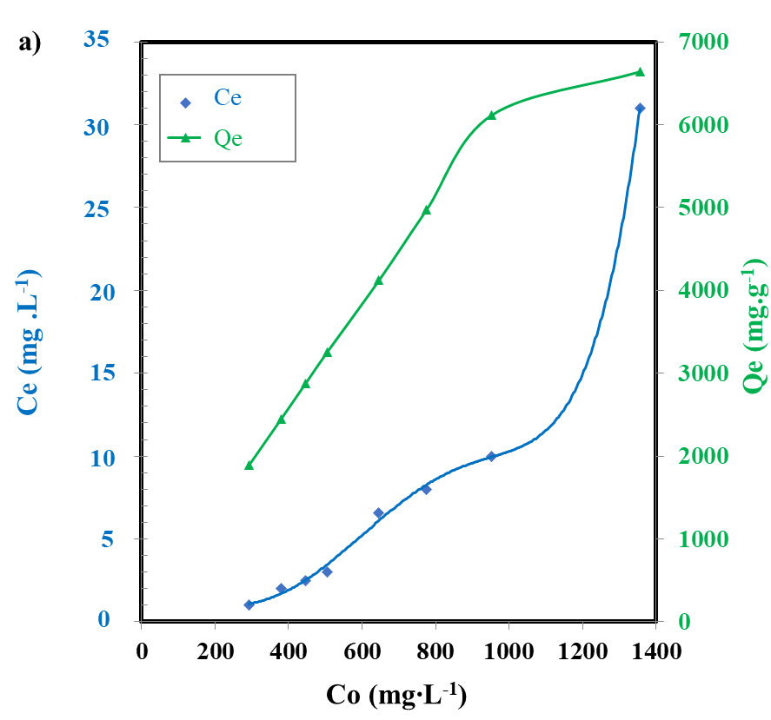
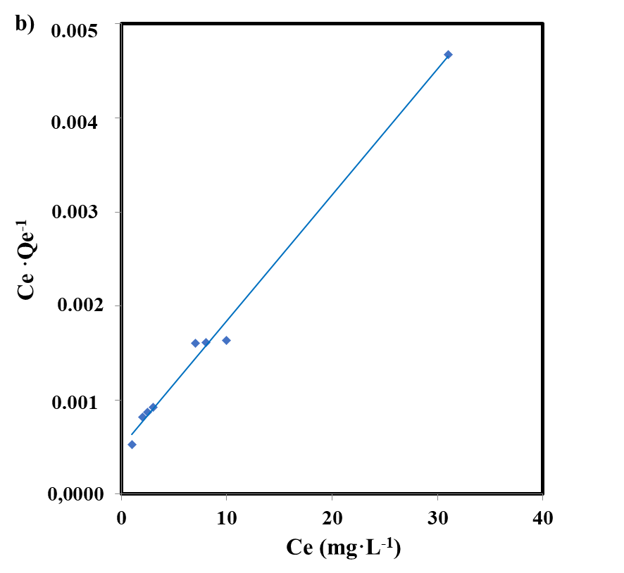
Figure 3. Removal of [Ni²⁺] at 9.8 mA·cm⁻², 60 ºC and pH 8.6, a) Equilibrium concentration (Ce) and adsorption capacity (Q_{e}) as a function of the initial concentration (Co) b) Langmuir isotherm.

The Langmuir´s isotherm (Fig. 3 b) was more representative of the data, this presented the highest quality of fit determined by the coefficient of determination (R²), the lower ARE 7.7 and MPSD 0.108, suggests monolayer adsorption in a specific number and fixed of accessible sites on the adsorbent surface, all active sites have the same energy. Once an adsorbate occupies a site, no farther adsorption can occur on that site and there is not interaction between adsorbate species.^{48,49,50} The maximum adsorption capacity (q_{max}) was 7519 mg·g⁻¹, the constant (K_{L}) 0.216 L·mg⁻¹ and the equilibrium parameter 0.003 ≤R_{L} ≤ 0.013.
The Redlich-Peterson´s isotherm (A: 4.84∙10⁻⁴ L·g⁻¹; beta-β: 0.61) and the Koble-Carrigan´s isotherm (A_{k}: 1429 mg·L⁻¹, B_{k}: 0.14 mg·L⁻¹, p: 1.08) refers that adsorption is a mixture (Langmuir and Freundlich) and not precisely the ideal adsorption monolayer; while the Toth´s isotherm (K: 0.25; n: 5.5 mg·g⁻¹) is a modification of the Langmuir´s equation and suggest a heterogeneous adsorption (n>1).
The Temkin´s model assumes linear rather than logarithm decrease of heat of adsorption while ignoring extremely low and very high concentration. It also assumes uniform distribution of bounding energy up to some maximum bonding energy,^{35,50} the heat of adsorption, b_{T}, is equal to 1.79 J·mol⁻¹, A: 2.88 L·mg⁻¹ and B: 1547.0.
Eventually, the lower value of the determination coefficient corresponded to the Freundlich´s isotherm, which assumes a heterogeneous distribution of active sites and energy on the surface, applicable to adsorption multilayers,^{48,50} K_{f}: 2001.4 (mg·g⁻¹)/(mg·L⁻¹)^{n} and n: 2.7.
Thus, the kinetic and equilibrium analyses suggest control of chemisorption on a monolayer, at a fixed and specific number of accessible sites on the adsorbent surface; although it does not specifically follow the ideal adsorption monolayer at identical sites, the interaction between the molecules is not neglected, due to the action of electrostatic forces and exchange reactions in the active sites of the coordination surface. In addition, the transport of solute through the internal structure of the adsorbent pores and the diffusion in the solid are neglected.

3.3 Analysis of the precipitate
In order to investigate the nickel removal mechanism by electrocoagulation the precipitate was analyzed. The ICP-OES, DXR and FTIR analysis showed the formation of Layered Double Hydroxide [Ni/Al-LDH] as the main product, with [NH₃] intercalated and the anions [SO₄²⁻] and [CO₃²⁻], also accompanied by phases impurities.
The largest diffraction peaks were obtained at 2theta (2θ) Bragg angles of 10.745º, 22.101º, 34.922º and 61.067º, which are assigned to the crystalline planes, according to the Miller indices (hkl): (003), (006), (012), (110) respectively, are also of interest at 46.43º (018) and 72.676º (119). These diffraction peaks are indexed on a hexagonal system
with rhombohedral symmetry, special group R-3m (polytype of three layers). The presence of 0kl peaks anticipates the presence of stacked layers, (see Fig. 4a), (JCPDS file 15-0087).^{22,27,28,34,39,53,}

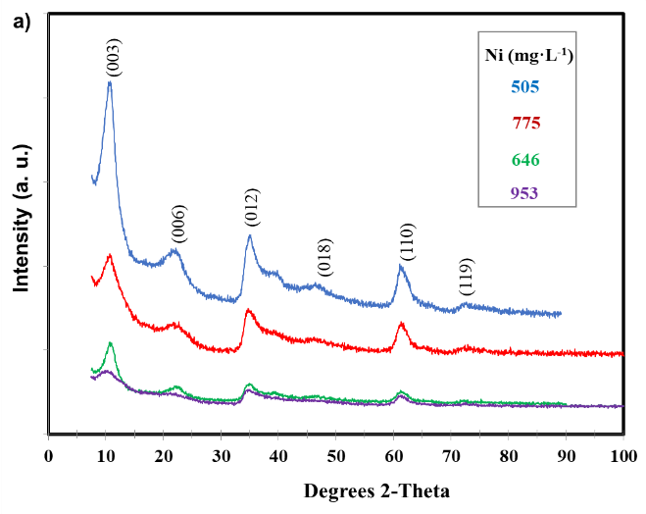
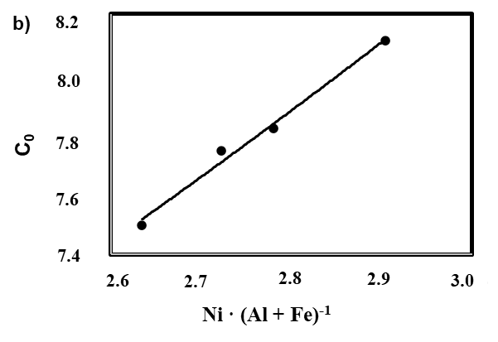
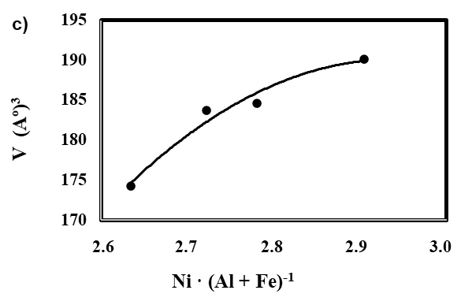
Figure 4. X-ray diffraction (XRD) of Ni/Al-LDH, Cu Kα1, λ=1.540598 Å, at 9.8 mA/cm², 30 min, 60 ºC and pH 8.6. a) Diffraction intensity for various Bragg reflection angles. b) Interaction of the basal axis c₀ with the molar ratio M(II)/M(III). c) Crystallite volume interaction V (Å)³ with M(II)/M(III).

The XRD pattern also showed phases impurities by comparison of the characteristic reflection pattern to a reference library of samples.
Through Fig. 4a, low intensity peaks attributed to the impurities the bayerite polymorphs Al(OH)₃ and aluminum hydroxide or gibbsite [γ-Al(OH)₃], (JCPDS 33-0018, JCPDS 20-0011, JCPDS 24-0006).^{15,40,54}
Also nickel hydroxide [Ni(OH)₂] indexed to the hexagonal [β-Ni(OH)₂]; the [Ni(OH)_{2·}0,75H₂O], nickel oxy-hydroxides corresponding to [β-NiOOH] and [γ-NiOOH] phases (JCPDS 14-0117, JCPDS 38-0715, JCPDS 06-0141, JCPDS 06-0075)^{55,56,57-59}
The presences of nickel aluminate were identified: [NiAl₂O₄], [NiAl₂₆O₄₀], [NiAl₃₂O₄₉] and [Ni₂Al₁₈O₂₉] (JCPDS 10-0339, JCPDS 20-0776, JCPDS 20-0777, JCPDS 22-0451).^{60,61}
These phases may be a consequence of the decrease in pH during the process from 8.53 (+/-0,07) to 8.35 (+/-0,08).
Fourier transform infrared spectroscopy (FTIR) analysis was used to determine structures of the molecules in the deposited material, (Fig. 5).

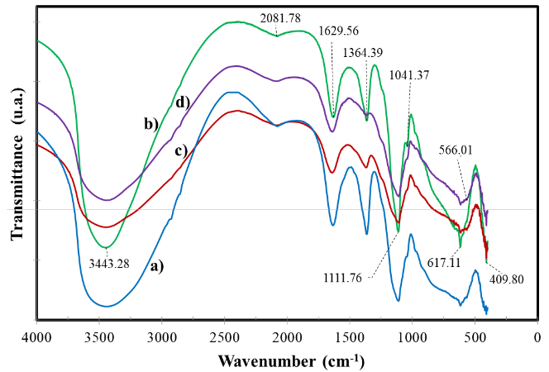
Figure 5. FTIR spectral of Ni/Al-LDH at different nickel concentration, a) 505 mg·L⁻¹, b) 646 mg·L⁻¹, c) 775 mg·L⁻¹, d) 953 mg·L⁻¹

The broadened bands that can be seen in the region from 3423 to 3465 cm⁻¹ are assigned to tension vibrations (stretching) (νOH) OH∙∙∙HOH of the hydroxyl group (OH⁻) in the Ni/Al -LDH, Ni(OH)₂, Al(OH)₃ and the water molecules adsorbed in the interlayer.^{25,26,27,36,53}
The peaks observed between 2077.9 and 2084.7 cm⁻¹ are associated with stretching vibration of the N-H bond.⁵³
The characteristic bands between 1629 and 1641 cm⁻¹ are attributed the deformation of (HOH) angle of water molecule (δH–O–H) which confirms the presence of water in the Ni/Al-LDH interlayer.^{17,21,25,26,36}
The spectrum shows intense bands located from 1364 to 1368 cm⁻¹ and represent symmetric stretching vibrations carbon-oxygen bond (C-O) of carbonate ions ν₃(CO₃²⁻).^{20,21,53,58}
The adsorption bands with peaks from 1108 to 1115 cm⁻¹ corresponded to S-O stretching vibrations of the sulfate anion ν₃(SO₄²⁻).^{20,24}
The characteristic band at 1041 cm⁻¹ represents the vibration ν(Al-OH). Also, between 615 and 617 cm⁻¹ can be assigned to the stretching vibration metal (M) - oxygen (Ni-O; Al-O; Ni-O-Al), related to the oxides and aluminates determined by DXR.^{25,36}
The peaks between 409.8 and 410.8 cm⁻¹ are assigned to nickel oxides and nickel hydroxides [Ni-O; Ni-O-H⁻]; and the bands between 566 – 567 cm⁻¹ are attributed to stretching vibrations [Ni³⁺-O] in [γ-NiOOH].^{14,25,58}
The precipitate had a nickel concentration between 33.40 and 40.68 %, aluminum from 6.43 to 7.0 % and charge density (x) from 0.256 to 0.36. The sulfate anion was predominant. When the initial concentration of nickel increased, there was a tendency to increase Ni in the precipitate (Table 5).

Table 5. Characterization of Ni/Al-LDH and estimated chemical formulas
[Ni²⁺] | Concentración  (% en peso) |  |  |  | Fórmulas químicas | Ni/(Al+Fe) (molar)
[Ni²⁺] | Ni | Al | S | Fe | Fórmulas químicas | Ni/(Al+Fe) (molar)
447 | 33.40 | 8.64 | 7.10 | 0.13 | [Ni_{0,640}Al_{0,360}(OH)₂]·(SO₄)_{0,156}·(CO₃)_{0,024}·xH₂O | 1.76
505 | 37.39 | 6.30 | 5.62 | 0.03 | [Ni_{0,732}Al_{0,268}(OH)₂]·(SO₄)_{0,113}·(CO₃)_{0,021}·xH₂O | 2.72
646 | 38.47 | 6.67 | 5.72 | 0.09 | [Ni_{0,726}Al_{0,274}(OH)₂]·(SO₄)_{0,123}·(CO₃)_{0,014}·xH₂O | 2.63
775 | 39.21 | 6.41 | 5.12 | 0.05 | [Ni_{0,738}Al_{0,262}(OH)₂]·(SO₄)_{0,107}·(CO₃)_{0,024}·xH₂O | 2.80
953 | 40.68 | 6.43 | 4.37 | 0.02 | [Ni_{0,744}Al_{0,256}(OH)₂]·(SO₄)_{0,115}·(CO₃)_{0,013}·xH₂O | 2.90
1356* | 39.20 | 7.00 | 3.75 | 0.05 | [Ni_{0,720}Al_{0,280}(OH)₂]·(SO₄)_{0,068}·(CO₃)_{0,071}·xH₂O | 2.57
*Sample analyzed after electrocoagulation for 40 min

From the DXR analysis, the spacing (d_{hkl}) of the LDHs, the crystal lattice parameters (a, c) and the crystallite size (D_{hkl}) were determined (Table 6).

Table 6. Lattice parameters and size of Ni/Al-LDH crystallites
Sample  Ni (g·mL⁻¹) | Spacing (Å) |  |  | Cell parameters (Å) |  | V  (Å)³ | Crystallite size (nm)
Sample  Ni (g·mL⁻¹) | d₀₀₃ | d₀₁₂ | d₁₁₀ | a=b | c | V  (Å)³ | D | D₀₀₃
505 | 8.227 | 2.567 | 1.516 | 3.02 | 23.237 | 184 | 5.40 | 8.45
646 | 8.305 | 2.560 | 1.513 | 3.00 | 24.336 | 174 | 5.69 | 8.92
775 | 8.266 | 2.546 | 1.511 | 3.02 | 23.460 | 185 | 6.35 | 9.90
953 | 8.632 | 2.585 | 1.507 | 3.00 | 22.495 | 190 | 6.71 | 10.5

The separation of the planes (d_{hkl}) of the LDH, also called spacing, basal distance or thickness of the interlayer gallery was calculated using Bragg's Law and is similar to the compounds synthesized by coprecipitation reported in the literature: [Ni/Al-SO₄²⁻] (8,01≤d₀₀₃≤8,59 Å) y [Ni/Al-NO₃⁻] (7,82≤d₀₀₃≤8,76 Å). The variation in the basal distance is due to the variation in the amount (intercalation degree) and type of anions (atom size and valence) in the LDH interlayer.^{24,26,62}
Parameters “a” and “c” were calculated using the relationship between the spacing (d_{hkl}) in the planes (hkl): (003), (012), (110) and the lattice parameters (a, b, c) for the hexagonal crystal system (b=c). The data was adjusted using the Statgraphic 5.1 software in the nonlinear regression option.
The average values of the lattice parameters (+/- standard deviation) were: a=b= 3.01 Å (+/-0.013) and “c” equal to 23.4 Å (+/-0.76), with a fit quality greater than 99.7 %, confirming that it is a hexagonal crystalline system. The parameter "a" is equivalent to the average distance between the center of adjacent cations in the lattice; and "c" is the basal axis, which is related to the distance between neighboring atoms and the interlayer distance.
The parameters have been reported for the compounds obtained by coprecipitation: [Ni/Al-SO₄²⁻]-LDH values of “a” 3.03 Å and “c” 24.05 Å; and for [Ni/Al-CO₃²⁻]-LDH in the following ranges: 3.02≤a≤3.08 Å and 22.2≤c≤24.05 Å.^{21,24,28}
The basal axis cell parameter for n-layers is c=n·c₀. For the polytype 3R with rhombohedral symmetry n=3, and with the lowest reflection (0 0 n) c₀ was calculated. An increase in the basal axis as the molar ratio [Ni²⁺ / (Al³⁺ + Fe³⁺)] increases was observed with a coefficient of determination (R²) equal to 97.42 %. This is because the nickel has a larger ionic radius than iron and aluminum (0.69 Å > 0.55 Å > 0.535 Å), (See figure 3 b).^{21,26}
The unit cell volume (V=0.866∙a²∙c) was 183 Å³ (+/- 6.58), similar to other [CO₃²⁻]-LDH obtained by co-precipitation such as [Zn/Al] 189 Å³, [Ni/Al] 187.6 Å³ y [Mg/Al] 180 Å³ and by the sol-gel method [Ni/Al] 148-163 Å³, the lower the molar ratio [Ni²⁺ / (Al³⁺ + Fe³⁺)] the smaller the volume, (See figure 4 c).^{21,28}
The crystallite size (D_{hkl}) was calculated using the Scherrer equation and the mean size (D) by the Williason-Hall "SSP" method. Both sizes reached lower values than other Ni/Al-LDHs synthetized by coprecipitation, but those were similar to the LDHs obtained by the sol-gel technique [Ni/Al-CO₃²⁻] (2.69≤D₀₀₃≤8.11 nm). Crystallinity increases with increasing temperature, current density and constant alkaline pH (table 6).^{21,34,63}
In that order of ideas, the average size of the crystallites (D) presented an inversely proportional relationship with the reaction rate constant (k_{av}) of the Avrami´s model, fallowing a linear function (R² 95.92 %). Regarding the fractional reaction order (n_{av}), it was related to the preferential orientation of the crystallites, according to the peak intensity in the I₀₀₃/I₀₁₂ ratio (1.43≤I₀₀₃/I₀₁₂≤1.82) with an inverse relationship and linear trend (R² 98.0%). Y. Liu (2015) used the ratio I₀₀₃/I₀₁₂ in the interval 0.2≤I₀₀₃/I₀₁₂≤2.7 to evaluate the orientation of Ni/Al-CO₃-LDH. He referred that a higher I₀₀₃/I₀₁₂ value indicates that the LDH has a c-axis preferred orientation, while a lower value demonstrates preferentially ab-oriented. Based on this criterion, it was supposed that when the fractional reaction order (n_{av}) increases the crystallites have a greater tendency to ab-orientation.⁴³

3.4 Nickel removal mechanism analysis
Taking into account the results of the kinetic and equilibrium analysis, the characterization of the product, as well as the information consulted in the literature, it is considered that the following reactions control the nickel removing by electrocoagulation of Ni(II)-NH₃-CO₂-SO₂-H₂O system, (Fig. 4). ^{6,7,10,11,15,64}
- Precipitation of nickel hydroxide.
- Co-precipitation of Ni in spinels [Ni_{x}Al_{y}O_{z}].
- Precipitation of layered double hydroxides.
- Cathodic electro-reduction to form metallic nickel
Where, the anionic ligands [CO₃²⁻], [S_{x}O_{y}^{z-}], [NO₃²⁻] on the coordination surface, depending on the dissolved Ni concentration, activate a synergism on the process that benefits removal.

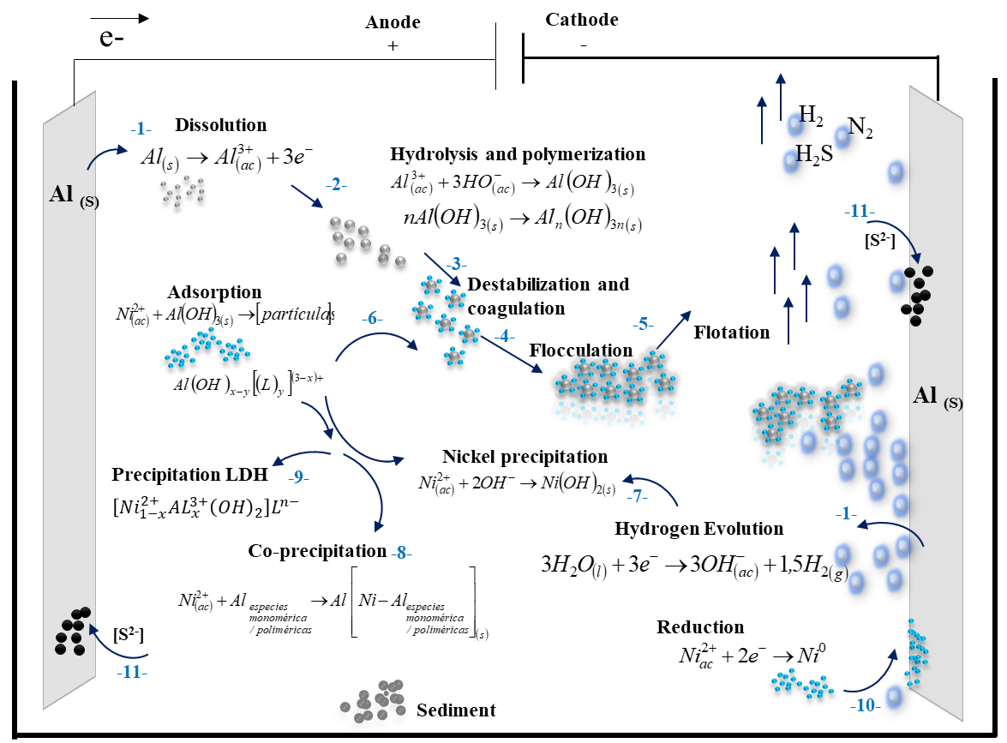
Figure 6. Schematic representation of the nickel removal mechanism by electrocoagulation of the Ni(II)-NH₃-CO₂-SO₂-H₂O system.

Due to the simultaneous electrolytic reactions that occur on the surface of the electrodes (step 1 Fig. 6), the electro-coagulant aluminum cation [Al³⁺] and the hydroxide anion [OH⁻] are produced, Eq. (18) and (19). These diffuse in the solution and spontaneously, the hydrolysis of aluminum occurs to form several monomeric and polymeric species, oligomeric complexes and aluminum hydroxide, Eq. (20) and (21), Step 2.⁶⁵
$$Al_{\left(s\right)}→Al^{3+}+3e^{-} (18)$$
$$3H_{2}O_{\left(l\right)}+3e^{-}→1,5{H_{2}}_{\left(g\right)}+3OH^{-} (19)$$
$$Al_{\left(ac\right)}^{3+}+3OH^{-}→Al{{\left(OH\right)}_{3}}_{\left(s\right)} \left(20\right)$$
$$nAl{{\left(OH\right)}_{3}}_{\left(s\right)}→Al_{n}{{\left(OH\right)}_{3n}}_{\left(s\right)} (21)$$
Nickel compounds and other contaminants, either colloids, suspended or dissolved material begin to destabilize due to: ^{6,7,11,13}
1) Compression of the diffuse double layer around the charged species because of the physical-chemical interactions with the generated ionic species, by the electrochemical dissolution of the sacrificial electrode (anode). These affect the potential difference between the surface of the particles and the solution, thus decreasing the interparticle repulsive forces.
2) Charge neutralization of the ionic species present in the solution due to the ions of opposite charge generated at the anode and the processes of adsorption, precipitation and co-precipitation; thus, the interparticle repulsive electrostatic forces decrease, instead the Van der Walls attraction forces predominate and as a result, coagulation occurs. While monomeric aluminum species neutralize the charge of contaminants by adsorbing on their surface and binding to their ionized groups, polymeric species can bind several contaminant particles (or molecules) at once, Step 3.
3) Following destabilization, flocs are formed as a result of aggregation of the destabilized particles, leading to sludge formation (flocculation), Step 4.
4) The hydrogen released in the cathodic reaction (2), enables the electro-flotation of the flocculated particles, which is also favored by the removal of sulfur in the form of hydrogen sulfide (H₂S), Step 5.
In parallel, mechanisms occur that favor the removal of nickel, as explained below:
Adsorption of [Ni²⁺] in the active centers of the surface of the aluminum species and fundamentally, on [Al(OH)₃] in interaction with other ions present in solution provided by the compounds CO₂ - SO₂ - NH₃. This process happens by two mechanisms: electrostatic attraction and coordination surface, Eq. (22), Step 6.
$$Ni^{2+}+Al{{\left(OH\right)}_{3}}_{\left(s\right)}→\left[partícula\right] (22)$$
Result of simultaneous reactions at the anode and cathode, hydroxide ion is released and nickel hydroxide precipitates, Eq. (23), Step 7.
$$Ni^{2+}+2OH^{-}→Ni{{\left(OH\right)}_{2}}_{(s)} (23)$$
Through sequential co-precipitation, [Ni(OH)₂] is incorporated into the crystal structure of [Al(OH)₃] and forms spinel: NiAl₂O₄], [NiAl₂₆O₄₀], [NiAl₃₂O₄₉], [Ni₂Al₁₈O₂₉], Eq. (24) and (25), Step 8.
$Ni^{2+}+Al \begin{matrix}monomérico \\ po\lim{é}rico\end{matrix}→Al {\left[Ni-Al \begin{matrix}monomérico \\ po\lim{é}rico\end{matrix}\right]}_{(s)} (24)$${Ni}^{2+}+Al \begin{aligned}monomérico \\ polimérico\end{aligned} →Al{\left[Ni-Al \begin{aligned}monomérico \\ polimérico\end{aligned}\right]}_{(s)}$
$2Ni{{\left(OH\right)}_{2}}_{(s)}+Al{\left(OH\right)}_{3}→2NiAl_{2}O_{4(s)} (25)$
Anions in solution are attracted by electrostatic forces to balance charges and adsorbed on the active centers of the coordination surface, where (L) represents anionic ligands such as [CO₃²⁻], [S_{x}O_{y}^{z-}], [NO₃²⁻], [OH⁻], Eq. (26) and (27).^{65,66}
$$Al{\left(OH\right) }_{x}^{\left(3-x\right)+}+yL^{-}↔Al{\left(OH\right)}_{x-y}{\left[L_{y}\right]}^{\left(3-x\right)+}+yOH^{-} (26)$$
$$mA{l }^{3+}+\left(3n-m\right)OH^{-}+mL^{-}↔Al_{m}{\left(L\right)}_{m}{\left[OH\right] }_{3n-m} (27)$$
Subsequently, the adsorbed ions can be displaced by other competing ions in the solution (exchange adsorption), due to the interactions between the ions on the charged surface and in the diffuse layer around the surface, and the nickel removal by formation of Ni-Al/LDH is promoted. LDH of high purity at alkaline pH and maximum temperature of 80 ºC has been prepared by co-precipitation, Eqs. (28) - (29), Step 9. ^{24,26,31,67,68}
$$\left(1-\frac{3}{2}x\right)Ni{\left(OH\right)}_{2}+xAl{\left(OH\right)}_{3}+\left(\frac{x}{2}\right)Ni{\left(L^{n-}\right)}_{2/n}↔\left[Ni_{1-x}^{2+}Al_{x}^{3+}{\left(OH\right)}_{2}\right]{\left(L^{n-}\right)}_{x/n} (28)$$
$$\left(1-x\right)Ni{\left(OH\right)}_{2}+xAl{\left(OH\right)}_{4}^{-}+\left(\frac{x}{2}\right){\left(L^{n-}\right)}_{2/n}↔{\left[Ni_{1-x}^{2+}Al_{x}^{3+}{\left(OH\right)}_{2}\right]}^{x+}{\left(L^{n-}\right)}_{x/n}+2xOH^{-} (29)$$
The hydrogen evolution reaction (HER) (2) occurs at the cathode to a standard potential of -0.826 V with the release of gaseous H₂; and the nickel reduction on the cathode surface to a more positive standard reduction potential of -0.25 V, Eq. (30), Step 10.
$Ni^{2+}+2e^{-}→Ni_{(s)} (30)$
The precipitation of [Ni(OH)₂], [Ni/Al-LDH] and the co-precipitation of Ni-Al spinels cause a synergistic effect in the process, achieving high efficiency of nickel removing. A greater effect is reached as the initial nickel concentration in dissolution increases, which is reflected by the kinetic model TCV Eq. (17).
The possibility of an electrocatalytic effect of Ni²⁺/Al³⁺-LDH and the pair Ni(OH)₂/[β-Ni³⁺OOH] on the anodic reaction of water electrolysis with oxygen evolution (OER) is also considered. The OER presupposes the absorption in the anode deposits of the hydroxide radicals generated by the hydrogen evolution (HER) in the cathode (0.404 V), Eq. (31).⁶⁹ The OER can promote the aluminum oxidation and the formation of LDH, Eq. (32) and (33).
$3OH^{-}→\frac{3}{4}O_{2}+\frac{3}{2}H_{2}O+3e^{- } (31)$
$2Al_{(s)}+\frac{3}{2}O_{2}→Al_{2}O_{3\left(s\right)} (32)$
$Al_{2}O_{3}+3H_{2}O+2OH^{-}→2Al{\left(OH\right)}_{4}^{-} (33)$
The intercalation of molecules (H₂O, NH₃) and anions [S_{x}O_{y}^{z-}], [CO₃²⁻] in the LDH interlayer let to more electrons could being transferred to the surface of the active sites of LDH [Ni_{1-x}Al_{x}OOH], stabilizing their high-valence states and increases the activity for the OER from the reversible redox pair Ni²⁺/Ni³. Zhou et al. (2018) showed that intercalated anions with strong reducing ability modify the electronic structure of surface metal sites and significantly improve the performance of the corresponding LDH for the OER with a linear relationship⁶², in the case of ions [S_{x}O_{y}^{z-}] it increases from [S₂O₈²⁻] to [SO₃²⁻].
Regarding NiOOH, it is a catalyst for OER under alkaline conditions and acts as an active center in the pair [Ni(OH)₂]/[β-NiOOH] for the adsorption of [OH⁻]. Nickel is capable of acquiring valences (+2, +3, +3.6) making it susceptible to various electronic transitions and phase transformations, Eq. (34). The Ni(OH)₂ has a large specific surface which favors contact between the active material and the electrolytic dissolution.^{59,70,71,72}
$\begin{matrix}α-Ni^{2+}{\left(OH\right)}_{2}+OH^{-} & ↔ & γ-Ni^{3,6+}OOH+H_{2}O+e^{-} \\ ↓ & & ↑ \\ β-Ni^{2+}{\left(OH\right)}_{2}+OH^{-} & ↔ & β-Ni^{3+}OOH+H_{2}O+e^{-}\end{matrix} (34)$
Reactions of sulfide formation (NiS, Al₂S₃), the release of irritating gases (H₂S) and the formation of deposits on the surface of the electrodes are considered. These deposits exert resistance to the passage of electrical current, reduce charge transfer, affect the efficiency of the process and the stability of the operation, Step 11.

3.5 Result of the operating cost estimate
The operating cost was estimated for electrode and electrical energy consumption for initial nickel concentration in the range 0.474≤Ni≤0.953 g·L⁻¹, 9.8 mA cm⁻², 60ºC, pH 8.6 and 98 % nickel removal, for a remainder between 6 and 19 mg·L⁻¹ (table 7).

Table 7. Estimated operating costs for nickel removal by electrocoagulation
Base: 98 % removing, 9.8 mA cm⁻², 60 ºC, pH 8.6
Ni (mg·L⁻¹) | 379 | 447 | 505 | 646 | 775 | 953
Cost ($·t⁻¹ Ni) | 320 | 382 | 509 | 521 | 537 | 534
See (kW·h·kg⁻¹Al) | 5.26 | 6.33 | 6.75 | 5.11 | 3.45 | 2.76

The operating cost amounted to between 382 and 537 $·t⁻¹ of nickel removed, where energy consumption represents between 15 and 30 % of the total. On the other hand, the specific energy consumption (Cee) was between 2.76 and 6.75 kW·h·kg⁻¹ of aluminum. The increase in nickel concentration in the initial liquor augments the electrocoagulation time necessary to achieve high removal efficiency and therefore also increases energy and electrode consumption. The higher the concentration of ionic species in the liquor, the conductivity is favored and Cee decreases.
According to the analyzed aspects of the removal mechanism, it is possible to reduce costs by designing a reactor with favorable geometric and hydrodynamic conditions to achieve adequate mass transfer between the phases. It also suggests recycling a suspension of the product obtained at the non-saturation conditions of the adsorption sites, according to the isotherm model to be followed.
4. Conclusions
The nickel removing by electrocoagulation from the liquor effluent of the nickel production plant in Punta-Gorda Cuba, Ni(II)-NH₃-CO₂-SO₂-H₂O system was studied, in order to determine the reaction kinetics, the adsorption isotherm, the mechanism and the preliminary cost of operation at different concentrations of dissolved nickel in the initial liquor.
In the interval defined for the operating variables, a removing efficiency between 97.7 and 99.7 % was obtained. A kinetic model of conversion time was proposed, which suggests that the process is determined by the combined effect of the resistances of the mechanisms: external diffusion, nucleation, and as controlling step the chemical reaction and a possible autocatalytic contribution. The removal was characterized by monolayer chemisorption at a finite number of specific adsorption sites, following the Langmuir isotherm.
The precipitate had between 33.4 and 40.7 % nickel and from 6.3 to 7.0 % aluminum, with a structure typical Ni/Al-LDH and phases impurities Al(OH)₃, Ni(OH)₂/NiOOH and nickel-aluminum spinels.
The operating costs were between 382 and 537 $·t⁻¹ of removed nickel, considering the energy and electrode consumption. The research represents the opportunity to diversify production, synthesize Ni/Al-LDH in situ, improve its properties and evaluate its applications for the projection of an industrial process.
5. Acknowledgment
Thanks to Nélida Powery Ebanks, NICAROTEC Co.; and colleagues of the Chemical Analysis Laboratory, CEDINIQ-Nicaro Cuba, for their collaboration.

Conflict of Interest
The authors declare no conflict of interest

6. References
- A. R. Vargas; M. E. T. Nieves; Y. G. Díaz. Acta Chimica Slovenica, 2020. 67, 1239-1249. DOI: 10.17344/acsi.2020.6147.
- A. R. Vargas, M. E. M. Haynes, A. R. Riveron. Rev. Metal. (Madrid, Spain). 2019. 55. DOI: 10.3989/revmetalm.149.
- L. C. Lamorú, A. O. C. Navarro, Y. A. Arias. Minería y Geología. 2018. 34, 422-439.
- A. R. Vargas, A. R. Riverón, M. P. Medina, E. O. Armaignac. Tecnol. Quim. 2020. 40, 363-382.
- L. M. Irions, A. R. Vargas, et al. Tecnol. Quim. 2020, 40. 19-36.
- A. S. Naje, S. Chelliapan, Z Zakaria, M A. Ajeel, P A Alaba. Rev. Chem. Eng. 2016. 33, 263-292. DOI: 10.1515/revce-2016-0019.
- J. N. Hakizimana, B. Gourich, M. Chafi, et al. Desalination. 2017. 404, 1–21. DOI: 10.1016/j.desal.2016.10.011.
- S. García-Segura, M.M.S.G. Eiband, J. Vieira de Melo, C.A.M. Huitle. J. Electroanal. Chem. 2017. 801, 267–299. DOI: 10.1016/j.jelechem.2017.07.047.
- Z. Al-Qodah, M. Al-Shannag, K. Bani-Melhem, et al. Environ. Chem. Lett. 2018, 16. 695-714. DOI: 10.1007/s10311-018-0711-1.
- Z. Al-Qodah, M. Al-Shannag. Sep. Sci. Technol. 2017. 52. 2649-2676, DOI: 10.1080/01496395.2017.1373677.
- S.M. Didar; U.I. Islam. Sustain. Water Resour. Manag. 2019, 5. 359-380. DOI: 10.1007/s40899-017-0152-1.
- K. Dermentzis, K. Karakosta, R. Kosheleva, N. Kokkinos. J. Eng. Sci. Tech. Rev., 2020. 13. DOI:10.25103/jestr.136.04.
- D. Ghernaout., A. Alghamdi, B. Ghernaout. J. Environ. Sci. Allied. Res. 2019. 51-67.
- T. S. Pertile, E. J. Birriel. Korean J. Chem. Eng. 2017. 34, 2631-2640. DOI: 10.1007/s11814-017-0178-y.
- X. Chen; P. Ren, Tao Li, et al. Chem. Eng. Journal. 2018. 31. 358-367. DOI: 10.1016/j.cej.2018.05.099.
- H. Zhao, B. Zhao, W. Yang, T. Li. Environ. Sci. Technol. 2010, 44, 9112–9116. DOI: 10.1021/es102540t.
- M. M. Mendoza, D. D. Victoria, N. M. Cabrales. MethodsX. 2018. 5, 915–923. DOI: 10.1016/j.mex.2018.07.019.
- L. Jiang, G. Huang, L. Shao, J. Huang, S. Peng, X. Yang. Colloids Surf. 2021, 608, 125589. DOI: 10.1016/j.colsurfa.2020.125589.
- Ou, J. Yan, T. Xu, Z. Jiang, H. Tan, S. He, B. Hu, G. Yu. J. Mol. Liq. 2021, 335, 116246. DOI: 10.1016/j.molliq.2021.116246.
- Y. Zhao, F. Xiao, Q. Jiao. J. Nanotechnol. 2011. DOI:10.1155/2011/646409
- M. Jitianu, D. C. Gunness, D. E. Aboagye, M. Zaharescu, A. Jitianu. Mater. Res. Bull. 2013. 48, 1864–1873. DOI: 10.1016/j.materresbull.2013.01.030.
- T. D. Nguyen, Q. T. P. Bui, H. Q. H. Phan. J. Mater. Sci. Surf. Eng. 2016. 4, 488-491.
- L. Li, K.S. Hui, K.N. Hui, et al. J. Alloys Compd. 2017. DOI: 10.1016/j.jallcom.2017.06.062.
- F. Z. Mahjoubi, A. Khalidi, M. Abdennouri, N. Barka. Desalin. Water Treat. 2015. 1-13. DOI: 10.1080/19443994.2015.1124055.
- F.Z. Mahjoubi, A. Elhalil, R. Elmoubarki, et al. JASI. 2017a. 2(1-3), 1-11.
- F. Z. Mahjoubi, A. Khalidi, O. Cherkaoui, et. al. J. Water Reuse Desalin. 2017b. DOI: 10.2166/wrd.2016.041.
- S. Jaerger, S. F. Zawadzki, A. Leuteritz, F. Wypych. J. Braz. Chem. Soc, 2017. 28, 2391-2401. DOI: 10.21577/0103-5053.20170093.
- W. M. A. El Rouby, S. I. El-Dek, M. E. Goher, S. G. Noaemy. Environ. Sci. Pollut. Res. 2018. DOI: 10.1007/s11356-018-3257-7.
- O. Rahmanian, M. H. Maleki, M. Dinari. J. Phys. Chem.
Solids. 2017, 110, 195-201. DOI: 10.1016/j.jpcs.2017.06.018.
- N. Taoufik, W. Boumya, A. Elhalil, et al. Int. J. Environ. Anal. Chem. 2020. DOI:10.1080/03067319.2020.1863387.
- M. Mousazadeh, S. M. Alizadeh, Z. Frontistis, et al. Water. 2021, 13, 656. DOI: 10.3390/w13050656.
- Z. Tang, Z. Qiu, S. Lu, X. Shi. Nanotechnol. Rev. 2020. 9, 800 –819. DOI: 10.1515/ntrev -2020 -0065.
- H. Lu, Q. Li, H. Xiao, et al. Am. J. Anal. Chem.2014. 5, 547-558. DOI: 10.4236/ajac.2014.59062.
- L. Yang, Z. Liu, S. Zhu, L. Feng, W. Xing. Materials Today Physics. 2021. 16, 100292. DOI: 10.1016/j.mtphys.2020.100292.
- N. Ayawei, A. N. Ebelegi, D. J. Wankasi. J. Chem. 2017. DOI: 10.1155/2017/3039817.
- M. Mamat, N. Roslan, K. H. K. Bulat, et al. Mater. Sci. Eng. 2018. 440. DOI:10.1088/1757-899X/440/1/012013.
- G. Li, X. Zhang, D. Qiu. Adv. Electron. Mater. 2019, 5, 1900215. DOI: 10.1002/aelm.201900215.
- X. Zhang, C. B. Cockreham, E. Yılmaz. ChemRxiv. 2020. DOI: 10.26434/chemrxiv.11919804.v2
- J. Wang, Y. Song, Z. Li. Energy Fuels. 2010, 24, 6463–6467: DOI:10.1021/ef101150b
- W. Wang, N. Zhanga, Z. Shia. Chem. Eng. J. 2018, 338. 55–61. DOI: 10.1016/j.cej.2018.01.024.
- Q. Xie, Z. Cai, P. Li, et al. Nano Res. 2018. 11, 4524–4534. DOI: 10.1007/s12274-018-2033-9.
- M. Gabrovska, D. Nikolova, M. Shopska, et al. W.E. Lee et al. (eds.), Proceedings of the III Advanced Ceramics and Applications Conference. 2016. DOI: 10.2991/978-94-6239-157-4_15.
- Y. Liu, T. Yu, R. Cai. RSC Adv. 2015, 5, 29552. DOI: 10.1039/c5ra01969a.
- S. Iguchi, S. Kikkawa, K. Teramura, et al. Phys. Chem. Chem. Phys. 2016, 18, 13811-13819. DOI: 10.1039/c6cp01646d.
- M. Gabrovska, R. E. Kardjieva, D. Crisan, et al. Reac. Kinet. Mech. Cat. 2012. 105. 79-99. DOI: 10.1007/s11144-011-0378-0.
- F. Touahra, M. Sehailia, W. Ketir, et al. Appl. Petrochem. Res. 2016. 6, 1–13. DOI: 10.1007/s13203-015-0109-y.
- E. C. Lima, A. R. Cestari, M. A. Adebayo. Desalin. Water Treat. 2015. 56, 19566-19571. DOI: 10.1080/19443994.2015.1095129.
- H. N. Tran, S.J. Youb, A. H. Bandegharaei, H. P. Chao. Water Res. 2017. 120. 88-116. DOI: 10.1016/j.watres.2017.04.014.
- A. I. Adeogun, R. B. Balakrishnan. Appl Water Sci. 2015. 7, 1711-1723. DOI: 10.1007/s13201-015-0337-4.
- A. A. Inyinbor, F. A. Adekola, G. A. Olatunji. Water Resour. Ind. 2016. 15, 4–27. DOI: 10.1016/j.wri.2016.06.001.
- N. A. Oladoja. Desalin. Water Treat. 2015. 57, 15813-15825. DOI: 10.1080/19443994.2015.1076355.
- A. R. Vargas. Tecnol. Quim. 2021. 42. 114-130.
- X. Xue, S. Zhang, H. Zhang. Am. J. Anal. Chem. 2015. 6. 334-341. DOI: 10.4236/ajac.2015.64032.
- N.F.M. Salleh, A.A Jalila, S. Triwahyonoc, et al. Appl. Surf. Sci. 2015. 349, 485-495. DOI: 10.1016/j.apsusc.2015.05.048.
- P. Lu, F. Liu, D. Xue, et al. Electrochim. Acta. 2012. 78, 1-10. DOI: 10.1016/j.electacta.2012.03.183.
- D. S. Hall, David; D. J. Lockwood, C. Bock, B. R. MacDougall. Proc. R. Soc. A. 2015. 471. DOI: 10.1098/rspa.2014.0792.
- M. H. Syafiq, O. M. Rozali. Int. J. Electrochem. Sci. 2018. 8, 4747– 4760.
- A. A. Lobinsky, V. P. Tolstoy, I. A. Kodinzev. Nanosyst.: Phys., Chem., Math. 2018. 9, 669–675. DOI: 10.17586/22208054201895669675.
- A. Khan, R. A. Senthil, J. Pan, Y. Sun. Chin. J. Chem. Eng. 2019. DOI: 10.1016/j.cjche.2019.01.025.
- C. G. Anchieta, L. Tochetto, H. B. Madalosso. Cerámica. 2015. 61, 477-481. DOI: 10.1590/0366-69132015613601925.
- C. Ragupathi, J. J. Vijaya, J. L. Kennedy. J. Saudi Chem. Soc. 2017. 21, 231–239. DOI: 10.1016/j.jscs.2014.01.006.
- D. Zhou, Z. Cai, Y. Bi. Nano Res. 2018. DOI: 10.1007/s12274-017-1750-9.
- Y. T. Prabhu, K. V. Rao, V. S. Kumar, B. S. Kumari. World J. Nano Sci. Eng. 2014, 4, 21-28. DOI: 10.4236/wjnse.2014.41004.
- E. Nariyan, M. Sillanpää, C. Wolkersdorfer. Sep. Purif. Technol. 2017. 177, 363–373. DOI: 10.1016/j.seppur.2016.12.042.
- B. Lekhlif, L. Oudrhiri, F. Zidane, et al. J. Mater. Environ. Sci. 2014. 5, 111-120.
- M.A. Sandoval, J.L. Nava, O. Coreño, et al. Int. J. Electrochem. Sci. 2017. 12, 1318-1330, DOI:10.20964/2017.02.08.
- J.J. Bravo-Suárez, E. A. Páez-Mozo, S. T. Oyama. Quim. Nova, 2004. 27, 601-614.
- R. Bloom, N. Hondow, V. Dupont, M.V. Twigg, S.J. Milne. Energy Rep. 2018. 4. 733–743. DOI: 10.1016/j.egyr.2018.10.008.
- Y. Cheng, S. P. Jiang. Prog. Nat. Sci.: Mater. Int. 2015, 25, 545-553. DOI: 10.1016/j.pnsc.2015.11.008.
- D. E. Pissinis, L. E. Sereno, J. M. Marioli. Open J. Phys. Chem. 2012, 2, 23-33. DOI: 10.4236/ojpc.2012.21004
- V. Kotok, V. Kovalenko, V. Malyshev. East. Eur. J. Enterp. Technol. 2017. 89, 5-12.
- Y. H Chung, I. Jang, J. H. Jang. Sci. Rep. 2017. 7, 8236. DOI:10.1038/s41598-017-08296-0.

