Synthesis, Molecular Docking Studies and ADME Prediction of Some New Albendazole Derivatives as α-Glucosidase Inhibitors

Sevil Senkardes, ^{1*} Necla Kulabas, ¹ Sukriye Guniz Kucukguzel²

¹Marmara University, Faculty of Pharmacy, Department of Pharmaceutical Chemistry, Maltepe, Başıbüyük, 34854, Istanbul, Turkey
²Fenerbahçe University, Faculty of Pharmacy, Department of Pharmaceutical Chemistry, Ataşehir, 34758, Istanbul, Turkey

*Corresponding author: E-mail: sevil.aydin@marmara.edu.tr
Tel. +90-216-777 52 00.

* This study was partly presented at the International Congress on Biological and Health Sciences on 26-28 February 2021 (Online), Turkey

Abstract
A series of novel 2-(substituted arylidene)-N-(5-(propylthio)-2,3-dihydro-1H-benzo[d]imidazol-2-yl)hydrazine-1-carboxamide derivatives (3a-i) were synthesized via condensation of N-(5-(propylthio)-1H-benzo[d]imidazol-2-yl) hydrazinecarboxamide (2), with the corresponding ketone or aldehydes. The chemical structures of the synthesized compounds were confirmed by analytical and spectral data. The compounds were screened for their α-glucosidase inhibitory activity and all of them showed better inhibition than acarbose except 3h. In particular, compound 3a proved to be the most active compound among all synthetic derivatives having IC₅₀ value 12.88±0.98 μM. Also, molecular docking studies were carried out for the compounds to figure out the binding interactions. Compound 3a has exhibited the highest binding energy (ΔG= -9.4 kcal/mol) and the exhibited the highest number of hydrogen bonding interactions with active sites. Eventually, in silico studies were in good agreement with in vitro studies.
Keywords: Benzimidazoles; albendazole; semicarbazones; antidiabetics; α-glucosidase; docking studies.

1. Introduction
Diabetes Mellitus (DM), known simply as diabetes, is a major health problem as a metabolic disease and characterized by a failure of insulin production. It can be classified into two broad categories; type 1 and type 2 diabetes. Type 2 diabetes ranks as the most common type of diabetes worldwide among all reported cases.¹ This form of diabetes results from a combination of insulin resistance and insulin secretion defects.² Insulin plays an important role in the regulation of blood glucose levels and energy metabolism.³ If diet and exercise fail to adequately control blood glucose levels, it is recommended to start oral drug therapy such as α-glucosidase inhibitors.
α-Glucosidase, is a key enzyme in carbohydrate digestion, released from mucosal cells and plays a significant role in carbohydrate metabolism.⁴ The enzyme has important functions in diabetes, viral infection, and cancer. α-Glucosidase inhibitors delay the hydrolysis of carbohydrates and this action reduces the glucose absorption. Acarbose, miglitol, and voglibose are used in the clinic as α-glucosidase inhibitors. Nevertheless, side effects such as diarrhea, hepatotoxicity and flatulence are observed in the long-term treatment with these inhibitors.^{5,6} Hence, developing novel α-glucosidase inhibitors with minimum side effects is always a promising medicinal chemistry effort.
Benzimidazoles are important nitrogen-containing heterocyclic compounds and literature review showed that there are a great number of studies on α-glucosidase inhibitory activity of benzimidazole derivatives. Zawawi et al.⁷ and Ozil et al.⁸ have reported that a novel series of benzimidazole derivatives (I-II) act as a new class of α-glucosidase inhibitors. Ahmad et al.⁹ provided an overview about the α-glucosidase inhibitory potential of a variety of benzimidazole derivatives (III) (Figure 1).
On the other hand, semicarbazones, as medicinally significant scaffolds, are imine derivatives formed by condensation reaction between aldehyde/ketone functional groups and the -NH₂ group of semicarbazides. These derivatives are known to have a broad range of biological properties including antidiabetic activity.^{10–14} For instance, pyrazole-phenyl semicarbazone derivatives were reported by Azimi et al. as potent α-glucosidase inhibitors (IV) (IC₅₀ values in the range of 65.1-695.0 μM compared to acarbose, IC₅₀=750.0 μM)¹⁴. More recently, a (E)-2-benzylidene-N-(3-cyano-4,5,6,7-tetrahydrobenzo[b]thiophen-2-yl)hydrazine-1-carboxamide derivative (V) has been reported for its α-glucosidase inhibitory potential (Figure 1).¹⁵
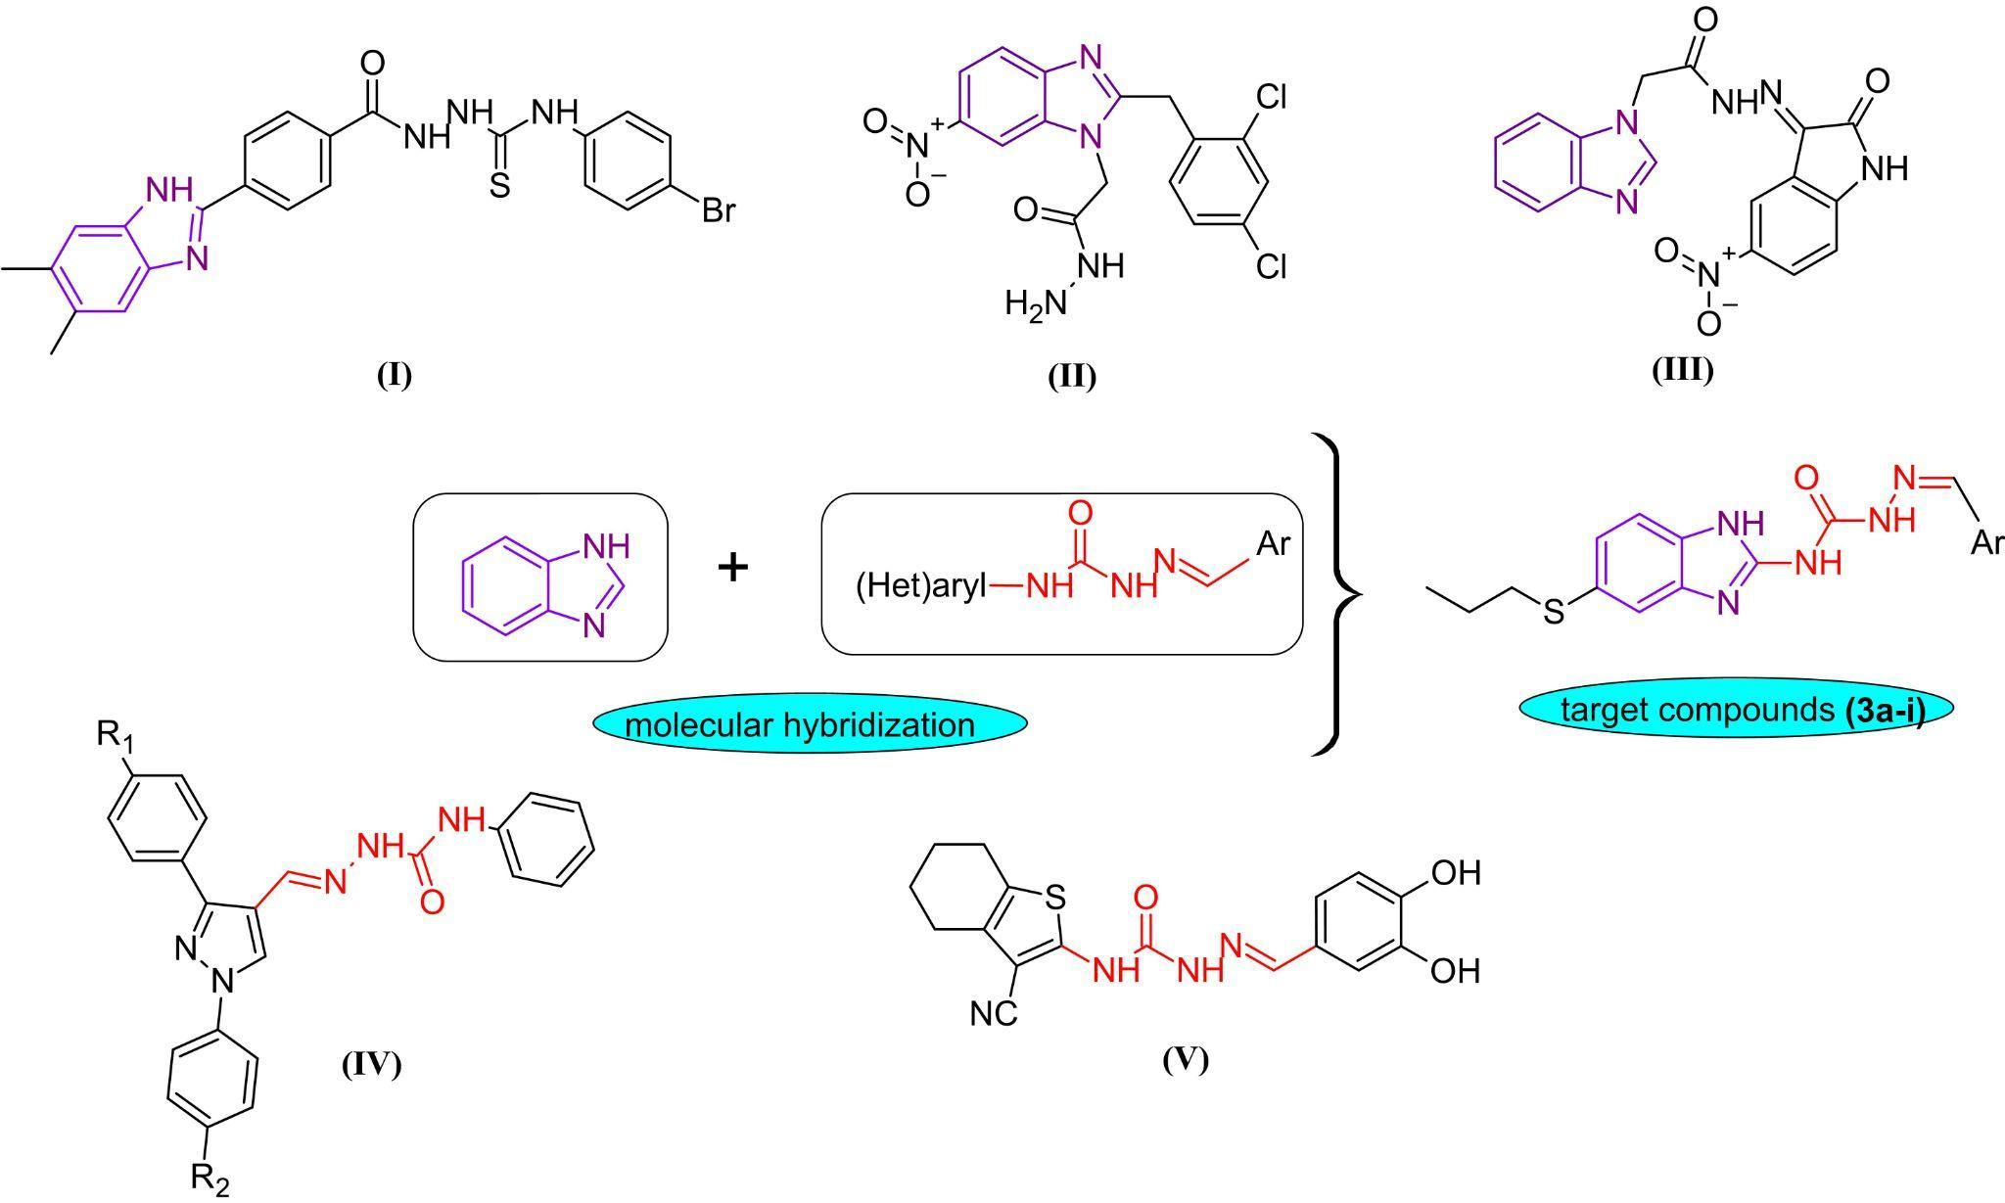
Figure 1. Designing of target molecules via molecular hybridization strategy.
From literature survey, we revealed that molecules containing benzimidazole and semicarbazone moiety have gained a huge interest as potent α-glucosidase inhibitors.

2. Experimental
2.1. General
All the reagents used were analytical reagent grade. All melting points were determined on a Thermo Scientific 9300 melting point apparatus and are uncorrected. The IR spectra were taken on a Shimadzu FTIR 8400S spectrophotometer. The ¹H-NMR spectra were measured on a Bruker Avance 300 spectrometer for DMSO-d₆ solutions using TMS as internal standard. Elemental analyses were determined on CHNS-932 (LECO) analyzer. The liquid chromatographic system consists of an Agilent Technologies 1100 series instrument equipped with a quaternary solvent delivery system and a model Agilent series G1315 A photodiode array detector. The chromatographic data were collected and processed using Agilent Chemstation Plus software. Chromatographic separation was performed at ambient temperature using a reverse phase Zorbax C8 (4.0×250 mm) column. All experiments were performed using acetonitrile-water gradient mobile phase (50:50 from 0 to 3 min; 75:25 to 50:50 from 3 to 6 min; 100:0 to 75:25 from 6 to 12 min; the ﬂow rate was 1.0 mL/min).

2.2. Chemistry
2.1.1. Synthesis of N-(5-(propylthio)-1H-benzo[d]imidazol-2-yl)hydrazinecarboxamide (2)
N-(5-(Propylthio)-1H-benzo[d]imidazol-2-yl) hydrazinecarboxamide (2) was prepared by heating hydrazine hydrate and Albendazole (1) in methanol. The product was purified by recrystallization from methanol which has resulted a white solid.
2.1.2. General procedure for the synthesis of 2-(substituted arylidene)-N-(5-(propylthio)-2,3-dihydro-1H-benzo[d]imidazol-2-yl)hydrazine-1-carboxamide (3a-i)
A mixture N-(5-(propylthio)-1H-benzo[d]imidazol-2-yl) hydrazinecarboxamide (2) (0.001 mol) and various aromatic aldehyde/ketone (0.001 mol) in absolute ethanol (20 ml), in the presence of a catalytic amount of glacial acetic acid and the reaction mixture was refluxed for 6-7 h. The reaction mixture was allowed to cool to room temperature and then poured onto the crushed ice. The precipitated compound was filtered and washed with water and recrystallized from absolute ethanol.
2-(5-Chloro-2-oxoindolin-3-ylidene)-N-(5-(propylthio)-2,3-dihydro-1H-benzo[d]imidazol-2-yl)hydrazine-1-carboxamide (3a)
Yield 79%; m.p. 296-297°C; HPLC t_{R} (min.): 6.32; FT-IR: ν/cm⁻¹: 3327 (NH), 1681 (C=O), 1630 (C=N), 1608 (C=C); ¹H-NMR (300 MHz), (DMSO-d₆/TMS) δ ppm: 0.96 (t, 3H, -S-CH₂CH₂CH₃), 1.56 (m, 2H, -S-CH₂CH₂CH₃), 2.88 (t, 2H, -S-CH₂CH₂CH₃), 7.15-8.34 (m, 6H, Ar-H), 10.92 (s, 1H, NH), 11.24 (s, 1H, NH), 11.61 (s, 1H, NH), 11.65 (s, 1H, NH); Anal. calcd for C₁₉H₁₇ClN₆O₂S.4/3H₂O: C, 50.39; H, 4.38; N, 18.56; S, 7.08 Found: C, 50.51; H, 4.69; N, 18.65; S, 7.02.
2-(2-Fluorobenzylidene)-N-(5-(propylthio)-2,3-dihydro-1H-benzo[d]imidazol-2-yl)hydrazine-1-carboxamide (3b)
Yield 72%; m.p. 196-197°C; HPLC t_{R} (min.): 5.27; FT-IR: ν/cm⁻¹: 3321 (NH), 1678 (C=O), 1631 (C=N), 1556 (C=C); ¹H-NMR (300 MHz), (DMSO-d₆/TMS) δ ppm: 0.96 (t, 3H, -S-CH₂CH₂CH₃), 1.56 (m, 2H, -S-CH₂CH₂CH₃), 2.86 (t, 2H, -S-CH₂CH₂CH₃), 7.24-8.41 (m, 8H, Ar-H&CH=N), 10.65 (s, 1H, NH), 11.34 (s, 1H, NH), 11.93 (s, 1H, NH); Anal. calcd for C₁₈H₁₈FN₅OS: C, 58.21; H, 4.88; N, 18.86; S, 8.63 Found: C, 58.60; H, 4.92; N, 18.74; S, 8.58.
2-(3-Fluorobenzylidene)-N-(5-(propylthio)-2,3-dihydro-1H-benzo[d]imidazol-2-yl)hydrazine-1-carboxamide (3c)
Yield 85%; m.p. 188-190°C; HPLC t_{R} (min.): 4.94; FT-IR: ν/cm⁻¹: 3348 (NH), 1674 (C=O), 1627 (C=N), 1552 (C=C); ¹H-NMR (300 MHz), (DMSO-d₆/TMS) δ ppm: 0.96 (t, 3H, -S-CH₂CH₂CH₃), 1.54 (m, 2H, -S-CH₂CH₂CH₃), 2.86 (t, 2H, -S-CH₂CH₂CH₃), 7.11-8.01 (m, 8H, Ar-H&CH=N), 11.32 (s, 1H, NH), 11.89 (s, 1H, NH), 11.92 (s, 1H, NH); Anal. calcd for C₁₈H₁₈FN₅OS: C, 58.21; H, 4.88; N, 18.86; S, 8.63 Found: C, 58.40; H, 4.72; N, 18.14; S, 8.11.
2-(2,5-Difluorobenzylidene)-N-(5-(propylthio)-2,3-dihydro-1H-benzo[d]imidazol-2-yl)hydrazine-1-carboxamide (3d)
Yield 74%; m.p. 202-204°C; HPLC t_{R} (min.): 5.20; FT-IR: ν/cm⁻¹: 3335 (NH), 1674 (C=O), 1631 (C=N), 1552 (C=C); ¹H-NMR (300 MHz), (DMSO-d₆/TMS) δ ppm: 0.96 (t, 3H, -S-CH₂CH₂CH₃), 1.56 (m, 2H, -S-CH₂CH₂CH₃), 2.86 (t, 2H, -S-CH₂CH₂CH₃), 7.11-8.45 (m, 7H, Ar-H&CH=N), 10.88 (s, 1H, NH), 11.44 (s, 1H, NH), 11.98 (s, 1H, NH); Anal. calcd for C₁₈H₁₇F₂N₅OS: C, 55.52; H, 4.40; N, 17.98; S, 8.23 Found: C, 55.91; H, 4.76; N, 17.80; S, 8.22.
2-(4-Methylbenzylidene)-N-(5-(propylthio)-2,3-dihydro-1H-benzo[d]imidazol-2-yl)hydrazine-1-carboxamide (3e)
Yield 82%; m.p. 199-200°C; HPLC t_{R} (min.): 3.19; FT-IR: ν/cm⁻¹: 3335 (NH), 1681 (C=O), 1625 (C=N), 1556 (C=C); ¹H-NMR (300 MHz), (DMSO-d₆/TMS) δ ppm: 0.96 (t, 3H, -S-CH₂CH₂CH₃), 1.53 (m, 2H, -S-CH₂CH₂CH₃), 2.35 (s, 3H, CH₃), 2.86 (t, 2H, -S-CH₂CH₂CH₃), 7.10-7.99 (m, 8H, Ar-H&CH=N), 10.29 (s, 1H, NH), 11.15 (s, 1H, NH), 11.91 (s, 1H, NH); Anal. calcd for C₁₉H₂₁N₅OS.1/4H₂O: C, 61.35; H, 5.83; N, 18.83; S, 8.62 Found: C, 61.52; H, 6.24; N, 18.56; S, 8.69.
2-(2,4-Dichlorobenzylidene)-N-(5-(propylthio)-2,3-dihydro-1H-benzo[d]imidazol-2-yl)hydrazine-1-carboxamide (3f)
Yield 78%; m.p. 177-179°C; HPLC t_{R} (min.): 4.22; FT-IR: ν/cm⁻¹: 3317 (NH), 1680 (C=O), 1631 (C=N), 1556 (C=C); ¹H-NMR (300 MHz), (DMSO-d₆/TMS) δ ppm: 0.95 (t, 3H, -S-CH₂CH₂CH₃), 1.53 (m, 2H, -S-CH₂CH₂CH₃), 2.51 (t, 2H, -S-CH₂CH₂CH₃), 7.05-8.53 (m, 7H, Ar-H&CH=N), 10.56 (s, 1H, NH), 11.17 (s, 1H, NH), 11.45 (s, 1H, NH); Anal. calcd for C₁₈H₁₇Cl₂N₅OS: C, 51.19; H, 4.06; N, 16.79; S, 7.59 Found: C, 51.04; H, 4.04; N, 16.79; S, 7.59.
2-(3,4-Dimethylbenzylidene)-N-(5-(propylthio)-2,3-dihydro-1H-benzo[d]imidazol-2-yl)hydrazine-1-carboxamide (3g)
Yield 81%; m.p. 191-193°C; HPLC t_{R} (min.): 6.02; FT-IR: ν/cm⁻¹: 3332 (NH), 1681 (C=O), 1627 (C=N), 1556 (C=C); ¹H-NMR (300 MHz), (DMSO-d₆/TMS) δ ppm: 0.96 (t, 3H, -S-CH₂CH₂CH₃), 1.54 (m, 2H, -S-CH₂CH₂CH₃), 2.25 (s, 3H, -CH₃), 2.26 (s, 3H, -CH₃), 2.85 (t, 2H, -S-CH₂CH₂CH₃), 7.11-7.96 (m, 7H, Ar-H&CH=N), 10.35 (s, 1H, NH), 11.16 (s, 1H, NH), 11.93 (s, 1H, NH); Anal. calcd for C₂₀H₂₃N₅OS: C, 62.71; H, 6.24; N, 17.92; S, 8.21 Found: C, 63.04; H, 5.96; N, 17.67; S, 7.99.
2-(5-Bromo-2-methoxybenzylidene)-N-(5-(propylthio)-2,3-dihydro-1H-benzo[d]imidazol-2-yl)hydrazine-1-carboxamide (3h)
Yield 81%; m.p. 198-200°C; HPLC t_{R} (min.): 5.86; FT-IR: ν/cm⁻¹: 3348 (NH), 1681 (C=O), 1627 (C=N), 1556 (C=C); ¹H-NMR (300 MHz), (DMSO-d₆/TMS) δ ppm: 0.96 (t, 3H, -S-CH₂CH₂CH₃), 1.54 (m, 2H, -S-CH₂CH₂CH₃), 2.86 (t, 2H, -S-CH₂CH₂CH₃), 3.84 (s,3H, -OCH₃), 7.04-8.50 (m, 7H, Ar-H&CH=N), 10.65 (s, 1H, NH), 11.26 (s, 1H, NH), 11.95 (s, 1H, NH); Anal. calcd for C₁₉H₂₀BrN₅O₂S: C, 49.36; H, 4.36; N, 15.15; S, 6.94 Found: C, 49.56; H, 4.36; N, 14.35; S, 6.55.
2-(4-Trifluoromethylbenzylidene)-N-(5-(propylthio)-2,3-dihydro-1H-benzo[d]imidazol-2-yl)hydrazine-1-carboxamide (3i)
Yield 75%; m.p. 208-210°C; HPLC t_{R} (min.): 6.72; FT-IR: ν/cm⁻¹: 3348 (NH), 1681 (C=O), 1614 (C=N), 1539 (C=C); ¹H-NMR (300 MHz), (DMSO-d₆/TMS) δ ppm: 0.96 (t, 3H, -S-CH₂CH₂CH₃), 1.54 (m, 2H, -S-CH₂CH₂CH₃), 2.86 (t, 2H, -S-CH₂CH₂CH₃), 7.11-8.15 (m, 8H, Ar-H&CH=N), 11.38 (s, 1H, NH, other NH proton not observed). Anal. calcd for C₁₉H₁₈F₃N₅OS: C, 54.15; H, 4.30; N, 16.62; S, 7.61 Found: C, 54.12; H, 4.33; N, 16.62; S, 7.43.

2.3. α-Glucosidase inhibition assay
The α-glucosidase inhibitor activity was evaluated as described by Ramakrishna et al. with slight modifications described by Sen et al.^{16,17} Each concentration had three replicates when preliminary screened and inhibition percentages were calculated using the following formula.
% Inhibition = [(A_{control} − A_{sample}) / A_{control}] × 100, where A is the absorbance
Finally, IC₅₀ values were also determined for the compounds having 50% or above inhibition values.

2.4. Molecular docking
Molecular docking simulations were performed against α-glucosidase by using AutoDock Vina software. ¹⁸ The protein data of α-glucosidase (PDB ID: 4J5T) was referenced from Protein Data Bank.¹⁹
The target protein was prepared into the three steps using the AutoDock Tools program²⁰ for docking studies: (1) were removed water molecules (2); were added polar hydrogen to α-glucosidase macromolecule; (3) the obtained structure was energy-minimized.
The synthesized compounds 3a–i and reference ligands were prepared into the two steps for docking studies: (1) were drawn with the Spartan 04 software (SPARTAN 04, Wavefunction, Inc., Irvine, USA)²¹ and optimized for each compound by using the semi-empirical PM3 method; (2) the docking input files of the most stable conformation were generated using the AutoDock Tools program.
The grid box size was determined as 78 Å × 69 Å × 104 Å within 0.375 Å grid spacing and center_x= -18.44, center_y= -20.91, center_z= 8.22 dimensions were used in α-glucosidase enzyme docking studies, appropriate to the literature.¹⁹ The Vina parameter “exhaustiveness” was set to the value of 10.
The reference ligands used in validation studies include sugars that form part of the biological substrate, as well as known inhibitors (acarbose, glucose, miglitol, deoxynojirimycin, and kojibiose). During study of validations as well as our docking of ligands were used flexible ligands in rigid protein. The results files were analyzed using Accelrys Discovery Studio Visualizer 4.0 program.

3. Results and Discussion
3.1. Chemistry
Scheme 1 shows the synthetic route for the target compounds. Albendazole (1) was reacted with hydrazine hydrate, affording 2 according to the similar method reported in the literature.²² The new derivatives 3a-i were obtained by the condensation of 2 with appropriate aromatic aldehydes/ketone in the presence of acid according to the literature procedure.²³⁻²⁶ The structures of the desired target compounds were confirmed by FT-IR, ¹H-NMR, and elemental analysis.
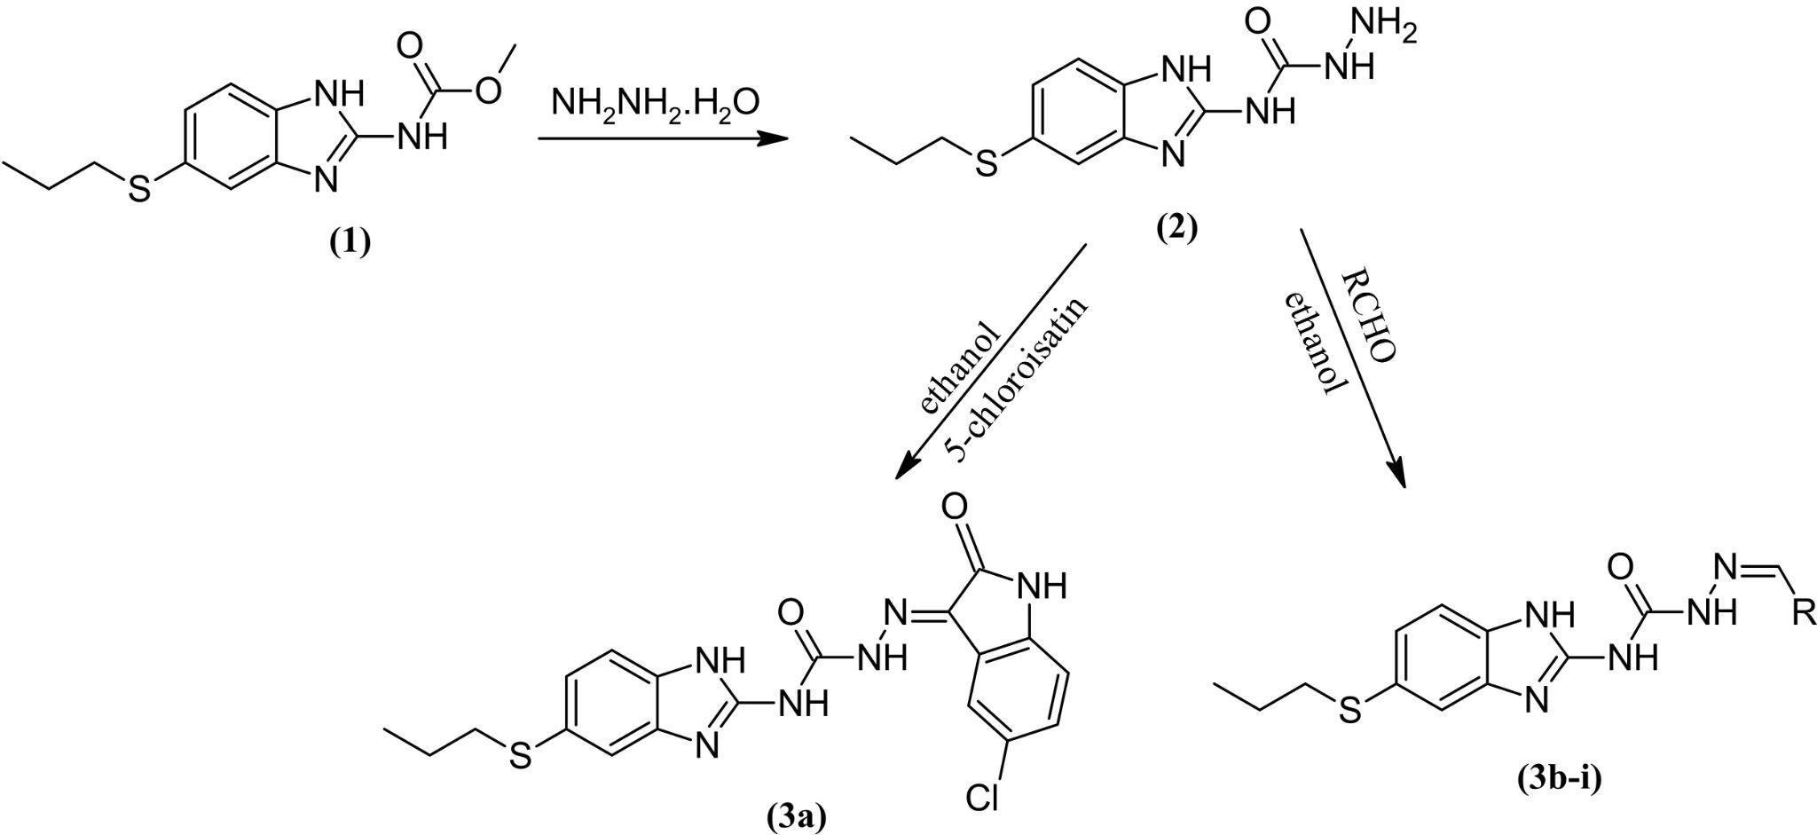
Scheme 1. Synthetic route to target derivatives 3a-i

In the IR spectra of the studied compounds, the less intense broad bands around 3317-3348 cm⁻¹ are assigned to ν(N-H) vibrations of the NHCO group. The band around at 1674-1681 cm⁻¹ corresponds to the carbonyl group of CONH. The azomethine band is observed at 1625-1631 cm⁻¹. ¹H-NMR spectrum revealed three signals around 10.29-11.98 ppm assigned to three NH protons. In the ¹H-NMR spectrum of compound 3i, the NH proton was seen as singlet at 11.38 ppm and two NH protons were not observed.

3.2. α-Glucosidase inhibitory activity
We have synthesized benzimidazole bearing semicarbazones (3a-i) and evaluated them for α-glucosidase inhibitory potential. All derivatives showed excellent inhibitory activities having IC₅₀ values ranging between 12.88-44.35 µM as compared to the standard acarbose (IC₅₀ = 40.06 µM) (Table 1). Its possibly potent inhibitory potential may be due to the benzimidazole core bearing a semicarbazone entity.
The isatin moiety of the most active compound 3a, was determined to be important for biological activity, suggesting intramolecular hydrogen bond formation.

Table 1. α-Glucosidase inhibitory activity (IC₅₀) of albendazole derivatives (3a-i)
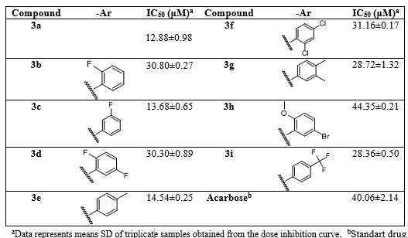
3.3. ADME prediction
The potent inhibitors 3a-i were evaluated in silico for selected ADME properties using the SwissADME online tool (http://www.swissadme.ch/). Table 2 shows the ADME prediction results of the compounds. Topological Polar Surface Area (TPSA) shows the surface belonging to polar atoms in the compound and lower TPSA values are appropriate for drug-likeness properties. The absorption percentage was also calculated by using the following formula: %Abs = 109 - [0.345 x TPSA] as given in the literature^{27,28} and showed a good absorption profile.
According to Lipinski's rule of five, drug candidate should have logP less than 5, its polar surface area within 140Å², it should have H bond acceptor less than 10, it should have H bond donor less than 5 and its molecular weight within 500 Da.²⁹ Also, the more negative the skin permeability (log Kp) value is, the less possible for the compound to penetrate the skin barrier. The tool predicted that derivatives have suitable skin permeability with log Kp values of -5.24 to -5.90 cm/s.
Eventually, all of the molecules were shown to comply best with these properties used to predict drug-likeness.

Table 2. ADME results of the albendazole derivatives (3a-i)
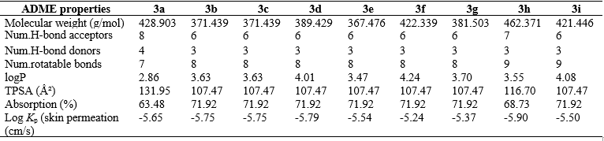
To reveal the capability of intestinal absorption and permeability of the blood–brain barrier (BBB), the Boiled-Egg model of the molecules was predicted using SwissADME. Molecules that fall in the yellow field depict the BBB permeation whereas the white eclipse region symbolizes gastrointestinal absorption. According to the boiled-egg plot, all of the compounds are BBB-impermeable and have good absorption except compound 3i. P-glycoprotein (P-gp) plays a significant role in drug absorption and disposition. Compounds 3a-i are non substrates of P-gp it can be theorized that they may possibly act as inhibitors of P-gp.
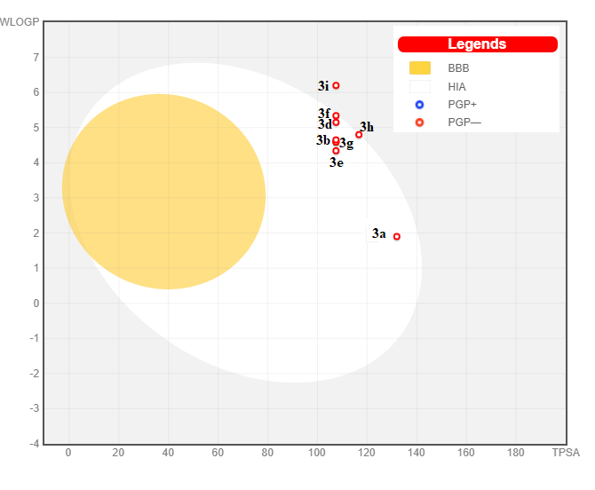
Figure 2. The boiled-egg plot of compounds 3a-i. HIA: Human Intestinal Absorption BBB: Blood-BrainBarrier PGP: Permeability GlycoProtein

3.3. Molecular modeling
The molecular docking analysis was carried out to investigate the binding mode of novel α-glucosidase inhibitors compounds 3a-i within the binding pocket of the target enzyme, and further understand their structure-activity relationship. Firstly, we examined the interactions of the known inhibitors (acarbose, glucose, miglitol, deoxynojirimycin, and kojibiose) with α-glucosidase active site to compare with our synthesized compounds 3a-i. The binding energies and interactions with the active site of the reference ligands and compounds 3a-i are given in Table 3.

Table 3. Types of interactions of the compounds 3a-i and small reference ligands with the binding site residues of α-glucosidase enzyme.
Compounds | Binding energy  ΔG (kcal/mol) | Binding  site | Distance (Å) | Hydrogen bond  interactions  (A/D)**
3a | -9.3 | A | 2.80  1.80  2.59  2.66 | Asp392 (A)  Arg428 (D)  Arg428 (D)  Arg428 (D)
3b | -7.7 | A | 2.50 | Arg428 (D)
3c | -8.4 | A | 2.25 | Arg428 (D)
3d | -7.9 | A | 2.88  2.49  2.25 | Trp391 (D)  Arg428 (D)  Arg428 (D)
3e | -8.4 | A | 2.31  2.97  2.78 | Arg428 (D)  Val446 (A)  Gln447 (D)
3f | -7.3 | A | 2.87 | Glu429 (A)
3g | -7.9 | A | 2.87 | Arg428 (D)
3h | -7.3 | A | 2.84 | Arg428 (D)
3i | -8.4 | A | 2.71  2.27  3.02 | Trp391 (D)  Asp568 (A)  Glu771(A)***
ACB | -8.1 | A | 3.09  3.16  3.09  1.97  3.33 | Glu443 (A)  Val446 (A)  Asp568 (A)  Trp710 (D)  Glu771 (A)
GLC | -5.5 | A | 1.84  2.26  2.73  2.46  2.72 | Trp391 (D)  Arg428 (D)  Arg428 (D)  Gly566 (A)  Asp568 (D)
DNJ | -5.4 | A | 2.54  2.13  2.69  1.98  2.37 | Trp391 (D)  Gly566 (A)  Gly566 (A)  Trp710 (D)  Trp710 (D)
MGL | -5.5 | A | 2.27 | Gly566 (A)
KJB | -6.1 | A | 2.41  2.75 | Ile362 (A)  Glu429 (A)
KJB | -6.4 | B | 2.66  2.21  2.44  2.46  1.96  2.33  2.62 | Leu50 (A)  His51 (A)  Phe56 (A)  Asp61 (A)  Arg209 (D)  Arg209 (D)  Arg209 (D)
*ACB: Acarbose; GLC: Glucose; DNJ: Deoxynojirimycin; MGL: Miglitol; KJB: Kojibiose. **A: H-bond acceptor; D: H-bond donor.*** Halogen bond.
As shown in Figure 3, one of the two binding sites of α-glucosidase has been defined as "site A" containing a glutamate (Glu771) and an aspartate (Asp568) while the other is "site B".¹⁹ It was determined among the known ligands ACB, GLC, DNJ and MGL docked into “site A” of α-glucosidase, while KJB docked into both of the sites.
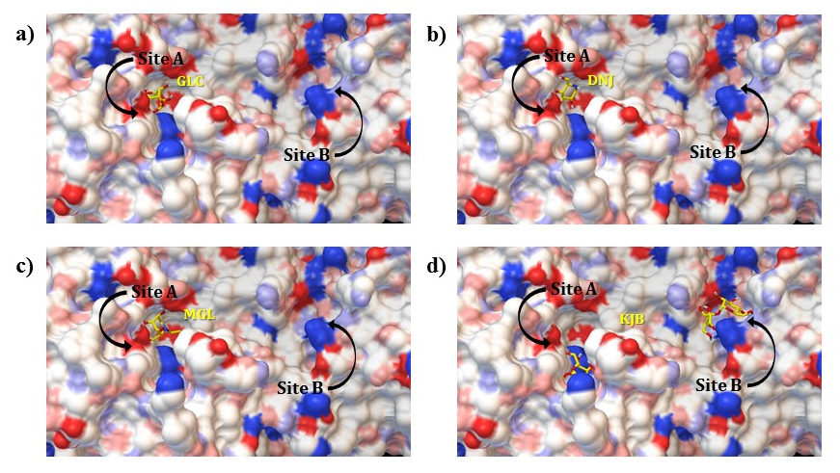
Figure 3. For α-glucosidase enzyme small references ligands a) GLC is in binding site A, b) DNJ is in binding site A, c) MGL is in binding site A, and d) KJB is in both binding site A and B. A surface representation of α-glucosidase was shown as the DG color scheme (neutral oxygen (pink), nitrogen atoms (light blue), charged oxygen (red) and nitrogen atoms (dark blue)).

According to the in silico molecular modeling studies, it has been determined that the synthesized compounds 3a-i interact with the binding site A. Binding energies of these compounds has been detected between -7.3 kcal/mol and -9.3 kcal/mol as higher than the known inhibitors GLC, DNJ, MGL and KJB. Compared with the binding energy of ACB (-8.1 kcal/mol) used in vitro inhibition studies, compound 3a was found to be remarkable with the value of -9.3 kcal/mol, while the other synthesized compounds showed similar results. These findings support the results of in vitro enzyme inhibition studies. All of the synthesized novel benzimidazole derivatives except 3f and 3i have exhibited hydrogen bond (H-bond) interaction with Arg428, like reference ligand GLC. Also it was detected compound 3a exhibited pi-anion interaction with active site residue Glu771, while compound 3i exhibited halogen bond interaction.
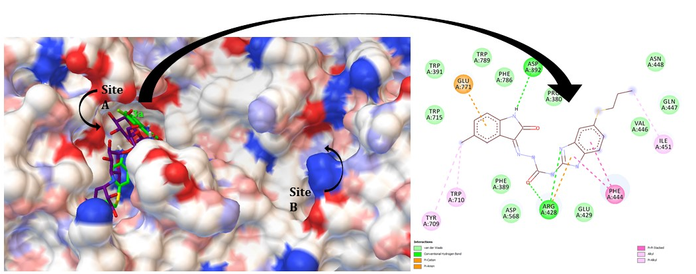
Figure 4. A surface representation of α-glucosidase was shown as the DG color scheme (neutral oxygen (pink), nitrogen atoms (light blue), charged oxygen (red) and nitrogen atoms (dark blue)). Positions of compound 3a (green) and acarbose (purple) in the binding site A of α-glucosidase enzyme and 2D interactions of the compound 3a with active site residues.

Compound 3a, which was found to be the most effective compound according to both in vitro and in silico studies, exhibited three H-bond interactions with Arg428. One of the three H-bond interactions were detected with =N- atom of benzimidazole structure and the others with CO group of semicarbazone moiety. Moreover it has been detected a H-bond interaction between the NH group of 2-oxoindolin structure and Asp392. Additionally, hydrophobic interactions have been determined between Arg428, Glu771 residues and benzimidazole (pi-cation), 2-oxoindolin (pi-anion) rings, respectively. These hydrophobic interactions were supported by the pi-pi stacking interactions of the benzimidazole ring with Phe444 besides other hydrophobic interactions between compound 3a and Ile451, Leu563, Trp709 and Trp710 (Figure 4). Finally, it has been detected that the compound 3a exhibits more hydrophobic interactions than all reference ligands and synthesized compounds and these findings contribute to having the highest binding energy.

4. Conclusions
The targeted 2-(substituted arylidene)-N-(5-(propylthio)-2,3-dihydro-1H-benzo[d]imidazol-2-yl)hydrazine-1-carboxamides (3a-i) were synthesized in good yields. All of the molecules demonstrated encouraging inhibitory activity against α-glucosidase which was also supported by molecular docking studies. Docking studies revealed that compound 3a is the most active compound with the highest binding energy value of -9.3 kcal/mol. As a result, It has been determined that the findings obtained from in vitro and in silico α-glucosidase enzyme inhibition studies were compatible. These compounds revealed also reasonable in silico physicochemical and pharmacokinetic parameters (ADME). The present findings may invite researchers to work in the area of development of the α-glucosidase inhibitors.

Conflict of Interest
Authors declare no conflict of interest.

References
1. G. Wang, M. Chen, J. Qiu, Z. Xie, A. Cao, Bioorg. Med. Chem. Lett. 2018, 28, 113–116. DOI:10.1016/j.bmcl.2017.11.047.
2. J. Zhang, H. Xie, Y. Li, K. Wang, Z. Song, K. Zhu, L. Fang, J. Zhang, C. Jiang, Bioorg. Med. Chem. Lett. 2017, 52, 1–5. DOI:10.1016/j.bmcl.2017.09.048.
3. E. S. Moghadam, M. H. Tehrani, R. Abdel-Jalil, M. A. Faramarzi, M. Amini, Polycycl. Aromat. Compd. 2021, 1–19. DOI: 10.1080/10406638.2021.1962369.
4. H. Bischoff, Clin. Invest. Med. 1995, 18, 303–311.
5. A. J. Krentz, C. J. Bailey, Drugs. 2005, 65, 385–411. DOI: 10.2165/00003495-200565030-00005.
6. S. -H. Hsiao, L. -H. Liao, P. -N. Cheng, T. -J. Wu, Ann. Pharmacother. 2006, 40, 151–154. DOI: 10.1345/aph.1G336.
7. N. K. N. A. Zawawi, M. Taha, N. Ahmat, A. Wadood, N. H. Ismail, F. Rahim, S. S. Azam, N. Abdullah, Bioorg. Chem. 2016, 64, 29–36. DOI: 10.1016/j.bioorg.2015.11.006.
8. M. Özil, C. Parlak, N. Baltaş, Bioorg. Chem. 2018, 76, 468–477. DOI: 10.1016/j.bioorg.2017.12.019.
9. M. U. Ahmad, M. Rafiq, B. Zahra, M. Islam, M. Ashraf, M. al-Rashida, A. Khan, J. Hussain, Z. Shafiq, A. Al-Harrasi, Drug Dev. Res. 2021, 82, 1033-1043. DOI: 10.1002/ddr.21807.
10. F. Carrasco, W. Hernández, O. Chupayo, C. M. Álvarez, S. Oramas-Royo, E. Spodine, C. Tamariz-Angeles, P. Olivera-Gonzales, J. Z. Dávalos, J. Chem. 2020, 7157281. DOI: 10.1155/2020/7157281.
11. L. Ma, H. Wang, J. Wang, L. Liu, S. Zhang, M. Bu, Molecules. 2020, 25, 1209. DOI: 10.3390/molecules25051209.
12. R. B. de Oliveira, E. M. de Souza-Fagundes, R. P. P. Soares, A. A. Andrade, A. U. Krettli, C. L. Zani, Eur. J. Med. Chem. 2008, 43, 1983–1988. DOI: 10.1016/j.ejmech.2007.11.012.
13. S. N. Pandeya, S. S. Panda, A. Pandeya, J. P. Stables, Indian J. Chem. 2003, 42, 2657–2661.
14. F. Azimi, J. B. Ghasemi, H. Azizian, M. Najafi, M. A. Faramarzi, L. Saghaei, H. Sadeghi-aliabadi, B. Larijani, F. Hassanzadeh, M. Mahdavi, Int. J. Biol. Macromol. 2021, 166, 1082–1095. DOI: 10.1016/j.ijbiomac.2020.10.263.
15. J. H. Zhang, H. X. Xie, Y. Li, K. M. Wang, Z. Song, K. K. Zhu, L. Fang, J. Zhang, C. S. Jiang, Med. Chem. Lett. 2021, 52, 128413. DOI: 10.1016/j.bmcl.2021.128413.
16. A. Sen, M. Kurkcuoglu, I. Senkardes, L. Bitis, K. H. C. Baser, J. Essent. Oil-Bearing Plants. 2019, 22, 1048–1057. DOI:10.1080/0972060X.2019.1662333.
17. F. Tok, B. Koçyiğit-Kaymakçıoğlu, Acta Chim. Slov. 2020, 67, 1139-1147. DOI: 10.17344/acsi.2020.6028.
18. O. Trott, A. J. Olson, J. Comput. Chem. 2010, 31, 455–461. DOI: 10.1002/jcc.21334.
19. M. K. Barker, D. R. Rose, J. Biol. Chem. 2013, 288, 13563-13574. DOI: 10.1074/jbc.M113.460436.
20. G. M. Morris, R. Huey, W. Lindstrom, M. F. Sanner, R. K. Belew, D. S. Goodsell, A.J. Olson, J. Comput. Chem. 2009, 30, 2785- 2791. DOI: 10.1002/jcc.21256.
21. J. J. P. Stewart, J. Mol. Model. 2007, 13, 1173–1213. DOI: 10.1007/s00894-007-0233-4.
22. B. S. Rani, K. B. Priyanka, G. Sammaiah, Int. J. Pharm. Bio. Sci. 2014, 4, 29–34.
23. S. Şenkardeş, Ö. Erdoğan, Ö. Çevik, G. Küçükgüzel, Synth. Commun. 2021, 51, 2634–2643. DOI:10.1080/00397911.2021.1945105.
24. S. Şenkardeş, A. Türe, S. Ekrek, A. T. Durak, M. Abbak, Ö. Çevik, B. Kaşkatepe, İ. Küçükgüzel, G. Küçükgüzel, J. Mol. Struct. 2021, 1223, 128962. DOI: 10.1016/j.molstruc.2020.128962.
25. E. Tatar, İ. Küçükgüzel, D. Daelemans, T. T. Talele, N. Kaushik-Basu, E. De Clercq, C. Pannecouque, Arch. Pharm. 2013, 346, 140-153. DOI: 10.1002/ardp.201200311.
26. H. Pervez, N. Khan, J. Iqbal, S. Zaib, M. Yaqub, M. M. Naseer, Acta Chim. Slov. 2018, 65, 108–118. DOI: 10.17344/acsi.2017.3649.
27. Y. H. Zhao, M.H. Abraham, J. Le, A. Hersey, C. N. Luscombe, G. Beck, B. Sherborne, I. Cooper, Pharm. Res. 2002, 19, 1446–1457. DOI: 10.1023/A:1020444330011.
28. S. Şenkardeş, N. Kulabaş, Ö. Bingöl Özakpinar, S. Kalayci, F. Şahin, İ. Küçükgüzel, G. Küçükgüzel, Turkish J. Pharm. Sci. 2020, 17, 81–93. DOI: 10.4274/tjps.galenos.2018.59389.
29. C. A. Lipinski, F. Lombardo, B. W. Dominy, P. J. Feeney, Adv. Drug Deliv. Rev. 2012, 64, 4–17. DOI: 10.1016/j.addr.2012.09.019.

