Ibuprofen loaded electrospun polymeric nanofibers: A strategy to improve oral absorption
Dibya Sundar Panda¹, Kalpana Swain², Satyanarayan Pattnaik^{2, *}
¹Pharmaceutics Department, College of Pharmacy, Jouf University, Sakaka, Kingdom of Saudi Arabia
² Talla Padmavathi College of Pharmacy, Warangal, India

*Corresponding author: Prof. Satyanarayan Pattnaik, Ph.D.
Division of Advanced Drug Delivery, Talla Padmavathi College of Pharmacy, Orus, Warangal, INDIA.
E.Mail: drsatyapharma@gmail.com
Mobile-+91-9849337607

Abstract
The poor aqueous solubility of candidate drugs has presented a great challenge to formulation scientists for their effective oral delivery. Poor solubility is often associated with poor dissolution behavior and, subsequently, poor bioavailability for those drugs when intestinal absorption is dissolution rate limited. In the present study electrospun polymeric nanofibers were developed to address the poor aqueous solubility of ibuprofen, a class-II drug according to the Biopharmaceutic Classification System. Various grades of hydrophilic spinnable polymers like polyvinyl pyrrolidone were deployed as carrier system. The electrospinning parameters were optimized for the electrospinning operation and the optimized conditions were: flow rate-2mL/h, DC voltage-12 Kv, and spinneret to collector distance-15 cm. The fabricated ibuprofen loaded nanofibers were characterized using scanning electron microscopy and differential scanning calorimetry. Drug release studies and ex vivo intestinal absorption studies were also carried out. The nanofiber-based platform significantly improved oral absorption of ibuprofen compared to pure ibuprofen crystals.

Keywords: Electrospinning; Nanomedicine; Bioavailability; Absorption; Ibuprofen.

- Introduction
Effective delivery of active ingredients (APIs) to the target site at the desired concentration and rate is of paramount importance in systemic drug therapy. Poorly soluble drug candidates continue to pose challenges to their optimal administration and have therefore drawn the attention of researchers around the world.¹⁻⁵ Poor water solubility of drug molecules often limits gastrointestinal absorption and hence oral bioavailability, leading to therapeutic failure. The aggressive research efforts to provide solutions to drug insolubility problems are evident from the abundance of literature available.
Based primarily on the physicochemical properties of the active ingredients, a diverse strategy for active ingredient delivery has been proposed in order to increase the solubility and / or the rate of dissolution of such molecules.⁶ These fascinating techniques include chemical modification,⁷ cocrystals,⁸ micro- / nanonization,^{3,5,6} polymorphic improvements,⁹ lipid-based systems,^{6,10} micellar solubilization including self-emulsifying drug delivery systems,¹¹ inclusion complexes,¹²⁻¹⁵ amorphous solid dispersion / solution¹⁶⁻¹⁸ etc. In addition, nanotechnology has provided solutions for improving solubility and / or bioavailability of active ingredients.¹⁹⁻²³ Among all of these available techniques, strategies involving the development of amorphous solid drug products have received much attention in the recent past due to the tremendous improvement in the solubility of drug candidates under this approach. Electrospinning is widely used by the pharmaceutical industry to deliver a wide variety of active ingredients to treat various disease states. The very efficient amorphization effect of electrospinning is based on the immediate evaporation of the solvent, which leads to a solid solution of the active ingredient in the polymer matrix. Amorphous solid dispersions based on electrospun fibers are able to retain an incorporated active substance in the amorphous physical form for longer periods of time due to their homogeneous distribution of active substances within the matrix and the possibility of inhibiting molecular mobility, which leads to impaired devitrification.
In the present study, attempts were made to explore a convenient and efficient electrospinning approach to amorphizing ibuprofen (a poorly soluble drug candidate) with the aim of improving its oral absorption.
2. Materials and Methods
  - Materials
Ibuprofen (Ib) was obtained as a gift sample from Cipla Ltd (Mumbai, India). Polyvinylpyrrolidone K30 (CAS Number-9003-39-8; PVP K30, MW= about 40,000), Polyvinylpyrrolidone K60 (PVP K60, MW= about 400000) and, ethanol (analytical grade) was obtained from Sigma-Aldrich Corp (India). All other chemicals used were of analytical grade and procured locally.
  - Fabrication of Nanofibers
The ibuprofen loaded PVP-based nanofibers and only PVP nanofibers were prepared by electrospinning equipment (Super ES 2; E-Spin Nanotech, India). The PVP (PVP K30 or PVP K60) nanofibers were electrospun from 8% (w/v) PVP solution with or without 2% (w/v) ibuprofen at an applied DC voltage of 12 kV. The working solution was initially stirred magnetically for 2-3 h to completely dissolve PVP in ethanol. This solution was then electrospun at a flow rate of 2.0 ml/h using a syringe pump. The spinneret-to-collector distance was fixed at 15 cm and a plate collector was used for collection of the nanofibers. The spinning parameters were optimized after the trial batches.

  - Scanning Electron Microscopy
The fiber morphology and diameter were analyzed using a scanning electron microscope (SEM). Samples were coated with 20 nm of gold under vacuum using a sputter coater. All micrographs were taken at an acceleration voltage of 5 kV.
  - Differential Scanning Calorimetry
The solid-state properties of the raw ibuprofen and fabricated nanofiber samples were studied using differential scanning calorimetry (DSC 822, Mettler Toledo). Each powdered sample (5 mg) was placed in an aluminium pan, sealed, and heated to 200 ° C at a heating ramp rate of 10 ° C / min under nitrogen gas (50 L/min). Before each measurement, the sample was allowed to equilibrate for 5 min at 30 ° C. Transition temperatures and enthalpy readings were automatically calculated using Mettler Toledo software for each peak.
  - Drug entrapment efficiency (DEE)
The drug loading efficiency was calculated using the following equation (Eq 1).
DEE (%) = (W_{m}/W_{a}) × 100% ………………. Eq 1
where W_{m} is the ibuprofen content measured in the electrospun nanofibers, and W_{a} is the ibuprofen added in the working fluid during the preparation. All tests were repeated in triplicate and mean are repeated. The ibuprofen content in the generated fibers was determined by dissolving the fibers in ethanol. The solutions were then analyzed spectrophotometrically at 220 nm to assess the amounts of ibuprofen in each sample.
  - In Vitro Dissolution Studies
Samples of pure ibuprofen drug (10 mg) and nanofiber sample equivalent to 10 mg ibuprofen were subjected to dissolution studies in 900 ml of distilled water (USP paddle method: Thermonic, Campbell Electronics, Mumbai, India, at 100 rpm and 37 °C).¹⁹ At predetermined intervals, a sample of the solution was removed and filtered through a 0.45 μm filter, and the same amount of medium was replaced at the same temperature. The drug content in the withdrawn aliquots was spectrophotometrically analyzed at 220 nm (UV-160, Shimadzu, Japan). The experimental points were the average of at least three repetitions.
  - Ex vivo intestinal permeation studies
The ex vivo intestinal permeation studies were performed as per a previously reported method by the author.¹⁹ The goat small intestine was collected from a local slaughterhouse for the study, kept in buffer fluid (Krebs-Ringer solution) and used immediately without storage for a prolonged period. The tissue sample was properly cleaned to separate the mesentery, rinsed with the buffer, and then cut into different sections. Each section was everted on a Teflon rod and fixed on its location by means of a thread. The setup consisted an intestinal holder which was a cylindrical glass vessel connected to a “U” glass tube whose one portion was represented by the intestine. Intestine holders (four in one set) filled with buffer fluid represented the receiver environment (4 × 12 mL) and the holder placed in the donor environment. Both the receiver and donor phases were continuously aerated to keep the intestine cells alive during experimentation. At regular interval of time, after beginning of the permeation test, 4 mL of the receiver phase were sampled from each intestine holder and replaced with pure buffer, for a time duration of 120 min. The concentration of ibuprofen in each of the four liquid phases sampled was estimated using a UV spectrophotometer (UV-160, Shimadzu, Japan).
3. Results and Discussions
Hydrophilic and water-soluble polymers have been widely exploited by the formulation scientists to enhance the solubility of poorly soluble drugs.^{19, 23-25} It is supposed that these polymers act as antinucleating agents and stabilizers inhibiting devitrification of amorphized drugs.⁶ Moreover, nanotechnology based drug delivery approaches have gained a lot of momentum providing viable solution for optimal therapeutic delivery of poorly soluble drug candidates.^{26, 27} In the present work, PVP was used for preparation of nanofibers due to its inherent properties such as outstanding physiological compatibility, and satisfactory solubility in water along with other organic solvents. The solvent plays a vital role in the successful preparation of electrospun nanofibers. The solvent should dissolve the drug conveniently while keeping electrospinnability of polymer solutions intact. Amongst several solvents screened for solubilization of ibuprofen and PVP, ethanol was found to be suitable.
3.1. Scanning Electron microscopic Investigation
The formation of nanoscopic fibers was confirmed using SEM (Fig. 1). The nanofiber diameter, as revealed by SEM, fell in the approximate range of 450–500 nm. The SEM images revealed no visible surface deposition of drug crystals indicting molecular dispersion of the loaded ibuprofen in the PVP matrices. On the other hand, SEM images of pure ibuprofen revealed distinct needle shaped crystals.
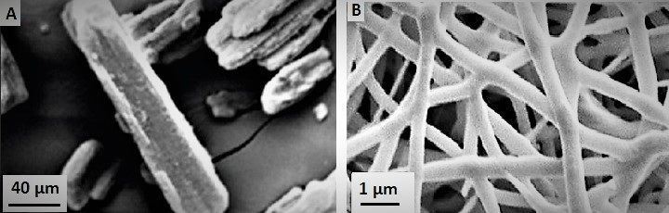
Fig 1. Scanning electron microscopy of (A) Raw ibuprofen and (B) Ibuprofen loaded PVP nanofibers.
3.2. X-ray diffraction studies
X-ray diffraction studies of the prepared samples were carried out to assess the polymorphic transitions (if any) that might have been taken place in ibuprofen when formulated as nanofibers. The X-ray diffraction patterns of ibuprofen (Ib) alone, as physical mixture with the matrix forming polymer and ibuprofen loaded nanofibers are depicted in Fig. 2. The XRD pattern of ibuprofen alone exhibited intense peaks high-intensity reflections to the interplanar distances 13.5, 7.2, 5.3, 4.7, and 4.0 Å at 6.3°, 12.4°, 15.9°, 18.2°, and 22.5° (2θ), respectively which reveal its crystalline nature. However, the pattern of ibuprofen loaded nanofibers showed broad and diffuse maxima peaks which may be attributed to the amorphization of ibuprofen in the nanofiber samples. Furthermore, the physical mixture (PM) samples prepared by physically mixing ibuprofen and PVP, exhibited the retained crystalline properties of ibuprofen. It has been well documented that the amorphous state of drug substances possesses many advantages including enhanced solubility, improved wettability and increased dissolution rate when compared to its crystalline counterpart.²⁸⁻²⁹
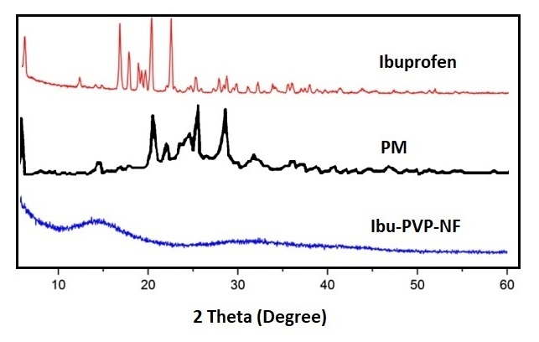
Fig 2. X-Ray diffraction pattern of the studied samples indicating negligible or no crystallinity in the nanofiber sample (Ibu-PVP-NF). The raw ibuprofen and physical mixture samples retained the crystalline peaks.

3.3. Differential scanning calorimetry (DSC)
The DSC thermograms of samples are in agreement with the results of XRD studies (Fig. 3). Ibuprofen alone showed sharp endothermic peak at 79.8℃ corresponding to its melting point confirming its crystalline nature. The physical mixture sample retained the melting endotherm of ibuprofen in the DSC studies. However, peak associated with ibuprofen melting was absent in the nanofiber samples indicating its amorphization. Thus, results of DSC studies were in accordance with the XRD analysis.
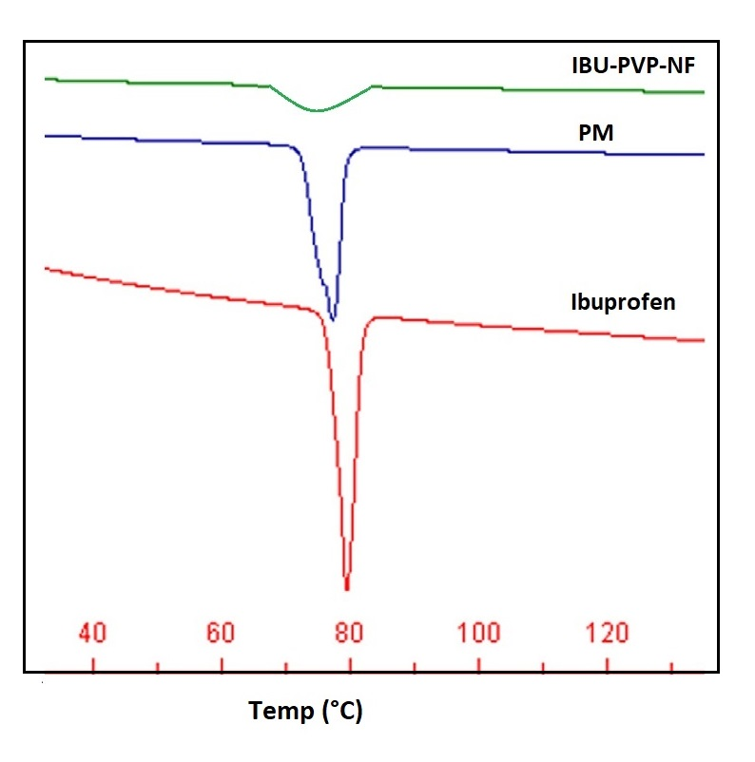
Fig 3. DSC thermograms of the studied samples indicating sharp melting endotherms at the melting point of ibuprofen in raw ibuprofen and physical mixture (PM) samples. Nanofiber sample (IBU-PVP-NF) lacks sharp endothermic peak.
3.4. Drug loading efficiency
Drug loading in drug delivery systems is considered as an important parameter while assessing the suitability of the drug carrier systems. The methods of drug loading in polymeric nanofibers are diverse which include blending (drug is dissolved/dispersed in polymer solution), surface modification (drugs is conjugated to the nanofiber surfaces), coaxial process (co-electrospinning of drug solution as core and polymer solution as sheath), etc. The present study adopted the blending method for loading of ibuprofen. The ibuprofen loading efficiency in the fabricated electrospun nanofibers was found to be as high as 93.42 ± 4.21%w/w.
3.5. In Vitro Dissolution Studies
For BCS II drug candidates like ibuprofen, dissolution is the rate limiting step for oral absorption. In such, scenario, improving the dissolution of drug has been an ideal strategy for its effective oral delivery. The raw ibuprofen (Ibu) dissolution in distilled water was found slow and incomplete (55.72± 4.82%). The dissolution profile of the studied samples (Fig. 4) revealed a significant improvement (p < 0.05) in drug release from the nanofiber samples (Ibu-PVP-NF) when compared to native raw ibuprofen (Ibu). The improved dissolution of ibuprofen from the nanofiber samples may be due to the amorphous state of the drug.³⁰ In our previous report, similar improvement in dissolution was observed while attempting co-processing with hydrophilic polymers like hydroxypropyl methylcellulose.¹⁹
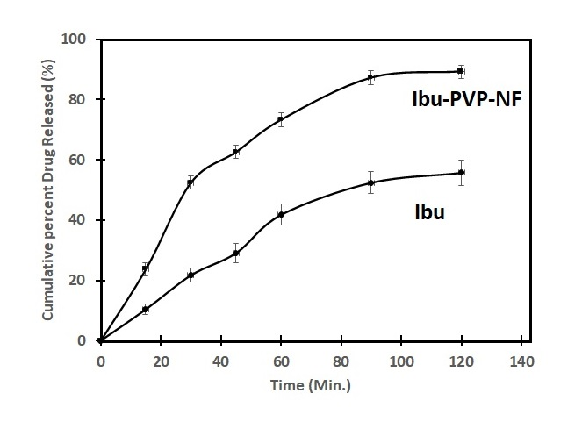
Fig 4. Dissolution profile of the raw ibuprofen (Ibu) and nanofiber (Ibu-PVP-NF) samples.
3.6. Ex vivo intestinal permeation studies
As a surrogate for in vivo bioavailability studies, we have carried out ex vivo intestinal permeation studies to confirm dissolution data. The study conducted for two hours revealed a significant (p < 0.05) improvement of rate and extent of permeation of ibuprofen from nanofiber samples when compared to raw ibuprofen samples (Fig. 5). Raw ibuprofen (Ibu) exhibited lower percent of permeation (34.66 ± 5.27 %). However, the nanofiber samples exhibited significantly (p > 0.05) higher intestinal permeation (79.83± 7.29 %). Since, intestinal permeation of ibuprofen is dissolution rate limited, the present approach to enhance the dissolution of ibuprofen using nanofiber technology successfully improved the ex vivo intestinal permeation of the cargo.
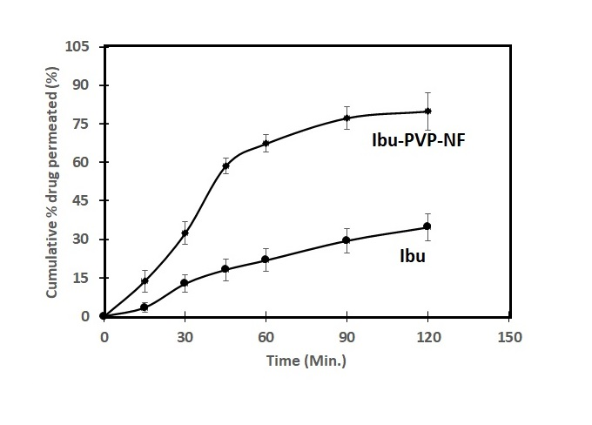
Fig 5. Ex vivo intestinal permeation pattern of raw ibuprofen (Ibu) and nanofiber (Ibu-PVP-NF) samples.
4. Conclusion
Hydrophilic polymer electrospun nanofibers for oral delivery of ibuprofen is reported with enhanced dissolution and ex vivo permeation. The results are very promising with existence of ibuprofen in amorphous state in the nanofiber matrix evident from the DSC and XRD investigations. Apparent absence of crystalline traces of ibuprofen in the nanofiber samples may be due to the antinucleating properties of PVP. The study has provided enough supporting data for further preclinical investigations.
Conflict of Interest
The authors declare no conflict of interest. The authors alone are responsible for the content and writing of the article.
Acknowledgement
This work was funded by the Deanship of Scientific Research at Jouf University, Kingdom of Saudi Arabia under grant No. DSR-2021-01-03135.
5. References
1. S. Mallick, S. Pattnaik, K. Swain, P. De, Drug Dev Ind Pharm 2007, 33, 535-541.
2. S. S. Hota, S. Pattnaik, S. Mallick, Acta Chimica Slovenica 2020, 67,179-188. DOI: http://dx.doi.org/10.17344/acsi.2019.5311.
3. Y.C. Yadav, S. Pattnaik, K. Swain, Drug Dev Ind Pharm 2019, 45,1889-1895. DOI: 10.1080/03639045.2019.1672717.
4. S. Pattnaik, K. Pathak, Curr Pharm Des 2017, 23, 467-480.
5. K. Pathak, S. Pattnaik, K. Swain, In: S. M. Jafari and D. J. McClements (Eds.): Nanoemulsions: Formulation, Applications and Characterization, Academic Press (Elsevier), Amsterdam, 2018, pp.415-433.
6. S. Mallick, S. Pattnaik, K. Swain, P. De, Drug Dev Ind Pharm 2007, 33, 865-873.
7. J. Morimoto, K. Miyamoto, Y. Ichikawa, et al., Sci Rep 2021, 11, 12697.
8. S. Abd Rahim, N.A. Rosli, and S.S. Mohd Khalid, Advanced Materials Research 2015, 1113, 417–421. https://doi.org/10.4028/www.scientific.net/amr.1113.417.
9. L. Nicoud, F. Licordari, and A. S. Myerson, Crystal Growth & Design 2018, 18, 7228-7237. DOI: 10.1021/acs.cgd.8b01200.
10. C. Porter, N. Trevaskis, & W. Charman, Nat Rev Drug Discov 2007, 6, 231–248. https://doi.org/10.1038/nrd2197.
11. A. Malkawi, A. Jalil, I. Nazir, B. Matuszczak, R. Kennedy, and A. Bernkop-Schnürch, Molecular Pharmaceutics 2020, 17, 3709-3719. DOI: 10.1021/acs.molpharmaceut.0c00389.
12. A. K. Mahapatra, P. N. Murthy, R. K. Patra, S. Pattnaik, Drug Delivery Letters 2013, 3, 210 - 219 . https://doi.org/10.2174/22103031113039990005.
13. S.B. Carneiro, F.I. Costa Duarte, L. Heimfarth, J.S. Siqueira Quintans, L.J. Quintans-Júnior, V.F.D. Veiga Júnior, A.A. Neves de Lima, Int J Mol Sci 2019, 20, 642. DOI: 10.3390/ijms20030642.
14. S. Pattnaik, K. Pathak, Current Pharmaceutical Design 2017, 23, 467-480.
15. N. Roy, B. Ghosh, D. Roy, B. Bhaumik, and M. N. Roy, ACS Omega 2020, 5, 30243-30251. DOI: 10.1021/acsomega.0c04716.
16. X. Cheng, J. Gao, J. Li, G. Cheng, M. Zou, H. Piao, AAPS PharmSciTech 2020, 21,160. DOI: 10.1208/s12249-020-01685-1.
17. Y. Ma, Y. Yang, J. Xie, J. Xu, P. Yue, M. Yang, Int J Nanomedicine 2018, 13, 3763-3779. DOI: 10.2147/IJN.S164228.
18. K. Ueda, K. Higashi, K. Moribe, Int J Pharm 2019, 561, 82-92. DOI: 10.1016/j.ijpharm.2019.02.034.
19. S. Pattnaik, K. Swain, J.V. Rao, V. Talla, K.B. Prusty, S.K. Subudhi, RSC Adv 2015, 5, 74720-74725.
20. S. Pattnaik, K. Swain, P. Manaswini, E. Divyavani, J. V. Rao, V. Talla, S. K. Subudhi, Journal of Drug Delivery Science and Technology 2015, 29, 199-209. DOI: https://doi.org/10.1016/j.jddst.2015.07.021.
21. S. Pattnaik, K. Swain, J.V. Rao, V. Talla, K.B. Prusty, S.K. Subudhi, RSC advances 2015, 5, 91960-91965.
22. S. Pattnaik, Y. Surendra, J. V. Rao, K. Swain, In: Masoud Mozafari (Ed.) Woodhead Publishing Series in Biomaterials, Nanoengineered Biomaterials for Advanced Drug Delivery, Elsevier, 2020, pp. 421-445. https://doi.org/10.1016/B978-0-08-102985-5.00018-8.
23. S. Pattnaik, K. Swain, In: Inamuddin, A. M. Asiri, A. Mohammad (Eds.) Woodhead Publishing Series in Biomaterials, Applications of Nanocomposite Materials in Drug Delivery, Woodhead Publishing, 2018, pp. 589-604. https://doi.org/10.1016/B978-0-12-813741-3.00025-X.
24. M. L. Ohnsorg, P.C. Prendergast, L. L. Robinson, M.R. Bockman, F.S. Bates, and T.M. Reineke, ACS Macro Letters 2021, 10, 375-381. DOI: 10.1021/acsmacrolett.0c00890.
25. D. N. Karunaratne, I. R. Ariyarathna, D. Welideniya, A. Siriwardhana, D. Gunasekera and V. Karunaratne, Current Nanomedicine 2017, 7, 84-110. DOI: https://dx.doi.org/10.2174/2468187307666161227171349.
26. H. Rahim, A. Sadiq, S. Khan, F. Amin, R. Ullah, A.A. Shahat, H.M. Mahmood, Int J Nanomedicine 2019, 14, 6287.
27. S.A. Fouad, F.A. Malaak, M.A. El-Nabarawi, K. Abu Zeid, A.M. Ghoneim, PLoS ONE 2021, 16, e0245482. https://doi.org/10.1371/journal.pone.0245482.
28. S. Mallick, S. Pattnaik, K. Swain, P. De, A. Saha, G. Ghoshal, A. Mondal, Eur J Pharm Biopharm 2008, 68, 346-351.
29. N. J. Babu and A. Nangia, Crystal Growth & Design 2011, 11, 2662-2679. DOI: 10.1021/cg200492w.
30. A. Ziaee, S. O'Dea, A. Howard-Hildige, L. Padrela, C. Potter, J. Iqbal, A.B. Albadarin, G. Walker, E.J. O'Reilly, Int J Pharm 2019, 572, 118816. DOI: 10.1016/j.ijpharm.2019.118816.

