iFIT: An automated web tool for determining enzyme-kinetic parameters based on the high-curvature region of progress curves
Boštjan Petrič, Marko Goličnik and Aljoša Bavec*

University of Ljubljana, Institute of Biochemistry and Molecular Genetics, Faculty of Medicine, Vrazov trg 2, SI-1000 Ljubljana, Slovenia
* Correspondence: aljosa.bavec@mf.uni-lj.si
Address correspondence to:
Prof. Aljoša Bavec, PhD
University of Ljubljana, Institute of Biochemistry and
Molecular Genetics, Faculty of Medicine
Vrazov trg 2, Ljubljana, SI-1000 Slovenia
aljosa.bavec@mf.uni-lj.si

Abstract
The area where progress curve exhibits maximum curvature contains the most information about kinetic parameters. To determine these parameters more accurately from progress curves, we propose an iterative approach that calculates the area of maximum curvature based on an estimate of kinetic parameters and then recalculates the parameters based on time-concentration data points within this area. Based on this algorithm, we developed a computer script called iFIT as a free web application at http://www.i-fit.si. The benefits of working with iFIT are that it decreases the importance of initial substrate concentration and the impact of certain side reactions on the final calculated kinetic parameters.
Keywords: progress curves; integrated Michaelis-Menten equation; Lambert W

1. Introduction
The classical way to determine enzyme-kinetic parameters, such as the Michaelis constant K_{m} and limiting rate V_{max}, was via initial-velocity-based approaches, such as the Michaelis-Menten (MM) diagram and its linearized derivations, e.g., the Lineweaver-Burk diagram. In recent decades, analyzing entire progress curves has mostly superseded the former approach as a simple way of determining kinetic parameters with greater accuracy and precision and using fewer measurements.¹ While a common problem of analyzing initial velocities is a shortage of experimental data points, progress curves often have too many data points, which may counterintuitively decrease the quality of the fitted parameters.
It is well understood that information about kinetic parameters is not equally encoded in all parts of a progress curve. Once the curve reaches its plateau, recording additional time-concentration points does not provide any further information about K_{m} or k_{cat}. Fitting a model function onto a curve with a long plateau might result in a model curve that fits perfectly onto the measured plateau, but at the expense of the area of maximum curvature (see Figure 1). Similarly, for progress curves at high substrate concentration relative to K_{m}, the initial part of the progress curve will be almost linear (zero-order), and similar considerations apply to it as to the plateau. The most information about kinetic parameters can be extracted from the progress curve’s area of maximum curvature.²
To ensure that the model function fits well onto the area of maximum curvature, different weights can be assigned to different areas of the progress curve, or parts of the curve (e.g., the plateau) can be manually removed. However, to avoid accusations of tampering with raw data, any such method for optimizing progress curves must be clearly defined, universally applicable, and based on sound mathematical principles. We here propose such a method, based on the theoretical work of Stroberg and Schnell². They published an equation that calculates the area of maximum curvature of a progress curve from already known kinetic parameters. Based on this, we developed an iterative approach for calculating the area without known kinetic parameters. Furthermore, we developed a computer script to automatically perform the iterative process.

2. Experimental
2.1 Study design
Our study was designed only for the development of simple and quick methodology for determination of serum paraoxonase 1 (PON1) kinetic characteristics. We utilized a leftover routine blood sample of a healthy blood-donor. Since the biological material used in this report has been obtained from a leftover specimen, and the sample was not used for any other particular study, informed consent from volunteers and ethical approval was unnecessary because the sample was no longer traceable.
2.2 Methods
The blood sample was collected in a heparin tube, immediately centrifuged at 2200 g, 4°C for 10 min, and the plasma was removed and stored at -80°C until measurement. Enzyme activity measurements were performed as in Goličnik and Bavec.³ Briefly, the measurements were conducted at room temperature, in a buffer consisting of 50 mM Tris and 1 mM CaCl₂, pH = 8. The substrate was dihydrocoumarin, prepared as a 25 mM stock solution in methanol. Each reaction had a total volume of 2 mL and was performed in a 1 cm cuvette.
For each measurement, 20 uL of substrate stock solution (final concentration: 250 uM) and 10 uL of plasma were added to 1970 uL of buffer. Substrate was added last, after which we started the measurement. Absorbance at 270 nm was measured every second until after the progress curve had clearly reached its plateau. Afterwards, the progress curve was analyzed using iFIT, which is explained in detail in the main text of the present article.
2.3 Data analysis
Stroberg and Schnell introduce the concept of t_{Q}, i.e., the length of time during which the progress curve is at its maximum curvature. t_{Q} depends on K_{m}, V_{max}, and initial substrate concentration (S₀), according to Equation 1:
$$t_{Q}= \frac{{27K}_{m}∙{\left[S\right]}_{0}}{4V_{max}\left(K_{m}+ {\left[S\right]}_{0}\right)}$$ | (1)

When an entire progress curve has been measured, and the extinction coefficient for the product is known, S₀ can be easily calculated. However, calculating K_{m} and V_{max} from a progress curve is not trivial, even if we are only interested in an estimate. Hence, using t_{Q} for an improved way to calculate K_{m} results in a chicken-and-egg problem, which can be solved with an iterated approach. We start by applying a model function to the entire progress curve to acquire estimates for K_{m} and V_{max}. We then use these estimates to calculate t_{Q} and subsequently analyze only the t_{Q}-bound region of the progress curve again with the model function to acquire more precise estimates of K_{m} and V_{max}. We continue this process until the calculated t_{Q} interval, i.e., the number of experimental time-concentration data points selected by the algorithm, is the same in two successive iterations.
Several approaches for calculating kinetic parameters directly from progress curves have been proposed. Briefly, it is possible to (1) model the enzymatic reaction with a system of differential equations (an example of such a program is Dynafit);⁴ (2) treat each derivative of the progress curve with respect to time as an initial velocity and plot these “initial velocities” onto the standard MM diagram;⁵ or (3) use an integrated version of the MM equation. We decided to use the latter: a numerical approximation by Goličnik (Equations 2 and 3):⁶

$${[P]}_{t}={[S]}_{0}-K_{m}∙(1.45869∙ln⁡(1.2∙\frac{x}{\ln\left(2.4∙\frac{x}{\ln\left(1+2.4x\right)}\right)})-0.45869∙ln⁡(2\frac{x}{\ln\left(1+2x\right)})$$ | (2)

$\text{where}$
$$x=\frac{{\left[S\right]}_{0}}{K_{m}}{∙e}^{\frac{{([S]}_{0}-V_{max}*t)}{K_{m}}}$$ | (3)
Goličnik’s approximation is based on an integrated MM equation (based on the Lambert Omega function) that was published by Schnell and Mendoza (Equation 4).⁷
$${[P]}_{t}={[S]}_{0}-K_{m}∙W_{0}(\frac{{\left[S\right]}_{0}}{K_{m}}∙\exp\left(\frac{{\left[S\right]}_{0}-V_{max}∙t)}{K_{m}}\right))$$ | (4)

3. Results and discussion
Performing the entire iterative procedure manually would be extremely time-consuming. Therefore, we developed a computer script in Python, provisionally referred to as iFIT. The script takes a progress curve as its input, asks the user for an initial selection of an area of the curve (not necessary) and an extinction coefficient, and automatically calculates estimates for substrate concentration, baseline, and V_{max}. The user then inputs an estimate for K_{m}, which is required by the integrated MM equation to start the fitting procedure. iFIT begins the iterative process of calculating t_{Q} from kinetic parameters and then recalculating kinetic parameters from the part of the curve described by t_{Q}. The area of the curve that is being fitted can expand, contract, or move left or right on the x-axis between successive iterations.
When two successive iterations produce the same selection of time-concentration data points as the result, it is output by the script as the final result, including calculated values for K_{m}, V_{max}, [S]₀, and the baseline. If iFIT does not converge to a t_{Q} value after 100 iterations (usually this occurs when the script oscillates between two values of t_{Q}), the procedure is terminated without a final result. Additionally, iFIT always draws all the intermediate graphs as well as the final graph, with both the data points and model curve displayed, so that the user can visually check whether the final fit is indeed sensible. An example of an initial and final graph is displayed in Figure 1. More detailed information how to use iFIT web application is available in Supplementary material.
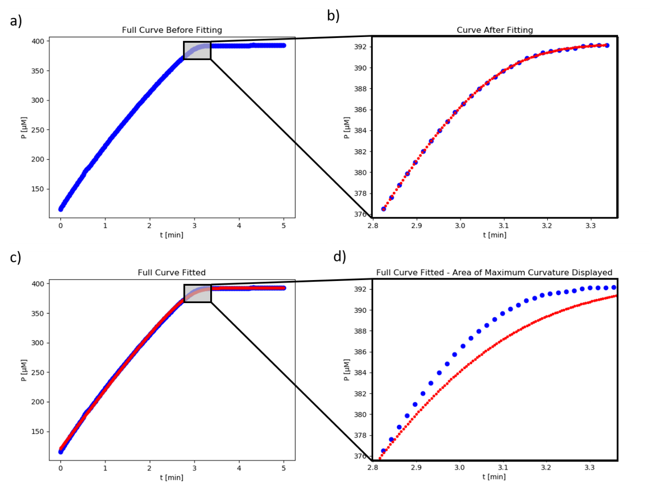
Figure 1: The fit of kinetic progress curve data by iFIT for human PON1. a) The entire curve (blue) before fitting with a model function, with the area of maximum curvature shown in the shaded window. b) The area of maximum curvature (blue) of the progress curve in a) and the best-fit curve with Equation 2 (red) after the final iteration of iFIT. The calculated value of K_{m} is 6.70 μM. c) The entire progress curve from a) (blue) fitted with the model function (red) after the first iteration of iFIT; the area of maximum curvature is shown in the shaded window and is the same as in a). The calculated value of K_{m} is 17.33 μM. d) The area of maximum curvature zoomed in after the entire curve (blue) was fitted with the model function (red). It is apparent from the comparison between b) and d) that iFIT can produce model functions which fit much more closely to the area of maximum curvature.
iFIT has two main requirements. 1) The progress curve must be smooth, without a substantial amount of noise. Even if each part of the curve can be fitted well with the integrated MM equation, noise may cause iFIT to oscillate between two or more different values of t_{Q} (and, consequently, two or more different output values of K_{m}). 2) The initial substrate concentration must not be substantially below K_{m}. In such cases, iFIT will conclude that the area of maximum curvature lies before the beginning of the progress curve, i.e., at a “negative” time interval. Since such intervals do not contain time-concentration data points, iFIT will be unable to continue the calculation. The same thing will happen if we try to input an exponential progress curve, e.g., from a first-order reaction.
Conversely, it is not a problem for iFIT if the initial substrate concentration is significantly above K_{m}, which is advised against in conventional enzyme-kinetic guidelines. As long as there are enough time-concentration data points in the high-curvature region of the progress curve, it does not matter how many other points lie outside of this region. It also does not matter if the progress curve’s plateau is very long, noisy, or deviates from a straight line; iFIT will simply not consider these points in the final result.
A related advantage of iFIT is that it can decrease the influence of certain side reactions on the final calculated value of K_{m}. During a MM reaction with a low K_{m} and an [S]₀ sufficiently above K_{m}, the rate of the reaction will slowly decrease as substrate is being consumed. If we perform the same reaction with a lower-affinity enzyme, the reaction rate will decrease more quickly as substrate is being consumed. The example of this is a first-order reaction, such as spontaneous substrate hydrolysis, where the reaction rate will decrease even more rapidly with respect to substrate concentration. This means that the side reactions of either an impure sample, containing an unwanted enzyme that catalyzes the same substrate (but with a higher K_{m}), or a substrate that undergoes first-order spontaneous hydrolysis will have the smallest impact on the total reaction just before the plateau of the progress curve, i.e., in the area of highest curvature. In such cases, fitting a model function on the entire progress curve produces a poorer fit and less accurate output kinetic parameters than fitting the same model function on only the high-curvature region using iFIT (see Figure 1).
Many methodological articles on enzyme kinetics conclude with recommendations regarding proper experimental design. The value of iFIT, however, is that it renders precise experimental design less important. Using progress curves instead of initial velocities minimizes the importance of ensuring precise initial substrate concentration or immediately starting the measurement, as long as the product’s extinction coefficient is known. An additional advantage of using iFIT is that we do not need to worry about substrate concentration at all. The script will trim any progress curves with excessive substrate concentration down to size, and iFIT can immediately notify that the substrate concentration is too small by calculating a t_{Q} interval that falls outside of the measured progress curve. When measuring progress curves, we must only ensure that the total absorbance of the solution does not exceed the functional range of the instrumentation being utilized.
Apart from reducing noise, it is also helpful to record as many time-concentration data points per unit of time as possible when measuring progress curves for iFIT. Especially when K_{m} is low and V_{max} is high, t_{Q} will be short as well, i.e., only a small part of the progress curve will end up being fitted by the model function. If this part of the curve contains only a few data points, the resulting fit might be less accurate.
For enzymatic reactions where the integrated MM equation cannot be applied to progress curves, iFIT cannot be applied as well. This includes equilibrium reactions (i.e reaction that are not irreversible), reactions which involve cosubstrates that are not present sufficiently in excess, and reactions with strong product inhibition. If progress curves cannot be measured at all because substrates and products have the same spectral properties, then iFIT obviously cannot help us either.
4. Conclusions
Utilizing Stroberg & Schnell’s equation to improve the determination of kinetic parameters does not require a scripted approach or the integrated MM equation as part of the iterative algorithm. However, our developed script is quick and easy to use. As it is based on the integrated MM equation, complex differential-equation-based models, such as those behind Dynafit or ENZO, are unnecessary.^{4,8} Using iFIT at http://www.i-fit.si, any research group that determines MM kinetic parameters from progress curves can solve the problem of unwanted data points at the beginning or end of progress curves.
Acknowledgements
This study was supported by the Slovenian Research Agency (grant P1-170). The authors thank Marjan Kužnik for his kind help with experimental work.
Potential conflict of interests
There are none.
CRediT authorship contribution statement
Boštjan Petrič: Conceptualization, Formal analysis, Investigation, Writing – original draft, Writing – review & editing, Visualization. Marko Goličnik: Conceptualization, Methodology, Software, Formal analysis, Investigation. Aljoša Bavec: Conceptualization, Methodology, Software, Formal analysis, Investigation, Writing – review & editing.
References
1. B. Choi, G. Rempala, J. K. Kim. Sci Rep. 2017, 7(1), 17018.
2. W. Stroberg, S. Schnell, Biophys. Chem. 2016, 219, 17–27.
3. M. Goličnik and A. Bavec, J Enzyme Inhib Med Chem. 2020, 35, 261-264.
4. P. Kuzmič, Anal. Biochem. 1996, 237, 260–273.
5. S.L. Yun, C.H. Suelter, Biochim. Biophys Acta 1977, 480(1), 1–13.
6. M. Goličnik, Biochem. Mol. Biol. Educ. 2011, 39(2), 117–125.
7. S. Schnell, C. Mendoza, J. Theor. Biol. 1997, 187, 207-212.
8. S. Bevc, J. Konc, J. Stojan, M. Hodošček, M. Penca, M. Praprotnik, D. Janežič, PLoS ONE 2011, 6(7), e22265.

