Design of “turn-off” fluorescent nanoprobe for highly sensitive detection of uric acid using green synthesized nitrogen-doped graphene quantum dots
Sopan Nangare¹, Shweta Baviskar², Ashwini Patil³, Pravin Patil^{2*}

^{1*}Department of pharmaceutics, H. R. Patel Institute of Pharmaceutical Education and Research, Shirpur-425405, Dist: Dhule, Maharashtra state, INDIA-425405
²Department of pharmaceutical chemistry, H. R. Patel Institute of Pharmaceutical Education and Research, Shirpur-425405, Dist: Dhule, Maharashtra state, INDIA-425405
³Department of Microbiology, R. C. Patel Arts, Science, and Commerce College, Shirpur, Dist: Dhule, Maharashtra state, INDIA-425405

*Address for Correspondence
Dr. Pravin O. Patil
Head and associate professor,
Department of Pharmaceutical Chemistry,
H. R. Patel Institute of Pharmaceutical Education and
Research, Shirpur-425405, Dist: Dhule (MS), India.
Email ID: rxpatilpravin@yahoo.co.in

Abstract: Green synthesized graphene quantum dots (GQD) have been doped with non-metallic elements in an attempt to boost their optical characteristics and application sectors. In the present investigation, the blue luminescent nitrogen doped GQDs (N-GQDs) were synthesized by single-step hydrothermal synthesis using tamarind shell powder as a precursor. The particle size of N-GQDs was found to be 11.4 nm. A quantum yield as high as 23.78 % was accomplished at an excitation wavelength of 330 nm at neutral pH that can be quenched sensitively and selectively in existence of uric acid (UA) combining static quenching, electron transfer, and an inner filter effect mechanism. A linear range was obtained for UA from 1 µM to 1000 µM, with a limit of detection (LOD) of 12 nM. Additionally, the N-GQDs were selective toward UA in the existence of metal ions and biomolecules that indicated its impending use to monitor UA in clinical samples. In conclusion, this work demonstrates that the N-GQDs as a sensing probe for UA recognition with notable advantages including socioeconomic, simple, and less time-consuming methods as compared to other methods. In the future, it can be potentially explored as a biosensor for UA detection in clinical samples.
Keywords: Graphene Quantum Dots; N-GQDs; Uric acid; Biosensor; Tamarind Shell Powder

1. Introduction
Principally, UA (2.6,8-trihydroxypurine) is the primary product of purine synthesis.¹ As per literature, in the general population, UA is referred to between 0.13-0.46 mM/L and 2.49-4.46 mM/L in serum and urine, respectively.² As we know, the abnormal levels of such metabolites in body fluids can cause several diseases.³ Plentiful literature revealed that the increased UA levels in body samples are indicative of hypertension, gout, cardiovascular disease, kidney disease, high cholesterol, and many more.⁴ In comparison, low concentrations of UA are also connected with multiple sclerosis and oxidative stress.^{5, 6} In diagnosis and healthcare, it is crucial to quantify metabolites in blood or other biological samples. Therefore, a rapid, responsive, precise, and cheap method of assessment must be developed to track such metabolites in body fluids including serum and urine.⁵
Literature survey reported that electrochemical sensing,⁷ a colorimetric method,⁸ a chromatographic method,⁹ etc. are currently engaged detection techniques for UA in different body fluid samples. However, some in-conveniences such as complicated synthesis or challenging extraction, advanced equipment, expensive and tedious limiting their practical uses, are present in these approaches.⁵ There are no exceptions, the benefit of fluorescence is that it is highly sensitive, has a fast reaction, and has operative simplicity in contrast to the other approaches available.^{5, 10} Thanks to its tunable photoluminescence properties GQDs have created substantial interest as a potential new class of carbon-based, luminescent nanomaterials.¹⁰ The growing advancement in fluorescent sensors and bioimaging has been growing for the GQD because of their high bio-compatibility and photostability.^{11, 12} Applications of GQDs in UA sensing a redox modulated fluorescent strategy for detection of UA and glucose using fluorescence GQDs probe has been reported.⁵ However, the QY of GQDs mentioned is far lower than traditional QDs, which restricts their wide-ranging use. Hence, the improvement of QYs has become one of the obstacles to the use of GQDs. Several scholars have successfully shown that GQDs can be reliably transformed into an amino-functionalized GQD or π-conjugated system employing doping of heteroatoms.¹² As per literature, doping is an efficient method to alter the electronic density of bulk semiconductor materials. Besides, it helps to tune the optical and electrical properties. Recently, nitrogen doping in graphene structure enabled the in-plane substitution of nitrogen atoms to graphene as an n-type semiconductor.¹³
Nitrogen doping is a feasible approach for altering the electrical, chemical, and structural functions of GQDs to boost their efficiency in sensing applications.¹⁴ Li and co-authors found, owing to the intense electron-withdrawing outcome of the doped ‘N’ atom, that the as-prepared N-GQDs have special optoelectronic properties.¹⁵ Besides, a potential mechanism for tuning GQDs fluorescent properties via charge transfer effect of the functional group was suggested by the Chattopadhyay group.¹⁶ Due to the high QY and superb bleaching resistance of fluorescent materials, many research groups have been used N-GQDs as fluorescent sensors for sensing biological small macromolecules, organic small molecules, and metal or non-metal ions.¹⁷ It is intended, by adjusting the surface characteristics and the associated fluorescent property, to design realistic sensors for the assessment of UA in the urine. In the meantime, N-GQDs normally have greater amounts of QY than GQDs and are good for the fluorescence study in spiked real-time body fluid (urine). While useful, following our current understanding, the N-GQDs have not been used to date to recognize UA in urine. A choice of methods has been developed for the N-GQDs preparation including hydrothermal method,¹⁸ direct electrolysis,¹⁹ pyrolysis,²⁰ etc. using different chemicals as a precursor. Additionally, owing to the costly facilities, complex and time-consuming processes, the aforementioned protocols are unconvincing. In this study, we illustrate a single step, relatively inexpensive and environmentally safe in preparing N-doped GQDs through hydrothermal treatment of Tamarind seed as a green source. Additionally, the synthesized N-GQDs show a high quantity of QY and emit light blue luminescence.
In this work, we present a new kind of fluorescent sensor for UA detection based on the fluorescence Turn On-Off strategy. Interestingly, owing to the stronger electrostatic interaction and electron transfer between blue luminescent N-GQDs and UA, the photoluminescence intensity of the N-GQDs could be quenched efficiently (Scheme 1). Finally, based on this the N-GQDs fluorescent sensor offers high sensitivity, selectivity for UA recognition. In brief, the N-GQDs biosensor can be employed for UA detection in real-time clinical samples.
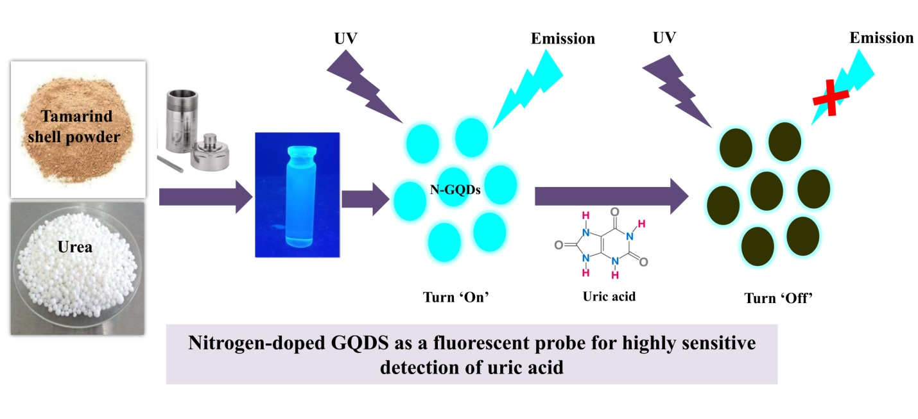
Scheme 1: One spot synthesis of N-GQDs using tamarind shell powder and sensing of UA
2. Materials and methods
2.1. Materials: Uric acid (2, 6, 8-trihydroxypurine, ≥99%) and urea (≥99%) were purchased from Sigma-Aldrich. The sodium hydroxide, sodium chloride, calcium chloride, glycine, glucose, sucrose, lysine, alanine, quinine sulfate were collected from Lobachemie, Chemicals. Pvt. Ltd. Mumbai, India. All chemicals plus reagents utilized for synthesis and characterization of N-GQDs were of analytical grade (AR) and applied as received without purification. Double distilled water (DDW) was prepared in the laboratory. Tamarind seed was collected from the local market of Shirpur, Maharashtra (India).
2.2. Methods
2.2.1. Processing of tamarind shell
In the beginning, 0.5 Kg of tamarind shell (Tamarindus indica) waste was collected from the local market, Shirpur city (Dhule, Maharashtra). Further, the tamarind shell waste was dried using a laboratory hot air oven. The temperature was programmed at 60 °C and then decreased to 40 °C at the rate of -0.14 °C/min for 12 h. After drying, the dried shells were checked for stuck dirty materials on the shells. Finally, shells were crushed into tiny pieces via a mortar pestle. Further, the obtained powder was subjected to grinding to obtain fine tamarind shell powder.
2.2.2. Synthesis of N-GQDs
The N-GQDs synthesis from Tamarind shell powder and urea was achieved through the one-pot hydrothermal method. Briefly, 500 mg of fine tamarind shell powder was dispersed in 20 mL of double-distilled water (DDW) followed by 20 minutes of sonication. After that, 100 mg urea was added to the above dispersion. Finally, the prepared dispersion was transferred into a Teflon-lined autoclave in a stainless-steel hydrothermal reactor in a hot air oven at 200 °C for 8h. After the end of the hydrothermal process, the resultant solution was kept to bath sonication for 20 minutes at 25 °C, which gives uniform dispersion of N-GQDs. For purification purposes, the obtained N-GQDs were shifted to the dialysis (for 24 h) using a dialysis bag (12,000 kDa, 0.22 μm), which help to remove the insoluble carbon materials. Afterward, the final dialyzed solution was transferred to centrifugation (Refrigerated Centrifuge, Elteck Overseas Pvt. India) at 9000 rpm for 20 minutes (4 °C to 10 °C) to remove the impurities.
2.2.3. Freeze-drying of N-GQDs
In this study, liquid N-GQDs solution was processed for lyophilization by using a laboratory freeze dryer (Freezone12, Labconco, MO, USA). Briefly, the N-GQDs solution was pre-freeze at –30 °C for 36 h at the laboratory deep freezer (Southern Scientific Lab Instrument, India). After that, the primary drying of N-GQDs was performed at -53 °C and 0.016 mBar for 24 h. Afterward, the secondary drying of N-GQDs was performed at 10 °C for 8 h and was followed by drying at 25 °C for 4 h with a steady increase in temperature at 1°C /minute. Finally, the temperature of the cold trap was maintained at -53°C until the end of the drying process.
2.2.4. Characterizations of N-GQDs
The synthesized N-GQDs were characterized by the UV-visible spectra was recorded between 800-400 nm on UV–vis spectrophotometer (UV 1800 Shimadzu, Japan) using a quartz cuvette. ATR-FTIR spectra of N-GQD were recorded using an FTIR spectrophotometer (Agilent CARY 630 FTIR) at 4 cm⁻¹ resolution in the absorption area of 4000-1000 cm⁻¹. Energy Dispersive X-ray Spectroscopy (EDS or EDX) was used to provide qualitative and quantitative surface analysis. The particle size of synthesized N-GQDs was measured via Nanoplus 3 Particulate System (Micromeritics, USA). The green synthesized N-GQDs shape, size, and crystalline nature was obtained using HR-TEM (HR-TEM, Jeol/JEM 2100) with a LaB6 light source at 200kV.

The fluorescence study of N-GQDs was performed using a UV chamber (details) at different wavelengths such as 254 nm and 365 nm along with visible light.
2.2.5. pH influence study
The pH of the N-GQDs solution actively affects the fluorescence properties of the N-GQDs since the pH affects the surface stability and molecularity of the surface functional groups. The N-GQDs were subjected to different pH ranges from 1-12 to study the pH dependant changes in the fluorescence intensity. Herein, N-GQD solution was prepared in different pH solutions at room temperature. The fluorescence intensity was recorded at excitation 330 nm and corresponding changes in the intensities were recorded.
2.2.6. Quantum yield (QY)
In this study, the ‘QY’ of the N-GQDs was calculated by using a comparative method. Quinine sulfate was dissolved in 0.1M sulphuric acid (φ_{st} = 54%) as a standard for QY determination. Then, the dilutions were prepared using double distilled water (DDW). The absorbance was measured at 350 nm via a UV-Vis spectrophotometer and optical density values were kept below 0.1 to reduce the re-absorption effect. Fluorescence emission spectra of quinine sulfate, as well as N-GQDs, were recorded at 350 nm excitation and a graph was plotted for integrated fluorescence intensity against absorbance
The ‘QY’ of N-GQDs was calculated using the following equation,
$$φ_{x}=φ_{st}\left(\frac{{Grad}_{x}}{{Grad}_{st}}\right)\left(\frac{η_{x}}{η_{st}}\right)$$
Wherein, ‘φ’ is representing the QY. The subscripts ‘x’ and ‘st’ represent test (N-GQDs) and standard (quinine sulfate) respectively. Grad is the slope of fluorescence intensity vs. absorbance plot. The ‘η’ is the refractive index of the solvent.
2.2.7. Uric acid-sensing study
Detection of UA was carried by using a spectrofluorometer (JASCO FP8200 spectrofluorometer) at neutral pH. Initially, 2 mL of synthesized N-GQDs solution were taken in quartz cuvette and excited at 330 nm with a slit width of 5 nm for both excitations as well as emission wavelength at a scanning range of 335 nm to 520 nm at room temperature. To study the sensitivity of N-GQDs for UA detection, different concentrations of UA from 10 μM to 1000 μM were incorporated into an aqueous solution of N-GQDs (2 mL) and uniformly shaken followed by 5 minutes of incubation time at controlled room temperature (25 °C). Lastly, fluorescence intensities were measured in triplicate for more accuracy. Notably, N-GQDs probe fluorescence intensity and the concentration of UA were found to have a linear function as the calibration curve. For real-time sample analysis, simulated urine samples (n=3) were prepared and spiked with a 20 μM concentration of UA. Further, the UA detection procedure of this sample followed the method discussed above in triplicate.
2.2.8. Interference study
The selectivity of N-GQDs (2 mL) was analyzed against a range of metal ions and biomolecules. For the interference study, an aliquot of the stock solutions of non-target samples namely, Na⁺, K⁺, Ca⁺, Ag⁺, lysine, glycine, alanine, glucose, sucrose, lactose, etc. were prepared in DDW (pH 7). A concentration of 100 µM was chosen for all the metal ions and biomolecules for interference study. Briefly, the 1 mL of N-GQDs solution was mixed with 500 µL of these interfering substance solutions. After 10 minutes, fluorescence intensity of all samples was recorded at 330 nm (excitation wavelength) with 5.0 nm silt width for both excitation and emission wavelength.
3. Results and discussion
3.1. Characterization of N-GQDs
In the present study, the applicability of N-GQDs as a fluorescent nanomaterial belonging to the ‘C’ family was explored for the recognition of UA in aqueous media. A one-step, facile and eco-friendly method was preferred to synthesize N-GQDs using tamarind shell powder in a Teflon-lined hydrothermal stainless-steel autoclave reactor. The Tamarind shell proved to be an efficient and reliable waste material for synthesizing of GQDs while urea successfully donated nitrogen for the doping of nitrogen on the GQD structure. Inside the reactor, under high pressure and temperature conditions, tamarind shell powder forms the primary graphitic frame, and the nitrogen atoms were doped onto the graphitic structure. The synthesis procedure was optimized by altering the precursor’s concentration as well as by changing the reaction time. The various batches thus synthesized displayed momentous variation in the fluorescence properties and from the results; the final optimized parameters were identified. Briefly, the fluorescence spectra were recorded at a fixed and varying wavelength to measure the excitation-dependent behavior. The synthesized N-GQDs were liquid and subjected to the different wavelengths in a UV- cabinet for fluorescence study. The solution of synthesized N-GQDs was looking pale yellow (or brownish) in visible light (Figure 1A). When a solution was transferred to the UV light excitation wavelength 254 nm, green fluorescence was seen (Figure 1B). In the case of UV light excitation wavelength 365 nm, the bright blue fluorescence of N-GQDs was seen by the naked eye.²¹ The varied colors observed in N-GQDs fluorescence were most possibly caused by solvent attachment/ different emissive traps of 'N' on green synthesized GQDs surface.²² The oxygen-rich group provides the blue shift in photoluminescence emission from N-GQDs. Moreover, ‘N’ contains strong electron affinity that offers the photoluminescence blue shift.¹⁵

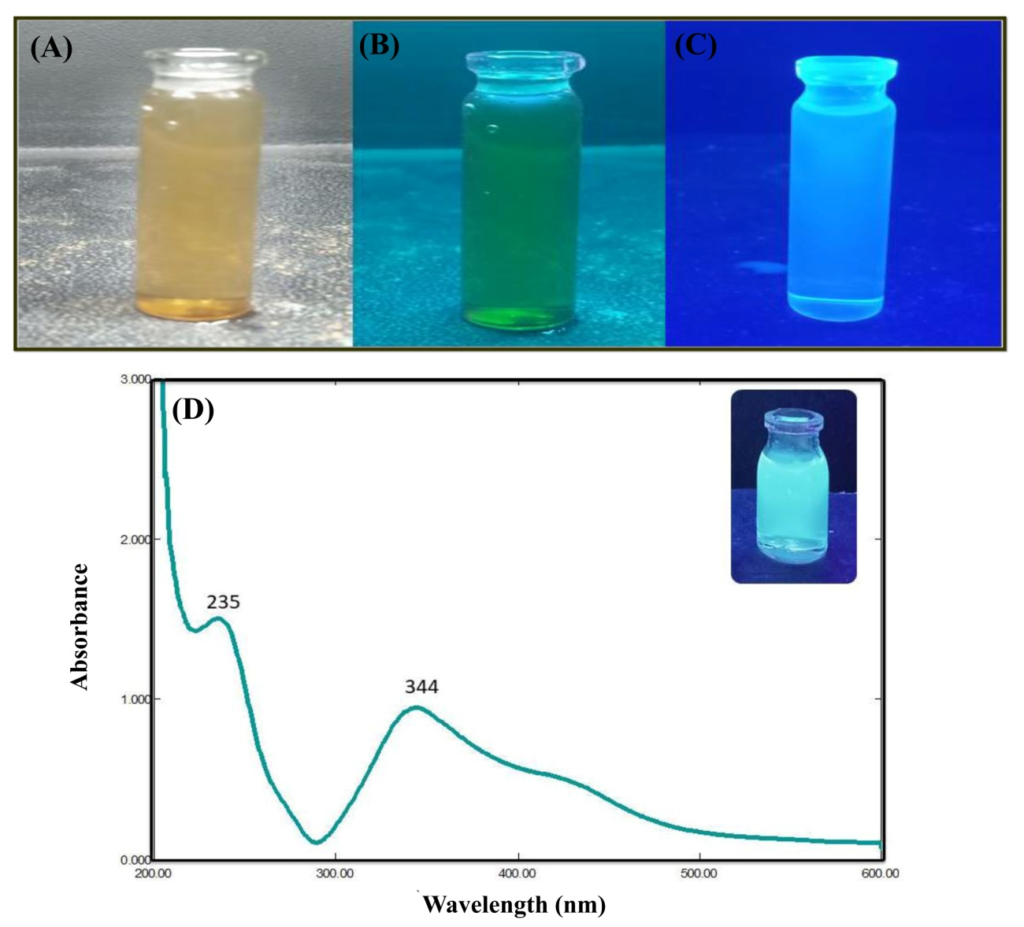
Figure 1: A) N-GQDs in Visible Light, (B) N-GQDs excited in UV light wavelength 254 nm, (C) N-GQDs excited in UV light wavelength 365 nm, (D) UV-Visible spectra of N-GQDs
For further investigation of optical properties of green synthesized GQDs, the UV-vis absorption spectra and fluorescence spectra were recorded. Figure 1D depicted the typical absorption peat at 229 nm that confirmed establishment of the graphitic structure of N-GQDs. Figure 2 shows the absorption peak of N-GQDs in water at 200 nm to 800 nm against DDW (as a blank). The UV visible spectra of synthesized N-GQDs show a maximum absorption peak at ~235 nm due to the π-π* transition of C=C. The shoulder peak at ~344 nm is due to n-π* transitions of C=O.²³ Herein, these two absorption peaks confirmed that there is a certain absorption peak in N-GQDs. In conclusion, it confirmed the green synthesis of N-GQDs using the hydrothermal method.^{17, 21}
FT-IR was used to characterize the presence of major functional groups in synthesized N-GQDs (Figure 2A). The FTIR spectrum of N-GQDs showed the absorption peak of the stretching vibration of the –OH group at 3412 cm⁻¹. The strong absorption peak 3230 cm⁻¹ can vibrate of NH₂ bond. The peak at 1408 cm⁻¹ can be attributed to the bimodal stretching vibration of –NH. The C-N stretching vibration was obtained at 1276.92 cm⁻¹. It confirms the chemical interaction between the ‘N’ source and carboxyl. Accordingly, it assures the existence of N on green synthesized GQDs surface.²¹ Also, the vibration peaks at 1658.84 cm⁻¹, 1120.68 cm⁻¹, and 1026.16 cm⁻¹ can be ascribed to C=O stretching, C–O stretching and C–O bending, respectively. In conclusion, the different functional groups including –OH, -NH, and –COOH on N-GQDs surface confirmed the hydrophilicity and stability of the N-GQDs in an aqueous system.²⁰
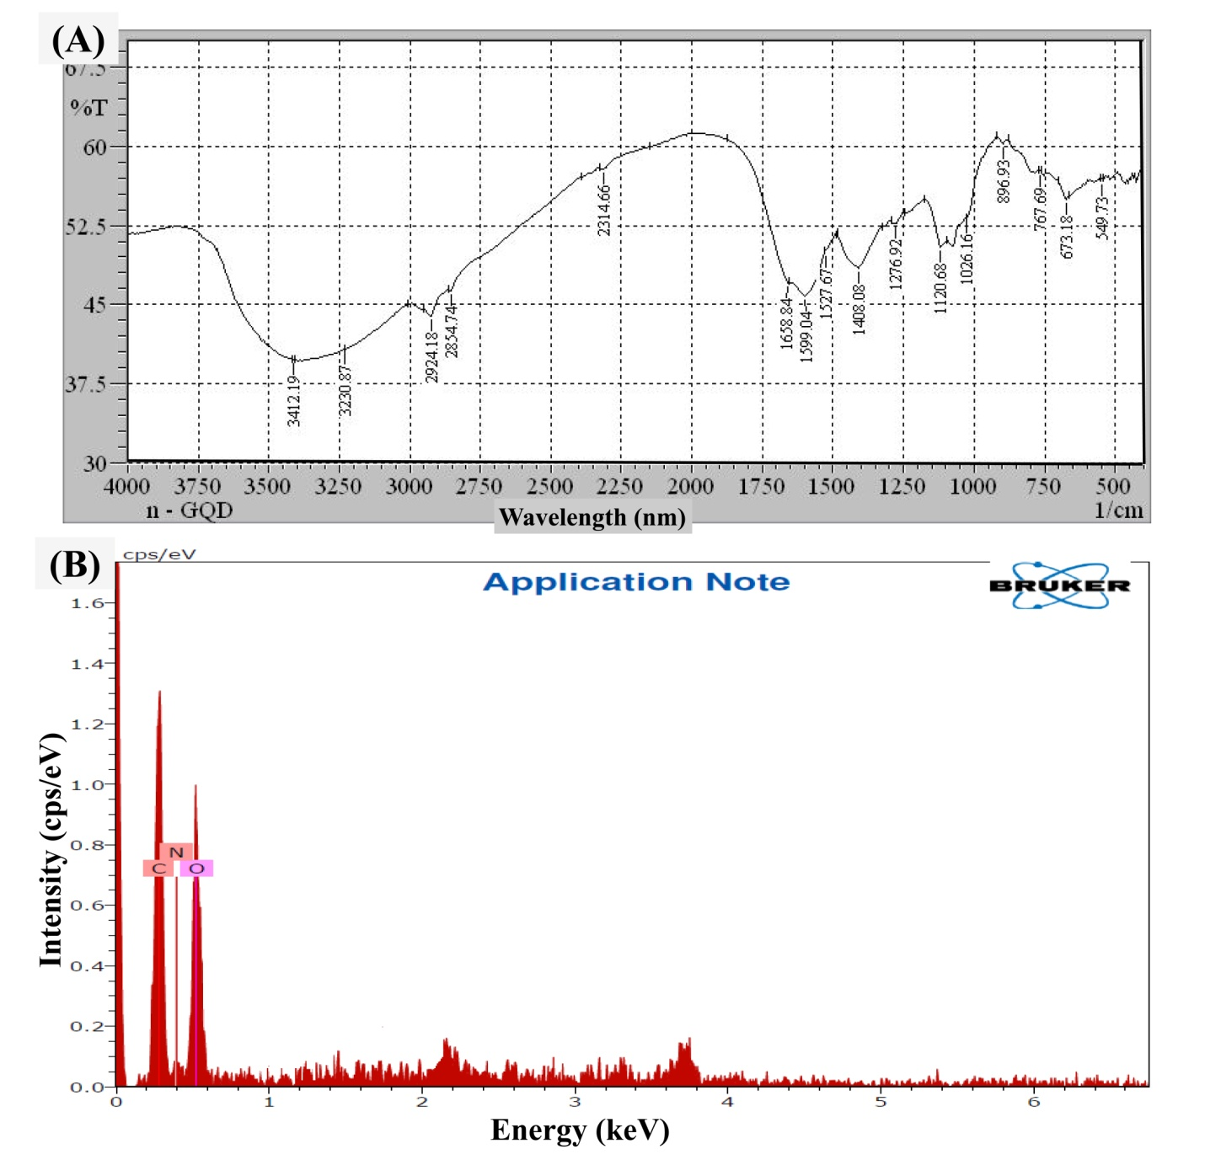
Figure 2: (A) FTIR Spectra of N-GQDs, (B) EDAX spectra of N-GQDs
The elemental analysis of synthesized N-GQDs was conducted for confirmation of the presence of C, O, and N (Figure 2B). It provides the details of wt. % of these mentioned elements in N-GQDs. Herein, the presence of C, O, and N was found to be 41.09 wt%, 49.00 wt%, and 9.91 wt% respectively. Therefore, the existence of these elements demonstrates the successful formation of the N-GQDs.²⁴ Moreover, the confirmation of the amide group in N-GQDs can form the hydrogen bonds between water molecules and N-GQDs, which improves the water solubility of N-GQDs.¹⁷

Particle size is the foremost critical factor since particle size is a potential technique for confirming the transformation of a micro-sized structure to a nano-sized structure. The particle size of synthesized N-GQDs was found to be 12.6 ± 11.1 nm that confirming the synthesis of nanosized N-GQDs (Figure 3A). Whereas, the polydispersity index (PDI) was found to be 0.35, which assure that the prepared N-GQDs show the uniform distribution in media. The zeta potential of N-GQDs was checked to confirm the surface chare as well as stability. As a result, the zeta potential of N-GQDs was found to be -35-53 mV (Figure 3B) which assures prepared N-GQDs exhibited good stability.
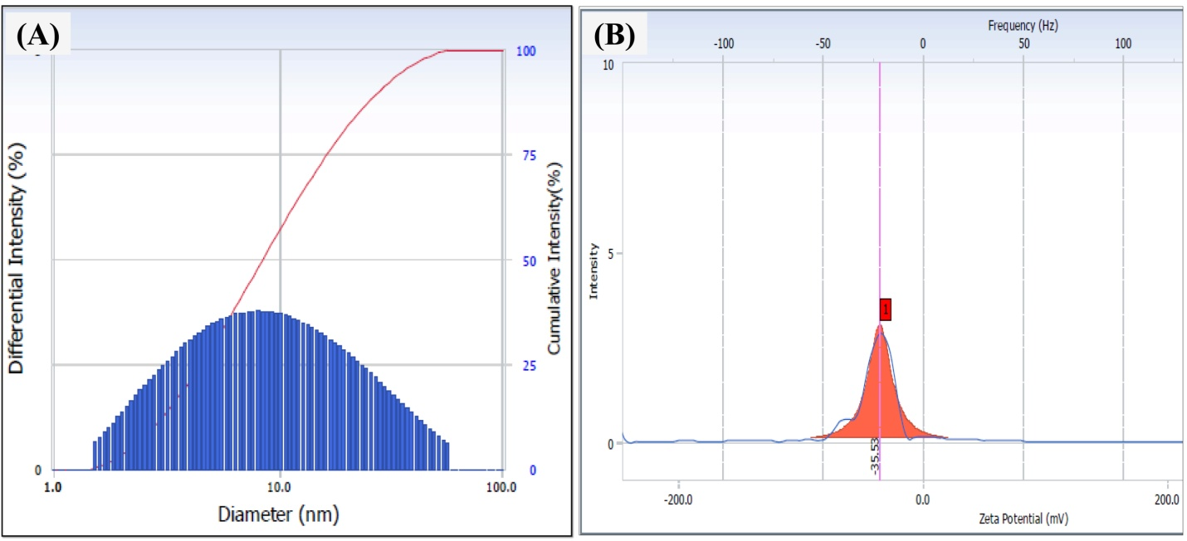
Figure 3: Particle size analysis (A) and zeta potential (B) of green synthesized N-GQDs
The morphological features of purified N-GQDs were characterized using HRTEM. As depicted in Figure 3A, the GQDs are small, rounded, and uniformly dispersed with an average particle of size 7 nm. Moreover, the typical lattice spacing was found to be 0.23 nm that demonstrated a graphitic structure of green synthesized N-GQDs. Figure 3B showed the selected area diffraction (SAED) pattern of N-GQDs. In brief, SAED patterns suggested that the N-GQDs were crystalline. In conclusion, it confirmed the successful synthesis of nanosized N-GQDs.¹⁷
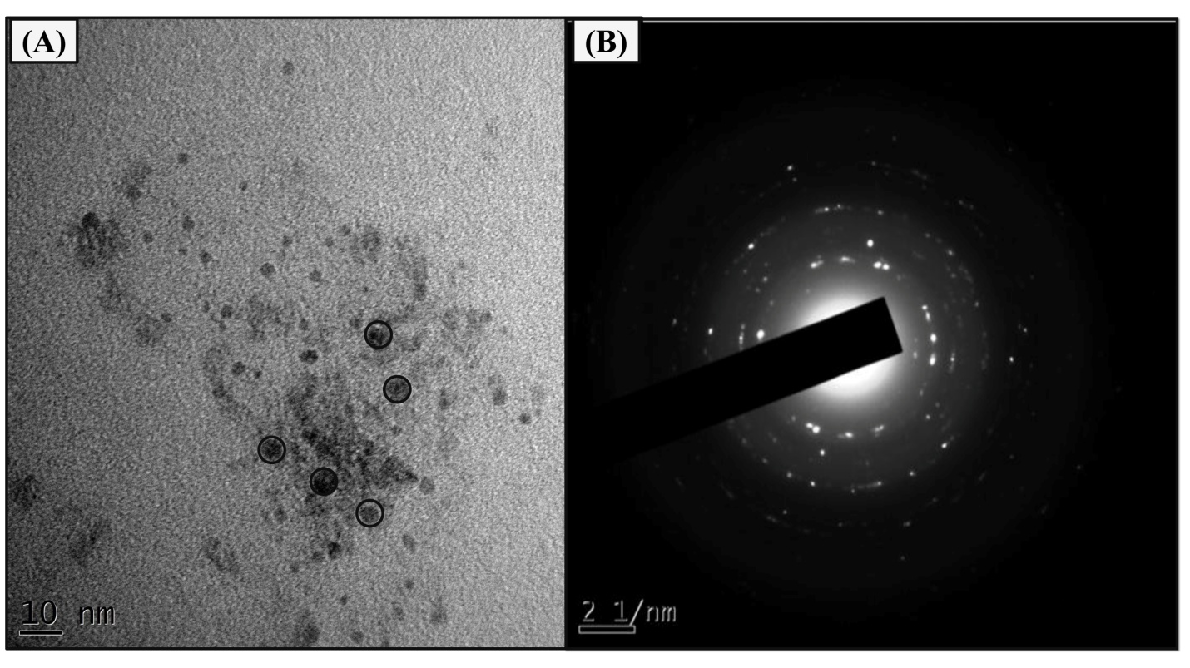
Figure 4: (A) HRTEM and (B) SAED images of N-GQDs
3.2. pH-dependent fluorescence study of N-GQDs
Nitrogen doping is a feasible approach for altering the electrical, chemical, and structural functions of GQDs to boost their efficiency in sensing applications. The synthesized N-GQDs solution was excited at different excitation wavelengths from 300 to 400 nm length, with an increment of 10 nm, slit width is 5 nm and scanning range is 315-525 nm at 25 °C (Figure 4A). The N-GQDs showed the emission at 400 nm when excited from 300 nm to 330 nm and the emission peak was decreased and shifted towards the longer wavelength when excited from 340 nm to 400 nm. The strongest emission peak was obtained at 400 nm when excited at 330 nm. In this study, the emission spectrum of the N-GQDs was showed excitation-dependent PL behavior. Literature survey reported that the shift in emission peak positions with different excitation wavelengths is depending on several key factors such as quantum confinement effect, size effect, elemental composition, edge states, surface functional groups, conjugated π-domains, and defects in the carbon framework.¹⁰ The effect of pH on synthesized N-GQDs was also studied by fluorescence spectroscopy. Fluorescence intensity of N-GQDs at different pH was shown in Figure 4B. The synthesized N-GQDs were dispersed in a solution of varying pH mainly 1, 3, 7, 9, and 12. As a result, the synthesized N-GQDs show the highest fluorescence intensity at neutral pH, whereas the N-GQDs fluorescence intensity was decreased significantly in acidic as well as basic pH. Therefore, neutral pH was selected for further sensing study of UA. The Quantum yield (QY) of synthesized N-GQDs was found to be 23.78%. Figure 4B concludes that the neutral pH (7) has the highest fluorescence intensity as compared to acidic pH (1, 3) and basic pH (9, 12). Owing to protonation or deprotonation of N-GQDs, it gives a carbene-like triplet state that causes quenching of photoluminescence.^{25, 26}
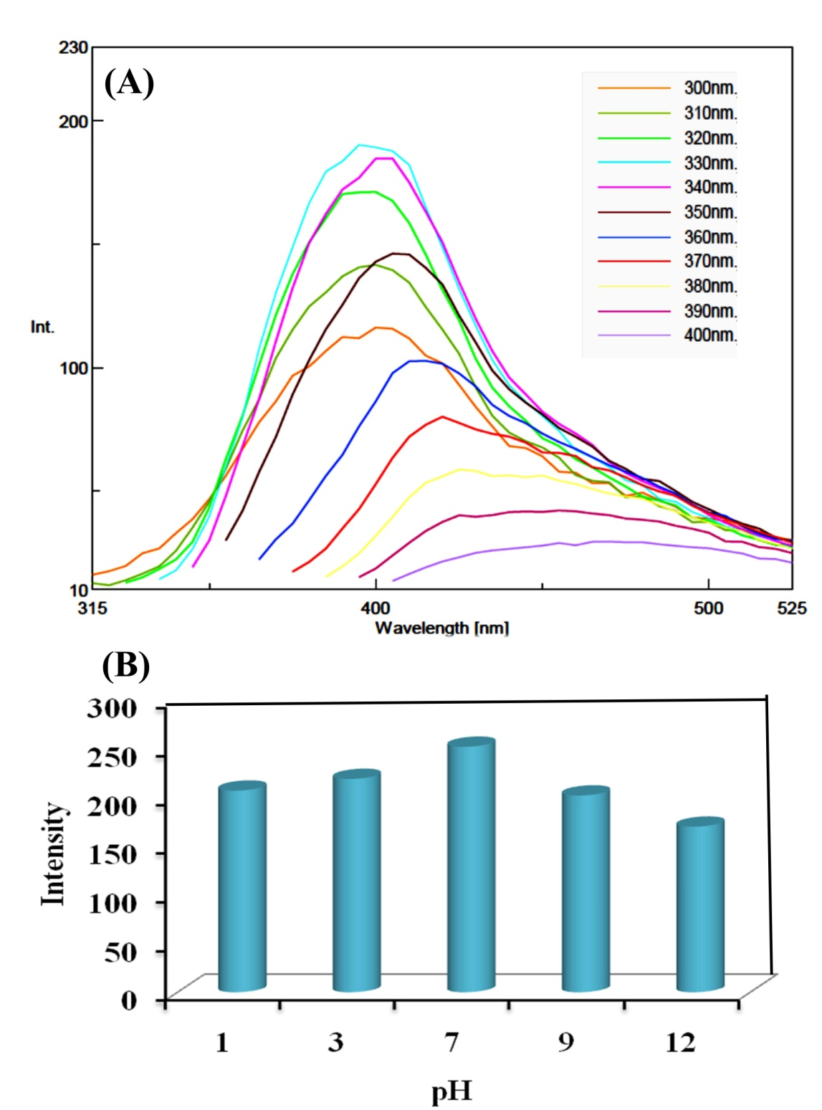
Figure 4: (A) Fluorescence spectra of N-GQDs at different excitation wavelength pH study; (B) Fluorescence intensity of N-GQDs at different pH

3.3. Detection of UA using N-GQDs
The fluorescence quenching of N-GQDs was studied by adding different concentrations of UA at 25 °C. The quenching of fluorescence upon addition of UA was shown in Figure 5A. The Fluorescence of N-GQDs observed in the UV cabinet was shown in Figure 5B. To study the sensitivity of N-GQDs for UA detection, different concentrations of UA were added to the aqueous solution of N-GQDs followed by measurement of fluorescence intensities. When UA with concentrations ranging from 10 to 1000 μm was added to the as-prepared N-GQDs, the fluorescence intensity of N-GQDs was gradually decreased at 245 nm. Presents the relationship of the fluorescent quenching value ΔF = F₀ – F*100 (F₀ and F are the fluorescence intensities of N-GQDs at 400 nm in the absence and presence of UA, respectively) in varying concentrations of UA (Figure 5C). The ΔF has a good linear relationship with the concentration of UA in the range of 10− 1000 μM, and the linear regression equation is ΔF = 0.354x + 3.579 with a correlation coefficient of 0.96. The lowest detection limit of12 nM was obtained based on a 3δ/S. Notably, the N-GQDs were exhibited as hydrophilic that may be due to the continuation of surface nitrogen, oxygen functionality. This hydrophilic surface can facilitate the better accessibility of interest analytes in the aqueous media to ‘C’ surface. Mainly, it may due to the high surface coverage, and more efficient adsorption. This mechanism can alter the surface ion interaction at the edge or on the basal plane of N-GQDs by the modification of surface charge properties. Besides, occurrence of oxygen functionalities offers more interaction among the analyte and carbon surface of N-GQDs.¹³ Literature survey divulged that nitrogen doping on nanomaterials surface could change the electrical conductivity and alter the bandgap. Additionally, it can produce electronic defects that can increase the charge transfer ability of nanomaterials. Accordingly, it gives good sensitivity and stability.²⁷ It is notable that the doping of nitrogen not only enhanced the QY but also improves the chelation ability like oxygen functional groups with the presence of a target marker such as UA that offers the effectual quenching of fluorescence.¹²
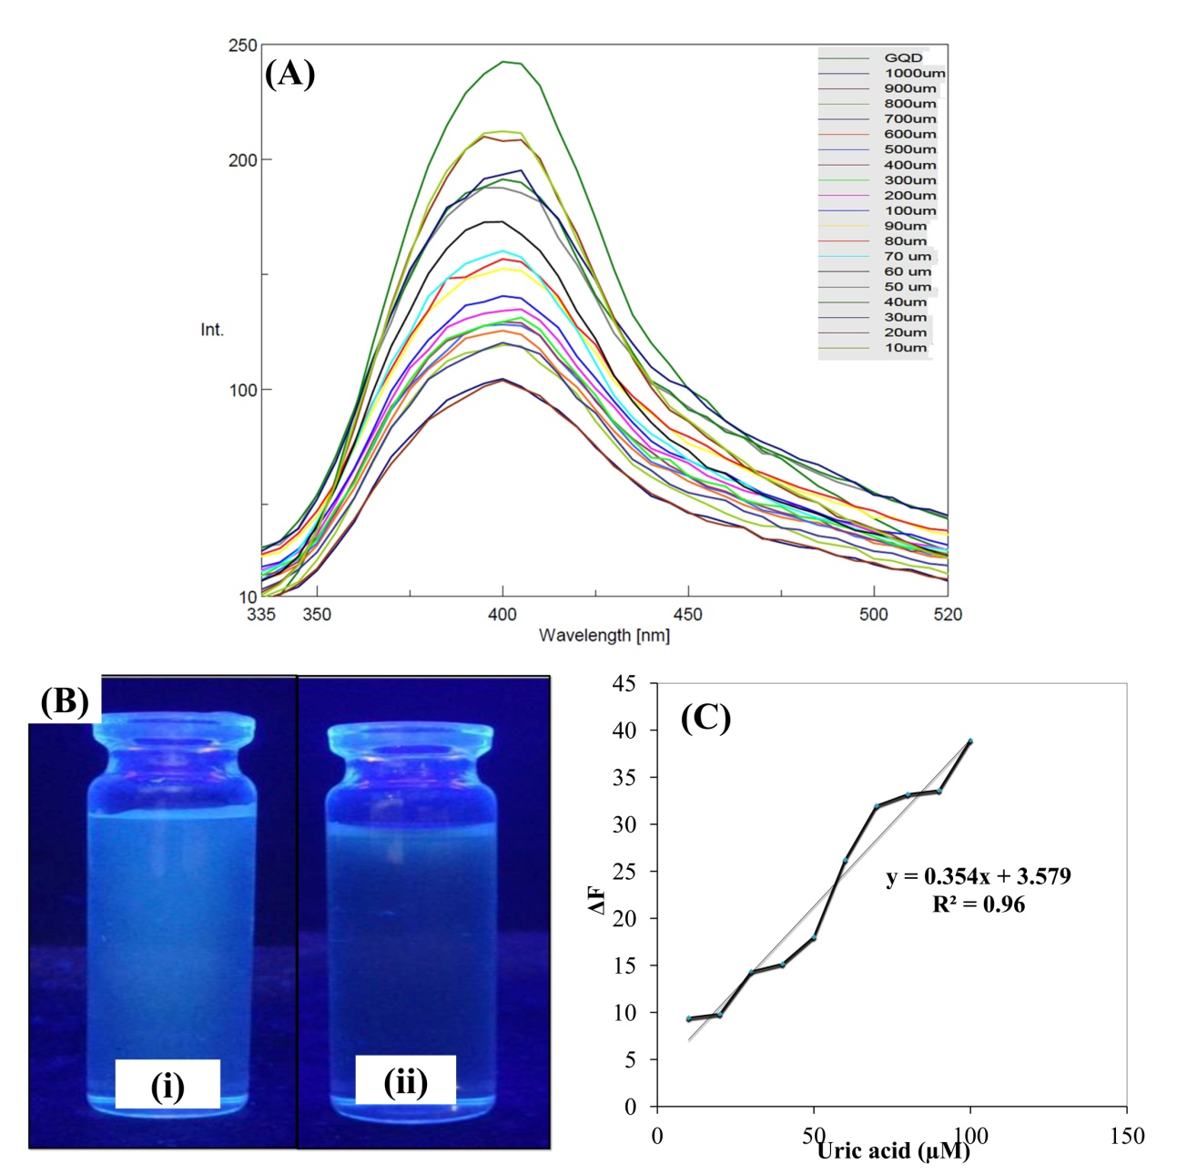
Figure 5: (A) Fluorescence spectra of N-GQDs with different concentrations of UA; (B) Fluorescence of N-GQDs, B) Fluorescence of N-GQD after addition of UA; (C) Fluorescence quenching linearity curve (ΔF vs UA concentration ranging from 10 - 100 μM).
3.4. Interference study
To estimate the selectivity of the proposed method for the determination of UA, the effects of some common metal ions and biomolecules such as NaCl, KCl, CaCl₂, AgNO₃, lysine, glycine, alanine, glucose, sucrose, and lactose were investigated (Figure 6). Common ions and biomolecules had little effect (or slight quenching effect) on the fluorescence of N-GQDs, which was considered to be tolerable. In addition, the fluorescent color alters of N-GQDs upon adding the common ions and biomolecules can be examined by naked eye below the UV lamp. The result showed that numerous metal ions and biomolecules had no obvious interference in the detection of UA. These results demonstrate that the method possesses a good selectivity for the determination of UA. Hence, N-GQDs could be a promising biosensing stage for UA detection in complex samples.
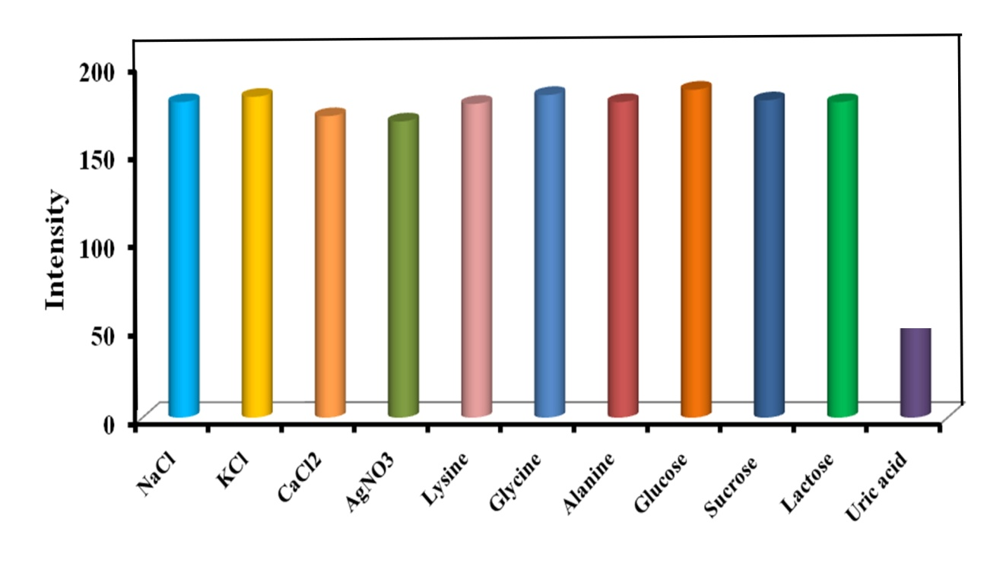
Figure 6: Fluorescence intensity in presence of different ions and biomolecules
4. Conclusion
Compared to methods reported in previous studies for N-GQDs synthesis, we have reported a single step, facile and green synthesis method, which is more economical and less time-consuming. The as-synthesized N-GQDs emitted strong blue color fluorescence with particle size in nm and showed good stability at neutral pH. Importantly, N-GQDs formation was confirmed by UV and FTIR spectral studies, whereas complete conversion of N-GQDs from precursor material was confirmed from HRTEM, EDAX, and fluorescence spectroscopy. Finally, the N-GQDs are used as a biosensor for sensitive and selective detection of UA. Under the optimum condition, a good linear response for UA was found in the range of 10-1000 μM with a detection limit of 12 nM. In comparison with another method, the proposed method is simple, low cost, and less time-consuming with good linearity, high sensitivity, and specificity. In the future, N-GQDs can be synthesized from different kinds of waste materials, which are present in nature and can be used for the determination of UA in human plasma and urine samples.
Declaration of interest
The authors declare no conflict of interest.
Acknowledgment
Authors are thankful to H. R. Patel Institute of Pharmaceutical Education and Research, Shirpur and Sophisticated Test and Instrumentation Center (STIC), Cochin (Kerala), India, for providing necessary facilities.
References
- J. Du, R. Yue, Z. Yao, F. Jiang, Y. Du, P. Yang and C. Wang, Colloids Surf A: Physicochem Eng Asp 2013, 419, 94-99.
- M. Alam, A. M. Asiri, M. Uddin, M. Islam, M. R. Awual and M. M. Rahman, New J Chem 2019, 43, 8651-8659.
- N. Chauhan and C. S. Pundir, Anal Biochem 2011, 413, 97-103.
- Y. Saito, A. Tanaka, K. Node and Y. Kobayashi, J Cardiol 2020, 78, 51-57
- H. Liu, X. Li, M. Wang, X. Chen and X. Su, Analytica chimica acta 2017, 990, 150-156.
- A. Vernerová, L. K. Krčmová, B. Melichar and F. Švec, Clin Chem Lab Med (CCLM) 2020, 59,797-812
- K. Shi and K. K. Shiu, Electroanalysis: An International Journal Devoted to Fundamental and Practical Aspects of Electroanalysis 2001, 13, 1319-1325.
- J. Lu, Y. Xiong, C. Liao and F. Ye, Analytical Methods 2015, 7, 9894-9899.
- Q. Li, Y. Qiu, W. Han, Y. Zheng, X. Wang, D. Xiao, M. Mao and Q. Li, RSC Adv 2018, 8, 25808-25814.
- R. S. Tade, S. N. Nangare, A. G. Patil, A. Pandey, P. K. Deshmukh, D. R. Patil, T. N. Agrawal, S. Mutalik, A. M. Patil and M. P. More, Nanotechnology 2020, 31, 292001.
- R. S. Tade and P. O. Patil, ACS Biomater Sci Eng 2020, 6, 5987-6008.
- J. Ju, R. Zhang, S. He and W. Chen, Rsc Adv 2014, 4, 52583-52589.
- S. Gu, C.-T. Hsieh, Y.-Y. Tsai, Y. Ashraf Gandomi, S. Yeom, K. D. Kihm, C.-C. Fu and R.-S. Juang, ACS Appl Nano Mater 2019, 2, 790-798.
- M. Kaur, M. Kaur and V. K. Sharma, Adv Colloid Interface Sci 2018, 259, 44-64.
- Y. Li, Y. Zhao, H. Cheng, Y. Hu, G. Shi, L. Dai and L. Qu, J Am Chem Soc 2012, 134, 15-18.
- G. S. Kumar, R. Roy, D. Sen, U. K. Ghorai, R. Thapa, N. Mazumder, S. Saha and K. K. Chattopadhyay, Nanoscale 2014, 6, 3384-3391.
- F. Lu, Y.-h. Zhou, L.-h. Wu, J. Qian, S. Cao, Y.-f. Deng and Y. Chen, Int J Opt 2019, 2019. DOI: 10.1155/2019/8724320
- Y. Yang, X. Xiao, X. Xing, Z. Wang, T. Zou, Z. Wang, R. Zhao and Y. Wang, Mater Res Express 2019, 6, 095615.
- F. Yang, W. Bao, T. Liu, B. Zhang, S. Huang, W. Yang, Y. Li, N. Li, C. Wang and C. Pan, Microchim Acta 2020, 187, 1-10.
- H. M. Kashani, T. Madrakian and A. Afkhami, New J Chem 2017, 41, 6875-6882.
- J. Yu, C. Xu, Z. Tian, Y. Lin and Z. Shi, New J Chem 2016, 40, 2083-2088.
- Z. Yan, X. Qu, Q. Niu, C. Tian, C. Fan and B. Ye, Anal Methods 2016, 8, 1565-1571.
- J. Ju, S. Regmi, A. Fu, S. Lim and Q. Liu, J Biophotonics 2019, 12, e201800367.
- J. Soleymani, M. Hasanzadeh, M. H. Somi, S. A. Ozkan and A. Jouyban, Int J Biol Macromol 2018, 118, 1021-1034.
- N. R. Mohanty, Kansas State University, 2011. Web:https://krex.k-state.edu/dspace/handle/2097/9264
- Q. Li, B. Chen and B. Xing, Environ Sci Technol 2017, 51, 1364-1376.
- K. Jindal, M. Tomar and V. Gupta, Analyst 2013, 138, 4353-4362.

