Crystallography and DFT Studies of Synthesized Tetraketones
Elma Veljović¹, Krešimir Molčanov², Mirsada Salihović¹, Una Glamočlija^{1,3,4}, Amar Osmanović^{1*}, Nevzeta Ljubijankić⁵, Selma Špirtović-Halilović¹

¹ University of Sarajevo, Faculty of Pharmacy, Zmaja od Bosne 8, 71 000 Sarajevo, Bosnia and Herzegovina
² Ruđer Bošković Institute, Bijenička 54, 10000 Zagreb, Croatia
³ University of Mostar, School of Medicine, Bijeli Brijeg bb, 88000 Mostar, Bosnia and Herzegovina
⁴ Bosnalijek JSC, Scientific-Research Unit, Jukićeva 53, 71 000 Sarajevo, Bosnia and Herzegovina
⁵ University of Sarajevo, Faculty of Science, Department of Chemistry, Zmaja od Bosne 35, 71000 Sarajevo, Bosnia and Herzegovina
*Corresponding author: amar.osmanovic@ffsa.unsa.ba
ABSTRACT
Two novel tetraketone derivatives were synthesized, whose structures have been confirmed by elemental analyses, NMR, HPLC-MS, and IR spectroscopy. The crystal structures of synthesized tetraketones were determined using X-ray single-crystal diffraction. To analyze the molecular geometry and compare with experimentally obtained X-ray crystal data of synthesized compounds 1 (2,2'-((4-nitrophenyl)methylene)bis(5,5-dimethylcyclohexane-1,3-dione)) and 2 (2,2'-((4-hydroxy-3-methoxy-5-nitrophenyl)methylene)bis(5,5-dimethylcyclo hexane-1,3-dione)), DFT calculations were performed with the standard 6-31G*(d), 6-31G**, and 6-31+G* basis sets. The calculated HOMO-LUMO energy gap for compound 1 was -4.6 eV and this small gap value indicated that compound 1 is chemically more reactive compared to compound 2 whose energy gap was -3.70 eV. Both compounds' calculated bond lengths and bond angles were in very good accordance to experimental values determined by X-ray single-crystal diffraction.

Keywords: Tetraketones, X-ray diffraction, DFT, HOMO-LUMO energies
- INTRODUCTION
Tetraketones (2,2'-(arylmethylene)bis(5,5-dimethyl-2-cyclohexane-1,3-diones)) represent an important class of compounds that have shown beneficial pharmacological effects in vitro. They are widely used as important precursors in the synthesis of various acridindiones as laser dyes and some heterocyclic compounds, xanthendiones and thioxanthenes.¹ Tetraketones exhibit antioxidant, antibacterial and antiviral effects.² These compounds are well studied as the inhibitors of the enzyme lipooxygenase.³ Tetraketones are being evaluated as prospective medicines in the treatment of inflammatory diseases, bronchiolitis, carcinoma, and autoimmune illnesses since lipooxygenases represent a potential target for rational drug design and identification of mechanism-based inhibitors for these conditions.^{4,5}
These compounds were studied by X-ray crystallography (X-ray), nuclear magnetic resonance (NMR), and molecular modeling, revealing important information about structure and conformation, such as the presence of intramolecular hydrogen bonds.⁶⁻⁹ One of the most important studies was conducted by Forsen et al. in 1969 when they determined by NMR that 2,2'-arylmethylene-bis(3-hydroxy-5,5-dimethyl-2-cyclohexene-1-ones) are found as dienol tautomers. As a result, these compounds are referred to as tetraketones in the literature (Fig.1).¹⁰

Fig. 1. Tetraketones and their keto-enol tautomeric forms.

- MATERIALS AND METHODS
  - Synthesis of tetraketone (2,2'-(arylmethylene)bis(5,5-dimethyl-2-cyclohexane-1,3-dione)) derivatives
Benzaldehyde (1 mmol), 5,5-dimethylcyclohexane-1,3-dione (2 mmol), and diazobicyclo(2.2.2)octane (DABCO) (0.05 g) were refluxed in water (20 mL). Thin-layer chromatography was used to monitor the reaction's flow and completion. Tetraketones are obtained approximately after 20 minutes of reflux. If the reflux is continued for more (30 minutes or more), reaction leads toward formation of the 9-aryl substituted 3,3,6,6-tetramethyl-3,4,5,6,7,9-hexahydro-1H-xanthene-1,8(2H)-diones.¹¹ The mixture was cooled to room temperature, filtered, and rinsed with water once the reaction was completed. Recrystallization of the resulting compounds was performed from 96% ethanol.¹² All chemicals have been obtained from Merck (Germany).
Newly synthesized compounds were obtained through Knoevengel condensation of aromatic aldehyde and Michael addition with 5,5-dimethylcyclohexandione-1,3-dione (Fig. 2). In this article, we present two new tetraketones whose structures have been confirmed by elemental analysis, IR, NMR spectroscopy and HPLC-MS spectrometry.

Fig. 2. Synthesis of 2,2’-(arylmethylene)bis(5,5-dimethyl-2-cyclohexane-1,3-dione) derivatives.

  - Characterization of Synthesized Products
Elemental analysis: For the synthesized tetraketone derivatives, elemental analysis was performed at the Institute of Chemistry, Technology and Metallurgy, Center for Chemistry in Belgrade, Serbia, on the Vario EL apparatus III C, H, N, S / O Elemental Analyzer, Elementar Analysensysteme GmbH, Hanau-Germany.
IR spectroscopy: IR spectra of the synthesized compounds were recorded at the Bosnalijek Pharmaceutical Company Ltd., Sarajevo-Bosnia and Herzegovina, on the Shimadzu IR Prestige 21 apparatus in the wavelength range from 4500 to 700 cm⁻¹.
NMR: ¹H-NMR and ¹³C-NMR spectra for the synthesized compounds were recorded at the Faculty of Science in Novi Sad, Serbia, using a Bruker AC 250 E apparatus. Compounds were recorded in deuterated chloroform using TMS (tetramethylsilane) as a reference.
HPLC-MS spectra: The mass spectra were recorded on an HPLC-MS triple quadrupole 6420 autosampler (Agilent Technologies, Palo Alto, CA, USA). The recordings were made at a temperature of 300 °C and a gas flow of 6 L min⁻¹. As the mobile phase, 0.1% formic acid in 50% methanol was used, at a flow rate of 0.2 mL min⁻¹. The spectra were processed using Agilent MassHunter software.
Melting point: The melting points of the synthesized compounds were determined at the Department of Pharmaceutical Chemistry, Faculty of Pharmacy in Sarajevo, Bosnia and Herzegovina, using the Melting point apparatus manufactured by Kruss Optronic, Germany.
X-ray diffraction: Single crystal measurements were performed on an Oxford Diffraction Xcalibur Nova R (microfocus Cu tube) at room temperature [293(2) K]. Program package CrysAlis PRO was used for data reduction.¹³ The structures were solved using SHELXS97 and refined with SHELXL97.¹⁴ The models were refined using the full-matrix least-squares refinement; all non-hydrogen atoms were refined anisotropically. Hydrogen atoms were modeled as riding entities using the AFIX command.
Table 1. Crystallographic data collection and structure refinement details.
Compound | 1 | 2
Empirical formula | C₂₃H₂₅NO₆ | C₂₄H₂₇NO₈
Formula wt. / g mol⁻¹ | 411.45 | 457.47
Crystal dimensions / mm | 0.12 x 0.10 x 0.09 | 0.14 x 0.11 x 0.08
Space group | P bc2₁ | P$\overline{1}$
a / Å | 23.5533(3) | 8.9958(3)
b / Å | 12.9754(1) | 9.3891(4)
c / Å | 28.1370(3) | 13.9171(6)
α / ° | 90 | 98.814(4)
β / ° | 90 | 99.380(3)
γ / ° | 90 | 90.925(3)
Z | 16 | 2
V / Å³ | 8599.05(16) | 1145.04(8)
D_{calc} / g cm⁻³ | 1.271 | 1.327
μ/ mm⁻¹ | 0.759 | 0.835
Θ range / ° | 3.14 – 75.83 | 3.26 – 75.95
T / K | 293(2) | 293(2)
Radiation vawelength | 1.54179 (CuKα) | 1.54179 (CuKα)
Diffractometer type | Xcalibur Nova | Xcalibur Nova
Range of h, k, l | –29<h<18;  –15<k< 15;  –30<l<35 | –11<h<8;  –11<k< 11;  –17<l<17
Reflections collected | 28964 | 10363
Independent reflections | 13399 | 4692
Observed reflections  (I ≥ 2σ) | 12660 | 4108
Absorption correction | Multi-scan | Multi-scan
R_{int} | 0.0212 | 0.0207
R (F) | 0.0463 | 0.0488
R_{w} (F²) | 0.1313 | 0.1470
Goodness of fit | 1.034 | 1.049
H atom treatment | Constrained | Constrained
No. of parameters | 1081 | 299
No. of restraints | 1 | 0
Flack parameter | 0.11(7) | -
Δρ_{max} , Δρ_{min} (eÅ^{–3}) | 0.380; -0.199 | 0.338; -0.168

Molecular geometry calculations were performed by PLATON,¹⁵ and molecular graphics were prepared using ORTEP-3,¹⁶ and CCDC-Mercury.¹⁷ Crystallographic and refinement data for the structures reported in this paper are shown in Table 1.
Supplementary crystallographic data can be obtained free of charge via www.ccdc.cam.ac.uk/conts/retrieving.html (or from the Cambridge Crystallographic Data Centre, 12, Union Road, Cambridge CB2 1EZ, UK; fax: +44 1223 336033; or deposit@ccdc.cam.ac.uk). CCDC 1990310-1990311 contains the supplementary crystallographic data for this paper.¹⁸
  - Computational Details
Quantum chemical computations were done for compounds 1 and 2 with comprehensive geometry optimizations using standard Spartan 14 software. At the B3LYP/6-31G*, 6-31G**, and 6-31+G* levels of theory, geometry optimization was performed.¹⁹ The HOMO (highest occupied molecular orbital) and LUMO (lowest unoccupied molecular orbital) energy distributions, as well as the HOMO-LUMO energy gap, were calculated using these levels of theory. The results of the DFT analysis were compared to those experimentally obtained crystallographic data.
- RESULT AND DISSCUSION

  - Chemistry
According to described Knoevengel condensation of aromatic aldehyde and Michael addition with 5,5-dimethyl-1,3-cyclohexandione, we synthesized compounds 1 (2,2'-((4-nitrophenyl)methylene)bis(5,5-dimethylcyclohexane-1,3-dione)) and 2 (2,2'-((4-hydroxy-3-methoxy-5-nitrophenyl)methylene)bis(5,5-dimethylcyclohexane-1,3-dione)) (Fig. 3).

Fig. 3. Structures of synthesized tetraketones.
The characterization of synthesized compounds 1 and 2 was achieved by FT- IR, ¹H and ¹³C NMR spectroscopy, and HPLC-MS spectrometry.
1: Yield: 81%. Mp198–203 ºC. Anal. Calcd for C₂₃H₂₇N₁O₆: C 66.81, H 6.58. Found C 66.74, H 6.62. IR (KBr) ν 3000 (Ar-H), 1670 (C=O), 1480 (C=C), 1300 (C-O), 1500 (C=O), 1250 (NO₂) cm^{–1}. ¹H NMR (600 MHz, CDCl₃) δ 11.8 (br s, 1H, OH, disappears with D₂O), 8.13 (d, 2H, J_{2',3'} = 8.9 Hz, H-3', H-5'), 7.24 (d, 2H, J_{2',3'} = 8.9 Hz, H-2', H-6'), 5.53 (s, 1H, CH), 2.21–2.57 (m, 8H, 4xCH₂), 1.11 and 1.23 (2 x s, 12 H, 4xCH₃). ¹³C NMR (150 MHz, CDCl₃) δ 190.82 (C=O), 189.46 (C-2), 146.49–146.03 (Ar-C), 127.56, 123.40 (Ar-CH), 114.81 (C-1), 46.91, 46.32 (CH₂), 33.18 (CH), 31.39 (C from C(CH₃)₂), 29.38, 27.38 (CH₃ from C(CH₃)₂). MS m/z (relative intensity): 412.2 (M+H).
2: Yield: 88%. Mp 230–232ºC. Anal. Calcd for C₂₄H₂₇N₁O₈: C 62.73, H 6.36. Found: C 63.10, H 6.08. IR (KBr) ν 3300–2500 (Ar-OH), 3042 (Ar-H), 1730 (C=O), 1607, 1588 (C=C), 1448 (O-CH₃), 1320 (C-O), 1200 (Ar-OH), 1595 (NO₂) cm^{–1}. ¹H NMR (600 MHz, CDCl₃) δ 10.60 (br s, 1H, OH, disappears with D₂O), 7.44 (s, 1H, H-6′), 6.90 (s, 1H, H-2′), 5.43 (s, 1H, H-13), 3.83 (s, 3H, OCH₃), 2.54–2.22 (m, 8H, H-3, H-11, H-5, H-9), 1.25 (s, 6H, H-15, H-17), 1.12 (s, 6H, H-14, H-16). ¹³C NMR (150 MHz, CDCl₃) δ 190.94 (C-6, C-8), 189.45 (C-2, C-12), 149.59 (C-3′), 144.41 (C-5′), 133.60 (C-4′), 114.71 (C-1, C-7), 117.04 (C-2′), 114.01 (C-6′), 33.18 (C-13), 31.39 (C-4, C-10), 29.82 (C-15, C-17), 26.87 (C-14, C-16). MS m/z (relative intensity): 460 (M+H).
  - Description of the structures
The compound 1 crystallizes in a non-centrosymmetric space group P bc2₁ with four symmetry-independent molecules in the asymmetric unit (i.e. Z' = 4), labeled as a, b, c, and d (Fig. 4.).

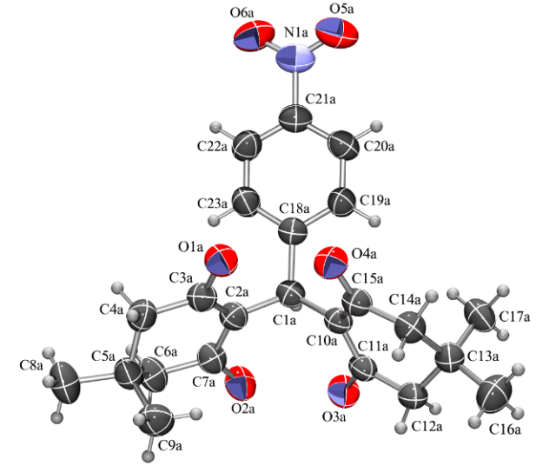a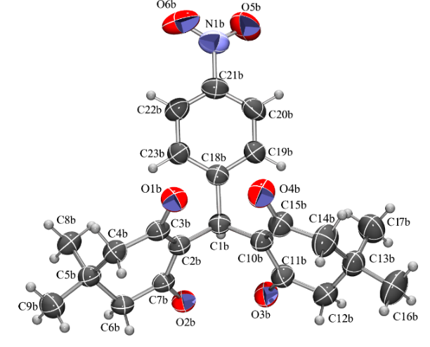b
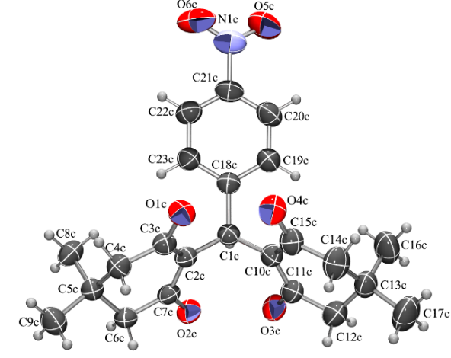c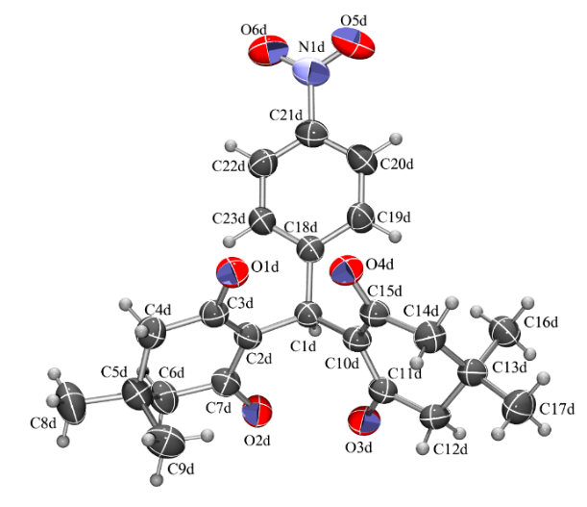d
Fig. 4. ORTEP-3 drawings of four symmetry-independent molecules in 1 with atom numbering schemes. Displacement ellipsoids are drawn for the probability of 50 % and hydrogen atoms are shown as spheres of arbitrary radii.
There are two conformers, with a different conformation of the ring C2→C6: one is comprised of molecules a and d, and the other of b and c. The rest of the molecule differs less than 3 e.s.d.'s (least-squares overlay is shown in Fig. 8. The compound lacks proton donors and no π-stacking is observed, so 3D packing (Fig. 5.) is achieved mainly through dispersion interactions.
The asymmetric unit of 2 contains one molecule (Fig. 6.), whose geometry and conformation are similar to those of 1 (Fig. 8). The molecule possesses a single proton donor, the O8-H8 hydroxyl group, which forms an intermolecular hydrogen bond with atom O5 of the nitro group as an acceptor. Crystal data and structure refinement summary of compounds 1 and 2 are given in Tables 2. and 3. Dispersion interactions are responsible for the 3D packing (Fig. 7).

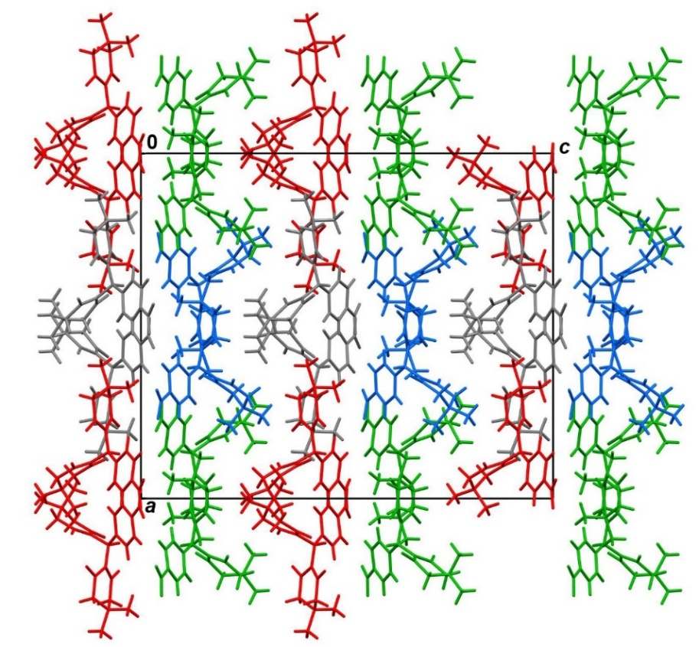
Fig. 5. Crystal packing of 1 viewed in the direction [010]. Symmetry-independent molecules are shown in different colors: a are green, b are blue, c are red and d are gray.

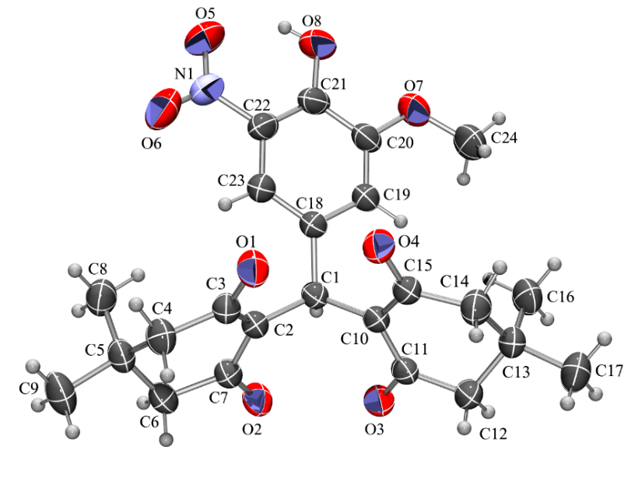
Fig. 6. ORTEP-3 drawing a molecule of 2 with the atom numbering scheme. Displacement ellipsoids are drawn for the probability of 50 % and hydrogen atoms are shown as spheres of arbitrary radii.

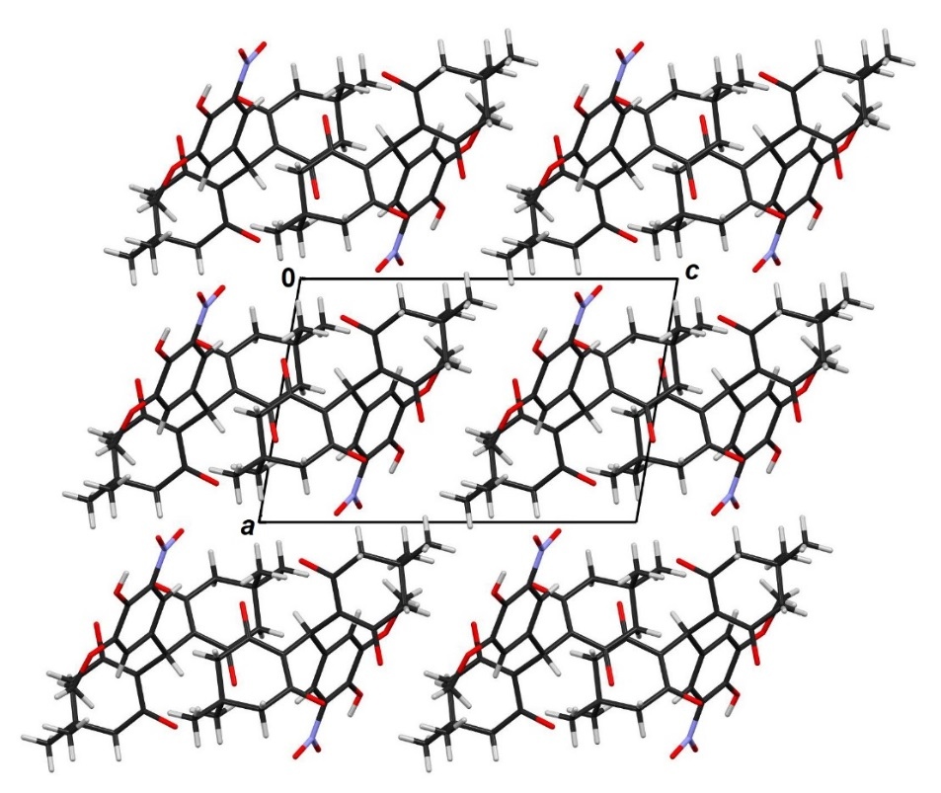
Fig. 7. Crystal packing of 2 viewed in the direction [010].

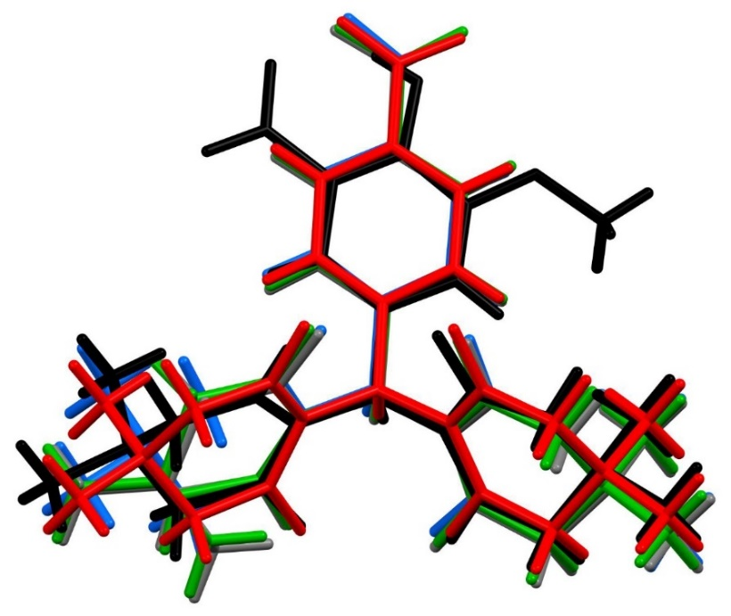
Fig. 8. Least-squares overlay of four symmetry-independent molecules of 1 (a is green, b is blue, c is red and d is gray) and 2 (black).

Table 2. Geometric parameters of hydrogen bonds and angles.
 | Cpd (D–H···A) | d(D–H)  (Å) |  |  | d(H···A)  (Å) |  | d(D···A)  (Å) |  | φ(D–H···A)  (°)
 |  |  | Exp | Calc | Exp | Calc | Exp | Calc | Exp | Calc | Symm. op. on A
1 | C1A–H1A∙∙∙O2A |  | 0.98 | 1.01 | 2.41 | 2.38 | 2.855(3) | 2.678 | 107 | 101 | x, y, z
1 | C1A–H1A∙∙∙O3A |  | 0.98 | 1.01 | 2.43 | 2.25 | 2.858(3) | 2.680 | 106 | 109 | x,y, z
1 | C1B–H1B∙∙∙O2B |  | 0.98 | 1.01 | 2.42 | 2.53 | 2.871(3) | 2.701 | 107 | 109 | x, y, z
1 | C1B–H1B∙∙∙O3B |  | 0.98 | 1.01 | 2.38 | 2.40 | 2.842(3) | 2.710 | 108 | 110 | x, y, z
1 | C1C–H1C∙∙∙O2C |  | 0.98 | 1.01 | 2.41 | 2.47 | 2.863(3) | 2.715 | 107 | 109 | x, y, z
1 | C1C–H1C∙∙∙O3C |  | 0.98 | 1.01 | 2.39 | 2.42 | 2.850(3) | 2.370 | 108 | 110 | x, y, z
1 | C1D–H1D∙∙∙O2D |  | 0.98 | 1.01 | 2.38 | 2.45 | 2.842(3) | 2.790 | 108 | 110 | x, y, z
1 | C1D–H1D∙∙∙O3D |  | 0.98 | 1.01 | 2.44 | 2.48 | 2.865(3) | 2.800 | 106 | 109 | x, y, z
1 | C20B–H20B∙∙∙O2A |  | 0.93 | 0.99 | 2.54 | 2.60 | 3.295(4) | 3.100 | 138 | 141 | x, −1+y,z
1 | C20D–H20D∙∙∙O6A |  | 0.93 | 0.99 | 2.53 | 2.58 | 3.434(4) | 3.110 | 165 | 163 | x, 3/2−y, 1/2+z
1 | C22B–H22B∙∙∙O6D |  | 0.93 | 0.99 | 2.57 | 2.61 | 3.458(4) | 3.120 | 160 | 161 | 1−x, 1−y, −1/2+z
1 | C22D–H22D∙∙∙O2D |  | 0.93 | 0.99 | 2.51 | 2.56 | 3.199(3) | 3.010 | 131 | 129 | 1−x, 1/2+y, z
2 | O8–H8∙∙∙O5 |  | 0.82 | 0.99 | 1.89 | 1.84 | 2.578(3) | 2.308 | 141 | 140 | x,y,z
2 | O8–H8∙∙∙N1 |  | 0.82 | 0.99 | 2.50 | 2.41 | 2.911(2) | 3.04 | 113 | 117 | x,y,z
2 | C1–H1∙∙∙O2 |  | 0.98 | 1.09 | 2.35 | 2.35 | 2.843(18) | 2.82 | 110 | 115 | x,y,z
2 | C1–H1∙∙∙O3 |  | 0.98 | 1.09 | 2.40 | 2.44 | 2.8506(1) | 2.81 | 108 | 106 | x,y,z
2 | C12–H12B∙∙∙O1 |  | 0.97 | 1.09 | 2.53 | 2.84 | 3.480(2) | 3.10 | 165 | 170 | 1+x,y, z

Table 3. Bond lengths [Å] and angles [°] of compounds 1 (molecule A, only) and 2.
Bond length and angles | Compound 1  Exp. Cal. | Compound 2  Exp. Cal.
C(1)-C(2) | 1.526(4) 1.548 | 1.5204(18) 1.548
C(1)-C(10) | 1.528(3) 1.557 | 1.5246(19) 1.556
C(10)-C(11) | 1.402(3) 1.530 | 1.3944(19) 1.530
C(11)-C(12) | 1.487(4) 1.520 | 1.499(2) 1.520
C(2)-C(3) | 1.402(4) 1.546 | 1.395(2) 1.545
C(21)-O(8) | ----- ----- | 1.345(2) 1.340
C(21)-N(1) | 1.470(4) 1.469 | ----- -----
N(1)-O(6) | 1.230(4) 1.232 | 1.211(3) 1.255
C(7)-O(2) | 1.279(4) 1.211 | 1.285(19) 1.340
C(11)-O(3) | 1.292(3) 1.215 | 1.297(19) 1.215
C(2)-C(1)-C(10) | 113.6(2) 113.2 | 115.2(11) 118.0
C(10)-C(11)-O(3) | 123.1(3) 124.0 | 123.0(13) 122.4
C(10)-C(11)-C(12) | 122.2(2) 119.4 | 121.5(14) 121.1
C(2)-C(3)-O(1) | 122.9(3) 120.0 | 123.3(13) 125.2
C(2)-C(3)-C(4) | 122.0(2) 122.9 | 121.2(13) 119.9
C(20)-C(21)-C(22) | 122.0(3) 122.7 | 116.9(14) 116.4
C(21)-N(1)-O(5) | 118.4(3) 120.0 | 118.2(19) 119.0
C(21)-N(1)-O(6) | 118.2(3) 119.8 | 119.8(16) 120.3

Compared calculated and experimentally obtained values in both Table 2 and Table 3 show very good accordance, differing mostly only in the second decimal place. Similar investigation and comparison of theoretical and experimental data, with good accordance for synthesized compounds, has been reported before.^{20,21}
  - Analysis of Molecular Orbital
The energy gap HOMO-LUMO of the molecules has a role in deciding its bioactivity and is an important parameter for quantum chemistry. The molecule becomes harder and more stable or less reactive when the HOMO–LUMO energy gap increases.²² The HOMO energy distinguishes electron donor capacity, whereas the LUMO energy distinguishes electron acceptor capacity, and the gap defines chemical stability.²³ The energy gap HOMO-LUMO for the compounds 1 and 2 were calculated by 6-31G*, 6-31G**, and 6-31+G* basis sets and these values were -4.60, -4.57, and -4.58 for compound 1 and -3.73, -3.69, and -3.70 for compound 2. The energies and energy gaps of HOMO and LUMO are shown in Table 4. The HOMO-LUMO orbital schemes for compounds 1 and 2 are shown in Fig. 9. (The positive phases are red, and the negative phases are blue).
Table 4. Calculated HOMO and LUMO energy values for compounds 1 and 2.
Parameters | B3LYP/6-31G*, B3LYP/6-31G**; B3LYP/6-31+G*  Compound 1 |  | B3LYP/6-31G*, B3LYP/6-31G**; B3LYP/6-31+G*  Compound 2
E_{HOMO} (eV) | -6.85 -6.87 -6.84 | -6.85 -6.87 -6.84
E_{LUMO} (eV) | -2.25 -2.30 -2.26 | -2.53 -2.58 -2.54
Energy gap (Δ) | 4.60 4.57 4.58 | 3.73 3.69 3.70

Fig. 9. Frontier molecular orbitals of compound 1 (a) and compound 2 (b).
Compound 1 HOMO electron density demonstrates that the HOMO is localized on carbonyl C groups, methyl, and benzene, while compound 2 HOMO is concentrated on hydroxyl and methoxy groups. The HOMO-LUMO energy gap for compound 1 is 4.60 and compound 2 is 3.73, indicating that an electron density passes from carbonyl C groups, methyl, and methoxy groups to hydroxyl and nitro groups. Compound 1 has a higher HOMO-LUMO energy gap than compound 2, making it less reactive and hence more stable. The descriptor of electron donor and acceptor is implicitly explained by the HOMO to LUMO transition to comprehend their interaction capabilities with their target molecules.

- CONCLUSIONS

The tetraketones (compounds 1 and 2) were successfully synthesized with excellent yield by condensation of aromatic aldehyde and Michael addition with 5,5-dimethylcyclohexane-1,3-dione. The synthesized compounds 1 and 2 were characterized using ¹H and ¹³C NMR, FTIR, HPLC-MS methods, and elemental analysis. Using single-crystal X-ray diffraction data, we presented the structural details of tetraketone compounds 1 (C₂₃H₂₅NO₆) and 2 (C₂₄H₂₇NO₈). To analyze the molecular geometry and compare it to experimentally available X-ray crystal data of investigated compounds, DFT calculations were done using a standard 6-31G*(d), 6-31G**, and 6-31+G* basis sets. For compound 2, the computed HOMO-LUMO energy gaps for basis set 6-31G*(d), 6-31G**, and 6-31+G* were 3.73, 3.69, and 3.70, respectively. Compound 2 is chemically more reactive than compound 1 based on these smaller gap values. The theoretically determined HOMO-LUMO energy gaps can be employed to describe the biological activity of the title compounds. The crystal structure is stabilized by both intramolecular and intermolecular hydrogen bonds, with the intermolecular N–H…O hydrogen bond in compound 2 generating the N1 and O8 chain motif. The bond lengths and angles calculated for compounds 1 and 2 were in very good accordance with the experimental values obtained from X-ray crystal diffraction.

- REFERENCES

- K. Khan, G. Maharvi, M. Khan, A. Jabbar Shaikh, S. Perveen, S. Begum, M. I. Choudhary, Bioorg. Med. Chem. 2006, 14, 344-351.
- R. W. Lambert, J. A. Martin, J. H. Merrett, K. E. B. Parkes, J. G. Thomas, PCT Int. Appl., WO 9706178 Chem. Abstr. 1997, 126, 212377y.
- S. Ali, G. M. Maharvi, N. Riaz, N. Afza, A. Malik, A. U. Rehman, M. Lateef, L. Iqbal, West Indian Med. J. 2009, 58, 92-98.
- G. M. Maharvi, S. Ali, N. Riaz, N. Afza, A. Malik, M. Ashraf, L. Iqbal, M, Lateef, J. Enzyme Inhib. Med. Chem. 2008, 23, 62-69.
- F. K. Rad, F. K. Behbahani, Curr. Org. Synth. 2017, 14, 22-39.
- M. Bolte, M. A. Scholtyssik, Acta Crystallogr., Sect. C: Cryst. Struct. Commun. 1997, 53, 1869-1871.
- M. Bolte, A. Degen, S. Rühl, Acta Crystallogr., Sect. C: Cryst. Struct. Commun. 2001, 57, 446-451.
- J. N. Low, J. Cobo, S. Cruz, J. Quiroga, C. Glidewell, Acta Crystallogr., Sect. C: Cryst. Struct. Commun. 2003, 59, 666-668.
- M. Sigalov, R. Vainer, V. Khodorkovsky, J. Mol. Struct. 2010, 977, 230-236.
- S. Forsen, W. Frankle, P. Laszlo, J. Lubochinsky, J. Magn. Reson. 1969, 1, 327-338.
- S. Zukić, E. Veljović, S. Spirtović-Halilović, S. Muratović, A. Osmanović, S. Trifunović, I. Novaković, D. Zavrsnik, Croat. Chem. Acta 2018, 91, 1-9.
- P. Paliwal, S. Jetti, A. Bhatewara, T. Kadre, S. Jain, ISRN Org. Chem. 2013, Article ID 526173, 6 pages, DOI: 10.1155/2013/526173.
- CrysAlis PRO, Oxford Diffraction Ltd., U.K., 2007.
- G. M. Sheldrick, Acta Crystallogr. 2008, 64, 112-122.
- A. L. Spek, J. Appl. Cryst. 2003, 36, 7-13.
- L. J. Farrugia, J. Appl. Cryst. 1997, 30, 565.
- C. F. Macrae, P. R. Edgington, P. McCabe, E. Pidcock, G. P. Shields, R. Taylor, M. Towler, J. ven de Streek, J. Appl. Cryst. 2006, 39, 453-457.
- F. H. Allen, Acta Crystallogr., Sect. B: Struct. Sci. 2002, 58, 380-388.
- M. Salihović, A. Osmanović, S. Špirtović-Halilović, S. Roca, A. Meščić, L. Vujisić, S. Trifunović, D. Završnik, E. Sofić, J. Mol. Struct. 2015, 1091, 170-176.
- U. Glamočlija, S. Špirtović-Halilović, M. Salihović, I. Turel, J. Kljun, E. Veljović, S. Zukić, D. Završnik, Acta Chim. Slov. 2021, 68, 144-150.
- M. Jayaraman, R. Balakrishnan, K. Muthu, M. Panneerselvam, V. Gnanasambandam, K. Ramadas, J. Crystallogr. 2014, Article ID 369061, DOI:10.1155/2014/369061.
- A. A. Kadhum, A. A. Al-Amiery, M. Shikara, A. Mohamad, Int. J. Phys. Sci. 2011, 6, 6692-6697.
- T. S. Xavier, I. H. Joe, Spectrochim. Acta, Part A 2011, 79, 332-337.

