Synthesis, Characterization, Biological Activities and Ab-initio Study of Transition Metal Complexes of [Methyl 2-((4-chlorophenyl)(hydroxy)methyle) acrylate]
¹Shazia Ishfaq, ²*Shazia Nisar, ³Saqib Ali, ⁴Sadaf Iqbal, ⁵Saima Imad, ⁶Samina Iqbal, ⁷Saeeda Bano, ⁸Syeda Kanwal Zahid, ⁹Nasreen Fatima, ¹⁰Muhammad Shahzaman,
^{1,2,4,8,9} Department of Chemistry, Faculty of Sciences, University of Karachi, 75270, Pakistan: shaziaashfaq006928@gmail.com, shazian@uok.edu.pk , sadaf_chem26@yahoo.com , skrj92@gmail.com, dr_nfatima1@yahoo.com
³Department of Chemistry, Faculty of Sciences, University of Kotli, 11100, Pakistan: saqibali.chem@gmail.com
^{5,6,7}PCSIR Laboratories Complexes, Karachi, 75270, Pakistan: saimaimad@gmail.com , iqbalsamina1@gmail.com, saedabano@hotmail.com
¹⁰School of Atmospheric Sciences, Nanjing University of Information Science and Technology, Nanjing 210044, China: mshahzaman786@nuist.edu.cn
*E-mail: shazian@uok.edu.pk, Phone No.00923343519338
ABSTRACT
Keeping in view the medicinal significance and diverse functions of synthetic Morita-Baylis-Hillman adducts (MBHA), the title ligand was synthesized and purified through column chromatography. Cr⁺³, Mn⁺², Co⁺³, Ni⁺², Cu⁺² complexes of the ligand were synthesized under basic condition. The characterization of the complexes was done through spectral analyses and verified with the IR spectrum generated computationally by the Hartree Fock (HF) B3LYP method in conjunction with the 3-21G(d,p) basis set. While, powder XRD helped to identify crystal class of the complexes. Moreover, the antibacterial, and antioxidant potential of MBHA and complexes were determined. All were found to be active antioxidants. The antibacterial activities, examined against four bacterial strains (S. aureus, E. coli, B. pumilis, S. typhi), have revealed that Cobalt complex has an excellent potential against all of them. Hence, these compounds can have potentialities for the discovery of new, cheaper and efficient drugs against various infectious diseases. Additionally, the study demonstrates as first example of utilization of MBHA in metal complex formation.
Key Words: MBH Adduct, Transition Metal Complexes, XRD, Antibacterial Activities, Antioxidant Activities

1. INTRODUCTION
The significance of Carbon-Carbon bond forming reaction that involves the coupling of the α-position of activated alkenes with carbon electrophiles under the influence of a catalyst cannot be overlooked in atom economy.^{1,2} The reaction ends up in the formation of Michael type dimers. There are many synthetic routes by which effectual and perfect C‒C bond emerging reactions can takes place.³ Additionally, medicinally relevant pharmaceutical compounds and natural products are very useful multifunctional building blocks for C‒C bond formation which is a major constituent of the synthetic organic chemistry.^{4,5} Besides this, Morita-Baylis-Hillman (MBH) compounds, especially carbonates, aldehydes, esters and acetates based derivatives are important intermediates in the synthesis of different structures. These compounds have become important as MBH originators and represent a valuable class of substrates for synthetic purposes and derivatives, widely examined as intermediates in the preparation of significant classes of compounds as building blocks for natural products. Moreover, Michael/aldol cyclic reactions, indorsing multiple C–C bond formations, also lead to important carbon frames that can be intentionally employed in drug synthesis.⁶ The MBH reaction is mainly a three-component reaction between the α-position of activated alkenes e.g ethyl or methyl acrylate, acrylonitrile and methyl vinyl ketones and electrophilic sp² carbon of aldehyde or imines in the presence of an appropriate catalyst, usually a tertiary amine or phosphine.⁵ The resulting Morita-Baylis-Hillman adducts (MBHA) have diverse functionalities and versatile reactivity. Consequently, they have been used widely as powerful precursors for the building of various carbocyclic, heterocyclic and biologically important compounds.⁷ These compounds are economical, biological friendly, perform number of functions and most importantly can be synthesized following green- one-step synthetic protocols. The antifungal, antimalarial, antitubercular activities of some MBHAs have been reported.⁸ The antileishmanial/antibacterial activities of some MBHA indicate that they can prove to be a novel and promising class of anti-parasitic compounds.^{9,10}
A discovery unlocked the entrance of an uncharted world of metal-based chemotherapeutic agents which have dissimilar kinetics and mechanism of action from those of traditional organic medications. Curative potentialities of metal complexes in tumor/cancer therapy as well as other biological functions intricate a ration of attention typically because central metals exhibit some special features. These metal-based complexes have variable coordination modes, curing drug activity and excellency in reactivity in the direction of the organic substrate.^{11,12} The metal complexation of ligands containing oxygen, nitrogen, hydroxyl, or ester functional groups with metals like copper, zinc, cobalt, and iron represent numerous finely-tuned activities such as antihypertensive, antimalarial, and antimicrobial. In addition, transition metal ion complexes are known to have an efficient electron transfer role in many biological processes.¹³ Though metals have long been used for medicinal purposes in a more or less empirical fashion, a wide variety of chelating number and geometrical forms, redox states, thermodynamic and kinetic properties of the metal cation and ligand itself suggest the medicinal chemist a wide spectrum of reactive sites that can be highly moralized.¹⁴ Thus, the biological diversity of the transition metal complex along with its pharmacological specificity is to be measured. Promising physiological responses of the applicant drugs need to be demonstrated by in vitro study with targeted biomolecules and tissues as well as in-vivo. Therefore, studies pertaining to ligands with multiple, medicinally dynamic binding sites may serve as models for biochemical processes.^{11,15,16} In this context, the wide variety of potent biotic activities of MBHA encouraged us to synthesize new series of products belonging to this class of compounds, possessing different functionalities and exhibiting potential antioxidant activity. Keeping in view the significance of reported research on synthetic MBH adducts as medicinally important candidates and having the diversity of functions, we conferred them as ligands for the novel drugs synthesis based upon their transition metal complexes. The present study designates synthesis, characterization, and computational studies of halo/chloro-benzaldehyde based MBH adducts and some of their novel metal complexes.
2. MATERIALS AND METHODS
2.1. General
In the present study various solvents such as n-hexane, methanol and ethyl acetate of synthetic grade were used. In addition, 4-Chlorobenzaldehyde (Sigma Aldrich), DABCO (Sigma Aldrich), Methyl Acrylate (Dae-Jung Kosdaq Reagents and Chemicals), NaCl (Sigma Aldrich), MgSO₄ anhydrous (Sigma Aldrich), NaOMe (Dae-Jung Kosdaq Reagents and Chemicals), CuCl₂.2H₂O (Sigma Aldrich), MnCl₂.2H₂O (Sigma Aldrich), NiCl₂.6H₂O (Sigma Aldrich), CoCl₃.6H₂O (Sigma Aldrich) and CrCl₃.6H₂O (Sigma Aldrich) were applied. UV lamp (monitoring TLC card), Digital hot plate with constant temperature and stirring system, Gallen Kamp melting point instrument, LAMBDA 1050+ UV/Vis/NIR spectrophotometer, FTIR Spectrophotometer of Shimadzu Company prestige-21, Mass spectrophotometer instrument of JEOL 600H1, for transition metal complexes used Electrospray ionization mass spectrometry (ESI MS) at QTrap hybrid triple-quadrupole (QTrap 2000, Applied Biosystems/MDS Sciex) and XRD Pananalytical company X-pro serial No. DYH313 for powder diffraction were the major instruments used for data analysis.
2.2. Synthesis of MBHA (Methyl 2-((4-chlorophenyl)(hydroxy)methyle) acrylate) L1
MBHA was prepared by addition of 5 equivalents of methyl acrylate to 4-chloro benzaldehyde (1 equivalent). The reaction mixture was further treated with 0.65 equivalents of Lewis base DABCO in round bottomed flask with constant stirring at room temperature. The progress of the reaction was monitored at regular intervals of one hour through TLC under UV lamp and the completion time was recorded 24 hours. The excess of methyl acrylate was evaporated which furnished gummy crude material upon complete evaporation. This was diluted further with 15 mL of each, ethyl acetate and brine solution. The organic layer developed in this mixture was separated through separating funnel, collected and process repeated thrice. Furthermore, the organic phase was concentrated by removing EtOAc through evaporation and concentrated crude was subjected to column chromatographic purification. Mobile phase system of ethyl acetate and n-hexane in ratio of 5:95 to 35:65 (v/v) was used. The main spot collected as product in pure form and was confirmed through its spectral analysis.^{7,9,17} Preparation of the MBHA is shown in scheme 1.
Scheme 1. Morita-Baylise Hillman reaction with e.g. aldehydes by using tertiary amine (DABCO) as catalyst at room temperature and other standard reaction conditions
A pearl white color gummy mass was found in the form of pure product of C₁₁H₁₁ClO₃ (compound 3) yield 80% (226.66 g/mol). B.P: 125.3-125.5℃. IR data (KBr: νmax, cm^{–1}): 3446, 2953, 2897, 1714, 1631, 1487, 1440, 1278, 1151, 1045,827 and 540. UV-visible data in DMSO [λ, nm (ε, M–1 cm–1)]: 267(124.23). [(m/z) M⁺, Cal./Obs.(%)] for C₁₁H₁₁ClO₃: 227 (56) M⁺, 207 (25), 191 (100), 160 (90), 132 (66), 104 (70), 77 (64)
2.3. Synthesis of metal complexes with ligand MBHA (L1)
About 20 mL of 0.02M each metal salt solutions in distilled water and 0.04M solution of L1 in hot ethanol were prepared separately (1:2). The metal salt solution was added in adduct solution drop wise, few drops of NaOH were added to maintain the pH 11 at continued stirring. The reaction mixture was refluxed at 60-70 °C with constant stirring for 3-5 hours until solid mass formed in the mixture.^{15,18} Only one spot appeared for the desired molecule on TLC strip suggesting its purity. After completion of the reaction (complete solid mass formation), the reaction mixture flask was cooled slowly at room temperature and precipitates were collected using vacuum filtration. The precipitates were washed thrice with ethanol and distilled water, the obtained product was dried in desiccator. The deduced structural formula of the each transition metal complex was shown in scheme 2.
Scheme 2. Molecular modifications by reacting the MBHA as Ligand with transition metal salts to synthesize corresponding metal complexes
2.4. Analytical data of transition metal complexes
CrL1 complex (compound 4) 577.37(g/mol), Light blue: m.p: >300℃. IR data (KBr: νmax, cm^{–1}): 3500-3380, 2915, 2980, 1708, 1625, 1550, 1438, 1382, 1105, 835, 603 and 520. UV-visible data in DMSO [λ, nm (ε, M^{–1} cm^{–1})]: 262(145.9). [(m/z) M⁺, Cal./Obs.(%)] for C₂₂H₃₀Cl₂O₁₀Cr³⁺: 192.02(100)/192.69(65.1)M⁺.
CoL1 complex (compound 5) 584.31(g/mol), Dark brown: m.p: >300℃. IR data (KBr: νmax, cm^{–1}): 3500-3400, 2935, 1651, 1620, 1483, 1386, 1109, 837, 653, 607 and 518. UV-visible data in DMSO [λ, nm (ε, M^{–1} cm^{–1})]: 260(136.58). [(m/z) M⁺, Cal./Obs.(%)] for C₂₂H₃₀Cl₂O₁₀Co³⁺:194.35(100)/195.02(63.9) M⁺.
NiL1 complex (compound 6) 548.04 (g/mol), Parrot green: m.p: >300℃. IR data (KBr: νmax, cm^{–1}): 3450-3350, 3005, 2850, 1640-1566, 1643, 1566, 1463, 1388, 1109, 609 and 455. UV-visible data in DMSO [λ, nm (ε, M^{–1} cm^{–1})]: 255(139.54). [(m/z) M⁺, Cal./Obs.(%)] for C₂₂H₂₆Cl₂O₈Ni²⁺: 274.01(100)/273.02(97.6)M⁺.
MnL1 complex (compound 7) 544.28(g/mol), Blackish brown: m.p: >300℃. IR data (KBr: νmax, cm^{–1}): 3505-3310, 3005, 2980, 1629, 1500, 1566, 1386, 1111, 748, 603 and 523. UV-visible data in DMSO [λ, nm (ε, M^{–1} cm^{–1})]: 253(128.10). [(m/z) M⁺, Cal./Obs.(%)] for C₂₂H₂₆Cl₂O₈Mn²⁺: 271.52(100)/272.52(65.6)M⁺.
CuL1 complex (compound 8) 552.89 (g/mol), Paris green: m.p: >300℃. IR data (KBr: νmax, cm^{–1}): 3480-3350, 3115, 2980, 1673, 1604, 1521, 1388, 1112, 746, 605 and 486. UV-visible data in DMSO [λ, nm (ε, M^{–1} cm^{–1})]: 250(161.10). [(m/z) M⁺, Cal./Obs.(%)] for C₂₂H₂₆Cl₂O₈Cu²⁺: 276.51(100)/275.51 (89.5)M⁺.
2.5. Computational Studies
All the calculations were performed with the Gaussian 16W program package on a ACPI x64 Core i7 laptop with 3.0 GHz processor and 16 GB Ram.¹⁹ The molecular structures of ligand and metal complexes, in the ground state are optimized by using the Hartree-Fock (HF),²⁰ and 3-21G (d,p) basis set.²¹ The vibrational frequencies were also calculated along with optimization. The assignment of the calculated wave numbers is aided by the animation option of Gauss View 6.0 graphical interface for Gaussian program,²² which gives a visual presentation of the shape of the vibrational modes.
2.6. X-Ray Diffraction
The XRD study (powder pattern) of the complexes were made with the help of X-ray diffractometer (Goniometer Radius mm=240.00 and Dist. Focus-Diverg. Slit mm=91.00) with Cu- anode material, Kα [A˚] =1.54060 and the generator settings 30 mA, 40 kV.
2.7. Antibacterial assay
The antibacterial activity of L1 and its complexes was evaluated by agar diffusion method,^{23,24} against two Gram-negative bacteria (Staphylococcus aureus, Escherichia coli) and two Gram- positive bacteria (Bacillus pumilis, Salmonella typhi). All extracts were sterilized by sterile membrane syringe filter (pore size 0.45µm, Millipore). For assay, 1mL of culture suspension of each strain (25% transmittance, 530nm) was added in 100 mL antibiotic agar No.11 (45°C) and mixed well. 25mL of inoculated agar was poured in each petri dish (20×100mm) and kept for solidification. After solidification 4 holes were made using sterile borer of 8mm diameter with 6mm internal diameter. Holes were marked and each extract (100µL) was poured in the respective well, and incubated for 24 hours at 37°C. The experiment was performed in triplicate under strict aseptic conditions. After incubation, zone of inhibition (mm) produced by each extract was measured and antibacterial activity expressed in terms of percent inhibition. Gentamycin (0.3%) was used as a standard antibiotic in comparison to L1 and complexes.
2.8. DPPH Radical Scavenging Activity
The free radical scavenging action was determined by using the DPPH (2,2-diphenyl-1-picrylhydrazyl) radical scavenging method with some modification.^{25,26} The 0.3mM solution of DPPH was prepared in methanol. 10μL of each sample of different concentration (25μg - 100μg) was mixed with 1.0 mL of DPPH solution. The reaction mixture was incubated at 37°C for about 30 min. The absorbance at 515 nm was measured by spectrophotometer and percent radical scavenging activity was determined in comparison with the methanol treated control. Ascorbic acid was used as standard for further samples analysis.²⁷ By using this standard the antioxidant activity of the MBHA (L1) and its metal complexes have been determined and recorded in the Table 4.
3. RESULTS AND DISCUSSIONS
The present work was initiated with (i) the synthesis of ligand MBHA (C₁₁H₁₁ClO₃) (Scheme 1), its transition metal complexes with five biologically significant transition metal ions (Scheme 2), (ii) characterization of these compounds and finally (iii) their subsequent biological and antioxidant investigations. The UV-Visible spectroscopic results have revealed the formation of metal complexes, which observed between 250nm-265nm of wavelength in contrast to BMHA (L1) that shows a λ_{max} 267 nm. Additionally, the m/z ratio and relative abundance (%) of MBHA and its metal complexes was observed using Electrospray ionization-mass spectrometry (ESI-MS). ²⁸ The results of study confirm that each transition metal (Cr⁺³, Co⁺³, Ni⁺², Mn⁺², Cu⁺²) complex with MBHA (L1) has 1:2 stoichiometric ratios (Fig. 1).
Fig. 1. Theoretical optimized geometry of the (1a) MBHA (L1), and its corresponding complexes, (1b) CrL1, (1c) CoL1, (1d) NiL1, (1e) MnL1 and (1f) CuL1. The results have confirmed that each metal is coordinated by two ligand molecules, Cr⁺³, Co⁺³ are octahedral and Ni⁺², Mn⁺², Cu⁺² are tetrahedral as per optimized geometrical structures
3.1. Theoretical and Experimental FTIR Analysis of ligand (MBHA)/Compound 3
The FTIR spectra of MBHA (L1) and their complexes [M(L1)₂(H₂O)₄]⁺³, [M(L1)₂(H₂O)₂]⁺² were recorded between 4000–500 cm⁻¹ using KBr disk and the data is presented in Table-2. The FTIR data corresponding to compound 3, has shown the characteristics -OH broad peak in 3446 cm⁻¹, prominent stretch of =C-H at 2953 cm⁻¹ and Sp³ C-H stretch at 2897cm⁻¹. The band observed at 1714 cm⁻¹ is due to ester carbonyl vibration. Furthermore, the frequency (ν̄ ) of C=C aromatic, -CH₃, C-O and C-Cl were designated as 1631 cm^{-1,} 1440 cm^{-1,} 1278cm⁻¹ and 540 cm⁻¹ respectively (Fig. 2a).²⁹ Moreover, in computational IR analysis, it was observed that OH peak is somewhat different from the observed spectrum. This fact is because of the breadth of OH band appeared by the water vapors. It might be obtained due to greater number of OH ions appeared in the same intensity.³⁰ The peak intensities of left aforementioned fragments (Fig. 2b) in calculated spectrum more about the similar values. The slight change may observed because of the theoretical results presented to isolated functional groups in gaseous state, while the experimental calculations belong to the molecules in solid state.³¹
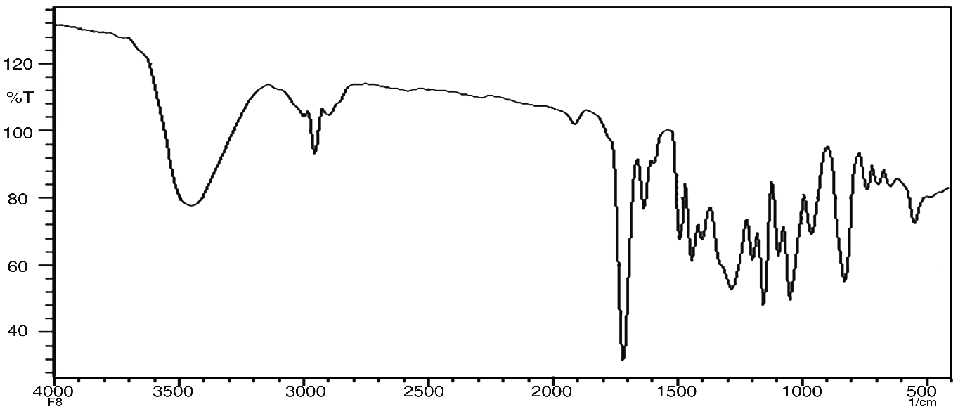
Fig. 2a. Experimental FTIR spectrum of Methyl 2-((4-chlorophenyl)(hydroxy)methyle) acrylate [MBHA (L1)]

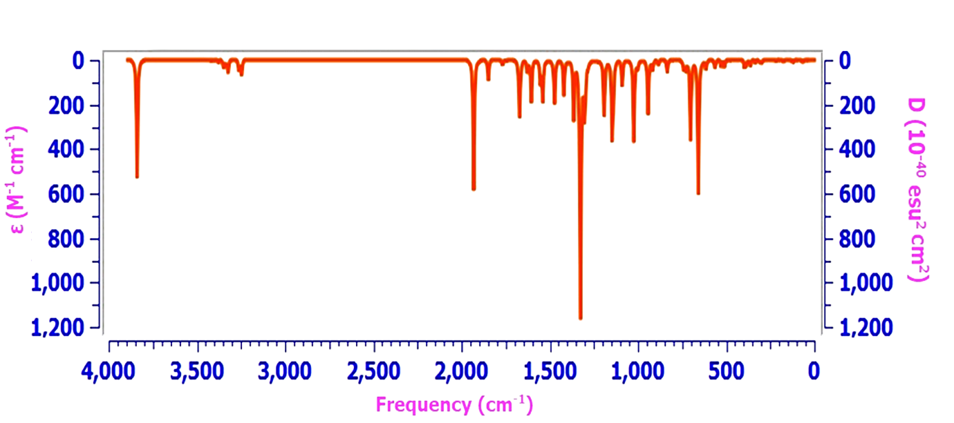
Fig. 2b. Theoretical FTIR spectrum of Methyl 2-((4-chlorophenyl)(hydroxy)methyle) acrylate [MBHA (L1)]
In Mass spectrum,⁸ a prominent peak of 226 m/z at 56.5% noted for M ^{+,} while 207 m/z (25%) , 191 m/z (100%), 160 m/z (90%), 132 m/z (66%), 104 m/z (70%) and 77 m/z (64%) for fragmentation peaks pertaining to synthesized MBHA were recorded.

3.2. Characterization of MBHA based on metal complexes
The transition metals (Cr⁺³, Co⁺³, Ni⁺², Mn⁺², Cu⁺²) complexes of MBHA (L1) were synthesized. Initially, Cr⁺³ based complex 4 of ligand was prepared by employing a reported method.³² The existence of a single complex specie in the reaction mixture and hence, the purity of the complex was confirmed through TLC, until a single spot was achieved on TLC plate (expected product 4) (Scheme 2). In addition to this, the major spot upon purification was subjected to UV- visible analysis, which presented considerable difference from MBHA band (expected product 4). By repeating the procedure with slight modification such as increasing the pH, precipitates were observed in 2.5 hours. Furthermore, the TLC analysis indicated 20-30 percent conversion with less spots and change in color. Based on current observation (TLC in 1.5h), any increase in the concentration of base up to 4M, maximum conversion of the reactants into product was observed (Scheme 2).
All the transition metal complexes (4-8) were subjected to characterization through their physical characteristics. Their molecular and structural formulae were established with the help of m/z ratio obtained through powder XRD and FTIR analyses. The data presented for m/z ratio of the ligand and compound 4-8 shows a good agreement between the calculated and observed values and thus support the suggested structures of the complexes.

3.3. Theoretical and Experimental FTIR Analysis of the Compounds 4-8
Table 1 provides the details of the experimental and computed IR vibrational frequencies of MBHA (compound 3) and metal complexes (compounds 4-8). Considering FTIR spectrum of compound 4, a broad band at 3500-3380 cm⁻¹ (–OH) can be observed, which might be either due to moisture or coordinated water in the complex. Moreover, we observed peak shifts toward lower frequency value for C=O group from a sharp peak of ligand at 1725 cm⁻¹ to a small peak at 1625 cm⁻¹. It suggests the coordination of carbonyl group through oxygen to the Cr⁺³ metal which ultimately reduces strength of the carbonyl group in complex. These results are also supported by literature.¹⁴ Similarly, the peaks of ligand and its C-O (of ester) appeared 1278 cm⁻¹ which showed a shift from 1105 cm⁻¹ (Table 1). Which may change because of environmental effect regarding C=O coordination towards the metal ion.^{33,34} Some additional peaks have also been observed to appear at 603 and 520 cm⁻¹. These peaks were assigned to Cr-O and Cr-Cl, respectively.³⁵ These findings have confirmed the participation of carbonylic functional group of the ligand in complex formation. No significant change in the IR frequency of C=C double bond was seen upon complex formation and hence, it is inferred that this group doesn’t participate in complexation (Fig. 1b). Based on these observations, the molecular and structural formulae of the compound 4 were deduced as [Cr(L1)₂(H₂O)₄]⁺³ .
In FTIR spectral results for the compound 5 we observed that –OH group has shown a broad signal ranging from 3400-3300 cm⁻¹. This signal was relatively at similar position as in the ligand. While comparing the C=C frequencies of both the ligand and complex 5, the peak was found to be slightly shifted from 1631 cm⁻¹ to 1620 cm⁻¹ which suggests that this functional group was not involved in coordination. The aromatic ring has shown frequencies (1604 and 1521cm⁻¹) almost at similar position as that of the ligand aromatic pi bonds which also suggests non coordination behavior of the aromatic ring in respective complex formation. A clearer signal appeared at 1651 cm⁻¹ was probably due to the carbonyl group and has significantly shifted from 1714 cm⁻¹ to 1651 cm⁻¹ upon complexation. This kind of shift has also been reported in literature,¹⁴ thus confirming the coordination of the ligand’s carbonyl site to the Co⁺³ metal. Another significant variation in the IR spectrum of complex was a slight shift to the higher frequencies in IR signal of C-O (of ester) i.e. ligand C-O frequency shifted from 1278 to 1386 (C-O of the complex) (Table 1). Additionally, a unique signal attributable to Co-O appeared at 607 cm⁻¹ and another noticeable variation in C-Cl frequency from 540 cm⁻¹ to 518 cm⁻¹ was also observed. Based on the overall information discussed above, the molecular formula [Co(L1)₂(H₂O)₄]⁺³ and structural formula (Fig. 1c) was established for the compound 5.
FTIR analysis for the Ni⁺² complex (compound 6) showed peaks for all the prominent functional groups along with some informative shifts which revealed the complex formation. Such as, an extremely weak band, almost negligible at 1640 cm⁻¹ correspond to carbonyl group which was comparatively at lower frequency than its precursor (Ligand) carbonyl absorption (1714 cm⁻¹). It suggests carbonyl coordination upon complex formation. Moreover, the peaks at 609 cm⁻¹ and 455 cm⁻¹ were assigned to Ni-O and C-Cl groups, respectively. Additionally the –OH and =CH groups exhibited peaks at 3450-3350 cm⁻¹ (broad) and 3005 cm⁻¹, respectively. Furthermore, we have also observed peaks for C=C bond at 1643 cm⁻¹ with no significant shift and simultaneously demonstrating that C=C do not participate in complexation (Fig. 1d). In spite of that we have also observed sharp peak instead at 3880-3886 cm⁻¹ of same (-OH) functional group. The difference is observed due to the presence of moisture in the compound, which has provided interference during recording of spectrum.³¹ Likewise, the remaining functional groups show a little change in the calculated values as is evident from their sharp pointed peaks at exact frequencies. In the observed spectrum these small peaks overlap with each other to give loops instead of sharp pointed peaks obtained in the theoretical spectrum (Fig. 3a & Fig. 3b).³⁰ Nevertheless, we have obtained good agreement in the observed and calculated values of frequencies and deduces the formula [Ni(L1)₂(H₂O)₂]⁺².³⁶

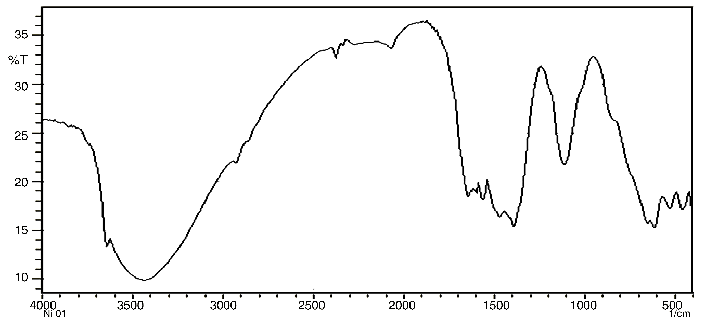
Fig. 3a. Observed FT-IR spectrum of Nickel Transition Metal with MBHA (L1)

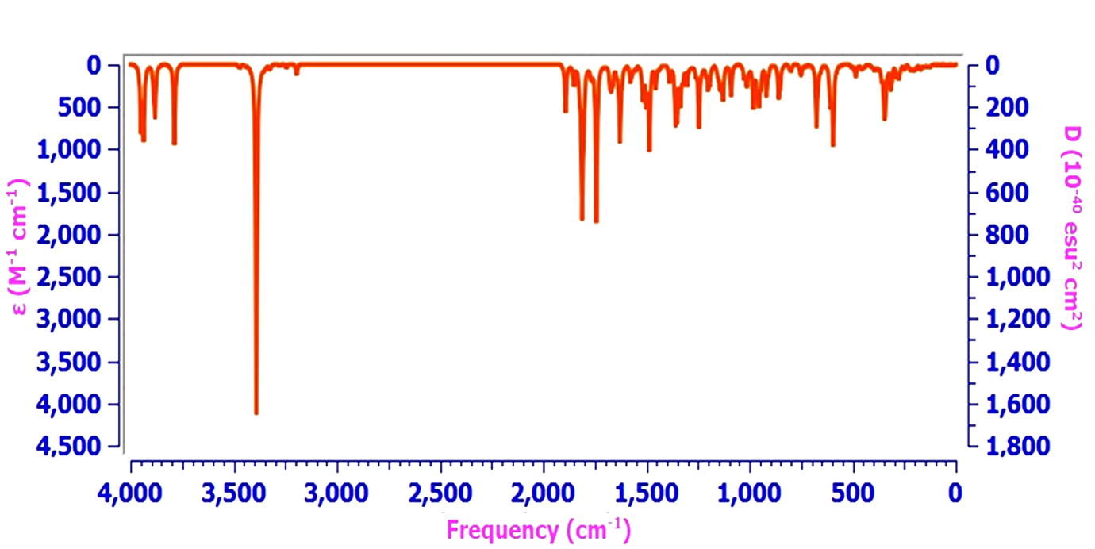
Fig. 3b. Theoretical FT-IR spectrum of Nickel Transition Metal with MBHA (L1)

FTIR spectral results for the compound 7 (Fig. 1e) reveal that –OH group gives a broad band ranging from 3505-3310 cm⁻¹ with relatively no change in its position as compared to the ligand. Similarly, the C=C ν̄ (1631 cm⁻¹) remains about the same upon complex formation i.e. at 1629 cm⁻¹ suggesting that this functional group was not involved in coordination. A clear disappearance of signal of the carbonyl group and its appearance at an entirely new position (Table 1) was probably due to its coordination with the metal ion. This kind of shift has also been reported in the literature,¹⁴ hence confirms the coordination of the ligand’s carbonyl site to the Mn⁺² metal ion. Moreover, the appearance of new peak at 603 cm⁻¹was attributed to Mn-O while C-Cl 540 cm⁻¹ shifted towards 523 cm⁻¹. The molecular [Mn(L1)₂(H₂O)₂]⁺² and structural formula were established for the compound 7.
FTIR results for the compound 8 (Fig. 1f) have revealed the presence of –OH functional group by a peak almost at similar position (3480-3350 cm⁻¹) as that of the ligand precursor. Almost similar results were obtained for the presence of sp² and sp³ C-H bonds of the complex i.e. their peaks were observed at 3115, 2980 cm⁻¹ respectively. The ester carbonyl absorption (1705 cm⁻¹) has completely disappeared as compared to that of the ligand carbonyl (1714 cm⁻¹) which suggests its participation in complex formation. No marked difference was observed in the frequency due to the C=C double bond (1673 cm⁻¹) and aromatic C=C bond (1604 cm⁻¹) suggesting no contribution in complex formation. These assumptions were further supported by appearance of IR peaks at 605 cm⁻¹, and 486 cm⁻¹ due to presence of Cu-O and C-Cl bond. Based on all these physical, analytical and spectral results the prepared complex was assigned the structure presented above in scheme 2 as compound 8 formulated as [Cu(L1)₂(H₂O)₂]⁺².

Table 1. Characteristic FTIR bands of the MBHA (L1) and its metal complexes (cm⁻¹) ν̄
Functional  groups | (L1) | Calc.  (L1) | CrL1 | CoL1 | NiL1 | Calc.  NiL1 | MnL1 | CuL1
ν̄ (-OH) | 3446 | 3838 | 3500-3380 | 3300-3400 | 3350-3450 | 3880-3886 | 3310-3505 | 3350-3480
ν̄ (=C-H) | 2953 | 3334 | 2915 | 2950 | 3005 | 3194 | 3005 | 3115
ν̄ (Sp³ C-H stretch), | 2897 | 3262 | 2810-2980 | 2860-2935 | 2850 | 3244 | 2980 | 2980
ν̄ (ester C=O), | 1714 | 1931 | 1625 | 1651 | 1640 | 1669 | - | -
ν̄ C=C (aromatic), | 1631 | 1767 | 1550 | 1620 | 1643 | 1627 | 1629 | 1673
ν̄ C=C | - | 1604 | 1438 | 1483 | 1566 | 1576 | 1500 | 1604
ν̄ (-CH₃) | 1440 | 1325 | - | - | 1463 | 1485 | 1566 | 1521
ν̄ (C-O) | 1278 | 1303 | 1105 | 1386 | 1388 | 1358 | 1386 | 1388
ν̄ (C-OCH₃) | - | - | 1382 | 1109 | 1109 | 1128 | 1111 | 1112
ν̄ (M-O) | - | - | 603 | 607 | 609 | 606 | 603 | 605
ν̄ (C-Cl) | 540 | 334 | 520 | 518 | 455 | 485 | 523 | 486
Only the observed changes in specified functional groups are represented
3.4. X-Ray Diffraction
The structure resolved from powder XRD analysis is a successful process that leads to evaluation of an exact crystal structure depending on the cautious handling of each step. Microcrystalline materials mainly organic based metal complexes can easily be resolved by XRD powder diffraction.^{13,25} The accuracy of a material whose structure is to be determined depends on the quality of the powder diffraction data. Besides, nature of the asymmetric unit such as the number, type of atoms, atomic arrangement and molecular geometry involves to prove the quality of the complex. However, for successful structure determination, monophasic powder sample of good crystallinity should be available for the material of interest.³⁷ The recorded result was summarized in Table 2. & Table 3.

Table 2. Crystallographic data and observed refinement parameters for complexes 4-8

S. No. | Sample complexes | S. Group  (G. No.) | Volume  (10⁶pm³) | Density  (g/cm) | Unit Cell Dimensions  (Å) | Crystal Class | No. of unit cells  (Z) | Reference Intensity Ratio (RIR)
1 | CrL1 | Pmmn  (59) | 94.58 | 3.63 | a≠b≠c  α=β=γ=90° | Orthorhombic | 2 | 4.60
2 | CoL1 | Fd-3m  (223) | 93.82 | 6.09 | a=b=c  α=β=γ=90° | Cubic | 2 | 6.39
3 | NiL1 | R-3m  (166) | 99.78 | 4.53 | a=b≠c  α=β=90°  γ=120° | Hexagonal | 3 | 6.38
4 | MnL1 | 141/amd  (141) | 518.94 | ……. | a=b=c  α=β=γ=90° | Cubic | 4 | 4.21
5 | CuL1 | Cc  (9) | 81.12 | 6.51 | a≠b≠c  α=γ=90°  β≠90° | Monoclinic | 4 | 3.72

Table 3. Crystal lattice Data and Summary of Data Collection and Refinement for complexes 4-8
S.NO. | Complex Compound | Miller Indices |  |  | d [Å] | 2̊𝜃 | Intensity (%)
S.NO. | Complex Compound | h | k | l | d [Å] | 2̊𝜃 | Intensity (%)
1 | [Cr(L1)₂(H₂O)₄]⁺³ | 0  1  1  1 | 0  0  1  1 | 1  1  0  1 | 7.6940  3.4523  2.4519  2.3397 | 11.492  25.785  36.620  38.443 | 100.0  48.3  37.2  14.1
2 | [Co(L1)₂(H₂O)₄]⁺³ | 2  3  5  4 | 2  1  1  4 | 0  1  1  0 | 2.8600  2.4380  1.5559  1.4293 | 31.249  36.837  59.350  65.222 | 40.0  100.0  35.0  45.0
3 | [Ni(L1)₂(H₂O)₂]⁺² | 1  1  1  1 | 1  0  0  0 | 0  1  4  7 | 4.7773  2.4201  2.0254  1.5724 | 18.558  37.119  44.706  58.663 | 100.0  26.9  36.9  9.4
4 | [Mn(L1)₂(H₂O)₂]⁺² | 2  1  2  2 | 1  0  2  2 | 1  3  0  4 | 3.4037  2.9359  2.8850  1.8266 | 26.160  30.421  30.97249.883 | 100.0  20.8  22.1  30.9
5 | [Cu(L1)₂(H₂O)₂]⁺² | 0  2  0  2 | 2  0  0  2 | 2  2  4  0 | 2.5300  2.3600  2.3350  2.0241 | 35.452  38.100  38.525  44.735 | 100.0  79.7  36.2  42.2
Each set of indices was chosen on the basis of highest intensity (%) of sharp peak
X-ray diffraction was performed for further confirmation of the structure of transition metal complexes. The patterns of diffracto-grams obtained for complexes are given in Fig. 4. Each metal complex pattern has one sharp peak of metal oxide (Fig. 4). This clearly gives an idea of the coordination of one oxygen atom from the ligand to the metal ions. Hence, the idea of coordination of ligand with the metal ions through the same site has been confirmed. Moreover, these patterns indicate crystalline nature of all the complexes. It can be observed that the rest of the pattern of metal complexes is almost dissimilar from each other owing to the formation of a distinct distorted crystalline structure. Most probably, this difference is due to the coordination of water molecules into the coordination sphere.^{15,16} Besides, they have different unit cell number and radius intensity ratio, because of this they belong to non-identical but unique crystal class. The resultant XRD output such as density, volume, radius intensity ratio, lattice parameters (a, b, c, α, β, γ) and probable crystal class have been given in the Table 2. The chromium complex (compound 4) was isolated, and crystallized in the orthorhombic system (space group Pmmn (59) with Z = 2). In the cobalt complex, the molecule contains one Cr⁺³ atom, two coordinated MBHA (L1) molecules at the two sites in a mononuclear complex.
It is noteworthy that the complexes cobalt and manganese (compound 5 and 7) were found to have cubic crystalline nature, having space group Fd-3m (223) and 141/amd (141), whereas they have 2 and 4, Z values, respectively. The indexing related to their structure elucidation as well as peak intensities and diffraction angle (2𝜃) is given in the Table 3. It is illustrated that the prepared complex of nickel (compound 6) has the space group R-3m (166), Z=3 and belongs to hexagonal crystal class. While, copper metal (compound 8) coordinated with MBHA has monoclinic crystalline nature. It has the space group Cc (9) and Z =4. Based on aforementioned analysis and to provide more strength in verdicts (energy balance and mass balance) the computational modeling was further performed.
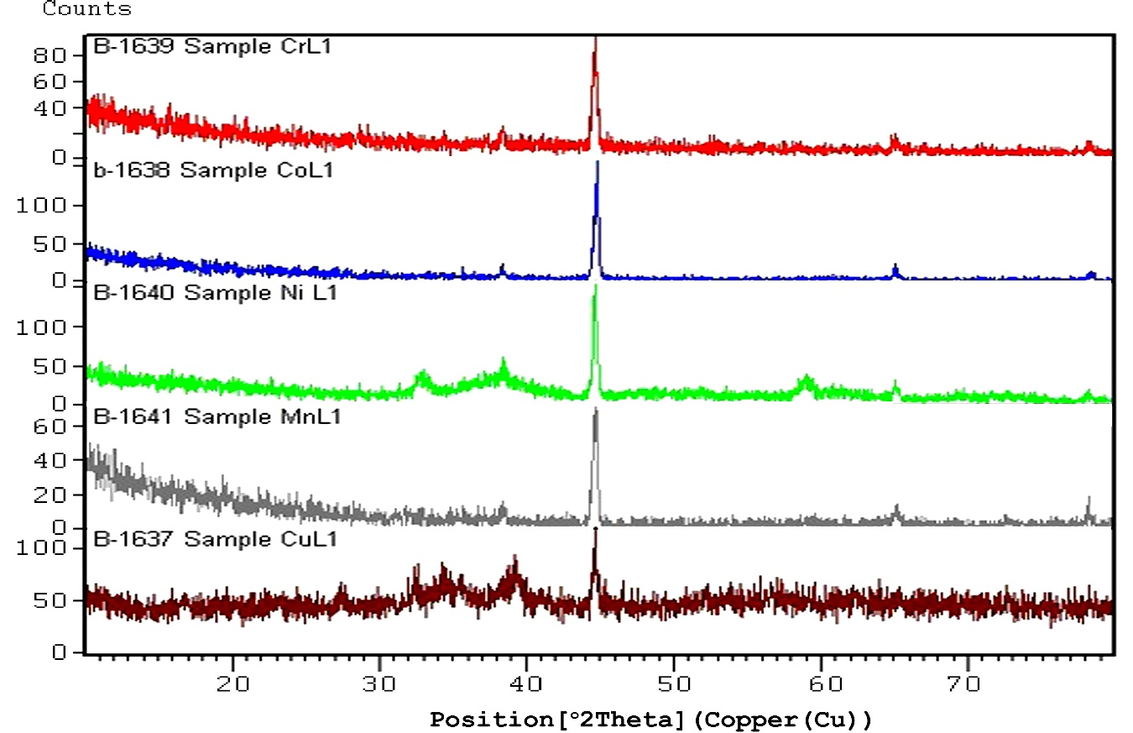
Fig. 4. X-ray diffraction patterns of complexes [M(L1)₂(H₂O)₄]⁺³ with M=Cr⁺³, Co⁺³and [M(L1)₂(H₂O)₂]⁺² with M= Ni²⁺, Mn⁺² and Cu²⁺

3.5. Antioxidant Activities of MBHA and Metal Complexes
These compounds (3-8) were tested to determine their efficiency for scavenging the DPPH radicals using ascorbic acid as standard, which has a known free radical scavenging activity. The potential of MBHA and metal complexes as antioxidants has been plotted in (Fig. 5 and Fig. 6). The alcoholic MBHA and ester containing compounds are highly active against antioxidant exhibition.^{25,38} The antioxidant potential of the MBHA and its transition metal complexes along with the standard (ascorbic acid) is documented in Table 4.
S. No. | Concentration  (mM) | Ascorbic Acid  (%) | Ligand/Complexes |  | Antioxidant Activity  (%)
1 | 1.00 | 20 | L1 |  | 56.7
2 | 2.00 | 39.4 | CrL1 |  | 9.7
3 | 3.00 | 58.1 | CoL1 |  | 17.1
4 | 4.00 | 76 | NiL1 |  | 10.8
5 | 5.00 | 92.7 | MnL1 |  | 19.7
6 | 6.00 | 96.8 | CuL1 |  | 18.7
Table 4. Antioxidant activity of MBHA (compound 3) and its formed metal complexes (compound 4-8)
DPPH scavenging effect (%) = Ac – As/Ac × 10, Ac = Absorbance of Control
The results have indicated that ascorbic acid has exhibited the highest antioxidant activity at high concentration. When the highest antioxidant exhibition percent among synthesized metal moieties was compared with MBHA, it was observed that MnL2 (compound 7) has the highest (19.7%) antioxidant activity. Additionally, the copper complex with MBHA has shown almost the same inhibition. However, L1 (MBHA) has comparatively maximum antioxidant activity. It is interesting to note that all these novel compounds (MBHA, [M(L1)₂(H₂O)₄]⁺³ and [M(L1)₂(H₂O)₂]⁺²) possess positive inhibition (Fig. 6).

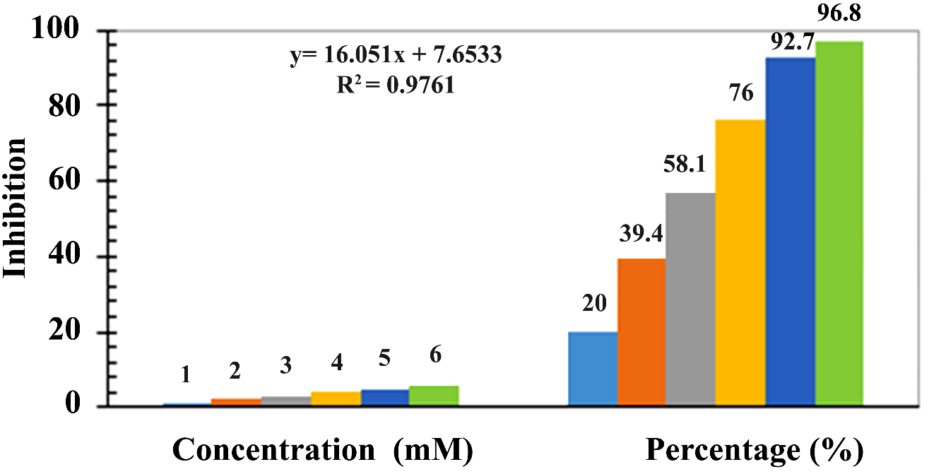
Fig. 5. Graphical representation of Antioxidant Activities of the Standard (Ascorbic Acid)

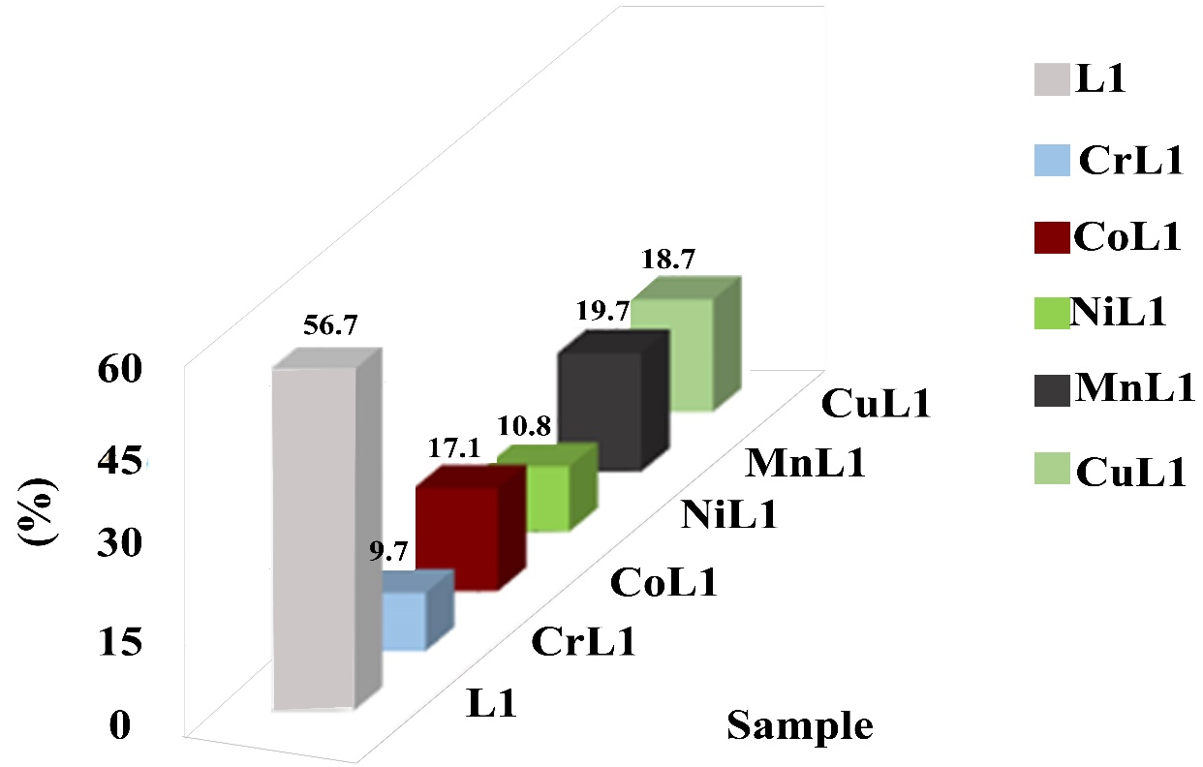

Fig. 6. Graphical representation of Antioxidant Activities of MBHA (L1) and compounds 4-8

3.6. Antibacterial Assay
The antibacterial activity of these compounds was screened by using agar disc diffusion method against four bacterial strains (Staphylococcus aureus, Escherichia coli, Bacillus pumilis, Salmonella typhi) while Gentamycin is used as standard (Table 5).
Table 5. Antibacterial activities of the MBHA and the complexes (compound 4-8)
S. No |  | Ligand/Complexes | S.aureus (%) | E.coli (%) | B.pumilis (%) | S.typhi (%)
1 |  | L1 | 71.4 | 62.5 | 80.3 | 45.8
2 |  | CrL1 | A | A | 40.7 | A
3 |  | CoL1 | 95.21 | 99.1 | 81.4 | 50.0
4 |  | NiL1 | 44.6 | 45.8 | 40 | 50.0
5 |  | MnL1 | 47.6 | A | 46.2 | A
6 |  | CuL1 | 52.3 | A | 44.4 | 48.0
Antimicrobial activity, expressed as inhibition zone diameter in millimeters (mm), of synthesized compounds against pathological strains based on agar well diffusion assays at 1 mg mL⁻¹. The experiment was carried out in triplicate and the average zone of inhibition was calculated.
A = Non active inhibition zone
The efficiency of compounds was categorized into three classes such as sensitive, transitional and resistant. The reported analysis is in consistent with our findings that if a compound is found to be sensitive, it could be a valuable medication against bacterial disease. Though, non-active compounds are found to be as least resistant.^{23,39,40} In contrast to the ligand an enhanced antibacterial potential was observed in metal complexes. Consequently, opening new ways in the fight against antibiotic resistance. This is because of coordination (ligand to metal) which could be best explained on the basis of chelation theory.^{16,41} The comparison of antibacterial activity, shown in Fig. 7 confirms that metal complex of cobalt (compound 5) was highly active than its corresponding MBHA ligand against all bacterial strains. It is evident from the results that all metal complexes and MBHA are significantly active against B.pumilis, however, chromium (compound 4) complex is completely resistive against the remaining bacterial strains (S.aureus, E.coli, S.typhi). It is interesting to note that compound 7 (manganese complex) is found non-reactive against two bacterial strains (E.coli and S. typhi), while compound 8 (copper complex) is resistant against E.coli only. Thus, all remaining complexes indicate extremely positive activity against the bacterial strains.

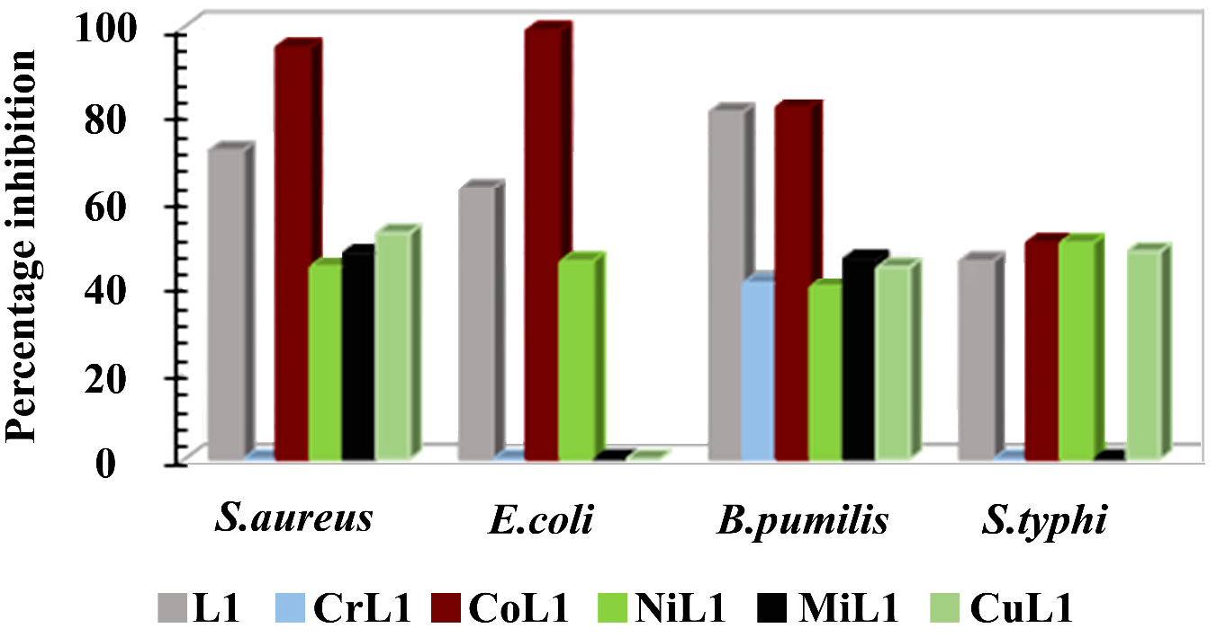
Fig. 7. A comparative histograms inhibition zone Antibacterial Assay of MBHA and compound 4-8, S.typhi, E.coli are two Gram-negative bacteria and B.subtilis, S.aureus are two Gram- positive bacteria

4. CONCLUSIONS
An aromatic MBHA Methyl 2-((4-chlorophenyl)(hydroxy)methyl) acrylate (compound 3) was prepared successfully by a well-known MBH reaction scheme 1 and used further in the synthesis of metal complexes with transition metal salts (Cr⁺³, Co⁺³, Ni⁺², Mn⁺²,Cu⁺²). We modified aforementioned scheme 2 and were successful to synthesize six novel compounds (3-8). An aromatic MBHA Methyl 2-((4-chlorophenyl)(hydroxy)methyle) acrylate (compound 3) was prepared successfully by a well-known MBH reaction scheme and used further in synthesis of metal complexes by transition metal salts (Cr⁺³, Co⁺³, Ni⁺², Mn⁺²,Cu⁺²). We modified aforementioned scheme and synthesized five novel compounds (3-8). The novel ligand MBHA (L1) and its corresponding complexes were characterized by means of their physical, analytical, spectral and computational analysis. The IR spectrum of the synthesized ligand and five metal complexes were also generated computationally by the Hartree Fock (HF) B3LYP method in conjunction with the 3-21G(d,p) basis set and we found good agreement with their observed FT-IR spectrum. These investigations have collectively suggested the molecular and structural formula. It has been found that MBHA (L1) coordinated with all the central metal ion in stoichiometric ratio of 2:1 ligand to metal. The well-defined crystalline homogeneous nature of all metal complexes was observed and confirmed through XRD powder diffraction analysis. Moreover, different crystal structure was found for different complexes. Such as, compound 4 is orthorhombic, compound 6 is hexagonal, and compound 8 is monoclinic while compounds 5 and 7 both lie in cubic crystal class. For antibacterial assay, four pathogenic strains (S. aureus, E. coli, B.pumilis, P. mirabilis, and S.typhi) were examined and compared with standard antibiotic, Gentamycin. It was inferred that Cobalt complexes displayed uppermost antibacterial potential compared to MBHA (L1). Whereas, Nickle based complex showed good inhibition against all four bacterial strains. Chromium based complexes were found active against B.pumilis only. Both Manganese and Copper based complexes were seen inactive against E. coli. Manganese complex inhibition potential against S.typhi indicated non-active, conversely, again showed good inhibition zone against the remaining bacterial strains. Furthermore, the DPPH radical scavenging assay (antioxidant) of compounds 3-8 demonstrated the positive inhibition with context to the standard (ascorbic acid). This study can be expanded further by synthesizing some other novel MBHA ligands and their metal complexes, in order to identify the most suitable medication against infectious diseases.
ACKNOLEDGEMENT
The authors are thankful to University of Karachi for providing such an appreciative infrastructure and environment. We are highly gratified to PCSIR laboratories Complex-Karachi, Pakistan and NED University of Engineering and Technology for their support in bioactivity studies and XRD analysis opportunity.
CONFLICT OF INTEREST
All authors declare that they have no conflict of interest.

REFENCES
1. F. Collet, R. H. Dodd, P. Dauban, Chem. Commun. 2009, Vol. 20 (34), pp. 5061–5074. DOI: 10.1039/b905820f.
2. E. C. Tavares, M. M. M. Rubinger, E. V. Filho, M. R. L. Oliveira, D. Piló-Veloso, J. Ellena, S. Guilardi, R. A. C. Souza, L. Zambolim, J. Mol. Struct. 2016, Vol. 1106, pp. 130–140. DOI: 10.1016/j.molstruc.2015.10.097.
3. R. O. M. A. de Souza, V. L. P. Pereira, M. F. Muzitano, C. A. B. Falcão, B. Rossi-Bergmann, E. B. A. Filho, M. L. A. A. Vasconcellos, Eur. J. Med. Chem. 2007, Vol. 42 (1), pp. 99–102. DOI: 10.1016/j.ejmech.2006.07.013.
4. J. Du, Y. Ma, F. Meng, R. Zhang, R. Wang, H. Shi, Q. Wang, Y. Fan, H. Huang, J. Cui, et al., 2019, pp. 9–12. DOI: 10.1021/acs.orglett.8b03709.
5. T. Narendar Reddy, V. Jayathirtha Rao, Tetrahedron Lett. 2018, Vol. 59 (30), pp. 2859–2875. DOI: 10.1016/j.tetlet.2018.06.023.
6. M. Tsednee, Y. C. Huang, Y. R. Chen, K. C. Yeh, Sci. Rep. 2016, Vol. 6 (May), pp. 1–13. DOI: 10.1038/srep26785.
7. V. Carrasco-Sanchez, M. J. Simirgiotis, L. S. Santos, Molecules. 2009, Vol. 14 (10), pp. 3989–4021. DOI: 10.3390/molecules14103989.
8. G. W. Amarante, M. Benassi, R. N. Pascoal, M. N. Eberlin, F. Coelho, Tetrahedron. 2010, Vol. 66 (24), pp. 4370–4376. DOI: 10.1016/j.tet.2010.04.018.
9. C. G. L. Junior, P. A. C. De Assis, F. P. L. Silva, S. C. O. Sousa, N. G. De Andrade, T. P. Barbosa, P. L. N. Nerís, L. V. G. Segundo, Í. C. Anjos, G. A. U. Carvalho, et al., Bioorg. Chem. 2010, Vol. 38 (6), pp. 279–284. DOI: 10.1016/j.bioorg.2010.08.002.
10. R. V. Pirovani, B. R. V. Ferreira, F. Coelho, Synlett. 2009, (14), pp. 2333–2337. DOI: 10.1055/s-0029-1217725.
11. S. Rehman, M. Ikram, F. Subhan, M. Sinnokrot, W. Khan, Open Chem. 2019, Vol. 17 (1), pp. 936–942. DOI: 10.1515/chem-2019-0108.
12. D. C. Crans, J. J. Smee, E. Gaidamauskas, L. Yang, Chem. Rev. 2004, Vol. 104 (2), pp. 849–902. DOI: 10.1021/cr020607t.
13. P. C. Bruijnincx, P. J. Sadler, Curr. Opin. Chem. Biol. 2008, Vol. 12 (2), pp. 197–206. DOI: 10.1016/j.cbpa.2007.11.013.
14. J. Martí-Rujas, Dalt. Trans. 2020, Vol. 49 (40), pp. 13897–13916. DOI: 10.1039/d0dt02802a.
15. S. Y. Liu, I. D. Hills, G. C. Fu, Organometallics. 2002, Vol. 21 (21), pp. 4323–4325. DOI: 10.1021/om020533b.
16. V. B. M. Brito, G. F. Santos, T. D. S. Silva, J. L. C. Souza, G. C. G. Militão, F. T. Martins, F. P. L. Silva, B. G. Oliveira, E. C. C. Araújo, M. L. A. A. Vasconcellos, et al., Mol. Divers. 2020, Vol. 24 (1), pp. 265–281. DOI: 10.1007/s11030-019-09950-7.
17. J. da Câmara Rocha, K. A. da Franca Rodrigues, P. L. do Nascimento Néris, L. V. da Silva, F. S. Almeida, V. S. Lima, R. F. Peixoto, J. da Câmara Rocha, F. de L. A. A. de Azevedo, R. C. Veras, et al., Parasitol. Res. 2019, Vol. 118 (10), pp. 3067–3076. DOI: 10.1007/s00436-019-06403-w.
18. H. Y. Qian, Acta Chim. Slov. 2019, Vol. 66 (4), pp. 995–1001. DOI: 10.17344/acsi.2019.5247.
19. H. Ahmed, A. Hashim, H. M. Abduljalil, Egypt. J. Chem. 2019, Vol. 62 (4), pp. 1167–1176. DOI: 10.21608/EJCHEM.2019.6241.1522.
20. P. Møller, Eur. J. Cardio-thoracic Surg. 1934, Vol. 53 (6), pp. 1237–1243.
21. L. S. Kassel, J. Chem. Phys. 1936, Vol. 4 (4), pp. 276–282. DOI: 10.1063/1.1749835.
22. Open J. Biophys. 2021, Vol. 20 (5), pp. 1–30.
23. S. Kirbag, F. Zengin, S. Fac, F. Processing, Antimicrob. Act. Some Euphorbia Species. 2013, Vol. 10 (12), pp. 305–309.
24. V. Alfredo Rodriguez, V. Alfredo, thesis. 2018, Vol. 1 (2019), pp. 300.
25. H. Elleuch, W. Mihoubi, M. Mihoubi, E. Ketata, A. Gargouri, F. Rezgui, Bioorg. Chem. 2018, Vol. 78, pp. 24–28. DOI: 10.1016/j.bioorg.2018.03.004.
26. A. L. Dawidowicz, D. Wianowska, M. Olszowy, Food Chem. 2012, Vol. 131 (3), pp. 1037–1043. DOI: 10.1016/j.foodchem.2011.09.067.
27. I. Gülçin, Arch. Toxicol. 2012, Vol. 86 (3), pp. 345–391. DOI: 10.1007/s00204-011-0774-2.
28. M. Tsednee, Y.-C. Huang, Y.-R. Chen, K.-C. Yeh, Sci. Rep. 2016, Vol. 6 (1), pp. 26785. DOI: 10.1038/srep26785.
29. B. Kavitha, M. Sravanthi, P. Saritha Reddy, J. Mol. Struct. 2019, Vol. 1185, pp. 153–167. DOI: 10.1016/j.molstruc.2019.02.093.
30. B. Kosar, C. Albayrak, Spectrochim. Acta - Part A Mol. Biomol. Spectrosc. 2011, Vol. 78 (1), pp. 160–167. DOI: 10.1016/j.saa.2010.09.016.
31. N. Sundaraganesan, S. Kalaichelvan, C. Meganathan, B. D. Joshua, J. Cornard, Spectrochim. Acta - Part A Mol. Biomol. Spectrosc. 2008, Vol. 71 (3), pp. 898–906. DOI: 10.1016/j.saa.2008.02.016.
32. Z. Yekke-Ghasemi, M. Ramezani, J. T. Mague, R. Takjoo, New J. Chem. 2020, Vol. 44 (21), pp. 8878–8889. DOI: 10.1039/d0nj01187h.
33. D. A. Köse, H. Necefoğlu, J. Therm. Anal. Calorim. 2008, Vol. 93 (2), pp. 509–514. DOI: 10.1007/s10973-007-8712-5.
34. I. Kostova, I. Manolov, I. Nicolova, S. Konstantinov, M. Karaivanova, Eur. J. Med. Chem. 2001, Vol. 36 (4), pp. 339–347. DOI: 10.1016/S0223-5234(01)01221-1.
35. T. Aiyelabola, E. Akinkunmi, I. Ojo, E. Obuotor, C. Adebajo, D. Isabirye, Bioinorg. Chem. Appl. 2017, Vol. 2017. DOI: 10.1155/2017/2956145.
36. M. A. Asraf, M. M. Rahman, D. C. Kabiraz, R. H. Ansary, M. F. Hossen, M. F. Haque, C. M. Zakaria, Asian J. Appl. Chem. Res. 2019, Vol. 3 (3), pp. 1–15. DOI: 10.9734/ajacr/2019/v3i330093.
37. A. Jacques, T. Auvray, R. Bevernaegie, F. Loiseau, M. Cibian, G. S. Hanan, A. Kirsch-De Mesmaeker, B. Elias, Inorganica Chim. Acta. 2018, Vol. 471 (Iii), pp. 8–16. DOI: 10.1016/j.ica.2017.10.018.
38. P. Jeslin Kanaga Inba, B. Annaraj, S. Thalamuthu, M. A. Neelakantan, Bioinorg. Chem. Appl. 2013, Vol. 2013. DOI: 10.1155/2013/439848.
39. B. Posssato, L. F. Dalmolin, L. M. Pereira, J. Q. Alves, R. T. C. Silva, R. V. Gelamo, A. P. Yatsuda, R. F. V. Lopez, S. de Albuquerque, N. B. Leite, et al., Eur. J. Pharm. Sci. 2021, Vol. 162 (April). DOI: 10.1016/j.ejps.2021.105834.
40. K. G. Harmon, J. R. Clugston, K. Dec, B. Hainline, S. Herring, S. F. Kane, A. P. Kontos, J. J. Leddy, M. McCrea, S. K. Poddar, et al., Br. J. Sports Med. 2019, Vol. 53 (4), pp. 213–225. DOI: 10.1136/bjsports-2018-100338.
41. M. I. Khan, A. Khan, I. Hussain, M. A. Khan, S. Gul, M. Iqbal, Inayat-Ur-Rahman, F. Khuda, Inorg. Chem. Commun. 2013, Vol. 35 (June), pp. 104–109. DOI: 10.1016/j.inoche.2013.06.014.

