The Use of Yeast Saccharomyces Cerevisiae as a Biorecognition element in the Development of a Model Impedimetric Biosensor for Caffeine Detection
Zala Štukovnikª, Regina Fuchs Godecª, Urban Bren^{a, b}
ª University in Maribor, Faculty for Chemistry and Chemical Engineering, Smetanova 17, 2000 Maribor, Slovenia
^{b} University of Primorska, Faculty of Mathematics, Natural sciences and Information Technologies, Glagoljaška 8, 6000 Koper, Slovenia

In the present study, an electrochemical-impedimetric biosensor using Saccharomyces cerevisiae as an effective biorecognition element was designed to detect caffeine. The presented biosensor consists of a previously developed stainless steel electrochemical cell constructed as a three-electrode system in the RCW side-by-side configuration. The electrochemical stability of the sensing electrode was evaluated by measuring the open circuit potential (OCP), and electrochemical impedance spectroscopy (EIS) was applied to determine the impedimetric response of the biosensor with Saccharomyces cerevisiae cells attached to the working electrode (WE) in the absence (0.9% NaCl) and presence (10 mg/mL in 0.9% NaCl) of caffeine. Moreover, the limit of detection (LOD) was determined. In this way, a new approach in biosensor development has been established, which involves assembling a low-cost and disposable electrochemical system to detect alkaloids such as caffeine. The developed biosensor represents a good candidate for detecting caffeine in beverages, foods, and drugs with the merits of time-saving, robustness, low cost, and low detection limit.
Keywords: impedimetric biosensor, Saccharomyces cerevisiae, electrochemical impedance spectroscopy, caffeine
- Introduction
The demand for biosensors has increased significantly in the recent years due to the need for specific sensors that can provide fast and reliable measurements in various research areas. The development of biosensors is of interest for different applications ranging from biochemical profiling of normal and pathologic cells, over clinical diagnostics and drug discovery to more straightforward analyses such as fermentation, process monitoring, environmental testing, and food and beverages quality control.¹⁻³ Detection of alkaloids such as caffeine has attracted abundant attention due to their extensive occurrence in beverages and drugs.⁴ However, conventional detection methods for caffeine (high-performance liquid chromatography-mass spectrometry (HPLC-MS), thin-layer chromatography (TLC), and immunoassay) have several drawbacks, including expensive equipment as well as complex and laborious sample preparation.⁵
Biosensors, as analytical devices, convert a biological response into an electrical signal and provide us with the information on the concentration of the target analyte.^{6, 7} Biosensors may present the best candidates for detecting caffeine with the merits of high sensitivity and specificity, convenience, time-saving, low cost, and low detection limit.⁸ Biosensors can be based on animal tissues, bacteria, or eukaryotic microorganisms such as yeasts.⁹ Although yeasts are highly resistant to adverse environmental conditions, they can sense and respond to a variety of stimuli and, unlike several alternative biological components, do not require sophisticated sterile techniques or complex media. ^{10, 11} Yeast Saccharomyces cerevisiae represents a single-cell eukaryotic organism used primarily in the food industry to produce bakery products and alcoholic beverages.^{9, 12} It is chemoorganotrophic and anaerobic organism classified in the kingdom of Fungi, phylum Ascomycota, class Saccharomycetes, order Saccharomycetales, and family Saccharomycetaceae.¹³ Saccharomyces cerevisiae can exist in two different forms, the haploid or the diploid form.^{13, 14} A yeast cell possesses the typical characteristics of a eukaryotic cell and characteristic organelles such as vacuoles and lipid droplets.¹² It is usually spherical to slightly spherical and occasionally ellipsoidal to cylindrical.¹⁵
Caffeine (1,3,7-trimethylxanthine), with the chemical molecular formula of C₈H₁₀N₄O₂, has been used for thousands of years and represents one of the most widely consumed food ingredient throughout the world.^{1, 16} It is found in common beverages such as coffee, tea, and soft drinks, as well as in products containing cocoa or chocolate, and in a variety of medications and dietary supplements.^{17, 18} Due to the high consumption of caffeinated foods, beverages, and medicines worldwide, caffeine is also considered to be the most representative pharmaceutically active pollutant with regard to its abundance in the environment.¹⁹ Based on the data reviewed, it is concluded that in the healthy adult population, daily caffeine intake at a dose exceeding 400 mg is associated with adverse effects such as general toxicity, cardiovascular effects, effects on bone status and calcium balance, changes in adult behavior, increased cancer incidence and effects on male fertility.²⁰ The caffeine content in coffee products ranges from 0.27 to 1.85 mg/mL, in tea from 0.11 to 0.23 mg/mL, in energy drinks from 0.30 to 0.37 mg/mL, and in soft drinks such as regular cola from 0.10 to 0.13 mg/mL.²¹⁻²³ Given these values, the biosensor may be sufficiently sensitive and robust enough to cover the range of caffeine concentrations present in beverages.

Figure 1: Chemical structure of the caffeine molecule

For the detection of different caffeine concentrations, the electrochemical impedance spectroscopy (EIS) method was applied. EIS is widely used in the production and optimization of biosensors as this method allows for the characterization of the biological component attached to the sensor and of the analyte present in the sample.^{24, 25} Because biosensors produce a rapid response, they can be applied to monitor molecular events in real-time.²⁶ The EIS technique measured the frequency response of the electric current, providing data on the Saccharomyces cerevisiae adhesion layer on the electrode surfaces.
The aim of this study was to develop a model electrochemical impedimetric biosensor for the detection of caffeine using Saccharomyces cerevisiae as an effective biorecognition element with many advantageous properties such as cell robustness, ease of maintenance, and cell production rate.

- Experimental
The developed biosensor consists of a stainless steel electrochemical cell (Figure 2) constructed as a three-electrode system in the RCW-side by side configuration, including the working electrode (WE) with yeast cells on the surface, the reference electrode (RE), and the counter electrode (CE). Such electrochemical cell was previously developed and tested.¹⁰ In assembling the electrochemical cell, stainless steel type SS316 (manufacturer TBJ Industries, Germany) was used. The electrodes were manufactured with a dimension of electrode 20 mm x 5 mm, where the active component was applied to the 5 mm x 5 mm. The electrodes were insulated on the fixation side, and the system was sealed with glass.
Saccharomyces cerevisiae was applied to the working electrode using a technique involving a mold made with a 3D printer, which ensured that the layer thickness (0.10 mm) was similar for all measurements.
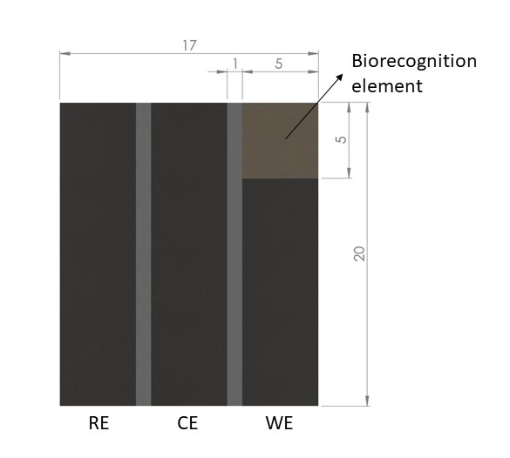
Figure 2: Electrochemical cell in the RCW-side-by-side configuration and the Saccharomyces cerevisiae cells attached to the working electrode (WE).
Two solutions were prepared for the measurements, the 0.9% NaCl solution (Sigma Aldrich, CAS: 7647-14-5, M: 58.44 g/mol) and 10 mg/mL caffeine (Sigma Aldrich, CAS: 58-08-2, M: 194.19 g/mol) in 0.9% NaCl solution. The electrochemical cell with Saccharomyces cerevisiae on the working electrode was connected to the Multi Palmsens4 potentiostat. Initially, 1 mL of the 0.9% NaCl solution was injected into the system, and the open circuit potential (OCP) and EIS measurements were performed. Then, the excess saline was drained. Afterward, 1 mL of the 10 mg/mL caffeine solution was injected into the system, and OCP and EIS measurements were repeated.
The electrochemical characterization of the working electrode was evaluated by measuring the OCP to assess the stability of the electrode. The duration of the measurement was 30 seconds since living yeast cells were utilized.
The EIS method was applied to evaluate the biosensor with yeast on the stainless steel surface. The measurements were again performed using a Multi Palmsens4 potentiostat. The frequency range for the EIS tests was 10 mHz to 100 kHz, the amplitude potential 20 mV, and the number of frequency points measured 61 = 10 ̸ dec. The EIS measurement's expected duration was 2 minutes and 15 seconds, although this time was often extended up to 3 minutes. EIS was used to obtain data on the processes on the surface of the electrode and the applied layers, and the Bode and Nyquist plots were interpreted as the results.
Moreover, the limit of detection (LOD) was determined based on the impedance drop with the increasing concentration of caffeine in 0.9% NaCl. For the measurement, seven different caffeine concentrations in saline (0.0 mg/mL, 0.01 mg/mL, 0.1 mg/mL, 0.25 mg/mL, 0.5 mg/mL, 1.0 mg/mL, and 5 mg/mL) were prepared and 1mL of each sample was injected into the system separately. The blank solution consisted of 0,9% NaCl solution (saline). The measurements were taken using identical parameters as in the measurements mentioned before, and the data were obtained at the frequency 125 mHz.
- Results and discussion

  - Open circuit potential (OCP) measurements
The electrochemical characterization of the sensing electrode was evaluated by measuring the OCP to assess the stability of the electrode. The OCP provides valuable insight into the thermodynamic stability of the electrode material involved in the electrochemical response.²⁷ Potential drift during an OCP measurement is attributed to an unstable electrode.
The results are represented in Figure 3. Since no potential drift occurred during the OCP measurements, the electrode material involved in the electrochemical reaction was found to be thermodynamically stable.
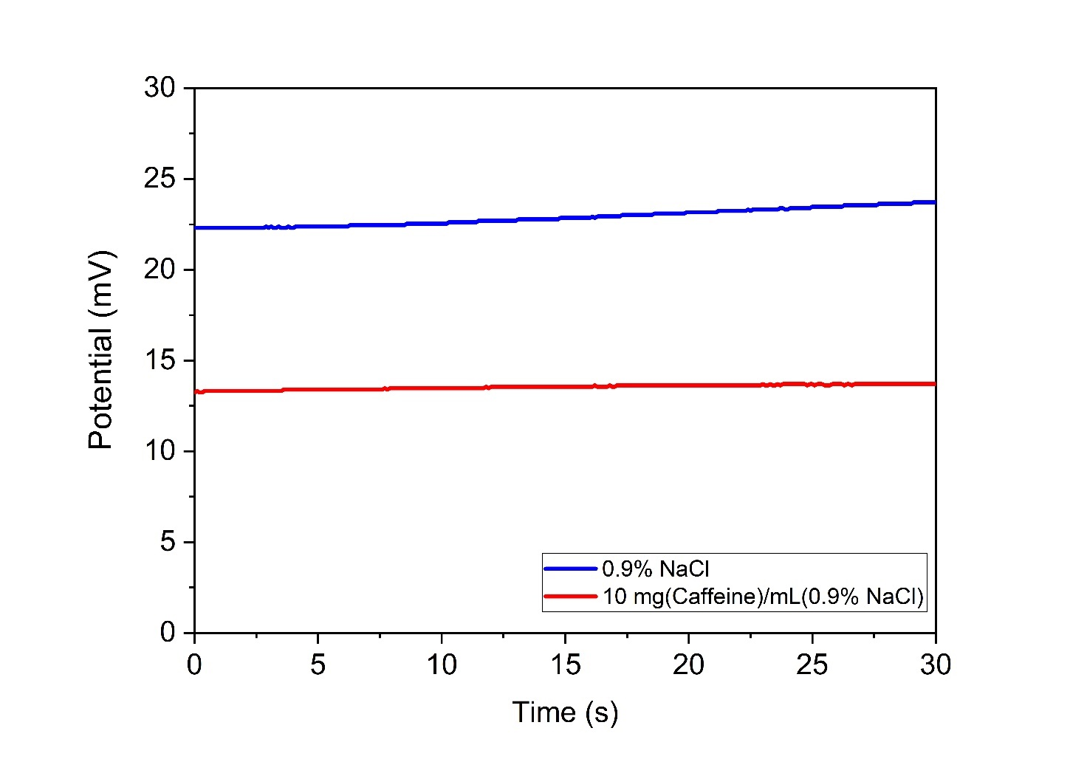Figure 3: The OCP measurements

  - Electrochemical impedance spectroscopy (EIS)
EIS represents a non-destructive method that can be used to quantify specific parameters and simultaneously monitor multiple electrochemical processes.²⁸ The measurements are explained with the real (electrical resistance) and imaginary (capacitance) components of the impedance response of an electrochemical system.¹⁰
In the Nyquist diagram (Figure 4), the solution resistance (R_{s}), the capacitance of the electric double layer (C_{dl}), and the charge transfer resistance (R_{ct}) are detected in the kinetic controlled process of the spectrum and are displayed as a semi-circle pattern. The mass transfer controlled process of the spectrum describes diffusion as a linear behavior. The semi-circle of the measurement where caffeine was added to the system is less prominent compared to the measurement where the blank solution was added to the system, confirming a higher conductivity and lower charge transfer resistance (R_{ct}). The higher conductivity and the lower charge transfer resistance (R_{ct}) suggest that the electrode surface was released due to the detachment of yeast cells from the electrode surface.
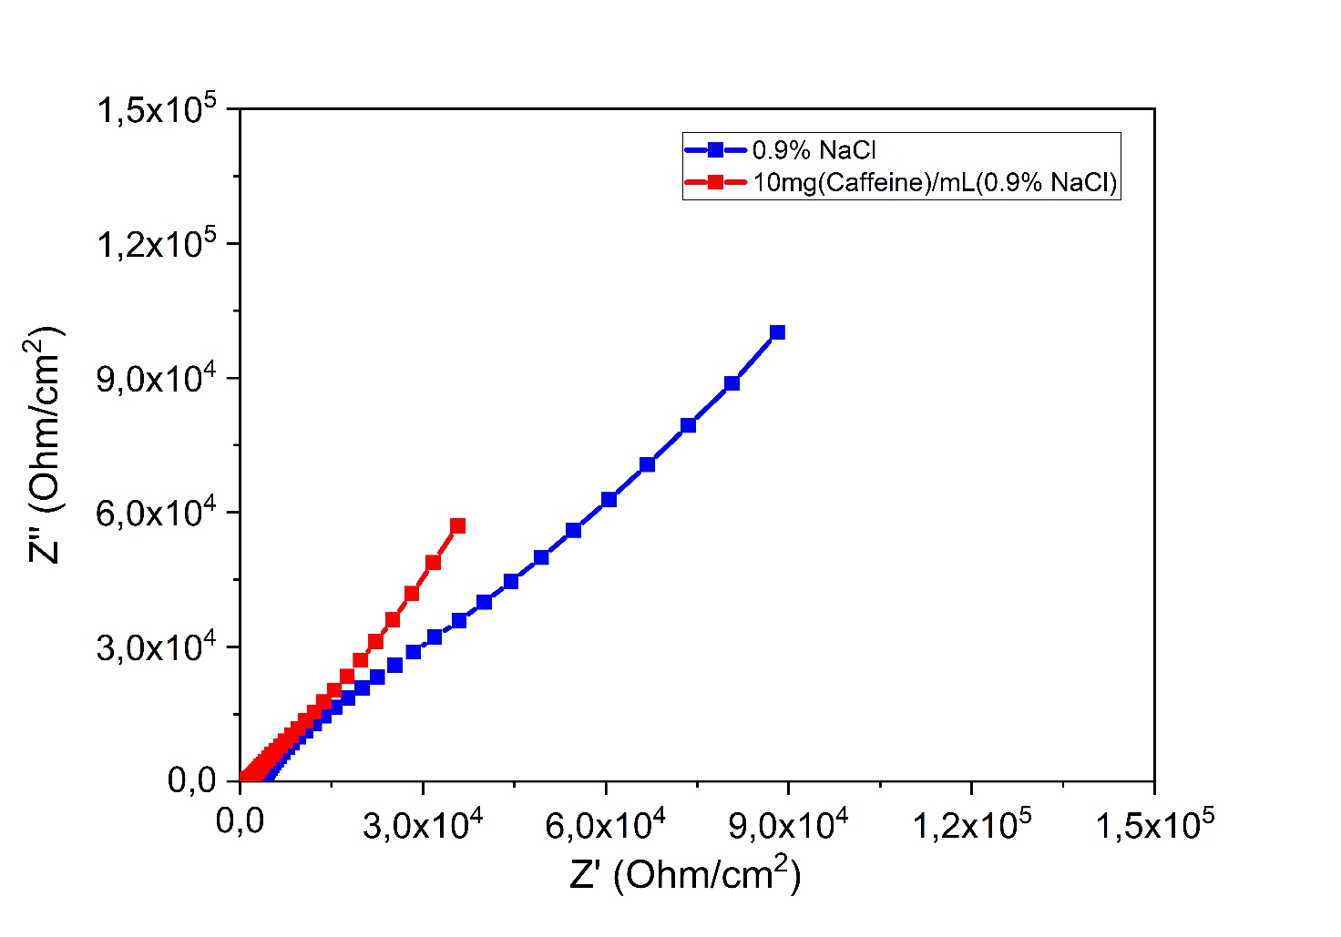
Figure 4: Nyquist diagram of the EIS measurement

Bode plots consist of two spectra simultaneously, the impedance spectrum and the phase spectrum, in which the dependence of impedance (Z) and the dependence of phase angle on the frequency is shown. In the impedance spectrum, the activity at the working electrode is determined from the slopes of the line, and in the phase spectrum, the activity is determined from a phase angle.
In the impedance spectrum of the Bode diagram (Figure 5), the solution resistance (R_{s}) with a slope of approximately 0, the capacitance of the electrical double layer (C_{dl}) with a slope of approximately -0.8, which occurs at the phase boundary between the electrode and the electrolyte, the charge transfer resistance with a slope of approximately 0 (R_{ct}) which occurs due to the electrochemical reaction or due to the charge transfer between the electrolyte and the metal, as well as the diffusion with a slope approximately -0.5 were detected.
In the phase spectrum of the Bode diagram (Figure 5), the resistance is described as the negative phase at approximately 0°, the diffusion at the negative phase at approximately 45°, and the non-ideal capacitance with the negative phase at approximately 60°.
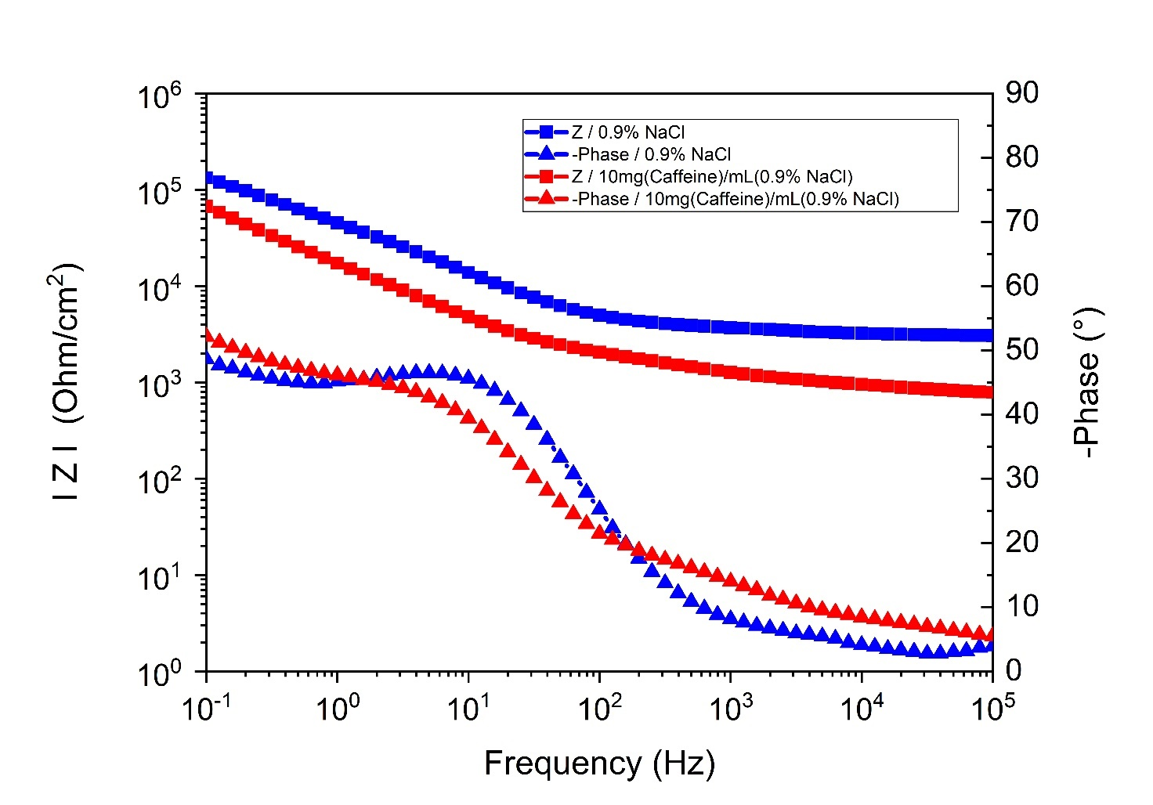Figure 5: Bode diagram of the EIS measurement. The Bode diagram includes an impedance diagram described with squares and a phase diagram described with triangles.

The equivalent electrical circuits (ECC) of the stainless steel electrochemical cell without and with the yeast on the working electrode (WE) are shown in Figure 6.
The ECC of the electrochemical cell without yeast cells attached to the stainless steel electrode is depicted in Figure 6A. The equivalent circuit consists of the solution resistance (R_{s}), the capacitance of the electrical double layer (C_{dl}), the charge transfer resistance (R_{ct}), and the Warburg impedance (W_{o}).
The ECC of the electrochemical cell with the yeast cells attached to the working electrode is shown in the Figure 6B and consists of the solution resistance (R_{s}), the yeast layer capacitance (C_{y}), the yeast layer resistance (R_{y}), the capacitance of the electrical double layer (C_{dl}), the charge transfer resistance (R_{ct}), and the Warburg open diffusion (W_{o}).
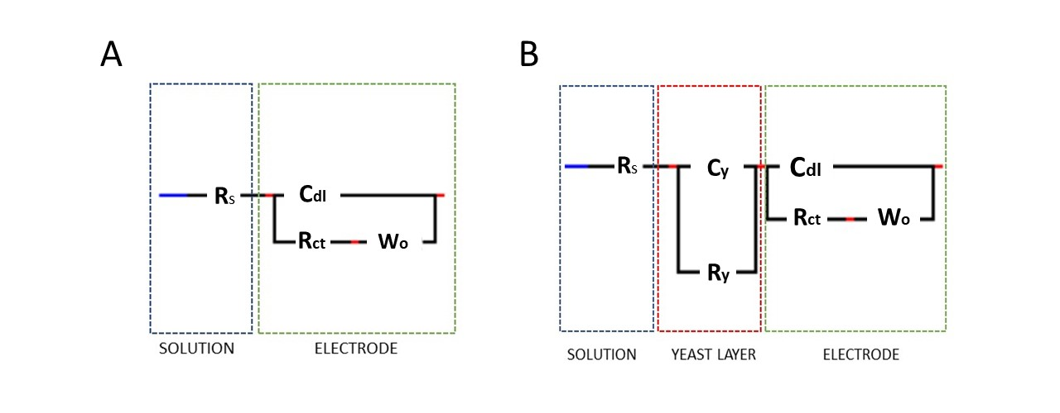
Figure 6: The equivalent electrical circuit (ECC) of the electrochemical cell without the yeast attached to the working electrode (A) and with the electrochemical cell with yeast attached to the working electrode (B)

The comparison of the values of the parameters where the 0.9% NaCl and the 10 mg/mL caffeine in 0.9% NaCl were separately added to the system is provided in Table 1.
When caffeine was added to the system, the Saccharomyces cerevisiae cells detached from the stainless steel surface, and consequently, the electrode surface was released. Consequently, the resistance of the system dropped, and the capacitance and the impedance of diffusion increased.

Table 1: Comparison of the ECC parameters when the 0.9% NaCl and the 10 mg/mL caffeine in 0.9% NaCl were added to the system.
Parameters | 0.9%NaCl | 10 mg/mL Caffeine
R_{s} (Ohm/cm²) | 3074.1 | 692.62
R_{y} (Ohm/cm²) | 55646 | 1080.2
R_{ct} (Ohm/cm²) | 103350 | 78969
C_{y} (µF/cm²) | 21.17 | 2237.20
C_{dl} (µF/cm²) | 77.26 | 208.72
W_{or} (Ohm/cm²) | 8415.3 | 1268200
W_{oc} (Ohm/cm²) | 0.08685 | 1.2139

  - Limit of detection (LOD)
Based on the evaluation of the impedance decrease with the increasing concentration (Figure 7), it is speculated that the caffeine LOD is at 0.10 mg/mL. It was also observed that the impedance decreased with the increasing concentration of the caffeine in the solution. Thus, it can be concluded that the biosensor can sense the presence of the caffeine in the solution.
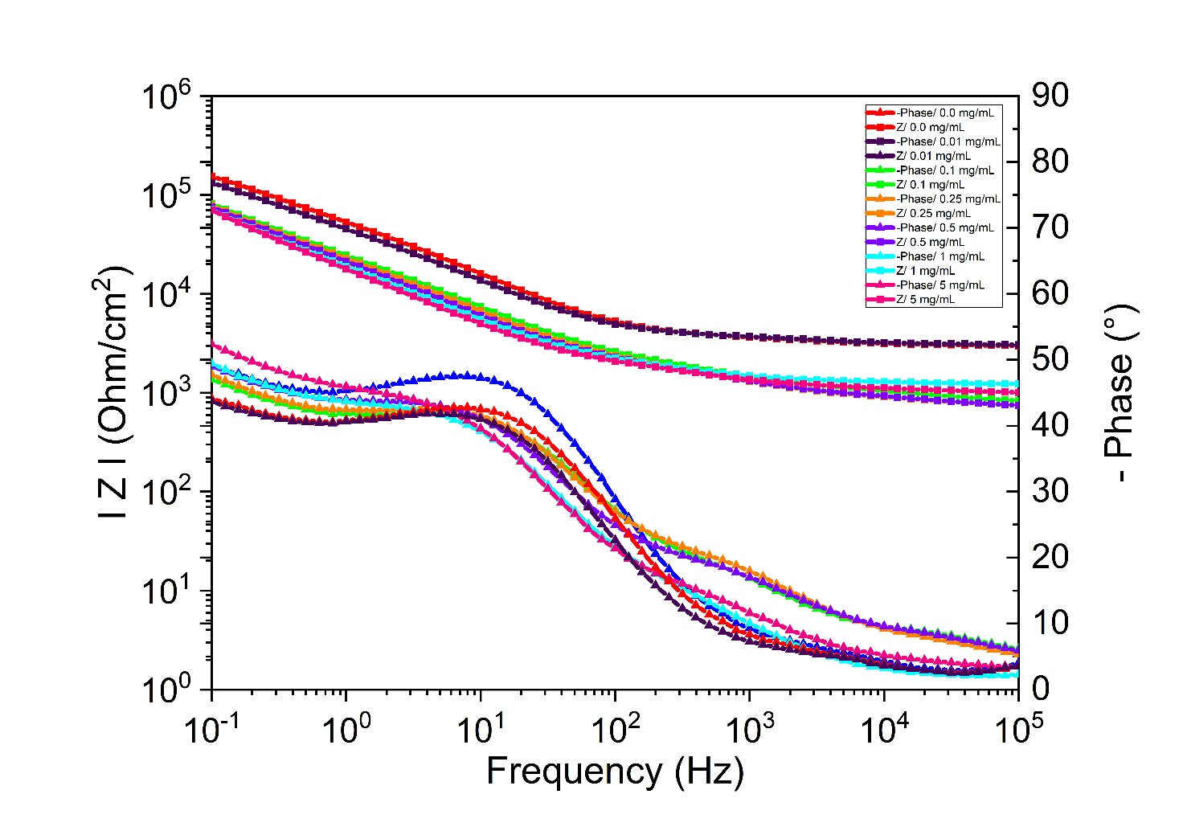

Figure 7: Bode diagram of the EIS measurements. The Bode diagram includes an impedance diagram depicted with squares and a phase diagram depicted with triangles.
Table 2 reports the decrease in impedance (Z) with the increasing concentration of caffeine in saline (C). Compared to the blank solution, the decrease in impedance is observed with the addition of 0.1 mg/mL of caffeine in 0.9% NaCl. The minimum reference total impedance (Z) value for the LOD was established at approximately Δ = 2 kΩ for 2 measurements at selected concentrations and at the lowest frequency (125 mHz).

Table 2: The decrease in impedance with increasing concentration of caffeine in 0.9% NaCl
C(mg/mL) | │Z│(kOhm/cm²)
0.00 | 139.96
0.01 | 119.95
0.10 | 71.95
0.25 | 68.71
0.50 | 66.22
1.00 | 64.12
5.00 | 60.67

- Conclusions

A new approach in biosensor development has been established, which involves assembling a low-cost and disposable electrochemical system for the detection of alkaloids such as caffeine. The caffeine detection with the presented method avoids an excessive use of solvents, requires only a small amount of analyte, and does not require lengthy preparation.
The Nyquist plot and the Bode plot of the investigated biosensor show that adding 10 mg/mL of caffeine in saline decreased the resistance and increased the capacitance, indicating that the electrode surface is released. Due to the Saccharomyces cerevisiae detachment from the stainless steel surface, the parameters of the ECC changed: the system's resistance decreased, and the capacitance increased. Consequently, it can be indeed concluded that the caffeine can cause the desorption and death of Saccharomyces cerevisiae cells.
Moreover, it was observed that the impedance decreased with the increasing concentration of the caffeine in the solution. It can be concluded that the developed biosensor is robust enough to detect the various caffeine concentrations. Based on the evaluation of the impedance decrease with the increasing caffeine concentration, it is speculated that the LOD is at 0.10 mg/mL. Therefore, it can be concluded that yeasts, although very resistant to the adverse environmental conditions, can sense and respond to caffeine as stimuli.
Biosensors have the potential to represent the best candidate for caffeine detection with the merits of time-saving, robustness, low cost, and low detection limit. In the future, an upgraded impedimetric biosensor with the biorecognition element Saccharomyces cerevisiae could be used to detect the caffeine content in various beverages, foods, and medicines. Furthermore, impedimetric biosensors based on the described approach and using a simplified potentiostat/galvanostat could also be applied on a large scale for food monitoring, environmental monitoring, or even medical diagnostics.

- Acknowledgments

Financial support from the Slovenian Research Agency through project (J1-2471) and programme (P2-0046) grants is gratefully acknowledged.
- References

1. V. R. S. Babu, S. Patra, N. G. Karanth, M. A. Kumar and M. S. Thakur, Analytica Chimica Acta 2007, 582, 329-334. DOI:10.1016/j.aca.2006.09.017
2. H. Kaur, A. Bhosale and S. Shrivastav, Int J Health Sci Res 2018, 8, 315-333.
3. P. Mehrotra, J Oral Biol Craniofac Res 2016, 6, 153-159. DOI:10.1016/j.jobcr.2015.12.002
4. J. dePaula and A. Farah, Beverages 2019, 5, 37.
5. W. Ye, T. Liu, W. Zhang, M. Zhu, Z. Liu, Y. Kong and S. Liu, Toxins (Basel) 2019, 12, 1. DOI:10.3390/toxins12010001
6. I. E. Tothill and A. P. F. Turner, in: B. Caballero (Ed.): Encyclopedia of Food Sciences and Nutrition (Second Edition), Academic Press, Oxford, 2003, pp. 489-499. DOI:10.1016/B0-12-227055-X/01374-2
7. B. Caballero, L. C. Trugo and P. M. Finglas, Book Encyclopedia of food sciences and nutrition, Academic, 2003.
8. A. Elif Burcu, A. Muhammet and S. Mustafa Kemal, Current Analytical Chemistry 2019, 15, 467-484. DOI:10.2174/1573411014666180912131811
9. H. Martin-Yken, Biosensors 2020, 10, 51. DOI:10.3390/bios10050051
10. Z. Štukovnik, U. Bren and M. Rozman, Acta Chimica Slovenica 2021. DOI:10.17344/acsi.2020.6545
11. W. Xu, T.-H. Kim, D. Zhai, J. C. Er, L. Zhang, A. A. Kale, B. K. Agrawalla, Y.-K. Cho and Y.-T. Chang, Scientific Reports 2013, 3, 2255. DOI:10.1038/srep02255
12. G. G. Stewart, in: C. A. Batt and M. L. Tortorello (Eds.): Encyclopedia of Food Microbiology (Second Edition), Academic Press, Oxford, 2014, pp. 309-315. DOI:10.1016/B978-0-12-384730-0.00292-5
13. S.-O. Suh, M. Blackwell, C. P. Kurtzman and M.-A. Lachance, Mycologia 2006, 98, 1006-1017. DOI:10.1080/15572536.2006.11832629
14. B. C. Viljoen and G. M. Heard, in: R. K. Robinson (Ed.): Encyclopedia of Food Microbiology, Elsevier, Oxford, 1999, pp. 1918-1925. DOI:10.1006/rwfm.1999.1355
15. J. I. Pitt and A. D. Hocking: Fungi and Food Spoilage, Springer US, Boston, MA, 1997, pp. 439-468. DOI:10.1007/978-1-4615-6391-4_10
16. S. Li, J. Wen, B. He, J. Wang, X. Hu and J. Liu, Environmental Pollution 2020, 263, 114371. DOI:10.1016/j.envpol.2020.114371
17. M. A. Heckman, J. Weil and E. G. De Mejia, Journal of Food Science 2010, 75, R77-R87. DOI:10.1111/j.1750-3841.2010.01561.x
18. J. L. Temple, C. Bernard, S. E. Lipshultz, J. D. Czachor, J. A. Westphal and M. A. Mestre, Front Psychiatry 2017, 8, 80-80. DOI:10.3389/fpsyt.2017.00080
19. C. V. T. Rigueto, M. T. Nazari, C. F. De Souza, J. S. Cadore, V. B. Brião and J. S. Piccin, Journal of Water Process Engineering 2020, 35, 101231. DOI:10.1016/j.jwpe.2020.101231
20. P. Nawrot, S. Jordan, J. Eastwood, J. Rotstein, A. Hugenholtz and M. Feeley, Food Additives & Contaminants 2003, 20, 1-30. DOI:10.1080/0265203021000007840
21. J. C. Verster, C. Aufricht and C. Alford, Int J Gen Med 2012, 5, 187-198. DOI:10.2147/IJGM.S29313
22. L. Bagwath Persad, Frontiers in Neuroscience 2011, 5. DOI:10.3389/fnins.2011.00116
23. S. E. George, K. Ramalakshmi and L. J. Mohan Rao, Critical Reviews in Food Science and Nutrition 2008, 48, 464-486. DOI:10.1080/10408390701522445
24. X. Fan, Z. Li, S. Wang, L. Liu, P. Liu, F. Chen and X. Zheng, Journal of the Brazilian Chemical Society 2019, 30, 1762-1768.
25. E. Randviir and C. Banks, Analytical methods 2013, 5, 1098-1115. DOI:10.1039/c3ay26476a
26. K. Kivirand, M. Min and T. Rinken: Environmental Biosensors, IntechOpen, 2019.
27. A. S. Tanak, B. Jagannath, Y. Tamrakar, S. Muthukumar and S. Prasad, Analytica Chimica Acta: X 2019, 3, 100029. DOI:10.1016/j.acax.2019.100029
28. N. Meddings, M. Heinrich, F. Overney, J.-S. Lee, V. Ruiz, E. Napolitano, S. Seitz, G. Hinds, R. Raccichini, M. Gaberšček and J. Park, Journal of Power Sources 2020, 480, 228742. DOI:10.1016/j.jpowsour.2020.228742

