Removal of diazo Dye Direct Red 28 and tetra azo Dye Direct Black 22 Using Synthesized Magnetic Kaolin Supported Zinc Ferrite

Serap Fındık^{1*}
¹ Chemical Engineering Department, Engineering Faculty, Hitit University, Kuzey Yerleşkesi, Cevre Yolu Bulvarı, 19030, Çorum, Turkey
* Corresponding author, E-mail: serapfindik@hitit.edu.tr
Abstract
The presence of dye molecules in water resources has harmful effects to the environment. Therefore, it is important to remove dyes from wastewater using eco-friendly materials. In this study, adsorptive removal of diazo dye Direct Red 28 (DR-28) and tetra azo dye Direct Black 22 (DB-22) was investigated using a new composite, kaolin supported zinc ferrite (KZF). Characteristics of the composite, KZF were determined using various analyzes such as FTIR, SEM, XRD, VSM, and EDS/Mapping. The effects of the heat treatment applied to the composite, contact time, initial dye concentration, adsorbent amount, temperature and initial pH of the solution on the adsorption of DR-28 and DB-22 were studied. The removal of DR-28 was found to be 92.4% at original pH, in a KZF concentration of 1g/200mL, an initial dye concentration of 20 mg/L, a contact time of 120 min, and at a temperature of 21°C. On the other hand the removal of DB-22 was found to be 91.7% under the same conditions at 40 °C. The results showed that Langmuir isotherm was suitable for the adsorption of DR-28 and DB-22. Adsorption of DR-28 was exothermic, while that of DB-22 was endothermic. The kinetic data ﬁtted well to the pseudo second order model for DR-28 and DB-22.
Keywords: adsorption, direct black 22, direct red 28, magnetic kaolin, zinc ferrite
1. Introduction
Dyes are chemical compounds used to color products in many fields such as textile, leather, paper, rubber, printing and plastic.¹ Dyes in wastewater are dangerous and negatively affect the water quality. When wastewater containing dyes is discharged into water resources, it causes a decrease in gas solubility, light and oxygen permeability, and therefore a decrease in photosynthesis. It also affects aquatic life and human life due to its carcinogenic and mutagenic effects.¹⁻⁴ Dyes entering the human body through the food chain cause diseases such as dizziness, jaundice, diarrhea, and nausea. They also cause damage to organs such as kidney, brain and liver.^{1,3}
Dyes can be divided into two categories: natural and synthetic dyes. With the increase in dye consumption, natural dyes have been replaced by synthetic ones. Synthetic dyes consist of three parts: chromophoric groups, auxochromes, and conjugated aromatic structures. Chromophoric groups are unsaturated and consist of atoms or groups of atoms that allow light rays to be absorbed.⁵ Dyes can also be classiﬁed according to chromophoric groups: Azo, Anthraquinone, Indigoid, Nitroso, Nitro, and Triarylmethane.^{1,6} Azo dyes are characterized by the number of azo bond groups such as monoazo, diazo, triazo, polyazo, and azoic. Polyazo dyes are complex and contain three or more azo groups in the same molecule.⁷
Direct red 28 (DR-28) and Direct black 22 (DB-22) are widely used in textile, paper, and plastic industries.^{8,9} DR-28 contains two azo groups and DB-22 contains tetra azo groups. Both DR-28 and DB-22 are anionic dyes.⁷ DR-28 and DB-22 in wastewater damage the environment due to their carcinogenic and toxic properties. Therefore, wastewater must be treated before it is released into the environment.
Different treatment methods such as coagulation-flocculation¹⁰, Fenton¹¹, ozonation¹², UV¹³, photocatalytic process¹⁴, and adsorption¹⁵ are applied to remove dyes from aqueous solutions.
Among these methods, adsorption has gained importance in recent years. The efficiency of the adsorption process depends on adsorbent. Adsorption process becomes more economical with cheap, simple, and efficient adsorbents. In recent years, the number of studies on the use of composite materials as an adsorbent has increased. Composite, a combination of two or more components provides physicochemical stability, high surface area, and cation exchange capacity. Natural adsorbents such as clinoptilolites, montmorillonites, esmectites, kaolinites, and bentonites have been successfully used for adsorption.¹⁶
Kaolin has a great potential in the removal of dyestuffs from wastewater thanks to its chemical and mechanical stability, high cation exchange capacity, adsorption ability, unique structural properties as well as its low cost, high efficiency, and abundance.^{17,18} In order to increase the adsorption capacity, the surface properties such as surface area and surface exchange sites should be improved. For this purpose, physical and chemical processes such as milling, heat treatment, acid treatment, and alkaline treatment can be applied. Alkaline treated kaolin has a low surface area. A higher surface area is obtained when the kaolin is activated by treatment with acid than when it is treated with alkali. However, acid treatment is difficult due to the inert nature of kaolin. Metakaolinite is obtained by the calcination of kaolinite.^{17,19} Magnetic adsorbents containing kaolin can be used to improve surface properties.
Magnetic adsorbents are new generation adsorbents with high adsorption capacity and speed. Compared to other adsorbents, magnetic adsorbents have some advantages such as less production cost, easy separation from solution, low diffusion resistance, and high surface area.⁴ Among these magnetic nanoparticles, spinel ferrites with the chemical composition of MFe₂O₄ (M=Cu, Mn, Zn, Mg, Co, Ni, and other metals) have been extensively studied so far due to their special properties, where oxygen ions (O^{2–}) make a cubic structure, Fe³⁺ cations occupy half of the octahedral holes, and M²⁺ ion is a divalent cation and place in the eight holes of the tetrahedral.² Zinc, cobalt, and nickel ferrites are widely used as a magnetic support thanks to their high saturation magnetization intensity and excellent mechanical strength.²⁰
The addition of inorganic particles such as spinel ferrite to the matrix of kaolinites can improve the adsorption capacity and increase the ease of separation from the aqueous solution by an external magnet. This process improves both the physical and chemical properties of kaolinite and provides high adsorption capacity by preventing agglomeration of inorganic nanoparticles.²¹
In this study, the removal of DR-28 and DB-22 were studied using kaolin prepared with iron II sulphate heptahydrate and zinc sulphate heptahydrate. The effects of the heat treatment applied to the composite KZF, adsorbent amount, initial dye concentration, contact time, initial pH of the solution, and temperature on the adsorption of DR-28 and DB-22 were investigated. The kinetics and isotherm of the adsorption were also investigated.
2. Materials and Methods
2.1. Materials
The kaolin clay with a particle size of 28 µ was procured from a company in Balıkesir, Turkey. It was a commercial product and used without purification. HCl and NaOH were procured from Tekkim, DR-28 from Isolab, DB-22 (commercial name Direct Black 22 VSF 1600) from a company named “HNY” in Turkey, and FeSO₄7H₂O and ZnSO₄7H₂O from Merck.
A magnetically stirrer (HSD-180), pH meter (C561, Consort), digital scale (Ohaus), centrifuge (Nuve, NF 200), oven (Proterm, PLF 120/5), and incubator (Ecocell) were used in the study. UV- spectrofotomoter (Hach, DR-2400) was used to measure absorbance of the sample.
2.2. Preparation of the Adsorbent
The composite kaolin/Zn/Fe was prepared by chemical coprecipitation method. First, iron II sulphate heptahydrate (FeSO₄.7H₂O) and zinc sulphate heptahydrate (ZnSO₄.7H₂O) with a molar ratio of 2:1 were dissolved in 200 ml distilled water. Then, kaolin clay was added to the solution and heated to 65-70 °C while stirring with a magnetic stirrer. The mixture was stirred for 30 min using a magnetic stirrer. 3M NaOH solution was added dropwise to the solution, and pH of the solution was adjusted to 12. After addition of NaOH solution, stirring was continued for one hour at 100 °C. The prepared composite was left for one day at room conditions, and then placed in water bath for 4 h at 95 °C. After that, it was dried at 95 °C for 90 hr. Finally, the dried composite was heat treated at 200 °C for 3 h. The composite with and without heat treatment were coded as KZF-200 and KZF, respectively, and the raw kaolin as K.
2.3. Characterization of Adsorbent
The adsorbents used in the study were characterized by XRD, FTIR, SEM, EDS, and VSM. Powder X-ray diffraction (XRD) patterns of the adsorbent were recorded using Rigaku Smart Lab with Cu-Kα radiation at 40 kV and 30 mA to determine the crystalline structure of the samples. The samples were scanned from 5°- 90° at a rate of 2°/min, and with a step size of 0.01. Fourier transform infrared (FTIR) (PerkinElmer, Spectrum Two) was used to identify the functional groups of the adsorbents before and after adsorption in the range of 400-4000 cm⁻¹. SEM and EDS analysis were performed using Jeol, JSM 7001F. Magnetic saturation was measured using a vibrating sample magnetometer (VSM Lake Shore 7407).
2.4. Adsorption Experiments
A stock solution of dye was prepared using distilled water. Standart dye solutions with known concentration were prepared using stock solution, then absorbance values of the standard dye solutions were recorded. The absorbance of DR-28 was recorded at 497 nm wavelength, while that of DB-22 at 481 nm wavelength. The calibration graph was drawn using the absorbance values of the standard solutions.
For the adsorption experiments, the desired amount of adsorbent was put in 200 ml of dye solutions and magnetically stirred continuously at 600 rpm. The stirring rate was constant in all the experiments. The dye solutions were kept at room temperature (21°C) in all experiments except those in which the effect of temperature was investigated. All the experiments were repeated two times. Process variables such as the heat treatment applied on the composite KZF, contact time, pH, the initial concentration of dye solution, amount of adsorbent, and temperature were investigated in the study. The samples were withdrawn from the reaction mixture and centrifuged at 5000 rpm for 10 minutes to remove the adsorbent. The absorbance of the samples was evaluated to find the concentration of dye.
Efficiency of the dye removal, (R) was calculated using Eq. (1).
R, % = [C_{o}-C_{t})/C_{o}]*100 (1)
Equation 2 gives the adsorption capacity of the adsorbent:
q_{e}= ((C_{o}-C_{e})*V)/W (2)
where q_{e} is the adsorption capacity of the adsorbent at equilibrium (mg/g), C_{o} is the initial concentration of dye, C_{t} is the concentration of dye at any time (mg/L), C_{e} is the concentration of dye at equilibrium (mg/L), V is the volume of the dye solution (L), and W is the weight of the adsorbent (g).
3. Results and Discussion
3.1. Adsorbent Characterization
The SEM and EDS/Map analyses were used to examine the structure and distribution of elements at the surface of the adsorbent. SEM, EDS spectra and EDS mapping images of the composite KZF are given in Fig. 1. As shown in Fig. 1-a, KZF has an irregular and porous surface structure. The EDS/Map analyses were used to determine the Zn and Fe particles in the kaolin layers, and the results confirm that there are Fe and Zn ions in the structure of KZF. KZF includes iron (7.1%), zinc (4.8%), silisium (6.2%), oxygen (45%), sodium (16.7%), aluminum (4.1%), carbon (9.6%) and sulphur (5.3%). According to the results of EDS analysis, kaolin was successfully loaded with Fe and Zn, and the elements were observed to distribute uniformly.

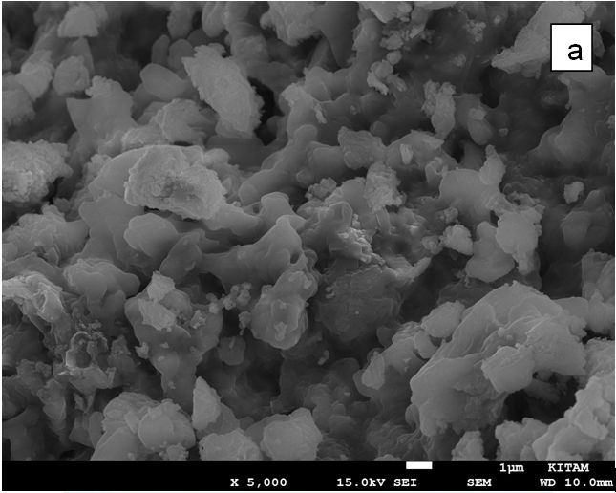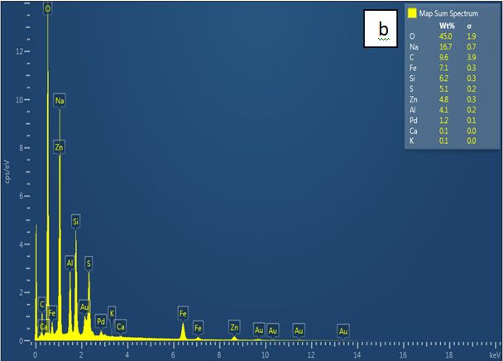
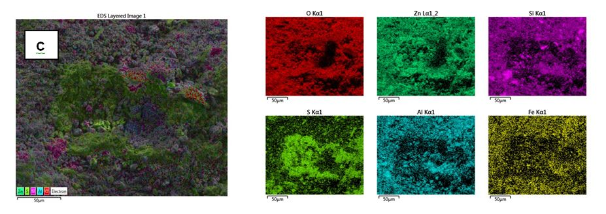
Fig. 1. The SEM (a), EDS spectra (b), EDS Mapping analyses (c) for KZF composite
The functional groups of the kaolin, KZF, KZF-200 and after the adsorption of DR-28 and DB-22 dyes on KZF were determined using FTIR analysis. FTIR spectra are shown in Fig. 2.
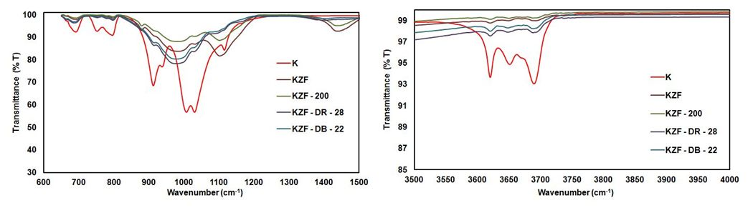
Fig. 2. FTIR spectra of K, KZF, KZF-200, and after adsorption of dye on KZF
As shown in Fig. 2, the bands found at ~3690 and 3620 cm⁻¹ are the typical bands showing the ordered structure of kaolin. The bands at ~3690 cm⁻¹ and 3620 cm⁻¹ indicate the OH stretching and H-O-H stretching respectively.¹⁹ The peaks at 1117, 1030, and 1001 cm⁻¹ may be due to Si-O stretching.^{2,19} The peak at 910 cm⁻¹ may be due to Al-OH-Al stretching vibration.²² The peaks at 796, 752, and 691 cm⁻¹ may be due to the tensile vibrations of Si-O-Si, Si-O-Al, and Si-O-Mg and the bending vibrations of SiO in the structure of kaolin.²
The peaks of the kaolin at 910, 940, 1001, 1030, and 1117 cm⁻¹ disappeared after the preparation of KZF and KZF-200. The bands of KZF and KZF-200 (752, 796, 3620 and 3690 cm⁻¹) were similar to those of the raw kaolin but transmittance of these bands was higher than that of the kaolin. The weak and disappeared peaks showed the change in the structure of kaolin. This can be interpreted that the Al³⁺ crystals in the kaolin structure were replaced by Fe³⁺.¹⁹ There were new bands at 1440, 1100, and 980 cm⁻¹ in KZF and KZF-200. The peaks at 1440, 1100, and 980 cm⁻¹ may be due to O-H bending, C-O stretcthing and C=C bending, respectively.
When the FTIR spectra of KZF were compared with the FTIR spectra taken after the adsorption of DR-28 or DR-22 on KZF, it was seen that both had the same bands except 1440 and 1100 cm⁻¹. After the adsorption of DR-28 and DB-22 by KZF, the peaks at 1440 and 1100 cm⁻¹ disappeared. The transmittance of KZF after the adsorption of dye was lower than that of KZF. This indicates that the functional groups of KZF were involved in the dye adsorption.²³ After the dyes were adsorbed by KZF, some of the peaks disappeared and the range of some of the absorption peaks changed. This may be due to the interaction between the functional groups in the KZF and the dye molecules.²
Fig. 3 shows XRD patterns of K, KZF, and KZF-200. As seen in Fig. 3, kaolin has three intense diffraction peaks at 2θ at 12.34°, 24.87°, and 26.61°. These peaks are associated with the presence of kaolinite. Similar diffraction peaks were reported by Meroufel et al.⁸ and Niu et al.²⁴ The diffraction peak at 20.86° is associated with quartz.⁸ Beside the typical peaks of kaolin, new peaks at 19°, 28.9°, 32.1°, 33.8°, 35°, 48.7°, 54.6°, 59.5° and 62° were observed in XRD spectra of KZF and KZF-200. According to the PDF card, peaks appear at 19°, 28.9°, 35°, 59.5° and 62° matchwell with PDF card 00-010-0467 (Franklinite, ZnFe₂O₄).
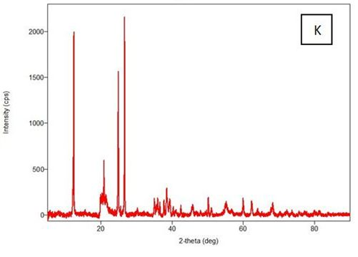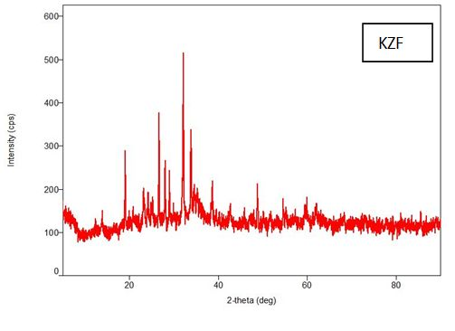
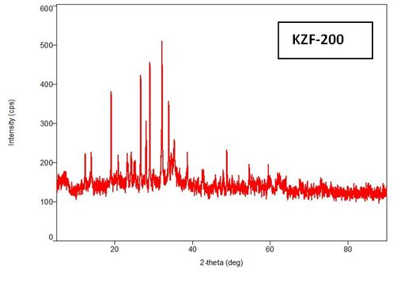
Fig. 3. XRD analysis of K, KZF and KZF-200

The peaks at 28.9° and 33.8° indicate that these composites contained typical zinc oxide, magnetite, and zinc ferrite structures. The diffraction peak at 28.9° indicates that a successful introduction of Zn to Fe spinel after synthesis. The peak at 35° shows the development of the spinel phase, indicating a zinc ferrite formation in the composite.²⁵
The magnetic behavior of KZF at 298K was investigated by VSM analysis. The result is shown in Fig. 4. As can be seen in the Fig. 4, the amount of magnetic saturation for the KZF was determined as 3.3 emu/g. The low value of magnetic saturation for KZF is due to the fact that the magnetite was covered by the kaolin.²⁶ However, KZF can be separated from the solution using a permanent magnet. The magnetization curve of KZF exhibited zero coercivities and remanences, indicating a superparamagnetic behavior of the sample at room temperature.²⁷
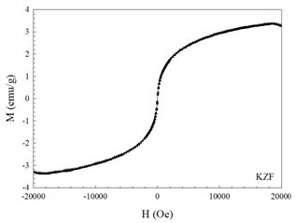

Fig. 4. VSM analysis of KZF at room temperature
3.2. Effect of Heat Treatment on the Adsorbent
To investigate the effect of the heat treatment applied to the composite on dye removal, the composites KZF and KZF-200 were tested. The experiments were performed at an initial dye concentration of 30 mg/L, with an adsorbent amount of 0.6g/200mL, at 21°C and with an original solution pH of 7.4. Fig. 5 shows the results. As seen in Fig. 5, lower removal rates were obtained for both DR-28 and DB-22 in the experiments with kaolin compared to those with KZF and KZF-200.
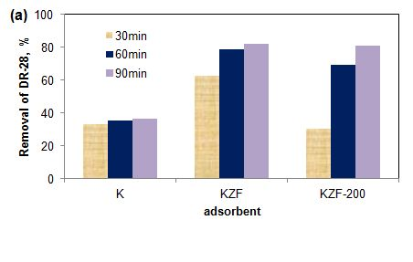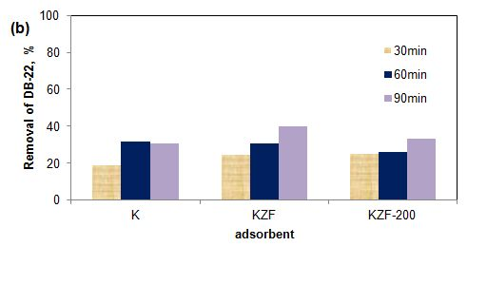
Fig. 5. Eﬀect of the heat treatment applied to KZF in the removal of (a) DR-28 and (b) DB-22 (initial concentration: 30 mg/L, temperature: 21 °C, adsorbent amount: 0.6g/200mL, initial pH:original)

DR-28 removals at the end of 90 minutes were found to be 82.3% and 81.1% in the experiments with KZF and KZF-200, respectively. The removal rates in the contact time of 90 min were almost the same. However, in the contact times of 30 and 60 minutes, KZF provided a higher DR-28 removal than KZF-200. In the experiments, DB-22 removal was found to be higher for the composite KZF. In the contact time of 90 min, the removals of DB-22 were found to be 40% and 33.3% in the experiment with KZF and KZF-200, respectively. Therefore, KZF was chosen as the adsorbent, and the effect of the other parameters was examined using KZF.
As shown in Fig. 2, KZF and KZF-200 had the same peaks, but the transmittance of KZF was lower than that of KZF-200. The kaolinite had a disordered structure at lower temperatures due to dehydroxylation.²⁸
The removal rate of DR-28 was found to be higher than that of DB-22. DR-28 has two azo bonds, on the other hand, DB-22 has tetra azo bonds. The higher the number of azo bonds, the higher the stability of dye, which makes the dye removal difficult.
In addition, the molecular weight of the tetra azo dye DB-22 was higher than that of the diazo dye DR-28. The molecular weights of DB-22 and DR-28 were 1084 g/mol and 696.67 g/mol, respectively. The distribution of dyes in water increases with the increase of the molecular weight of the azo dyes, which causes a decrease in the rate of azo dye degradation.⁷
3.3. Effect of Adsorbent Amount
In the present study, the effect of adsorbent amount on dye removal was also investigated. Experiments were done with a various amounts of adsorbent at the initial concentration of 30 mg/L, at 21°C and original pH. Fig. 6 shows the effect of adsorbent amounts on the removal of DR-28 and DB-22. The removal of DR-28 increased with increasing KZF amount from 0.6g/200mL to 0.8g/200mL then remained constant. DR-28 removals were found to be 89.7%, 90.2% and 90.1% in the KZF amounts of 0.8, 1, and 1.2g/200mL respectively, at the end of 90 min. At the end of 30 min, the removals of DR-28 were found to be 76.4% and 88.9% in the KZF amounts of 0.8g/200mL and 1g/200mL respectively. Therefore, 1g/200mL of KZF was chosen as the optimum adsorbent amount.
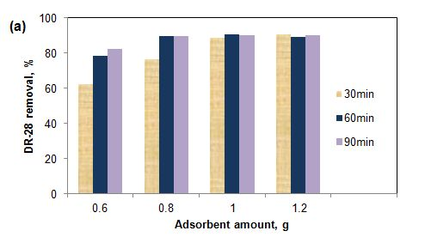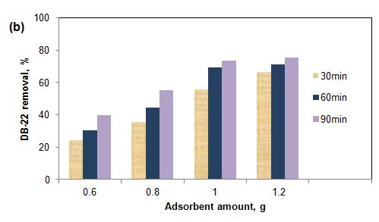
Fig. 6. Effect of KZF amount on the removal of (a) DR-28 and (b) DB-22 (initial concentration: 30 mg/L, temperature: 21 °C, initial pH: original)

The removal of DB-22 increased with the increasing adsorbent amounts within the range of 0.6g/200mL-1.2g/200mL. The removals of DB-22 at the end of 90 min, were 40%, 55.3%, 73.2%, and 75.4% in the KZF amounts of 0.6, 0.8, 1, and 1.2g/200mL respectively. There was no significance difference between the KZF amounts of 1g/200mL and 1.2g/200mL in terms of DB-22 removal.
DB-22 removal was lower than the removal of DR-28 under the studied conditions. As mentioned in the previous section, removal of tetra azo dyes is more difficult than that of diazo dyes.
The removal of DR-28 and DB-22 increased with the increasing adsorbent amount due to the increase in surface area and number of active sites. After the optimum adsorbent amount, the effective active surface area decreased due to the accumulation of adsorbent particles, and as a result, removal rate remained almost constant. Similarly, Boushehrian et al.², reported that the removal of methylene blue and methyl violet remained almost constant after the adsorbent dosage of 1.5g/L. Cao et al.²⁹ investigated the adsorption of reactive brilliant red using magnetic Fe₃O₄/chitosan nanoparticles and reported that the optimum adsorbent amount was 0.6 g/L, and after the optimum adsorbent amount, the removal rate was almost the same. In another study, Karthikeyan et al.³⁰ studied adsorption of phosphate and nitrate ions from water using magnetic kaolin (MK) chitosan beads and reported that, the removal of phosphate and nitrate increased with the increasing amounts of MK-chitosan beads due to the increase in reactive vacant sites of the adsorbent surface. Moreover, they also reported that, there was no significant change in the removal rate at the adsorbent amounts greater than 100 mg. Koohi et al.³¹ also reported similar results. They found that the removal efficiency of Congo red increased with the increasing amounts of Fe₃O₄/NiO due to the increase in the active surface area, and after the adsorbent amount of 15 g/L, no significant change was observed in the removal rate. The decrease in the surface area due to the aggregation of particles causes a decrease in the adsorption capacity. Esvandi et al.³ examined the adsorption of sunset yellow and Nile blue using magnetic nanoparticle, and reported that the removal efficiency increased when the adsorbent amount was increased from 0.4 g/L to 1 g/L (optimum adsorbent amount), and after the adsorbent amount of 1 g/L, the removal rate remained constant.
3.4. Effect of Initial pH
The pH of solution is an important parameter affecting the dye adsorption onto the adsorbent. DR-28 is a diazo dye which changes colour at low pHs due to protonation of its amino groups. The red color of DR-28 changes to bluish color below the pH 5.^{8,21,32} For this reason the effect of pH was not investigated under strong acidic conditions.
The effect of pH on the removal of DR-28 and DB-22 was studied at the initial pHs of 6.5, ≈7.4, 8.5, and 9. ≈7.4 is the original pH of the dye solution. The results are presented in Fig. 7. The pH of the dye solution was adjusted at the beginning of the experiment and not controlled during the adsorption process.
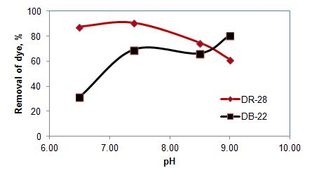
Fig. 7. Effect of initial pH of the dye solution on the removal of DR-28 and DB-22 (initial concentration: 30 mg/L, temperature: 21 °C, adsorbent: KZF, adsorbent amount: 1g/200mL, contact time: 60 min)
The removal rate of DR-28 increased from 87.5% to 90.5% when the pH of the solution was increased from 6.5 to 7.4. After the original pH, the removal rate decreased with the increase of solution pH, which could be due to the de-protonation of the adsorbent surface. Similarly, Koohi et al.³¹ reported that the removal of congo red decreased as the pH was increased after the optimum pH. They also reported that, the adsorption capacity gradually decreased, due to the repulsion between the congo red ions and the adsorbent molecules. Das et al.³² investigated the effect of pH on the decolorization of congo red and reported that, highly acidic and highly basic conditions were not suitable for the decolorization of congo red. They obtained the maximum decolorization of congo red at pH 7.
The removal of DB-22 increased when the pH was increased from 6.5 to 7.4 (original pH). At the pHs of 7.4 and 8.5, there was no significant change in the removal rate. The removal of DB-22 was found to be 80.4% in pH 9. Sun et al.³³ reported similar result for the adsorption of anionic dye reactive red 123 and explained the effect of pH on the adsorption by electrostatic interaction between the adsorbent and the dye molecules. Based on these results, it can be asserted that the adsorption mechanism is not dependent solely on electrostatic interaction. The molecular structure of dyes may also affect the adsorption process.
3.5. Effect of Temperature
Temperature indicates whether the adsorption process is exothermic or endothermic. In the study, the effect of temperature on dye removal was also investigated. The experiments were done at different temperatures at the initial concentration of 30 mg/L, with the adsorbent amount of 1g/200mL and the contact time of 60 min at original pH. Fig. 8 presents the effect of temperature on the removal of DR-28 and DB-22.
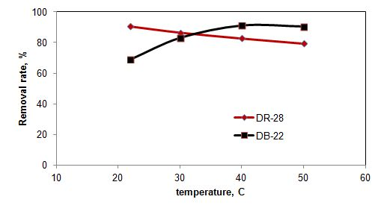
Fig. 8. Effect of temperature on the removal of DR-28 and DB-22 (pH: original, initial concentration: 30 mg/L, adsorbent: KZF, adsorbent amount: 1g/200mL, contact time: 60 min)
The removal of DR-28 decreased with the increasing temperatures. This result shows that, the adsorption of DR-28 was exothermic. As the temperature increases, the tendency of the dye adsorbed on the adsorbent surface to separate from the surface increases.² According to Esvandi et al.³, adsorption efficiency decreases with the increasing temperatures due to the desorption of dye molecules from the adsorbent surface.
On the other hand, the removal of DB-22 increased with the increasing temperatures up to 40°C. The removals of DB-22 at the initial concentration of 30 mg/L and the contact time of 60 min were found to be 69.2%, 83.2% and 91.3% at the solution temperatures of 21, 30, and 40 °C, respectively. After 40 °C, the removal rate remained almost constant. So, the adsorption of DB-22 was an endothermic process. Magdy et al.¹⁹ reported similar results for the adsorption of Direct Red 23. The mobility of dye molecules changes with temperature. As the temperature of the solution increases, the mobility of the dye molecules increases and as a result, the number of dye molecules interacting with the free active sites on the composite surface increases.
Based on the experimental results, it can be asserted that the optimum temperatures for the removal of DR-28 and DB-22 were 21 °C and 40 °C, respectively. For this reason, the experiments examining the effect of initial concentration were carried out at these optimum temperatures.
3.6. Effect of Initial Concentration and Contact Time
In the study, the effects of initial concentration and contact time on dye removal were also investigated. The experiments were done within an initial concentration range of 20-50 mg/L with an adsorbent amount 1g/200mL, at original pH. The experiments examining the effect of contact time and initial concentration were carried out at the optimum temperature values specified in the previous section (21°C for DR-28 and 40°C for DB-22). Fig. 9 presents the effect of initial concentration and contact time on the removal of DR-28 and DB-22.
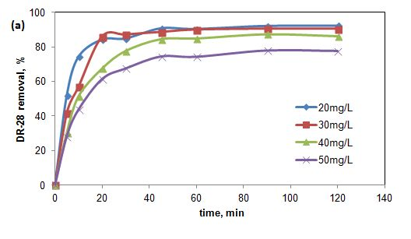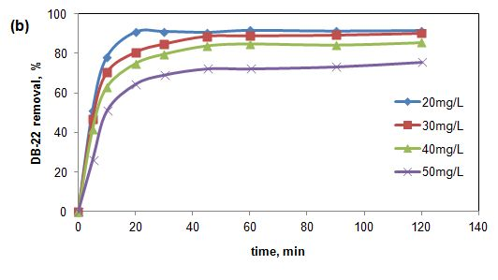
Fig. 9. Effect of initial concentration and contact time on the removal of (a) DR-28 and (b) DB-22 (pH: original, temperature: 21 °C (for DR-28), 40 °C (for DB-22), adsorbent: KZF, adsorbent amount: 1g/200mL)
The experimental results showed that the removal rates of DR-28 and DB-22 were faster for the first 20 min, and then slowed down. The removal rate was almost constant after the contact time of 30 min. At the beginning of the adsorption process, active surface area is high. As the time progresses, empty areas begin to fill and the appropriate surface area decreases due to saturation with dye molecules. Accordingly, the rate of the adsorption process decreases and reaches an equilibrium.^{2,30}
As seen in Fig. 9, the removal of DR-28 and DB-22 decreased with the increasing initial concentrations. The removals of DR-28 for the contact time of 120 min were found to be 92.4%, 89%, 86% and 77% at the initial dye concentrations of 20, 30, 40, and 50 mg/L, respectively. Similar result was obtained for DB-22. The removals of DB-22 were found to be 91.7%, 90.2%, 85.5%, and 75.6% at the initial DB-22 concentration of 20, 30, 40, and 50 mg/L respectively. Mass transfer occurs due to the concentration difference between the aqueous phase and the adsorbent surface. Initial concentration of the dye solution is the driving force for mass transfer. The removal rate decreases with the increasing initial concentrations due to the decrease in the number of active sites of the adsorbent.¹⁶ Magdy et al.¹⁹ reported similar results. As the dye concentration increases, the adsorbent reaches saturation quickly for a fixed amount of adsorbent, and the active surfaces are covered with dye molecules. According to Sanad et al.³⁴, at high dye concentrations, the unit mass of the adsorbent is exposed to more dye molecules. As a result, the active sites gradually fill until they reach saturation, causing a decrease in removal efficiency. Boushrean et al.² examined the effect of initial concentration on the removal of methylene blue and methyl violet and reported that, at lower dye concentrations, the ratio of the active surface area of the adsorbent to the dyes in the solution was high, and for this reason, all the dye molecules interacted with the adsorbent, and thus a higher removal efficiency was achieved.
3.7. Adsorption Isotherms
The adsorption equilibrium data collected at the dye concentrations of 20-50 mg/L were ﬁtted by common isotherms Langmuir and Freundlich models. The Langmuir isotherm model assumes that the adsorbate is coated in a monolayer on the homogeneous adsorbent surface, and the adsorption takes place only at the active sites on the adsorbent. The Freundlich equation is an empirical equation used to describe heterogeneous systems.²⁹
Langmuir and Freundlich models are given in Eqs. (3) and (4), respectively. ^{2,22,35}
$\frac{Ce }{qe}$= $\frac{Ce}{qmax}+\frac{1}{qmax KL}$ (3)
$lnqe=lnkf+ \frac{1}{n}lnCe$ (4)
$RL= \frac{1}{1+KLCo}$ (5)
where q_{max} is the adsorption capacity (mg/g), K_{L} is the adsorption energy (L/g), and K_{f} and n are the Freundlich constants.
The value of R_{L} specifies whether the adsorption process is irreversible (R_{L}=0), desirable (0<R_{L}<1), linear (R_{L}=1) or undesirable (R_{L}>1). The value of n determines whether the adsorption process is linear (n=1), physical (n>1) or chemical (n<1).
The adsorption isotherm models were calculated at the initial dye concentrations of 20-50 mg/L. The other factors, such as initial pH, adsorbent amount, and temperature were kept constant. For DR-28 and DB-22, the initial pH was original pH, and the amount of the adsorbent KZF was 1g/200mL. While the parameters such as adsorbent amount and pH were the same for both dyes, the temperature was 21°C for DR-28 and 40°C for DB-22.
The values and constants of the Langmuir and Freundlich isotherm models for DR-28 and DB-22 are given in Table 1. The results of the Langmuir adsorption isotherm models for DR-28 and DB-22 are shown in Fig. 10 and Fig. 11, respectively.
The values of R² for the Langmuir model were found to be 0.9969 and 0.9926 for DR-28 and DB-22, respectively. The values of R² for the Freundlich model were found to be 0.9308 and 0.8381 for DR-28 and DB-22, respectively. DR-28 and DB-22 adsorptions were found to be in a good agreement with the Langmuir isotherm. The calculated R_{L} values of DR-28 and DB-22 were between 0 and 1. Based on these results, it can be asserted that the adsorption process was desirable.
Table 1. Langmuir and Freundlich isotherm parameters for the adsorption of DR-28 and DB-22 (pH: original, adsorbent: KZF, adsorbent amount: 1 g/200mL, temperature: 21 °C for DR-28, 40 °C for DB-22)
Isotherm | Constants | DR-28 | DB-22
Langmuir | q_{max} mg/g) | 7.640 | 8.404
 | K_{L} (L/mg) | 0.722 | 0.605
 | R² | 0.9969 | 0.9926
 | R_{L} | 0.027-0.064 | 0.032-0.076
Freundlich | n  K_{f} (mg/g)  R² | 3.59  3.71  0.9308 | 3.03  3.53  0.8381
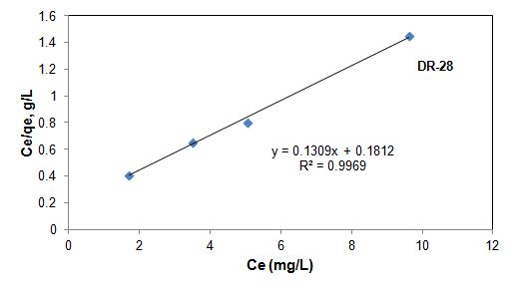
Fig. 10. Langmuir isotherm for DR-28 onto KZF (pH: original, temperature: 21 °C, adsorbent: KZF, adsorbent amount: 1 g/200mL)
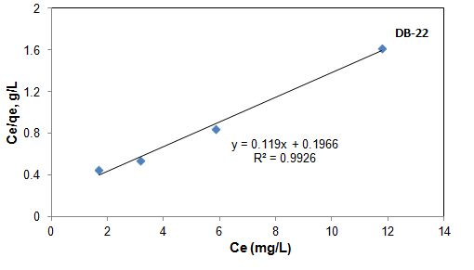
Fig. 11. Langmuir isotherm for DR-22 onto KZF (pH: original, temperature: 40 °C, adsorbent: KZF, adsorbent amount: 1 g/200mL)
3.8. Adsorption Thermodynamics
To understand the behaviour of the adsorption process, thermodynamic parameters (ΔG⁰, ΔH⁰, ΔS⁰) were calculated using the Eqs. (6), (7), and (8). The values of ΔH⁰ and ΔS⁰ were calculated from the slope and intercept of a linear plot lnK_{c} versus 1/T.^{4,35,36}
$ΔGo= ΔHo-TΔSo$ (6)
$\ln{Kc= - \frac{ΔGo}{RT}= \frac{ΔSo}{R}}- \frac{ΔHo}{RT}$ (7)
$Kc=\frac{qe}{ Ce}$ (8)
where ΔG⁰ is the standard change free Gibbs energy (J/mol), ΔH⁰ is the standard change enthalpy (J/mol), ΔS⁰ is the standard change entropy (J/molK), and R is the universal gas constant (8.314 J/molK), K_{c} is the ratio of the equilibrium concentration of adsorbate (q_{e}) loaded to the equilibrium concentration in solution (C_{e}).
The adsorptions of DR-28 and DB-22 on KZF were thermodynamically studied at an initial concentration of 30 mg/L, with an adsorbent amount of 1g/200mL, and a contact time of 60 min, at the original pH. The results of the thermodynamic study are given in Fig. 12. Table 2 shows the obtained thermodynamic parameters for DR-28 and DB-22.
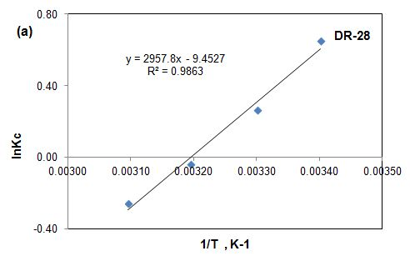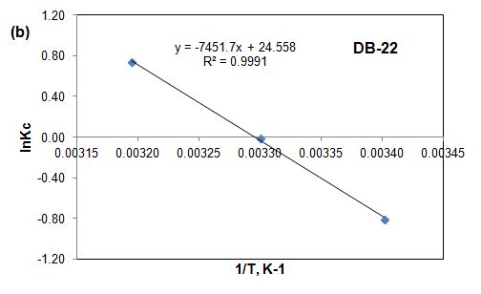
Fig. 12. The thermodynamics of the adsorption of (a) DR-28 and (b) DB-22 on the adsorbent KZF (pH: original, initial concentration: 30 mg/L, contact time: 60 min, KZF amount: 1 g/mL)
The enthalpy change (ΔH⁰) for DR-28 dyes was found to be -24.59kJ/mol, which shows that, the adsorption of DR-28 using the composite KZF was exothermic. ΔG⁰ values were -1.364, -0.653, 0.137 and 0.927kJ/mol at the adsorption temperatures of 21, 30, 40, and 50 °C, respectively. The negative ΔG⁰ values at 21 and 30 °C indicate that the adsorption process occured spontaneously.²⁹ The positive ΔG⁰ values at 40, and 50 °C suggest that the adsorption of DR-28 onto KZF was not a spontaneous process. The decrease in ΔG⁰ value with the decrease in temperature indicates that lower temperatures are suitable for the adsorption of DR-28 molecules onto KZF.²² The value of ΔS⁰ for DR-28 dye was also found to be negative. According to Boushehrian et al.², the negative ΔS⁰ values indicate a decrease in the random collision of dye molecules and the adsorbent surface during the adsorption process.
On the other hand, ΔH⁰ value for DB-22 was found to be 61.95kJ/mol, which shows that the adsorption process was endothermic. ΔG⁰ values were 1.974, 0.138, and -1.902kJ/mol at the adsorption temperatures of 21, 30, and 40 °C, respectively. The positive ΔG⁰ value at 21 and 30 °C indicated that the adsorption process was not spontaneous. The negative ΔG⁰ value at 40 °C suggests that the adsorption of DB-22 onto KZF was a spontaneous process.⁴ The decrease in ΔG⁰ value with the increase in temperature shows that higher temperatures are suitable for the adsorption of dye molecules onto adsorbent.²² As mentioned in the section 3.5 there was no increase in the removal rate of dye after 40°C. So, there is no need to work at a temperature of more than 40°C. ΔS⁰ was found to be 204 J/mol. The positive ΔS⁰ shows the increase in disorder and randomness at the composite KZF and DB-22 dye solution interface during the adsorption process.¹⁹
Table 2. Thermodynamic parameters for the adsorptions of DR-28 and DB-22 onto KZF
Dye | Temperature  (°C) | ΔH⁰  (kJ/mol) | ΔS⁰  (J/molK) | ΔG⁰  (kJ/mol)
DR-28 | 21 | -24.59 | -79 | -1.364
 | 30 |  |  | -0.653
 | 40 |  |  | 0.137
 | 50 |  |  | 0.927
DB-22 | 21  30  40 | 61.95 | 204 | 1.974  0.138  -1.902

3.9. Adsorption Kinetics
To understand the dynamics of the adsorption process of DR-28 and DB-22 onto KZF, the adsorption kinetics experiments were performed at the adsorbent amount 1g/200mL, with the initial dye concentration of 30 mg/L at original pH. Adsorption temperature was 21 °C for DR-28 and 40 °C for DB-22. Common adsorption kinetic models, pseudo ﬁrst order equation, and pseudo second order equation were employed to ﬁt the experimental data.
The linear form of the pseudo ﬁrst order kinetic model is presented as Eq. 9:
$\ln\left(qe-qt\right)= \ln{qe-k1t}$ (9)
In this relation, q_{e} is the adsorption capacity in the equilibrium state (mg/g), q_{t} is the adsorption capacity at any time (mg/g), and k₁ is the rate constant (min⁻¹). k₁ can be obtained by drawing the experimental data of ln(q_{e} - q_{t}) versus t.^{2,35}
The pseudo second order kinetic model is given in the Eq. 10:
$\frac{t}{qt}= \frac{1}{k2qe2}+ \frac{t}{qe}$ (10)
where k₂ (g/mg.min) is the rate constant of the pseudo second order kinetics. Drawing the linear graph of t/q_{t} versus t can provide the pseudo second order kinetic rate parameter.^{2,35}
Regression coefficient (R²) is important to determine the agreement of calculated q_{e} values with experimental data. A relatively higher R² value indicates that the model is suitable for the adsorption process. The values and constants of the pseudo first order and pseudo second order models for DR-28 and DB-22 are given in Table 3 and Table 4, respectively. The results of the pseudo second order model obtained for the adsorption of DR-28 and DB-22 are shown in Fig. 13 and Fig. 14, respectively
Table 3. Pseudo first order and pseudo second order kinetic models constants for DR-28 adsorption using the adsorbent KZF
Kinetic model | Parameters | Initial concentration of DR-28, mg/L
 |  | 20 | 30 | 40 |  | 50
Pseudo First Order | R²  k₁  q_{cal}  q_{exp} | 0.9531  0.0624  1.788  4.166 | 0.9205  0.0783  3.009  5.434 | 0.9699  0.0727  5.385  6.266 |  | 0.8018  0.0597  4.739  6.633
Pseudo Second order | R²  k₂  q_{cal}  q_{exp} | 0.9997  0.0755  4.292  4.17 | 0.9980  0.0410  5.692  5.43 |  | 0.9974  0.0195  6.798  6.270 |  | 0.9979  0.0177  7.179  6.63
Table 4. Pseudo first order and pseudo second order kinetic models constants for DB-22 adsorption using the adsorbent KZF
Kinetic model | Parameters | Initial concentration of DB-22, mg/L
 |  | 20 | 30 | 40 | 50
Pseudo First Order | R²  k₁  q_{cal}  q_{exp} | 0.532  0.0467  0.372  3.754 | 0.8783  0.07  2.749  5.831 | 0.7863  0.0464  2.252  6.898 | 0.7998  0.0338  2.718  7.265
Pseudo Second order | R²  k₂  q_{cal}  q_{exp} | 0.9992  0.145  3.83  3.75 | 0.9995  0.049  6.05  5.83 | 0.9993  0.036  7.16  6.90 | 0.9976  0.021  7.65  7.27

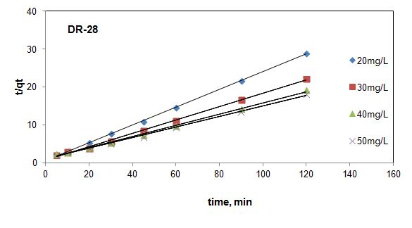
Fig. 13 Pseudo second order model for the adsorption of DR-28 onto KZF
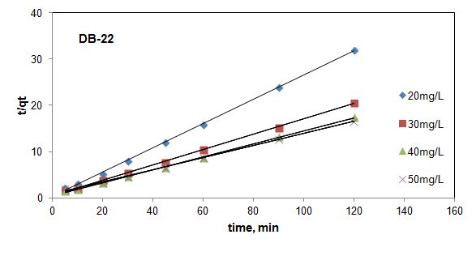
Fig. 14 Pseudo second order model for the adsorption of DB-22 onto KZF
As can be seen in Table 3 and Table 4, the correlation coefﬁcient (R²) of the pseudo second order was higher than that of the pseudo first order. This result shows that the pseudo second order was the best model in describing the kinetics of KZF toward DR-28 and DB-22.
4. Conclusion
In the study, the adsorptive removals of diazo dye Direct Red 28 (DR-28) and tetra azo dye Direct Black 22 (DB-22) were investigated using a new composite, kaolin supported zinc ferrite (KZF). The magnetic composite, KZF, was prepared by co-precipitation method for adsorption of DR-28 and DB-22 from aqueous solutions. The characteristics of the composite were determined using FTIR, SEM, EDS/Elemental Mapping, XRD, and VSM. The effects of the heat treatment applied to the composite, initial pH of the solution, initial concentration, temperature, adsorbent amount, and contact time were investigated. The heat treatment applied to the composite at 200 °C had no positive effect on the adsorption. The composite KZF gave better results. The highest removal rates of DR-28 and DB-22 with the composite KZF were obtained at the original pH, at the initial concentration of 20mg/L, with the adsorbent amount of 1g/200mL, and the contact time of 120 min, and at 21°C for DR-28 and 40°C for DB-22. Under these conditions, the removal rates of DR-28 and DB-22 from aqueous solutions were found to be 92.4% and 91.7% respectively. In addition, the adsorption isotherm, kinetic, and thermodynamic behavior of the adsorption process were investigated using the composite KZF. The experimental results were better ﬁtted with the Langmuir isotherm model. Adsorption process occurred on the homogeneous surfaces. The kinetic behavior of the adsorption of DR-28 and DB-22 showed that the pseudo second-order kinetic model was better ﬁtted with the results. Moreover, the adsorption of DR-28 was exothermic, while that of DB-22 was endothermic.

5. References
1. Y. Zhou, J. Lu, Y. Liu, Env. Pol., 2019, 252, 352-3659.
DOI:10.1016/j.envpol.2019.05.072
2. M. M. Boushehrian, H. Hossein Esmaeili, R. Foroutan, J. Env. Chem. Eng., 2020, 8, 103869.
DOI:10.1016/j.jece.2020.103869
3. Z. Esvandia, R. Foroutan, J.S. Peighambardoust, A. Akbari, B. Ramavandi, Surf. and Int., 2020 21, 100754.
DOI:10.1016/j.surfin.2020.100754
- M. Fayazi, D. Afzalic, A. Mostafavi, V. K Gupta, J. Mol. Liq., 2015, 212, 675–685.
DOI:10.1016/j.molliq.2015.09.045
- S. Benkhaya, S. M'rabet, A. El Harﬁ, A., In. Chem. Com., 2020, 115, 107891.
DOI:10.1016/j.inoche.2020.107891
- M. Berradi, R. Hsisou, M. Khudhair, M. Assouag, O. Cherkaoui, A. El Bachiri, A. El Harﬁ, Hel., 2019, 5, e02711.
DOI:10.1016/j.heliyon.2019.e02711
- S. Benkhaya, S. M'rabet, A. El Harﬁ, Hel., 2020, 6, e03271.
DOI:10.1016/j.heliyon.2020.e03271
- B. Meroufel, O. Benali, M. Benyahia, Y. Benmoussa, M. A. Zenasni, J. Mat. Env. Sc., 2013, 4(3), 482-491.
- N. T. Hien, L. H. Nguyen, H. T. Van, T. D. Nguyen, T. H. V. Nguyen, T. H. H. Chu, T. V. Nguyen, V. T. Trinh, X. H. Vu, K. H. H. Aziz, Sep. Pur. Tech., 2020, 233, 115961.
DOI:10.1016/j.seppur.2019.115961
- H. Patel, R. T. Vashi, J. Sa. Chem. Soc., 2012, 16, 131–136.
DOI:10.1016/j.jscs.2010.12.003
- R. Saleh, A. Taufik, Sep. Pur. Tech., 2019, 210, 563-573.
DOI:10.1016/j.seppur.2018.08.030
- M. Khadhraoui, H. Trabelsi M. Ksibi, S. Bouguerra, B. Elleuch, J. Haz. Mat., 2009, 161, 974-981.
DOI:10.1016/j.jhazmat.2008.04.060
- F. H.. AlHamedi, M. A. Rauf, S. S. Ashraf, Des., 2009, 239, 159-166.
DOI:10.1016/j.desal.2008.03.016
- N. Guy, S. Çakar, M. Özacar, J. Coll. Int. Sc., 2016, 466, 128-137.
DOI:10.1016/j.jcis.2015.12.009
- M. Hu, X. Yan, X. Hu, J. Zhang, R. Feng, M. Zhou, J. Coll. Int. Sc., 2018, 510, 111-117.
DOI:10.1016/j.jcis.2017.09.063
- A. Kanwal, H. N. Bhatti, M. Iqbal, S. Noreen, Wat. Env. Res., 2017, 89(4), 301-311.
DOI:10.2175/106143017x14839994522984
- Z. Gao, X. Li, H. Wu, H. Zhao, W. Deligeer, S. Asuha, Mic. Mes. Mater., 2015, 202, 1-7.
DOI:10.1016/j.micromeso.2014.09.029
- Z. Chen, Y. Cheng, Z. Chen, M. Megharaj, R. Naidu, J. Nanopart. Res., 2012, 14:899, 1-8.
DOI:10.1007/s11051-012-0899-0
- A. Magdy, Y. O. Fouad, M. H. Abdel-Aziza, A. H. Konsowa, J. Ind. Eng. Chem., 2017, 56, 299-311.
DOI:10.1016/j.jiec.2017.07.023
- F. Sun, Q. Zeng, W. Tian, Y. Zhu, W. Jiang, J. Env. Chem. Eng., 2019, 7, 103011.
DOI:10.1016/j.jece.2019.103011
- S. J. Olusegun, N. D. S. Mohallem, Env. Poll., 2020, 260, 114019.
DOI:10.1016/j.envpol.2020.114019
- Q. Huang, M. Liu, J. Chen, K. Wang, D. Xu, F. Deng, H. Huang, X. Zhang, Y. Wei, J.Mat. Sci., 2016, 51, 8116-8130.
DOI:10.1007/s10853-016-0082-6
- A. H. Jawad, A. S. Abdulhameed, Surf. Int., 2020, 18, 100422.
DOI:10.1016/j.surfin.2019.100422
- S. Niu, X. Xie, Z. Wang, L. Zheng, F. Gao, Y. Miao, Env. Tech., 2021, 42(10), 1472-1481.
DOI:10.1080/09593330.2019.1670269
- D. Ar Rahim, W. Fang, G. Zhu, H. Wibowo, D. Hantoko, Q. Hu, H. Susanto, Z. Gao, M. Yan, Chem. Eng. Proc.-Pr. Int., 2021, 68, 108565.
DOI:10.1016/j.cep.2021.108565
- D. L. Rossatto, M. S. Netto, S. L. Jahn, E. S. Mallmann, G. L. Dotto, E. L. Foletto, J. Env. Chem. Eng., 2020, 8, 103804.
DOI:10.1016/j.jece.2020.103804
- R. Nicola, S-G. Muntean, M-A. Nistor, A-M. Putz , L. Almasy, L. Sacarescu, Chemos., 2020, 261, 127737.
DOI:10.1016/j.chemosphere.2020.127737
- A. Souri, F. Golestani-Fard, R. Naghizadeh, S. Veiseh, App. Cl. Sci., 2015, 103, 34-39.
DOI:10.1016/j.clay.2014.11.001
- C. Cao, L. Xiao, C. Chen, X. Shi, Q. Cao, L. Gao, Pow. Tech., 2014, 260, 90–97.
DOI:10.1016/j.powtec.2014.03.025
- P. Karthikeyan, S. Meenakshi, Int. J. Bio. Mac., 2021, 168, 750-759.
DOI:10.1016/j.ijbiomac.2020.11.132
- P. Koohi, A. Rahbar-kelishami, H. Shayesteh, Env. Tech. Inn., 2021, 23, 101559.
DOI:10.1016/j.eti.2021.101559
- R. Das, M. Bhaumik, S. Giri, A. Maity, Ult. Son., 2017, 37, 600-613.
DOI:10.1016/j.ultsonch.2017.02.022
- D. Sun, X. Zhang, Y. Wu, X. Liu, J. Haz. Mat., 2010, 181, 335-342.
DOI:10.1016/j.jhazmat.2010.05.015
- M. M. S. Sanad, M.M. Farahat, M. A. Abdel Khalek, Adv. Pow. Tech., 2021, 32, 1573-1583.
DOI:10.1016/j.apt.2021.03.013
- R. Salahshour, M. Shanbedi, H. Esmaeili, Acta Chim. Slov., 2021, 68, 363–373.
DOI:10.17344/acsi.2020.6311
- T. A. Aragaw, F. T. Angerasa, Hel., 2020, 6, e04975.
DOI:10.1016/j.heliyon.2020.e04975

